Original Research Article

ANTIDIARRHEAL AND ELECTROLYTE-MODULATORY EFFECTS OF Manihot esculenta FLAKES: SUGAR-ADDED VERSUS SUGAR-FREE AQUEOUS SUSPENSIONS IN CASTOR OIL-INDUCED DIARRHEAL RATS

ABSTRACT
Diarrhea remains a worldwide public health priority, particularly in resource-poor settings where access to conventional pharmaceutical therapy may be compromised. Current drugs for diarrhea, including loperamide, while effective, have such limitations as cost, side effects, and availability that safe, cheap, and convenient local substitutes are preferable. This study was aimed at evaluating the antidiarrheal, electrolyte-restorative, and intestinal mucosal healing effect of sugar-free and sugar-containing suspensions of Manihot esculenta flakes (garri) in castor oil-induced models of diarrhea in rats. Garri had an impressive antidiarrheal effect, reducing diarrheal feces to 4.52 ± 0.49, equivalent to 52.4% inhibition, very closely comparable to that of the sugar-containing preparation (4.61 ± 0.67; 51.4%) and approaching the standard drug, loperamide (3.78 ± 0.13; 60.2%). In enteropooling model, garri lowered intestinal content weight and volume of liquid to 2.08 ± 0.80 g and 1.52 ± 0.41 ml, respectively—comparable with loperamide (2.57 ± 1.56 g, 1.78 ± 0.12 ml). The type with added sugar, though effective, showed slightly lower efficacy (2.98 ± 0.48 g, 1.61 ± 0.67 ml). Garri inhibition of intestinal motility was 24.5% (charcoal distance: 31.52 ± 1.09 cm), and 25.8% with sugar, compared to 29.1% with loperamide. Electrolyte analyses showed that garri normalized serum chloride, sodium, and potassium in rats compared to untreated rat castor oil-depleted group. Histological analysis confirmed mucosal regeneration, reduced inflammation, and improved integrity of submucosal glands in garri groups, where greater results were noted in the sugar-free version. These findings provides scientific basis for the historical use of M. esculenta flakes as a diarrheal traditional remedy. The flakes, especially when administered without added sugar, may constitute a cheap acceptable cultural option with equal efficacy to that of traditional pharmacotherapy, justifying their further investigation as adjunct therapy for treatment of diarrheal disease.
Keywords: Manihot esculenta flakes; Antidiarrheal; Electrolyte; Castor oil-induced diarrhea Gastrointestinal motility
1. Introduction
Diarrhea is a gastrointestinal disorder characterized by altered bowel habits resulting in the frequent passage of loose or unformed stools with increased fluidity and volume (Ihara et al., 2024). The World Health Organization (WHO) defines diarrhea as passing at least three watery stools within a 24-hour period or a frequency exceeding an individual's usual pattern (WHO, 2023). Prolonged episodes of diarrhea often lead to dehydration due to significant fluid and electrolyte losses, and in severe cases, it may progress to symptoms such as decreased urination, pallor, rapid heart rate, and reduced responsiveness (WHO, 2023). This condition is frequently accompanied by pain, urgency, perianal discomfort, and incontinence, further impacting the quality of life (Sperber et al., 2021). Effective management of diarrhea focuses on maintaining hydration, correcting fluid and electrolyte imbalances, and minimizing complications to reduce mortality and morbidity (Pawlowski et al., 2009).
Globally, diarrheal diseases remain a significant cause of morbidity and mortality, particularly among children under five years of age. It ranks as the third leading cause of death in this age group, accounting for approximately 443,832 fatalities annually (WHO, 2024). Acute diarrhea is primarily caused by enteric pathogens, including viruses, bacteria, and parasites, while chronic diarrhea often arises from conditions such as inflammatory bowel disease and malabsorption disorders (Chu et al., 2020). Dietary factors, such as food intolerances, allergies, or consumption of substances that disrupt normal digestion and absorption, also contribute to the etiology of diarrhea (Motuma et al., 2025).
Castor oil is a widely employed agent in experimental models to induce diarrhea due to its ability to disrupt normal gut physiology. The primary active component, ricinoleic acid, is released upon hydrolysis in the small intestine and stimulates intestinal secretion and motility (Ahmed et al., 2025). Ricinoleic acid activates the EP3 prostanoid receptor, increasing cyclic AMP levels, which in turn stimulates the secretion of water and electrolytes into the intestinal lumen (Akuodor et al., 2018).
Loperamide is a widely used antidiarrheal agent that functions primarily by targeting opioid receptors in the gut. It slows intestinal motility by acting on the μ-opioid receptors of the myenteric plexus, reducing the rate of water and electrolyte loss. This mechanism allows the bowel to absorb more fluids, enhancing stool consistency and reducing frequency.
Manihot esculenta (Cassava), a member of the Euphorbiaceae family, is a staple crop cultivated across tropical regions and a primary food source for over 2 billion people, especially in developing countries. Beyond its nutritional significance, cassava serves as a raw material in pharmaceutical and chemical industries. Due to its rapid spoilage within two to three days post-harvest, cassava is often processed into long-lasting products, such as Manihot esculenta (Cassava) flakes (garri), semolina, flour, fufu, tapioca, and starch. Garri, a partially gelatinized, roasted, fermented granular product, is particularly notable for its nutritional quality, ease of preparation, and extended shelf life (Airaodion et al., 2019).
The processing of cassava into garri involves steps that detoxify the roots by removing their cyanogenic glucosides, ensuring safety for consumption. Garri also exhibits prebiotic and probiotic properties, promoting gut health and overall well-being. Anecdotal evidence suggests that cassava flakes, consumed as a pasty solution, may alleviate diarrhea symptoms, potentially due to their fiber content, which retains water and modulates stool consistency. However, there is limited scientific validation of these claims. This study aimed to evaluate the antidiarrheal and electrolyte-modulatory effects of Manihot esculenta flakes, prepared as sugar-free and sugar-added aqueous suspensions, in castor oil-induced diarrheal rats. By employing in vivo biochemical approaches, this research seeks to elucidate the therapeutic potential of cassava flakes in mitigating diarrhea.
2.0 Materials and Methods
2.1 Materials
2.1.1 Manihot esculenta Flakes
Two cups of Manihot esculenta flakes were procured from Mandate Market, Adewole, Ilorin, Nigeria. The flakes were processed into powder using a NutriBullet 900 series blender (NutriBullet, LLC), while distilled water, obtained from Labtrade Nigeria Company, Ilorin, was utilized for the preparation of the Manihot esculenta aqueous suspensions.
2.1.2 Experimental Animals
Forty-five (45) male and female Wistar rats (weighing between 150–200 g) were used for the study. The animals were obtained from a certified animal breeding facility and were acclimatized under standard laboratory conditions, including a 12-hour light/dark cycle, controlled temperature (22 ± 2°C), and unrestricted access to water. The animals were fed a standard rat pellet diet (Livestock Feeds, Nigeria) except during fasting periods as required for specific experiments. All animal handling procedures adhered to National Institute of Health ethical guidelines for the care and use of laboratory animals.
2.1.3 Chemicals/Reagents
Castor oil (J. T. Baker Chemical Co., USA) was used to induce diarrhea in experimental models. Loperamide (2.5 mg/kg body weight, Johnson & Johnson, USA) was used as the standard antidiarrheal drug. Sodium, potassium, and chloride diagnostic kits (Teco Diagnostics, Anaheim, CA, USA) were used for serum electrolyte analysis. The chloride assay utilized a mercuric thiocyanate reagent, while the sodium assay employed a magnesium uranyl acetate reagent, and the potassium assay involved sodium tetraphenylboron. The sugar used was purchased from Dangote group of companies, Nigeria. Hematoxylin and Eosin stains (Sigma-Aldrich, St. Louis, MO, USA) were used for histological preparations.
2.2 Methods
2.2.1 Preparation of Manihot esculenta Flakes Aqueous Suspension
Two samples of Manihot esculenta flakes were prepared, one without sugar and the other with sugar. For the sample without sugar, Manihot esculenta flakes were blended into powder using NutriBullet 900 series blender (NutriBullet, LLC), and 5 % w/v of the powder was prepared using distilled water as solvent. This yielded a pasty solution which was administered immediately to the experimental animals for antidiarrheal study. For the Manihot esculenta Flakes + Sugar mixture, 1 g of sugar was added to 4 g of Manihot esculenta flakes powder, ensuring evenly distribution of the sugar in the powder, and the mixture was used to prepare 5 % w/v Manihot esculenta flakes+ sugar suspension. The procedure was repeated for assessment of enteropooling and gastrointestinal transit.
2.2.2 Castor Oil-induced Diarrhea in Rats
The induction of diarrhea in rats followed the protocol reported by Gerald et al. (2007). Fifteen (15) animals were randomly grouped into 5 groups. The animals were deprived of food for 18 hours but had unrestricted access to water. Rats in Groups 1, 2, and 3 were orally administered 1 ml of distilled water, DMSO, and loperamide (2.5 mg/kg body weight), respectively. Then 5ml/kg b.w. Manihot esculenta flakes suspesnsion was administered to Group 4 (Garri) immediately after the suspension was prepared, and group 5 (Garri + Sugar) received 5ml/kg b.w. suspesnsion of Manihot esculenta flakes-sugar mixture immediately after the suspension was prepared. After 30 minutes of pre-treatment with the extracts or the drug, all animals except those in the normal control group were given 1 ml of castor oil orally to induce diarrhea. The latency period before the appearance of the first diarrheal drop was recorded. Observations on the severity of diarrhea were conducted over a 6-hour period by counting diarrheal drops. Data on total fecal output, diarrheal feces, and the weight of feces were averaged and compared across groups. Additionally, the inhibition percentage of diarrheal defecation for each group was calculated using a standard formula.
% inhibition = $\frac{TCF-TDF}{TCF}$ ×100
Where: TCF= Total number of faeces in control group TDF= Total number of diarrhoeal faeces in treated group
2.2.3 Evaluation of Anti-Enteropooling Activity of Manihot Esculenta Flakes Aqueous Suspensions
The effect of the extract on intraluminal fluid accumulation was assessed using the method described by Havagiray et al. (2004). For this experiment, another fifteen (15) rats were grouped randomly into 5 groups with each group comprising three animals. Before the experiment, the animals were fasted for 18 hours but allowed free access to water. Rats in groups 1, 2, and 3 were orally administered 1 ml of distilled water, DMSO, and loperamide (2.5 mg/kg body weight), respectively. Then 5ml/kg b.w. Manihot esculenta flakes suspension was administered to group 4 (Garri) immediately after the suspension was prepared, and group 5 (Garri + Sugar) received 5ml/kg b.w. suspension of Manihot esculenta flakes-sugar mixture immediately after the suspension was prepared. Following treatment, all groups received 1 ml of castor oil. After one hour, the animals were euthanized under ether anesthesia, and their small intestines were excised and tied at the pyloric and cecal ends. The intestinal contents were expelled into a measuring cylinder to determine both the volume and weight of the contents, enabling the assessment of the extract's anti-enteropooling activity.

2.2.4 Gastrointestinal Motility in Castor Oil-induced Diarrheal Rats
The influence of the ethanolic extract on small intestinal motility was examined using the procedure described by Gerald et al. (2007). The rats were fasted for 18 hours prior to the experiment but allowed access to water. Three animals were included in each group. Rats in Groups 1, 2, and 3 were orally administered 1 ml of distilled water, DMSO, and loperamide (2.5 mg/kg body weight), respectively. Then 5ml/kg b.w. Manihot esculenta flakes aqueous suspension was administered to group 4 (Garri) immediately after the suspension was prepared, and group 5 (Garri + Sugar) received 5ml/kg b.w. suspesnsion of Manihot esculenta flakes-sugar mixture immediately after the suspension was prepared. Thirty minutes post-treatment, all animals were given 1 ml of a charcoal meal consisting of a 10% (w/v) charcoal suspension in 5% nutrient agar. Sixty minutes after the charcoal meal, the animals were euthanized under ether anesthesia, and their small intestines, from the pylorus to the cecum, were carefully removed. Measurements were taken to determine both the total length of the small intestine and the distance traveled by the charcoal meal, providing a quantitative assessment of the effect of the extract on gastrointestinal motility. The distance travelled by the charcoal meal was then estimated as follows:
% charcoal motility inhibition = $\frac{MDC-MDT}{MDC}$ × 100
Where; MDC = Mean distance in control group
MDT = Mean distance in treated group
2.3 Serum Electrolytes
To minimise the sacrifice of animals, the serum of animals used for antidiarrheal model was used for analysis of electrolytes; chloride, sodium and potassium.
2.3.1 Chloride Ion (Cl⁻) Concentration
Chloride ion concentration was determined using a mercuric thiocyanate-based colorimetric method. In this assay, serum samples were reacted with a reagent mixture containing mercuric thiocyanate and ferric nitrate in an acidic medium. Chloride ions formed a complex with mercuric thiocyanate, producing a colored product. The absorbance of this chromophore was measured at 480 nm using a spectrophotometer. Chloride concentration was calculated by comparison against a standard curve derived from solutions of known chlorides concentration (Yokoi, 2002).
2.3.2 Sodium Ion (Na⁺) Concentration
Sodium ion concentration was determined using the magnesium uranyl acetate method, a very popular method for the measurement of serum electrolyte. Sodium ions were precipitated out as a triple sodium, magnesium, and uranyl acetate salt. Following precipitation, excess uranyl ions were reacted with ferrocyanide to produce a chromophore. The absorbance of the chromophore was measured at 600 nm using a UV-Vis spectrophotometer. The sodium concentration was then calculated by comparing the absorbance value with a standard calibration curve prepared using known concentrations of sodium (Taylor & James, 1996; Ceylan Koydemir et al., 2020).
2.3.3 Potassium Ion (K⁺) Concentration
Concentration of potassium ion was ascertained using a method based on the reaction with sodium tetraphenylboron. The serum samples were mixed with a reagent containing sodium tetraphenylboron to form a colloidal suspension. The turbidity of this suspension, which is inversely proportional to the concentration of potassium ions in the sample, was measured at 500 nm using a UV-Vis spectrophotometer. Potassium concentrations were then determined from a standard calibration curve using solutions of known potassium concentration. This is a very effective technique for measuring potassium concentrations with great precision in experimental and clinical settings (Zhybak et al., 2016; Cerón et al., 2004).
2.4 Histological Examination of the Small Intestine
Histological analysis of the small intestine was performed using the method reported by Mohri et al. (2009). Tissue samples were collected from each experimental group and preserving them in 10% formalin. The specimens were subsequently dehydrated using increasing concentrations of ethanol, cleared in xylene, and embedded in molten paraffin wax to create tissue blocks. Thin sections, approximately 5 µm thick, were cut from the blocks and stained with Hematoxylin and Eosin. The stained sections were examined under a light microscope to identify any pathological changes resulting from castor oil-induced gastrointestinal dysfunction and the effects of treatment with Manihot esculenta flakes aqueous suspesnsion and Manihot esculenta flakes-sugar aqueous suspension.
2.5 Statistical Analysis
The results of the study were expressed as the mean ± standard error of the mean (SEM) based on three replicates. Statistical analysis was performed using one-way Analysis of Variance (ANOVA), and differences were considered significant at a probability level of p < 0.05. The analysis was conducted using GraphPad Prism software, version 8.0.2 (GraphPad Software, Inc., San Diego, California, USA).
3.0 Results
3.1 Castor Oil-induced Diarrhea
The ethanolic extract of garri powder demonstrated a significant reduction in diarrheal symptoms induced by castor oil in rats. The diarrheal group, treated with castor oil alone, had the highest fecal output (18.73 ± 3.54 total feces and 9.49 ± 2.04 diarrheal feces), which served as the pathological baseline (Table 1). Loperamide, the standard anti-diarrheal drug, showed the greatest efficacy, reducing diarrheal feces to 3.78 ± 0.13 and achieving 60.2% inhibition of diarrheal symptoms. The garri extract treatment reduced diarrheal feces to 4.52 ± 0.49, with a moderate 52.4% inhibition rate, which was comparable to the garri combined with sugar treatment (4.61 ± 0.67 diarrheal feces and 51.4% inhibition).
Table 1. Effect of Ethanolic Extract of Garri Powder on Castor Oil-induced Diarrhoeal Rats
Group | Treatment | Total Number of Faeces (n) | Total number of Diarrheal Faeces (n) | Percentage Inhibition
1 | Normal Control | 10.82±1.21ª | - | -
2 | Diarrheal | 18.73±3.54 ^{c} | 9.49±2.04 ^{b} | -
3 | 2.5 mg/kgb.w. Loperamide | 10.57±1.56 ª | 3.78±0.13 ^{c} | 60.2 ^{b}
4 | 5 ml/kg b.w. Garri | 11.52±.0.80 ^{b} | 4.52±0.49 ^{b} | 52.4 ª
5 | 5 ml/kg b.w. Garri + Sugar | 10.98±0.48 ª | 4.61±0.67 ^{b} | 51.4 ª
Values are expressed as Mean ± SEM of three replicates, and rows with different superscripts are significantly different (p < 0.05)
3.2 Gastroenteropooling
The garri extract exhibited significant inhibitory effects on enteropooling, characterized by reductions in both intestinal content weight and fluid volume. The diarrheal group exhibited the highest intestinal content weight (4.73 ± 0.54 g) and fluid volume (2.94 ± 0.04 ml), reflecting severe fluid retention caused by castor oil (Table 2). Loperamide effectively reduced these values to near-normal levels (content: 2.57 ± 1.56 g, fluid: 1.78 ± 0.12 ml). Similarly, garri extract reduced intestinal content and fluid levels to 2.08 ± 0.80 g and 1.52 ± 0.41 ml, respectively, demonstrating comparable efficacy to loperamide. The addition of sugar to the garri extract yielded slightly higher values (content: 2.98 ± 0.48 g, fluid: 1.61 ± 0.67 ml) but remained effective. These results highlight the extract’s ability to mitigate enteropooling and restore normal intestinal function.
Table 2. Effect of ethanolic extract of Garri Powder on Castor-oil induced Enteropooling in Rats
Group | Treatment | Weight of Intestinal Content (g) | Volume of Intestinal Fluid (ml)
1 | Normal Control | 2.43±0.32 ª | 1.19±0.15 ª
2 | Diarrheal | 4.73±0.54 ^{b} | 2.94±0.04 ^{b}
3 | 2.5 mg/kgb.w. Loperamide | 2.57±1.56 ª | 1.78±0.12 ª
4 | 5 ml/kg b.w. Garri | 2.08.7±.0.80 ª | 1.52±0.41 ª
5 | 5 ml/kg b.w. Garri + Sugar | 2.98±0.48 ª | 1.61±0.67 ª
Values are expressed as Mean ± SEM of three replicates, and rows with different superscripts are significantly different (p < 0.05)
3.3 Gastrointestinal Transit of Charcoal Meal
The garri extract showed significant effects in slowing the intestinal transit of charcoal meal, indicative of its potential to reduce hypermotility caused by diarrhea. In the diarrheal group, the charcoal traveled the longest distance (41.73 ± 3.41 cm), signifying increased intestinal motility (Table 3). Loperamide treatment reduced the transit distance to 29.57 ± 1.62 cm, achieving 29.1% inhibition of motility. The garri extract reduced the distance to 31.52 ± 1.09 cm, with a corresponding 24.5% inhibition rate, while the addition of sugar slightly improved the inhibition to 25.8% (30.98 ± 0.48 cm transit distance). Although slightly less effective than Loperamide, the extract showed promise in moderating intestinal motility and alleviating diarrheal symptoms.
Table 3. Effect of Ethanolic Extract of Garri Powder Stem Bark on the Intestinal Transit of Charcoal Meal in Castor Oil-induced Diarrhoeal Rats
Group | Treatment | Distance travelled by charcoal (cm) | Percentage Inhibition
1 | Normal Control | 27.82±1.18 ª | -
2 | Diarrheal | 41.73±3.41 ^{d} | -
3 | 2.5 mg/kgb.w. Loperamide | 29.57±1.62 ^{b} | 29.1 ^{b}
4 | 5 ml/kg b.w. Garri | 31.52±1.09 ^{c} | 24.5 ª
5 | 5 ml/kg b.w. Garri + Sugar | 30.98±0.48 ^{c} | 25.8 ª

Values are expressed as Mean ± SEM of three replicates, and rows with different superscripts are significantly different (p < 0.05)
3.4 Serum Chloride Concentration
The serum chloride level was significantly lower (p < 0.05) in the diarrheal untreated group compared to the normal control, 2.5 mg/kg bwt loperamide (standard), 5 ml/kg bwt garri and and 5 ml/kg bwt garri + sugar groups (Figure 1). There was no significant difference in the serum chloride levels of normal control, 2.5 mg/kg bwt loperamide (standard), 5 ml/kg bwt garri and and 5 ml/kg bwt garri + sugar groups.

Figure 1. Serum Chloride Concentrations of Castor Oil-Induced Diarrheal Rats Administered Manihot esculentus Flakes Aqueous Suspension
Values are expressed as Mean ± SEM of three replicates, and bars with different superscripts are significantly different (p < 0.05)
3.5 Serum Sodium Ion Concentration
The serum sodium ion level was significantly lower (p < 0.05) in the diarrheal untreated group compared to the normal control, 2.5 mg/kg bwt loperamide (standard), 5 ml/kg bwt garri and and 5 ml/kg bwt garri + sugar groups (Figure 2). There was no significant difference in the serum sodium ion levels of 2.5 mg/kg bwt loperamide (standard) and 5 ml/kg bwt garri + sugar groups, and their sodium ion levels were significantly lower (p < 0.05) than 5 ml/kg bwt garri. The serum sodium ion concentration in the normal control group was significantly higher (p < 0.05) than compared to the diarrheal untreated, 2.5 mg/kg bwt loperamide (standard), 5 ml/kg bwt garri and and 5 ml/kg bwt garri + sugar groups.
Figure 2. Serum Sodium Ion Concentrations of Castor Oil-Induced Diarrheal Rats Administered Manihot esculentus Flakes Aqueous Suspension
Values are expressed as Mean ± SEM of three replicates, and bars with different superscripts are significantly different (p < 0.05)
3.6 Serum Potassium Ion Concentration
The serum potassium ion level was significantly lower (p < 0.05) in the diarrheal untreated group compared to the normal control, 2.5 mg/kg bwt loperamide (standard), 5 ml/kg bwt garri and and 5 ml/kg bwt garri + sugar groups (Figure 3). There was no significant difference in the serum potassium ion levels of normal control, 2.5 mg/kg bwt loperamide (standard), 5 ml/kg bwt garri and and 5 ml/kg bwt garri + sugar groups.
Figure 3. Serum Potassium Ion Concentrations of Castor Oil-Induced Diarrheal Rats Administered Manihot esculentus Flakes Aqueous Suspension
Values are expressed as Mean ± SEM of three replicates, and bars with different superscripts are significantly different (p < 0.05)
3.7 Histopathology
Figure 4a to 4e show the histological findings on the intestinal tissues of the experimental animals. The lower intestinal segment of the normal control group had shorter crypts and abundant submucosal glands (Figure 4a). The lower segment of the intestine of diarrheal untreated group had heavy inflammatory reaction (Figure 4b), while that of the loperimide group was filled with villi (red arrow), crypts (yellow arrow), goblet cells (black arrow) and abundant submucosal glands (Figure 4c). The lower intestinal segment of the 5 ml/kg b.w. garri group had tall mucosal epithelia, lined by goblet cells and vili (red arrow), abundant sub mucosal glands (black arrow) and inflammatory infiltrate (yellow arrow) (Figure 4d), while thte lower segment intestinal tract of the garri + sugar group had shorter mucosal lining epithelium infiltrated with inflammatory cells (black arrow) and supported by numerous submucosal glands (green arrow) (Figure 4e).

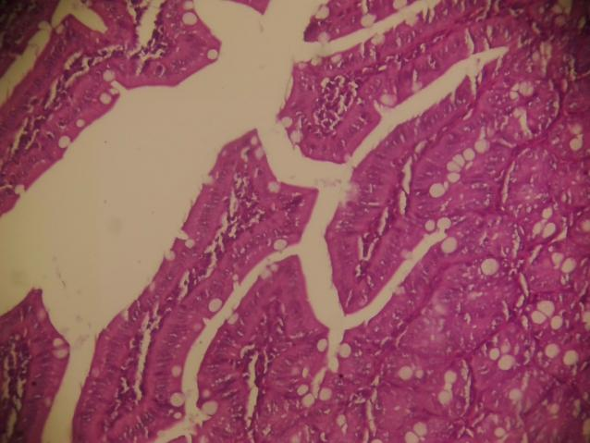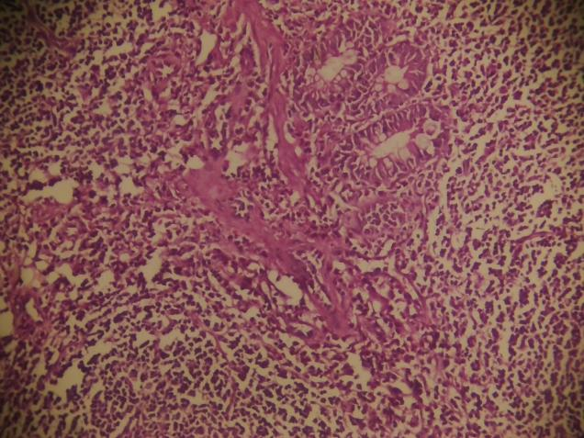
B
A
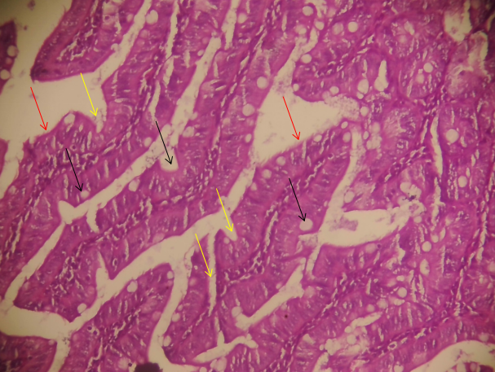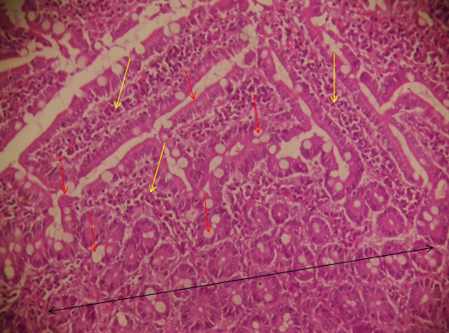
C
D
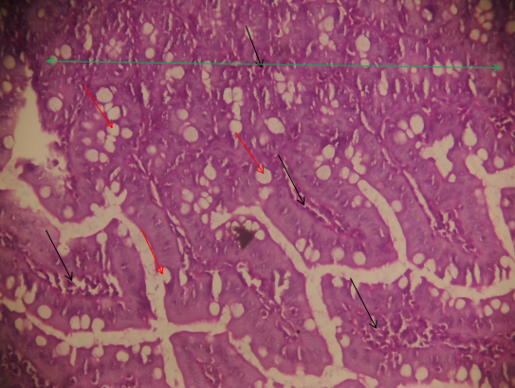
E

Figure 4 (A-E). Photomicrographs of small intestines of distilled water-adminstered normal control (A) and castor oil-induced diarrheal rats orally administered DMSO (B), loperamide at 2.5 mg/kg b. wt (C) 5 ml/kg bwt garri (D) and 5 ml/kg bwt garri + sugar groups (E).

4.0 Discussion
The findings of this study demonstrate the garri powder ethanolic extract's anti-diarrheal activity through its significant action on fecal output, intestinal fluid accumulation, and motility in castor oil-induced diarrheal models. The results agree with previous studies on plant-based drugs used for diarrhea treatment, whose activity has been attributed to bioactive phytochemicals such as tannins, flavonoids, alkaloids, and phenolics (Toklo et al., 2021). These compounds were discovered to modulate intestinal activity, hence explaining the use of traditional plant medicines for the treatment of gastrointestinal disorders across the globe.
Castor oil-induced diarrhea is greatly driven by the action of ricinoleic acid, a fatty acid that disrupts intestinal permeability, increases mucosal secretion, and induces prostaglandin-mediated smooth muscle contractions (Ahmed et al., 2022; Mmari & Mugonza, 2024; Okorie et al., 2025; Sharma et al., 2023). The resulting intestinal fluid accumulation and hypermotility produce the typical symptoms of diarrhea (Umer et al., 2013; Konaté et al., 2015). In the current research, garri extract showed a statistically significant reduction in diarrheal feces and intestinal fluid compared to the diarrheal control group, demonstrating that it mitigates the actions of ricinoleic acid through mechanisms that may include prostaglandin synthesis inhibition and intestinal motility regulation (Tadesse et al., 2014).
Phytochemicals in the garri extract, including tannins and flavonoids, were likely to have caused the anti-diarrheal activity. Tannins possess antisecretory activity and are able to reduce mucosal secretion and intestinal motility by creating protein tannates that reinforce mucosal barriers (Konaté et al., 2015). Flavonoids similarly inhibit autacoid and prostaglandin release, reducing hypersecretion and normalizing motility (Bhuiyan et al., 2020; Ammon et al., 1993). These effects are consistent with the decreases in intestinal content and fluid accumulation of garri-treated animals, which favourably compared with that of the reference drug, loperamide.
In the intestinal transit test, garri extract significantly inhibited charcoal movement, demonstrating its ability to suppress intestinal hypermotility, one of the primary mechanisms of diarrhea. This is in agreement with previous reports wherein phytochemicals such as alkaloids and phenolics modulate colonic motility and promote the reabsorption of water and electrolytes, thereby alleviating symptoms of diarrhea. The observed reduction in motility may also be explained by the relaxation of smooth muscle contractions, as theorized in studies of other plant extracts with the same effect (Osuntokun et al., 2017).
The findings also corroborate the safety and efficacy of phyto-compounds in gastrointestinal disorders. T. madagascariense methanol extracts, for instance, have been reported to inhibit intestinal motility and fluid accumulation with no toxicity at therapeutic levels. This underscores the contribution of phytoconstituents to traditional diarrhea remedies and their potential for being integrated into modern therapy regimens.
Electrolyte disturbances are markers of acute diarrhea, driven by the hypersecretion and impaired reabsorption of ions in the gut. The disruption of chloride homeostasis, as in this study, is of key significance given its role in fluid homeostasis and the regulation of intestinal secretion. Chloride ions are integral components of the secretory processes controlled by the mucosal immune system and the enteric nervous system. Prostaglandins and histamine, mediators that are released in response to inflammation or toxins, increase the secretion of chloride into the intestinal lumen, which encourages further fluid loss and dehydration (Beyder and Farrugia, 2016). Plant phytchemicals such as flavonoids and tannins were shown to inhibit chloride secretion by suppressing prostaglandin synthesis and stabilizing epithelial ion channels, in line with the observed restoration of chloride levels of garri-treated groups (Bhuiyan et al., 2020; Tadesse et al., 2014).
Sodium imbalance is the major determinant of the severity of dehydration in diarrhea and the mortality associated with it. Sodium plays a key role in the maintenance of extracellular osmolality and the facilitation of nutrient uptake through sodium-coupled transport processes. The gross sodium loss in untreated diarrheal states, as observed in this research, is a mirror of the pathological hypersecretion instigated by castor oil-stimulated prostaglandin release (Konaté et al., 2015). The normalization of serum sodium levels by the garri extract indicates a twofold mechanism of action: the promotion of sodium reabsorption and the minimization of luminal sodium loss. These findings are consistent with the role of flavonoids in the modulation of ion transport and promotion of mucosal integrity (Toklo et al., 2022). Garri extract's regulation of sodium also demonstrates its therapeutic potential as persistent hyponatremia in diarrhea is associated with neurological complications and death (Zahan et al., 2024).
Potassium depletion, as occurs in diarrhea, has life-threatening implications for cardiac and neuromuscular functions. Hypokalemia during diarrheal episodes has a tendency to arise from increased colonic secretion and impaired renal conservation mechanisms. The fact that garri extract corrected the potassium level is a pointer to its role in counteracting electrolyte imbalance by normalizing colonic potassium handling and minimizing systemic losses. Tannins and flavonoids, known constituents of garri, are likely culprits of such an action through their modulatory influence on colonic ion transporters and cell permeability. This is significant as high occurrences of hypokalemia in diarrheal patients, with complications of paralytic ileus and arrhythmias, have been documented in many studies. Through the minimization of potassium loss, the garri extract exerts a protective action that is therapeutic in the treatment of diarrhea.
These findings are backed by recent studies on plant drugs for the treatment of diarrhea. The content of phytochemicals in garri, particularly in bioactive compounds like flavonoids and tannins, aligns with global evidence of the effectiveness of traditional medicines in restoring electrolyte balance and reducing diarrheal severity (El-Saadony et al., 2025). Additionally, the similar or superior activity of garri extract over loperamide underscores its potential as a natural and safe option in diarrheal disease management. The addition of garri to therapeutic regimens can provide a cheap and accessible option, particularly in regions where diarrhea remains a source of morbidity and mortality (Gilani et al., 2014).
The histology of intestinal tissues in experimental groups exhibited extensive variation in structural integrity, inflammation, and epithelial repair, reflecting differential diarrhea and intervention effects. The healthy control group exhibited intact intestinal architecture with shorter crypts and many submucosal glands, indicative of healthy tissue. The diarrheal untreated group exhibited severe inflammation, indicating intestinal barrier breakdown and immune activation. Therapeutic treatments were of differential efficacy, with the loperamide-treated group showing significant restoration of intestinal morphology, with well-developed villi, crypts, goblet cells, and submucosal glands, pointing to successful attenuation of inflammatory injury and enhanced absorption of fluids. The garri-treated group at 5 ml/kg b.w. showed mucosal epithelial regeneration with profuse submucosal glands and protective mucus secretion, though residual inflammation was evident. However, the garri and sugar group also had worse epithelial recovery, shorter mucosal lining, and persistent inflammation, possibly because the addition of sugar disrupted gut homeostasis or enhanced immune responses.
5. Conclusion
A limitation of the present study is the absence of detailed phytochemical analysis of the Manihot esculenta flakes. Future studies are recommended to include comprehensive phytochemical profiling to identify and quantify the bioactive constituents responsible for the observed antidiarrheal and electrolyte-modulatory effects.
The findings from this study establish the antidiarrheal potential of garri extract, supported by its significant effects on reducing diarrheal symptoms, modulating intestinal motility, and restoring electrolyte imbalances. The ability of garri extract to normalize serum chloride, sodium, and potassium levels emphasizes its role in preventing the severe dehydration and systemic complications often associated with diarrhea. By restoring these electrolytes, garri not only alleviates immediate symptoms but also mitigates risks such as hypokalemia-induced cardiac arrhythmias and sodium depletion-related neurological impairments. Its comparable or superior efficacy to loperamide underscores its promise as a safe, natural, and accessible treatment option, particularly for populations in low-resource settings where diarrhea remains a significant health challenge. Further study analyzing the bioactive compounds accountable for this antidiarrheal activity of M. esculentus is recommended.
Ethical approval
All experimental protocols involving animals were approved by the Institutional Animal Ethics Committee and were conducted in accordance with national and international guidelines for the care and use of laboratory animals.

COMPETING INTERESTS DISCLAIMER:
Authors have declared that they have no known competing financial interests OR non-financial interests OR personal relationships that could have appeared to influence the work reported in this paper.
Disclaimer (Artificial intelligence)
Authors hereby declare that NO generative AI technologies such as Large Language Models (ChatGPT, COPILOT, etc.) and text-to-image generators have been used during the writing or editing of this manuscript.
REFERENCES

Ahmed, M. U., Samson, M., & Adamu, Y. M. (2025). Evaluation of the Antidiarrheal Activity of Aqueous Leaf Extract of Senna surattensis on Castor Oil-Induced Diarrhea in Rats. African Journal of Sciences and Traditional Medicine, 2(1), 1–11.

Ahmed MU, Umaru IJ, Haruna AH, Titus D. Evaluation of Antidiarrheal Activity of Aqueous Extract of Cucurbita moschata (Pumpkin) Leaf in Castor Oil Induced Diarrhea Wistar Rats. J. Compl. Altern. Med. Res. [Internet]. 2022 Dec. 27 [cited 2025 Jun. 12];20(3):18-24. Available from: https://journaljocamr.com/index.php/JOCAMR/article/view/416
Bhuiyan, F. R., Howlader, S., Raihan, T., & Hasan, M. (2020). Plants metabolites: possibility of natural therapeutics against the COVID-19 pandemic. Frontiers in Medicine, 7, 444. https://doi.org/10.3389/fmed.2020.00444
Ceylan Koydemir, H., Tseng, D., Karinca, D., et al. (2020). Sensing of electrolytes in urine using a miniaturized paper-based device. Scientific Reports, 10, 13941. https://doi.org/10.1038/s41598-020-70456-6
Chu, C., Rotondo-Trivette, S., & Michail, S. (2020). Chronic diarrhea. Current Problems in Pediatric and Adolescent Health Care, 50(7), 100873. https://doi.org/10.1016/j.cppeds.2020.100873
El-Saadony, M. T., Saad, A. M., Mohammed, D. M., Korma, S. A., Alshahrani, M. Y., Ahmed, A. E., Ibrahim, E. H., Salem, H. M., Alkafaas, S. S., Saif, A. M., Elkafas, S. S., Fahmy, M. A., Abd El-Mageed, T. A., Abady, M. M., Assal, H. Y., El-Tarabily, M. K., Mathew, B. T., AbuQamar, S. F., El-Tarabily, K. A., & Ibrahim, S. A. (2025). Medicinal plants: bioactive compounds, biological activities, combating multidrug-resistant microorganisms, and human health benefits – a comprehensive review. Frontiers in Immunology, 16, 1491777.
Ihara, E., Manabe, N., Ohkubo, H., Ogasawara, N., Ogino, H., Kaji, T., & Fujimoto, K. (2024). Evidence-based clinical guidelines for chronic diarrhea 2023.
Digestion, 105(6), 480–494. Evidence-Based Clinical Guidelines for Chronic Diarrhea 2023 | Digestion | Karger Publishers
Konaté, K., Yomalan, K., Sytar, O., & Brestic, M. (2015). Antidiarrheal and antimicrobial profile of Trichilia emetica. Asian Pacific Journal of Tropical Biomedicine, 5(5), 378–384. https://doi.org/10.1016/j.apjtb.2015.01.004
Mohri, M., & Rezapoor, H. (2009). Effects of heparin, citrate, and EDTA on plasma biochemistry of sheep: comparison with serum. Research in Veterinary Science, 86(1), 111–114.
Motuma A, Tolera ST, Alemu FK, Adare D, Argaw R, Birhanu A, Shiferaw K, Hunduma G, Letta S, Admassu Ayana D., & Temesgen S. (2025). Prevalence and risk factors of diarrhea among under-five children in Ethiopia: A systematic review and meta-analysis. BMC Public Health, 25, 1959.https://doi.org/10.1186/s12889%E2%80%91025%E2%80%9123086%E2%80%914
Okorie NH, Adonu CC, Nnadi CO. (2025). Evaluation of anti-motility and anti-secretory effects of Annona muricata leaves extract in castor oil-induced diarrhoeic rats. Pharmacological Research-Natural Products. Feb 2:100167.

Osuntokun, O. S., Olayiwola, G., Adalumo, O. A., & Olorunsogo, F. O. (2017).
Medicinal plants in the treatment of diarrhea: A review of phytochemistry and pharmacology.
UNIOSUN Journal of Science, 6(1), 146–158.
Pawlowski, S. W., Warren, C. A., & Guerrant, R. (2009). Diagnosis and treatment of acute or persistent diarrhea. Gastroenterology, 136(6), 1874–1886. https://doi.org/10.1053/j.gastro.2009.02.072
Plaatjie, M. T. A., Onyiche, T. G. E., Ramatla, T., et al. (2024). Medicinal plants for diarrhea in Sub-Saharan Africa. Tropical Medicine and Health, 52, 8. https://doi.org/10.1186/s41182-023-00569-x
Sperber, A. D., Bangdiwala, S. I., Drossman, D. A., et al. (2021). Worldwide prevalence and burden of functional gastrointestinal disorders, results of Rome Foundation Global Study. Gastroenterology, 160(1), 99–114. https://doi.org/10.1053/j.gastro.2020.04.014
Tadesse, W. T., Hailu, A. E., Gurmu, A. E., et al. (2014). Experimental assessment of antidiarrheal and antisecretory activity of Zehneria scabra. BMC Complementary and Alternative Medicine, 14, 460. https://doi.org/10.1186/1472-6882-14-460
Taylor, R. P., & James, T. J. (1996). Enzymatic determination of sodium and chloride in sweat. Clinical Biochemistry, 29(6), 529–533. https://doi.org/10.1016/S0009-9120(95)02003-9
Toklo, M. T., Ahomadegbe, M. A., Placide, H. M., & Gbaguidi, A. (2021). Plants used against diarrheal diseases in traditional African medicine: Cross-referencing pharmaco-chemical data for a valorization and pedagogical perspective.
Chemistry Research Journal, 6(6), 68–84.
Umer, S., Tekewe, A., & Kebede, N. (2013). Antidiarrhoeal and antimicrobial activity of Calpurnia aurea leaf extract. BMC Complementary and Alternative Medicine, 13, 21. https://doi.org/10.1186/1472-6882-13-21
World Health Organization. (2023). Diarrhoeal disease. https://www.who.int/news-room/fact-sheets/detail/diarrhoeal-disease
World Health Organization. (2024). Global Health Estimates 2024: Child mortality by cause. https://www.who.int/data/gho/data/themes/topics/topic-details/GHO/global-child-mortalityNatural and Applied Sciences 7(1), 20-28.
Yokoi, K. (2002). Colorimetric determination of chloride in biological samples by using mercuric nitrate and diphenylcarbazone. Biological Trace Element Research, 85(1), 87–95. https://doi.org/10.1385/BTER:85:1:87
Zahan, M. S., Hasan, M. M., Ferdous, J., Rahman, A., Khan, M., & Rahman, M. A. (2024). Pharmacological and computational profiling of Bombax ceiba Linn. leaves revealed pharmacological properties against oxidation, hyperglycemia, pain, and diarrhea. Heliyon, 10(3), e24553.
Zhybak, M., Beni, V., Vagin, M. Y., & Dempsey, E. (2016). Creatinine and urea biosensors based on a novel ammonium ion-selective copper-polyaniline nano-composite. Biosensors and Bioelectronics, 84, 22–29. https://doi.org/10.1016/j.bios.2016.04.068

