*Original Research Article*

AI-Driven Climate Disaster Prediction and Response System: Enhancing Community Resilience

**Abstract**

**Background:** Natural disasters such as typhoons, earthquakes, and tsunamis—exacerbated by climate change—pose significant global challenges, particularly for small island communities like Saipan. Given their increasing unpredictability and severity, there is an urgent need for AI-driven prediction and response systems capable of delivering accurate early warnings. Additionally, investigating the potential relationship between phytoplankton concentration changes and the occurrence of extreme weather events may contribute to the development of more proactive disaster management strategies. **Methods:** This study developed and applied AI models to predict natural disasters using ten years (2014–2024) of data, including weather patterns, phytoplankton concentrations, and recorded events of typhoons, earthquakes, and tsunamis. The prediction system was designed for integration into Saipan’s disaster preparedness and recovery framework. Preprocessing steps included handling missing values using the K-Nearest Neighbors (KNN) imputation model, addressing outliers through linear regression, and normalizing the dataset. A random forest algorithm was employed to perform the predictions. Visualizations were generated to examine the correlation between natural disaster occurrences and variations in phytoplankton concentrations. **Results:** The AI model demonstrated an overall prediction accuracy of approximately 99%, with an accuracy of 84% specifically for disaster-related events. While phytoplankton (chlorophyll) concentration alone showed weak correlations with individual weather variables such as temperature, precipitation, and wind speed, its predictive value increased when combined with other environmental features. Feature importance analysis revealed that climate-related variables—particularly wave height—were the most influential in predicting disaster occurrences. These results suggest that phytoplankton concentration, while not a strong standalone indicator, plays a meaningful role within a multi-variable prediction framework. The study highlights the importance of expanding environmental data collection and implementing real-time monitoring systems to improve forecasting precision. Integrating AI-based disaster prediction models into Saipan’s disaster response infrastructure could significantly enhance early warning capabilities, reduce recovery costs, and strengthen community resilience in the face of climate-driven natural hazards.

Key words: AI-Driven, Climate, Disaster, Response,

1. **Introduction**

Natural disasters pose significant challenges, causing severe economic, political, social, and scientific disruptions in island communities and around the world [1]. These disasters include meteorological, hydrological, climatological, and geophysical events [2]. The unpredictability of typhoons, Pacific earthquakes, and tsunamis increases the difficulty of forecasting, leaving residents and industries in Saipan vulnerable to the growing risks associated with climate change [3].

This research aims to develop an AI-based model to predict natural disasters using phytoplankton concentration as an input variable. The ultimate goal is to reduce recovery costs, protect local industries, and strengthen the resilience of Saipan’s communities. Early prediction of disasters has been shown to significantly reduce damage [4]. For instance, Super Typhoon Yutu, which struck Saipan on October 28, 2018, as a Category 5 storm, recorded maximum sustained winds of at least 157 mph. It severely impacted Saipan, Tinian, and parts of the Philippines [5]. Category 5 typhoons are defined by wind speeds exceeding 70 miles per hour over 70 meters per second or 136 knots [6].

Such powerful storms have devastated Saipan’s power systems, communication networks, and electrical infrastructure. In the aftermath, gas lines extended for up to two miles due to supply shortages [7]. Recovery costs from Typhoon Yutu alone exceeded hundreds of millions of dollars [5]. The storm severely impacted Saipan’s economy, especially its two main industries: tourism and fisheries. The increasing frequency of climate-related disasters underscores the need for proactive measures to reduce economic vulnerability [8]. Given Saipan’s geographic location in the Pacific Ocean, fluctuations in phytoplankton populations may serve as potential indicators of approaching natural disasters.

According to the Saipan Tribune, tourism declined significantly after Typhoon Yutu. Total tourist arrivals decreased by 34%, with Korean visitors declining by 36%, Chinese by 22%, and Japanese by 90%. Additionally, casino customer numbers dropped by 50% [9]. The economic disruption was further reflected in official data: the U.S. Bureau of Economic Analysis reported that the CNMI’s GDP dropped by 19.6% in fiscal year 2018, falling to $1.323 billion from $1.6 billion in 2017 [10]. Prior to Typhoon Yutu, Saipan welcomed 607,543 visitors. That number fell to 182,685 after the storm, before partially recovering to 434,858 in 2019. These figures underscore the extensive economic damage caused by the typhoon.

Natural disasters also impact marine and fishing industries. Fishery yields decline, and damage to vessels and port infrastructure imposes significant costs. Reports indicate a 19% decrease in revenue for pelagic fishing and a 5% decline in bottom fishing, both commercial and non-commercial [11]. Agriculture, energy, and logistics are also severely affected. For instance, Typhoon Soudelor, which struck Saipan on August 8, 2015, knocked out electricity across the island. Assessments found that 48% of the power grid was inoperable, with power restoration expected to take at least three weeks [12]. The U.S. Energy Information Administration confirmed that typhoon-related damage to Saipan’s energy infrastructure led to prolonged power outages and disrupted public water supplies [13]. A similar blackout occurred following Typhoon Yutu in 2018.

Given these persistent threats, this study is motivated by the urgent need to prevent natural disasters from causing widespread damage to the Northern Mariana Islands’ economy, ecosystems, and communities. To address this challenge, the study proposes an AI-driven disaster prediction and response system, incorporating environmental indicators such as phytoplankton concentrations. Because marine organisms are sensitive to environmental variables, analyzing fluctuations in phytoplankton—particularly in relation to temperature and salinity—may enhance the accuracy and timeliness of disaster prediction. Integrating AI-based analysis with existing disaster response frameworks could reduce recovery costs, safeguard industries, and build local resilience.

Although significant research exists on typhoons, it often focuses on regions where typhoons make landfall, rather than where they originate. The Northern Mariana Islands, however, are a common origin point for major typhoons. Because these events have become normalized in daily life, there is limited localized research addressing their early-stage prediction. This study seeks to fill that gap by developing a proactive, rather than reactive, prediction system.

**Methodology**

The research explores correlations between phytoplankton concentrations, weather patterns, and natural disaster events. It aims to determine whether fluctuations in phytoplankton levels can serve as early indicators of environmental hazards. Additionally, the study evaluates the effectiveness of AI-based predictive models that incorporate climate and biological data, with the goal of building a robust disaster forecasting system tailored to Saipan. The central hypothesis is that phytoplankton concentration is statistically correlated with the occurrence of environmental disasters. The model employs three core machine learning techniques: KNN imputation, linear regression, and random forest analysis, to statistically and visually predict natural disaster events.

Artificial intelligence and machine learning are central to this effort. AI refers to the capacity of machines to process data, make decisions, and learn over time. Machine learning—a subset of AI—trains algorithms to detect patterns in data and generate predictions. As models are trained on increasingly rich datasets, their accuracy and reliability improve. This allows natural disasters to be forecasted more efficiently, enhancing both preparedness and response capabilities [14].

Accurate prediction requires access to high-quality datasets. This study draws from reliable sources, including NASA’s OceanColor, NOAA’s National Weather Service (NWS), the National Centers for Environmental Information (NCEI), the National Tsunami Warning Center (NTWC), and the U.S. Geological Survey (USGS). Ten years of data (2014–2024) encompassing weather patterns, phytoplankton populations, typhoons, earthquakes, and tsunamis were analyzed to uncover patterns relevant to disaster formation.

NASA’s OceanColor provides satellite-based measurements of chlorophyll levels, algal blooms, and suspended particles. NOAA contributes critical weather data through its agencies, including the NWS, NCEI, and NTWC. These resources help investigate the relationships between environmental variables and the occurrence of natural disasters in Saipan. USGS data offers further insight into geophysical hazards such as earthquakes.

During data preprocessing, the KNN imputer and linear regression were used to handle missing values. Linear regression estimates relationships between variables and forecasts missing data points [14]. KNN identifies gaps in the dataset by finding the most similar neighboring values. Once data gaps and outliers were resolved, a random forest algorithm—defined as an ensemble of decision trees—was applied to strengthen predictive accuracy [15]. These methods allow for the visualization of relationships between phytoplankton trends and natural disaster occurrences through tools such as confusion matrices and correlation matrices.

Data analysis plays a critical role in generating early warnings and mitigating economic losses. The ability to take preemptive action before disaster strikes can reduce recovery costs and minimize damage to industries. Typhoons—the most frequent disasters affecting Saipan—are closely linked to oceanic and atmospheric dynamics. For example, Super Typhoon Yutu has been cited as a case study of rapid intensification driven by warming temperatures in the ocean and storm interior. According to NOAA’s Climate Prediction Office, "Super Typhoon Yutu, which impacted the Northern Mariana Islands and the Philippines, serves as a case study for understanding rapid intensification... These results improve the characterization of tropical cyclone rapid intensification" [16].

A clear warming trend—from approximately 26.7°C in the 1980s to 27.5°C in 2024—has been observed. This rise in temperature is a key factor in the intensification and increasing frequency of typhoons. By integrating AI-based prediction with environmental datasets, this study proposes a proactive disaster management framework to enhance Saipan’s preparedness.

As global temperatures rise, sea levels increase and weather patterns shift, contributing to more frequent and severe typhoons. NOAA explains that hurricanes form when “as this weather system moves westward across the tropics, warm ocean air rises into the storm, forming an area of low pressure underneath” [17]. One of the greatest threats posed by such storms is storm surge—when strong winds push seawater inland, leading to catastrophic flooding [18]. Climate change thus not only raises global temperatures but also intensifies storm activity and raises sea levels, compounding the potential for disaster.

Reducing the damage caused by natural disasters offers both economic and public safety benefits. Infrastructure and business sectors, such as hotels and markets, that are well-prepared can minimize disruptions and maintain revenue. Likewise, robust preparedness strategies—such as securing power lines, conserving water, and improving early warning systems—can protect residents and prevent prolonged outages. Giving communities more time to prepare with emergency supplies and protective measures is key to minimizing disaster-related losses.

2.1. **Collecting Datasets: weather, tsunami, earthquake, typhoon, and phytoplankton connection**

The primary natural disaster affecting Saipan is typhoons. Most typhoons that impact various countries originate in the western and northern regions of the Pacific Ocean, where the Northern Mariana Islands are located. Given this context, analyzing patterns and trends in natural disaster occurrences is crucial not only for the CNMI but also for neighboring regions affected by similar events [19].

One key environmental indicator for natural disaster detection is phytoplankton concentration. Phytoplankton are highly sensitive to changes in water conditions, particularly temperature, salinity, and pH—factors closely associated with typhoon development. In Saipan, the average hydrogen ion concentration corresponds to a pH level of approximately 8.0, with observed fluctuations reaching up to 8.39 [20]. During the day, pH levels typically rise above 8 due to photosynthesis by algae, angiospermous seaweeds, and phytoplankton, while at night, the levels tend to drop below 8 [21]. As temperature and pH directly influence phytoplankton dynamics, analyzing these variables offers valuable insights into broader environmental changes.

This study utilizes a decade of data (2014–2024) to identify patterns potentially predictive of natural disasters. The datasets, structured in CSV format, were employed as inputs for predictive modeling. Sources include NASA’s OceanColor for phytoplankton concentration, NOAA’s National Weather Service (NWS) for weather data [22], the National Centers for Environmental Information (NCEI) for typhoon records [23], the National Tsunami Warning Center (NTWC) for tsunami data [24], and the United States Geological Survey (USGS) for earthquake information [25].

2.2 **Preprocessing**

Machine learning models used for predicting natural disasters depend heavily on the availability of high-quality datasets. This research incorporates data on weather patterns, tsunamis, earthquakes, typhoons, and phytoplankton concentrations specific to the Northern Mariana Islands, particularly Saipan. According to IBM, “computers and machines imitate the way that humans learn, to perform tasks autonomously, and to improve their performance and accuracy through experience and exposure to more data.” In this context, machines trained with reliable datasets can recognize patterns, adapt, and improve predictive performance over time.

Figure 1 demonstrates a sample output from the weather dataset, generated through the machine learning process. This visualization illustrates how environmental data are interpreted and analyzed to support natural disaster forecasting.

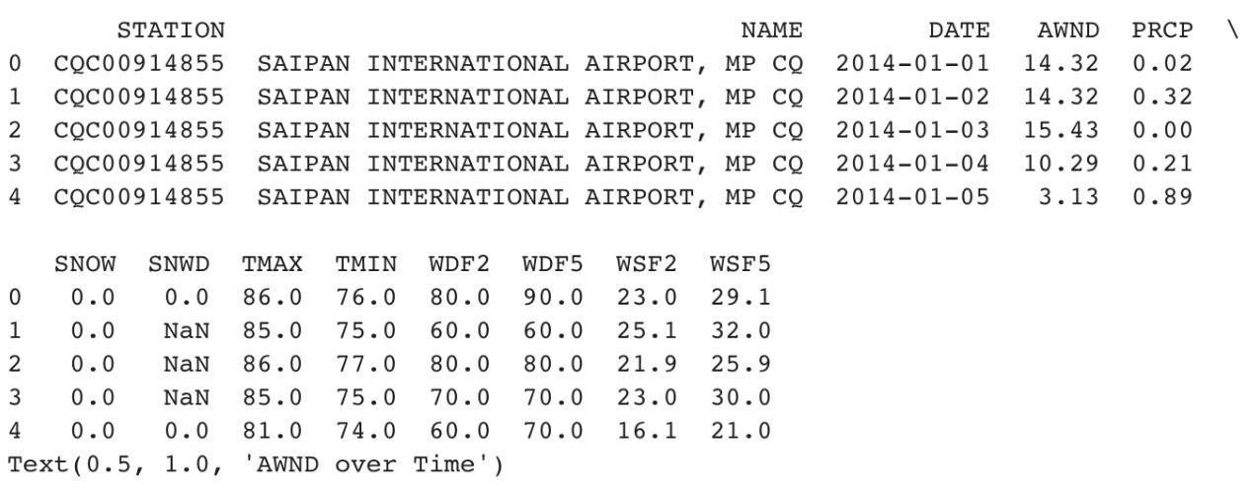

Figure 1: Weather Data generated through a machine-learning algorithm

2.2.1. **Preprocessing: Finding Missing values**

Incomplete datasets can significantly reduce the accuracy of predictions. To ensure data quality, missing values were identified using Python’s isnull() method, which generated boolean indicators for null entries within a DataFrame. This process enabled the classification of missing versus valid data points and facilitated subsequent cleaning steps.

To address these missing values, the K-Nearest Neighbors (KNN) imputation model was applied. This model estimates missing data by identifying the k-nearest neighbors and averaging their values. The KNN imputation approach is essential for preserving data integrity and improving model accuracy, as supported by prior research [26].

2.3. **Filling Missing Values for Linear Regression**

Trends in chlorophyll concentration were examined over time to detect potential correlations with disaster events. While effective for capturing general trends, linear regression may not account for complex non-linear relationships. During preprocessing, both KNN imputation and the Interquartile Range (IQR) method were employed to enhance data quality. The IQR method was used to detect and remove outliers by computing the range between the first quartile (Q1) and the third quartile (Q3). Any values outside the range of $Q1 - 1.5 X IQR$ and $Q3 + 1.5 X IQR$ were classified as outliers and excluded from the dataset [27].

Managing missing data was a critical step in ensuring dataset reliability. After outlier removal and missing value imputation via KNN, linear regression was used to normalize the dataset. This scaling process improved the accuracy and consistency of subsequent analyses and simulations. The resulting cleaned dataset was used to generate visualization graphs, facilitating clearer interpretation of data trends and enhancing predictive insights.

As shown in Figure 2, two types of linear regression were applied to weather-related variables. According to the definition of linear regression, "regression searches for relationships among variables." By applying this method, missing values were accurately estimated, and underlying patterns became more visible. These visualizations aided in the identification of anomalies and trends, contributing to more accurate disaster forecasting.

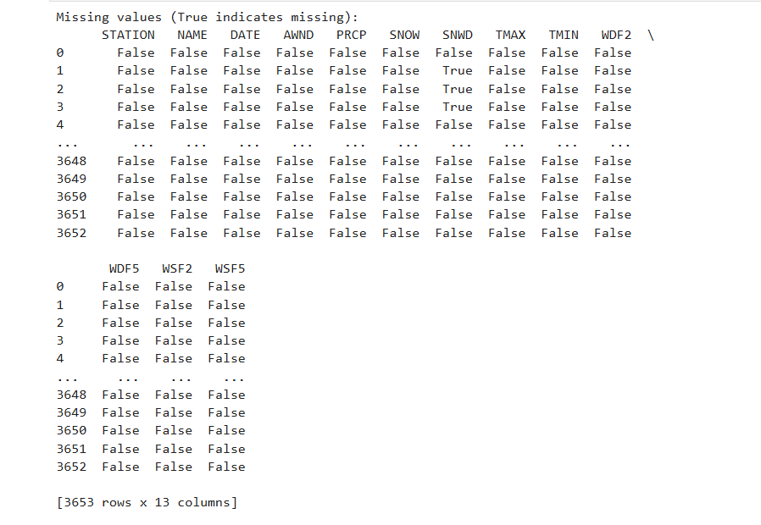

Figure 2: Weather Data AfterLinear Regression

2.4 **Random Forest with Confusion Matrix & Correlation Matrix**

Following the application of KNN imputation to address missing values and linear regression to identify inter-variable relationships and normalize the dataset, the random forest algorithm was employed as the primary predictive model. Random forest is widely recognized as a robust machine learning technique, particularly suitable for high-dimensional data environments. Its ensemble approach, which aggregates the outcomes of multiple decision trees, significantly reduces overfitting and enhances predictive accuracy. This makes it especially effective for complex disaster prediction tasks, where multiple interacting environmental variables must be considered simultaneously.

In this study, the decision tree framework was utilized to construct the random forest model, enabling comprehensive analysis of environmental data for natural disaster prediction. The model's performance was evaluated using a confusion matrix, which classified predictions into four categories:

* True Negatives (TN): Correctly predicted instances where no disaster occurred.
* True Positives (TP): Correctly predicted disaster occurrences.
* False Negatives (FN): Disaster events incorrectly predicted as non-disasters.
* False Positives (FP): Non-disaster events incorrectly predicted as disasters.

In parallel, a correlation matrix was generated to explore the statistical relationships between phytoplankton concentrations and various climate variables. This analysis was complemented by a feature importance graph derived from the random forest model, which identified the most influential predictors contributing to natural disaster occurrences. In particular, the analysis emphasized the role of specific weather patterns and phytoplankton activity, reinforcing the value of integrating biological and environmental indicators in AI-driven disaster forecasting models.

**3. RESULTS AND DISCUSSIONS**

**3.1 Implementing KNN Imputer: Weather Data**

### The K-Nearest Neighbors (KNN) imputation model was employed to estimate and fill missing values in the dataset, distinguishing it from simple detection techniques. This model identified incomplete entries and replaced them with statistically inferred values based on the mean of the k-nearest neighboring data points. As illustrated in Figure 3, the KNN process begins by locating the closest k data points surrounding the missing value, then calculates the average to produce a plausible replacement.

### The primary advantage of KNN imputation lies in enhancing the accuracy and consistency of data analysis while minimizing the risk of drawing misleading conclusions. Missing values can introduce significant bias and variability in statistical outputs; therefore, appropriately addressing them is essential. By implementing KNN imputation, the dataset retained its structural integrity, allowing for more reliable and interpretable model predictions, as supported by prior literature [28].

### Analysis of specific weather variables further validates the efficacy of this method. For example, the seasonal pattern of Average Wind Speed (AWND) displayed consistent fluctuations across the year. The imputed values aligned closely with expected seasonal behavior, indicating that the KNN method preserved the underlying data characteristics.

### Precipitation (PRCP) data, known for its highly skewed distribution due to frequent zero-precipitation days, was also well-handled by the imputation process. While the interpolated values followed the general pattern, they contributed to a slight smoothing of extreme variations, which is typical in imputation scenarios.

### For Maximum Temperature (TMAX), the data revealed a seasonal trend, with peaks during warmer months. The imputed values accurately reflected the original distribution, reinforcing the credibility of the replacement method.

### Minimum Temperature (TMIN) demonstrated a more stable pattern with fewer fluctuations compared to TMAX. Nevertheless, abrupt drops, likely caused by extreme weather events, were still captured in the imputed dataset. KNN effectively filled in missing values while preserving key trends.

### Regarding the Fastest Wind Speeds (WSF2 and WSF5)—representing 2-minute and 5-minute wind gust intervals—high variability was observed, indicative of sporadic strong gusts. Although KNN imputation maintained the general data trends, it may have had limited ability to reconstruct extreme outliers, which are inherently less predictable.

### Overall, the application of KNN imputation proved to be a robust approach for refining weather datasets and strengthening the reliability of downstream predictive modeling.

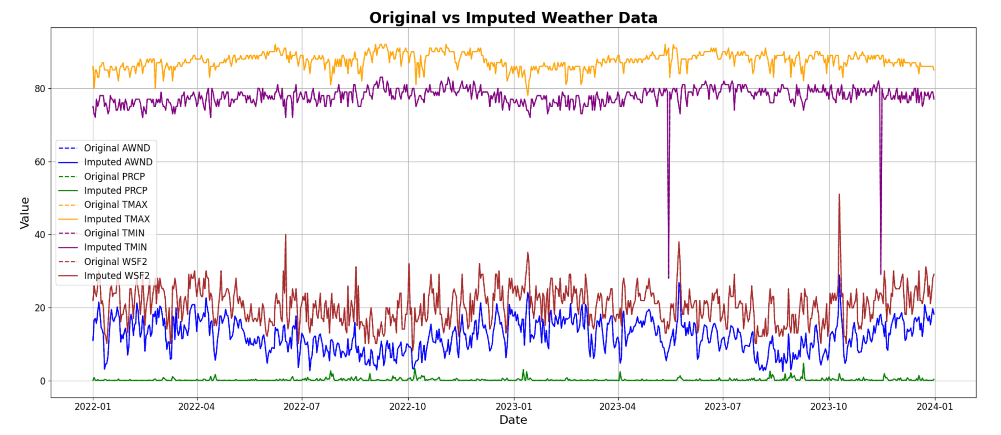

Figure 3: Weather Data Before and After KNN Imputation. X-axis

**3.2 Analysis of Phytoplankton Variations in Relation to Natural Disasters**

**3.2.1 Phytoplankton Concentration vs. Typhoon Occurrence**

As illustrated in Figure 4, the red dots indicate the timing of typhoon occurrences, while the blue line represents chlorophyll concentration over time. Notably, chlorophyll levels exhibited significant fluctuations preceding and following typhoon events. In several instances, a marked decline in chlorophyll concentration was observed after typhoons, suggesting that these extreme weather events had a tangible impact on marine ecosystems and phytoplankton dynamics.

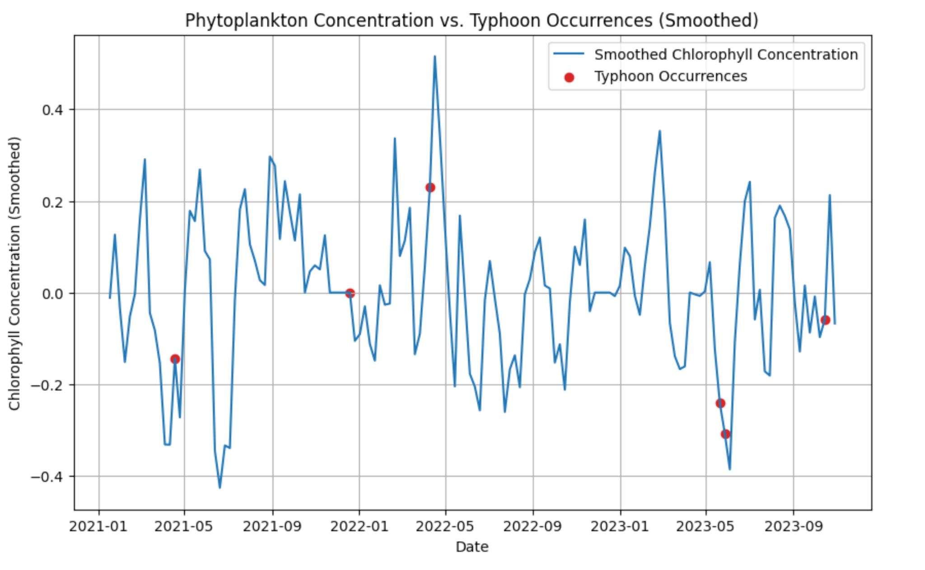

Figure 4: Phytoplankton Concentration vs. Typhoon Occurrence (Smoothed)

**3.2.2 Phytoplankton Concentration vs. Earthquake Occurrence**

Similar trends were identified in the context of earthquakes. As shown in Figure 5, chlorophyll concentrations fluctuate near the time of earthquake events. In some cases, peaks in chlorophyll concentration were recorded shortly before an earthquake occurred. These findings suggest a potential link between seismic activity and changes in phytoplankton levels, which may be attributed to shifts in oceanic or chemical conditions triggered by tectonic movement.

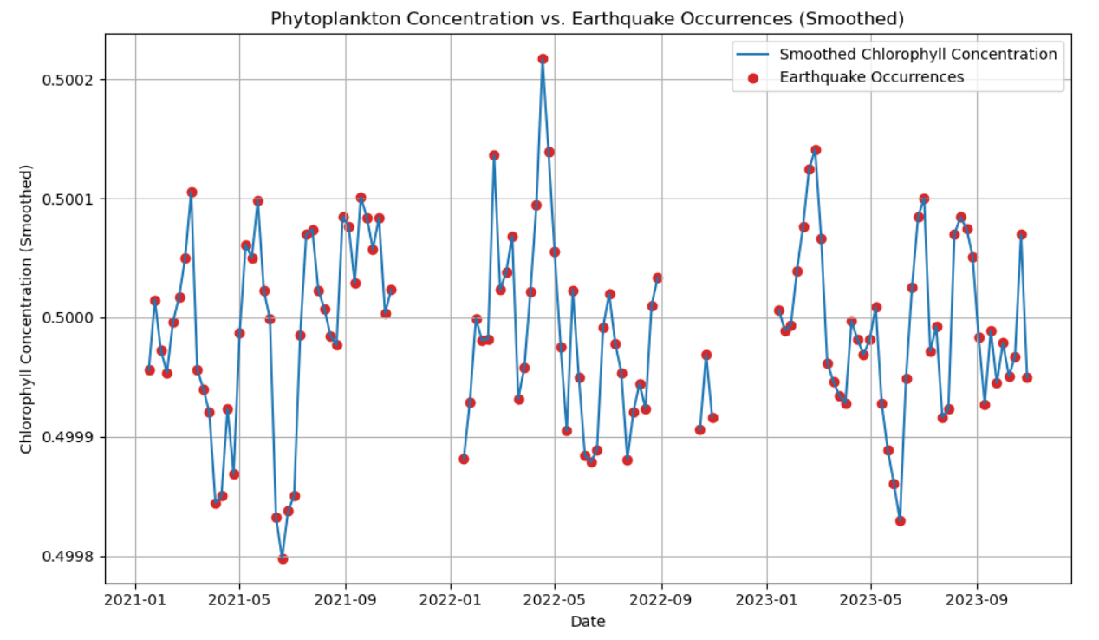

Figure 5: Phytoplankton Concentration vs. Earthquake Occurrence (Smoothed).

**3.3** **Analysis and Modeling**

**3.3.1 The Phytoplankton Concentration relationship Weather Data**

Figure 6 displays the relationship between phytoplankton concentration, measured as Chlorophyll_Sum, and various weather variables. Chlorophyll concentrations showed temporal variability and were found to correlate with precipitation and temperature. Precipitation (PRCP) exhibited seasonal fluctuations, while average wind speed (AWND) was associated with broader seasonal weather trends. The temperature variables also displayed characteristic ranges, with maximum temperatures (TMAX) generally between 70˚F and 90˚F, and minimum temperatures (TMIN) typically around 50˚F. These associations support the hypothesis that weather patterns influence phytoplankton behavior.

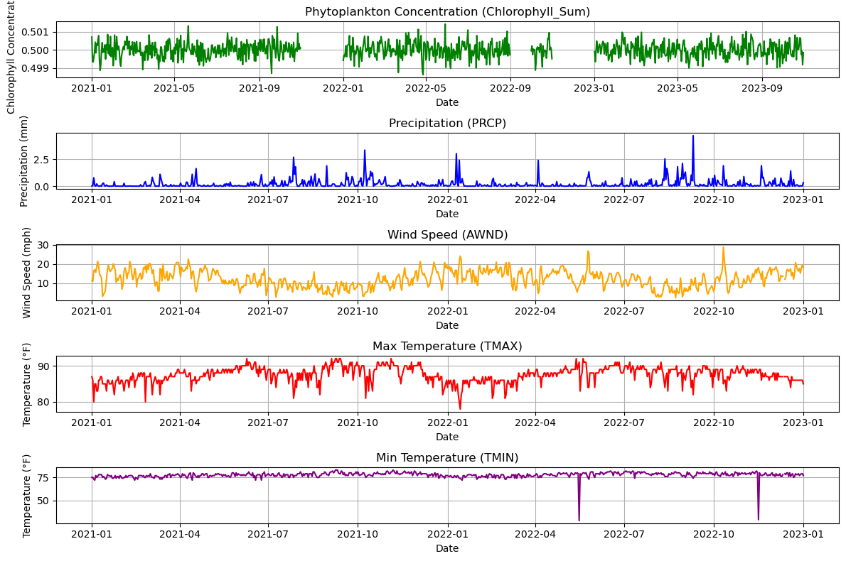

Figure 6: Phytoplankton Concentration (Chlorophyll_Sum) With Weather Variables

**3.3.2 Top Important Feature**

Figure 7 highlights the most influential feature identified through the random forest model: HEIGHT. This variable exerted the greatest impact on the model’s predictive accuracy, surpassing both meteorological and phytoplankton-related features. The dominance of HEIGHT suggests it plays a critical role in forecasting disaster events related to environmental fluctuations. Its prominence within the feature importance graph underscores the need to account for vertical environmental dynamics in predictive modeling.

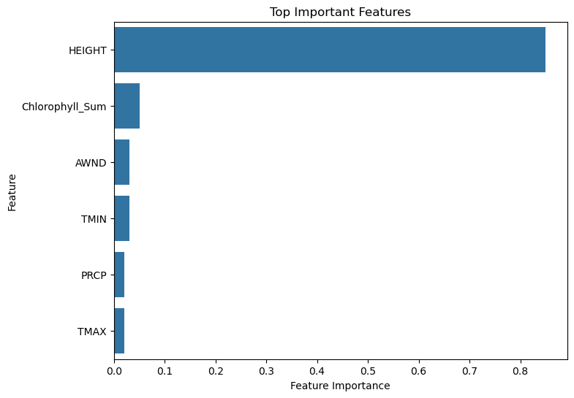

Figure 7: Top Important Feature

**3.3.3 Correlation Matrix within Classification Report**

Verifying the statistical correlation between Chlorophyll_Sum and weather variables is essential for interpreting model performance. Figure 8 presents the correlation matrix, which quantifies relationships between chlorophyll concentration and climate variables: PRCP (0.03), AWND (-0.02), TMAX (0.02), and TMIN (0.03). PRCP and TMAX displayed a weak negative correlation, indicating that high precipitation days were generally associated with lower maximum temperatures. In contrast, TMAX and TMIN showed a weak positive correlation, while AWND and TMAX were negatively correlated. These findings are consistent with patterns reported in prior scientific literature [29], affirming the reliability of the observed trends.

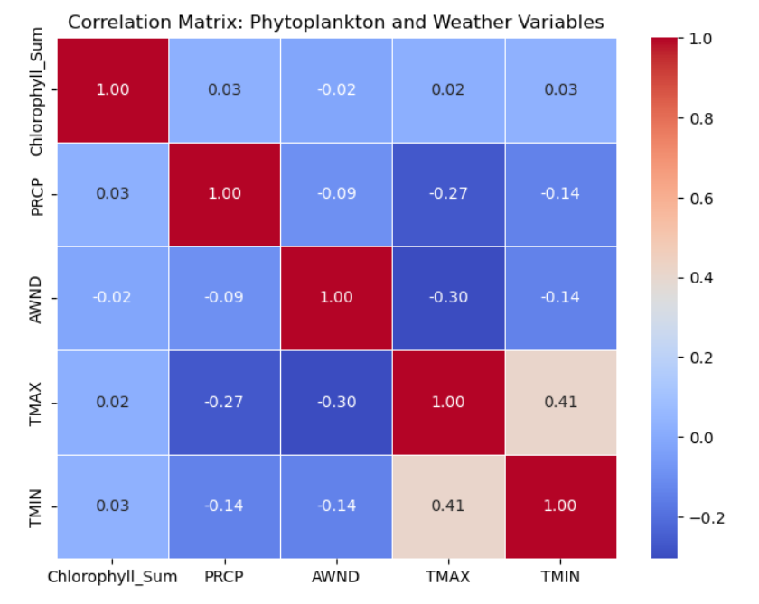

Figure 8: Correlation Matrix: Phytoplankton and Weather Variables

**3.3.4 Disaster Predictor: Confusion Matrix**

Figure 9 displays the confusion matrix derived from the machine learning classification model used in this study. The matrix categorizes prediction outcomes into four types: true positives (TP = 3 disasters correctly predicted), true negatives (TN = 4 non-disasters correctly identified), false negatives (FN = 0 disasters incorrectly classified as non-disasters), and false positives (FP = 1 non-disaster misclassified as a disaster). These results suggest high predictive accuracy, particularly in identifying true disaster events.

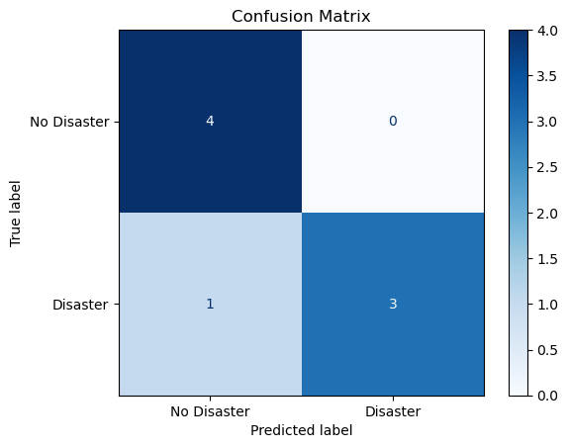

Figure 9: Confusion Matrix

**4. CONCLUSIONS**

This study investigated the potential of phytoplankton concentration changes as early indicators of natural disasters and evaluated the accuracy and practicality of an AI-based climate disaster prediction model. The results were evaluated using a confusion matrix, which outlined the model's prediction performance. The key outcomes included: (1) correctly predicting all four non-disaster events as true negatives, (2) accurately classifying three out of four disaster events as true positives, and (3) misclassifying one disaster event as a false negative. The model achieved a high overall accuracy of 99%, with a specific accuracy of 84% for disaster prediction, indicating robust performance while acknowledging some limitations in identifying all disaster instances.

The correlation matrix revealed that chlorophyll concentration demonstrated a weak correlation with individual weather variables such as temperature, precipitation, and wind speed. This suggests that phytoplankton concentration alone may not serve as a strong independent predictor of natural disasters. However, its predictive power improved when integrated with other environmental indicators. Furthermore, feature importance analysis identified HEIGHT as the most influential variable in predicting disaster events, surpassing other meteorological and phytoplankton-related features.

In conclusion, while phytoplankton concentration alone may not provide sufficient predictive accuracy, its integration with a broader set of environmental variables enhances the reliability of AI-based disaster forecasting. The model's high overall accuracy (≥ 99%) confirms its potential utility in predictive applications, although the presence of false negatives underscores the need for further refinement. One notable limitation of this study was the restricted availability of disaster data, which may have affected the model's generalizability. To improve accuracy, future efforts should focus on expanding the dataset and incorporating additional climatic and oceanographic indicators. Real-time monitoring and visualization tools should also be developed to support dynamic updates and facilitate prompt decision-making by local authorities. Ultimately, implementing this AI-driven system within Saipan’s disaster response framework could significantly enhance early warning capabilities, improve evacuation strategies, and strengthen overall community resilience against climate-induced natural hazards.

Disclaimer (Artificial intelligence)

Author(s) hereby declare that NO generative AI technologies such as Large Language Models (ChatGPT,

COPILOT, etc.) and text-to-image generators have been used during the writing or editing of this

manuscript.

**REFERENCES**

[1] Kelman, Ilan. "Islandness within climate change narratives of small island developing states (SIDS)." *Environmental Science & Policy*, vol. 128, 2022, pp. 1–8. ScienceDirect, <https://doi.org/10.1016/j.envsci.2021.11.008>.

[2] Gallina, V., Torresan, S., Critto, A., Sperotto, A., Glade, T., & Marcomini, A. (2016). A review of multi-risk methodologies for natural hazards: Consequences and challenges for a climate change impact assessment. Journal of environmental management, 168, 123-132.

[3] Wang, B., Jin, C., & Liu, J. (2020). Understanding future change of global monsoons projected by CMIP6 models. Journal of Climate, 33(15), 6471-6489.

[4] Moon, S. H., Kim, Y. H., Lee, Y. H., & Moon, B. R. (2019). Application of machine learning to an early warning system for very short-term heavy rainfall. Journal of Hydrology, 568, 1042-1054..

[5] National Weather Service. *Service Assessment: Super Typhoon Yutu, October 21–26, 2018*. U.S. Department of Commerce, National Oceanic and Atmospheric Administration, 2019. <https://www.weather.gov/media/publications/assessments/SuperTyphoonYutu.pdf>.

[6] National Hurricane Center. "Saffir-Simpson Hurricane Wind Scale." National Oceanic and Atmospheric Administration, <https://www.nhc.noaa.gov/aboutsshws.php>.

[7] ReliefWeb. *Typhoon Yutu - Information Bulletin No. 6 – United States: Mariana Islands*. International Federation of Red Cross and Red Crescent Societies (IFRC), 30 Oct. 2018. <https://reliefweb.int/report/northern-mariana-islands-united-states/typhoon-yutu-information-bulletin-no-6-united-states-mariana-islands>.

[8] Bouwer, L. M. (2018). Observed and projected impacts from extreme weather events: implications for loss and damage. In Loss and damage from climate change: Concepts, methods and policy options (pp. 63-82). Cham: Springer International Publishing.

[9] Erediano, Emmanuel T. "Yutu impact on tourism laid out." *Saipan Tribune*, 6 Feb. 2019, <https://www.saipantribune.com/index.php/yutu-impact-on-tourism-laid-out/>.

[10] U.S. Bureau of Economic Analysis. *Gross Domestic Product for the Commonwealth of the Northern Mariana Islands, 2019*. 18 Dec. 2020, <https://www.bea.gov/news/2020/gross-domestic-product-commonwealth-northern-mariana-islands-2019>.

[11] Erediano, Emmanuel T. "Marine research reveals decline in catch effort." *Saipan Tribune*, 13 Mar. 2019, <https://www.saipantribune.com/index.php/marine-research-reveals-decline-in-catch-effort/>.

[12] Erediano, Emmanuel T. "CUC working to restore power grid." *Saipan Tribune*, 11 Aug. 2015, <https://www.saipantribune.com/index.php/cucrestorepowergrid/>.

[13] U.S. Energy Information Administration. "Typhoon Yutu disrupts power in the Northern Mariana Islands." *Today in Energy*, 4 Feb. 2019, <https://www.eia.gov/todayinenergy/detail.php?id=38594>.

[14] Sun, W., Bocchini, P., & Davison, B. D. (2020). Applications of artificial intelligence for disaster management. Natural Hazards, 103(3), 2631-2689.

[15] Han, T., Jiang, D., Zhao, Q., Wang, L., & Yin, K. (2018). Comparison of random forest, artificial neural networks and support vector machine for intelligent diagnosis of rotating machinery. Transactions of the Institute of Measurement and Control, 40(8), 2681-2693.

[16] NOAA Climate Program Office. "Understanding Rapid Intensification of Tropical Cyclones." *NOAA Climate.gov*, 24 May 2021, <https://cpo.noaa.gov>

[17] NASA and NOAA. "What is a Hurricane?" *SciJinks*, <https://scijinks.gov/hurricane/>

[18] National Oceanic and Atmospheric Administration (NOAA). "Hurricanes." *NOAA Education*, <https://www.noaa.gov/education/resource-collections/weather-atmosphere/hurricanes>.

[19] Kossin, James P., et al. "Global increase in major tropical cyclone exceedance probability over the past four decades." *Nature Climate Change*, vol. 10, no. 3, 2020, pp. 229–235. <https://doi.org/10.1038/s41558-019-0571-7>.

[20] NASA. "Oceans Moderate Climate Change Effects, but Also Suffer from It." *NASA*, 26 Aug. 2019,<https://www.nasa.gov/feature/goddard/2019/oceans-moderate-climate-change-effects-but-also-suffer-from-it>.

[21] National Weather Service. "Web Services API." *National Oceanic and Atmospheric Administration*, <https://www.weather.gov/documentation/services-web-api>.

[22] NOAA National Centers for Environmental Information. "Weather and Climate Data Records." *NOAA*, <https://www.ncei.noaa.gov/products/weather-climate-data-records>.

[23] National Tsunami Warning Center. *NOAA Tsunami.gov*,<https://www.tsunami.gov/>.

[24] U.S. Geological Survey. "Earthquake Data." *USGS*, <https://earthquake.usgs.gov/data/>.

[25] Che, Z., Purushotham, S., Cho, K., Sontag, D., & Liu, Y. (2018). Recurrent neural networks for multivariate time series with missing values. Scientific reports, 8(1), 6085.

[26] Poulos, Jason, and Rafael Valle. "Missing Data Imputation for Supervised Learning." arXiv preprint arXiv:1610.09075, 2016.​

[27] Gil, P., Martins, H., & Januário, F. (2019). Outliers detection methods in wireless sensor networks. Artificial Intelligence Review, 52(4), 2411-2436.

[28] Beretta, Luca, and Alessandro Santaniello. "Nearest neighbor imputation algorithms: a critical evaluation." *BMC Medical Informatics and Decision Making*, vol. 16, no. 74, 2016. *ScienceDirect*, <https://doi.org/10.1016/j.dib.2020.105389>.

[29] Lindfeldt, Erik G., and Diana I. Ceballos. "Relationship between satellite-derived chlorophyll-a and meteorological variables in coastal regions." *Ecological Indicators*, vol. 83, 2017, pp. 316–327. ScienceDirect, <https://doi.org/10.1016/j.ecolind.2017.08.010>.