Review Article
Integrative Approaches for Climate Resilience in Pulse Production Systems

Abstract
Pulse crops have higher protein content which is nearly double than the cereals. So, it has a significant role in human and animal nutrition as well as is beneficial to soil and environment. However, the increasing the threat of climate change poses significant challenges to global agriculture. Therefore, this review paper discusses about the technologies to ensure sustainable pulse production. Climate change refers to long-term shifts in global or regional climate patterns that are primarily caused by human activities such as industrialisation, urbanisation, deforestation, agriculture, changes in land use patterns, and so on. These activities emit greenhouse gases, which accelerates climate change. The impact of climate change is complex and no single strategy will address the issue adequately. Therefore, an integrated approach combining improved genetics, sustainable agronomic practices and supportive policies is essential to ensure sustainable pulse production under changing climatic conditions. To enhance the resilience of pulse crops, it is crucial to adopt a package of climate-smart technologies including the development and selection of climate-resilient varieties that can withstand heat, drought and salinity, practices that improve water and nutrient use efficiency and techniques that strengthen crop resistance to both biotic and abiotic stresses. The technologies adopted by farmers could minimize the impact of weather aberrations and contribute towards sustainability and built resilience. Pulses are climate smart crops, their physiological and morphological traits, such as deep root systems, short growing periods and low water and fertilizer requirements, make them well-suited to cope with extreme weather conditions. In addition to adapting to climate change, pulses contribute to its mitigation by reducing dependency on synthetic fertilizers, lowering greenhouse gas emissions and improving soil carbon sequestration.
Key words: Pulses, climate change, resilience, climate smart crops, greenhouse gas, carbon sequestration
Introduction
Pulses, the humble heroes of Indian agriculture are renowned for their ability to thrive in subsistence production systems and endure harsh growing conditions. Gifted with unique ability of fixing atmospheric nitrogen legumes possess various morphological attributes, such as deep root system, higher water use efficiency, ability to host beneficial microbes in the rhizosphere to solubilize phosphate, etc., as well as low water and nutrient requirements. Legumes, recognized globally during 2016 International Year of Pulses under the theme "Pulses: nourishing soils and people", play a crucial role in sustainable agriculture by enhancing soil health through nitrogen fixation, supporting climate resilience, and promoting human nutrition.

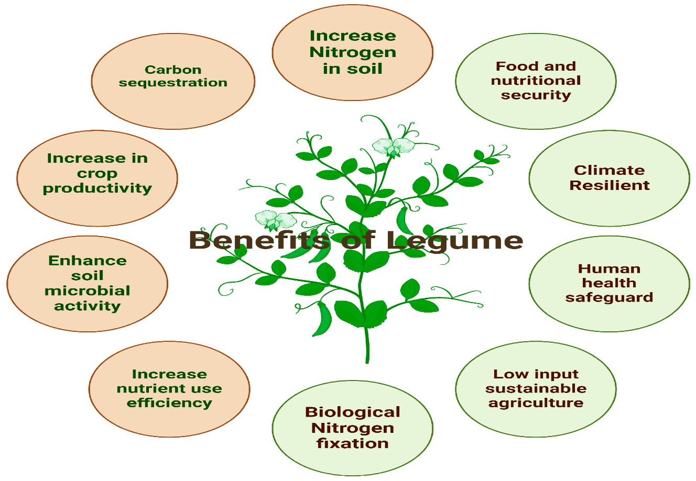
Fig 1: Schematic representation of the benefits of legumes for humans and soil.
In Andhra Pradesh, pulses are grown to an extent of 10.33 lakh hectares of area with total production of 10.87 lakh tonnes. (Season and Crop Report- Andhra Pradesh, 2022-23). Chickpea (49.61%), pigeon pea (15.46%), Mungbean (11.60%), urdbean (10.17%), lentil (4.65%) which together contribute 91.48% of total pulse production in India during 2021–22. As per the final estimates for 2022–23, the pulse production in India reached 26.06 million tons in 2022–23. Pulse productivity was adversely affected by changing climatic conditions, including temperature fluctuations, unpredictable rainfall patterns and increased frequency of extreme weather events (e.g., heatwaves, floods). (Masters et al., 2010).
Climate change refers to long-term shifts in global or regional climates which is, primarily caused by human activities that release greenhouse gases into the atmosphere. It is driven by both natural factors including volcanic eruptions, circulation of ocean currents, earths orbital variation, solar variation, tectonic plate movements and anthropogenic factors including fossil fuel emissions, deforestation, excessive fertilizer usage, urbanization. Farmers can minimize weather – related impacts and promote sustainability by adopting climate resilient technologies. For pulses, this includes developing and implementing improved technologies including breeding, agronomic strategies and government policy and innovations.
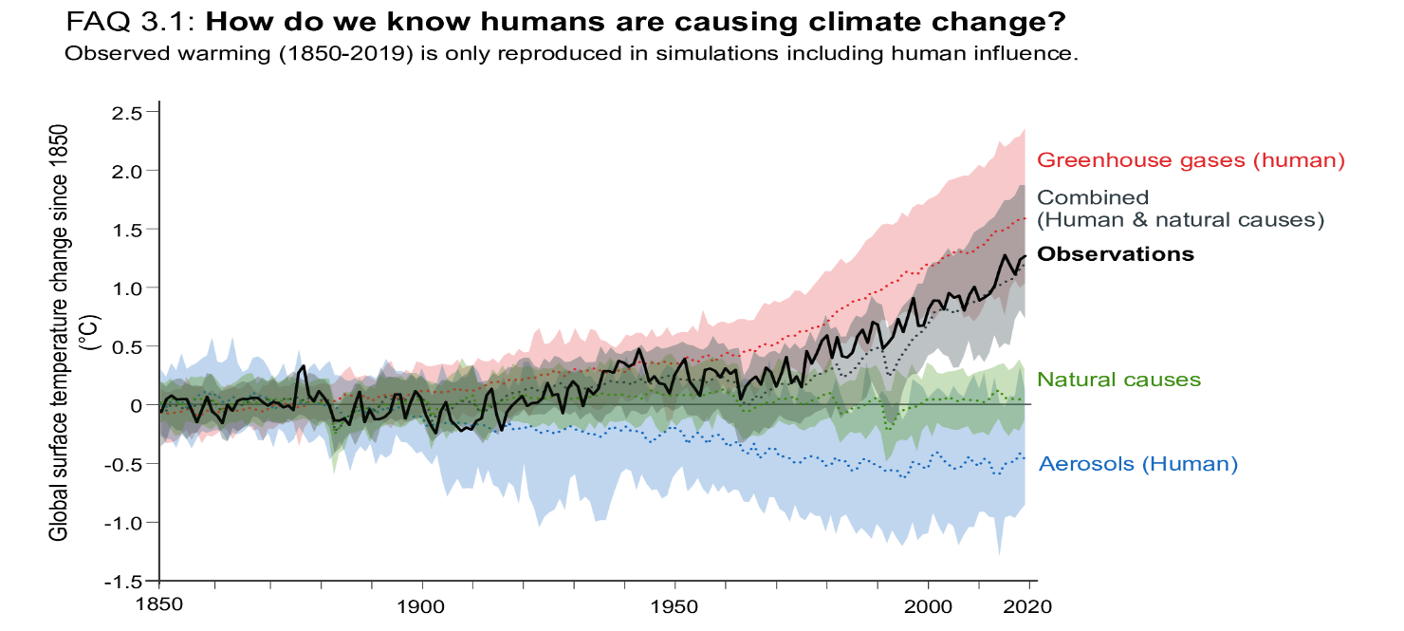
Fig 2: IPCC Sixth Assessment Report shows the dominant role of humans in driving recent climate change
Source: 6th Assessment Report Intergovernmental Panel on Climate Change (IPCC), 2021
IPCC Sixth Assessment Report shows that “the dominant role of humans in driving recent climate change is clear. Global surface temperature changes in observations, compared to climate model simulations of the response to all human and natural forcings (grey band), greenhouse gases only (red band), aerosols and other human drivers only (blue band) and natural forcings only (green band). Solid coloured lines show the multi-model mean, and coloured bands show the 5–95% range of individual simulations”.
Climate change mitigation and adaptation
Climate mitigation involves efforts to diminish or prevent the release of greenhouse gas emissions. There are two strategies that address climatic change: adaptation and mitigation. Adaptation (adjustments) involves the ability of system to adjust to climate change to mitigate moderate potential damage or to cope with the consequences whereas mitigation (root cause) involves actions taken to permanently eliminate or reduce the long-term risk and hazards of climate change.
Climate resilience: It refers to the ability of a system to deal with stresses and disturbances, while retaining the same basic structure and ways of functioning, capacity for self-organisation and capacity to learn an adapt to change.
Climate resilient practices: “This includes the incorporation of adaption, mitigation and other practices in agriculture which increases the capacity of system to respond to various climate related disturbances by resisting damage and recovering quickly” (Hadimani, 2016).
Climate resilience crops: A climate-resilient crop is resistant to multiple stress factors, which can be abiotic, including both human-made and climate-driven factors, as well as soil associated or biotic stress factors.
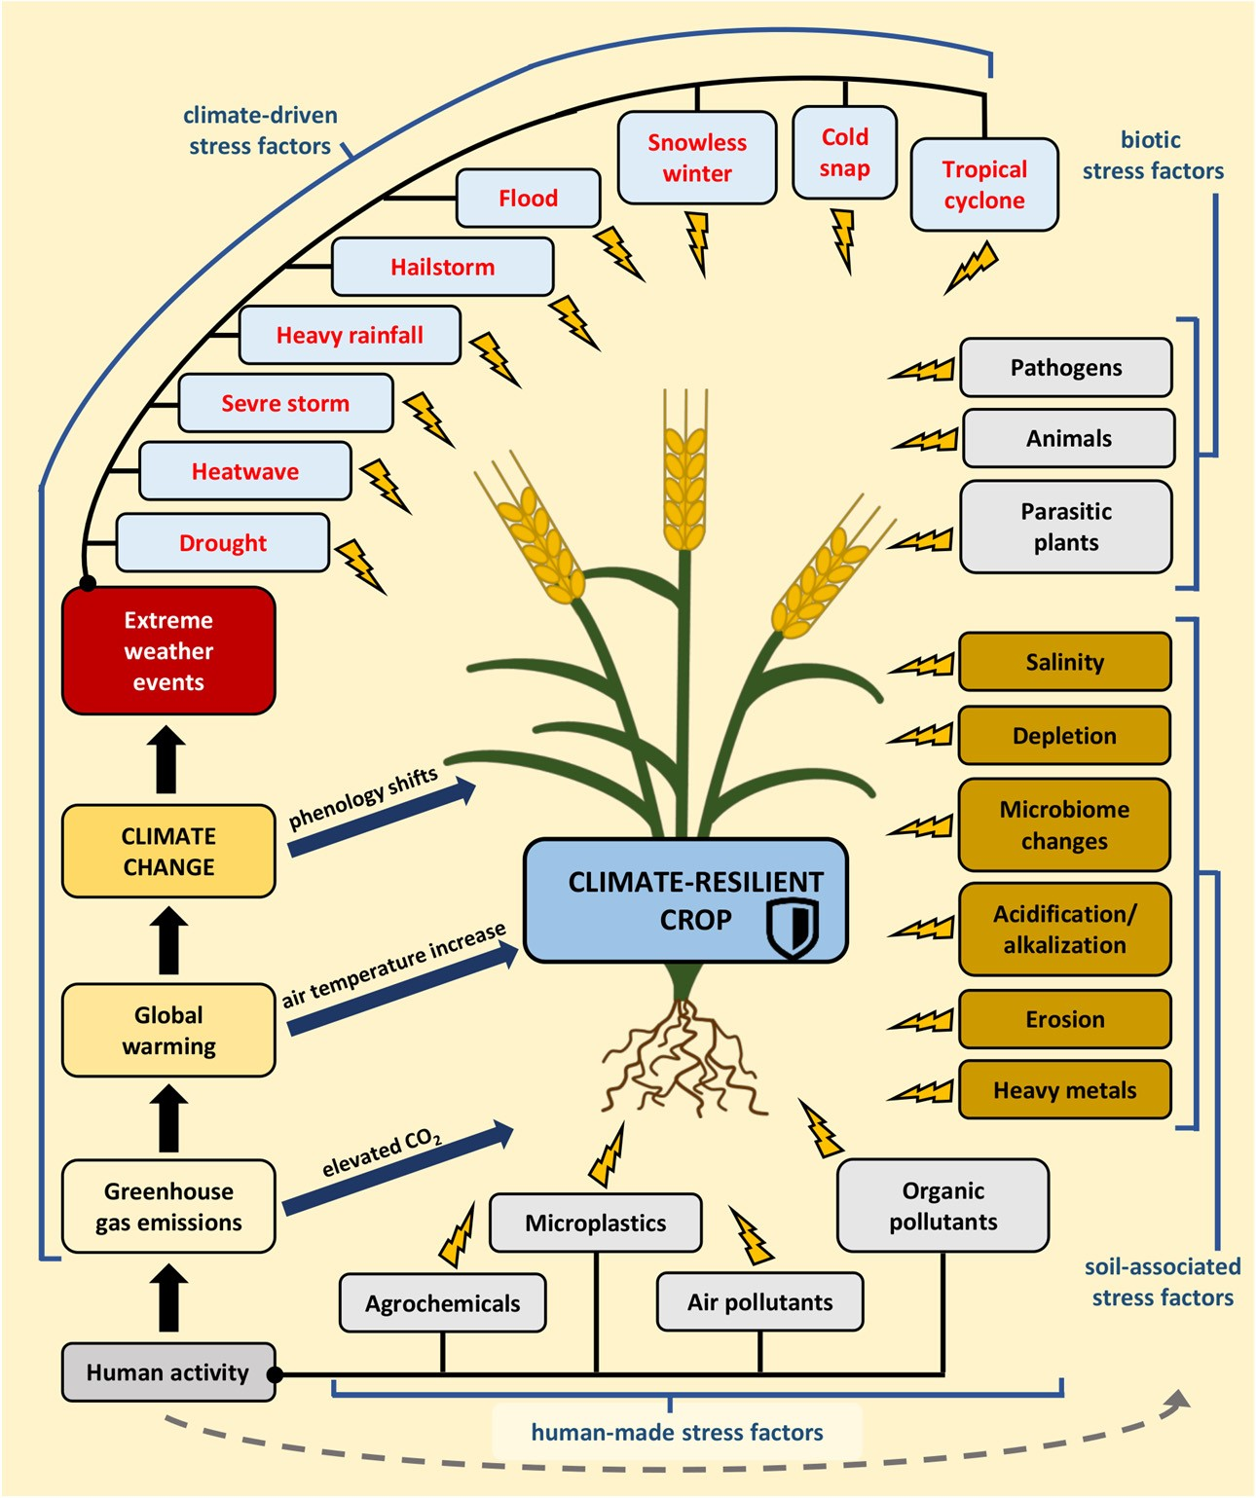Fig 3: The stress factors affecting climate-resilient crops
List 1: Strategies for enhancing crop resilience to climate change
Breeding strategies  - Heat resistant  - Disease resistant  - Pest resistant  - Salinity resistant  - Photo and thermo insensitive varieties | Agronomic strategies  - Conservation agriculture  - Use of adaptive crops  - Crop diversification  - Multistoried cropping system  - Maintaining adequate soil organic matter  - Water harvesting and supplemental irrigation  - Seed priming  - Seed bombing  - Foliar application  - Plant growth Regulators  - Biofertilizers  - Nano fertilizers  - Nano biochar  - Fertigation  - Traditional and indigenous knowledge | Government policy and innovation  - NICRA  - PMFBY

Breeding strategies
Climate-resilient breeding involves developing crop varieties that can withstand biotic and abiotic stresses. Examples include photo and thermo-insensitive chickpea varieties (ICCV 92944, ICCV 96029 and ICCV 96030), blackgram lines such as PGRU 95016, IPU 99-89, BGP-247 (Basu et al., 2016) as well as heat-tolerant greengram (Narendra Mung 1). For disease resistance, chickpea varieties like Sweta (ICCV 2) and Bharti (ICCV 10) against wilt disease (Bera et al., 2021).
Agronomic strategies
Agronomic practices are the tactics and procedures used in agricultural production to increase soil health, plant growth, and yield. Farmers can boost crop output by employing effective agronomic methods that save natural resources and promote long-term agricultural sustainability.
Conservation agriculture
The three main principles (minimum soil disturbance, crop diversification, and permanent soil cover) help to protect the environment by reducing both the effects of climate change on agricultural systems (adaptation) and the contribution of agricultural practices to greenhouse gas emission reduction through sustainable land management. In a field experiment conducted by Suresh et al. (2024) concluded that vertical tillage with subsoiler upto 60 cm deep at 1m interval with application of 125% RDF and foliar application of KNO₃ 1% twice with 15 days interval at 50 per cent flowering stage resulted in better yield attributes and seed yield of pigeonpea.
Fig 4: Three principles of conservation agriculture
Use of adaptive crops
Adaptive plants (Reynolds and Ortiz, 2010) are more vibrant and resilient to unfavourable climatic conditions which require fewer herbicides or fertilizers and are more resistant to waterlogging or droughts. Kumarajoshi et al. (2021) recorded maximum yield attributes i.e., number of clusters plant⁻¹, number of pods plant⁻¹, number of seeds pod⁻¹, pod weight, 100 seed weight and grain yield of IC426766 variety of blackgram under drought conditions. In a field experiment conducted by Khoiwal et al. (2017) concluded that the combination of moisture stress situation S_{FL} × V5 (S_{FL}– Water withheld from flowering in variety V5–JG 16) was found better in terms of productivity and profitability.
Crop diversification
“Crop diversification provides resilience against extreme and highly variable weather conditions resulting from climate change by` increasing carbon sequestration in soils while mitigating greenhouse gas emissions. In essence, agroforestry refers to the practice of the purposeful growing of trees and crops and/or animals, in interacting combinations, for a variety of benefits and services” (Nair et al., 2008). Emerging technologies and tools are increasingly being used to support and enhance crop diversification strategies. These includes remote sensing and GIS, AI-powered decision support systems, mobile applications for farmers and soil health monitoring sensors.
Multistoried cropping system
To maximise sunshine, nutrient consumption, sustainable land use, and ecological balance, a multi-story cropping system allows crops of varied heights, canopy patterns, and root systems. These cropping system results in the efficient use of resources such as sunlight, water, soil and nutrients leading to increased biological diversity, more crops per unit area and production sustainability.
Maintaining adequate soil organic matter
Pulses have lower fertilizer requirement as they can fix atmospheric nitrogen, which helps in lowering greenhouse gas emissions. Since, soil organic carbon has been decreasing due to climate change, farming practices that boost soil carbon are important to lower emissions and improve pulse productivity.
Water harvesting and supplemental irrigation
Pulses are mainly confined to rainfed area, leading to suboptimal productivity levels. Winter pulses are more susceptible to drought, especially during the later part of the growth stages.
Seed priming
“Seed priming is a pre-sowing seed treatment that involves controlled hydration of seeds, enabling them to undergo initial germination processes but preventing complete radicle emergence. This process enhances seed germination rate, uniformity and vigor, particularly under challenging environmental conditions. It may be concluded that hydro-priming (distilled water) with 10 cm sowing depth recorded significantly highest growth, yield attributes and yield of chickpea was the most effective treatment followed by Manitol 4% priming with 10 cm sowing depth” (Lhungdim et al., 2018).
Seed bombing
Aerial seed bombing is a cutting-edge technology for large-scale ecological restoration, providing a game-changing solution to the issues of widespread vegetation regeneration across many landscapes. Its capacity to penetrate tough or inaccessible terrains enhances biodiversity by introducing a diverse range of plant species, perhaps improving ecosystem stability and resilience. It also accelerates the reforestation process by improving soil health, reducing erosion, promoting rapid ecosystem recovery, providing broad coverage, precision targeting, and sequestering carbon, all of which help to mitigate the effects of climate change and improve agricultural resilience.
Foliar application
Under heat stress, high water status can be attained by various macronutrients and micronutrients like potassium, calcium, boron, selenium and manganese which activate various physiological and stomatal functions in plants. The impact of boron deficiency on assimilate partitioning may greatly influence the ability of plants to cope with other unfavourable environmental conditions such as soil water deficits and low supplies of other nutrients. In a study conducted by Aslam et al. (2019) observed that the foliar application of 19:19:19 @ 0.5% Spray + Seaweed extract @ 2% at 30 and 45 DAS proved to be promising nutrient management practice for obtaining higher yield attributes and yield of greengram.
Plant growth regulators
The mechanism by which it deals with drought stress includes mechanisms such as phosphorus solubilization, organic acids, nitrogen fixation, production of siderophores, and production of enzymes such as ACC (1-aminocyclopropane-1-carboxylate) deaminase. This enzyme plays a crucial role in plant growth and development, particularly under stress conditions, by breaking down the plant hormone ethylene's precursor, 1-aminocyclopropane-1-carboxylic acid (ACC). Nagamani et al. (2020) reported that “higher seed yield, stalk yield and nutrient uptake by the crop was recorded with foliar application of NAA (25 ppm) and DAP (2 %) applied at 60 and 80 DAS of pigeonpea”.
Biofertilizers
Biofertilizers, created from beneficial microorganisms, are a viable alternative to chemical fertilisers in agriculture and offer great potential as a strategy for mitigating climate change. Biofertilizers have the ability to absorb carbon, reduce greenhouse gas emissions, and improve soil resilience, all of which contribute to climate change mitigation efforts via mechanisms such as nitrogen fixation, plant growth promotion, and soil microbial community stimulation. Biofertilizers help to reduce greenhouse gas emissions in agricultural systems by eliminating the need for synthetic fertilisers and lowering nitrous oxide and methane emissions. From the study conducted by Yadav et al. (2022) inferred that “application of 100% RDF along with Rhizobium + Phosphate solubilizing Bacteria + Plant Growth Promoting Rhizobacteria was found better in achieving the yield and quality of late sown chickpea crop”.
Nano fertilizers
“Agriculture significantly contributes to climate change through greenhouse gas emissions and fertilizer loss. Nano fertilizers, particularly slow-release ones, can mitigate these issues by reducing nutrient input, boosting productivity and minimizing climate-related problems like soil nutrient imbalance and agricultural emissions. By providing controlled nutrient release, nano fertilizers improves soil health, fertility and structure, ultimately enhancing food quality and safety. This makes them a valuable strategy for reducing climate change impacts on agriculture. As nano fertilizers can provide controlled or slow-release nutrients according to crop demand, they could also contribute to the synchronization of macro and micro nutrients, achieving better balance in soil and synergetic effects for crops” (Monreal et al., 2016).
Nano Biochar
Nano biochar improves soil health and fertility, hence increasing agricultural climate resistance. Its increased surface area and reactivity allow it to effectively retain water and nutrients, decreasing the need for regular watering and fertilisation, while also encouraging good microbial activity in the soil, which can help crops endure stress from extreme weather conditions. Furthermore, its ability to sequester carbon helps to reduce greenhouse gas emissions, which contributes to overall climate change mitigation. Nano biochar helps to improve soil structure, water retention, and nutrient availability, promoting more resilient and sustainable agriculture.
Fertigation
Much of the applied fertilizer runs off into waterways, or gets broken down by microbes in the soil, releasing the potent greenhouse gas nitrous oxide into the atmosphere. Integrated water and fertilizer management is important for promoting the sustainable development of agriculture. Climate-smart drip irrigation with fertilizer coupling strategies plays an important role to mitigate greenhouse gas emissions, which can increase fertilizer use efficiency, ensuring food production and alleviating water scarcity and excessive use of fertilizers.
Traditional and Indigenous Knowledge
“Traditional agriculture includes the practices such as agroforestry, crop rotation, intercropping, traditional organic composting, cover cropping and integrated crop-animal farming, which can be accepted as the model methods for climate-smart agriculture. These practices enhance agricultural sustainability and help in mitigating climate change” (Singh and Singh, 2017). “Sharing the experience gained by local producers and integrating local knowledge into regional and national adaptation policies will help develop more effective adaptation strategies to decrease vulnerability to climate change” (Garcia et al., 2021).
Government policy and intervention
National Initiative on Climate Resilient Agriculture (NICRA)
A network project implemented by the Indian Council Agricultural Research (ICAR) in February, 2011 with an outlay of Rs. 350 crores, being implemented at a large number of research institutes of ICAR, State Agricultural Universities and 100 KVK’s to demonstrate the climate resilient technologies to climatic vulnerable districts of the country.
Aim of the project
To enhance resilience of Indian agriculture to climate change and climate vulnerability through strategic research and technology demonstration.
Objectives
1. To enhance the resilience of Indian agriculture covering crops, livestock and fisheries to climatic variability and climate change
2.To demonstrate site specific technology packages on farmers' fields
3.To enhance the capacity building of scientists and other stakeholders in climate resilient agricultural research and its application.
Pradhan Mantri Fasal Bhima Yojana (PMFBY)
Launched on 18 February 2016 with an outlay of Rs. 13,625 crore 2023-24 at Kisan Maha Sammelan at Sehore, Madhya Pradesh.
Objectives
1. To provide insurance coverage and financial support.
2. To stabilize the income of farmers to ensure their continuance in farming.
3. To encourage farmers to adopt innovative and modern agricultural practices.
4. To ensure the flow of credit to the agriculture sector.
Budget under PMFBY
The PMFBY has received an additional impetus with the government allocation Rs. 13625 crore 2023-24. (Ministry of Agriculture and Farmers Welfare) Under this new crop insurance plan, the premium rate will be 2%, 1.5% and 5% for all types crop like kharif and rabi crops, Horticulture and commercial crops.
Conclusion
Climate change poses significant threats to agricultural productivity, particularly in India, where agriculture remains a vital sector for livelihoods and food security. However, pulses, owing to their inherent resilience and ecological benefits offer a critical solution in the fight against climate change. Recognized as climate-smart crops, have the dual ability to adapt to changing climatic conditions while, also contributing to climate change mitigation. This report highlights the importance of integrated strategies to strengthen pulse production in the face of climate stress. These including Breeding climate-resilient varieties, adopting sustainable agronomic practices, leveraging traditional agricultural knowledge, implementing supportive policy frameworks such as NICRA and PMFBY and improved agronomic practices such as intercropping, conservation tillage and optimized nutrient management not only enhance pulse productivity but also contribute to soil and water conservation. Additionally, these practices play a key role in increasing soil organic carbon and reducing CO₂ emissions, thereby mitigating the adverse impacts of climate change. To boost climate-resilient pulse production, future efforts should focus on developing stress-tolerant varieties using modern tools like gene editing. Smart technologies, including AI and drones, can support better farming decisions and real-time monitoring. Enhancing soil health through pulses helps store carbon and cut emissions. Simple impact-assessment tools, supportive policies and public-private partnerships will aid adoption. Involving farmers and blending traditional knowledge with innovation, along with improving post-harvest systems, can increase sustainability and farmer incomes.

Disclaimer (Artificial intelligence)
Option 1:
Author(s) hereby declare that NO generative AI technologies such as Large Language Models (ChatGPT, COPILOT, etc.) and text-to-image generators have been used during the writing or editing of this manuscript.
Option 2:
Author(s) hereby declare that generative AI technologies such as Large Language Models, etc. have been used during the writing or editing of manuscripts. This explanation will include the name, version, model, and source of the generative AI technology and as well as all input prompts provided to the generative AI technology
Details of the AI usage are given below:
1.
2.
3.

References
Abobatta, W. F. 2018. Nanotechnology application in agriculture. Acta Scientific Agriculture, 2(6): 99–102.
Aslam, M., Nagavani, A. V., Subramanyam, D and Murthy, B. R. 2019. Influence of foliar nutrients and biostimulant on growth, yield attributes and yield of greengram (Vigna radiata L.). International Journal of Current Microbiology and Applied Sciences. 8(6): 2540-2545.
Basu P. S., Singh, U., Kumar, A., Praharaj, C. S and Shivran, R. K. 2016. Climate change and its mitigation strategies in pulses production. Indian Journal of Agronomy.61(4):71 82.
Bera, A. 2021. Impact of climate change on pulse production and it’s mitigation strategies. Asian Journal of Advances in Agricultural Research. 15(2): 14-28.
Dave, K., Kumar, A., Dave, N., Jain, M., Dhanda, P. S., Yadav, A and Kaushik, P. 2024. Climate change impacts on legume physiology and ecosystem dynamics: a multifaceted perspective. Sustainability. 16(14): 6026.
Directorate of Economics and Statistics. Ministry of Agriculture and Farmers Welfare, Government of India.
Gull, R., Bhat, T. A., Sheikh, T. A., Wani, O. A., Fayaz, S., Nazir, A and Nisa, R. 2020. Climate change impact on pulse in India-A. Journal of Pharmacognosy and Phytochemistry. 9(4): 3159-3166.
Hadimani, P. S. 2016. Awareness and Adoption of Climate Resilient Practices by Potato Growers of Dharwad District (Doctoral dissertation, University of Agricultural Science, Dharwad).
Intergovernmental Panel on Climate Change (IPCC- 6th Assessment Report), 2021.
Kopec, P. 2024. Climate change—The rise of climate-resilient crops. Plants. 13(4): 1-12.
Kumarajoshi, G., Naik, K. S., Nayak, B. R and Kumar, G. V. 2021. Evaluation of blackgram (Vigna mungo L. Hepper) genotypes for yield and physiological parameters under drought condition. International Journal of Agricultural Science and Research. 11(2): 239-244.
Kumari, V. V., Roy, A., Vijayan, R., Banerjee, P., Verma, V. C., Nalia, A and Hossain, A. 2021. Drought and heat stress in cool-season food legumes in sub-tropical regions: consequences, adaptation, and mitigation strategies. Plants. 10(6): 1038.
Lhungdim, J., Singh, T. T., Devi, K. N., Singh, N. A and Devi, Y. S. 2018. Influence of seed priming methods on growth, yield attributes and seed yield of desi chickpea under acidic soils. Agricultural Science Digest-A Research Journal. 38(3): 205-208.
Ma, X., Yang, Y., Tan, Z., Cheng, Y., Wang, T., Yang, L and Liang, S. 2024. Climate-smart drip Irrigation with fertilizer coupling strategies to improve tomato yield, quality, resources use efficiency and mitigate greenhouse gases emissions. Land. 13(11): 1872.
Masters, G., Baker, P., Flood, J., 2010. Climate change and agricultural commodities. CABI Work Pap 2, 1–38.
Monreal, C. M., DeRosa, M., Mallubhotla, S. C., Bindraban, P. S and Dimkpa, C. 2016. Nanotechnologies for increasing the crop use efficiency of fertilizer- micronutrients. Biology and Fertility of Soils. 52: 423-437.
Nagamani, C., Sumathi, V and Reddy, G. P. 2020. Yield and nutrient uptake of pigeonpea (Cajanus cajan (L.)) as influenced by sowing window, nutrient dose and foliar sprays. Agricultural Science Digest-A Research Journal. 40(2): 149-153.
Nair, P. K. R., Gordon, A. M and Mosquera-Losada, M.-R. 2008: Agroforestry. Encyclopedia of Ecology. Elsevier. 1: 101–110.
Reynolds, M. P and Ortiz, R. 2010. Adapting crops to climate change: a summary. In Climate Change and Crop Production (pp. 1-8). Wallingford UK: CABI.
Ruiz-García, P., Conde-Álvarez, C., Gómez-Díaz, J. D and Monterroso-Rivas, A. I. 2021. Projections of local knowledge-based adaptation strategies of Mexican coffee farmers. Climate. 9(4): 1-17.
Season and Crop Report- Andhra Pradesh, 2022-23.
Siddiqui, M. H., Al-Whaibi, M. H., Firoz, M and Al-Khaishany, M. Y. 2015. Role of nanoparticles in plants. Nanotechnology and plant sciences: nanoparticles and their impact on plants. 19-35.
Singh, R and Singh, G. S. 2017. Traditional agriculture: a climate-smart approach for sustainable food production. Energy, Ecology and Environment. 2: 296-316.
Singh, R., Machanuru, R., Singh, B and Shrivastava, M. 2021. Climate-resilient agriculture: enhance resilience toward climate change. Global climate change. 45-61.
Solanki, P., Bhargava, A., Chhipa, H., Jain, N and Panwar, J. 2015. Nano-fertilizers and their smart delivery system. Nanotechnologies in food and agriculture. 81-101.
Subbulakshmi, S., Selvarani, A., Sanjivkumar, V and Baskar, K. 2024. Land configurations and drought mitigation practices to improve productivity and profitability of blackgram (Vigna mungo) under moisture stress conditions. The Indian Journal of Agricultural Sciences. 94(1): 096-099.
Sultana, R., Imam, Z., Kumar, R. R., Banu, V. S., Nahakpam, S., Bharti, R and Siddiqui, M. W. 2025. Signaling and defence mechanism of jasmonic and salicylic acid response in pulse crops: role of WRKY transcription factors in stress response. Journal of Plant Growth Regulation. 44(1): 5-21.

