Morphological Variations in Bark Characteristics of Melia dubia Among Natural Populations

ABSTRACT
This study investigated morphological variations in bark characteristics of Melia dubia among four natural populations in South Gujarat, India. Using five qualitative descriptors, the research examines differences in bark colour, texture, exfoliation, lenticel pattern and shape. Results revealed that the dark brown bark color is predominant in most populations, with exfoliation and rough bark texture being common in the Sagai and Waghai populations, while smooth bark with absent exfoliation is more prevalent in the Kaprada and Nanapondha populations. Additionally, lenticel patterns varied with scattered lenticels being dominant in all populations. These findings highlight the role of biological, environmental and mechanical factors in shaping bark morphology, which can aid in understanding the trees potential and adaptability for genetic improvement in forestry.

Keywords: Melia dubia, Variation, Populations, Bark characteristics

1. INTRODUCTION
Melia dubia, commonly known by its trade name ‘Malabar Neem’ belongs to the family Meliaceae. It is native to moist localities and tropical forests distributed in Kerala, Karnataka, Sikkim, the Himalayas, North Bengal, Upper Assam, Khasi Hills, the Hills of Orissa, Northern Circars, Deccan and the Western Ghats (Troup, 1921). It is a handsome avenue tree and also used as a shade tree in plantations and for reforestation purposes. It grows rapidly, goes up to 30 m in height, 9 m of clear bole and 1.2 to 1.5 m in diameter at breast height. Malabar neem grows up to an altitude of 1,500-1,800 meters. With an annual rainfall of 800 mm or more, the trees thrive on sandy loam, red and lateritic soils. The bark is dim earthy coloured, peeling in flimsy, restricted strips with expansive, shallow, longitudinal breaks. The leaves are packed with 30 to 90 cm long-tail and typically bi-pinnate or every so often tri-pinnate. The tree blooms from January to April, when the leaves fall off and the fruits ripen from November to February the following year (Hooker, 1875; Troup, 1921). During the summer months, the dense, verdant canopy of tree provides an excellent supply of fodder (Suresh and Devakumar, 2017).
The wood of M. dubia is traditionally used for packing cases, cigar boxes, ceiling planks, building purposes, agricultural implements, pencils, match boxes stick, tea boxes splints and musical instruments. M. dubia is renowned for its termite and fungus-resistant timber (Suprapti et al., 2004). Nowadays, Malabar neem is widely utilized as an alternative source for pulpwood (Parthiban et al., 2009), plywood (Uday et al., 2011) and fuelwood (Saravanan et al., 2013).
Apart from wood, other parts of M. dubia also have significance and used in traditional medicine for a variety of ailments. Fruits contain anti-helminthic properties and used to treat colic and skin infections (Velentina et al., 2013). Fruits are also reported to have anti-arthritic, anti‐inflammatory and antioxidant activity (Kumar and Chauha, 2019). Leaf and root extracts are known to possess anti-bacterial and antifungal agents, used for the treatment of various diseases (Chanthuru et al., 2014). Antifungal activity of natural dye from barks of plant can be used in commercial dyeing and protective finishing of different kinds of textile fabrics (Tripathi et al., 2016). Fallen fruits are also eaten by sheep, goat and deer and serve as an excellent source of alternate feedstock (Sukhadiya et al., 2021).
Despite M. dubia enormous importance, diverse uses and broad distribution range in South Gujarat, very little effort has been made to maximize genetic benefit for improving farmland productivity (Chauhan et al., 2018). Awareness of existing genetic diversity in plant population is fundamental for the efficient management and utilization of crop genetic resources. The improvement of crop genetic resources is dependent on continuous infusions of wild relatives, traditional varieties and the use of modern breeding techniques and these processes invariably require an assessment of diversity in order to select resistant and highly productive germplasm (Bekele and Bekele, 2014). Our study focused on assessing and analysing the morphological variations in bark characteristics among natural populations of M. dubia different geographic locations. The findings aim to support the identification of superior genotypes for future selection, tree improvement and sustainable forestry initiatives.

2. MATERIALS AND METHODS
Morphological variations in bark characteristics were assessed under the present investigation. In this study, three qualitative characters of bark appearance and two characters related to lenticels shape and pattern were evaluated among populations, as per standard descriptors suggested by the Protection of Plant Variety and Farmers Rights Authority (PPV and FRA) for this species.
Bark characteristics of natural populations were assessed visually in the field and data were recorded for each individual (e.g., 10 individual trees randomly selected from each of the four natural populations). Differences in bark colour were classified as light or dark brown as per intensity, sensed by the eyes. Exfoliation in the bark was assessed visually and data were recorded as a binary answer present or absent. Judgments of bark texture were taken by visually observation and tactile assessment the surface and recorded as rough or smooth. Lenticels' shape and pattern were evaluated with the help of standard figures developed by PPV and FRA for M. dubia.

3. RESULTS AND DISCUSSION
3.1 Morphological Variations in Bark Characteristics
Qualitative assessments of morphological variations in bark characteristics were conducted across four natural populations of M. dubia using five morphological descriptors. The detailed findings are presented in Table 1 and their frequency distributions are illustrated in Fig. 1.
Regarding bark color, dark brown was the predominantly recorded color in the Waghai (80.00%), Sagai (70.00%) and Kaprada (70.00%) populations. In contrast, the Nanapondha population exhibited a higher frequency of light brown bark (60.00%). Bark exfoliation was largely absent in the Kaprada and Nanapondha populations, with only 20.00% of individuals showing its presence and 80.00% indicating absence in each. Conversely, Sagai and Waghai populations displayed higher frequencies of bark exfoliation, recorded at 90% and 80% presence, respectively.
Concerning bark texture, the frequency of individuals with smooth and rough surfaces was nearly balanced (19% smooth, 21% rough) when considering all four populations collectively. However, a significant difference was observed at the population level: Kaprada and Nanapondha populations predominantly (80% each) comprised individuals with smooth-surfaced bark, while Sagai (90%) and Waghai (80%) populations were characterized by rough-surfaced bark.
Variations were also evident in the shape and pattern of lenticels among the studied populations. In Kaprada and Nanapondha populations, a 'Mixed' pattern of lenticel shape was dominant, with frequencies of 50% and 70%, respectively. Conversely, Sagai and Waghai populations exhibited a clear dominance of 'Linear' shaped lenticels, with a frequency of 90% in each. Rarer shapes such as 'Ellipsoidal' and 'Star' accounted for not more than 10% across any population. Regarding lenticel patterns, 'Scattered' was the dominant type in all studied populations: 70% in Kaprada, 70% in Nanapondha, 100% in Sagai and 90% in Waghai, with the remaining proportion in Kaprada, Nanapondha and Waghai being 'Linear'.
Table. 1: Variations in qualitative bark characteristics among natural populations of M. dubia
Stem  Attributes | Populations
Stem  Attributes | Kaprada | Nanapondha | Sagai | Waghai
Bark color | Dark brown | Light brown | Dark brown | Dark brown
Bark peeling | Absent | Absent | Present | Present
Bark texture | Smooth | Smooth | Rough | Rough
Lenticels shape | Mixed | Mixed | Linear | Linear
Lenticels pattern | Scattered | Scattered | Scattered | Scattered

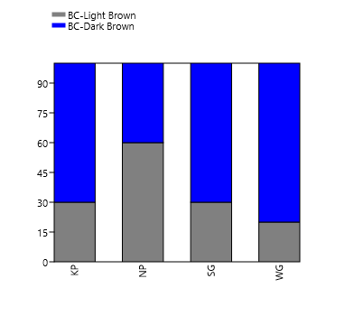(a) Bark color | 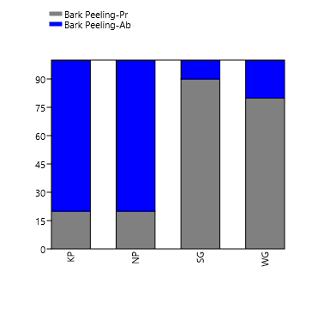  (b) Bark exfoliation
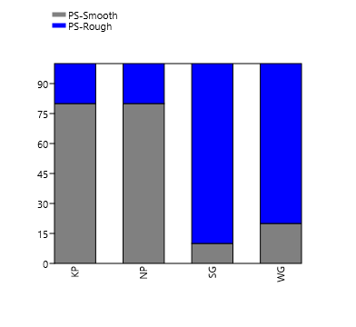
(c) Bark peeled surface texture
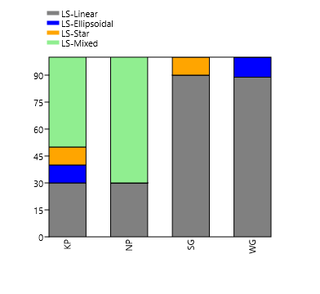(d) Stem lenticel shape | 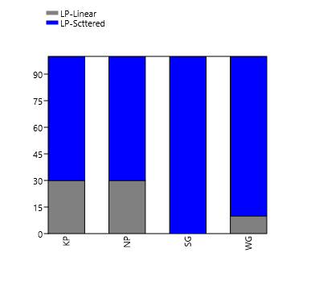(e) Stem lenticel pattern
Fig. 1: Frequency distribution of qualitative bark characteristics (a-e) among the natural populations of M. dubia

3.2. Discussion
The observed morphological variations in bark characteristics across the four natural populations of M. dubia in South Gujarat highlight significant phenotypic diversity within the species. Bark, a unique and often species-specific feature, plays a crucial role in tree identification and protection. While its appearance can remain consistent throughout a tree's life, age-related changes are common (Wolfe and Hitchcock, 2015). Furthermore, bark morphology can be influenced by various environmental (e.g., drought, frost), biological (e.g., fungal and bacterial infection) and mechanical (e.g., wind exposure) stimuli (Kales, 2020).
In the present study, the dominance of dark brown, exfoliating and rough bark in the Sagai and Waghai populations, contrasting with the predominantly smooth bark and absence of exfoliation in the Nanapondha and Kaprada populations, suggests potential adaptive responses or age-related patterns. The primary function of bark is stem protection and exfoliation and roughness are known to occur with age, often as a mechanism to shed diseased bark, particularly from bacterial and fungal growth in younger trees (Morris and Jansen, 2017). Thus, variations in tree age within respective populations, indirectly evidenced by their mean height and diameter, might contribute to the observed bark morphologies. The relationship between adult tree stature and bark traits is well-documented in species such as M. azedarach (Lev-Yadun and Aloni, 1993), as well as in other tree species (Poorter et al., 2014; Groover, 2017). Additionally, variations in bark color, such as the lighter margin observed in some individuals from Nanapondha and Kaprada, could be explained by differential cambial heating (Lev-Yadun, 2019).
Lenticels, which are distinct pores on the stem, facilitate essential gas exchange, especially for bark photosynthesis. The variations in their shapes, sizes and patterns, particularly visible on smooth bark, are prevalent across many species. The observed shape variations in this study, such as the dominance of 'Linear' shapes in Sagai and Waghai versus 'Mixed' in Nanapondha and Kaprada, are suspected to be developmental changes occurring over the years, enhancing their capacity for efficient gas exchange, as demonstrated in Avicennia marina (Purnobasuki, 2011). Structural changes in lenticels have also been indicated as seasonal modifications, crucial for balancing transpiration and respiration in species like Picea abies (Rosner and Kartusch, 2003).
The distinct morphological characteristics observed across the natural populations highlight the existing phenotypic diversity of M. dubia in South Gujarat. This variation is crucial for understanding the species' adaptability and provides a foundational basis for identifying superior genotypes. Such insights are invaluable for future selection, targeted tree improvement programs, and ensuring the sustainable management of M. dubia in forestry initiatives.

CONCLUSION
This study revealed significant morphological variations in the bark characteristics of Melia dubia across the four natural populations assessed in South Gujarat. Distinct differences were observed in bark color, texture, exfoliation and lenticel patterns, with notable contrasts between populations; for instance, Waghai and Sagai exhibited predominantly rough bark with exfoliation, while Kaprada and Nanapondha displayed smooth bark with minimal exfoliation. Despite varying shapes, a scattered lenticel pattern was common across all populations. These findings underscore the considerable phenotypic diversity within Melia dubia, providing crucial insights into its intraspecific variation and adaptability. This documented morphological diversity is vital for the effective management and conservation of the species' genetic resources, holding substantial potential for guiding future genetic improvement programs and sustainable agroforestry applications.

DISCLAIMER (ARTIFICIAL INTELLIGENCE)
Authors hereby declare that NO generative AI technologies such as Large Language Models (ChatGPT, COPILOT, etc) and text-to-image generators have been used during writing or editing of this manuscript.
ACKNOWLEDGEMENT
The authors are thankful to the authorities of Center for Advanced Agricultural Science and Technology on Secondary Agriculture (CAAST), Navsari Agricultural University, Navsari, Gujarat, India, for providing funds to conduct the study and the Gujarat Forest Department officials for permitting sample collection.
COMPETING INTERESTS
Authors have declared that no competing interests exist.

REFERENCES
- Bekele, A., & Bekele, E. (2014). Overview: Morphological and molecular markers role in crop improvement programs. International Journal of Current Research in Life Sciences, 3(3), 035-042.
- Chanthuru, A., Prabhu, M. M., Aysha, O. S., & Karthik, R. (2014). Evaluation of leaf and root extracts of Melia dubia L. against larvae of Culex quinquefasciatus and five important human pathogens. Biosci Biotechnol Res Asia, 11(1), 207-210.
- Chauhan, R. S., Jadeja, D. B., Thakur, N. S., Jha, S. K., & Sankanur, M. S. (2018). Selection of candidate plus trees (CPTs) of Malabar neem (Melia dubia Cav.) for enhancement of farm productivity in south Gujarat, India. International Journal of Current Microbiology and Applied Sciences, 7(5), 3582-3592.
- Groover, A. (2017). Age-related changes in tree growth and physiology. eLS. 1-7, 1-7.
- Hooker J. D. (1875) “The Flora of British India,” L. Reeve and Co, London, 178 p.
- Keles, S. (2020). How anatomical and morphological characteristics affect the flexural properties of two angiosperm species at the sapling stage. BioResources, 15(3), 5843.
- Kumar, H. K., & Chauha, J. B. (2019). Assessment of anti-arthritic, anti-inflammatory and antioxidant activity of Melia dubia. Journal of Pharmacognosy and Phytochemistry, 8, 2579-2582.
- Lev-Yadun, S. (2019). Why is the bark of common temperate Betula and Populus species white?. International Journal of Plant Sciences, 180(6), 632-642.
- Lev-Yadun, S., & Aloni, R. (1993). Bark structure and mode of canopy regeneration in trees of Melia azedarach L. Trees, 7(3), 144-147.
- Morris, H., & Jansen, S. (2017). “Bark: its anatomy, function and diversity”. International Dendrochronology Society, pp. 51-61.
- Pal, A., Kumar, R., & Tripathi, Y. C. (2016). Antifungal activity of natural colourant from Melia composita bark and its application in functional textile finishing. International Journal of Pharmacy and Pharmaceutical Sciences, 8(5), 387-391.
- Parthiban, K. T., Bharathi, A. K., Seenivasan, R., Kamala, K., & Rao, M. G. (2009). Integrating Melia dubia in agroforestry farms as an alternate pulpwood species. APA News, 34, 3-4.
- Poorter, L., McNeil, A., Hurtado, V. H., Prins, H. H., & Putz, F. E. (2014). Bark traits and life‐history strategies of tropical dry‐and moist forest trees. Functional Ecology, 28(1), 232-242.
- Purnobasuki, H. (2011). Structure of Lenticels on the Pneumatophores of Avicennia marina: as Aerating Device Deliver Oxygen in Mangrove’s root. Journal of Plant Biota, 16, 309-315.
- Rosner, S., & Kartusch, B. (2003). Structural changes in primary lenticels of Norway spruce over the seasons. Iawa Journal, 24(2), 105-116.
- Saravanan, V., Parthiban, K. T., Kumar, P., and Marimuthu, P. (2013). Wood characterization studies on Melia dubia cav. for pulp and paper industry at different age gradation. Research Journal of Recent Sciences, 2, 183-188.
- Sukhadiya, M. L., Thakur, N. S., Patel, V. R., Gunaga, R. P., Kharadi, V. B., Tyagi, K. K., & Singh, S. (2021). Provenance variations in proximate principles, mineral matter, total phenols and phytochemicals of Melia dubia drupes: an unexplored alternate livestock feed stock. Journal of Forestry Research, 32(1), 119-131.
- Suprapti, S., Djarwanto, D., & Hudiansyah, H. (2004). The resistance of five wood species against several wood destroying fungi. Journal Penelitian Hasil Hutan, 22(4): 239–246.
- Suresh, T., & Devakumar, A. S. (2017). Morphological characterization of Melia dubia seeds: implications to germination. Indian Journal of Pure & Applied Biosciences, 5(4): 721–725.
- Troup, R. S. (1921). “Silviculture of Indian Trees”, Clarendon Press. London, U.K., 3: 152.
- Uday, D. N., Sujatha, D., & Pandey, C. N. (2011). Suitability of Melia dubia (malabar neem wood) for plywood manufacture. Journal of the Indian Academy of Wood Science, 8(2), 207-211.
- Valentina, P., Ilango, K., Kiruthiga, B., & Parimala, M. J. (2013). Preliminary phytochemical analysis and biological screening of extracts of leaves of Melia dubia Cav. International Journal of Ayurveda Research, 4, 417-419.
- Wolfe, K., & Hitchcock, A. (2015). Observing nature: learn to identify trees by their bark. New York: McGraw-Hill.

