Original Research Article
Effects of Plant growth Regulators on Growth, Quality and Yield of Bitter Gourd (Momordica charantia L.)
ABSTRACT
A field experiment was conducted during the spring season of 2024–25 at the Research Farm of Mewar University, Chittorgarh (Rajasthan), to evaluate the effects of various plant growth regulators (PGRs) on the growth, yield, and quality of bitter gourd (Momordica charantia L.) cv. Arka Harit. The study comprised ten treatments involving foliar applications of gibberellic acid (GA₃), naphthalene acetic acid (NAA), and methyl jasmonate (MeJA) at varying concentrations, arranged in a Randomized Block Design with three replications. Results revealed that the application of GA₃ at 150 ppm (T3) significantly enhanced vine length (399.10 cm), leaf number (102 at 45 DAS), fruit diameter (3.48 cm), fruit length (14.94 cm), vitamin C content (84.94 mg/100 g), and total soluble solids (5.7 °Brix), along with a high fruit yield (1790 g/plant). However, the combination treatment T4 (NAA 50 ppm + GA₃ 150 ppm) recorded the highest fruit yield per plant (1930 g), while T5 (NAA 100 ppm + GA₃ 100 ppm) showed the highest fruit number per plant (41.22) and iron content (0.260%). Among MeJA treatments, T8 (MeJA 100 ppm) showed better performance compared to the control but was less effective than GA₃ or NAA combinations. The control (T10) consistently recorded the lowest values for all measured parameters. Economic analysis also indicated higher net returns with GA₃ and NAA combinations. Overall, the foliar application of GA₃ at 150 ppm alone or in combination with NAA significantly improved growth, yield, and quality traits of bitter gourd. The treatment T4 (NAA 50 ppm + GA₃ 150 ppm) was concluded to be the most effective for optimizing both yield and quality in bitter gourd cultivation under the studied conditions.
Keywords: Bitter gourd, Plant growth regulators, GA₃, NAA, MeJA, yield, quality

- INTRODUCTION
Bitter gourd (Momordica charantia L.), a member of the Cucurbitaceae family, is an important vegetable crop grown in tropical and subtropical regions of the world, particularly in South and Southeast Asia. In India, bitter gourd holds substantial commercial value due to its high nutritional quality and demand in both fresh and processed markets. It is a rich source of vitamins, especially vitamin C (88 mg/100 g), vitamin A, and essential minerals, which play a vital role in human health (Akter et al., 2009; Behera, 2011). The crop is also known for its therapeutic properties, including antioxidant, antimicrobial, antiviral, anti-ulcerogenic, hepatoprotective, and hypoglycemic effects, contributing to its use in traditional medicine systems (Behera, 2011; Wasternack & Hause, 2013). In recent years, increasing agricultural productivity without compromising produce quality has become a critical objective. Among the various strategies, the application of plant growth regulators (PGRs) is gaining attention as an effective approach for enhancing growth, yield, and quality parameters in vegetable crops (Olszewski et al., 2002). PGRs act as chemical messengers that influence physiological and developmental processes such as cell elongation, fruit setting, flowering, and senescence, depending on their nature and application methods (GhasemiPirbalouti et al., 2014; Rafeekher et al., 2002).
Gibberellic acid (GA₃) is one of the most widely used growth-promoting substances in horticulture. It enhances internodal elongation, increases photosynthetic efficiency, and improves the translocation of photoassimilates, resulting in better fruit development and yield (Rafeekher et al., 2002; Olszewski et al., 2002). Several studies have demonstrated the positive effects of GA₃ on growth and yield parameters in vegetables such as onion, okra, muskmelon, and sponge gourd (Akshya et al., 2021; Meena et al., 2017; Desai, 1983; Dubey, 1983). In bitter gourd, the use of GA₃ has been found to significantly enhance vine growth, flowering, and fruit setting. Similarly, naphthalene acetic acid (NAA), a synthetic auxin, plays a vital role in regulating apical dominance, root initiation, and fruit development. NAA has been reported to influence the hormonal balance of the plant, promoting higher fruit retention and reducing premature fruit drop, thus contributing to increased yield (Meena et al., 2017; Yadagiri & Gupta, 2017). Foliar application of NAA in vegetable crops like okra and onion has shown considerable improvements in both quantitative and qualitative yield parameters (Dwivedi et al., 2019; Ballabh & Rana, 2012).
Methyl jasmonate (MeJA), a derivative of jasmonic acid, is an emerging class of PGRs known to mediate responses to biotic and abiotic stresses and influence plant growth and development (Wasternack & Hause, 2013; Conconi et al., 1996). Jasmonates are involved in defense responses and also contribute to reproductive development and secondary metabolite production. Studies have shown that MeJA applications in crops such as tomato, citrus, cabbage, and summer squash can improve stress tolerance and enhance fruit quality attributes like flavor and nutrient content (Maserti et al., 2011; Gad et al., 1993; Y. & Hwang, 2016). GhasemiPirbalouti et al. (2014) highlighted the significant role of MeJA and its derivatives in agricultural biotechnology due to their role in signaling pathways that regulate plant defense, growth, and metabolic activities. The beneficial effects of PGRs are also influenced by application methods, concentrations, and crop stages. For instance, foliar spraying has proven to be a convenient and effective technique to supply PGRs directly to plant tissues, thereby ensuring better absorption and faster physiological responses (Dwivedi et al., 2019; Bista et al., 2022). It has also been observed that combinations of different PGRs can produce synergistic effects, enhancing overall crop performance more than individual applications (Dev et al., 2020).
Despite the growing body of research on PGRs, limited studies have evaluated the comparative efficacy of GA₃, NAA, and MeJA in bitter gourd. Moreover, there is a lack of consensus on the optimal combinations and concentrations for maximizing growth, yield, and quality traits under different agro-climatic conditions. Therefore, the present investigation was undertaken to assess the impact of foliar applications of GA₃, NAA, and MeJA, individually and in combination, on the growth, yield, and quality of bitter gourd under the semi-arid conditions of Rajasthan. The findings aim to identify the most effective treatment for enhancing bitter gourd productivity and offer insights into the integrated use of PGRs for sustainable horticultural practices.

- MATERIAL AND METHODS
2.1 Experimental Site and Climatic Conditions
The field experiment was conducted during the spring (summer) season of 2024–25 at the Research Farm of the Department of Horticulture (Vegetable Science), Faculty of Agriculture and Veterinary Sciences, Mewar University, Gangrar, Chittorgarh, Rajasthan (India). The experimental site is located in the semi-arid region of southern Rajasthan, characterized by a sub-tropical climate with distinct summer and monsoon seasons. The region receives the majority of its rainfall between June and September due to the South-West monsoon, with occasional showers in winter. During the cropping season, the maximum temperature ranged between 40°C and 45°C, while the minimum temperature ranged from 5°C to 6°C, providing optimal thermal conditions for bitter gourd cultivation.
2.2 Experimental Design and Treatments
The experiment was laid out in a Randomized Block Design (RBD) with ten treatments replicated three times, resulting in a total of 30 experimental plots. Each plot measured 2.5 m × 2.0 m, with standard spacing maintained between plants (60 cm) and rows (120 cm) to ensure proper growth and air circulation. The bitter gourd cultivar ‘Arka Harit’, known for its high yield potential and market preference, was used as the test variety.
The treatments involved foliar applications of three types of plant growth regulators (PGRs): Gibberellic Acid (GA₃), Naphthalene Acetic Acid (NAA), and Methyl Jasmonate (MeJA), either alone or in combinations, at different concentrations. The details of the treatments were as follows:
- T1: GA₃ 50 ppm
- T2: GA₃ 100 ppm
- T3: GA₃ 150 ppm
- T4: NAA 50 ppm + GA₃ 150 ppm
- T5: NAA 100 ppm + GA₃ 100 ppm
- T6: NAA 150 ppm + GA₃ 50 ppm
- T7: MeJA 50 ppm
- T8: MeJA 100 ppm
- T9: MeJA 150 ppm
- T10: Control (no PGR application)
Foliar sprays were administered at 45 and 90 days after sowing (DAS) using a knapsack sprayer, ensuring uniform coverage of the plant foliage. A non-ionic surfactant (0.1%) was added to each solution to enhance absorption.
2.3 Data Collection and Observations
Observations were recorded on growth, yield, and quality parameters at specified growth stages:
- Growth Parameters: Vine length (cm), number of branches per plant, and number of leaves per plant were recorded at 45 and 90 DAS from five randomly selected plants per plot.
- Yield Parameters: Fruit length (cm), fruit diameter (cm), average fruit weight (g), number of fruits per plant, and fruit yield per plant (g) were measured at harvest using standard measuring tools and weighing scales.
- Quality Parameters: Total soluble solids (°Brix) were measured using a hand refractometer. Vitamin C content (mg/100 g) was estimated using the 2,6-dichlorophenol-indophenol titration method. Iron content (%) was determined using atomic absorption spectrophotometry from composite fruit pulp samples.
2.4 Statistical Analysis
The collected data were subjected to analysis of variance (ANOVA) using appropriate statistical software. The significance of treatment effects was tested at the 5% level of probability (p < 0.05). The critical difference (CD) was calculated to compare the means of significantly different treatments. Standard error (SEm±) values were also computed to assess data variability.

- RESULT AND DISCUSSION

3.1 Effects of Plant Growth Regulators on Growth Parameters

Effects of Plant growth Regulators on yield parameters in different treatment efficacy tabulated in Table 1 and illustrated in Fig. 1.

Length of Vine (cm)
The vine length of bitter gourd was significantly influenced by the application of different plant growth regulators. At 90 days after sowing (DAS), the maximum vine length (399.10 cm) was recorded with the foliar application of GA₃ at 150 ppm (T3), followed by T6 (NAA 150 ppm + GA₃ 50 ppm) with 368.85 cm, and T4 (NAA 50 ppm + GA₃ 150 ppm) with 349.34 cm. The shortest vine length was observed in the control treatment (T10), recording only 300.32 cm. The increased vine elongation with GA₃ treatments is attributed to enhanced cell division and elongation activity, as also reported in earlier studies on cucurbitaceous vegetables (Rafeekher et al., 2002; Meena et al., 2017). Similar findings in muskmelon and sponge gourd also confirm the positive role of GA₃ on vine growth (Desai, 1983; Dubey, 1983).

Number of Branches per Plant
The highest number of branches at 90 DAS was recorded in T3 (GA₃ 150 ppm) with 13.60 branches per plant, followed by T4 (NAA 50 ppm + GA₃ 150 ppm) with 13.53, and T9 (MeJA 150 ppm) with 13.31. The control treatment (T10) produced the fewest branches (8.60). The increase in branching could be due to the synergistic effect of GA₃ and NAA in stimulating meristematic activity, thereby promoting lateral shoot formation (Meena et al., 2017; Arora et al., 1982).

Number of Leaves per Plant
At 90 DAS, the maximum number of leaves (225.40) was observed in T4 (NAA 50 ppm + GA₃ 150 ppm), followed by T3 (220.00) and T5 (222.00). In contrast, the control (T10) showed the lowest number of leaves (197.20). The increased leaf number may be linked to enhanced photosynthetic efficiency and hormonal balance due to GA₃ and NAA application (Rafeekher et al., 2002; Akshya et al., 2021). Treatments with MeJA also improved leaf production, consistent with previous observations on the role of jasmonates in growth and defense responses (Wasternack & Hause, 2013; GhasemiPirbalouti et al., 2014).

3.2 Effects of Plant Growth Regulators on Yield Parameters

Effects of Plant growth Regulators on yield parameters in different treatment efficacy tabulated in Table 2 and illustrated in Fig. 2.

Fruit Length (cm)
Among the treatments, T3 (GA₃ 150 ppm) recorded the longest fruit (14.94 cm), followed by T5 (NAA 100 ppm + GA₃ 100 ppm) at 14.09 cm and T2 (GA₃ 100 ppm) at 12.06 cm. The shortest fruits were found in T10 (control) with 10.75 cm. These results align with the findings of Rafeekher et al. (2002) and Meena et al. (2017), where GA₃ significantly increased fruit size due to improved cell elongation.

Fruit Diameter (cm)
T3 (GA₃ 150 ppm) produced fruits with the greatest diameter (3.48 cm), followed by T5 (3.30 cm) and T2 (3.10 cm). The smallest diameter was recorded in the control treatment (2.82 cm). The improved fruit girth could be attributed to increased assimilate accumulation and vascular activity, as previously reported by Dev et al. (2020).

Average Fruit Weight (g)
T2 (GA₃ 100 ppm) showed the highest average fruit weight (46.93 g), followed by T3 (45.00 g) and T4 (44.12 g). Control plants (T10) showed the lowest average weight (40.21 g). GA₃ has been known to improve sink strength, leading to heavier fruits (Olszewski et al., 2002) and (Sripontan & Hwang, 2016).

Fruit Yield per Plant (g)
Maximum fruit yield per plant was observed in T4 (NAA 50 ppm + GA₃ 150 ppm) with 1930 g, followed by T3 (1790 g), T2 (1610 g), and T5 (1630 g). Control plants yielded only 1320 g per plant. The enhanced yield in T4 and T3 may be the combined result of increased fruit number, size, and weight due to synergistic PGR effects (Dwivedi et al., 2019; Yadagiri & Gupta, 2017).

3.3 Effects of Plant Growth Regulators on Quality Parameters

Effects of Plant growth Regulators on quality parameters in different treatment efficacy tabulated in Table 3 and illustrated in Fig. 3.

Total Soluble Solids (°Brix)
The highest TSS content was recorded in T3 (GA₃ 150 ppm) with 5.70 °Brix, followed by T6 (5.6 °Brix), and T8 (5.3 °Brix). The control (T10) recorded the lowest TSS (4.8 °Brix). GA₃ improves sugar translocation and carbohydrate metabolism, enhancing sweetness (Wagh & Deore, 1995). MeJA also enhances sugar content by modulating stress responses (Gad et al., 1993).

Vitamin C (mg/100g)
Vitamin C content was highest in T3 (84.94 mg/100g), followed by T6 (82.90 mg/100g) and T8 (81.15 mg/100g). The control recorded 63.79 mg/100g. These results agree with Akter et al. (2009) and Bista et al. (2022), who reported increased vitamin C content due to foliar sprays of growth regulators enhancing antioxidant synthesis.

Iron Content (%)
The maximum iron content was recorded in T5 (NAA 100 ppm + GA₃ 100 ppm) at 0.2600%, followed by T3 (0.2200%) and T4 (0.2100%). The control showed the lowest iron content (0.1500%). Auxin and gibberellin combinations may improve nutrient uptake and accumulation, supporting findings by Ballabh & Rana (2012) and Akshya et al. (2021).
CONCLUSION
The present investigation demonstrated that foliar application of plant growth regulators (PGRs) significantly influenced the growth, yield, and quality attributes of bitter gourd (Momordica charantia L.). Among the ten treatments tested, GA₃ at 150 ppm (T3) and its combination with NAA 50 ppm (T4) proved most effective in enhancing key parameters. T3 showed superior results in terms of vine length, fruit length, fruit diameter, vitamin C content, and TSS, indicating the efficacy of GA₃ in stimulating vegetative growth and improving fruit quality. Meanwhile, T4 (NAA 50 ppm + GA₃ 150 ppm) recorded the highest fruit yield per plant, suggesting a synergistic effect of auxin and gibberellin on fruit set and development. MeJA treatments also showed moderate improvements over the control, especially in enhancing quality parameters. The control consistently lagged across all metrics. These findings support the practical use of GA₃ and NAA, particularly in combination, to maximize bitter gourd productivity and nutritional quality. Based on the results, T4 is recommended for commercial cultivation under semi-arid conditions to achieve both higher yield and economic returns. Future studies may focus on refining application timing and evaluating residual effects on soil health and subsequent crops.

DISCLAIMER (ARTIFICIAL INTELLIGENCE)
Author(s) hereby declare that NO generative AI technologies such as Large Language Models (ChatGPT, COPILOT, etc.) and text-to-image generators have been used during the writing or editing of this manuscript.
REFERENCES

Akshya, K., Pavitra, d., Jitendra, K., Krishna, C., Vinuj, K., Bijender, S. and Pandey, P. S., 2021, Effect of plant growth regulators on growth and yield performance of onion (Allium cepa L.) cv. Pusa Red. Prog. Agric., 21 (1), 12-16.
Anonymous, (2023). Indian Horticulture Database, published by National Horticulture Board.
Arora, S.K., Pandita, M. L. and Sidhu, A.S. (1982. Effect of maleic hydrazide on vegetative growth, lowering and fruiting of bottlegourd. ScientiaHortic., 17, 211-215.
Ballabh, K., & Rana, D. K. (2012). Response of micronutrients on qualitative and quantitative parameters of onion (Allium cepa L.). Progressive Horticulture, 44(1), 40-46.
Bangal, D.B., Deshmukh, S.N. and Patil, V.A., 1982. Note on the effect of growth. regulators and urea on yield and yield attributes of gram (Cicer arietinum L.). Legume Res., 5(1), 54-56.
Bista, D., Sapkota, D., Paudel, H., and Adhikari, G., 2022, Effect of foliar application of growth regulators on growth and yield of onion (Allium cepa L.). Int. J. Hort. Sci. Technol., 9 (2), 247-254.
Bose, T.K., Kabir, J., Das, P. and Joy, P.P. (2000). Tropical Horticulture, NayaProkash, Calcutta, India. 2:175. *Boose,G.V. 1966. Increasing seed viability in cucumbers and tomatoes under glass house conditions. Trudy prikland-Bot. Gene't. Selek. 38(1), 179-190.
Conconi, A., Smerdon, M. J., Howe, G. A. & Ryan, C. A. Teoctadecanoidsignalling pathway in plants mediates a response to ultraviolet radiation. Nature 383, 826-829 (1996).
Desai, J.R. (1983). Expression, yield and quality of muskmelon (Cucumismelo. L. Madhu under sub-humid thesis)tropics of South Gujarat. M.Sc. (Agri. submitted to Gujarat Agril. University, S.K.Nagar.
Dev, R., Singh, V.K., Raj, S. and Shukla, K.C., 2020, Effect of plant growth regulators on growth and yield of cabbage (Brassica oleracea var. capitata L.). J. Pharmacogn. Phytochem., 9 (3), 1024-1026. 62/70
Devi, J., 2017, Effect of foliar application of growth regulators on growth, yield and quality of onion. M.Sc., Thesis, PDKV, Akola.
Dubey, K.C. (1983 hydrazide on growth, flowering and yield of spongegourd. Indian J.)Agric. Sci., 28(2 25-27. . Sex expression and yield)Gad, A.A., Alsadon, A.A. and Wahdan, H.M. (1993) responses of summer squash to MeJA . Annals Agril. Sci., 38(1 251-259.
Dwivedi, B., & Asati, K. P. (2019). Effect of PGRs and their methods of application on yield, quality and economics of Kharif onion (Allium cepa L.) cv. Agri found Dark Red. The Pharma Innovation Journal, 8(10), 70-73.
Dwivedi, B., Diwan, G., & Asati, K. P. (2019). Effect of plant growth regulators and their methods of application on growth of kharif onion (Allium cepa L.) cv Agrifound Dark Red. Int. J. Curr. Microbiol. App. Sci, 8(9), 1597-1610.
Ghasemi Pirbalouti, A., Sajjadi, S. E., & Parang, K. (2014). A review (research and patents) on jasmonic acid and its derivatives. Archiv der Pharmazie, 347(4), 229-239.
Maserti, B. E., Del Carratore, R., Della Croce, C. M., Podda, A., Migheli, Q., Froelicher, Y., ... & Rossignol, M. (2011). Comparative analysis of proteome changes induced by the two spotted spider mite Tetranychus urticae and methyl jasmonate in citrus leaves. Journal of plant physiology, 168(4), 392-402.

Meena, R.K., Dhaka, R.S., Meena, N. K. and Meena, S., 2017, Effect of foliar application of NAA and GA3 on growth and yield of okra (Abelmoschus esculentus (L.) Moench) cv. ArkaAnamika. Int. J. Pure App. Biosci., 5 (2), 1057-1062.
Olszewski, N., Sun, T.P., Gubler, F. (2002), Gibberellin signaling: Biosynthesis, catabolism and response pathways. Plant cell (14), S61-S80.
Wagh, R.S. and B.P. Deore, (1995). Effects of Growth Substances on Seed Yield and Quality of Onion. J.Maharashtra Agric. Univ. 20(1), 144-149.
Wasternack, C., & Hause, B. (2013). Jasmonates: biosynthesis, perception, signal transduction and action in plant stress response, growth and development. An update to the 2007 review in Annals of Botany. Annals of botany, 111(6), 1021-1058.
Sripontan, Y., & Hwang, S. Y. (2016). Jasmonate-induced defense in tomato and cabbage deterred Spodoptera litura (Noctuidae) growth. Journal of Asia-Pacific Entomology, 19(4), 1125-1129.
Yadagiri, J. and Gupta, P. K. (2017). Effect of growth regulator and bio-control agent on growth bulb yield, yield contributing traits and economics of onion (Allium cepa 1.)cv .Agrifound light red. Plant Archives, 17(2), 877-883.

Table 1: Effects of Plant growth Regulators on yield parameters in different treatment efficacy
Treatments |  | Vine length (cm) |  | Branch of per plant (cm) |  | Leaves of per plant (cm)
 |  | 45 DAS | 45 DAS | 45 DAS | 90 DAS | 90 DAS | 90 DAS
T₁ | GA ₃ 50 PPM | 8.23 | 99.40 | 211.20 | 10.33 | 183.10 | 328.92
T₂ | GA ₃ 100 PPM | 9.50 | 100.20 | 215.50 | 11.50 | 191.18 | 354.14
T₃ | GA ₃ 150 PPM | 10.30 | 102.00 | 220.00 | 13.60 | 195.45 | 399.10
T₄ | NAA 50PPM+GA ₃ 150 PPM | 10.45 | 95.30 | 225.40 | 13.53 | 180.60 | 349.34
T₅ | NAA100PPM+GA₃100 PPM | 9.20 | 92.60 | 222.00 | 11.31 | 177.82 | 341.13
T₆ | NAA 150PPM+GA ₃ 50 PPM | 8.80 | 89.00 | 217.70 | 11.24 | 184.52 | 368.85
T₇ | Methyl Jasmonate 50 PMM | 8.30 | 86.20 | 204.60 | 10.52 | 168.92 | 305.13
T₈ | Methyl Jasmonate 100 PMM | 9.70 | 88.40 | 207.30 | 11.64 | 166.12 | 317.16
T₉ | Methyl Jasmonate 150 PMM | 9.10 | 92.00 | 210.80 | 13.31 | 168.92 | 303.30
T₁₀ | Control | 7.50 | 83.10 | 197.20 | 8.60 | 154.00 | 300.32
S. Em± |  | 3.46 | 0.35 | 1.63 | 4.84 | 0.37 | 8.86
CD at 5% |  | 7.26 | 0.74 | 1.82 | 5.42 | 1.08 | 25.71

Table 2: Effects of Plant growth Regulators on Fruits yield per plant
Treatments |  | Fruit length (cm) | Fruit diameter (cm) | Average fruit weight(g) | Fruits yield per plant (g)
T₁ | GA ₃ 50 PPM | 3.05 | 44.81 | 1700 | 11.89
T₂ | GA ₃ 100 PPM | 3.10 | 46.93 | 1610 | 12.06
T₃ | GA ₃ 150 PPM | 3.48 | 45.00 | 1790 | 14.94
T₄ | NAA 50PPM+GA ₃ 150 PPM | 3.02 | 44.12 | 1930 | 11.59
T₅ | NAA 100PPM+GA ₃ 100 PPM | 3.30 | 43.90 | 1630 | 14.09
T₆ | NAA 150PPM+GA ₃ 50 PPM | 2.95 | 44.71 | 1650 | 12.37
T₇ | Methyl Jasmonate 50 PMM | 2.82 | 42.10 | 1490 | 11.74
T₈ | Methyl Jasmonate 100 PMM | 2.98 | 42.91 | 1510 | 12.47
T₉ | Methyl Jasmonate 150 PMM | 2.92 | 42.32 | 1540 | 12.58
T₁₀ | Control | 2.82 | 40.21 | 1320 | 10.75
S. Em± |  | 0.39 | 0.099 | 1.24 | 101.55
CD at 5% |  | 1.17 | 0.29 | 3.60 | 294.68

Table 3. Effects of Plant growth Regulators on in Vitamin C, Iron and TSS in different treatments
Treatments |  | Vitamin C (mg/100g) | Iron % | TSS (^{O}Brix)
T₁ | GA ₃ 50 PPM | 0.1900 | 4.8 | 69.03
T₂ | GA ₃ 100 PPM | 0.2200 | 4.9 | 72.03
T₃ | GA ₃ 150 PPM | 0.1500 | 5.7 | 84.94
T₄ | NAA 50PPM+GA ₃ 150 PPM | 0.2100 | 5.0 | 77.89
T₅ | NAA 100PPM+GA ₃ 100 PPM | 0.2600 | 5.1 | 66.59
T₆ | NAA 150PPM+GA ₃ 50 PPM | 0.1400 | 5.6 | 82.90
T₇ | Methyl Jasmonate 50 PMM | 0.1800 | 5.4 | 74.13
T₈ | Methyl Jasmonate 100 PMM | 0.1100 | 5.3 | 81.15
T₉ | Methyl Jasmonate 150 PMM | 0.1300 | 5.5 | 65.06
T₁₀ | Control | 0.1500 | 4.8 | 63.79
S. Em± |  | 1.39 | 0.010 | 0.058
CD at 5% |  | 2.94 | 0.030 | 0.172
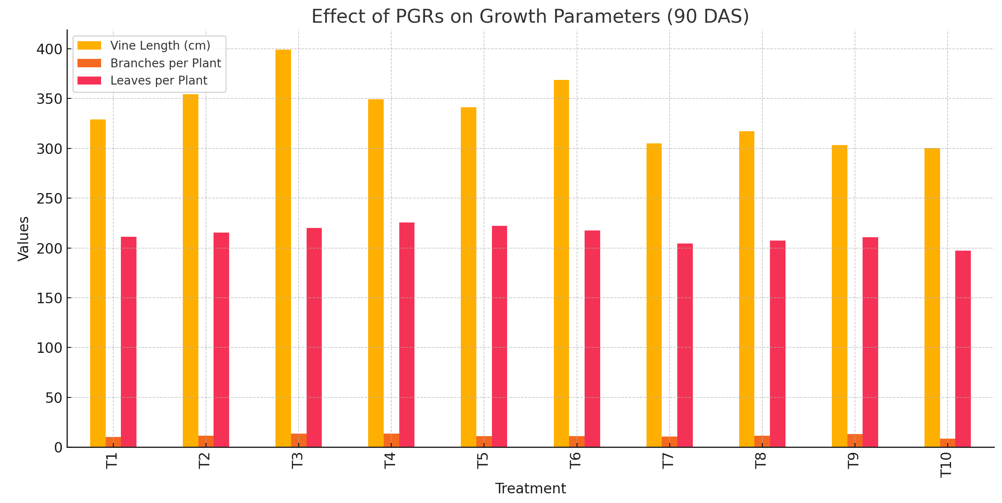
Fig. 1 Effects of Plant growth Regulators on Yield parameters in different treatment efficacy

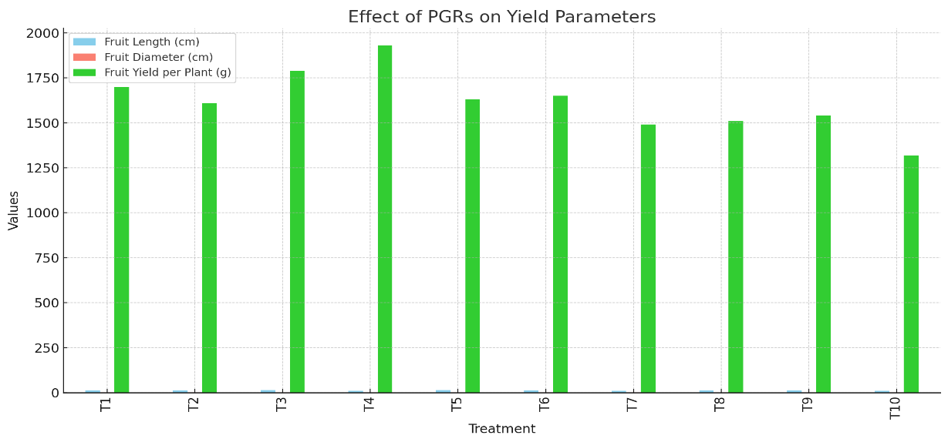
Fig. 2 Effects of Plant growth Regulators on Fruits yield per plant

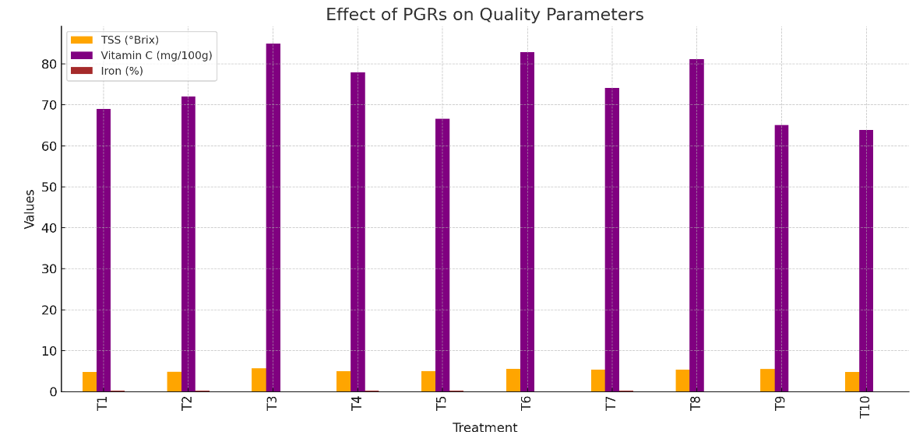

Fig. 3 Effects of Plant growth Regulators on Changes in Vitamin C, Iron and TSS in different treatments

