Original Research Article

Effect of Vermicompost and Biofertilizers on Growth, Yield and Quality of Onion (Allium cepa L.)

ABSTRACT
A field experiment was conducted during the Rabi season of 2024–25 at the Research Farm, Mewar University, Gangrar (Rajasthan), to evaluate the effect of vermicompost and biofertilizers on growth, yield, and quality of onion (Allium cepa L.), using the cultivar ‘Udaipur-102’. The experiment employed a factorial randomized block design comprising four levels of vermicompost (0, 2, 4, and 6 t/ha) and four biofertilizer treatments (control, Azotobacter @ 10 g/kg seed, Pseudomonas @ 10 g/kg seed, and a combination of both), totaling 16 treatment combinations replicated thrice. Results indicated that the combined application of vermicompost at 6 t/ha and biofertilizers (Azotobacter + Pseudomonas) significantly enhanced growth parameters, with maximum plant height (48.96 cm), number of leaves per plant (11.18), leaf length (52.08 cm), and chlorophyll content (1.61). Yield attributes also showed significant improvement under this treatment, including polar diameter (6.69 cm), equatorial diameter (7.33 cm), neck thickness (1.68 cm), average bulb weight (68.10 g), and marketable yield (25.81 t/ha). Quality parameters such as total soluble solids (14.42 °Brix), nitrogen (1.53%), phosphorus (0.23%), and potassium (2.88%) content were also highest in this treatment. Among all treatments, the combination of V4 (vermicompost 6 t/ha) and B4 (Azotobacter + Pseudomonas) consistently outperformed others across growth, yield, and quality indicators. These findings underscore the potential of integrated organic nutrient management to improve onion productivity and quality under sustainable agricultural practices.
Keywords: Onion, Allium cepa, Vermicompost, Biofertilizers, Azotobacter, Pseudomonas, Yield, Quality
- INTRODUCTION
Onion (Allium cepa L.) is an important bulb crop of the family Alliaceae. The crop is grown in India as well as most of the countries of the world. Central Asia is primary center of origin of onion and Mediterranean region is the secondary center of origin (Vavilov, 1951) Botanically its growth habit is annual or perennial type but in India it is cultivated as annual. As a vegetable and condiment, onions are a must-have in any kitchen, hence regularly alluded to be the "Queen of Kitchen." The feeding organ of the onion is a highly connected underground stalk with thicker, meaty leaves. The volatile oil "allyl propyl disulphide," an organic molecule high in sulphur, gives onion distinct and palatable flavour and pungency. The use of organic manures is improvement of physical, chemical, and biological properties of the soil, its effect as a source of necessary elements, its ability to increase the obtainability of particular nutrients as well as its effect in reducing the leaching out of minerals (Abdelkader, 2019). Organic manures are all-important for vegetable cultivation in the densely peopled areas due to the frequently low organic matter content of the arable land. This production system is an important priority area globally because of the growing demand for safe and healthy food and long-term sustainability in addition to concerns about environmental pollution. In this system, production is grounded on synergism with nature which accounts for its sustainability (Sheraz et al. 2010). Decreasing environmental pollution and saving healthy foods are the fundamental goals and optimal use for the integration of organic fertilizers. The popularity of garlic crops has lately increased, in part because of the multitudinous health and nutritive benefits attributed to garlic consumption (Rashwan et al., 2018). Bio-fertilizers are the recent sources for fixation of atmospheric nitrogen in to the soil and making it readily available for the growth of plants (Khokhar, 2019). Among the bio-fertilizers, Azotobacter though having limited use in vegetables, yet has established its bio-activity in cereals, oilseeds and other crops for mobilizing the useful macro nutrient nitrogen from unusable to usable state and increase the crop production by enhancing soil fertility. In addition, the bio-fertilizers not only supplement the nutrition but also improve the efficiency of applied nutrients (Somani et al. 1990).

MATERIALS AND METHODS

2.1 Experimental Site and Soil Characteristics
The field experiment was carried out during the Rabi season of 2024–2025 at the Research Farm of the Department of Agriculture (Horticulture), Faculty of Agriculture and Veterinary Sciences, Mewar University, Gangrar, Chittorgarh, Rajasthan (India). The geographical location of the site falls under a semi-arid climate with low to moderate rainfall and temperature fluctuations typical of the region. The experimental field soil was sandy loam in texture, moderately saline in reaction with a pH of 7.6, and poor in organic carbon (0.16%). The soil was deficient in available nitrogen (176 kg/ha) and phosphorus (20.2 kg/ha), moderate in available potassium (320 kg/ha), and low in micronutrients such as zinc (0.48 ppm) and iron (1.2 ppm). These initial soil parameters were recorded by standard laboratory methods prior to sowing.
2.2 Experimental Design and Treatments
The experiment was laid out in a factorial randomized block design (FRBD) comprising 16 treatment combinations, replicated three times, totaling 48 plots. Each plot measured 2.0 m × 2.0 m in size. The treatments involved four levels of vermicompost (V) and four levels of biofertilizers (B) as follows:
- Vermicompost Levels (Main plot treatments):
  - V1: Control (No application)
  - V2: Vermicompost @ 2 t/ha
  - V3: Vermicompost @ 4 t/ha
  - V4: Vermicompost @ 6 t/ha
- Biofertilizer Levels (Sub-plot treatments):
  - B1: Control (No application)
  - B2: Azotobacter @ 10 g/kg seed
  - B3: Pseudomonas fluorescens @ 10 g/kg seed
  - B4: Azotobacter @ 10 g/kg seed + Pseudomonas fluorescens @ 10 g/kg seed

2.3 Crop Details and Agronomic Practices
The onion variety ‘Udaipur-102’, known for its medium maturity and local adaptability, was used as the test crop. Healthy seedlings were raised in a nursery and transplanted at 4-week-old stage with a spacing of 15 cm × 10 cm. The vermicompost was thoroughly mixed in the soil of respective plots 10 days before transplanting. Seeds were treated with respective biofertilizers just before sowing by coating them uniformly using a 10% jaggery solution as an adhesive. Standard agronomic practices for onion cultivation were uniformly followed across all plots, including timely irrigation, manual weeding, and pest and disease management. No chemical fertilizers were applied during the experiment to maintain the integrity of organic treatment effects.

2.4 Data Collection and Observations
Data were recorded on growth, yield, and quality parameters at regular intervals using standard protocols:
- Growth parameters: Plant height (cm), number of leaves per plant, leaf length (cm), and chlorophyll content (measured at 75 DAT using SPAD meter).
- Yield parameters: Polar diameter (cm), equatorial diameter (cm), neck thickness (cm), average bulb weight (g), and total bulb yield (t/ha).
- Quality parameters: Total soluble solids (°Brix) measured by hand refractometer, and bulb N, P, K contents (%) analyzed using Kjeldahl digestion, Olsen’s method, and flame photometry, respectively.

2.5 Statistical Analysis
The collected data were subjected to analysis of variance (ANOVA) using the standard procedure for factorial randomized block design. The significance of treatment effects was tested at 5% probability level, and critical difference (CD) values were calculated for comparison of means. Statistical analysis was carried out using standard software such as OPSTAT or SPSS.
- RESULTS AND DISCUSSION

3.1 Growth parameters
Effect of vermicompost and biofertilizers manures on growth parameters of onion tabulated in Table 1 and illustrated in Fig. 1. In case of vermicompost the data were showed significant effect on plant height at 30, 40 and 60 days after transplanting. The maximum plant height (28.33, 36.71 and 48.96 cm) was observed with treatments V₄-Vermicompost 6 t/ha; closely followed by with treatment V₃-Vermicompost 4 t/ha (26.70, 35.08 and 47.34 cm). The minimum plant height was recorded with V₁-Control (No application) (23.09, 31.47 and 43.13 cm) at 30, 40 and 60 DAT, respectively. In case of biofertilizer the data were showed significant effect on plant height at 30, 40 and 60 days after transplanting. The maximum plant height (26.40, 34.78 and 47.04 cm) was observed with treatments B₄-Azotobacter @ 10 g/kg seed + Pseudomonas @ 10 g/kg seed; it was found at par with B₂-Azotobacter @ 10 g/kg seed and B₃-Pseudomonas @ 10 g/kg seed. The minimum plant height was recorded with B₁-Control (No application) (27.79, 33.17 and 44.82 cm) at 30, 40 and 60 DAT, respectively. In case of vermicompost the data were showed significant effect on number of leaves per plant at 90 DAT. The maximum number of leaves per plant (11.18) was observed with treatments V₄-Vermicompost 6 t/ha; closely followed by with treatment V₃-Vermicompost 4 t/ha (9.96). The minimum number of leaves per plant was recorded with V₁-Control (No application) (8.63). In case of biofertilizer the data were showed significant effect on number of leaves per plant at 90 DAT. The maximum number of leaves per plant (10.09) was observed with treatments B₄-Azotobacter @ 10 g/kg seed + Pseudomonas @ 10 g/kg seed; it was found at par with B₂-Azotobacter @ 10 g/kg seed and B₃-Pseudomonas @ 10 g/kg seed (9.85). The minimum number of leaves per plant was recorded with B₁-Control (No application) (9.45). In case of vermicompost the data were showed significant effect on leaf length at 90 DAT. The maximum leaf length (52.08 cm) was observed with treatments V₄-Vermicompost 6 t/ha; closely followed by with treatment V₃-Vermicompost 4 t/ha (48.80 cm). The minimum leaf length was recorded with V₁-Control (No application) (43.06 cm). In case of biofertilizer the data were showed significant effect on leaf length at 90 DAT. The maximum leaf length (48.82 cm) was observed with treatments B₄-Azotobacter @ 10 g/kg seed + Pseudomonas @ 10 g/kg seed; it was found at par with B₂-Azotobacter @ 10 g/kg seed and B₃-Pseudomonas @ 10 g/kg seed (47.90 and 47.07 cm). The minimum leaf length was recorded with B₁-Control (No application) (45.90 cm). In case of vermicompost the data were showed significant effect on chlorophyll content at 75 DAT. The maximum chlorophyll content (1.61) was observed with treatments V₄-Vermicompost 6 t/ha; closely followed by with treatment V₃-Vermicompost 4 t/ha (1.53). The minimum chlorophyll content was recorded with V₁-Control (No application) (1.36). In case of biofertilizer the data were showed significant effect on chlorophyll content at 75 DAT. The maximum chlorophyll content (1.52) was observed with treatments B₄-Azotobacter @ 10 g/kg seed + Pseudomonas @ 10 g/kg seed; it was found at par with B₂-Azotobacter @ 10 g/kg seed and B₃-Pseudomonas @ 10 g/kg seed (1.50 and 1.47). The minimum chlorophyll Anand et al. (2017), content was recorded with B₁-Control (No application) (1.45). Same findings’ also reported by Kumar et al. (2019), Preethi et al. (2022), Das et al. (2020), Hore et al. (2021), Banjare et al. (2023), Patel et al. (2024) and Bandi et al. (2024).
  - Yield attributes
Effect of vermicompost and biofertilizers manures on yield attributes of onion tabulated in Table 2 and Fig. 2. In case of vermicompost the data were showed significant effect on polar diameter. The maximum polar diameter (6.69 cm) was observed with treatments V₄-Vermicompost 6 t/ha; closely followed by with treatment V₃-Vermicompost 4 t/ha (5.57 cm). The minimum polar diameter was recorded with V₁-Control (No application) (5.43 cm). In case of biofertilizer the data were showed significant effect on polar diameter. The maximum polar diameter (6.46 cm) was observed with treatments B₄-Azotobacter @ 10 g/kg seed + Pseudomonas @ 10 g/kg seed; closely followed by with treatment B₂-Azotobacter @ 10 g/kg seed and B₃-Pseudomonas @ 10 g/kg seed (610 and 6.01 cm). The minimum polar diameter was recorded with B₁-Control (No application) (5.13 cm). In case of vermicompost the data were showed significant effect on equatorial diameter. The maximum equatorial diameter (7.33 cm) was observed with treatments V₄-Vermicompost 6 t/ha; closely followed by with treatment V₃-Vermicompost 4 t/ha (7.07 cm). The minimum equatorial diameter was recorded with V₁-Control (No application) (5.89 cm). In case of biofertilizer the data were showed significant effect on equatorial diameter. The maximum equatorial diameter (6.88 cm) was observed with treatments B₄-Azotobacter @ 10 g/kg seed + Pseudomonas @ 10 g/kg seed; it was found at par with treatment B₂-Azotobacter @ 10 g/kg seed (6.78 cm). The minimum equatorial diameter was recorded with B₁-Control (No application) (6.48 cm). In case of vermicompost the data were showed significant effect on neck thickness. The maximum neck thickness (1.68 cm) was observed with treatments V₄-Vermicompost 6 t/ha; closely followed by with treatment V₃-Vermicompost 4 t/ha (1.55 cm). The minimum neck thickness was recorded with V₁-Control (No application) (1.22 cm). In case of biofertilizer the data were showed significant effect on neck thickness. The maximum neck thickness (1.53 cm) was observed with treatments B₄-Azotobacter @ 10 g/kg seed + Pseudomonas @ 10 g/kg seed; closely followed by treatment B₂-Azotobacter @ 10 g/kg seed (1.48 cm). The minimum neck thickness was recorded with B₁-Control (No application) (1.37 cm). In case of vermicompost the data were showed significant effect on average weight of bulb. The maximum average weight of bulb (68.10 g) was observed with treatments V₄-Vermicompost 6 t/ha; closely followed by with treatment V₃-Vermicompost 4 t/ha (63.96 g). The minimum average weight of bulb was recorded with V₁-Control (No application) (58.98 g). In case of biofertilizer the data were showed significant effect on average weight of bulb. The maximum average weight of bulb (64.95 g) was observed with treatments B₄-Azotobacter @ 10 g/kg seed + Pseudomonas @ 10 g/kg seed; it was found at par with treatment B₂-Azotobacter @ 10 g/kg seed and B₃-Pseudomonas @ 10 g/kg seed (63.96 and 63.03 g). The minimum average weight of bulb was recorded with B₁-Control (No application) (61.55 g). In case of vermicompost the data were showed significant effect on yield. The maximum yield (25.81 t/ha) was observed with treatments V₄-Vermicompost 6 t/ha; closely followed by with treatment V₃-Vermicompost 4 t/ha (25.09 t/ha). The minimum yield was recorded with V₁-Control (No application) (21.13 t/ha). In case of biofertilizer the data were showed significant effect on yield. The maximum yield (24.77 t/ha) was observed with treatments B₄-Azotobacter @ 10 g/kg seed + Pseudomonas @ 10 g/kg seed; it was found at par with treatment B₂-Azotobacter @ 10 g/kg seed ed (24.29 t/ha). The minimum yield was recorded with B₁-Control (No application) (22.75 t/ha). Similar result also reported by Mohanty et al. (2020), Shumbulo et al. (2024), Raval et al. (2024), Patil et al. (2024) and Tofiq et al. (2024).
  - Quality parameters
Effect of vermicompost and biofertilizers manures on quality parameters of onion tabulated in Table 3 and illustrated in Fig. 3. In case of vermicompost the data were showed significant effect on TSS. The maximum TSS (14.42 ⁰Brix) was observed with treatments V₄-Vermicompost 6 t/ha; it was found at par with treatment V₃-Vermicompost 4 t/ha (14.26 ⁰Brix). The minimum TSS was recorded with V₁-Control (No application) (13.61 ⁰Brix). In case of biofertilizer the data were showed significant effect on TSS. The maximum TSS (14.21 ⁰Brix) was observed with treatments B₄-Azotobacter @ 10 g/kg seed + Pseudomonas @ 10 g/kg seed; it was found at par with treatment B₂-Azotobacter @ 10 g/kg seed ed and B₃-Pseudomonas @ 10 g/kg seed (14.13 and 14.10 ⁰Brix). The minimum TSS was recorded with B₁-Control (No application) (13.85 ⁰Brix). In case of vermicompost the data were showed significant effect on N content. The maximum N content (1.53%) was observed with treatments V₄-Vermicompost 6 t/ha; closely followed by treatment V₃-Vermicompost 4 t/ha (1.44%). The minimum N content was recorded with V₁-Control (No application) (1.23%). In case of biofertilizer the data were showed significant effect on N content. The maximum N content (1.43%) was observed with treatments B₄-Azotobacter @ 10 g/kg seed + Pseudomonas @ 10 g/kg seed; it was found at par with treatment B₂-Azotobacter @ 10 g/kg seed ed and B₃-Pseudomonas @ 10 g/kg seed (1.40 and 1.38%). The minimum N content was recorded with B₁-Control (No application) (1.34%). In case of vermicompost the data were showed significant effect on P content. The maximum P content (0.23%) was observed with treatments V₄-Vermicompost 6 t/ha; it was found at par with treatment V₃-Vermicompost 4 t/ha (0.21%). The minimum P content was recorded with V₁-Control (No application) (0.17%). In case of biofertilizer the data were showed significant effect on P content. The maximum P content (0.22%) was observed with treatments B₄-Azotobacter @ 10 g/kg seed + Pseudomonas @ 10 g/kg seed; it was found at par with treatment B₃-Pseudomonas @ 10 g/kg seed and B₂-Azotobacter @ 10 g/kg seed (0.20 and 0.19%). The minimum P content was recorded with B₁-Control (No application) (0.18%). In case of vermicompost the data were showed significant effect on K content. The maximum K content (2.88%) was observed with treatments V₄-Vermicompost 6 t/ha; closely followed by treatment V₃-Vermicompost 4 t/ha (2.68%). The minimum K content was recorded with V₁-Control (No application) (2.21%). In case of biofertilizer the data were showed significant effect on K content. The maximum K content (2.65%) was observed with treatments B₄-Azotobacter @ 10 g/kg seed + Pseudomonas @ 10 g/kg seed; it was found at par with treatment B₂-Azotobacter @ 10 g/kg seed (0.60%). The minimum K content was recorded with B₁-Control (No application) (2.41%). Similar result also reported by Mohanty et al. (2020), Shumbulo et al. (2024), Raval et al. (2024), Patel et al. (2024) and Bandi et al. (2024).

CONCLUSION
The present investigation clearly demonstrated the significant effects of integrated nutrient management involving vermicompost and biofertilizers on the growth, yield, and quality of onion (Allium cepa L.) variety ‘Udaipur-102’ under field conditions. Among the various treatment combinations, the application of vermicompost at 6 t/ha (V4) in conjunction with biofertilizers (Azotobacter @ 10 g/kg seed + Pseudomonas fluorescens @ 10 g/kg seed) (B4) consistently recorded the highest values for all growth, yield, and quality parameters. This integrated treatment (V4B4) resulted in significantly taller plants (48.96 cm), a greater number of leaves per plant (11.18), longer leaves (52.08 cm), and higher chlorophyll content (1.61) at harvest, indicating enhanced vegetative vigor. In terms of yield attributes, the V4B4 treatment significantly improved bulb development, as evidenced by the maximum polar diameter (6.69 cm), equatorial diameter (7.33 cm), neck thickness (1.68 cm), bulb weight (68.10 g), and total yield (25.81 t/ha). Additionally, it enhanced the quality of onion bulbs by recording the highest total soluble solids (14.42 °Brix), nitrogen (1.53%), phosphorus (0.23%), and potassium (2.88%) contents. These improvements may be attributed to better nutrient availability, increased microbial activity, and improved soil health due to the synergistic action of vermicompost and beneficial microbes. The study concludes that integrated use of organic amendments and biofertilizers not only boosts onion productivity but also enhances bulb quality without relying on chemical fertilizers, making it a sustainable and eco-friendly approach. Therefore, the combination of vermicompost @ 6 t/ha + Azotobacter + Pseudomonas (V4B4) is recommended as the most effective and viable nutrient management practice for onion cultivation under similar agro-climatic conditions.
DISCLAIMER (ARTIFICIAL INTELLIGENCE)

Author(s) hereby declare that NO generative AI technologies such as Large Language Models (ChatGPT, COPILOT, etc.) and text-to-image generators have been used during the writing or editing of this manuscript.

REFERENCES
Abdelkader, A. E. (2019). Effect of different levels of farmyard manure, mineral fertilization and potassium humate on growth and productivity of garlic. Middle East J. Appl. Sci., 9(2), 287-296.
Bandi, S. P., Ramesh, E., Deepti, S., & Pal, A. (2024). Studies on the influence of biofertilizers in combination with inorganic nutrients on growth, yield and quality attributes of onion (Allium cepa L.). Environment Conservation Journal, 25(4), 956-963.
Banjare, C., Shukla, N., Sharma, P.K., Patanwar, M. and Chandravanshi, D. 2023. Effect of organic substances on yield and quality of onion (Allium cepa L.). International Journal of Farm Sciences, 5(1), 30- 35.
Das, S., Chanchan, M. and Hore, J.K. 2020. Effect of inorganic and biofertilizer on growth and yield of garlic (Allium sativum L.). Research on Crops,15 (4), 912-915.
Hore, J.K., Das, S. and Chanchan, M. 2021. Effect of inorganic and biofertilizer on growth and yield of garlic (Allium sativum L.). 2nd International conference on Agricultural and Horticulture Science, Hyderabad, February 03-05. Omics Group Conference, Hyderabad, 2 (4), 42.
Khokhar, K. M. (2019). Mineral nutrient management for onion bulb crops–a review. The Journal of Horticultural Science and Biotechnology, 94(6), 703-717.
Kumar, R.K., Ali, S.A., Niwariya, J. and Mewara, N. 2019. Effect of sulphur and zinc on growth and yield of kharif onion (Allium cepa L.). The Pharma Innovation Journal, 9(1), 359-362.
Mohanty, A., Behera, P., & Harichandan, S. (2020). Effect of nutrient management on the growth and productivity of onion. Agricultural Science Digest-A Research Journal, 35(3), 241-243.
Patel, K. M., Patel, H. C., & Gediya, K. M. (2024). Effect of nitrogen, organic manures and bio-fertilizers on growth and bulb yield of onion (Allium cepa L.) varieties. Research on Crops, 9(3), 631-635.
Patil, N. B., Sharma, R., Patil, B. N., & Kumar, A. (2024) Impact of chemical fertilizer, biodynamic and organic manure on growth, yield, quality and profitability of late kharif onion (Allium cepa L.). Plant Archives Vol. 24, No. 1. pp. 1319-1324
Preethi, K., Kerketta, A., Bahadur, V., & Rajkumar, S. (2022) Effect of Organic Manures and Inorganic Fertilizers on Growth, Yield and Quality of Onion (Allium cepa) var. Nashik Red. International Journal of Environment and Climate Change 12(11), 1491-1497.
Rashwan, B. R. Ali and H. Ferweez (2018). Growth, Yield, Bulb Quality and Storability of Garlic (Allium sativum L.) as Affected by Using Poultry Manure, Sulphur and Different Levels of Phosphorus Fertilizer. J. Soil Sci. Agric. Eng., Mansoura Univ., Vol. 9(10), 447 – 459.
Raval, C. H., Satodiya, B. N., Patel, A. J., & Parekh, D. D. (2024). Effect of Organic Sources of Nutrients on Yield, Quality, Soil Fsertility Status and Economics of Onion (Allium cepa L.). International Journal of Plant & Soil Science, 36(5), 613-620.
Sheraz, M.S.; G.I. Hassan; S.A. Samoon; H.A. Rather; A. ShawkatDar and B. Zehra (2010). Bio-fertilizers in organic agriculture. J. Phytology, 2(10), 42-54.
Shumbulo, A., Jemal, M., & Bosha, A. (2024). Garlic (Allium sativum L.) yield and quality as affected by different integrated fertilizer levels at Wachemo university, southern Ethiopia. bioRxiv, 2024-10.
Somani, L.L., Bhandari, S.C., Sexena, S.N. and Gulati, I.J. 1990. Phosphors microorganism. Scientific Publishers, Jodhpur, pp. 271- 290.
Tofiq, G. K., Halshoy, H. S., Mohammed, H. J., & Braim, S. A. (2024). Potential impact of biochar and organic fertilizer application on morphology, productivity and biochemical composition of onion plants. Cogent Food & Agriculture, 10(1), 2432441.
Vavilov NI. 1951. Origin, variation, immunity and breeding of cultivated plants. Journal of Chronical Botany, 13:1-364.

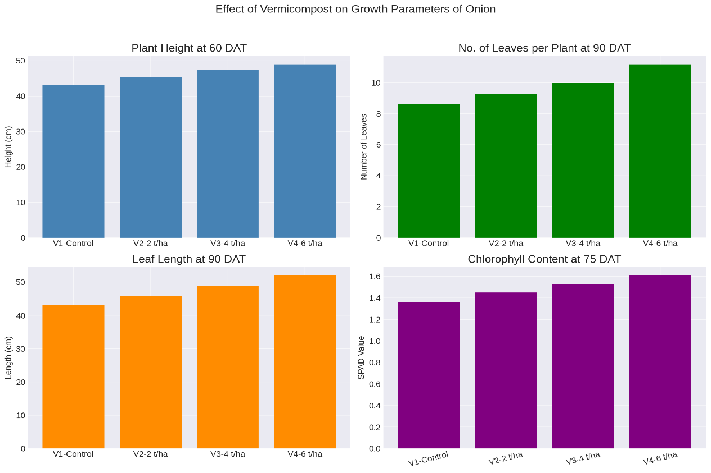
Fig. 1 Effect of vermicompost and biofertilizers on growth parameters of onion

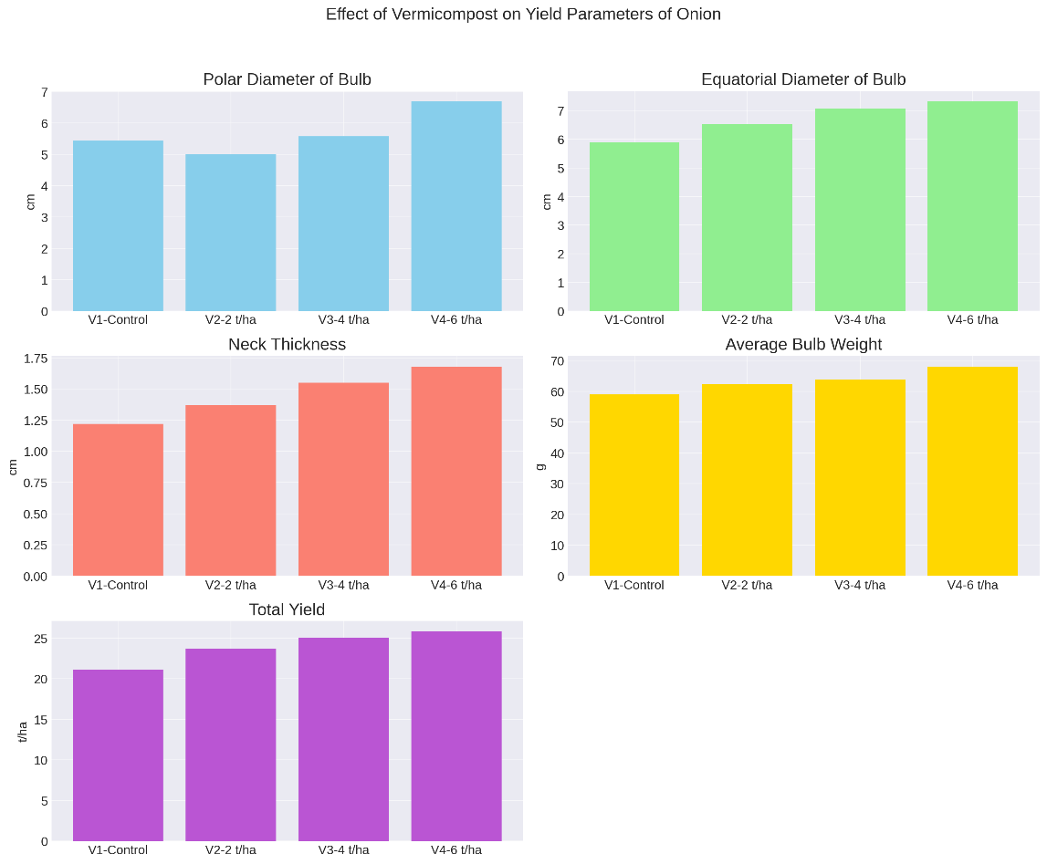
Fig. 2 Effect of vermicompost and biofertilizers manures on yield parameters of onion
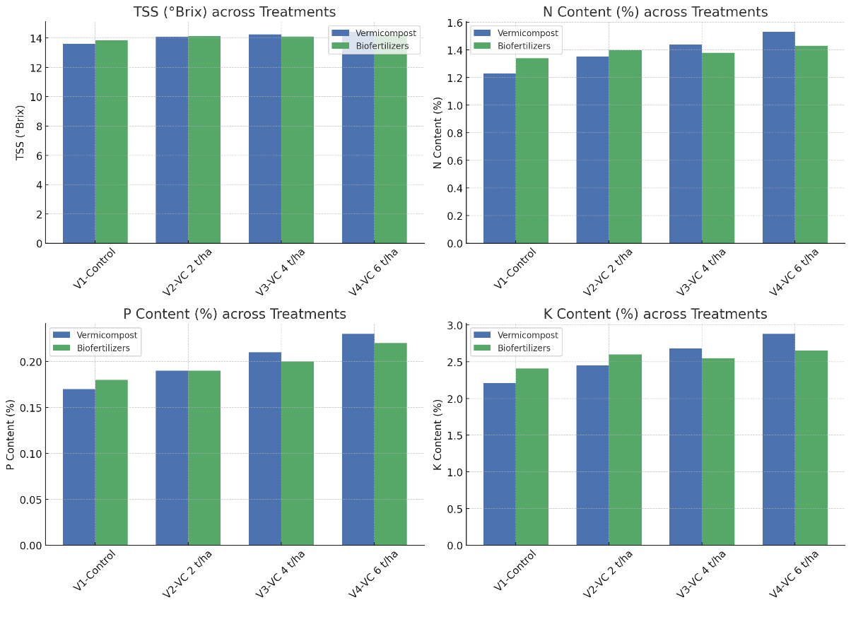
Fig. 3 Effect of vermicompost and biofertilizers manures on quality parameters of onion
Table 1 Effect of vermicompost and biofertilizers on growth parameters of onion
Treatments | Plant heigh (cm) |  |  | Number of leaves  per plant at 90 DAT | Leaf length  at 90 DAT | Chlorophyll  content at 75 DAT
 | 30 DAT | 40 DAT | 60 DAT | Number of leaves  per plant at 90 DAT | Leaf length  at 90 DAT | Chlorophyll  content at 75 DAT
Vermicompost
V₁-Control (No application) | 23.09 | 31.47 | 43.13 | 8.63 | 43.06 | 1.36
V₂-Vermicompost 2 t/ha | 24.74 | 33.12 | 45.35 | 9.26 | 45.75 | 1.45
V₃-Vermicompost 4 t/ha | 26.70 | 35.08 | 47.34 | 9.96 | 48.80 | 1.53
V₄-Vermicompost 6 t/ha | 28.33 | 36.71 | 48.96 | 11.18 | 52.08 | 1.61
S. Em. ± | 0.36 | 0.39 | 0.32 | 0.13 | 0.65 | 0.02
CD @0.05% | 1.05 | 1.14 | 0.94 | 0.38 | 1.88 | 0.05
Biofertilizers
B₁-Control (No application) | 24.79 | 33.17 | 44.82 | 9.45 | 45.90 | 1.45
B₂-Azotobacter @ 10 g/kg seed | 26.08 | 34.46 | 46.70 | 9.85 | 47.90 | 1.50
B₃-Pseudomonas @ 10 g/kg seed | 25.59 | 33.97 | 46.22 | 9.65 | 47.07 | 1.47
B₄-Azotobacter @ 10 g/kg seed + Pseudomonas @ 10 g/kg seed | 26.40 | 34.78 | 47.04 | 10.09 | 48.82 | 1.52
S. Em. ± | 0.36 | 0.39 | 0.32 | 0.13 | 0.65 | 0.02
CD @0.05% | 1.05 | 1.14 | 0.94 | 0.38 | 1.88 | 0.05

Table 2 Effect of vermicompost and biofertilizers manures on yield parameters of onion
Treatments | Polar diameter of bulb (cm) | Equatorial diameter of bulb (cm) | Neck thickness  (cm) | Average weight of bulb (g) | Yield (t/ha)
Vermicompost
V₁-Control (No application) | 5.43 | 5.89 | 1.22 | 58.98 | 21.13
V₂-Vermicompost 2 t/ha | 5.01 | 6.53 | 1.37 | 62.44 | 23.73
V₃-Vermicompost 4 t/ha | 5.57 | 7.07 | 1.55 | 63.96 | 25.09
V₄-Vermicompost 6 t/ha | 6.69 | 7.33 | 1.68 | 68.10 | 25.81
S. Em. ± | 0.09 | 0.04 | 0.01 | 0.34 | 0.26
CD @0.05% | 0.26 | 0.12 | 0.03 | 0.99 | 0.75
Biofertilizers
B₁-Control (No application) | 5.13 | 6.48 | 1.37 | 61.55 | 22.75
B₂-Azotobacter @ 10 g/kg seed | 6.10 | 6.78 | 1.48 | 63.96 | 24.29
B₃-Pseudomonas @ 10 g/kg seed | 6.01 | 6.66 | 1.44 | 63.03 | 23.95
B₄-Azotobacter @ 10 g/kg seed + Pseudomonas @ 10 g/kg seed | 6.46 | 6.88 | 1.53 | 64.95 | 24.77
S. Em. ± | 0.09 | 0.04 | 0.01 | 0.34 | 0.26
CD @0.05% | 0.26 | 0.12 | 0.03 | 0.99 | 0.75
Table 3 Effect of vermicompost and biofertilizers manures on quality parameters of onion
Treatments | TSS  (⁰Brix) | N Content  (%) | P content  (%) | K content  (%)
Vermicompost
V₁-Control (No application) | 13.61 | 1.23 | 0.17 | 2.21
V₂-Vermicompost 2 t/ha | 14.09 | 1.35 | 0.19 | 2.45
V₃-Vermicompost 4 t/ha | 14.26 | 1.44 | 0.21 | 2.68
V₄-Vermicompost 6 t/ha | 14.42 | 1.53 | 0.23 | 2.88
S. Em. ± | 0.07 | 0.02 | 0.01 | 0.03
CD @0.05% | 0.21 | 0.07 | 0.03 | 0.09
Biofertilizers
B₁-Control (No application) | 13.85 | 1.34 | 0.18 | 2.41
B₂-Azotobacter @ 10 g/kg seed | 14.13 | 1.40 | 0.19 | 2.60
B₃-Pseudomonas @ 10 g/kg seed | 14.10 | 1.38 | 0.20 | 2.55
B₄-Azotobacter @ 10 g/kg seed + Pseudomonas @ 10 g/kg seed | 14.21 | 1.43 | 0.22 | 2.65
S. Em. ± | 0.07 | 0.02 | 0.01 | 0.03
CD @0.05% | 0.21 | 0.07 | 0.03 | 0.09

