Original Research Article
Effects of Nano DAP and Urea on Growth and Yield of Bitter Gourd (Momordica charantia L.)

ABSTRACT
A field experiment was conducted during the spring-summer season of 2024–25 at the Research Farm, Mewar University, Chittorgarh (Rajasthan), to evaluate the effect of nano diammonium phosphate (DAP) and nano urea on the growth, yield, and quality of bitter gourd (Momordica charantia L.) cv. Arka Harit. The experiment followed a Randomized Block Design (RBD) comprising 10 treatments and three replications. Treatments included combinations of reduced recommended doses of nitrogen (RDN) and phosphorus (RDP) along with different foliar sprays of nano DAP and nano urea. Results indicated that the application of T9 treatment—50% RDN + full P as basal + three foliar sprays of nano urea—significantly improved growth parameters such as vine length (71.95 cm at 30 DAS and 195.45 cm at 60 DAS), number of leaves (30.33 at 30 DAS and 163.33 at 60 DAS), and branches (8.89). Yield attributes including fruit length (14.00 cm), diameter (4.40 cm), fruits per plant (32.50), average fruit weight (77.40 g), and fruit yield per plant (2.51 kg) were also maximized under T9. Quality traits such as TSS (5.70 °Brix), vitamin C (84.94 mg/100g), and iron content (1.78 mg/100g) recorded their highest values with T9. Economic analysis revealed the highest net return (Rs. 190,052/ha) and B:C ratio (4.13) under the same treatment. The study concludes that the integrated use of reduced chemical fertilizers with nano urea significantly enhances crop performance and profitability while potentially reducing environmental impacts.
Keywords: Bitter gourd, Nano DAP, Nano urea, Growth parameters, Fruit yield, Quality traits

- Introduction
The Cucurbitaceae family includes the tropical and subtropical bitter gourd (Momordica charantia L.). A popular vegetable crop in India, bitter gourd is the most favoured crop by Indian farmers due to its greater yield and greatest returns. Vitamin C (88 mg/100 g) is abundant in bitter gourd, which are regarded as a rich source of minerals and vitamins. It can help lower blood sugar levels and has antioxidant, antibacterial, antiviral, anti-hepatotoxic, and anti-ulcerogenic qualities (Behera, 2011). Bitter gourd is commonly cultivated as a summer vegetable in kitchen gardens. However, it is now also cultivated commercially near cities. Additionally, it can be grown in any type of soil, provided there is adequate drainage. Nutritionally, bitter gourds are both fruit and vegetable rich in nutrients. They contain significant amounts of water (83–92%), carbs (4.0–10.5%), protein (1.5–2.0%), fat (0.2–1.0%), minerals (0.5–1.0%), and fiber (0.8–1.7%). Ripe fruits are also high in vitamin A (Akter et al., 2009). Due to its nutritional value and therapeutic qualities, Bitter gourd is one of the economically important cucurbitaceous vegetable crops that is widely cultivated throughout the country. The fruits are frequently used in fried, boiled, and stuffed forms and can be prepared in a variety of ways for eating. It is a climbing vine and a crop that is heavily cross-pollinated (Behera et al. 2010).
Nano urea, a novel technology in fertilizer designing, is expected to reduce environmental pollution caused by the granular form by decreasing its excessive application that causes environmental pollution. Nano urea is gaining importance in Indian agriculture because of its ability in increasing nutrient use efficiency, increasing crop yields, and reducing excessive use of synthetic fertilizers (Dubey et al., 2023). Utilising nano urea is expected to boost output, reduce environmental issues, and enhance input efficiency. IFFCO's development of nano urea (liquid) for agriculture could improve nutrient delivery by offering a more precise and efficient mechanism. A 500 ml bottle contains 40,000 ppm of nitrogen. IFFCO nano urea liquid can replace regular urea by 50% and contains the same quantity of nitrogen as one bag of traditional urea. Nano urea is better at absorbing nutrients since there are less losses. When sprayed on plants during critical phases of crop growth and initiation, Nano urea easily enters through stomata and other openings, getting absorbed by the plant cells smoothly (Subramani et al., 2023).
Nano DAP (liquid) serves as a source of nitrogen and phosphorus, containing approximately 8% (80,000 ppm) nitrogen and 16% (160,000 ppm) phosphorus. It has a higher surface area to volume ratio when particle sizes of less than 100 nanometres (nm) this product effectively meets the nitrogen and phosphorus needs of crops when applied as a foliar spray (Prakash et al., 2023). Nano- technology based fertilizers improve soil fertility, boost agricultural productivity and enhance crop quality by altering conventional fertilizers or extracting plant components through different physical, chemical and biological methods (Singh et al., 2017).

- MATERIAL AND METHODS

2.1 Experimental Site and Climate
The field experiment was conducted during the spring-summer season of 2024–25 at the Research Farm of the Faculty of Agriculture and Veterinary Sciences, Mewar University, Gangrar, Chittorgarh, Rajasthan (Latitude 24.9°N, Longitude 74.6°E). The experimental site is situated in the southern part of Rajasthan, characterized by a semi-arid climate with moderate to high temperatures during the cropping season. The soil of the experimental plot was loamy in texture, with good drainage and moderate fertility, suitable for bitter gourd cultivation.

2.2 Crop and Variety
The experiment was conducted on bitter gourd (Momordica charantia L.), using the high-yielding commercial variety ‘Arka Harit’, known for its medium-sized fruits, vigorous growth habit, and adaptability to diverse agro-climatic conditions.

2.3 Experimental Design and Treatments
The study employed a Randomized Block Design (RBD) comprising 10 treatments with three replications. The treatments were formulated using reduced doses of recommended nitrogen and phosphorus (RDN and RDP) in combination with foliar sprays of nano urea and nano DAP. The ten treatments were as follows:
- T1: Control (no fertilizer)
- T2: 50% RDF (N and P) + 1 spray nano DAP + 1 spray nano urea
- T3: 50% RDF (N and P) + 1 spray nano DAP + 2 sprays nano urea
- T4: 50% RDF (N and P) + 2 sprays nano DAP + 1 spray nano urea
- T5: 50% RDN + full P as basal + 1 spray nano urea
- T6: 50% RDN + full P as basal + 1 spray nano DAP
- T7: 50% RDN + full P as basal + 2 sprays nano urea
- T8: 50% RDN + full P as basal + 2 sprays nano DAP
- T9: 50% RDN + full P as basal + 3 sprays nano urea
- T10: 50% RDN + full P as basal + 3 sprays nano DAP
Each treatment was randomly allocated within a block, and uniform agronomic practices were followed across all plots.

2.4 Fertilizer and Foliar Spray Application
Nano urea (containing 40,000 ppm nitrogen) and nano DAP (containing 8% nitrogen and 16% phosphorus) were used as foliar sprays according to the treatment schedule. The recommended doses for bitter gourd cultivation were 100 kg N and 60 kg P₂O₅ per hectare. For treatments involving 50% RDN and RDP, basal phosphorus was applied conventionally, while nitrogen was partly substituted with nano formulations. Foliar applications were conducted using a knapsack sprayer during early morning hours to avoid rapid evaporation and maximize absorption. Sprays were timed during active vegetative and early reproductive stages to coincide with peak nutrient demand.

2.5 Observations Recorded
Data on various growth parameters (vine length, number of leaves, number of branches), yield attributes (fruit length, fruit diameter, number of fruits per plant, average fruit weight, fruit yield per plant), quality traits (total soluble solids, vitamin C, iron content), and economic parameters (cost of cultivation, gross return, net return, benefit:cost ratio) were recorded. Observations for growth were taken at 30 and 60 days after sowing (DAS). Fruit samples for quality analysis were collected at harvest and analyzed in the laboratory using standard protocols.

2.6 Statistical Analysis
The collected data were subjected to statistical analysis using Analysis of Variance (ANOVA) appropriate for RBD. Critical Difference (CD) values at 5% level of significance were used to determine statistical differences between treatment means. The statistical computations were performed using OPSTAT software and Microsoft Excel.

- RESULT AND DISCUSSION
The physical features of the bitter gourd crop recorded on vine length (cm), number of leaves per plant, number of branches per plant, fruit length(cm), fruit diameter(cm), number of fruits per plant, average fruit weight(g), fruit yield per plant(kg), TSS (^{O}Brix), Vitamin C (mg/100g) and Iron (mg/100g) were influenced by the foliar spray of Nano DAP and nano urea. The data related to various observations on growth and yield parameters of bitter gourd are presented in Table 1, quality parameters in Table 2, and economic analysis in Table 3.

3.1 Effect of Nano DAP and Nano Urea on Growth and Yield of Bitter Gourd
The foliar application of nano DAP and nano urea significantly influenced growth and yield traits of bitter gourd. Among all treatments, T9 (50% RDN + full P as basal + 3 sprays of nano urea) recorded the maximum vine length (71.95 cm at 30 DAS and 195.45 cm at 60 DAS), number of leaves (30.33 at 30 DAS and 163.33 at 60 DAS), and number of branches per plant (8.89). In contrast, the minimum values for these parameters were recorded under control (T1), indicating the superior efficacy of nano urea in stimulating vegetative growth through enhanced nitrogen uptake and utilization (Neogi and Das, 2022; Girigoud et al., 2023; Sathyan, 2022). In terms of yield attributes, T9 also showed maximum fruit length (14.00 cm), fruit diameter (4.40 cm), number of fruits per plant (32.50), average fruit weight (77.40 g) and fruit yield per plant (2.51 kg) (Fig. 1). These improvements are attributable to nano fertilizers enhancing chlorophyll content, photosynthetic activity, protein synthesis, and efficient nutrient transport (Merghany et al., 2019; Panda et al., 2020; Al-Bayati et al., 2023). Treatments T3 and T10 followed T9 in performance, whereas T1 (control) consistently produced the lowest values across all growth and yield parameters.

3.2 Effect of Nano DAP and Nano Urea on Quality Parameters of Bitter Gourd

Table 2 presents the effect of treatments on fruit quality traits such as total soluble solids (TSS), vitamin C, and iron content. T9 treatment exhibited the highest TSS (5.70 °Brix), vitamin C (84.94 mg/100g), and iron content (1.78 mg/100g). The improved TSS under nano fertilizer application may be due to increased CO₂ assimilation and enhanced sugar metabolism facilitated by nano nitrogen (Kumar et al., 2014; Chauhan et al., 2023). The vitamin C and iron content were also highest in T9 (Fig. 2), which can be attributed to enhanced micronutrient mobilization and assimilation by nano-scale particles, thereby improving fruit nutritional quality (Al-juthery et al., 2020; Mishra et al., 2020; Panda et al., 2020). Other treatments like T3 and T10 also showed improved quality over control, but remained inferior to T9. The lowest quality values were consistently recorded in the untreated control (T1), highlighting the role of nano fertilization in enhancing fruit nutrient density.

3.3 Effect of Nano DAP and Nano Urea on Economics of Bitter Gourd Production
The economic analysis (Table 3) reveals significant differences among treatments in terms of cost of cultivation, gross return, net return, and benefit:cost (B:C) ratio. The highest net return (Rs. 190,052/ha) and B:C ratio (4.13) were obtained under T9, followed by T3 (Rs. 171,422.35/ha, B:C ratio 3.88) and T10 (Rs. 151,644/ha, B:C ratio 3.40). Despite a slightly higher cultivation cost for T10, the increase in returns offset the expense due to better yield performance. The lowest economic returns were observed in the control treatment (T1), with a net return of only Rs. 29,235.35/ha and a B:C ratio of 1.51 (Fig.3). These results clearly indicate that the use of nano urea and nano DAP, particularly in combination with reduced conventional fertilizer doses, improves input use efficiency and ensures higher profitability (Kumar et al., 2023; Subramani et al., 2023).

- CONCLUSION
The present study demonstrated that the application of nano DAP and nano urea significantly improved the growth, yield, quality, and economics of bitter gourd (Momordica charantia L.). Among the ten treatments tested, T9 (50% RDN + full P as basal + 3 foliar sprays of nano urea) consistently outperformed others in terms of vine length, number of leaves and branches, fruit length, diameter, number of fruits per plant, average fruit weight, and total fruit yield per plant. In addition to enhancing vegetative and reproductive traits, T9 also resulted in the highest total soluble solids (TSS), vitamin C, and iron content in fruits, indicating superior quality. From an economic standpoint, T9 recorded the maximum net return and benefit:cost ratio, confirming the profitability of nano fertilizer use in bitter gourd cultivation. The results suggest that integrating nano urea with reduced doses of conventional fertilizers not only boosts nutrient use efficiency but also reduces input costs and minimizes environmental risks associated with excessive fertilizer use. Therefore, nano fertilizer-based nutrient management strategies could serve as a sustainable approach in vegetable production systems, especially under resource-limited conditions. Further research under different agro-climatic conditions and long-term studies will strengthen the findings and support broader adoption of nano technologies in agriculture.
Disclaimer (Artificial intelligence)
Option 1:
Author(s) hereby declare that NO generative AI technologies such as Large Language Models (ChatGPT, COPILOT, etc.) and text-to-image generators have been used during the writing or editing of this manuscript.
Option 2:
Author(s) hereby declare that generative AI technologies such as Large Language Models, etc. have been used during the writing or editing of manuscripts. This explanation will include the name, version, model, and source of the generative AI technology and as well as all input prompts provided to the generative AI technology
Details of the AI usage are given below:
1.
2.
3.

REFERENCES
Al-Bayati, H. J. M.; Alabade, A. I. Y.; Al-Khashab, S. M. H. and Malallah, K. A. G. (2023). Reducing the chemical fertilizer by nano fertilizers in two varieties of potatoes (Solanum tuberosum L.). Earth and Environ. Sci., 1158(4): 1-7.
Al-Bayati, H. J. M.; Al-Harbawy, K. A. M.; Allela, W. B. A.; Al-Sabawy, M. M. S.; Ibraheem, F. F. R.; Al-Taey, D.K. A. and Mahmood, S. S. (2023). Response growth and yield of three cucumber hybrids (Cucumis sativus L.) to nano fertilizer N₂₀P₂₀K₂₀ under protected house. Earth and Environ. Sci., 1213(1): 1-6.
Al-juthery, H.W.A. and Al-Maamouri, E.H.O. (2020). Effect of urea and nano-nitrogen fertigation and foliar application of nano-boron and molybdenum on some growth and yield parameters of potato. Al-Qadisiyah J. Agric. Sci., 10(1): 253-263.
Akter, L., M. S. Islam, M. N. Uddin and S. Ahmed (2009). Evaluation of New Bitter Gourd Germplasum. Research Report, 2008-2009. Horticulture Research Centre, BARI, Gazipur. p. 16.
Behera TK, Behera S, Bharathi LK, Joseph JK, Simon PW, Staub JE. Bitter Gourd: Botany, Horticulture, Breeding, Horticultural Reviews, Janick. Journal of Wiley-Blackwell, (2010): 37.
Behera T.K., Sureja, A. K., Sabina, Islam, Munshi, A. D., and Sidhu, A. S. (2011). Minor cucurbits. Genetics, genomics and breeding of cucurbits:17-60.
Dubey, P. M.; Upadhyay, J.; Chowdhury, S. and Bagare, V. (2023). Response of onion (Allium cepa L.) to foliar application of nano urea and urea. Int. J. Environ. and Clim. Change, 13(11): 1816-1821.
Chauhan, A.; Pallvi ; Rattan, P.; Ludarmani and Sharma, A. (2023). Effect of pre-soaking of potato (Solanum tuberosum L.) tubers in nano-urea and nano-zinc on its growth, quality and yield. J. Pharm. Innov., 12(7): 980-995.
Girigoud, A.; Naik, A.; Siddaram; Bhat, S.N and Bellakki, M. A. (2023a). Effect of Nano-DAP on growth and yield of pigeon pea under rainfed condition. J. Pharm. Innov., 12(12): 1536-1539.
Kazem, A. T.; Issa, F. H. and Abdulla, A. A. (2021). Effect of nano NPK fertilizer on growth and early yield of eggplant. Earth and Environ. Sci., 923(1): 1-4.
Kumar, A.; Singh, K.; Sharma, S.; Mishra, J. P.; Sharmila, J. S.; Kumar, Y.; Lakshmanan, A.; Singh, T.; Singh, S.; Panwar, A. and Sivashankari, L. (2023). Effect of organic manure, bio-fertilizer and nano-fertilizer on yield and economics of different vegetable crops and soil nutrient status. Research Square, 1-13. DOI: https://doi.org/10.21203/rs.3.rs-2960032/v1.
Kumar, M.; Dwivedi, R.; Anand, A.K. and Kumar, A. (2014). Effect of nutrient on physicochemical characteristics of phalsa (Grewia subinaequalis DC) fruits. Glo. J. Bio. Sci. and Biotech., 3(3): 320-323.
Manikanta, B.; Channakeshava, S.; Tambat, B.; Mamatha, B. and Gayathri, B. (2023). Effect of nano-nitrogen, copper and zinc liquid fertilizers on growth, yield and quality of potato (Solanum tuberosum L.). J. Pharm. Innov., 12(4): 2590-2596.
Merghany, M. M.; Shahein, M. M.; Sliem, M. A.; Abdelgawad, K. F. and Radwan, A. F. (2019). Effect of nano-fertilizers on cucumber plant growth, fruit yield and it’s quality. Plant Arch., 19(2): 165-172.
Mishra, B.; Sahu, G. S.; Mohanty, L. K.; Swain, B. C. and Hati, S. 2020. Effect of Nano fertilizers on growth, yield and economics of tomato variety Arka Rakshak. Indian Journal of Pure and Applied Biosciences 8(6): 200-204.
Neogi, S.; and Das S.K. (2022). Effect of nitrogen and zinc in nano forms on growth and productivity of potato (Solanum tuberosum L.) in inceptisols. J. crop and weed, 18(1): 32-38.
Panda, J.; Nandi, A.; Pattnaik, A. K.; Mahapatra, P.; Jena, N. K. and Swain, A. A. (2020). Effects of nano fertilizer on vegetative growth of tomato (Solanum lycopersicum L.). Int. J. Curr. Microbiol. App. Sci., 9(3): 1980-1986.
Prakash; Naik, A.; Siddaram; Ravi, M.V. and Bellakki, M. A. (2023). Response of nano DAP on growth, yield and economics of soybean (Glycine max L.). J. Pharm. Innov., 12(12): 1985-1989.
Sahithi, B.; Babu, K. K.; Prasanth, P.; Lakshminarayana, D. and Gouthami, P. (2023). Studies on effect of nano urea and nano DAP alone and in combination with different levels of nitrogen and phosphorus on growth and yield of marigold (Tagetes erecta L.) cv. Superball. J. Pharm. Innov., 12(11): 901-906.
Sathyan, D. (2022). Effect of nano nutrients on pea growth and yield (Pisum sativum L.). J. Pharm. Innov., 11(9): 1895-1898.
Singh, M.D.; Chirag, G.; Patidar, O.P.; Meena, H.M.; Prakasha, G. and Vishwajith (2017). Nanofertilizers is a new way to increase nutrients use efficiency in crop production. Int. J. Agric. Sci., 9(7); 3831-3833.
Subramani,T.; Velmurugan,A.; Bommayasamy,N.; Swarnam,T.P.; Ramakrishna,Y.; Jaisankar, I. and Singh,L. (2023). Effect of nano urea on growth, yield and nutrient use efficiency of okra under tropical island ecosystem. Int. J. Agric. Sci., 19: 134-139.

Table.1 Effects of Nano DAP and nano urea on growth and yield of bitter gourd
Treatment | Vine length (cm) |  | Number of leaves |  | Number of branches | Fruit length (cm) | Fruit diameter (cm) | Number of fruits per plant | Average fruit weight (g) | Fruit yield per plant (kg)
Treatment | 30 DAS | 60 DAS | 30 DAS | 60 DAS
T₁ | 60.92 | 154.00 | 26.83 | 122.67 | 6.56 | 10.58 | 3.01 | 18.17 | 47.35 | 0.86
T₂ | 70.57 | 177.82 | 28.67 | 137.33 | 7.11 | 11.15 | 3.65 | 23.33 | 62.98 | 1.49
T₃ | 68.80 | 191.70 | 28.00 | 158.67 | 8.22 | 13.48 | 4.27 | 31.33 | 73.87 | 2.31
T₄ | 65.47 | 180.60 | 25.50 | 147.17 | 7.78 | 12.40 | 4.01 | 29.50 | 70.38 | 2.07
T₅ | 65.05 | 168.92 | 23.37 | 133.67 | 6.67 | 11.02 | 3.31 | 20.50 | 59.13 | 1.21
T₆ | 63.92 | 166.12 | 23.33 | 130.67 | 6.78 | 11.25 | 3.13 | 18.33 | 54.32 | 0.99
T₇ | 62.88 | 184.52 | 23.50 | 146.00 | 7.56 | 12.17 | 3.73 | 25.50 | 65.15 | 1.66
T₈ | 70.32 | 183.10 | 27.33 | 139.67 | 7.00 | 11.10 | 3.47 | 22.67 | 61.35 | 1.39
T₉ | 71.95 | 195.45 | 30.33 | 163.33 | 8.89 | 14.00 | 4.40 | 32.50 | 77.40 | 2.51
T₁₀ | 68.32 | 191.18 | 27.5 | 157.5 | 7.67 | 12.78 | 4.11 | 30.00 | 71.96 | 2.15
S. Em± | 1.34 | 3.46 | 0.91 | 1.19 | 0.23 | 0.26 | 0.035 | 0.60 | 2.89 | 0.27
CD at 5% | 2.81 | 7.26 | 1.90 | 2.49 | 0.48 | 0.56 | 0.073 | 1.27 | 6.08 | 0.56

Table.2 Effects of Nano DAP and nano urea on quality of bitter gourd
Treatment | TSS (^{O}Brix) | Vitamin C (mg/100g) | Iron (mg/100g)
T₁ | 4.03 | 63.79 | 1.20
T₂ | 4.36 | 72.03 | 1.59
T₃ | 5.20 | 82.90 | 1.74
T₄ | 4.83 | 77.89 | 1.67
T₅ | 4.27 | 66.59 | 1.55
T₆ | 4.19 | 65.06 | 1.48
T₇ | 4.50 | 74.13 | 1.62
T₈ | 4.38 | 69.03 | 1.58
T₉ | 5.70 | 84.94 | 1.78
T₁₀ | 5.13 | 81.15 | 1.70
S. Em± | 0.12 | 1.39 | 0.07
CD at 5% | 0.25 | 2.94 | 0.16

Table.3 Effects of Nano DAP and nano urea on economics of bitter gourd
Treatment | Total cost of cultivation (Rs/ha) | Gross return (Rs/ha) | Net return (Rs/ha) | B:C ratio
T₁ | 56649.65 | 85900 | 29235.35 | 1.51
T₂ | 58713.65 | 148840 | 90127.35 | 2.53
T₃ | 59337.65 | 230760 | 171422.35 | 3.88
T₄ | 60153.65 | 206780 | 146626.35 | 3.43
T₅ | 59440.00 | 120860 | 61420 | 2.03
T₆ | 60256.00 | 98900 | 38644 | 1.64
T₇ | 60064.00 | 165820 | 105756 | 2.76
T₈ | 61696.00 | 138860 | 77164 | 2.25
T₉ | 60688.00 | 250740 | 190052 | 4.13
T₁₀ | 63136.00 | 214780 | 151644 | 3.40

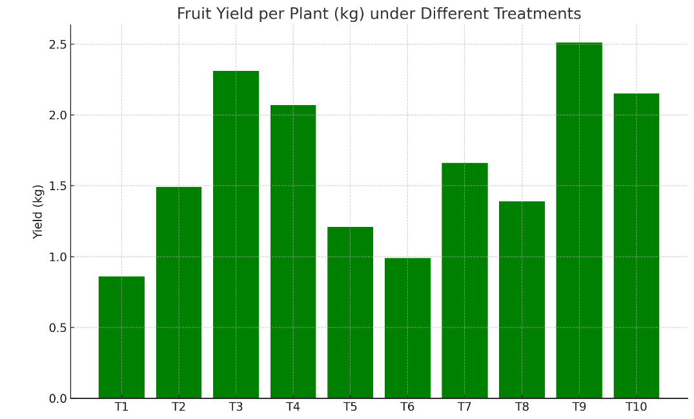
Fig. 1 Effects of Nano DAP and nano urea on fruit yield per plant

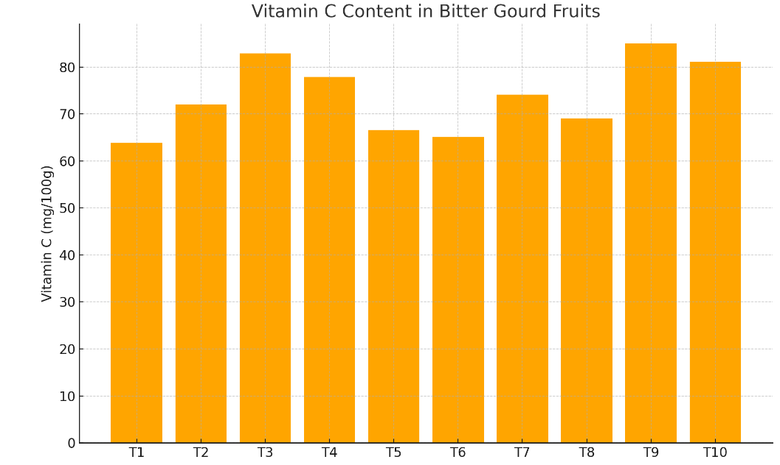
Fig. 2 Effects of Nano DAP and nano urea on Vitamin c content
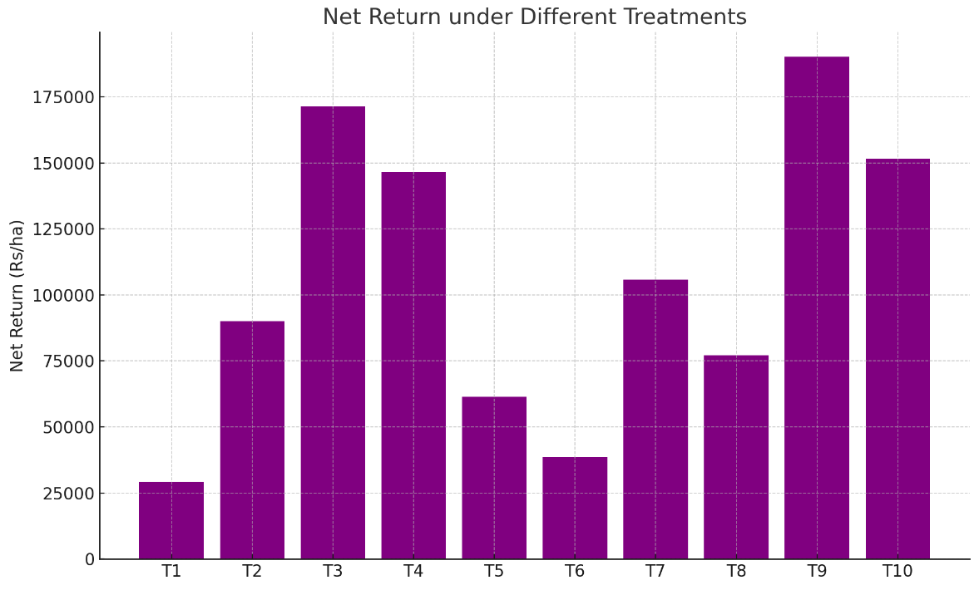
Fig. 3 Effects of Nano DAP and nano urea on net return

