Original Research Article

Effect of Bio-Enzyme and Humic Acid on Growth and Yield of Onion (Allium cepa L.)

ABSTRACT
A field experiment was conducted during the Rabi season of 2024 at the Research Farm, Department of Agriculture (Horticulture), Mewar University, Gangrar, Chittorgarh (Rajasthan) to evaluate the effects of bio-enzyme and humic acid on growth and yield attributes of onion (Allium cepa L.), variety ‘Nasik Red’. The experiment was laid out in a factorial randomized block design comprising two factors: four levels of bio-enzyme (control, salicylic acid @ 100 ppm, citrus peel-based bio-enzyme @ 60 ppm, and a combination of both), and four levels of humic acid (control, 1, 2, and 3 kg/ha), making a total of 16 treatment combinations with three replications. The results revealed that the combined application of salicylic acid @ 100 ppm and citrus peel-based bio-enzyme @ 60 ppm along with humic acid @ 3 kg/ha (treatment B4H4) significantly improved various growth parameters such as plant height (48.23 cm), number of leaves per plant (7.15), and leaf length (44.13 cm). Likewise, yield attributes including polar diameter (5.87 cm), equatorial diameter (6.64 cm), neck thickness (1.13 cm), average bulb weight (64.15 g), and total yield (27.15 t/ha) were also highest under the B4H4 treatment. These results suggest that salicylic acid and citrus-based bio-enzymes enhance physiological processes, while humic acid improves soil fertility, thereby synergistically promoting onion growth and productivity. In conclusion, the combination of salicylic acid and citrus peel-based bio-enzyme with humic acid at 3 kg/ha proved to be the most effective for optimizing the growth and yield of onion. This integrated approach can be recommended for sustainable and efficient onion cultivation under similar agro-climatic conditions.
Keywords: Bio-enzyme, Humic acid, Onion, Growth, Yield, Salicylic acid, Citrus peel
- INTRODUCTION
Onion (Allium cepa L.) is an important bulb crop of the family Alliaceae. The crop is grown in India as well as most of the countries of the world. Central Asia is primary center of origin of onion and Mediterranean region is the secondary center of origin (Vavilov 1951) Botanically its growth habit is annual or perennial type but in India it is cultivated as annual. As a vegetable and condiment, onions are a must-have in any kitchen, hence regularly alluded to be the "Queen of Kitchen." The feeding organ of the onion is a highly connected underground stalk with thicker, meaty leaves. The volatile oil "allyl propyl disulphide," an organic molecule high in sulphur, gives onion distinct and palatable flavour and pungency. Onions are cool season crops, but can grow well in diverse climates. Optimal conditions include mild weather without extreme cold, heat or excessive rainfall. Salicylic acid (SA) is a phenolic phytochrome that acts as a key regulator of the signalling network in plants under abiotic and biotic stresses. Salicylic acid exerts stimulatory effects on various physiological processes related to plant growth and development. Salicylic acid is one of the important bio-regulator which positively affects growth of plants.
By the application of Humic substance to plants, the growing plants are supplied with food, its application also results in productive and fertile soil, which increase the water holding capacity of soil. It plays a pivot role in making the plants more resistant against drought stress, and also stimulates germination. Humic is technically not a fertilizer, although in some walks, people do consider it that, Humic is an effective agent use as a complement to synthetic or organic fertilizers. In many instances, use of Humic regularly, will reduce the need for fertilization due to the soil's and plant's ability to make better use of it. In some occurrences, fertilization can be eliminated entirely if sufficient organic material is present and the soil can become self-sustaining through microbial processes and humus production.
Whenever possible, the use of Humic with fertilizer, Humic ability to absorb fertilizer components and increases their release to plants is well documented. The judicious use of Humic and fertilizer, will improve the performance of marginally fertile soils, of soils with low native organic matter, and of crops grown in arid regions (Chen and Aviad, 1990). Humic substances are formed through the process of humification of organic materials as byproduct of microbial metabolism and are found in soil, coal, sediments water, peat and organic matter (Verma et al., 2023). HA is a complex molecule and is considered an alkali soluble, polymeric organic acid of aromatic structure substituted by carboxyl, phenolic, hydroxyl and alkyl groups linked together by ester linkages (Gaines and Page, 1983).

MATERIALS AND METHODS

2.1 Experimental Site and Soil Characteristics

A field experiment was carried out during the Rabi season of 2024–2025 at the Research Farm, Department of Agriculture (Horticulture), Faculty of Agriculture and Veterinary Sciences, Mewar University, Gangrar, Chittorgarh, Rajasthan (India). The experimental site is situated in a semi-arid region with a subtropical climate. The soil of the experimental field was sandy loam in texture, saline in reaction with a pH of 7.6, and characterized by low organic carbon content (0.16%). The soil was deficient in available nitrogen (176 kg/ha), phosphorus (20.2 kg/ha), zinc (0.48 ppm), and iron (1.2 ppm), but had a medium level of available potassium (320 kg/ha).

2.2 Experimental Design and Treatments
The experiment was laid out in a Factorial Randomized Block Design (FRBD) with two factors and three replications. The first factor was Bio-Enzyme (Factor A) at four levels:
- B1: Control (No application)
- B2: Salicylic acid @ 100 ppm
- B3: Citrus peel-based Bio-Enzyme @ 60 ppm
- B4: Salicylic acid @ 100 ppm + Citrus peel-based Bio-Enzyme @ 60 ppm
The second factor was Humic Acid (Factor B) applied at four levels:
- H1: Control (No application)
- H2: Humic acid @ 1 kg/ha
- H3: Humic acid @ 2 kg/ha
- H4: Humic acid @ 3 kg/ha
This resulted in 16 treatment combinations replicated three times, totaling 48 experimental plots.

2.3 Crop Details and Cultural Practices
The experimental crop was onion (Allium cepa L.), variety ‘Nasik Red’. Healthy, uniform-sized seedlings were transplanted at the appropriate stage following standard agronomic practices. Irrigation, weed control, and other intercultural operations were performed uniformly across all treatments.

2.4 Data Collection and Statistical Analysis
Growth parameters such as plant height, number of leaves per plant, and leaf length were recorded at 60 days after transplanting (DAT). Yield attributes, including polar and equatorial diameter of bulbs, neck thickness, average bulb weight, and total yield (t/ha), were measured at harvest. The collected data were statistically analyzed using Analysis of Variance (ANOVA) as per the FRBD design to test the significance of treatment effects. Critical Difference (CD) at 5% probability level was used to compare the means, and standard error of mean (S.Em. ±) was calculated.
3. RESULTS AND DISCUSSION

3.1 Growth parameters
Effect of bio enzyme and humic acid on plant height, number of leaves per plant and leaf length tabulated in Table 1 and Fig. 1. In case of bio-enzyme the data were showed significant effect on plant height at 60 days after transplanting. The maximum plant height (48.23 cm) was observed with treatments B₄-Salicylic acid @ 100 ppm + Citrus peel-based Bio Enzyme @ 60 ppm; it was found at par with B₃-Citrus peel-based Bio Enzyme @ 60 ppm (46.71 cm). The minimum plant height was recorded with B₁-Control (No application) (43.54 cm). In case of humic acid, the data were showed significant effect on plant height at 60 days after transplanting. The maximum plant height (48.03 cm) was observed with treatments H₄-Humic acid @ 3 kg/ha; it was found at par with H₄-Humic acid @ 2 kg/ha and H₃-Humic acid @ 1 kg/ha (47.33 and 45.85 cm). The minimum plant height was recorded with H₁-Control (No application) (43.17 cm). In case of bio-enzyme the data were showed significant effect on number of leaves per plant at 60 days after transplanting. The maximum number of leaves per plant (7.15) was observed with treatments B₄-Salicylic acid @ 100 ppm + Citrus peel-based Bio Enzyme @ 60 ppm; closely followed by treatments B₃-Citrus peel-based Bio Enzyme @ 60 ppm (6.93). The minimum number of leaves per plant was recorded with B₁-Control (No application) (6.33). In case of humic acid, the data were showed significant effect on number of leaves per plant at 60 days after transplanting. The maximum number of leaves per plant (7.25) was observed with treatments H₄-Humic acid @ 3 kg/ha; closely followed by treatments H₃-Humic acid @ 2 kg/ha (7.06). The minimum number of leaves per plant was recorded with H₁-Control (No application) (7.17). In case of bio-enzyme the data were showed significant effect on leaf length at 60 days after transplanting. The maximum leaf length (44.13 cm) was observed with treatments B₄-Salicylic acid @ 100 ppm + Citrus peel-based Bio Enzyme @ 60 ppm; ; it was found at par with treatments B₃-Citrus peel-based Bio Enzyme @ 60 ppm (42.44 and 41.91 cm). The minimum leaf length was recorded with B₁-Control (No application) (40.53). In case of humic acid, the data were showed significant effect on leaf length at 60 days after transplanting. The maximum leaf length (43.73 cm) was observed with treatments H₄-Humic acid @ 3 kg/ha; it was found at par with treatments H₄-Humic acid @ 2 kg/ha and H₄-Humic acid @ 1 kg/ha (42.99 and 42.09 cm). The minimum leaf length was recorded with H₁-Control (No application) (40.19 cm). Similar result also reported by Calvo et al. (2014), Mohammed and Ibraheem (2020), El-Saadony et al. (2018), Dixit et al. (2018), Sajid et al. (2018), Koppad et al. (2020), Prajapati et al. (2023) and Abdel et al. (2024).

  - Yield attributes
Effect of bio enzyme and humic acid on yield parameters of onion tabulated in Table 2 and Fig. 2. In case of bio-enzyme the data were showed significant effect on polar diameter of bulb. The maximum polar diameter of bulb (5.87 cm) was observed with treatments B₄-Salicylic acid @ 100 ppm + Citrus peel-based Bio Enzyme @ 60 ppm; closely followed by treatments B₃-Citrus peel-based Bio Enzyme @ 60 ppm (5.25 cm). The minimum polar diameter of bulb was recorded with B₁-Control (No application) (4.38 cm). In case of humic acid, the data were showed significant effect on polar diameter of bulb. The maximum polar diameter of bulb (5.62 cm) was observed with treatments H₄-Humic acid @ 3 kg/ha; closely followed by treatments H₃-Humic acid @ 2 kg/ha and H₂-Humic acid @ 1 kg/ha (5.14 and 4.81 cm). The minimum polar diameter of bulb was recorded with H₁-Control (No application) (40.19 cm). In case of bio-enzyme the data were showed significant effect on equatorial diameter of bulb. The maximum equatorial diameter of bulb (6.64 cm) was observed with treatments B₄-Salicylic acid @ 100 ppm + Citrus peel-based Bio Enzyme @ 60 ppm; closely followed by treatments B₃-Citrus peel-based Bio Enzyme @ 60 ppm (6.24 cm). The minimum equatorial diameter of bulb was recorded with B₁-Control (No application) (5.61 cm). In case of humic acid, the data were showed significant effect on equatorial diameter of bulb. The maximum equatorial diameter of bulb (6.52 cm) was observed with treatments H₄-Humic acid @ 3 kg/ha; it was found at par with treatments H₃-Humic acid @ 2 kg/ha (6.31 cm). The minimum equatorial diameter of bulb was recorded with H₁-Control (No application) (5.60 cm). In case of bio-enzyme the data were showed significant effect on neck thickness. The maximum neck thickness (1.13 cm) was observed with treatments B₄-Salicylic acid @ 100 ppm + Citrus peel-based Bio Enzyme @ 60 ppm; closely followed by treatments B₃-Citrus peel-based Bio Enzyme @ 60 ppm (1.06 cm). The minimum neck thickness was recorded with B₁-Control (No application) (0.95 cm). In case of humic acid, the data were showed significant effect on neck thickness. The maximum neck thickness (1.12 cm) was observed with treatments H₄-Humic acid @ 3 kg/ha; it was found at par with treatments H₃-Humic acid @ 2 kg/ha (1.08 cm). The minimum neck thickness was recorded with H₁-Control (No application) (0.92 cm). In case of bio-enzyme the data were showed significant effect on average bulb weight. The maximum average bulb weight (64.15 g) was observed with treatments B₄-Salicylic acid @ 100 ppm + Citrus peel-based Bio Enzyme @ 60 ppm; closely followed by treatments B₃-Citrus peel-based Bio Enzyme @ 60 ppm (61.08 g). The minimum average bulb weight was recorded with B₁-Control (No application) (57.50 g). In case of humic acid, the data were showed significant effect on average bulb weight. The maximum average bulb weight (63.58 g) was observed with treatments H₄-Humic acid @ 3 kg/ha; it was found at par with treatments H₃-Humic acid @ 2 kg/ha (62.10 g). The minimum average bulb weight was recorded with H₁-Control (No application) (56.73 g). In case of bio-enzyme the data were showed significant effect on yield. The maximum yield (27.15 t/ha) was observed with treatments B₄-Salicylic acid @ 100 ppm + Citrus peel-based Bio Enzyme @ 60 ppm; closely followed by treatments B₃-Citrus peel-based Bio Enzyme @ 60 ppm (25.82 t/ha). The minimum yield was recorded with B₁-Control (No application) (23.14 t/ha). In case of humic acid, the data were showed significant effect on yield. The maximum yield (26.94 t/ha) was observed with treatments H₄-Humic acid @ 3 kg/ha; it was found at par with treatments H₃-Humic acid @ 2 kg/ha (26.44 t/ha). The minimum yield was recorded with H₁-Control (No application) (22.73 t/ha). Similar result also confirmed by Ranjan et al. (2020), Abd-Elkader (2020), Dixit et al., (2022), Patel et al. (2022), Kumar et al. (2023)

CONCLUSION

The present study evaluated the individual and combined effects of salicylic acid, citrus peel-based bio-enzyme, and humic acid on the growth and yield performance of onion (Allium cepa L.), variety ‘Nasik Red’, under field conditions during the Rabi 2024–2025 season. The findings clearly demonstrated that both bio-enzyme and humic acid treatments significantly improved various agronomic and yield-related traits compared to the control. Among the various treatment combinations, the integrated application of Salicylic acid @ 100 ppm + Citrus peel-based Bio-Enzyme @ 60 ppm + Humic acid @ 3 kg/ha (B4H4) exhibited the most promising results. This treatment recorded the highest plant height (48.23 cm), maximum number of leaves per plant (7.15), and longest leaf length (44.13 cm), indicating improved vegetative growth. In terms of yield attributes, the same treatment also resulted in the greatest polar diameter (5.87 cm), equatorial diameter (6.64 cm), neck thickness (1.13 cm), average bulb weight (64.15 g), and overall bulb yield (27.15 t/ha). These improvements can be attributed to the synergistic action of salicylic acid, which enhances plant physiological responses; citrus-based bio-enzymes, which stimulate microbial activity and nutrient mobilization; and humic acid, which enhances soil fertility and root development. Together, these inputs help in maximizing both the growth potential and productivity of onion crops in nutrient-deficient and semi-arid soils. Based on the results, it can be concluded that the combined application of salicylic acid, citrus peel-based bio-enzyme, and humic acid at higher recommended doses offers a sustainable and effective agronomic practice for improving onion productivity. This integrated nutrient management approach could be recommended to onion growers aiming for higher yields and improved crop health under similar agro-climatic conditions.

DISCLAIMER (ARTIFICIAL INTELLIGENCE)
Author(s) hereby declare that NO generative AI technologies such as Large Language Models (ChatGPT, manuscript.

REFERENCES
Abd-Elkader, D. Y. (2016). Effect of foliar spraying with micronutrients and salicylic acid on growth, yield and quality of garlic plants. Alex. J. Agric. Sci, 61(6), 649-658.
Calvo, P., Nelson, L., & Kloepper, J. W. (2014). Agricultural uses of plant biostimulants. Plant and soil, 383(1), 3-41.
Chen, Y., & Aviad, T. (1990). Effects of humic substances on plant growth. Humic substances in soil and crop sciences: Selected readings, 161-186.
Dixit S, Dubey AK and Dube HV. (2022). Studies on the efficiency of Salicylic Acid (SA) as foliar spray on growth, yield and yield components of onion (Allium Cepa L.). International Journal of Advanced Biological Research, 8(2), 238-240.
El-Saadony, F. M., Nawar, D. A., & Zyada, H. G. (2017). Effect of foliar application with salicylic acid, garlic extract and proline on growth, yield and leaf anatomy of pea (Pisum sativum L.) grown under drought stress. Middle East J. Appl. Sci, 7(3), 633-650.
Gaines, A. F., & Page, F. M. (1983). Comparison of fast atom bombardment, secondary ion and laser microprobe mass spectrometry as techniques for determining coal structure. Fuel, 62(9), 1041-1045.
Koppad, S. R., S.B. Babaleshwar, P.R. Dharmatti and K.K. Math. (2020). Influence of salicylic acid on growth and bulb yield of onion (Allium cepa L.). Int. J. Curr. Microbiol. App. Sci 6(9), 1732-1737.
Kumar, A.M., Wani, P.V. and Patil, A.S. (2023). Effect of VAM and Azospirillum inoculation to onion (Allium cepa L.) cv. B 780 with respect to N, P and micronutrient uptake. Orrisa Journal of Horticulture, 32 (1), 82-88.
Mohammed, A. S., & Ibraheem, F. F. (2020). Response of onion plant to the humic acid application and spraying with liquid fertilizer on growth and yield of green onion. Plant Archives, 20(1), 1141-1144.
Patel, Z. Bhalerao, P.P. Gaikwad, S.S. and Sachin, A.J. (2022). Effect of foliar application of chemicals on growth and yield of garlic (Allium sativum L.) var. GG-4. International Journal of Chemical Studies, 5 (4), 1035-1037.
Prajapati, S., Jain, P. K., & Tiwari, A. (2016). Effects of Salicylic acid (SA) and Azospirillum on growth and bulb yield of Onion (Allium cepa L.) cv. Agrifound Light Red. Int. J. Agric. Environ. Biotechnol, 9(3), 393-402.
Ranjan, A., Kant, K., Kumar, M., Singh, N.K., Kumari, S. and Kumari, R. (2020). Effect of inorganic fertilizers and bio fertilizers on yield and economics of Onion (Allium cepa L.) Production. International Journal of Current Microbiology and Applied Science, 9(3), 603-608.
Sajid, M., Rab, A., Shah, S. T., Jan, I., Haq, I., Haleema, B., ... & Zada, H. (2012). Humic acids affect the bulb production of onion cultivars. African Journal of Microbiology Research, 6(28), 5769-5776.
Vavilov, N.I. (1951). Origin, variation, immunity and breeding of cultivated plants. Journal of Chronical Botany, 13, 1-364.
Verma, H., Pandey, B. R., Bisen, B. P., Verma, B. K., Biswal, M., & Awasthi, L. R. (2023). Growth and Quality Profiency of Onion (Allium cepa L.) by Application of Biofertilizer, GA3 and Humic Acid. International Journal of Environment and Climate Change, 13(11), 2707–2715.

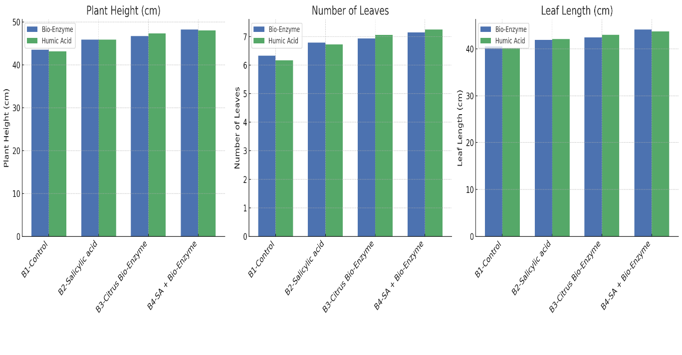

Fig. 1 Effect of bio enzyme and humic acid on plant height, number of leaves per plant and leaf length

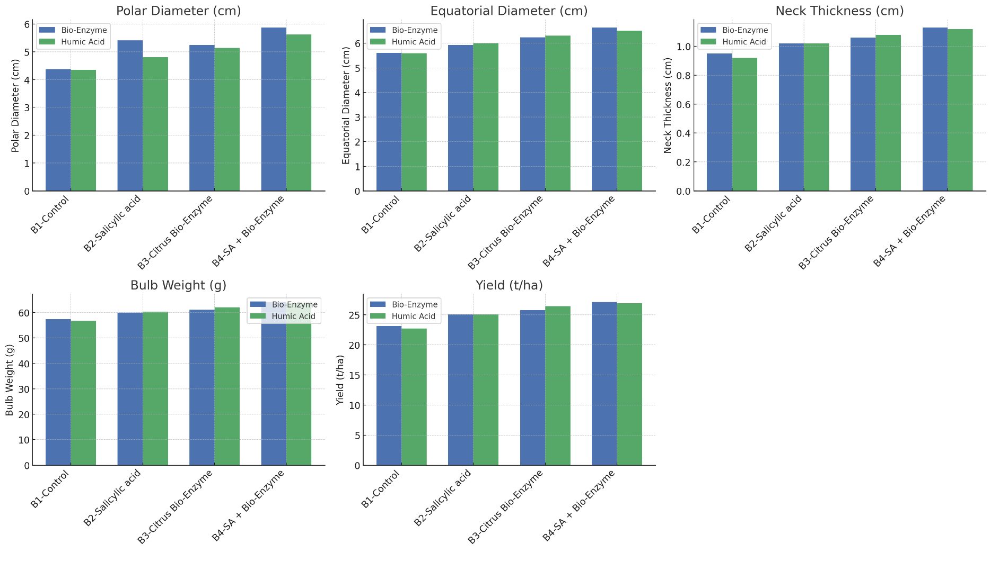

Fig. 2 Effect of bio enzyme and humic acid on yield parameters of onion
Table 1 Effect of bio enzyme and humic acid on plant height, number of leaves per plant and leaf length
Treatments | Plant height  (cm) | Number of leaves per plant | Leaf length (cm)
Factor-A (Bio Enzyme)
B₁-Control (No application) | 43.54 | 6.33 | 40.53
B₂-Salicylic acid @ 100 ppm | 45.90 | 6.79 | 41.91
B₃-Citrus peel-based Bio Enzyme @ 60 ppm | 46.71 | 6.93 | 42.44
B₄-Salicylic acid @ 100 ppm + Citrus peel-based Bio Enzyme @ 60 ppm | 48.23 | 7.15 | 44.13
S. Em. ± | 0.78 | 0.06 | 0.77
CD @0.05% | 2.26 | 0.17 | 2.23
Factor-B (Humic acid)
H₁-Control (No application) | 43.17 | 6.17 | 40.19
H₂-Humic acid @ 1 kg/ha | 45.85 | 6.72 | 42.09
H₃-Humic acid @ 2 kg/ha | 47.33 | 7.06 | 42.99
H₄-Humic acid @ 3 kg/ha | 48.03 | 7.25 | 43.73
S. Em. ± | 0.78 | 0.06 | 0.77
CD @0.05% | 2.26 | 0.17 | 2.23

Table 2 Effect of bio enzyme and humic acid on yield parameters of onion
Treatments | Polar diameter of bulb (cm) | Equatorial diameter of bulb | Neck thickness (cm) | Average bulb weight (g) | Yield (t/ha)
Factor-A (Bio Enzyme)
B₁-Control (No application) | 4.38 | 5.61 | 0.95 | 57.50 | 23.14
B₂-Salicylic acid @ 100 ppm | 5.41 | 5.94 | 1.02 | 60.00 | 25.10
B₃-Citrus peel-based Bio Enzyme @ 60 ppm | 5.25 | 6.24 | 1.06 | 61.08 | 25.82
B₄-Salicylic acid @ 100 ppm + Citrus peel-based Bio Enzyme @ 60 ppm | 5.87 | 6.64 | 1.13 | 64.15 | 27.15
S. Em. ± | 0.08 | 0.07 | 0.02 | 0.88 | 0.42
CD @0.05% | 0.23 | 0.21 | 0.05 | 2.54 | 1.22
Factor-B (Humic acid)
H₁-Control (No application) | 4.35 | 5.60 | 0.92 | 56.73 | 22.73
H₂-Humic acid @ 1 kg/ha | 4.81 | 6.00 | 1.02 | 60.32 | 25.09
H₃-Humic acid @ 2 kg/ha | 5.14 | 6.31 | 1.08 | 62.10 | 26.44
H₄-Humic acid @ 3 kg/ha | 5.62 | 6.52 | 1.12 | 63.58 | 26.94
S. Em. ± | 0.08 | 0.07 | 0.02 | 0.88 | 0.42
CD @0.05% | 0.23 | 0.21 | 0.05 | 2.54 | 1.22

