Traffic Noise Pollution and Its Health Implications: A Case Study of Ambur Town, Tamil Nadu, India
Abstract
Noise pollution, an often overlooked environmental issue, significantly impacts human health and quality of life, especially in densely populated and traffic-congested urban areas. This study investigates the extent of traffic-induced noise pollution in Ambur town, a rapidly developing and congested region in Tamil Nadu, India. Sound level measurements were conducted at ten critical locations, including the bus stand, hospital, bypass road, market, railway station (inside and outside), theatre, school, and residential and industrial zones like Nethaji Nagar and Eureka Leather Factory. Noise levels were recorded during peak traffic hours in the morning (6:30–9:25 a.m.) and evening (5:30–9:25 p.m.) using a sound level meter for a period of 5-10 minutes at each location and the mean value was taken. The results revealed that evening noise levels were consistently higher than morning levels, with nearly 90% of the sites exceeding the ambient noise standards. The highest recorded level was 100 dB at the bypass area, while the lowest was 69 dB near Lakshmi Hospital. Vehicle horns, particularly from buses, trucks, and bikes, were identified as major noise sources. The study highlights the urgent need for noise mitigation strategies in Ambur, especially with increasing vehicular density. It also emphasizes the role of vegetation and green belts as natural barriers to reduce noise levels and improve the urban acoustic environment.

Keywords: Noise pollution, Traffic noise, Sound level meter, Urban environment, Health impacts, Vehicle horns, Ambient noise level
- Introduction
Noise is commonly defined as unwanted or disturbing sound (Fink, 2019). When sound levels exceed acceptable limits and interfere with daily activities such as sleeping, working, or communication, it becomes noise pollution (Orikpete et al., 2021). Unlike visible forms of pollution, noise cannot be seen, smelled, or tasted, making it a less recognized yet serious environmental issue. The World Health Organization (2024) has identified noise as a major threat to human health and well-being. In urban areas, the rapid increase in population, vehicular traffic, and industrial activities has led to a significant rise in environmental noise levels.
Traffic noise is now one of the most persistent and widespread forms of pollution in cities (Ihemeje & Onyelowe, 2021). Over the past two decades, there has been a growing body of research linking environmental noise exposure to significant health outcomes such as cardiovascular diseases, sleep disorders, hearing loss, and impaired cognitive performance in both adults and children (Clark et al., 2025; Hahad et al., 2022; Hahad et al., 2025; Jafari et al., 2019; Mehrotra et al., 2024; Münzel et al., 2014; Münzel et al., 2018).
Several empirical studies have highlighted the prevalence and health implications of urban noise pollution. For instance, Abbaspour et al. (2015) applied a decision-support approach to evaluate noise-prone areas in District 14 of Tehran Metropolitan City. Rather than relying solely on direct sound level measurements, they proposed a predictive overlay method that incorporates multiple urban variables such as land use, population density, and road types. Mesene et al. (2022) investigated noise pollution as an urban social problem in Wolaita Sodo, Ethiopia. They found that noise pollution not only disrupted communication, sleep, and productivity but also strained social relations and mental well-being. Jafari et al. (2024) conducted a comprehensive noise assessment in Khorramabad city, Iran, revealing that noise levels exceeded permissible standards in over 90% of monitored locations, particularly in commercial and traffic-dense zones.
In India, research efforts have focused primarily on metropolitan cities like Delhi, Mumbai, and Bengaluru (Garg et al., 2017; Jamir et al., 2014; Solanki et al., 2016), where traffic congestion and industrialization have made noise a critical urban health issue. However, semi-urban areas, which are rapidly transforming due to urban sprawl and industrial expansion, remain underrepresented in current research.
Ambur, a semi-urban town in Tamil Nadu, is undergoing rapid urban and industrial development. Located in the Vellore district, Ambur is known for its leather manufacturing industry and its growing population, which has resulted in increased vehicular movement and urban density. The aim of this study is to assess the intensity and spatial distribution of traffic-induced noise pollution in Ambur town, correlate it with vehicular density patterns, and generate baseline data to inform targeted noise mitigation strategies and future urban planning initiatives in semi-urban regions of India.
- Materials and Method

  - Study area
Ambur town, located in Vellore district, Tamil Nadu (12.7802° N, 78.7177° E), is a major hub for leather, shoe, and sugarcane industries. It comprises 77 villages, with nearly every village hosting at least one shoe factory, contributing to Ambur’s status as a leading exporter of shoes in India. The region houses around 85 leather factories, which significantly impact the local environment, particularly soil and groundwater due to tannery wastewater. While these industries provide vital employment and income to residents, they also contribute to severe environmental issues. Among the 53 firkas in Vellore, Ambur Firka is the most affected by noise pollution.
  - Study design
The study of noise pollution in Ambur Town was conducted at ten major locations during morning hours from 6:30 AM to 9:25 AM. Each location was observed for 10 minutes using a digital sound level meter, and the observations included traffic volume, temperature, humidity, and noise levels in decibels (dB). These sites were selected based on their high traffic density and relevance to various urban activities, such as transport hubs, commercial zones, educational institutions, and industrial areas. The noise pollution levels were re-assessed during the evening hours (5:30 PM to 9:25 PM) at the same ten key locations in Ambur Town, Tamil Nadu, to compare day and night-time noise variations. Measurements were taken using a sound level meter for 10 minutes at each site with 5-minute intervals.

The study involved monitoring noise pollution levels at key locations in Ambur Town, identified based on high vehicular traffic. Selected sites included the Bus Stand, Lakshmi Hospital, Bypass Road, Rajkamal Theatre, Railway Station (inside and outside), Market Area, Nethaji Nagar, Eureka Leather Factory, and Hindu School. Each location represented different urban characteristics such as road width, building patterns, and traffic flow. Noise levels were recorded at selected high-traffic locations during morning (6:30 AM–9:25 AM) and evening (5:30 PM–9:25 PM) peak hours for a period of 5-10 minutes in each location and mean values were recorded. Observations included noise intensity, sources of noise, and vehicle counts categorized by type—buses, cars, two-wheelers, autos, light motor vehicles and heavy motor vehicles. Vehicle counts were recorded at two-hour intervals during both peak and non-peak periods.
Noise measurements were taken at distances of 0.90 m and 1.10 m from the nearest road edge, with the instrument placed 1.30 m above road level to reflect human ear height. The EQUINOX EQ-805 Sound Level Meter (IEC 651 TYPE II), using an ‘A’ weighted network, was employed for its accurate correspondence to human hearing sensitivity. The recorded values were compared with the permissible limits set by Central Pollution Control Board standards for noise pollution.
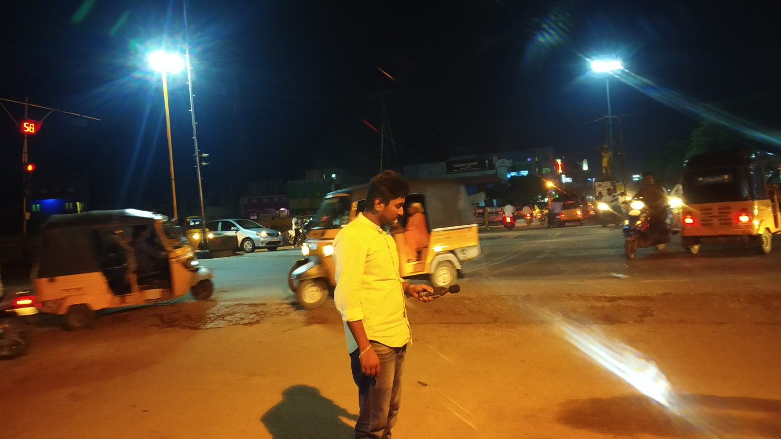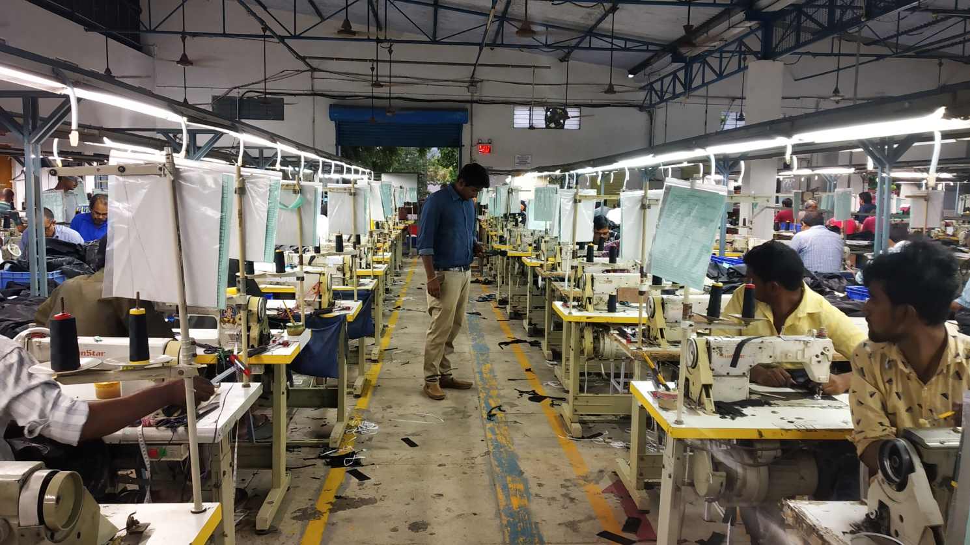
Plate 1. Noise observations at different locations in Ambur town

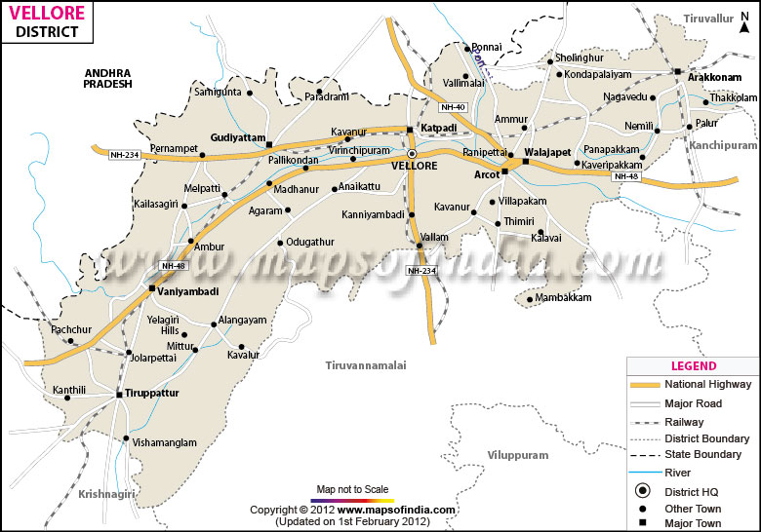
Figure 1. Vellore district map (Source: Maps of India, 2025)

- Results and Discussion

Table.1 Noise level observations recorded at different locations in Ambur town
S/No | Location | Time (am) | Noise level (dB) | Time (pm) | Noise level (dB)
1 | Bustand | 6.30–6.40 | 78 | 5.30–5.40 | 87
2 | Lakshmi hospital | 6.45–6.55 | 70 | 5.45–5.55 | 77
3 | ByePass road | 7.00–7.10 | 86 | 6.00–6.10 | 93
4 | Rajkamal theater | 7.15–7.25 | 82 | 6.15–6.25 | 84
5 | Railway station outside | 7.30–7.40 | 78 | 6.30–6.40 | 82
6 | Railway station inside | 8.00–8.10 | 91 | 7.00–7.10 | 88
7 | Market area | 8.15-8.25 | 95 | 7.15-7.25 | 93
8 | Nethaji nagar | 8.30-8.40 | 94 | 7.30-7.40 | 90
9 | Eureka leather garments | 8.45-8.55 | 90 | 7.46 -7.55 | 86
10 | Hindhu school | 9.15-9.25 | 80 | 8.16-8.25 | 80

At the Ambur Bus Stand, located on the NH-47 connecting Chennai and Bangalore, sound levels ranged between 70 dB and 85 dB. This area, serving as a central transport hub with high vehicular movement—especially heavy vehicles like buses and trucks—exhibited significant noise due to frequent horn usage, with 85 vehicles counted during the observation period (Banerjee et al., 2008). The temperature recorded was 25.8°C with 78% humidity. Lakshmi hospital situated on Uma Road in a designated silent zone, recorded sound levels from 65 dB to 75 dB, exceeding the permissible limit of 50–70 dB as per Indian standards. The noise here was primarily from two-wheelers, lorries, and ambulances, with temperature and humidity at 26°C and 76%, respectively. Indiscriminate use of horn by the vehicles and wide spread use of loudspeakers in Indian social and religious ceremonies caused several health hazards to the urban inhabitants. It may cause deafness, nervous breakdown, mental disorder, heart troubles, high blood pressure, dizziness and insomnia.
The bypass road, a critical connection between Pernambut and Krishnapuram, experienced the highest traffic with 187 vehicles and noise levels ranging from 80 dB to 95 dB, marking it as one of the most congested roads in Ambur. The recorded temperature was 26.5°C with 76% humidity. Rajkamal Theatre located on the national highway, noise ranged from 75 dB to 90 dB. A total of 107 vehicles, mainly bikes, lorries, and buses, contributed to these levels, with temperature at 26.4°C and humidity at 75%. Outside the Railway Station, the noise level was measured between 70 dB and 82 dB with 34 vehicles passing by, mainly autos and bikes. The temperature was 27.6°C with 69% humidity. Inside the Railway Station, noise ranged significantly from 71.5 dB to 104.5 dB due to announcements and train movements, indicating brief but intense noise events. The Market Area, known for its commercial activity, recorded the highest noise level of the entire morning session, reaching 110.7 dB with a minimum of 86.5 dB. Approximately 152 vehicles, including autos, lorries, and bikes, were observed. The temperature was 28.5°C and humidity 65%. In Nethaji Nagar, a densely populated area with schools and leather shops, noise ranged from 82.2 dB to 103.4 dB. The temperature was 29.1°C and humidity 62%, with 149 vehicles recorded. Eureka Leather Factory area, an industrial site, showed noise levels from 77.1 dB to 93.7 dB with 109 vehicles. Temperature and humidity were 32.4°C and 62%, respectively. At Hindu School, located near the bus stand, noise ranged between 72.9 dB and 87.5 dB, with 75 vehicles, mostly bikes and autos, observed. Temperature was 32.4°C and humidity 61%. In a similar study the average of noise pollution in the industrial zone, commercial, Residential, Silence and Traffic zone were recorded as 79.75dB, 76.35dB, 58.05 dB, 57.025 dB and 83.55dB respectively in Madurai city. In this study, evidently reported that the noise level is beyond much more than the permissible limit in commercial and silent zones and sometimes in residential zones which fallout in noise pollution. Noise can be emitted from various sources such as aircraft, construction, factories, railway and road traffic. Among those sources, research reported that road traffic is by far the major source of noise in the urban areas contributing to 55% of the total noise (Banerjee et al., 2008; Nirjar et al., 2003). Social surveys conducted in various cities throughout the world have revealed that road traffic noise is the major source of nuisance and annoyance (Dora, 1999). In an urban noise study conducted by Calixto et al. (2003), about 73% of the respondents believed that road traffic noise was the main source of annoyance.
At Hindu School, sound levels ranged from 71.5 dB to 85.0 dB between 5:31 PM and 5:40 PM, with 96 vehicles passing. The temperature was 29°C and humidity 68%. Rajkamal Theatre, a traffic-prone area, recorded noise from 79.2 dB to 95.3 dB (5:46 PM to 5:55 PM), with 110 vehicles contributing to elevated noise levels. At Eureka Leather Garments, from 6:01 PM to 6:10 PM, the noise ranged between 78.5 dB and 95.7 dB. The temperature was 28.5°C, humidity 71%, and 61 vehicles passed, primarily bikes and autos. In the Market Area, which becomes busier in the evening, the noise levels rose to between 89.1 dB and 102.6 dB (6:16 PM–6:25 PM). Temperature and humidity were 28°C and 75%, with 106 vehicles contributing. Similar to this, a study of traffic noise in Tirupur city has been done in the busy areas of the city which have high traffic flow in peak hours, results obtained in the study shows that the whole city is affected heavily by noise pollution more during the evening hours when compared to morning hours and in almost 90% of the area prevailing noise level is more than the ambient noise level. It has been found that in many areas the noise level prevailing averages around 85 db at 90% of the busy points of the city. Most of the noise is generated only due to horns of vehicles like rickshaws, buses, wagons & trucks etc (Keerthana et al., 2013).
Outside the Railway Station, evening levels from 6:31 PM to 6:40 PM ranged from 77.8 dB to 94.2 dB, slightly higher than morning due to increased vehicle flow (48 vehicles). Inside the station (7:01 PM–7:10 PM), levels ranged from 71.5 dB to 105.2 dB, impacted by announcements and train crossings (Kumar et al., 2023). At Nethaji Nagar (7:16 PM–7:25 PM), a densely populated area, noise levels ranged from 82.2 dB to 103.4 dB with 156 vehicles. Lakshmi Hospital, a silent zone, recorded 70.5 dB to 86.6 dB (7:31 PM–7:40 PM), exceeding permissible limits due to 91 vehicles, including ambulances and lorries. Ambur Bus Stand (7:46 PM–7:55 PM) recorded levels from 81.5 dB to 94.1 dB, with 127 vehicles. Heavy honking from buses and trucks was the main source. Finally, at the Bypass Road (8:16 PM–8:25 PM), the noise peaked at 107.6 dB, with a low of 87.5 dB. Temperature was 26.5°C, humidity 72%, and 155 vehicles were counted. Overall, noise levels during evening hours were generally higher due to increased traffic congestion and human activity, especially in commercial and transit zones (Kumar et al., 2023). Most sites exceeded permissible noise limits, indicating a critical need for noise control interventions. Developing green belt in these zones will bring down the noise levels within the limits.
The analysis clearly indicates that noise levels in all surveyed locations of Ambur town exceed the permissible limits prescribed by Central Pollution Control Board (2024), which set the allowable noise for commercial areas at 65 dB during the day and 55 dB at night. Observations show consistent noise levels ranging from 70 dB to over 100 dB, especially during peak traffic hours—between 8:00–9:00 AM and 4:00–6:30 PM. Noise sources primarily include vehicular traffic, frequent honking, engine idling, and crowd activity in market and bus stand areas. Prolonged exposure to such high noise levels can lead to both auditory and non-auditory health effects. Continuous exposure to 60–80 dB can result in irreversible hearing loss, while noise levels above 85 dB are linked to increased risks of hypertension, heart disease, sleep disturbances, mental stress, and lack of concentration (Bhargawa, 2001). In some locations like markets and railway stations, noise levels exceeded 100 dB multiple times in a short span, indicating severe pollution and immediate need for intervention. Research has shown noise from household appliances and vehicles often exceeds safe limits, leading to health issues like mental fatigue, hypertension, and headaches. This ecological disruption, combined with the human health impacts, underlines the urgent need for strict enforcement of existing laws, increased public awareness, and effective urban planning to mitigate noise pollution in growing towns like Ambur.
- Conclusion
The findings from Ambur town highlight a critical public health and environmental issue: noise levels in all surveyed locations consistently exceed the permissible limits set by the Central Pollution Control Board. Persistent exposure to such high decibel levels, especially during peak traffic hours and special events, poses significant risks of hearing loss, cardiovascular disease, mental stress, and impaired cognitive function. The situation is exacerbated by unregulated use of loudspeakers and frequent violations of noise control laws, impacting not only human residents but also local wildlife. These results underscore the urgent need for comprehensive noise management strategies, including strict enforcement of existing regulations, greater public awareness, and improved urban planning. Without immediate intervention, the escalating noise pollution in Ambur threatens both community well-being and ecological balance, making it imperative for authorities and citizens alike to prioritize noise mitigation efforts for a healthier, more sustainable urban environment.
Disclaimer (Artificial intelligence)
Option 1:
Author(s) hereby declare that NO generative AI technologies such as Large Language Models (ChatGPT, COPILOT, etc.) and text-to-image generators have been used during the writing or editing of this manuscript.
Option 2:
Author(s) hereby declare that generative AI technologies such as Large Language Models, etc. have been used during the writing or editing of manuscripts. This explanation will include the name, version, model, and source of the generative AI technology and as well as all input prompts provided to the generative AI technology
Details of the AI usage are given below:
1.
2.
3.
References:
Abbaspour, M., Karimi, E., Nassiri, P., Monazzam, M. R., & Taghavi, L. (2015). Hierarchal assessment of noise pollution in urban areas–A case study. Transportation Research Part D: Transport and Environment, 34, 95-103. https://doi.org/10.1016/j.trd.2014.10.002
Banerjee, D., Chakraborty, S. K., Bhattacharyya, S., & Gangopadhyay, A. (2008). Evaluation and analysis of road traffic noise in Asansol: An industrial town of eastern India. International Journal of Environmental Research and Public Health, 5(3), 165-171. https://doi.org/10.3390/ijerph5030165
Calixto, A., Diniz, F. B., & Zannin, P. H. (2003). The statistical modeling of road traffic noise in an urban setting. Cities, 20(1), 23-29. https://doi.org/10.1016/S0264-2751(02)00093-8
Central Pollution Control Board. (2024, January 10). Noise pollution (Regulation and Control) Rules, 2000. Ministry of Environment, Forest and Climate Change, Government of India. https://cpcb.nic.in/noise-pollution-rules/
Clark, C., Vienneau, D., & Aasvang, G. M. (2025). Noise and effects on health and well-being. In A sound approach to noise and health (pp. 51–74). Springer-AAS Acoustics Series. Springer. https://doi.org/10.1007/978-981-97-6121-0_4
Dora, C. (1999). A different route to health: Implications of transport policies. Bmj, 318(7199), 1686-1689. https://doi.org/10.1136/bmj.318.7199.1686
Fink, D. (2019). A new definition of noise: Noise is unwanted and/or harmful sound. Proceedings of Meetings on Acoustics, 39(1), 1–12. https://doi.org/10.1121/2.0001186
Garg, N., Sinha, A. K., Dahiya, M., Gandhi, V., Bhardwaj, R. M., & Akolkar, A. B. (2017). Evaluation and analysis of environmental noise pollution in seven major cities of India. Archives of Acoustics, 42(2), 175-188. https://doi.org/10.1515/aoa-2017-0020
Hahad, O., Jimenez, M. T. B., Kuntic, M., Frenis, K., Steven, S., Daiber, A., & Muenzel, T. (2022). Cerebral consequences of environmental noise exposure. Environment International, 165, 1-14. https://doi.org/10.1016/j.envint.2022.107306
Hahad, O., Kuntic, M., Al-Kindi, S., Kuntic, I., Gilan, D., Petrowski, K., Daiber, A., & Münzel, T. (2025). Noise and mental health: Evidence, mechanisms, and consequences. Journal of Exposure Science & Environmental Epidemiology, 35(1), 16–23. https://doi.org/10.1038/s41370-024-00642-5
Keerthana, G. R., Singhvi, N., Chitravel, V., Saranya, S., & Kannan, T. (2013). An analysis of noise pollution in Tirupur city. Scholar Journal of Engineering and Technology, 1, 154-168.
Ihemeje, J., & Onyelowe, K. C. (2021). State-of-the-art review on the assessment and modelling of traffic noise intensity on roadside dwellers: The Port Harcourt, Nigeria case. Cleaner Engineering and Technology, 5, 1-13. https://doi.org/10.1016/j.clet.2021.100328
Jafari, A., Ghadepoori, M., Saadati, S., & Azimi, F. (2024). Monitoring and measuring noise pollution in urban environments (Case study: Khorramabad city). Journal of Air Pollution and Health, 9(3), 331-348. https://doi.org/10.18502/japh.v9i3.16678
Jafari, M. J., Khosrowabadi, R., Khodakarim, S., & Mohammadian, F. (2019). The effect of noise exposure on cognitive performance and brain activity patterns. Open access Macedonian Journal of Medical Sciences, 7(17), 2924-2931. https://doi.org/10.3889/oamjms.2019.742
Jamir, L., Nongkynrih, B., & Gupta, S. K. (2014). Community noise pollution in urban India: Need for public health action. Indian Journal of Community Medicine, 39(1), 8-12. https://doi.org/10.4103/0970-0218.126342
Maps of India. (2025, June 30). Districts of Vellore, Tamil Nadu [Map]. Maps of India. https://www.mapsofindia.com/maps/tamilnadu/districts/vellore.htm
Mehrotra, A., Shukla, S. P., Shukla, A. K., Manar, M. K., Singh, S. K., & Mehrotra, M. (2024). A comprehensive review of auditory and non-auditory effects of noise on human health. Noise and Health, 26(121), 59-69. https://doi.org/10.4103/nah.nah_124_23
Mesene, M., Meskele, M., & Mengistu, T. (2022). The proliferation of noise pollution as an urban social problem in Wolaita Sodo city, Wolaita zone, Ethiopia. Cogent Social Sciences, 8(1), 1-20. https://doi.org/10.1080/23311886.2022.2103280
Münzel, T., Schmidt, F. P., Steven, S., Herzog, J., Daiber, A., & Sørensen, M. (2018). Environmental noise and the cardiovascular system. Journal of the American College of Cardiology, 71(6), 688-697. https://doi.org/10.1016/j.jacc.2017.12.015
Münzel, T., Gori, T., Babisch, W., & Basner, M. (2014). Cardiovascular effects of environmental noise exposure. European Heart Journal, 35(13), 829-836. https://doi.org/10.1093/eurheartj/ehu030
Nirjar, R. S., Jain, S. S., Parida, M., Katiyar, V. S., & Mittal, N. (2003). A study of transport related noise pollution in Delhi. Journal of the Institution of Engineers(India): Environmental Engineering Division, 84(1), 6-15.
Orikpete, O. F., Leton, T. G., & Momoh, O. L. Y. (2021). Exploring the perception and impact of helicopter noise: A case study of Mgbuoshimini community, Nigeria. Scientific African, 13, 1-16. https://doi.org/10.1016/j.sciaf.2021.e00943
Solanki, H. K., Ahamed, F., Gupta, S. K., & Nongkynrih, B. (2016). Road transport in Urban India: Its implications on health. Indian Journal of Community Medicine, 41(1), 16-22. https://doi.org/10.4103/0970-0218.170959
Kumar, V., Ahirwar, A. V., & Prasad, A. D. (2023). Assessment of noise pollution and health impacts of the exposed population in an urban area of Chhattisgarh, India. Nature Environment and Pollution Technology, 22(3), 1139–1153. https://pdfs.semanticscholar.org/eb63/b7a9d3cc2b6260e61c67291f659e2fb6ed26.pdf
World Health Organization. (2024, July 3). Guidance on environmental noise. In Compendium of WHO and other UN guidance on health and environment. https://www.who.int/tools/compendium-on-health-and-environment/environmental-noise

