Burnout and Burden Among Informal Caregivers of Older Adults in Nigeria: Implications for Public Health and Social Support
Abstract
Nigeria is undergoing a demographic transition marked by a rapidly aging population, yet the country lacks the formal infrastructure needed to support the complex needs of older adults. In this setting, informal caregivers, primarily family members and especially women, have become the foundation of eldercare by providing essential support in the absence of institutional services. Although their role is critical, these caregivers remain largely invisible in public discourse and policy frameworks. Informal caregiving in Nigeria places significant burdens on individuals, including physical exhaustion, emotional distress, financial strain, and social isolation. Prolonged exposure to these stressors often leads to caregiver burnout, which negatively affects both the well-being of the caregiver and the quality of care provided to older adults. The impact extends beyond individual households and creates wider public health risks, such as increased hospital admissions, mental health crises, and economic losses due to reduced productivity. This paper emphasizes the urgent need to recognize and support informal caregivers through national policies, mental health services, caregiver training, and social protection programs. Integrating caregivers into public health and social welfare planning can help Nigeria develop a more equitable, resilient, and sustainable approach to aging that protects the dignity and well-being of both caregivers and the older adults they support.
1. INTRODUCTION
Nigeria is in the midst of a profound demographic transition characterized by a rapidly aging population [1,2]. As improvements in healthcare, nutrition, and public health interventions extend life expectancy and as fertility rates decline, the number of older adults in the country is steadily increasing [3]. According to projections by the United Nations, the population aged 60 years and above in Nigeria is expected to rise significantly in the coming decades, reflecting broader global trends in population aging [4]. This demographic shift is occurring at a time when the nation’s healthcare system remains chronically underfunded and overstretched, with limited institutional capacity to provide specialized care for older adults [5]. Public hospitals and clinics often lack geriatric wards, trained personnel, or long-term care facilities, and the few private eldercare institutions that exist are largely inaccessible to the majority of the population due to high costs [6]. Consequently, the care and support of older persons in Nigeria has become the primary responsibility of families.
In this context, informal caregiving has emerged as the dominant model of eldercare across the country. Family members, particularly adult children, daughters-in-law, spouses, and other relatives, provide essential day-to-day assistance with tasks such as bathing, feeding, administering medications, escorting the elderly to hospital visits, and offering emotional companionship [2]. This form of caregiving is deeply rooted in traditional African values that emphasize filial piety, intergenerational responsibility, and communal support. In Yoruba culture, for instance, caring for elderly parents is seen as a moral obligation that brings honor and spiritual reward [7]. Similar expectations are present among the Igbo and Hausa ethnic groups, where neglecting elders is considered socially unacceptable [8]. While these cultural norms serve as powerful motivators for family caregiving, they also contribute to the normalization of unpaid labor, often at great personal cost to the caregivers themselves.
Caregiving roles in Nigeria are highly gendered, with women disproportionately bearing the responsibility for elder support [9]. Daughters and daughters-in-law are frequently expected to provide care regardless of their employment status, educational pursuits, or personal health conditions. Many women are compelled to leave the labor force, reduce their work hours, or abandon educational opportunities to fulfill caregiving duties. This not only leads to long-term economic insecurity but also undermines their physical and mental well-being [9]. The situation is particularly challenging for caregivers who support older adults with chronic illnesses such as stroke, diabetes, or dementia, conditions that require sustained attention, patience, and specialized skills [10]. Without access to training or assistive devices, caregivers often rely on trial-and-error approaches to meet complex needs, which increases the risk of injury, emotional exhaustion, and poor caregiving outcomes [10].
The growing reliance on unpaid, untrained, and unsupported informal caregivers has created a largely unacknowledged public health challenge in Nigeria. Caregivers are frequently exposed to intense and prolonged stressors, including physical fatigue, emotional distress, financial strain, and social isolation [11]. These pressures can culminate in caregiver burnout, a state of psychological and physiological exhaustion marked by feelings of hopelessness, detachment, and diminished caregiving efficacy. Burnout not only compromises the health of caregivers but also affects the quality of care received by older adults, increasing the risk of neglect, medical errors, or institutionalization [12]. The ripple effects extend beyond individual households to affect entire communities and the healthcare system at large, leading to increased hospital admissions, delayed discharges, and higher rates of caregiver-related morbidity [13].
Despite the critical role that informal caregivers play in supporting Nigeria’s aging population, their contributions remain largely invisible in national health discourse and policy frameworks. Caregivers receive little recognition, few legal protections, and almost no targeted support services [14]. This invisibility perpetuates a cycle of neglect and vulnerability that threatens to overwhelm both caregivers and care recipients as the elderly population continues to grow. Furthermore, the burden is unequally distributed across social classes and geographic regions. While some urban caregivers may benefit from proximity to health services or community resources, those in rural areas often face more acute challenges, including poverty, poor transportation networks, and the absence of local clinics or pharmacies [15].
This paper aims to bring visibility to the experiences of informal caregivers of older adults in Nigeria by examining the multidimensional nature of their burden and the phenomenon of caregiver burnout. It explores the underlying structural, cultural, and systemic factors that contribute to caregiver strain and highlights the broader implications for public health and social welfare. Drawing on theoretical insights and empirical evidence, the paper argues for urgent policy attention and presents a set of actionable recommendations to support caregivers, improve care quality, and strengthen Nigeria’s eldercare system. In doing so, it calls for a reframing of informal caregiving from a private family matter to a public health priority central to building a more equitable and sustainable aging society.
2. LITERATURE REVIEW
2.1 Conceptual Framework
Understanding the lived experiences of informal caregivers requires a clear articulation of the foundational concepts and theoretical models that frame caregiving as a complex, multidimensional phenomenon. Informal caregiving is generally defined as the provision of unpaid, long-term support to an individual, typically an older adult, by a relative, friend, or community member [16]. In the Nigerian context, this care frequently involves assistance with essential daily activities such as bathing, dressing, feeding, administering medication, and facilitating mobility [17]. It often extends to emotional support and the management of chronic or degenerative illnesses such as arthritis, stroke, diabetes, or dementia [17]. This care is rarely short-term. It typically continues over many months or years and is usually undertaken without formal training, financial compensation, or institutional support [16].
A central concept in understanding informal caregiving is caregiver burden, which refers to the cumulative strain—physical, emotional, psychological, and financial—that caregivers experience as a result of their responsibilities [18]. Caregiver burden encompasses both the objective tasks involved in providing care, such as the number of hours spent assisting with activities of daily living, and the subjective perception of stress or overwhelm [19]. Closely related is the concept of caregiver burnout, a more advanced stage of strain marked by emotional exhaustion, depersonalization, and a diminished sense of personal accomplishment [19]. Burnout often emerges when caregiving demands become chronic and unrelieved, leading to feelings of helplessness, resentment, and emotional withdrawal from the caregiving role [20].
To better understand the pathways through which caregiving produces stress and poor outcomes, two theoretical models offer particularly useful insights: the Stress Process Model and Role Theory. The Stress Process Model, developed by Pearlin and colleagues, conceptualizes caregiving stress as evolving from primary stressors such as the intensity or complexity of caregiving tasks and secondary stressors such as the disruption of employment, family conflict, or financial insecurity [21]. These stressors interact with mediators, including coping strategies or social support networks, to influence caregiver outcomes such as physical health, psychological well-being, and caregiving satisfaction [21]. In Nigeria, for example, a caregiver may struggle not only with the physical demands of lifting and feeding a frail parent as a primary stressor but also with the pressure of maintaining employment in a labor market that lacks flexible work arrangements as a secondary stressor [22]. Without support systems to buffer these pressures, stress accumulates and often results in negative health outcomes.
Role Theory provides an additional lens through which to interpret caregiver burden, especially in settings where individuals must manage multiple, often conflicting, social expectations. According to this perspective, stress arises when caregivers experience role conflict, such as between being a caregiver, a parent, and a wage earner, and role overload, where the cumulative demands of these roles exceed one’s capacity or available resources [23]. In Nigeria, many women serve as caregivers while also being expected to fulfill traditional duties as mothers, wives, employees, and community members. The inability to meet these overlapping demands can result in emotional strain, guilt, and the erosion of personal identity, further intensifying the caregiving burden [24].
Importantly, caregiver burden is not a uniform experience. It is inherently multidimensional, affecting caregivers in various and intersecting ways. Physically, the daily labor involved in caregiving, especially without assistive devices, can lead to chronic pain, fatigue, and even injury [24]. Emotionally, caregivers often experience symptoms of anxiety, depression, and guilt, particularly when they perceive themselves as failing to meet care expectations. Financially, caregiving can be devastating [25]. Many caregivers reduce their work hours or leave employment altogether, leading to income loss, while simultaneously incurring additional costs for medications, transportation, special diets, or home modifications [26]. Socially, caregivers are at risk of isolation, as the demands of caregiving can lead to reduced participation in community life, strained friendships, and marital conflict. In some cases, caregivers report being stigmatized, especially when caring for individuals with mental illness or age-related cognitive decline, which further alienates them from support networks [27].
To illustrate how these overlapping stressors evolve and culminate in negative outcomes, this paper adapts the Stress Process Model to the Nigerian caregiving context. As presented in Figure 1, the model highlights how primary stressors such as physically demanding tasks, when compounded by secondary pressures like financial insecurity and lack of respite, can lead to cumulative stress. This stress, in turn, manifests in harmful outcomes including deterioration of the caregiver’s physical health, emotional exhaustion, and eventual social withdrawal [23]. The Nigerian context is especially relevant given the minimal availability of institutional support, which amplifies the intensity of both primary and secondary stressors and heightens the risk of caregiver burnout.

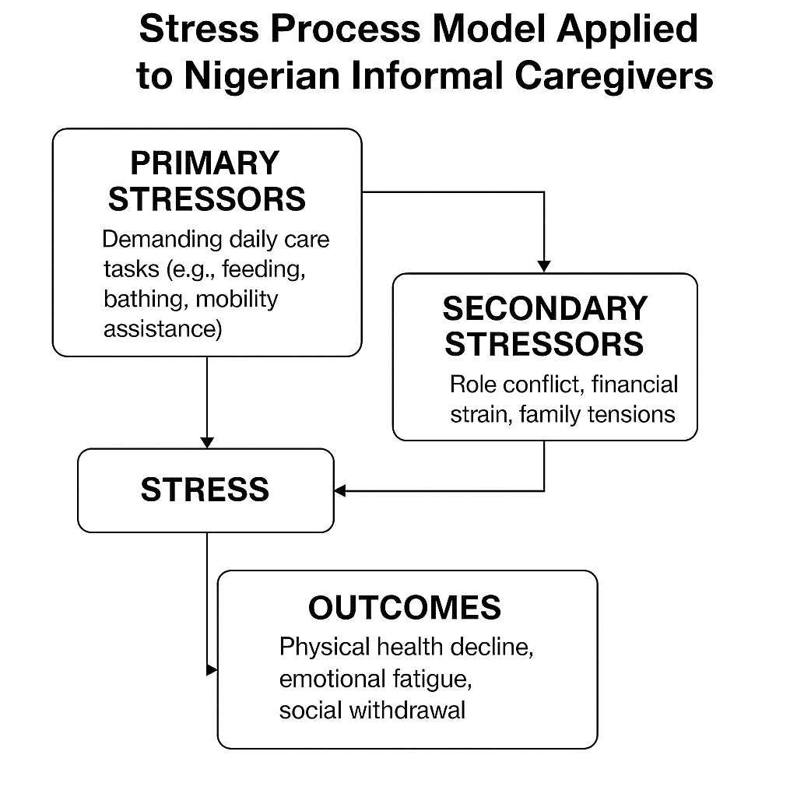

Figure1: Stress Process Model Applied to Nigerian Informal Caregivers. This figure illustrates the Stress Process Model as applied to informal caregivers in Nigeria.
2.2. Context of Informal Caregiving in Nigeria
Informal caregiving for older adults in Nigeria is shaped by a complex interplay of cultural expectations, gender roles, and systemic inadequacies [5]. Rooted in traditional African values, caregiving is widely regarded as a moral duty and a sign of respect for elders, particularly within Yoruba, Igbo, and Hausa communities where filial responsibility is deeply embedded in family life [28]. These cultural norms reinforce the belief that caring for aging parents or relatives is both honorable and obligatory. However, this normative expectation exists alongside a critical absence of institutional eldercare. The limited availability of geriatric services, subsidized home care, or long-term residential facilities means that family-based caregiving remains the default model of support for the elderly across the country [1].
This caregiving landscape is further defined by entrenched gender norms. Women, especially daughters, daughters-in-law, and wives, shoulder the majority of caregiving responsibilities, often while managing employment, childcare, and domestic duties [29]. For many, this role conflict results in chronic stress and difficult trade-offs. Some women are forced to leave the workforce, defer educational aspirations, or abandon entrepreneurial pursuits, leading to long-term economic vulnerability and reduced health autonomy [30]. The gendered nature of caregiving in Nigeria not only reinforces existing inequalities but also perpetuates the invisibility of women’s unpaid labor in national economic and health policy discussions [30].
Geographical disparities further complicate the caregiving experience. In urban settings, caregivers may benefit from closer proximity to hospitals or pharmacies, yet still face significant challenges such as time scarcity, traffic congestion, and balancing formal employment with caregiving demands. Rural caregivers, on the other hand, contend with more severe barriers including limited access to health services, inadequate transportation infrastructure, and higher rates of poverty [10]. These rural-urban differences highlight the uneven distribution of caregiving strain and underscore the importance of context-specific interventions [10].
Nigeria’s healthcare and social support systems offer little relief to caregivers regardless of location. There is a glaring shortage of geriatric healthcare professionals, a lack of caregiver training programs, and minimal government-led support services [31]. Although faith-based organizations and community groups occasionally provide assistance through volunteerism or charitable donations, these efforts are often fragmented, temporary, and not designed with caregiver well-being in mind [32]. The absence of coordinated support structures leaves caregivers to navigate their responsibilities with limited guidance, often at great personal cost.
2.3. Dimensions of Caregiver Burden and Burnout
The burden borne by informal caregivers of older adults in Nigeria is complex and far-reaching, affecting physical health, emotional well-being, economic stability, and social relationships. One of the most immediate and visible challenges is the physical strain associated with caregiving. Many caregivers are responsible for lifting, feeding, bathing, and cleaning care recipients, often without the aid of assistive devices or ergonomic training [27]. These physically demanding tasks lead to chronic fatigue, musculoskeletal pain, and sleep disruptions, particularly when night-time caregiving is involved. Over time, the constant focus on another person’s needs often causes caregivers to neglect their own health, missing medical appointments or delaying treatment for their own ailments [32].
Equally pressing are the emotional and psychological consequences of sustained caregiving. When care is provided to individuals with chronic illnesses or progressive conditions such as dementia, the emotional toll can be particularly severe [33]. Many caregivers experience persistent anxiety, depressive symptoms, and emotional exhaustion. Feelings of hopelessness, frustration, guilt, and self-doubt are common, particularly when caregivers believe they are falling short of expectations or are unable to halt the decline of the care recipient’s condition. The absence of societal recognition and a lack of psychosocial support amplify these emotional challenges, leaving caregivers to manage distress in isolation [19].
The economic and occupational impacts of caregiving are also profound. In order to meet the time demands of caregiving, many individuals are forced to reduce their work hours, switch to less demanding and lower-paying jobs, or leave the labor force entirely [34]. For families already experiencing financial strain, this loss of income can be catastrophic. In addition to forgone earnings, caregivers often incur significant out-of-pocket expenses to cover transportation to medical appointments, prescription medications, nutritional supplements, and hygiene-related supplies [35]. These hidden costs accumulate over time, deepening economic vulnerability.
Social and relational burdens further compound the caregiving experience. The intense demands of caregiving often result in withdrawal from previously fulfilling social roles, reduced community participation, and weakened personal relationships. Marital strain may arise from unmet expectations or emotional neglect, while conflicts within extended families can occur due to disagreements over the distribution of caregiving responsibilities [10]. In some cases, caregivers find themselves isolated not only physically but also emotionally, as they lack peers who can relate to the unique pressures of their role.
When these physical, emotional, financial, and social stressors converge without adequate relief, caregivers may experience burnout. Burnout is characterized by emotional numbness, disconnection from the care recipient, and a pervasive sense of helplessness or failure. As caregivers lose empathy and struggle to carry out basic caregiving tasks, both their own health and the well-being of the older adult are compromised. This deterioration in care quality can lead to a cycle of worsening outcomes, including preventable hospitalizations and increased mortality risk for care recipients [11]. The cumulative and intersecting nature of these burdens calls for urgent intervention by health systems, social welfare institutions, and policymakers to recognize, support, and protect caregivers as essential contributors to eldercare in Nigeria.
To better understand the multifaceted nature of caregiver strain, Table 1 outlines the key dimensions of burden experienced by informal caregivers of older adults in Nigeria.

Table 1: Dimensions of Caregiver Burden Among Informal Caregivers in Nigeria
Dimension | Description | Examples
Physical Burden | Physical strain and health deterioration due to caregiving duties. | Fatigue, sleep disturbances, back pain, lack of time for self-care.
Emotional Burden | Psychological stress from prolonged caregiving and emotional attachment to the care recipient. | Anxiety, depression, guilt, frustration, emotional exhaustion.
Economic Burden | Financial hardship resulting from caregiving responsibilities. | Loss of income, high out-of-pocket expenses, job resignation, reduced work hours.
Social Burden | Social isolation and the erosion of personal relationships due to caregiving demands. | Reduced social interactions, marital conflict, neglect of other family members, community withdrawal.

3. PUBLIC HEALTH IMPLICATIONS
The health and well-being of informal caregivers are fundamentally intertwined with broader public health goals, particularly in aging societies such as Nigeria. Caregivers play a pivotal role in sustaining the day-to-day care of older adults, and when their health deteriorates, the ripple effects are felt throughout the healthcare system [36]. Burned-out caregivers are more likely to make errors, experience physical or mental health crises, or withdraw from caregiving altogether, leaving older adults vulnerable to neglect or premature institutionalization. Such outcomes compromise not only the quality of care but also the resilience and efficiency of an already strained healthcare infrastructure [37]. When informal care breaks down, elderly individuals are more frequently hospitalized or placed in long-term care facilities, which are often under-resourced, overcrowded, and ill-equipped to meet growing demand. These emergency interventions are costlier and more labor-intensive, further burdening Nigeria’s fragile health system [37].
Beyond the immediate health implications, caregiving stress generates a cascade of intergenerational effects that destabilize family dynamics. Children and spouses of caregivers may experience emotional neglect, increased household tension, or financial insecurity, leading to psychological distress and long-term mental health concerns [38]. Despite the magnitude of these challenges, mental health remains one of the most neglected domains in Nigeria’s public health agenda. For caregivers, stigma surrounding mental illness, combined with a lack of accessible and affordable psychosocial services, means that emotional exhaustion and psychological strain often go unaddressed [38]. Moreover, informal caregivers constitute an invisible yet indispensable workforce that contributes substantial economic value through unpaid labor. Their support enables older adults to remain in home environments and reduces reliance on formal healthcare services. However, this vital contribution remains unrecognized in national health policies and economic planning. The failure to formally acknowledge and support informal caregivers represents a missed opportunity to enhance both community-based eldercare and national productivity. Investing in the health and resilience of caregivers is not only a moral imperative but also a strategic public health priority. A sustainable and inclusive healthcare system in Nigeria must integrate caregiver well-being into its design, ensuring that those who care for others are not themselves left vulnerable and unsupported.
4. GAPS IN SOCIAL AND HEALTH SUPPORT SYSTEMS
Informal caregivers in Nigeria function within a health and social support system that offers minimal recognition, protection, or assistance, despite the essential role they play in sustaining eldercare. Government support for caregivers is virtually nonexistent, with no national policies in place to provide financial relief such as tax deductions, caregiving allowances, or integration into pension or social insurance schemes [39]. Many caregivers, particularly women, are forced to leave the labor market or reduce work hours to provide care, resulting in significant income loss and long-term economic insecurity. This financial vulnerability is compounded by out-of-pocket expenses related to transportation, medications, special diets, and assistive supplies for older adults. In countries with more developed care systems, financial assistance and tax benefits serve as buffers against poverty for caregiving households [39]. In Nigeria, the lack of such policy frameworks leaves caregivers with few options, increasing the risk of burnout and care discontinuity.
Equally concerning is the near-total absence of respite care services, mental health support, and training programs tailored to caregivers’ needs. Most caregivers provide continuous care without breaks, often for years, resulting in chronic physical exhaustion and emotional fatigue. The mental health needs of caregivers are especially neglected. Few primary healthcare centers offer caregiver-focused counseling, and cultural stigma around mental health further deters help-seeking behaviors. This contributes to the normalization of psychological distress, even among caregivers exhibiting symptoms of depression and anxiety [40]. Additionally, the vast majority of informal caregivers receive no formal education or practical training in eldercare, leaving them ill-equipped to manage complex health conditions such as dementia, stroke, or incontinence [41]. This not only undermines the safety and quality of care provided to older adults but also increases the caregiver’s risk of injury and emotional distress. While some NGOs, faith-based institutions, and community groups have stepped in to fill these gaps through ad hoc programs, their efforts remain fragmented, underfunded, and geographically limited. Without national coordination, sustained investment, and integration into health policy frameworks, these piecemeal interventions are unlikely to address the scale and complexity of caregiver needs in Nigeria’s rapidly aging society.
5. RECOMMENDATIONS AND POLICY IMPLICATIONS
To effectively address the mounting burden on informal caregivers and reduce its public health consequences, Nigeria must adopt a coordinated, multisectoral strategy that formally recognizes and supports caregiving as a critical component of the national care infrastructure. The foundation of such a strategy should be the creation of national caregiver support policies that define caregiving roles, rights, and entitlements. These policies should align with international best practices and provide a framework for institutional recognition, legal protection, and structured assistance. Central to this agenda is the urgent need to develop respite care programs, both in-home and facility-based, that allow caregivers temporary relief to rest, manage personal affairs, or seek healthcare. Equally important is the expansion of accessible and affordable mental health services tailored to caregivers’ emotional needs. Integrating counseling, support hotlines, and stress management resources into primary healthcare, particularly at the community level, can help mitigate the psychological toll of long-term caregiving.
In parallel, Nigeria should invest in large-scale training and capacity-building programs delivered through community health extension networks. These initiatives would empower caregivers with essential skills in hygiene, nutrition, medication management, and mobility assistance, improving both care quality and caregiver confidence. To address the economic vulnerabilities faced by caregiving households, policymakers should consider targeted financial interventions such as conditional cash transfers, caregiving stipends, and tax exemptions, especially for low-income, full-time caregivers. Additionally, improving national data systems through regular surveys and research on caregiver burden, health outcomes, and service gaps is vital for evidence-informed policymaking. Community-based interventions also have a critical role to play. The establishment of peer support groups, engagement with faith-based institutions, and the promotion of public-private partnerships can foster local caregiving networks, reduce isolation, and promote resilience. Together, these strategies offer a sustainable and culturally grounded pathway for strengthening informal caregiving and building a more inclusive eldercare system in Nigeria.
Figure 2 summarizes the recommended policy and programmatic interventions needed to support informal caregivers in Nigeria, emphasizing a multi-level, integrated approach.
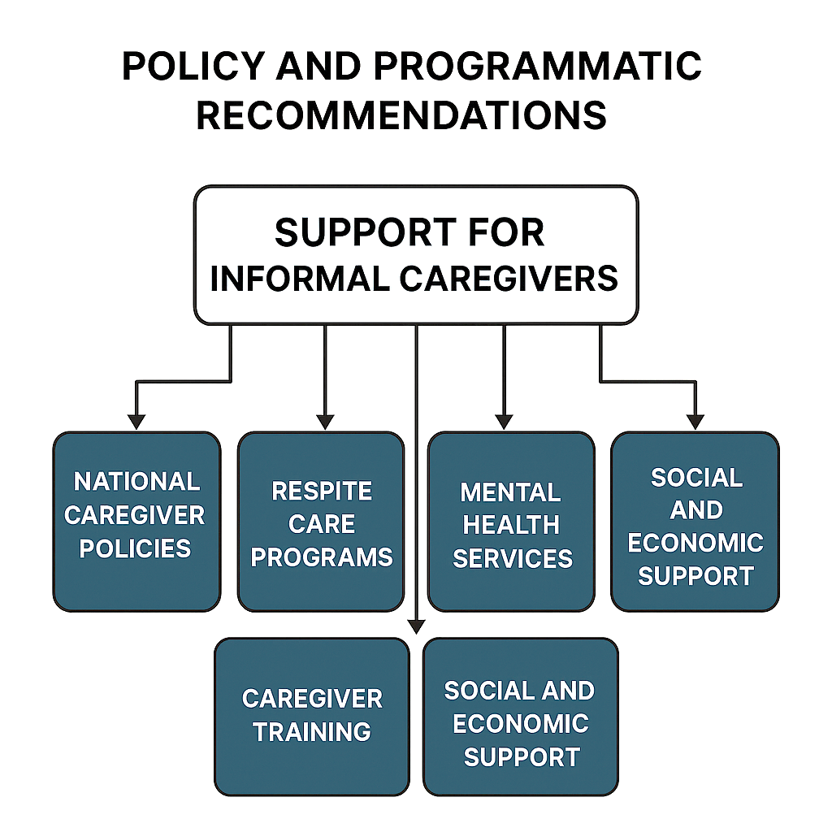
Figure 2: Policy and Programmatic Recommendations Flowchart. presents a flowchart outlining key recommendations to support informal caregivers of older adults in Nigeria. Central to this framework is the need for structured national caregiver support, which can be operationalized through five key strategies: national caregiver policies, respite care programs, mental health services, caregiver training, and socioeconomic support. Together, these components offer a roadmap for building a resilient, inclusive eldercare system that values and empowers caregivers.
8. Conclusion
Informal caregivers play a critical yet often overlooked role in sustaining eldercare in Nigeria, filling the gap left by inadequate formal care systems. They provide indispensable physical, emotional, and logistical support under challenging conditions, frequently without training, recognition, or institutional assistance[42-45]. This widespread neglect not only undermines their own health and livelihoods but also jeopardizes the quality of care received by older adults. Addressing this crisis requires a national commitment to integrating caregiver needs into health and social policy, expanding access to mental health and respite services, and strengthening community-based support structures. Recognizing informal caregivers as vital stakeholders, rather than peripheral actors, is essential for building a sustainable and equitable care system—one that safeguards the dignity and well-being of both caregivers and the aging population they serve.
References
- Folorunsho S, Sanmori M, Suleiman M. The role of formal social networks in mitigating age-related mental stress among older Nigerians living in poverty: Insights from social capital theory. Glob Ment Health (Camb). 2025 May 30;12:e56. doi: 10.1017/gmh.2025.10012.
- Reed HE, Mberu BU. Capitalizing on Nigeria's demographic dividend: reaping the benefits and diminishing the burdens. Etude Popul Afr. 2014 Mar;27(2):319-330. doi: 10.11564/27-2-477
- Worldometer. Nigeria Demographics 2023 [Internet]. Dover, Delaware: Worldometer; 2023 [cited 2025 Jul 7]. Available from: https://www.worldometers.info/demographics/nigeria-demographics/
- United Nations, Department of Economic and Social Affairs, Population Division. World Population Ageing 2020 Highlights: Living arrangements of older persons [Internet]. New York: United Nations; 2020 [cited 2025 Jul 7]. Available from: https://www.un.org/development/desa/pd/news/world-population-ageing-2020-highlights
- Oleribe OO, Momoh J, Uzochukwu BS, Mbofana F, Adebiyi A, Barbera T, Williams R, Taylor-Robinson SD. Identifying Key Challenges Facing Healthcare Systems In Africa And Potential Solutions. Int J Gen Med. 2019 Nov 6;12:395-403. doi: 10.2147/IJGM.S223882
- Folorunsho S, Ajayi V, Sanmori M, Suleiman M, Abdullateef R, Abdulganiyu A. Access to and Utilization of Dental Care Services by Older Adults in Nigeria: Barriers and Facilitators. Spec Care Dentist. 2025 May-Jun;45(3):e70040. doi: 10.1111/scd.70040
- Omobowale AO. An ethnographic textual analysis of aging and the elders in South Western Nigeria. Can J Sociol. 2014;39(2):211–30. Available from: https://journals.library.ualberta.ca/cjs/index.php/CJS/article/view/22237
- Uzonna E, Christopher I. A critical evaluation of care-giving to the aged in rural Igboland of eastern Nigeria and the effects of youth migration: The Old Testament approach. IGWEBUIKE: African Journal of Arts and Humanities. 2018;4(4).
- Ukman AU, Folorunsho S, Taofeeq AO. Social determinants of health and aging in Africa: structural inequality, vulnerability, and the future of care [Internet]. Lincoln (NE): University of Nebraska–Lincoln, Department of Sociology; 2025 [cited 2025 Jul 7]. (Faculty Publications: Paper 867). Available from: https://digitalcommons.unl.edu/sociologyfacpub/867
- Abdullateef R, Folorunsho S, Olawale A, Adeyemi R. Ageing: A sin in Nigerian society? [Internet]. Lincoln (NE): University of Nebraska–Lincoln, Department of Sociology; 2018 [cited 2025 Jul 7]. (Dissertations, Theses, and Student Research: Paper 88). Available from: https://digitalcommons.unl.edu/sociologydiss/88
- Faronbi JO. Correlate of burden and coping ability of caregivers of older adults with chronic illness in Nigeria. Scand J Caring Sci. 2018 Dec;32(4):1288-1296. doi: 10.1111/scs.12572.
- Ojifinni OO, Uchendu OC. Experience of burden of care among adult caregivers of elderly persons in Oyo State, Nigeria: a cross-sectional study. Pan Afr Med J. 2022 May 24;42:64. doi: 10.11604/pamj.2022.42.64.32715
- Agyemang-Duah W, Rosenberg MW. Healthcare utilization among informal caregivers of older adults in the Ashanti region of Ghana: a study based on the health belief model. Arch Public Health. 2023 Oct 23;81(1):187. doi: 10.1186/s13690-023-01200-5
- Emanuel RH, Emanuel GA, Reitschuler EB, Lee AJ, Kikule E, Merriman A, Emanuel LL. Challenges faced by informal caregivers of hospice patients in Uganda. J Palliat Med. 2008 Jun;11(5):746-53. doi: 10.1089/jpm.2007.0220
- Miller KEM, Ornstein KA, Coe NB. Rural disparities in use of family and formal caregiving for older adults with disabilities. J Am Geriatr Soc. 2023 Sep;71(9):2865-2870. doi: 10.1111/jgs.18376.
- Ikeorji CR, Ubani TC. Supporting informal older adult caregivers in Nigeria: Recommendations for policy. Afr J Soc Work. 2024;14(6):311
- Kazemi A, Azimian J, Mafi M, Allen KA, Motalebi SA. Caregiver burden and coping strategies in caregivers of older patients with stroke. BMC Psychol. 2021 Apr 1;9(1):51. doi: 10.1186/s40359-021-00556-z
- Hughes TB, Black BS, Albert M, Gitlin LN, Johnson DM, Lyketsos CG, Samus QM. Correlates of objective and subjective measures of caregiver burden among dementia caregivers: influence of unmet patient and caregiver dementia-related care needs. Int Psychogeriatr. 2014 Nov;26(11):1875-83. doi: 10.1017/S1041610214001240
- Fasiku MM, Akande OW, Bolarinwa OA, Akande TM. Prevalence and determinants of stress of informal caregiving: A cross-sectional study among informal caregivers of hospitalised patients in a tertiary hospital in Nigeria. Niger Postgrad Med J. 2022 Jan-Mar;29(1):20-28. doi: 10.4103/npmj.npmj_700_21
- Pearlin LI, Mullan JT, Semple SJ, Skaff MM. Caregiving and the stress process: an overview of concepts and their measures. Gerontologist. 1990 Oct;30(5):583-94. doi: 10.1093/geront/30.5.583
- Gordon JR, Pruchno RA, Wilson-Genderson M, Murphy WM, Rose M. Balancing Caregiving and Work: Role Conflict and Role Strain Dynamics. J Fam Issues. 2012 May;33(5):662-689. doi: 10.1177/0192513x11425322
- Kisangala E, Mbivnjo EL, Webb EJD, Barrett B, Rukundo GZ, Namisango E, Heslin M. Health and economic impact of caregiving on informal caregivers of people with chronic diseases in sub-Saharan Africa: A systematic review. PLOS Glob Public Health. 2024 Dec 31;4(12):e0004061. doi: 10.1371/journal.pgph.0004061
- Kayaalp A, Page KJ, Rospenda KM. Caregiver Burden, Work-Family Conflict, Family-Work Conflict, and Mental Health of Caregivers: A Mediational Longitudinal Study. Work Stress. 2021;35(3):217-240. doi: 10.1080/02678373.2020.1832609
- Hailu GN, Gebru HB, Hagos GG, Weldemariam AH, Tadesse DB, Mebrahtom G. The role of family caregivers in supporting older adults in Africa: systematic review. BMC Geriatr. 2025 Jul 3;25(1):491. doi: 10.1186/s12877-025-06154-7
- Folorunsho S, Okyere M. The impact of neglect, physical, and financial abuse on mental health among older adults: a systematic review. Aging Ment Health. 2025 Apr;29(4):567-577. doi: 10.1080/13607863.2024.2436468
- Folorunsho S. Sociological analysis of stress management among farmers and rural development in selected communities in Kwara State [Internet]. Lincoln (NE): University of Nebraska–Lincoln, Department of Sociology; 2024 [cited 2025 Jul 7]. (Dissertations, Theses, and Student Research: Paper 87). Available from: https://digitalcommons.unl.edu/sociologydiss/87
- Daliri DB, Aninanya GA, Laari TT, Abagye N, Dei-Asamoa R, Afaya A. Exploring the barriers to mental health service utilization in the Bolgatanga Municipality: the perspectives of family caregivers, service providers, and mental health administrators. BMC Health Serv Res. 2024 Mar 5;24(1):278. doi: 10.1186/s12913-024-10567-2
- Ene J, Agwu P, Ekoh P, Okoye U. Is filial care for older adults in Nigeria threatened? Examining concerns from adult offspring providing care. J Aging Stud. 2022 Dec;63:101078. doi: 10.1016/j.jaging.2022.101078
- Allotey D, Flax VL, Ipadeola A, Kwasu S, Bentley ME, Worku B, Kalluru K, Valle CG, Bose S, Martin SL. Maternal and paternal involvement in complementary feeding in Kaduna State, Nigeria: The continuum of gender roles in urban and rural settings. Matern Child Nutr. 2022 Apr;18(2):e13325. doi: 10.1111/mcn.13325
- Dawaki S, Al-Mekhlafi HM, Ithoi I, Ibrahim J, Atroosh WM, Abdulsalam AM, Sady H, Elyana FN, Adamu AU, Yelwa SI, Ahmed A, Al-Areeqi MA, Subramaniam LR, Nasr NA, Lau YL. Is Nigeria winning the battle against malaria? Prevalence, risk factors and KAP assessment among Hausa communities in Kano State. Malar J. 2016 Jul 8;15:351. doi: 10.1186/s12936-016-1394-3
- Oyinlola O, Adebusoye LA, Olowookere OO, Cadmus EO, Afolabi A. Motivations and Impact of Training of Home Care Workers for Older Adults in Nigeria. Comprehensive Health and Biomedical Studies. 2024;2(2)
- Siegler EL, Lama SD, Knight MG, Laureano E, Reid MC. Community-Based Supports and Services for Older Adults: A Primer for Clinicians. J Geriatr. 2015;2015:678625. doi: 10.1155/2015/678625
- Oni OD, Olagunju AT, Okpataku CI, Erinfolami AR, Adeyemi JD. Predictors of caregiver burden after stroke in Nigeria: Effect on psychosocial well-being. Indian J Psychiatry. 2019 Sep-Oct;61(5):457-464. doi: 10.4103/psychiatry.IndianJPsychiatry_395_18
- Udechukwu CI, Sa’ad SF, Martin OC, Monday MS, Onyinyechukwu NJ. Prevalence of depression among primary caregivers of stroke survivors in Nigeria. Middle East J Rehabil Health Stud. 2018;5(2):e65080. Available from: https://doi.org/10.5812/mejrh.65080
- Ozor O, Nwokolo C, Teixeira de Siqueira Filha N, Odii A, Hicks JP, Li S, Ezenwaka U, Dawkins B, Onwujekwe O. Inequities in Household Out-Of-Pocket Spending Among Urban Slum Dwellers in Southeast Nigeria. Int J Public Health. 2025 Mar 27;70:1607969. doi: 10.3389/ijph.2025.1607969
- Committee on Family Caregiving for Older Adults, Board on Health Care Services, Health and Medicine Division, National Academies of Sciences, Engineering, and Medicine, Schulz R, Eden J, editors. Families caring for an aging America. Washington (DC): National Academies Press (US); 2016 Nov 8 [cited 2025 Jul 7]. Available from: https://www.ncbi.nlm.nih.gov/books/NBK396401/ doi:10.17226/23606
- Obi LI, Otabil C, Lawal OP, Motilewa OO, Agbaje GO, Orobator ET. Optimizing diabetes treatment in aging populations: a focus on longevity, life quality, and innovation. Asian J Res Rep Endocrinol. 2025;8(1):118–26. Available from: https://doi.org/10.9734/ajrre/2025/v8i1112
- Udoh EE, Omorere DE, Sunday O, Osasu OS, Amoo BA. Psychological distress and burden of care among family caregivers of patients with mental illness in a neuropsychiatric outpatient clinic in Nigeria. PLoS One. 2021 May 6;16(5):e0250309. doi: 10.1371/journal.pone.0250309
- Lawal O, Oyebamiji HO, Kelenna IJ, Chioma FJ, Oyefeso E, Adeyemi BI, Foster-Pagaebi E, Moses EF. A review on usage of digital health literacy to combat antibiotic misuse and misinformation in Nigeria. Journal of Pharma Insights and Research. 2025 Apr 5;3(2):258-69.
- Lawal OP, Egwuatu EC, Akanbi KO, Orobator ET, Eweje OZ, Omotayo EO, Igbokwe C, Ogundeko-Olugbami O, Awuah SB, Chibueze ES. Fighting Resistance With Data: Leveraging Digital Surveillance to Address Antibiotic Misuse in Nigeria. Path of Science. 2025;11(3):1009-17.
- Folorunsho S. The Role of Social Determinants of Health in Shaping Racial and Disability Disparities Among Older Adults in the United States. J Aging Soc Policy. 2025 Jul 2:1-17. doi: 10.1080/08959420.2025.2528584.
- Onwuemelem, L.A., Orobator,E.T., Onyedum, N.N., Chibueze, E.S., Kanu,I., Christopher,A.A., Lawal, O., & Ben-Anike,B. (2025). Molecular Mechanisms of Clonal Hematopoiesis in Age-Related Cardiovascular Disease and Hematologic Malignancies: Review Article. Journal of Pharma Insights and Research, 3(2), 358-372. https://doi.org/10.69613/gexxbw35
- Ayomide, I. T., Promise, L. O., Christopher, A. A., Okikiola, P. P., Esther, A. D., Favour, A. C., Agbo, O. S., Sandra, O.-A., Chiagozie, O. J., Precious, A. C., & Ugonna, U. K. (2024). The Impact of Antimicrobial Resistance on Co-INFECTIONS: Management Strategies for HIV, TB and Malaria. International Journal of Pathogen Research, 13(6), 117–128. https://doi.org/10.9734/ijpr/2024/v13i6326
- Oseghale, I. D., Lawal, O. P., Ubebe, D. O., Orjiewulu, V. C., Igunma, A. A., Odey, O. P., Ajibola, D. T., Chima, D. I., Tuador, N. K., & Ani, C. P. (2024). Ethnomedicinal and Phytopharmacological Aspects of Vernonia amygdalina (Bitter Leaf) Utilized as a Traditional Medicinal Herb. Asian Journal of Research in Biochemistry, 14(6), 41–57. https://doi.org/10.9734/ajrb/2024/v14i6326
- Lawal, O. P., Taiye, A. F., Okafor, C. E., Elechi, K. W., Orobator, E. T., Kolapo, T. J., Olaniyi, A. O., Mandal, M., & Olaniyi, H. I. (2025). The Automated Insulin Delivery System in Nigeria: Advances, Challenges, And Future Prospects in Closed-Loop Insulin Delivery Systems. Journal of Medical Science, Biology, and Chemistry, 2(1), 64-74. https://doi.org/10.69739/jmsbc.v2i1.501

