Loneliness, Social Isolation, and Depression Among Older Adults in Nigeria: A Public Health Crisis

Abstract
Nigeria is undergoing a rapid demographic transition, with a growing proportion of its population entering old age. Despite this trend, the mental health needs of older adults remain significantly under-addressed. Among the most pressing challenges are loneliness, social isolation, and depression—interrelated but distinct psychosocial conditions that contribute profoundly to morbidity, diminished quality of life, and premature mortality in later life. Loneliness refers to the subjective perception of inadequate social relationships, while social isolation is defined by a lack of actual social contact; both are potent risk factors for late-life depression, which is often underdiagnosed and untreated in Nigeria. This review synthesizes current evidence on the prevalence, determinants, and consequences of these conditions among older Nigerians. Key risk factors include the erosion of extended family networks, economic insecurity, chronic illness, and the absence of age-friendly environments. The impacts extend beyond individual health, contributing to increased healthcare utilization, caregiver burden, and societal costs. Notably, there is a paucity of longitudinal data, culturally validated screening tools, and locally tested interventions. The public health implications are substantial, especially in a country where geriatric mental health is marginalized within national policy frameworks. The review calls for the development of a national aging policy that incorporates mental health, investment in primary care-based screening and support systems, community-based participatory interventions, and stigma-reduction campaigns. It also underscores the need for regionally tailored and gender-sensitive research. Addressing the mental health needs of Nigeria’s older adults is both a moral imperative and a developmental necessity.
1 Introduction
Loneliness, social isolation, and depression are distinct yet interconnected psychosocial conditions that pose a growing threat to the well-being of older adults [1]. Loneliness refers to the subjective feeling of being emotionally or socially disconnected, irrespective of the actual size or frequency of social contact [2,3]. Social isolation, by contrast, is the objective condition of limited or absent interpersonal relationships [4]. Depression, a common but often overlooked mental disorder in later life, is characterized by persistent sadness, lack of interest in daily activities, and significant functional impairment [5]. When these conditions intersect, they can profoundly affect physical health, psychological resilience, and overall quality of life, especially among older populations.
In Nigeria, these challenges are unfolding against the backdrop of a demographic transformation. Like many low- and middle-income countries (LMICs), Nigeria is witnessing an increase in life expectancy and a steady rise in the proportion of its population aged 60 and above [6]. However, this demographic transition has not been accompanied by a corresponding development of supportive infrastructure, such as geriatric health services, social welfare systems, or age-friendly environments. Many older Nigerians confront cumulative life-course disadvantages, including poverty, chronic illness, bereavement, and weakened intergenerational ties, all of which increase their vulnerability to loneliness, isolation, and depression [7].
This review critically examines the antecedents, consequences, and public health implications of loneliness, social isolation, and depression among older adults in Nigeria. Specifically, it aims to (a) synthesize current epidemiological evidence on the prevalence and co-occurrence of these conditions; (b) explore their socio-cultural, economic, and health-related determinants in the Nigerian context; and (c) identify policy and programmatic strategies for prevention and intervention. By situating these issues within the broader public health and development agenda, the review contributes to national and global discourses on healthy aging and social equity.
Addressing the mental health needs of Nigeria’s older population is not only a moral imperative but also a strategic priority for sustainable development. The integration of geriatric mental health into national public health planning aligns with global commitments such as the United Nations Sustainable Development Goals (SDGs), particularly SDG 3 (Good Health and Well-being) and SDG 10 (Reduced Inequalities). Urgent, context-specific action is needed to ensure that older Nigerians are not left behind in the pursuit of equitable and inclusive health systems.
2 Conceptual and Theoretical Framework
Loneliness and social isolation are often mistakenly used interchangeably, yet they represent distinct constructs with critical implications for mental health in later life. Loneliness is a subjective emotional state, experienced when there is a perceived gap between the quality or quantity of social relationships a person desires and what they actually have [1,2]. Social isolation, on the other hand, refers to the objective lack of social contact, interactions, or engagement. While these experiences may occur independently, they frequently overlap and interact in ways that increase susceptibility to psychological distress, particularly depression—a condition that remains one of the leading contributors to disease burden among older adults globally [4].
Understanding these psychosocial experiences requires a comprehensive theoretical lens. The Biopsychosocial Model of Aging offers a valuable starting point, emphasizing the interplay of biological aging processes, psychological resilience, and sociocultural context in shaping mental health trajectories in later life [8]. According to this model, loneliness and social isolation are not merely personal or psychological problems but are deeply embedded in wider social and environmental conditions [8]. Complementing this perspective, Socioemotional Selectivity Theory (SST) posits that as individuals age and perceive time as increasingly limited, they become more selective in their social interactions, prioritizing emotionally meaningful relationships [9]. This selectivity, while adaptive, can render older adults particularly vulnerable to emotional loss or the disruption of close ties. Additionally, the Social Convoy Model highlights how the composition and function of social networks evolve over the life course. Events such as widowhood, retirement, or the migration of younger family members can significantly disrupt these networks, weakening the informal support systems that older adults in Nigeria often rely upon [10; 11].
In the Nigerian context, these theoretical insights must be situated within a rapidly changing social landscape. Traditional norms that once supported extended family caregiving and community belonging are being eroded by urbanization, economic strain, and intergenerational mobility [12,13]. As such, applying these frameworks in Nigeria requires attention to cultural values, shifting familial structures, and the absence of formal geriatric care systems.
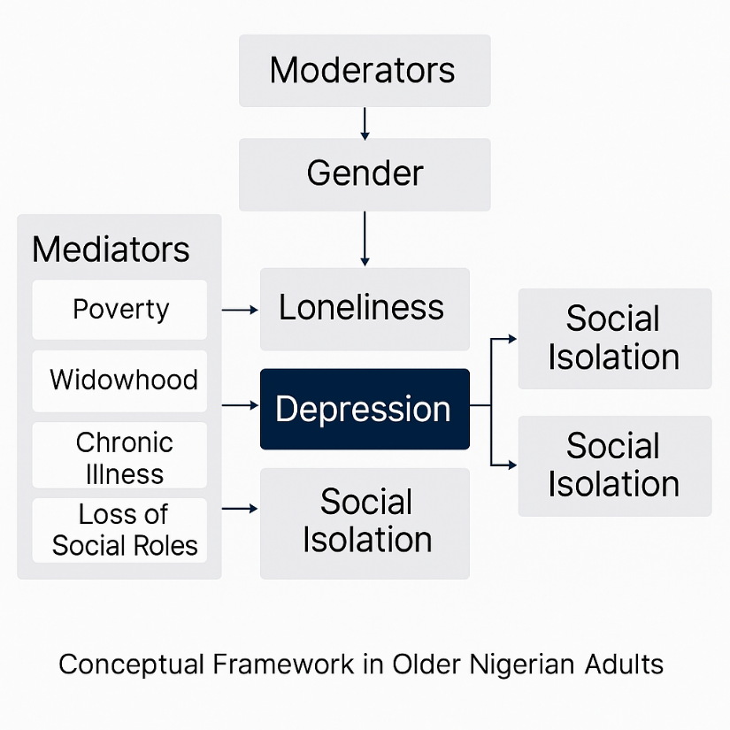
Figure 1. Conceptual framework illustrating the interrelationship between loneliness, social isolation, and depression in older Nigerian adults. The model highlights key mediators (e.g., poverty, chronic illness) and moderators (e.g., gender, rural-urban context) relevant to the Nigerian socio-cultural setting. Adapted from theoretical models including the Biopsychosocial Model of Aging and Socioemotional Selectivity Theory [14,15]
However, the application of these models must be culturally and contextually grounded in the Nigerian setting. In Nigeria, collectivist norms, intergenerational living, religious beliefs, and community belonging profoundly shape the social fabric of aging. The erosion of extended family networks due to urbanization, economic pressures, and youth migration has disrupted traditional support systems, necessitating localized adaptations of these theories [11]. Integrating cultural variables enhances explanatory power and ensures the design of interventions that are not only theoretically sound but contextually relevant and socially acceptable.
3 Epidemiology and Prevalence in Nigeria
Nigeria is undergoing a profound demographic shift, marked by a steady rise in the proportion of older adults. In 2005, individuals aged 60 and above comprised approximately 4.9% of the population; by 2017, this had grown to 6.0%, and projections indicate that by 2025, this number will reach 11.5 million and may approach 25.5 million by 2050 [16]. Despite these trends, geriatric mental health has received limited policy attention, and investments in eldercare infrastructure remain inadequate. Data on the psychosocial well-being of older Nigerians—particularly loneliness, social isolation, and depression—are limited but increasingly suggestive of a growing crisis [16, 17]. Qualitative studies from southeastern Nigeria have identified rural–urban migration, physical disability, and the erosion of traditional family support as key drivers of social fragmentation. Quantitative data show wide variation: one 2014 survey found loneliness prevalence as high as 52.8%, while others report rates ranging from 41% to 45%. A large-scale household study of older adults (n = 1,704) reported that 16.7% met clinical criteria for loneliness, and those affected were more than twice as likely to experience major depressive disorder, with poor social engagement acting as a mediating factor [18].
The Ibadan Study of Ageing (ISA) further highlights the burden of late-life depression, reporting a lifetime prevalence of 26.2% and a 12-month prevalence of 7.1% for major depressive disorder among older Nigerians. In North Central Nigeria, newer data show that 21.8% of retirees experienced loneliness, while a striking 52.0% met criteria for depression, and 20.5% showed signs of comorbid anxious depression [19]. Geographic disparities also persist, although they remain underexplored. In rural areas, isolation is often intensified by the migration of younger family members to urban centers, while in urban settings such as Lagos, older adults may face neglect and high social fragmentation despite living in densely populated environments [20]. Unfortunately, the national data infrastructure remains weak. Nigeria lacks a dedicated aging surveillance system or a mental health registry that captures geriatric-specific indicators. National surveys rarely disaggregate findings by age, and few include psychosocial variables such as loneliness or social isolation [17]. Although the National Senior Citizens Centre was established under the 2018 Senior Citizens Act, its operational capacity and data systems are still underdeveloped. These gaps present significant barriers to evidence-based planning and targeted interventions for Nigeria’s rapidly aging population [21].

Figure 2 illustrates geographic and demographic disparities in depression and social isolation, emphasizing the unequal distribution of psychosocial distress among older adults across Nigeria’s regions, genders, and residential settings.
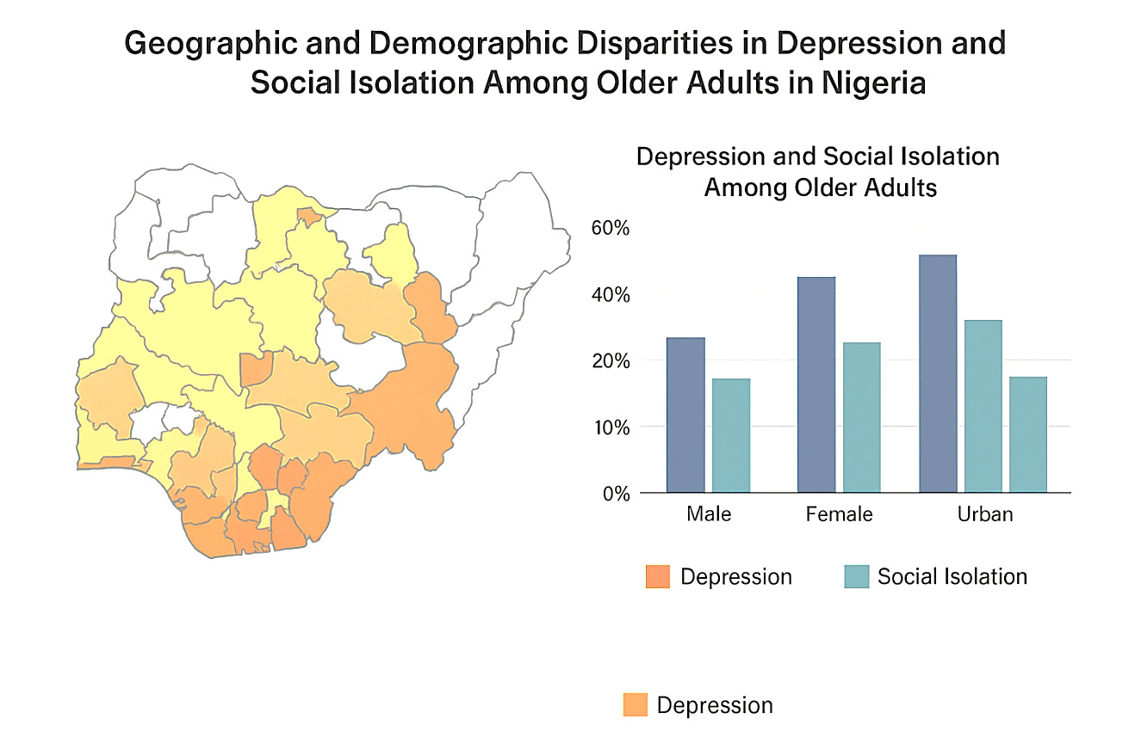
Figure 2. Geographic and demographic disparities in depression and social isolation among older adults in Nigeria. The left panel maps regional prevalence estimates (from studies such as Ajayi et al., 2020), while the right panel compares urban–rural and gender-based prevalence. The figure emphasizes population segments at heightened risk of psychosocial distress. Adapted from Ajayi et al. (2020), Balogun & Ojedokun (2021), and WHO (2017). https://doi.org/10.1186/s12877-020-01821-3, https://doi.org/10.1080/01634372.2020.1868210
4. RISK FACTORS AND DETERMINANTS

4.1 Social and Cultural Determinants

Nigerian society has traditionally been rooted in collectivist values, with the extended family system providing emotional, financial, and caregiving support for older adults. However, these long-standing structures are rapidly weakening due to the combined pressures of urbanization, globalization, and socio-economic transformation [22]. As younger generations migrate to urban areas or abroad in search of better opportunities, aging parents are often left behind in rural communities with minimal contact or daily assistance. The once-assumed obligation that adult children will care for their elders is increasingly difficult to fulfill amid rising youth unemployment, inflation, and economic precarity [22]. This erosion of intergenerational reciprocity contributes to increased social isolation and emotional neglect. Widowhood further compounds vulnerability, especially for women, who in many Nigerian communities face social exclusion, dispossession of property, and degrading cultural practices that exacerbate psychological distress [23]. Older adults without children—or those whose children are deceased, estranged, or disengaged—frequently report intense feelings of abandonment and loss of purpose. In addition, the gradual withdrawal from socially valued roles through retirement, bereavement, or declining physical function deepens their marginalization, often leading to diminished self-worth and a sense of social invisibility [24]. These culturally and structurally mediated experiences form a critical backdrop to the psychosocial risks faced by older Nigerians.

4.2 Economic Factors

Economic insecurity remains one of the most significant determinants of mental distress among older adults in Nigeria. A large proportion of the elderly population lives below the poverty line, often without reliable income or formal financial support. For many, retirement does not come with the security of pensions or social benefits—particularly for those who spent their working years in the informal sector, where participation in contributory pension schemes is rare or nonexistent [25]. As a result, aging frequently ushers in a period of economic hardship marked by dependence, deprivation, and vulnerability [26]. The lack of affordable health insurance, coupled with the near absence of long-term care services, imposes additional financial strain on older adults and their families, especially when managing chronic illnesses or functional decline. Moreover, inadequate public investment in age-friendly infrastructure—such as accessible housing, transport systems, and safe communal spaces—limits the mobility and autonomy of older persons, reinforcing social isolation [27].
4.3. Health-Related Risk Factors
The burden of chronic non-communicable diseases (NCDs) among older adults in Nigeria is substantial, with conditions such as hypertension, arthritis, and diabetes occurring frequently and often in combination. These illnesses not only contribute to physical pain and functional impairment but also significantly reduce older adults’ capacity to engage in social and economic activities, thereby increasing the risk of isolation and emotional distress [28]. Functional decline—whether through deteriorating vision, limited mobility, or general frailty—can restrict older individuals to their homes, further deepening social withdrawal and dependence. These challenges are exacerbated by the limited availability of specialized geriatric and mental health services across the country. Access to appropriate care is highly uneven, with most facilities located in urban centers and a persistent shortage of trained professionals in geriatric psychiatry, counseling, and psychosocial support [29]. The underdevelopment of Nigeria’s health infrastructure leaves many older adults without adequate diagnosis, treatment, or long-term management for both physical and mental health conditions. This systemic neglect not only worsens individual health outcomes but also reinforces the cycle of exclusion, loneliness, and depression in late life.
5 IMPACTS AND CONSEQUENCES

5.1 Mental Health Consequences
There is a well-established trajectory linking loneliness and social isolation to the onset and exacerbation of clinical depression. Persistent feelings of disconnectedness contribute to negative affect, hopelessness, and diminished self-worth—hallmarks of depressive illness. In older adults, these symptoms may be masked by somatic complaints or misattributed to aging, leading to underdiagnosis. Suicide risk, though understudied in Nigeria’s elderly, is a documented endpoint of untreated depression globally. Some individuals resort to self-medication, including alcohol or unregulated pharmaceuticals, in attempts to manage emotional distress [15]. Furthermore, chronic isolation is increasingly recognized as a modifiable risk factor for cognitive decline and dementia, with neurobiological studies implicating social deprivation in hippocampal atrophy and impaired neuroplasticity [30].

5.2 Physical Health Impacts
Loneliness is not merely a psychological experience — it has tangible effects on the body. Studies link it to reduced immune function, heightened inflammation, and increased all-cause mortality, equating its impact to well-known risk factors such as smoking or obesity. Older adults experiencing isolation often have delayed or compromised recovery from illnesses or surgical interventions due to lack of support and reduced adherence to medical regimens [31]. Malnutrition and neglect are common among those living alone or in poverty, particularly when physical limitations impede meal preparation or access to food [31].

5.3 Social and Economic Impacts
The cascading effects of late-life psychosocial distress extend to families and society. There is a heightened burden on informal caregivers, often women, who must navigate physical, emotional, and financial challenges [32]. This, in turn, contributes to increased healthcare utilization and unsustainable cost pressures on a health system already operating at its margins. At scale, these dynamics impose substantial strain on social support services, highlighting the urgent need for proactive, community-level interventions to mitigate long-term societal costs [32].
6 Cultural and Contextual Considerations
Cultural beliefs, religious values, and communal norms play a central role in shaping how older adults in Nigeria experience and respond to loneliness, social isolation, and depression. For many, religion and spirituality offer crucial sources of meaning, emotional resilience, and social connection. Participation in faith-based communities provides a buffer against isolation by creating informal support systems that foster belonging and routine engagement [33]. At the same time, traditional belief systems can influence how mental health challenges are perceived—often attributing emotional distress to spiritual causes, such as ancestral displeasure or witchcraft. These interpretations may hinder recognition of depression as a medical condition and discourage help-seeking [13]. Stigma surrounding mental illness remains widespread, with depression in old age frequently seen as a sign of weakness, divine punishment, or a normal aspect of aging rather than a treatable disorder [34]. Consequently, older adults may be dismissed, marginalized, or urged to rely solely on prayer, delaying timely intervention. Gender norms further complicate these dynamics. Older women, particularly widows, are more likely to face social and economic exclusion due to discriminatory inheritance practices and dependency on male relatives. Meanwhile, older men may struggle with the loss of status following retirement but are often less willing to express emotional vulnerability or seek support due to masculine ideals of stoicism [34].
7. Interventions and Best Practices
Community-driven responses are pivotal in environments where formal geriatric infrastructure is lacking. Community health workers (CHWs)—already integral to Nigeria’s primary care system—can be trained to identify and support older adults experiencing loneliness, isolation, or depressive symptoms [35]. Non-governmental organizations (NGOs) and faith-based groups, with their deep community roots and cultural legitimacy, are also strategically positioned to facilitate psychosocial support. Innovative models such as “Elder Companionship Programs”—piloted in countries like Kenya and India—pair volunteers with socially isolated seniors to provide regular emotional and practical support. These initiatives promote intergenerational engagement, reduce loneliness, and can be tailored for Nigeria’s rural and peri-urban contexts [35]. Moreover, leveraging community radio and storytelling traditions can help destigmatize mental illness among older populations.
Integrating mental health screening into primary healthcare—particularly at community health posts and general hospitals—would facilitate early identification of depressive symptoms among older adults. Brief screening tools like the Geriatric Depression Scale (GDS), adapted for local languages and literacy levels, could be employed by frontline workers. The establishment of geriatric mental health clinics, especially within teaching hospitals and tertiary centers, would serve as referral hubs while supporting provider training. Additionally, mobile health (mHealth) platforms—using SMS reminders, voice-based helplines, or smartphone apps—can help reduce isolation, deliver mental health education, and even offer telepsychiatry services in under-resourced settings. These technologies have demonstrated feasibility and acceptability in several African LMICs.

7.3. Policy and Structural Interventions
Despite the launch of Nigeria’s National Health Policy (2016) and the National Senior Citizens Centre (NSCC) under the Senior Citizens Act (2018), emphasis on geriatric mental health remains peripheral. Policy reform should explicitly recognize older adults as a priority demographic and allocate funding for age-specific programs [36]. Expanding social protection schemes, such as conditional cash transfers and non-contributory pensions, could reduce economic insecurity and indirectly mitigate psychosocial stress. Finally, revisions to national mental health legislation must ensure age-inclusive service delivery, training mandates, and data systems that disaggregate by age, enabling evidence-informed interventions for older adults. Sustainable solutions will require intersectoral collaboration and political will to translate policy into action [36].
8. Research Gaps and Future Directions
Despite increasing recognition of the mental health challenges faced by older adults in Nigeria, critical research gaps continue to hinder the development of effective and culturally responsive interventions. One of the most pressing issues is the lack of longitudinal data capable of tracking the psychosocial trajectories of aging populations. Most existing studies are cross-sectional, limiting the ability to assess changes over time or to establish causal relationships between risk factors and outcomes such as loneliness, social isolation, and depression. The establishment of longitudinal cohort studies is therefore essential to inform evidence-based policies and long-term planning. Additionally, there is a significant shortage of culturally validated screening tools for identifying mental health conditions among older Nigerians. Instruments developed in high-income countries often fail to account for linguistic nuances, cultural beliefs, and contextual realities, thereby undermining their accuracy and relevance. Locally adapted and tested tools are urgently needed for both clinical use and population-level surveillance. Moreover, the effectiveness of psychosocial interventions remains largely untested within the Nigerian context. While models such as elder companionship programs and mobile mental health services show promise globally, few have been evaluated in local settings, limiting their scalability and policy adoption. Future research should prioritize community-based participatory approaches that engage older adults not merely as subjects but as co-creators of knowledge. Intergenerational research can also offer insights into how shifting family dynamics impact elder well-being. Finally, greater attention must be paid to regional and gender-specific disparities, ensuring that the diverse experiences of older men and women across Nigeria’s rural–urban and ethno-religious spectrum are fully understood and addressed.
9 Recommendations and Policy Implications
Addressing the escalating public health challenge of loneliness, social isolation, and depression among older adults in Nigeria requires a coordinated, multisectoral policy response grounded in the principles of healthy and inclusive aging. A critical first step is the development of a comprehensive national aging policy that explicitly integrates mental health as a strategic priority. Such a policy should align with international frameworks on aging and health, setting clear goals for the promotion of psychosocial well-being in later life. Building age-friendly communities through inclusive urban planning, accessible public transportation, and the establishment of community centers can help foster social engagement and reduce isolation. Simultaneously, efforts to strengthen intergenerational bonds—such as school-based elder engagement programs and family support incentives—can help restore traditional support systems weakened by urbanization and migration. At the health system level, the integration of geriatric mental health into primary care is essential. Routine screening, early intervention, and efficient referral mechanisms must be adapted to meet the specific needs of older adults. Community health workers, who play a central role in local service delivery, should receive targeted training in geriatric mental health, including basic counseling skills, cultural competence, and mental health literacy. Finally, national public health campaigns are needed to challenge entrenched stigmas and misconceptions about aging and mental illness. By leveraging the influence of religious institutions, mass media, and trusted community leaders, these campaigns can promote awareness, encourage help-seeking, and affirm the dignity and rights of older people across Nigeria’s diverse communities.
10 Conclusion
Loneliness, social isolation, and depression among older adults in Nigeria constitute an urgent yet insufficiently recognized public health challenge. As the country's aging population expands, the psychosocial well-being of older Nigerians is increasingly jeopardized by the erosion of traditional family structures, entrenched poverty, limited access to mental health services, and persistent societal stigma. This review has illuminated the complex and intersecting nature of these issues, spanning social, economic, health, and cultural dimensions, and emphasized the critical need for holistic and evidence-based responses. An effective and age-inclusive public health strategy must prioritize mental health across the life course, promote investment in age-friendly infrastructure, and reinforce community-based systems of support. These efforts must be grounded in culturally relevant research and anchored in a rights-based framework that upholds the dignity, autonomy, and social inclusion of older adults. Achieving sustainable progress will require coordinated and cross-sector collaboration by stakeholders in health, social welfare, housing, education, and civil society to ensure that older Nigerians are not left behind in the national pursuit of health equity and social justice.

References
- Donovan NJ, Blazer D. Social Isolation and Loneliness in Older Adults: Review and Commentary of a National Academies Report. Am J Geriatr Psychiatry. 2020 Dec;28(12):1233-1244. doi: 10.1016/j.jagp.2020.08.005.
- Van As BAL, Imbimbo E, Franceschi A, Menesini E, Nocentini A. The longitudinal association between loneliness and depressive symptoms in the elderly: a systematic review. Int Psychogeriatr. 2022 Jul;34(7):657-669. doi: 10.1017/S1041610221000399
- Folorunsho S, Okyere M. The impact of neglect, physical, and financial abuse on mental health among older adults: a systematic review. Aging Ment Health. 2025;29(4):567–77. doi:10.1080/13607863.2024.2436468
- Veazie S, Gilbert J, Winchell K, et al. Addressing Social Isolation To Improve the Health of Older Adults: A Rapid Review [Internet]. Rockville (MD): Agency for Healthcare Research and Quality (US); 2019 Feb. Appendix F, Social Isolation and Loneliness Definitions and Measures.
- Sekhon S, Patel J, Sapra A. Late-Life Depression. [Updated 2023 Jun 26]. In: StatPearls [Internet]. Treasure Island (FL): StatPearls Publishing; 2025 Jan-.
- Abdullateef R, Folorunsho S, Olawale A, Adeyemi R. Ageing: A sin in Nigerian society? [dissertation]. Lincoln (NE): University of Nebraska-Lincoln; 2018. Department of Sociology: Dissertations, Theses, and Student Research. Report No.: 88. Available from: https://digitalcommons.unl.edu/sociologydiss/88
- Folorunsho S, Ajayi V, Sanmori M, Suleiman M, Abdullateef R, Abdulganiyu A. Access to and utilization of dental care services by older adults in Nigeria: Barriers and facilitators. Spec Care Dentist. 2025;45(3):e70040. doi:10.1111/scd.70040.
- Borrell-Carrió F, Suchman AL, Epstein RM. The biopsychosocial model 25 years later: principles, practice, and scientific inquiry. Ann Fam Med. 2004 Nov-Dec;2(6):576-82. doi: 10.1370/afm.245
- Carstensen LL. Socioemotional Selectivity Theory: The Role of Perceived Endings in Human Motivation. Gerontologist. 2021 Nov 15;61(8):1188-1196. doi: 10.1093/geront/gnab116. PMID: 34718558; PMCID: PMC8599276.
- Kahn RL, Antonucci TC. Convoys over the life course: Attachment roles and social support. In: Baltes PB, Brim OG, editors. Life-span development and behavior. New York: Academic Press; 1980. p. 253–286.
- Folorunsho S, Sanmori M, Suleiman M. The role of formal social networks in mitigating age-related mental stress among older Nigerians living in poverty: Insights from social capital theory. Glob Ment Health (Camb). 2025;12:e56. doi:10.1017/gmh.2025.10012.
- Mbam KC, Halvorsen CJ, Okoye UO. Aging in Nigeria: A growing population of older adults requires the implementation of national aging policies. Gerontologist. 2022 Nov;62(9):1243–50. doi:10.1093/geront/gnac121.
- Folorunsho S. Sociological analysis of stress management among farmers and rural development in selected communities in Kwara State. 2024 Jan 5.
- Cacioppo JT, Cacioppo S. The growing problem of loneliness. Lancet. 2018 Feb 3;391(10119):426. doi: 10.1016/S0140-6736(18)30142-9
- Holt-Lunstad J, Smith TB, Baker M, Harris T, Stephenson D. Loneliness and social isolation as risk factors for mortality: A meta-analytic review. Perspect Psychol Sci. 2015;10(2):227–37. doi:10.1177/1745691614568352
- Dangana-Onuche GO, Timiun GA, Haruna SA. Demography of ageing population in Nigeria: Trends, challenges and implications. Gusau J Sociol [Internet]. 2025 Jan 18 [cited 2025 Jun 29];4(3):107–23. Available from: https://gujos.com.ng/index.php/gujos/article/view/59
- Tanyi PL, André P, Mbah P. Care of the elderly in Nigeria: Implications for policy. Cogent Soc Sci. 2018;4(1). doi:10.1080/23311886.2018.1555201
- Ojagbemi A, Gureje O. Social relationships and the association of loneliness with major depressive disorder in the Ibadan Study of Aging. World Soc Psychiatry. 2019;1(1):82–8. doi:10.4103/WSP.WSP_6_19.
- Gureje O, Kola L, Afolabi E. Epidemiology of major depressive disorder in elderly Nigerians in the Ibadan Study of Ageing: a community-based survey. Lancet. 2007 Sep 15;370(9591):957-64. doi: 10.1016/S0140-6736(07)61446-9
- Ojembe BU, Ebe Kalu M. Describing reasons for loneliness among older people in Nigeria. J Gerontol Soc Work. 2018 Aug-Sep;61(6):640-658. doi: 10.1080/01634372.2018.1487495
- Ogunyemi AO, Balogun MR, Ojo AE, Welch SB, Onasanya OO, Yesufu VO, Omotayo AO, Hirschhorn LR. Provider and facility readiness for age-friendly health services for older adults in primary health care centres in southwest, Nigeria. PLOS Glob Public Health. 2023 Aug 8;3(8):e0001411. doi: 10.1371/journal.pgph.0001411
- Ogunyemi AO, Balogun MR, Ojo AE, Welch SB, Onasanya OO, Yesufu VO, Omotayo AO, Hirschhorn LR. Provider and facility readiness for age-friendly health services for older adults in primary health care centres in southwest, Nigeria. PLOS Glob Public Health. 2023 Aug 8;3(8):e0001411. doi: 10.1371/journal.pgph.0001411
- Nwokocha EE. Widowhood in Igboland, Nigeria: A cultural and psychosocial analysis. Int J Soc Sci Humanit Stud [Internet]. 2016 [cited 2025 Jun 29];8(1):198–210. Available from: https://dergipark.org.tr/tr/download/article-file/540392
- Aiyedun TG, Udujih OS. Widowhood and social exclusion in Esan, Nigeria: An examination of culture and inheritance rights. J Women Aging Afr [Internet]. 2017 [cited 2025 Jun 29];1(2):90–112. Available from: https://www.inia.org.mt/wp-content/uploads/2017/01/1.2-4-Nigeria-90-to-112-Final.pdf
- Amoo EO. Social support and economic security among older persons in Nigeria. Public Health Res. 2012;2(4):92–101. Available from: https://article.sapub.org/10.5923.j.phr.20120204.05.html
- Evans DK, Sunal A, Yakubu Y. Evaluating the impact of social pensions in Ekiti State, Nigeria [Internet]. Washington (DC): World Bank; 2019 [cited 2025 Jun 29]. Available from: https://ideas.repec.org/p/dls/wpaper/0322.html
- African Academy of Sciences. Addressing long-term care for Nigeria’s aging population [Internet]. Nairobi: AAS; 2022 [cited 2025 Jun 29]. Available from: https://aasciences.africa/news/addressing-long-term-care-for-nigerias-aging-population
- Elechi KW, Inuaeyen JU, Samba AM, Godfrey OC, Ezinwanne TH, Adedeji SJ, Lawal OP. Evidence-Based Integration of Traditional Medicine in Nigeria: Translational Impacts on Healthcare Access, Quality, and Resilience. Path of Science. 2025 May 31;11(5):10001-10.
- Lawal OP, Elechi KW, Adekunle JF, Farinde O, Kolapo TJ, Igbokwe CU, Elechi US, Uwakwe VI, Desmond CO. A review on artificial intelligence and point-of-care diagnostics to combat antimicrobial resistance in resource-limited healthcare settings like Nigeria. J Pharm Innov Res. 2025;3(2):166–75. doi:10.69613/reeh4906. Available from: https://jopir.in/index.php/journals/article/view/385
- Maier A, Riedel-Heller SG, Pabst A, Luppa M. Risk factors and protective factors of depression in older people 65+. A systematic review. PLoS One. 2021 May 13;16(5):e0251326. doi: 10.1371/journal.pone.0251326
- Smith KJ, Gavey S, RIddell NE, Kontari P, Victor C. The association between loneliness, social isolation and inflammation: A systematic review and meta-analysis. Neurosci Biobehav Rev. 2020 May;112:519-541. doi: 10.1016/j.neubiorev.2020.02.002
- Ojifinni OO, Uchendu OC. Experience of burden of care among adult caregivers of elderly persons in Oyo State, Nigeria: a cross-sectional study. Pan Afr Med J. 2022 May 24;42:64. doi: 10.11604/pamj.2022.42.64.32715
- , Okoh CF, Egbumike CJ, Chukwu DA, Irem FO, et al. Impact of religious participation and spirituality on the health of Nigerian older people: an online survey. J Relig Spiritual Aging. 2021;33(4):360–81. doi:10.1080/15528030.2021.2001407
- Adegboyega O, Babatunde MO, Oladayo O. Exploring the socio-psychological impact of widowhood among elderly women in a traditional setting in Nigeria. Int J Psychosoc Stud. 2024;10(4):1–20. doi:10.1177/10436596241286244
- Ekoh PC, Agbawodikeizu PU, Ejimkararonye C, George EO, Ezulike CD, Nnebe I. COVID-19 in Rural Nigeria: Diminishing Social Support for Older People in Nigeria. Gerontol Geriatr Med. 2020 Dec 28;6:2333721420986301. doi: 10.1177/2333721420986301
- Obi LI, Otabil C, Lawal OP, Motilewa OO, Agbaje GO, et al. Optimizing diabetes treatment in aging populations: a focus on longevity, life quality, and innovation. Asian J Res Rep Endocrinol. 2025;8(1):118–26. doi:10.9734/ajrre/2025/v8i1112. Available from: https://hal.archives-ouvertes.fr/hal-05091313

