*Original Research Article*

The Effect of Arbuscular Mycorrhizal Tablets and Sachets on Mineral Content in *Aloe vera* Tissue.

ABSTRACT

|  |
| --- |
| **Aims:** This study aims to test the effect of arbuscular mycorrhizal (AM) tablets and sachets on the mineral nutrient content of *Aloe vera* (Av) tissue.  **Study design:**  **Place and Duration of Study:** This research was conducted on community land around the Muhammadiyah University of Parepare, South Sulawesi, Indonesia, at an altitude of 37.0 meters above sea level with coordinates 3°59’30” S; 119°38’4 E, between January 2024 and August 2024..  **Methodology:** This study used a one-factor Completely Randomized Design with treatments of AM powder/control, AM sachets, and AM tablets. Observations were made at the age of 60 days after planting on the variables of the level of colonization of the AM structure (hyphae, arbuscules, vesicles, and spores), mineral nutrient content in the root, stem, and leaf tissues of Va  **Results:** The results showed that the percentage of AM colonization levels was moderate (10%- 30%) to high (>30%). AM tablets and sachets affected the mineral nutrient content in plant tissue and were significantly different from AM powder. Thus, AM tablets and sachets can be recommended to farmers as an easy, environmentally friendly, and sustainable method of AM application that does not inhibit the symbiotic process between plants and AM.  **Conclusion:** AM tablets and sachets did not inhibit the AM colonization process in root tissue and showed different concentrations of nutrient minerals in the roots, stems, and leaves of Av.. |

*Keywords: Colonization; dosage form; endomycorrhiza; infection, mineral; nutrition.*

1. INTRODUCTION

Aloe vera (Av) belongs to the Liliaceae family and has 548 species. This plant has green, thick, fleshy, serrated leaves, which contain gel as an essential part of the plant that has economic value, and latex, consisting of polysaccharides, proteins, amino acids, vitamins, and anthraquinones (Khajeeyan et al., 2022; Matei et al., 2025; Mensah et al., 2025).

One of the horticultural commodities that is long-lived and drought-resistant is Av. However, Av can be cultivated in tropical areas and has the potential to be developed in Indonesia (Jompa et al., 2022), as it has applications in the pharmaceutical, cosmetic, and food industries (Al-Maamari & Nasser, 2021; Shafara et al., 2023), which can increase farmers' and the country's income.

Research using Av as an object of observation has been conducted by several researchers to investigate its potential as a plant growth stimulant, antimicrobial agent, herbal medicine, and health supplement (Yousaf et al., 2025). In addition, several researchers have also examined the effects of fertilizers (Chowdhury et al., 2020), hormones (Ahmad et al., 2024; Atteya et al., 2021), and plant growth on marginal land (Chandel et al., 2025; Fentaw et al., 2022), as well as farmer planting patterns on the growth and production of aloe vera (Chandran et al., 2022; Mensah et al., 2025). However, information on the effects of arbuscular mycorrhizal (AM) as biofertilizers on the physiological aspects of aloe vera plants is still very limited.

Physiologically, Av uses the crassulacean acid metabolism (CAM) pathway to bind carbon dioxide (CO2) during the dark phase of photosynthesis, when the stomata are open at night (Hogewoning et al., 2021; van Tongerlo et al., 2021). This phenomenon allows the plant to adapt when soil water availability is insufficient. In addition to the physiological phenomena required by Av to survive, the role of microorganisms is needed to increase the area of water absorption by the roots, namely, AM.

The AM are fungi that are symbiotic with plant roots and form special structures inside root cells (Kuila & Ghosh, 2022; Vieira et al., 2025). AM consists of hyphae, vesicles, and arbuscules. Arbuscules are small, tree-like structures that function to exchange nutrients between fungi and plants, while vesicles are storage structures that form inside root cells. Hyphae are the part of the fungus that grows in the soil and absorbs nutrients, and helps spread mycorrhizae (da Silva et al., 2022; Du et al., 2025). According to (Kuila & Ghosh, 2022); (Shi et al., 2021); (Wahab et al., 2023), the role of AM in symbiosis can significantly increase the need for phosphorus, nitrogen, and potassium for plants.

The use of AM in aloe vera cultivation, in addition to having a positive impact on the environment due to its biological properties, also allows AM to produce antibiotic compounds and growth regulators to support plant growth (Nacoon et al., 2023; Wahab et al., 2023). According to Etesami et al., (2021) and Khaliq et al., (2022), AM can also increase the absorption of P and other essential nutrients, including N, K, Mg, Zn, Cu, S, B, and Mo. In addition, AM can increase plant immunity to disease, especially root rot disease (Corrales-Sanchez et al., 2022; Fiorilli et al., 2024), and improve plant resistance to environmental stress such as drought, low pH, and heavy metal contamination such as lead (Pb), cobalt (Co), chromium (Cr), copper (Cu), nickel (Ni), manganese (Mn), iron (Fe), zinc (Zn) (Ahmed et al., 2025; Nie et al., 2024).

The application of AM to various types of terrestrial plants has been carried out by several farmers using AM propagules. A propagule is a part of a plant or other organism that can be used for propagation or the spread of the plant or other organism to a new environment. AM propagules isolated from the rhizosphere of host plant roots, and still in the form of AM powder (Hijri & Ba, 2023; Wilkes, 2021). The weakness of AM powder is that sometimes the AM application dose is not uniform. AM spores contained in the propagules will be lost, carried away by water flow and/or wind exposure during application, so an innovation is needed to suppress the loss of spores with a uniform dose, in the form of AM tablets and sachets. So the purpose of this study was to test whether The Effect of Arbuscular Mycorrhizal Tablets and Sachets on Mineral Content in Aloe vera Tissue. The novelty of the research obtained is the availability of AM tablets and sachets as a solution to avoid spore loss in AM propagules and provide positive effects on plant physiological components.

2. material and methods

This research was conducted in the community land around Muhammadiyah University of Parepare, South Sulawesi, Indonesia, at an altitude of 37.0 meters above sea level with coordinates 3°59’30” S; 119°38’4 E.

The study used a one-factor Completely Randomized Design with treatments being AM powder/control (A1); AM sachet (A2); AM tablet (A3), each treatment was repeated 5 times, and each repetition consisted of 20 experimental units.

The AM powder is a propagule consisting of spores, pieces of host plant roots, zeolite with a particle size of 80 mesh, fine sand, and rice husk biochar used in AM spore propagation. Each plant will be given 5 g of AM powder (Figure 1A).

The AM sachets are made using gauze bags with dimensions of 80-100 mm wide x 90-115 mm long and 4-6 mm thick and have fine pores (average 176.63 µm). Each AM sachet contains 5 g of AM propagules (Figure 1B).

The AM tablets are made using a tablet press made of acrylic and adhesive materials in the form of triple super phosphate (TSP) and/or clay, each tablet weighs 5-6 g, is 1.5-2 cm high, has a diameter of 2-2.5 cm and contains 5 g of AM propagules (Figure 1C).

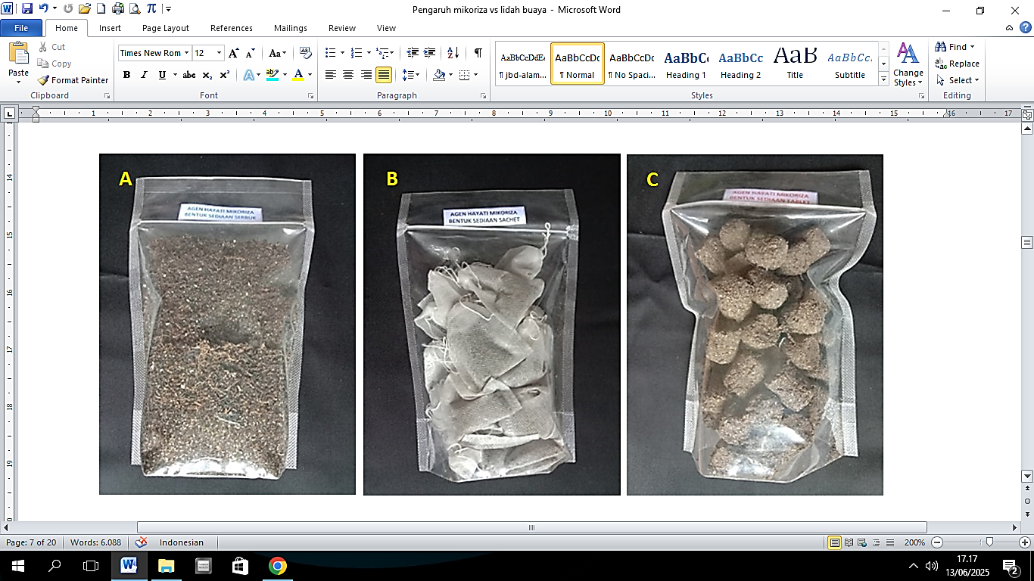

**Fig 1. Material of AM powder, sachet and tablet**

The planting media used consists of soil and compost that have undergone wet sterilization for 8-9 hours with a ratio of 1:1 (Table 1). The sterile planting media is put into a planter bag measuring 18 cm x 20 cm. Each planter bag that has been filled with planting media will be used to plant one aloe vera seedling and application of AM powder, sachet, or tablet.

**Table 1. Analysis of physical and chemical properties of planting media**

|  |  |  |  |
| --- | --- | --- | --- |
| No | Component | Value | Category [1] |
| 1 | Sand (%) | 72 |  |
| 2 | Dust (%) | 13 |  |
| 3 | Clay (%) | 15 |  |
| 5 | pH (H2O) | 6.76 | Neutral |
| 7 | CEC (cmol.kg-1) | 30.21 | High |
| 8 | SB (%) | 50 | Medium |
| 9 | N (%) | 0.26 | Very low |
| 10 | P2O5 (ppm) | 21.25 | Medium |
| 12 | Mg (ppm) | 1.85 | Very low |
| 13 | K (ppm) | 0.42 | Medium |

Plant maintenance in the form of watering, fertilizing using liquid fertilizer, weeding by cutting weeds so as not to interfere with AM activity and the roots of the main plant, controlling pests, and plant diseases was carried out during the research.

Observation components were carried out before planting in the planting medium, while on the main plant, observations were carried out at the age of 60 days after planting, including the percentage of colonized roots (hyphae, arbuscules, vesicles, and spores). The mycorrhizal infection was calculated based on the formula (Giovannetti & Mosse, 1980).

$$AM colonized = \frac{\sum{number of root colonized }}{\sum{number of root observed }}×100$$

The data from the laboratory and field observations were analyzed using Analysis of Variance based on a Complete Randomized Design, followed by Duncan's Test, using either Microsoft Excel or the Statistical Package for the Social Sciences (SPSS) application. The data from the analysis will be displayed in the form of Tables and Figures.

3. results and discussion

**3.1 The mycorrhizal infection**

The level of colonization in Av roots due to MA application had a significant effect (Figure 2d), and the results of observations of the MA structure in Av root tissue found hyphae, arbuscules, vesicles and spores (Figure 2a and b) in the epidermis tissue with a percentage level of colonization that is classified as moderate (10% -30%) to high (>30%) (Figure 2c). It is suspected that Av can create a favorable rhizosphere environment for the growth and development of MA, allowing MA powder, sachets, and tablets to infect roots effectively. Ahmad et al., (2023) stated in a previous study that the form of MA preparations (MA tablets and sachets) did not affect the performance of MA in stimulating the growth of *Puraria javanica*, as measured by root length and volume. However, the Duncan test revealed that MA sachets resulted in a higher level of colonization and were significantly different from the levels of colonization observed with MA powder and tablets (Figure 2d). The development of MA structures in Av root tissue resulting from the application of MA sachets shows the development of more MA structures, this is probably caused by the relatively small number of MA spores lost, as a result of being washed away by the water flow when watering the plants because the sachet material blocks them. Apart from that, the remaining spores will germinate, colonize, and undergo further growth and structural development within the epidermal tissue.

Several AM experts have found that AM colonization and symbiosis are facilitated through biochemical communication between AM in the rhizosphere and the host plant's roots (Boyno & Demir, 2022; Wahab et al., 2023). AM fungi will release myc enzymes that can be recognized by receptors, which have the potential to activate the symbiotic signaling pathway between AM and roots (Crosino & Genre, 2022; He et al., 2024). Strigolactone compounds released by host roots can induce AM spore germination and hyphal growth towards the origins of the host plant (Naz et al., 2025; Pina-Torres et al., 2023). After the AM hyphae reach the root surface, the AM hyphae will form hyphopodia (Bortolot et al., 2024; Prasetya et al., 2024). Furthermore, the AM hyphae then enter and grow between root cells and finally create a branched structure called an arbuscule in the cortex cell tissue (Bortolot et al., 2024; Chaudhary et al., 2025). Branched arbuscules provide a large surface area for nutrient exchange. Mineral nutrients such as phosphorus (P) and nitrogen (N) are transported from the AM fungus to the host plant through the symbiotic interface (Luo et al., 2023; Rui et al., 2022; Wahab et al., 2023).

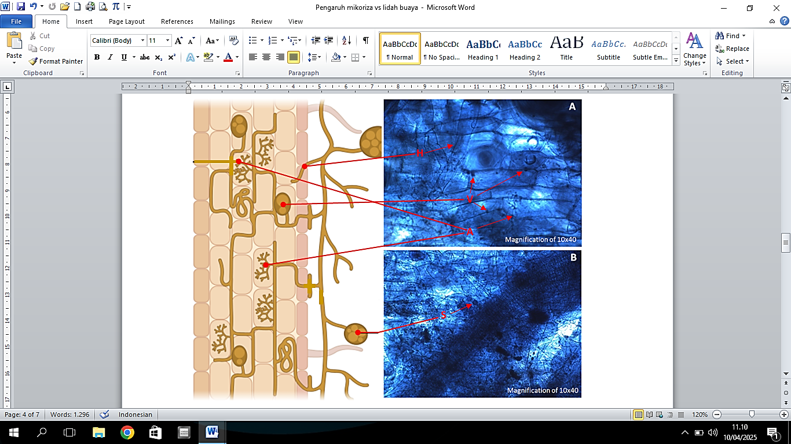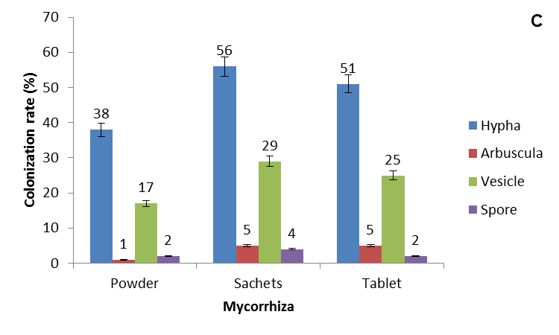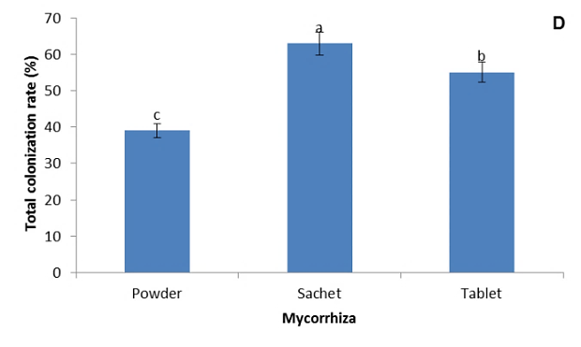

**Fig 2. Development of AM structures in root tissue (A, B), colonization level of each AM structure (C), and total AM colonization level (D) in AM powder, sachet, and tablet (H, Hypha; A, Arbuscula; V, Vesicle; S, Spore).**

**3.2 Mineral nutrients in plant tissue**

The mineral nutrient content in Av tissue is affected by AM application, where the mineral content of N and P is more dominantly found in Av tissue that is applied with AM tablets. The effect of AM tablets is significantly different from the effect of AM powder and sachets on the mineral nutrient content of N, P, and K in Av tissue (Figure 3A). Figures 3B, C, and D show that the application of AM tablets tends to increase the N and P content in Av leaves. This is thought to be due to the proximity of the AM spores in the tablets and the Av root area, which is not far apart, allowing for a faster colonization process that immediately facilitates the absorption of N and P through AM hyphae and Av roots. According to Kumar & Tapwal, (2022) and Salim et al., (2020), the distance between AM spores and roots is a key factor in determining the speed of colonization. The closer the spores are to the roots, the faster the mycorrhiza can colonize the roots, the hyphal network formed from AM spores will expand the area of nutrient absorption by plants (Cargill et al., 2025; Khaliq et al., 2022). Rui et al., (2022) and Zhang et al., (2021) added that roots colonized by AM have two nutrient absorption pathways, namely directly via the root epidermis tissue and root hairs (direct path) and indirectly through the transfer of external AM hyphae into root cortex cells (Luo et al., 2023; Wahab et al., 2023), where the arbuscules provide a symbiotic interface (mycorrhizal pathway) (Ho-Plagaro & Garcia-Garrido, 2022; Nguyen & Saito, 2021).

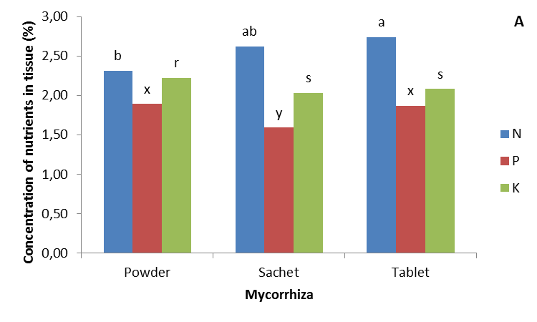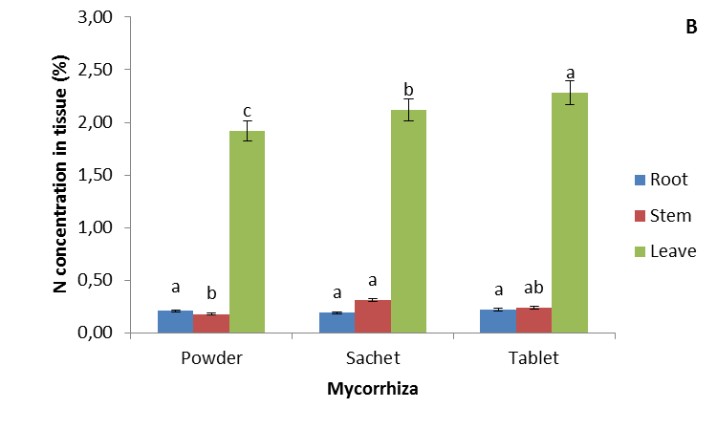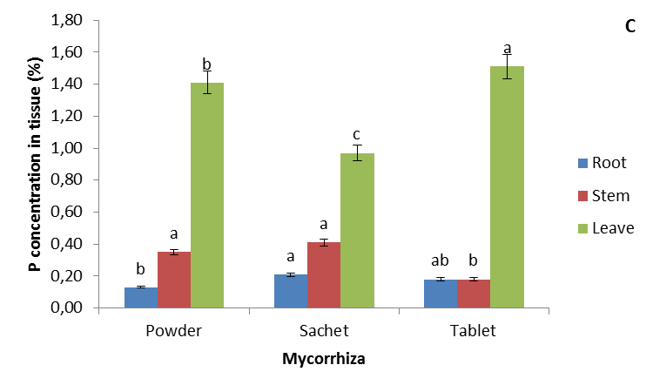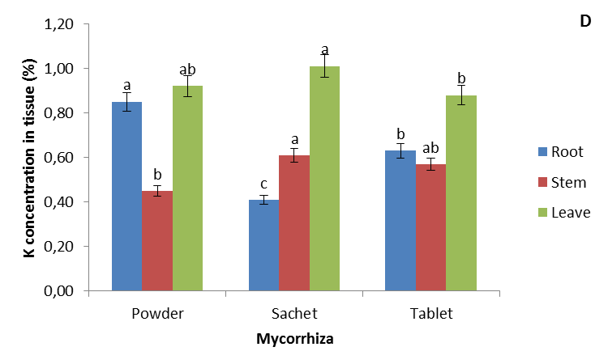

**Fig 3. Mineral nutrient content of N, P, and K in Av tissue due to application of MA powder, sachets, and tablets.**

The naturally occurring nitrogen (N) in the soil usually limits plant growth, and Table 1 indicates that the availability of N in the planting medium falls into the very low category (0.26%) and Figure 3A shows that more N was accumulated in Av leaves. According to Balestrini et al., (2020) and Ma et al., (2022), N absorption by host plants can be increased by AM colonization. In the AM pathway, N in the form of ammonium and/or nitrate is absorbed by the extraradical mycelium and assimilated into glutamine to form arginine (Vergara et al., 2019; Wang et al., 2017). Arginine is the dominant amino acid in the extraradical mycelium, and it is transferred to the intraradicular mycelium through AM hyphae and broken down into urea and ornithine in the intraradicular mycelium (Fossalunga & Novero, 2019; Rui et al., 2022). This finding suggests that ammonium and/or nitrate are likely released through the symbiotic interface by AM and absorbed by the host plant (Basiru et al., 2025; Bucking & Kafle, 2015).

Phosphorus (P) is the main nutrient for plants, Figure 3C shows that P minerals are found more in Av leaf tissue. According to Ho-Plagaro & Garcia-Garrido, (2022) and Suo et al., (2025), AM can decompose P elements bound in the soil by releasing phosphatase enzymes and organic acids as exudates, making P elements available and usable by plants. AM causes an increase in the area of water and nutrient absorption in plants and releases organic acids that can dissolve P minerals bound by soil colloids (Etesami et al., 2021; Santoro et al., 2024). In rice colonized by AM fungi, about 70% of the total phosphorus (P) obtained is supplied by symbiotic fungi (Ren et al., 2023; Rui et al., 2022). According to Wahab et al., (2023) and Prasetya et al., (2024), the distribution of hyphae in the soil can affect the efficiency of phosphorus absorption by AM.

Potassium (K+) is one of the most abundant elements in soil composition, but its very low availability limits plant growth and ecosystem productivity (Cornut et al., 2021; Xu et al., 2020). This cation participates in many metabolic processes, its constitutive absorption from soil solution is very important for plant cell productivity. In Figure 3D, it shows that potassium is more accumulated in Av leaves, according to Ho et al., (2020); Shah et al.,(2024); and Xu et al., (2020), potassium functions to help plant photosynthesis, sugar translocation, activate enzyme activity, and regulate water potential pressure in guard cells so that it affects the opening and closing of stomata, increases the root system, prevents the effect of plant lodging, counteracts the negative effects of N, provides a balance effect between N and P, and is important for chlorophyll development.

4. Conclusion

AM tablets and sachets did not inhibit the AM colonization process in root tissue and showed different concentrations of nutrient minerals in the roots, stems, and leaves of Av.

References

Ahmad, N., Akib, M. A., Qadri, S. N., Syatrawati, & Prayudyaningsih, R. (2023). Effect of Arbuscular Mycorrhizal Tablets and Sachets on the growth of Pueraria javanica. *Gontor Agrotech Science Journal*, *9*(1), 11–19. https://doi.org/10.21111/agrotech.v9i1.8877

Ahmad, S., Tariq, M., Saniya, Belwal, V., Shah, M. H., Kumar, P., Sharma, M., Kole, C., Jain, M., & Kaushik, P. (2024). Efficient in-vitro regeneration protocol for large-scale propagation of Aloe vera (L.) Burm.f. *Journal of Applied Research on Medicinal and Aromatic Plants*, *43*(October), 100588. https://doi.org/10.1016/j.jarmap.2024.100588

Ahmed, N., Li, J., Li, Y., Deng, L., Deng, L., Chachar, M., Chachar, Z., Chachar, S., Hayat, F., Raza, A., Umrani, J. H., Gong, L., & Tu, P. (2025). Symbiotic synergy: How Arbuscular Mycorrhizal Fungi enhance nutrient uptake, stress tolerance, and soil health through molecular mechanisms and hormonal regulation. *IMA Fungus*, *16*, e144989. https://doi.org/10.3897/imafungus.16.144989

Al-Maamari, S., & Nasser, J. (2021). Pharmacological Effects and Pharmaceutical Dosage Forms Development of Aloe vera. *Journal of Pharmacy Science and Practice I*, *8*(2), 85–90.

Atteya, A. K. G., Omer, E. A., Genaidy, E. A. E., Fouad, R., & Elnony, A. F. A. (2021). Impact of in vitro propagation on chemical composition of Aloe vera plants. *Middle East Journal of Agriculture Research*, 654–673. https://doi.org/10.36632/mejar/2021.10.2.48

Balestrini, R., Brunetti, C., Chitarra, W., & Nerva, L. (2020). Photosynthetic traits and nitrogen uptake in crops: Which is the role of arbuscular mycorrhizal fungi? *Plants*, *9*(9), 1–16. https://doi.org/10.3390/plants9091105

Basiru, S., Mhand, K. A. S., & Hijri, M. (2025). Deciphering the mechanisms through which arbuscular mycorrhizal symbiosis reduces nitrogen losses in agroecosystems. *Applied Soil Ecology*, *206*, 105799. https://doi.org/10.1016/j.apsoil.2024.105799

Bortolot, M., Buffoni, B., Mazzarino, S., Hoff, G., Martino, E., Fiorilli, V., & Salvioli Di Fossalunga, A. (2024). The Importance of Mycorrhizal Fungi and Their Associated Bacteria in Promoting Crops’ Performance: An Applicative Perspective. *Horticulturae*, *10*(12), 1–26. https://doi.org/10.3390/horticulturae10121326

Boyno, G., & Demir, S. (2022). Plant-mycorrhiza communication and mycorrhizae in inter-plant communication. *Symbiosis*, *86*(2), 155–168. https://doi.org/10.1007/s13199-022-00837-0

Bucking, H., & Kafle, A. (2015). Role of arbuscular mycorrhizal fungi in the nitrogen uptake of plants: Current knowledge and research gaps. *Agronomy*, *5*(4), 587–612. https://doi.org/10.3390/agronomy5040587

Cargill, R. I. M., Shimizu, T. S., Kiers, E. T., & Kokkoris, V. (2025). Cellular anatomy of arbuscular mycorrhizal fungi. *Current Biology*, *35*(11), 545–562. https://doi.org/10.1016/j.cub.2025.03.053

Chandel, N. S., Singh, H. B., & Vaishnav, A. (2025). Mechanistic understanding of metabolic cross-talk between Aloe vera and native soil bacteria for growth promotion and secondary metabolites accumulation. *Frontiers in Plant Science*, *16*(March), 1–12. https://doi.org/10.3389/fpls.2025.1577521

Chandran, D., Rajasekharan, A., Marthandan, V., Emran, T. Bin, Sharun, K., Mitra, S., Buttar, H. S., Kumar, H., Tuli, H. S., & Dhama, K. (2022). Potential Health Benefits of Using Aloe vera as a Feed Additive in Livestock : A Mini-Review. *Indian Veterinary Journal*, *99*(1), 9–18. https://doi.org/10.21608/javs.2 023.243964.1287

Chaudhary, A., Poudyal, S., & Kaundal, A. (2025). Role of Arbuscular Mycorrhizal Fungi in Maintaining Sustainable Agroecosystems. *Applied Microbiology*, *5*(6), 1–19. https://doi.org/10.3390/applmicrobiol5010006

Chowdhury, M. A. H., Sultana, T., Rahman, M. A., Chowdhury, T., Enyoh, C. E., Saha, B. K., & Qingyue, W. (2020). Nitrogen use efficiency and critical leaf N concentration of Aloe vera in urea and diammonium phosphate amended soil. *Heliyon*, *6*(12), e05718. https://doi.org/10.1016/j.heliyon.2020.e05718

Cornut, I., Le Maire, G., Laclau, J. P., Guillemot, J., Mareschal, L., Nouvellon, Y., & Delpierre, N. (2021). Potassium limitation of wood productivity: A review of elementary processes and ways forward to modelling illustrated by Eucalyptus plantations. *Forest Ecology and Management*, *494*, 119275. https://doi.org/10.1016/j.foreco.2021.119275

Corrales-Sanchez, J. B., Lopez-Meyer, M., Valdez-Morales, M., Aguilar, D. T., Bojorquez-Armenta, Y. D. J., Valle-Castillo, C. E., Ibarra-Sarmiento, C. R., Romero-Urias, C. D. L. Á., & Mora-Romero, G. A. (2022). Arbuscular Mycorrhiza Symbiosis Reduces the Rhizoctonia Root Rot and Alters the Phenolic Profile in Common Bean. *Acta Biologica Colombiana*, *27*(3), 316–325. https://doi.org/10.15446/abc.v27n3.87627

Crosino, A., & Genre, A. (2022). Peace talks: symbiotic signaling molecules in arbuscular mycorrhizas and their potential application. *Journal of Plant Interactions*, *17*(1), 824–839. https://doi.org/10.1080/17429145.2022.2108150

da Silva, A. K. V., Aguiar, T. da S., Dos Santos, M. E. C., de Araújo, J. K. P., Freire, Á. da C., Salami, G., & Araujo, P. C. D. (2022). Vegetative Propagation of Mimosa Caesalpiniifolia By Mini-Cuttings Technique. *Revista Arvore*, *46*, e4631. https://doi.org/10.1590/1806-908820220000031

Du, X., Yin, Y., Xia, G., & Yuan, Y. (2025). Effect of Arbuscular Mycorrhizal Hyphae on The Structure of Fungal and Bacterial Communities: An in Situ Study. *Rhizosphere*, *34*, 101082. https://doi.org/10.1016/j.rhisph.2025.101082

Etesami, H., Jeong, B. R., & Glick, B. R. (2021). Contribution of Arbuscular Mycorrhizal Fungi, Phosphate–Solubilizing Bacteria, and Silicon to P Uptake by Plant. *Frontiers in Plant Science*, *12*, 699618. https://doi.org/10.3389/fpls.2021.699618

Fentaw, E., Dagne, K., Wondimu, T., Demissew, S., Bjorå, C. S., & Grace, O. M. (2022). Uses and perceived sustainability of Aloe L. (Asphodelaceae) in the central and northern Highlands of Ethiopia. *South African Journal of Botany*, *147*, 1042–1050. https://doi.org/10.1016/j.sajb.2020.11.001

Fiorilli, V., Martínez-Medina, A., Pozo, M. J., & Lanfranco, L. (2024). Plant Immunity Modulation in Arbuscular Mycorrhizal Symbiosis and Its Impact on Pathogens and Pests. *Annual Review of Phytopathology*, *62*(1), 127–156. https://doi.org/10.1146/annurev-phyto-121423-042014

Fossalunga, A. S. di, & Novero, M. (2019). To Trade in The Field: The Molecular Determinants of Arbuscular Mycorrhiza Nutrient Exchange. *Chemical and Biological Technologies in Agriculture*, *6*, 12. https://doi.org/10.1186/s40538-019-0150-7

Giovannetti, M., & Mosse, B. (1980). An Evaluation of Tecnique for Measuring Vesicular Arbuscular Mycorrhizal Infection in Roots. *New Phytologist*, *84*, 489–500. https://doi.org/10.1111/j.1469-8137.1980.tb04556.x

He, J., Huang, R., & Xie, X. (2024). A gap in the recognition of two mycorrhizal factors: new insights into two LysM-type mycorrhizal receptors. *Frontiers in Plant Science*, *15*(September), 1–8. https://doi.org/10.3389/fpls.2024.1418699

Hijri, M., & Ba, A. (2023). Editorial: Mycorrhizal Fungi and Plants in Terrestrial Ecosystems. *Frontiers in Plant Science*, *14*, 1180884. https://doi.org/10.3389/fpls.2023.1180884

Ho-Plagaro, T., & Garcia-Garrido, J. M. (2022). Molecular Regulation of Arbuscular Mycorrhizal Symbiosis. *International Journal of Molecular Sciences*, *23*, 5960. https://doi.org/10.3390/ijms23115960

Ho, L., Rode, R., Siegel, M., Reinhardt, F., Neuhaus, H. E., Yvin, J., Pluchon, S., & Hosseini, S. A. (2020). Potassium Application Boosts Photosynthesis and Sorbitol Biosynthesis and Accelerates Cold Acclimation of Common Plantain ( Plantago major L .). *Plants*, *9*, 1259. https://doi.org/10.3390/plants9101259

Hogewoning, S. W., Boogaart, S. A. van den, Tongelo, E. van, & Trouborst, G. (2021). CAM‐physiology and carbon gain of the orchid Phalaenopsis in response to light intesity, light integral and CO2. *Plant Cell Environmental*, *44*, 762–774. https://doi.org/10.1111/pce.13960 ORIGINAL

Jompa, S., Syarief, R., Sutjahjo, S. H., & Yulianto, A. (2022). Aloe Vera Agribusiness Development Sustainability Analysis in Bogor Regency. *International Journal of Agriculture System (IJAS)*, *9*(2), 80–90. https://doi.org/10.20956/ijas.v9i2.2988

Khajeeyan, R., Salehi, A., Movahhedi Dehnavi, M., Farajee, H., & Kohanmoo, M. A. (2022). Growth parameters, water productivity and aloin content of Aloe vera affected by mycorrhiza and PGPR application under different irrigation regimes. *South African Journal of Botany*, *147*, 1188–1198. https://doi.org/10.1016/j.sajb.2021.02.026

Khaliq, A., Perveen, S., Alamer, K. H., Haq, M. Z. U., Rafique, Z., Alsudays, I. M., Althobaiti, A. T., Muneera A, S., Hussain, S., & Attia, H. (2022). Arbuscular Mycorrhizal Fungi Symbiosis to Enhance Plant–Soil Interaction. *Sustainability*, *14*, 7840. https://doi.org/10.3390/su14137840

Kuila, D., & Ghosh, S. (2022). Aspects, problems and utilization of Arbuscular Mycorrhizal (AM) application as bio-fertilizer in sustainable agriculture. *Current Research in Microbial Sciences*, *3*, 100107. https://doi.org/10.1016/j.crmicr.2022.100107

Kumar, A., & Tapwal, A. (2022). Diversity of arbuscular mycorrhizal fungi and root colonization in Polygonatum verticillatum. *Nusantara Bioscience*, *14*, 53–63. https://doi.org/10.13057/nusbiosci/n140107

Luo, X., Liu, Y., Li, S., & He, X. (2023). Interplant Carbon and Nitrogen Transfers Mediated by Common Arbuscular Mycorrhizal Networks: Beneficial Pathways for System Functionality. *Frontiers in Plant Science*, *14*, 1169310. https://doi.org/10.3389/fpls.2023.1169310

Ma, Q., Chadwick, D. R., Wu, L., & Jones, D. L. (2022). Arbuscular Mycorrhiza Fungi Colonisation Stimulates Uptake of Inorganic Nitrogen and Sulphur but Reduces Utilisation of Organic Forms in Tomato. *Soil Biology and Biochemistry*, *172*, 108719. https://doi.org/10.1016/j.soilbio.2022.108719

Matei, C. E., Visan, A. I., & Crestescu, R. (2025). Aloe Vera Polysaccharides as Therapeutic Agents : Benefits Versus Side Effects in Biomedical Applications. *Polysaccharides*, *6*, 1–32. https://doi.org/10.3390/polysaccharides6020036

Mensah, E. O., Adadi, P., Asase, R. V., Kelvin, O., Mozhdehi, F. J., Amoah, I., & Agyei, D. (2025). Aloe vera and its Byproducts as Sources of Valuable Bioactive Compounds: Extraction, Biological Activities, and Applications in Various Food Industries. *PharmaNutrition*, *31*, 100436. https://doi.org/10.1016/j.phanu.2025.100436

Nacoon, S., Seemakram, W., Ekprasert, J., Theerakulpisut, P., Sanitchon, J., Kuyper, T. W., & Boonlue, S. (2023). Arbuscular Mycorrhizal Fungi Enhance Growth and Increase Concentrations of Anthocyanin, Phenolic Compounds, and Antioxidant Activity of Black Rice (Oryza sativa L.). *Soil Systems*, *7*(2), 1–14. https://doi.org/10.3390/soilsystems7020044

Naz, M., Afzal, M. R., Raza, M. A., Tariq, M., Yan, M., Dai, Z., Qi, S., & Du, D. (2025). The Significant Effects of Strigolactones on Plant Growth and Microbe Interactions: A Review. *Plant Growth Regulation*, 1–21. https://doi.org/10.1007/s10725-025-01325-3

Nguyen, C. T., & Saito, K. (2021). Role of Cell Wall Polyphosphates in Phosphorus Transfer at the Arbuscular Interface in Mycorrhizas. *Frontiers in Plant Science*, *12*, 725939. https://doi.org/10.3389/fpls.2021.725939

Nie, W., He, Q., Guo, H., Zhang, W., Ma, L., Li, J., & Wen, D. (2024). Arbuscular Mycorrhizal Fungi: Boosting Crop Resilience to Environmental Stresses. *Microorganisms*, *12*, 2448. https://doi.org/10.3390/microorganisms12122448

Pina-Torres, I. H., Davila-Berumen, F., Gonzalez-Hernadez, G. A. G.-H., Terres-Guzman, J. C., & Padilla-Guerrero, I. E. (2023). Hyphal Growth and Conidia Germination Are Induced by Phytohormones in the Root Colonizing and Plant Growth Promoting Fungus Metarhizium guizhouense. *Journal of Fungi*, *9*, 945. https://doi.org/10.3390/jof9090945

Prasetya, B., Arfiyanti, H., & Arfarita, N. (2024). Exploring the benefit of arbuscular mycorrhizal Glomus spp. in improving available soil P and crop growth of sorghum cultivated on ex-coal mine soil. *Biodiversitas*, *25*(12), 5112–5122. https://doi.org/10.13057/biodiv/d251249

Ren, Y., Wang, X., Liang, J., Wang, S., Chen, H., & Tang, M. (2023). Arbuscular Mycorrhiza Fungi Rhizophagus irregularis Regulate Iron and Zinc Homeostasis in Tobacco by Mediating the Expression of Yellow Stripe-Like 7. *Industrial Crops and Products*, *204*, 117356. https://doi.org/10.1016/j.indcrop.2023.117356

Rui, W., Mao, Z., & Li, Z. (2022). The Roles of Phosphorus and Nitrogen Nutrient Transporters in the Arbuscular Mycorrhizal Symbiosis. *International Journal of Molecular Sciences*, *23*, 11027. https://doi.org/10.3390/ijms231911027

Salim, M. A., Budi, S. W., Setyaningsih, L., Iskandar, Wahyudi, I., & Kirmi, H. (2020). Root Colonization by Arbuscular Mycorrhizal Fungi (AMF) in Various Age Classes of Revegetation Post-coal Mine. *Biodiversitas*, *21*, 5013–5022. https://doi.org/10.13057/biodiv/d211005

Santoro, V., Schiavon, M., & Celi, L. (2024). Role of Soil Abiotic Processes on Phosphorus Availability and Plant Responses with A Focus on Strigolactones in Tomato Plants. *Plant and Soil*, *494*, 1–49. https://doi.org/10.1007/s11104-023-06266-2

Shafara, F. Q., Irawan, B., & Ernah, E. (2023). Bioprospecting of Pontianak Aloe as An Indonesian Plant for Coemeceutical: A Review. *AGROLAND: The Agricultural Sciences Journal*, *10*, 50–57. https://doi.org/10.22487/agroland.v0i0.1440

Shah, I. H., Jinhui, W., Li, X., Hameed, M. K., Manzoor, M. A., Li, P., Zhang, Y., Niu, Q., & Chang, L. (2024). Exploring the Role of Nitrogen and Potassium in Photosynthesis Implications for Sugar: Accumulation and Translocation in Horticultural Crops. *Scientia Horticulturae*, *327*, 112832. https://doi.org/10.1016/j.scienta.2023.112832

Shi, S., Luo, X., Dong, X., Qiu, Y., Xu, C., & He, X. (2021). Arbuscular mycorrhization enhances nitrogen, phosphorus and potassium accumulation in vicia faba by modulating soil nutrient balance under elevated co2. *Journal of Fungi*, *7*(5), 1–15. https://doi.org/10.3390/jof7050361

Suo, Y., Li, T., von Sperber, C., Ge, L., Cao, C., Zhai, Z., Bu, Z., & Wang, M. (2025). Low Molecular Weight Organic Acids Mobilize Soil Organic Phosphorus for Enzymatic Hydrolysis in A Temperate Montane Peatland. *Biogeochemistry*, *168*, 19. https://doi.org/10.1007/s10533-025-01210-1

van Tongerlo, E., Trouwborst, G., Hogewoning, S. W., van Ieperen, W., Dieleman, J. A., & Marcelis, L. F. M. (2021). Crassulacean Acid Metabolism Species Differ in The Contribution of C3 and C4 Carboxylation to End of Day CO2 Fixation. *Physiologia Plantarum*, *172*, 134. https://doi.org/10.1111/ppl.13312

Vergara, C., Araujo, K. E. C., de Souza, S. R., Schultz, N., Jaggin Júnior, O. J., Sperandio, M. V. L., & Zilli, J. É. (2019). Plant-Mycorrhizal Fungi Interaction and Response to Inoculation with Different Growth-Promoting Fungi. *Pesquisa Agropecuaria Brasileira*, *54*, e25140. https://doi.org/10.1590/S1678-3921.pab2019.v54.25140

Vieira, C. K., Marascalchi, M. N., Rozmos, M., Benada, O., Belova, V., & Jansa, J. (2025). Arbuscular Mycorrhizal Fungal Highways – What, How and Why? *Soil Biology and Biochemistry*, *202*, 109702. https://doi.org/10.1016/j.soilbio.2024.109702

Wahab, A., Muhammad, M., Munir, A., Abdi, G., Zaman, W., Ayaz, A., Khizar, C., & Reddy, S. P. P. (2023). Role of Arbuscular Mycorrhizal Fungi in Regulating Growth, Enhancing Productivity, and Potentially Influencing Ecosystems under Abiotic and Biotic Stresses. *Plants*, *12*, 3102. https://doi.org/10.3390/plants12173102

Wang, W., Shi, J., Xie, Q., Jiang, Y., Yu, N., & Wang, E. (2017). Nutrient Exchange and Regulation in Arbuscular Mycorrhizal Symbiosis. *Molecular Plant*, *10*(9), 1147–1158. https://doi.org/10.1016/j.molp.2017.07.012

Wilkes, T. I. (2021). Arbuscular Mycorrhizal Fungi in Agriculture. *Encyclopedia*, *1*, 1132. https://doi.org/10.3390/encyclopedia1040085

Xu, X., Du, X., Wang, F., Sha, J., Chen, Q., Tian, G., Zhu, Z., Ge, S., & Jiang, Y. (2020). Effects of Potassium Levels on Plant Growth, Accumulation and Distribution of Carbon, and Nitrate Metabolism in Apple Dwarf Rootstock Seedlings. *Frontiers in Plant Science*, *11*, 904. https://doi.org/10.3389/fpls.2020.00904

Yousaf, Z., Hussain, S. M., Ali, S., Kucharczyk, D., Nowosad, J., Turkowski, K., Paray, B. A., & Naeem, A. (2025). Aloe vera: A Promising Natural Herbal Supplement for Enhancing Growth, Physiology, Antioxidant Activity and Immunity in Catla catla. *Aquaculture Reports*, *41*, 102662. https://doi.org/10.1016/j.aqrep.2025.102662

Zhang, L., Chu, Q., Zhou, J., Rengel, Z., & Feng, G. (2021). Soil Phosphorus Availability Determines The Preference for Direct or Mycorrhizal Phosphorus Uptake Pathway in Maize. *Geoderma*, *403*, 115261. https://doi.org/10.1016/j.geoderma.2021.115261