**Marker-Assisted Introgression of *bmr6* allele into sweet sorghum and high biomass sorghum lines for improving biomass-based biofuel yield**

**Abstract**

The production of renewable fuels from plants is important because of their high energy, low cost, and reduced greenhouse gas emissions. The introgression of the *bmr* gene into elite biomass sorghum reduces lignin concentration in the cell wall, which improves biomass enzymatic digestibility and hence 2G ethanol bioconversion process yield. The present research aimed to study the impact of introgression of lignin-reducing *bmr-*6 gene into sweet sorghum to enhance biofuel production. The gene was introgressed in elite wild-type (WT) lines using the backcrossing technique. The plant material included three WT recurrent parents, i.e., two *bmr* sweet sorghum varieties (SSV84, ICSV18003) and one *bmr* high biomass sorghum variety (ICSV15024), and a *bmr6* mutant donor (N609). Recurrent parents were hand emasculated and *bmr* (*bmr-6*) trait successfully transferred into elite WT lines using marker-assisted backcrossing; BC2F1 populations were selfed to obtain BC2F2 populations. The presence of *bmr-6* allele in the introgressed lines were confirmed by KASPar assays.

**Keywords:** *Sorghum bicolor (L.) moench*, KASPar, *bmr6,* biomass, introgression, lignin, CAD2.

**Introduction**

*Sorghum bicolor* **(**L.) *moench,* is considered as one of the important cereal crops; it is used for fodder, food grains and biofuel production. It belongs to *Poaceae* family with five races (bicolor, durra, guinea, caudatum and kafir) and several hybrids therefrom. It is an annual crop with short life cycle ranging from 3-4 months (Reddy *et al*., 2005), which can be grown in almost all seasons i.e., rainy, post-rainy & summer because of its wide adaptability (da Silva *et al*. 2020; Oliveira *et al*. 2019). Production of biofuel is an important application of sorghum and increased yield depends greatly on the type of hybrid or variety used. This increase in the biomass depends upon many characteristics such as plant height, maturity, fresh and dry stalk yield (Nagaiah *et al*., 2012). Unlike many other crops used for renewable energy production, sweet sorghum, simultaneously produces food as well as energy products (Mathur *et al*., 2017), allowing to produce biofuels without competing with food production. Compared to other sorghums, sweet sorghum yields less grain, but its stem contains an elevated amount of readily fermentable carbohydrates (Mask & Morris 1991, Bennett & Anex 2009). It produces 23% more fermentable carbohydrates, require 37% less nitrogen fertilizer and 17% less irrigation water when compared to maize, and may produce more ethanol than maize in drought years [Hills *et al*., 1990, Putnam *et al*., 1991). Sorghum is the prominent feedstock for second-generation (2G) lignocellulosic biofuel production , and can produce 288 L of ethanol per ton of dry biomass by utilizing both C5 and C6 sugars (Umakanth *et al*., 2022). Lignin plays important role in the plant. As a complex phenolic polymer, lignin enhances plant cell wall rigidity, hydrophobic properties and promotes minerals transport through the vascular bundles in plant (Schuetz *et al*., 2014). In addition, lignin is an important barrier that protects against pests and pathogens (Ithal *et al*., 2007). However, increased lignin concentration limits enzymatic digestibility and biofuel recovery, suggesting that reducing the lignin quantity in biomass can be a game changer in biofuel production (Oliveira *et al*., 2020).

Brown midrib (*bmr*) is phenotypically characterized by the presence of brown vascular tissues, observed on the leaf midribs and stems. These *Bmr* mutations have been identified and observed in maize (*Zea mays*) and sorghum (*Sorghum bicolor*) either by spontaneous or chemical mutagenesis. In sorghum, reduced lignin content was associated with brown midrib mutants. The sorghum brown midrib (*bmr*) trait derived its name from intense brown coloration of leaf midrib (as compared to wild type with white or green leaf midrib color) and *bmr* mutants maintain reduced lignin in its stover compared to conventional wildtype sorghums (Porter et al. 1978; Oliver *et al*. 2005). The intensity of brown colour is not a measure for lignin reduction, but is an indicator for the presence of *bmr* alleles. This phenotype (Reddish brown coloration) is found to be positively correlated with two homologous loci *bmr1* & *bmr3*, that are commonly found in maize (*Zea mays*) and *bmr6* & *bmr12* in sorghum. Various *bmr* loci have been identified so far and extensively investigated in maize (*Zea mays)* and sorghum (*Sorghum bicolar*) by many researchers (Sattler *et al*., 2010, Rao *et al*., 2012, Adeyanju *et al*., 2021).

The *bmr* plants exhibit less polymerized lignin with fewer phenolic monomers that affects digestion (Jung & Fahey 1983) and thereby increased the livestock digestibility (Sattler *et.al*.,2010). It is primarily associated with lignin reduction in crops like sorghum, maize and pearl millet (Kuc and Nelson, 1964;). The reduction of lignin content represents a positive impact on the conversion of *bmr* biomass sorghum into simple sugars, which makes the second-generation ethanol production process more efficient. Brown midrib sorghums, both forage and biomass types, were shown to exhibit improved 2G ethanol bioconversion compared to conventional sorghums (Cotton *et al.* 2013; Dien *et al*. 2009). The development of sorghum cultivars with lower lignin accumulation is an important strategy for bioenergy production (Corredor *et al*. 2009; Anderson and Akin 2008). Hence, the present research aimed to study the impact of lignin reducing *bmr6* gene introgression into elite sweet sorghum BMR WT to enhance the ethanol bioconversion process yield.

**Materials and Methods**

The research was carried out for four seasons till the development of BC2F2 population in sweet sorghum and high biomass sorghum lines, at the International Crops Research Institute for the Semi-Arid Tropics (ICRISAT), Patancheru, Hyderabad, India (17o 27’N and 78o 28’E).

**Plant materials**

The introgression was aimed to develop high biomass sweet sorghum varieties with reduced lignin content. The parental lines included two *BMR* WT sweet sorghum varieties i.e., SSV84, ICSV18003, one *BMR* WT high biomass sorghum varieties ICSV15024 along with one *bmr6* mutant as *bmr* trait donor parent N609 (Table 1).

|  |  |  |  |
| --- | --- | --- | --- |
| **S. No** | **Parent** | ***bmr*/*Non* *bmr*** | **Trait** |
| 1 | SSV84 | *Non*-*bmr* | SS |
| 2 | ICSV15024 | *Non*-*bmr* | HBM |
| 3 | ICSV18003 | *Non*- *bmr* | SS |
| 4 | N609 | *bmr* | *bmr6* |

Table 1: Parental lines used in the *bmr* trait introgression. SS: Sweet Sorghum, HBM: High Biomass sorghum, , *bmr*: brown midrib

**Population development**

The selection of parents and successive crossing were performed in the first season i.e., post rainy 2020, by hand-emasculating the recurrent parent and pollinating it with pollen collected from the *bmr-6* donor *parent*. The resulting mature crossed seeds were collected from the recurrent parent and BC0F1s were back crossed to the recurrent parent during kharif 2021 to generate the BC1F1s . The BC1F1s were further back crossed for generating BC2F1 population during 3rd season i.e., post-rainy 2021, followed by advancing to BC2F2 populations in 4th season, post rainy 2022.

These BC0F1 and BC1F1 populations were confirmed for heterozygosity at the *bmr*-6 locus using validated KASPar SNP markers. Only BC0F1 & BC1F1 plants which showed polymorphism (heterozygosity) at the *bmr*-6 locus were used in backcrossing. The below diagram illustrates the crossing block used in this study (Fig. 1)

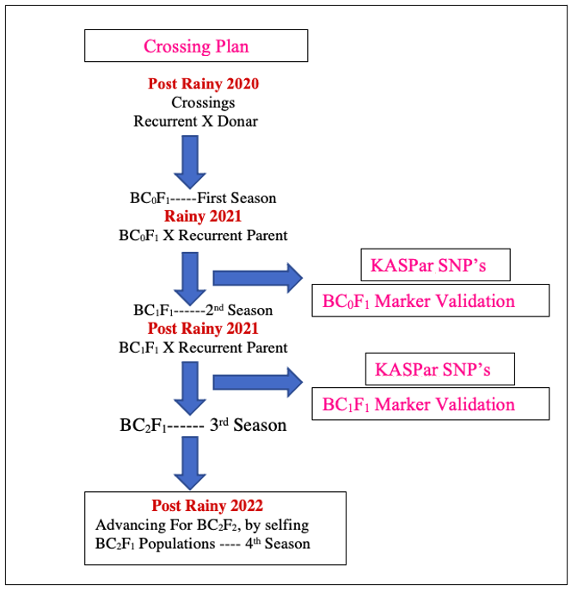

Fig. 1- Backcrossing program to introgress *bmr*-*6* in the recurrent parent.

**DNA extraction**

After obtaining BC1F1 generations, genomic DNA was extracted using Phenol-chloroform method [Xia *et al*., 2019]. Briefly, 100 mg of Sorghum was grounded and one ml of DNA extraction buffer (20 g SDS/l, 150 mM NaCl, 100 mM Tris/HCl, 25 mM EDTA, pH 8.0) preheated at 65°C was added and mixed followed by adding 10μl Proteinase K (10 mg/ml). Then, the reaction tube was incubated at 65°C for 1 h, with stirring every 10 min. After centrifuging the tube for 10 min at 12000×g, the supernatant was extracted twice with phenol/chloroform/isoamyl alcohol (P: C: I, 25: 24: 1, v/v/v) (first extraction) and chloroform/isoamyl alcohol (C: I, 24: 1, v/v) (second extraction), respectively. Then the upper aqueous phase was added with 0.1 volume potassium acetate solution (3 M, pH 5.5) and double volume of ethanol solution (95%, v/v, −20°C) (first precipitation), followed by gentle inversion and vortex for 10 min at 15000×g to pellet DNA. After washing the pellet with ethanol solution (70%, v/v, −20°C) twice and air drying for 5 min, the dried pellet was dissolved with 400 μl Tris/EDTA buffer (10 mM Tris, 1 mM EDTA). Ten milligram of RNase was added in the mixture and an incubation at 37°C for 30 min was performed to eliminate the remaining RNA. Another extraction with C:I (third extraction) was carried out to remove protein from DNA solution. Recovering the upper layer to a new sterile tube containing 2.5 vol of ethanol (second precipitation) would help precipitate DNA readily. After spinning tube at 15000×g for 10 min and washing DNA pellet twice, the dried DNA was redissolved in 200 μl sterile, deionized water.

**Marker-assisted selection**

The above genomic DNA was analyzed for CAPS for *bmr6*, by amplifying by PCR using the primer pair CACAACCACTCCCACTACTG CGAAC (Forward primer) and GTCACCAC AAGGCATACG (Reverse primer) in a 20-μl reaction (Sattler *et al*. 2009). Further, the foreground selection across the donor-recurrent parent combination was performed by identifying the presence of one KASPar SNP (snpSB00519)marker in target *bmr* region on the chromosome 4 (*bmr* 6) (Gorthy *et al* 2013). These KASPar assays for the targeted Chr-4, mutation C-to-T at 2800 bp of CAD gene were conducted using the primers for WT allele: GGCGAAGCCGCCCTG, mutant allele: GGCGAAGCCGCCCTA and common reverse primer: GCAACAAGAAGA-TCTGGTCCT, which are adapted from (Burow *et al*., 2019). Genotyping reactions were performed in a final volume of 10μl reaction mixture containing 1× KASP Reaction Mix, 1-μl assay mix which includes the two allele specific SNP primers plus the common reverse primer, and 10–20 ng genomic DNA. The cycling conditions for PCR were: 15 min at 94 °C; 10 touchdown cycles of 20 s at 94 °C, 60 s at 63–55 °C (dropping 0.8 °C per cycle); and 30 cycles of 20 s at 94 °C, 60 s at 55 °C.

**Kompetitive allele specific polymerase (KASP) assays for SNP validation**

KASPar assays were performed for all the identified SNPs in the *bmr* introgressed plants both genotypically and phenotypically. When F1 and BC1F1 populations were developed, genotyping has been performed for both parents and off-springs at four leaf stage, using specific KASP markers. Specific SNP of N609 for *bmr6*, where *bmr6*-39-3699, chr4, A to G at 3699 of cinnamyl alcohol dehydrogenase (CAD) gene, was selected for marker validation. The specific KASP primers for *bmr6*- (*BMR6*-132) was verified for deployment as markers for the brown midrib trait at seedling stage using an F2 population from a cross of {(SSV84 X N609) X SSV84)}. Accordingly, phenotyping of each individual involved was also performed to validate the correspondence of genotype to phenotype.

**Foreground selection of (KASP)-SNP molecular markers**

Crosses were made among the recurrent and donor parents for obtaining BC0F1. DNA was collected from the leaf samples at the 4 to 5-leaf stage. Standard protocols for DNA isolation were followed by PCR amplification of the amplified products, which were size fractionized, by using capillary electrophoresis on ABI3700 automatic DNA sequencer (Applied Biosystems USA). The KASPar SNP genotyping of samples was done at Intertek Hyderabad. For designing *bmr6* genes specific KASPar-SNP markers and using them in identifying for screening of BC0F1, BC1F1, which carries the *bmr6* genes in sweet sorghum/high biomass sorghum lines that concern in the heterozygous conditions, BC2F1’s was self-fertilized for producing BC2F2 lines and plants carrying *bmr6* genes were selected in homozygous positions.

**Data analysis**

The genotypic segregation of populations in BC0F1 & BC1F1 was assessed by Chi square test (χ2) and the obtained proportion of populations were compared with expected codominant segregation (1:2:1). These analyses was carried out using the GENES program (Cruz 2016). R-studio software was used to generate the cluster plots.

**Results**

**Development of bmr6 hybrids through marker-assisted backcrossing**

The brown midrib trait as conferred by *bmr6* with N609 as source, was successfully introgressed into 2 sweet sorghum and one high biomass sorghum line for developing superior elite introgressed lines expressing bmr trait in the background of sweet sorghum and high biomass type of sorghum phenotype. Crosses were made between sweet sorghum, high biomass sorghum WT lines and *bmr* donor parent. Hybridity in BC-F1s was confirmed through *bmr* phenotyping and foreground selections using KASPar SNP markers. The foreground selection clearly identified the plants that carried *bmr*-6 allele in heterozygous state (Fig. 2).

Fig.2-Display of the recurrent and the donor parents along with introgression lines

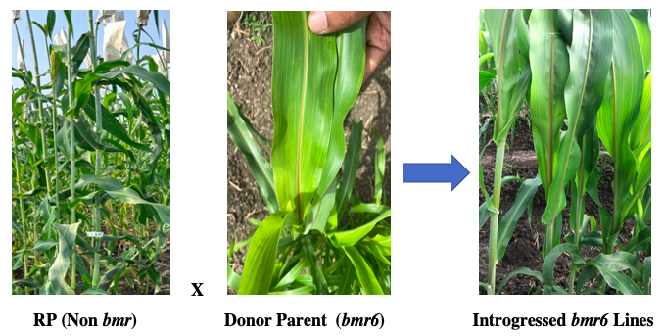

**KASPar assays for SNP**

The parent N609 harbors homozygous SNP mutation for *bmr6*-ref as expected and the SSV84 parent is WT. The resulting F1- (SSV84 X N609) was heterozygous for *bmr6*-ref, which is similar to other recipient recurrent parents ICSV18003 and ICSV15024 (Table 2). These are further back crossed for resulting heterozygous SNP mutated (A:G) generation.

Table 2. Genotypic Data for 3 elite bmr-6 introgressed populations

|  |  |  |  |  |
| --- | --- | --- | --- | --- |
| S. No | Parent/Cross | Generation | snpSB00519_CALL | Status |
| 1 | SSV84 | RP | G:G | Polymorphic |
| 2 | N609 | DP | A:A | Polymorphic |
| 3 | (SSV84 X N609) | BC0F1 | A:G | Polymorphic |
| 4 | {(SSV84 X N609) X SSV84} | BC1F1 | A:G | Polymorphic |
| 5 | {(SSV84 X N609) X SSV84 X SSV84)} | BC2F1 | Advanced for BC2F2 | |
| S. No | Parent/Cross | Generation | snpSB00519_CALL | Status |
| 1 | ICSV18003 | RP | G:G | Polymorphic |
| 2 | N609 | DP | A:A | Polymorphic |
| 3 | (ICSV18003 X N609) | BC0F1 | A:G | Polymorphic |
| 4 | {(ICSV18003 X N609) X ICSV18003} | BC1F1 | A:G | Polymorphic |
| 5 | {(ICSV18003X N609) X ICSV18003 X ICSV18003)} | BC2F1 | Advanced for BC2F2 | |
| S. No | Parent/Cross | Generation | snpSB00519_CALL | Status |
| 1 | ICSV15024 | RP | G:G | Polymorphic |
| 2 | N609 | DP | A:A | Polymorphic |
| 3 | (ICSV15024 X N609) | BC0F1 | A:G | Polymorphic |
| 4 | {(ICSVI5024 X N609) X ICSV15024)} | BC1F1 | A:G | Polymorphic |
| 5 | {(ICSV15024 X N609) X ICSV15024 X ICSV15024)} | BC2F1 | Advanced for BC2F2 | |

(RP-Recipient Parent, DP-Donor Parent, BC0F1 -F1generation without back cross, BC1F1-F1 generation with one back cross, BC2F1- F1generation with two back crosses)

**Foreground selection**

About six (6) plants were used for first cross combination of SSV84 X N609 where in F1 generation three (3) true hybrids were obtained, followed by twelve (12) plants were used for backcrossing them and the resulting generation had four (4) true hybrids. Further, two (2) plants were used for second cross ICSV15024 X N609, resulting two true hybrids in F1 generation, followed by four (4) true hybrids in BC1F1 generation. In addition, third combination of ICSV18003 X N609 resulted two (2) true hybrids in F1 generation, followed by one (1) true hybrids in BC1F1 generation, respectively. The results obtained are depicted in table-3.

Table 3: Selections for foreground SNP markers across cross combinations in BC-F2 generations *bmr6* introgression

|  |  |  |  |  |  |
| --- | --- | --- | --- | --- | --- |
| No of plants and true hybrids in each generation | | | | | |
|  |  | BC0F1 | | BC1F1 | |
| Cross Combination | No of KASPar SNPs utilized for FGS | No of Plants | No of True Hybrids | No of Plants | No of True Hybrids |
| (SSV84 X N609) | 1 | 6 | 3 | 12 | 4 |
| (ICSV15024 X N609) | 1 | 2 | 2 | 9 | 4 |
| (ICSV18003 X N609) | 1 | 5 | 2 | 3 | 1 |

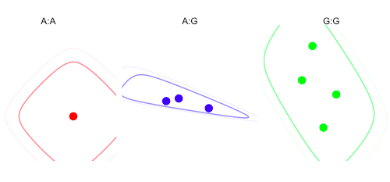 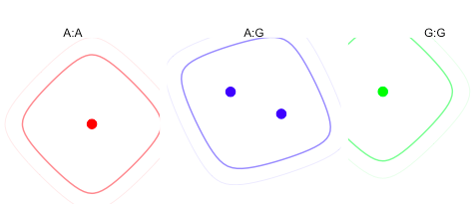

(b) BC0F1- (ICSV15024 X N609)

(a) BC0F1-(SSV84 X N609)

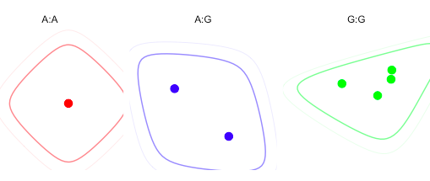 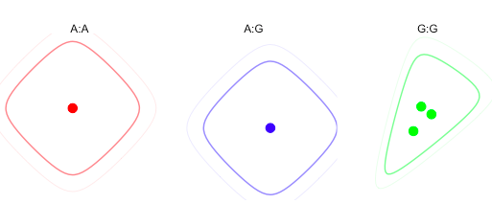

(d) BC1F1-{(ICSV18003 X N609) X ICSV18003)}

(c) BC0F1- (ICSV18003 X N609)

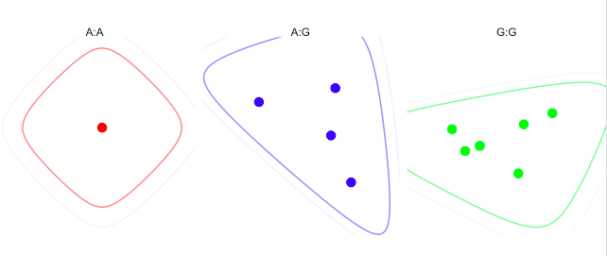 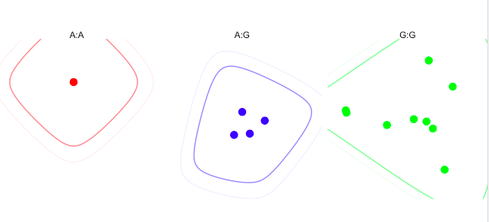

(e) BC1F1-{(ICSV15024 X N609) X ICSV15024)}

(f) BC1F1-{(SSV84 X N609) X SSV84)}

Fig.3- Genotyping of BC0F1 & BC1F1 individuals with the KASP marker (snpSB00519)

From the diagrammatic representation, introgressed plants were screened at BC0F1 & BC1F1 stages using KASPar SNPs. The dots show polymorphism at a locus on the chromosome SBI 4. The red spots represent the homozygous gene (A:A) from the donor parents N609 (*bmr6*) and the blue spots represent the heterozygous allele (A:G) from both the parents, whereas green spots indicate the homozygous gene (G:G) from high biomass parent & sweet sorghum recurrent parents i.e. (ICSV15024 ) and (ICSV18003 & SSV84). The highest number of true hybrids were obtained in the BC1F1 cross {(ICSV15024 X N609)X ICSV15024)} and {(SSV84 X N609) X SSV84)} compared with BC1F1s {(ICSV18003 X N609) X ICSV18003)}.

**Discussion**

Sweet sorghum, a lignocellulosic grass species, represents a good source of 2nd generation biofuel feedstock [Kanbar *et al*., 2020]. Sweet sorghum is characterized by wide adaptability to marginal growing conditions, resilience, and, due to its efficient C4 photosynthetic pathway, it produce high biomass yield [Mullet *et.al*., 2014] in a more stable way. Sorghum gives a better energy yield and net gain than sugar beet (*Beta vulgaris* L.), and has a higher net energy balance than grain sorghum and maize [Palambo et al., 2014]. In sorghum, brown midrib *bmr*6 and *bmr*12 impair the last two steps of monolignol synthesis. The *bmr* genes were introduced into grain sorghum to improve the digestibility of lignocellulosic tissues for grazing or bioenergy uses following grain harvest [Sattler *et al*., 2010]. In the present study, we aimed at transferring the *bmr*6 allele into sweet sorghum and high biomass sorghum lines for developing new elite high biomass and low lignin sorghum lines. Crosses and backcrosses involved sweet sorghum, high biomass sorghum lines and *bmr6* donor parents, SSV84 X N609, ICSV18003 X N609 & ICSV15024 X N609, to generate 3 populations of lines introgressed with *bmr6* gene for the purpose of obtaining higher yileds of ethanol bioconversion process without compromising the primary productivity in terms of biomass and grain production.

According to Silva [2020], sorghum plants can be recognised visually and categorised as either having brown midrib (*bmr*) or (WT) phenotypes as early as the 8-leaf growth stage. In this study, images of both *bmr* and non-*bmr* plants were obtained at a later stage to document the variation for leaf midrib phenotype since brown midrib was not visible or certain at earlier stages.

Additionally, it was shown that some *bmr* genotypes can lose their phenotype throughout the reproductive stage, making the application of DNA markers essential for precisely identifying the lines that carry the true *bmr* lines. In sorghum, the use of DNA markers for marker-assisted breeding and selection is still in its infancy (Burow *et al*. 2019). The goal of the KASP test in marker-assisted backcrossing in sorghum and other cultivars is to expedite the production of nearly isogenic lines in 3 years as opposed to 5–6 years using the traditional backcrossing approach, and this can enhance yield. A stop codon was created by an induced mutation from C to T at amino acid position 132 in the cinnamyl alcohol dehydrogenase (CAD) gene, which controls *bmr6* (Sattler et al. 2009). This served as the concept for the *bmr6* CAPS marker that was used in this investigation to determine the genotype of *bmr6* lines. For each gene, heterozygotes were easily distinguished, and the observed F2 phenotypes matched the identified genotypic conditions. In the present study, the *bmr6* gene of chromosome 4, was successfully introgressed and identified in BC1F1 generation, through marker validation.

**Conclusions**

The *bmr6* allele was successfully introgressed and identified in F1 generations of the back crosses. This allele was observed in almost all the crosses, and at least one true hybrid was obtained from each cross. The phenotypic and genotypic identification of SNP-SB00519 confirmed the introgression of the *bmr6* gene into sweet and high biomass sorghums. The introgressed lines developed in this work are expected to boost *bmr* breeding programmes in sorghum and improve ethanol bioconversion processes for sustainable bioenergy production.

**References**

1. Reddy, B. V., Ramesh, S., Reddy, P. S., Ramaiah, B., Salimath, M., & Kachapur, R. (2005). Sweet sorghum-a potential alternate raw material for bio-ethanol and bio-energy. International Sorghum and Millets Newsletter, 46, 79-86.
2. Mask, P. L., & Morris, W. C. (1991). Sweet sorghum culture and syrup production. Circular ANR-Alabama Cooperative Extension Service, Auburn University (USA).
3. Dilley, R. J., & Morrison, W. A. (2014). Vascularisation to improve translational potential of tissue engineering systems for cardiac repair. The international journal of biochemistry & cell biology, 56, 38-46.
4. Hills, F., Lewellen, R., & Skoyen, I. (1990). Sweet sorghum cuItivars for alcohol production. California agriculture, 44(1), 14-16.
5. Putnam, D. H., Lueschen, W. E., Kanne, B. K., & Hoverstad, T. R. (1991). A comparison of sweet sorghum cultivars and maize for ethanol production. Journal of Production Agriculture, 4(3), 377-381.
6. Porter et.al., (1978). Phenotype, fiber composition and invitro organic matter disappearance of chemically induced brown midrib mutants of sorghum. Crop Sciences 18,205.
7. Sattler et.al., (2010). Brown midrib mutations and their importance to the utilization of maize, sorghum and pearl millet lignocellulosic tissues. Plant Science178, 229-238.
8. Sunita Gorthy et.al., (2012). Molecular Characterization of allelic variation in spontaneous brown midrib mutants of Sorghum (Sorghum bicolor (L.) Moench. Molecular Breeding. DOI:10.1007/s11032-012-9834-4.
9. Saballos A, Vermerris W, Rivera L, Ejeta G (2008). Allelic association, chemical characterization and saccharification properties of brown midrib mutants of sorghum.
10. Barriere Y., et.al (2003). Genetic variation and breeding strategies for improved cell wall digestibility in annual forage crops. A review. Animal Research, EDP sciences,52 (3), pp.193-228<10.1051/animres:2003018>. <hal00889970>.
11. Nagaiah D, Srinivasa Rao P, Prakasham RS, Uma A, Radhika K, Barve Y, Umakanth AV (2012). High biomass sorghum as a potential raw material for biohydrogen production: a preliminary evaluation. Current Trends in Biotechnology & Pharmacy, 6: 1-6.
12. Jung, H.G. and G.C. Fahey. 1983. Nutritional implications of phenolic monomers and lignin: a review. J. Anim. Sci. 57:206.
13. Kuc’, J. and O.E. Nelson. 1964. The abnormal lignins produced by the brown midrib mutants of maize. I. The brown midrib-1 mutants. Arch. Biochem. Biophys. 105:103.
14. Mathur, S., Umakanth, A. V., Tonapi, V. A., Sharma, R., & Sharma, M. K. (2017). Sweet sorghum as biofuel feedstock: recent advances and available resources. Biotechnology for Biofuels, 10, 1-19.
15. Umakanth, A. V., Datta, A., Reddy, B. S., & Bardhan, S. (2022). Biomass feedstocks for advanced biofuels: Sustainability and supply chain management. Advanced Biofuel Technologies, 39-72.
16. Oliveira, D. M., Mota, T. R., Grandis, A., de Morais, G. R., de Lucas, R. C., Polizeli, M. L., ... & dos Santos, W. D. (2020). Lignin plays a key role in determining biomass recalcitrance in forage grasses. Renewable Energy, 147, 2206-2217.
17. Sattler, S. E., Funnell-Harris, D. L., & Pedersen, J. F. (2010). Efficacy of singular and stacked brown midrib 6 and 12 in the modification of lignocellulose and grain chemistry. Journal of Agricultural and Food Chemistry, 58(6), 3611-3616.
18. Palumbo, A. D., Vonella, A. V., Garofalo, P., D'Andrea, L., & Rinaldi, M. (2014). Response of a two-year sugar beet-sweet sorghum rotation to an agronomic management approach diversified by soil tillage and nitrogen fertilisation. Italian Journal of Agronomy, 9(3), 109-114.
19. Kanbar, A., Shakeri, E., Alhajturki, D., Horn, T., Emam, Y., Tabatabaei, S. A., & Nick, P. (2020). Morphological and molecular characterization of sweet, grain and forage sorghum (Sorghum bicolor L.) genotypes grown under temperate climatic conditions. Plant Biosystems-An International Journal Dealing with all Aspects of Plant Biology, 154(1), 49-58.
20. da Silva, M. J., Damasceno, C. M. B., Guimarães, C. T., de Oliveira Pinto, M., de Almeida Barros, B., de Souza Carneiro, J. E., ... & da Costa Parrella, R. A. (2020). Introgression of the *bmr*6 allele in biomass sorghum lines for bioenergy production. Euphytica, 216(6), 95.
21. Schuetz M., Benske A., Smith R.A., Watanabe Y., Tobimatsu Y., Ralph J., Demura T., Ellis B., Samuels A.L. Laccases direct lignification in the discrete secondary cell wall domains of protoxylem. *Plant Physiol.*2014;166:798–807. doi: 10.1104/pp.114.245597
22. Ithal N., Recknor J., Nettleton D., Maier T., Baum T.J., Mitchum M.G. Developmental transcript profiling of cyst nematode feeding cells in soybean roots. *Mol. Plant Microbe Interact.*2007;20:510–525. doi: 10.1094/MPMI-20-5-0510.
23. Rao, P. S., Deshpande, S., Blümmel, M., Reddy, B. V., & Hash, T. (2012). Characterization of brown midrib mutants of sorghum (Sorghum bicolor (L.) Moench). European Journal of Plant Science and Biotechnology.
24. Adeyanju, A. O., Sattler, S. E., Rich, P. J., Rivera-Burgos, L. A., Xu, X., & Ejeta, G. (2021). Sorghum brown midrib19 (Bmr19) gene links lignin biosynthesis to folate metabolism. Genes, 12(5), 660.
25. Oliver AL, Pedersen JF, Grant RJ, Klopfenstein TJ (2005) Comparative effects of the sorghum bmr-6 and bmr-12 genes. I Forage sorghum yield and quality. Crop Sci 45:2234–2239
26. Cruz CD. Genes Software-extended and integrated with the R, Matlab and Selegen. Acta Scientiarum. Agronomy. 2016;38:547-552.
27. Burow G, Chopra R, Sattler S, Burke J, Acosta-Martinez V, Xin Z. Deployment of SNP (CAPS and KASP) markers for allelic discrimination and easy access to functional variants for brown midrib genes *bmr6* and *bmr12* in *Sorghum bicolor*. Molecular Breeding. 2019;39:1-10.
28. Cotton J, Burow G, Acosta-Martinez V, Moore-Kucera J (2013) Biomass and Cellulosic Ethanol Production of Forage Sorghum Under Limited Water Conditions. Bioenergy Research 6 (2):711-718. doi:10.1007/s12155-012-9285-0.
29. Corredor DY, Salazar JM, Hohn KL, Bean S, Bean BRENTl, Wang DONGHAI. Evaluation and characterization of forage sorghum as feedstock for fermentable sugar production. Applied Biochemistry and Biotechnology. 2009;158:164-179.
30. Bennett AS, Anex RP. Production, transportation and milling costs of sweet sorghum as a feedstock for centralized bioethanol production in the upper Midwest. Bio resource Technology. 2009;100(4):1595-1607.