**“Biological management of late blight of potato (*Solanum tuberosum L*) using *Trichoderma* spp*.”***

**ABSTRACT**

The potato (*Solanum tuberosum L*) is a member of the *Solanum* genus within the *Solanaceae* family, with a chromosome number of 2n=48.The experiment was performed in Rabi season (2024-25) at Plant Pathology lab in Rama University, and Randomized *Block Design (RBD*) was followed. In present study treatment was taken as five types: The treatments included: T₁ - inoculation with *P. infestans*; T₂ - inoculation with *Trichoderma* spp. only; T₃ -*Trichoderma* spp. + *P. infestans* (protective treatment); T₄ -*Trichoderma* spp. and *P. infestans* applied simultaneously; and T₅ - uninoculated control. Late blight of potato, caused by *Phytophthora infestans*, leads to major yield losses. In this study, the antagonistic activity of different *Trichoderma* species was evaluated in vitro and in vivo. Dual culture assays revealed that *T. harzianum* (Th2) inhibited *P. infestans* by 95%, followed by *T. asperellum* (80%) and *T. viride* (75%). Moderate inhibition was shown by *T. koningii* and *T. longibrachiatum*.Defence enzyme activities in potato leaves were significantly enhanced by *T. harzianum* (T1), with PAL activity increased 3.6-fold at 48 h, PO by 8.2-fold at 72 h, and PPO by 5.4-fold at 72 h. *T. viride* (T2) and *T. asperellum* (T3) also induced enzyme activity.Plant growth under late blight stress was improved by *Trichoderma* treatments, especially T1, which recorded root length of 17.8 cm, shoot length of 142.25 cm, 18.4 leaves per plant, and 21.80 g dry weightat 90 DAT. T2 and T3 followed in efficacy, while the control showed the lowest values. These results highlight *T. harzianum* as the most effective biocontrol agent against late blight in potato.

**KEYWORDS**: *Solanum tuberosum*, *Phytophthora infestans*, *Trichoderma harzianum*, Late blight, Biocontrol

**INTRODUCTION**

Potato (*Solanum tuberosum* L.), a tetraploid member of the Solanaceae family (2n=48), stands as one of the most vital food crops worldwide. It is cultivated over 19.32 million hectares with an annual global yield of approximately 325.3 million tonnes (FAO, 2007). Praised for its high nutritional value, affordability, and adaptability to diverse climates, the potato has earned the moniker “friend of the poor.” In India, potato is a key cash crop, accounting for approximately 28% of total vegetable production (CMIE, 2023). India ranks second globally, producing around 54.23 million metric tonnes. However, potato production is influenced by climatic variability and population pressure. In 2023, Uttar Pradesh remained the largest producer with 54.89 million tonnes, followed by West Bengal and Gujarat. The area under cultivation ranged from 2.05 to 2.33 million hectares between 2019 and 2023 (NHB, 2023).

Among the major threats to potato cultivation is late blight, caused by *Phytophthora infestans* (Mont.) de Bary-an oomycete pathogen notorious for causing the Irish potato famine in the *1840s* and still responsible for crop losses exceeding $5 billion annually. In India, late blight severely affects cooler, humid regions such as Uttar Pradesh, West Bengal, Punjab, Himachal Pradesh, and Jharkhand.The disease is favoured by cool temperatures (10–20°C) and high humidity. The pathogen spreads rapidly via wind- or water-dispersed sporangia and zoospores, infecting plant tissues through natural openings or wounds. Common symptoms include water-soaked lesions on foliage and brown rot in tubers. *P. infestans* reproduces both asexually (through sporangia) and sexually (via oospores), making it highly adaptive and difficult to control even with improved cultivars and advanced agronomic practices.

*Trichoderma* spp. (Ascomycota: Hypocreaceae), first described in 1794, are beneficial soil fungi widely recognized for their biocontrol potential. These fungi combat plant pathogens by mechanisms such as rapid root colonization, nutrient competition, mycoparasitism, and production of antimicrobial compounds. More than 200 species have been identified, with *T. viride* and *T. harzianum* being the most extensively studied.

Biocontrol, broadly defined as the use of living organisms or their metabolites to suppress plant diseases, is gaining prominence. While several microbial biopesticides are commercially available, their efficacy often depends on environmental conditions. Thus, the term “bioprotectants” has been proposed to encompass both living agents and their natural bioactive compounds, offering a broader scope for disease management solutions.

MATERIALS &METHODS

**Experimental Site**

The study was carried out in the Department of Plant Pathology, Faculty of Agricultural Sciences & Allied Industries, Rama University, Mandhana, Kanpur (U.P.), utilizing diseased potato samples collected from late blight-affected fields in Kanpur and nearby districts including Kannauj, Farrukhabad, Etawah, Hapur, Rampur, Unnao, Auraiya, Hamirpur, and Fatehpur. Kanpur lies in the central part of Uttar Pradesh at with an elevation of 285 meters above mean sea level. The laboratory facilities used for this research were fully equipped for the isolation, identification, pathogenicity testing of *Phytophthora infestans*, and for in vitro bioassays under controlled environmental conditions.

**Collection and Isolation of *Phytophthora infestans***

During the 2024-25 cropping season, a random roving survey was conducted in multiple potato-growing regions to record the incidence and severity of late blight. Disease scoring was performed using a 1-9 scale, where 1 indicated no symptoms and 9 represented severe disease. Leaves showing typical symptoms of late blight were collected in clean paper bags and transported promptly to the laboratory for further analysis.

For isolation, 3-5 mm sections were excised from the junction between healthy and infected tissue. These segments were surface sterilized in 0.1% mercuric chloride (HgCl₂) for 30 seconds, followed by three rinses in sterile distilled water to eliminate njjresidual disinfectant. The tissues were then aseptically transferred to sterile Petri dishes containing Potato Dextrose Agar (PDA) medium. Plates were incubated at 20-25°C for 5-7 days. Fungal colonies emerging from the tissues were regularly sub-cultured to obtain pure cultures. These pure cultures were maintained on PDA slants at 4°C for further use.

The morphology of emerging fungal colonies was observed after culturing on PDA. Colonies typically appeared cottony white to greyish in colour with radiating, slow-growing mycelia. For microscopic examination, a small amount of mycelium was stained with lactophenol cotton blue and examined under a compound microscope at 10× and 40× magnification. Microscopic observations revealed coenocytic (non-septate) hyphae and papillate, lemon-shaped sporangia borne on simple or branched sporangiophores. The release of zoospores under cold conditions confirmed the identity of the pathogen. These morphological and microscopic features were compared with standard literature (*Erwin & Ribeiro, 1996*) to confirm the isolate as *Phytophthora infestans*.

To verify the pathogenicity of the isolated organism, Koch’s postulates were followed. A sporangial suspension was prepared by flooding 7-day-old cultures of *P. infestans* grown on PDA with sterile distilled water, followed by gentle scraping to dislodge the sporangia. The suspension was filtered through muslin cloth and adjusted to a concentration of approximately 5 × 10⁴ sporangia/mL using a hemacytometer. Four-week-old healthy potato plants (cv. Kufri Bahar) were uniformly sprayed on the abaxial leaf surfaces using a hand sprayer. Inoculated plants were kept under high humidity (>90%) and at a temperature of 18-22°C to promote disease development. Typical late blight symptoms such as water-soaked lesions, brown necrotic patches, and sporulation were observed within 7-10 days. The pathogen was re-isolated from symptomatic tissue, and its identity was confirmed based on colony morphology and microscopic features, thereby fulfilling Koch’s postulates.

***In Vitro* Evaluation of *Trichoderma* spp. Against *Phytophthora infestans***

*Trichoderma* spp. were isolated from the rhizospheric soil of healthy potato plants growing in districts such as Kannauj, Unnao, Farrukhabad, Auraiya, and Hamirpur. Soil samples were collected from a depth of approximately 10-15 cm using a sterile spatula and transported in sterile polythene bags to the laboratory. The samples were shade-dried, sieved, and processed using the serial dilution method. Ten grams of soil were suspended in 90 mL of sterile distilled water and serially diluted up to 10⁻⁵.

Aliquots (1 mL) from 10⁻³ to 10⁻⁵ dilutions were aseptically poured onto sterile Petri plates containing Trichoderma Selective Medium (TSM). Plates were incubated at 25 ± 2°C for 5-7 days. Colonies showing rapid growth and characteristic green pigmentation were considered as *Trichoderma* spp. and were sub-cultured on PDA for purification. The pure cultures were maintained on PDA slants at 4°C for future studies.

To assess the antagonistic effect of *Trichoderma* isolates against *P. infestans*, a dual culture assay was performed. A 5 mm mycelial disc from a 7-day-old *Trichoderma* culture was placed 1 cm from the edge of a PDA plate. On the opposite side, another 5 mm disc from a 7-day-old *P. infestans* culture was placed approximately 3 cm apart. Plates inoculated with only *P. infestans* served as controls. All plates were incubated at 20 ± 2°C for 5-7 days. The radial growth of *P. infestans* was measured in both treated and control plates. The percentage inhibition over control was calculated using the formula: $$PI=\frac{C-T}{C}× 100$$

Where, **PI = per cent inhibition over control**, **C = Growth of test pathogen with absence of antagonist (mm)**. **T = Growth of test pathogen with antagonist (mm)**. (*Whipps, 1997).*

**Efficacy of *Trichoderma* spp. Against Late Blight in Pot Culture.**

To prepare the inoculum, *Phytophthora infestans* was cultured on Rye Agar Medium and incubated at 20 ± 2°C for 7 days. A sporangial suspension was prepared by flooding the culture plate with sterile distilled water, gently scraping the surface, filtering through sterile muslin cloth, and adjusting the concentration to 5 × 10⁴ sporangia/mL using a hemocytometer. *Trichodermaspp.* isolates were grown on Potato Dextrose Agar (PDA) for 7 days at 25 ± 2°C, and a conidial suspension was prepared and adjusted to 1 × 10⁷ conidia/mL. Certified seed tubers of potato (cv. *Kufri Bahar*) were surface sterilized using 0.1% sodium hypochlorite, rinsed with sterile water, and air-dried. Pots (12-inch diameter) were filled with 5 kg of autoclaved soil mixture (loam, sand, compost in 2:1:1 ratio), and one tuber was planted per pot. The experiment was arranged in a Completely Randomized Design (CRD) with five treatments: inoculation with *P. infestans* alone (pathogen control), inoculation with *Trichoderma* alone, application of *Trichoderma* 48 hours before *P. infestans* (protective treatment), simultaneous application of *Trichoderma* and *P. infestans*, and an uninoculated healthy control. Each treatment was replicated three times.

In protective treatment, *Trichoderma* was applied both as a soil drench (100 mL per pot) and foliar spray (20 mL per plant) 48 hours before pathogen inoculation. In the pathogen control and protective treatments, *P. infestans* suspension was sprayed on the foliage until runoff during the evening to mimic natural infection. To maintain high humidity (>90%), plants were covered with transparent plastic bags for 48 hours and kept at 18-22°C under greenhouse conditions. Disease severity was assessed 10 days post-inoculation using a 0-5 rating scale, and Percent Disease Index (PDI) was calculated using the formula:

**PDI= $∑$ (Disease score x Number of leaves) X 100**

**Total leaves x 5**

In addition to disease scoring, plant growth parameters such as height, number of leaves, fresh and dry weight of shoot and root were recorded. Dry weights were obtained after oven drying samples at 60°C for 48 hours. Collected data were subjected to ANOVA using SPSS or R, and means were compared using LSD or Tukey’s test at a 5% significance level.

**Biochemical Analysis**

To assess biochemical defense responses in potato leaves, samples were collected at 0, 24, 48, 72, and 96 hours after inoculation with *P. infestans*. The activities of phenylalanine ammonia-lyase (PAL), peroxidase (PO), polyphenol oxidase (PPO), superoxide dismutase (SOD), total phenol content (TPC), and hydrogen peroxide (H₂O₂) were analysed using standard protocols with slight modifications.

For PAL assay, 0.1 g of fresh leaf tissue was homogenized in 2 mL of ice-cold sodium borate buffer (0.1 M, pH 7.0) with 1.4 mM β-mercaptoethanol. After centrifugation at 16,000 rpm for 15 minutes at 4°C, the supernatant was mixed with phenylalanine solution and incubated at 32°C for 30 minutes. PAL activity was measured at 290 nm and expressed as µmol trans-cinnamic acid formed per gram of fresh weight. For PPO, 0.1 g leaf tissue was homogenized in phosphate buffer (0.1 M, pH 6.5), centrifuged, and the supernatant was reacted with catechol. The increase in absorbance was recorded at 405 nm, and enzyme activity was expressed as ΔOD min⁻¹ g⁻¹ FW. PO activity was estimated using pyrogallol and hydrogen peroxide, with absorbance monitored at 420 nm. The result was expressed as change in absorbance per minute per gram of fresh weight.

Disease incidence was scored based on a 0–4 visual scale, where 0 indicated healthy plants with no symptoms, and 4 represented complete infection with more than 60% foliage blighted. Intermediate scores reflected increasing severity (1 = 1–20% affected, 2 = 21–40%, 3 = 41–60%). Disease incidence (%) was calculated as:

$$Disease incidence \left(\%\right)=\frac{∑scale ×number of plants infected}{highest scale × total number of plants}$$

This method allowed quantitative assessment of the effectiveness of *Trichoderma* in suppressing late blight in potato plants.

**RESULTS AND DISCUSSION.**

A survey was conducted in 10 districts of Kanpur and nearby regions during 2024-25 to assess late blight incidence and collect infected potato samples. Twenty isolates of *Phytophthora infestans* (Pi-01 to Pi-20) were obtained and purified. Pathogenicity tests revealed that 10 isolates produced typical late blight symptoms, confirming Koch’s postulates. Among them, **Pi-2 (Kannauj)** was the most virulent and selected for further studies.

Cultural variability was observed among the ten pathogenic isolates. Radial growth ranged from 35.4 mm to 71.0 mm, with differences in colony colour, texture, and presence of aerial mycelium. Pi-2, Pi-8, and Pi-16 showed fast growth and dense mycelium, while Pi-19 had the least growth.

Under pot culture, no symptoms appeared at 15 days after inoculation (DAI), but initial symptoms were observed at 30 DAI in Pi-2, Pi-8, Pi-16, and Pi-17. By 90 DAI, Pi-2 showed the highest percent disease incidence (PDI), followed by Pi-8 and Pi-16. Isolates Pi-6, Pi-9, Pi-19, and Pi-20 showed lower PDI.

*In vitro* studies revealed that *Trichoderma harzianum* (Th2) had the highest antagonistic activity against *P. infestans*, reducing its radial growth by 95%, followed by *T. asperellum* (80%) and *T. viride* (75%). Mycelial deformation and hyphal lysis of *P. infestans* were observed in dual culture, especially with Th2.

**Effect of Various *Trichoderma* spp. on Growth Parameters of Potato Crop (2024-2025) Under Late Blight Stress**

**Root Length**

All *Trichoderma*-treated plants showed significantly higher root length than the control (T5) at all time intervals. *T. harzianum* (T1) performed best throughout, followed by *T. viride* (T2), *T. asperellum* (T3), and *T. koningii* (T4). At 90 DAT, T1 recorded the highest root length (17.8 cm) compared to the control (9.0 cm).

**Table 1: Effect of *Trichoderma* spp. on Root Length (cm) of Potato Under Late Blight Stress**

|  |  |  |  |  |  |
| --- | --- | --- | --- | --- | --- |
| Treatment | *Trichoderma* spp. | 15 DAT | 45 DAT | 60 DAT | 90 DAT |
| T1 | *T. harzianum* | 11.50 | 13.80 | 15.50 | 17.80 |
| T2 | *T. viride* | 9.60 | 12.50 | 14.00 | 16.40 |
| T3 | *T. asperellum* | 8.90 | 10.60 | 12.20 | 14.30 |
| T4 | *T. koningii* | 6.70 | 8.30 | 10.00 | 12.10 |
| T5 | Control | 5.50 | 6.50 | 7.80 | 9.00 |
| SE(m)± |  | **0.32** | **0.38** | **0.42** | **0.47** |
| CD (5%) |  | **0.94** | **1.12** | **1.23** | **1.37** |

**Shoot Length**

*Trichoderma*-treated plants exhibited enhanced shoot growth. *T. harzianum* (T1) showed the maximum shoot length at all stages. At 90 DAT, T1 recorded 142.25 cm versus 94.60 cm in the control.

**Table.2: Effect of *Trichoderma* spp. on Shoot Length (cm) of Potato.**

|  |  |  |  |  |  |
| --- | --- | --- | --- | --- | --- |
| Treatment | *Trichoderma* spp. | 15 DAT | 45 DAT | 60 DAT | 90 DAT |
| T1 | *T. harzianum* | 57.50 | 88.65 | 117.40 | 142.25 |
| T2 | *T. viride* | 45.13 | 74.80 | 98.25 | 128.60 |
| T3 | *T. asperellum* | 42.25 | 69.45 | 93.10 | 119.80 |
| T4 | *T. koningii* | 37.10 | 60.75 | 85.60 | 112.25 |
| T5 | Control | 30.50 | 49.20 | 73.80 | 94.60 |
| SE(m)± |  | **1.52** | **1.94** | **2.12** | **2.38** |
| CD (5%) |  | **4.50** | **5.74** | **6.28** | **7.02** |

**Number of Leaves per Plant**

All treatments enhanced leaf production significantly. T1 recorded the highest leaf count across intervals. At 90 DAT, T1 had 84.5 leaves compared to 57.1 in T5.

**Table.3**: **Effect of *Trichoderma* spp. on Number of Leaves per Plant.**

|  |  |  |  |  |  |
| --- | --- | --- | --- | --- | --- |
| Treatment | *Trichoderma* spp. | 15 DAT | 45 DAT | 60 DAT | 90 DAT |
| T1 | *T. harzianum* | 18.4 | 42.3 | 68.7 | 84.5 |
| T2 | *T. viride* | 15.6 | 38.9 | 62.4 | 77.3 |
| T3 | *T. asperellum* | 14.2 | 35.7 | 58.9 | 73.0 |
| T4 | *T. koningii* | 12.8 | 31.6 | 52.3 | 66.4 |
| T5 | Control | 10.3 | 25.9 | 44.5 | 57.1 |
| SE(m)± |  | **0.58** | **1.12** | **1.43** | **1.78** |
| CD (5%) |  | **1.70** | **3.28** | **4.18** | **5.21** |

**Dry Weight of Potato Plants**

Dry weight accumulation increased significantly in all treated plants, with T1 showing the highest values. At 90 DAT, T1 reached 21.80 g versus 12.35 g in T5.

**Table. 4**: **Effect of *Trichoderma* spp. on Dry Weight (g) of Potato Plants.**

|  |  |  |  |  |  |
| --- | --- | --- | --- | --- | --- |
| Treatment | *Trichoderma* spp. | 15 DAT | 45 DAT | 60 DAT | 90 DAT |
| T1 | *T. harzianum* | 3.15 | 9.45 | 15.65 | 21.80 |
| T2 | *T. viride* | 2.75 | 8.40 | 14.20 | 18.65 |
| T3 | *T. asperellum* | 2.60 | 7.95 | 13.60 | 17.40 |
| T4 | *T. koningii* | 2.20 | 6.85 | 11.80 | 15.25 |
| T5 | Control | 1.85 | 5.60 | 9.45 | 12.35 |
| SE(m)± |  | **0.12** | **0.28** | **0.42** | **0.51** |
| CD (5%) |  | **0.36** | **0.84** | **1.26** | **1.54** |

**Biochemical Responses of Potato Plants Challenged with *Phytophthora infestans***

**Phenylalanine Ammonia Lyase (PAL) Activity**

Phenylalanine Ammonia Lyase (PAL) plays a pivotal role in the phenylpropanoid pathway, involved in plant defence. PAL activity was significantly elevated in all Trichoderma-treated plants, peaking at 48 hours post-treatment.

**T1 (T. harzianum)** showed the highest induction (3.6-fold over control), followed by **T2 (3.5-fold)** and **T3 (2.5-fold)**. This indicates enhanced systemic resistance, especially in T1-treated plants.

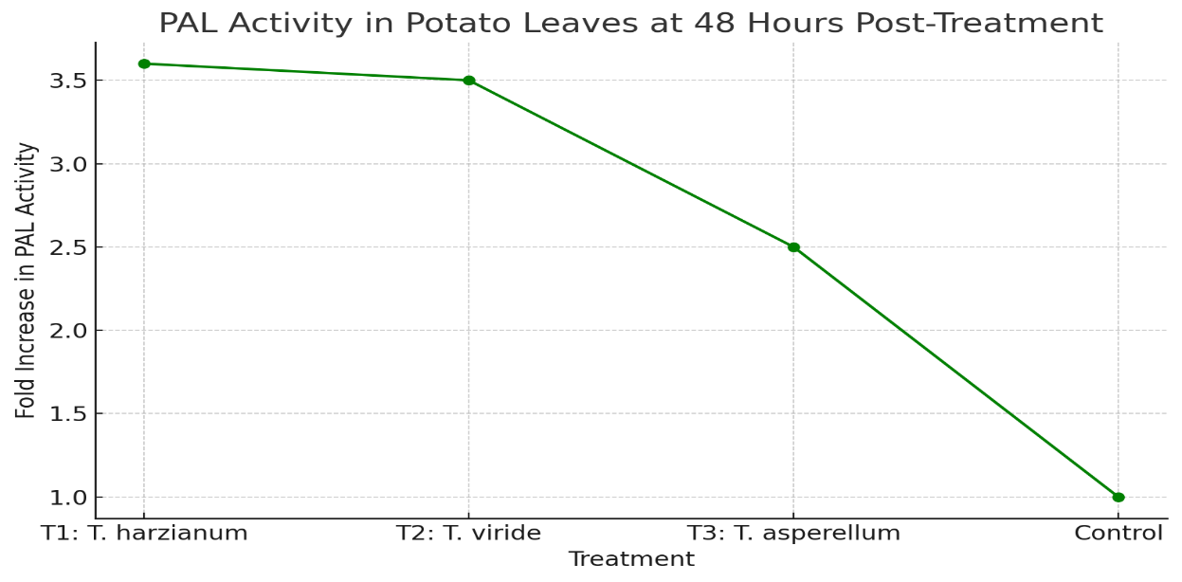  
**Figure.1:PAL activity (48 HPT) in potato under late blight stress**.

**Peroxidase (PO) Activity.**

PO activity, essential for oxidative burst and cell wall reinforcement, peaked at 72 hours post-treatment.

Maximum activity was observed in **T1 (8.2-fold)**, followed by **T2 (7.5-fold)** and **T3 (4.5-fold)** over the control. These findings confirm the role of Trichoderma, particularly T. harzianum, in stimulating PO-mediated defence.  
**Figure 2:** Peroxidase activity (72 HPT) under *P. infestans* challenge.

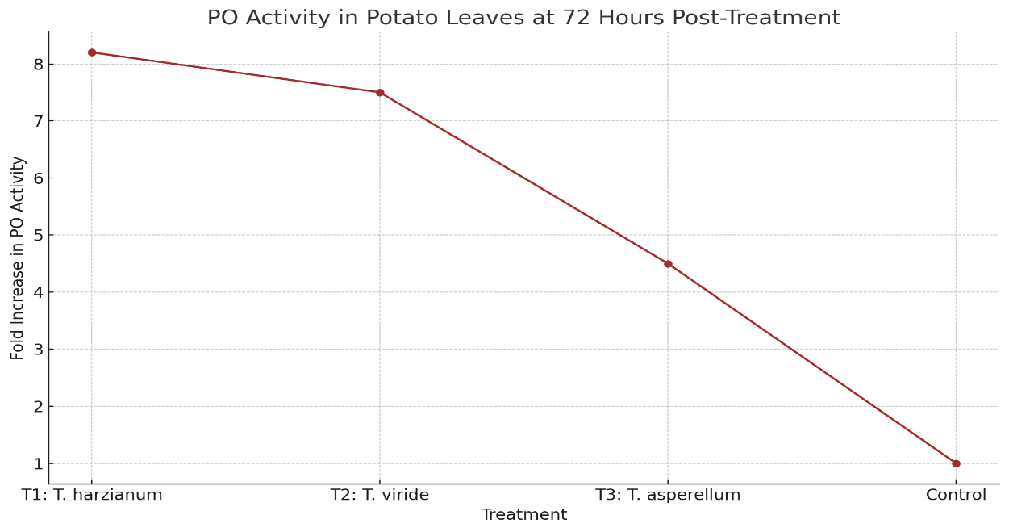

**Figure.2: PO (Peroxidase) activity in potato leaves at 72 hours post-treatment.**

**Polyphenol Oxidase (PPO) Activity.**

PPO activity also peaked at 72 hours post-treatment.

**T1-treated** plants showed the highest induction (5.4-fold over control), followed by **T2** and **T3**. This suggests that T. harzianum strongly activates oxidative

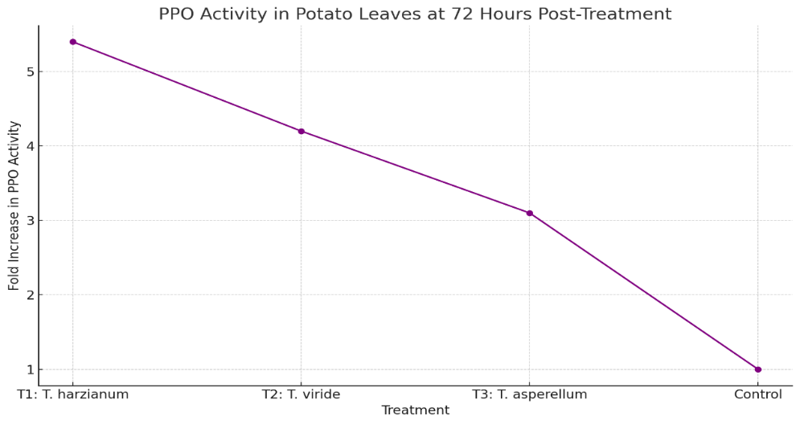

**Figure.3:PPO (Polyphenol Oxidase) activity graph in potato leaves at 72 hours post-treatment**

The present study evaluated the efficacy of different *Trichoderma* species in mitigating late blight caused by *Phytophthora infestans* in potato and their role in enhancing plant growth and activating biochemical defense mechanisms.

Among the treatments, *Trichoderma harzianum (T1)*consistently demonstrated superior performance across all growth parameters-including root length, shoot length, number of leaves, and dry weight-at various intervals (15, 45, 60, and 90 DAT). The enhanced vegetative growth in T1-treated plants may be attributed to its known plant growth-promoting traits, such as improved nutrient solubilization, phytohormone production, and competitive exclusion of pathogens (*Harman et al., 2004*). Other species, namely *T. viride* (T2) and *T. asperellum* (T3), also showed significant improvements over the untreated control, though to a lesser extent.

Biochemical analyses further confirmed the induction of defence responses by *Trichoderma* spp. Under late blight stress, **PAL, PO, and PPO** activities were significantly upregulated in treated plants. Notably, **T1-treated plants recorded the highest PAL activity (3.6-fold), PO activity (8.2-fold), and PPO activity (5.4-fold)** over the control. These enzymes play vital roles in systemic resistance, lignin biosynthesis, and the oxidative burst-key components of the plant’s defence machinery.

The induction of PAL suggests activation of the phenylpropanoid pathway, contributing to the synthesis of phenolics and structural barriers against pathogen penetration (*Dixon et al., 2002*). Similarly, the elevated PO and PPO activities reflect an enhanced oxidative defence, contributing to cross-linking of cell wall proteins and the production of antimicrobial compounds.

The overall results align with earlier studies indicating that *Trichoderma* spp. not only act as biocontrol agents by antagonizing pathogens through mycoparasitism and competition but also function as effective inducers of systemic resistance (*Yedidia et al., 2003*). The strong biochemical and physiological responses observed, especially in T1 treatments, confirm the dual role of *Trichoderma harzianum* in promoting plant health and disease suppression.

These findings support the integration of *Trichoderma* spp., particularly *T. harzianum*, as an eco-friendly and sustainable component in late blight disease management programs for potato cultivation.

**CONCLUSION:**

The comprehensive analysis of growth parameters and defence enzyme activities demonstrates that *Trichoderma harzianum* is particularly effective in enhancing both the growth and resistance of potato plants under late blight stress. The use of *Trichoderma* spp., especially *T. harzianum*, offers a promising biocontrol strategy for managing late blight in potato cultivation.

**REFERENCE.**

Agrios, G. N. (2005). *Plant Pathology* (5th ed.). Elsevier Academic Press.

Akrami, M., Yousefi, M., &Goltapeh, E. M. (2011). Biological control of *Phytophthora infestans* by *Trichoderma harzianum* under in vitro and greenhouse conditions. *Journal of Plant Protection Research*, 51(3), pp275–280.

Al-Rahmah, A. N., Mostafa, A. A., Abdel-Megeed, A., &Yakout, S. M. (2013). Antifungal potential of *Trichoderma* species isolated from agricultural soils against *Phytophthora infestans*. *African Journal of Microbiology Research*, 7(48), pp5469-5474.

Atanasova, L., Druzhinina, I. S., & Jaklitsch, W. M. (2013). Two hundred *Trichoderma* species recognized on the basis of molecular phylogeny. *Fungal Diversity*, 61(1), pp1-29.

Axel, C., Zannini, E., Coffey, A.,Guo, J., Waters, D. M., & Arendt, E. K. (2012). Ecofriendly control of potato late blight causative agent and the potential role of lactic acid bacteria: A review. *Applied Microbiology and Biotechnology*, 96, pp37-48.

Bary, A. de. (1876). Researches into the nature of the potato fungus *Phytophthora infestans*. *Journal of the Royal Society of Agriculture of England*, 12, pp239-269.

Chaverri, P., & Samuels, G. J. (2011). Evolution of habitat preference in *Trichoderma* and *Hypocrea* species: A phylogenetic approach. *The New Phytologist*, 189(2), pp508-519.

Chet, I., Harman, G. E., & Baker, R. (1981).*Trichoderma hamatum*: Its hyphal interactions with *Rhizoctonia solani* and *Pythium* spp. *Microbial Ecology*, 7(1), pp29-38.

Cooke, D. E. L., Cano, L. M., Raffaele, S., et al. (2012). Genome analyses of an aggressive and invasive lineage of the Irish potato famine pathogen. *PLoS Pathogens*, 8(10), e1002940.

Dey, T., Sharma, R. C., & Singh, B. P. (2013). Status of late blight of potato in India. *Indian Phytopathology*, 66(3), pp215-220.

Elad, Y., Chet, I., & Katan, J. (1983).*Trichoderma harzianum*: A biocontrol agent effective against *Sclerotium rolfsii* and *Rhizoctonia solani*. *Phytopathology*, 73(3), pp365-370.

Erwin, D. C., & Ribeiro, O. K. (1996). *Phytophthora Diseases Worldwide*. APS Press.

Fry, W. E. (2008).*Phytophthora infestans*: The plant (and R gene) destroyer. *Molecular Plant Pathology*, 9(3), pp385-402.

Gomez, R. G., Rodríguez, P., & Silva, L. (2014). Evaluation of *Trichoderma* isolates against *Phytophthora infestans* in potato. *Biocontrol Science and Technology*, 24(10), pp1153-1165.

Gveroska, B., &Ziberoski, J. (2012).*Trichoderma harzianum* as a biocontrol agent against *Phytophthora infestans* on potato. *African Journal of Agricultural Research*, 7(3), pp318-323.

Haas, B. J., Kamoun, S., Zody, M. C., et al. (2009). Genome sequence and analysis of the Irish potato famine pathogen *Phytophthora infestans*. *Nature*, 461(7262), pp393-398.

Harman, G. E., Howell, C. R., Viterbo, A., Chet, I., & Lorito, M. (2004).*Trichoderma* species-opportunistic, avirulent plant symbionts. *Nature Reviews Microbiology*, 2(1), pp43-56.

Judelson, H. S., & Blanco, F. A. (2005). The spores of *Phytophthora*: Weapons of the plant destroyer. *Nature Reviews Microbiology*, 3, pp47-58.

Kumar, V., Sharma, P., & Roy, S. (2020). Evaluation of *Trichoderma* isolates for the management of potato late blight under field conditions. *Journal of Biological Control*, 34(3), pp215-221.

Leesutthiphonchai, W., Vu, A. L., Ah-Fong, A. M., & Judelson, H. S. (2018). How does *Phytophthora infestans* evade control efforts? Modern insight into the late blight disease. *Phytopathology*, 108(8), pp 916-924.

Singh, B. P., Gupta, P. K., & Pandey, K. K. (2014). Antagonistic activity of *Trichoderma* spp. against *Phytophthora infestans*. *Indian Phytopathology*, 67(2), pp123-127.

Singh, V., & Chaurasia, S. (2020). Biocontrol efficacy of *Trichoderma viride* against *Phytophthora infestans* causing late blight of potato. *International Journal of Current Microbiology and Applied Sciences*, 9(2), pp2875-2882.

Woo, S. L., Scala, F., Ruocco, M., & Lorito, M. (2006). The molecular biology of the interactions between *Trichoderma* spp., phytopathogenic fungi, and plants. *Phytopathology*, 96(2), pp181-185.

Yuen, J. (2021). Pathogens which threaten food security: *Phytophthora infestans*, the potato late blight pathogen. *Food Security*, 13(2), pp247-253.