**Bufell grass (*Cenchrus ciliaris* L.) in symbiosis with arbuscular mycorrhizae produced mitigation of drought stress.**

ABSTRACT

|  |
| --- |
| **Aims:** The objective was to study the C*enchrus ciliaris*–*Rizhophagus intraradices* symbiosis under water stress.  **Study design:** The plant - mycorrhizal symbiosis grants hydraulic ability to the plant, allowing it to be more efficient in arid soils, in addition to intervening in plant nutrition and improving soils for the recolonization of native species. The plants (P) grew in a culture chamber with 16:8 hours of light: dark and 25°C of temperature. Half of the plants were inoculated with mycorrhizae (AM) and the rest were not (NM). The stresses studied were 60% and 40% water (drought levels) and the control was 100% water.  **Place and Duration of Study:** The study was carried out in the Plant Physiology laboratory, in the Ecology Area, of the Biology Department, of the Faculty of Chemistry, Biochemistry and Pharmacy, of the National University of San Luis from March to November 2024. **Methodology:** Morphophysiological and biochemical parameters were measured: length, fresh and dry weight of stem and roots; photosynthetic pigments, proline and malondialdehyde (cellular stress markers)  **Results:** The roots were stained and the percentage of mycorrhization was quantified. Most morphophysiological parameters were higher in AM in relation to NM plants. Proline increased at maximum levels of drought in NM plants; in the M plants the values remained stable. MDA has a significant decrease in AM plants with respect to NM plants, in all treatments of drought and control, demonstrating that mycorrhization confers protection in front of stresses **Conclusion:** It is concluded that mycorrhizae mitigate water stress in Buffel grass plants (C. *ciliaris* L.), a species recommended for semi-arid and arid environments in Argentina. |

*Keywords: Arbuscular mycorrhizae Cenchrus ciliaris*, *Rizhophagus intraradices,* *water stress*

1. INTRODUCTION

Soil is a dynamic biogeochemical natural resource that supports all the components comprising terrestrial ecosystems. Soil is known as the pedosphere, and the processes occurring within it are linked to ecosystem services and central to the biogeochemical cycles of nutrients and carbon that sustain life (Taboada, 2018). One of the characteristics of arid and semi-arid climate zones is the low availability of water, quantified based on average annual precipitation in relation to evaporation from a given geographic area. The trend toward desertification of the Earth and soil degradation is mainly due to population growth, high pressure on the use of natural resources, poor agricultural practices, and human activity, which have contributed to climate change, the main effect of which is the increase in average temperatures of the planet, the decrease in fresh water reserves and the salinization of a high percentage of arable soil (Mazuela-Águila *et al.,* 2013). Planting native and introduced grasses represents a productive option for improving rangeland conditions in arid and semi-arid zones, especially in areas where the best native forages have disappeared. Factors limiting the establishment of these grasses are low rainfall and low soil fertility (Loredo *et al.,* 2004). The use of mulch helps prevent soil erosion, provides plant-available nutrients, increases microbial activity that transforms organic matter, and retains soil moisture (Márquez *et al.,* 2003). Buffelgrass (*Cenchrus ciliaris* L.) belongs to the *Poaceae* family, subfamily *Panicoideae* and tribe *Paniceae*. It is a vigorous, summer-growing, perennial grass that is tolerant of drought and high temperatures (45°C), and some cultivars are cold-tolerant (-10°C) (Ayerza *et al.,* 1981). It is a species native to Africa that begins to sprout with spring rains and dries out with the first frosts. The optimal growth temperature is 25-35°C; germination 25°C and 300 mm of rain during its growing season. Arbuscular mycorrhizae (AM) are present in existing agricultural systems and are the most widespread type of symbiosis in nature, capable of establishing associations in 80–85% of vascular plants (Castillo-González, 2009). Arbuscular mycorrhizal fungi (AMF) are obligate symbionts, which mean they cannot complete their biological cycle in the absence of the host plant and must remain associated with the plant root to obtain carbohydrates from photosynthesis. In return, the fungus supplies the plant with mineral nutrients and water extracted from the soil, extending the plant roots beyond the nutrient-depleted zone created around them (Ruiz Lozano *et al.,* 2001 b). AMF have a significant influence on plant physiology and water relations under stress conditions. In arid and semi-arid ecosystems, mycorrhization increases water acquisition in various plant species, decreasing lipid peroxidation, increasing K+: Na+ and Ca2+: Na+ ratios and increasing the production of glycine, betaine and proline (Harris-Valle *et al*., 2009). AMF contribute to improving the physical and chemical properties of the soil by enriching organic matter and stimulating the formation of particle aggregates that improve soil structure and stability, reducing erosion and increasing its water retention capacity (Finlay, 2008). In areas degraded by land-use change, AMs play an important role in ecological recovery (Carrillo-Saucedo *et al.,* 2022). AMF play a key role in the establishment and development of most plants, improving productivity, survival and resistance to pathological factors; improving the productive capacity of soils such as those affected by desertification, salinization, water and wind erosion (Castillo González, 2009), and can partially or totally reduce the use of fertilizers (Cruz-Hernández *et al.,* 2014).Symbiosis favors water absorption and allows for improved plant development in conditions of drought, salinity, and cold, particularly in forage species from semi-desert environments (Pedranzani *et al.,* 2015 a and b). Khan *et al.* (2008) observed that the association of AM with *C. ciliaris* L. in two water regimes (100 and 50% field capacity) increased water use efficiency in both cases. Díaz Franco y Garza-Cano(2006) observed that mycorrhizal root colonization was 42% in *C. ciliaris* and that there were significant increases in chlorophyll content, leaf protein, and dry and root biomass. Our objective was to study the effect of the symbiotic relationship of *C. ciliaris* L. with AM in response to drought, through morphological, physiological and biochemical parameters

2. material and methods

**2.1- Sowing and growing plants.**

Scarified *C. ciliaris* L. seeds were germinated in Petri dishes on moist absorbent paper in an oven at 30 C° and darkness. The seedlings were sown one per pot in a soil: perlite mixture (1:1) sterilized at 70 C° for 96 hs. The experimental design was 24 pots of 250 ml, 50% were inoculated with 1 cm3 of commercial mycorrhiza (*Rhizophagus intraradices* spores) and the rest were not. Non-mycorrhizal (NM) and mycorrhizal (AM) plants grew in a sowing chamber at 24-26 ºC; with a photoperiod of 16:8, light:dark and were watered weekly until they reached a height of 25 cm and from there the stress treatments were started.

Treatments were carried out weekly for one month: Control = 100 ml of water (field capacity); 60% = 60 ml of water (60% field capacity); 40%= 40 ml of water (60% field capacity). The plants were harvested, and LA (shoot length) and AFW (aerial fresh weight) were measured. The roots were washed, and RL (root length) and RFW (root fresh weight) were measured. They were placed in a drying oven at 70°C for 72 hours, and ADW (shoot dry weight) and RDW (root dry weight) were measured

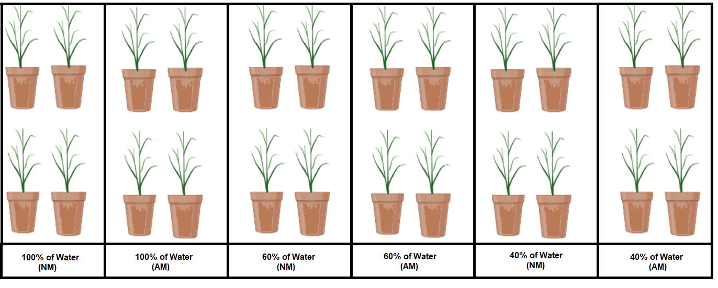

**Figure 1:** Experimental design

**2.2-Quantification of mycorrhizal infection in roots** The Phillips and Hayman (1970) differential staining method was used, which consisted of rinsing the roots and staining them with a specific dye for the fungal chitin wall. To quantify root colonization, the grid line intersection method was used (Giovannetti and Mosse, 1980). The percentage of mycorrhized roots (% MIC) was obtained from the formula: % MIC = (100 m /T), where "m" is the number of "mycorrhized" intersections and "T" is the total number of intersections observed.

**2.3- Chlorophyll a, b, and carotenoids determination.** 100 mg of aerial foliage tissue was collected and homogenized in a mortar with 80% acetone. It was then filtered through a funnel filled with filter paper and measured using a spectrophotometer. To quantify chlorophyll a and b, absorbance was measured at 646.6 nm and 663.6 nm, respectively, and carotenoids at 470 nm. 80% (v/v) acetone was used as a blank. Samples were taken in triplicate. Endogenous chlorophyll content was calculated according to Porra (2002) and carotenoids content according to Sims and Gamon (2002). Results are expressed as mg/g DW (for chlorophylls) and mg/PF (for carotenoids).

**2.4-Proline Determination** Proline determination was performed according to the method of Bates et al. (1973). Absorbance was read at 520 nm using the following blanks: 2 ml of distilled water + 2 ml of acid nitrohydrin + 2 ml of glacial acetic acid. Proline concentration was determined from a standard curve and is expressed as proline content per unit of fresh weight

**2.5- Malondialdehyde (MDA) determination.** 200 mg of leaves was homogenized with liquid nitrogen and extracted with 600 ul of extraction buffer (50 mM Tris-Cl pH 7.5 + 0.1 mM EDTA + 2% Triton) shaken, and centrifuged at 10,000 rpm for 30 minutes at 4°C. Then 200 ul of supernatant from each sample plus 1 ml of MR (0.375% TBA and 15% TCA) were added; the mixture was shaken and placed in a hot water bath at 95-100°C for 15 min and on ice for 5 min. The mixture was centrifuged for 5sec. at 2000 rpm and read in a spectrophotometer at 535 nm wavelength. For the standard curve, hydrolyzed TMP was prepared at a concentration of 1:100

**2.6- Statistical Analyses** Statistical analyses were performed with the GraphPad Prism Version 8.0.2 (263). The morphological parameters were analyzed by Student T parametric and percentage of colonization, pigments, proline and MDA results were analyzed by multifactorial ANOVA. Significant differences among treatments were identified using the Tukey B test (p < 0.05).

3. results and discussion

**3.1- Mycorrhizal Quantification**

In the quantification of mycorrhizae using the method (Giovannetti and Mosse, 1980), it was observed that there were no significant differences between the percentages of mycorrhization among the different treatments (Table 1) 60%, 57,1%, 44,6%

**Table 1: Percentage of mycorrhization.**

|  |  |  |  |
| --- | --- | --- | --- |
| **Treatments** | **Roots accountability** | | **Percentage of mycorrhization** |
| 100% Water  60% water | 310  268 | 60,0 % a  57,1 %a | |
| 40% of water | 204 | 44,6 %a | |
|  |  |  | |

*Different letters mean significant differences, * P < 0.05 significant from normal control*

**3.2- Morphological and growth parameters.**

In the control treatment, all measured parameters were significantly higher in AM plants than in NM plants. In the water-restricted treatment (60% of water), all parameters increased, except for ADW. In the 40% water treatment, AM plants also showed greater increases than NM plants, except for AFW and RFW (Table 2 and Figure 2)

**Table 2: Morphological parameters of *Cenchrus ciliaris* L in Mycorrhizal (AM) and Non-mycorrhizal (NM) plants (AL) aerial large, (RL): root large; (AFW) aerial fresh weight, (RFW) root fresh weigth, (ADW) aerial dry weight (RDW) root dry weigth.**

|  |  |  |  |  |  |  |  |  |  |
| --- | --- | --- | --- | --- | --- | --- | --- | --- | --- |
| **Parameters** |  | **Control** | | | **60% of water** |  | | **40% of water** |  |
| **AL (cm)**  **RL (cm)**  **AFW (g)**  **RFW (g)**  **ADW (g)**  **RDW(g)** | NM  60 b  15f  6b  1,5d  1,1d  0,4f | | AM  **69a**  **19e**  **9a**  **2,9c**  **2c**  **0.8e** | NM  52c  15f  4c  1e  1,4d  0,5f | | AM  **59a**  **21e**  **4,9b**  **1,6d**  1,1d  **0,8e** | NM  45d  15f  2,8c  0,5e  1e  0,4f | | AM  **52c**  **28e**  2c  0,5e  **2,2c**  **0,6e** |
|  |  | |  |  | |  |  | |  |

*Different letters mean significant differences, * P < 0.05 significant from normal control*

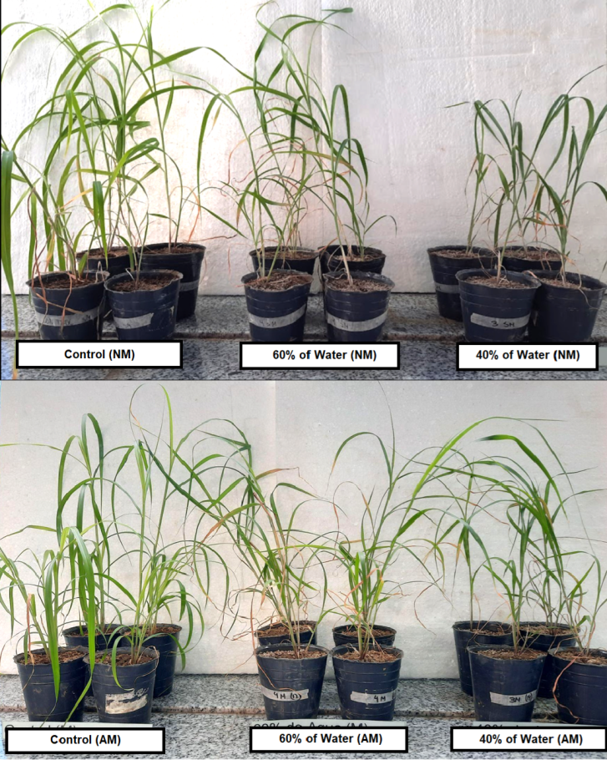

**Figure 2: Images of *C. ciliaris* L. (*Buffel grass)* plants under control and drought treatments**

**3.3- Photosynthetic pigments.**

Photosynthetic pigments indicate the physiological state of the plant under water stress. Figure 3A shows that under control conditions and with 60% water, chlorophyll a did not change in NM and AM plants. With 40% water, AM plants increased their chlorophyll a content (Figure 3 A). Chlorophyll b did not change in any of the treatments, in AM and NM plants (Figure 3 B). Carotenoids are protective pigments that increase in the presence of stress to protect the photosynthetic apparatus. In our experiment, carotenoids increased under stress conditions (60 and 40% water) in NM plants. In AM plants, there were no significant differences due to mycorrhizal protection (Figure 3 C)

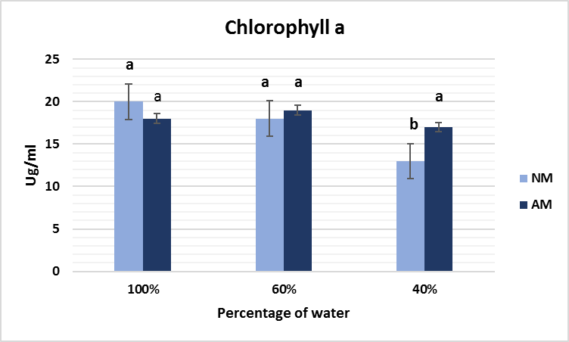**A**

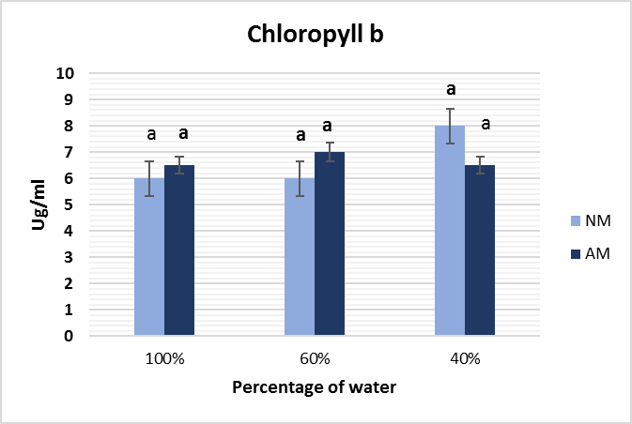**B**

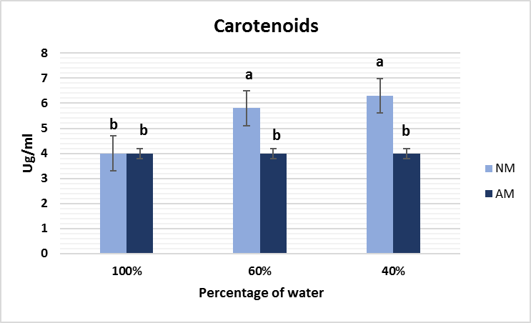**C**

**Figure 3: Photosynthetic pigments of *C. ciliaris* under water stress. A: Chlorophyll a; B: Chlorophyll b; C: Carotenoids** in Non-mycorrhizal (NM) and Mycorrhizal plants (AM**).** *Different letters mean significant differences, * P < 0.05 significant from normal control*

*Mean ± S.E.M = Mean values ± Standard error of means of four experiments*

**3.4- Proline**

The function of proline, like any compatible osmolyte, is to increase cellular water retention under abiotic stress. In NM plants, proline increased significantly with 40% water. In AM plants, proline remained unchanged at all water stress levels, likely due to the protection of mycorrhizae (Figure 4).

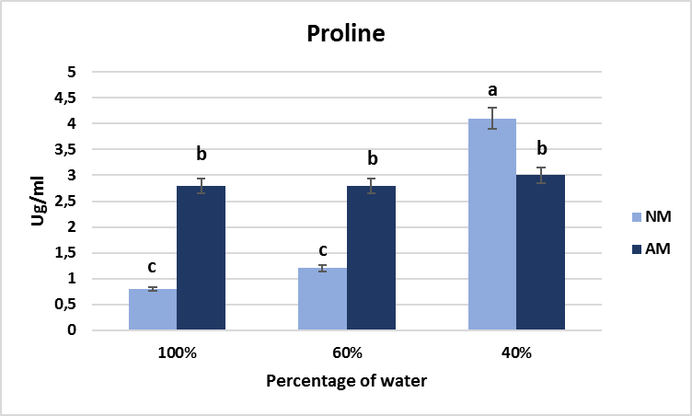

**Figure 4: Proline of *C. ciliaris* under water stress.) in Non-mycorrhizal (NM) and Mycorrhizal plants (AM).** *Different letters mean significant differences, * P < 0.05 significant from normal control Mean ± S.E.M = Mean values ± Standard error of means of four experiments*

**3.5- Malondialdehyde**

Reactive oxygen species (ROS) increase under abiotic stress. These are potentially toxic molecules that cause nonspecific oxidation of membrane proteins and lipids and are linked to DNA damage. This results in an increase in malondialdehyde (MDA) (Murube Torcida,2014). In our study, water stress caused a significant increase in MDA as stress increased in NM plants. In both control and water-stressed AM plants, there was no synthesis of this compound, demonstrating mycorrhizal protection (Figure 5)

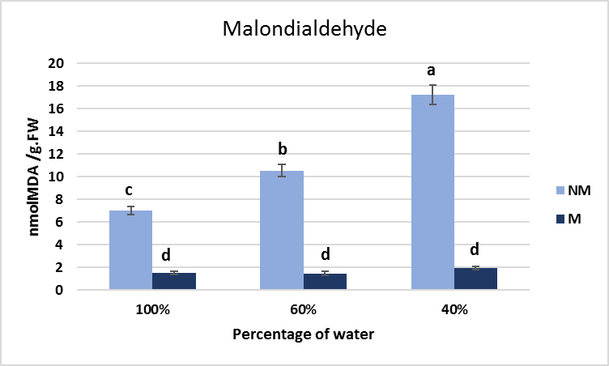

**Figure 5: Malondialdehyde content of *C. ciliaris* under water and salt stress. .NM: Non mycorrhizal plants. AM Mycorhyzal plants.** *Different letters mean significant differences, * P < 0.05 significant from normal control Mean ± S.E.M = Mean values ± Standard error of means of four experiments*

**DISCUSSION**

**Growth** All morphophysiological parameters (AL, RL, AFW, RFW, ADW, RDW) were higher in AM control plants. Under water stress of 60%, all parameters were higher in AM plants except for ADW. Under water stress of 40%, AM plants performed the same except for AFW and RFW. NM plants behaved similarly to Tommasino (2018). For *Glycine max*, plant height and weight were lower in NM plants (Porcel *et al*., 2006) and alfalfa (Achiary *et al*., 2024). It was observed that mycorrhizae helped plants produce biomass in both control and water-stressed plants, motivating them. This could be explained by the contribution of mycorrhizae in obtaining resources, adaptation and tolerance to water stress conditions.

**Percentage of mycorrhization in roots.** The % mycorrhization after two months was around 50% in all treatments in *C. ciliaris,* which means that stress did not affect mycorrhization. Díaz Franco y Garza-Cano(2006) found a mycorrhizal colonization of 42% in the same species after seven months of contact, although they used soil inoculum and pieces of sorghum roots, while in our case, commercial spores in powder form were used in the substrate. In different species of the genus Prosopis subjected to salinity, values of up to 80% mycorrhizae were found (Scambato *et al.,* 2013). In *Medicago sativa*, under water and saline stress, the mycorrhization percentages were similar to the control without stress (Pedranzani *et al.,* 2021)**.**

**Photosynthetic Pigments** Photosynthetic pigments are related to leaf function. chlorophyll tends to decrease more rapidly than carotenoids under stress or senescence (Cervantes-Sanchéz, 2014). Chlorophyll a decreased in *C. ciliaris* L. under water stress in NM plants, while it remained constant in AM plants. Chlorophyll b did not differ at any stress level, and carotenoids increased as a protective factor at both water stress levels in NM plants, while remaining constant in AM plants. The same results were found in *Zea mays* L. (Samano Leiva, 2014). The decrease in chlorophyll a is due to the plant's inability to efficiently capture energy, and the increase in carotenoids is related to the detoxification of reactive oxygen forms formed during photosynthesis due to stress. Similarly, the decrease in chlorophylls with respect to carotenoids may be a trait of resistance to drought, which is why they can be classified as tolerant to this type of stress (Argentel *et al.,* 2006).

**Proline** Proline is one of the osmoprotectants linked to plant tolerance to drought and salinity conditions. Its function is to maintain tissue turgor, protecting the plant from desiccation. It is also linked to nitrogen storage that would be used during rehydration and non-enzymatic antioxidant defense (Ferres Jaunsolo and Monsa, 2008). Proline in C*. ciliaris* L. AM under water stress did not vary at either stress level (60% and 40% water) compared to the control. In contrast, in NM plants, proline content increased significantly at both water stress levels. In *Pistacia vera* L. similar results were found (Abbaspour *et al.,* 2012) while in *Medicago sativa* (Pedranzani *et al.,* 2021) and *Zea mays* (Samano, 2014) the results are contrasting. Therefore, *C.ciliaris* NM plants suffered stress more severely, while in AM plants, mycorrhizae mitigated the lack of water and helped retain soil moisture.

**Malondialdehyde** The most common consequence of most abiotic stresses is an increase in reactive oxygen species (ROS). This leads to an increase in malondialdehyde (MDA) (Murube *et al.,* 2014). During water stress, an increase in MDA was observed in NM plants as stress increased, while AM plants did not change their MDA content. In *Leymus chinensis* (Zhen *et al.,* 2007) and wheat (Amin *et al.,* 2023), MDA increased with increasing water stress in both AM and NM plants. In tomato plants, the results were similar to ours; mycorrhizal plants under water stress had lower MDA contents than NM plants (Ruscitti *et al.,* 2015). It can be seen that mycorrhizae mitigate water stress in *C. ciliaris* L.

4. Conclusion

C*enchrus ciliaris* L*.*–*Rizhophagus intraradices* Symbiosis under water stress produces tolerance in plants, demonstrating greater resistance in morphological, physiological and antioxidant defense parameters

References

Abbaspour, H., Saeidi-Sar, S., Afshari, H. & Abdel-Wahhabc M.A. 2012. Tolerance of Mycorrhiza infected Pistachio (*Pistacia vera* L.) seedling to drought stress under glasshouse conditions. Journal of Plant Physiology 169 (2012) 704–709.

Achiary, M.; Chiroli, C.; Pacheco Insausti, M.C.; Gallardo, L.; Ponce, A. & Pedranzani. H.E. (2024). Arbuscular Mycorrhizae Confers Salinity Tolerance to *Medicago sativa* L. Stresses 4, 752–761.

Amin, M.W., Aryan S. & Samadi. AF. 2023 Interpretation of morpho‑physiological and biochemical responses of winter wheat under different sodium chloride concentrations Journal of Crop Science and Biotechnology https://doi.org/10.1007/s12892-023-00200-9

Argentel, L., González, M., & Aguilera, A. (2006). Behavior of relative water content and photosynthetic pigment concentration of wheat varieties grown under saline conditions. Tropical Crops, vol. 27, no. 3, 2006, pp. 49-53

Ayerza (h.), R. (1981). Buffelgrass: utility and management of a promising grass. Southern Hemisphere, Buenos Aires, Argentina. 139 p.

Bates, L.S., Waldren, R.P. & Teare, I.D. (1973). Rapid determination of free proline for water-stress studies. Plant Soil 39, 205–207 (1973).

Carrillo-Saucedo, S.M., Puente-Rivera, J., Montes-Recinas, S. & Cruz-Ortega, R. 2022. Mycorrhizae as a tool for ecological restoration. Acta Botánica Mexicana 129: e1932. DOI: http://doi.org/10.21829/abm129.2022.1932

Castillo-González, M.L. (2009). Morphological characterization of arbuscular mycorrhizae associated with roots of wild (Solanum cajanumensis) and cultivated (Solanum betacea) tree tomato in two areas of the province of Loja. Universidad Técnica Particular de Loja, School of Biochemistry and Pharmacy.

Cervantes Sánchez S. (2014). Genetic variability for leaf senescence in Cenchrus ciliaris L. Institution for teaching and research in agricultural sciences, Montecillo campus. Postgraduate program in genetic resources and livestock productivity.

Cruz Hernandez, Y., García Rubido, M., León González Y. & Acosta Aguiar, Y. (2014) Influence of arbuscular mycorrhizae application and reduced mineral fertilizer use on tobacco seedlings. Tropical Crops 35(1):21–24

íaz Franco, A. & Garza-Cano, I. (2006). Arbuscular mycorrhizal colonization and growth of buffelgrass (Cenchrus ciliaris L.) genotypes. Rev. Fitotec. Mex. Vol. 29 (3):203–206.

Ferrés Jaunsolo, M. F. & Monza, J. (2008). Biochemical and physiological markers of water stress response in Lotus uliginosus. AGRIS - International System for Agricultural Science and Technology.

Finlay, R. D. (2008). Ecological aspects of mycorrhizal symbiosis: with special emphasis on the functional diversity of interactions involving the extraradical mycelium. Journal of Experimental Botany, 59, 1115–1126.

Giovannetti, M. & Mosse, B. (1980). An Evaluation of Techniques for Measuring Vesicular Arbuscular Mycorrhizal Infection in Roots. New Phytologist, 84, 489–500.http://dx.doi.org/10.1111/j.1469-8137.1980.tb04556.x

Harris-Valle, C., Esqueda, M., Valenzuela-Soto, E.M. & Castellanos, A.E. (2009). Water stress tolerance in plant-arbuscular mycorrhizal fungus interactions: energy metabolism and physiology. Rev. fitotec. Mex vol. 32 no. 4 Chapingo Oct./Dec. 2009.

Khan, I.A., Ayub, N., Mirza, S.N., Nizami, S.M. & Azam, M. (2008). Yield and water use efficiency (WUE) of Cenchrus ciliaris as influenced by vesicular arbuscular mycorrhizal (VAM). Pak. J. Bot., 40(2): 931–937.

Loredo-Osti, C., López-Reyes, L. & Espinosa-Victoria, D. (2004). Plant growth-promoting bacteria associated with grasses. A review. Terra Latinoamericana, 22(2): 225–239.

Márquez, R., Córdova, T., Castejón, L. & Higuera, A. (2003). Effect of mulching with Cenchrus ciliaris L. and phosphorus fertilization on weed control percentage, yield, and phosphorus concentration in Vigna unguiculata (L.) Walp bean seeds. Journal of the Faculty of Agronomy, 20 (4), 443-452.

Mazuela Águila, P.C. (2013). Agriculture in arid and semiarid zones IDESIA (Chile) Volume 31(2) 3-13

Murube Torcida, E.M. (2014). Oxidative stress and physiological responses to heavy metal accumulation in mycorrhizal and non-mycorrhizal Betula celtiberica grown in contaminated soil (Master's thesis). University of Oviedo, Spain

Pedranzani, H.; Rodríguez Rivera, M., Gutiérrez, M., Porcel, R. & Ruiz Lozano J.M. (2015a). Arbuscular mycorrhizal symbiosis regulates physiology and performance of Digitariaeriantha plants subjected to abiotic stresses by modulating antioxidant and jasmonate levels. Mycorrhiza 26 (2): 141–152.

Pedranzani, H., Tavecchio, N., Gutiérrez, M., Garbero, M., Porcel, R. & Ruiz-Lozano, J.M. (2015b). Differential Effects of Cold Stress on the Antioxidant Response of Mycorrhizal and Non-Mycorrhizal Jatropha curcas (L.) Plants Journal of Agricultural Science 8 (7): 35-43. ISSN1916-9752 E.

Pedranzani, H.E., Gutiérrez, M.E., Molina Arias, S., Zapico, M.G. & [Ruiz-](http://www.researchgate.net/profile/Hilda_Pedranzani)Lozano, J.M. (2021). Arbuscular Mycorrhiza Interaction with *Medicago sativa* Plants: Study of Abiotic Stress Tolerance in Sustainable Agriculture*.* 10.53897/*Rev AIA.*21.25.14 (03):26-40

Phillips, J.M. & Hayman, D.S. (1970). Improved Procedures for Clearing Roots and Staining Parasitic Vesicular-Arbuscular Mycorrhizal Fungi for Rapid Assessment of Infection. Transactions of the *British Mycological Society*, 55, 158-161.  
 http://dx.doi.org/10.1016/S0007-1536 (70)80110-3.

Porcel, R., Aroca, R., Azcón, R. & Ruiz-Lozano, J.M. (2006). PIP aquaporin gene expression in arbuscularmycorrhizal *Glycine max* and *Lactuca sativa* plants in relation to drought stress tolerance. Plant Mol Biol 60:389–404. doi:10.1007/s11103-005-4210-

Porra, R.J. (2002). The Chequered History of the Development and Use of Simultaneous Equations for the Accurate Determination of Chlorophylls a and b. Photosynthesis Research, 73, 149-156.<http://dx.doi.org/10.1023/A:1020470224740>.

Ruiz-Lozano, J.M., Collados, C., Barea, J.M. & Azcón, R. (2001b). Arbuscular mycorrhizal symbiosis can alleviate drought-induced nodule senescence in soybean plants. *New Phytol 1*51:493–502

Ruscitti, M., Garita, S., Arango, M.C. & Beltrano J. 2015. Inoculation with selected isolates of vesicular arbuscular fungi as an alternative to moderate water stress in tomato plants from La Plata under greenhouse conditions. Journal of the Faculty of Agronomy, La Plata (2015) Vol 114 (2): 219-229.

Samano-Leyva, M.G. (2014). Effect of a consortium of arbuscular mycorrhizal fungi from a geothermal area on maize under water stress. Interdisciplinary Research Center for Regional Integral Development, Michoacán Unit.

Scambato, A.A. (2013). Influence of symbiosis with arbuscular mycorrhizae and rhizobia on growth and salt stress tolerance in forest Prosopis species. (Doctoral Thesis. University of Buenos Aires, Faculty of Exact and Natural Sciences.

Sims, D.A. & Gamon, J.A. (2002). Relationships between leaf pigment content and spectral reflectance across a wide range of species, leaf structures, and developmental stages. Remote Sensing of Environment, 81(2-3), 337-354.

Taboada, M.A. (2018). Soil as a natural resource. In what framework does bioremediation fit? In Brutti L.N., Beltrán M.J., García de Salamone I. (Eds). Bioremediation of Natural Resources (pp. 12-319). INTA Editions.

Tommasino, E.A. (2018). Utilization of oxidative stress and antioxidant defense for the characterization and early identification of Cenchrus ciliaris L. genotypes tolerant to abiotic stress. National University of Córdoba, Faculty of Agricultural Sciences.

Zhen-Zhu X & Guang-Sheng Z. 2007. Photosynthetic Recovery of a Perennial Grass Leymuschinensis after Different Periods of Soil Drought, Plant Production Science, 10:3, 277-285, DOI: 10.1626/pps.10.277 Zhen 2006