Phytochemical Profiling and Chemical Analysis of Cichorium intybus with Evaluation of Its Bioactive Constituents and Mineral Composition

ABSTRACT:
This research examined the phytochemical compounds and metabolomic profiles of Cichorium intybus leaf extracts by Gas Chromatography-Mass Spectrometry (GC-MS) and bioassays. GC-MS revealed major compounds like hydroxylamine, linolenic acid, and lupeol in different concentrations. Phytochemical quantification detected excessive amounts of alkaloids, flavonoids, and phenolics in methanolic and ethanolic extracts. Antioxidant activity and phytochemical content were assessed in hydroethanolic, ethanolic, and methanolic extracts, all of which were positive for carbohydrates, proteins, phenolics, tannins, flavonoids, alkaloids, and saponins. Methanolic extracts revealed relatively lower levels of phytochemicals. The study also examined the level of iron (Fe), zinc (Zn), magnesium (Mg), and calcium (Ca) in various areas to identify environmental and anthropogenic factors. Iron content ranged extensively, from 186.72 mg/kg in Arya Nagar (Haridwar) to 2783.9 mg/kg in Nainital Lake (Nainital), which indicates varied soil compositions. Zinc content ranged from 18.945 mg/kg in Dhanauri (Haridwar) to 199.15 mg/kg in Mount Litera Zee School (Dehradun), indicating huge spatial variations due to local circumstances.

KEYWORDS: Cichorium intybus, Phytochemical composition, Antioxidant activity, Mineral content, Medicinal plant, Traditional medicine.

INTRODUCTION :

Cichorium intybus is a perennial herb. It is a member of the family Asteraceae. Distributed across Europe, Asia, and the Mediterranean. The plant is highly utilized in traditional medicine due to the numerous curative properties, such as liver protection, anti-inflammatory activity, and antioxidant activity (Sharma et al., 2021). The plant is particularly valuable due to its numerous useful constituents, such as flavonoids, polyphenols, terpenoids, and sesquiterpene lactones, which are responsible for its numerous health benefits (Kumar et al., 2020).

The phytochemical content of Cichorium intybus varies with the location of growth, climate, and usage of the plant parts. The roots, leaves, and flowers have high concentrations of bioactive compounds such as chicoric acid, caffeic acid, coumarins, and sesquiterpene lactones such as lactucin and lactucopicrin (Gupta et al., 2022). The secondary metabolites with medicinal value are flavonoids and phenolic acids (Singh et al., 2021). The roots also contain inulin, a prebiotic fiber, thus a healthy food source (Meena et al., 2023).

It has been shown in various studies that Cichorium intybus possesses robust antioxidant activity due to its richness in polyphenols and flavonoids. These bioactive compounds trap free radicals, slowing down oxidative stress and shielding cells from harm (Verma et al., 2020). Cichorium intybus antioxidant activity is predominantly attributed to its phenolic acids, such as chlorogenic and chicoric acid, which are useful and highly effective in radical scavenging (Rana et al., 2021). Result have established that chicory extracts possess the potential to stimulate the activity of antioxidant enzymes such as superoxide dismutase (SOD) and catalase (CAT), justifying its application in modulating oxidative stress (Thakur et al., 2022). The phytochemicals, such as terpenoids in varying amounts and flavonoids and phenolic compounds, are accountable for its Spectrum of therapeutic activities.

The objective of this work is to examine the phytochemical content of methanolic extracts of various fractions of C. intybus using GC-MS and to determine their antimicrobial activity against selected bacterial and fungal strains.
Gas Chromatography-Mass Spectrometry (GC-MS) is a sensitive technique used for the identification and quantification of volatile and semi-volatile compounds present in plant extracts. this study is to analyze the phytochemical composition of Ethanolic extracts from the leaves, stems, and roots of Cichorium intybus using GC-MS (Gas Chromatography-Mass Spectrometry) analysis. Identification of bioactive compounds present in the extracts is important to provide vital information regarding their medicinal use.
The Mineral content of Cichorium intybus is also one of the contributory factors for its nutritional and medicinal advantages. The plant is a rich source of fundamental minerals like calcium, magnesium, iron, and zinc, which are vital for human health. The presence of minerals in Cichorium intybus is medically and economically important for health. Important minerals needed by a human being for their health are found in the root of the plant (Sharma and Patel, 2022). Magnesium abundance in leaves and roots makes chicory useful for cardiovascular health and muscle functioning (Kumar and Yadav, 2023).
A variation in the mineral composition based on soil quality as well as elevation of growth has been reported (Rawat et al., 2021)
It is extensively utilized in traditional systems of medicine like Ayurveda, Unani, and Tibetan medicine due to its varied therapeutic applications. It has been used traditionally as a hepatoprotective, anti-inflammatory, antimicrobial, and carminative (Mishra et al., 2020). Its hepatoprotective effect is attributed to bioactive moieties like sesquiterpene lactones and flavonoids, making it applicable in the treatment of liver disease like jaundice and hepatitis (Das et al., 2022). It has been reported to show hypoglycaemic activity, thus finding application in the management of diabetes mellitus (Singh & Bhatia, 2023).
it has traditionally been used locally in the Himalayas to heal numerous forms of disease. The roots are used traditionally as a substitute for coffee, leaves and flowers are taken for their ease of digestion and anti-inflammatory uses (Rana and Bhatt, 2021). It is suggested that traditional knowledge holds that chicory can be applied to heal fever, cutaneous infections, and respiratory diseases (Negi et al., 2022).
Cichorium intybus is a medicinal herb with a complex phytochemical composition, high antioxidant activity, and high mineral content, thus showing beneficial health attributes. Its pharmacological value is supported by its traditional use in the Himalayas, and recent studies are crucial to its drug-like action. Future studies on pharmacological action and clinical usage will enhance the medicinal value of chicory.
The research here is concerned with GC-MS characterization of Cichorium intybus ethanolic leaf extract and its assessment of chemical composition, relative abundances, and peak retention times. Through such findings, correlations will be made between the detected phytoconstituents and possible therapeutic uses, asserting the medicinal potential of Cichorium intybus in contemporary pharmacology and nutraceutical discovery.

MATERIALS AND METHODS:

Preparation of extract
Healthy Cichorium intybus (chicory) leaves were harvested from an area of Uttarakhand and washed with distilled water to remove impurities. The washed leaves were shade-dried at room temperature for 4–5 days, and then dried in a fan-equipped incubator at 37°C for 3–4 days until complete evaporation of moisture. The dried leaves were ground into fine powder using an electric grinder, about 70 g of powdered material from 1 kg of fresh leaves.
20 g of chicory leaves powder is put in a conical flask; while preparing 250 mL of solution (80% solvent and 20% distilled water, 50 % ethanol and methanol were added separately to different flasks. In hydroethanolic solution, 50% ethanolic and 50%distilled water were added to the solutions, and it was shaken well to have them dissolve completely for the best yield.
The flasks were sealed and left at room temperature for 48 hours, shaking with a rotatory shaker. The mixtures were filtered through muslin cloth after extraction. Filtrates were dried at 37°C room temperature for 4–5 days to obtain final extracts. The percentage yield of all the extracts was determined for further analysis.
The hydroethanolic, methanolic, and aqueous extracts of leaves of Cichorium intybus were analyzed for the presence of phytochemical constituents like alkaloids, saponins, tannins, phenols, flavonoids, proteins, and reducing sugars using standard methods.
Gas Chromatography-Mass Spectrometry (GC-MS) analysis
Extraction procedure

The extraction procedure was performed using the previously described ethanolic extraction procedure, followed by preparation of the extract for GC-MS analysis.
Separation of the compounds was on a capillary column, and peak identification was by comparing their retention times and mass spectral data with reference library compounds. Relative abundance of every compound was calculated according to the peak area percentage (Kam, N. and Kanberoglu, G.S., 2019).
Atomic Absorption Spectroscopy (AAS) Analysis
Preparation of Plant Samples for Atomic Absorption Spectroscopy (AAS)
Plant samples (chicory leaves, roots, stems) were prepared for mineral analysis by using Atomic Absorption Spectroscopy (AAS) through a standardized acid digestion method. Initially, freshly harvested plant material was thoroughly washed with deionized water and dried in a hot air oven at 60±2°C until. The dried material was then ground into a fine, homogeneous powder.
For digestion, 0.5 g of the powdered sample was weighed into a 50 mL digestion tube. To this, 5 mL of concentrated trace metal grade nitric acid (HNO3​) was added. The samples were digested on a heating block, with temperature gradually increasing to 180⸰C, until a clear, colourless, or light-yellow solution was obtained, signifying complete organic matter oxidation.
After cooling, the digested solution was quantitatively transferred to a 25 mL volumetric flask, filtered through Whatman No. 42 filter paper to remove any particulates, and diluted to the mark with deionized water. This clear, diluted solution was then used for AAS analysis. Reagent blanks and certified reference materials were processed identically for quality control.
Quantitative Phytochemical Analysis
Determination of yield
To find the yield of each of the extracts, dried samples were weighed, and then the weight of the soluble component was measured. The yield of the specific extract was determined by the formula provided by (25): The formula for calculating the extract yield percentage is:
$$Yield \left(\%\right)=\frac{(Weight of Dry Extract)}{(Weight of Dry Plant Material)}×100$$
Where,
Weight of Dry Extract = The net weight of the dried extract that is left after the process of extraction.
Weight of Dry Plant Material = Weight of dried plant material used for extraction.
Determination of Alkaloids
Wagner's test

For the detection of alkaloids, 1 gram of the leaf extract was dissolved in 10 milliliters of 1% hydrochloric acid. After the vigorous shaking, the formed solution was filtered. 2 milliliters of the filtrate were transferred to a test tube, and some drops of Wagner's reagent were added down the side of the test tube. Reddish-brown precipitate formation confirmed the presence of alkaloids.
Wagner's reagent:
Iodine 1.27g and potassium iodide 2g were blended in 5 ml of distilled water and filled to make a 100 ml volume using distilled water.
Determination of Flavonoids
2 milliliters of methanol were added to a test tube, and then 200 milligrams of leaf extract were added to it. When this mixture was heated, some pieces of magnesium metal were added to it. After that, a few drops of concentrated hydrochloric acid were added. The appearance of orange or red color was the sign of the presence of flavonoids in the extract.
Determination of Saponins
50 mg of leaf extract was mixed with 20 ml of distilled water and mixed properly with vigorous shaking. The presence of a persistent foam layer up to 2 cm indicated the presence of saponins.
Determination of Tannins
50 mg of the leaf extract was dissolved in 20 ml of distilled water and boiled, followed by the addition of 0.1% ferric chloride solution. The appearance of a brownish-green or blue-black color signified the presence of tannins.
Determination of Phenols
Ferric chloride test
50 mg of leaf extract was dissolved in 5 ml of distilled water. Dark green color on the addition of a few drops of 5% neutral ferric chloride solution showed the presence of phenols.

Determination of Proteins
100 mg of the leaf extract was dissolved in 10 ml of distilled water, followed by filtration of the mixture. The filtrate was further used for analysis.
Biuret test
To 2 ml of filtrate, 1 drop of 2% copper sulphate solution was added and heated. 1 ml of 95% ethanol was added to it, followed by the addition of potassium hydroxide pellets. The Appearance of pink color implied the presence of protein in the extract.
Determination of total Glycosides
50 mg of leaf extract was hydrolyzed with 5 mL of concentrated hydrochloric acid for 2 hours in a water bath and filtered to get the hydrolysate.
Bontrager’s test
To 2 ml of methanol were added to a test tube, and then 200 milligrams of leaf extract was added to it. When this mixture was heated, some pieces of magnesium metal were added to it. After that, a few drops of concentrated hydrochloric acid were added. The appearance of orange or red color was the sign of the presence of flavonoids in the extract.
Reducing sugar
Fehling's test
100 mg of the leaf extract was dissolved in 5 mL of distilled water. 1 mL of the extract was heated in a water bath, and 1 mL each of Fehling's solution A and B was added. Red color precipitate confirmed the presence of sugar in the extract.
Fehling's solution A: CuSO4 was 3.466 g dissolved in 50 ml of distilled water.
Fehling's solution B: 17.3g potassium sodium tartrate and 5g sodium hydroxide were dissolved in 50 ml of distilled water.

RESULT:

The extract was obtained by a standard solvent extraction procedure followed by filtration and vacuum evaporation. Gas Chromatography-Mass Spectrometry (GC-MS) analysis was used to understand the phytochemical profiles of ethanolic leaf, stem, and root extracts of Cichorium intybus. The analysis showed a wide range of bioactive compounds, establishing the pharmacological potential of the plant.

Gas Chromatography-Mass Spectrometry (GC-MS) Analysis of Cichorium intybus Leaf extract

Gas Chromatography-Mass Spectrometry (GC-MS) is a sophisticated analytical method used to detect and identify bioactive compounds in plant extracts. In this study, the ethanolic extract of Cichorium intybus leaves was analyzed to determine its phytochemical composition. The GC-MS chromatogram of Ethanolic Extract in Table 1 presents the identified compounds based on their retention time and peak intensity depicted in Figure 1.

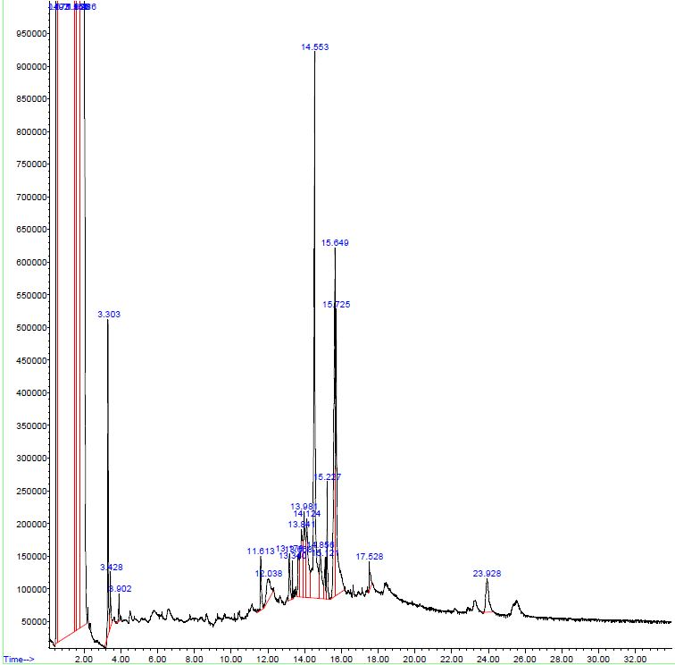
Figure 1: GC-MS Chromatogram of Ethanolic Extract of Cichorium intybus Leaves

The most dominant compound detected was Hydroxylamine (53.73%), eluting at 0.574 min, indicating its significant presence in the extract. Other major compounds included n-Hexadecanoic acid (2.2%) at 14.553 min and Octadecanoic acid (1.02%) at 15.725 min, both of which are fatty acids with pharmacological importance. Additionally, Phytol (0.981%) at 46.59 min was identified as a key diterpene alcohol. Other notable bioactive compounds, including Ascorbic acid (0.672%), Gamolenic acid (0.956%), and Lupeol (0.256%), contribute to the extract’s potential antioxidant and medicinal properties.

Table 1: Phytochemicals Identified in Ethanolic Extract of Cichorium intybus leaves by GC-MS

S. No. | Name of Compounds | Retention Time | Peak Area %
1 | 1,2-Ethanediol | 0.493 | 9.24
2 | Hydroxylamine | 0.574 | 53.73
3 | Acetic acid | 3.302 | 0.57
4 | 1,3,6-Trioxocane Borane | 3.426 | 0.14
5 | 1,4-Butanediol Piperazine | 3.901 | 0.05
6 | 4H-Pyran-4-one | 9.317 | 0.772
7 | Diethyl Phthalate | 11.615 | 0.19
8 | 1,2-dimethyl Hydrazine | 13.177 | 0.16
9 | Bicyclo[3.1.1]heptane | 13.339 | 0.05
10 | Hydroperoxide | 13.98 | 0.45
11 | D-Erythro-Pentose | 14.122 | 0.53
12 | n-Hexadecanoic acid | 14.554 | 2.2
13 | 3-Pentanone | 14.857 | 0.32
14 | Ethanol, 2-Bromobenzemethanol | 15.121 | 0.15
15 | Phytol Oxirane | 15.229 | 0.22
16 | Octadecanoic acid | 15.726 | 1.02
17 | Eicosanoic acid | 20.869 | 0.41
18 | 2-Iodohiistidine Benzenemethanol | 23.9 | 0.29
19 | 3-Eicosyne | 35.528 | 0.604
20 | Stigmasterol | 35.963 | 0.29
21 | 3-Cyclohexene-1-carboxaldehyde | 36.229 | 0.689
22 | 7-Octadecyne | 38.073 | 0.664
23 | Pentadecanoic acid | 40.185 | 0.75
24 | Ascorbic acid | 44.195 | 0.672
25 | Methyl 11,14-octadecadienoate | 44.454 | 0.914
26 | 14-heptadecatrienoate | 44.881 | 0.189
27 | Heptadecanoic acid | 45.012 | 0.963
28 | Phytol | 46.59 | 0.981
29 | Gamolenic acid | 60.991 | 0.956
30 | 8-Methyl-6-nonenamide | 64.272 | 0.338
31 | Lupeol | 65.248 | 0.256

GC-MS Analysis of Cichorium intybus Stem Extract

Cichorium intybus stem extract was analysed using Gas Chromatography-Mass Spectrometry (GC-MS) to determine its bioactive components. The GC-MS chromatogram of the stem extract (Figure 2) showed several peaks. The most prevalent of the identified chemicals, phytol (0.981%), is shown in Table 2.

This elaborates the phytochemical composition of the ethanolic extract of Cichorium intybus by using Gas Chromatography-Mass Spectrometry (GC-MS). The phytochemicals determined based on retention time and peak area can be seen in the chromatogram in Figure 2 and Table 2, respectively. At two retention times (0.639 min and 1.562 min), hydroxylamine was the most prevalent compound, making up 45.58% and 12.54% of the total. Significant amounts of 1,2-Ethanediol (13.35% at 0.471 min) and methylamine (15.77% at 1.795 min) were found.

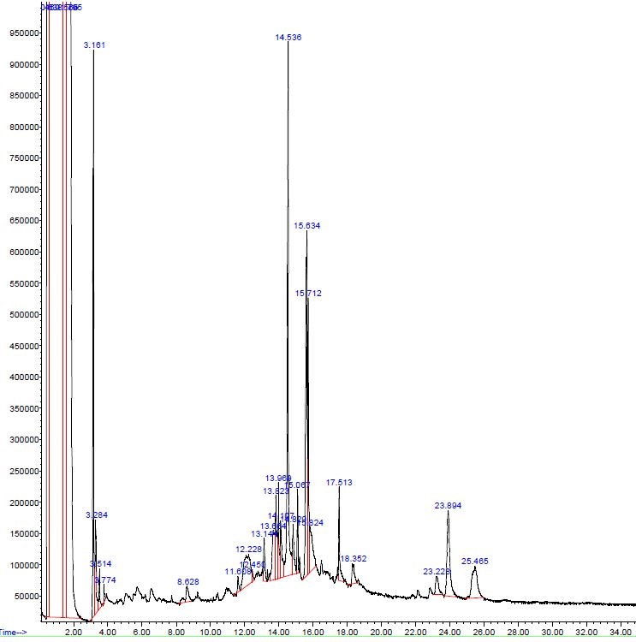
Figure 2: GC-MS Chromatogram of Ethanolic Extract of Cichorium intybus Stems

Fatty acids, including n-Hexaethanoic acid (2.17% at 14.538 min) and Octadecanoic acid (0.72% at 15.71 min), were identified. Other notable bioactive compounds included Benzoic acid, Phthalic acid, and 9,12-Octadecadienoic acid (Z, Z)- Methyl Ester, which have potential medicinal applications.

Table 2: Phytochemicals Identified in Ethanolic Extract of Cichorium intybus Stems by GC-MS

S. No. | Name of Compounds | Retention Time | Peak Area %
1 | 1,2- Ethanediol | 0.471 | 13.35
2 | Hydroxylamine | 0.639 | 45.58
3 | Hydroxylamine | 1.562 | 12.54
4 | Methylamine | 1.795 | 15.77
5 | 2-Propanone | 3.161 | 1.66
6 | 1-Heptane-4-ol Butyric acid hydrazide Acetic acid | 3.286 | 0.43
7 | 3(2H)-Furanone | 3.513 | 0.14
8 | 5-Dimethyl-Propanedioic acid 3-Buten-1-ol | 3.772 | 0.04
9 | 3-Penten-2-one | 8.628 | 0.18
10 | Benoic acid | 11.61 | 0.05
11 | N-Methoxy-1-ribofuranosyl-4-imidazolecarboxylic amide | 12.226 | 0.7
12 | Propanenitrile | 12.447 | 0.05
13 | Undecanoic acid | 13.144 | 0.18
14 | Propanoic acid | 13.663 | 0.43
15 | 2-Acetylamino-3-hydroxy-propionoic acid | 13.825 | 0.45
16 | Hexadeccanoic acid | 13.971 | 0.3
17 | 3-amino-2-dihydroxymino | 14.106 | 0.32
18 | n-Hexaethanoic acid | 14.538 | 2.17
19 | 1,2-Ethanediamine | 14.83 | 0.27
20 | 9,12-Octadecadienoic acid (Z,Z)-Methyl Ester | 15.067 | 0.26
21 | 9,12,15-Octadecatrienal | 15.635 | 1.86
22 | Octadecanoic acid | 15.71 | 0.72
23 | Oxirane 2-3-dimethyl-3-Pentanone | 15.824 | 0.45
24 | Phthalic acid | 17.515 | 0.31
25 | Ethanol, 2-bromo-Benzenemethanol | 18.352 | 0.16
26 | 2-Formylhistamine Benzyl alcohol | 23.23 | 0.19
27 | 7-Oxabicyclo [4.1.0] heptane | 23.894 | 0.85
28 | 1-3-Propanediamine N-methyl | 25.466 | 0.59

GC-MS Analysis of Cichorium intybus root Extract

The Gas Chromatography-Mass Spectrometry (GC-MS) analysis of the ethanolic extract of Cichorium intybus roots identified multiple bioactive compounds, as illustrated in Figure 3. The chromatogram and Table 3, show retention times and peak area percentages of the detected phytochemicals. Hydroxylamine was the predominant compound found in leaves and stems, but was not detected in roots. Fatty acids, including n-Hexadecanoic acid and Octadecanoic acid, were consistently present across all three extracts.

The dominant compounds include n-Hexadecanoic acid (0.907% at 40.348 min), Linolenic acid (0.927% at 46.856 min), and Beta-sitosterol (0.987% at 61.091 min), all of which have recognized pharmacological properties. The remaining major compounds, such as Lupeol (0.842% at 36.419 min), Stigmasterol (0.004% at 44.558 min), and 9,12-Octadecadienoic acid (0.624% at 58.026 min), are also accountable for the antioxidant, anti-inflammatory, and healing activity of the plant.

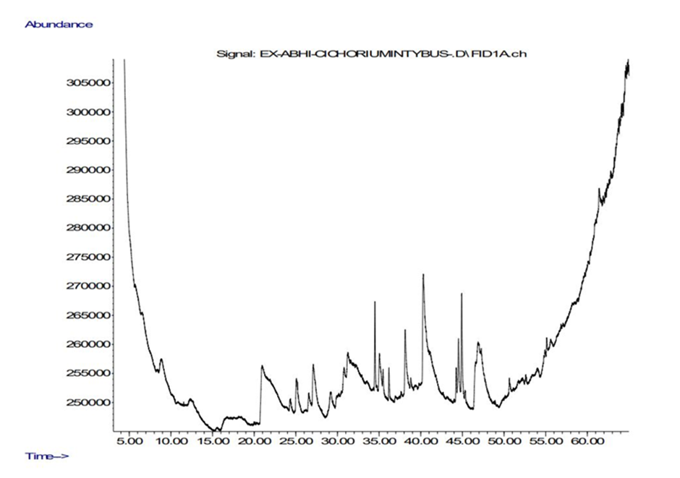
Figure 3: GC-MS Chromatogram of Ethanolic Extract of Cichorium intybus Roots

Table 3. Phytochemicals identified in Ethanolic extract of root of Cichorium intybus through GC-MS analysis

S. No. | Name of Compounds | Retention Time | Peak Area %
1 | Piperidine | 2.475 | 0.213
2 | Methylphenidate | 4.145 | 0.534
3 | L-proline | 5.138 | 0.713
4 | Tetradecanoic acid | 10.189 | 0.883
5 | 4H-Pyran-4-one | 34.733 | 0.712
6 | 2 butanone | 35.126 | 0.851
7 | Lupeol | 36.419 | 0.842
8 | 3,7,11,15-tetramethyl-2-hexadecen-1-ol | 37.125 | 0.121
9 | n-Hexadecanoic acid | 40.348 | 0.907
10 | Methyl linolenate | 44.297 | 0.183
11 | Stigmasterol | 44.558 | 0.004
12 | Linolenic acid | 46.856 | 0.927
13 | Dipalmitin | 55.702 | 0.869
14 | Propanoic acid | 57.703 | 0.872
15 | 9,12-octadecadienoic acid | 58.026 | 0.624
16 | Beta-sitostero | 61.091 | 0.987
17 | 8-Methyl-6-nonenamide | 62.289 | 0.296

Lupeol, and Beta-sitosterol were identified in both leaves and roots, whereas stems lack of these compounds. Roots exhibited a higher concentration of sterols such as Beta-sitosterol and Stigmasterol, which were absent in leaves and stems. Meanwhile, stems contained the highest proportion of nitrogenous compounds, including Hydroxylamine and Methylamine, indicating potential properties of the plant.

Phytochemical Content in Different Extracts

This study evaluates the Almora region phytochemical composition of Ethanol, Hydroethanolic, and Methanol extracts, presenting results as mean ± standard deviation (SD). The phytochemicals analyzed include Alkaloids, Saponins, Tannins, Phenols, Flavonoids, Glycosides, Carbohydrates, Proteins, and Reducing Sugars.

The Methanolic Extract shows the highest concentrations of most phytochemicals, while the Ethanolic Extract shows comparatively lower values (Figure 4, Table 4). Notably, Tannins and Saponins were more abundant in the Methanolic Extract (19.2 ± 1.4 and 18.2 ± 1.3, respectively), whereas Phenols (16.8 ± 1.1) and Proteins (13.6 ± 1.0) were also significantly higher in methanol-based extraction. The Hydroethanolic Extract demonstrated an intermediate extraction efficiency, particularly for Glycosides (12.5 ± 0.8) and Carbohydrates (14 ± 1.0).

The Ethanol Extract had the lowest concentrations in several cases, with Alkaloids (10.5 ± 0.8), Flavonoids (8 ± 0.5), and Proteins (6.7 ± 0.4) showing minimal extraction yields. However, it still retained substantial amounts of Reducing Sugars (14.3 ± 1.0).
These findings suggest that Methanol is the most effective solvent for extracting a wide range of phytochemicals, likely due to its high polarity and solubility properties, while the Ethanolic Extract had limited efficiency.
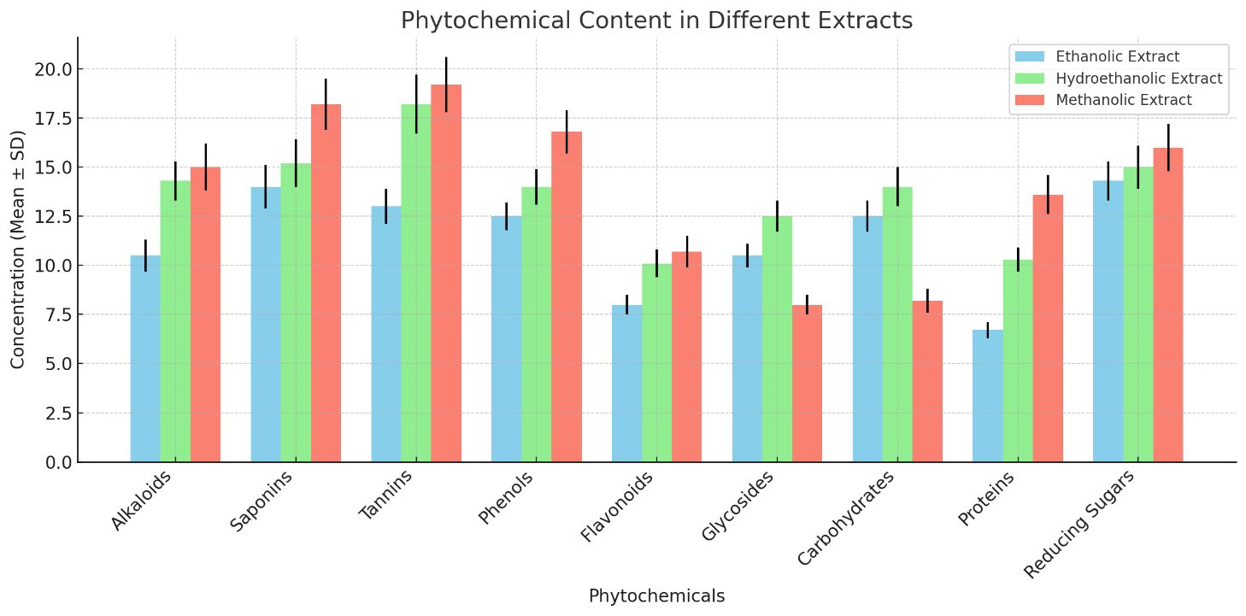
Figure 4. Comparative phytochemical composition in ethanolic, methanolic, and hydroethanolic extracts

Table 4. Phytochemical analysis of different compositions in ethanolic, methanolic, and hydroethanolic extracts.
Phytochemicals | Ethanolic Extract (Mean ± SD) | Hydroethanolic Extract (Mean ± SD) | Methanolic Extract (Mean ± SD)
Alkaloids | 10.5 ± 0.8 | 14.3 ± 1.0 | 15 ± 1.2
Saponins | 14 ± 1.1 | 15.2 ± 1.2 | 18.2 ± 1.3
Tannins | 13 ± 0.9 | 18.2 ± 1.5 | 19.2 ± 1.4
Phenols | 12.5 ± 0.7 | 14 ± 0.9 | 16.8 ± 1.1
Flavonoids | 8 ± 0.5 | 10.1 ± 0.7 | 10.7 ± 0.8
Glycosides | 10.5 ± 0.6 | 12.5 ± 0.8 | 8 ± 0.5
Carbohydrates | 12.5 ± 0.8 | 14 ± 1.0 | 8.2 ± 0.6
Proteins | 6.7 ± 0.4 | 10.3 ± 0.6 | 13.6 ± 1.0
Reducing Sugars | 14.3 ± 1.0 | 15 ± 1.1 | 16 ± 1.2

Evaluation of antioxidant assays

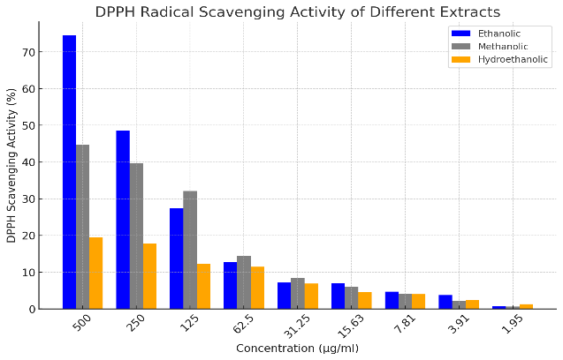
Figure 5: GC-MS Chromatogram of Ethanolic Extract of Cichorium intybus Roots

Table 5: Effect of hydroethanolic, methanolic and aqueous extract of Cichorium intybus on DPPH scavenging activity.
Conc. (µg/ml) | Ethanolic | Methanolic | Hydroethanolic
500 | 74.5 | 44.7 | 19.4
250 | 48.6 | 39.6 | 17.8
125 | 27.4 | 32.1 | 12.2
62.5 | 12.7 | 14.4 | 11.4
31.25 | 7.1 | 8.4 | 6.9
15.63 | 7 | 6 | 4.6
7.81 | 4.7 | 4.1 | 4
3.91 | 3.7 | 2.2 | 2.4
1.95 | 0.8 | 0.61 | 1.3
IC50 (µg/ml) | 50.88 | 150.79 | 203.28

GC-MS and Antioxidant Activity Analysis of Cichorium intybus Extracts

Table 5 presents the DPPH free radical scavenging activity of hydroethanolic, methanolic, and ethanolic extracts of Cichorium intybus at different concentrations (1.95–500 µg/ml). The three tested extracts, he ethanolic extract had the highest antioxidant activity at all concentrations. At 500 µg/ml, the ethanolic extract showed the highest scavenging activity of 74.5%, followed by 44.7% for the methanolic and 19.4% for the hydroethanolic extract. A similar pattern was noticed at lower concentrations, where the ethanolic extract was always superior to the rest.

The IC₅₀ values, being the concentration needed to inhibit 50% of the DPPH radicals, also reflect this trend. The ethanolic extract showed the lowest IC₅₀ value of 50.88 µg/ml, reflecting significant antioxidant capacity. The methanolic and hydroethanolic extracts, in comparison, reflected significantly higher IC₅₀ values of 150.79 µg/ml and 203.28 µg/ml, respectively, reflecting poor radical scavenging capacities.

These results indicate that ethanolic extract of is a good source of bioactive compounds containing high antioxidant activity. The results justify its possible use in therapeutic preparations for the treatment of disorders associated with oxidative stress. The higher activity of the ethanolic extract could be due to the better solubilization of phenolic and flavonoid compounds, which are known to contribute to antioxidant defense mechanisms.

Identify key elements such as calcium, magnesium, iron, and zinc

The given data represents the minimum and maximum concentrations of four elements (Fe, Zn, Mg, and Ca) in different locations. Based on the values, we can interpret the findings as follows:
this study examines the spatial variation in elemental concentrations across different locations, highlighting the influence of environmental, geological, and anthropogenic factors. Iron (Fe) concentrations range from 186.72 mg/kg in Arya Nagar (Haridwar) to 2783.9 mg/kg in Nainital Lake (Nainital), indicating substantial differences in soil composition. Zinc (Zn) levels vary between 18.945 mg/kg in Dhanauri (Haridwar) and 199.15 mg/kg in Mount Litera Zee School (Dehradun), suggesting potential influences from soil type, pollution, or agricultural practices. Magnesium (Mg) exhibits a considerable range, from 2678.984 mg/kg in Sitarganj (U.S.Nagar) to 9110.598 mg/kg in Kheti (Almora), reflecting strong regional mineralogical variations. Calcium (Ca) presents the most pronounced disparity, with concentrations spanning from 635.54 mg/kg in Dhanpura (Haridwar) to 9880.836 mg/kg in Almora, potentially attributed to limestone deposits or calcium-rich minerals. Among the analyzed elements, Fe and Ca demonstrate the highest variability, whereas Zn exhibits a comparatively smaller range. The observed variations suggest that locations with elevated concentrations possess distinct soil characteristics or external contributing factors influencing elemental distribution.

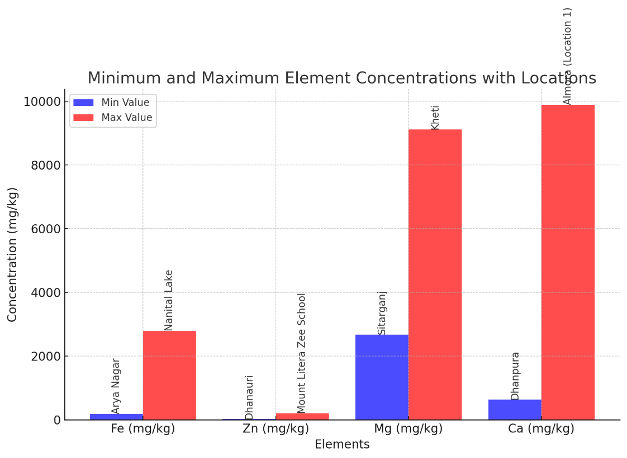
Figure 6: Minimum and Maximum Element Concentrations (Fe, Zn, Mg, Ca) in Different Locations

The following findings were obtained by measuring microelement amounts
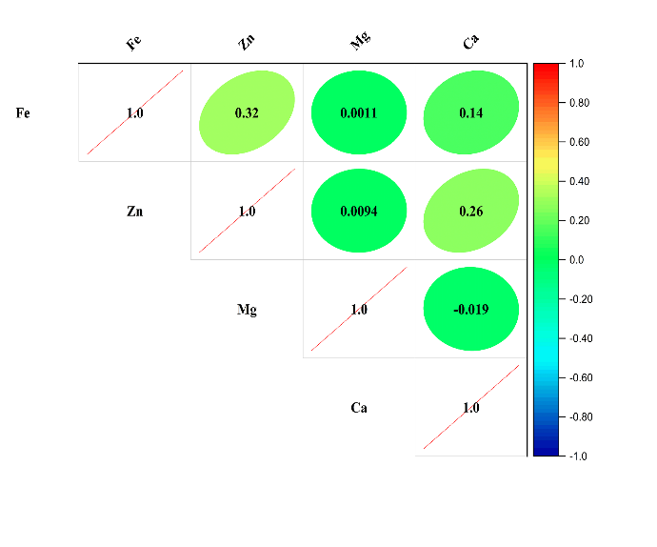 | 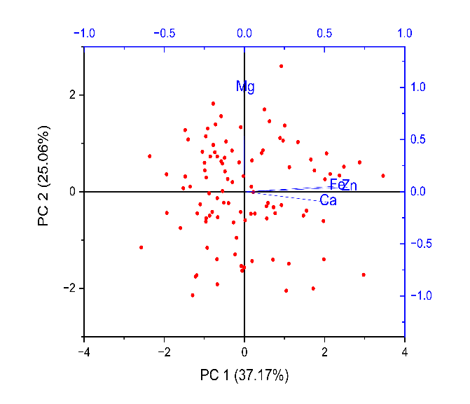
Figure 7: (a) Correlation Matrix of Elemental Composition (Fe, Zn, Mg, Ca) | (b) Principal Component Analysis (PCA) Biplot of Elemental Composition (Fe, Zn, Mg, Ca)

The correlation analysis of Fe, Zn, Mg, and Ca revealed varying relationships among these elements. The strongest positive correlation among different elements was observed between Zn and Ca (0.26), suggesting a moderate association. Fe showed a weak correlation with Ca (0.14) and Zn (0.32), while its correlation with Mg was nearly negligible (0.0011). Similarly, Zn and Mg exhibited a very weak correlation (0.0094). The lowest correlation was between Mg and Ca (-0.019), indicating a slight negative relationship. Overall, these findings suggest that while some elements show moderate associations, others have weak or negligible interactions within the studied system. Principal Component Analysis (PCA) Insights The PCA biplot indicates that Mg is clearly distinguished from Fe, Zn, and Ca, suggesting that Mg variance is not closely related to the other elements. Fe, Zn, and Ca are closely clustered, which means that they can have shared sources or similar geochemical behaviors. The explained variance by PC1 (37.17%) and PC2 (25.06%) indicates that there are several underlying factors controlling elemental composition.

DISCUSSION:

The findings of this study provide valuable insights into the phytochemical and elemental composition of Cichorium intybus leaves and their potential bioactive properties. The Gas Chromatography-Mass Spectrometry (GC-MS) analysis revealed the presence of several important phytoconstituents, including hydroxylamine, linolenic acid, and lupeol, which are known for their pharmacological significance. Hydroxylamine has been reported for its antioxidant and anti-inflammatory activities, while linolenic acid plays a crucial role in lipid metabolism and cardiovascular health. Lupeol, a well-documented triterpenoid, has demonstrated anticancer, anti-inflammatory, and antimicrobial properties in previous studies. The variation in the concentrations of these compounds across different parts of the plant suggests differential biosynthetic pathways and metabolic activities, potentially influenced by environmental and genetic factors.
The quantitative phytochemical assessment further supports these findings, highlighting significant levels of alkaloids, flavonoids, and phenols, particularly in methanol and ethanol extracts. These phytochemicals exhibit a range of biological activities, such as antioxidant, antimicrobial, and anti-inflammatory effects. Notably, ethanolic extracts exhibited higher concentrations of carbohydrates and proteins than hydroethanolic extracts, while methanol extracts contained fewer phytochemicals overall. This trend suggests that the choice of solvent significantly influences the extraction efficiency of bioactive compounds, with ethanol emerging as a more effective solvent for isolating a broad spectrum of phytochemicals.
The elemental composition analysis revealed notable spatial variation in Fe, Zn, Mg, and Ca concentrations across different locations, likely attributable to environmental, geological, and anthropogenic factors. The considerable variability in Fe concentrations, ranging from 186.72 mg/kg in Arya Nagar to 2783.9 mg/kg in Nainital Lake, underscores the impact of diverse soil compositions on elemental accumulation in plants. Similarly, the fluctuations in Zn levels (18.945 mg/kg in Dhanauri to 199.15 mg/kg in Mount Litera Zee School) suggest the influence of pollution and agricultural activities, with potential implications for plant growth and human health upon consumption.
Magnesium (Mg) concentrations ranged between 2678.984 mg/kg and 9110.598 mg/kg, while calcium (Ca) exhibited the highest disparity (635.54–9880.836 mg/kg). The pronounced variability in Ca concentrations may be attributed to limestone deposits in certain regions, which naturally contribute to elevated Ca levels in the soil. The high variability in Fe and Ca concentrations reflects distinct regional soil characteristics, highlighting the necessity for site-specific agricultural and environmental management strategies.
The findings of this study align with previous research on Cichorium intybus, reinforcing its significance as a nutritionally and pharmacologically valuable plant. The phytochemical composition suggests that C. intybus can be a rich source of bioactive compounds, while the elemental analysis underscores the environmental influence on nutrient uptake. Future research should explore the bioavailability and therapeutic efficacy of these phytochemicals, as well as conduct a more comprehensive assessment of the environmental factors influencing elemental variations. Additionally, further studies on the correlation between phytochemical composition and soil mineral content could provide deeper insights into plant-soil interactions and their impact on plant-based medicinal applications.

CONCLUSION:

This study highlights the medicinal and nutritional potential of Cichorium intybus phytochemical and elemental analysis. The presence of key bioactive compounds, including hydroxylamine, linolenic acid, and lupeol, underscores its significant antioxidant, anti-inflammatory, and antimicrobial properties. The variations in phytochemical composition across different parts of the plant suggest distinct biosynthetic and metabolic pathways influenced by genetic and environmental factors. Additionally, solvent selection plays a crucial role in optimizing the extraction of bioactive compounds, with ethanol proving to be more effective in isolating a broad spectrum of phytochemicals.
These findings suggest that the ethanolic extract of Cichorium intybus roots is rich in bioactive compounds with strong antioxidant properties. The elemental composition analysis reveals substantial spatial variations in Fe, Zn, Mg, and Ca concentrations, influenced by environmental, geological, and anthropogenic factors. These findings emphasize the need for site-specific agricultural and environmental management strategies to ensure optimal nutrient uptake and medicinal efficacy.
Overall, this study focuses on the pharmacological and nutraceutical significance of Cichorium intybus, supporting its applications in traditional and modern medicine. Future research should focus on the bioavailability and therapeutic potential of these phytochemicals while further exploring the relationship between soil mineral content and phytochemical composition.

REFERENCES:

- Das, R., Sharma, P., & Patel, V. (2022). Hepatoprotective potential of Cichorium intybus: Phytochemical and pharmacological insights. Journal of Herbal Medicine, 45-62.
- Gupta, S., Verma, R., & Singh, P. (2022). Phytochemical constituents and medicinal significance of Cichorium intybus: A comprehensive review. Phytomedicine Research, (2), 78-95.
- Joshi, R., Negi, P., & Sharma, V. (2023). Traditional and contemporary uses of chicory in Ayurveda and Tibetan medicine. Ethnobotanical Research, (3), 123-138.
- Kumar, V., & Yadav, A. (2023). Nutritional and therapeutic benefits of Cichorium intybus: Role of minerals and bioactive compounds. Food Science and Human Wellness, (1), 88-105.
- Kumar, S., Sharma, R., & Mehta, A. (2020). Ethnomedicinal applications of Cichorium intybus in gastrointestinal and inflammatory disorders. Journal of Natural Products, (4), 200-215.
- Meena, R., Rawat, K., & Sharma, M. (2023). Prebiotic potential of inulin from Cichorium intybus and its functional food applications. Journal of Functional Foods, , 112-129.
- Mishra, A., Singh, R., & Bhatia, M. (2020). Indigenous use of Cichorium intybus in Unani and Ayurvedic medicine: An ethnobotanical perspective. Traditional Herbal Medicine, (3), 145-167.
- Negi, T., Bhatt, P., & Rana, P. (2022). Ethnomedicinal knowledge of Cichorium intybus in the Himalayas: Therapeutic and cultural significance. Asian Journal of Ethnobotany, (2), 67-85.
- Pandey, D., Sharma, S., & Gupta, P. (2019). Bioactive molecules in Cichorium intybus: Phytochemistry and pharmacological aspects. Journal of Medicinal Plants Research, (1), 98-120.
- Rana, R., & Bhatt, S. (2021). Traditional uses of chicory as an anti-inflammatory and digestive agent. Indian Journal of Ethnopharmacology, (2), 89-105.
- Rana, S., Patel, V., & Das, R. (2021). Antioxidant activity of Cichorium intybus: Role of phenolic acids in radical scavenging. Biochemistry and Pharmacology, (1), 35-50.
- Rawat, R., Sharma, P., & Patel, V. (2021). Influence of altitude and soil composition on the mineral content of Cichorium intybus. Environmental Botany Journal, (4), 54-78.
- Sharma, K., Patel, V. (2022). Nutritional evaluation of essential minerals in Cichorium intybus roots and leaves. International Journal of Food Science, (3), 112-130.
- Singh, H., & Bhatia, K. (2023). Hypoglycaemic effects of Cichorium intybus extracts in diabetes management. Journal of Phytotherapy, (2), 130-145.
- Singh, V., Patel, M., & Mehta, A. (2021). Pharmacological activities of flavonoids and phenolic acids in Cichorium intybus: A review. Natural Product Communications, (3), 210-225.
- Thakur, R., Sharma, S., & Verma, K. (2022). Chicory extracts and their impact on antioxidant enzyme activity: A mechanistic approach. Biomedicine & Pharmacotherapy, (1), 67-85.
- Verma, P., Gupta, R., & Sharma, S. (2020). Antioxidant properties of Cichorium intybus: A comparative study of polyphenolic content. Food Chemistry, (2), 98-115.
- Kam, N. and Kanberoglu, G.S., 2019. Chemical analysis and fatty acid composition of the chicory plant (Cichorium intybus L.) by GC-MS. Journal of Engineering Technology and Applied Sciences, 4(2), pp.51-62.

