***Original Research Article***

**SSR markers mediated diversity analysis of brinjal *(Solanum melongena* l.)**

**ABSTRACT**

Brinjal (*Solanum melongena* L.) is an essential vegetable crop that is consumed globally, particularly in areas that are prone to drought. Due to its remarkable range of sizes and shapes, this vegetable is highly valued for both its nutritional content and aesthetic appeal. Because of its high protein content, potent antioxidants, and vital minerals, brinjal is a valuable supplement to a balanced diet. Brinjal is widely grown in Bihar, but little is known about the genetic diversity among its genotypes, despite its importance in agriculture and the economy. In order to develop improved varieties with improved traits like increased yield, disease resistance, and environmental adaptability, breeding programs must have a thorough understanding of genetic variation. The genetic diversity of 19 brinjal genotypes—16 inbred lines and three wild varieties—was assessed in this study using 21 SSR markers. EM107, EM114, EM133, EM140, EM145, EMB01I13, EMB01D10, and EMK03O04 were the eight polymorphic markers used in the genetic analysis. The genotypes were grouped into two major clusters using UPGMA clustering, and these clusters were further subdivided into four sub-clusters according to their genetic similarity. The degree to which the various genotypes are related to one another was revealed by this classification. The markers EMK03O04 (0.3957) and EMB01D10 (0.4139) had the highest Polymorphic Information Content (PIC) values, suggesting that they are very useful and informative in differentiating between the genetic variants found in the brinjal genotypes. To further enhance our understanding of genetic diversity, future research is encouraged to encompass a wider variety of genotypes and markers, paving the way for more comprehensive insights into this important vegetable crop. This would serve to further deepen knowledge of genetic diversity in this significant vegetable crop, ultimately leading to improved cultivation practices and crop varieties.

**Keywords**: Molecular diversity, Brinjal, inbred, wild relatives, SSR markers, genetic clustering, UPGMA, PIC value.

**INTRODUCTION**

Brinjal (Solanum melongena L., 2n=2x=24), commonly known as eggplant in the United States, is a prominent member of the Solanaceae family. It is widely recognized in India as the regional name of Bangna, Bhagwata, Badanik, and Vangi, reflecting its deep cultural and agricultural importance. India is the main source and diversity center of the brinjal and its historical records indicate that it has been cultivated for over 4,000 years [1]. The crop has been widely grown in Asia and Europe [2], with world production of about 54.08 billion tonnes, with Asia contributing 93 per cent of the production. China dominates global production with 45% of GDP, followed by India with 24% [3]. The main producers of brinjal in India are West Bengal, Maharashtra and Bihar [4].

Nutritionally, brinjal is a valuable source of carbohydrates, fats, proteins, food fibers, essential minerals, vitamins and antioxidants. Medications are used in traditional treatments such as diabetes, leprosy, gonorrhea, cholera, cancer, bronchitis, pneumonia, pneumonia, asthma and bleeding [5]. In addition, brinjal has important pharmacological properties, including low cholesterol, spasmogenic, central nervous system inhibitor, blocking calcium channels, and hypotensive properties [6]. In addition to its nutritional and medical value, brinjal has significant potential as a raw material for the pickle and dehydration industries. This multifunctional crop is still a key element of food security, traditional medicine and agricultural industry, and its diverse role in sustainable agriculture and public health reflects this.

Brinjal's wide genetic diversity is demonstrated by the considerable variation in both its morphological and biochemical traits [7]. Breeding programs that aim to improve yield, disease resistance, and stress tolerance must advance by understanding the molecular diversity and genetic relationships among native genotypes. For evaluating genetic variation both within and between populations, molecular markers like Random Amplified Polymorphic DNA (RAPD), Amplified Fragment Length Polymorphism (AFLP), Simple Sequence Repeat (SSR), and Inter-Simple Sequence Repeat (ISSR) have become essential instruments [8, 9, 10, 11]. By providing reliable information about genetic relationships, these markers help identify agronomically valuable traits for marker-assisted selection (MAS) and enable precise evaluation of genetic diversity.

The first SSR markers for brinjal, developed by Nunome et al. [8], showed their efficacy in genetic analysis and mapping of agronomic characteristics, which was a major advance in molecular breeding. Subsequent studies have highlighted the use of SSR markers to assess the genetic diversity of various brinjal accessions [8,9]. Nevertheless, although its agricultural, nutritional, and economic importance is small, the Salini genome has not been studied as much as other solanaceous crops, such as tomatoes, potatoes, and peppers [11,12]. Recent advances in next-generation sequencing (NGS) and high-throughput sequencing technologies have provided promising paths for deep genomic research and the identification of new markers related to important traits [13, 14, 15].

Given the limited comprehensive studies on brinjal’s genetic diversity, the present investigation aims to estimate the level of genetic variation among diverse brinjal genotypes using SSR markers. This approach is expected to provide valuable insights for future breeding strategies, contributing to sustainable crop improvement and resilience to biotic and abiotic stresses.

**MATERIALS AND METHODS**

**Experimental Materials:** Table 1 presents a comprehensive list of 19 genotypesutilized in the experiment,encompassing both cultivated and wild accessions of Solanum species. The genotypes arecategorized primarily asinbred lines and wildaccessions, sourced from prestigious agricultural research institutesacross India. Among thecultivated genotypes,'Sel 91-2 (PH-6male)' and 'Sel Br-112 (PH-6female)' are inbred linesprocured from IARI, NewDelhi, and maintained atBAU, Sabour. Other notable cultivated genotypes include'Haritha' from KAU, Kerala,'Swarna Mani' from CHES, Ranchi,'IIHR-563' from IIHR,Bengaluru, and 'Pant Samrat' from GBPUAT, Pantnagar,each preserved at BAU, Sabour.Additionally, genotypes such as 'Rajendra Baigan-2,' 'VR-2,' and a series of BRBL lines (BRBL-01, BRBL-02, BRBL-04, BRBL-06, BRBL-07, BRBL-10, and BRBL-11)were sourced from BAU, Sabour.The wild accessions, including'BRBWM-07' and 'BRBWM-06' (Solanum macrocarpon), and S. gilo (Solanum gilo), were collected from BCKV, Mohanpur, andsubsequently maintained at BAU, Sabour. Thisdiverse set of genotypes represents significant genetic variability, which iscritical for breedingprograms, stress tolerancestudies, and the enhancement of desirableagronomic traits. The seeds from allthe genotypes were cultivated inclean and sterilizedpetri disheswithin a plant growthchamber. A total of 19 brinjalgenotypes, selected for their uniformity,viability, health, and freedomfrom disease andinsects, were utilized to growseedlings. DNA extractionfrom these 19genotypes wasconducted under controlled conditions to facilitate diversity analysis.

**DNA Extraction:** Genomic DNA was extracted from 15-day-old brinjal seedlings using immature leaf tissue (200-300 mg) by CTAB [16] with the necessary modifications. The tissue was homogenised with 1 ml of CTAB buffer, incubated for 45 minutes at 65 degrees Celsius and then centrifuged with chloroform:isoamyl alcohol (24:1). The aqueous phase was precipitated with cooled isopropanol and the resulting DNA pellet was washed with 70 per cent ethanol, dried in air and dissolved in 100 ml 10-triols of buffer. The quality and quantity of DNA was assessed by 0.8-percent agarose gel electrophoresis and visualised under UV light using the GelDoc system.

**SSR-Marker analysis:** For SSR analysis, the genomic DNA was diluted to 40 ng per ml using 21 primers from 19 brinjal genotypes (primer sequences available in the supplementary file). PCR reactions (10.10 ml total volume) consisted of 1.5 ml DNA, 0.30 ml each of primers upstream and downstream, 4.0 ml pre-mix (10 times buffer, dNTP, MgCl, Taq polymerase) and water free from nucleosides. The induction consisted of initial denaturation at 94 degrees Celsius for 5 min followed by 35 cycles at 94 degrees Celsius for 30 seconds, 65 degrees Celsius for 1 min, 72 degrees Celsius for 2 min and finally a final prolongation at 72 degrees Celsius for 7 min. The products were separated by means of a catalytic converter of 2 percent agarose gel at 100 V and visualised under a UV light. The 100-bp DNA ladder was used to estimate the size of the PCR fragments. The gel images were documented with the Uvitec Gel Documentation System for further analysis.

**Statistical analysis of SSR data:** The expected size of the amplified bands for each SSR marker was determined by comparing their migration patterns with the 100-bp DNA ladder. Clear, distinct bands were visually scored as present (1) or absent (0) for eight polymorphic SSR markers in 19 brinjal genotypes. Polymorphic information content (PIC) and heterozygosity have been calculated to evaluate the marker's ability to detect genetic variation. Binary data was used to construct a dendrogram based on a matrix of similarities generated by the Jaccard standard. Clustering was performed using UPGMA (Unweighted paired-group method with arithmetic mean) to illustrate the genetic relations between genotypes.

**RESULTS AND DISCUSSION**

Nineteen brinjal genotypes were evaluated for allelic diversity using 21 SSR markers. Amplified products, resolved on 2% agarose gel, were compared against a 100 bp DNA ladder to estimate fragment sizes. Among the 21 markers, eight were polymorphic, while thirteen were monomorphic, yielding 18 alleles. Polymorphic Information Content (PIC) values ranged from 0.1706 to 0.4139, with EMB01D10 (0.4139) and EM140 (0.3126) being the most informative markers. Genetic diversity was analyzed using UPGMA clustering and Jaccard's coefficient, with genetic distances ranging from 0.091 (e.g., PH-6 male with Mukta Keshi, IIHR-563, BRBL-04, BRBL-07, BRBL-10) to 0.875 (BRBL-11 with S. gilo), averaging 0.401. Complete genetic similarity (0% dissimilarity) was observed among several genotype pairs, including PH-6 male, PH-6 female, Swarna Mani, and RB-2, as well as Mukta Keshi, IIHR-563, BRBL-01, BRBL-04, BRBL-07, and BRBL-10 **(Fig. 1)**.

The genetic relationships among 19 brinjal genotypes were elucidated through phylogenetic analysis using the Unweighted Pair Group Method with Arithmetic Mean (UPGMA) algorithm implemented in DARwin 5.0 software. The analysis incorporated allelic variation data obtained from eight polymorphic SSR markers, revealing distinct clustering patterns in the resultant dendrogram (Fig. 2). The UPGMA tree topology segregated the germplasm into two major clades with significant bootstrap support. Clade I exclusively contained wild accessions, forming a monophyletic group that further bifurcated into two well-supported subclades comprising S. macrocarpon (BRBWM-07 and BRBWM-06) and S. gilo genotypes. Clade II encompassed all cultivated inbred lines, demonstrating clear genetic differentiation from wild relatives, and was resolved into two distinct subclusters. These subclusters systematically grouped the genotypes based on their breeding history and pedigree relationships, including PH-6 derived lines (male and female parents), improved cultivars (Harita, Mukta Keshi, Swarna Mani, IIHR-563, Pant Samrat), and advanced breeding lines (RB-2, VR-R2, and the BRBL series from BRBL-01 to BRBL-11). The observed clustering pattern provides molecular evidence for the genetic divergence between cultivated and wild Solanum germplasm, while revealing finer-scale relationships among improved varieties and breeding lines.

Numerous studies have employed various molecular marker systems to assess genetic diversity in brinjal (Solanum melongena L.), demonstrating the critical role of DNA-based technologies in facilitating selective breeding through parental diversity characterization and germplasm enhancement (17). Extensive molecular characterization has consistently revealed substantial genetic variation among eggplant cultivar groups (8, 9, 18-20). While Random Amplified Polymorphic DNA (RAPD) markers have been traditionally predominant in brinjal diversity studies, showing greater efficiency than Inter-Simple Sequence Repeat (ISSR) markers (21, 22), comparative analyses by Demir et al. (23) and Akhther et al. (24) have established the superior discriminatory power of Simple Sequence Repeat (SSR) markers. SSR-based studies have particularly demonstrated robust phylogenetic relationships within the Solanum complex (including S. viarum, S. melongena, and S. aethiopicum from the Aculeatum group), confirming their utility as ideal markers for genetic variation analysis (8, 9, 25). Quantitative evaluation of polymorphism information content (PIC) by Rajan et al. (26) revealed moderate genetic diversity levels, with PIC values ranging from 0.1706 to 0.4139, where markers EMB01D10 (PIC=0.4139) and EM140 (PIC=0.3126) emerged as particularly informative for germplasm characterization. These collective findings underscore the progressive refinement of molecular tools for eggplant genetic studies, with SSR markers currently representing the most robust system for comprehensive diversity assessment in breeding programs.

Lipio et al. [27] employed SSR markers to assess genetic diversity among various eggplant varieties. They identified a range of allelic variations and clustering patterns that reflect the genetic relationships among different genotypes. The cluster analysis revealed that several genotypes grouped closely together, with both the PH-6 male and PH-6 female lines—two widely cultivated varieties in India—showing minimal genetic variation. This lack of variation is likely due to their extensive use in heterosis breeding programs.

These results are consistent with findings from Fallahi et al. [11] and Akhther et al. [24], who reported a high pairwise similarity index among closely related brinjal genotypes, indicating a narrow genetic base at the molecular level. The brinjal genome, estimated to be 1,155.8 Mb in size, comprises approximately 70.1% repetitive sequences [28], which complicates the detection of polymorphism using a limited number of SSR markers.

Recent studies by Musa et al. [25] and Oladosu et al. [29] also reported restricted allelic variation in brinjal due to the limited number of primers used for diversity analysis. Therefore, there is a need for a greater number of polymorphic markers and advanced genomic tools for more comprehensive analysis.

**CONCLUSIONS**

The usefulness of SSR markers in determining the genetic diversity among 19 brinjal genotypes—a critical step for successful breeding and conservation strategies—is highlighted in the current study. The potential of the 21 SSR markers used for molecular diversity analysis was demonstrated by the discovery that eight of them (EM107, EM114, EM133, EM140, EM145, EMB01I13, EMB01D10, and EMK03O04) were polymorphic. The genotypes were effectively grouped using UPGMA-based cluster analysis into two major clusters and four sub-clusters, with inbred lines making up Cluster II and wild varieties making up Cluster I. The PIC values (0.4139 for EMB01D10 and 0.3957 for EMK03O04) and the greatest genetic distance (200–300 bp) demonstrate the dependability and informativeness of these markers for genetic differentiation. The study determines the degree of genetic diversity, groups genotypes into clusters, and assesses the informativeness of particular genotypes by analyzing 19 genotypes—including inbred lines and wild varieties—using SSR markers.

**REFERENCES**

1. Vavilov NI (1951) The Origin, Variation, Immunity and Breeding of Cultivated Plants, *Leningadskiy Ovoshnoy Zhurnal*, 72 (6), 482.
2. Ansari AM, Singh YV (2014) Combining ability analysis for vegetative, physiological and yield components in brinjal (*Solanum melongena* L), *International Science Journal*, 1(2), 53-59.
3. FAOSTAT: [https://wwwfaoorg/faostat/en/#data](https://www.fao.org/faostat/en/#data), 2022.
4. Akhtar S, Kumari R, Solankey SS, Baranwal DK (2019)Phenotypic stability in brinjal genotypes, *Journal of Crop and Weed*, 15(3):79–86.
5. Nandi LL, Saha P, Jaiswal S, Lyngdoh YA, Behera TK, Pan RS, Tomar BS (2021) Bioactive compounds, antioxidant activity and elements content variation in indigenous and exotic Solanum sp and their suitability in recommended daily diet, *Scientia Horticulturae*, 287, 110232.
6. Saha P, Singh J, Bhanushree N, Harisha SM, Tomar BS, Rathinasabapathi B (2023) Eggplant (Solanum melongena L) nutritional and health promoting phytochemicals In Compendium of Crop Genome Designing for Nutraceuticals, Springer Nature Singapore. 1-32.
7. Arivalagan M, Bhardwaj R, Gangopadhyay KK, Prasad TV, Sarkar SK (2013) Mineral composition and their genetic variability analysis in eggplant (*Solanum melongena* L) germplasm, *Journal of Applied Botany and Food Quality*, 86(1).
8. Nunome T, Negoro S, Kono I, Kanamori H, Miyatake K, Yamaguchi H, Fukuoka H (2009) Development of SSR markers derived from SSR-enriched genomic library of eggplant (*Solanum melongena* L), *Theoretical and Applied Genetics*, 119(6), 1143-1153.
9. Stàgel A, Portis E, Toppino L, Rotino GL, Lanteri S (2008) Gene-based microsatellite development for mapping and phylogeny studies in eggplant, *BMC genomics*, 9(1): 1-14.
10. Caguiat XGI, Hautea DM (2014) Genetic diversity analysis of eggplant (*Solanum melongena* L) and related wild species in the Philippines using morphological and SSR markers, *SABRAO Journal of Breeding and Genetics*, 46(2), 183-201.
11. Fallahi F, Abdossi V, Bagheri M, Ghanbari Jahromi M, Mozafari H (2022) Genetic diversity analysis of Eggplant Germplasm from Iran: assessments by morphological and SSR markers, *Molecular Biology Reports*, 49(12), 11705-11714.
12. Rao VG, Viswanath HS, Ambadkar CV, Navgire KD, Apet KT (2022) Management of Fusarium Wilt (*Fusarium oxysporum* f sp *melongenae*) using Organic Soil Amendments in Eggplant, *International Journal of Plant & Soil Science*, 34(24), 47-56.
13. Hirakawa H, Shirasawa K, Miyatake KOJI, Nunome T, Negoro S, Ohyama AKIO, Fukuoka H (2014) Draft genome sequence of eggplant (*Solanum melongena* L): the representative solanum species indigenous to the old world, *DNA Research*, 21(6): 649-660.
14. Prasad SS, Singh A, Patil K, Ramteke PW, Kumar N, Shukla PK, Srija MSL (2024) Next-Generation Sequencing (NGS) Application in Plant Breeding, *Plant Molecular Breeding in Genomics Era*, 149.
15. Gaccione L, Martina M, Barchi L, Portis E (2023) A compendium for novel marker-based breeding strategies in eggplant, *Plants*, 12(5), 1016.
16. Doyle JJ and Doyle JL (1990) Isolation of Plant DNA from Fresh Tissue, *Focus*, 12 (1), 13-15.
17. Fu Q, Liu C, Ding N, Lin Y, Guo B (2010) Ameliorative effects of inoculation with the plant growth-promoting rhizobacterium Pseudomonas sp DW1 on growth of eggplant (*Solanum melongena* L) seedlings under salt stress Agricultural Water Management, *Agricultural Water Management*, 97(12), 1994-2000.
18. Cericola F, Portis E, Lanteri S, Toppino L, Barchi L, Acciarri N, Rotino GL (2013) Genetic structure, linkage disequilibrium and first insights on association mapping in an eggplant (*Solanum melongena* L) germplasm collection, *Breakthroughs in the Genetics and Breeding of Capsicum and Eggplant : XV EUCARPIA Meeting on Genetics and Breeding of Capsicum and Eggplant*, 113-121.
19. Gramazio P, Prohens Tomás J, Plazas Ávila, MDLO, Mangino G, Herraiz García FJ, García-Fortea E, Vilanova Navarro, S (2018) Genomic tools for the enhancement of vegetable crops: a case in eggplant, *Notulae Botanicae Horti Agrobotanici Cluj-Napoca*, 46(1), 1-13.
20. Tümbilen Y, Frary A, Mutlu S, Doganlar S (2011) Genetic diversity in Turkish eggplant (*Solanum melongena*) varieties as determined by morphological and molecular analyses, *International Research Journal of Biotechnology*, 2(1), 16-25.
21. Tiwari SK, Karihaloo JL, Hameed N, Gaikwad AB (2009) Molecular characterization of brinjal (*Solanum melongena* L) cultivars using RAPD and ISSR markers, *Journal of Plant Biochemistry and Biotechnology*, 18, 189-195.
22. Thakkar JR, Mandavia MK, Golakiya BA, Sabara PH (2014) Analysis of genetic diversity among brinjal (*Solanum melongena* L) genotypes through dominant markers, *Indian Journal of Agricultural Biochemistry*, 27(2), 165-169.
23. Demir, KÖKSAL, Bakir MELİKE, Sarikamis GÖLGE, Acunalp S (2010) Genetic diversity of eggplant (*Solanum melongena*) germplasm from Turkey assessed by SSR and RAPD markers, *Genetics and Molecular Research*, 9(3) .
24. Akhther N, Islam MM, Hassan MK (2021) Assessment of genetic diversity among sixty Five Brinjal Genotypes Using SSR markers, *Bangladesh Journal of Nuclear Agriculture*, 35: 71-83.
25. Musa I, Yusop MR, Magaji U, Chukwu SC, Ayanda AF, Rini BY, Kiri AS (2024) Morphological and molecular diversity of eggplant accessions (*Solanum melongena* L) using simple sequence repeats (SSR) markers, *Innovations in Agriculture*, 7, 1-9.
26. Rajan N, Debnath S, Perveen K, Khan F, Pandey, B, Srivastava A, Lal M (2023) Optimizing hybrid vigor: a comprehensive analysis of genetic distance and heterosis in eggplant landraces, *Frontiers in Plant Science*, 14, 1238870.
27. Lipio PLG, Oloc-oloc IBM, Guinto TD, Diamante BAA, Caraan JAM, Hermoso RT, Hautea DM (2024) Genetic Diversity Analysis of a Multi-Gene Bank Collection of Eggplant (*Solanum melongena* L): Insights from Morphological Traits and SSR Markers, *bioRxiv*, 2024-04.
28. Li D, Qian J, Li W, Yu N, Gan G, Jiang Y, Wang Y (2021) A high‐quality genome assembly of the eggplant provides insights into the molecular basis of disease resistance and chlorogenic acid synthesis, *Molecular Ecology Resources*, 21(4), 1274-1286.
29. Oladosu Y, Rafii MY, Arolu F, Chukwu SC, Salisu MA, Olaniyan BA, Muftaudeen TK (2021) Genetic diversity and utilization of cultivated eggplant germplasm in varietal improvement, *Plants*, 10(8), 1714.

**Table 1** List of the genotypes that used in experiment

|  |  |  |  |  |
| --- | --- | --- | --- | --- |
| **SN** | **Genotypes** | **Types** | **Sources** | **Code** |
| 1 | Sel 91-2 (PH-6 male) | Inbred line | Collected from IARI, New Delhi maintained at BAU, Sabour | G1 |
| 2 | Sel Br-112 (PH-6 female) | Inbred line | Collected from IARI, New Delhi maintained at BAU, Sabour | G2 |
| 3 | Haritha | Inbred line | Collected from KAU, Kerala maintained at BAU, Sabour | G3 |
| 4 | Muktakeshi | Inbred line | BAU, Sabour | G4 |
| 5 | Swarna Mani | Inbred line | Collected from CHES, Ranchi maintained at BAU, Sabour | G5 |
| 6 | IIHR-563 | Inbred line | Collected from IIHR, Bengaluru maintained at BAU, Sabour | G6 |
| 7 | Rajendra Baigan-2 | Inbred line | BAU, Sabour | G7 |
| 8 | VR-2 | Inbred line | Collected from IIVR, Varanasi maintained at BAU, Sabour | G8 |
| 9 | Pant Samrat | Inbred line | Collected from GBPUAT, Pantnagar maintained at BAU, Sabour | G9 |
| 10 | BRBL-01 | Inbred line | BAU, Sabour | G10 |
| 11 | BRBL-02 | Inbred line | BAU, Sabour | G11 |
| 12 | BRBL-04 | Inbred line | BAU, Sabour | G12 |
| 13 | BRBL-06 | Inbred line | BAU, Sabour | G13 |
| 14 | BRBL-07 | Inbred line | BAU, Sabour | G14 |
| 15 | BRBL-10 | Inbred line | BAU, Sabour | G15 |
| 16 | BRBL-11 | Inbred line | BAU, Sabour | G16 |
| 17 | BRBWM-07 | Wild accession of *Solanum macrocarpon* | Collected from BCKV, Mohanpur, maintained at BAU, Sabour | G17 |
| 18 | BRBWM-06 | Wild accession of *Solanum macrocarpon* | Collected from BCKV, Mohanpur, maintained at BAU, Sabour | G18 |
| 19 | *S gilo* | Wild accession of *Solanum gilo* | Collected from BCKV, Mohanpur, maintained at BAU, Sabour | G19 |

**Table 2: List of brinjal SSR primers used for diversity analysis**

|  |  |  |
| --- | --- | --- |
| **SN** | **SSR Primer** | **Sequence (5`→3`)** |
|
|  | EM107 | **FP**- GGCCCTAGACTGAGCCTGAAATGTT  **RP**- TGGTACAACCAACACAACCCTCAA |
|  | EM133 | **FP-** GCGGATCACCTGCAGTTACATTAC  **RP-** TCCTTTGACCTATAGTGGCACGTAGT |
|  | EM140 | **FP-** CCAAAACAATTTCCAGTGACTGTGC  **RP-** GACCAGAATGCCCCTCAAATTAAA |
|  | EM145 | **FP-** TGATTTGGCCCTTAAGCCTAAGTATG  **RP-** GACTCCTCAAGCCTTTACCTCCAA |
|  | *ecm*031 | **FP-**  ACCAAAGGAGAAGGAGATGTGCTA  **RP-**  GTTTGCTTCCCTTCCAAAATGACAAG |
|  | emf21N03 | **FP-**  ACCAGAGGAGCAAAGGGAAAAATA  **RP-** GTTTACGCTACTGGACCAAACCAACAAT |
|  | eme08D09 | **FP-**  ATGGATTAGCATGTGGAGGACTGAA  **RP-**  GTTTCATGGTAGGTGGAGACAGAACCA |
|  | *emf*21H22 | **FP-**  CACAAGATGAACAAGACTAAGGAGTGC  **RP-**  CTTCTTCAACCTGTCTTTAGCCCA |
|  | SMSSR11 | **FP-** AAACAAACTGAAACCCATGT  **RP-** AAACAAACTGAAACCCATGT |
|  | SMSSR14 | **FP-** ATACCACATCAATCCAAAGC  **RP-** CATCATCATCTTCACAGTGG |
|  | EMB01D10 | **FP-** AAGAATCGGTCCTCTTTGCATTGT  **RP-** TGCTTTTCACCTCTCCGCTATCTC |
|  | EMB01I13 | **FP-** AGTCGTGTAGGTCAAAGCAACTGA  **RP-** GTTTAGCTACGTTGGTTTGGTGCTGAA |
|  | EMK03O04 | **FP-** ATGATTTGGGCAGCCACTTTTGTA  **RP-** GTTTGGAACCAACTAAACTTAGGGCA |
|  | *emf*21C11 | **FP-**  TGGTTGGAGCCATGATTACTTGAA  **RP-**  ATGCTACCTATCAAACAGGCGGAA |
|  | *emh*11O01 | **FP-**  GATGTGTCGATGAGATTTTGGTCA  **RP-**  TAGCTACGTTGGTTTGGTGCTGAA |
|  | SMSSR01 | **FP-** GTGACTACGGTTTCACTGGT  **RP-** GATGACGACGACGATAATAGA |
|  | EMB01L13 | **FP-**  TCAAAAGACTTGAAACCCGATGGT  **RP-**  GTTTATCAGGTTTTTGATCACCGGACA |
|  | EM114 | **FP-** AGCCTAAACTTGGTTGGTTTTTGC  **RP-** GAAGCTTTAAGAGCCTTCTATGCAG |
|  | SMSSR03 | **FP-** ATTGAAAGTTGCTCTGCTTC  **RP-** GATCGAACCCACATCATC |
|  | EM139 | **FP-** TGC TAA GTC GTC ATC CAACAA GAA  **RP-** GAT TTT GGC TCC TTG ACC ATT TTG |
|  | *eme*03A05 | **FP-**  ATTTTATGCTGCTCCTCGGATTGAT  **RP-**  GTTTGTGCATCTCTTGTTGGTAGGAGC |

**Table 3**: Summary of polymorphic markers

|  |  |  |  |  |  |  |
| --- | --- | --- | --- | --- | --- | --- |
| **SN** | **Primer** | **Total Numberof alleles** | **Total Number of Polymorphic alleles** | **Range** | **Heterozygosity** | **PIC Value** |
| **1** | EM107 | 2 | 2 | 210-190 | 02659 | 02306 |
| **2** | EM114 | 2 | 2 | 210-200 | 00997 | 00948 |
| **3** | EM133 | 2 | 2 | 190-180 | 02659 | 02306 |
| **4** | EM140 | 2 | 2 | 280-210 | 03878 | 03126 |
| **5** | EM145 | 2 | 2 | 190-180 | 01884 | 01706 |
| **6** | EMB01D10 | 3 | 3 | 300-200 | 05088 | 04139 |
| **7** | EMB01I13 | 2 | 2 | 210-200 | 02659 | 02306 |
| **8** | EMK03O04 | 3 | 3 | 200-130 | 04383 | 03957 |

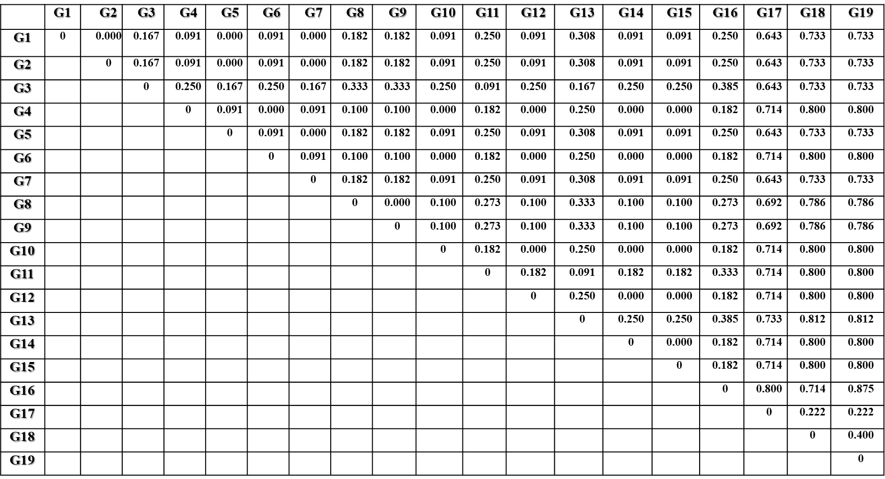**Figure 1:** Distance matrix based on Jaccard coefficient (UPGMA)

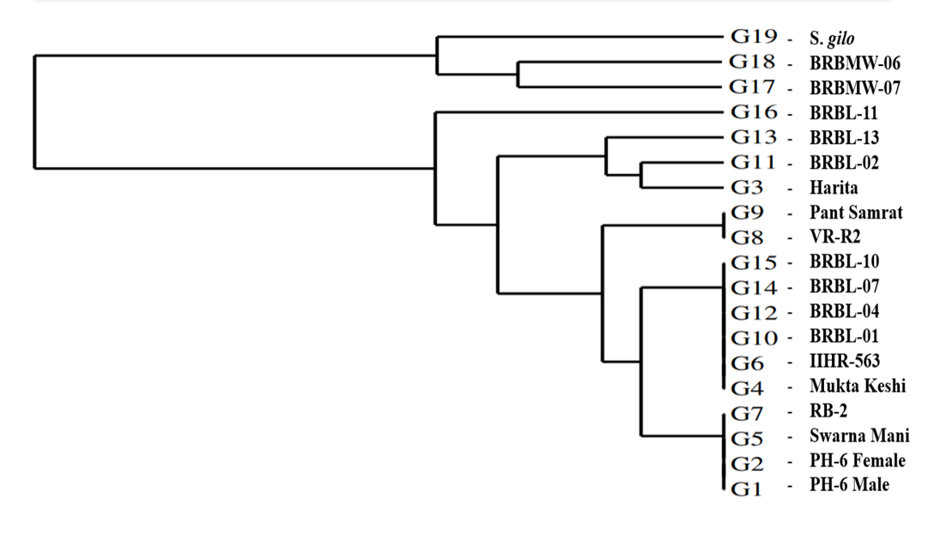

**Figure 2: clustering of brinjal genotypes by UPGMA using molecular data**