**Anti-Cancer Effects of Plant based herbal Formulation on Vero And Human Colorectal Cancer Cell Lines.**

**Abstract**

The aim of the present study is to search for excellent antineoplastic agent avertable to human colorectal malignancies. In vitro assay for cytotoxicity activity (3‑[4,5‑dimethylthiazol‑2‑yl] ‑2,5‑diphenyltetrazolium bromide assay) (MTT Assay), DNA fragmentation were analysed by single gel electrophoresis and the activities of certain tumour specific marker enzymes such as acid phosphatase, aspartate amino transferase, lactate dehydrogenase, alanine amino transferase, alkaline phosphatase are also analysed. Our results envisage that the non-cytotoxic nature of polyherbal formulation on Vero and human colorectal carcinoma[HT – 29] cell lines and the poly herbal formulation possess the strong anticancer activities on human colorectal carcinoma cell lines.The evaluation and the discovery of new anticancer agents is a longterm process that encompasses many steps. The step broaches with the screening for anticancer properties, followed by the isolation and identification of bioactive compounds obliged to anticancer properties, toxicity estimation of the isolated compounds and finally in vivo anticancer activity testing to verify the aptitude of the compounds.

**Key words:** Anticancer agent, Non-coding RNA, Colorectal tumours, Heterozygosity, Microsatellite instability, Polyherbal formulation.

**Introduction**

Plant based compounds manifest many beneficial effects and can possibly inhibit several stages of human malignancies. Despite there is significant progress in cancer therapeutics in the past decades, the need to discover and develop new synergistic plant based anticancer agents are in the emerging stage. In the present study, we attempted to exploit the anticancer efficacy of a poly herbal formulation on colon cancer and Vero cell lines were evaluated. Colorectal cancer has been emerged as a major challenge for mankind. For treatment of this cancer some drugs available in market and many are under investigation. Colorectal tumors arise from one or a combination of chromosomal instability or instability of microsatellite. Instability of genetic material is usually caused by aneuploidy and dysfunctions or loss of heterozygosity. Mutations in the tumor suppressor proteins or cell cycle genes may also lead to the cellular transformation. Similarly, epigenetic and or genetic alterations resulting in impaired cellular pathways, such as mechanisms of DNA repair may lead to the instability of microsatellite and mutator phenotype. Non coding RNAs, more importantly micro RNAs and long non coding RNAs have also been implicated at colorectal tumorigenesis. Understanding the specific mechanisms of tumorigenesis and the underlying genetic and epigenetic traits is critical in comprehending the disease phenotype. Tremendous possibilities are reviewed and collected from the herbal source for the successful management of colorectal cancer. Intensive research had been done worldwide on the plant source that increases possibilities for providing great opportunities to improve the management of the colorectal cancer. Natural therapies, such as the use of plant derived products in malignant tumor treatment, may reduce the adverse side effects. Currently, a few plant products are being used to treat various cancer. However, a myriad of many plant products exist that have shown very promising anti-cancer efficacies in vitro, but have yet to be evaluated in humans. Further study is required to determine the effects of the medicinal plant-based products in treating malignancies in humans [1].

The winnowing natural products particularly plant extracts after effect the breakthrough of few excellent anticancer agents [2]. Cancer remains a worldwide health problem, thus endeavouring the search for new alternate approach. In defiance of astonishing advances in modern medicine, such as surgery, radiotherapy, chemotherapy, and hormone therapy [3]. Therefore, the present study aims to investigate the antitumour role of a poly herbal formulation on HT-29 cell lines induced human colorectal malignancy. The genus *Hugonia L.* of family *Linaceae* comprise about 40 species in the world; of which *Hugonia mystax L*. was reported from India. This plant *Hugonia mystax* is locally known as Modirakanni. Ethnobotanically, the fruits are used by the tribals of Kalakad- Mundanthurai for the treatment of Rheumatism [4]. This medicinal plant roots were used as anthelmintic, astringent and also used for dysentery, snake bite, fever, rheumatism and inflammations. Biological activities such as analgesic, anti-inflammatory and ulcerogenic were reported [5]. *Wedelia* is an extensive genus of the family *Asteraceae*, comprising about 60 different species. *Wedelia trilobata* Linn. has long been used as traditional herbal medicine in South America, China, Japan, India and for the treatment of a variety of ailments. The aerial parts of this plant are used in traditional medicine in the Caribbean and Central America against bronchitis, colds, abdominal pains, dysmenorrhea and even as a fertility enhancer [6]. In folk medicine, it is employed to treat backache, muscle cramps, rheumatism, stubborn wounds, sores and swellings, and arthritic painful joints [7]. The Miskito Indians of eastern Nicaragua use leaves for treatment of kidney dysfunction, cold, stingray wounds, snakebite, purge and amenorrhea [8].The fruits, leaves and stem are used in childbirth and in the treatment of bites and stings, fever and infection [9]. In Trinidad and Tobago, used for reproductive problems, amenorrhea, dysmenorrhea and it is used for the treatment of fever and malaria in Vietnam [10]. *Cassia alata Linn*. belongs to the family of *Caesalpiniaceae* and is a large shrub with thick downy branches, found wild almost throughout India. Leaflets are 8-12 pairs, lower leaflet oblong-elliptic; upper ones broadly obovate. It is known as Ringworm shrub and winged senna in English; Dadrughna and Dvipagsti in Sanskrit; semaiagathi and Vandugolli in Tamil [11]. Therefore, it is of interest to investigate the anti-cancer efficacy of chloroform extract of polyherbal formulation on Vero and HT-29 cell lines.

**Materials and methods**

**Collection of samples**

The novel poly herbal formulation is used for this study. The herbal formulation was prepared by the available literature.

**Preparation of Herbal medicine**

The herbal formulation was prepared in the department of Industrial Biotechnology, Bharath Institute of Higher Education and Research, Bharath University, Chennai, India. The equal volume of shade dried leaves of *Hugonia syntax*, W*edelia trilobata* and *Cassia alata* were taken in to mortar and pestle. The plant material was coarsely powdered, then filtered by muslin cloth and the filtrate was used for further extraction.

**Preparation of extracts**

1000 grams of poly herbal powder was packed in round bottom flask for sample extraction using solvent namely Chloroform. The extraction was conducted by 250 ml of the solvent mixture for a period of 24 hours. At the end of the extraction the respective solvents were concentrated under reduced pressure and keep it in water bath (at 50°c). Now the extracted experimental solutions were stored in refrigerator.

**In vitro assay for cytotoxicity activity (3‑[4,5‑dimethylthiazol‑2‑yl] ‑2,5‑diphenyltetrazolium bromide assay) (MTT Assay).**

The anticancer activity of samples on HT- 29 and Vero cell lines was determined by the MTT assay. Cells (1 × 105/well) were plated in 0.2 ml of medium/well in 96‑well plates. Incubate at 5% CO2 incubator for 72 h. Then, add various concentrations of the samples in 0.1% DMSO for 24 h at 5% CO2 incubator. After removal of the sample solution and washing with phosphate‑buffered saline (pH 7.4), 20 μl/well (5 mg/ml) of 0.5%, MTT in phosphate‑buffered saline solution was added. After 4 h incubation, 1 ml of DMSO was added. Viable cells were determined by the absorbance at 540 nm. Measurements were performed, and the concentration required for a 50% inhibition of viability (IC50) was determined graphically. The effect of the samples on the proliferation of HT- 29 and Vero cells was expressed as the % cell viability, using the following formula: Calculation: % cell viability= A540 of treated cells / A540 of control cells × 100% [12].

**DNA fragmentation Analysis**

**Isolation of DNA**

Two millilitre of cells was taken and centrifuged at 3000 rpm for 5 min. The obtained pellet must be suspended in 200 μL of 1X Tris‑EDTA (TE) Buffer and 100 μL of 10% sodium dodecyl sulphate and mixed well. Then the tube is incubated at 50°C for 20 min. 300 μL of phenol: Chloroform: Isoamyl alcohol (25:24:1) w added in the incubated tube and centrifuge at 10,000 rpm for 10 min. The supernatant was transferred to new 1.5 mL eppendorf tube, and 1000 μL of isopropanol was added and mixed by inverting the tube (4–5 times), then centrifuged at 1000 rpm for 10 min. The supernatant was discarded, and 500 μL of 70% ethanol was added and centrifuged at 10,000 rpm for 10 min and the supernatant was discarded. Now, air‑dry the pellet till there were no traces of ethanol and resuspend the pellet in 20 μL of 1X TE Buffer [12].

**Agarose gel electrophoresis**

The extracted DNA was carried out with agarose gel electrophoresis in a horizontal submarine electrophoresis unit [13]. The casting was done with the 1.2% agarose gel and 0.72 g of Agarose in 60 mL of diluted 1X Tris‑borate‑EDTA (TBE) buffer (do not mix), which were dissolved by heating the content to get up to clear solution. The solution was allowed to cool at room temperature, and then 5 μL of ethidium bromide added, mixed and poured the agarose into the casting system with combs. The gel was allowed to solidify, and then carefully disassemble the casting system without disturbing the wells. The gel is transferred to 1X TBE buffer filled electrophoresis tank. 5 μL of gel loading dye added to 20 μL of sample DNA, mixed well, and then the total 25 μl of sample loaded to gel. 10 μl of 1 kb DNA marker added near to the well. The power card terminals were connected at respective positions to run the gel. The unit was switched off after the gel loading dye migrated more than half of the length of gel the unit; the separated DNA bands visualized under ultraviolet transilluminator.

**Visualization of propidium iodide‑stained cells**

To identify those cells undergoing apoptosis, the cells were cytospined and mounted on the slides. Changes in cell morphology were examined under a differential microscope and a fluorescence microscope [14]. Cells were seeded in 12‑well plates at seeding densities of 5 × 105 cells/well and then treated with the ginger extract at the specified concentration for 24 h. Then, the cells were washed with phosphate‑buffered saline (PBS); after washing once with PBS, the cells were stained with 100 μl of a propidium iodide (4 μg/ml). The cells were immediately washed with PBS, cytospined and mounted on the slides. Changes in cell morphology were examined to identify those cells undergoing apoptosis under Nikon‑inverted fluorescent microscope (TE‑Eclipse 300, Nikon, Tokyo, Japan) attached to the camera .

**Estimation of Tumour Specific Marker Enzymes**

**Lactate Dehydrogenase (LDH) (E.C.1.1.1.27)**

LDH enzyme activity was measured in the culture media using a diagnostic LDH-L kit according to the instructions provided by the manufacturer. In brief, the supernatant of each well was collected after treatment. A substrate provided by the kit was then incubated at 37°C for 5 min, followed by the addition of NAD to the mixture. Spectrophotometric absorbance at 340 nm was registered for 2 min. Finally, LDH concentration measured in units/liter (U/l) was obtained by the equation [LDH]=(ΔA/min) × factor, where ΔA indicates absorbance difference between second 120 and 1, and factor represents εNAD/NADH= 6230 M-1 cm-1. [15].

**Alkaline Phosphatase (EC: 3.1.3.1).**

A total of 1.0 or 1.5 × 106 cells were incubated with 10 ml RPMI-1640 medium with 25 mM HEPES and 5% fetal calf serum. The medium was changed after 24 h and unless stated otherwise the cells were incubated for 72 h before harvesting. The cells were washed with phosphate-buffered saline and extracted with 0.5% NP40, 0.25 M NaCl, 5 mM EDTA and 50 mM Tris pH 8.0. The protein concentration of the extract was determined using the BCA Protein Assay Reagent from Pierce, Rockford, IL, USA. Alkaline phosphatase was assayed at 37°C as previously described using para-nitrophenyl phosphate as substrate. Formation of the product was monitored by the change in absorbance at 410 nm [16].

**Alanine amino transferase (EC: 2.6.1.2), Aspartate amino transferase (EC:2.6.1.1) and Acid phosphatise (EC:3.1.3.2)**

The hepatic enzymes AST, ALT and ACP were used as the biochemical markers for human malignancies. The serum marker enzyme activities were determined by using a commercial diagnostic kit Biocompare, BioVision, Thermo scientific and Bio scientific Max discovery (USA).

**Results and Discussion**

Figure 1: The Percentage of cell viability of a poly herbal formulation on *vero* cell lines.

Figure 2: Percentage of cell viability of a polyherbal formulation on HT-29 cell lines.

Figure 3: The invitro cytotoxicity effects of a polyherbal formulation on vero cell lines.

500 µg 250 µg

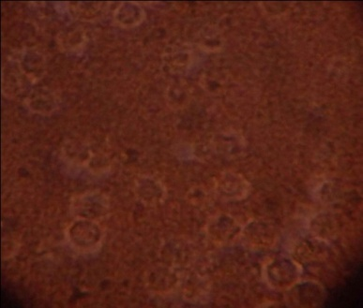 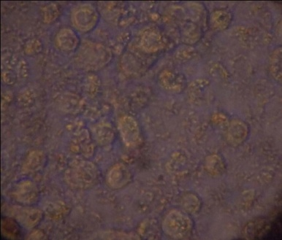

125 µg 62.50 µg

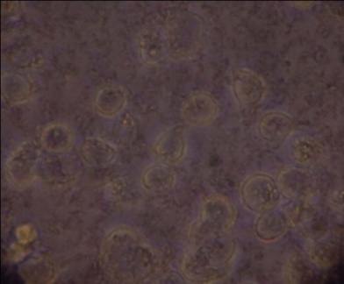 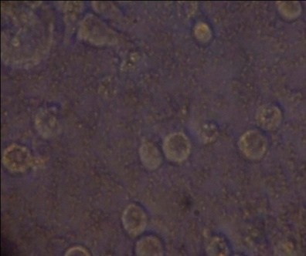

31.25µg 16.62µg

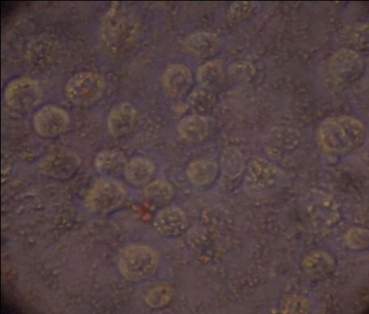 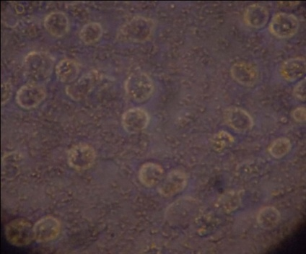

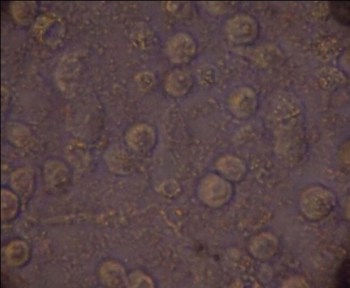 **HT-29 Control cell line**

**Figure 4: The invitro cytotoxicity effects of a polyherbal formulation on HT-29 cell lines.**

500 µg 250 µg

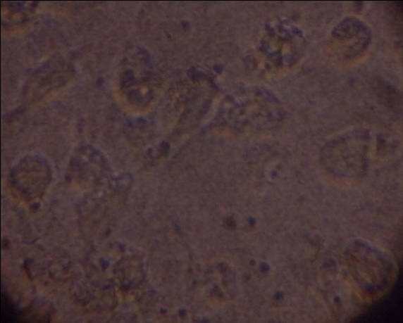 

125 µg 62.50 µg

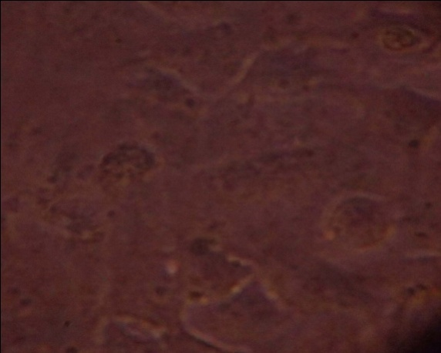 

31.25 µg 16.62 µg

 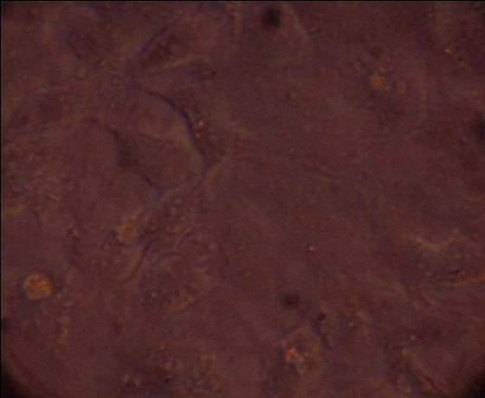

**Vero control cells**

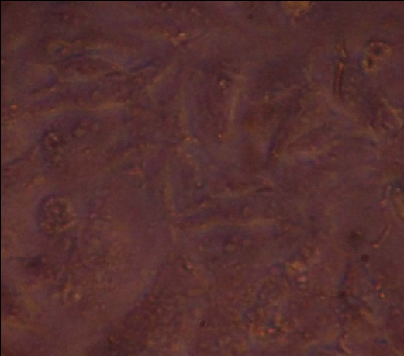

Figure 5 : Alkaline phosphatase activityof poly herbal formulation on control cell lines.

Figure 6 : Alkaline phosphatase activity of poly herbal formulation on colon cancer cell lines.

Figure 7 : Lactate dehydrogenase activity of herbal formulation on control cell lines

Figure 8 : Lactate dehydrogenase activity of herbal formulation on colon cancer cell lines.

Figure 9: Acid phosphatase activity of a poly herbal formulation on *Vero* cell lines.

Figure 10: ACP Activity of poly herbal formulation on colon cancer cell lines.

Figure 11: ALT activity of herbal formulation on control cell lines.

figure 12: ALT activity of herbal formulation on colon cancer cell lines.

Figure 13: Aspartate amino transferase activity of herbal formulation on control cell lines.

Figure 14: AST activity of polyherbal formulation of colorectal cancer cell lines.

Figure 15: DNA Fragmentation analysis of herbal formulation on Vero cell lines

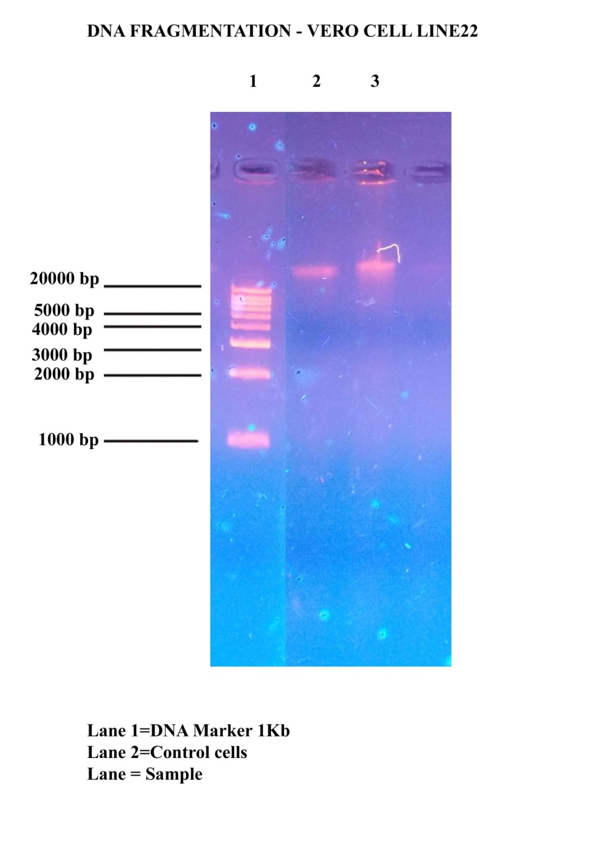

Figure 16: DNA Fragmentation analysis of herbal formulation on HT-29 Cell lines.

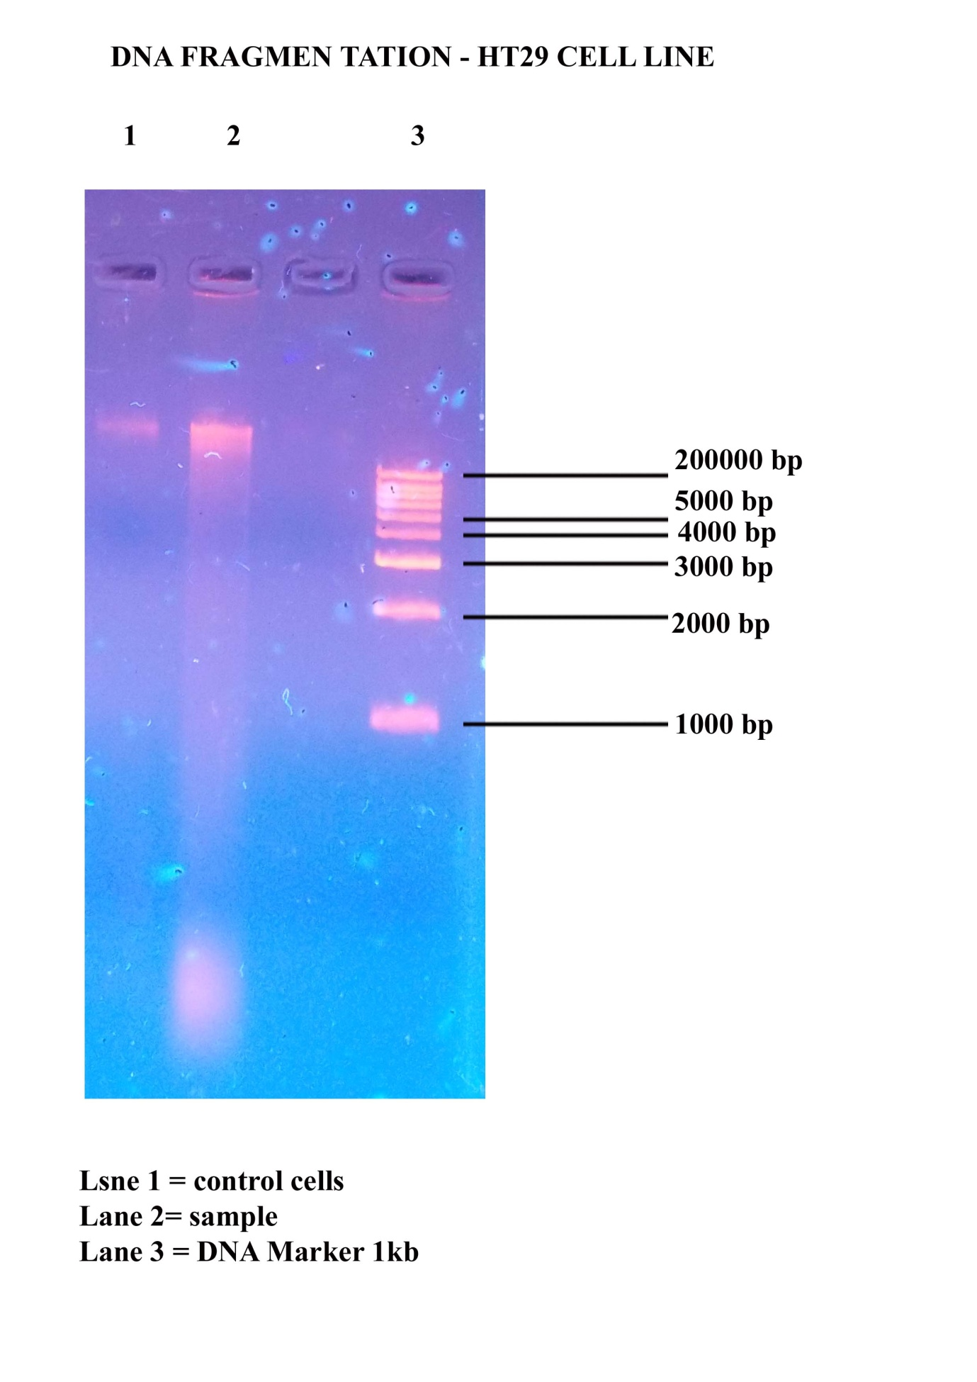

Medicinal plants continue to provide humanity with new remedies. It is therefore important to explore medicinal plants for their safety, quality, toxicity, appropriate amount of plant materials to use, and efficacy. Natural products of plants possess several biological activities including antioxidant and anti-inflammatory activity. Medicinal plants are rich in active phytochemical compounds with various biological activities. Researchers are highly interested in studying plants with the aim of isolating novel active drugs to replace synthetic drugs present in the market. The availability of these plants constituents provides a source of natural drugs for modern medicine. Hence, cytotoxic level of medicinal plants must also be evaluated against host cells. The safety of plants as a potential therapeutically agents must be ascertained and the side effects should be acceptable to the host. Bioactive compounds with no or less toxic effect to the host are the good candidates for formulation of drugs [17].

Figure 1 and 2 shows that the percentage viability of a polyherbal formulation on Vero and human colorectal carcinoma cell lines. Cytotoxicity analysis by MTT assay can be used for the measurement of cell proliferation in response to growth factors, cytokines, mitogens, and nutrients and analysis of cytotoxic and cytostatic compounds, such as anticancer drugs and other pharmaceutical compounds. A major concern about bioactive compounds from plants is that some of these compounds are toxic to our normal system; therefore, safety is critical in development of novel drugs. In this study cytotoxic effect of chloroform extract of a poly herbal formulation at concentration ranging from 100–500 μg/mL was investigated on Vero and human colon cancer cell lines were shown in figure 3 and 4. Effect of poly herbal formulation of chloroform extract on Vero and HT-29 cell line was evaluated after 24 and 48 hours of cell exposure to the extracts. Percentage cell viability was calculated by measuring the absorbance of pink colour formation were formed from reduction of MTT solution by the presence of mitochondrial dehydrogenase in viable cells. The poly herbal extract was toxic to both cell lines at the higher concentration of 500 μg/mL. Morphology of cells was also altered from its normal shape of fibroblast to oval shape, because of the toxic effect of extract to the cells. However, at the lower concentrations (100 μg/mL), chloroform extract had more than 90% cell viability after 24 and 48 hours of exposure [18].

Identifying the mechanism of plant derived anticancer agents provides helpful information in cancer therapy. Natural products have been used for the treatment of various diseases for centuries [19]. Evidences have shown that active principle compounds from plants may serve as potent chemotherapeutic agents with less toxicity to normal tissues and at low cost. They are associated with induction of apoptosis, cell cycle arrest, inhibition of various signal transducers, and signalling pathways. Thus, it is important to screen the crude extract of plants or isolated compounds for their apoptotic potentials. The use of alternative medicine is increasing and many pharmaceutical industries are interested in developing plant derived medicinal compounds. The increasing cost of conventional treatments and the lack of effective drugs encouraged people to depend more on folk medicine [20].

Alkaline phosphatise activity of chloroform extract of a polyherbal formulation were shown in figure 5 and 6.ALP is an enzyme commonly expressed in almost all living organisms. In humans and other mammals, determinations of the expression and activity of alkaline phosphatase have frequently been used for cell determination in developmental studies and or within clinical trials. Alkaline phosphatase also seems to be one of the key markers in the identification of pluripotent embryonic stem as well as related cells. However, alkaline phosphatases exist in some isoenzymes and isoforms, which have tissue specific expressions and functions [21].

Figure 7 and 8 shows that the effect of poly-herbal formulation on lactate dehydrogenase activity on Vero and HT-29 cell lines. LDH is a product regulates the anaerobic transformation of pyruvate to lactate for energy acquisition. The significance of serum elevation in LDH as a predictive indicator for the malignant potential and prognosis in colorectal cancer. Lactate dehydrogenase plays an important role in this process by mediating the conversion of pyruvate and lactate, and this enzyme is an emerging anticancer target. In addition, elevated lactate dehydrogenase levels are consistently reported as a prognostic factor for poor survival among several cancer groups [22]. Lactate dehydrogenase is a cytoplasmic enzyme with a wide distribution in tissue where it catalyses the inter conversion of lactate to pyruvate. Functional LDH are homo- or hetero-tetramers composed of M and H protein subunits encoded by the LDHA and LDHB genes, respectively. Five isoenzymes are derived from the different monomeric compositions (LDH 1 to 5) and differ from each other in terms of their structural composition, biochemical properties and tissue distribution. LDH is involved in tumor initiation and metabolism. The LDHA gene is a transcriptional target of HIF1α and is induced in hypoxic conditions or when oncogenes activate HIF1α [23]. The figure 9 and 10 shows that the activity of acid phosphatise on polyherbal formulation of vero and colorectal carcinoma cell lines. ACP is a ubiquitous lysosomal enzyme that hydrolyses organic phosphates at an acid pH. Although the post pubertal prostatic epithelial cell contains a uniquely high concentration of acid phosphatase, cellular components of bone, spleen, kidney, liver, intestine, and blood also contain this enzyme. However, unequivocal documentation of the validity of these statements is not available. Newer immunologic techniques for measuring acid phosphatase may significantly alter our current concept of its role as a tumour marker [24].

Alanine amino transferases are shown (figure 11 and 12) in the activity of polyherbal formulation on HT-29 cell lines as well as the control Vero cell lines. Figure 13 and 14 were shown the activity of chloroform extract of a polyherbal formulation on the Vero and colorectal tumour cell lines. These enzymes are the major critical enzymes in the biological processes. The synthesized ALT and stored AST changes in serum levels have become diagnostic tools and markers for assessing the liver function. Reports have suggested that their levels increase in different hepatic injures, such as hepatitis and cirrhosis induced by alcohol, drugs, viruses, and also under oxidative stress. The liver could easily be exposed to internal stimuli which produce reactive oxygen species. The oxidative stress could damage the liver cells. The levels of ALT and AST in the serum have been generally accepted as a better predictor of liver injury. Oxidative stress and inflammation are related to the development of many human cancers at the same time, oxidative stress and inflammation could also lead to damaged liver cells. With the development of tumour biology, there is growing evidence that the presence of a systemic inflammatory response is linked to poor survival in patients with different types of malignancies [25, 26].

A DNA fragmentation assay was used to determine whether the action of chloroform extract of a poly herbal formulation was associated with apoptosis or not. As shown in (Figure15 and 16) Poly herbal formulation was strongly effective on control and experimental cell types. In this experiment, all tested cell lines were incubated with Poly herbal formulation at the IC50 concentration. DNA fragmentation was found on Vero cells and HT-29 cells at 2, 3, 4 and 7 days after exposure. In the HT-29 cells, the ladder pattern was observed for a maximum of 3 days because all cells died. Therefore, the effect of Poly herbal formulation was selective for colon cancer cell lines and mediated through the induction of apoptosis. Medicinal plant- based drug discovery continues to provide new and important leads against various pharmacological targets including cancer [27]. The DNA fragmentation forms a ladder pattern that can be used to distinguish between apoptosis and necrosis. This phenomenon can be generally detected by agarose gel electrophoresis. The DNA was isolated from the treated cells and subjected to agarose gel electrophoresis and examinations revealed a ladder formation, which is characteristic of apoptosis [28]. Here our results showed that the DNA ladders of HT-29 and Vero cells treated with Poly herbal formulation were observed within seven days. Therefore, DNA ladder formation indicated that the cytotoxic effect of Poly herbal formulation caused inhibition in the growth of colon cancer cells and normal Vero cells through apoptosis. Poly herbal formulation also inhibited growth in normal colon cells, but not to the point of death through apoptosis. In the Vero cells, Poly herbal formulation inhibited cell growth within six days and induced cell death on Day 7 after incubation. Although treated Vero cells showed DNA ladders at Day 7, the incubation time was longer and the dose was higher than in the colon cancer cell lines. Therefore, our Poly herbal formulation seemed to be safe for normal cells. However, further experiments are needed to evaluate the specific molecules in the apoptotic pathway [29].

**Conclusion**

The current mode of treatment for various diseases including human malignancies is based on synthetic drugs. These drugs are effective but they show serious adverse effects and also alter the genetic and metabolic activity of the patient. More over some drugs prepared from medicinal plants and their constituents show more efficacy than the synthetic counter-parts. Earlier reports have shown that the regular consumption of herbs, fruits and vegetables are strongly related with reduced risk of various forms of diseases. Thus, it is of interest to investigate the anti-neoplastic role of chloroform extract of herbal formulation were undertaken. Our results indicate that the efficacy of the plant-based drug on HT – 29 human colorectal carcinoma cell lines.

**5. References**

1. Newman DJ, Cragg GM: Natural products as sources of new drugs over the last 25 years. J Nat Prod 2007; 70:1022–1037.

2. Gueritte F, Fahy J: The vinca alkaloids. In: Cragg GM, Kingston DGI, Newman D, editors. Anticancer agents from natural products. Boca Raton: Taylor and Francis; 2005. pp. 123–136.

3 Sutha S, Mohan V R, Kumaresan S, Murugan C and Athiperumalsami T. Ethnomedicinal plants used by the tribals of Kalakad Mundanthurai Tiger Reserve (KMTR), Western Ghats, Tamil Nadu for the treatment of rheumatism. Ind J Traditional Knowl 2009; 9 :502-09.

4. Dhivaharan V, Madhavan S, Balu S. Ethnobotany of Point Calimere Wildlife Sanctuary, Tamil Nadu: A preliminary survey. Adv Plant Sci 2008; 21: 343-45.

5. Coe F G. and Anderson G J. Screening of medicinal plants used by the Garifuna of eastern Nicaragua for bioactive compounds. J Ethnopharmacol 1996; 53: 29-50.

6. Arvigo R and Balik M: Rainforest Remedies, One Hundred Healing Herbs of Belize, USA: Lotus Press, Twin Lakes, WI, 1993.

7. Duke J. American agricultural research service-phytochemical and ethnobotanical Database, 2002.

8. Lans C. Ethnomedicines used in Trinidad and Tobago for reproductive problems. J Ethnobiol Ethnomed 2007; 3: 13-25.

9. That Q T, Jossang J, Jossang A , Kim P P and Jaureguiberry G, Wedelolides A . A and B: Novel sesquiterpene -lactones, (9R)-eudesman-9, 12-olides, from *Wedelia trilobata* J Org Chem 2007; 72: 7102–7105.

10. Chopra RN, Nayar SL, and Chopra IC. Glossary of Indian Medicinal plant: Publication and information Directorate, CSIR, New Delhi, 1986, p.54.

11. Kumar A, Selvakumar S. Antiproliferative efficacy of Tabernaemontana divaricata against HEP-2 cell line and Vero cell line. Phcog Mag 2015; 11:46-52.

12. Oberhammer F, Wilson JW, Dive C, Morris ID, Hickman JA, Wakeling AE et al. Apoptotic death in epithelial cells: Cleavage of DNA to 300 and/or 50 kb fragments prior to or in the absence of internucleosomal fragmentation. EMBO J 1993; 12:3679-84.

13. Darzynkiewicz Z, Li X, Gong J. Assays of cell viability: Discrimination of cells dying by apoptosis. Methods Cell Biol 1994; 41:15-3.

14. Hapon MB, Hapon MV, Persia FA, Pochettino A, Lucero GS, et al. Aqueous Extract of Prosopis strombulifera (LAM) BENTH Induce Cytotoxic Effects against Tumor Cell Lines without Systemic Alterations in BALB/c Mice. J Clin Toxicol 2014; 4:222

15. Lea MA, Ibeh C, Shah N, Moyer MP. Induction of differentiation of colon cancer cells by combined inhibition of kinases and histone deacetylase. Anticancer Res. 2007; 27:741–748.

16. Talib WH, Mahasneh AM. Antimicrobial, cytotoxicity and phytochemical screening of Jordanian plants used in traditional medicine. Molecules. 2010 ;15(3):1811–1824.

17. Morobe I C, Mthethwa N S, Bisi-Johnson M A. et al. Cytotoxic effects and safety profiles of extracts of active medicinal plants from South Africa. Journal of Microbiology Research 2012; 2(6): 176–182.

18. Sakarkar D M, Deshmukh V N. Ethnopharmacological review of traditional medicinal plants for anticancer activity. International Journal of PharmTech Research2011;3(1):298–308.

19. Zhang Y, Xu X.-M, Zhang M et al. Effects of tubeimoside-1 on the proliferation and apoptosis of BGC823 gastric cancer cells in vitro. Oncology Letters 2013;5(3):801–804.

20. Mc Comb R M, Bowers G N, and Posen S. Alkaline Phosphatase, Springer, New York, NY, USA, 2011.

21. Doherty JR, Cleveland JL. Targeting lactate metabolism for cancer therapeutics. J Clin Invest 2013;123(9):3685–92.

22. Miao P, Sheng S, Sun X, Liu J, Huang G. Lactate dehydrogenase A in cancer: a promising target for diagnosis and therapy. IUBMB Life. 2013; 65: 904–910.

23.Henneberry MO, Engel G, Grayhack JT. Acid phosphatase. Urol Clin North Am. 1979; 6(3):629-41.

24. Toiyama Y, Inoue Y, Saigusa S, Kawamura M, Kawamoto A, Okugawa Y, Hiro J, Tanaka K, Mohri Y, Kusunoki M. C-reactive protein as predictor of recurrence in patients with rectal cancer undergoing chemoradiotherapy followed by surgery. Anticancer Res 2013: 33: 5065–5074.

25. Park JH, Watt DG, Roxburgh CS, Horgan PG, McMillan D C. Colorectal cancer, systemic inflammation, and outcome: Staging the tumor and staging the host. Ann Surg 2016; 263: 326–336.

26.Elmore S. Apoptosis: A review of programmed cell death. Toxicol Pathol 2007: 35: 495– 516.

27. Silva M J D, Carvalho A J S, Rocha C Q, Vilegas W, Silva M A, Gouvea C M C P. Ethanolic extract of Mimosa caesalpiniifolia leaves: Chemical characterization and cytotoxic effect on human breast cancer MCF-7 cell line. S Afr J Bot 2014, 93, 64–69.

28.Potchanapond Graidist, Mananya Martla and Yaowapa Sukpondma. Cytotoxic Activity of Piper cubeba Extract in Breast Cancer Cell Lines. Nutrients 2015; 7: 2707-2718.