Review Article

Code Against Contagion: How Health IT Is Reshaping Public Health Surveillance in the Pandemic Era

Abstract

The COVID-19 pandemic served as a global stress test for public health surveillance systems, exposing critical weaknesses in data timeliness, coordination, and analytic capacity. In response, governments and health institutions worldwide turned to digital technologies ranging from electronic health record (EHR) linked reporting platforms to mobile contact tracing apps and AI-driven analytics to close gaps and accelerate decision-making. These innovations signaled a pivotal shift from reactive, manual surveillance to digital, real-time, and predictive public health infrastructure. This article examines how Health Information Technology (Health IT) is reshaping the future of epidemic intelligence through three major transformations: technical integration, including interoperable data systems and standards such as HL7 FHIR; ethical governance, which balances privacy with public health objectives; and institutional sustainability, encompassing workforce development, long-term investment, and global interoperability. Case studies from countries including South Korea, Singapore, and the United Kingdom illustrate both the promise and the challenges of digitally enabled surveillance. As the world prepares for future pandemics, the lessons of COVID-19 call for a new model that embeds digital capacity as core public health infrastructure. Achieving this vision will require strategic alignment across sectors, transparent governance, and a global commitment to equity in digital readiness.

1.0. Introduction

The COVID-19 pandemic marked a critical inflection point for global public health, exposing longstanding weaknesses in disease surveillance systems and revealing the urgent need for modernization. As SARS-CoV-2 spread rapidly across borders, the limitations of traditional public health infrastructure—built largely on manual reporting, siloed data systems, and delayed laboratory confirmations—became glaringly evident. These analog systems, while historically adequate for slower-moving outbreaks, proved ill-equipped to detect and respond to a fast-evolving global pandemic. The reactive nature of such surveillance approaches hindered timely containment, limited situational awareness, and exacerbated disparities in data capacity and coordination both between and within countries[1,2].

In the early stages of the pandemic, even foundational epidemiological questions such as where infections were increasing, which populations were most vulnerable, or whether hospitals were approaching capacity remained difficult to answer. This was largely due to fragmented data collection across jurisdictions, institutions, and care settings. Inconsistent reporting formats and delayed case confirmations further hampered efforts to model transmission dynamics, allocate resources, and implement evidence-based interventions. Although some surveillance systems were theoretically robust, the absence of interoperability, automation, and real-time analytics meant they could not keep pace with the virus's trajectory[3].

It was within this strained landscape that digital health technologies emerged as indispensable components of the global response. Tools such as electronic health records, cloud-based data warehouses, mobile contact tracing applications, and artificial intelligence-driven analytics were deployed with unprecedented speed and scale. These technologies augmented and, in some cases, replaced conventional surveillance methods by enabling faster case identification, large-scale symptom tracking, and the integration of clinical, demographic, and behavioral data in near real-time. Perhaps most critically, they opened the door to predictive modeling and automated alert systems, which traditional surveillance methods were largely incapable of supporting[4,5].

In retrospect, the pandemic functioned as a global stress test for public health surveillance, a moment in which outdated systems faltered and digital innovations proved their worth. The experience demonstrated that digital health technologies are no longer optional enhancements but essential components of a resilient public health infrastructure. As governments and institutions shift from emergency response to long-term preparedness, it has become clear that Health Information Technology must be treated as a fundamental element of 21st-century epidemic intelligence and health security[6].
2. Digital Innovations in Real-Time Surveillance
The urgency of the COVID-19 pandemic triggered a global surge in digital innovation, fundamentally reshaping how public health surveillance operates in real time. As traditional manually driven systems struggled under the pressure of rapidly escalating case numbers, governments and health institutions increasingly turned to Health Information Technology (Health IT) to close critical gaps. These tools were designed to improve data collection, enhance situational awareness, and enable more agile and responsive decision-making. Deployed at unprecedented speed, these digital interventions marked a pivotal transformation in the monitoring, prediction, and control of infectious disease outbreaks[1,7].
One of the most consequential changes during the pandemic was the integration of electronic health record (EHR) data into public health reporting workflows. Automating the flow of clinical data into national surveillance databases allowed health authorities to bypass conventional reporting delays and gain near-instantaneous visibility into COVID-19 testing, hospitalization rates, and intensive care unit utilization[8]. In the United Kingdom, the NHS COVID-19 Data Store aggregated information from EHRs, laboratory systems, and logistics chains to power a central dashboard used for resource allocation and policy planning. Similarly, in the United States, the HHS Protect platform integrated data from over 200 sources to support forecasting models and inform federal response strategies[9–11].
Mobile technologies also played a crucial role in expanding the reach, speed, and granularity of surveillance activities. Digital contact tracing applications such as Singapore’s TraceTogether and South Korea’s cell-tower-based tracking system enabled authorities to quickly identify and notify individuals potentially exposed to the virus. Often supplemented with QR code-based venue check-ins and real-time mobility data, these tools allowed for targeted containment strategies that avoided the economic and social costs of full-scale lockdowns. In parallel, symptom monitoring and self-assessment platforms such as the UK’s COVID Symptom Study app collected population-level health data that helped identify emerging transmission clusters and patterns in near real time[12,13]. In addition to improving detection and monitoring, artificial intelligence (AI) and machine learning (ML) technologies were used to anticipate outbreak dynamics and inform clinical decision-making. For example, South Korea employed AI systems that analyzed mobility and contact data to predict potential superspreading events. In the United States, researchers leveraged natural language processing to identify early syndromic trends from free-text clinical notes in EHRs, offering earlier warnings of respiratory illness spikes. Other machine learning models were used to support hospital triage, estimating patient deterioration risk based on vital signs and comorbidities in real time[14].
Despite the clear benefits of these innovations, their effectiveness varied significantly across settings, revealing important contextual factors. First, digital readiness—including the presence of robust infrastructure, skilled personnel, and regulatory flexibility—was essential for rapid implementation. Countries with pre-existing integrated health data systems were far better positioned to scale up digital surveillance tools. Second, effective governance was key[15]. Where oversight mechanisms were transparent and policies ensured equitable access, public engagement and tool uptake were higher. Third, public trust proved indispensable. The legitimacy of surveillance tools depended heavily on how they were introduced and managed, particularly in societies with histories of data misuse or limited privacy protections. Moreover, digital surveillance did not replace traditional epidemiology but rather enhanced its reach, precision, and timeliness. These innovations enabled public health responses that were far more dynamic and data-driven than would have been possible under legacy systems[16]. However, their rapid adoption also surfaced new challenges including data standardization issues, questions about ethical use, and concerns over technological equity that must be addressed as digital tools transition from emergency response mechanisms to permanent features of the public health landscape[17].
As illustrated in Figure 1, modern public health surveillance is increasingly characterized by its capacity to synthesize multiple digital data streams in real time, enabling predictive modeling, responsive intervention, and evidence-based policy-making at scale[18].
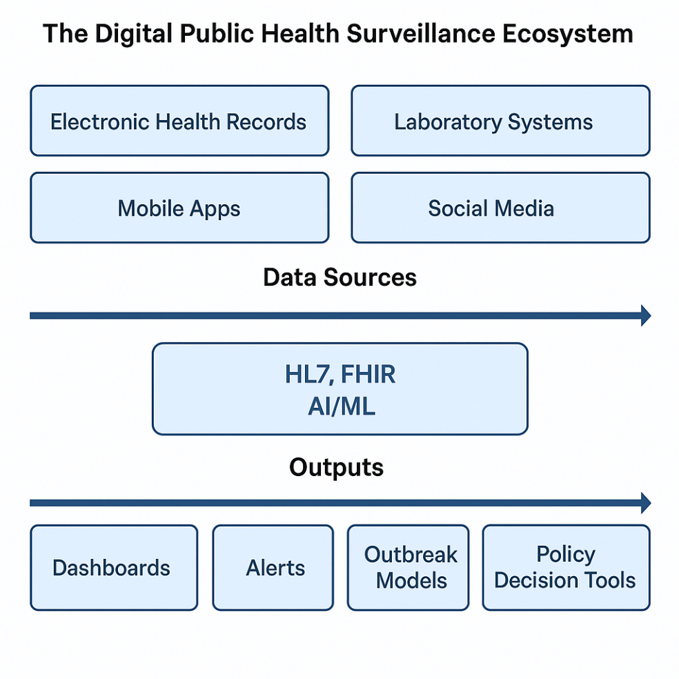
Figure 1. The Digital Public Health Surveillance Ecosystem. A conceptual framework illustrating how diverse data sources—including electronic health records, laboratory systems, mobile apps, and social media—feed into an integrated surveillance system via interoperability standards (e.g., HL7, FHIR) and advanced analytics (AI/ML). The outputs support public health decision-making through dashboards, alerts, outbreak modeling, and policy tools.

3 Data Integration and Interoperability

The effectiveness of pandemic surveillance depends not only on data collection but also on the ability to integrate, interpret, and act upon information from diverse sources in real time. During the COVID-19 crisis, Health Information Technology (Health IT) played a central role in enabling this integration. However, the process was far from seamless. The global emergency revealed both the potential and the persistent challenges of cross-system data harmonization, highlighting the urgent need for robust interoperability frameworks and widely adopted data standards[19].

Interoperability, defined as the capacity of disparate systems and organizations to exchange, interpret, and use data in a cohesive manner, emerged as a critical determinant of surveillance responsiveness. International standards such as Health Level Seven (HL7) and Fast Healthcare Interoperability Resources (FHIR) offered foundational tools to align clinical and public health data. These standards enabled better communication among electronic health records (EHRs), laboratory information systems, and public health databases[20]. In the United States, FHIR-based application programming interfaces (APIs) facilitated the real-time exchange of structured data into centralized surveillance systems like HHS Protect, which consolidated hospital capacity, case numbers, testing outcomes, and supply chain data from over 6,000 healthcare institutions. Similarly, the World Health Organization’s Epidemic Intelligence from Open Sources (EIOS) platform aggregated data from news outlets, social media, and official health reports to generate early signals of outbreaks worldwide[21,22].

Integrated platforms like these offered numerous advantages. They significantly reduced delays in reporting, improved situational awareness of disease progression, and enabled more accurate predictive modeling. By linking EHR data to geospatial and demographic information, health authorities could identify emerging hotspots, assess the effectiveness of interventions, and make data-informed decisions about vaccine distribution. Interoperability also contributed to data quality by minimizing duplicate entries and improving the resolution of individual case records across systems[23]. Nevertheless, these advances were constrained by major technical and institutional hurdles. One persistent challenge was semantic heterogeneity, or the inconsistency in how health conditions, procedures, and laboratory results were coded across different systems. In the absence of universal terminologies or standardized value sets such as SNOMED CT and LOINC, the process of aggregating data often required labor-intensive cleaning, manual mapping, and reconciliation. Compounding this issue, many public health agencies lacked the digital infrastructure or trained personnel needed to implement new data standards quickly, which led to significant delays and bottlenecks in integration efforts[20,24].

Non-standardized reporting protocols across jurisdictions further complicated both national and global coordination. While some countries operated under centralized data governance models that facilitated uniform data flow, others had highly decentralized systems where data collection and reporting varied widely. These inconsistencies created fragmented and unreliable data landscapes. Efforts to build real-time dashboards were often hindered by incomplete, infrequent, or overly aggregated data, which undermined the ability to conduct timely and granular analyses[25]. Additionally, the pandemic also exposed the fact that interoperability is as much a matter of governance as it is of technology. Many countries lacked clear policies regarding data ownership, access rights, and stewardship responsibilities. In several instances, the absence of legal frameworks and data-sharing agreements delayed the exchange of vital information during key phases of the outbreak response. In some contexts, bureaucratic barriers were even more obstructive than technical limitations, impeding the seamless flow of critical data[26].

Despite these challenges, the COVID-19 experience underscored that integrated data systems are not optional but essential for pandemic preparedness and response. Building a resilient and equitable surveillance infrastructure for the future will require sustained investment in interoperability tools, universal data vocabularies, and coordinated cross-sector partnerships. Only through such efforts can health systems ensure that they are equipped to respond swiftly, transparently, and effectively to the next global health crisis[27,28].
4.0. Ethics, Privacy, and Public Trust
The rapid deployment of digital surveillance technologies during the COVID-19 pandemic brought urgent ethical concerns to the forefront, particularly regarding the balance between public health protection and individual civil liberties. Although these technologies were instrumental in tracking virus transmission, predicting outbreaks, and guiding public health interventions, they also introduced significant risks related to personal privacy, informed consent, and social trust[29]. The global experience emphasized a critical truth: technological effectiveness alone is insufficient. For surveillance systems to succeed, they must also be ethically sound and socially legitimate[30].
At the core of these concerns lies a fundamental tension between public safety and personal privacy[31]. Tools such as contact tracing applications, digital quarantine enforcement systems, and geolocation tracking mechanisms enabled rapid identification of transmission networks. However, they often required the collection of sensitive data, including users’ locations, proximity histories, and health statuses[32]. In many countries, these surveillance mechanisms were implemented under emergency legislation with limited public oversight or predefined expiration timelines. The extension of such powers beyond the immediate crisis raised serious concerns about the normalization of intrusive surveillance and the potential for unintended long-term uses[33]. Additionally, Design differences in digital surveillance technologies reflected broader variations in national approaches to privacy governance. Some countries, including Singapore and South Korea, adopted centralized systems where personally identifiable information was stored and managed by state agencies. Others, such as Germany and Switzerland, opted for decentralized models that used the Google-Apple Exposure Notification (GAEN) framework, which emphasized anonymity and local data storage. These architectural choices had significant implications for public trust and adoption. In contexts where governments provided clear communication, involved civil society stakeholders, and implemented safeguards for data use, public acceptance was generally higher[34].
Ethical surveillance requires more than minimal compliance with data protection laws. It must be guided by principles of transparency, proportionality, data minimization, and purpose limitation. Individuals should be clearly informed about the nature of the data being collected, the purposes of its use, the entities with access to it, and the duration of its retention. Data collection should be limited to what is strictly necessary for legitimate public health objectives, and any secondary use—such as for policing or commercial purposes—should only occur with explicit justification and public consent[35,36].
Several international frameworks offer valuable guidance for ethical digital health practices. The OECD Principles on Artificial Intelligence, the European Union’s General Data Protection Regulation (GDPR), and the World Health Organization’s Guidance on Ethical Data Use all emphasize key values such as accountability, human rights, and responsible governance by design. Equally important is the incorporation of equity into ethical deliberations[37]. Digital tools must be evaluated for their distributional effects, ensuring that marginalized populations are not disproportionately excluded, stigmatized, or misrepresented due to algorithmic bias or data inequities[32]. Moreover, public trust is not just an ethical ideal; it is a functional necessity for effective surveillance. Systems that are perceived as coercive, opaque, or unaccountable are less likely to garner the public cooperation required for successful implementation. Embedding ethical considerations throughout the full lifecycle of digital surveillance tools—from design and deployment to evaluation and decommissioning—is essential for building lasting public confidence[38]. This approach will not only enhance pandemic response but also lay the groundwork for resilient and inclusive surveillance systems in the future.
As illustrated in table 1, countries adopted a wide range of privacy models in their digital contact tracing strategies. These models reflect varying degrees of centralized control and individual data sovereignty, underscoring the trade-offs between public health coordination and personal privacy protections.
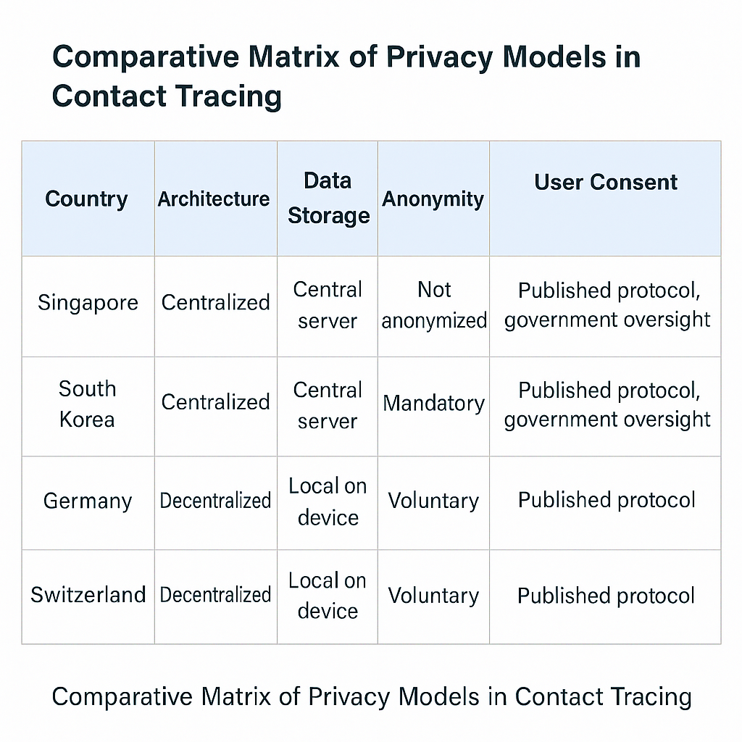
Table 1. Comparative Matrix of Privacy Models in Contact Tracing. A comparative matrix outlining the privacy design choices of four national contact tracing systems—Singapore, South Korea, Germany, and Switzerland—across five key dimensions: system architecture, data storage method, level of anonymity, and user consent mechanisms. The matrix highlights the tension between centralized efficiency and decentralized privacy preservation in digital public health surveillance. Adapted from publicly available national protocols and published analyses, including the MIT Technology Review COVID Tracing Tracker and WHO privacy assessments.

5.0. Toward a Resilient Digital Public Health Infrastructure
As the acute phase of the COVID-19 pandemic fades, the focus must shift from emergency-driven innovation to long-term institutionalization. The rapid deployment of digital tools during the crisis revealed their transformative potential for disease surveillance and public health decision-making. However, many of these technologies were developed as stopgap solutions under crisis conditions. Without sustained investment, policy reform, and structural integration, the momentum of pandemic-era digital innovation could be lost. Building a resilient digital public health infrastructure requires deliberate and coordinated efforts to embed Health Information Technology (Health IT) as a foundational element of both national and global health systems.[39]
The first priority is to institutionalize digital surveillance platforms. During the pandemic, many countries rapidly created dashboards, data exchanges, and analytic systems tailored to immediate needs[40,41]. These ad hoc solutions must now be standardized, secured, and integrated into routine public health operations. Institutionalization involves more than technological upgrades[42]. It requires the development of formal governance frameworks that establish oversight responsibilities, data-sharing agreements, and ethical safeguards. Digital surveillance should be recognized as critical public health infrastructure, subject to the same strategic planning, regulatory oversight, and sustained funding as laboratory networks, emergency stockpiles, and hospital systems[43].
A second pillar of resilience lies in workforce development. The pandemic revealed a global shortage of professionals with the digital and analytical skills necessary to support advanced surveillance efforts. Building a workforce for digital epidemiology will require cross-disciplinary training programs that equip public health practitioners with expertise in data science, machine learning, informatics, and geospatial analysis. Public health must follow the lead of clinical medicine in developing hybrid professional roles—such as the clinician-informatician—who can navigate both technical and domain-specific knowledge. These professionals will serve as vital connectors between data infrastructure and public health action[44].
As depicted in Figure 2, the long-term sustainability of digital surveillance systems depends on four interdependent pillars: institutionalization, workforce development, long-term funding, and interoperability. Each of these components reinforces the system’s capacity to anticipate, detect, and respond to public health threats at scale. Together, they form the foundation for a modernized surveillance architecture that is not only responsive during emergencies but also durable and equitable in routine public health practice.
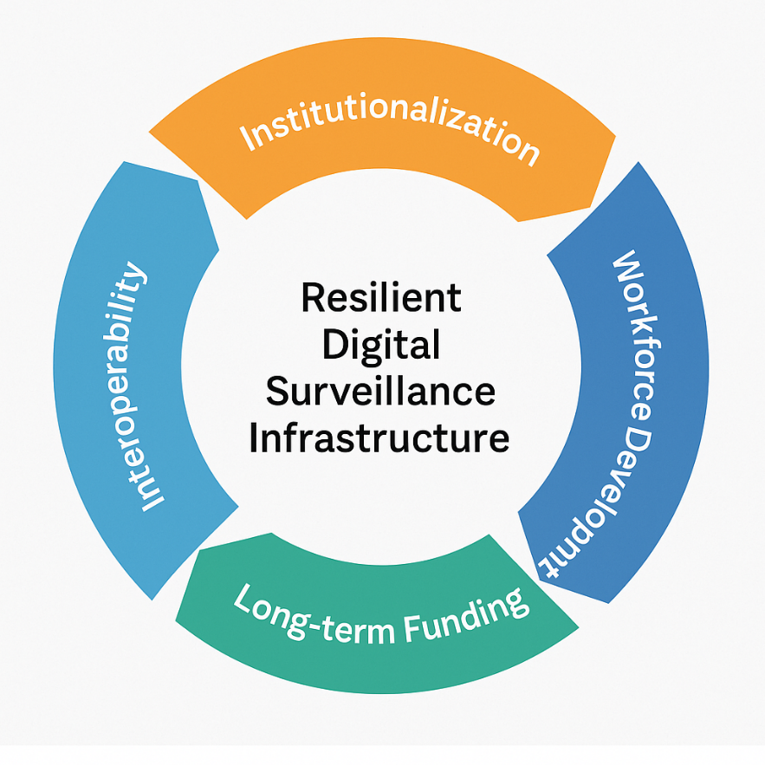

Figure 2: A circular conceptual framework illustrating the four foundational components of a resilient digital public health surveillance system: Institutionalization, Workforce Development, Long-term Funding, and Interoperability. These interconnected elements emphasize the need for structural, financial, and cross-border continuity to sustain digital health surveillance capacity beyond crisis periods. Original figure created by the authors, informed by global digital health infrastructure guidelines and post-COVID policy recommendations.

Third, sustainable progress depends on long-term funding and coherent policy alignment. Digital health infrastructure cannot thrive on short-term, crisis-driven financial support. Governments must commit to stable, recurring budget allocations and pursue strategic public-private partnerships to fund infrastructure maintenance, strengthen cybersecurity, enhance platform interoperability, and support ongoing innovation. In parallel, policy frameworks must be aligned to facilitate secure data exchange while upholding individual privacy rights. This is especially important in the context of transboundary health threats, where disjointed regulatory regimes can hinder timely response and coordination[45].

Equally essential is the extension of interoperability beyond national borders. The global nature of infectious disease threats demands a transnational digital surveillance architecture capable of enabling real-time, cross-border data sharing and coordinated action[46]. Achieving this vision requires the alignment of technical standards such as FHIR (Fast Healthcare Interoperability Resources) and SNOMED CT, as well as the development of legal agreements and ethical frameworks for cross-jurisdictional data governance. Platforms like the World Health Organization’s Epidemic Intelligence from Open Sources (EIOS) offer promising foundations for such global integration. The concept of a global digital public health commons—a federated yet interconnected network of national surveillance capacities—could significantly enhance early warning systems, reduce fragmentation, and improve the equity and efficacy of global health responses[47].

However, building this infrastructure is not only a technical endeavor. It is also a deeply political and ethical challenge. Trust must be cultivated among nations, and equity must be embedded in both design and implementation. Many low-resource countries face structural disadvantages in digital readiness, lacking the tools, infrastructure, and workforce needed to fully participate in a globally integrated system. Without deliberate efforts to address these digital divides, digital surveillance risks replicating or even amplifying the inequalities that public health systems seek to overcome[48].

Conclusion
The COVID-19 pandemic did not simply disrupt global health systems; it redefined the infrastructure needed to sustain them. Digital innovation played an indispensable role in managing the crisis, from enabling real-time surveillance and predictive modeling to supporting coordinated public health responses. The lesson is clear: digital technologies are no longer optional enhancements. They are foundational components of 21st-century public health systems. However, technology alone cannot guarantee resilience. To ensure that digital tools serve all populations equitably, ethically, and effectively, strategic governance, sustained investment, and robust cross-sector collaboration are essential[49]. Countries must move beyond fragmented, ad hoc innovation and instead build integrated, interoperable systems grounded in transparency, informed consent, and public trust. This includes addressing persistent global disparities in digital capacity and establishing reliable mechanisms for coordinated data sharing across borders.
Pandemic preparedness must now be fundamentally reframed. Just as vaccines, diagnostics, and clinical infrastructure are viewed as essential elements of health security, so too must digital data systems be recognized as critical public health infrastructure[50]. The crises of the future will test not only our clinical capabilities but also our digital readiness. Rewriting the code of preparedness requires designing systems that are as intelligent, inclusive, and adaptive as the public health challenges we are certain to face.

REFERENCES
1. Lau DT, Sosa P, Dasgupta N, He H. Impact of the COVID-19 Pandemic on Public Health Surveillance and Survey Data Collections in the United States. Am J Public Health. 2021 Dec;111(12):2118–21.
2. Public Health COVID-19 Impact Assessment: Lessons Learned and Compelling Needs - NAM [Internet]. [cited 2025 Jul 9]. Available from: https://nam.edu/perspectives/public-health-covid-19-impact-assessment-lessons-learned-and-compelling-needs/
3. Lederberg J. Summary and Assessment. In: Public Health Systems and Emerging Infections: Assessing the Capabilities of the Public and Private Sectors: Workshop Summary [Internet]. National Academies Press (US); 2000 [cited 2025 Jul 9]. Available from: https://www.ncbi.nlm.nih.gov/books/NBK100244/
4. Ahmed MM, Okesanya OJ, Olaleke NO, Adigun OA, Adebayo UO, Oso TA, et al. Integrating Digital Health Innovations to Achieve Universal Health Coverage: Promoting Health Outcomes and Quality Through Global Public Health Equity. Healthcare. 2025 May 5;13(9):1060.
5. Bajwa J, Munir U, Nori A, Williams B. Artificial intelligence in healthcare: transforming the practice of medicine. Future Healthc J. 2021 Jul;8(2):e188–94.
6. Ezenwaji CO, Alum EU, Ugwu OPC. The role of digital health in pandemic preparedness and response: securing global health? Glob Health Action. 17(1):2419694.
7. Filip R, Gheorghita Puscaselu R, Anchidin-Norocel L, Dimian M, Savage WK. Global Challenges to Public Health Care Systems during the COVID-19 Pandemic: A Review of Pandemic Measures and Problems. J Pers Med. 2022 Aug 7;12(8):1295.
8. Lawal OP, Taiye AF, Okafor CE, Elechi KW, Orobator ET, Kolapo TJ, et al. The Automated Insulin Delivery System in Nigeria: Advances, Challenges, And Future Prospects in Closed-Loop Insulin Delivery Systems. Journal of Medical Science, Biology, and Chemistry. 2025 Jun 30;2(1):64–74.
9. Satterfield BA, Dikilitas O, Kullo IJ. Leveraging the Electronic Health Record to Address the COVID-19 Pandemic. Mayo Clin Proc. 2021 Jun;96(6):1592–608.
10. Tomines A, Readhead H, Readhead A, Teutsch S. Applications of Electronic Health Information in Public Health: Uses, Opportunities & Barriers. EGEMS (Wash DC). 2013 Oct 28;1(2):1019.
11. Vos JFJ, Boonstra A, Kooistra A, Seelen M, van Offenbeek M. The influence of electronic health record use on collaboration among medical specialties. BMC Health Services Research. 2020 Jul 22;20(1):676.
12. Chow BWK, Lim YD, Poh RCH, Ko A, Hong GH, Zou SWL, et al. Use of a digital contact tracing system in Singapore to mitigate COVID-19 spread. BMC Public Health. 2023 Nov 16;23(1):2253.
13. Hogan K, Macedo B, Macha V, Barman A, Jiang X. Contact Tracing Apps: Lessons Learned on Privacy, Autonomy, and the Need for Detailed and Thoughtful Implementation. JMIR Med Inform. 2021 Jul 19;9(7):e27449.
14. Pandit JA, Radin JM, Quer G, Topol EJ. Smartphone apps in the COVID-19 pandemic. Nat Biotechnol. 2022 Jul;40(7):1013–22.
15. Almeman A. The digital transformation in pharmacy: embracing online platforms and the cosmeceutical paradigm shift. Journal of Health, Population and Nutrition. 2024 May 8;43(1):60.
16. Asimakopoulos G, Antonopoulou H, Giotopoulos K, Halkiopoulos C. Impact of Information and Communication Technologies on Democratic Processes and Citizen Participation. Societies. 2025 Feb;15(2):40.
17. Junaid SB, Imam AA, Balogun AO, Silva LCD, Surakat YA, Kumar G, et al. Recent Advancements in Emerging Technologies for Healthcare Management Systems: A Survey. Healthcare. 2022 Oct 3;10(10):1940.
18. Zeng D, Cao Z, Neill DB. Artificial intelligence–enabled public health surveillance—from local detection to global epidemic monitoring and control. Artificial Intelligence in Medicine. 2020 Sep 11;437.
19. Vorisek CN, Lehne M, Klopfenstein SAI, Mayer PJ, Bartschke A, Haese T, et al. Fast Healthcare Interoperability Resources (FHIR) for Interoperability in Health Research: Systematic Review. JMIR Med Inform. 2022 Jul 19;10(7):e35724.
20. Torab-Miandoab A, Samad-Soltani T, Jodati A, Rezaei-Hachesu P. Interoperability of heterogeneous health information systems: a systematic literature review. BMC Med Inform Decis Mak. 2023 Jan 24;23:18.
21. Cao Z, Liu C, Peng C, Ran Y, Yao Y, Xiao G, et al. Ebola virus VP35 perturbs type I interferon signaling to facilitate viral replication. Virol Sin. 2023 Oct 13;38(6):922–30.
22. Jahn B, Friedrich S, Behnke J, Engel J, Garczarek U, Münnich R, et al. On the role of data, statistics and decisions in a pandemic. AStA Adv Stat Anal. 2022 Sep 1;106(3):349–82.
23. Tsai CH, Eghdam A, Davoody N, Wright G, Flowerday S, Koch S. Effects of Electronic Health Record Implementation and Barriers to Adoption and Use: A Scoping Review and Qualitative Analysis of the Content. Life (Basel). 2020 Dec 4;10(12):327.
24. Evans RS. Electronic Health Records: Then, Now, and in the Future. Yearb Med Inform. 2016 May 20;(Suppl 1):S48–61.
25. Bernier A, Molnár-Gábor F, Knoppers BM. The international data governance landscape. J Law Biosci. 2022 Apr 4;9(1):lsac005.
26. Tacconelli E, Gorska A, Carrara E, Davis RJ, Bonten M, Friedrich AW, et al. Challenges of data sharing in European Covid-19 projects: A learning opportunity for advancing pandemic preparedness and response. The Lancet Regional Health - Europe. 2022 Oct 1;21:100467.
27. Lal A, Abdalla SM, Chattu VK, Erondu NA, Lee TL, Singh S, et al. Pandemic preparedness and response: exploring the role of universal health coverage within the global health security architecture. Lancet Glob Health. 2022 Nov;10(11):e1675–83.
28. Lawal OP, Egwuatu EC, Akanbi KO, Orobator ET, Eweje OZ, Omotayo EO, et al. Fighting Resistance With Data: Leveraging Digital Surveillance to Address Antibiotic Misuse in Nigeria. Path of Science. 2025 Mar 31;11(3):1009–17.
29. Donelle L, Comer L, Hiebert B, Hall J, Shelley JJ, Smith MJ, et al. Use of digital technologies for public health surveillance during the COVID-19 pandemic: A scoping review. Digit Health. 2023 May 17;9:20552076231173220.
30. Lawal OP, Igwe EP, Olosunde A, Chisom EP, Okeh DU, Olowookere AK, et al. Integrating Real-Time Data and Machine Learning in Predicting Infectious Disease Outbreaks: Enhancing Response Strategies in Sub-Saharan Africa. Asian Journal of Microbiology and Biotechnology. 2025 May 28;10(1):147–63.
31. Hogan K, Macedo B, Macha V, Barman A, Jiang X. Contact Tracing Apps: Lessons Learned on Privacy, Autonomy, and the Need for Detailed and Thoughtful Implementation. JMIR Med Inform. 2021 Jul 19;9(7):e27449.
32. Lawal O, Oyebamiji HO, Kelenna IJ, Chioma FJ, Oyefeso E, Adeyemi BI, et al. A Review on Usage of Digital Health Literacy to Combat Antibiotic Misuse and Misinformation in Nigeria: Review Article. Journal of Pharma Insights and Research. 2025 Apr 5;3(2):258–69.
33. Onwuemelem LA, Orobator ET, Onyedum NN, Chibueze ES, Kanu I, Christopher AA, et al. Molecular Mechanisms of Clonal Hematopoiesis in Age-Related Cardiovascular Disease and Hematologic Malignancies: Review Article. Journal of Pharma Insights and Research. 2025 Apr 5;3(2):358–72.
34. Seberger JS, Patil S. Post-COVID Public Health Surveillance and Privacy Expectations in the United States: Scenario-Based Interview Study. JMIR Mhealth Uhealth. 2021 Oct 5;9(10):e30871.
35. Wang X, Wu YC, Zhou M, Fu H. Beyond surveillance: privacy, ethics, and regulations in face recognition technology. Front Big Data. 2024 Jul 3;7:1337465.
36. Folorunsho S, Ajayi V, Sanmori M, Suleiman M, Abdullateef R, Abdulganiyu A. Access to and Utilization of Dental Care Services by Older Adults in Nigeria: Barriers and Facilitators. Special Care in Dentistry. 2025;45(3):e70040.
37. Bolgouras V, Zarras A, Leka C, Stylianou I, Farao A, Xenakis C. Eu regulatory ecosystem for ethical AI. AI Ethics [Internet]. 2025 Jun 2 [cited 2025 Jul 9]; Available from: https://doi.org/10.1007/s43681-025-00749-x
38. Wacksman J. Digitalization of contact tracing: balancing data privacy with public health benefit. Ethics Inf Technol. 2021;23(4):855–61.
39. Anastasiadou O, Tsipouras M, Mpogiatzidis P, Angelidis P. Digital Healthcare Innovative Services in Times of Crisis: A Literature Review. Healthcare (Basel). 2025 Apr 12;13(8):889.
40. Ayomide IT, Promise LO, Christopher AA, Okikiola PP, Esther AD, Favour AC, et al. The Impact of Antimicrobial Resistance on Co-INFECTIONS: Management Strategies for HIV, TB and Malaria. International Journal of Pathogen Research. 2024 Nov;13(6):117–28.
41. Folorunsho S, Ajayi V, Abdulrazaq O. Juvenile delinquency as a contemporary issue in Nigeria: understanding the impacts of parenting styles, single parenting and marital discord. African Journal of Social Issues. 2024 Mar 23;7(1):116–32.
42. Oseghale ID, Lawal OP, Ubebe DO, Orjiewulu VC, Igunma AA, Odey OP, et al. Ethnomedicinal and Phytopharmacological Aspects of Vernonia amygdalina (Bitter Leaf) Utilized as a Traditional Medicinal Herb. Asian Journal of Research in Biochemistry. 2024 Oct 14;14(6):41–57.
43. Kostkova P, Saigí-Rubió F, Eguia H, Borbolla D, Verschuuren M, Hamilton C, et al. Data and Digital Solutions to Support Surveillance Strategies in the Context of the COVID-19 Pandemic. Front Digit Health. 2021 Aug 6;3:707902.
44. Bedi JS, Vijay D, Dhaka P, Gill JPS, Barbuddhe SB. Emergency preparedness for public health threats, surveillance, modelling & forecasting. The Indian Journal of Medical Research. 2021 Mar;153(3):287.
45. Kruk ME, Gage AD, Arsenault C, Jordan K, Leslie HH, Roder-DeWan S, et al. High-quality health systems in the Sustainable Development Goals era: time for a revolution. Lancet Glob Health. 2018;6:e1196–252.
46. Elechi KW, Igboaka CD, Tiamiyu BB, Ugbor MJE, Arthur C, Ezeh OM, et al. Phytochemical Screening of Ficus globosa Latex (Moraceae) as a Source of Novel Antimicrobial Compounds. Path of Science. 2025 Mar 31;11(3):9001–10.
47. Towett G, Snead RS, Grigoryan K, Marczika J. Geographical and practical challenges in the implementation of digital health passports for cross-border COVID-19 pandemic management: a narrative review and framework for solutions. Globalization and Health. 2023 Dec 8;19(1):98.
48. Walter Y. Managing the race to the moon: Global policy and governance in Artificial Intelligence regulation—A contemporary overview and an analysis of socioeconomic consequences. Discov Artif Intell. 2024 Feb 26;4(1):14.
49. Lukman A, Folorunsho S, Taofeeq A. Social Determinants of Health and Aging in Africa: Structural Inequality, Vulnerability, and the Future of Care. Department of Sociology: Faculty Publications [Internet]. 2025 Jan 1; Available from: https://digitalcommons.unl.edu/sociologyfacpub/867
50. Folorunsho S. The Role of Social Determinants of Health in Shaping Racial and Disability Disparities Among Older Adults in the United States. Journal of Aging & Social Policy [Internet]. 2025 Jul 4 [cited 2025 Jul 9]; Available from: https://www.tandfonline.com/doi/abs/10.1080/08959420.2025.2528584

