**The Role of Performance and Arts in Acquiring Language Skills and Developing Social-Emotional Learning in Childhood**

**Abstract**

This review examines the role played by performance and art in making children acquire language and have social-emotional skills. We explore the available research to gauge how using the arts as a pedagogical practice enhances language acquisition in developing other critical social and emotional skills. This paper applies various theories such as Vygotsky Social Development Theory, constructivism, Maslow’s hierarchy of needs, and CASEL model to get an insight into why arts are very effective to use in learning. We found that performance arts can present positive conditions to learn a language, because they involve real social interoperating, a high number of senses, and they tend not to be disrespectful to many cultures. Results of case studies, and actual classroom experiences reveal definite positive results in improving student confidence, grades, cultural activities, and communication aptitudes. Our identification of such significant problems as funding issues, teacher training requirements, and blocks in the school system, as well as propositions of the kind to manage these issues through improved professional growth opportunities, community-based learning paradigm, and equal educational processes, have been a cause of concern to us. The findings indicate that students that use arts in learning acquire better language, creativity, culture and teamwork skills to suit the demands of the modern world. In this review, it is revealed that application of performance arts is not an option as a teaching method but rather a way of ensuring full development of children in the contemporary education.

**Keywords:** Performance arts, Language acquisition, social-emotional learning, arts integration, early childhood education, multilingual education, constructivist pedagogy, CASEL framework

**Introduction**

In recent times, performance and arts have been one of the most influential tools in education altering our processes of teaching languages and the way children are built. In this review, literature on arts-based instructional techniques as a way of enhancing language acquisition which develops critical social and emotional attributes are discussed. We consider theories and research studies and real classroom experiences to explain why performance arts are important tools in learning, and not just additional activities. Our area of interest is in the performance of various sorts such as drama, music, visual arts, storytelling, and digital media and the way these are applied in early childhood and primary school. However, due to the integration of the research entailing linguistics, psychology, education, and cultural studies, we demonstrate how performance arts form the most efficient learning conditions when the cultures of different people remain respected and vital skills of the 21st century are developed.

Applying performance and arts in teaching language; this transforms the way in which children converse as well as develop as wholesome beings. Such practice establishes a powerful association between language learning and creative expression which is hard to approach through conventional methods of teaching. How can one speak about Arts integration as the process of applying creative activities to develop language skills and, at the same time, to construct enriched learning conditions and environments where every student will be able to succeed (Corbisiero-Drakos et al., 2021). This approach of teaching benefits mostly students of varying language and cultural backgrounds who have alternative means of achieving success in school and friendship. The ability to express oneself matters a lot in shaping the personalities of the students, and art subjects provide the students with control to express themselves without any restrictions and find their interests as well as confidence (Santana et al., 2022).

Current society demands the development of students into the multi-faceted global environment to which standard teaching will no longer suffice. The use of arts-based teaching might be considered fascinating and original, where various approaches can be adopted to teach learners, which are of paramount importance in modern communication (Burke & Field, 2023). The teaching of drama and music is currently mainstreamed as the creative means of enhancing the learning of a language in early childhood existence worldwide (Wu, 2022). Experiments conducted always reveal that creativity and innovation is one of the main motors that spurs economic and social growth to the world. Art was one of the crucial components of education to Dewey since it fosters creativity, self-expression, and ideas about other people (Tiley, 2022). The two advantages of arts integration cannot be avoided in preparing children to face the challenges of the future in the inter-connected world.

**Theoretical Frameworks**

There are several theories why performance arts are such good means of language learning. According to the Social Development Theory by Vygotsky, children can only learn language in a meaningful manner on being engaged in interaction with other people in their surroundings since without interaction with other people, no child can develop good language skills as per Vygotsky (Ghani et al., 2022). With the assistance of adults i.e. parents and teachers, children learn to connect with their world in a more meaningful way. Vygotsky observed that the greatest social interaction in the development of the baby exists. Performance-based tasks such as school plays need children to argue out roles, rehearse lines collectively and get problems filled in creatively, which makes ideal environments regarding spontaneous problem-solving and actual social intermingling that leads the clarity of language.

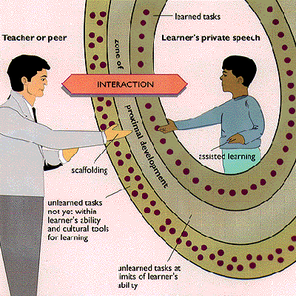

**Figure 1. Picture showing Social Development Theory by Vygotsky**

Source : <https://www.learning-theories.org/doku.php?id=learning_theories:social_development_theory>

Constructivist theory, particularly Bruner claims that we do not merely receive the information but instead construct the knowledge. Learning refers to the direct experience of the active construction of personal knowledge and teaching is not a form of knowledge delivery (Cunningham, 2024). This strategy is demonstrated in performance arts because children make meaning using drama, storytelling, as well as music. Group dynamic is highly influential on the success of learning foreign languages with group environments able to assist or detriment the performance of students (Atmowardoyo & Sakkir, 2021). Performance arts can change group dynamics as the anxiety that may arise through group dynamics impacts on thinking, especially among students having problems with motivation. Children are actively involved in developing language skills and this happens through creation and their own performance of the stories as opposed to imitating the teacher models.

CASEL framework allows the comprehension of social-emotional learning in terms of five interconnected domains catering to the skills, knowledge, attitudes, and behaviours involved in establishing goals, behavioural management, relationship-building and interpreting information under favourable conditions (Levin & Segev, 2023). The theories of Maslow demonstrate why creativity is critical in learning- the healthiest individuals are the most creative, and when they express their creativity; they feel content and joyful (Teems, 2021). Education is not possible unless the basic needs of children are taken care of such as in terms of safety, love, belonging, and respect. Performance arts also naturally build all the CASEL competencies and develop language learning at the same time generating very strong educational effects. Combined, those theories demonstrate that practical experiences, sense use, and self-satisfaction promote expressing creativity and achieving a full-child development, which makes the integration of arts not only theoretically reasonable but also practically efficient.

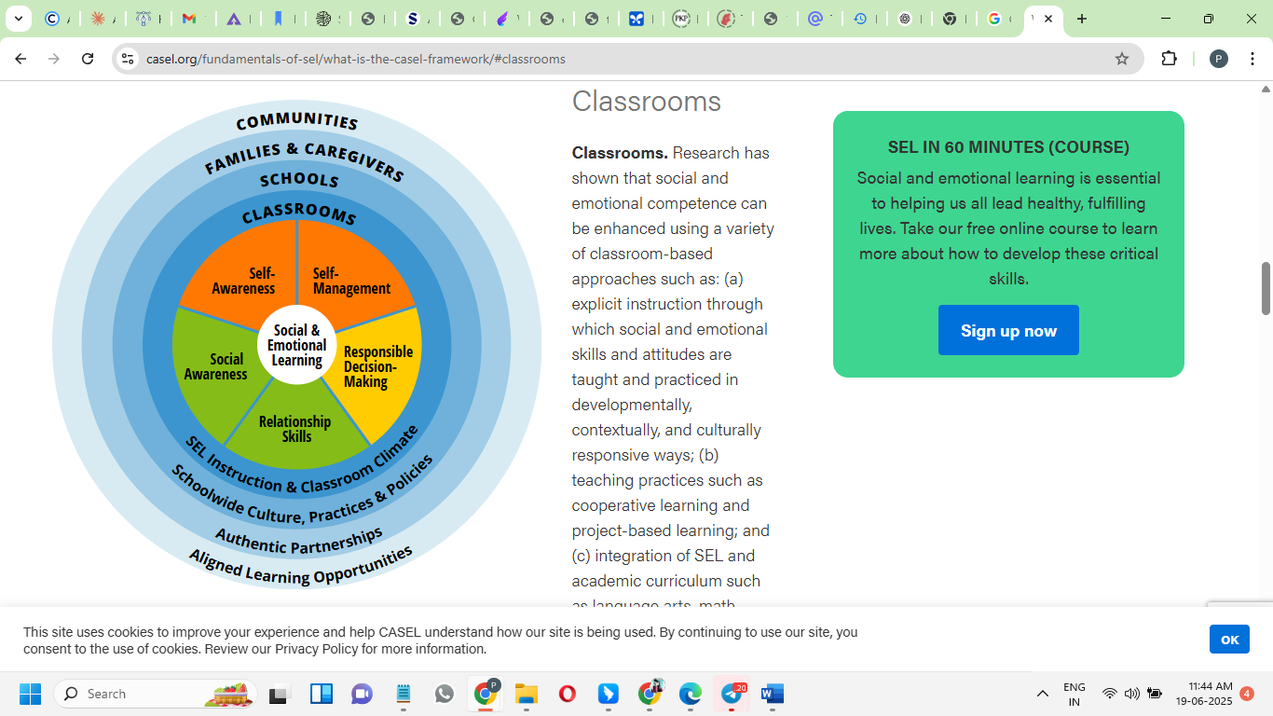

Figure 2. CASEL Framework

Source: <https://casel.org/fundamentals-of-sel/what-is-the-casel-framework/>

**Language Learning Through Arts**

There are various interrelated ways performance arts provide language learning that could utilize various sections of thinking and development. Music and rhythm have a particularly high power in teaching a language and they have founded joint strong brain links of music and language processing. It is natural that babies perceive word boundaries in speech with the help of rhythm, and this example shows the fundamental connection between rhythm and language comprehension (Pino et al., 2023). This relationship between language and music implies that they evolved together at the beginning of the human way of communication as both music and language use pitch, rhythm and melody to convey ideas and feelings. Such downfalls apply music in teaching languages because the sensitivity of pitch and rhythm of a much fascinating aspect of a language facilitate the development of grammar in school students forming more brain set cells during language study.

Visual arts can assist in language acquisition because both of a person brain parts are involved simultaneously left-brain processing of language and right brain visual thinking (Marosi, 2021). By children drawing story characters and explaining them using the new words, the children will form memories comprising of both visual information and language information. Like the language symbols, art symbols facilitate naming perceptions and giving an imagination of experiences as well as thinking skills. Fairy tales can be used to tell stories, which present excellent backgrounds to learn natural vocabulary and cultures (Eshkobilova & Ruziyeva, 2025). Fairy tales contain a lot of conversation which exposes children to phrases of conversation, formal language, and expressions of emotions in interesting tales. The role-playing allows the students to emulate the role of a fairy tale with a certain vocabulary and the retelling stories will contribute to retention and sentence construction.

A performance assessment allows educators to observe the effectiveness of children in using language in real communication when they are required to apply the knowledge and skills of separate fields in solving tasks (Heydarnejad et al., 2022). These methods are based on the theory by Vygotsky, which lays importance on the process of social interaction by using cooperative activity. The story of Paimin demonstrates the success of a person by means of performance-based learning: he succeeded at mastering the English language by audio options like voice recording, copying native speakers, reading aloud, and practising monologues (Atmowardoyo & Sakkir, 2021). Intelligence, motivation, good attitudes, and good teaching made him succeed. Digital storytelling re-invents the old storytelling and combines it with the use of digital technology, such as images, graphics, music, and narrations (Nair & Yunus, 2021). In the process of enhancing the pronunciation and fluency of the English-speaking language, students use various resources to exercise their voices, identities, and departments.

**SEL Benefits**

Performance arts are not only used to learn a language; they also bring a whole person development that is social-emotional. One of the greatest challenges to second language learning is speaking anxiety, which usually prevents students when they want to enter communication activities that are necessary in learning a language (Rianti et al., 2022). However, when working collectively on art assignments, children do not concentrate on personal anxieties but on common artistic project, which decreases tension and paves the way to an exertion to communicate spontaneously. The collaboration in the forms of working in pairs using arts allows establishing favourable conditions under which students can experiment with language without any fear and thus practice more frequently gaining confidence. Art production in a partnership will enable confidence to take shape gradually and be ready to take higher risks with their language, as well as enhance cooperation and engagement.

Theatre activities are comprehensive platforms of building several skills in social emotion. When students perform in front of the audiences, they obtain the confidence and self-esteem and learn how to overcome stage fright and take the risk in favourable conditions (Jain & Sharma, 2024). Theatre productions require much teamwork by the cast and the crew members, which also develops a sense of teamwork, cooperation and respect, whilst teaching empathy and emotional intelligence through multifaceted characters and narratives. Theatre instruction provides interest and curiosity and makes learning engaging since it is a student-based practice. Classroom educators view teaching theatre positively, and understand how it can enhance student involvement, comprehension, and retention as well as enhance participation, enhance communication, foster confidence, hone creativity, and create empathy about other views.

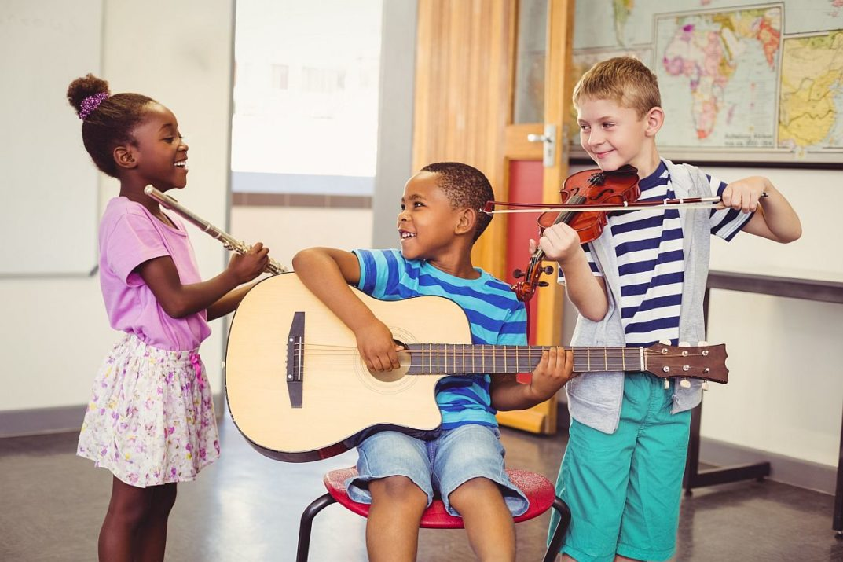

**Figure 3.** Music and Performing Arts Improve Social-Emotional Skills

**Source:** [**https://blog.planbook.com/improve-social-emotional-skills/**](https://blog.planbook.com/improve-social-emotional-skills/)

Cases of public speaking anxiety are common in language learning and the inability to exercise English is because of both the language and the non-language factor (Martiningsih et al., 2024). Role-playing helps to build empathy and emotional smarts because children get a chance to understand various character angels in a simulated way and allow students to build empathy based on the character portrayed in groups (Jannah et al., 2024). Emotion management and appropriate response to interpersonal challenge comes into the domain of teaching the students, which would be of use in communicating with other cultures and languages. Performance art is inherently able to handle anxiety by use of various techniques such as practice, relaxation and thinking positively, encouraging one another and acceptance. Drama targets several attributes of the student involvement through the direct situation-based learning, as drama entangles listening, talking, thinking, exploring and body development (Bessadet, 2022). Learning English through theatre is useful in making students lose fears to express themselves and makes active participation in learning stronger.

**Curriculum Integration Strategies**

Incorporating performance arts in language teaching takes a lot of planning to achieve the optimal learning estimates. The puppet storytelling demonstrates the way in which the traditional art of storytelling may be enhanced by using the tools of interactive media to establish the experience to target various goals. The puppets allow the children to be able to experience the conflict and emotions of a character without being threatened personally (Syafii et al., 2021). This safety allows a further exploration of the language without getting bored. It can take a maximum of six sessions: three when reading and talking about stories, three when teaching students to use storytelling methods, with a puppet, and three when the students will perform.

The concept of digital storytelling is an upgrade to the conventional storytelling to the modern learners. Its re-implements story and includes ancient storytelling into digital possibilities of creating stories and using voices of the authors, digital images, graphics, music, and sound (Rahiem, 2021). As much as the digital storytelling is emerging as global, the educators in different parts of the world have been implementing it in incorporating technology to take their students through the areas of learning such as speaking skills massively. Educators may change the old way of telling stories by redefining these performances as theatrical performances to attract the learners and encourage their advanced thinking. Drama super tales among young children is very encouraging and enables deeper thoughts as compared to the basic instructions. These activities are well planned by the teachers in such a way that they make sure that the curriculum is followed and select the known programmes that they can carry out with ease.

The primary advantage of play-based learning is that the inclusion of social-emotional skills into the normal lesson becomes natural, as it is a movement based on play, but not the preservation of traditional ideas about it, promoting active roles of teachers in the development of child thoughts and learning (Larsen et al., 2023). Teachers watch and detect the SEL needs of the children during playtime and on that basis, they come up with the activity which offers them some practice. Evidence of the effective integration is the programme by the name Tools of the Mind where dramatic play is taken by teachers and results in the enhancement of attention, self-regulation and cooperation, as teachers assist the children develop so called play plans and take on games that have been designed to help the children establish skills in self-regulation. The inclusion of the cultural content into the community programme that saves the local languages demonstrates the possibility of effective integration of the cultural content into a community programme that cannot be reduced to its purpose (Watimelu, 2024). They are language courses, video-based educational materials, mobile applications, and neighbourhood events through which people encourage each other to use the language.

Cross cultural views emphasise on incorporating the conventional aspects with the new procedures. Local teachers are interested in the links of language development with thinking and interpersonal skills and pay attention to the fact that a confident language expression influences the willingness of children to report their needs (Fu et al., 2024). Culture-specific ways of improving language, by means of performance-related activities cross-culturally, are demonstrated in the case of "duikou" (structured dialogue). The use of these strategies demonstrates the ability of performance arts to pay tribute to traditions and have contemporary goals, producing inclusive atmospheres about heritage and developing vital strengths in being a global citizen.

**Practice-Based Observations**

The experiences that can be gained in the real world can be helpful in terms of the effectiveness of the arts-based language learning. At Wenshang School, organisation of performances and exhibitions introduced students of various academic years, raised attendance and involved more students into the process. This corroborated studies that demonstrated that the involvement in arts promotes self-esteem, confidence, and marks in school and creates possibilities of leadership (Teems, 2021). Years 1-3 Multilingual teaching was an example of how the arts integration responds to a variety of needs but is rigorous and culturally sensitive. Primary cultural activities provided peer-to-peer learning environments through which the older students tutored the younger ones, and thereby, they increased their language as well as leadership skills. The performance-based education as used in the "Star of Reading" National Youth reading Talent Show indicates that when applied on a broader basis across ages it is successful; teaching on the ancient recitation of poetry indicates that traditional literature may be made interesting through performance. Outstanding results against regional contests proved that performance abilities are involved into achievement of academic results, which proves how classic literature may be applied with the usage of modern approaches.

The training encompassed Zhongge Arts Group that highlighted the effect of progressive performance education on the confidence levels of the learners and their marks. This responded to the research results in relation to the role of music and movement in developing the confidence to speak and integration and communication within the social setting (Wu, 2022). Parent-teacher communication also demonstrated the effectiveness of family involvement in terms of enhancing the performance of students since it forms support networks even outside the classroom. The experience of working in Chinese environments suggested that integrating the old and new strategies, paying attention to the local traditions and being knowledgeable about the particularities of local values, as well as correlating language and social skills are the aspects that need to be put into balance in the educational process (Fu et al., 2024). This will grant that education will become effective and culturally appropriate to various learners.

**Challenges**

The problem in the implementation of arts-integrated language education is serious and needs an aggressive reform. The second most important impediment is financial limitations because lack of funds is the most significant one (Bland, 2024). This issue affects primarily the rural and low-income areas and deprives the most in need of students of the opportunities. The loss of funding on COVID-19 relief unveiled its unreliable sources of financing and the sports programs alongside those of arts are becoming weak as there is a conflict of funding the athletics rather well-adequately funded and arts underfunded. The preparation of teachers is another complicated matter because teachers have difficulties with teaching several subjects and attaining the skills that are not in the sphere of their main interest (Milara & Orduña, 2024). The challenges met by teachers include inadequate time to plan, little time to teach, and time to restore resources. Arts integration requires teachers to be well trained in arts as well as pedagogy, which would require an educational change in culture, and curriculum to respect the value of interdisciplinary skills.

The implementation is also limited by systemic barriers, as many teachers consider equity practices as supplementary components of the instruction but not as necessary ones (Peercy et al., 2024). This forms gaps between the research and implementation in schools since the teacher might not be provided sufficient practical directions. Arts education has certain hurdles associated with it, such as time restrictions and capacity issues (Archibald et al., 2024), and professional artists are concerned about the representation of cultures when these artists do not fall into the same background, which is why cultural competency is an issue, and the framework should be more definite regarding its implementation.

**Recommendations**

To overcome the problems, significant adjustments are needed such as improvement in professional development, resources, and support of the institutions. It includes more active training and less theory as a source of professional development with references to the community language maintenance without relying on the arts of arts integration skills and interdisciplinary learning (Watimelu, 2024). To be able to achieve actual changes in the educational system in the classroom, teachers are to have the means of fast work, meaning that teachers need to have interactive applications, cultural resources, and videos to apply them to the classroom (Milara & Ordua, 2024). The community learning models can transfer the effect outside the classroom so that people can unite to generate cultural support. The education with the use of arts-integrated models can imply the creation of the networks of resources, knowledge, and validation. The formations such as awareness campaigns and cultural events are one of the strategies to create support and connect learning at school with the community-based actions. Reform must impact the structural blocks and ensure fairness that would ensure that all students enjoy the benefits by advocating critical thinking and teamwork in the areas of fairness, justice, and social issues (Ramirez et al., 2021). It must develop confidence in the students through establishing environments where harmony is respected as the culture of all people. Practices, clear routines, positive relationships and possibilities to create self-regulation are a must. The resources strategies are supposed to employ long-term solutions to respond to the needs both now and in future.

**Conclusion**

The combination of performance arts as a form of language pedagogy takes care of both linguistic and social-emotional growth in any context. Convergence theories in Vygotsky, constructivism, Maslow, and CASEL give scientific foundation to know the effectiveness of arts in different settings. These insights indicate how performance arts establish the ideal practice in terms of language and development in form of authentic, engaging and culturally responsive experiences. The signs have been consistent on how arts cut across borders and remain effective, evidenced in Paimin to the preservation of communities. Performance arts put children into organic situations in which they learn language but also foster empathy, confidence, collaboration, and cultural awareness to succeed throughout life, whether they use puppets, digital stories, theatre, or music. Practices in Wenshang School, Zhongge Arts Group, and “Star of Reading” have documentation to show quantifiable end results such as better attendance, performance, involvement, and associations. These were successful among the barriers of funding, training, and adoption among others. Based on that, to proceed, systems should accept arts as language teaching essential in respect to traditions and training students to be global citizens as these may demand applying long-term commitment to reform such as professional development, resources allocations, and policies to achieve responsiveness and fairness.

**References**

Archibald, M. M., Sharifat Makinde, & Tongo, N. (2024). Arts-Based Approaches to Priority Setting: Current Applications and Future Possibilities. *International Journal of Qualitative Methods*, *23*. <https://journals.sagepub.com/doi/full/10.1177/16094069231223926>

Atmowardoyo, H., & Sakkir, G. (2021, November 30). *The Development of Language Learning Theory Based on Best Practice: A Literature Review*. Www.atlantis-Press.com; Atlantis Press. <https://www.atlantis-press.com/proceedings/icla-21/125964918>

Bessadet, L. (2022). Drama-Based Approach in English Language Teaching. *Arab World English Journal*, *13*(1), 525–533. <https://files.eric.ed.gov/fulltext/EJ1336524.pdf>

Bland, T. (2024). What Determines Investment into Fine Arts Programs in Public High Schools? <https://griffinshare.fontbonne.edu/cgi/viewcontent.cgi?article=1670&context=all-etds>

Burke, R., & Field, R. S. (2023). Arts-Based Approaches to Languages Education with Refugee-Background Learners in the Early Years: Co-Creating Spaces of Hope. *Education Sciences*, *13*(1), 85. <https://doi.org/10.3390/educsci13010085>

Corbisiero-Drakos, L., Reeder, L. K., Ricciardi, L., Zacharia, J., & Harnett, S. (2021). Arts integration and 21st century skills: A study of learners and teachers. *International Journal of Education & the Arts*, *22*(2). <http://www.ijea.org/v22n2/v22n2.pdf>

Cunningham, T. M. D. D. J. (2024). 7. Constructivism: Implications for the Design and Delivery of Instruction. *Accessed: Mar*, *12*. <https://people.potsdam.edu/betrusak/621/Duffy%20and%20Cunningham%20(1996)-constructivism.pdf>

Fu, Q., Zhao, F., & Qin, J. (2024). Perspectives on early childhood development in China: key dimensions and contextual contributions. *Frontiers in Psychology*, *15*. <https://doi.org/10.3389/fpsyg.2024.1370641>

Ghani, N., Jamian, A. R., & Jobar, N. A. (2022). The Relationship Between Language Acquisition and Theory of Social Interactionist. *ICCCM Journal of Social Sciences and Humanities*, *1*(4), 54–59. <https://doi.org/10.53797/icccmjssh.v1i4.9.2022>

Heydarnejad, T., Tagavipour, F., Patra, I., & Farid Khafaga, A. (2022). The impacts of performance-based assessment on reading comprehension achievement, academic motivation, foreign language anxiety, and students’ self-efficacy. *Language Testing in Asia*, *12*(1). <https://doi.org/10.1186/s40468-022-00202-4>

Jain, D. K., & Sharma, R. (2024). Examine The Trainee Teachers' Viewpoints Regarding Theater-Based Teaching (TBT). *ShodhKosh: Journal of Visual and Performing Arts*, 675-690. <https://www.researchgate.net/publication/380355395_EXAMINE_THE_TRAINEE_TEACHERS'_VIEWPOINTS_REGARDING_THEATER-BASED_TEACHING_TBT>

Jannah, A. R., Chasanah, I. M., & Musnandar, A. (2024, December). ROLE-PLAY AND SIMULATION METHODS IN STRENGTHENING EMPATHY AND STUDENT LEARNING OUTCOMES: A CASE STUDY OF STUDENTS'MORALS IN ELEMENTARY SCHOOL. In *International Seminar On Islamic Education & Peace* (Vol. 4, pp. 273-284). <https://ejournal.uniramalang.ac.id/isiep/article/view/5971/3569>

Larsen, N., Pyle, A., Danniels, E., Marzouca, M., & Nazeem, R. (2023). Kindergarten teachers’ facilitation of social and emotional learning in classroom play contexts. *Education Inquiry*, 1–22. <https://doi.org/10.1080/20004508.2023.2192900>

Levin, O., & Segev, Y. (2023). The Missing Piece in the CASEL Model: The Impact of Social–Emotional Learning on Online Literature Teaching and Learning. *Education Sciences*, *13*(11), 1123–1123. <https://doi.org/10.3390/educsci13111123>

Marosi, R. (2021). Developing cognitive and language skills through visual arts. *Opus et Educatio*, *8*(1). <https://doi.org/10.3311/ope.420>

Martiningsih, I., Susilawati, E., & Rezeki, Y. S. (2024). Students’ Strategies to Overcome Public Speaking Anxiety. *Inspiring: English Education Journal*, *7*(1), 66–86. <https://doi.org/10.35905/inspiring.v7i1.8766>

Milara, Iván Sánchez, & Orduña, M. C. (2024). *Possibilities and challenges of STEAM pedagogies*. ArXiv.org. <https://arxiv.org/abs/2408.15282>

Nair, V., & Yunus, M. M. (2021). A Systematic Review of Digital Storytelling in Improving Speaking Skills. *Sustainability*, *13*(17), 9829. <https://doi.org/10.3390/su13179829>

Ozoda Eshkobilova, & Sevinch Ruziyeva. (2025). IMPROVING VOCABULARY THROUGH STORYTELLING WITH FAIRY TALES. *Modern Education and Development*, *18*(5), 32–37. <https://scientific-jl.com/mod/article/view/93>

Peercy, M. M., Troyan, F. J., Fredricks, D. E., & Hardy‐Skeberdis, M. (2024). Calling for a Humanizing Turn in Language Teacher Education: Problematizing Content and Language Instruction. *TESOL Quarterly*, *59*(1), 421–447. <https://doi.org/10.1002/tesq.3319>

Pino, M. C., Giancola, M., & D’Amico, S. (2023). The Association between Music and Language in Children: A State-of-the-Art Review. *The Association between Music and Language in Children: A State-of-The-Art Review*, *10*(5), 801–801. <https://doi.org/10.3390/children10050801>

Rahiem, M. D. H. (2021). Storytelling in early childhood education: Time to go digital. *International Journal of Child Care and Education Policy*, *15*(1), 1–20. <https://doi.org/10.1186/s40723-021-00081-x>

Ramirez, T., Brush, K., Raisch, N., Bailey, R., & Jones, S. M. (2021). Equity in Social Emotional Learning Programs: A Content Analysis of Equitable Practices in PreK-5 SEL Programs. *Frontiers in Education*, *6*. <https://doi.org/10.3389/feduc.2021.679467>

Rianti, R., Syahid, A., & Qamariah, Z. (2022). The Effectiveness of Pair Work Activities on Students’ Speaking Anxiety and Speaking Ability. *Jurnal Educatio FKIP UNMA*, *8*(4), 1471–1477. <https://doi.org/10.31949/educatio.v8i4.3760>

Santana, F. D. T., Hartono, H., Narawati, T., Cahyono, A., & Hapidzin, R. I. (2022). Self-Expression Art Education Orientation: Art Education for Early Childhood in the Independent Learning Curriculum. *International Conference on Science, Education, and Technology*, *8*, 683–691. <https://proceeding.unnes.ac.id/ISET/article/view/1822>

Syafii, M. L., Santoso, S., & Hartono, S. (2021). Story-Telling Technique Utilizing Puppets to Enhance the Learners’ Speaking Competence. *International Journal on Social and Education Sciences*, *3*(2), 304–341. <https://eric.ed.gov/?id=EJ1294678>

Teems, H. (2021). The Benefits and Barriers To Arts Integration: Arts Accessibility In Public Montessori. *All Theses and Dissertations*. <https://dune.une.edu/theses/363/>

Tiley, W. (2022). Modern Art in the Language Classroom: Cultivating Interests, Building Confidence. *KOTESOL Proceedings 2022*, 35. <https://www.researchgate.net/publication/365851841_Modern_Art_in_the_Language_Classroom_Cultivating_Interests_Building_Confidence>

Watimelu, W. O. S. (2024). Community-Led Initiatives in Language Preservation: Strategies for Endangered Language Documentation and Revitalization. *LIER: Language Inquiry & Exploration Review*, *1*(1), 1-9. <https://pppii.org/index.php/lier/article/view/10>

Wu, Z. (2022, February 1). *A Review of Drama-based and Music-based Pedagogy in Early Childhood Language Learning and Development*. Www.atlantis-Press.com; Atlantis Press. <https://doi.org/10.2991/assehr.k.220131.129>