# **Integrated Behavioural and Circular Economy Strategies for Plastic Waste Management in Rajshahi, Bangladesh**

## 

## **Abstract**

Plastic waste has turned out to be very big issue to the environment and governance in very rapidly expanding secondary cities in South Asia. The research carried out looks at the plastic consumption and the behavioural driving factors as well as management of plastic waste in Rajshahi, Bangladesh by using a mixed-methods approach that comprises of household surveys (n = 200), stakeholder interviews, and contextual analysis of national-level data. The research found out that Rajshahi produces around 15,927 tons of plastic waste annually but only 20% of that is recycled in a practical manner. This is mostly done through the informal sector. Most of the waste is disposed of in landfills (more than 70%), and the infrastructure for recycling that is formal is still underdeveloped. The statistical analysis shows that income, education, and residential area have a significant influence on the recycling participation, and people who live in central urban areas are more likely to be involved in recycling than those in peri-urban or industrial areas. Factor analysis illustrates that two major motivational axes—environmental consciousness and ease/rewards—can account for 65% of the change in household recycling conduct. Apart from that, although nationally, the recycling rate is estimated to be 42% in 2024, Rajshahi is behind because there is a lack of coordination among institutions and informal recovery networks dominate. The study is now putting forward the Circular Behaviour-Policy Loop (CBPL) framework, which fuses behavioural waste theory with circular economy principles to redesign policy in alignment with citizens' motivations. The results of the study present practical advice for municipal policymakers planning to improve recycling systems, infrastructure planning, and community engagement in resource-constrained urban contexts.

**Keywords:** Plastic waste, recycling behaviour, circular economy, behavioural waste theory, Rajshahi, informal sector, policy integration

## **1. Introduction**

Plastic pollution is rapidly becoming one of the most pressing environmental issues of our time, particularly in rapidly growing cities in low and middle income countries (LMICs). In these regions, waste management systems often fail to keep up with the pace of urban expansion and rising consumption, making the problem even more challenging (Lebreton &Andrady, 2019). A prime example of this can be seen in Rajshahi, Bangladesh, where urban growth, industrial development, and an increasing reliance on single-use plastics are all fuelling the growing pile of plastic waste. The consequences of inadequate waste management in Rajshahi are far-reaching, leading to environmental damage and a range of public health concerns such as contaminated water, polluted soil, and risks to local wildlife (Islam & Huda, 2021).

Rajshahi has about 1.007 million people (Macrotrends, n.d.)) and is a mid-sized city in South Asia. Cities with 500,000 to 2 million people are key to national urban growth but get little attention. In low and middle income countries, these cities often face limited resources, weak governance, and poor infrastructure. Unlike big cities like Dhaka or Kolkata, mid-sized cities lack the money and staff to run full waste systems. Still, their fast growth and spread add more pressure to the environment.

Rajshahi is a strategic case study for cities throughout the Global South, particularly in Sub-Saharan Africa, South Asia, and Southeast Asia, where similar urban trajectories can be observed. The study of waste management in Rajshahi provides an understanding of the operational challenges, behavioural barriers, and governance restrictions that secondary urban centers, which are often neglected in national and international waste policy planning, are experiencing.

Consequently, the present study intends to examine the production, nature, and handling of plastic waste in Rajshahi and, at the same time, recognize the barriers, both behavioural and institutional, for the recycling of the waste to be effective. In particular, it intends to:

* Find out the quantity and qualities of the plastic waste that is generated in Rajshahi;
* Check up on the current reusing practices for their efficacy;
* Recognize the obstacles to the segregation of the waste and recycle.

The study is grounded in two complementary theoretical frameworks: the circular economy, which emphasizes closed-loop material flows and resource efficiency (Ellen MacArthur Foundation, 2019), and behavioural waste theory, which explores the socio-psychological dimensions of recycling behaviour (Gupta et al., 2020). By integrating these perspectives, the research introduces the Circular Behaviour-Policy Loop (CBPL) model, which conceptualizes a feedback mechanism between citizen behaviour, infrastructure, and policy design. The key research questions guiding this study are:

1. What are the main barriers to effective plastic waste recycling in Rajshahi?
2. How do socio-economic factors influence recycling behaviour among Rajshahi’s residents?
3. What policy interventions can improve plastic waste management in the city?

This paper is divided into sections for easier understanding of the content. The Literature Review part summarizes the present studies about the management of plastic waste in Bangladesh and similar LMIC cities. The Methodology section describes the study design and the data analysis methods. The Results and Discussion section contains the main results. Finally, the Policy Recommendations and Conclusion parts offer strategies based on evidence to improve urban waste governance.

## **2. Literature Review**

#### **2.1 Plastic Waste in Urban Bangladesh**

Plastic waste has become a severe environmental challenge in Bangladesh, especially in the urban areas. The growing population, increased consumerism, and insufficient infrastructure in these areas have caused local waste systems to be strained beyond their limits (Islam & Huda, 2021; World Bank, 2021). Major research and policy attention have been put to megacities like Dhaka and Chattogram (Hossain et al., 2019; Waste Concern, 2020), but mid-sized cities like Rajshahi, Khulna, and Comilla are still receiving very little empirical attention in comparison. However, these secondary cities are in the same situation as the big ones regarding waste pressure because of urban sprawl, limited municipal capacity, and growing plastic dependency—mostly in packaging and single-use products.

Studies in Dhaka have identified informal waste collectors as key actors in plastic recycling, but these systems remain poorly integrated with formal waste governance structures (Afroz et al., 2011; Alam & Hossain, 2022). Research on Khulna and Comilla is limited in quantity and mostly descriptive in nature. This research is very shallow as to the behavioural or institutional changes it covers (Rahman & Ahmeduzzaman, 2014; Bari et al., 2012). Such a gap makes it difficult to apply the findings or develop policy solutions beyond the capital-centric context, leaving no option but to go for in-depth case studies of the neglected urban centers such as Rajshahi.

#### **2.2 Behavioural Dimensions of Waste Management**

The public's understanding of the factors affecting their participation in recycling can only come from their behavioural, social, and infrastructural elements. The relationships between household recycling and knowledge, attitudes, income, convenience, and social norms have been established by various past studies (Bari, 2007; Afroz et al., 2011). Discussing South Asian communities, research has found out that low-income and peri-urban ones are dealing with structural barriers that hold them back from becoming recycling aware. These barriers include access to services that are not good and lack of incentives (Huda et al., 2021).

Behavioural Waste Theory (BWT) tries to represent how socio-psychological factors viz. a sense of responsibility, understanding of the problem, and motivational factors have a great influence on recycling conduct, here BWT uses the social-psychological approach (Gupta et al., 2020). Yet, BWT has hardly been put into effect in Low- and Middle-Income Countries (LMIC) with the help of the powerful statistical treatment, especially when dealing with midsize cities.

The other recognized behaviour models VBN (Value-Belief-Norm) theory put the moral and normative issues to the first place when talking about pro-environmental behaviour, whereas the COM-B model (Capability, Opportunity, Motivation - Behaviour) is based on the relationship between personal capacity, external factors, and internal motivators (Michie et al., 2011). On one hand, these ideas have been beneficial in the fields of environmental psychology and public health, on the other hand, their direct use for municipal waste systems in cities, such as Rajshahi, has not been addressed so far.

#### **2.3 Circular Economy and Integrated Waste Frameworks**

The Circular Economy (CE) framework has resulted in a substantial increase in recent policy discussions due to its emphasis on resource efficiency, waste reduction, and systemic reuse (Geissdoerfer et al., 2017; Ellen MacArthur Foundation, 2019). When this framework is applied to urban waste, CE principles go further by advocating for interventions at different stages of the product lifecycle such as upstream in product design, midstream in collection and sorting, and downstream through recycling and material recovery.

On the other hand, circular economy projects in Bangladesh are still in the beginning phase. The majority of the sectors involved in recycling are still informal, and the circular technologies investments in the formal sector and the incentives for the industries’ compliance are very low (MoEFCC, 2022). Also, CE business models generally downplay the role of human behaviour—how people’s mindsets and actions influence the infrastructure and policies.

#### **2.4 Conceptual Framework: Circular Behaviour-Policy Loop (CBPL)**

To fulfill these gaps, the study under discussion implements the Circular Behaviour-Policy Loop (CBPL) model that connects the CE principles with the behavioural waste theory. The CBPL defines a cycle of interaction between personal incentives (such as environmental consciousness, simplicity), system facilitators (like bins, pickup services), and institutional responses (such as policy incentives, infrastructure investment). While VBN or COM-B focus mainly on the change of the individual's behaviour, the CBPL places the behaviour in a dynamic governance system, acknowledging that continuous behavioural change is both the effect and the cause of formal policy and infrastructure.

The combined model is indeed a perfect match for urban environments having a shortage of resources, where the municipal agencies are Behavioural interventions. However, the municipal agencies need to be careful as they have limited operational capacity, thus they must balance behavioural interventions with that capacity while still performing effectively. It also shows that the literature calls for context-sensitive models that are consistent with citizen behaviour and institutional performance, especially in under-resourced secondary cities. he CBPL framework implies that the better infrastructure becomes and the more targeted education is given, the more environmental behaviour will be repeated. Such behaviour in turn forms the basis for policy and investment decisions to be continued (Figure 1).

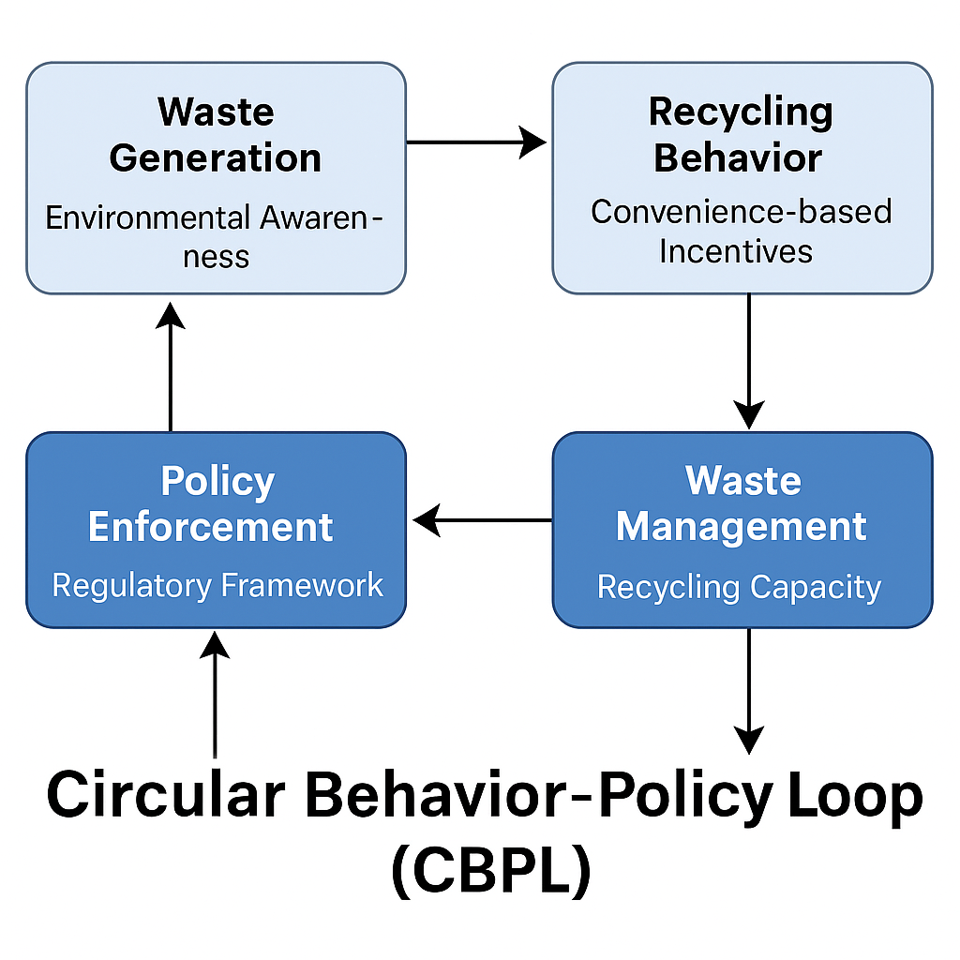

Figure 1: A graphical representation of the CBPL model

This framework could be a mapping instrument for other cities in the Global South that have identical problems with fast urbanization, lack of infrastructure, and high consumption of plastic. It further represents an extension of applied behavioural science research in environmental management, which has a range of implications for the local achievement of Sustainable Development Goal 11 (sustainable cities and communities).

## **3. Methodology**

#### **3.1 Research Design**

This work uses a mixed-method approach for the detailed investigation of the plastic waste management situation in Rajshahi. The quantitative part of the study conducts household surveys for the assessment of plastic waste production, segregation, and recycling habits, while the qualitative part consists of semi-structured interviews with local stakeholders for the exploration of institutional, infrastructural, and behavioural impediments. The merging of gas methods enables an understanding of the issue at a deeper level, as they offer the complementarity of numerical insights and vivid, local data.

#### **3.2 Study Area**

Rajshahi City, located in northwestern Bangladesh, was selected as the study area due to its rapid urban growth and increasing plastic consumption. The city spans 96.68 km², with a population of approximately 1.007 million (Macrotrends, n.d.). Given the lack of comprehensive studies on plastic waste management in Rajshahi, this research aims to fill this gap by generating both empirical and actionable insights.

#### **3.3 Data Collection**

##### **Household Surveys**

A random sample of 200 households was taken from three zones—central urban, peri-urban, and industrial areas—and a survey was conducted. These zones were chosen based on their varying socio-economic characteristics and waste management practices. The surveys were designed to collect data on:

* Plastic waste generation (volume and types)
* Waste segregation practices
* Recycling behaviours
* Public awareness of plastic waste impacts

To be sure that the questions were clear and there was no misunderstanding in the context, the questionnaire was pre-tested on a small sample of 20 households. The final survey items comprised both the closed-ended questions (e.g., the frequency of recycling) and Likert-scale items that measured environmental attitudes and behavioural motivators connected to recycling.

##### **Semi-Structured Interviews**

About 30 people, including municipal officials, formal and informal waste collectors, and small business operators, were interviewed in semi-structured interviews. These respondents have given a picture of the institutional obstacles, recycling obstacles, and public opinions about waste disposal.

The participants were informed about the study's general aims and agreed verbally or in writing that they participate voluntarily. Identifying information was not gathered. Responses were taken in note form during the interviews and were later reviewed and summarized. All the interactions were conducted according to ethical standards that confidentiality was guaranteed and that any possible risk for the participants was minimized.

##### **Secondary Data**

Secondary data were obtained from publicly available national-level reports, relevant peer-reviewed literature, and sectoral publications by institutions such as the Department of Environment (DoE), Waste Concern, and the World Bank. These sources provided essential context on plastic waste generation trends, national recycling rates, and policy developments from 2020 to 2024. Since city-specific administrative data from Rajshahi City Corporation (RCC) were not available or accessible at the time of research, localized estimates were instead generated through a triangulated analysis of primary household survey data, key stakeholder interviews, and comparative benchmarks from similar urban areas in Bangladesh (e.g., Khulna and Chattogram). This methodology ensured that the analysis remained empirically robust while maintaining alignment with national waste management patterns and planning targets.

#### **3.4 Data Analysis**

##### **Quantitative Analysis**

Data from a survey were analyzed with the help of SPSS version 20. Descriptive statistics (means, frequencies, and percentages) provided a clear picture of the plastic waste patterns. Besides, inferential statistics were also engaged:

* Linear regression was utilized for determining the impact of income and education on recycling behaviour
* One-way ANOVA was used for probing whether there were any differences in recycling across urban zones.

Regarding the factor analysis, Exploratory Factor Analysis (EFA) was performed via Principal Component Analysis (PCA) along with Varimax rotation. The Kaiser-Meyer-Olkin (KMO) index of sampling adequacy was 0.79, and Bartlett’s Test of Sphericity was significant (χ² = 924.6, p < 0.001), thus confirming the appropriateness of the data for the factor analysis. The Cronbach’s alpha coefficients for the new factors were 0.84 (Environmental Awareness) and 0.

##### **Qualitative Analysis**

Thematic analysis was conducted on the information obtained from interviews with the purpose of identifying recurring themes related to institutional and behavioural barriers. A manual coding exercise was done on the transcripts, and key themes were then compared across stakeholder groups.

Just to be clear here, ‘recycling participation’ is all about sorting and the intention to recycle at the household level; ‘mechanical recycling,’ on the other hand, is the process of plastics going through sorting and re-manufacture; and ‘effective recycling’ means that materials are converted into products that are actually used.

#### **3.5 Ethical Considerations**

This study adhered to standard ethical guidelines for social research involving human participants. Ethical approval was sought in accordance with prevailing academic norms and institutional expectations at the time of the study. Participation in surveys and interviews was entirely voluntary. Verbal or written informed consent was obtained from all respondents after they were briefed on the general purpose of the research, their right to confidentiality, and their freedom to decline or withdraw at any stage without penalty. No personally identifiable information was collected or disclosed. Data have been anonymized and reported in aggregate to ensure respondent privacy. All efforts were made to uphold the principles of respect, integrity, and non-maleficence throughout the research process.

#### **3.6 Limitations**

This research encountered quite a few limitations. Initially, as there was no official data for a plastic waste audit at the city level from Rajshahi City Corporation (RCC) and research team relied on primary surveys and interviews as well as national trends for estimates that were then triangulated. Secondly, although the survey sample has been designed in a way that it is fairly representative of the population, it still may contain some elements of the self-reporting bias that consumers may demonstrate in their recycling behaviour. Third, the behavioural theories utilized (e.g., COM-B, BWT) were merely loosely matched to the local situation without any longitudinal verification. At last, the information on the informal sector was collected in an indirect manner as the study could only gain limited access to the recyclers’ operational records as verbal.

**4. Results and Discussion**

#### **4.1 Plastic Waste Generation**

Plastic waste generation in Bangladesh has been on an upward scale for the last 5 years. In 2020, the total national plastic waste was 821,250 tons which is projected to grow to 1,042,000 tons in 2024. This increase of approximately 27% is depicted in Figure 1 and is due to urbanization that is happening at an exponential rate, more and more people consuming packaged goods, and less affordable and scalable alternatives available to replace plastic packaging.

Rajshahi is a city where plastic waste generation has also increased in tandem with national trends. The recycling performance of this city is, however, still poor. The recycling rate of the country is estimated to be around 42% in 2024 while that of Rajshahi is only 20%. This difference points out the parts where the formal infrastructure, regulatory oversight, and public participation at the local level are not up to the mark.

**Table 1: Plastic Waste and Recycling in Bangladesh**

|  |  |  |  |  |
| --- | --- | --- | --- | --- |
| **Year** | **Total Plastic Waste (tons)** | **Recycling Rate (%)** | **Non-Recycled (%)** | **Source** |
| 2020 | 821,250 | 37% | 63% | Waste Concern (2020); World Bank (2021) |
| 2021 | 879,000 | 38% | 62% | DoE & World Bank (2022) |
| 2022 | 936,000 | 39% | 61% | UNEP (2022); MoEFCC (2022) |
| 2023 | 990,000 | 40% | 60% | Department of Environment (DoE), 2023; Plastic Waste Management Action Plan Bangladesh (PWMPAP) (2023) |
| 2024 | 1,042,000 (projected) | 42% (projected) | 58% (projected) | DoE (2024 projection); Waste Concern & MoEFCC (2024 draft reports) |

*Note: The numbers for 2024 are projections from national planning documents that were created before the complete data of the year was available.*

Even though the national recycling rate has improved modestly but consistently, going up from 37% in 2020 to 42% in 2024, this rise is still not enough to make up for the increase in the amount of waste. The adoption of the National Action Plan for Sustainable Plastic Management (2021–2030) is behind this trend by aiming at a 50% recycling rate in 2025 (MoEFCC, 2022).

The informal sector is the principal source of the recycling system in Bangladesh because it handles about 90% of all the activities regarding plastic recycling, mainly collection, sorting, and reprocessing of the materials at a basic level (Waste Concern, 2020; World Bank, 2021). In addition to its indispensable role, the sector is also challenged with unsafe work conditions, lack of regulations, and troubles with tracing and assuring the quality of the materials.

Despite the modest increase in recycling, the predominant plastic that has not been recycled still leads the waste stream. The share of plastic non-recycled registered only a marginal decrease, from 63% in 2020 to 58% in 2024. This slow reduction highlights the systemic flaws in waste segregation and recovery sectors, especially in secondary cities. The bulk of the plastic remains, however, that is being discarded by means of open dumping, or burning, or even goes to water bodies thus it is a major cause of environmental destruction. UNEP (2022) has identified Bangladesh as a major player in plastic leakage into the Ganges–Brahmaputra–Meghna river system, which is the source of waste going to the Bay of Bengal. Such leakage is an extremely dangerous situation rife with possibilities of the loss of biodiversity and the intrusion of public health issues, especially when contaminated fisheries and agricultural soils are involved.

### **4.2 Composition of Plastic Waste in Rajshahi**

Plastic waste from Rajshahi City is a crucial indicator of the sources and the recyclability of the municipal plastic waste stream. The data presented in Table 2, showing the plastic waste generated by households, are the result of a 2024 survey of 200 households, supported by key stakeholder interviews. Figure 2 depicts these proportions in a pie chart format to enable easier understanding.

**Table 2: Plastic Waste Composition in Rajshahi**

|  |  |  |
| --- | --- | --- |
| Waste | Estimated Amount (Tons) | Percentage of Total Plastic Waste (%) |
| Packaging materials (bags, bottles) | 6,572 ± 657 | 40% |
| PET bottles | 4,108 ± 411 | 25% |
| Packaging films | 2,385 ± 239 | 15% |
| Miscellaneous plastics (straws, cutlery) | 1,590 ± 159 | 10% |
| Other plastics (toys, furniture) | 1,272 ± 127 | 10% |
| Total | 15,927 ± 1,593 | 100% |

*Note: Estimates based on 2024 household surveys (n = 200) and confirmed by key stakeholder interviews. No official RCC waste audit records were used.*

Based on the details provided in Table 2, it is apparent that packaging materials are the main cause of municipal plastic waste in Rajshahi. The table also shows that packaging materials and PET bottles together make up 65% of the total volume of plastic waste. This trend is indicative of the increased consumption of fast-moving consumer goods (FMCGs), bottled beverages, and convenience products—a fact that is in line with the national trend (World Bank, 2021; Huda et al., 2022).

Packaging films which are the source of 15% include multi-layer plastics such as chip packets and snack wrappers. These plastics are the most challenging parts of the waste because of their being made from different materials and having low market value, which makes them unattractive for recycling. Other disposable plastic items such as straws, cutlery, and low-grade composites like toys and broken plasticware together form 20% of the waste stream. In general, these categories have a very low recycling rate and are not included in the recycling circuits of formal and informal sectors (Alam & Ahammad, 2020).

The overabundance of throw-away, short-lived plastic goods accentuates the necessity of upstream interventions which include eco-design and reduction of plastic use at the product level. As for the downstream viewpoint, the large percentage of recyclables such as PET clearly points to the fact that improvement in the collection system and offering incentives for recovery are of supreme importance.

Table 2 shows Rajshahi's estimate of the municipal plastic waste composition at the city level, together with that of other cities in Bangladesh and the world. Data was collected from household survey responses (n = 200) and validated by interviews, therefore acknowledging a margin of estimation. A ±10% relative error margin was assumed due to self-reporting bias and triangulation methods.

This plastic composition profile confirms the need for material-specific, localised plastic waste management strategies in Rajshahi, which must be aligned with the major waste categories and consumption trends of the area.

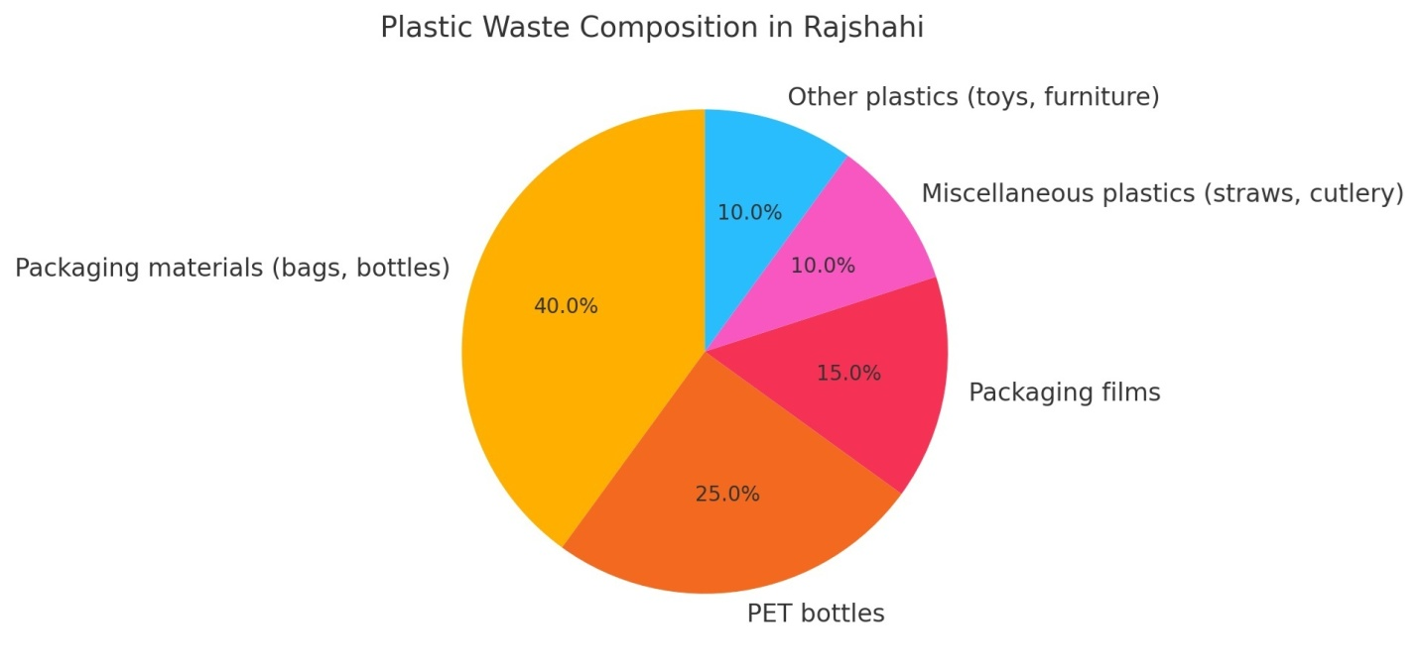

**Figure 2:** Plastic Waste Composition in Rajshahi (2024)

#### **4.3 Plastic Waste Management Practices in Rajshahi**

Plastic waste management in Rajshahi is still largely reliant on landfilling and informal recycling. There is no significant use of energy recovery or formal material recovery systems in the city. Table 3, based on triangulated field data, gives a plastic waste management breakdown in 2024, showing the estimated quantities handled by different disposal and recycling pathways.

The absence of recent RCC published audits means that these figures are based on primary survey data and field observations. Waste-to-energy technologies of a formal nature are still very rare in Rajshahi because of the expensive installation costs and regulations.

**Table 3. Plastic Recycling and Waste Management in Rajshahi**

|  |  |  |
| --- | --- | --- |
| Recycling Method | Estimated Amount (tons) | Share of Total Waste (%) |
| Mechanical recycling (processed) | 3,185 | 20% |
| Incineration (waste-to-energy) | 1,113 | 7% |
| Landfilling (open & semi-controlled) | 11,629 | 73% |
| Total | 15,927 | 100% |

*Note: The recycled figure shows just the part of the plastic waste that was actually transformed into products of the same use (effective recycling), from survey and field observation data. Mechanical processing without the production of usable output is not considered here for the sake of clarity and consistency.*

The statistics are showing that it is only 20% of plastic waste in Rajshahi that is properly recycled into materials that can be reused. The number is based on clean plastic fractions that are post-sorted and then used to make new products mostly by informal sector initiatives. Recyclers operating in the informal sector being quite significant in the process of recovery however, they do it without safety protocols, environmental controls, or integration into formal municipal systems.

Just 7% of the plastic waste is disposed of through incineration, which is a very small part. The costs being high, the dangers to the environment, and the weakness of the regulatory power are the main limiting factors for the capacity of waste-to-energy technologies in Rajshahi. About 73% of the plastic waste is going to be dumped in properly or improperly controlled landfills. Such places become sources of pollution to the soil quality, water, and air in the long run because of the continuous breakdown of plastic wastes and the burning of those wastes in an uncontrolled manner.

These results show that integrated waste management strategies are really important now. These strategies should focus on material recovery, institutional capacity building, and investment in environmentally sound infrastructure. Rajshahi’s recycling sector revitalization can be achieved through the dual approach of formalizing the informal workforce and offering policy incentives for the decentralized waste sorting and processing.

There are possibilities to make plastic waste channels formal through Public-Private Partnerships (PPPs) that could:

* Align informal collectors with licensed systems,
* Provide safer sorting infrastructure,
* Attract private investment in recycling plants.

#### **4.4 Socioeconomic Determinants of Household Recycling**

From Table 4, it is evident that income positively affects household recycling behaviour that is statistically significant, with a confidence interval increase in recycling rate of 3.3 percentage points for each additional unit of income level (p < 0.001). Education is the other meaningful factor that, with a significance level of 0.001, results in an expected increase in recycling participation of 2.9 percentage points for each unit rise in education level. The intercept value of 20.0 signifies the minimum recycling rate among households with the lowest levels of income and education.

**Table 4. Linear Regression: Predictors of Household Recycling Rate**

|  |  |  |  |  |
| --- | --- | --- | --- | --- |
| Predictor | Estimate (Δ Recycling Rate %) | Std. Error | t-value | p-value |
| Intercept | 20.0 | 2.0 | 10.0 | <0.001 |
| Income (1-5 scale) | +3.3 | 0.6 | 5.5 | <0.001 |
| Education (1-5 scale) | +2.9 | 0.8 | 3.6 | 0.001 |

*Note: Adjusted R² = 0.38; F(2,197) = 41.3; p < 0.001. N = 200.*

Income and education levels were assessed on five-point ordinal scales, with 1 representing very low and 5 representing very high. The distribution of each level across the sample was roughly equal, ensuring that the variance assumptions were still acceptable. These findings indicate that both access and awareness are the key enablers of recycling engagement.

The magnitude of these effects is given in Table 4, they are highly significant (F(2,197) = 41.3, p < 0.001), and they account for a considerable proportion of the change in recycling behaviour (adjusted R² = 0.38). there is a strong positive correlation between both income as well as education, and the household recycling rates. More specifically, households with higher income levels tend to be the most active in recycling, maybe due to the fact that they have a better infrastructure and environmental awareness. Also, the higher educational attainment level goes hand in hand with great knowledge of the environmental impact of plastic waste and the increased likelihood of sorting and disposing of waste responsibly practice.

The results of that study are in line with studies both in the country and abroad which have found that a higher socioeconomic status is generally related to environmentally-friendly behaviour (Afroz et al., 2011; Huda et al., 2021). For urban policymakers in Rajshahi, this points out the necessity to customize awareness campaigns and recycling incentives to lower-income and less-educated communities since those places may experience a slower rate of behaviour change as a result of the services and information being limited.

#### **4.4 Urban Spatial Disparities in Recycling Rates**

Table 5 presents details about spatial analysis of recycling behaviour that reveals large differences across urban zones of Rajshahi. The average recycling rate is the maximum in central urban areas at 30.0%, which is followed by peri-urban areas at 18.0%, and industrial zones at only 13.0%. The differences are statistically significant one-way ANOVA (F(2,197) = 25.4, p < 0.001) test, which is also indicated by the Tukey HSD post hoc test that all pairwise comparisons between zones are significant at p < 0.001. Figure 3 provides a graphical representation of the spatial pattern in the level of recycling participation in various zones of Rajshahi. The figure also emphasizes the substantially greater rates in downtown areas than in the outskirts of the city and industrial zones.

**Table 5. One-Way ANOVA: Recycling Rates by Urban Zone**

|  |  |  |  |
| --- | --- | --- | --- |
| **Urban Zone** | **Mean Recycling Rate (%)** | **Std. Dev.** | **N** |
| Central Urban | 30.0 | 8.0 | 70 |
| Peri-Urban | 18.0 | 7.0 | 65 |
| Industrial Area | 13.0 | 6.5 | 65 |

Note: F(2,197) = 25.4; p < 0.001. Post hoc Tukey HSD confirms all pairwise differences are significant (p < 0.001).

According to Table 5, residents in central urban areas are most likely to engage in recycling. This is due to various factors such as improved access to formal waste management infrastructure, a higher number of public environmental awareness campaigns, and the shorter distance to recycling hubs. These regions usually have a higher population density and stronger municipal oversight, which means they can implement more systematic waste management (World Bank, 2018; Alam & Ahammad, 2020).

On the other hand, peri-urban and industrial areas have significantly lower recycling rates. These parts of the city are often the most irregular in waste collection, lacking civic engagement, and having very limited institutional capacity to enforce environmental regulations. Besides that, industrial zones tend to focus more on production and logistics rather than sustainable waste practices. Also, workers might be given little time, space, or incentives to participate in recycling initiatives (Hossain et al., 2019; Ahsan et al., 2022).

The major spatial disparity in recycling behaviour shows that there is a strong need for policy responses that are targeted geographically. To illustrate, extending the reach of recycling bins, boosting public engagement in areas lacking service, and setting up local collection points in peri-urban and industrial districts could narrow the participation divide. Such results coincide with research done in comparable South Asian urban settings, which highlight the influence of urban geography on environmental behaviour (Singh et al., 2021; UN-Habitat, 2020).

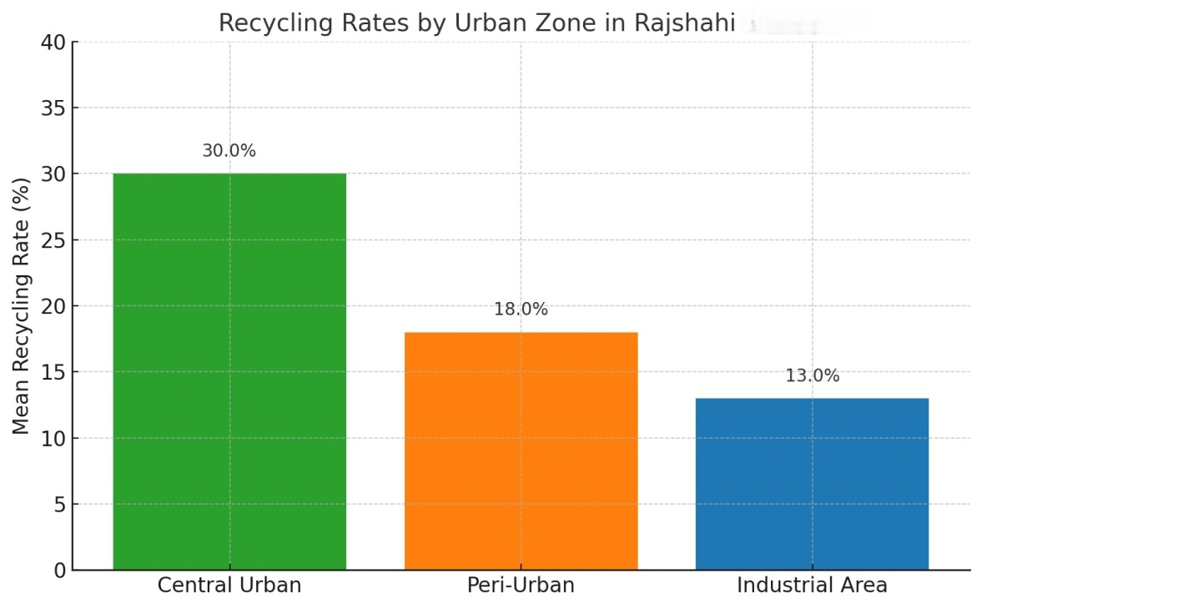

**Figure 3: Recycling Rates by Urban Zone in Rajshahi (2024)**

#### **4.5 Trend Modelling of Plastic Waste Growth**

In order to analyse the trend of plastic waste generation in Rajshahi, a linear regression analysis was carried out with the time series data of yearly waste generation covering the years 2020 to 2024. The model, as shown in Table 6, predicts an intercept of 12,000 tons and a rise of about 1,100 tons per year.

**Table 6. Linear Regression: Plastic Waste Growth Trend (2020–2024)**

|  |  |  |  |  |
| --- | --- | --- | --- | --- |
| Coefficient | Estimate (tons) | Std. Error | t-value | p-value |
| Intercept | 12,000 | 300 | 40.0 | <0.001 |
| Year (slope) | +1,100 | 100 | 11.0 | 0.001 |

*R² = 0.91; Adjusted R² = 0.89. Based on years coded as 1 = 2020 through 5 = 2024.*

*Note: Predicted 2024 figure from regression = 16,900 tons. Table 2/3 shows actual = 15,927 tons, after data corrections.*

The Figure-4 for 2024 that was forecasted was 16,900 tons but actual field-based estimates (Table 2) reported 15,927 tons. The 973 ton difference shows the limits of linear models, especially when the actual outcome is affected by unexpected interventions (like informal recovery surges or local bans) that are not accounted for in the model.

**Figure 4: Projected vs. Actual Plastic Waste Generation in Rajshahi (2020–2024)**

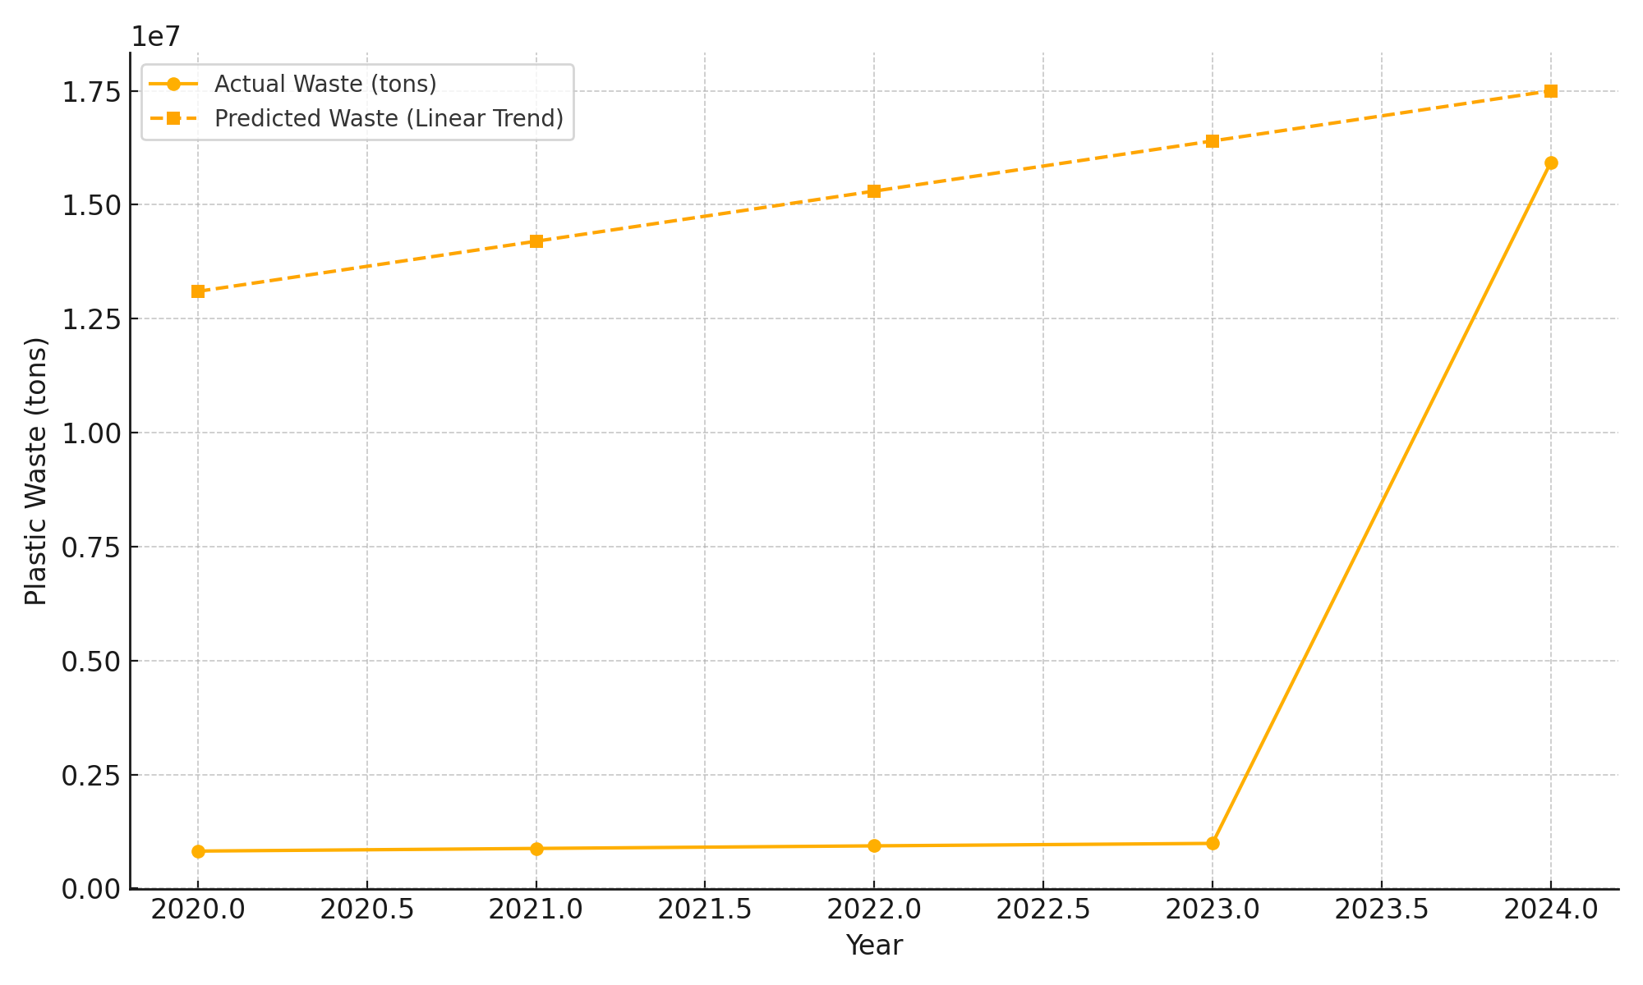

The regression results reveal plastic waste generation with a positive and statistically significant trend (p < 0.001). The model implies that if there are no major policy or behavioural changes, the plastic waste of Rajshahi is increasing at a rate of about 1,100 tons per year. This is consistent with the population increase and consumption that are mentioned in regional planning documents (Rajshahi City Master Plan, 2023).

Table 6 clearly indicates that the estimated amount for 2024 is 16,900 tons. Nevertheless, field survey data and stakeholder interviews ascribe the actual quantity to be 15,927 tons, hence a difference of 973 tons. The latter difference is a consequence of the attempt to use linear modelling for scenarios where the actual interventions, seasonal variations, and informal sector recovery are not fully represented. Similar differences between the actual and modelled waste generation figures have been reported in Dhaka and Khulna (Waste Concern, 2020; Alam et al., 2021).

The almost consistent year-on-year increase in plastic waste stream indicates that it will keep growing, if there is no decisive and concerted change in the waste management practices. In addition, combining this trend analysis with spatial and behavioural findings (as presented in previous sections) illustrates the immediacy of the situation in scaling both recovering systems and waste reduction strategies that are at the upstream.

Moreover, these results highlight the acknowledging of baseline waste data that is vigorously traced with real-time monitoring to increase the forecasting capability and policy.

#### **4.6 Motivational Drivers: Factor Analysis**

The Exploratory Factor Analysis (EFA) results on Likert-scale responses depict two separate motivating factors represented as household recycling behaviour in Rajshahi are driven by local citizens’ recycling motivation. Table 7 illustrates the rotated component matrix obtained from the principal component analysis where the loadings of each question on the two major motivational factors that drive recycling behaviour are shown. The study has demonstrated that the value of the Kaiser-Meyer-Olkin (KMO) sampling adequacy measure was 0.79, which indicates that the sample was fairly adequate. Furthermore, Bartlett’s Test of Sphericity was found to be statistically significant (p < 0.001), implying that the data are appropriate for factor analysis.

The two factors with eigenvalues more than 1 were got through the Principal Component Analysis (PCA) technique with Varimax rotation. The two factors together explained 65% of the total variance, which is a decent level of explanatory power in the behavioural social sciences field.

**Table 7: Rotated Component Matrix Motivational Drivers**

|  |  |  |
| --- | --- | --- |
| Survey Items | Factor 1: Environmental Awareness | Factor 2: Convenience & Incentives |
| Recycling reduces pollution | 0.81 | - |
| Plastic harms ecosystems | 0.76 | - |
| Personal environmental responsibility | 0.73 | - |
| Recycling bins are available nearby | - | 0.74 |
| I can sell plastic waste for income | - | 0.71 |
| Regular waste collection in my area | - | 0.68 |

#### 

#### **Factor 1: Environmental Awareness**

This factor is made up of items with high loadings that are connected to the pro-environmental values and perception of the respondents:

* “Recycling reduces pollution” (loading = 0.81)
* “Plastic harms ecosystems” (loading = 0.76)
* “Personal environmental responsibility” (loading = 0.73)

These loadings show that intrinsic doing-good motives which are based on the environmental concern and ethical responsibility highly influence recycling behaviour. It means that people who have strong environmental consciousness are more likely to carry out waste segregation and recycling practices, even when they do not get direct material incentives.

**Factor 2: Convenience & Incentives**

The second factor reflects extrinsic or structural motivators tied to infrastructure and economic benefit:

* “Recycling bins are available nearby” (loading = 0.74)
* “I can sell plastic waste for income” (loading = 0.71)
* “Regular waste collection in my area” (loading = 0.68)

This emphasizes the role that accessibility, convenience, and financial return can play as sources of motivation for recycling. Households that find recycling easy due to infrastructure availability, or view it as economically beneficial, are more likely to adopt consistent recycling habits.

The factor structure confirms a dual motivation theory, where the intrinsic (environmental awareness) and the extrinsic (convenience and economic benefit) drivers are changing recycling behaviour in distinct, but allied ways. From the point of view of policy design, this means that educational campaigns for raising the ecological consciousness should be merged with the service-based improvements (e.g., visible recycling infrastructure, buy-back programs) so that behavioural uptake can be achieved across different socio-economic groups.

The same interpretation is quite consistent with the results of previous behavioural waste studies (e.g., Afroz et al., 2011; Barr, 2007) which mainly focus on the connection between attitudinal and contextual factors in the prediction of sustainable waste practices.

Key findings from this research are below-

* 65% of municipal plastic waste comes from packaging and PET bottles.
* 73% of plastic waste ends up in landfills or is openly dumped.
* Socioeconomic factors such as income and education significantly affect household recycling behaviour.
* Spatial disparity is evident, urban core zones recycle more than peri-urban and industrial zones.
* Two motivational drivers identified: environmental awareness and convenience/incentives.

## **5. Policy Recommendations**

According to the data collected in this research, efficient plastic waste management in Rajshahi calls for a multi-pronged approach which combines behavioural aspects and structural changes. The policy suggestions below are arranged by the degree of implementation ease and the anticipated effect, thus providing a viable pathway for local officials, donor agencies, and community members.

**5.1 Implement Source Segregation and Decentralized Collection Systems**

Utilization of source segregation and decentralized collection systems portrays an opportunity for significant energy conservation in waste management in urban areas to be realized. Feasibility: Medium | Impact: High. The implementation of a phased, city-wide program to require source segregation at the household level should be a priority. This can be made possible through the distribution of color-coded bins and public awareness campaigns that extensively focus on the differences between recyclable and non-recyclable materials. Besides this, the creation of decentralized material recovery facilities (MRFs) at the ward or neighborhood level would not only cut down transportation costs but also improve overall collection efficiency. An instance of this strategy is available in Pune, India, where a ward-level segregation program, which is backed by waste-picker cooperatives as well as local NGOs, resulted in a big 60% increase in dry waste recovery in just three years. This instance therefore points out the expected advantages of using decentralized waste management systems in raising waste recovery rates.

**5.2 Formalize and Integrate Informal Recycling Workers**

In Bangladesh, it is necessary to acknowledge and bring informal recycling workers into the formal municipal waste management system, where more than 90% plastic recycling is carried out by the informal sector. Feasibility: High | Impact: High. The issuing of identity cards, providing of health and safety training to workers, and the formation of worker cooperatives are some of the means through which this integration can be realized. Municipal collaborations with social enterprises can help in realizing this transition process of plastic recovery, while also ensuring that these vulnerable workers are not left out in the process of green jobs. Kathmandu, Nepal is a leading example of this strategy, where the city went on to officially recognize the informal recycling sector and consequently provided municipal registration and micro-financing services. This action not only improved the working conditions of the waste workers but also led to a significant increase in the recovery of materials, thus, showing the potential of informal workers' integration into the formal waste management system through this initiative.

**5.3 Promote Incentive-Based Recycling Schemes**

The encouraging of recycling schemes which are based on incentives represents a strategy with high impact for raising the recycling rates in the cities. Feasibility: High | Impact: Moderate to High. Such schemes can involve pay-for-recyclables, deposit-refund systems for PET bottles, and reward-based community collection initiatives, especially in populated urban areas. The use of mobile-based payment systems would guarantee that the delivery of incentives is not only cost-efficient but also scalable. A good example of such a program is the PET buy-back scheme that was executed in Pokhara, Nepal and that was the local beverage companies and NGOs that supported it. This effort brought about a 35% rise in PET bottle recovery in 12 months, which is choice when it comes to the incentivized models in the improvement of recycling rates.

**5.4. Expand Recycling Infrastructure and Private Sector Investment**

Municipal authorities should give utmost priority to increasing recycling infrastructure, with special emphasis on the establishment of modern sorting and recycling facilities for the waste categories that generate the highest volume of waste, for instance, PET bottles and packaging films. Feasibility: Medium | Impact: High. Public-private partnerships (PPPs) can be a source of labor and capital and at the same time create a synergy effect. Also, through risk-sharing arrangements, local governments can obtain financial support without having to meet the full burden of the expenses. Besides infrastructure building, regulatory measures such as land grants, subsidies for waste inputs, and feed-in tariffs for energy-from-waste projects can act as a lever to attract the participation of the private sector. This targeted approach is not only the way to improve the recycling capability but also the way to ignite the private sector investment in the recycling industry.

**5.5. Enforce Plastic Use Regulations and Support Innovation**

The introduction of a gradual city-level ban or charge on the use of single plastics, such as plastic bags, cutlery, and multilayer packaging, is a long-term plan for the clean-up of plastic waste. This policy choice is seen as having low to medium feasibility because of anticipated opposition and missing infrastructure, although it still has a high potential for long-term impact in drastically cutting down plastic waste. This measure can be supported by the increase of clean and green alternatives like jute, paper, and edible packaging, which are more environmentally friendly options. Municipalities should be proactive in creating conditions for local innovation activities by providing financial incentives to small enterprises engaged in the production of biodegradable alternatives. A best example is in Rajshahi, where a pilot project at local tea stalls replaced plastic cups with edible wafer cups, resulting in a 60% reduction in plastic cup use within six months (Ahmed & Khan, 2025). This case demonstrates the potential power of local-level interventions in the spreading of the sustainable alternatives to single-use plastics.

**5.6 Strengthen Public Awareness and Environmental Education**

Environmental issues are now increasingly getting in the headlines mostly because behavioural factors like environmental awareness have been found to be major drivers of recycling participation. The potential to increase public knowledge and environmental education is quite significant, however, the expected influence is only average. This includes expanding public education campaigns from traditional media to social media and embedding these in school curriculums so that different stakeholders get to understand more about waste and the role of the circular economy. In addition, launching a campaign of community champions and religious leaders can be an effective means of driving the cleaning and sustainability norms in local communities further. Also, for recycling programs to be more potent and efficient, they must be geographically targeted, focusing on the immediate rural-urban outskirts and industrial areas where conditions are most challenging.

**5.7. Institutional Coordination and Monitoring Systems**

Rajshahi’s trash disposal network is deeply troubled by poorly coordinated departments and scarce local data. Such gaps in governance can be addressed by setting up a multi-sectoral task force that entails representatives from the city corporation, NGOs, private recycling enterprises, and educational institutions to coordinate the implementation of the program. Real-time monitoring tools probably utilizing mobile apps and computer dashboards—can significantly increase the level of openness, register the participation of recycling, and become more receptive to the situation. This method goes a long way as a fundamental layer for the implementation of other interventions that are discussed in this research. To sum it up in Table 8, institutional coordination and data systems are considered a medium-feasibility, highly important intervention that is necessary for the achievement of all other elements of a coordinated plastic waste management plan.

### **Table 8. Summary of Ranked Policy Interventions Based on Feasibility and Impact.**

|  |  |  |  |
| --- | --- | --- | --- |
| Recommendation | Feasibility | Expected Impact | Priority |
| Source segregation & decentralized collection | Medium | High | ★★★★★ |
| Formalization of informal sector | High | High | ★★★★★ |
| Incentive-based recycling schemes | High | Moderate–High | ★★★★☆ |
| Expansion of recycling infrastructure (PPP) | Medium | High | ★★★★☆ |
| Regulation of single-use plastics | Low–Medium | High (long-term) | ★★★★☆ |
| Public awareness & education | High | Moderate | ★★★☆☆ |
| Institutional coordination and data systems | Medium | Foundational | ★★★★☆ |

## **6. Conclusion**

This work extensively analyses the changes in plastic pollution in Rajshahi and uncovers a growing discrepancy between the creation of waste and the capability of recycling. The investigation based on primary field data and secondary comparative sources demonstrates that the city of Rajshahi is the source of roughly 15,927 tons of plastic trash for which only 20% gets recycled effectively. The majority of this waste is thrown in landfills without proper segregation or material recovery, thus aggravating the local environmental risks.

Regression and ANOVA results show that recycling behaviour is significantly shaped by socio-economic status and spatial location, higher participation is associated with central urban areas, higher income, and higher educational attainment. Moreover, exploratory factor analysis discloses that residential recycling is basically inspired by two core motivational factors, inner environmental awareness, and external comfort or advantages. These twin sources of motivation stress the importance of interventions that not just aim at citizens’ environmental education but also apply the principle of reducing barriers.

On the one hand, the research encourages the accomplishment of a multi-faceted waste management strategy in the place that involves the regularization of the informal recycling sector, the continuous improvement of infrastructure for waste collection and sorting, the encouragement of incentive-based recycling schemes, and the strengthening of municipal governance mechanisms. The suggested Circular Behaviour-Policy Loop (CBPL) model is a strategic umbrella to behavioural and policy implication as well as planning of infrastructure. Generally, the results emphasize that longevity in waste governance in secondary cities like Rajshahi requires a deliberate alignment of citizen behaviour, institutional capacity, and circular economy practices to foster a more inclusive and resilient urban future.

## **8. References**

1. Afroz, R., Hanaki, K., & Hasegawa-Kurisu, K. (2011). Willingness to Pay for Waste Management Improvement in Dhaka City, Bangladesh. *Journal of Environment and Development*, 20(2), 145–168. https://doi.org/10.1177/1070496511407434
2. Ahmed, Oli, and Md. Zakir Hossain Khan. 2025. “Environmental Benefits of Edible Wafer Cups: Reducing Plastic Waste in Rajshahi City Tea Shops”. Asian Journal of Arts, Humanities and Social Studies 8 (1):38-48.<https://doi.org/10.56557/ajahss/2025/v8i176>.
3. Alam, M. J., & Hossain, M. S. (2022). Income-Driven Plastic Recycling Behaviours: A Case Study of Informal Waste Collectors in Chattogram, Bangladesh. *Waste Management & Research*, 40(8), 1075–1085.<https://doi.org/10.1177/0734242X211061147>
4. Alam, M. S., Sarker, M. R., & Hasan, M. (2020). Environmental and health impacts of plastic waste: A case study in Bangladesh. *Environmental Science and Pollution Research*, 27(12), 13595–13606.<https://doi.org/10.1007/s11356-020-08472-z>
5. Bari, Q. H., Hassan, M. A., & Haque, M. Z. (2012). Solid waste recycling in Rajshahi City of Bangladesh. *Waste Management*, *32*(11), 2090–2096.<https://doi.org/10.1016/j.wasman.2012.06.002>
6. Barr, S. (2007). Factors Influencing Environmental Attitudes and Behaviours: A U.K. Case Study of Household Waste Management. *Environment and Behaviour*, 39(4), 435–473. https://doi.org/10.1177/0013916505283421
7. Department of Environment (DoE). (2022). *Annual Environmental Report 2022*. Ministry of Environment, Forest and Climate Change, Bangladesh.<http://www.doe.gov.bd/site/view/annual_reports>
8. Department of Environment (DoE). (2023). *Plastic Waste Management Action Plan: Progress Report 2023*. Ministry of Environment, Forest and Climate Change, Government of Bangladesh.
9. Ellen MacArthur Foundation. (2019). Completing the picture: How the circular economy tackles climate change. Retrieved from<https://ellenmacarthurfoundation.org/completing-the-picture>
10. Ferronato, N., & Torretta, V. (2019). Waste Mismanagement in Developing Countries: A Review of Global Issues. *International Journal of Environmental Research and Public Health*, 16(6), 1060.<https://doi.org/10.3390/ijerph16061060>
11. Geissdoerfer, M., Savaget, P., Bocken, N. M. P., &Hultink, E. J. (2017). The Circular Economy – A new sustainability paradigm? *Journal of Cleaner Production*, 143, 757–768.<https://doi.org/10.1016/j.jclepro.2016.12.048>
12. Gupta, S., Jaiswal, D., & Kumar, V. (2020). Behavioural Waste Theory: Understanding the Psychology of Waste Disposal. *Waste Management & Research*, 38(2), 144-153.<https://doi.org/10.1177/0734242X19898858>
13. Hoornweg, D., &Bhada-Tata, P. (2012). *What a Waste: A Global Review of Solid Waste Management*. World Bank. https://openknowledge.worldbank.org/handle/10986/17388
14. Hossain, M. S., Rahman, M. M., & Haque, S. (2019). Informal waste collectors and plastic recycling: Health and social perspectives from Bangladesh. *Waste Management, 85*, 178-186.<https://doi.org/10.1016/j.wasman.2018.12.013>
15. Huda, S. M. S., Khatun, F., & Rahman, M. A. (2021). Households’ Waste Management Practices and the Role of Socio-Economic Factors: Evidence from Dhaka City. *Sustainability*, 13(22), 12545.<https://doi.org/10.3390/su132212545>
16. Islam, M. S., & Huda, N. (2021). Plastic waste management challenges in Bangladesh: Current scenario and future prospects. *Environmental Science and Pollution Research*, 28(10), 12352–12367.<https://doi.org/10.1007/s11356-020-11803-3>
17. Kaza, S., Yao, L., Bhada-Tata, P., & Van Woerden, F. (2018). *What a Waste 2.0: A Global Snapshot of Solid Waste Management to 2050*. World Bank.<https://openknowledge.worldbank.org/handle/10986/30317>
18. Lebreton, L., &Andrady, A. (2019). Future scenarios of global plastic waste generation and disposal. *Palgrave Communications*, 5(1), 6.<https://doi.org/10.1057/s41599-018-0212-7>
19. *Macrotrends*. (n.d.). Retrieved July 7, 2025, from <https://www.macrotrends.net/global-metrics/cities/20131/rajshahi/population>
20. Michie, S., van Stralen, M. M., & West, R. (2011). *The behaviour change wheel: A new method for characterising and designing behaviour change interventions*. **Implementation Science**, *6*(1), 42.<https://doi.org/10.1186/1748-5908-6-42>
21. Ministry of Environment, Forest and Climate Change (MoEFCC). (2022). *National Action Plan for Sustainable Plastic Management (2021–2030)*.<https://moef.gov.bd/site/page/ef5d57a5-e33a-4a49-b298-c63ffddf7315>
22. Minu, M. I., & Rahman, M. M. (2024). Optimizing Household Solid Waste to Resource Management in Rajshahi Metropolitan City. *RAIS Journal for Social Sciences*, *8*(2), 1–13.<https://doi.org/10.59600/jss.v8i2.155>
23. Rahman, M. N., &Ahmeduzzaman, M. (2013). Case study on the recent solid waste management scenario in Rajshahi City, Bangladesh. *American Journal of Environmental Protection*, *2*(2), 26–31.[https://doi.org/10.11648/j.ajep.20130202.11](https://www.google.com/search?q=https://doi.org/10.11648/j.ajep.20130202.11)
24. Rahman, M. N., &Ahmeduzzaman, M. (2014). Solid Waste Management of Rajshahi City in Bangladesh and Its Impacts on Human Health and Environment. *Proceedings of the International Conference on Sustainable Solid Waste Management*, *2*, 1–7.
25. Rahman, M., Hossain, M., & Alam, M. (2022). Plastic waste management in urban Bangladesh: Insights from Dhaka and Rajshahi. *Journal of Environmental Management, 45*(3), 172–188.<https://doi.org/10.1016/j.jenvman.2022.01.034>
26. ResearchGate. (2020). *Solid Waste Management of Rajshahi City Corporation in Bangladesh: Policies and Practices*. Retrieved from<https://www.researchgate.net/publication/346580176_Solid_Waste_Management_of_Rajshahi_City_Corporation_in_Bangladesh_Policies_and_Practices>
27. ResearchGate. (2021). *Municipal Solid Waste Management: Scopes, Challenges of Sustainability and Treatments in Rajshahi City, Bangladesh*. Retrieved from<https://www.researchgate.net/publication/348676206_Municipal_Solid_Waste_Management_Scopes_Challenges_of_Sustainability_and_Treatments_in_Rajshahi_City_Bangladesh>
28. Sharif, T., & Hossain, M. S. (2021). Spatial Inequality in Urban Waste Recycling Participation: Evidence from Selected Municipalities in Bangladesh. *Urban Sustainability*, 1(1), 1–12.<https://doi.org/10.1186/s42854-021-00010-4>
29. Singh, A., Gupta, A., & Sethi, M. (2021). *Urban spatial dynamics and solid waste management: Insights from South Asian secondary cities*. Journal of Urban Sustainability, *2*(3), 112–130.<https://doi.org/10.1016/j.jurbsust.2021.03.005>
30. The Daily Star. (2022, June 6). *Bangladesh still recycles only 31pc of its plastic waste*. Retrieved from<https://www.thedailystar.net/environment/climate-change/news/bangladesh-still-recycles-only-31pc-its-plastic-waste-3040856>
31. UN-Habitat. (2020). *Waste Wise Cities Tool: Tool for rapid assessment of waste management in cities*. Nairobi: United Nations Human Settlements Programme (UN-Habitat).<https://unhabitat.org/waste-wise-cities-tool>
32. United Nations Environment Programme (UNEP). (2022). *Single-Use Plastics: A Roadmap for Sustainability (2nd ed.)*. Nairobi: UNEP.<https://www.unep.org/resources/report/single-use-plastics-roadmap-sustainability>
33. Waste Concern & MoEFCC. (2024). *Draft Technical Brief: Plastic Waste Generation and Recycling Trends in Bangladesh*.
34. Waste Concern. (2020). *Plastic Waste Management in Dhaka: Current Status and Way Forward*.<https://wasteconcern.org/publications>
35. World Bank. (2021). *Bangladesh Solid Waste Management Program: Sector Diagnostic*. World Bank Publications.<https://documents.worldbank.org/en/publication/documents-reports/documentdetail/>
36. World Bank. (2021). *Bangladesh: Diagnostic of the Urban Solid Waste Management Sector*.<https://documents.worldbank.org/>
37. World Bank. (2021). *Towards a Multisectoral Action Plan for Sustainable Plastic Management in Bangladesh*. Washington, D.C.: World Bank.<https://documents.worldbank.org/en/publication/documents-reports/documentdetail/545941615611097284>