Screening of Plant Species for Revegetation of Nutrient-Depleted Mine Spoils

Abstract
Mine spoils are characterized by poor nutrient content and limited microbial activity, posing significant challenges for revegetation. Initial analysis of mine spoil samples from the experimental site revealed low organic carbon (0.12%), available nitrogen (82 kg/ha), and sparse microbial populations. To identify plant species suitable for rehabilitation of such degraded lands, three pot culture experiments were conducted at the Horticultural Research Station, Yercaud. A total of 5 grass species, 7 creepers, 39 medicinal plants, and 21 tree species were screened using 4 kg of mine spoil per pot, replicated four times. Biometric parameters such as shoot and root lengths were recorded. Among grasses and creepers, Cynodon dactylon, Vetiveria zizanioides, and Ipomoea sp. performed well. Medicinal plants like Adathoda vasica, Ocimum sp., and Gloriosa superba exhibited promising growth. Tree species including Acacia nilotica, Eucalyptus tereticornis, and Casuarina equisetifolia showed good adaptability. These findings provide potential candidates for mine spoil revegetation and ecological restoration.
Keywords: Mine spoil, Revegetation,Plant screening, Soil restoration, Biometric analysis
Introduction
Magnesite mine spoil deposits are located at the foot of the famous Yercaud hills and spread over an area of more than 600 acres. Recovery of Magnesite from blasted earth is about one in fourteen and the remaining reject material is back filled in the mined out area which contain no nutrients and microbes. The extensively mined land usually doesn’t possess sufficient surface soil to anchor plants, and the plant growth is inhibited by the presence of toxic metals. The process of natural succession on surface-mined soils is slow due to the removal of topsoil, resulting in elimination of soil seed bank and root stocks due to soil profile disturbances. An important goal of ecological rehabilitation is to accelerate natural successional processes so as to increase biological productivity, reduce rates of soil erosion, increase soil fertility, and increase biotic control over biogeochemical fluxes within the recovering ecosystems. Mining activities often damage the land and leave behind mine spoils. These spoils have very low nutrients, less organic matter, and fewer helpful microbes. Because of this, plants do not grow easily in such soils. To restore these lands, we need to plant species that can survive in poor and hard conditions. Revegetation helps in controlling soil erosion, improving soil health, and bringing back the natural environment. For this, it is important to select the right plant species that can grow well in mine spoils. Grasses, creepers, medicinal plants, and trees with strong roots and tolerance to stress are useful for this purpose.This study was carried out to find out which plant species can grow better in mine spoils. Pot culture experiments were done at the Horticultural Research Station, Yercaud. Different grasses, medicinal plants, and tree species were tested to identify the best plants for mine spoil revegetation.
Materials and Methods:
i)Composition of mine spoil
Initial mine spoil sample were collected from the experimental site as per the standard procedure and analysed for various physico-chemical properties.The nutrient status of mine spoil was characterized by a poor Organic content of 0.12 % and low available Nitrogen content of 82 kg/ha. Microbial population of mine spoil was very poor. The bacterial population was 12x 10⁵ CFU g⁻¹ dry spoil, fungi was 8x103³ CFU g⁻¹ dry spoil and actinomycetes was 2x10² CFU g⁻¹ dry spoil.
ii)Pot culture experiments:
Three pot culture experiments were carried out at Horticultural Research Station, Yercaud. The study was mainly done to screen different species of grasses, tolerable medicinal plants and trees grown in mine spoils in order to identify the best suited plant species for mine spoil revegetation. In general, the screening included grasses, medicinal plants and trees of different families which were compared and selected purely based on their ability to tolerate harsh environment and not on any genetic characteristics. A total of 4 kgs of mine spoils were filled up in each pot and the following plants were grown with four replications.
i) Screening of grass species and creepers for mine spoil revegetation
Nearly 5 grasses and 7 creepers were evaluated to choose the best species suitable for the mine spoils
ii) Screening of Medicinal plants for mine spoil revegetation
Nearly 39 medicinal plants were evaluated to choose the best species suitable for the mine spoils
iii) Screening of tree species for mine spoil revegetation
About 21 tree species were evaluated to choose the best species suitable for the mine spoils
I )Biometric characters recorded:
a) Shoot length: The length was measured from the root collar region to the tip of the stem and the mean length was expressed in centimeters.
b) Root length: The root length was measured from the root collar region to the tip of the tap root and the mean length was expressed in centimeters.
Evaluation of potting mixture
Different amendments in different proportions were tried as potting mixture with following treatments to find out the best potting mixture for better growth of plants.
- T₁- Mine spoil alone (100%),
- T₂ - Mine spoil + Top soil + Sand + FYM (1:1:1:1),
- T₃ – Mine spoil + Top Soil + Sand (1:1:1) + Vermi compost (100g/plant),
- T₄ – Mine spoil + Top soil + sand (1:1:1) + Azospirillum (100gms/plant),
- T₅ – Mine spoil + Top soil + sand (1:1:1) + Phosphobacteria (100 gm/plant),
- T₆ -Mine spoil + top soil + sand (1:1:1) + VAM (100 gms/plant) and
- T₇ – Top soil + Sand + FYM(2:1:1)
Of the 7 treatments, plants grown on the following treatments performed well when compared to other treatments.The best treatments were (1)Mine spoil + Top soil + sand (1:1:1 ratio) + 100 gmsVermicompost / plant and (2) Mine spoil + Top soil + Sand (1:1:1 ratio) + VAM 100 gms / plant (Table 3.). For standardizing the potting mixture, addition of vermicomposts and VAM along with other amendments showed better results. Compost can be applied to any amount to each plant, this in turn reduces the amount of fertilizer application and helps in increase in beneficial microbial populations. The appropriate grass, medicinal plants and tree species screened can be used successfully for rehabilitation and revegetation of degraded mine spoil ecosystems.

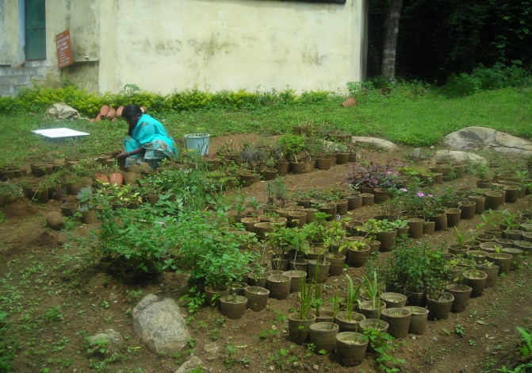  Fig .1 Pot culture experiment with medicinal plants | 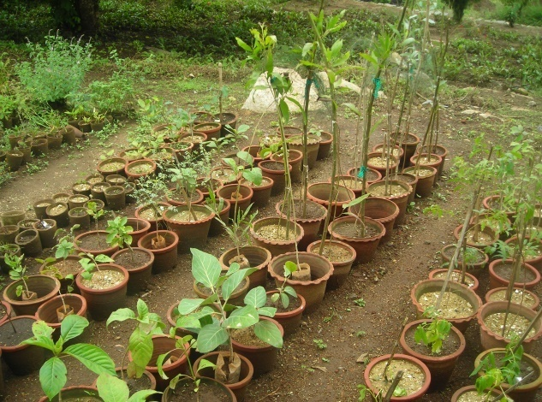  Fig .2 Pot culture experiment with tree species

Results and Discussion
- Medicinal Plants:

The study assessed root length and the number of secondary and tertiary roots of 39 medicinal plant species grown in mine spoil conditions to evaluate their suitability for revegetation. Root development is a critical factor in plant establishment, particularly in nutrient-poor and structurally degraded soils like mine spoils. Plants with longer roots and more lateral branching tend to have better anchorage, nutrient absorption, and drought resistance.
Among the tested species, Pepino recorded the highest root length of 45.5 cm, followed closely by Adathoda vasica (43.3 cm), Solanum nigrum (43.0 cm), Jatropha curcas (41.8 cm), and Polygala sp. (41.5 cm), indicating strong vertical root penetration. In contrast, Cissus quadrangularis had the shortest root length (6.5 cm), making it less ideal for mine spoil stabilization. This review highlights the importance of root development for plant establishment in mine spoils. It explains that plants with longer and more branched roots have better anchorage, nutrient absorption, and drought resistance—traits essential for survival and growth in nutrient-poor, structurally degraded soils Wong, M. H. (2003).
Regarding the total number of secondary and tertiary roots, Adathoda vasica (184.0) and Ocimum sanctum (137.3) showed the highest lateral root proliferation, suggesting a strong capacity for nutrient uptake and soil binding. Ruta graveolens also showed a high number of lateral roots (114.3), further highlighting its potential in soil stabilization despite having only moderate root length (25.0 cm).
Species like Gloriosa superba, Mentha arvensis, Plantago major, and Velarina demonstrated a good balance between root length and branching, making them suitable candidates for mine spoil revegetation. On the other hand, plants such as Marjorana hortensis and Coleus aromaticus had both short roots and fewer secondary/tertiary roots, indicating poor adaptability to mine spoil environments. Another study supports these findings that species like Gloriosa superba and Plantago major, which exhibit both traits, are suitable candidates for mine spoil rehabilitation (Martínez-Ruiz, C., & Fernández-Santos, B., 2005).
Overall, species with deeper and well-branched roots—such as Adathodavasica, Ocimum sanctum, Polygala sp., Solanum nigrum, and Jatropha curcas—performed well under harsh conditions and can be considered as potential candidates for mine spoil rehabilitation. Another study supports that species with high numbers of secondary and tertiary roots, such as Adhatoda vasica and Ocimum sanctum, have enhanced soil-binding capacity, which is vital for erosion control and long-term ecosystem recovery on mine spoils (Tripathi, N., Singh, R. S., & Hills, C. D., 2016). Root length and lateral root proliferation contribute to soil stabilization and nutrient cycling in mine spoils and species with deep and highly branched root systems (e.g.,Adhatoda vasica, Ocimum sanctum) are more effective in stabilizing degraded soils ( Sheoran, V. et al., 2010). Plant species with longer roots and greater lateral branching are better adapted to the harsh, nutrient-deficient conditions of mine spoils and species like Solanum nigrum and Jatropha curcas, with extensive root systems, perform well in such environments (Kumar, A., & Singh, J. S., 1980).

Table 1. Observations on the rooting behaviour of medicinal grown in mine spoils

S.No. | Species | Root length | Total no.of secondary and tertiary roots
1 | Acorus calamus | 31.25 | 7.3
2 | Adathoda vasica | 43.3 | 184.0
3 | Agave sisalana | 20.0 | 8.0
4 | Agchelia sp | 33.0 | 30.8
5 | Allium sp | 19.0 | 13.0
6 | Alternanthera sessilis | 31.25 | 7.3
7 | Amaranthus sp | 39.3 | 13.3
8 | Arrow root | 34.5 | 30.3
9 | Artemesia absinthium | 30.8 | 18.3
10 | Ashwaganthi sp | 41.0 | 62.8
11 | Centalla asiatica | 32.6 | 25.5
12 | Cissus quadrangularis | 6.5 | 22.8
13 | Coix lachrymal | 32.25 | 34.8
14 | Coleus aromaticus | 16.8 | 9.0
15 | Coleus forskholi | 28.8 | 32.0
16 | Coleus sp | 34.0 | 26.0
17 | Gloriosa superba | 38.0 | 13.3
18 | Lavendulla officianolis | 24.5 | 11.4
19 | Marjorana hortensis | 12.0 | 5.0
20 | Mentha arvensis | 34.5 | 29.0
21 | Ocimum sanctum | 23.5 | 137.3*
22 | Origanum sp | 33.0 | 13.0
23 | Origanum valgare | 25.5 | 11.7
24 | Orthosiphan stamineus | 35.3 | 7.8
25 | Pandanus sp | 30.1 | 12.3
26 | Pellrgonium graveolens | 24.0 | 14.0
27 | Pepino sp | 45.5 | 23.5
28 | Plantago major | 34.5 | 31.3
29 | Pogostemon patchouli | 26.1 | 26.0
30 | Polygala sp | 41.5 | 29.7
31 | Rosemarinus officianolis | 23.1 | 22.9
32 | Ruta graveolens | 25.0 | 114.3*
33 | Solanum nigrum | 43.0 | 26.5
34 | Sombu | 26.5 | 14.0
35 | Souropita androgynensis | 22.0 | 10.0
36 | Stevia ribaudiana | 29.0 | 15.0
37 | Tinospora cardifolia | 24.3 | 15.1
38 | Velarina sp | 35.0 | 37.0
39 | Jatropha curcas | 41.8 | 22.5

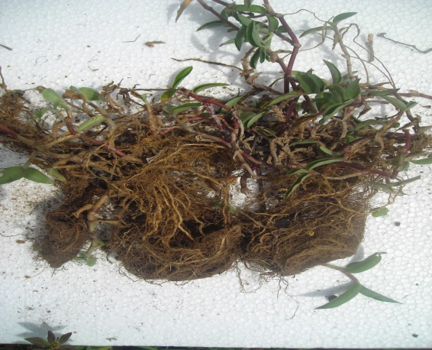  Fig .3Cana sp grown in mine spoil | 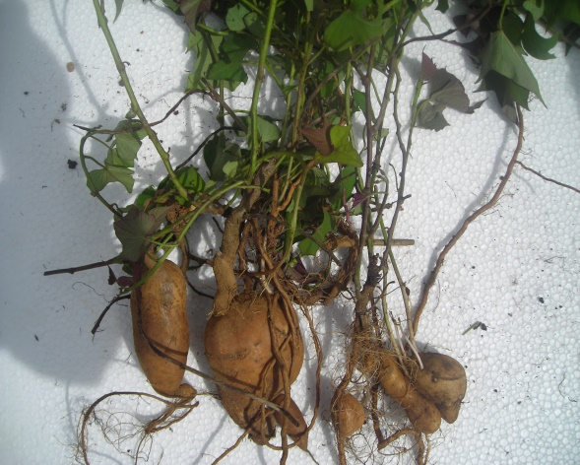  Fig .4 Ipomea sp grown in mine spoil

- Grasses and Creepers:
Root development in grasses and creepers plays a vital role in the success of mine spoil revegetation, as well-established root systems improve soil stability, nutrient uptake, and drought tolerance. This study assessed root length and the number of secondary and tertiary roots to identify suitable species for restoring degraded mine spoils.
Among the evaluated species, Ipomea sp. (Pal Kodi) recorded the highest root length (75.6 cm), showing excellent vertical root growth. This deep root system can help anchor the plant firmly in loose, degraded soils. Similarly, Vettivera zizonoides exhibited a root length of 63.25 cm along with the highest number of secondary and tertiary roots (84.3), indicating exceptional root branching. These characteristics make it an ideal candidate for erosion control and long-term soil stabilization.
Cyandon dactylon and Cymbopogon flexuosus also showed considerable root lengths (43.5 cm and 40.25 cm, respectively) with moderate lateral root development, suggesting good adaptability to mine spoil conditions. Cenchrus sp. stood out for its extensive lateral rooting (41.3), even though its vertical root length was moderate (26.8 cm). This extensive fibrous root system can effectively bind the upper soil layers. Organic amendments and selection of species with extensive root systems are crucial for long-term soil improvement and stabilization on mine spoils (Bendfeldt, E.S., Burger J.A., & Daniels W.L., 2001).
On the other hand, species such as Caladium sp. (15.0 cm), Ipomea sp. (16.7 cm), and Pyrostegia sp. (10.4 cm) exhibited relatively short roots and fewer secondary branches, indicating limited suitability for harsh spoil conditions. While Tylophora asthmatica and Rosa sp. had moderate rooting parameters, their performance was less impressive compared to stronger rooting species. Robust root systems in grasses and creepers enhance plant establishment and soil recovery in challenging mine spoil Conditions (Souza E.D. et al., 2021).
In conclusion, Vettivera zizonoides, Ipomea sp. (Pal Kodi), Cynodon dactylon, and Cymbopogon flexuosus demonstrated superior rooting characteristics and are promising candidates for effective revegetation of mine spoils due to their strong rooting systems and adaptability. Singh & Singh (2006) demonstrates the effectiveness of grasses and creepers with strong root systems in improving soil structure and accelerating mine spoil recovery.

Table 2.Observations on the rooting of grasses and creepers grown in mine spoils

S.No. | Species | Root length | Total no.of secondary and tertiary roots
1 | Cyanodon dactylon | 43.5 | 23.5
2 | Caladium sp | 15.0 | 8.0
3 | Canasp | 33.1 | 19.8
4 | Cenchrus sp | 26.8 | 41.3
5 | Cyanodan sp | 36.0 | 28.0
6 | Cymbapogan flexuosus | 40.25 | 20.0
7 | Ipomea sp | 16.7 | 11.5
8 | Ipomea sp.(Pal Kodi) | 75.6 | 37.0
9 | Pyrostegia sp. | 10.4 | 11.0
10 | Rosasp (wild type) | 21.0 | 12.0
11 | Tylophora asthmatica | 24.3 | 15.1
12 | Vettivera zizonoides | 63.25 | 84.3

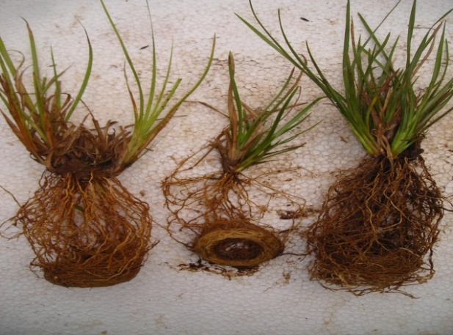  Fig .5 Vettiver sp grown in mine spoil | 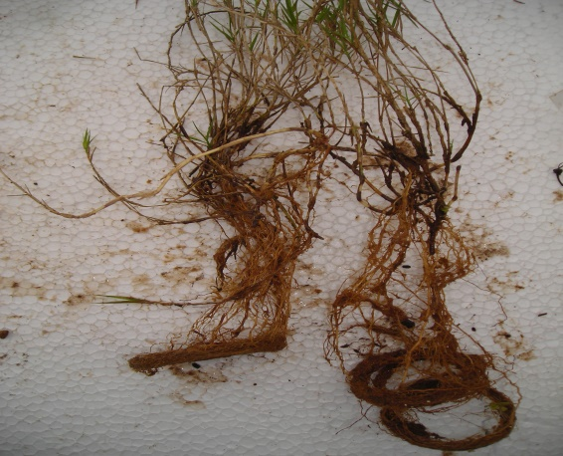  Fig .6 Cynodan sp in mine spoil

- Trees:
The successful establishment of trees on degraded mine spoils largely depends on their rooting ability, which determines their capacity to access water, absorb nutrients, and stabilize the soil. This study analyzed the root length and the number of secondary and tertiary roots of 21 tree species to identify the most suitable candidates for revegetation.
Among the evaluated species, Derris indica showed the most promising rooting traits, with the longest root length (74.0 cm) and a high number of secondary and tertiary roots (54.0), indicating a strong capacity for deep soil penetration and lateral spread. Casuarina equisetifolia also demonstrated excellent rooting with a root length of 64.0 cm and 48.5 lateral roots, suggesting high adaptability to nutrient-poor spoil soils. Eucalyptus tereticornis, Acacia auriculiformis, Acacia nilotica, and Hardwickia binnata exhibited long roots (ranging from 60.0 to 63.5 cm) with moderate lateral rooting, showing good potential for deeper anchorage and moisture acquisition. Wrightia tinctoria and Acacia holosercia also performed well in terms of both root depth and branching.
On the other hand, species like Aegle marmelos, Ailanthus excelsa, and Delonix regia showed relatively short root lengths (12.0–19.0 cm) and lower lateral root development, suggesting weaker performance in poor spoil environments. These species may require soil amendments or supportive conditions for successful establishment. Pietrzykowski, (2019) discusses the consequences of mining on soil and the importance of selecting tree species with strong rooting abilities for successful reclamation and long-term ecosystem recovery.
Interestingly, Ficus religiosa and Ficus benghalensis showed moderate root lengths (22.8–39.3 cm) but higher lateral root numbers (up to 39.5), indicating good surface soil binding potential, which could be useful for erosion-prone areas.
Tree species such as Derris indica, Casuarina equisetifolia, Eucalyptus tereticornis, and Acacia auriculiformis emerged as highly suitable for mine spoil revegetation due to their robust root systems. These species can be prioritized in ecological restoration efforts to improve vegetation cover and soil health in degraded mine lands. Dutta & Agrawal (2003) quantifies growth characteristics, biomass accumulation, and net primary production of tree species on coal mine spoils, identifying species such as Eucalyptus camaldulensis and Pongamia pinnata as highly suitable for restoration due to their robust growth and root development Souza et al. (2021) highlights the critical role of root development in plant establishment on mine spoils and identifies N-fixing legumes as among the best performers for rooting and establishment in challenging substrates.

Table 3.Observations on the rooting of tree species grown in mine spoils

S.No. | Species | Root length | Total no.of secondary and tertiary roots
1 | Acacia holosercia | 52.5 | 29.0
2 | Acacia nilotica | 60.0 | 20.0
3 | Acacia auriculiformis | 63.5 | 18.4
4 | Aeglemarmelos | 12.0 | 19.0
5 | Ailanthus excelsa | 17.0 | 21.0
6 | Azardirachtaindica | 29.0 | 28.3
7 | Cassia siamea | 29.0 | 19.0
8 | Casuarinaequisetifolia | 64.0 | 48.5
9 | Delonixregia | 19.0 | 13.0
10 | Derris indica | 74.0 | 54.0
11 | Eucalyptus tereticornis | 62.5 | 46.5
12 | Feroniaelephantum | 48.0 | 20.0
13 | Ficusbenghalensis | 22.8 | 25.5
14 | Ficusreligiosa | 39.3 | 39.5
15 | Hardwickiabinnata | 63.5 | 23.0
16 | Leuceanaleucocephala | 46.2 | 28.0
17 | Pterocarpusmarsupium | 30.5 | 19.5
18 | Tecomaundulans | 30.0 | 21.0
19 | Tectonagrandis | 43.0 | 26.5
20 | Terminaliachebula | 37.0 | 21.5
21 | Wrightiatinctoria | 56.2 | 22.5

Evalaution of different potting mixtures:

The growth performance of twelve tree species was evaluated under seven different potting mixtures (T1–T7) to identify the most effective combination for enhancing seedling development in mine spoil conditions. Key parameters observed included plant height, root length, plant biomass, root biomass, and total biomass.
Among all treatments, T6 generally resulted in superior growth for most species, with the highest total biomass recorded in Leuceanaleucocephala (18.45 g), Eucalyptus tereticornis (18.45 g), and Casuarinaequisetifolia (21.24 g). This suggests that the T6 potting mixture provided optimal nutrient availability, moisture retention, and aeration. T5 also performed well for several species, including Azadirachtaindica, Acacia nilotica, and Hardwickiabinnata, all of which recorded higher root lengths (up to 87.0 cm in Acacia nilotica) and increased total biomass. Another study shows that the addition of organic amendments (such as coco peat and peat moss) to mine spoil significantly improves soil quality and enhances plant germination, root length, and total biomass. Maun, M.A., et al., 2015. On the other hand, T3 and T7, while showing excellent root development in some species (e.g., Eucalyptus tereticornis with 100 cm in T3 and Casuarina equisetifolia with 83 cm in T7), did not always correspond with higher above-ground biomass. This could be due to imbalanced nutrient distribution, causing root proliferation at the expense of shoot growth.

Species-wise Observations
Casuarina equisetifolia showed consistent and excellent performance across all treatments, especially T2–T6, with root lengths exceeding 80 cm and total biomass consistently above 20 g. Eucalyptus tereticornis and Derris indica recorded high root lengths (up to 100 cm and 72 cm, respectively) and biomass in T3, T5, and T6, suggesting their strong adaptability to mine spoil environments with enriched potting mixtures. Acacia nilotica also showed strong root growth and total biomass in T5 and T6, indicating effective utilization of nutrients in these mixtures. Ailanthus excelsa, Hardwickia binnata, and Feronia elephantum consistently showed lower performance compared to other species, particularly in terms of above-ground biomass, despite moderate root development.

Root Development Trends
Potting mixtures T3, T5, and T6 led to the longest root systems in most species. Particularly, Eucalyptus tereticornis (100 cm in T3) and Casuarina equisetifolia (100 cm in T4) demonstrated exceptional rooting. This indicates that these treatments likely contained components (e.g., compost, vermicompost, or soil conditioners) favorable for deep root penetration. Species with robust root systems—both deep and well-branched—are consistently more successful in mine spoil rehabilitation (Navarro-Ramos, S. E., et al., 2022).

Biomass Accumulation
Total plant biomass was highest in Casuarina equisetifolia (21.75 g in T1 and 21.24 g in T6), followed by Eucalyptus tereticornis (18.65 g in T3, 18.45 g in T6), and Derris indica (10.76 g in T7). The improved biomass under these treatments shows enhanced nutrient uptake and growth-supporting conditions in amended spoils.

Conclusion
A study was conducted to evaluate the performance of twelve tree species in mine spoils using seven different potting mixtures. Key growth parameters such as plant height, root length, plant biomass, and root biomass were recorded. Among the treatments, T6 and T5 showed superior results, significantly improving root and shoot development across most species. Casuarina equisetifolia, Eucalyptus tereticornis, Derris indica, and Acacia nilotica consistently performed well, recording higher root lengths (up to 100 cm) and total biomass, indicating their adaptability and suitability for mine spoil restoration. Potting mixtures T3 and T7 also supported excellent root growth, although not always accompanied by proportional shoot biomass. The study highlights the importance of potting mixture selection in enhancing plant growth in nutrient-deficient mine spoils. The results can be used to identify effective plant species and soil mixtures for eco-restoration programs aiming to rehabilitate degraded mine lands and improve ecological sustainability.

Table 4.Evalaution of different potting mixtures

 |  | Ailanthus excelsa | Acacia holosercia | Azardirachta  indica | Cassia  siamea | Casuarina  equisetifolia | Derris indica | Eucalyptus tereticornis | Leuceana  leucocephala | Acacia nilotica | Tectona  grandis | Feronia  elephantum | Hardwickia  b  innata
T1 | Mean height | 23.00 | 45.30 | 39.00 | 40.00 | 53.00 | 25.00 | 59.00 | 28.00 | 51.00 | 19.50 | 21.00 | 22.50
 | Mean plant biomass | 2.68 | 6.37 | 1.83 | 0.55 | 12.64 | 2.70 | 8.05 | 1.62 | 2.42 | 1.52 | 0.43 | 0.45
 | Root length | 32.00 | 44.80 | 45.00 | 26.00 | 67.30 | 55.50 | 80.00 | 32.00 | 60.00 | 32.30 | 39.50 | 33.80
 | Mean root biomass | 2.28 | 4.74 | 4.10 | 2.10 | 9.11 | 6.04 | 8.60 | 6.17 | 8.85 | 3.49 | 1.51 | 1.56
 | Total plant biomass | 4.96 | 11.11 | 5.93 | 2.65 | 21.75 | 8.74 | 16.65 | 7.79 | 11.27 | 5.01 | 1.94 | 2.01
T2 | Mean height | 28.00 | 49.30 | 43.00 | 46.00 | 60.00 | 30.00 | 65.00 | 34.00 | 61.00 | 21.30 | 25.00 | 28.00
 | Mean plant biomass | 2.89 | 6.75 | 1.91 | 0.59 | 12.13 | 2.80 | 7.59 | 1.50 | 2.59 | 1.80 | 0.61 | 0.53
 | Root length | 35.00 | 49.10 | 48.00 | 35.00 | 79.00 | 62.30 | 91.00 | 39.00 | 73.00 | 35.00 | 42.00 | 46.00
 | Mean root biomass | 2.51 | 4.82 | 4.30 | 2.45 | 9.15 | 6.35 | 9.10 | 7.21 | 8.90 | 3.51 | 1.35 | 1.67
 | Total plant biomass | 5.40 | 11.57 | 6.21 | 3.04 | 21.45 | 9.15 | 16.69 | 8.71 | 11.49 | 5.31 | 1.96 | 2.20
T3 | Mean height | 3.50 | 5.10 | 53.00 | 49.00 | 58.00 | 36.00 | 69.00 | 37.00 | 38.00 | 31.00 | 29.00 | 33.30
 | Mean plant biomass | 2.45 | 6.70 | 3.50 | 1.01 | 10.56 | 2.65 | 7.15 | 1.70 | 3.65 | 1.70 | 0.82 | 0.35
 | Root length | 45.00 | 56.00 | 70.00 | 41.00 | 90.00 | 72.00 | 100.00 | 42.00 | 85.00 | 52.00 | 48.00 | 49.00
 | Mean root biomass | 2.18 | 5.23 | 2.91 | 2.45 | 10.13 | 7.20 | 11.50 | 6.91 | 7.98 | 2.75 | 1.70 | 1.79
 | Total plant biomass | 4.63 | 11.93 | 6.41 | 3.46 | 20.69 | 9.85 | 18.65 | 8.61 | 11.63 | 4.45 | 2.52 | 2.14
T4 | Mean height | 31.00 | 48.00 | 45.00 | 43.00 | 50.00 | 32.00 | 61.00 | 30.00 | 61.00 | 28.00 | 25.00 | 31.50
 | Mean plant biomass | 2.31 | 6.50 | 3.30 | 0.95 | 10.19 | 2.55 | 7.12 | 1.50 | 3.25 | 1.65 | 0.71 | 0.16
 | Root length | 46.00 | 51.00 | 65.00 | 42.00 | 100.00 | 63.00 | 85.00 | 36.00 | 79.00 | 48.00 | 45.00 | 40.00
 | Mean root biomass | 2.31 | 5.11 | 2.89 | 2.51 | 11.21 | 6.75 | 10.21 | 6.92 | 7.59 | 2.72 | 1.65 | 1.63
 | Total plant biomass | 4.62 | 11.61 | 6.19 | 3.46 | 21.40 | 9.30 | 17.33 | 8.42 | 10.84 | 4.37 | 2.36 | 1.79
T5 | Mean height | 35.00 | 55.00 | 51.00 | 59.00 | 64.00 | 29.00 | 70.00 | 43.00 | 65.00 | 33.00 | 27.00 | 30.00
 | Mean plant biomass | 2.42 | 6.80 | 3.20 | 0.91 | 11.08 | 2.76 | 7.95 | 1.48 | 3.96 | 1.70 | 0.67 | 0.15
 | Root length | 45.00 | 65.00 | 59.00 | 36.00 | 81.00 | 65.00 | 89.00 | 42.00 | 87.00 | 41.00 | 40.00 | 50.00
 | Mean root biomass | 2.65 | 5.21 | 3.75 | 2.32 | 10.15 | 7.91 | 10.12 | 7.62 | 8.91 | 2.61 | 1.51 | 1.65
 | Total plant biomass | 5.07 | 12.01 | 6.95 | 3.23 | 21.23 | 10.67 | 18.07 | 9.10 | 12.87 | 4.31 | 2.18 | 1.80
T6 | Mean height | 33.00 | 49.00 | 52.00 | 49.00 | 57.00 | 35.00 | 65.00 | 36.00 | 65.00 | 30.10 | 22.10 | 32.30
 | Mean plant biomass | 2.71 | 7.60 | 3.15 | 0.78 | 10.89 | 2.51 | 7.05 | 1.21 | 3.78 | 1.65 | 0.42 | 0.15
 | Root length | 40.10 | 50.60 | 57.50 | 40.10 | 82.70 | 69.70 | 96.00 | 41.60 | 84.20 | 42.30 | 43.00 | 45.00
 | Mean root biomass | 2.90 | 5.51 | 4.62 | 2.70 | 10.35 | 6.92 | 11.30 | 7.62 | 8.99 | 2.98 | 1.53 | 1.87
 | Total plant biomass | 5.61 | 13.11 | 7.77 | 3.48 | 21.24 | 9.43 | 18.45 | 8.83 | 12.77 | 4.63 | 1.95 | 2.02
T7 | Mean height | 3.50 | 5.40 | 51.00 | 56.00 | 65.00 | 34.00 | 68.00 | 39.00 | 70.00 | 31.50 | 29.00 | 33.50
 | Mean plant biomass | 2.61 | 2.30 | 2.15 | 0.87 | 10.79 | 2.85 | 7.99 | 1.68 | 4.51 | 1.80 | 0.76 | 0.13
 | Root length | 41.00 | 52.00 | 58.00 | 41.00 | 83.00 | 71.00 | 95.00 | 43.00 | 86.00 | 42.45 | 49.00 | 46.00
 | Mean root biomass | 2.79 | 5.10 | 4.85 | 2.60 | 11.21 | 7.32 | 10.15 | 7.51 | 9.20 | 3.11 | 1.45 | 1.70
 | Total plant biomass | 5.26 | 7.51 | 5.90 | 3.19 | 20.94 | 10.76 | 18.11 | 9.30 | 13.42 | 4.41 | 2.27 | 1.78

References:
Brown, R.W., &Amacher, M.C. (2003). Reestablishing natural succession on acidic mine spoils at high elevation in the New World Mining District, Montana.

Bendfeldt E.S., Burger J.A., & Daniels W.L. (2001). Quality of amended mine soils after sixteen years. Soil Science Society of America Journal, 65(5):1736-1744.

Dutta, R.K., &Agrawal, M. (2003). Restoration of opencast coal mine spoil by planting exotic tree species: A case study in India. Ecological Engineering, 21(1), 1–15.

Kumar, A., & Singh, J. S. (1980). Use of grasses for revegetation of coal mine spoils. Environmental Conservation, 7(4), 281–286.

Martínez-Ruiz, C., & Fernández-Santos, B. (2005). Natural revegetation on topsoiled mining-spoils according to the exposure. Science of the Total Environment, 338(1-2), 1–12.
Maun M.A. et al., (2015). Initial Plant growth in Sand mine spoil amended with organic materials. Ecological Restoration, 33(2), 202-210.

Navarro-Ramos, S. E., et al. (2022). Active revegetation after mining: what is the contribution of peer-reviewed studies, Plants, 11(3), 366.

Pietrzykowski, M. (2019). Tree species selection and reaction to mine soil properties in reclamation. Ecological Engineering, 136, 1–13.

Souza, E.D., et al. (2021). Compromised root development constrains the establishment potential of native plants in unamended alkaline post-mining substrates. Plant and Soil, 461(1-2), 163–179.

Sheoran, V., Sheoran, A. S., & Poonia, P. (2010). Soil reclamation of abandoned mine land by revegetation: A review. International Journal of Soil, Sediment and Water, 3(2), 13.
Singh A.N., & Singh J.S. (2006). Experiments on ecological restoration of coal mine spoil using native trees and grasses: a case study from dry tropical region, India. Ecological Engineering 26(3): 228-236

Tripathi, N., Singh, R. S., & Hills, C. D. (2016). Reclamation of coal mine spoil and its effect on soil properties and growth of some tree species. Environmental Science and Pollution Research, 23(21), 21824–21834.

Wong, M. H. (2003). Ecological restoration of mine degraded soils, with emphasis on metal contaminated soils. Chemosphere, 50(6), 775–780

