**Assessment Of Trace Metal Elements In Tilapia (*Sarotherodon Melanotheron*) In The Urban Nature Reserve Of The Grande Niaye Of Pikine And Surroundings (Dakar, Senegal)**

**ABSTRACT**

**Background:** This study examines the contamination of *Sarotherodon melanotheron* (tilapia) by trace metal elements, cadmium (Cd), mercury (Hg), and lead (Pb), in the Grande Niaye de Pikine Urban Nature Reserve and its Dependencies (RNUGNPD), a highly anthropized urban aquatic ecosystem in Dakar, Senegal.

**Objectives:** The primary aim is to quantify heavy metal concentrations in tilapia tissue and to assess the toxicological risks posed to human health through their consumption.

**Methods:** Fish samples were collected during the dry and rainy seasons of 2021 and 2022. Concentrations of Cd, Hg, and Pb in muscle tissue were determined using atomic absorption spectrometry. The Metal Pollution Index (MPI) was used to evaluate the overall level of contamination, while the Target Hazard Quotient (THQ) was calculated to assess potential health risks for adult and child consumers.

**Results:** Heavy metal concentrations were particularly elevated during the rainy season, often exceeding international safety limits set by the FAO/WHO. MPI values indicated significant seasonal and interannual variation, with 2021 showing the highest levels of contamination. THQ values for Cd and Hg exceeded 1, especially in children, indicating a substantial non-carcinogenic health risk.

**Conclusion:** These findings underscore a serious environmental and public health concern. Urgent intervention is needed to mitigate metal pollution through stricter regulation of industrial and domestic effluents, improved wastewater treatment infrastructure, and community education regarding the risks of consuming contaminated fish.

**Keywords:** Bioaccumulation, Ecosystem pollution, Public health, Toxicological assessment, Food safety risks, Nature reserve.

1. **INTRODUCTION**

Since the 19th century, human activities have significantly increased the presence of chemical pollutants in the environment, particularly through industrialization, intensive agriculture, metallurgy, and the expansion of transportation networks (Landrigan et al., 2018; UNEP, 2021). Among these pollutants, heavy metals or trace metal elements (TMEs) such as cadmium (Cd), mercury (Hg), and lead (Pb) are of growing concern due to their high toxicity, persistence in natural environments, and bioaccumulation within aquatic food chains (Järup, 2003; WHO, 2022).

Environmental contamination by these TMEs primarily results from untreated industrial discharges, urban effluents, and the excessive use of pesticides and mineral fertilizers (FAO & WHO, 2019). The health consequences of this pollution are well documented, as exemplified by emblematic environmental disasters, such as Minamata disease linked to mercury exposure in Japan, or Itai-itai disease caused by cadmium in Sweden (Harada, 1995; Tchounwou et al., 2012; Kouadio, 2021).

Although industrialized countries have historically been the most affected, developing countries particularly those in sub-Saharan Africa, such as Senegal are now at the forefront of this issue, due to rapid urbanization, inadequate waste management infrastructure, and still limited environmental regulation (Faye, 2017; UNEP, 2022).

In Senegal, wetlands such as the Urban Nature Reserve of the Grande Niaye of Pikine and Dependencies (UNRGNPD) play a crucial ecological role while supporting vital socio-economic activities. However, they are increasingly threatened by pollution, particularly from domestic, agricultural, and industrial discharges (Diop et al., 2016; Ndiaye et al., 2023). The black tilapia (*Sarotherodon melanotheron*), a key species in these ecosystems, is particularly vulnerable to such contamination, raising public health concerns, especially given its importance as a food resource for part of the local population.

Although some studies have reported the presence of heavy metals in this wetland, no systematic investigation has yet examined the seasonal and interannual dynamics of their accumulation in aquatic organisms. This study therefore aims to assess the bioaccumulation of Hg, Pb, and Cd in *Sarotherodon melanotheron* over a four-year period, in order to determine contamination levels, estimate toxicological risks for human consumers, and propose recommendations for the sustainable management of the UNRGNPD.

1. **MATERIALS AND METHODS**

**2.1. Study area description**

The study was conducted within the Grande Niaye de Pikine Urban Nature Reserve, specifically in the Technopole area of Dakar, in the Dakar region (Senegal) (see Figure 1). This wetland, with an estimated area of 300 hectares, is one of the last remaining active natural depressions in the Dakar urban agglomeration (Ba et al., 2015; Tine et al., 2022). It is characterized by the coexistence of permanent and temporary water bodies, halophytic vegetation, and peripheral market gardening zones. The main water body is fed by a combination of sources, including runoff, urban discharges, and shallow groundwater. However, the site is under increasing anthropogenic pressure due to rapid urbanization, uncontrolled solid waste dumping, untreated wastewater discharges, and intensive agricultural practices (Ndour et al., 2018; Diop et al., 2021). These activities result in chronic and diffuse pollution, promoting the accumulation of contaminants such as heavy metals and pesticide residues in aquatic organisms (Fall et al., 2023). Despite these threats, the Technopole remains an active artisanal fishing site, particularly targeting Sarotherodon melanotheron, a euryhaline species frequently used as a bioindicator of aquatic ecosystem quality in West Africa (Faye et al., 2022).

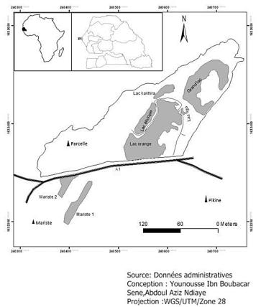

Figure 1: Map of the Urban Nature Reserve of the Grande Niaye of Pikine and its Dependencies.

**2.2. Sampling method**

Six sampling campaigns were carried out between 2021 and 2024, systematically covering the dry and rainy seasons of each year to account for seasonal variability in environmental conditions. The first campaign was conducted during the rainy season of 2021 and the last during the dry season of 2024. Sampling was conducted in collaboration with an experienced local fisherman using a cast net (standard 10 mm mesh), allowing fish to be caught in shallow water areas. The study focused on three water bodies within the UNRGNPD: Grand Lac, Lake Kakhira, and Lake Ethiopia. Other initially identified water bodies were excluded due to the absence of captured individuals during the first campaign. A total of 18 samples were collected during the campaigns, each consisting of 10 fish individuals. Immediately after capture, the specimens were individually placed in labeled plastic bags and stored in an ice-filled cooler to prevent tissue degradation. Samples were then transported under optimal conditions to the laboratory for subsequent biological and physicochemical analyses.

**2.3. Chemical analyses**

For calibration of the atomic absorption spectrometer (AAS110), analytical standards of Pb, Cd, and Hg were used. For each sample, 0.5 g of tissue was digested using 15 ml of 65% nitric acid, 3 ml of hydrochloric acid, and 0.5 ml of perchloric acid in Pyrex volumetric flasks containing an additional 6 ml of 1% nitric acid. The solution was then diluted and adjusted to 50 ml with acidified water (0.1 N), and metal concentrations were quantified using AAS110 with a graphite furnace. Mercury (Hg) was analyzed using the Cold Vapor AAS110 method. Calibration solutions were prepared for each metal to calibrate the device. A spiked sample was used to determine metal recovery rates, with doping concentrations included within the calibration range. All concentrations are expressed in mg/kg dry weight. The limits of quantification (LOQ) for Pb, Cd, and Hg were 0.05, 0.005, and 0.01 mg/kg, respectively.

**2.4. Ecological risk assessment**

The Metal Pollution Index (MPI) is a key tool for evaluating and comparing overall levels of metal contamination in studied species across different seasons. It is calculated using the following formula:

IPM = (M1 × M2 × M3 × . . . × Mn) (1/n). (1)

where MnMn​ represents the concentration of a specific metal expressed in mg·kg⁻¹ wet weight (Usero et al., 1997; Talbi et al., 2024). This geometric mean provides a reliable indicator of overall metal pollution levels.

In this study, the equation simplifies to:

IPM = (MCd x MHg x MPb) 1/3. (2)

where MCd, MHg, and MPb correspond to the mean concentrations of cadmium, mercury, and lead, respectively.

### ****2.5. Health risk assessment****

#### **Target hazard quotient (THQ)**

The THQ is calculated based on the ratio between exposure dose and reference dose (RfD), to assess health risks associated with heavy metal exposure through fish consumption. A THQ value below 1 suggests negligible risk, while a value above 1 indicates potential adverse health effects.

The estimation followed standard assumptions from the USEPA’s integrated risk assessment model (2000), based on the formula from Chien et al. (2002), Aendo et al. (2019), and Younis et al. (2024), using:

-3.  (3)

Where:

* EF (Exposure Frequency): 52 days/year (weekly consumption)
* ED (Exposure Duration): 70 years (adults), 7 years (children)
* CM (Metal Concentration): Measured concentration in the sample
* FIR (Fish Ingestion Rate): 65.34 g/day (FAO, 2022)
* Cf (Conversion Factor): 0.208 (fresh to dry weight, assuming 79% moisture)
* WAB (Body Weight): 60 kg (adults), 32 kg (children) (USEPA, 2008)
* RfD: Cd = 0.001 µg/g/day, Pb = 0.004 µg/g/day, Hg = 0.0001 µg/g/day (USEPA, 2023)
* ATn (Average Time for Non-Carcinogens): EF × ED
* AT (Average Time for Carcinogens): EF × 70 years

#### **Cancer risk (CR)**

Cancer risk is calculated using the Cancer Slope Factor (CSF), as defined by USEPA (1989), using the following formula (Khellaf, 2024):

CR = [(EF × ED × IRd × MC × CSF) / (BW × AT)] × 10−3.  (4)

CSF is the oral cancer slope factor from the USEPA IRIS database.

* CR > 1×10⁻⁴: unacceptable risk
* 1×10⁻⁶ ≤ CR ≤ 1×10⁻⁴: acceptable risk
* CR < 1×10⁻⁶: negligible risk

Only cadmium (Cd) was evaluated for carcinogenic risk, as it is classified by IARC as a Group 1 human carcinogen. For lead and mercury, no CSF values are currently available.

**2.6. Statistical data treatment**

Metal concentrations were expressed in mg·kg⁻¹ dry weight. Given the small sample size and non-normal distribution of data, only non-parametric statistical tests were used. Data analysis was performed using Excel and RStudio, with the NADA package for censored data below detection limits. Shapiro-Wilk and Levene’s tests were used for normality and variance homogeneity. In the absence of normality, Kruskal-Wallis and Wilcoxon tests assessed differences among categories. Kruskal-Wallis tests detected overall differences, while Dunn’s test was used for pairwise comparisons with Bonferroni-adjusted p-values. Kendall’s correlation test evaluated relationships between metals to assess potential shared sources. Results are expressed as p-values (0 to 1). A p-value ≤ 0.05 was considered statistically significant.

1. **RESULTS**

**3.1. Levels of fish contamination**

The analysis of Cd, Hg, and Pb concentrations revealed heterogeneous contamination, marked by high levels for some metals and significant variability (Table 1).

**Table 1**. Maximum, minimum, and mean concentrations (mg/kg) of TMEs in S. melanotheron muscle tissue from the UNRGNPD (2021–2024).

|  |  |  |  |  |
| --- | --- | --- | --- | --- |
| **TME** | **Maximum** | **Minimum** | **Mean** | **Std. Deviation** |
| Cd | 28.19 | 0.025 | 4.03 | 9.57 |
| Hg | 7.92 | 0.01 | 1.13 | 2.77 |
| Pb | 2.24 | 0.025 | 0.66 | 0.78 |

Cadmium (Cd) exhibited particularly high concentrations, reaching up to 28.19 mg/kg, with a minimum of 0.025 mg/kg and an average of 4.03 ± 9.57 mg/kg. Mercury (Hg) was also present, with an average of 1.13 ± 2.77 mg/kg and a maximum of 7.92 mg/kg. In contrast, lead (Pb) showed more moderate levels, with an average of 0.66 ± 0.78 mg/kg and a maximum of 2.24 mg/kg. The spatial distribution analysis of trace metals showed that fish from Lake Kakhira had significantly higher bioaccumulation levels than those from other sites (Figure 2a). However, Kruskal-Wallis tests applied to each metal did not reveal statistically significant differences between sites (*p > 0.05*), indicating spatial homogeneity of metal contamination. Seasonal trends showed notably higher Cd and Hg concentrations during the rainy season, while Pb slightly increased during the dry season (Figure 2c). Among the metals, only Cd exhibited a statistically significant seasonal variation (*p < 0.05*), whereas Hg and Pb did not (*p > 0.05*). Interannual variations were more pronounced, with peaks in Pb and Hg concentrations in 2021 and a Pb maximum in 2024 (Figure 2b). In contrast, 2022 and 2023 recorded particularly low TME concentrations. These temporal dynamics were supported by highly significant interannual differences in all metals (*p < 0.01*).

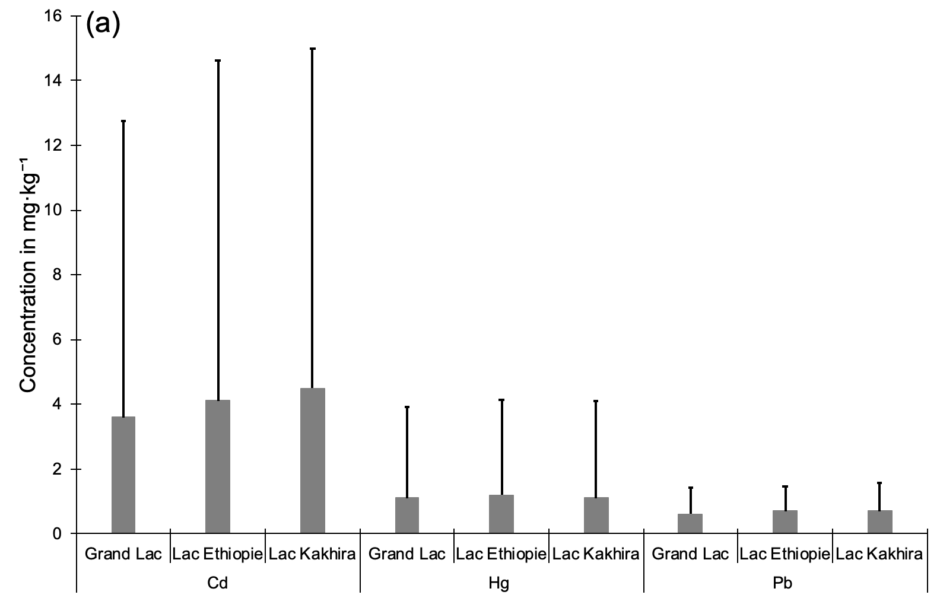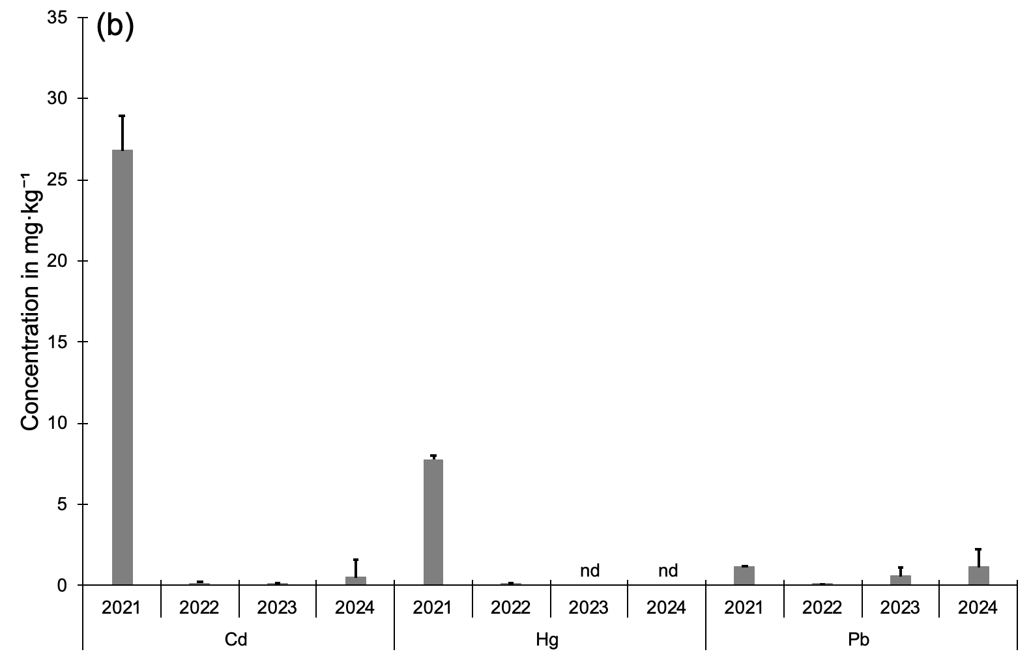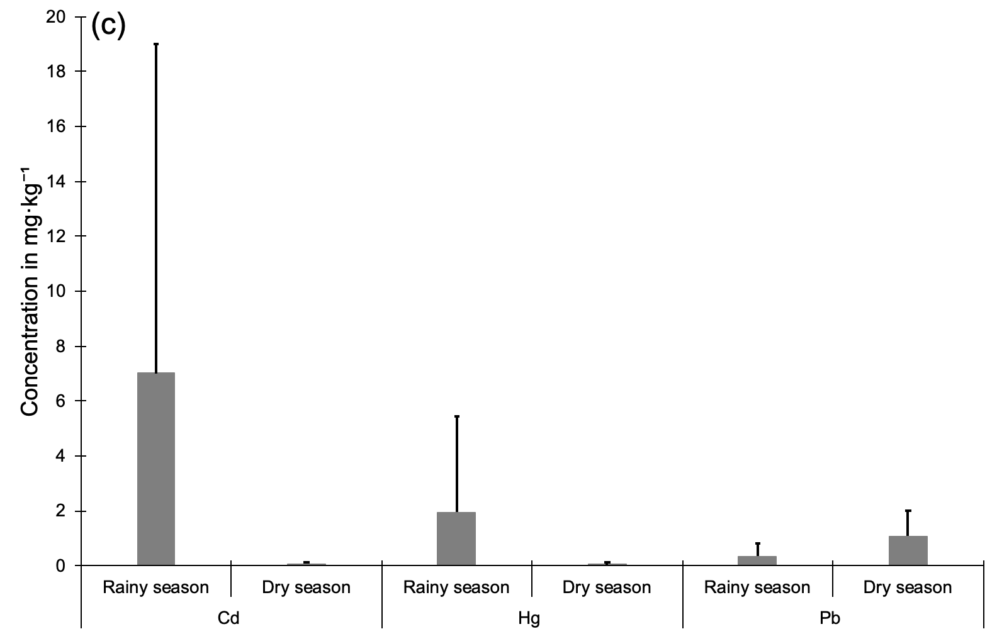

Figure 2: Spatiotemporal variations in the average concentrations of trace metal elements (TMEs) in the flesh of *Sarotherodon melanotheron* from the UNRGNPD.

**3.2. Metal pollution index (MPI)**

The MPI analysis (Table 2) revealed strong interannual variability. The MPI dropped from 6.20 in 2021 to 0.18 in 2024, indicating a marked decrease in overall contamination levels after the first year of monitoring. Kruskal-Wallis tests confirmed statistically significant differences between 2021 and the following years (*p << 0.05*). However, no significant differences were found among 2022, 2023, and 2024, suggesting a stabilization of pollution levels during this period. Seasonally, MPI values tended to be higher during the rainy season, though this trend was not statistically significant (*p > 0.05*), suggesting no clear seasonal impact on overall contamination dynamics.

Table 2. MPI by year and season

|  |  |  |  |  |  |  |
| --- | --- | --- | --- | --- | --- | --- |
|  | Season | | Year | | | |
| Rainy season | Dry season | 2021 | 2022 | 2023 | 2024 |
| IPM | 1.69 | 0.14 | 6.20 | 0.06 | 0.09 | 0.18 |

**3.3. Health risk assessment**

##### ***3.3.1. Target hazard quotient (THQ)***

Seasonal variations showed that the highest THQ values for Cd were recorded during the rainy season, especially in children, indicating increased exposure in this vulnerable group (Table 3). THQ values were lower and similar between adults and children in the dry season. Kruskal-Wallis tests confirmed a significant seasonal difference for Cd (*p < 0.05*). For Hg, THQ values remained low across all groups and seasons, with no significant differences (*p > 0.05*). Pb THQ values were higher during the dry season, particularly in children, with statistically significant seasonal differences (*p < 0.05*).

**Table 3.** Seasonal THQ values in adults and children.

|  |  |  |  |
| --- | --- | --- | --- |
| **Season** | **Element** | **Adults** | **Children** |
| Wet | Cd | 7.69 | 15.37 |
| Hg | 0.53 | 1.06 |
| Pb | 3.85 | 7.71 |
| Dry | Cd | 0.07 | 0.14 |
| Hg | 0.01 | 0.02 |
| Pb | 11.68 | 23.37 |

Interannual variability revealed that the highest THQ for Cd was recorded in 2021, reaching ~30 in adults and over 60 in children, indicating severe health risks. From 2022 onward, THQ values fell below the critical threshold of 1 for both groups. Kruskal-Wallis tests showed significant interannual differences (*p < 0.05*), and Dunn’s post hoc test identified significant changes only between 2021 and 2022. For Hg, THQ values remained below 1 throughout the study, suggesting consistently low risk. However, Kruskal-Wallis indicated a significant difference between years (*p < 0.05*), with Dunn’s test revealing only a marginal difference between 2021 and 2022. For Pb, THQ values in children exceeded 1 in 2021, 2022, and 2024, indicating persistent potential risk. In adults, values were more moderate but still near 1 during the same years. Both Kruskal-Wallis and Dunn tests confirmed significant differences, especially between 2021 and 2022 (*p < 0.05*).

**Table 4.** Interannual THQ variation in adults and children.

|  |  |  |  |
| --- | --- | --- | --- |
| **Year** | **Element** | **Adults** | **Children** |
| 2021 | Cd | 29.372 | 58.74 |
| Hg | 2.120 | 4.24 |
| Pb | 12.566 | 25.13 |
| 2022 | Cd | 0.139 | 0.28 |
| Hg | 0.016 | 0.03 |
| Pb | 0.274 | 0.55 |
| 2023 | Cd | 0.126 | 0.25 |
| Hg | 0.003 | 0.01 |
| Pb | 6.283 | 12.57 |
| 2024 | Cd | 0.529 | 1.06 |
| Hg | 0.003 | 0.01 |
| Pb | 12.392 | 24.78 |

##### ***3.3.2. Cancer risk (CR)***

Cadmium-related cancer risk (CR) was assessed by season and year (Table 5). In the rainy season, CR reached 0.047, well above the acceptable threshold (1 × 10⁻⁴), indicating serious concern. During the dry season, CR dropped to 0.0004, still above the threshold, although lower than in the rainy season. However, Kruskal-Wallis tests showed no significant seasonal difference (*p > 0.05*). Interannual analysis revealed that CR peaked at 0.18 in 2021, far exceeding acceptable limits. Although values declined in subsequent years, they remained above the threshold (0.0008 in 2022 and 2023, 0.003 in 2024). Kruskal-Wallis confirmed highly significant interannual differences (*p << 0.05*), and Dunn’s test indicated that only the difference between 2021 and 2022 was statistically significant (*p < 0.05*).

**Table 5.** Seasonal and interannual variation in cancer risk (CR) for Cd.

|  |  |  |  |  |  |  |  |
| --- | --- | --- | --- | --- | --- | --- | --- |
| Season | | | Year | | | | |
| Rainy season | Dry season | 2021 | | 2022 | 2023 | 2024 |
| 0,047 | 0,00045 | 0,18 | | 0,0008 | 0,0008 | 0,003 |

1. **DISCUSSION**

**4.1. Contamination levels**

The findings of this study reveal significant contamination by cadmium (Cd), mercury (Hg), and lead (Pb) in Sarotherodon melanotheron collected from the Grande Niaye de Pikine Urban Nature Reserve and Dependencies (UNRGNPD). The metal concentrations measured in 2021 far exceeded the food safety limits established by the FAO and WHO: 0.05 mg·kg⁻¹ for Cd, 0.5 mg·kg⁻¹ for Pb, and 1.0 mg·kg⁻¹ for Hg (FAO/WHO, 2011). Specifically, concentrations reached 28.19 mg·kg⁻¹ for Cd (approx. 81 times the limit), 2.24 mg·kg⁻¹ for Pb (≈ 4.5 times over the limit), and 7.92 mg·kg⁻¹ for Hg (≈ 1.3 times the limit). These exceptionally high values reflect intense anthropogenic pressure in this urban zone, likely due to domestic discharges, urban agriculture, the use of unregulated fertilizers, and informal industrial activities, similar to trends observed in other African urban ecosystems (Ouedraogo et al., 2023; Sylla et al., 2022). These results sharply contrast with those of Diop et al. (2019), who reported an absence of Cd and only low Pb levels in fish from this area. Regionally, N’Doua et al. (2024) found Cd concentrations of 0.002–0.074 mg·kg⁻¹, Pb at 0.04–0.204 mg·kg⁻¹, and Hg at 0.01–0.341 mg·kg⁻¹ in fish from Jacqueville (Ivory Coast), all significantly lower than levels observed in this study—particularly during the rainy season of 2021. This period is typically associated with runoff and remobilization of metals from soils and sediments into the water column (Wu et al., 2022; Zhang et al., 2021). Overall, the levels measured in 2021 align with recent research on metal bioaccumulation in fish species adapted to polluted environments, emphasizing the role of sentinel species in coastal ecosystem monitoring (Alimba et al., 2023; Zhou et al., 2022).

**4.2. Probable sources of contamination**

Although TMEs naturally occur in environmental compartments (water, soil, sediment), their accumulation at high levels in aquatic organisms generally points to anthropogenic origins (Kassinos et al., 2023). The RNUGNPD is highly impacted by urban effluents from Dakar, including untreated or poorly treated wastewater (Sambou et al., 2018; Mbaye et al., 2022). The persistence of TMEs in aquatic environments, combined with their bioaccumulative and biomagnifying nature within trophic chains, poses major ecological and health risks (Dione, 2022; Tchounwou et al., 2024). The benthic feeding behavior of tilapia, which forages near sediments, makes it particularly vulnerable to sediment-bound pollutants (Diop et al., 2019; Kasozi et al., 2021). A significant positive correlation between Cd and Hg suggests a shared source, likely contaminated sediments. This hypothesis aligns with higher concentrations observed during the rainy season, when metal remobilization through runoff is intensified (Wu et al., 2022). Agricultural inputs, particularly phosphate fertilizers, are a major Cd source, whereas Hg primarily originates from fossil fuel combustion, electronics manufacturing, batteries, fluorescent lamps, and certain artisanal practices (Jeong et al., 2024; Zitoun et al., 2024). These metals also exhibit high bioavailability: Cd as soluble Cd²⁺ and Hg as methylmercury (MeHg), which is highly toxic and readily absorbed by biological membranes. Such chemical speciation promotes accumulation in fish muscle tissues and enhances trophic transfer (Zhou et al., 2022; Alimba et al., 2023). Conversely, Pb is not correlated with Cd or Hg, due to distinct sources and speciation. Pb mainly comes from legacy sources, such as leaded fuel, paints, and industrial waste. In aquatic environments, it is often immobilized in sediment as inorganic forms (PbCO₃, PbS), making it less bioavailable (Botté et al., 2022; Adetutu et al., 2023). This explains the moderate levels found in fish muscle despite environmental presence. Thus, exposure mechanisms differ: Cd and Hg are highly mobile and bioavailable, while Pb tends to be sequestered in sediments. This underscores the importance of integrating chemical speciation, ecological traits of bioindicator species, and local human activities to accurately interpret metal contamination profiles in tropical ecosystems (Zhang et al., 2023; Kaboré et al., 2024).

**4.3. Spatiotemporal variability**

The lack of significant differences among the three studied water bodies may be attributed to their natural hydrological connectivity, which intensifies during the rainy season. This facilitates mixing and redistribution of contaminants, leading to spatial homogenization. Such processes have been observed in other systems, such as mixed-use catchments in northeast Germany, where seasonal hydrological connectivity reduced contamination gradients (Wang et al., 2024). The relatively stable Cd and Pb concentrations during 2022-2024 (excluding 2021) are consistent with studies by Togbé et al. (2019) on Ebrié Lagoon waters and by Nakweti et al. (2021) in Pool Malebo (DRC), which reported low but persistent levels of these metals. These patterns are often attributed to a convergence of industrial, domestic, and urban runoff discharges. However, the MPI reveals pronounced seasonal variability, with markedly higher values in the rainy season, especially in 2021, the year with the most severe contamination. Similar findings were reported by Keshavarzi et al. (2018), where the Hazard Index (HI) exceeded 1 in fish exposed to contaminated sediments, indicating unacceptable health risks. Peak contamination may be linked to exceptional hydrological conditions or pollution events, such as industrial spills or wastewater treatment failures. The extreme contamination observed in 2021 likely reflects a one-time pollution event coupled with heavy rainfall and intensive soil runoff (Wu et al., 2022; Kassinos et al., 2023). This interpretation is reinforced by the sharp decline in concentrations from 2022 onward, suggesting a transient anomaly rather than a continuous trend. These results highlight the need to consider hydrological regimes, land use, and extreme events in understanding contaminant dynamics in vulnerable tropical ecosystems.

1. **CONCLUSION**

This study highlights alarming contamination levels in the aquatic ecosystems of the Grande Niaye de Pikine Urban Nature Reserve and Dependencies (UNRGNPD) by three trace metals, cadmium (Cd), mercury (Hg), and lead (Pb), which were detected in significant quantities in the muscle tissues of *Sarotherodon melanotheron*. Maximum concentrations recorded in 2021 far exceeded international safety standards (FAO/WHO), particularly for cadmium, reflecting acute pollution likely driven by anthropogenic activities, including domestic, agricultural, and industrial discharges. Spatiotemporal analysis revealed substantial interannual variability, with a contamination peak in 2021 followed by a notable decrease in Cd and Hg levels from 2022 onward. In contrast, Pb concentrations remained consistently high throughout the study period, especially during the rainy season, indicating its persistent bioavailability and environmental stability. Health risk assessments revealed chronic exposure risks, particularly among children, for whom Target Hazard Quotient (THQ) values frequently exceeded the critical threshold, especially for lead. The cancer risk (CR) associated with Cd exposure in 2021 was estimated at 0.18, vastly surpassing the tolerable limit of 1 × 10⁻⁴, and thus represents a serious public health concern. In light of these findings, urgent measures are needed to mitigate the risks: strengthening environmental monitoring, identifying specific sources of contamination, improving wastewater treatment systems, and reducing agricultural and industrial pollutant inputs. Furthermore, it is essential to conduct complementary studies focused on metal speciation and trophic transfer processes to better understand contamination dynamics and to develop sustainable remediation strategies for urbanized tropical wetlands.

**REFERENCES**

Adetutu, E. M., Adegbola, P. I., & Aborisade, A. B. (2023). Heavy metal concentrations in four fish species from the Lagos lagoon and their human health implications. Heliyon, 9(10), e21689. <https://doi.org/10.1016/j.heliyon.2023.e21689>

Aendo, P., Thongyuan, S., Songserm, T., & Tulayakul, P. (2019). Carcinogenic and non-carcinogenic risk assessment of heavy metals contamination in duck eggs and meat as a warning scenario in Thailand. Science of the Total Environment, 689, 215–222. <https://doi.org/10.1016/j.scitotenv.2019.06.414>

Alimba, C. G., Oladipo, G. G., & Ogunwale, O. M. (2023). Bioaccumulation and human health risk assessment of heavy metals in edible aquatic species from tropical ecosystems: A review. Environmental Research, 220, 115010. <https://doi.org/10.1016/j.envres.2023.115010>

Ba, D., Sarr, F., & Mbaye, N. (2015). Physicochemical characterization and mapping of urban wetlands in Dakar: The case of the Grande Niaye de Pikine. African Review of the Environment, 3(2), 45–54.

Bošković, N., Joksimović, D., & Bajt, O. (2023). Content of trace elements and human health risk assessment via consumption of commercially important fishes from the Montenegrin coast. Foods, 12(4), 762. https://doi.org/10.3390/foods12040762

Botté, C., Seguin, C., & Nahrgang, J. (2022). Lead in the marine environment: Concentrations and effects on invertebrates. Ecotoxicology, 31, 194–207. https://doi.org/10.1007/s10646-021-02504-4

Chien, L. C., et al. (2002). Daily intake of TBT, Cu, Zn, Cd and As for fishermen in Taiwan. Science of the Total Environment, 285(1–3), 177–185. https://doi.org/10.1016/S0048-9697(01)00903-6

Diop, C., Sambou, A., Sane, M., & Cissé, G. (2019). Trace metal levels in water and fish from five ponds in Dakar and risks to human health. Journal of Applied Biosciences, 137, 1–12.

Diop, C., Sambou, A., & Ndiaye, I. (2021). Anthropogenic Pressures and Water Quality in the Technopole Area of Dakar. Senegalese Journal of Sciences, 13(1), 22–35.

Dione, D. (2022). Ecotoxicology of Heavy Metals in Coastal Urban Areas of Senegal (PhD thesis, Cheikh Anta Diop University).

FAO/WHO. (2011). Codex Alimentarius: General Standard for Contaminants and Toxins in Food and Feed (Codex Stan 193-1995). Rome: FAO/WHO. https://www.fao.org/fao-who-codexalimentarius/codex-texts/list-standards/en/

Faye, M. (2017). Challenges of Solid Waste Management and Urban Pollution in Dakar. African Urban Studies, 5(2), 22–34.

Faye, M., Diagne, A., & Seck, S. (2022). Use of black tilapia (Sarotherodon melanotheron) as a bioindicator in the lagoon ecosystems of Dakar. African Journal of Biology, 16(4), 121–134.

Förstner, U., & Wittmann, G. T. W. (2012). Metal Pollution in the Aquatic Environment. Springer. https://doi.org/10.1007/978-3-642-70776-2

Harada, M. (1995). Minamata disease: Methylmercury poisoning in Japan caused by environmental pollution. Critical Reviews in Toxicology, 25(1), 1–24. https://doi.org/10.3109/10408449509089885

Jeong, J., Lee, M., & Kang, H. (2024). Global trends in aquatic metal pollution and human health risk. Science of the Total Environment, 918, 168748. https://doi.org/10.1016/j.scitotenv.2024.168748

Järup, L. (2003). Hazards of heavy metal contamination. British Medical Bulletin, 68(1), 167–182. https://doi.org/10.1093/bmb/ldg032

Kaboré, M., Ouedraogo, B., & Ilboudo, E. (2024). Trophic transfer and sediment-bound metals in West African wetlands. Ecotoxicology and Environmental Safety, 263, 115287. https://doi.org/10.1016/j.ecoenv.2024.115287

Kassinos, D., Vasquez, M. I., & Michael, C. (2023). Urban wastewater discharges as hotspots of trace metal pollution. Journal of Hazardous Materials, 446, 130698. https://doi.org/10.1016/j.jhazmat.2023.130698

Kasozi, N., Rutaisire, J., & Masaba, T. (2021). Sediment-associated heavy metals and their ecological risk in African fishery wetlands. Marine Pollution Bulletin, 166, 112242.

Keshavarzi, B., Moore, F., & Lahijanzadeh, A. R. (2018). Ecological and human health risks of heavy metal exposure in fish from Persian Gulf coasts. Ecotoxicology and Environmental Safety, 148, 158–165. https://doi.org/10.1016/j.ecoenv.2017.10.024

Khellaf, N. (2024). Modeling the carcinogenic risk of heavy metals in aquatic ecosystems. Environmental Risk Assessment Journal, 7(1), 45–58.

Lawrence, D. T., Akinpelu, A. A., & Okonkwo, J. O. (2019). Bioaccumulation and health risk of heavy metals in freshwater fish in Nigeria. Ecotoxicology, 28(5), 552–564. https://doi.org/10.1007/s10646-019-02059-1

Mbaye, M., Diop, B., & Ndiaye, I. (2022). Effects of urban wastewater on peri-urban lagoons of Dakar. African Environmental Review, 11(3), 34–45.

N’Doua, A. D., Brou, K., & Kouamé, K. (2024). Heavy metal contamination of fish in Jacqueville, Côte d’Ivoire. European Scientific Journal, 20(3), 53–68.

Nakweti, K. J., et al. (2021). Trace metal levels in the Malebo Pool (DRC). European Scientific Journal, 17(25), 174–194.

Ouedraogo, D., Kafando, P., & Traoré, M. (2023). Sources and ecological risks of heavy metals in West African aquatic systems. Environmental Pollution, 320, 121005.

Sambou, A., Cissé, G., & Sane, M. (2018). Characterization of anthropogenic inputs in the Niaye de Pikine. African Journal of Environmental Sciences, 13(2), 45–56.

Sylla, M., Ba, M., & Diallo, A. (2022). Impact of urban wastewater on the quality of aquatic environments in West Africa. African Journal of the Environment, 10(1), 55–66.

Talbi, M., Zidane, H., & Ouhammou, A. (2024). Heavy metal contamination and risk assessment in freshwater fish: A case study from Morocco. Environmental Monitoring and Assessment, 196(1), Article 35.

Tchounwou, P. B., Yedjou, C. . G., Patlolla, A. K., & Sutton, D. J. (2012). Heavy metal toxicity and the environment. EXS, 101, 133–164. https://doi.org/10.1007/978-3-7643-8340-4_6

Tchounwou, P. B., Ogungbe, I. V., & Anane, R. (2024). Human exposure to toxic metals through aquatic food chains. Toxicology Reports, 11, 132–148.

Togbé, A. M. O., et al. (2019). Évaluation de la contamination des eaux de la lagune Ebrié. International Journal of Biological and Chemical Sciences, 13(2), 1162–1179.

UNEP. (2021). Making Peace with Nature: A scientific blueprint to tackle the climate, biodiversity and pollution emergencies. Nairobi: United Nations. https://www.unep.org/resources/making-peace-nature

USEPA. (2023). Integrated Risk Information System (IRIS): Chemical Assessments for Cadmium, Lead, Mercury. https://www.epa.gov/iris

Wang, Y., Müller, B., & Hofmann, H. (2024). Hydrological connectivity reduces spatial contamination heterogeneity in mixed-use catchments. Environmental Pollution, 328, 121070.

Wu, J., Yang, W., & Zhang, H. (2022). Rainfall-driven mobilization of sediment-bound metals in tropical coastal systems. Chemosphere, 308, 136527. https://doi.org/10.1016/j.chemosphere.2022.136527

Younis, M. A., Farag, M. A., & Hegazy, H. G. (2024). Assessment of health risks associated with heavy metal contamination in fish and crustaceans from Lake Temsah. Scientific Reports, 14, Article 18706. https://doi.org/10.1038/s41598-024-45670-1

Zhang, L., He, J., & Zhao, M. (2023). Speciation and ecological risk assessment of metals in interlinked aquatic systems. Environmental Pollution, 316, 120594. https://doi.org/10.1016/j.envpol.2022.120594

Zhou, Q., Zhang, J., & Wang, L. (2022). Heavy metal exposure through fish consumption and associated health risks in developing countries. Chemosphere, 295, 133946. https://doi.org/10.1016/j.chemosphere.2022.133946

Zitoun, R., Zaldívar, J. M., & Lasserre, F. (2024). Climate change-driven effects on trace element biogeochemistry in marine ecosystems. Communications Earth & Environment, 5, Article 1679. https://doi.org/10.1038/s43247-024-01075-z