Review Article
Climate Resilient Technologies for sustainable pulse production

Abstract
Pulses are the backbone of Indian agriculture due to their significant role in human and animal nutrition, soil ameliorative properties, environmental sustainability and economic viability. Pulses are emerged as super foods because of higher protein content of about 20-25 % which is almost double than cereals. Climate change refers to long-term shifts in global or regional climate patterns, primarily caused by human activities such as industrialization, urbanization, deforestation, agriculture, change in land use pattern etc. leads to emission of greenhouse gases due to which the rate of climate change is much faster. The impact of climate change is complex and no single strategy will address the issue adequately. To ensure sustainable pulse production under the impact of changing climate, integrated package of practices are needed to increase the resilience of crops towards climate change, while simultaneously enhancing crop yields to ensure future food security. The technologies adopted by farmers could minimize the impact of weather aberrations and contribute towards sustainability and built resilience. Pulses are climate smart as they simultaneously adapt to climate change and contribute towards mitigating its effect by improved technologies like selection of suitable variety, enhancing water and nutrient use efficiencies, better buffering to heat and cold stress, biotic and abiotic stress etc. must be developed.
Key words: Pulses, super foods, climate change, climate smart.
Introduction
Pulses, the humble heroes of Indian agriculture are renowned for their ability to thrive in subsistence production systems and endure harsh growing conditions. Gifted with unique ability of fixing atmospheric nitrogen legumes possess various morphological attributes, such as deep root system, higher water use efficiency, ability to host beneficial microbes in the rhizosphere to solubilize phosphate, etc., as well as low water and nutrient requirements. Legumes offer a range of benefits, from climate resilience and carbon sequestration to biological nitrogen fixation, low-input sustainable agriculture and improved human health, making them a valuable crop for farmers and ecosystems. The year 2016 was recognised as “International Year of Pulses” declared by the 68th United Nations (FAO, 2016) with the theme: 'Pulses: nourishing soils and people'.
In Andhra Pradesh, pulses are grown to an extent of 10.33 lakh hectares of area with total production of 10.87 lakh tonnes. (Season and Crop Report- Andhra Pradesh, 2022-23). Chickpea (49.61%), pigeon pea (15.46%), Mungbean (11.60%), urdbean (10.17%), lentil (4.65%) which together contribute 91.48% of total pulse production in India during 2021–22. As per the final estimates for 2022–23, the pulse production in India reached 26.06 million tons in 2022–23. Pulse productivity was adversely affected by changing climatic conditions, including temperature fluctuations, unpredictable rainfall patterns and increased frequency of extreme weather events (e.g., heatwaves, floods).
Climate change refers to long-term shifts in global or regional climates, primarily caused by human activities that release greenhouse gases into the atmosphere. Climate change driven by both natural factors includes volcanic eruptions, circulation of ocean currents, earths orbital variation, solar variation, tectonic plate movements and anthropogenic factors includes fossil fuel emissions, deforestation, excessive fertilizer usage, urbanization. Farmers can minimize weather – related impacts and promote sustainability by adopting climate resilient technologies. For pulses, this includes developing and implementing improved technologies includes breeding, agronomic strategies and government policy and innovations.
Fig 1: IPCC Sixth Assessment Report shows the dominant role of humans in driving recent climate change
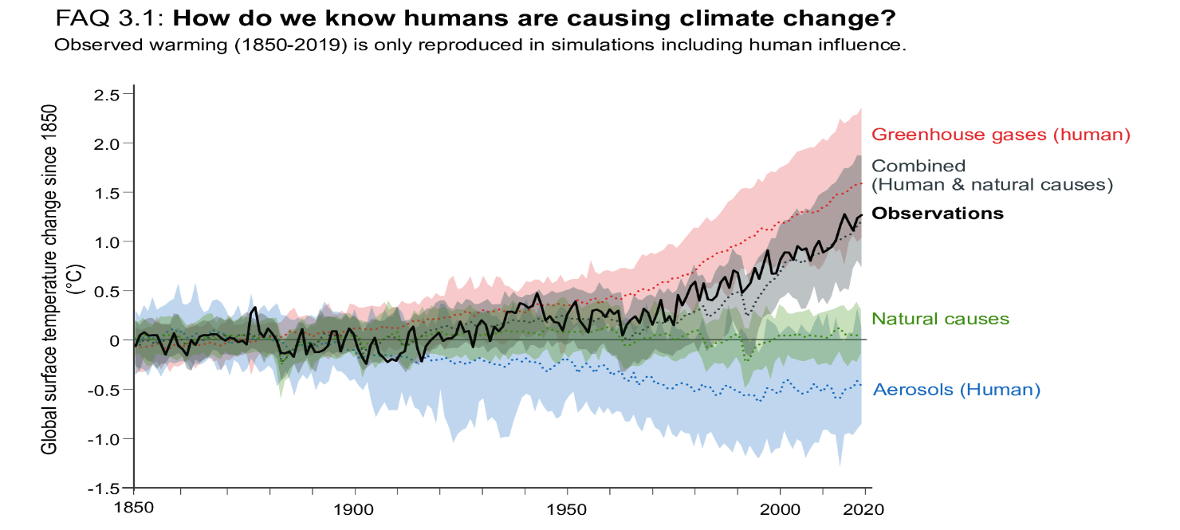
Source: 6th Assessment Report Intergovernmental Panel on Climate Change (IPCC), 2021
IPCC Sixth Assessment Report shows that the dominant role of humans in driving recent climate change is clear. Global surface temperature changes in observations, compared to climate model simulations of the response to all human and natural forcings (grey band), greenhouse gases only (red band), aerosols and other human drivers only (blue band) and natural forcings only (green band). Solid coloured lines show the multi-model mean, and coloured bands show the 5–95% range of individual simulations.
Climate change scenario
Climate change scenarios include higher temperatures, changes in precipitation and higher atmospheric CO₂ concentrations. Increased concentration of greenhouse gases like Carbon-dioxide (CO₂), Water vapour, Methane (CH₄), Nitrous oxide (N₂O), HFCs, SF₆ which can entrap solar radiation, are major responsible for elevating global temperature. Due to anthropogenic activities has contributed to an overall increase of the earth’s temperature, leading to a global warming. The atmospheric CO₂ concentration has increased from 280 ppm to 395 ppm, CH₄ concentration increased from 715 ppb to 1882 ppb and N₂O concentration from 227 ppb to 323 ppt for the year 1750 and 2012. 2023 is confirmed as the warmest calendar year in global temperature data records going back to 1850. 2023 had a global average temperature of 14.98°C, 0.17°C higher than the previous highest annual value in 2016. 2023 was 0.60°C warmer than the 1991-2020 average and 1.48°C warmer than the 1850-1900 pre-industrial level.
Climate change mitigation and adaptation
Climate mitigation involves efforts to diminish or prevent the release of greenhouse gas emissions. There are two strategies that address climatic change: adaptation and mitigation. adaptation (adjustments) involves the ability of system to adjust to climate change to mitigate moderate potential damage or to cope with the consequences whereas mitigation (root cause) involves actions taken to permanently eliminate or reduce the long term risk and hazards of climate change.
Climate resilience: It refers to the ability of a system to deal with stresses and disturbances, while retaining the same basic structure and ways of functioning, capacity for self-organisation and capacity to learn an adapt to change.
Climate resilient practices: Means the incorporation of adaption, mitigation and other practices in agriculture which increases the capacity of system to respond to various climate related disturbances by resisting damage and recovering quickly (Hadimani, 2016).
Climate resilience crops: A climate-resilient crop is resistant to multiple stress factors, which can be abiotic, including both human-made and climate-driven factors, as well as soil associated or biotic stress factors.
Fig 2: The stress factors affecting climate-resilient crops
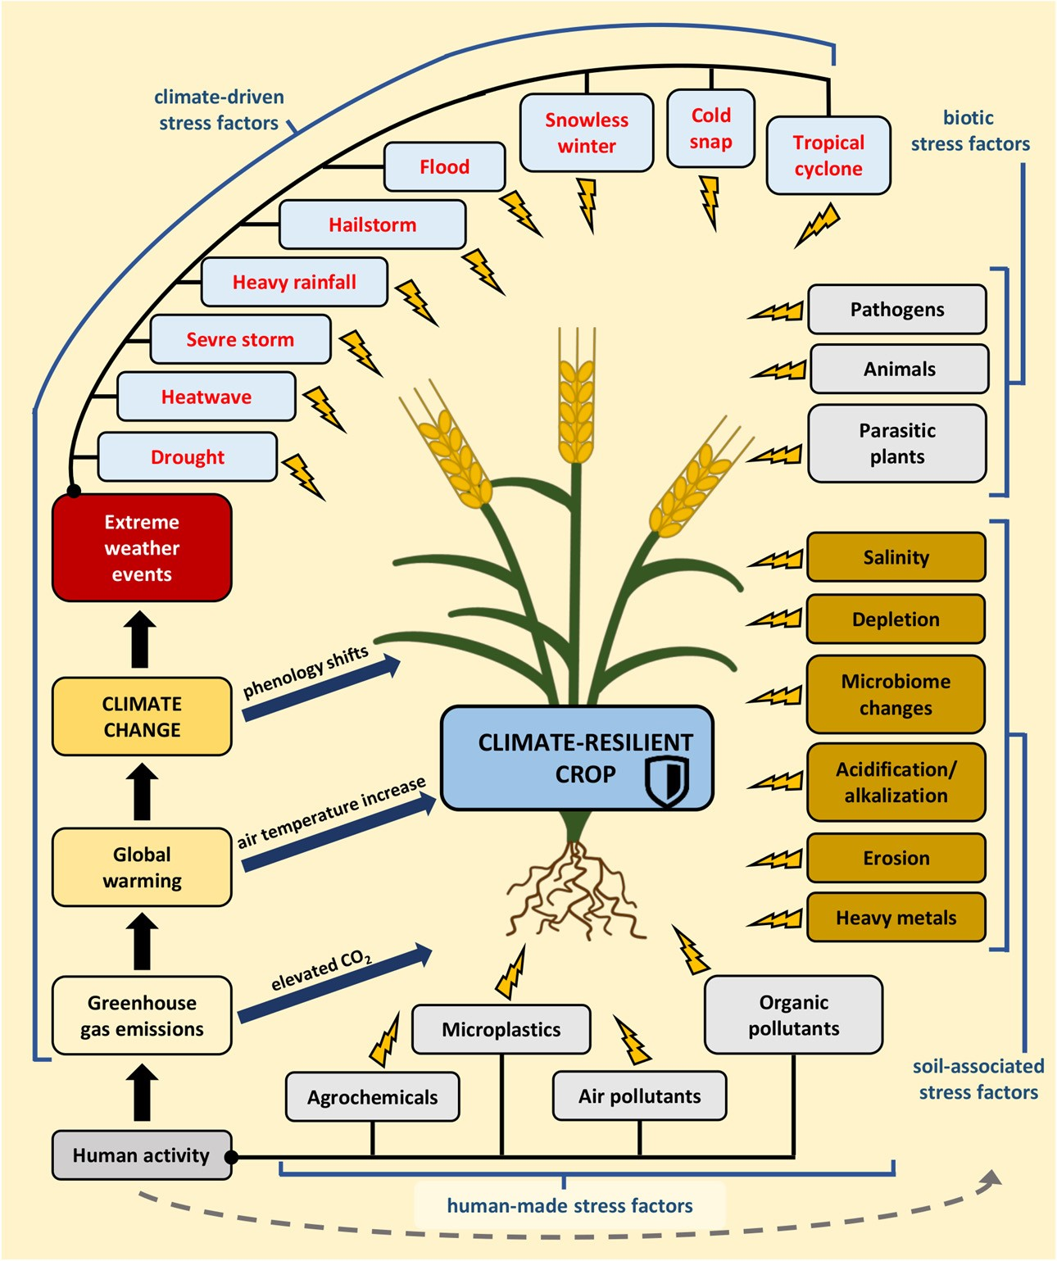
Breeding strategies  - Heat resistant  - Disease resistant  - Pest resistant  - Salinity resistant  - Photo and thermo insensitive varieties | Agronomic strategies  - Conservation agriculture  - Use of adaptive crops  - Crop diversification  - Multistoried cropping system  - Maintaining adequate soil organic matter  - Water harvesting and supplemental irrigation  - Seed priming  - Seed bombing  - Foliar application  - Plant growth Regulators  - Biofertilizers  - Nano fertilizers  - Nano biochar  - Fertigation  - Traditional and indigenous knowledge | Government policy and innovation  - NICRA  - PMFBY

List 1 : Strategies for enhancing crop resilience to climate change

Breeding strategies
Breeding strategies for climate mitigation refers to the use of plant breeding techniques to develop crop varieties that can tolerate or adapt to changing climate conditions (drought, heat, floods) have improved resource use efficiency (water and nutrients) can mitigate greenhouse gas emissions (e.g., through improved nitrogen fixation), development of photo and thermo insensitive varieties (ICCV 92944, ICCV 96029 and ICCV 96030 of chickpea, PGRU 95016, IPU 99-89, BGP-247 of blackgram (Basu et al., 2016) and ICPL- 90011 of pigeonpea) and development of varieties which are resistance against various abiotic (Narendra Mung 1 of greengram resistance against heat stress) and biotic stress (e.g., Sweta (ICCV 2) and Bharti (ICCV 10) of chickpea against wilt disease (Bera et al., 2021).
Agronomic strategies
Agronomic practices refer to the strategies and techniques used in crop production to improve soil health, enhance plant growth and optimize yield. By implementing effective agronomic practices, farmers can increase crop productivity while conserving environmental resources and promoting long term agricultural sustainability.
Conservation agriculture
Conservation agriculture is a farming system that promotes maintenance of a permanent soil cover, minimum soil disturbance, and diversification of plant species. It enhances biodiversity and natural biological processes above and below the ground surface, which contribute to increased water and nutrient use efficiency and to improved and sustained crop production. The three main principles of conservation agriculture (minimum soil disturbance, crop diversification, and permanent soil cover) help to protect the environment and to reduce both the impacts of climate change on agricultural systems (adaptation) and the contribution of the agricultural practices to greenhouse gases emissions mitigation through sustainable land management. In a field experiment conducted by Suresh et al. (2024) concluded that vertical tillage with subsoiler upto 60 cm deep at 1m interval with application of 125% RDF and foliar application of KNO₃ 1% twice with 15 days interval at 50 per cent flowering stage resulted in better yield attributes and seed yield of pigeonpea.
Fig 3: Three principles of conservation agriculture
Use of adaptive crops
Adaptive plants (Reynolds and Ortiz, 2010) are more vibrant and resilient to unfavourable climatic conditions. They require fewer herbicides or fertilizers and are more resistant to waterlogging or droughts. The results revealed by Kumarajoshi et al. (2021) recorded maximum grain yield and yield attributes i.e., number of clusters plant⁻¹, number of pods plant⁻¹, number of seeds pod⁻¹, pod weight and 100 seed weight of IC426766 variety of blackgram under drought conditions. In a field experiment conducted by Khoiwal et al. (2017) and concluded that the combination of moisture stress situation S_{FL} × V5 (S_{FL}– Water withheld from flowering in variety V5–JG 16) was found better in terms of productivity and profitability.
Crop diversification
Crop diversification provides resilience against extreme and highly variable weather conditions resulting from climate change by increasing carbon sequestration in soils while mitigating greenhouse gas emissions. In essence, agroforestry refers
to the practice of the purposeful growing of trees and crops, and/or animals, in interacting combinations, for a variety of benefits and services (Nair et al., 2008) The different Agroforestry systems includes agri-silviculture, silvi-pastoral system, agri-silvi-pastoral system, agri-horticultural system, horti-pastoral system and alley cropping.
Multistoried cropping system
A multi-storey cropping system accommodates crops of varying heights, canopy patterns and root systems to maximize sunlight, nutrient use, sustainable land use and ecological balance which results in efficient use of resources such as sunlight, water, soil and nutrients in this cropping system leads to increased biological diversity, more crops per unit area and production sustainability.
Maintaining adequate soil organic matter
Pulses have lower fertilizer requirement as they fix atmospheric nitrogen hence helps in lowering greenhouse gas emissions. Under changing climatic scenario, the soil organic carbon has been reducing continuously. Agricultural practices that enhances soil organic carbon must be followed to reduce GHGs and increase carbon sequestration in soil. Crop specific agronomic practices hold tremendous scope to raise pulse productivity potential under changing climatic scenario.
Water harvesting and supplemental irrigation
Pulses are mainly confined to rainfed area, leading to suboptimal productivity levels. Winter pulses are more susceptible to drought, especially during the later part of the growth stages.
Seed priming
Seed priming is a pre-sowing seed treatment that involves controlled hydration of seeds, enabling them to undergo initial germination processes but preventing complete radicle emergence. This process enhances seed germination rate, uniformity and vigor, particularly under challenging environmental conditions. Different methods of seed priming includes hydro priming, osmo priming, halo priming, hormonal priming and biopriming. It may be concluded that hydro-priming (distilled water) with 10 cm sowing depth recorded significantly highest growth, yield attributes and yield of chickpea was the most effective treatment followed by Manitol 4% priming with 10 cm sowing depth (Lhungdim et al., 2018).
Seed bombing
Aerial seed bombing is a cutting-edge method for large-scale ecological restoration, offering a revolutionary solution to the challenges of extensive vegetation recovery across various landscapes. Key features include its ability to reach difficult or inaccessible terrains, such as steep slopes or remote regions, which are challenging for traditional planting methods. This technique promotes biodiversity by introducing a variety of plant species, which can enhance ecosystem stability and resilience. Additionally, it accelerates the reforestation process, improving soil health, reducing erosion, rapid ecosystem recovery, wide coverage, precision targeting and sequestering carbon, all of which contribute to mitigating climate change impacts and enhancing agricultural resilience.
Foliar application
Under heat stress, high water status can be attained by various macronutrients and micronutrients like potassium, calcium, boron, selenium and manganese activate various physiological and stomatal functions in plants. The impact of boron deficiency on assimilate partitioning may greatly influence the ability of plants to cope with other unfavorable environmental conditions such as soil water deficits and low supplies of other nutrients. In a study conducted by Aslam et al. (2019) observed that the foliar application of 19:19:19 @ 0.5% Spray + Seaweed extract @ 2% at 30 and 45 DAS proved to be promising nutrient management practice for obtaining higher yield attributes and yield of greengram.

Plant growth regulators
The mechanism by which it deals with drought stress includes mechanisms such as phosphorus solubilization, organic acids, nitrogen fixation, production of siderophores, and production of enzymes such as ACC (1-aminocyclopropane-1-carboxylate) deaminase. This enzyme plays a crucial role in plant growth and development, particularly under stress conditions, by breaking down the plant hormone ethylene's precursor, 1-aminocyclopropane-1-carboxylic acid (ACC). Nagamani et al. (2020) reported that higher seed yield, stalk yield and nutrient uptake by the crop was recorded with foliar application of NAA (25 ppm) and DAP (2 per cent) applied at 60 and 80 DAS of pigeonpea.
Biofertilizers
Biofertilizers, derived from beneficial microorganisms, alternative to chemical fertilizers in agriculture and hold significant promise as a tool for mitigating climate change. The potential of biofertilizers in sequestering carbon, reducing greenhouse gas emissions and enhancing soil resilience, thereby contributing to climate change mitigation efforts through mechanisms such as nitrogen fixation, promotion of plant growth and stimulation of soil microbial communities. By reducing the need for synthetic fertilizers and curbing emissions of nitrous oxide and methane, biofertilizers contribute to greenhouse gas emission reduction in agricultural systems. From the study conducted by Yadav et al. (2022) inferred that application of 100% RDF along with Rhizobium + Phosphate solubilizing Bacteria + Plant Growth Promoting Rhizobacteria was found better in achieving the yield and quality of late sown chickpea crop.
Nano fertilizers
Agriculture significantly contributes to climate change through greenhouse gas emissions and fertilizer loss. Nanofertilizers, particularly slow-release ones, can mitigate these issues by reducing nutrient input, boosting productivity and minimizing climate-related problems like soil nutrient imbalance and agricultural emissions. By providing controlled nutrient release, nanofertilizers improves soil health, fertility and structure, ultimately enhancing food quality and safety. This makes them a valuable strategy for reducing climate change impacts on agriculture. As nanofertilizers can provide controlled or slow-release nutrients according to crop demand, they could also contribute to the synchronization of macro and micro nutrients, achieving better balance in soil and synergetic effects for crops (Monreal et al., 2016).
Nano Biochar
Nano biochar enhances climate resilience in agriculture by improving soil health and fertility. Its increased surface area and reactivity allow it to effectively retain water and nutrients, reducing the need for frequent irrigation and fertilization, also promotes beneficial microbial activity in the soil, which can help crops better withstand stress from extreme weather conditions. Additionally, its ability to sequester carbon helps mitigate greenhouse gas emissions, contributing to overall climate change mitigation. By enhancing soil structure, water retention, and nutrient availability, nano biochar supports more resilient and sustainable agricultural practices

Fertigation
Much of the applied fertilizer runs off into waterways, or gets broken down by microbes in the soil, releasing the potent greenhouse gas nitrous oxide into the atmosphere. Integrated water and fertilizer management is important for promoting the sustainable development of agriculture. Climate-smart drip irrigation with fertilizer coupling strategies plays an important role to mitigate greenhouse gas emissions, can increase fertilizer use efficiency, ensuring food production and alleviating water scarcity and excessive use of fertilizers.
Traditional and Indigenous Knowledge
Traditional agriculture includes such practices as agroforestry, crop rotation, intercropping, traditional organic composting, cover cropping and integrated crop-animal farming, which can be accepted as the model methods for climate-smart agriculture. These practices enhance agricultural sustainability and help in mitigating climate change (Singh and Singh, 2017). Sharing the experience gained by local producers and integrating local knowledge into regional and national adaptation policies will help develop more effective adaptation strategies to decrease vulnerability to climate change (Garcia et al., 2021).
Government policy and intervention
National Initiative on Climate Resilient Agriculture (NICRA)
A network project implemented by the Indian Council Agricultural Research (ICAR) in February, 2011 with an outlay of Rs. 350 crores, being implemented at a large number of research institutes of ICAR, State Agricultural Universities and 100 KVK’s to demonstrate the climate resilient technologies to climatic vulnerable districts of the country.
Aim of the project
To enhance resilience of Indian agriculture to climate change and climate vulnerability through strategic research and technology demonstration.
Objectives
1. To enhance the resilience of Indian agriculture covering crops, livestock and fisheries to climatic variability and climate change
2.To demonstrate site specific technology packages on farmers' fields
3.To enhance the capacity building of scientists and other stakeholders in climate resilient agricultural research and its application.
Pradhan Mantri Fasal Bhima Yojana (PMFBY)
Launched on 18 February 2016 with an outlay of Rs. 13,625 crore 2023-24 at Kisan Maha Sammelan at Sehore, Madhya Pradesh.

Objectives
1. To provide insurance coverage and financial support.
2. To stabilize the income of farmers to ensure their continuance in farming.
3. To encourage farmers to adopt innovative and modern agricultural practices.
4. To ensure the flow of credit to the agriculture sector.
Budget under PMFBY
The PMFBY has received an additional impetus with the government allocation Rs. 13625 crore 2023-24. (Ministry of Agriculture and Farmers Welfare) Under this new crop insurance plan, the premium rate will be 2%, 1.5% and 5% for all types crop like kharif and Rabi crops, Horticulture and commercial crops.
Conclusion
Climate is the primary determinant of agricultural productivity with direct impact on food production across the globe. Increase in the mean seasonal temperature can reduce the duration of many pulse crops and hence reduce final yield. Improved agronomic practices hold tremendous potential to combat adverse impact of climate change on pulse production. By the adoption of recommended management practices, agriculture contributes not only to soil and water conservation, but also for enhancing the amount of soil organic carbon in soil and mitigating CO₂ emission effects on climate change. Pulses are climate smart as they simultaneously adapt to climate change and contribute towards mitigating its effects.
References
Abobatta, W. F. 2018. Nanotechnology application in agriculture. Acta Scientific Agriculture, 2(6): 99–102.
Aslam, M., Nagavani, A. V., Subramanyam, D and Murthy, B. R. 2019. Influence of foliar nutrients and biostimulant on growth, yield attributes and yield of greengram (Vigna radiata L.). International Journal of Current Microbiology and Applied Sciences. 8(6): 2540-2545.
Basu P. S., Singh, U., Kumar, A., Praharaj, C. S and Shivran, R. K. 2016. Climate change and its mitigation strategies in pulses production. Indian Journal of Agronomy.61(4):71 82.
Bera, A. 2021. Impact of climate change on pulse production and it’s mitigation strategies. Asian Journal of Advances in Agricultural Research. 15(2): 14-28.
Dave, K., Kumar, A., Dave, N., Jain, M., Dhanda, P. S., Yadav, A and Kaushik, P. 2024. Climate change impacts on legume physiology and ecosystem dynamics: a multifaceted perspective. Sustainability. 16(14): 6026.
Directorate of Economics and Statistics. Ministry of Agriculture and Farmers Welfare, Government of India.
Food and Agriculture Organization of the United Nations. 2016. International Year of Pulses 2016: Pulses – nourishing soils and people. https://www.fao.org/pulses-2016/en/
Gull, R., Bhat, T. A., Sheikh, T. A., Wani, O. A., Fayaz, S., Nazir, A and Nisa, R. 2020. Climate change impact on pulse in India-A. Journal of Pharmacognosy and Phytochemistry. 9(4): 3159-3166.
Hadimani, P. S. 2016. Awareness and Adoption of Climate Resilient Practices by Potato Growers of Dharwad District (Doctoral dissertation, University of Agricultural Science, Dharwad).
Intergovernmental Panel on Climate Change (IPCC- 6th Assessment Report), 2021.
Kopec, P. 2024. Climate change—The rise of climate-resilient crops. Plants. 13(4): 1-12.
Kumarajoshi, G., Naik, K. S., Nayak, B. R and Kumar, G. V. 2021. Evaluation of blackgram (Vigna mungo L. Hepper) genotypes for yield and physiological parameters under drought condition. International Journal of Agricultural Science and Research. 11(2): 239-244.
Kumari, V. V., Roy, A., Vijayan, R., Banerjee, P., Verma, V. C., Nalia, A and Hossain, A. 2021. Drought and heat stress in cool-season food legumes in sub-tropical regions: consequences, adaptation, and mitigation strategies. Plants. 10(6): 1038.
Lhungdim, J., Singh, T. T., Devi, K. N., Singh, N. A and Devi, Y. S. 2018. Influence of seed priming methods on growth, yield attributes and seed yield of desi chickpea under acidic soils. Agricultural Science Digest-A Research Journal. 38(3): 205-208.
Ma, X., Yang, Y., Tan, Z., Cheng, Y., Wang, T., Yang, L and Liang, S. 2024. Climate-smart drip Irrigation with fertilizer coupling strategies to improve tomato yield, quality, resources use efficiency and mitigate greenhouse gases emissions. Land. 13(11): 1872.
Monreal, C. M., DeRosa, M., Mallubhotla, S. C., Bindraban, P. S and Dimkpa, C. 2016. Nanotechnologies for increasing the crop use efficiency of fertilizer- micronutrients. Biology and Fertility of Soils. 52: 423-437.
Nagamani, C., Sumathi, V and Reddy, G. P. 2020. Yield and nutrient uptake of pigeonpea (Cajanus cajan (L.)) as influenced by sowing window, nutrient dose and foliar sprays. Agricultural Science Digest-A Research Journal. 40(2): 149-153.
Nair, P. K. R., Gordon, A. M and Mosquera-Losada, M.-R. 2008: Agroforestry. Encyclopedia of Ecology. Elsevier. 1: 101–110.
Reynolds, M. P and Ortiz, R. 2010. Adapting crops to climate change: a summary. In Climate Change and Crop Production (pp. 1-8). Wallingford UK: CABI.
Ruiz-García, P., Conde-Álvarez, C., Gómez-Díaz, J. D and Monterroso-Rivas, A. I. 2021. Projections of local knowledge-based adaptation strategies of Mexican coffee farmers. Climate. 9(4): 1-17.
Season and Crop Report- Andhra Pradesh, 2022-23.
Siddiqui, M. H., Al-Whaibi, M. H., Firoz, M and Al-Khaishany, M. Y. 2015. Role of nanoparticles in plants. Nanotechnology and plant sciences: nanoparticles and their impact on plants. 19-35.
Singh, R and Singh, G. S. 2017. Traditional agriculture: a climate-smart approach for sustainable food production. Energy, Ecology and Environment. 2: 296-316.
Singh, R., Machanuru, R., Singh, B and Shrivastava, M. 2021. Climate-resilient agriculture: enhance resilience toward climate change. Global climate change. 45-61.
Solanki, P., Bhargava, A., Chhipa, H., Jain, N and Panwar, J. 2015. Nano-fertilizers and their smart delivery system. Nanotechnologies in food and agriculture. 81-101.
Subbulakshmi, S., Selvarani, A., Sanjivkumar, V and Baskar, K. 2024. Land configurations and drought mitigation practices to improve productivity and profitability of blackgram (Vigna mungo) under moisture stress conditions. The Indian Journal of Agricultural Sciences. 94(1): 096-099.
Sultana, R., Imam, Z., Kumar, R. R., Banu, V. S., Nahakpam, S., Bharti, R and Siddiqui, M. W. 2025. Signaling and defence mechanism of jasmonic and salicylic acid response in pulse crops: role of WRKY transcription factors in stress response. Journal of Plant Growth Regulation. 44(1): 5-21.

