Morphological variations in stem characteristics among natural populations of M. dubia

ABSTRACT
Morphological variations in stem characteristics of Melia dubia among four natural populations in South Gujarat. Using five qualitative descriptors, the research examines differences in bark colour, texture, exfoliation, lenticel pattern and shape. Results indicate that the dark brown bark color is predominant in most populations, with exfoliation and rough bark texture being common in the Sagai and Waghai populations, while smooth bark with absent exfoliation is more prevalent in the Kaprada and Nanapondha populations. Additionally, lenticel patterns varied with scattered lenticels being dominant in all populations. These findings highlight the role of biological, environmental and mechanical factors in shaping bark morphology, which can aid in understanding the trees potential and adaptability for genetic improvement in forestry.

Keywords: Variation, Populations, Stem characteristics, Melia dubia

INTRODUCTION
Melia dubia, commonly known by its trade name ‘Malabar Neem’ belongs to the family Meliaceae. It is native to moist localities and tropical forests distributed in Kerala, Karnataka, Sikkim, the Himalayas, North Bengal, Upper Assam, Khasi Hills, the Hills of Orissa, Northern Circars, Deccan and the Western Ghats (Troup, 1921). It is a handsome avenue tree and also used as a shade tree in plantations and for reforestation purposes. It grows rapidly, goes up to 30 m in height, 9 m of clear bole and 1.2 to 1.5 m in diameter at breast height. Malabar neem grows up to an altitude of 1,500-1,800 meters. With an annual rainfall of 800 mm or more, the trees thrive on sandy loam, red and lateritic soils.
The bark is dim earthy coloured, peeling in flimsy, restricted strips with expansive, shallow, longitudinal breaks. The leaves are packed with 30 to 90 cm long-tail and typically bi-pinnate or every so often tri-pinnate. Leaflets are ovate or oblong-lanceolate and 4 to 8 cm long, with 2 to 11 pairs. The panicles in the upper axils are shorter and have more flowers than the leaves. The violet and white flowers are numerous, fragrant and about 8 mm long and are borne on the upper axils of the leaves. The petals are hairy and the fruit is drupaceous, ellipsoid, 1.5 cm long, smooth and shiny when young, and yellowish when fully ripe. Ovary, 5 celled, drupe, ellipsoidal 1.2 cm or more, fruit with 5 or fewer cells and seed solitary in each cell. The tree blooms from January to April, when the leaves fall off and the fruits ripen from November to February the following year (Hooker, 1875; Troup, 1921). During the summer months, the dense, verdant canopy of tree provides an excellent supply of fodder (Suresh and Devakumar, 2017).
The wood of M. dubia is traditionally used for packing cases, cigar boxes, ceiling planks, building purposes, agricultural implements, pencils, match boxes stick, tea boxes splints and musical instruments. M. dubia is renowned for its termite and fungus-resistant timber (Suprapti et al., 2004). Nowadays, Malabar neem is widely utilized as an alternative source for pulpwood (Parthiban et al., 2009), plywood (Uday et al., 2011) and fuelwood (Saravanan et al., 2013).
Apart from wood, other parts of M. dubia also have significance and used in traditional medicine for a variety of ailments. Fruits contain anti-helminthic properties and used to treat colic and skin infections (Velentina et al., 2013). Fruits are also reported to have anti-arthritic, anti‐inflammatory and antioxidant activity (Kumar and Chauha, 2019). Leaf and root extracts are known to possess anti-bacterial and antifungal agents, used for the treatment of various diseases (Chanthuru et al., 2014). Antifungal activity of natural dye from barks of plant can be used in commercial dyeing and protective finishing of different kinds of textile fabrics (Tripathi et al., 2016). Fallen fruits are also eaten by sheep, goat and deer and serve as an excellent source of alternate feedstock (Sukhadiya et al., 2021).
Despite M. dubia enormous importance, diverse uses and broad distribution range in South Gujarat, very little effort has been made to maximize genetic benefit for improving farmland productivity (Chauhan et al., 2018). Awareness of existing genetic diversity in plant population is fundamental for the efficient management and utilization of crop genetic resources. The improvement of crop genetic resources is dependent on continuous infusions of wild relatives, traditional varieties and the use of modern breeding techniques and these processes invariably require an assessment of diversity in order to select resistant and highly productive germplasm (Bekele and Bekele, 2014). Our study focused on assessing and analysing the morphological variations in stem characteristics among natural populations of M. dubia different geographic locations. The findings aim to support the identification of superior genotypes for future selection, tree improvement and sustainable forestry initiatives.

MATERIAL AND METHOD
Morphological variations in stem characteristics were assessed under the present investigation. In this study, three qualitative characters of bark appearance and two characters related to lenticels shape and pattern were evaluated among populations, as per standard descriptors suggested by the Protection of Plant Variety and Farmers Rights Authority (PPV and FRA) for this species.
Stem characteristics of natural populations were assessed visually in the field and data were recorded for each individual. Differences in bark colour were classified as light or dark brown as per intensity, sensed by the eyes. Exfoliation in the bark was assessed visually and data were recorded as a binary answer present or absent. Judgments of bark texture were taken by ‘seeing and feeling’ the surface and recorded as rough or smooth. Lenticels' shape and pattern were evaluated with the help of standard figures developed by PPV and FRA for M. dubia.

RESULTS AND DISCUSSION
Morphological variations in tree stem characteristics assessed qualitatively, among four populations of M. dubia using five morphological descriptors, are shown in (Table 1 and Fig. 1). Dark brown colour of bark was pre-dominantly recorded in Waghai (80.00 %), Sagai (70.00 %) and Kaprada populations (70.00 %), whereas frequency percentage of light brown colour of the bark (60.00 %) was noted in Nanapondha population. Bark exfoliation was present in 20.00 % each of individuals in Kaprada and Nanapondha population and absent in 80.00 % individual in each population. Similarly, presence and absence percentage of bark exfoliation was recorded 90 and 10 per cent in Sagai and 80 and 20 percent in Waghai population. As far as peeled surface texture is concerned, frequency of individuals having smooth and rough surface was nearly equal (19 and 21) across the four populations. Maximum population (80 % each) of Kaprada and Nanapondha registered smooth surfaced individuals whereas, rough surfaced individuals were recorded 90 and 80 % in Sagai and Waghai populations, respectively. Shape and pattern of lenticels, found varied among the studied populations. In Kaprada and Nanapondha population, ‘Mixed’ pattern of lenticels shape was dominant with frequencies of 50 and 70%. Whereas, Sagai and Waghai populations recorded dominance of ‘Linear’ shaped lenticels with frequency percentage of 90 each. ‘Ellipsoidal’ and ‘Star’ shape of lenticels were rare, accounting for not more than 10 % of divergence across the populations. Frequency of the lenticel pattern in Kaprada populations was visualized 30 % linear and 70 % scattered, Nanapondha populations was 30 % linear and 70% scattered, Sagai populations was 100 % scattered, Waghai populations was 10 % linear and 90 % scattered.

Table. 1: Variations in qualitative stem characteristics among natural populations of M. dubia
Stem  Attributes | Populations
Stem  Attributes | Kaprada | Nanapondha | Sagai | Waghai
Bark color | Dark brown | Light brown | Dark brown | Dark brown
Bark peeling | Absent | Absent | Present | Present
Bark texture | Smooth | Smooth | Rough | Rough
Lenticels shape | Mixed | Mixed | Linear | Linear
Lenticels pattern | Scattered | Scattered | Scattered | Scattered

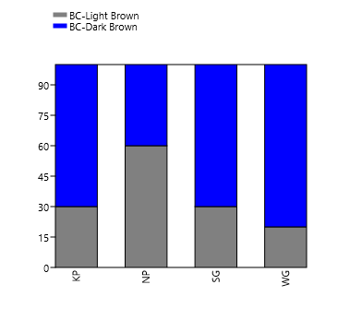(a) Bark color | 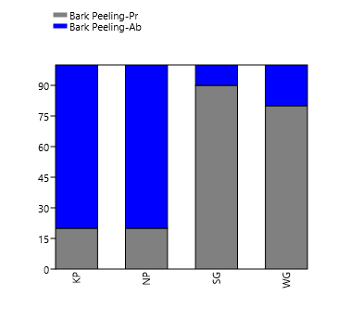  (b) Bark exfoliation
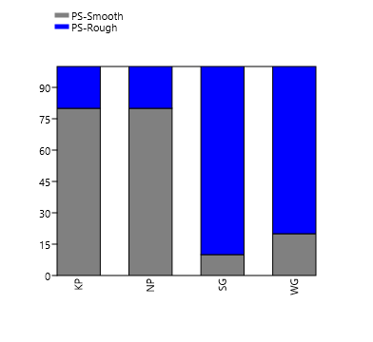
(c) Bark peeled surface texture
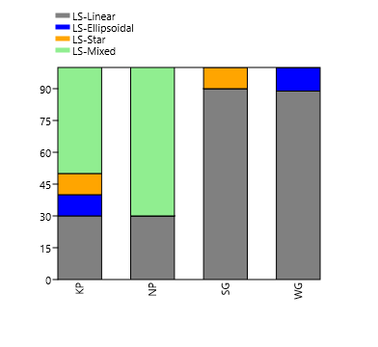(d) Stem lenticel shape | 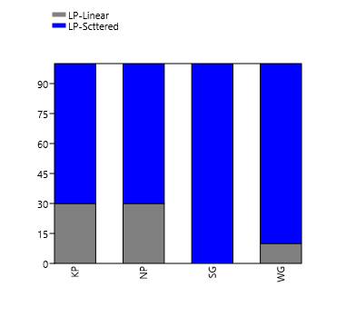(e) Stem lenticel pattern
Fig. 1: Frequency distribution of qualitative stem characteristics (a-e) among the natural populations of M. dubia
Conclusively, dark brown colour of bark was dominant in Waghai, Kaprada and Sagai population (more than 70 %) whereas; light brown in Nanapondha (60 %). Absence of exfoliation and smooth textured surface was dominant bark character in Kaprada and Nanapondha. On the contrary, dominance of presence of exfoliation and rough textured surface was observed in Sagai and Waghai populations. Maximum individuals (>90 %) of Sagai and Waghai individuals were found to have ‘Linear’ shaped lenticels whereas, in Nanapondha and Kaprada, ‘mixed’ shape was dominant. As far as lenticel patterns are concerned, the ‘Scattered’ type was dominant in all studied populations. The structure and appearance of the bark is the unique character in most of the tree species. Many trees can be easily identified by the characteristics of their bark alone. In some species the bark looks similar throughout the life, while in others some changes occur with age (Wolfe and Hitchcock, 2015). However, individuals of same species can alter the bark morphology with the varying level of environmental (drought and frost), biological (fungal and bacterial infection) and mechanical (wind exposure) stimuli (Kales, 2020). In the present study, dominant character of dark brown, exfoliating and rough bark in Sagai and Waghai populations observed whereas, absence of exfoliation and smooth bark was predominantly visualized in Nanapondha and Kaprada population. However, bark colour found to vary in Nanapondha and Kaprada population with as light margin. Since, primary function of bark is to protect stem, exfoliation and roughness of bark is known to takes place with the age, as a matter of getting rid of diseased bark, usually infected with bacterial and fungal growth at young age (Morris and Jansen, 2017). Hence, age of trees in respective population, as evident indirectly from their mean height and diameter might be the cause of such display in bark morphology. The relation of adult stature of tree on bark traits are well documented in M. azedarach by Lev-Yadun and Aloni, (1993) and in other species by Poorter et al. (2014) and Groover, (2017). In addition, the variations in bark colour explained as differential cambial heating (Lev-Yadun, 2019). Lenticels are the distinct pores on stem, known to facilitate gas exchange, necessary for bark photosynthesis. The variety of shapes, sizes and pattern of lenticels can be visible, particularly on smooth bark in many species. The resultant shape variations in this study are suspected as developmental changes over the years, to make them capable in efficient gas exchange, as demonstrated in Avicennia marina by Purnobasuki, (2011). Structural changes in lenticels are also indicated as seasonal modifications, in order to balance transpiration and respiration in Picea abies by Rosner and Kartusch (2003).

CONCLUSION
Morphological variations in the stem characteristics of Melia dubia across four natural populations in South Gujarat. The research highlights distinct differences in bark color, exfoliation, texture and lenticel patterns, suggesting that environmental and biological factors influence these traits. Populations in Waghai and Sagai exhibited rough bark with exfoliation, while Kaprada and Nanapondha populations predominantly displayed smooth bark with no exfoliation. The lenticels in all populations followed a scattered pattern, with varying shapes, notably linear in Waghai and Sagai. These findings emphasize the importance of morphological diversity in the species and underscore the potential for further genetic improvement and conservation efforts in agroforestry applications.
REFERENCES
Bekele, A., & Bekele, E. (2014). Overview: Morphological and molecular markers role in crop improvement programs. International Journal of Current Research in Life Sciences, 3(3), 035-042.
Chanthuru, A., Prabhu, M. M., Aysha, O. S., & Karthik, R. (2014). Evaluation of leaf and root extracts of Melia dubia L. against larvae of Culex quinquefasciatus and five important human pathogens. Biosci Biotechnol Res Asia, 11(1), 207-10.
Chauhan, R. S., Jadeja, D. B., Thakur, N. S., Jha, S. K., & Sankanur, M. S. (2018). Selection of candidate plus trees (CPTs) of Malabar neem (Melia dubia Cav.) for enhancement of farm productivity in south Gujarat, India. International Journal of Current Microbiology and Applied Sciences, 7(5), 3582-3592.
Groover, A. (2017). Age-related changes in tree growth and physiology. eLS. 1-7, 1-7.
Hooker J. D. (1875) “The Flora of British India,” L. Reeve and Co, London, 178 p.
Keles, S. (2020). How anatomical and morphological characteristics affect the flexural properties of two angiosperm species at the sapling stage. BioResources, 15(3), 5843.
Kumar, H. K., & Chauha, J. B. (2019). Assessment of anti-arthritic, anti-inflammatory and antioxidant activity of Melia dubia. Journal of Pharmacognosy and Phytochemistry, 8, 2579-2582.
Lev-Yadun, S. (2019). Why is the bark of common temperate Betula and Populus species white?. International Journal of Plant Sciences, 180(6), 632-642.
Lev-Yadun, S., & Aloni, R. (1993). Bark structure and mode of canopy regeneration in trees of Melia azedarach L. Trees, 7(3), 144-147.
Morris, H., & Jansen, S. (2017). “Bark: its anatomy, function and diversity”. International Dendrochronology Society, pp. 51-61.
Pal, A., Kumar, R., & Tripathi, Y. C. (2016). Antifungal activity of natural colourant from Melia composita bark and its application in functional textile finishing. International Journal of Pharmacy and Pharmaceutical Sciences, 8(5), 387-391.
Parthiban, K. T., Bharathi, A. K., Seenivasan, R., Kamala, K., & Rao, M. G. (2009). Integrating Melia dubia in agroforestry farms as an alternate pulpwood species. APA News, 34, 3- 4.
Poorter, L., McNeil, A., Hurtado, V. H., Prins, H. H., & Putz, F. E. (2014). Bark traits and life‐ history strategies of tropical dry‐and moist forest trees. Functional Ecology, 28(1), 232- 242.
Purnobasuki, H. (2011). Structure of Lenticels on the Pneumatophores of Avicennia marina: as Aerating Device Deliver Oxygen in Mangrove’s root. Journal of Plant Biota, 16, 309- 315.
Rosner, S., & Kartusch, B. (2003). Structural changes in primary lenticels of Norway spruce over the seasons. Iawa Journal, 24(2), 105-116.
Saravanan, V., Parthiban, K. T., Kumar, P., and Marimuthu, P. (2013). Wood characterization studies on Melia dubia cav. for pulp and paper industry at different age gradation. Research Journal of Recent Sciences, 2, 183-188.
Sukhadiya, M. L., Thakur, N. S., Patel, V. R., Gunaga, R. P., Kharadi, V. B., Tyagi, K. K., & Singh, S. (2021). Provenance variations in proximate principles, mineral matter, total phenols and phytochemicals of Melia dubia drupes: an unexplored alternate livestock feed stock. Journal of Forestry Research, 32(1), 119-131.
Suprapti, S., Djarwanto, D., & Hudiansyah, H. (2004). The resistance of five wood species against several wood destroying fungi. Journal Penelitian Hasil Hutan, 22(4): 239– 246.
Suresh, T., & Devakumar, A. S. (2017). Morphological characterization of Melia dubia seeds: implications to germination. Indian Journal of Pure & Applied Biosciences, 5(4): 721– 725.
Troup, R. S. (1921). “Silviculture of Indian Trees”, Clarendon Press. London, U.K., 3: 152.
Uday, D. N., Sujatha, D., & Pandey, C. N. (2011). Suitability of Melia dubia (malabar neem wood) for plywood manufacture. Journal of the Indian Academy of Wood Science, 8(2), 207-211.
Valentina, P., Ilango, K., Kiruthiga, B., & Parimala, M. J. (2013). Preliminary phytochemical analysis and biological screening of extracts of leaves of Melia dubia Cav. International Journal of Ayurveda Research, 4, 417-419.
Wolfe, K., & Hitchcock, A. (2015). Observing nature: learn to identify trees by their bark. New York: McGraw-Hill. Retrieved from https://s3.wp.wsu.edu › uploads › sites › 2014/03 [Accessed 18 June, 2025].

