Assessment of Traffic-Induced Noise Pollution in Ambur Town, Tamil Nadu, India

Abstract:
Noise pollution, an often overlooked environmental issue, significantly impacts human health and quality of life, especially in densely populated and traffic-congested urban areas. This study investigates the extent of traffic-induced noise pollution in Ambur town, a rapidly developing and congested region in Tamil Nadu, India. Sound level measurements were conducted at ten critical locations, including the bus stand, hospital, bypass road, market, railway station (inside and outside), theatre, school, and residential and industrial zones like Nethaji Nagar and Eureka Leather Factory. Noise levels were recorded during peak traffic hours in the morning (6:30–9:25 a.m.) and evening (5:30–9:25 p.m.) using a sound level meter. The results revealed that evening noise levels were consistently higher than morning levels, with nearly 90% of the sites exceeding the ambient noise standards. The highest recorded level was 100 dB at the bypass area, while the lowest was 69 dB near Lakshmi Hospital. Vehicle horns, particularly from buses, trucks, and bikes, were identified as major noise sources. The study highlights the urgent need for noise mitigation strategies in Ambur, especially with increasing vehicular density. It also emphasizes the role of vegetation and green belts as natural barriers to reduce noise levels and improve the urban acoustic environment.
Keywords: Noise pollution, Traffic noise, Ambur town, Sound level meter, Urban environment, Health impacts, Vehicle horns, Ambient noise level, Noise monitoring, Vegetation barriers.
Introduction:
Noise is commonly defined as unwanted or disturbing sound. When sound levels exceed acceptable limits and interfere with daily activities such as sleeping, working, or communication, it becomes noise pollution. Unlike visible forms of pollution, noise cannot be seen, smelled, or tasted, making it a less recognized yet serious environmental issue. The World Health Organization has identified noise as a major threat to human health and well-being. In urban areas, especially in developing countries like India, the rapid increase in population, vehicular traffic, and industrial activities has led to a significant rise in environmental noise levels [6,7].
Traffic noise is now one of the most persistent and widespread forms of pollution in cities, contributing to both auditory and non-auditory health problems including stress, hypertension, sleep disturbances, hearing loss, and cognitive impairments in children [8-10]. Ambur, a semi-urban town in Tamil Nadu, is undergoing rapid urban and industrial development. This study focuses on assessing the vehicular noise levels during peak morning and evening hours at various key locations in the town. Using a sound level meter (SL-4001), noise measurements were taken to understand the intensity and impact of traffic noise on the local environment and community. The findings aim to support future planning and noise mitigation strategies.
Methodology:
Study Area
Ambur town, located in Vellore district, Tamil Nadu (12.7802° N, 78.7177° E), is a major hub for leather, shoe, and sugarcane industries. It comprises 77 villages, with nearly every village hosting at least one shoe factory, contributing to Ambur’s status as a leading exporter of shoes in India. The region houses around 85 leather factories, which significantly impact the local environment, particularly soil and groundwater due to tannery wastewater. While these industries provide vital employment and income to residents, they also contribute to severe environmental issues. Among the 53 firkas in Vellore, Ambur Firka is the most affected by noise pollution.
Study analysis
The study involved monitoring noise pollution levels at key locations in Ambur Town, identified based on high vehicular traffic. Selected sites included the Bus Stand, Lakshmi Hospital, Bypass Road, Rajkamal Theatre, Railway Station (inside and outside), Market Area, Nethaji Nagar, Eureka Leather Factory, and Hindu School. Each location represented different urban characteristics such as road width, building patterns, and traffic flow. Noise levels were recorded using a sound level meter. Periodical monitoring was preferred for its cost-effectiveness. The recorded values were compared with the permissible limits set by the Environmental Protection Rules, 1986 and CPCB standards for noise pollution.
Data Collection:
Data collection is essential for obtaining accurate, defined information to address research questions and assess outcomes effectively. In this study, data on noise pollution in Ambur town were systematically collected to ensure valid and reliable findings. Noise levels were recorded at selected high-traffic locations during morning (6:30 AM–9:25 AM) and evening (5:30 PM–9:25 PM) peak hours. Observations included noise intensity, sources of noise, and vehicle counts categorized by type—buses, cars, two-wheelers, autos, LMVs, and HMVs. Vehicle counts were recorded at two-hour intervals during both peak and non-peak periods.
Noise measurements were taken at distances of 0.90 m and 1.10 m from the nearest road edge, with the instrument placed 1.30 m above road level to reflect human ear height. The EQUINOX EQ-805 Sound Level Meter (IEC 651 TYPE II), using an ‘A’ weighted network, was employed for its accurate correspondence to human hearing sensitivity. This setup ensured reliable data for noise analysis.
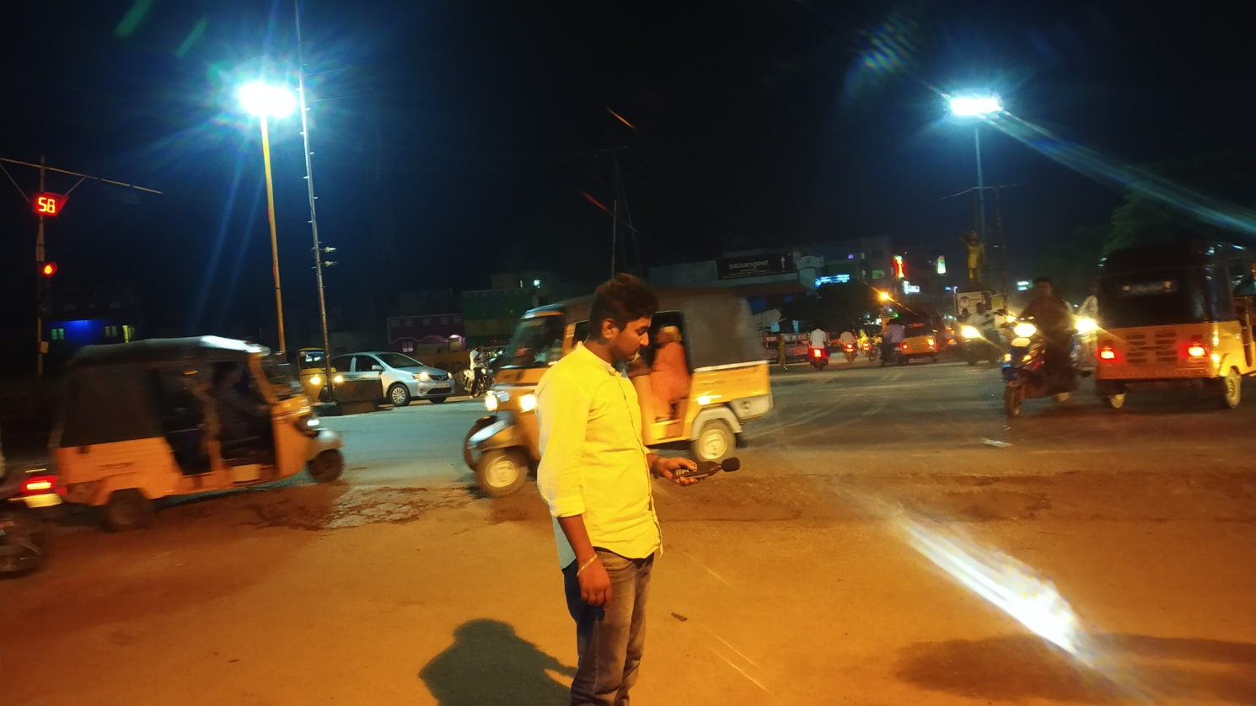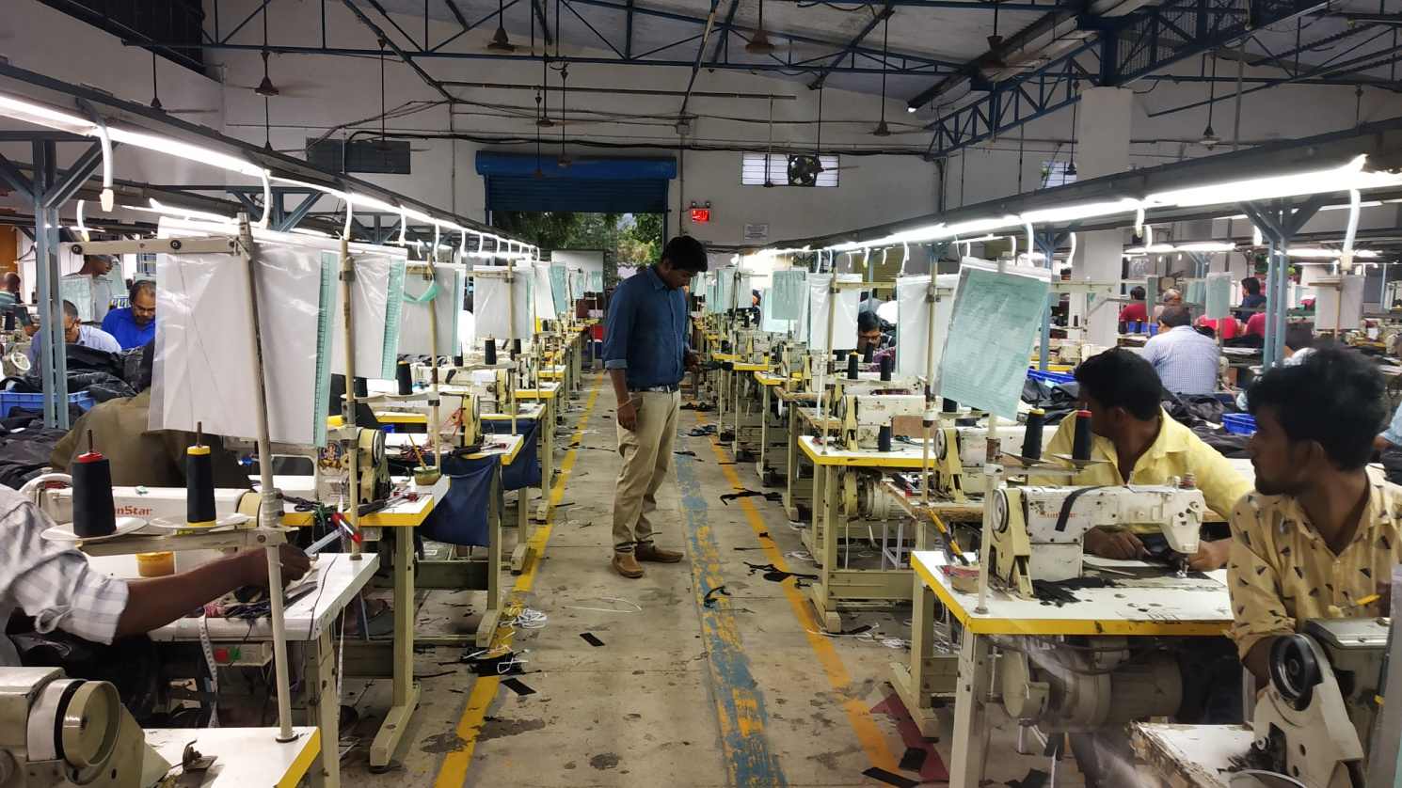
Fig .1 Noise observations at different locations in Ambur town
Results and discussion
Noise Levels Monitored During Morning Hours:
The study of noise pollution in Ambur Town was conducted at ten major locations during morning hours from 6:30 AM to 9:25 AM. Each location was observed for 10 minutes using a digital sound level meter, and the observations included traffic volume, temperature, humidity, and noise levels in decibels (dB). These sites were selected based on their high traffic density and relevance to various urban activities, such as transport hubs, commercial zones, educational institutions, and industrial areas.
At the Ambur Bus Stand, located on the NH-47 connecting Chennai and Bangalore, sound levels ranged between 70 dB and 85 dB. This area, serving as a central transport hub with high vehicular movement—especially heavy vehicles like buses and trucks—exhibited significant noise due to frequent horn usage, with 85 vehicles counted during the observation period (Banerjee et al., 2006; TNIFMC, 2020). The temperature recorded was 25.8°C with 78% humidity. Lakshmi hospital situated on Uma Road in a designated silent zone, recorded sound levels from 65 dB to 75 dB, exceeding the permissible limit of 50–70 dB as per Indian standards. The noise here was primarily from two-wheelers, lorries, and ambulances, with temperature and humidity at 26°C and 76%, respectively (Banerjee et al., 2006; CPCB, 2000). The bypass road, a critical connection between Pernambut and Krishnapuram, experienced the highest traffic with 187 vehicles and noise levels ranging from 80 dB to 95 dB, marking it as one of the most congested roads in Ambur (TNIFMC, 2020). The recorded temperature was 26.5°C with 76% humidity. Rajkamal Theatre located on the national highway, noise ranged from 75 dB to 90 dB. A total of 107 vehicles, mainly bikes, lorries, and buses, contributed to these levels, with temperature at 26.4°C and humidity at 75%. Outside the Railway Station, the noise level was measured between 70 dB and 82 dB with 34 vehicles passing by, mainly autos and bikes. The temperature was 27.6°C with 69% humidity. Inside the Railway Station, noise ranged significantly from 71.5 dB to 104.5 dB due to announcements and train movements, indicating brief but intense noise events. The Market Area, known for its commercial activity, recorded the highest noise level of the entire morning session, reaching 110.7 dB with a minimum of 86.5 dB. Approximately 152 vehicles, including autos, lorries, and bikes, were observed. The temperature was 28.5°C and humidity 65%. In Nethaji Nagar, a densely populated area with schools and leather shops, noise ranged from 82.2 dB to 103.4 dB. The temperature was 29.1°C and humidity 62%, with 149 vehicles recorded. Eureka Leather Factory area, an industrial site, showed noise levels from 77.1 dB to 93.7 dB with 109 vehicles. Temperature and humidity were 32.4°C and 62%, respectively. At Hindu School, located near the bus stand, noise ranged between 72.9 dB and 87.5 dB, with 75 vehicles, mostly bikes and autos, observed. Temperature was 32.4°C and humidity 61%. Overall, the data indicate that all surveyed areas in Ambur Town exceeded the permissible noise limits during morning hours, primarily due to traffic congestion, frequent horn usage, and industrial activities (CPCB, 2000, Vishal Kumar et al., 2023).
Noise Levels Monitored During Evening Hours:
The noise pollution levels were re-assessed during the evening hours (5:30 PM to 9:25 PM) at the same ten key locations in Ambur Town, Tamil Nadu, to compare day and night-time noise variations. Measurements were taken using a sound level meter for 10 minutes at each site with 5-minute intervals.
At Hindu School, sound levels ranged from 71.5 dB to 85.0 dB between 5:31 PM and 5:40 PM, with 96 vehicles passing. The temperature was 29°C and humidity 68%. Rajkamal Theatre, a traffic-prone area, recorded noise from 79.2 dB to 95.3 dB (5:46 PM to 5:55 PM), with 110 vehicles contributing to elevated noise levels. At Eureka Leather Garments, from 6:01 PM to 6:10 PM, the noise ranged between 78.5 dB and 95.7 dB. The temperature was 28.5°C, humidity 71%, and 61 vehicles passed, primarily bikes and autos. In the Market Area, which becomes busier in the evening, the noise levels rose to between 89.1 dB and 102.6 dB (6:16 PM–6:25 PM). Temperature and humidity were 28°C and 75%, with 106 vehicles contributing.
Outside the Railway Station, evening levels from 6:31 PM to 6:40 PM ranged from 77.8 dB to 94.2 dB, slightly higher than morning due to increased vehicle flow (48 vehicles). Inside the station (7:01 PM–7:10 PM), levels ranged from 71.5 dB to 105.2 dB, impacted by announcements and train crossings (Vishal Kumar et al., 2023). At Nethaji Nagar (7:16 PM–7:25 PM), a densely populated area, noise levels ranged from 82.2 dB to 103.4 dB with 156 vehicles. Lakshmi Hospital, a silent zone, recorded 70.5 dB to 86.6 dB (7:31 PM–7:40 PM), exceeding permissible limits due to 91 vehicles, including ambulances and lorries. Ambur Bus Stand (7:46 PM–7:55 PM) recorded levels from 81.5 dB to 94.1 dB, with 127 vehicles. Heavy honking from buses and trucks was the main source. Finally, at the Bypass Road (8:16 PM–8:25 PM), the noise peaked at 107.6 dB, with a low of 87.5 dB. Temperature was 26.5°C, humidity 72%, and 155 vehicles were counted. Overall, noise levels during evening hours were generally higher due to increased traffic congestion and human activity, especially in commercial and transit zones (Tamil Nadu Urban Flagship Investment Program, 2021; Vishal Kumar et al., 2023). Most sites exceeded permissible noise limits, indicating a critical need for noise control interventions (CPCB, 2000, Vishal Kumar et al., 2023).
The analysis clearly indicates that noise levels in all surveyed locations of Ambur town exceed the permissible limits prescribed under the Environmental Protection Rules, 1986, which set the allowable noise for commercial areas at 65 dB during the day and 55 dB at night. Observations show consistent noise levels ranging from 70 dB to over 100 dB, especially during peak traffic hours—between 8:00–9:00 AM and 4:00–6:30 PM. Noise sources primarily include vehicular traffic, frequent honking, engine idling, and crowd activity in market and bus stand areas. Prolonged exposure to such high noise levels can lead to both auditory and non-auditory health effects. Continuous exposure to 60–80 dB can result in irreversible hearing loss, while noise levels above 85 dB are linked to increased risks of hypertension, heart disease, sleep disturbances, mental stress, and lack of concentration (Bhargava, 2001; Singh, 1984). In some locations like markets and railway stations, noise levels exceeded 100 dB multiple times in a short span, indicating severe pollution and immediate need for intervention. Research has shown noise from household appliances and vehicles often exceeds safe limits, leading to health issues like mental fatigue, hypertension, and headaches (Nagi et al., 1993).This ecological disruption, combined with the human health impacts, underlines the urgent need for strict enforcement of existing laws, increased public awareness, and effective urban planning to mitigate noise pollution in growing towns like Ambur.
Sl.No | Location | Time  (am) | Noise level (dB) | Time  (pm) | Noise level (dB)
1 | Bustand | 6.30-6.40 | 78 | 5.30-5.40 | 87
2 | Lakshmi hospital | 6.45-6.55 | 70 | 5.45-5.55 | 77
3 | ByePass road | 7.00-7.10 | 86 | 6.00-6.10 | 93
4 | Rajkamal theater | 7.15-7.25 | 82 | 6.15-6.25 | 84
5 | Raliway station outside | 7.30-7.40 | 78 | 6.30-6.40 | 82
6 | Railway station inside | 8.00-8.10 | 91 | 7.00-7.10 | 88
7 | Market area | 8.15-8.25 | 95 | 7.15-7.25 | 93
8 | Nethaji nagar | 8.30-8.40 | 94 | 7.30-7.40 | 90
9 | Eureka leather garments | 8.45-8.55 | 90 | 7.46 -7.55 | 86
10 | Hindhu school | 9.15-9.25 | 80 | 8.16-8.25 | 80

Table.1 Noise level observarions recorded in different locations in Ambur town

Conclusion:
The findings from Ambur town highlight a critical public health and environmental issue: noise levels in all surveyed locations consistently exceed the permissible limits set by the Environmental Protection Rules, 1986. Persistent exposure to such high decibel levels, especially during peak traffic hours and special events, poses significant risks of hearing loss, cardiovascular disease, mental stress, and impaired cognitive function. The situation is exacerbated by unregulated use of loudspeakers and frequent violations of noise control laws, impacting not only human residents but also local wildlife. These results underscore the urgent need for comprehensive noise management strategies, including strict enforcement of existing regulations, greater public awareness, and improved urban planning. Without immediate intervention, the escalating noise pollution in Ambur threatens both community well-being and ecological balance, making it imperative for authorities and citizens alike to prioritize noise mitigation efforts for a healthier, more sustainable urban environment.
References:
- Bhargava, S.K. (2001). Environmental Noise Pollution in India: Its Impact and Control. In: Proceedings of the International Conference on Environmental Pollution, New Delhi, India.
- Central Pollution Control Board (CPCB). (2000). Ambient air, automobiles, fuels, industries and noise: Environmental Standards. Pollution Control Law Series: PCLS/4/2000–2001. Ministry of Environment & Forests, Government of India, New Delhi
- Nagi, G.K., Dhillon, M.K., & Dhillon, M.S. (1993). Noise pollution: Sources, effects and control. Indian Journal of Environmental Protection, 13(4), 278-281
- Singh, N. (1984). Noise Pollution and Human Health. Indian Journal of Environmental Health, 26(2), 136-143
- Vishal Kumar et al., (2023). Assessment of Noise Pollution and Health Impacts of the Exposed Population in an Urban Area. Nature Environment and Pollution Technology, 22(3), 1141-1147.
- Islam, M. T., Nahar, N., Islam, M. J., Islam, M. A., & Hossen, M. A. M. (2015). Traffic induced noise pollution and its impact on human health in Chittagong city corporation. Journal of Environmental Science and Natural Resources, 8(2), 37-40.
- Tang, U. W., & Wang, Z. S. (2007). Influences of urban forms on traffic-induced noise and air pollution: Results from a modelling system. Environmental Modelling & Software, 22(12), 1750-1764.
- Dubey, P., Singh, K. R., & Goyal, S. K. (2024). Assessment of traffic-induced noise pollution using correspondence analysis. Innovative Infrastructure Solutions, 9(4), 89.
- Chowdhury, R. B., Dey, R., Alam, M. S., & Chakraborty, P. (2010). Extent of traffic induced noise in the noise sensitive institutions of Chittagong city, Bangladesh. Noise & Vibration Worldwide, 41(1), 28-36.
- Hoque, M. M. M., Islam, M. A., & Kabir, M. H. (2020). Traffic induced noise level in different places at the Dhaka capital city of Bangladesh. Bangladesh J. Environ. Sci, 38, 41-46.

