Expression of sialic acid α2-3, α2-6 and Galectin 3 in MCF cells stimulated with TNFα

ABSTRACT
Protein sialylation has been demonstrated to play a role in tumour progression and metastasis. Elevated levels of sialic acid have been shown to interfere with receptor-ligand interactions, thereby providing a protective barrier for tumour cells against the immune system. Galectin 3 is a protein that binds to β-galactosides, and its increased expression is required for proliferation, angiogenesis and the inhibition of apoptosis in cancer cells. In this study, the expression levels of sialic acid α2-3, α2-6 and Galectin 3 in MCF-7 cells stimulated with TNF α were determined using flow cytometry and fluorescence microscopy. The percentage of cells expressing α2, 3 sialic acid recognised by the Maackia amurensis lectin increases at four hours. In the case of α2, 6 sialic acid recognised by the Sambucus nigra lectin, exhibited a higher intensity at 6 hours. Furthermore, the expression of both α-2,3 and α-2,6 sialic acid was observed on the cell surface. The results obtained for Galectin 3 demonstrated a decrease in expression relative to unstimulated cells. Galectin-3 expression was predominantly observed in the nucleus and cytoplasm. These results suggest that alterations in the expression of sialic α2,3 and α2,6 and galectin-3 may promote tumour cell migration; however, further research is required to validate this hypothesis.

Keywords: Tumor Necrosis Factor- α, human, Lectin, MCF-7, Sialic Acid.

1. INTRODUCTION
Protein sialylation plays a significant role in regulating cellular properties by interfering with the function of the associated proteins. Altered sialylation status is associated with cancer since sialylation of glycoproteins regulates cellular properties such as cell–cell and cell–matrix adhesion, migration of cells, response towards extracellular stimuli, and interaction with immune cells (Nardy et al., 2016). Expression of sialic acid is often upregulated in breast cancer; sialic acid shields the cancer cells from immune surveillance by masking tumor epitopes and thereby reduces the antitumor immunity and alternative complement activation (Zhang et al., 2018; Lübbers et al., 2018). Sialic acid is involved in the regulation of immune cells by binding to receptors of the SIGLECS (sialic-acid-binding immunoglobulin-like lectins) family of immune effector cells such as NK and T cells by inducing inhibitory tyrosine motifs (Nagasundaram et al., 2020). Sialic acid an act as ligands for selectins and aid the metastatic cancer cells to bind to the target site (Vajaria et al., 2015). Thus, Sialic acid could play a role in breast cancer pathogenesis.
Galectin-3 is a Mr 31,000 protein. It belongs to a family of carbohydrate-binding proteins. This protein family has an affinity for β-galactoside which contains conserved amino acid sequences and glycoconjugates in their carbohydrate-binding domain (Liu et al., 2005; Boutas et al., 2021). Galectin-3 has a vital role to play in cell growth, invasion, tumor progression and protection against apoptosis via a cell to cell or a cell to matrix adhesion process (Boutas et al., 2021). The expression of Galectin-3 has been associated with the progression of the breast cancer disease and the metastasis that may incur by using human breast cancer cell lines (Honjo et al., 2001; Song et al., 2015). Galecrin-3 is therefore considered to be a tumor-associated antigen of breast cancer (Lin et al., 2015).
Tumor necrosis factor-α (TNF-α) is an important pro-inflammatory cytokine found in the tumor microenvironment that is involved in all stages of breast cancer development, affecting tumor cell proliferation and survival, epithelial-to-mesenchymal transition (EMT), metastasis and recurrence (Cruceriu et al., 2020) TNF-α belongs to the TNF/TNFR superfamily of cytokines, being a type II transmembrane protein. It can, however, act both as a membrane-integrated protein and as a soluble molecule in the initiation of different signaling pathways, by interacting with its two specific receptors: TNFR1 (TNFRSF1A) and TNFR2 (TNFRSF1B). TNFR1 is expressed on the surface of many types of cells, including tumor epithelial cells, while TNFR2 is mainly found as a transmembrane protein in hematopoietic cell (Balkwill et al., 2006). TNF-α stimulates proliferation in T47D cells (Rubio, et al., 2006; Rivas et al., 2008) and exhibits proapoptotic (Simstein, et al., 2003; Donato et al., 2004) and antimitotogenic (Jeoung et al., 1995) activities in MCF7 cells. In MCF cells, TNF-α was found to induce cell cycle arrest in the G1 phase in a dose- and time-dependent manner, increasing the expression of the tumour suppressor protein p53 and the cell cycle inhibitor protein Cip1 (p21).
The present study aimed to evaluate the expression of sialic acid α2-3, α2-6 and Galectin-3 in MCF-7 cells stimulated with Tumor necrosis factor-α.
2. MATERIALS AND METHODS
2.1 Chemicals and lectins
Lectins from Maackia amurensis and Sambuccus nigra labeled with fluorescein were obtained from Vector Laboratories (Burlingame, CA USA). Galectin 3 antibody conjugated with phycoerythrin (PE) was obtained from Invitrogen (Carlsbad, CA USA). Gibco™ Dulbecco's modified Eagle's medium (DMEM), penicillin-streptomycin solution, and L-glutamine were purchased from Thermo Fisher Scientific, Inc. (Waltham, MA, USA). Hyclone™ fetal bovine serum (FBS) was obtained from GE Healthcare Life Sciences (Logan, UT, USA). Tumor Necrosis Factor- α, human, from Sigma, St Louis, MO, USA) were stored in a stock solution of 1 mg/ml at −20°C until use.
2.2 Cell culture
MCF-7 cells were purchased from the American Type Culture Collection and maintained in dulbecco modified Eagles minimal essential medium (DMEM), supplemented with 1% penicillin/streptomycin antibiotics (Gibco CA), 1% glutamine and 10% fetal bovine serum (Gibco CA) in 75 cm culture bottle, incubated at 37 ° C and 5% CO₂, until obtaining a confluence of 80%.

2.3 Cells stimulation with TNF α
Total Cells (2 x 10⁵) were seeded in six-well plates until obtaining a confluence of 80 and were treated for 2, 4, and 6 hours with TNF α at 5 ng/mL after incubation cells were washed three times with phosphate-buffered saline (PBS) containing. Cells are detached with trypsin at 0.5% and placed in an Eppendorf fixed with 200 µl of 1% formaldehyde for 15 minutes and then washed again with PBS. After TNF α stimulation, cells were incubated with Maackia amurensis lectin or Sambuccus nigra lectin at 5 µg/ml or with anti-Galectin 3 antibody conjugated with phycoerythrin (PE) used at 1:100. for flow cytometry or immunofluorescence assays. Cell viability was 95%. Untreated cells were used as a control.
2.4 Flow Cytometry analysis
Cells with TNF α treatment or without treatment were analysed by indirect immunofluorescence. In brief, cells were permeabilized with perm/wash buffer (BD Biosciences US) according to the manufacturer's instructions. Total Cells (2 x 10⁵) were incubated with 200 µl of Maackia amurensis or Sambuccus nigra lectins at 5 µg/ml for 90 min at 37°, or with anti-Galectin 3 antibody conjugated with phycoerythrin (PE) used at 1:100, subsequently, the cells were washed with PBS for 5 minutes and resuspended in 500 µl of PBS. Analysis of the MCF-7 region was performed according to cell size and granularity; Debris and dead cells were excluded using side scatter and forward scatter plots. Ten thousand events were acquired in Attune NxT Cytometer (Applied Biosystems). The FlowJo® software package (version 10.0) was used for analyzing flow cytometry data.
2.5 Immunofluorescence Microscopy
Total Cells (2 x 10⁵) were seeded in eight well chamber slides (LAB-TEK Brand Products Thermo Fischer Scientific) until obtaining a confluence of 80% and were treated with TNF α at 5 ng/mL during 2, 4, and 6 hrs. After incubation, cells were washed three times with PBS and permeabilized with perm/wash buffer (BD Biosciences US) according to the manufacturer's instructions. Cells were incubated with 200 µl of Maackia amurensis or Sambuccus nigra lectins at 5 µg/ml for 90 min at 37°or with anti-Galectin 3 antibody conjugated with phycoerythrin (PE) used at 1:100, after incubation cells were washed with PBS for 5 minutes. The slides were removed from the incubator and 1µl of DAPI was added and covered with a coverslip. The lectins binding was visualized using a green filter, Galectin 3 was visualized using a red filter and DAPI was visualized using a blue filter. The slides were viewed under an Axioscop 40 microscope (Zeiss, Germany) and micrographs were analyzed using ZEN 2011 Software (Zeiss, Germany). Control experiments consisted of incubation of lectin with sialic acid α2-3 or α2-6 at 200 mM for 30 minutes before adding it to the cells.
2.6 Statistical analysis
All statistical analyses were performed using SPSS (Statistical Package for the Social Sciences) software (version 16; SPSS Inc., Chicago, IL, USA) to demonstrate that the data groups came from the same population; a unidirectional-univariate analysis performed using the non-parametric Kruskal-Wallis test (from William Kruskal and W. Allen Wallis). To isolate the group or groups that differ from the others (statistically significant difference), a multiple comparison procedure (Tukey's test) was used.
3. RESULTS
Figure 1 shows the results of α2,3-sialic acid expression in MCF-7 cells stimulated with TNF-α at 2, 4 and 6 h. The results showed that α2,3-sialic acid recognized by MAA lectin (Maackia amurensis) was expressed in the plasma membrane of MCF-7 cells, in cells that did not receive stimuli and in cells stimulated with TNF-α at 2, 4, and 6 hours.
Statistical analysis of mean fluorescence intensities revealed no statistical significance in unstimulated cells and cells stimulated at 2, 4 and 6 hours.

MCF-7 cells MAA-Lectin u/c 2 hrs TNF-α 4 hrs TNF-α 6 hrs TNF-α
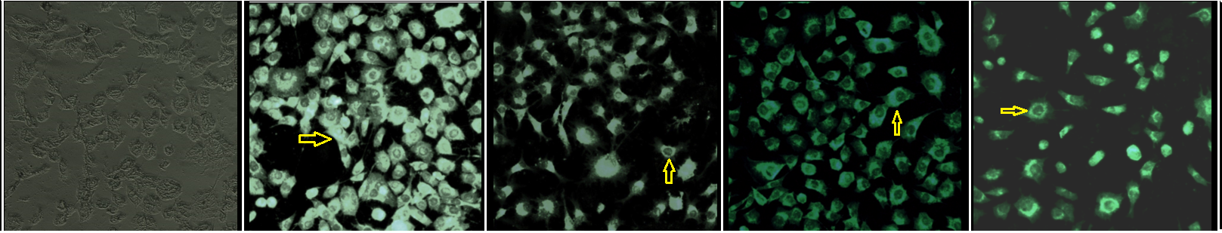
Figure 1. Effect Tumor necrosis factor-α (TNF-α) on α2,3-sialic acid expression in MCF-7 cells. MCF-7 cells were stimulated with TNF-α 5 ng/ml at 2, 4 and 6 hours, then incubated with Maackia amurensis lectin (MAA). The lectin labelling in green. The yellow arrow indicates lectin recognition. Micrographs at 20X. The results are from a representative experiment of three independent experiments.

Figure 2 shows the results of α2,6-sialic acid expression in MCF-7 cells stimulated with TNF-α at 2, 4 and 6 h. The results showed that α2,6-sialic acid recognized by SNA lectin (Sambuccus nigra) was expressed in the plasma membrane of MCF-7 cells, in cells that did not receive stimuli and in cells stimulated with TNF-α at 2, 4, and 6 hours. Statistical analysis of the mean fluorescence intensities shows an increase in the expression of α2,6 sialic acid at 6 hours of stimulus (p= 0.04)
MCF-7 cells SNA-Lectin u/c 2 hrs TNF-α 4 hrs TNF-α 6 hrs TNF-α
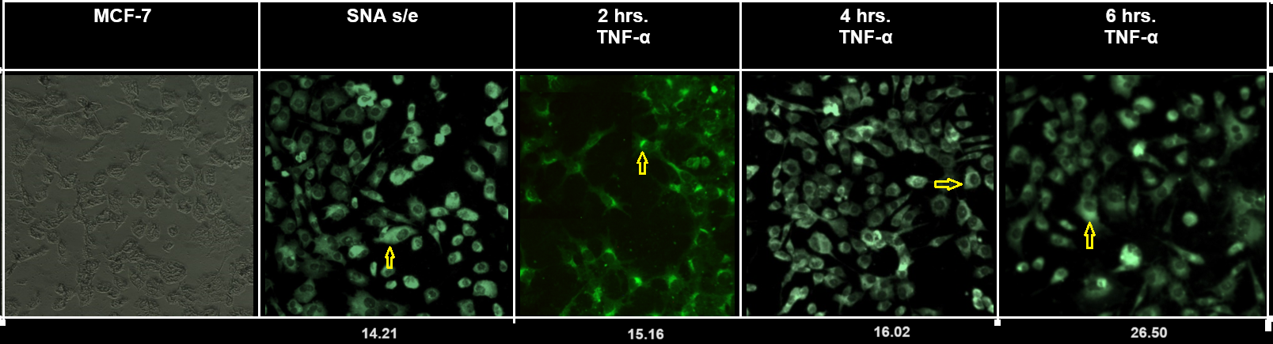
Figure 2. Effect Tumor necrosis factor-α (TNF-α) on α2,3-sialic acid expression in MCF-7 cells. MCF-7 cells were stimulated with TNF-α 5 ng/ml at 2, 4 and 6 hours, then incubated with Sambuccus nigra lectin (SNA). The lectin labelling in green. The yellow arrow indicates lectin recognition. Micrographs at 20X. The results are from a representative experiment of three independent experiments.

Figure 3 shows the results of galectin-3 expression in MCF-7 cells stimulated with TNF-α at 2, 4 and 6 h. The results showed that gakectin-3 was expressed in in cytoplasm and nucleus of MCF-7 cells, in cells that did not receive stimuli and in cells stimulated with TNF-α at 2, 4, and 6 hours. Statistical analysis of the mean fluorescence intensities shows no statistically significant differences.
MCF-7 cells Galectin-3 u/c 2 hrs TNF-α 4 hrs TNF-α 6 hrs TNF-α
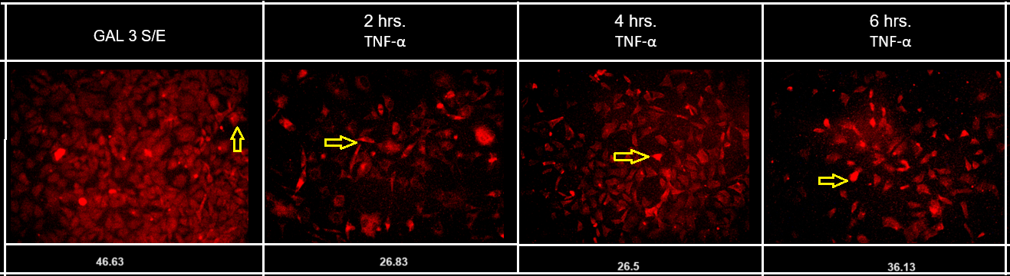
Figure 3. Effect Tumor necrosis factor-α (TNF-α) on Galectin-3 expression in MCF-7 cells. MCF-7 cells were stimulated with TNF-α 5 ng/ml at 2, 4 and 6 hours, then incubated with anti-Galectin-3 antibody. The lectin labelling in red. The yellow arrow indicates lectin recognition. Micrographs at 20X. The results are from a representative experiment of three independent experiments

Figure 4 shows the Immunofluorescence results of the expression of α2,3-sialic acid and Galectin-3 expression in MCF-7 cells stimulated with TNF-α at 2, 4 and 6 h.
The results showed colocalization in the cell membrane and cytoplasm, mainly in unstimulated cells and in cells stimulated for two hours with TNF, but colocalization decreased after four and six hours of stimulation.
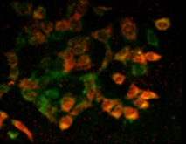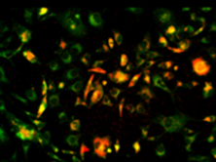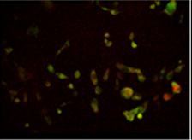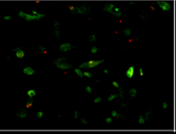
B
D
C
A

Figure. 4. Double-labelling Immunofluorescence (A) Unstimulated cells (B) The cells were stimulated with TNF-α for two hours and then incubated with Maackia amurensis lectin labeled with fluorescein (MAA) for two hours and finally incubated with monocolonal anti-galectin-3 antibody labeled with PE for two hours. (C). The cells were stimulated with TNF-α for four hours and then incubated with Maackia amurensis lectin labeled with fluorescein (MAA) for two hours and finally incubated with monocolonal anti-galectin-3 antibody labeled with PE for two hours. (D) The cells were stimulated with TNF-α for six hours and then incubated with Maackia amurensis lectin labeled with fluorescein (MAA) for two hours and finally incubated with monocolonal anti-galectin-3 antibody labeled with PE for two hours. In all cases the merge is presented. The green channel is for MAA lectin, The red channel is for anti-galectin-3 antibody, yellow arrows indicate colocalization in any case. Micrographs at 20X. The results are from a representative experiment of three independent experiments

Figure 5 shows the Immunofluorescence results of the expression of α2,6-sialic acid and Galectin-3 expression in MCF-7 cells stimulated with TNF-α at 2, 4 and 6 h. The results showed colocalization in cytoplasm in unstimulated cells and in TNF-stimulated cells at two and four hours, while no colocalization was observed at six hours.

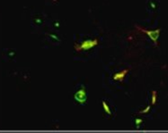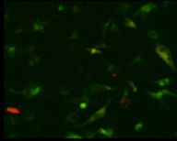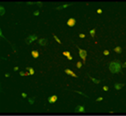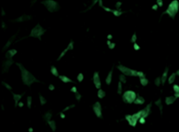
B
C
A

Figure. 5. Double-labelling Immunofluorescence (A) Unstimulated cells (B) The cells were stimulated with TNF-α for two hours and then incubated with Sambuccus nigra lectin labeled with fluorescein (SNA) for two hours and finally incubated with monocolonal anti-galectin-3 antibody labeled with PE for two hours. (C) The cells were stimulated with TNF-α for four hours and then incubated with Sambuccus nigra lectin labeled with fluorescein (SNA) for four two and finally incubated with monocolonal anti-galectin-3 antibody labeled with PE for two hours. (D) The cells were stimulated with TNF-α for six hours and then incubated with Sambuccus nigra lectin labeled with fluorescein (SNA) for two hours and finally incubated with monocolonal anti-galectin-3 antibody labeled with PE for twp hours. In all cases the merge is presented. The green channel is for MAA lectin, The red channel is for anti-galectin-3 antibody, yellow arrows indicate colocalization in any case. Micrographs at 20X. The results are from a representative experiment of three independent experiments

Figure 6 shows the flow cytometry results for the expression of α2,3 sialic acid recognized by Maackia amurensis lectin (MAA) and α2, 6 sialic acid recognized by Sambucus nigra lectin (SNA). In the case of Maackia amurensis lectin (MAA), the results showed that on average 67% of the population expressed sialic acid in unstimulated cells, while at 2 hours 62% of the cells expressed sialic acid, at 4 hours of 85% the cells expressed sialic acid and at 6 hours 71% of the cells expressed sialic acid (Figure 6 A). Statistical significance is observed at four hours (p=072) in comparison with 2 and 6 hours of TNF stimulation.
In the case of Sambucus nigra lectin (SNA), the results showed that on average 41% of the population expressed sialic acid in unstimulated cells, while at 2 hours 44% of the cells expressed sialic acid, at 4 hours 54% of the cells expressed sialic acid and at 6 hours 69% of the cells expressed sialic acid. (Figure 6 B). Statistical analysis shows significant changes at six hours (p=0.04) in comparison to cells stimulated with TNF for two and four hours.
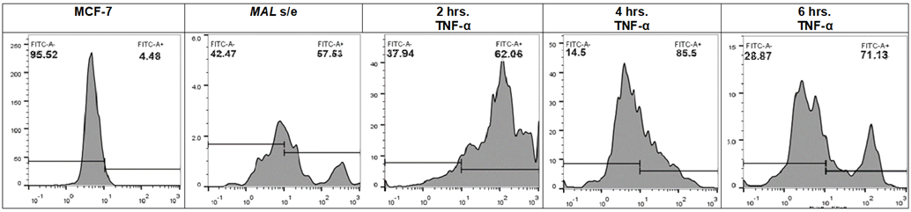
MAA-FTC LECTIN
RELATIVE CELLS NUMBER
A)
CONTROL UNSTIMULATED CELLS 2 HOURS 4 HOURS 6 HOURS

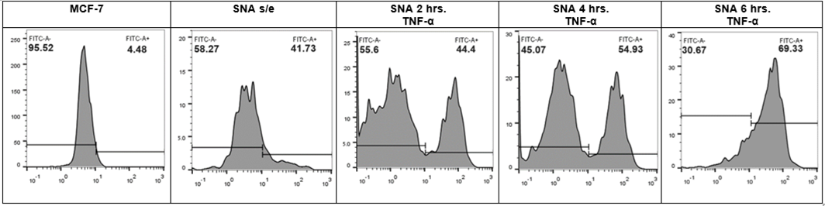
SNA-FTC LECTIN
B)
CONTROL UNSTIMULATED CELLS 2 HOURS 4 HOURS 6 HOURS

Figure 6 Effect of TNF-α on α2,3 and α2,6 sialic acid expression in the breast cancer cell line MCF-7 by flow cytometry. MCF-7 cells were treated with 5 ng/ml TNF-α for 2,4 and 6 h. Control and treated cells were incubated for 1.5 h under dark conditions with FITC-conjugated Maackia amurensis (MAA) lectin and FITC-conjugated Sambucus nigra (SNA) at 5 µg/ml. In A result for the expression of α2,3 sialic acid recognized by Maackia amurensis lectin (MAA). Populations expressing α2,3-sialic acid increase after 4 hours of TNF-α stimulation. In B. Populations expressing α2,6-sialic acid increase at 4 hours of stimulation and decrease at 6 hours of TNF-α stimulation. The results are from a representative experiment of three independent experiments.

4. DISCUSSION
Cell surface carbohydrates are characteristic of the cell type and are specifically expressed according to the stage of development of the cells or tissues (Lis et al., 1993). In neoplasms, this normal cell expression is modified, which favors tumor progression in some cases due to interactions of carbohydrates with ligands that promote dissemination or alter the normal recognition by components of the immune response against tumor (Varki et al., 2017). Sialylation of glycoconjugates is mediated by different sialyltransferase enzymes that can establish different types of bonds, for example, an α2-3 or α2-6 bond to galactose (Gal); through an α2-6 bond with N-acetylgalactosamine (GalNAc) or N-acetylglucosamine (GlcNAc); or an α2-8 bond with another sialic acid, forming poly(sialic acid) (Videira et al., 2009). The mechanisms that lead to altered glycan structures in cancer cells involve changes in epigenetics, genetic mutations, dysregulated expression of glycosyltransferase and chaperone genes, and mislocalization of glycosyltransferases (Munkley et al., 2016). These changes can be studied using sialic acid-specific lectins.
Galectin‐3 plays an important role in several types of cancer, such as thyroid cancer, lung cancer, ovarian cancer, and pancreatic cancer (Chen et al., 2022). Galectin‐3 enhances the activity and invasiveness of tumor cells, inhibits apoptosis, and promotes angiogenesis and metastasis (Chen et al., 2022).
In the present study, the expression of α2,3 and α2,6 sialic acids in MCF-7 cells when treated with 5 ng TNF-α was assessed using fluorescence microscopy and cytometry. α2,3 and α2,6 sialic acids were expressed in the plasma membrane of MCF-7 cells; at 2 and 4 hours, while at 6 hours there was an increase in the expression of sialic acid recognized by Sambucus nigra lectin. studies on the expression of α2,3 and α2,6 sialic acid using LPS liposaccharide show similar results in the expression of sialic acid in the cell membrane, but its expression varies with incubation time (Olivera et al., 2024; Akasov et al., 2016).
The expression of α2,3 sialic acid recognized by Maackia amurensis lectin (MAA) 67.6 % of the population expressed sialic acid in unstimulated cells, while at 2 hours 62 % of the cells expressed sialic acid, at 4 hours of 85 % the cells expressed sialic acid and at 6 hours 71% % of the cells expressed sialic acid. The expression of α2,3 sialic acid recognized by Sambucus nigra lectin (SNA), 41.7 % of the population expressed sialic acid in unstimulated cells, while at 2 hours 44.4 % of the cells expressed sialic acid, at 4 hours 54.9 % of the cells expressed sialic acid and at 6 hours 69.3 % of the cells expressed sialic acid. Populations expressing α2,3-sialic acid increase at four hours of TNF-α treatment, while populations expressing α2,6-sialic acid increase at six hours of TNF-α treatment, decreasing at four and six hours of treatment, identifying the possibility of differential expression of the sialyltransferases. time (Akasov et al., 2016).
TNF serves as a ligand for two receptors, tumor necrosis factor receptor 1 (TNFR1) and tumor necrosis factor receptor 2 (TNFR2). Signaling by TNFR1 can promote either cell survival or cell death, depending upon cell context (Ting.et al., 2016; Varfolomeev et al., 2018; Preedy et al., 2024). The effects of glycosylation on TNFR1 structure and function have received limited attention. TNFR1-mediated apoptosis is inhibited by the addition of α2-6-linked sialic acids to the N-glycans on TNFR1 (Holdbrooks.et al., 2018; Alexander et al., 2020; Liu et al., 2011). Inhibition of ST6GAL1 mediated α2-6 sialylation in HEK293 cells, causes an increase in apoptosis, when ST6GAL1 activity is re-established, TNFR1 sialylation is favored and apoptosis is decreased (Hwang et al., 2025).
The expression of Galectin-3 in MCF-7 cells when treated with five ng TNF-α was assessed using fluorescence microscopy and cytometry. Galectin-3 expression was observed in the cytoplasm and cell membrane. The percentage of the population expressing Galcetin-3 in unstimulated cells was 56.5% at 2 hours of stimulation 46.9%, at 5 hours of stimulation 47.9% and at 6 hours of stimulation 46.1%.
Galectin-3 protects cells from apotosis through its interaction with Bcl-2 by inbiation of Tumor necrosis factor (TNF)–related apoptosis-inducing ligand (TRAIL) (Oka et al., 2005). Galectin-3 bind to β-galactosides, However, when they are sialylated in the α 2,6 position, they are not recognized by galectin-3. (Zhuo et al., 2011). TNF-α regulates the proteolytic degradation of ST6Gal-1, by an increase in the activity of β-site amyloid precursor protein enzyme 1 (BACE1) (Deng et al., 2017).
6. CONCLUSIONS
The results of the present study suggest that TNF-α causes an alteration in the expression of α2,3 and α2,6-sialic acid and galectin-3, which may promote tumour cell migration; however, further research is required to validate this hypothesis.
7. DISCLAIMER (ARTIFICIAL INTELLIGENCE)
Authors hereby declare that NO generative AI technologies such as Large Language Models (ChatGPT, COPILOT, etc) and text-to-image generators have been used during writing or editing of this manuscript.

REFERENCES.
Akasov, R. Haq, S. Haxho, F. Samuel, V. Burov, S.V. Markvicheva, E. Neufeld, R.J. Szewczuk, M.R. (2016). Sialylation transmogrifies human breast and pancreatic cancer cells into 3D multicellular tumor spheroids using cyclic RGD-peptide induced self-assembly. Oncotarget. 4;7(40):66119-66134. doi: 10.18632/oncotarget.11868.
Alexander, K.L. Serrano, C.A. Chakraborty. A. Nearing, M. Council, L.N. Riquelme A., Bellis, S.L. Smythies, L.E. Smith, P.D. (2020). Modulation of glycosyltransferase ST6Gal-I in gastric cancer-derived organoids disrupts homeostatic epithelial cell turnover. J. Biol. Chem, 295:14153–14163. doi: 10.1074/jbc.RA120.014887.
Balkwill, F. (2006). TNF-alpha in promotion and progression of cancer. Cancer Metastasis Rev, 25, 409–416.
Boutas I, Potiris A, Makrakis E, Messaropoulos P, Papaioannou G.K, Kalantaridou S.Ν. (2021). The expression of Galectin-3 in breast cancer and its association with metastatic disease: a systematic review of the literature. Mol Biol Rep. 48, (1):807-815. doi: 10.1007/s11033-020-06122-x.
Chen, Y. Xu, J. Pan, W. Xu, X. Ma, X. Chu, Y. Wang, L. Pang, S. Li, Y. Zou, B. Zhou, G. Gu, J. (2022) Galectin-3 enhances trastuzumab resistance by regulating cancer malignancy and stemness in HER2-positive breast cancer cells. Thorac. Cancer, 13:1961-1973. doi: 10.1111/1759-7714.14474.
Cruceriu D, Baldasici O, Balacescu O, Berindan-Neagoe I. (2020). The dual role of tumor necrosis factor-alpha (TNF-α) in breast cancer: molecular insights and therapeutic approaches. Cell Oncol (Dordr), 43, (1):1-18. doi: 10.1007/s13402-019-00489-1.
Deng, X. Zhang, J. Liu, Y. Chen, L. Yu, C. (2017). TNF-α regulates the proteolytic degradation of ST6Gal-1 and endothelial cell-cell junctions through upregulating expression of BACE1. Sci Rep, 16;7:40256. doi: 10.1038/srep40256.
Donato, N.J. Klostergaard, J. (2004) Distinct stress and cell destruction pathways are engaged by TNF and ceramide during apoptosis of MCF-7 cells. Exp Cell Res, 294, 523–533.
Holdbrooks, A.T. Britain, C.M. Bellis, S.L. (2018). ST6Gal-I sialyltransferase promotes tumor necrosis factor (TNF)-mediated cancer cell survival via sialylation of the TNF receptor 1 (TNFR1) death receptor. J. Biol. Chem, 293:1610–1622. doi: 10.1074/jbc.M117.801480.
Honjo Y, Nangia-Makker P, Inohara H, Raz A (2001) Down-regulation of galectin-3 suppresses tumorigenicity of human breast carcinoma cells. Clin Cancer Res, 7, 661–668.
Hwang, J. Rao, T.C. Tao, J. Sha, B. Narimatsu, Y. Clausen, H. Mattheyses, A.L. Bellis, S.L. (2025). Apoptotic signaling by TNFR1 is inhibited by the α2-6 sialylation, but not α2-3 sialylation, of the TNFR1 N-glycans. J Biol Chem, 301(1):108043. doi: 10.1016/j.jbc.2024.108043.
Jeoung, D.I. Tang, B. Sonenberg, M. (1995). Effects of tumor necrosis factor-alpha on antimitogenicity and cell cycle-related proteins in MCF-7 cells. J Biol Chem, 270, 18367–18373.
Lin T.W, Chang H.T., Chen C.H., Chen C.H., Lin S.W., Hsu T.L., Wong C.H. (2015). Galectin-3 Binding Protein and Galectin-1 Interaction in Breast Cancer Cell Aggregation and Metastasis. J Am Chem Soc, 137(30), 9685-93. doi: 10.1021/jacs.5b04744.
Lis, H. Sharon, N. (1993). Protein glycosylation. Structural and functional aspects. Eur J Biochem, 218, (1):1-27. doi: 10.1111/j.1432-1033.1993.tb18347.x.
Liu FT, Rabinovich G.A. (2005) Galectins as modulators of tumour progression. Nat Rev Cancer, 5, (1):29–41.
Liu, Z. Swindall, A.F. Kesterson. R.A. Schoeb. T.R. Bullard, D.C. Bellis, S.L. (2011). ST6Gal-I regulates macrophage apoptosis via alpha2-6 sialylation of the TNFR1 death receptor. J. Biol. Chem, 286:39654–39662. doi: 10.1074/jbc.M111.276063.
Lübbers J, Rodríguez E., Van Kooyk Y. (2018). Modulation of Immune Tolerance via Siglec-Sialic Acid Interactions. Front. Immunol, 9, 2807. doi: 10.3389/fimmu.2018.02807.
Munkley, J. Elliott, D.J. (2016). Hallmarks of glycosylation in cancer. Oncotarget. 7, (23):35478-89. doi: 10.18632/oncotarget.8155.
Nagasundaram M, Horstkorte R, Gnanapragassam V.S. (2020). Sialic Acid Metabolic Engineering of Breast Cancer Cells Interferes with Adhesion and Migration. Molecules. 5, 2632. doi: 10.3390/molecules25112632.
Nardy A.F.F.R., Freire-De-Lima L., Freire-De-Lima C.G., Morrot A. (2016). The Sweet Side of Immune Evasion: Role of Glycans in the Mechanisms of Cancer Progression. Front. Oncol, 6, 207691. doi: 10.3389/fonc.2016.00054.
Oka, N. Nakahara, S. Takenaka, Y. Fukumori, T. Hogan. V. Kanayama, H.O. Yanagawa, T. Raz, A. (2005). Galectin-3 inhibits tumor necrosis factor-related apoptosis-inducing ligand-induced apoptosis by activating Akt in human bladder carcinoma cells. Cancer Res, 65(17):7546-53. doi: 10.1158/0008-5472.CAN-05-1197.
Olivera, Brenda Santiago, Itandehui Belem Gallegos Velasco, Verónica Vallejo Ruiz, and Pedro Antonio Hernández Cruz. (2024). Expression of Sialic Acid α2-3 and α2-6 in MCF Cells Upon Stimulation with Lipopolysaccharide. Journal of Biology and Nature 16 (1):15-25. https://doi.org/10.56557/joban/2024/v16i18581.
Preedy, M.K. White, M.R.H. Tergaonkar, V. (2024). Cellular heterogeneity in TNF/TNFR1 signalling: live cell imaging of cell fate decisions in single cells. Cell Death Dis, 15:202. doi: 10.1038/s41419-024-06559-z.
Rivas, M.A. Carnevale, R.P. Proietti, C.J. Rosemblit, C. Beguelin, W. Salatino, M. Charreau, E.H. Frahm, I. Sapia, S. Brouckaert, P. Elizalde, P.V. Schillaci, R. (2008) TNF alpha acting on TNFR1 promotes breast cancer growth via p42/P44 MAPK, JNK. Akt and NF-kappa B-dependent pathways. Exp Cell Res, 314, 509–529.
Rubio, M.F. Werbajh, S. Cafferata, E.G. Quaglino, A. Colo, G.P. Nojek, I.M. Kordon, E.C. Nahmod, V.E. Costas, M.A. (2006). TNF-alpha enhances estrogen-induced cell proliferation of estrogen- dependent breast tumor cells through a complex containing nuclear factor-kappa B. Oncogene. 25, 1367–1377.
Simstein, R. Burow, M Parker A., Weldon, C. Beckman, B. (2003) Apoptosis, chemoresistance, and breast cancer: Insights from the MCF-7 cell model system. Exp Biol Med, 228, 995–1003.
Song Y.K, Billiar T.R, Lee Y.J (2002) Role of galectin-3 in breast cancer metastasis: involvement of nitric oxide. Am J Pathol, 160, 1069–1075.
Ting. A.T. Bertrand, M.J.M. (2016). More to Life than NF-kappaB in TNFR1 signaling. Trends Immunol, 37:535–545. doi: 10.1016/j.it.2016.06.002.
Vajaria B.N, Patel K.R, Begum R, Patel P.S. (2015). Sialylation: An Avenue to Target Cancer Cells. Pathol. Oncol. Res, 22, 443–447. doi: 10.1007/s12253-015-0033-6.
Varfolomeev, E. Vucic, D. (2018). Intracellular regulation of TNF activity in health and disease. Cytokine. 101:26–32. doi: 10.1016/j.cyto.2016.08.035.
Varki, A. (2017). Biological roles of glycans. Glycobiology, 27, (1):3-49. doi: 10.1093/glycob/cww086
Videira, P.A. (2009). ST3Gal.I sialyltransferase relevance in bladder cancer tissues and cell lines. BMC cancer, 9, 357. doi.org/10.1186/1471-2407-9-357.
Zhang Z., Wuhrer M., Holst S. (2018). Serum sialylation changes in cancer. Glycoconj. J, 35,139–160. doi: 10.1007/s10719-018-9820-0.
Zhuo, Y. Bellis, S.L. (2011). Emerging role of alpha2,6-sialic acid as a negative regulator of galectin binding and function. J Biol Chem, 25;286(8):5935-41. doi: 10.1074/jbc.R110.191429.

