Evaluation on the Impact of Ownership Structure to Internationalization: Case Studies

Abstract
This report analyzes how ownership structure impacts firms’ internationalization strategies, focusing on risk tolerance in state-owned enterprises (SOEs) and private-owned enterprises (POEs), as well as controlling vs. minority shareholders. SOEs show lower risk tolerance due to government oversight, delaying overseas investments. POEs, driven by profit, are more flexible and willing to take risks. Controlling shareholders (like families) prefer safer models to avoid losing control, while minority foreign investors push for internationalization to diversify, though family firms often ignore minority views. Family control initially limits risk-taking but can improve with foreign investment or experienced managers. Hybrid models with state and private stakes face conflicts, often leading to caution. In short, ownership structure shapes how firms approach global expansion: SOEs prioritize stability, POEs seek growth, and balancing control with expertise is key for success in emerging markets.

1.0 Introduction
Internationalisation – the process by which firms expand their operations across national borders through exports, joint ventures (JVs), foreign direct investment (FDI), or other means – is a pivotal growth strategy for companies in emerging markets (EMs) (Wang, 2024). Over the past few decades, the emerging markets of China and India have experienced remarkable economic growth. From 1984 – widely regarded as the start of China's modern economic reform and opening-up drive – to 2018, China's GDP growth rates fluctuated between a low of 3.9 percent and a high of 15.1 percent on an annual average basis. During the same period, India saw its annual average GDP growth rates range from 1.1 percent to 9.6 percent. (Loehde et al., 2020). It offers access to larger markets, opportunities for learning and innovation, diversification benefits, and the potential to build global brands (Costa et al., 2018). However, internationalization for emerging market companies is risky. According to Dumitrescu et al. (2019), international business encounters key challenges. Varying regulations across countries complicate operations and raise costs. Differences in consumer preferences, shaped by culture and market conditions, demand tailored strategies. Specifically, ownership structures of international companies affect operation in risk preferences (Panicker et al., 2019). While firms leverage competitive advantages to overcome these hurdles, the decision to bear these risks is not uniform. This report posits that a firm's ownership structure is a fundamental determinant of its propensity to internationalise.

2.0 Types of Ownership Structures and Risk Tolerance
Ownership structure demonstrates who owns a business and how control is exercised, this structure determines whether ownership and management are separated or unified, directly influencing governance and risk perceptions (Moffett et al., 2020). The type of owners and the distribution of control within a firm significantly influence its strategic priorities, time horizons, and appetite for risk – all crucial factors in internationalisation.

2.1 State vs. Private Ownership
State ownership refers to government-controlled enterprises that balance public service objectives (e.g., infrastructure, social welfare) with profit generation. Private ownership involves firms controlled by individuals, families, or institutional investors, prioritizing profit maximization and shareholder returns. The difference in features resulted in different risk preferences.

2.1.1 State Ownership: Risk Aversion
State-owned enterprises (SOEs) often exhibit lower risk tolerance due to political mandates and bureaucratic inefficiencies. In China, SOEs face strict government oversight, which prioritizes stability and policy alignment over profit-driven risk-taking. For example, Chinese SOEs in capital-intensive sectors require multiple government approvals for overseas investments, delaying decisions and limiting exposure to high-risk markets (Hu & Cui, 2014). Similarly, Indian SOEs in the automotive and pharmaceutical sectors were less likely to engage in outward foreign direct investment (FDI) compared to private peers, as state ownership correlated with risk aversion rooted in accountability to political stakeholders (Bhaumik et al., 2010).

2.1.2 Private Ownership: Flexibility
Private firms, including family-owned and publicly traded entities, often demonstrate higher risk tolerance when driven by profit and growth objectives. Indian private pharmaceutical firms like Dr. Reddy’s pursued aggressive overseas acquisitions to access global markets and patents, leveraging their agility to bypass bureaucratic hurdles (Bhaumik et al., 2010).

2.2 Controlling vs. Minority Interests
Controlling interests (majority ownership, >50% voting shares) hold decision-making power over corporate strategy, while minority interests (ownership <50%) lack control but retain financial stakes and potential influence through shareholder rights. The difference in features between the shareholders resulted in different risk preferences.

2.2.1 Controlling Shareholders: Risk Conservatism
Controlling shareholders, such as families or concentrated institutional investors, often prioritize control and risk mitigation. In India, family-owned firms with high ownership concentration exhibited lower FDI propensity, as leaders feared losing control or diluting socioemotional wealth (Bhaumik et al., 2010). Research published by Loehde et al. (2020) stressed the opinion of when family businesses enter EMs, they prefer the international joint ventures (IJVs) rather than FDIs, which traded off control for risk alleviation. Pressure-sensitive institutional investors (PSIIs), such as Indian banks, securities and other financing companies, further discouraged internationalization in family-controlled firms due to their dual role as creditors, prioritizing debt repayment over risky expansions (Panicker et al., 2019).

2.2.2 Minority Interests: Pro-Risk Incentives
Minority shareholders, particularly foreign institutional investors (FIIs) and funds, often push for internationalization to diversify portfolios and access growth opportunities. In India, FIIs and mutual funds (pressure-resistant institutional investors, PRIIs) supported foreign investments, leveraging their familiarity with global markets to reduce perceived risks (Panicker et al., 2019). For example, Chinese firms with foreign institutional ownership demonstrated higher FDI propensity, as these investors provided capital, expertise, and signals of governance quality (Hu & Cui, 2014).
However, principal-principal conflicts in emerging markets can hinder minority-driven risk-taking. In Indian family firms, minority shareholders often face barriers to influencing strategic decisions, leading to underinvestment in high-risk ventures (Bhaumik et al., 2010).

2.3 Interactive Effects
Aside from ownership nature and the share status, there are other interactive effects in ownership structure affecting the risk appetite of companies to go internationalize.

2.3.1 Family Control and Institutional Voids
In countries like India, family-controlled firms dominate due to historical reliance on informal networks and trust in the absence of strong contract-enforcing institutions (Khanna & Palepu, 1997). While family ownership provides stability in domestic markets, it often discourages internationalization due to fear of losing control and unfamiliarity with global environments (Rajverma, 2024). However, when foreign institutional investors (e.g., FIIs) entered as minority shareholders, these firms gained access to capital and global market expertise, gradually increasing their risk tolerance for cross-border investments (Panicker et al., 2019). This illustrates that family control initially limits risk-taking, but minority foreign ownership can partially offset this by providing legitimacy and acquiring more information (Serban et al., 2012). Research published by Tsao et al. (2018) showcasing that family ownership tends to make companies more conservative, with higher family shareholding linked to lower internationalization (β = -0.23). However, when families are actively involved in governance, firms are more likely to expand globally (β = 0.22). Among top managers, those with overseas work experience support greater international growth (β = 0.23), while overseas education background has little effect on international strategy (β = 0.06).
Table 1 Regression Analysis on Internationalization
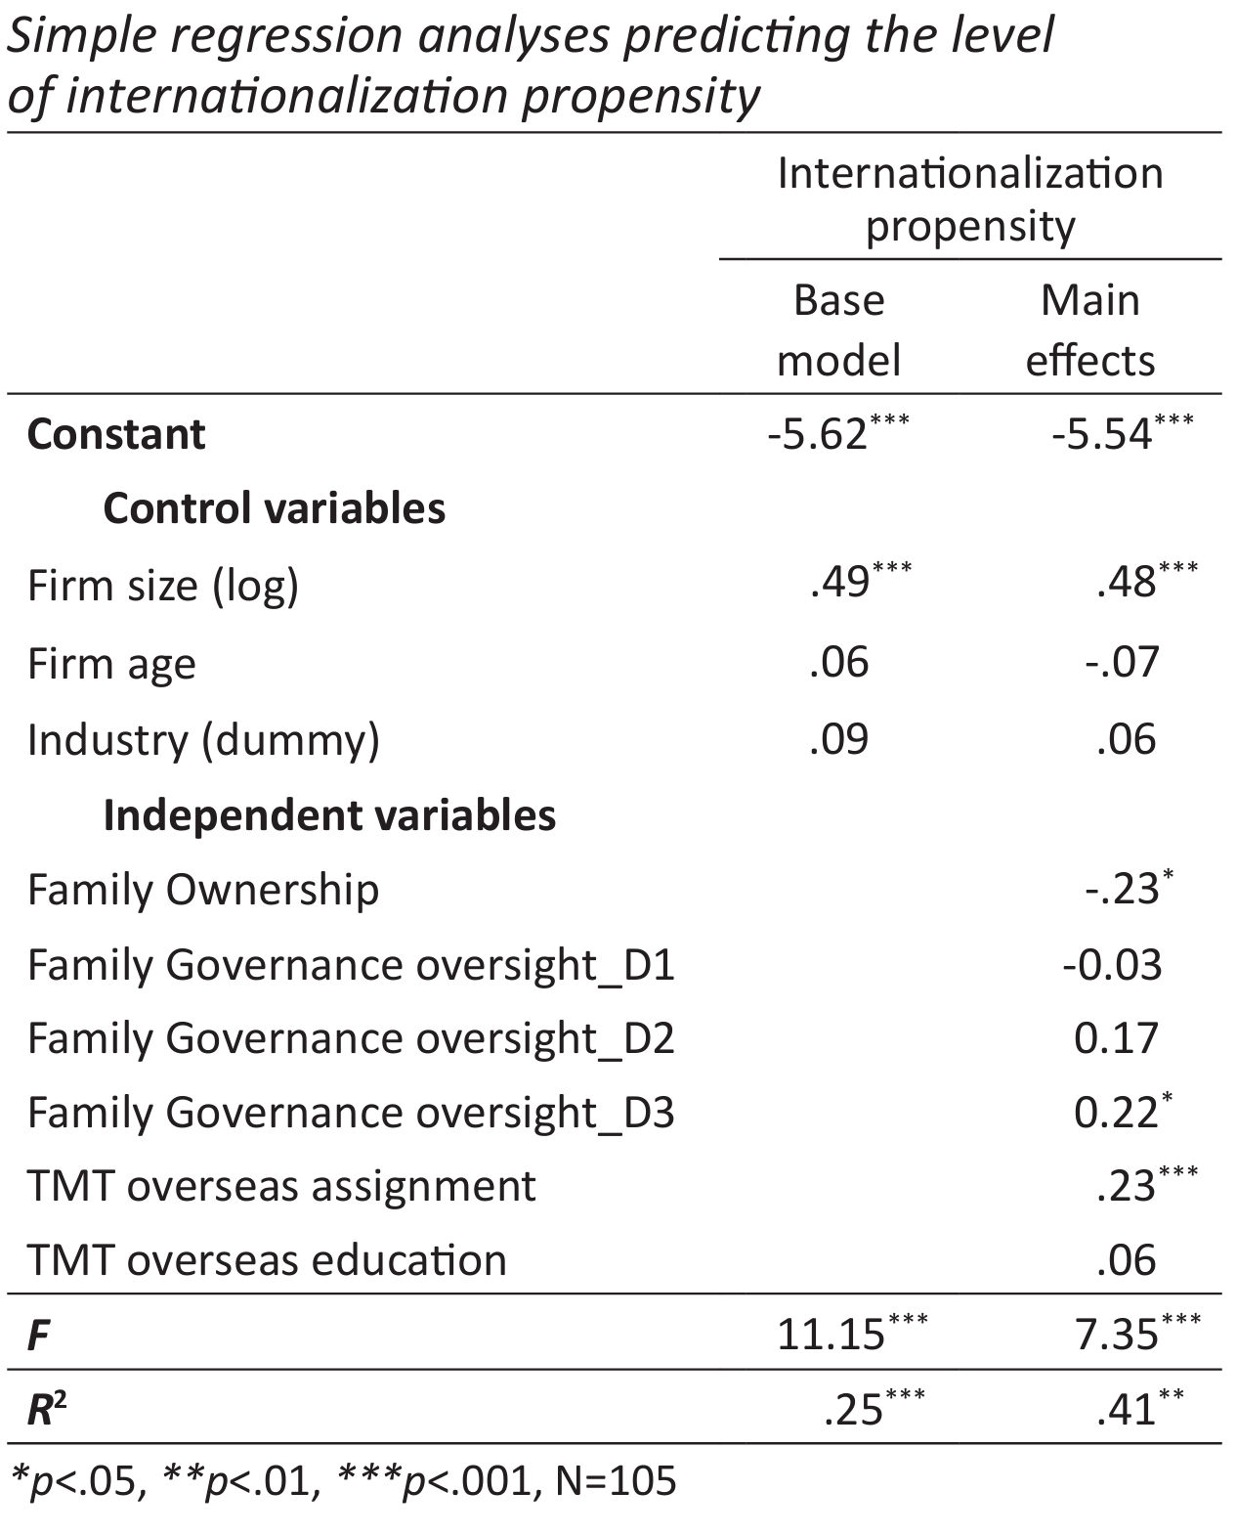
Source From: Tsao, C., Wang, M., Lu, C., Chen, S., & Wang, Y. (2018). Internationalization propensity in family-controlled public firms in emerging markets. Journal of Small Business Strategy. https://www.semanticscholar.org/paper/Internationalization-propensity-in-public-firms-in-Tsao-Wang/2b2e5c3d1cbb26d395ac1028f3470a2c40b8edc1

2.3.2 Hybrid Models and Behavioral Biases
Hybrid ownership structures, such as partially state-owned and publicly traded firms, face conflicting goals. While private shareholders seek profit through internationalization, state stakeholders prioritize national interests, creating internal conflicts over risk tolerance (Storch, 2006). Behavioral biases also play a role: Turkish investors in Ethiopia exhibited herding behavior toward familiar markets, driven by psychological preferences rather than rational analysis (Ali & Oran, 2018), highlighting how controlling managers in private firms may let biases shape risk decisions. In reality, hybrid models often illustrates risk aversion as the state stakeholders always take the dominant position in controlling the enterprise.

3.0 Case Studies

3.1 Case Study of State Power Investment Corporation

3.1.1 Brief Introduction
As a key state-owned enterprise directly supervised by China’s State-owned Assets Supervision and Administration Commission (SASAC), the State Power Investment Corporation or “SPIC” (formerly China Power Investment Corporation) exhibits a notably low risk tolerance in its foreign investments, a characteristic closely linked to its state-owned structure (Kong, 2015).

3.1.2 Mechanisms of Ownership Affects Risk Preferences
State ownership imposes multiple policy objectives that weaken profit orientation. SPIC must balance goals such as energy security, clean energy transition, and regional coordination, rather than simply pursuing maximum investment returns. For example, its nuclear power assets (SPIC is the only domestic enterprise with hydropower, thermal power, nuclear power, and renewable energy assets) are subject to national strategies for technological self-reliance, which limits exploration of high-risk technological paths(About SPIC, 2025).
Accountability mechanisms reinforce risk-averse tendencies. Clear responsibility boundaries and high costs of misconduct (such as administrative penalties for decision-making errors) constrain managerial behavior. SASAC has established strict regulations on overseas investments by central enterprises (e.g., the "Interim Measures on the Supervision and Administration of State-owned Assets Overseas for Central Enterprises")(SASAC of the State Council, 2011), emphasizing the prevention of state asset loss. Empirical studies by Huang (2020) show that SOE managers, due to their politically appointed status, tend to prioritize career advancement over long-term returns, demonstrating significantly lower willingness to take risks compared to private firms.

3.1.3 Behaviors and Underlying Causes of Low Risk Tolerance
Political risks are often beyond the control of SOEs. In 2011, SPIC’s fully owned Myitsone Hydropower Project in Myanmar was suspended due to U.S. interference, political changes in Myanmar, and environmental disputes. The project fell far beyond the company's control, triggering an exit mechanism. It remains stalled to this day, resulting in massive sunk costs (Kong, 2015). This case highlights how SOEs with strong state ties are more likely to become targets in host country political struggles, leading to more conservative decision-making.
The state maintains strong control over the enterprise. SPIC’s management includes few international professionals, and research indicates a “serious lack of internationally competent personnel with technical expertise and knowledge of global rules.” (Kong, 2015) Seniority-based promotion practices in SOEs further hinder the recruitment of high-quality talent. As a result, senior managers have limited understanding of overseas investment destinations, leading them to make more cautious decisions.

3.2 Case Study of OPPO Mobile Telecommunication

3.2.1 Brief Introduction
As a typical private enterprise in China's emerging economy, OPPO's ownership structure is characterized by centralized private control, where actual controller, which is also founder, Chen Mingyong indirectly holds 61.08% of voting rights through the labor union committee of Guangdong Ouga Holdings Co., Ltd., forming a "founder-led + employee stock ownership" structure. The founder holds approximately 10% of the shares, with the remaining equity dispersed among management, employees, and foreign capital. Foreign capital holds less than 40% of shares through Hong Kong-based companies but has no control rights.

Figure 1 Share Structure and Voting Right Structure of OPPO

3.2.2 Mechanisms of Ownership Affecting Risk Preferences
Centralized Control and Long-Term Strategic Tolerance The founder-led structure reduces principal-agent conflicts of interest, avoiding conservative strategies (Gomez-Mejia et al., 2017). Chen Mingyong directly decides on international expansion and supports long-term high-risk investments. Since its establishment in 2004, OPPO's business has expanded to over 70 countries and regions worldwide (OPPO Global, 2025). In 2018, OPPO spent billions of yuan to purchase patents to enter the European market, reflecting the positive correlation mechanism between private enterprises' "control rights and risk-taking."
Employee Stock Ownership Plans and Diversified Risk Perceptions Employee stock ownership plans align individual gains with long-term corporate growth, fostering a "risk-sharing" culture (Chen et al., 2016). A management team with functional diversity tends to embrace risk-taking. OPPO's decentralized equity structure promotes pluralistic decision-making, supporting its "gradual internationalization" strategy.
Foreign Capital Participation and Risk Culture Penetration Cross-national studies show that foreign ownership correlates positively with corporate risk-taking. OPPO's foreign capital share (less than 40%) introduces a high-risk tolerance mindset, driving entry into high-barrier markets such as Europe's patent litigation environment. In regions with sound institutions like Europe, foreign-backed enterprises are more willing to take risks—OPPO's local compliance investments in Europe reflect its adaptive strategy for high-risk markets (Beyond Next, 2025).

3.2.3 Behaviors and Underlying Causes of Low Risk Tolerance
Table 2 Empirical Evidence of High-Risk Internationalization Behaviors
Behavior Domain | Specific Case | Risk Quantification Index
Patent Litigation | Withstood Nokia's patent lawsuits in 9 countries and risk of German sales bans while insisting on market deepening. | Billions spent on patent purchases.
Market Entry Strategy | Adopted a "high-cost" European-first strategy (2018 Paris launch event) instead of low-risk emerging markets. | Establishment of Western European headquarters and localized teams.
Financial Risk Exposure | Did not hedge foreign exchange risks, actively accepting exchange rate fluctuations to protect overseas supply chains. | Foreign exchange exposure management strategy.
Source summarized from: Sheyan Finance. (2025). Analysis of OPPO’s dilemma: the breakthrough path under the triple challenges of high - end market, overseas expansion and innovation. cnFOL. http://mp.cnfol.com/49592/article/1743169804-141725357.html and other listed references
Strategic Consistency via Controlling Unions. Chen Mingyong ensures "strategic consistency" through union control, such as the sustained implementation of the "three-step" internationalization strategy (Southeast Asia → Europe → Global) (Oceanengine, 2023), avoiding strategic vacillation caused by dispersed equity.
Flexibility of Private Ownership. Reduced government intervention allows agile responses to trade compliance risks, such as quickly adjusting European operations to avoid patent sanctions, unlike SOEs bound by administrative directives.

4.0 Conclusion
This paper shows that a firm's ownership structure fundamentally influences its internationalization risk perception. State-owned enterprises (SOEs) show risk aversion due to political and bureaucratic constraints, while private firms prioritize profit and exhibit higher risk tolerance. Controlling shareholders often adopt conservative strategies to protect control, whereas minority shareholders push for internationalization to seek growth. Interactive effects and hybrid models further shape risk decisions. In short, ownership type, control distribution, and stakeholder dynamics determine how firms balance risks and opportunities in global expansion.

COMPETING INTERESTS DISCLAIMER:
Authors have declared that they have no known competing financial interests OR non-financial interests OR personal relationships that could have appeared to influence the work reported in this paper.

Reference
Wei, Q. (2025). A Review of China’s Electric Vehicle Consumption Market: The Impact of the Unique Chinese Culture on Car Buying Behavior. Advances in Economics Management and Political Sciences, 166(1), 8–14. https://doi.org/10.54254/2754-1169/2025.20870
About SPIC. (2025). SPIC. http://eng.spic.com.cn/2021/whoweare/aboutspic/ Belt and Road Portal. (2025). BRI Official Website. https://eng.yidaiyilu.gov.cn/ Beyond Next. (2025). From China to the Globe: A Collection of OPPO’s 16-Year Overseas Expansion Experience Stories. https://www.wearebn.com/zh/2025021901
Bhaumik, S. K., Driffield, N., Pal, S., Aston Business School, Aston University, UK, & School of Social Sciences, Brunel University, UK. (2010). Does ownership structure of emerging-market firms affect their outward FDI? The case of the Indian automotive and pharmaceutical sectors. In Academy of International Business, Journal of International Business Studies (pp. 437–450) [Journal-article]. https://doi.org/10.1057/jibs.2009.52
Changjiang Business School. (2024). OPPO: Build a Global Enterprise with Deep Localization. WeChat Public Account. https://mp.weixin.qq.com/s?__biz=MjM5MzM0NjY2MA%3D%3D&mid=2652671510&idx=2&sn=cc470ee1c9f9180af099d4012e2dae7c&chksm=bc87c6c5f3487cbd08bfea116fa5205f8b91c8f648806a43f42740bc42b8fd3309ee8c433419&scene=27
Chen, C., Wu, X., & Wei, F. (2016). Heterogeneity of top management team,managerial ownership,and risk taking. Journal of Management Sciences in China, 2016(19-5)(1–13). https://jmsc.tju.edu.cn/jmsc/article/abstract/20160501 Costa, A. D., Camboim,
G. F., & Zen, A. C. (2018). Internationalization patterns and their effects on company performance. Journal of Operations and Supply Chain Management, 11(1), 53–63. https://doi.org/10.12660/joscmv11n1p53-63
Dumitrescu, M.-S., Paraschiv, D., Nițu, M., & Bucharest University of Economic Studies. (2019). Internationalization of Companies – Stages and Challenges in the Global Business Environment. Ovidius
University Annals, Economic Sciences Series, XIX(1 /2019). https://www.stec.univ-ovidius.ro/html/anale/RO/wp-content/uploads/2019/08/4.pdf Gomez-Mejia, L. R., Neacsu, I., & Martin, G. (2017). CEO Risk-Taking and Socioemotional Wealth: The Behavioral Agency Model, Family Control, and CEO Option Wealth. Journal of Management, 45(4), 1713–1738. https://doi.org/10.1177/0149206317723711
Huang, Y. (2020). Research on the Impact of Senior Managers’ Risk Preferences on Inefficient Investment. Times Finance, 2020(13),65-67. https://cstj.cqvip.com/Qikan/Article/Detail?id=00002EKIL5587JP0MPDG6JP06P
R Khanna, T., & Palepu, K. (1997). Why Focused Strategies May Be Wrong for Emerging Markets. Harvard Business Review. https://hbr.org/1997/07/why-focused-strategies-may-be-wrong-for-emerging-markets
Kong, X. (2015). Research on the Internationalization Development Strategy of Large - scale State - owned Energy Central Enterprises: Taking China Power Investment Group Corporation as an Example. University of International Business and Economics, Beijing. https://d.wanfangdata.com.cn/thesis/ChhUaGVzaXNOZXdTMjAyNDA5MjAxNTE3MjUSB0Q3MjI4NDcaCGQyaXVnbjY5
Loehde, A. S. K., Calabrò, A., Torchia, M., & Kraus, S. (2020). Joint (Ad)ventures—Family firms’ international entry mode choices for emerging markets. International Journal of Entrepreneurial Behaviour & Research, 26(6), 1235–1258. https://doi.org/10.1108/ijebr-10-2019-0573
Lu, J. W., & Beamish, P. W. (2004). International Diversification and Firm Performance: The S-curve Hypothesis. Academy of Management Journal, 47(4), 598–609. https://doi.org/10.5465/20159604
Oceanengine. (2023). 2022 China Smart Manufacturing Observation Report. https://trendinsight.oceanengine.com/arithmetic-report/detail/802
OPPO Global. (2025). About OPPO. OPPO. https://www.oppo.com/en/about/
Panicker, V. S., Mitra, S., & Upadhyayula, R. S. (2019). Institutional Investors and International Investments in Emerging economy firms: A Behavioral Risk perspective. Journal of World Business, 54(4), 322–334. https://doi.org/10.1016/j.jwb.2018.12.002
Rajverma, A. (2024). Impact of Ownership Structure and Dividends on Firm Risk and Market Liquidity. Journal of Risk and Financial Management, 17(7), 262. https://doi.org/10.3390/jrfm17070262
Serban, E., Borisov, D., & Dobrea, R. (2012). EMERGING MARKETS: CONCEPT EVOLUTION AND BUSINESS ENVIRONMENT PARTICULARITIES. Management Research and Practice. https://www.semanticscholar.org/paper/EMERGING-MARKETS%3A-CONCEPT-EVOLUTION-AND-BUSINESS-Serban-Borisov/4e9bcec4bf565b169137786f2dc3d5c9fda8d590
Sheyan Finance. (2025). Analysis of OPPO’s dilemma: the breakthrough path under the triple challenges of high - end market, overseas expansion and innovation. cnFOL. http://mp.cnfol.com/49592/article/1743169804-141725357.html
State-owned Assets Supervision and Administration Commission of the State Council. (2011). Interim measures for the supervision and administration of state-owned assets overseas for central enterprises. https://www.gov.cn/zhengce/2022-01/12/content_5718603.htm
Tsao, C., Wang, M., Lu, C., Chen, S., & Wang, Y. (2018). Internationalization propensity in family-controlled public firms in emerging markets. Journal of Small Business Strategy. https://www.semanticscholar.org/paper/Internationalization-propensity-in-public-firms-in-Tsao-Wang/2b2e5c3d1cbb26d395ac1028f3470a2c40b8edc1
Wang, C. (2024). State-Owned Capital Participation and Private Enterprises Internationalize—Formation Mechanism and Testing of the Inverted U-Shaped Relationship. E-Commerce Letters, 13(04), 2579–2591. https://doi.org/10.12677/ecl.2024.1341431

