Review Article

Navigating General Exceptions in Digital Trade: A Legal Case Analysis of China’s Data Sovereignty Strategy under the CPTPP and DEPA Frameworks

Abstract: This study employs a qualitative case study analysis approach to demonstrate how the general exception clauses have been integrated into CPTPP and DEPA frameworks in lieu of digital trade. Simultaneously, it focuses on China’ regulatory model. The study examines the legal flexibility offered by these agreements and evaluates the compatibility with China’s data governance laws such as PIPL, DSL and Cybersecurity laws with international obligations. The study finds that exception do account for public interest protections, yet China’s broad security justifications posit a serious challenge. Thus, strategic engagement and modular compliance is necessary to navigate sovereignty and protection.
Key Words: China, CPTPP, DEPA, DSL, PIPL, Cybersecurity Law

- Introduction
Digital trade encompasses the exchange of commodities enabled via electronic means. WTO (2023) states that digital trade provides opportunities to launch new products and contributes to increasing inclusivity in the global scenario. It is thus a cornerstone of modern global economy. Additionally, according to the U.S. Congressional Research Service (2025), digital trade can be defined as commercial transactions and digitally enabled activities that are conducted via internet or other networked computer system. This includes trade of digital goods and services alongside infrastructure, platforms and data flows that support them. Therefore, such as expensive definition underscores the complexity of governing digital trade in a world that is increasingly interconnected. In the contemporary world, the growth in digitally delivered services over the last 2 decades has been evident. Figure-1 shows that it increased from US$6.6 trillion in 2005 to US$29.1 trillion in 2024, capturing the rising trend in digitally delivered services. Subsequently, as cross-border data flow intensified, it increased concerns around data protection, cybersecurity and state sovereignty. Thus, this has led to renewed attention on general exception clauses within trade agreements.

Figure 1: Increase in Digital Trade Services 2005-2024
Data Source: WTO (2025)
Regional Trade Agreements (RTAs) encompass a few jurisdictions and coverage which has been captured in Figure-2. These RTAs tend to vary significantly based on their comprehensiveness. In fact, Figure-2 posits that Joint Initiative (JI) participants under WTO’s e-commerce discussion, such as members of Comprehensive and Progressive Agreement for Trans-Pacific Partnership (CPTPP) and Digital economy Partnership Agreement (DEPA) (The Asian Foundation, 2024), tend to address a wider range of digital trade issues, relative to non-JI jurisdictions. Key provisions include rules on data privacy, scams, consumer protection, cross-border data flows and electronic authentication. In contrast, non-JI countries often omit such issues or address them less robustly. This reflects a broad trend of regulatory fragmentation. In this context, plurilateral agreements pursue deep digital integration, while others adopt a more cautious or sovereignty-focused approach. Amidst this divergence, general exception clauses serve as crucial legal functions. They are either rooted in Article XX of GATT (WTO, n.d.a) or Article XIV of GATS (WTO, n.d.b). These clauses allow countries to deviate from trade obligations for policy goals that are legitimate. These include public morals, national security and data protection. However, their application to digital trade is rather complex and often contested. This is especially true when nations assert data sovereignty via domestic laws.
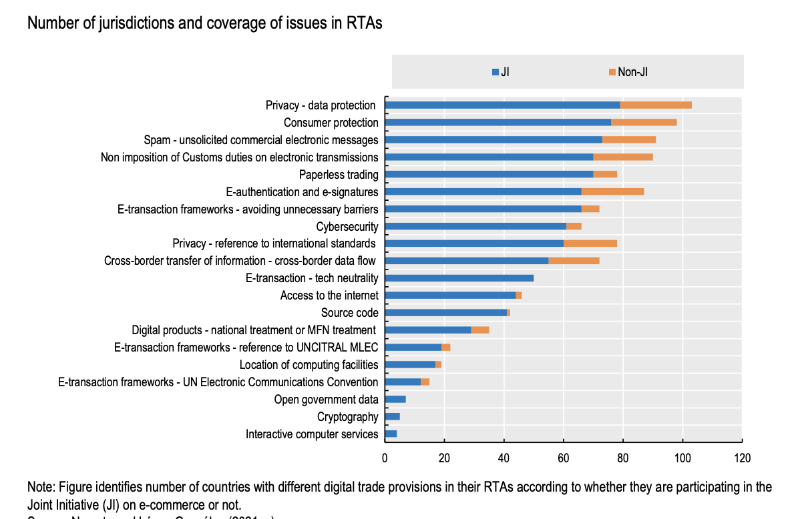
Figure 2: RTA Coverage of data privacy concerns (OECD, 2023)

These clauses serve as legal safeguard for sovereign policymaking within the liberalized trade order. On one hand, digital trade promotes openness and efficiency. However, on the other hand it raises questions regarding privacy, regulation of content and national security. In this context, general exceptions offer governments a means via which they can reconcile trade commitments with domestic public interest. However, their interpretation alongside their application in the digital domain remains contested. This is particularly true in the cases of data localization, cross-border data flows and cybersecurity regulation. Therefore, it is imperative to understand how general exceptions clauses function in plurilateral agreements such as CPTPP and DEPA, becomes critical when it comes to evaluating the legal and strategic viability of national digital regimes of nations like China.
This case study will therefore examine how these general exception clauses articulate in CPTPP and DEPA. It will primarily demonstrate how they intersect with China’s evolving legal framework on digital trade. China is not currently a member of either agreement. However, it has applied for CPTPP accession and has also expressed formal interest in DEPA. Thus, this raises important legal and strategic questions regarding China’s data localization laws, cybersecurity regime and broader digital governance model, and how these may align or perhaps conflict with the principles of digital openness, that is enshrined in these agreements.
  - Research Questions
- How do CPTPP and DEPA incorporate general exception clauses in digital trade?
- How has China responded to these frameworks through its domestic laws and data governance strategy?
- What tensions or compatibilities exist between China’s legal regime and the general exceptions in these agreements?
- Literature Review
As the complexity surrounding digital trade has grown, it has brought renewed attention on the role of general exception clauses in international trade laws. These clauses are rooted in GATT Article XX and GATS Article XIV. They were originally designed to permit limited deviations from trade obligations in cases of public interest. These include but are not limited to the protection of public morals, maintenance of public order and national security, the enforcement of domestic laws, protection of plant, animal and human life or health, and the conservation of non-renewable natural resources (Bartels, 2017; Marwell, 2006). However, their extension to the context of digital trade has been rather contentious. Several scholars have debated their adequacy in addressing emerging challenges such as data privacy (Sun, 2025; Brkan, 2019; Woods, 2016), cybersecurity (Peng, 2015; Nanxiang, 2023) and cross-border data flows (Voss, 2020; Zhang, 2020). Additionally, recent research has explored how agreements such as CPTPP and DEPA structure digital trade provisions. In this regard, Burri (2021) posited that having larger cluster of nations under CPTPP and DEPA, admit norms on data localization ban, data flows, source code and open access to internet. This provides a useful basis for creating a model of international participation.
According to Kimura (2019), chapter 14 of CPTPP mandates cross-border data flow and prohibits data localization. It encompasses the e-commerce chapter that necessitates no imposition of import duties under Article 14.3, no discriminatory treatment under Article 14.4. It also prohibits data localization under Article 14.10. and cross-border transfer of computing facilities under Article 14.13. Lastly, it inhibits forced transfer of software source codes. However, it also includes general exceptions in Chapter 29 to preserve policy space (CPTPP Portal, 2025). On the other hand, DEPA encompasses a modular framework that emphasizes regulatory cooperation and interoperability which offers flexibility while simultaneously supporting liberalization. In this regard, the US, EU and China are utilizing domestic and foreign policies to reap the benefits from data-oriented economies of scale and scope (Aaronson & Leblond, 2018). However, tensions between trade liberalization and protection of domestic regulatory autonomy, epitomize in this framework (EU Parliament, 2020). This is particularly true across digital domains. Therefore, while on hand, digital transformation and technological enhancement are crucial to achieve sustainability of resources and reduce trade costs (Yingchao & Xiang, 2024; Xiang & Zhao, 2025), on the other, trade provision and privacy protection clauses in the RTA tend to exert much stronger positive impacts on imports than provisions for data flow (Xiang & Zhao, 2025).
In the same context, China’s evolving data governance regime is rooted in the Cybersecurity Law of 2017, Data Security Law (DSL) of 2021 and Personal Information Protection Law (PIPL) of 2021 (NZFAT, 2022). These embodies a strategy of data sovereignty. It emphasizes state control over data that has been generated within its territory. These policies are in sharp contrast with that of the US and EU, as the former has a market friendly data governance model whereas the latter entails the General Data Protection Regulation (GDPR) framework (Yun, 2024). Both of these models prioritize the protection of human rights. Thus, although in the context of China, data sovereignty has been framed as necessary for national security and public interest, these laws subsequently raise concerns regarding China’s compatibility with international frameworks of digital trade.
Thus, despite a rich literature that exists in this realm, there is a notable gap in examining how general exceptions operate as legal bridges or perhaps points of friction between multilateral agreements and domestic digital regimes. Therefore, the concepts of legal pluralism, regulatory sovereignty and digital protection are essential to understand where China stands in this normative landscape that is so highly contested.
  - Legal Background: WTO General Exceptions and the Two-Tier test
General exception clauses that are embedded in Article XX of GATT and Article XIV of GATS, provides member states with a legal space that is essential to adopt trade-restrictive measures. These measures pursue public policy objectives that are legitimate. These include the protection of public morals, human, animal or plant life and health, and national security (Bartels, 2017; Marwell, 2006). However, in order to prevent the misuse of such clauses, they have been subjected to strict legal scrutiny and have rarely been invoked successfully. In this regard, as per Public Citizen (205), as of 2015, only 1 out of 44 attempts to use the general exception clauses, have succeeded. This was the EC-Asbestos case. Moreover, out of the 44 cases, the general exceptions were considered to be relevant enough across 33 cases however, 32 out of these 33 cases failed to satisfy 1 out of 3 of the threshold tests that the clauses’ application demand. These are:
Table 1: Threshold Tests
Adapted from Public Citizen, 2015
Threshold Test | Definition | Number of cases failed
Matter/Scope threshold | “Tribunal concluding that the Respondent failed to show that the measure was designed for the protection of human health or for securing compliance with laws or regulations which were not inconsistent with WTO provisions” | 5
“Necessary” or ‘Related” threshold | - | 18
Chapeau threshold | “Tribunal finding arbitrary or unjustifiable discrimination in the measures’ application.” | 9

Both GATT Article XX and GATS Article XIV adopt a two-tier structure. According to Van den Bossche & Zdouc, 2017) The first-tier mandates that a contested measure falls within one of the listed sub-paragraphs such as Article XX(b) for health protection or Article XX(a) for public morals. The second tier which is often referred to as the chapeau, imposes additional constraints. It demands that the measure ought to not be applied in a manner that would constitute as arbitrary or unjustifiable discrimination. Moreover, it should not be a disguised restriction on international trade. This two-step analysis has been clarified by the WTO jurisprudence repeatedly. In the US-Gambling, the Appellate Body emphasized that even when a measure serves a legitimate purpose, it must still be a “necessary” and should be applied non-discriminatorily in order to qualify under the chapeau (Appellate Body report, 2005). Moreover, the burden of proof lies with the party that is invoking the exception which in turn must satisfy both the necessity of the measure and its consistency with the chapeau (Cottier et al., 2008). The WTO Dispute settlement Body has also underscored that the general exceptions must be interpreted narrowly. This will help in preserving the liberalizing goals of the system. However, recent decisions such as EC – Seal Products and compliance ruling in Shrimp/Turtle and Tuna, Mexico (Appellate Body Report, 1998; 2012), suggests that there is a growing willingness to balance trade and regulatory autonomy. This is particularly true in areas such as public morals and environment protection. However, the high threshold for satisfying both tiers of the tests implies that several state measures risk failing legal scrutiny especially those in the digital domain.
- Methodology
This paper adopts a qualitative case study approach to examine how general exception clauses in digital trade agreements interact with China’s data sovereignty regime. A case study method helps in developing historical explanations regarding particular cases and attaining high levels of construct validity, while analyzing new or omitted variables and hypotheses, intervening variables that might have been at work and generalization of complex model relationships (Bennett, 2004). Thus, for this study, the case study method is appropriate given the complex legal, institutional and geopolitical context that surrounds China’s digital governance. It also reflects in its evolving relationship with CPTPP and DEPA. These agreements serve as contrasting yet complementary frameworks via which exception clauses and digital trade commitments are articulated. Therefore, the analysis for this study will employ a legal-interpretive method. It involves close reading and comparative interpretation of legal texts. Hence, the primary sources include the full texts of CPTPP and DEPA, especially chapters on digital trade and general exceptions. Additionally, Chinese laws such as Cybersecurity, DSL and PIPL, will also be analyzed in correspondence. Furthermore, secondary sources such as academic commentary, policy papers and institutional reports will also be included. Overall, this methodology allows the study to assess how exception clauses are structured in order to accommodate state interest. However, China either aligns with or resists these provisions. They stand on a grey zone as their focus remains on legal function of exceptions as mechanisms of flexibility, contestation or normative divergence in digital trade governance.
- Case Analysis
  - CPTPP and General Exceptions
The CPTPP establishes a comprehensive framework for digital trade under Chapter 14 (CPTPP, n.d.). This mandates free flow of information and restricts data localization as suggested by Kimura (2019). In this context, Article 14.11.2 of CPTPP (n.d., p. 14-6) states:
“Each Party shall allow the cross-border transfer of information by electronic means, including personal information, when this activity is for the conduct of the business of a covered person.”
Thus, this implies that CPTPP members ought to permit data including personal data, to be transferred across borders when it is deemed essential for businesses. However, Article 14.13.2 (CPTPP, n.d., p. 14-7). states:
“No Party shall require a covered person to use or locate computing facilities in that Party’s territory as a condition for conducting business in that territory.”
This implies that members of the CPTPP cannot force businesses to store data or set up servers locally as a condition for them to operate in that country. Thus, these provisions aim to eliminate barriers to digital trade while fostering interoperability across jurisdictions.
Nonetheless, these commitments are subjected to general exception clauses included in Chapter 29 (CPTPP, n.d). It reflects the structure of GATT Article XX and GATS Article XIV. It thereby permits deviations wherein measures are crucial for the protection of public morals or public order reiterating Bartels (2017) and Marwell (2006). It also allows deviation to ensure compliance with domestic laws provided that the measures are not applied in a “manner which would constitute a means of arbitrary or unjustifiable discrimination between Parties or between Parties and non-Parties where like conditions prevail, or a disguised restriction on investment in financial institutions or cross-border trade in financial services as covered by this Chapter” (CPTPP, n.d., p. 11-12). Thus, this two-tier test requires a legitimate objective and necessity-based proportionality. This has been clarified in WTO jurisprudence that demands a weighing and balancing of policy goal, trade restrictiveness and existence of less intrusive alternatives (WTO, n.d.a; WTO, n.d.b).
In this regard, China’s current legal regime reveals structural incompatibilities given the aforementioned requirements. Article 38 of PIPL requires that any cross-border transfer must undergo a security assessment that has been organized by national authorities (China Briefing, 2021). Furthermore, Article 40 imposes a localization mandate on ‘critical information infrastructure operators’ (China Briefing, 2021). It requires personal data to be stored within Chinese territories regardless of case-specific risks. These provisions create a de jure localization obligation that directly contravenes CPTPP Article 14.13.2. Moreover, DSL reinforces this approach. Article 24 authorized the export of important data if such transfers could affect national security or public interest (China Law Translate, 2021). Additionally, the 2025 draft amendments to Cybersecurity Law proposes enhanced enforcement mechanisms that include administrative penalties, license revocation, and business suspension for firms failing to comply with cross-border data rules (Fan & Zhou, 2025). Thus, collectively, these laws construct a regulatory model that centered around preventive state control over digital infrastructure and outbound flows of information.
Although China may attempt to justify the restrictions under the general exceptions section of CPTPP Chapter 29, the broad and inflexible nature of the measures presents considerable legal challenges. Burri (2017) argues that exception clauses should be narrowly interpreted in order to preserve the liberalization objective of digital trade agreements. Thus, blanket mandates and risk-averse transfer bans are unlikely to satisfy CPTPP’s necessity and non-discrimination criteria especially when they are implemented without demonstrating proportionality or offering less trade-restrictive alternatives. Additionally, while applying WTO’s two-tier test, CPTPP parties ought to first assess whether China’ s data localization rules pursue a legitimate objective for instance national security or public morals. This threshold is likely to be met. However, the more difficult question arises while assessing whether China’s measures are “necessary” under Article XX(a) or (b) and whether they satisfy the chapeau. WTO jurisprudence such as in US-Gambling, requires the demonstration that there are no reasonable available alternatives that are less trade restrictive. Moreover, blanket localization rules are unlikely to pass this test without any risk-based differentiation. Furthermore, the chapeau prohibits measure that result in arbitrary or unjustifiable discrimination. For instance, in EC-Seal products, the Appellate body found that the legitimate moral justification was insufficient wherein inconsistent application undermined fairness. If China’s enforcement of localization disproportionately impacts foreign firms without any transparent justification, it may also face a similar failure as per chapeau standard. Furthermore, the case Russia-traffic in Transit clarifies the restrictions motivated by security must still conform to objective legal principles. Although the CPTPP adopts its own language, these WTO precedents are rather informative given the structural equivalence of chapter 29 with GATT Article XX. Therefore, CPTPP scrutiny of China’s laws would likely be shaped by the WTO’ evolving standard of necessity and non-discrimination. Overall, China’s legal framework reflects a sovereignty first model. It prioritizes national control over digital policy. This stance may fundamentally misalign CPTPP’s vision of open and rules-based digital trade even though it is anchored in legitimate regulatory concerns.
  - DEPA
DEPA represents a novel approach to digital trade governance via its modular framework. It allows economies to engage flexibly across 16 core areas. The modular framework of DEPA is captured chronologically in Table-2. These include cross-border data flows, artificial intelligence, cybersecurity, and digital inclusion. DEPA’s design supports high-standard digital commitments alongside differentiated paths of implementation. Hence, it has attracted interest from diverse economies including China.
Table 2: DEPA Modular Framework (DEPA, n.d.)
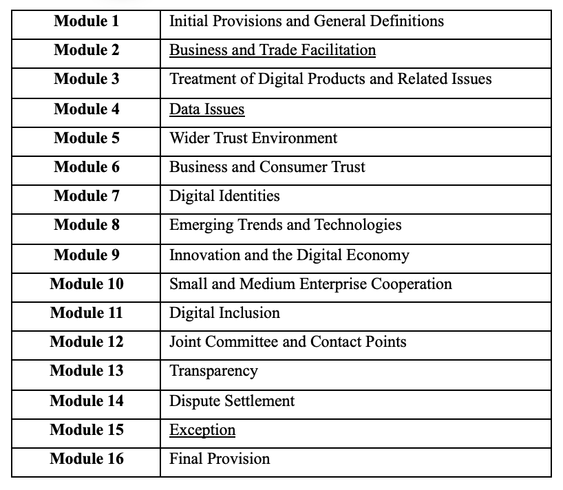
At the core of DEPA’s digital governance are commitments to interoperability and regulatory trust. Module 4.3. clause 2 (DEPA, n.d., p. 4-3) mandates:
“Each Party shall allow the cross-border transfer of information by electronic means, including personal information, when this activity is for the conduct of the business of a covered person.”
This is the same as Article 14.11.2 of CPTPP. Additionally, the cross-border transfer of information under DEPA is subjected to limited exceptions for legitimate public policy objective that are not applied in a manner which would constitute a means of arbitrary or unjustified discrimination. Similarly, parties are also discouraged from imposing data localization requirements. These provisions collectively mirror the CPTPP digital norms however, they have been integrated into a more flexible and cooperative context.
China formally applied to join DEPA in November 2021 and the Accession Working Group (AWG), chaired by Chile was established in August 2022 (APEC, 2024). According to MOFCOM (2024), positive progress is being made as China actively exchanges views with DEPA members. This strategic interest reflects China’s intent to enhance participation in regional digital governance frameworks. It consequently signals regulatory openness to global investors.
However, the domestic legal regimes in China represents several frictions with DEPA’s vision. For instance, PIPL requires cross-border transfers to undergo state-organized security review and mandates data localization for critical infrastructure operators (China Briefing, 2021). Additionally, Article 24 of DSL authorized restrictions on outbound data (China Law Translate, 2021). Meanwhile, the Cybersecurity Law Amendments (2025) reinforce compliance mechanisms such as license revocation and business suspension for violations (Fan & Zhou, 2025). In this context, DEPA’s exception clause under Module 15 incorporates Article XX of GATT and Article XIV of GATS ‘mutatis mutandis” (DEPA, n.d., p. 14-5). These clauses allow regulatory measures that are necessary to protect public morals, privacy or national security. However, these measures should not be arbitrary or unjustifiable or perhaps disguised as restrictions on trade. The interpretive flexibility in this context offers a more diplomatic space than CPTPP. Yet it still mandates transparency, proportionality and dialogue. Moreover, the term mutatis-mutandis signals that although DEPA draws from the WTO’s general exception framework. Its application is adjusted to fir the digital context and cooperative spirit of the agreement. This approach arguably gives China a softer landing than CPTPP which directly transplants the stricter two-tier test. However, DEPA still expects members to uphold core principles of proportionality and non-discrimination as developed by the WTP case laws such as US-Gambling and EC- Seal Products.
To further clarify, Table-2 below compares how CPTPP, DEPA and WTO agreements respectively frame and apply general exception in digital trade. This table shows that while DEPA is more flexible procedurally, it inherits the same substantive obligations that have led to failure in 32 of 33 WTO cases attempting to invoke general exceptions (Public Citizen, 2015). Hence, legal divergence may be tolerated in form, but not in effect.
Table 3: Comparison of General Exceptions Frameworks
Agreement | Basis for Exceptions | Non-Discrimination Test
CPTPP Chapter 29 | Article XX GATT-style (explicit) | Yes – via chapeau
DEPA Module 15 | GATT/GAT’S exceptions “mutatis mutandis” | Yes – adapted, but still binding
WTO (GATT XX / GATS XIV) | Structured two-tier test | Strict jurisprudence (e.g., US – Gasoline)

Thus, instead of a legal confrontation, DEPA’s cooperative model offers a path for gradual alignment. Aaronson and Leblond (2018) argue that such frameworks allow regulatory experimentation without forcing any binary choices. Thus, China’s success in joining DEPA will not depend on strict legal equivalence. Instead, it will be based on its willingness to engage in trust-based convergence. This will demonstrate that its data governance model can be made compatible with international interoperability norms, if not completely identical.
- China’s Strategic Response
China’s model for data governance reflects a deliberate legal strategy entailing ‘controlled openness’. It balances global integration with data sovereignty. In the same context, Chinese laws such as PIPL, DSL and Cyrbersecurity laws are usually justified on the grounds of general exception clauses under CPTPP, DEPA, GATT and GATS frameworks. These account for public safety and moral concerns. These measures invoke legitimate objectives. However, they blanket application is rather contested as far as proportionality and transparency is concerned (Sun, 2025; Brkan, 2019). Thus, China should not oppose global digital rules completely. Instead, it should participate in CPTPP and DEPA accession talks in lieu of adopting pragmatic and incremental approaches to shaping its norms. In this regard, firms such as Alibaba and Tencent makes this approach rather evident. They have built compliance systems that are specific to jurisdictions (Tusikov, 2019; Cao, 2020). Hence, nations like China ought to navigate their digital rulemaking rather strategically. It will help them gain economic as well as regulatory leverage as suggested by Aaronson and Leblond (2018). Overall, it will transform compliance to a competitive advantage.
- Policy Implication and Future Research
To enhance compatibility, China should adopt proportionality assessment. It should create transparency portals and pilot security review sandboxes in collaboration with partner economies. These steps would demonstrate a commitment to fair and non-discriminatory digital regulation. In addition, establishing dedicated regulatory liaison units to coordinate with DEPA and CPTPP members could ensure real-time policy alignment and dispute prevention. Such institutional mechanisms would demonstrate China’s willingness to participate in rules-based governance and reduce legal uncertainty for digital investors. Furthermore, the pressing need for a plurilateral digital-trade exception toolkit, that would harmonize how necessity and chapeau standards are applied across agreements, become rather evident. Thus, future WTO Joint Statement Initiative (JSI) discussions on e-commerce should consider codifying uniform general exception tests, drawing on the evolving jurisprudence from cases such as US – Gambling and EC – Seal Products.
- Conclusion
The case study thus explored how CPTPP and DEPA incorporates general exception clauses in digital trade. It also examined the legal and strategic tensions posed by China’s data governance model that relied primarily on PIPL, DSL and Cybersecurity laws. Thus, while both agreements allow flexibility of policies under exceptions to incorporate public interest and national security, they simultaneously impose conditions of necessity, proportionality, and non-discrimination. These are criteria that China’s rigid localization mandates. Moreover, opaque enforcement might not consistently meet these criteria. Nonetheless, China positions itself in direct opposition to these frameworks. It pursues controlled openness while signaling interest in joining CPTPP and DEPA. It also demands to maintain its core regulatory sovereignty. Moreover, Chinese firms further reinforce this hybrid approach by adapting compliance models to international standards. This dual-track strategy enables Beijing to assert digital sovereignty while mitigating international criticism and preserving trade ties. Thus, China’s legal regime ought to coincide with DEPA and CPTPP in the future. This necessitates institutional transparency, case-by-case assessments, and the development of interoperability mechanisms. This will enable China to balance digital trade sovereignty with cooperations. The nation will then be able to position itself not only as a rule-taker, but as a credible participant in shaping the future of global digital trade.

References
Aaronson, S. A., & Leblond, P. (2018). Another Digital Divide: The Rise of Data Realms and its Implications for the WTO. Journal of International Economic Law, 21(2), 245–272. https://doi.org/10.1093/jiel/jgy019.
APEC. (2024). Digital Economy Partnership Agreement. Asia-Pacific Economic Cooperation. Available at: https://mddb.apec.org/Documents/2024/CTI/CTI3/24_cti3_004_r.pdf.
Appellate Body Report. (1998). United States - Import Prohibition of Certain Shrimp and Shrimp Products - AB-1998-4 - Report of the Appellate Body. World Trade Organization. Available at: https://docs.wto.org/dol2fe/Pages/FE_Search/FE_S_S006.aspx?Query=(@Symbol=%20wt/ds58/ab/r*%20not%20rw*)&Language=ENGLISH&Context=FomerScriptedSearch&languageUIChanged=true#.
Appellate Body Report. (2005). United States - Measures Affecting the Cross-Border Supply of Gambling and Betting Services - AB-2005-1 - Report of the Appellate Body – Corrigendum. World Trade Organization. Available at: https://docs.wto.org/dol2fe/Pages/FE_Search/FE_S_S006.aspx?Query=(@Symbol=%20wt/ds285/ab/r*%20not%20rw*)&Language=ENGLISH&Context=FomerScriptedSearch&languageUIChanged=true#.
Appellate Body Report. (2012). United States - Measures Concerning the Importation, Marketing and Sale of Tuna and Tuna Products - AB-2012-2 - Report of the Appellate Body. World Trade Organization. Available at: https://docs.wto.org/dol2fe/Pages/FE_Search/FE_S_S006.aspx?Query=(@Symbol=%20wt/ds381/ab/r*%20not%20rw*)&Language=ENGLISH&Context=FomerScriptedSearch&languageUIChanged=true#.
Bartels, L. (2017). The chapeau of the general exceptions in the WTO GATT and GATS agreements: a reconstruction. American Journal of International Law, 109(1), 95–125. https://doi.org/10.5305/amerjintelaw.109.1.0095.
Bennett, A. (2004), Case Study Methods: Design, Use and Comparative Advantages. In Detlef, F.S., and Yaek, W.N. (eds) Models, Numbers, and Cases: Methods for Studying International Relations. University of Michigan Press.
Brkan, M. (2019). The essence of the fundamental rights to privacy and data protection: finding the way through the maze of the CJEU’s constitutional reasoning. German Law Journal, 20(6), 864–883. https://doi.org/10.1017/glj.2019.66.
Burri, M. (2017). The Regulation of Data Flows Through Trade Agreements. Georgetown Journal of International Law, 48(1). https://ssrn.com/abstract=3028137.
Burri, M. (2021). Towards a New Treaty on Digital Trade. SSRN Electronic Journal.
Cao, Y. (2020). Regulating digital platforms in China: current practice and future developments. Journal of European Competition Law & Practice, 11(3–4), 173–180. https://doi.org/10.1093/jeclap/lpaa001.
China Briefing. (2021). The PRC Personal Information Protection Law (Final): A Full Translation. China Briefing. Available at: https://www.china-briefing.com/news/the-prc-personal-information-protection-law-final-a-full-translation/.
China Law Translate. (2021). Data Security Law of the PRC. China Law Translate: Community-supported, Crowd-Sourced Translation and Commentary. Available at: https://www.chinalawtranslate.com/en/datasecuritylaw/.
Congressional Research Service. (2025). Digital Trade and Data Policy: Key Issues Facing Congress. Congress.Gov. Available at: https://www.congress.gov/crs-product/IF12347#:~:text=Digital%20trade%20includes%20trade%20in,%2C%20streaming%20or%20cloud%20services).
Cottier, T., Delimatsis, p., Deibold, N.F. (2008). Article XIV GATS: General Exceptions. MAX PLANCK COMMENTARIES ON WORLD TRADE LAW, WTO - TRADE IN SERVICES, Rüdiger, W., Peter-Tobias, S. and Clemens, F., eds., volume 6, pp. 287-328, Leiden/Boston: Martinus Nijhoff Publishers, 2008.
CPTPP Portal. (2025). Chapter 29 – Exception and General Provisions. Asia Pacific Foundation of Canada. Available at: https://apfccptppportal.ca/agreement/31.
CPTPP. (n.d.). Comprehensive and Progressive Agreement for Trans-Pacific Partnership. Institute of International Law and Justice. Available at: https://www.iilj.org/wp-content/uploads/2018/03/CPTPP-consolidated.pdf.
DEPA. (n.d.). Digital Economy Partnership Agreement. Ministry of Trade & Industry. Available at: https://www.mti.gov.sg/-/media/MTI/Microsites/DEAs/Digital-Economy-Partnership-Agreement/Text-of-the-DEPA.pdf.
EU Parliament. (2020). Legal Analysis of International Trade Law and Digital Trade. Directorate-General for External Policies: Policy Department. Available at: https://www.europarl.europa.eu/RegData/etudes/BRIE/2020/603517/EXPO_BRI(2020)603517_EN.pdf.
Fan, C. & Zhou, Q. (2025). China’s Cybersecurity Law Amendments: Key Changes in the Second Draft. China Briefing. Available at: https://www.china-briefing.com/news/china-cybersecurity-law-amendments-2025/.
Kimura, F. (2019). The Importance and Implication of the e-Commerce Clause in the CPTPP. Financial Cooperation in East Asia, 106-113. https://www.jstor.org/stable/resrep25423.17.
Marwell, J. C. (2006). Trade and Morality: The WTO Public Morals Exception after Gambling. New York University of Law Review, 81, 802. https://papers.ssrn.com/sol3/papers.cfm?abstract_id=907393.
MOFCOM. (2022). Report on Foreign Investment in China. Ministry of Commerce People’s Republic of China. Available at: https://wzs.mofcom.gov.cn/cms_files/oldfile//wzs/202301/20230104194942451.pdf.
MOFCOM. (2024). Ministry of Commerce Holds Regular Press Conference. Ministry of Commerce People’s Republic of China. Available at: https://english.mofcom.gov.cn/News/PressConference/art/2024/art_95700a953fdb4d7085628008e7a825d9.html.
Nanxiang, S. (2023). Internet Regulation and the Invocation of Security Exceptions in the WTO Agreeement, HeinOnline, J. WTO & China, 13.
NZFAT. (2022). China’s Data Governance Framework takes shape: Implications for New Zealand business. New Zealand Foreign Affairs & Trade. Available at: https://www.mfat.govt.nz/assets/Trade-General/Trade-Market-reports/China-data-governance-framework-takes-shape.pdf.
OECD. (2023). Key Issues in Digital Trade: OECD Global Forum on Trade 2023 “Making Digital Trade Work for All”. OECD. Available at: https://www.oecd.org/content/dam/oecd/en/publications/reports/2023/01/key-issues-in-digital-trade-review_5a91f9a0/b2a9c4b1-en.pdf.
Peng, S. (2015). Cybersecurity threats and the WTO national security exceptions. Journal of International Economic Law, 18(2), 449–478. https://doi.org/10.1093/jiel/jgv025.
Public Citizen. (2015). Only One of 44 Attempts to Use the GATT Article XX/GATS Article XIV “General Exception” Has Ever Succeeded: Replicating the WTO Exception Construct Will Not Provide for an Effective TPP General Exception. Public Citizen. Available at: https://www.citizen.org/wp-content/uploads/general-exception_1.pdf.
Sun, Q. (2025). The Study on Exception Clauses of Cross-Border Data Flows in International Trade Agreements. Journal of Theory and Practice in Humanities and Social Sciences, 2(2), 1-18.
The Asian Foundation. (2024). Digital Trade and Digital Economy Agreements in Asia and the Pacific. The Asian Foundation. Available at: https://asiafoundation.org/wp-content/uploads/2024/05/Digital-Trade-Agreements-in-Asia-and-the-Pacific_Tech-Policy.pdf.
Tusikov, N. (2019). How US-made rules shape internet governance in China. Internet Policy Review, 8(2). https://doi.org/10.14763/2019.2.1408.
Van den Bosschem, P. & Zdouc, W. The Law and Policy of the World Trade Organization: Text, Cases and Materials, 4th edition. Cambridge, United Kingdom; New York, USA: Cambridge University Press, 2017.9, p.547.
Voss, W.G. (2020). Cross-Border Data Flows, the GDPR, and Data Governance. HeinOnline: Wah, Int’l L.j., 29, 485.
Woods, A.K. (2016). Against Data Exceptionalism. HeinOnline: Stan. L. Rev, 68, 729.
WTO. (2023). Digital Trade for Development. World Trade Organization. Available at: https://www.wto.org/english/res_e/booksp_e/dtd2023_e.pdf.
WTO. (2025). Digitally delivered services trade dataset. World Trade Organization. Available at: https://www.wto.org/english/res_e/statis_e/gstdh_digital_services_e.htm.
WTO. (n.d.a). Article XX: General Exceptions. World Trade Organization. Available at: https://www.wto.org/english/res_e/booksp_e/gatt_ai_e/art20_e.pdf.
WTO. (n.d.b). Article XIV: General Exceptions. World Trade Organization. Available at: https://www.wto.org/english/res_e/publications_e/ai17_e/gats_art14_jur.pdf.
Xiang, X., & Zhao, J. (2025). Enhancing sustainable development through digital service trade liberalization: Analyzing the effects and mechanisms on bilateral imports. Sustainability, 17(5), 1823. https://doi.org/10.3390/su17051823.
Yingchao, H., & Xiang, Y. (2024). Influence of trade liberalization and digital trade on material footprint in the BRICS region. Resources Policy, 88, 104374. https://doi.org/10.1016/j.resourpol.2023.104374.
Yun, H. (2024). China’s Data Sovereignty and Security: Implications for Global Digital Borders and Governance. Chinese Political Science Review.
Zhang, S. (2020). Protection of Cross-Border Data Flows Under International Investment Law. Handbook of International Investment Law and Policy, 1-23.

