Growth forms and Plants Conservation Status in Impacted Lotic Wetlands associated with the Lower Niger River Basin, Delta State, Nigeria.

Abstract
Despite ongoing urbanization compromising their form and function, wetlands remain biodiversity hotspots that provide essential ecological services. We assessed the the diversity of plant growth forms and IUCN conservation status across three impacted roadside lotic wetlands of Asaba Metropolis associated with the lower Niger River Basin, Delta State, Nigeria. A total of 67 species were identified, belonging to 32 plant families. The most dominant family was Fabaceae, with 12 species (17.9%), followed by Poaceae (9 species; 13.4%) and Cyperaceae (5 species; 7.5%). Life form analysis showed a significant dominance of herbaceous species, constituting over 50% of all recorded flora, suggesting ecological disturbance and a prevalence of pioneer colonizers. Other life forms included shrubs (16%), trees (15%), climbers, aquatic macrophytes, sedges, and ferns. A preliminary assessment of species conservation status using the IUCN Red List revealed that they were classified either as Least Concern (LC) or Not Evaluated (NE), highlighting a gap in conservation documentation for several tropical species. Species distribution analysis showed that 17 species (25.4%) were ubiquitous across all three sites, including Acroceras zizaniodes, Alchornea cordifolia, and Bambusa vulgaris, reflecting high ecological plasticity. In contrast, more 20 species (29.9%) were site-restricted, indicating spatial heterogeneity and the influence of local environmental conditions. Despite considerable species diversity, the dominance of generalist and disturbance-tolerant species, coupled with the underrepresentation of rare or conservation-sensitive taxa, indicates that these wetlands are experiencing ecological deterioration. The data underscore the urgent need for proactive wetland conservation and urban ecological planning. Monitoring biodiversity trends and integrating conservation assessments into land-use decisions are vital for sustaining the ecological integrity of wetland habitats in the Niger River Basin.
INTRODUCTION
Wetlands are among the valuable and most resourceful earth’s ecosystems supporting critical ecological functions such as water purification, flood control, habitat diversification sources carbon sequestration, and biodiversity conservation (Mitsch and Gosselink, 2015; Anwana et. al 2020). Within the tropics, freshwater lotic wetlands which are characterized by flowing water support a unique assemblage of flora adapted to fluctuating hydrological conditions. However, rapid urbanization with its associated land-use changes in sub-Saharan Africa have increasingly encroached upon these sensitive habitats, leading to habitat fragmentation, pollution, and species displacement (Ogbemudia et al., 2014; Effiong et. al. 2020, Ogbemudia et. al. 2025).
Asaba Metropolis, located within the lower Niger River Basin, exemplifies a landscape undergoing intensive urban expansion. The city’s lotic wetlands, once biologically diverse and hydrologically functional, are now subjected to significant anthropogenic disturbances including channelization and rechannelization, sand mining, effluent discharge, and encroachment by invasive species. Despite their ecological significance, wetlands remain underrepresented in scientific literature and conservation planning (Anwana et. al. 2014; Mbong, et. al. 2020a). Understanding the composition, distribution, and ecological status of plant species in such systems is crucial for monitoring ecosystem health and guiding conservation strategies (Ubom, et al. 2012).
Urban expansion and environmental degradation have significantly altered the ecological balance of wetlands in Nigeria (Anwana et al. 2018; Mbong, et. al. 2020a; Effiong et al. 2021; Ogbemudia et. al. 2025). The lotic wetlands in Asaba Metropolis and other similar urban cities are increasingly threatened by unregulated development, pollution, and biological invasions. However, there is a dearth of empirical data on the composition, structure, and conservation status of plant species in wetland ecosystems (Ogbemudia, et. al. 2014; Anwana et al. 2018). Without such baseline information, ecological degradation may go undetected, and policy interventions may be misdirected or ineffective. Furthermore, the absence of local floristic assessments hampers Nigeria’s contribution to regional and global biodiversity databases (Bassey et al. 2024.). This study therefore seeks to create a valid plant checklist, growth form spectra, and report conservation status of plant species across three impacted roadside lotic wetlands within Asaba Metropolis. The study is very timely and essential because it provides a valid floristic baseline which is vital for assessing long-term ecological changes and evaluating the impacts of urbanization on wetland vegetation (Ezekiel et. al. 2024). Also the study may help identify or highlight current gaps in conservation status data using the IUCN Red list database as a benchmark. The findings of this study could support local and national policy initiatives aimed at wetland conservation and highlight the need for regional conservation prioritization, which would help Nigeria comply with international agreements such as the Ramsar Convention and the Convention on Biological Diversity (CBD).

Materials and Methods

Study Area
Three different lotic wetlands in Asaba Metropolis, Delta State, Nigeria, were the sites of the study. These sites lie within the Niger River Basin, characterized by seasonal rainfall (April to October), and a mean annual temperature range of 26–32°C. The wetlands are embedded in a rapidly urbanizing matrix and are subjected to varying degrees of anthropogenic disturbances including wetland decimation and reclamation, drainage re-channelization, overgrazing, effluent and solid waste dumping, open defecation and other forms of impacts
List 1 : Location of the chosen Sites
Site | Latitude (º) | Longitude (º) | Altitude (m.a.s.l)
Site 1 (Ibuzor) | 6.1706270 | 6.065990 | 52
Site 2 (ADP) | 6.1844211 | 6.654142 | 53
Site 3 (DOU) | 6.241816 | 6701325 | 34

Field Sampling and Species Identification
Field surveys were conducted during the months of April–June 2025. Systematic random sampling was employed to ensure representative coverage of each wetland. Plant species were identified in situ and with the aid of botanical guides and herbarium specimens from the University of Uyo Herbarium (UUH) according to the standard scientific methods (Ogbemudia et al. 2013; Mbong et al. 2020, Mbong, et. al. 2023; and Ezekiel et. al. 2024). Nomenclature followed the Angiosperm Phylogeny Group IV (APG IV) classification system. Photographs of plants were taken using a 108 megapixels android version 11device main Camera (Oppo Reno 8T5G). Site details (longitude, latitudes and altitudes) were determined using handheld Garmin Etrex 10 worldwide GPS navigator.

Life Form and Conservation Status Classification
Each species was categorized based on growth forms and habit (herb, shrub, tree, climber, sedge, macrophyte, or fern) according to morphological and ecological traits. The conservation status of species was determined by cross-referencing the IUCN Red List database. Where data was unavailable, species were noted as Not Evaluated (NE) according to the methods of Bassey et. al (2024) and Ezekiel et al. (2024).

Data Analysis
Species and family count data were represented using descriptive statistics comprising of tables and bar chats and also expressed in percentage (Bassey et. al. 2024). Distributional data were used to identify widespread and restricted species across the wetlands. Comparative analysis across wetlands was performed using presence-absence matrices (Anwana et. al. 2020; Bassey 2024).
RESULTS
A total of 67 plant species were recorded from impacted lotic wetlands in Asaba Metropolis, spanning 32 botanical families. The Fabaceae family was the most dominant with 12 species, indicating its strong adaptability to disturbed wetland environments. It was followed by Poaceae (9 species) and Cyperaceae (5 species). These three families collectively accounted for about 40% of the total species, underscoring their ecological plasticity and prevalence in riparian and open habitats. While many families such as Lamiaceae, Myristicaceae, Verbenaceae, Pontederiaceae, Moraceae, Apocynaceae, Connaraceae, Combretaceae, Ceratophyllaceae, Passifloraceae, Pteridaceae, Cucurbitaceae, Cleomaceae recorded a single species each.

Table 1: Species Checklist of three Impacted Lotic Wetlands within Asaba Metropolis
No. | Species Name | Author Citation | Family
1 | Acroceras zizaniodes | (Kunth) Dandy | Poaceae
2 | Alchornea cordifolia | Müll.Arg. | Euphorbiaceae
3 | Alstonia boonei | De Wild. | Apocynaceae
4 | Alternanthera sessilis | (L.) R.Br. ex DC. | Amaranthaceae
5 | Amaranthus spinosus | L. | Amaranthaceae
6 | Anthocleista djalonensis | A. Chev. | Gentianaceae
7 | Anthocleista vogelii | Planch. | Gentianaceae
8 | Bambusa vulgaris | Schrad. ex J.C.Wendl. | Poaceae
9 | Barteria nigritiana | Hook.f. | Passifloraceae
10 | Brachiara lata | (Schumach.) C. E. Hubbard | Poaceae
11 | Brachystegia eurycoma | Harms | Fabaceae
12 | Calopogonium mucunoides | Desv. | Fabaceae
13 | Ceratophyllum demersum | L. | Ceratophyllaceae
14 | Chromolaena odorata | (L.) R.M.King and H.Rob. | Asteraceae
15 | Cleome viscosa | L. | Cleomaceae
16 | Cnestis ferruginea | Vahl ex DC. | Connaraceae
17 | Coelocaryon preussii | Warb. | Myristicaceae
18 | Combretum mannii | Hook.f. ex Benth. | Combretaceae
19 | Commelina benghalensis | L. | Commelinaceae
20 | Croton hirtus | L'Hér. | Euphorbiaceae
21 | Cyperus difformis | L. | Cyperaceae
22 | Cyperus iria | L. | Cyperaceae
23 | Cyperus rotundus | L. | Cyperaceae
24 | Cyperus surinamensis | Rottb. | Cyperaceae
25 | Cyrtosperma senegalense | (Schott) Engl. | Araceae
26 | Digitaria ciliaris | (Retz.) Koeler | Poaceae
27 | Echinochloa colona | (L.) Link | Poaceae
28 | Eclipta prostrate | (L.) L. (syn. Eclipta alba) | Asteraceae
29 | Eichhornia crassipes | (Mart.) Solms | Pontederiaceae
30 | Elaeis guineensis | Jacq. | Arecaceae
31 | Eleusine indica | (L.) Gaertn. | Poaceae
32 | Ficus sur | Forssk. | Moraceae
33 | Gmelina arborea | Roxburgh ex Smith | Lamiaceae
34 | Ipomoea aquatic | Forssk. | Convolvulaceae
35 | Ipomoea asarifolia | (Desr.) Roem. and Schult. | Convolvulaceae
36 | Ipomoea involucrate | P. Beauv | Convulvulaceae
37 | Lagenaria breviflora | (Benth.) Roberty | Cucurbitaceae
38 | Laportea aestuans | (L.) Chew | Urticaceae
39 | Ludwigia decurrens | Walt. | Onagraceae
40 | Mimosa diplotricha | C. Wright ex.. Sauville | Fabaceae
41 | Mimosa pigra | L. | Fabaceae
42 | Mimosa pudica | L. | Fabaceae
43 | Mitragyna ciliate | Aubrév. and Pellegr. | Rubiaceae
44 | Mussaenda polita | Hutch. | Rubiaceae
45 | Nauclea latifolia | Sm. | Rubiaceae
46 | Nymphaea odorata | Aiton | Nymphaeaceae
47 | Panicum maximum | Jacq. | Poaceae
48 | Panicum repens | Linn. | Poaceae
49 | Paspalum vaginatum | Sw. | Poaceae
50 | Pentaclethra macrophylla | Benth. | Fabaceae
51 | Phragmites australis | (Cav.) Trin. ex Steud. | Poaceae
52 | Phyllanthus amarus | Schumach. and Thonn. | Phyllanthaceae
53 | Pityrogramma calomelanos | (L.) Link | Pteridaceae
54 | Raphia hookeri | G. Mann and H. Wendl. | Arecaceae
55 | Senna obtusifolia | (L.) H.S.Irwin and Barneby | Fabaceae
56 | Senna siamea | (Lam.) H.S.Irwin and Barneby | Fabaceae
57 | Sesbania sesban | (L.) Merr. | Fabaceae
58 | Setaria barbata | (Lam.) Kunth | Poaceae
59 | Setaria megaphylla | (Steud.) Dur. and Schinz | Poaceae
60 | Setaria verticillata | (L.) P.Beauv. | Poaceae
61 | Sida acuta | Burm.f. | Malvaceae
62 | Sorghum halepense | (L.) Pers. | Poaceae
63 | Stachytarpheta cayennensis | (Rich.) Vahl | Verbenaceae
64 | Syndrella nudiflora | Gaertn. | Asteraceae
65 | Thelypteris denta | (Forssk.) E.P. St.John | Thelypteridaceae
66 | Uapaca staudtii | Pax | Phyllanthaceae
67 | Urena lobata | L | Malvaceae

Species in the wetlands exhibited diverse growth habits, with herbs and grasses making up the majority, further emphasizing the disturbed nature and openness of the wetlands. Herbs were the most prevalent, with over 15 entries, such as Alternanthera sessilis, Amaranthus spinosus, and Cleome viscosa. Also, Grasses were significantly represented (e.g., Panicum maximum, Digitaria ciliaris). Other growth habits included shrubs, trees, climbers, macrophytes, sedges, and ferns. Ferns and Sedges (represented by only 2 and 4 species each respectively). Notably, the conservation status indicates that the plants fell within these two IUCN conservation categories: Not-evaluated (NE) or Least-concerned (LC). Most specifically, 35 species where not evaluated while the remaining 32 species are Least concerned (LC).
Table 2: Plants’ IUCN Conservation Status in Lotic Wetlands of Asaba Metropolis
No. | Species Name | Growth Habits | Conservation Status
1 | Acroceras zizaniodes | Grass | NE
2 | Alchornea cordifolia | Shrub | LC
3 | Alstonia boonei | Tree | LC
4 | Alternanthera sessilis | Herb | LC
5 | Amaranthus spinosus | Herb | NE
6 | Anthocleista djalonensis | Tree | LC
7 | Anthocleista vogellii | Tree | LC
8 | Bambusa vulgaris | Shrub | NE
9 | Barteria nigritiana | Tree | NE
10 | Brachiara lata | Grass | NE
11 | Brachystegia eurycoma | Tree | LC
12 | Calopogonium mucunoides | Climber | NE
13 | Cassia siamea | Tree | LC
14 | Ceolocaryon preusii | Tree | NE
15 | Ceratophyllum demersum | Macrophyte | LC
16 | Chromolaena odorata | Shrub | NE
17 | Cleome viscosa | Herb | NE
18 | Cnestis ferruginea | Shrub | NE
19 | Combretum mannii | Climber | NE
20 | Commelina benghalensis | Macrophyte | LC
21 | Croton hirtus | Herb | NE
22 | Cyperus difformis | Sedge | LC
23 | Cyperus iria | Sedge | LC
24 | Cyperus rotundus | Sedge | LC
25 | Cyperus surinamensis | Sedge | NE
26 | Cyrtosperma senegalense | Macrophyte | LC
27 | Digitaria ciliaris | Grass | NE
28 | Echinochloa colona | Grass | LC
29 | Eclipta prostrate | Herb | NE
30 | Eichhornia crassipes | Macrophyte | NE
31 | Elaeis guineensis | Tree | LC
32 | Eleusine indica | Grass | LC
33 | Ficus sur | Tree | LC
34 | Gmelina arborea | Tree | LC
35 | Ipomoea aquatic | Herb | LC
36 | Ipomoea asarifolia | Climber | NE
37 | Ipomoea involucrate | Climber | NE
38 | Lagenaria breviflora | Climber | NE
39 | Laportea aestuans | Herb | NE
40 | Ludwigia decurrens | Shrub | NE
41 | Mimosa diplotricha | Shrub | NE
42 | Mimosa pigra | Shrub | LC
43 | Mimosa pudica | Shrub | LC
44 | Mitragyna ciliate | Tree | NE
45 | Mussaenda polita | Shrub | NE
46 | Nauclea latifolia | Tree | LC
47 | Nymphaea odorata | Macrophyte | LC
48 | Panicum maximum | Grass | NE
49 | Panicum repens | Macrophyte | LC
50 | Paspalum vaginatum | Grass | LC
51 | Pentaclethra macrophylla | Tree | LC
52 | Phragmites australis | Macrophyte | LC
53 | Phyllanthus amarus | Herb | NE
54 | Pityrogramma calomelanos | Fern | NE
55 | Raphia hookeri | Tree | LC
56 | Senna obtusifolia | Herb | LC
57 | Sesbania sesban | Herb | LC
58 | Setaria barbata | Grass | NE
59 | Setaria megaphylla | Grass | NE
60 | Setaria verticillata | Macrophyte | NE
61 | Sida acuta | Herb | NE
62 | Sorghum halepense | Grass | NE
63 | Stachytarpheta cayensis | Herb | NE
64 | Syndrella nudiflora | Herb | NE
65 | Thelypteris dentata | Fern | NE
66 | Uapaca staudtii | Tree | LC
67 | Urena lobata | Shrub | LC

This table outlines the distribution of 67 species across three different impacted wetland locations. Seventeen (17) species were recorded in all three sites. These were: Acroceras zizaniodes, Alchornea cordifolia, Bambusa vulgaris, Brachystegia eurycoma, Calopogonium mucunoides, Commelina benghalensis, Cyperus iria, Cyrtosperma senegalense, Echinochloa colona, Eclipta alba, Elaeis guineensis, Eleusine indica, Ipomoea involucrata, Ludwigia decurrens, Mimosa diplotricha, Mimosa pudica. While these other ones were local to one location: Amaranthus spinosus, Anthocleista djalonensis, Lagenaria breviflora, Laportea aestuans, Setaria barbata, Syndrella nudiflora, Pityrogramma calomelanos, Gmelina arborea, Senna siamea, among others. Specifically, Location 1 had more unique macroophyte species species that did not occur in Location 2 or 3 (Ceratophyllum demersum and Nymphaea odorata). Location 2 appeared to support a wide variety of species, but often in combination with either Location 1 or 3. Location 3 had more species that were only found there, suggesting possible ecological niche variation or higher isolation.

Table 3: Species Distribution across Wetlands within Asaba Metropolis
 | Species | Location 1 | Location 2 | Location 3
1 | Acroceras zizaniodes | + | + | +
2 | Alchornea cordifolia | + | + | +
3 | Alstonia bonnie | - | + | +
4 | Amaranthus spinosus | - | - | +
5 | Anthocleista djalonensis | - | - | +
6 | Anthocleista vogelli | - | + | +
7 | Athenanthera sessils | + | - | +
8 | Bambusa vulgaris | + | + | +
9 | Bateria nigritiana | + | - | -
10 | Brachiara lata | - | + | +
11 | Brachystegia eurycoma | + | + | +
12 | Calapogonium muconoides | + | + | +
13 | Cassia siamea | - | + | -
14 | Ceolocaryon preusii | - | + | -
15 | Ceratophyllum demersum | + | - | -
16 | Eichonea crassipes | + | - | -
17 | Chromolaena odorata | - | + | -
18 | Cleome viscosa | - | +
19 | Cnestis feruginea | + | - | -
20 | Combretum manni | - | + | -
21 | Commelina benghalense | + | + | +
22 | Croton hirtus | + | + | -
23 | Cyperus difformmis | + | - | +
24 | Cyperus iria | + | + | +
25 | Cyperus rotundus |  | + | +
26 | Cyperus surinamensis | + | + | -
27 | Cyrtospermum senegalense | + | + | +
28 | Digitaria ciliate | - | - | +
29 | Echinocloa colonum | + | + | +
30 | Eclipta alba | + | + | +
31 | Elaeis guineensis | + | + | +
32 | Eleusine indica | + | + | +
33 | Ficus sur | + | - | -
34 | Gmelina arborea | - | + | -
35 | Ipomoea aquatic | - | + | +
36 | Ipomoea asarifolia | - | - | +
37 | Ipomoea involucrata | + | + | +
38 | Lagenaria breviflora | - | - | +
39 | Laportea aestuans | - | - | +
40 | Ludwigia decurens | + | + | +
41 | Mimosa diplotricha | + | + | +
42 | Mimosa pigra | - | + | -
43 | Mimosa pudica | + | + | +
44 | Mitragyna ciliate | - | + | +
45 | Musaenda polita | + | - | +
46 | Nauclea latifolia | - | + | +
47 | Nymphea odorata | + | - | -
48 | Panicum maximum | - | + | +
49 | Panicum repens | - | + | +
50 | Paspalum vaginatum | - | - | +
51 | Pentaclethra macrophylla | + | + | -
52 | Phragmite australis | - | - | +
53 | Phyllanthus amarus | - | - | +
54 | Pityrogramma calomelanos | - | - | +
55 | Raphia hookeri | - | + | -
56 | Senna obtusifolia | - | + | -
57 | Sesbania sesban | - | + | -
58 | Settaria barbata | - | - | +
59 | Settaria megaphylla | - | + | +
60 | Settaria verticilata | - | - | +
61 | Sida acuta | - | + | -
62 | Sorghum halapense | - | + | +
63 | Stachytarpheta cayensis | - | + | -
64 | Syndrella nudifora | - | - | +
65 | Thelypteris dentate | + | + | -
66 | Uapaca staudtii | - | + | -
67 | Urena lobata | - | + | +

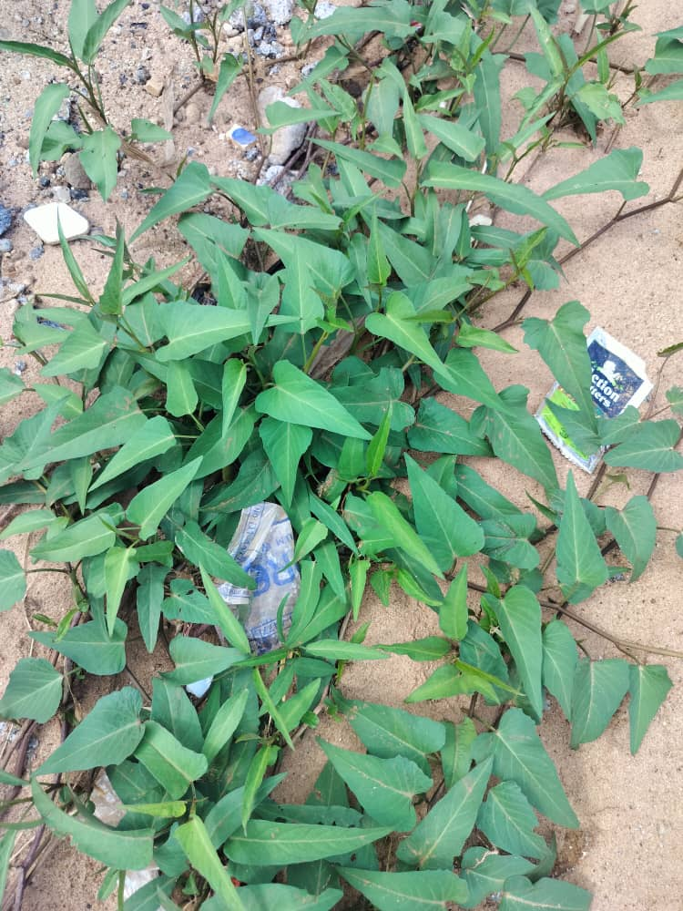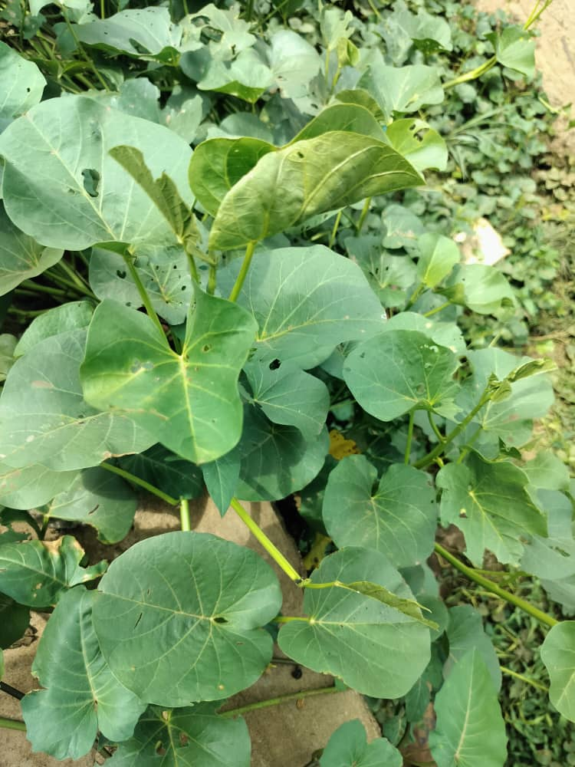
B
A

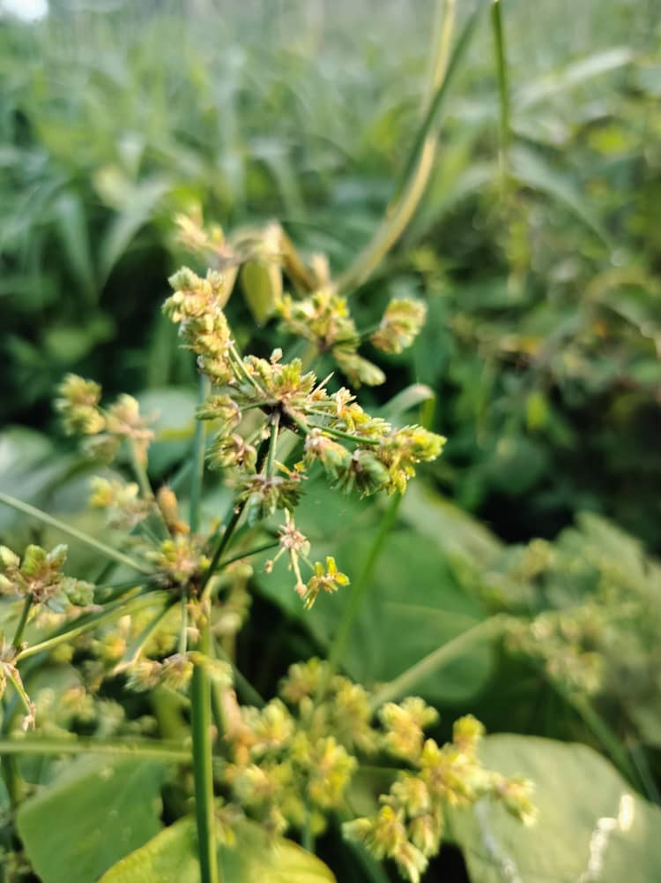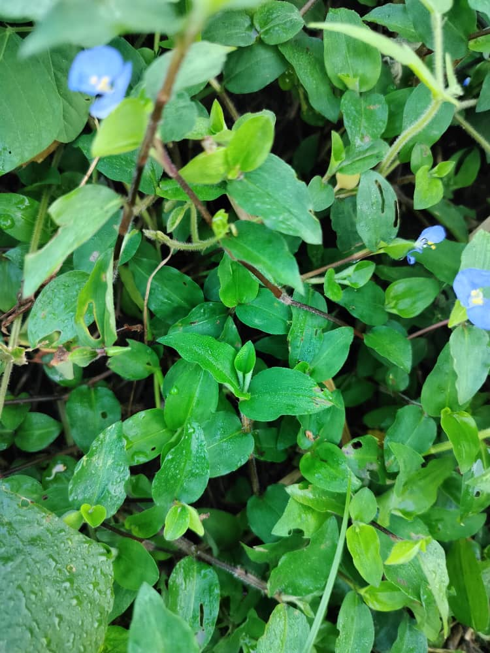
D
C
Figure 3: a. Ipomoea aquatica; b. Ipomoea asarifolia; c. Cyperus surinamensis; d. Commeina diffusa

Discussion
The phytodiversity observed in the impacted lotic wetlands of Asaba Metropolis is indicative of an ecosystem undergoing pronounced ecological shifts, primarily driven by sustained anthropogenic pressures (Ogbemudia et al., 2014; Rojas et al., 2019; Mohibul et al., 2023; Ayadiuno & Ndulue, 2024). The presence of 67 plant species across thirty-two (32) botanical families illustrates moderate species richness. This aligns with earlier findings by Nsoh, et al. (2021) Borisade and Odiwe (2021) and Slezak et al. (2022) and Alemu et al. (2023) who observed similar diversity levels in disturbed riparian zones and similar wetlands within and outside southern Nigeria. The dominance of Fabaceae (17.9%), Poaceae (13.4%), and Cyperaceae (7.5%) is well noticed and clearly understood. This vegetation composition typical is disturbed wetlands or transitional ecosystems, as these families are well known for their adaptability to varying ecological conditions, including nutrient fluctuation and hydrological variability. This assertion aligns with the views of Signh et. al. (2021) noting the dominance of Fabaceae, Poaceae and Cyperaceae in the unexplored Bani Valley, Indian Himalayas.
The life form spectrum further underscores the disturbed nature of the wetlands. Herbs constituted over 50% of the recorded species, followed by shrubs and trees. This is a common indicator of degraded habitats where open areas created by human encroachment facilitate the colonization of fast-growing, opportunistic herbaceous plants (Lougheed et al. 2008 and Zhang et al., 2019). The relatively low occurrence of trees and aquatic macrophytes points to possible hydrological alteration, reduced water quality, and increased human activity, such as sand mining and waste disposal, all of which are known to impact species composition in freshwater ecosystems (Romero et al, 2022; Mcfadden et al. 2022).
The conservation status evaluation revealed that most species assessed were either listed as Least Concern (LC) on the IUCN Red List database, or were Not Evaluated (NE). Similar observations were made by earlier researchers including Okon et. al. (2022) and Ezekiel et. al. (2023) and Bassey et al (2024). This reflects a broader trend in biodiversity data gaps, particularly in tropical Africa where many native species remain un-assessed or poorly documented (IUCN, 2023). The absence of species assessments in IUCN conservation databases does not indicate that species are secure; rather, it often reflects neglect in conservation planning and can lead to underestimating threats to indigenous and localized species, many of which are increasingly vulnerable to urbanization, pollution, and hydrological changes. More validly, this ring signals for institutionalizing complementary local and regional conservation assessments and creation of up-to-date and well managed database in order not to obscure the vulnerability of localized or endemic species, many of which face mounting threats from urbanization, pollution, and hydrological alterations
Concurrently, the distributional patterns further reinforce the ecological divergence across sites. While 17 species were ubiquitous, over 20 species were site-restricted, indicating the presence of unique microhabitats or site-specific disturbance regimes (Anwana et. Al., 2020). In this case, these restricted species, such as Lagenaria breviflora, Laportea aestuans, and Pityrogramma calomelanos, are important for conservation as their confinement to single locations may reflect narrow ecological amplitudes or dependence on intact habitat patches (Abbit et. al., 2000; Butchart et. al., 2012; Campbell et. al. 2023). Furthermore, the confinement of these species to a single location, point to localized niche requirements or differential impacts of environmental stressors such as flooding regimes, soil type, and pollution gradients (Mbong, et. al., 2020b; Tameirão et al., 2021). On the other hand, the prevalence of seventeen (17) species across the three wetlands is indicative of high ecological plasticity (Ubom et. al., 2012; Mbong et. al., 2023). Some of these species, including Acroceras zizaniodes, Alchornea cordifolia, and Mimosa pudica, have been listed as common flora of disturbed wetland habitats and often serve as bioindicators of environmental resilience (Ogbemudia, et. al., 2014; Anwana et al., 2018).
Studies across temperate and tropical forests show that fragmented landscapes and open canopies promote the proliferation of herbaceous species, especially at forest edges, while forest specialists and woody species decline due to habitat isolation, altered soil conditions, and increased exposure to environmental stressors (Honnay et al., 2005; De Paw et. al., 2024). In line with this, the dominance of herbaceous species (comprising over half of the total flora) signals landscape fragmentation and increased canopy openness, both of which are linked to early successional stages or disturbed environments. Fragmentation and the creation of forest edges lead to greater light availability and altered microclimates, favoring generalist and disturbance-tolerant herbaceous plants while reducing the abundance of forest-dependent life forms such as trees and climbers, which are more sensitive to edge effects and anthropogenic pressures (Brunnet, et. al., 2011).
The findings suggest that while the wetlands retain notable phytodiversity, the composition is skewed toward disturbance-tolerant and invasive species, including Mimosa pudica, Mimosa invisa, Chromolaena odorata and Eichhornia crassipes. These species have been documented to aggressively outcompete native flora, reduce biodiversity, and alter ecosystem services (Ehrenfeld, 2008; Akobundu, et. al., 2016).
A notable ecological observation is the presence of Eichhornia crassipes (water hyacinth) in only one of the three wetlands. The species' presence is ecologically significant and worrisome since it is known to create dense mats that lower oxygen levels, restrict native aquatic plants, and change hydrological flow regimes (Gaballa et al., 2021). The presence of Eichhornia crassipes (water hyacinth) in only one of three wetlands is likely linked to specific environmental conditions, particularly nutrient enrichment. Empirical evidence consistently shows that E. crassipes thrives in waters with elevated nutrient levels, specifically phosphates and nitrates, which are often the result of sewage discharge, agricultural runoff, or industrial effluents (Zarkkami, Esfandi, and Sadeghi 2021; Gaballa et. al., 2021). Its occurrence in the study area is a bioindicator of eutrophication, signifying a potential trophic imbalance and elevated nutrient loading possibly arising from consistent dumping of organic solid waste and effluent rich in phosphates and nitrates from meat processing activities and the nearby market. Another possible reason for the proliferation of this floating invasive weed may be its massive inflow into the stream through tidal current arising from the river Niger with which the stream share close proximity.
Similarly, the presence of Ceratophyllum demersum (coontail) in only one wetland offers contrasting ecological implications. As a submerged, free-floating macrophyte, C. demersum is often associated with relatively clear, calm, slow-moving and oxygen-rich waters (Xio Jiang et al., 2013; Syed et al., 2018). Its restriction to a single site suggests local environmental heterogeneity, possibly linked to water chemistry, flow velocity, or light penetration. This species’ absence in the other wetlands may be due to uncontrolled sedimentation, turbidity, or competition with more aggressive colonizers like E. crassipes.
Conclusion and Recommendation
Generally, the impacted wetlands within Asaba Metropolis present a case of floristic resilience amid degradation. While plant diversity persists, its structure is skewed toward disturbance-tolerant and invasive species, with fewer representatives of climax or conservation-significant taxa. The co-occurrence of E. crassipes and C. demersum in separate sites exemplifies a gradient of ecological health, ranging from eutrophic to potentially mesotrophic systems. Baased on the current findings, it is imperative to sustain ecological integrity and targeted restoration interventions. This includes controlling invasive species, rehabilitating buffer zones, regulating effluent discharge, and instituting indigenous knowledge and community-based conservation strategies. Moreover, future research should prioritize long-term monitoring, functional trait analysis, and hydrological assessments to better understand wetland resilience and thresholds under continued anthropogenic stress.
References
Abbitt, R., Scott, J., and Wilcove, D. (2000). The geography of vulnerability: incorporating species geography and human development patterns into conservation planning. Biological Conservation, 96, 169-175. https://doi.org/10.1016/S0006-3207(00)00064-1.
Alemu, T., Pertoldi, C., Hundera, K., and Ambelu, A. (2023). Spatial patterns of riparian vegetation community composition and diversity along human‐ affected East African highland streams. Ecohydrology, 16. https://doi.org/10.1002/eco.2524.
Anwana, E. D., Ita, R. E. and Mbong, E. O.(2018). The Distribution of Cyrtospermum senegalense (Schott) Engl. in a Seasonal Wetland in Akwa Ibom State. Tropical Freshwater Biology, 27(2): 1-11.
Anwana, E. D., Mbong, E. O. and Etim, N. (2020). Trends in Macrophyte Diversity in Anthropogenic Perturbed Lentic Ecosystems within Uyo Metropolis. Journal of Environmental and Waste Management, 7 (1): 339-344.
Anwana, E. D., Udoinyang E. P. and Ogbemudia, F. O. (2015). Plant Diverssity in an urban Recreational Pond. International Journal of Innovative Agriculture and Biology, 3(2): 20 - 24
Ayadiuno, R., and Ndulue, D. (2024). Integrating Remote Sensing and GIS-Based Map Analysis in Determining Spread of Built-Ups and Land-Use Dynamics of Terrain of Onitsha Metropolis, Anambra State, Nigeria. Land. https://doi.org/10.3390/land13111896.
Bassey, M. E., Anwana E. D., Mbong, E. O. and Umoh, O. T. (2023) Diversity and Distribution of Vascular Cryptogams in relation to Elevation Gradient in Osomba Range of the Cross River National Park. Cross River State. World Journal of Applied Science and Technology, 15(1): 26-32.
Bassey, M. E., Anwana, E. D., Umoh, O. T and Mbong, E. O. (2024). Pteridophytes and Lycophytes of Osomba Hills, Cross River State National Park. Ceylon Journal of Science, 53(2): 219 -229.
Borisade, T., and Odiwe, A. (2021). Regeneration status of common woody species in the riparian forests in Southwestern Nigeria. Ecological Questions, 32, 1-16. https://doi.org/10.12775/EQ.2021.012.
Brunet, J., Valtinat, K., Mayr, M., Felton, A., Lindbladh, M., and Bruun, H. (2011). Understory succession in post-agricultural oak forests: Habitat fragmentation affects forest specialists and generalists differently. Forest Ecology and Management, 262, 1863-1871. https://doi.org/10.1016/J.FORECO.2011.08.007.
Butchart, S., Scharlemann, J., Evans, M., Quader, S., Aricò, S., Arinaitwe, J., Balman, M., Bennun, L., Bertzky, B., Besançon, C., Boucher, T., Brooks, T., Burfield, I., Burgess, N., Chan, S., Clay, R., Crosby, M., Davidson, N., De Silva, N., Devenish, C., Dutson, G., Fernández, D., Fishpool, L., Fitzgerald, C., Foster, M., Heath, M., Hockings, M., Hoffmann, M., Knox, D., Larsen, F., Lamoreux, J., Loucks, C., May, I., Millett, J., Molloy, D., Morling, P., Parr, M., Ricketts, T., Seddon, N., Skolnik, B., Stuart, S., Upgren, A., and Woodley, S. (2012). Protecting Important Sites for Biodiversity Contributes to Meeting Global Conservation Targets. PLoS ONE, 7. https://doi.org/10.1371/journal.pone.0032529.
Effiong, Y. I., George, U. U., Oboho,, D. E. and Mbong, E. O. (2021). Spatial and Temporal Variation in Zooo planktons composition and Abundance in a Tropical Freshwater Ecosystem in the Niger Delta, Nigeria. New York Science Journal, 14(4): 1-12
Ehrenfeld, J. (2008). Exotic invasive species in urban wetlands: environmental correlates and implications for wetland management. Journal of Applied Ecology, 45, 1160-1169. https://doi.org/10.1111/J.1365-2664.2008.01476.X.
Ezekiel, A. G., Umoh, O. T., Mbong, E. O., Ntukidem, A U. and William, R. A. (2024) Distribution and Conservation Status of Plants’ Species in the Botanical Garden and Arboretum domiciled in the University of Uyo, Nigeria. Dutse Journal of ure and Applied Science, 10(1b): 74 – 84.
Gaballah, M., Ismail, K., Aboagye, D., Ismail, M., Sobhi, M., and Stefanakis, A. (2021). Effect of design and operational parameters on nutrients and heavy metal removal in pilot floating treatment wetlands with Eichhornia Crassipes treating polluted lake water. Environmental Science and Pollution Research, 28, 25664 - 25678. https://doi.org/10.1007/s11356-021-12442-7.
Honnay, O., Jacquemyn, H., Bossuyt, B., and Hermy, M. (2005). Forest fragmentation effects on patch occupancy and population viability of herbaceous plant species.. The New phytologist, 166 3, 723-36 . https://doi.org/10.1111/J.1469-8137.2005.01352.X.
Syed, I., Fatima, H., Mohammed, A. and Siddiqui, M. A. (2018). Ceratophyllum demersum a Free floating Aquatic Plant: A Review Indian Journal of Pharmaceutical and Biological Research (IJPBR), 6(2): 10 – 17.
Lougheed, V., McIntosh, M., Parker, C., and Stevenson, R. (2008). Wetland degradation leads to homogenization of the biota at local and landscape scales. Freshwater Biology, 53, 2402-2413. https://doi.org/10.1111/J.1365-2427.2008.02064.X
Mbong, E. O., Ivon, E. A., Idio, E., Utuk, K. E., Okon, J. E. and Anwana, E. D. Correlating habitat dynamism with foliar anatomical modulations: A study with Phymatosorus scolopendria (Burm. F.) ching (2023). World Journal of Applied Science and Technology 15 (1), 61-68.
Mbong, E. O., Ogbemudia F. O. and Samuel, E. I (2020b). Tree Species Diversity and Dominance in Relation to Soil Properties in University of Uyo Arboretum. International Journal of Plant, Animal and Environmental Sciences, 10 (3):135 – 142.
Mbong, E. O., Osu, S. R., Uboh, D. G. and Ekpo, I. (2020a). Abundance and distribution of Species in relation to Soil Properties in Sedge-dominated Habitats in Uyo Metropolis, Southern Nigeria. Global Journal of Ecology, 5(1): 24 -29.
McFadden, I., Sendek, A., Brosse, M., Bach, P., Baity-Jesi, M., Bolliger, J., Bollmann, K., Brockerhoff, E., Donati, G., Gebert, F., Ghosh, S., Ho, H., Khaliq, I., Lever, J., Logar, I., Moor, H., Odermatt, D., Pellissier, L., De Queiroz, L., Rixen, C., Schuwirth, N., Shipley, J., Twining, C., Vitasse, Y., Vorburger, C., Wong, M., Zimmermann, N., Seehausen, O., Gossner, M., Matthews, B., Graham, C., Altermatt, F., and Narwani, A. (2022). Linking human impacts to community processes in terrestrial and freshwater ecosystems. Ecology Letters, 26, 203 - 218. https://doi.org/10.1111/ele.14153.
Mohibul, S., Sarif, M., Parveen, N., Khanam, N., Siddiqui, M., Naqvi, H., Nasrin, T., and Siddiqui, L. (2023). Wetland health assessment using DPSI framework: a case study in Kolkata Metropolitan Area. Environmental Science and Pollution Research, 30, 107158-107178. https://doi.org/10.1007/s11356-023-25854-4.
Nsor, C., Mensah, J., Barnes, V., and Akomatey, P. (2021). Anthropogenic drivers of plant species coexistence in selected riparian systems, Kumawu district, Ashanti region (Ghana). Journal of Freshwater Ecology, 36, 323 - 344. https://doi.org/10.1080/02705060.2021.1985642.
Ogbemudia, F. O., Anwana E. D., Onyebule, C. L., and Mbong, E. O. (2025). Epiphytic Vascular Cryptogams as Bioindicators of Atmospheric Heavy Metals Pollution in Eket Wetllands, Nigeria. Asian Journal of Research in Botany, 8 (1): 214 – 226.
Ogbemudia, F.O and Mbong, E.O. (2013). Studies on some Pedological indices, Nutrient flux Pattern and Plant Distribution in Metropolitan Dumpsites in Uyo, Akwa Ibom State. Indian Journal of Phramaceutical and Biological Research, 1(2): 40 – 45.
Ogbemudia, F.O; Anwana, E.D., Mbong, E.O and Joshua, E.E. (2014). Plant Diversity Status and Soil Physicochemistry in a Flood Plain. International Journal of Research, 1(10): 1977 – 1985.
Rojas, C., Munizaga, J., Rojas, O., Martínez, C., and Pino, J. (2019). Urban development versus wetland loss in a coastal Latin American city: Lessons for sustainable land use planning. Land Use Policy. https://doi.org/10.1016/J.LANDUSEPOL.2018.09.036
Romero, F., Acuña, V., and Sabater, S. (2020). Multiple Stressors Determine Community Structure and Estimated Function of River Biofilm Bacteria. Applied and Environmental Microbiology, 86. https://doi.org/10.1128/AEM.00291-20.
Singh, S., Singh, B., Surmal, O., Bhat, M., Singh, B., and Musarella, C. (2021). Fragmented Forest Patches in the Indian Himalayas Preserve Unique Components of Biodiversity: Investigation of the Floristic Composition and Phytoclimate of the Unexplored Bani Valley. Sustainability, 13, 6063. https://doi.org/10.3390/SU13116063.
Slezak, M., Douda, J., Šibíková, M., Jarolímek, I., Senko, D., and Hrivnák, R. (2022). Topographic indices predict the diversity of Red List and non-native plant species in human-altered riparian ecosystems. Ecological Indicators. https://doi.org/10.1016/j.ecolind.2022.108949.
Tameirão, L., Caminha-Paiva, D., Negreiros, D., Veloso, M., Berbara, R., Dias, L., Pierce, S., and Fernandes, G. (2021). Role of environmental filtering and functional traits for species coexistence in a harsh tropical montane ecosystem. Biological Journal of The Linnean Society. https://doi.org/10.1093/BIOLINNEAN/BLAA181.
Ubom, R. M., Ogbemudia, F. O. and Benson, K. O. (2012). Soil vegetation Relationship in Fresh Water Swamp Forest. Scientific Journal of Biological Science, 1: 43 - 45.
Xiong Jian, H., Jian-tuan, N L. and Bang-ding, X. (2013) The Effects of Nutrient Concentration on Purificaion Ability and Eco-Physiology of Ceratophyllum Demersum[J]. ACTA HYDROBIOLOGICA SINICA, 2013, 37(6): 1066-1072. DOI: 10.7541/2013.143
Zarkami, R., Esfandi, J., and Sadeghi, R. (2021). Modelling Occurrence of Invasive Water Hyacinth (Eichhornia crassipes) in Wetlands. Wetlands, 41, 1-13. https://doi.org/10.1007/s13157-021-01405-w.
Zeb, B., Mahmood, Q., Irshad, M., Zafar, H., and Wang, R. (2024). Sustainable treatment of combined industrial wastewater: synergistic phytoremediation with Eichhornia crassipes, Pistia stratiotes, and Arundo donax in biofilm wetlands.. International journal of phytoremediation, 1-7 . https://doi.org/10.1080/15226514.2024.2403037.
Zhang, D., Qi, Q., Tong, S., Wang, X., An, Y., Zhang, M., and Lu, X. (2019). Soil Degradation Effects on Plant Diversity and Nutrient in Tussock Meadow Wetlands. Journal of Soil Science and Plant Nutrition, 1-10. https://doi.org/10.1007/s42729-019-00052-9.

