**Evaluating Digital Transformation in the Libyan Telecommunications Sector: A Methodical Approach Utilising the (LDT) Model**

**Abstract**

Digital transformation initiatives have transformed from a technology opportunity to an essential requirement, with the Libyan telecommunications sector being no exception. Digital transformation has become a vital strategy for organizations aiming to boost their competitiveness and operational efficiency in the rapidly evolving digital economy. The Libyan Telecommunications Company faces challenges in adapting to technological advancements, reconciling conflicting strategies and plans, ensuring data security, and integrating new technology with its existing infrastructure. This paper employed a qualitative case study methodology, featuring an illustrative analysis of three groups: customers, telecom company employees, and decision-makers within the telecom sector. The paper presents a structural model for assessing digital transformation across four essential contexts: customers, technology, organizations, and environments. The customer context analysis examines cultural factors, knowledge awareness, and service protocols that influence user adoption and engagement. The technical context pertains to the use of digital technologies, worker adaptation, and the comparative benefits of technological integration. The organizational context emphasizes financial investment, regulatory flexibility, strategic alignment, and executive support, all of which affect the efficacy of transformation. The environmental context encompasses market rivalry, partner influence, and policy assistance, all of which, when combined, impact the dynamics of digital transformation. The Libyan Digital Transformation (LDT) model provides a comprehensive framework for evaluating and enhancing digital transformation efforts by incorporating various dimensions. This paper aims to help firms utilize contextual data to achieve sustained digital innovation and growth.

*Keywords—Digital transformation; Libyan telecommunication companies; Qualitative research; LDT Model*

# **Introduction**

Digital transformation (DT) is a critical change that enables organizations to utilize their resources and processes more effectively in response to the continually evolving customer demands for services and products (Kääriäinen et al., 2020). Organizations that effectively utilize digital transformation enhance resource productivity, resulting in increased revenues. The swift pace of technological progress and innovation leads to changes in consumer and societal behavior; thus, digital transformation (DT) can be broadly described as the adoption or modification of business models or frameworks (Vărzaru & Bocean, 2024).

A framework, occasionally referred to as a model in scholarly discourse, is a graphical representation of an event that encompasses its essential elements, factors, and their interactions. The corporate landscape is evolving due to contemporary digital transformation tendencies. Service organizations face significant pressure to enhance efficiency, minimize costs, and improve service quality in today's competitive landscape (Elia et al., 2024).

Digital transformation (DT) has evolved from a technological option to an essential requirement for addressing the growing global population's needs and expectations (Kraus et al., 2022)(Kraus et al., 2021). As a result of these advancements, numerous businesses have undergone substantial transformations, with digital transformation providing novel processes and systems that can significantly impact the core structures of a company's operations (Agustian et al., 2023). Digital transformation is a significant challenge for both individual enterprises and bigger economies. National governments should derive insights from digital transformation (DT) initiatives to evolve into a digital country where enterprises, authorities, and citizens coexist within a digital society that facilitates the exchange and generation of value for all stakeholders involved (Zaoui & Souissi, 2020).

The worldwide effects of COVID-19 in 2020 intensified the demand for individuals and organizations in both public and commercial sectors, especially governmental entities, to implement digital transformation. Worldwide, just 30% of digital transformation initiatives have achieved success (Petropoulou et al., 2024). The COVID-19 pandemic has galvanized the research community to develop early diagnostic techniques. (Syahrin et al., 2023).Furthermore, this epidemic has validated the necessity for the digitalization of public and commercial entities, including companies and organizations. The pandemic presented an opportunity to innovate and expedite digital transformation, ensuring the continuity and viability of companies (Tønnessen et al., 2021). Moreover, surveys indicate that 16% to 34% of organizations experienced significant enhancements as a result of their digital transformation initiatives. Developing nations are often regarded as lacking digital maturity and as needing digital advancement (Al-Moaid & Al-Marhdi, 2024).

Digital transformation refers to an organizational change achieved through the implementation of digital technologies and innovative business models aimed at enhancing the operational performance of the organization. The process encompasses more than just the deployment of an appropriate technology solution; it requires a strong alignment between information technology and business processes to achieve significant results for the organization. This includes considerations of organizational readiness, change management, and the management of key stakeholders (Studies, 2024). Furthermore, digital transformation represents a significant challenge for organizations. The impact of digital transformation and its potential to help companies maintain market competitiveness has been underscored by the growing digitalization of economies. However, the issue of where to initiate the facilitation of digital processes and services remains a pervasive concern. The emergence of mobile technology, allowing workers to work remotely, has compelled firms to adjust to new challenges and opportunities in digital transformation processes (Aghayari et al., 2022).

Digital transformation strategies are a crucial method for organizing, structuring, and implementing digital transformation operations. Nonetheless, a substantial theoretical and empirical gap exists regarding the development and implementation of these methods for individuals and organizations. The worldwide effects of COVID-19 in 2020 intensified the demand for individuals and organizations in both public and commercial sectors, especially governmental entities, to implement digital transformation (Plekhanov et al., 2023). Organizations and businesses have undergone substantial transformations termed "digital transformation" to capitalize on the opportunities presented by technological advancements and societal changes that have facilitated their evolution. Digital transformation has profoundly transformed how firms engage with their clients and conduct business. Recently, enterprises across nearly all sectors have developed strategies to adopt new digital technologies and capitalize on their benefits. Current and developing digital technologies—such as artificial intelligence (AI), the Internet of Things, cloud computing, and big data—along with their rapid and extensive use in business contexts, are the primary focus of attention (Huang & Tang, 2025). Organizations must develop a comprehensive strategy to leverage information technology effectively. Numerous studies have provided definitions and phases of digital strategies (Korachi & Bounabat, 2020).

Libya is no exception to this change. Researchers are encouraged to conduct more studies on digital transformation, particularly in light of the growth of big data, the Internet of Things, and Artificial Intelligence. However, researchers paid little attention to investigating the DT issues in Libya. Libya is currently making significant strides in this field through its enterprises, especially since the slogan "Smart Citizen, Smart Companies, Smart Cities, Smart Country" was introduced by telecom firms in Libya. However, this work also requires additional effort and assistance from researchers to enhance its plan performance efficiency (Wynn et al., 2021).

This paper primarily addresses key points in the telecom sector plan in Libya for DT based on the following steps:

* Recognize and break down the components of the Libyan telecom company's digital transformation plan.
* Determine the implementation of structured methods for change management on digital transformation projects in Libya's telecom sector.
* Investigate the key elements of change management necessary for the telecom sector in Libya to implement digital transformation successfully.

This paper is structured as follows: The next section presents the literature review, followed by the methodology section, which is then supplemented by the LDT model, including a discussion and conclusion.

# **LITERATURE REVIEW**

## **2.1 Concepts and Principles of Digital Transformation**

Digital transformation refers to the widespread adoption of digital technologies across all aspects of a company, significantly impacting operational processes and customer value delivery. It involves the use of new technology, the optimization of processes, and the cultivation of a digital culture that promotes continual development and innovation. The essential elements of digital transformation are cloud computing, big data and analytics, the Internet of Things (IoT), artificial intelligence (AI), and automation (Manda, 2020). Digital transformation (DT) is increasingly essential for meeting the demands of the growing global population, evolving into more than merely a technological opportunity. (Kraus et al., 2021). While previous literature has enhanced our understanding of certain facets of digital transition, a comprehensive understanding of its nature and implications remains elusive. Not surprisingly, scholars have developed a significant interest in studying digital transformation (DT) over the past few decades. The challenge of adapting to a digital world affects governments, cities, organizations, industries, and individuals worldwide (Kraus et al., 2022).

## **Strategy of Digital Transformation**

A substantial amount of knowledge has been generated regarding technological advancements in SMEs and Industry 4.0 (I4.0) to inform essential recommendations for their implementation. A digital transformation involves utilizing technology to enhance the efficiency and reach of organizations significantly. Digital transformation is a crucial foundation for empowering companies to improve their business operations, thereby creating value and competitiveness. This alteration will succeed if executed within a digital strategy framework. Numerous studies have explored the concepts and challenges of digital transformation (Korachi & Bounabat, 2019).

A thorough review of the literature on digital transformation strategy has been conducted; the most cited articles focus on understanding the definitions, concepts, dimensions, phases, and components of digital transformation. As a result, they do not provide an integrative framework that offers precise guidelines for creating and tracking digital transformation strategies. Researchers attempted to identify a process that supports business goals and business strategy through the development of information systems (Korachi & Bounabat, 2019).

There is still disagreement around the definitions, frameworks, and formulation of the digital transformation plan. Despite comprehensive studies on digital transformation strategies and assessments, a definitive global model defining the overarching principles and guidelines for effective digital transformation remains absent (Butt, 2020). The conventional approach to planning and implementation is particularly ineffective in this dynamic era, characterized by rapid change, where competitors are not easily discernible, and new technologies are emerging continuously. Digital technology has transformed business strategies, processes, and capabilities across various industries and organizations. In this context, organizations must cooperate and address these developments by employing distinctive management strategies. The applied method involves formulating a digital strategy to leverage digital advancements across the organization and integrate all interactions and operations (Adewumi et al., 2024).

A digital strategy enables a corporation to synchronize its digital efforts with its overarching business objectives. The company's daily activities are consequently interconnected with its digital strategy. A digital strategy helps an organization integrate all its digital initiatives with its business objectives. Consequently, the organization's daily activities are intrinsically linked to its digital strategy (Tuukkanen et al., 2021).

## **The Impact of Digital Transformation on the Telecom Sector**

The telecommunications sector has always been the cornerstone of global communication, connecting individuals across vast distances and enabling the swift transmission of information. From the advent of telegraphy to the contemporary era of 5G and fiber optics, telecommunications have been crucial to societal progress. As we near the Fourth Industrial Revolution, the digital revolution is profoundly reshaping this industry. Understanding these changes and their implications is vital for stakeholders seeking to maintain a competitive advantage in a rapidly evolving landscape (Manda, 2020).

These changes have a profound impact on the telecommunications company, characterized by substantial infrastructure and complex operations. The shift to digital transformation in telecommunications is driven by the need to meet rising customer expectations, the goal of operational efficiency, and the requirement to stay competitive in a rapidly evolving technological environment (Manda, 2020). Digital transformation is revolutionizing the telecoms industry, necessitating changes in business structures and service offerings. Studies demonstrate that digital transformation leads to an increase in subscribers and a decrease in pricing for telecommunications services(Agustian et al., 2023) . Companies must persist in meeting their clients' needs in the market. Conversely, those who endure in the market must invest greater effort in anticipatory research and evaluate customer prospects and behaviours to align their value proposition accordingly.

The advancement of digital technology, particularly the Internet, has significantly contributed to education, facilitating connections among individuals and disseminating information more effectively. Telecom companies aim to be premier digital telecommunications providers, facilitating digitalization through their infrastructure and connections while also delivering services. As a result, telecom companies utilize new data technology, support communication through various channels, and reach a broader audience by staying current with digital technology advancements, following trends, and continually enhancing their knowledge and skills to remain relevant. To achieve this objective, corporate communications employ several techniques, including preserving the company's reputation, leveraging social media platforms, engaging with the media, and implementing effective internal communications. The company utilizes digital services and platforms(Dwivedi et al., 2021a) .

## **The Importance of Digital Transformation**

Digital transformation refers to the implementation of digital technologies throughout an organization, specifically in altering the methods by which value is generated and delivered to customers(Jain et al., 2023). Additionally, digital transformation is a culture shift that persistently evaluates employees' prior experiences and the organization's present condition. Digital technology is improving corporate performance through process change methodologies. For an organization to maintain its competitiveness, digitalization must become the core factor upon which plans are built (Zhou et al., 2005). The subsequent list delineates five important objectives for digital transformation:

* Effective connection with clients
* Business adaptability
* Operational efficiency and cost reduction
* Service innovation
* Development chances (Kraus et al., 2022)

# **METHODOLOGY**

Digital transformation requires further exploration, as it remains a novel and frequently misunderstood phenomenon(Dwivedi et al., 2021a). The case study employed a research methodology to gain a deeper understanding of digital transformation in Libya. This paper is based on a questionnaire and interviews conducted with a diverse array of employees, including engineers, technicians, and senior management, as well as customers, in Libyan telecommunications companies. This paper utilized questionnaires across three categories. Qualitative research methods are often employed to investigate novel phenomena and emerging concepts, as well as to develop new theories. In Information Systems research, qualitative methods are used to formulate new theories derived from observed phenomena. Conversely, researchers' analyses of responses to open-ended questionnaire items, referred to as unrestricted questions, employ qualitative methodologies. Researchers employ open-ended questionnaires to gather primary data, which they subsequently discuss and critically analyze without utilizing figures or computations (Conboy et al., 2012). The following questionnaires were used: Computer questionnaire: The questionnaire was sent to respondents, including customers and employees. Several decision-makers from Libyan telecommunications contacted firms via telephone. Interviews were conducted with the officials responsible for the digital transformation project in Libya.

## **Data Collection**

This paper addresses a set of questionnaires regarding digital transformation in Libya and the role of local telecommunications companies in facilitating services and keeping pace with new technologies, as communication infrastructure is the backbone of digital transformation. The scope of this research is limited to examining the impact of change management on digital transformation in the Libyan telecom sector. The listed Libyan government telecom companies are the following:

• Hatif Libya Company

• Almadar Company

• Libyana Company

• Libya Telecom and Technology Company.

The target respondents were leaders, decision-makers, and employees of digital transformation organizations in these companies. Additionally, they gather feedback from customers who use telecommunications services in Libya. The questionnaires will be as follows:

• Customers

• Telecommunications company employees

• Leaders and decision-makers

The data collection plan is as follows: The plan involves communicating with clients of telecommunications companies through an electronic questionnaire, conducting interviews, and engaging in personal communication with individuals via telephone. The content of the questions was as follows:

• The customer's address.

• The company's name that provides services.

• The type of Internet is wired, wireless, or other.

• Evaluating digital services in terms of quality.

• Application service.

• Evaluate the cost compared to the level of services.

The above factors were considered because they are crucial in supporting digital transformation projects in Libya. Libya is a large country in terms of geographical area, spanning approximately 1.76 million square kilometer(Khamallag, 2018). Therefore, these regions require a thorough geographical examination to plan technological infrastructure, including densely populated cities, smaller towns, and the desert and mountains in both eastern and western Libya. All these areas necessitate a technical assessment to inform technological decisions surrounding them.

Data was collected from multiple Libyan cities, including Tripoli, Misurata, and Benghazi, as well as from several mountainous regions such as Gharyan, Al-Asaba, Zintan, Derna, Msallata, and Tarhuna. Furthermore, data were gathered from towns characterized by desert landscapes, including Sebha, Zilah, Ubari, Awjila, Ghat, Kufra, and Ubari in the southernmost region of Libya, as well as other cities such as Sabratha, Sorman, Al-Zawiya, Zuwara, Zliten, Al-Khoms, Janzour, and Al-Aziziyah. During the second phase of data collection, information was gathered from employees of telecommunications companies through direct communication with various departments and decision-makers overseeing digital transformation projects in the sector. The questionnaire evaluated the readiness of these companies for digital transformation initiatives related to communications infrastructure, the application of artificial intelligence programs, data management via cloud computing, and employee preparedness to implement these projects. Figure 1 illustrates the necessary phases for attaining the proposed model.

.

Fig. 1. Phases of LDT model development

Whereas the questionnaire for telecom employees focused more on the use of digital transformation projects and technologies. The content of the questions is as follows:

* Digital transformation projects.
* Digital strategy integrated with the corporate strategy.
* Which of the following factors hinder digital transformation at your company? Legacy systems, insufficient Funding, Cybersecurity and Privacy Requirements, Conflicting corporate strategies, Communications infrastructure, and Laws and regulations.
* What do you think are the most important factors for successful digital transformation? Strong leadership in promoting digitalization, Strong cybersecurity Strategy/program, and sufficient funding. Adequate collaboration between IT and business lines. Building a constant culture of change.
* Which is your greatest digitalization shortage? Lack of hardware/equipment, Lack of software, Lack of data availability.
* The extent of operations at your site/company is automated.

This section contains questions related to digital transformation (DT) collected through interviews with leaders in telecommunication companies, as they are responsible for making decisions regarding digital transformation in Libya. The content of the questions is as follows:

* The plan for the next three to five years of action regarding the development of digital transformation.
* The efficiency of current infrastructure.
* Employee competence and readiness to implement digital transformation projects.
* Which modern technologies, such as artificial intelligence, cloud computing, virtual reality, augmented reality, and the Internet of Things, do you believe will have the most positive impacts on your business? Does your company invest in these technologies?
* The laws of Libya, along with their flexibility and the capacity to support digital transformation.

## **Data Cleaning**

Attributes, including integrity, completeness, validity, and consistency, generally characterize data quality. Assessing the integrity of web-based survey data and implementing a data cleaning process before analysis are critical steps often overlooked by researchers (Conboy et al., 2012). To elicit coherent and valid responses from telecom customers, the identical question was posed in various formats to identify any discrepancies in the individual's answers. All superfluous and illogical responses were subsequently corrected. This method aimed to assess the customer's understanding and awareness of technology utilization. We analyzed the open-ended responses to discern any ambiguous or illogical patterns, as well as any recurring answers. The data cleaning process involves identifying and correcting missing values, eliminating duplicate entries, standardizing formats, detecting outliers, and validating the accuracy of responses.

## **Data Analysis**

The data acquired from the Google Forms survey and interviews yielded significant insights into perspectives on digital transformation. As previously stated, there exists a distinct questionnaire tailored for customers, another for employees of telecommunication firms, and interviews conducted with decision-makers within those organizations. The sample comprised customers from 24 cities located in the eastern, western, and southern regions of Libya. Their replies were almost indistinguishable in terms of quality and expense. The majority of telecom customers perceive that their daily usage predominantly centers on entertainment, with a minimal fraction allocated to academic pursuits. Feedback regarding speed was assessed as average to good. Survey respondents reported that they do not utilize technological methods for governmental operations and that paper-based systems continue to be the dominant method. Moreover, although electronic resources are occasionally accessible, they frequently experience interruptions or necessitate substantial time to execute operations. Responses indicate that some customers lack the requisite expertise to utilize digital services effectively and often seek assistance in doing so. Numerous individuals reported recurrent internet disruptions during standard phone calls, underscoring deficiencies in the telecommunications infrastructure.

The second section of the survey focused on inquiries aimed at employees of telecommunications firms. The survey focused on employees' readiness to implement digital transformation initiatives. It also analyzed the primary obstacles that may hinder service improvement, as well as technologies that are currently unavailable but could advance digital initiatives. Upon reviewing the responses, it became evident that there is no definitive strategy for implementation and that the digital infrastructure remains inadequate despite ongoing development initiatives. The responses reveal a clear interest in undertaking digital projects; however, the lack of a vision and strategic plan is a significant obstacle to the execution of digital transformation.

The final section of the survey included direct interviews with several officials from telecommunications companies, including Hatif Libya, Al-Madar, Libyana, and Libya Telecom and Technology. All officials emphasized the need to develop the telecommunications sector. A senior management official stated that they are presently enhancing the telecommunications infrastructure via the Fibre to the Home (FTTH) project. He emphasized the financial obstacles confronting this project, asserting that its successful execution would have a positive influence on the advancement of the telecommunications sector. In a separate context, another official emphasized the necessity of cultivating an appropriate environment, which includes enforcing Libyan laws to prosecute cyber crimes, imposing penalties on individuals obstructing digital project advancement, enhancing cybersecurity measures, and legislating to facilitate daily digital transactions. In response to inquiries regarding strategies for the digital transformation project, another official stated that the approach requires collaborative efforts among Libyan telecommunications companies. He also emphasized the need to enhance digital awareness among administrative and technical personnel through specialized training programs. In conclusion, digital transformation necessitates sustained commitment from all stakeholders and the development of explicit strategies to progress in sync with the global telecommunications industry.

# **THE LIBYAN DIGITAL TRANSFORMATION MODEL FOR THE TELECOMMUNICATIONS SECTOR (LDT) AND DISCUSSION**

The Libyan Digital Transformation (LDT) model structure centers on supporting digital transformation initiatives in Libyan telecommunications firms. This model aims to establish a dependable framework for formulating strategic plans to improve communication services in Libya. Communication and internet services constitute the essential foundation for implementing any digital transformation initiative. A comprehensive data analysis identifies critical elements that will enhance the effectiveness of telecommunications services and operations during digital transformation. Figure 2 examines the essential elements that may serve as focal points for enhancing digital transformation initiatives within the Libyan context. The model identifies four developmental contexts: consumer context, technology context, organizational context, and environmental context, each encompassing various factors and sub-factors, as illustrated in Figure 2. This method helps to identify the different stages of adoption in the communications sector, providing an evaluation of what is needed to move from one stage to the next in the model. Below is a brief overview of each category.

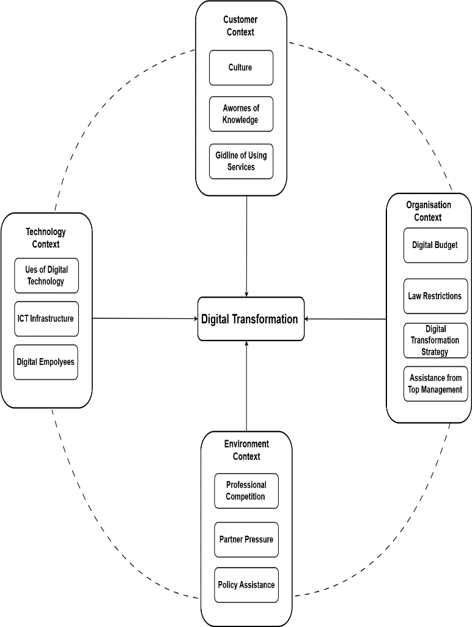

Fig. 2. The main features and elements of the LDT model

## **Customer Context**

This dimension focuses on the customer and encompasses cultural factors, cognitive awareness, and criteria for service usage. These elements significantly influence customers' perceptions and interactions with digital solutions. While technology is a crucial factor in facilitating digital transformation, the human element holds equal importance (Manda, 2020). The lack of technology adoption and the absence of genuine digital transactions in Libya will directly affect the country's digital progress. Traditional systems continue to dominate, whether they are paper-based or accessed through offline platforms. Whether they are paper-based or accessed through offline platforms, traditional systems continue to dominate, and even when connected to the Internet, they limit interaction. As digital advancements proliferate globally, Libya will inevitably experience this transformation. Telecommunications firms must develop a digital culture that promotes innovation. They should prioritize collaboration and ongoing education. Moreover, customer-centricity must be at the heart of their processes. In the realm of digital transformation, it is crucial to ensure that new services and solutions align with the evolving needs and expectations of customers. Figure 3 illustrates a strategic framework for understanding customer needs in telecommunications services, with subsequent points clarifying the requirements for enhanced digital awareness to augment the effectiveness of digital initiatives.

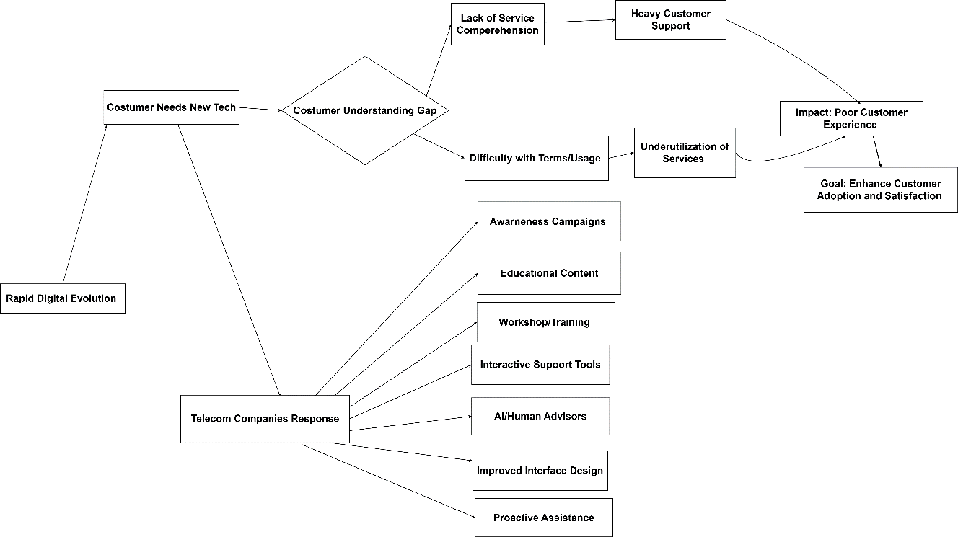

Fig. 3. Strategic framework for addressing customer understanding in telecom services

1. Culture: Digital technology evolves rapidly; consumers increasingly demand the use of new technologies. Organizations should initiate awareness campaigns through social media and television to elucidate fundamental concepts. Educational content comprises videos and articles that explain the functioning of various networks and services in a comprehensible manner (Dwivedi et al., 2021b). Customers are offered workshops and training sessions, either in-store or online, to illustrate the effective utilization of various services.
2. Knowledge awareness: The lack of comprehension regarding new digital services compels telecommunication companies to continuously provide customer support, including interactive tools and applications or websites that assess services based on customer needs (Jain et al., 2023). Therefore, improving customer service for Libyan telecom companies through the use of artificial intelligence or human advisors is crucial for guiding customers to the most appropriate options and preparing users for upcoming digital services.
3. Guidelines for using services: Customers may find it challenging to understand the terms of use or may neglect critical steps to optimize the benefits of the services. The telecommunications companies' teams must commence improving the interface design by optimizing application and website interfaces to enable the efficient retrieval of critical information. Additionally, I intend to provide technical support by offering proactive assistance and issuing notifications or reminders regarding service usage. Implementing these solutions enhances the customer experience and mitigates issues stemming from a lack of culture and awareness in the telecommunications sector.

## **Technological Context**

This dimension relates to the utilization of digital technology, the infrastructure of Information and Communication Technologies (ICT), and the role of digital personnel in adopting new technologies, as shown in Figure 4. These factors dictate the efficiency and efficiency of technology implementation. Nevertheless, the country's insufficient ICT infrastructure constrains its capacity to implement sophisticated digital solutions. Moreover, employees often possess inadequate digital skills, thereby diminishing their ability to adapt to digital work environments. They are also unfamiliar with digital systems, such as Agile, and encounter challenges in data access due to the absence of cloud computing. The resistance to change, combined with a lack of understanding of the advantages of new technologies, leads to a sluggish transformation. The organization does not fully leverage digital technology, resulting in diminished productivity and efficacy. Telecommunications companies ought to contemplate the subsequent considerations:

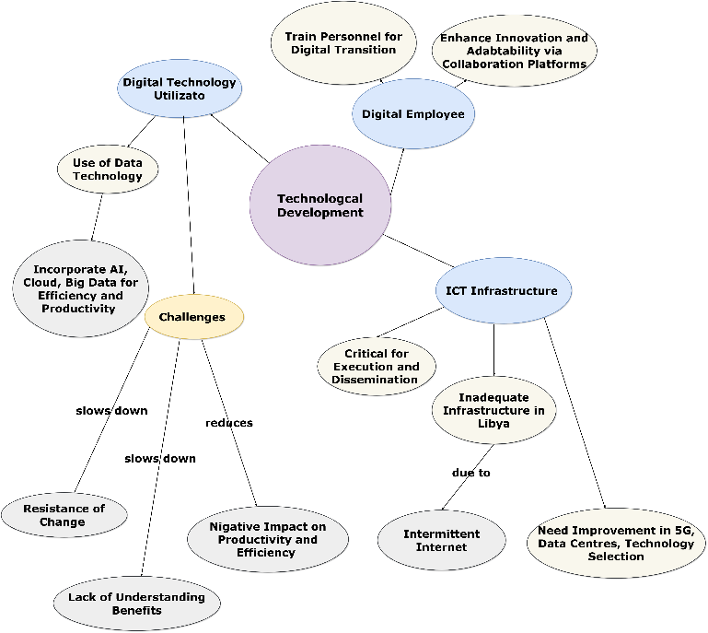

Fig. 4. Technological development

1. Use of digital technology: Aiming to incorporate technological solutions, including artificial intelligence, cloud computing, and big data analytics, to improve efficiency and productivity.
2. ICT infrastructure: ICT infrastructure is a crucial component in the execution and dissemination of digital transformation(Wynn et al., 2021). The primary obstacle to executing digital projects is the inadequacy of Libya's communications infrastructure. A considerable number of users’ experience intermittent internet outages while 3G and 4G networks remain operational. Another reason is the unfinished fiber optic cable project. Improvements must be made by installing new 5G antennas, upgrading data centers and servers to handle increased data volumes, adding more small stations within crowded cities, and selecting appropriate technologies, especially in mountainous and desert areas.
3. Digital Employees: Equipping personnel to embrace technology for task execution, providing training opportunities in these areas, and transitioning the organization from traditional automation to digital automation to align with digital transformation initiatives, thereby fostering innovation and adaptability within enterprises. To enhance productivity and flexibility, it is crucial to utilize digital collaboration platforms.

## **Organizational Context**

This process encompasses the digital budget, regulatory flexibility, digital transformation strategy, and support from senior management. These factors affect an organization's capacity to implement digital transformation effectively. Figure 5 emphasizes the essential elements that underpin an organization's success while also illustrating the interrelatedness of financial, strategic, regulatory, and managerial dimensions in facilitating digital transformation initiatives.

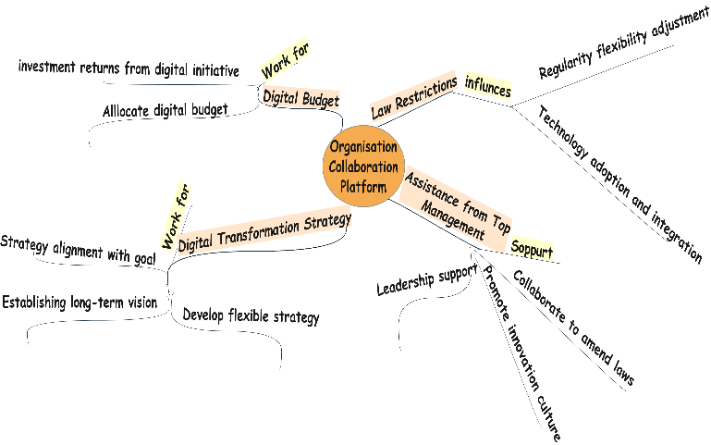

Fig. 5. Organization collaboration platform

1. Digital Budget: The absence of financial resources and a digital budget will adversely affect the execution of digital initiatives. Investing in technology necessitates sufficient Funding, and organizations may be hesitant to allocate resources for this endeavor. Allocating a suitable digital budget for investment in digital transformation requires careful consideration, as it will enhance the subsequent financial returns of these initiatives.
2. Law Restrictions: Specific laws and regulations may hinder the implementation of cutting-edge technology. Collaboration with legislative bodies is crucial for amending statutes in line with technological advancements, particularly in areas such as data protection, e-commerce, and cybersecurity.
3. Digital Transformation Strategy: The absence of solid strategies among Libyan telecom companies and the lack of a unified digital plan frequently result in conflicting objectives and a diminished vision, hindering institutions from collaborating on the execution of digital transformation initiatives. It is essential to develop a comprehensive digital strategy that aligns with the organization's goals and remains flexible to modifications.
4. Assistance from Top Management: A subset of employees and managers presents a considerable obstacle due to their resistance to change, driven by fears of losing control or traditional roles. The lack of support from leaders and decision-makers is deemed a primary factor hindering the implementation of digital transformation in Libyan telecom companies. Promoting a culture of innovation within the organization through employee training and cultivating an environment that welcomes change is an effective approach for engaging in digital transformation initiatives. Leaders and decision-makers must adopt digital solutions as they augment the efficacy of the transformation.

## **Environment Context**

This category encompasses professional competition, partner influence, and policy support. External forces can either facilitate or impede the digital transformation initiatives of businesses.

1. Professional Competition: Neglecting to analyze the market and identify optimal strategies for adapting to current competition may result in the implementation of underdeveloped technologies. Consequently, it is highly advantageous to refrain from hastily embracing new technologies before thoroughly examining and analyzing the competitive landscape (Zhou et al., 2005). The objective is to guarantee optimal decisions that promote development and sustainability in the digital domain.
2. Partner Pressure: Partner pressure may lead to the imposition of adverse conditions or the inadvertent acceleration of the digital transformation process, potentially incurring unforeseen expenses or operational complexities. To surmount these challenges, strategy formulation must be cooperative and grounded in a balance of mutual interests. The Libyan scenario necessitates collaboration among telecommunications companies, consulting firms, and governmental agencies regarding the essential digital infrastructure.
3. Policy Assistance: Policy assistance in the field of digital transformation involves the frameworks, rules, and strategic direction established by governments and organizations to facilitate the effective use of digital technologies. Moreover, it ensures that digital transformation aligns with economic, social, and ethical factors while promoting innovation and inclusivity (Elia et al., 2024).

# **CONCLUSION**

Libyan telecommunications companies are striving to enhance digital communication services to address contemporary technological challenges and keep pace with the rapidly evolving digital age. Libyan telecommunications firms are enabling digital transformation by developing infrastructure, offering seamless countrywide communication services, and striving to provide a range of digital services and platforms. The proposed model provides a comprehensive framework by incorporating four critical contexts —customer, technology, organization, and environment —to evaluate and improve digital transformation activities. Understanding consumer requirements and cultural influences, leveraging technical innovations, enhancing organizational flexibility and strategic coherence, and responding to diverse external constraints are essential elements for achieving successful digital adaption.

**Disclaimer (Artificial Intelligence)**

Authors hereby declares that NO generative AI technologies such as Large Language Models (ChatGPT, COPILOT, etc) and text-to-image generators have been used during writing or editing of this manuscript.

##### **References**

1. J. Kääriäinen, O. Kuusisto, P. Pussinen, M. Saarela, L. Saari, and K. Hänninen, (2020), "Applying the positioning phase of the digital transformation model in practice for SMEs: Toward systematic development of digitalization," *Int. J. Inf. Syst. Proj. Manag.*, vol. 8, no. 4, pp. 24–43, doi: 10.12821/ijispm08040
2. A. A. Vărzaru and C. G. Bocean, (2024), "Digital Transformation and Innovation: The Influence of Digital Technologies on Turnover from Innovation Activities and Types of Innovation," *Systems*, vol. 12, no. 9, p. 359, [Online]. Available: https://www.mdpi.com/2079-8954/12/9/359
3. G. Elia, G. Solazzo, A. Lerro, F. Pigni, and C. L. Tucci, (2024), "The digital transformation canvas: A conceptual framework for leading the digital transformation process," *Bus. Horiz.*, vol. 67, no. 4, pp. 381–398, doi: 10.1016/j.bushor.2024.03.007.
4. S. Kraus, S. Durst, J. J. Ferreira, P. Veiga, N. Kailer, and A. Weinmann, (2022), "Digital transformation in business and management research: An overview of the current status quo," *Int. J. Inf. Manage.*, vol. 63, no. doi: 10.1016/j.ijinfomgt.2021.102466.
5. S. Kraus, P. Jones, N. Kailer, A. Weinmann, N. Chaparro-Banegas, and N. Roig-Tierno, (2021), "Digital Transformation: An Overview of the Current State of the Art of Research," *SAGE Open*, vol. 11, no. 3, doi: 10.1177/21582440211047576.
6. K. Agustian, E. S. Mubarok, A. Zen, W. Wiwin, and A. J. Malik, (2023), "The Impact of Digital Transformation on Business Models and Competitive Advantage," *Technol. Soc. Perspect.*, vol. 1, no. 2, pp. 79–93, doi: 10.61100/tacit.v1i2.55.
7. F. Zaoui and N. Souissi, "Roadmap for digital transformation: A literature review, (2020), "*Procedia Comput. Sci.*, vol. 175, pp. 621–628, doi: 10.1016/j.procs.2020.07.090.
8. A. Petropoulou, E. Angelaki, I. Rompogiannakis, I. Passas, A. Garefalakis, and G. Thanasas, (2024), "Digital Transformation in SMEs: Pre- and Post-COVID-19 Era: A Comparative Bibliometric Analysis," *Sustain.*, vol. 16, no. 23, doi: 10.3390/su162310536.
9. S. Syahrin, K. Almashiki, and E. Alzaanin, (2023), "The Impact of COVID-19 on Digital Competence," *Int. J. Adv. Comput. Sci. Appl.*, vol. 14, no. 1, pp. 511–519, doi: 10.14569/ijacsa.2023.0140156.
10. Ø. Tønnessen, A. Dhir, and B. T. Flåten, (2020), "Digital knowledge sharing and creative performance: Work from home during the COVID-19 pandemic," *Technol. Forecast. Soc. Change*, vol. 170, doi: 10.1016/j.techfore.2021.120866.
11. N. A. A. Al-Moaid and S. G. Al-Marhdi, (2024), "The Impact of Change Management on Digital Transformation in The Yemeni Telecom Sector," *مجلة جامعة صنعاء للعلوم الإنسانية*, vol. 1, no. 2, pp. 470–482, doi: 10.59628/jhs.v1i2.836 .
12. Boonstra, A., 2024. Change management for digital transformation. In *A Research Agenda for Digital Transformation* (pp. 227-254). Edward Elgar Publishing.
13. J. Aghayari, C. Valmohammadi, and M. Alborzi, (2022), "Explaining the Effective Factors on Digital Transformation Strategies in the Telecom Industry of Iran Using the Delphi Method," *Discrete. Dyn. Nat. Soc.*, vol. 2022, doi: 10.1155/2022/9562936.
14. D. Plekhanov, H. Franke, and T. H. Netland, (2023). "Digital transformation: A review and research agenda," *Eur. Manag. J.*, vol. 41, no. 6, pp. 821–844, doi: 10.1016/j.emj.2022.09.007.
15. Q. Huang and Y. Tang, (2025). "Enterprise Digital Transformation Strategy: The Impact of Digital Platforms," *Entropy*, vol. 27, no. 3, pp. 1–23, doi: 10.3390/e27030295.
16. Z. Korachi and B. Bounabat, (2020). "General approach for formulating a digital transformation strategy," *J. Comput. Sci.*, vol. 16, no. 4, pp. 493–507, doi: 10.3844/JCSSP.2020.493.507.
17. M. Wynn, A. Bakeer, and Y. Forti, (2021). "E-government and digital transformation in Libyan local authorities," *Int. J. Teach. Case Stud.*, vol. 12, no. 2, p. 119, doi: 10.1504/ijtcs.2021.116139.
18. J. Manda, (2020). "Digital Transformation Impact on Telecom Infrastructure : Analyzing the implications of digital transformation initiatives on telecom infrastructure and operational strategies, based on your experience in digital transformation projects .," vol. 5, no. 8, pp. 5–17.
19. Z. Korachi and B. Bounabat, (2019). "Integrated methodological framework for digital transformation strategy building (IMFDS)," *Int. J. Adv. Comput. Sci. Appl.*, vol. 10, no. 12, pp. 242–250, doi: 10.14569/ijacsa.2019.0101234
20. J. Butt, (2020). "A conceptual framework to support digital transformation in manufacturing using an integrated business process management approach," *Designs*, vol. 4, no. 3, pp. 1–39, doi: 10.3390/designs4030017.
21. A. Adewumi, S. E. Ewim, and N. J. Sam-bulla, (2024). "Strategic innovation in business models : Leveraging emerging technologies to gain a competitive advantage," vol. 6, no. 10, pp. 3372–3398, doi: 10.51594/ijmer.v6i10.1639.
22. V. Tuukkanen, E. Wolgsjö, and L. Rusu, (2021). "Cultural Values in Digital Transformation in a Small Company," *Procedia Comput. Sci.*, vol. 196, no. 2021, pp. 3–12, doi: 10.1016/j.procs.2021.11.066.
23. Y. K. Dwivedi *et al.*, (2020). "Setting the future of digital and social media marketing research: Perspectives and research propositions," *Int. J. Inf. Manage.*, vol. 59, no. July 2020, p. 102168, doi: 10.1016/j.ijinfomgt.2020.102168.
24. Sheth, J.N., Jain, V., Mogaji, E. and Ambika, A., 2024. *Customer Centric Support Services in the Digital Age*. Springer. Cham.
25. K. Z. Zhou, C. K. Yim, and D. K. Tse,(2005), "The effects of strategic orientations on technology- and market-based breakthrough innovations," *J. Mark.*, vol. 69, no. 2, pp. 42–60, doi: 10.1509/jmkg.69.2.42.60756.
26. Dwivedi, Y. K., Ismagilova, E., Hughes, D. L., Carlson, J., Filieri, R., Jacobson, J., ... & Wang, Y. (2021). Setting the future of digital and social media marketing research: Perspectives and research propositions. *International journal of information management*, *59*, 102168.
27. Khamallag, M. M. (2019). *Towards an Improved Framework of E-Government Implementation in Chaotic Environment; Proposed Social Collaboration Model: Case study of Libya* (Doctoral dissertation, University of Bradford).
28. Jain, V., Sheth, J. N., Mogaji, E., & Ambika, A. (2023). Customer-centric support services: an introduction to the next frontier for competitive advantage in the digital era. In *Customer Centric Support Services in the Digital Age: The Next Frontier of Competitive Advantage* (pp. 1-10). Cham: Springer International Publishing.