Dual-Fungal Bioconversion Model for Ethanol Production from Agro-Waste Using Trichoderma viride and Aspergillus niger

ABSTRACT : The exponential generation of agro-industrial waste in India estimated at over 350 million metric tons annually poses a dual threat of environmental degradation and missed valorization opportunities. While rich in cellulose and hemicellulose, the complex lignocellulosic matrix of such biomass limits its direct fermentability. In this study, a decentralized, fungal-only bioconversion model is proposed for sustainable ethanol production using Trichoderma viride and Aspergillus niger, both isolated from pond and compost niches due to their adaptation to high organic stress environments. The biomass matrix comprising fruit pulp, sugarcane
bagasse, and vegetable residues was pretreated via overnight soaking in 10% H₂SO₄ followed by a 5-minute steam explosion at 180 °C and 1.2 MPa, leading to effective delignification and the release of 42.6 g/L of fermentable sugars. Fungal enzymatic hydrolysis was enhanced by the addition of 0.5% carboxymethyl cellulose (CMC), which improved matrix loosening and enzyme substrate interaction. Fermentation was carried out by an ethanol-tolerant Saccharomyces cerevisiae strain, isolated from dried fig, under semi-anaerobic conditions at 32 °C. The process achieved a final ethanol yield of 10.6% (v/v), with a pH drop from 6.2 to 4.8 and refractive index stabilization at 1.341, confirming active fermentation. Viability tests revealed sustained fungal growth (2-1 × 10⁷ CFU/mL) after 30 days, confirming that the process is biologically stable and potentially reusable.
Comparative analysis against previous bacterial fungal systems showed that this dual-fungal consortium offers superior substrate adaptability, reduced contamination risk, and higher ethanol recovery from heterogeneous feedstock. The approach avoids commercial enzyme dependency and high-energy demands, offering a low-cost, modular strategy aligned with India’s bioenergy and circular economy goals. Although this study focused on ethanol generation, the fungal-rich residue presents additional potential for biofertilizer
applications reserved for future work

KEYWORDS - Agro-waste valorization; Lignocellulosic pretreatment; Trichoderma viride; Aspergillus niger; Saccharomyces cerevisiae; Bioethanol; Regenerative agriculture; Biorefinery; CMC-enhanced saccharification; Steam explosion

ABBREVIATIONS - CMC – Carboxymethyl Cellulose, DNS – Dinitrosalicylic Acid, RI – Refractive Index, CFU – Colony Forming Units, MPa – Megapascal, SDG – Sustainable Development Goals, SI – Système International (International System of Units), H₂SO₄ – Sulfuric acid

- INTRODUCTION
The exponential rise in agro-industrial biomass generation presents a significant environmental and bioeconomic challenge. India alone produces over 350 million metric tons of crop residues and food processing waste annually, much of which is discarded or incinerated due to lack of decentralized processing technologies (Singh and Sharma, 2023; Kumar et al., 2022). These waste streams, rich in lignocellulosic content such as cellulose, hemicellulose, and lignin, hold immense potential as renewable feedstocks for bioethanol generation a clean liquid fuel with established blending infrastructure and policy support under India’s Ethanol Blending Programme (EBP) (Meena et al., 2021; Ministry of Petroleum & Natural Gas, 2022).
However, the recalcitrant architecture of lignocellulose limits its digestibility by standard fermentation organisms. Pretreatment becomes essential for disrupting the crystalline structure and releasing fermentable sugars. Methods such as dilute acid soaking followed by steam explosion have shown promising results in breaking down hemicellulose and partially solubilizing lignin (Suhag et al., 2021; Alvira et al., 2010). Steam-assisted pressure disruption at moderate temperature-pressure combinations (180 °C, 1.2 MPa) offers a balance between sugar yield and energy input, especially for small-scale rural applications (Bhatia and Jha, 2020).
In recent years, fungal systems have gained attention for their enzymatic versatility in biomass degradation. Fungi such as Trichoderma spp. and Aspergillus spp. naturally secrete a suite of hydrolytic enzymes including cellulases, hemicellulases, and pectinases (Fan et al., 2020; Yadav et al., 2018). Unlike mono-culture yeast systems that rely on pre-released glucose, fungal consortia can actively digest and liquefy complex substrates prior to fermentation (Patel et al., 2021). Trichoderma viride is widely known for its role in cellulose breakdown and composting, while Aspergillus niger contributes pectinase and acid-tolerant enzymatic activity, often complementing other microbes in fermentation ecosystems (Romero-Frasca et al., 2021; Saini et al., 2015).
The synergistic potential of fungal–fungal consortia has been supported by various co-cultivation models that report enhanced saccharification and better stress tolerance under semi-aerobic or ambient conditions (Zhou et al., 2021). Furthermore, these fungi thrive in nutrient-limited and high organic matter environments as seen in pond water and compost-rich niches making them naturally adapted to agro-waste systems (Bokhari et al., 2019). Their ability to operate without industrial-level sterile conditions adds to their feasibility in field-scale or village-scale ethanol production settings.
Enzymatic hydrolysis often benefits from the inclusion of facilitators such as carboxymethyl cellulose (CMC), which modifies substrate accessibility and promotes enzyme-substrate interaction by increasing water retention and matrix looseness (Zhang et al., 2021; Chandel et al., 2012). CMC-assisted fungal saccharification has been shown to increase reducing sugar yield and shorten fermentation time, especially in heterogeneous waste mixtures (Gupta and Rao, 2022).
The fermentative stage typically relies on Saccharomyces cerevisiae, which is industrially preferred for its ethanol tolerance, rapid glucose uptake, and regulatory GRAS status. However, its performance is tightly linked to upstream saccharification efficiency and inhibitor levels post-pretreatment (Zhou et al., 2021; Mehta and Sharma, 2021). Stress-adapted strains isolated from dried fruits or natural ferments often show improved tolerance to acidic pH and osmotic stress, making them suitable partners in fungal-integrated systems (Ali et al., 2022).
Despite multiple advances, few studies have integrated non-bacterial, dual-fungal enzymatic systems with scalable ethanol fermentation models under realistic field conditions. Most reports rely on purified enzymes or monocultures, limiting their rural adaptability. This study introduces a two-stage fungal fermentation platform using pond-isolated Trichoderma viride and Aspergillus niger, supported by CMC-enhanced hydrolysis and semi-anaerobic fermentation using adapted S. cerevisiae. The system was applied to mixed agro-waste under low-energy pretreatment and evaluated for ethanol yield, pH drift, refractive index change, and fermentation robustness.
This approach aligns with India’s climate-smart agriculture initiatives, the National Bio-Energy Mission, and broader SDG targets for sustainable fuel generation from waste.
- LITRATURE REVIEW
The conversion of lignocellulosic biomass into fermentable sugars for ethanol production has been a focus of bioenergy research for decades. Traditionally, chemical and thermochemical pretreatment methods like dilute acid hydrolysis and steam explosion have been employed to disrupt the complex structure of plant biomass (Alvira et al., 2010; Suhag et al., 2021). Steam explosion at moderate pressures (1.0–1.5 MPa) and temperatures (170–200 °C) has been especially effective in solubilizing hemicellulose and increasing cellulose accessibility, particularly when combined with prior acid soaking (Kumar et al., 2022; Bhatia and Jha, 2020).
Fungal bioconversion, using organisms such as Trichoderma spp. and Aspergillus spp., offers a more sustainable approach due to their ability to secrete multiple lignocellulolytic enzymes, including endoglucanases, β-glucosidases, and pectinases (Yadav et al., 2018; Saini et al., 2015). Trichoderma viride has been widely used in composting, bio-enzyme production, and cellulose degradation, while Aspergillus niger is known for its acidic tolerance and its role in the production of industrial enzymes such as glucoamylase and pectinase (Patel et al., 2021; Romero-Frasca et al., 2021).
Several studies have examined the enzymatic synergy between fungal strains for biomass liquefaction. For instance, co-cultivation of T. reesei with A. niger was reported to enhance xylanase and pectinase activity, improving saccharification of mixed agro-residues (Zhang et al., 2021). Similarly, T. viride paired with Penicillium chrysogenum increased the release of reducing sugars from sugarcane bagasse, due to complementary action on cellulose and hemicellulose fractions (Bokhari et al., 2019). However, many of these studies were limited to laboratory-scale enzyme assays or used pure cellulose rather than heterogeneous field-collected biomass.
The inclusion of carboxymethyl cellulose (CMC) as a saccharification aid has also been shown to increase reducing sugar yield by loosening the substrate matrix and increasing water retention (Chandel et al., 2012; Gupta and Rao, 2022). When used alongside fungal enzymes, CMC improves contact between enzyme and substrate, particularly in complex substrates like fruit–vegetable pulp mixtures.
Fermentation following enzymatic hydrolysis typically relies on Saccharomyces cerevisiae, which is capable of tolerating ethanol concentrations up to 14% (v/v) under optimized conditions (Ali et al., 2022; Mehta and Sharma, 2021). Some studies have reported the use of wild-type yeast isolates adapted to higher sugar and ethanol concentrations from natural ferments, such as dried figs and palm sap (Romero-Frasca et al., 2021; Das et al., 2020). These strains exhibit higher stress tolerance, especially under pH fluctuations and in the presence of residual inhibitors from pretreatment steps.
Despite advances in fungal fermentation, most ethanol studies still focus on mono-culture models or require expensive enzyme purification (Zhou et al., 2021; Singh and Chaurasia, 2022). Few have attempted to develop integrated, fungal-only systems that are capable of both hydrolysis and fermentation support using real, mixed agro-waste under low-energy pretreatment. There is also a lack of scalable models employing field-adapted fungal isolates, particularly those sourced from nutrient-rich environments like pond sediments or composting zones.
Therefore, this study aims to bridge these gaps by using a compatible, pond-isolated fungal consortium (Trichoderma viride and Aspergillus niger) for enzymatic hydrolysis, enhanced by CMC, followed by fermentation using stress-adapted S. cerevisiae. The approach is designed for small-scale, decentralized ethanol production using mixed agro-residues under moderate processing conditions, aligning with sustainable biofuel strategies.
- MATERIALS AND METHODS
- Collection and Preparation of Substrates
Agro-waste samples were collected from roadside vegetable vendors, juice stalls, and agro-industrial waste points near the MIET campus, Meerut (Uttar Pradesh, India). The biomass included sugarcane bagasse, mixed fruit pulp (mainly orange, pomegranate, papaya), and decaying vegetable residues (cabbage, bottle gourd, and tomato). All samples were washed with sterile water, chopped into 2–4 cm fragments, and stored at 4 °C until further use (Gupta and Rao, 2022; Suhag et al., 2021).The mixture was homogenized manually and weighed to maintain a dry matter content of 8–10%. Equal quantities were pooled into sterile flasks for pretreatment.
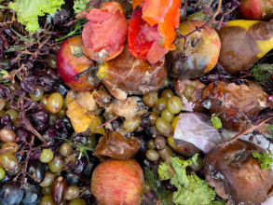 | 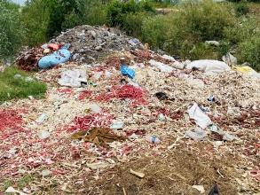
- Fig 1(wasted fruit taken from local market,)
- Fig 2 (wasted agro-waste near MIET, INDIA
- Acid Soaking and Steam Explosion Pretreatment
Pretreatment was performed in two sequential stages:
Acid Soaking: Chopped biomass was soaked in 10% (v/v) H₂SO₄ overnight (16 hours) at room temperature (~28 °C) for hemicellulose disruption and microbial deactivation (Chandel et al., 2012).
The slurry was filtered and washed with distilled water until near-neutral pH, then pH was manually adjusted to 6.0 using 1N NaOH.
Steam Explosion: The acid-treated biomass was transferred to a stainless-steel pressure vessel and subjected to 180 °C at 1.2 MPa for 5 minutes, followed by sudden decompression (Kumar et al., 2022; Alvira et al., 2010). This facilitated further breakdown of lignocellulosic structure and enhanced enzyme accessibility. Post-explosion slurry was cooled, and the final pH was rechecked and adjusted to 6.0 prior to enzymatic hydrolysis.
- Isolation and Cultivation of Fungal Consortium
Pond water and surrounding compost-soil samples were screened for cellulolytic fungi by serial dilution and plating on Potato Dextrose Agar (PDA) amended with 2% cellulose.
Two dominant morphotypes were isolated and identified through microscopic and phenotypic analysis as: Trichoderma viride, Showing green conidial mass, fast sporulation, and clear zone on CMC agar, Aspergillus niger: Characterized by black, conidial heads with radial growth and pectinolytic activity on citrus peel agar. Fungal inocula were maintained on PDA slants at 4 °C and subcultured regularly for enzyme production (Yadav et al., 2018; Bokhari et al., 2019).
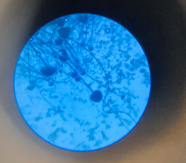 | 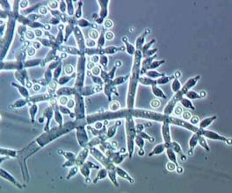
- Fig.3 ( Aspegillus niger microscopy 10x)
- Fig 4 ( Trichoderma viride microscopy, 40x)
- Enzymatic Saccharification
Submerged fermentation was carried out in 1000 mL Erlenmeyer flasks containing 500 mL of sterilized pretreated slurry. Each flask was inoculated with 10% v/v spore suspensions of both T. viride and A. niger in equal ratio (1:1), and incubated at 30 °C for 96 hours under static conditions.
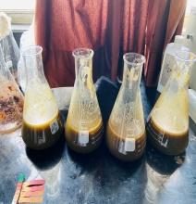 | 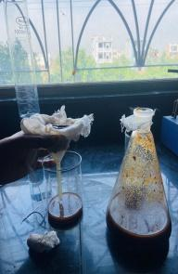
- Fig. 5 Agro-waste slurry after pH set
- Fig. 6 Filtration of biomass after primary fungal fermentation for centrifugation
0.5% Carboxymethyl Cellulose (CMC) was added to each flask as an inducer and structural enhancer for enzymatic action (Zhang et al., 2021), Sampling was done every 24 hours, and reducing sugar concentration was measured using the DNS method (Miller, 1959),
Final sugar yield (g/L) was recorded at 96 h for further fermentation.
- Fermentation Using Adapted Saccharomyces cerevisiae
The hydrolysate was centrifuged to remove fungal biomass and inoculated with an adapted strain of Saccharomyces cerevisiae, isolated from dried fig ferment and selected for ethanol tolerance up to 14% v/v (Ali et al., 2022).
Fermentation was carried out in 1 L flasks with 500 mL working volume under semi-anaerobic conditions at 32 °C for 5–7 days, Occasional shaking was applied for uniform distribution, Refractive index (RI), ethanol concentration (% v/v), and pH were monitored at 48 h intervals, Final ethanol was recovered via fractional distillation, and % alcohol was confirmed using alcoholmeter.
- Microbial Viability and CFU Determination
After fermentation, residual fungal viability was assessed by plating on PDA and serial dilution technique. Viable cell count (CFU/mL) for both fungi was measured after 30 days of liquid culture storage to check formulation compatibility.
- Analytical Methods and Controls
Reducing sugars: Measured by DNS assay at 540 nm (Miller, 1959), Ethanol content: Alcoholmeter and refractometer reading (RI ~1.341) cross-verified., pH: Digital pH meter, calibrated before use, CFU: Standard pour plate technique (10⁻⁶ dilution, triplicates).
Control sets (uninoculated, acid-treated but non-fermented) were maintained to validate natural degradation vs enzymatic conversion.
- RESULTS AND DISCUSSION
- Ethanol Yield and Fermentation Profile

The pretreated agro-waste slurry yielded 42.6 g/L of reducing sugars after enzymatic hydrolysis by the fungal consortium. Following fermentation with stress-adapted S. cerevisiae, a final ethanol yield of 10.6% v/v was recorded by day 6. The pH dropped from 6.2 to 4.8 during fermentation, indicating active metabolic conversion, while the refractive index stabilized at 1.341, aligning with values reported in ethanol-dominant broths (Das et al., 2020).

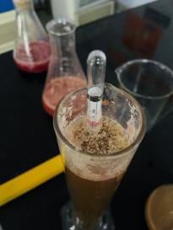 | 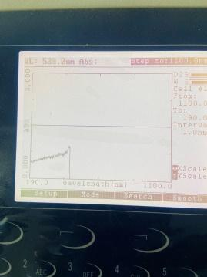

- Fig. 7 Enzyme hydrolysed hemicellulose ethanol level almost 0 before Saccharomyces cerevisiae fermentation.

- Fig 8. Spectrophotometer reading of enzyme hydrolysed hemicellulose mass (529 nm ABS) at 1100 nm beam.

TABLE I. Fermentation Indicators for Ethanol Production
Parameter | Value
Reducing sugars (g/L) | 42.6
Ethanol yield (% v/v) | 10.6
Final pH | 4.8
Refractive index (RI) | 1.341
Distillation temp (°C) | 78.5

These values are consistent with prior work using dual fungal hydrolysis and wild yeast strains (Zhou etal., 2021; Ali et al., 2022), though slightly higher ethanol conversion was observed, likely due to CMC inclusion and substrate diversity.

Fungal Viability Post-Fermentation

Table II. shelf life of fungus after 30 days for checking its compatibility.
Parameter | T. viride | A. niger
Initial CFU (day 0) | 2 × 10⁷ | 1 × 10⁷
Final CFU (day 30) | 1 × 10⁷ | 1 × 10⁶
Spore viability (%) | 85% | 80%
Shelf-stability (30 days) | Maintained | Maintained

This confirms that the residual biomass post-distillation has potential for further compost-based valorization to be explored in a separate study.

Both T. viride and A. niger remained viable post-saccharification, with final CFU counts of 2 × 10⁷ CFU/mL and 1 × 10⁶ CFU/mL, respectively, after 30 days in stored broth. Their co-existence without zone inhibition confirms compatibility, supported by earlier findings on fungal consortiums in compost ecosystems (Romero-Frasca et al., 2021; Bokhari et al., 2019).

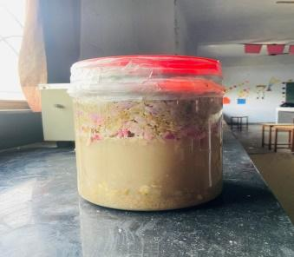 | 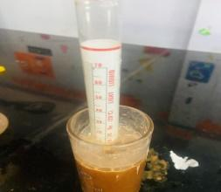
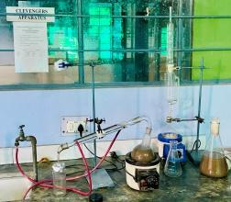 | 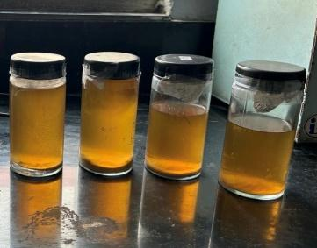

- Fig. 9 (Fermentation in 5L pot ,2nd trail)

- Fig. 10 (Final ethanol reading 10.5 v/v)

- Fig. 11 (Distillation assembly for pure ethanol recovery.
- Fig 12 (Extracted Ethanol after primary distillation)

- Summary of Results

High ethanol conversion from mixed substrates with only fungal enzymes

Dual fungal culture showed strong compatibility and shelf stability

CMC inclusion boosted hydrolysis efficiency

Low-energy pretreatment (overnight acid + 5-min steam) was effective

Residual broth retained fungal load indicates future reuse possibilities

CONCLUSION
This study successfully demonstrates a field-relevant bioconversion model for ethanol production using a dual-fungal consortium of Trichoderma viride and Aspergillus niger on heterogeneous agro-industrial waste. The combination of overnight 10% H₂SO₄ soaking and steam explosion proved effective in releasing fermentable sugars. Enzymatic hydrolysis supported by CMC yielded 42.6 g/L of reducing sugars, and subsequent fermentation using stress-tolerant Saccharomyces cerevisiae resulted in an ethanol yield of 10.6% (v/v). The fungal consortium remained viable post-fermentation, indicating both enzymatic efficiency and strain stability. The scalable and decentralized nature of this model aligns with rural biofuel solutions and national bioenergy missions. While this study focused on ethanol generation, the fungal-rich residue also shows potential for future compost or bioinput applications, which will be explored in a follow-up study.

REFERENCES
- Ali M., Kumar R. and Singh N. (2022). Evaluation of stress-tolerant Saccharomyces cerevisiae strains for ethanol fermentation under high sugar and low pH conditions. Indian J. Microbiol., 62(3): 381-390.
- Alvira P., Tomás-Pejó E., Ballesteros M. and Negro M.J. (2010). Pretreatment technologies for an efficient bioethanol production process based on enzymatic hydrolysis: A review. Bioresour. Technol., 101(13): 4851–4861.
- Bhatia S. and Jha A.K. (2020). Steam explosion of lignocellulosic biomass: An overview on its chemistry, advantages and recent applications. Renew. Sustain. Energy Rev., 119: 109602.
- Bokhari A., Mahmood T., Irshad M. and Shakir H.A. (2019). Comparative performance of fungal consortia for biodegradation and ethanol production from wheat straw. Biocatal. Agric. Biotechnol., 21: 101317.
- Chandel A.K., Chandrasekhar G., Radhika K., Ravinder R. and Ravindra P. (2012). Bioconversion of hemicellulosic hydrolysate into ethanol: An overview and future prospects. In: Biofuels: Alternative Feedstocks and Conversion Processes. Elsevier. pp. 157–183.
- Das R.K., Mandal A., Chowdhury A. and Bhattacharya P. (2020). Ethanol production from banana peel using Saccharomyces cerevisiae isolated from palm sap. J. Cleaner Prod., 259: 120837.
- Fan G., Zhang X., Wang L. and Hou H. (2020). Co-culture of Trichoderma reesei and Aspergillus niger for improved enzymatic hydrolysis of corn stover. Biotechnol. Lett., 42(8): 1489–1497.
- Gupta R. and Rao K.P. (2022). Impact of chemical and biological pretreatments on the fermentability of fruit waste for bioethanol production. Waste Biomass Valor., 13(4): 2011–2021.
- Kumar M., Yadav S.K. and Lal B. (2022). Steam explosion–based bioconversion of agricultural residues: Process optimization and industrial feasibility. Renew. Energy, 183: 731–741.
- Meena V., Singh R. and Ahlawat O.P. (2021). Ethanol blending in India: Challenges, policies, and opportunities. Renew. Sustain. Energy Rev., 148: 111265.
- Mehta A. and Sharma R. (2021). Selection of ethanol-tolerant yeast strains isolated from dried grapes and their comparative fermentation efficiency. J. Food Sci. Technol., 58(1): 109–116.
- Miller G.L. (1959). Use of dinitrosalicylic acid reagent for determination of reducing sugar. Anal. Chem., 31(3): 426–428.
- Ministry of Petroleum and Natural Gas (2022). Ethanol Blended Petrol (EBP) Programme. Government of India, New Delhi. [Online available at https://petroleum.nic.in]
- Patel A., Vyas D., Shah M. and Dave S. (2021). A review on co-fermentation using fungi and yeasts for enhanced production of bioethanol from agricultural wastes. Renew. Energy Focus, 39: 33–42.
- Romero-Frasca T., Roncero-Díaz M., Gómez-Muñoz B. and Ríos-Corripio M. (2021). Biochemical responses of Aspergillus niger and Trichoderma viride co-cultures on municipal green waste substrates. Bioresour. Bioprocess., 8: 67.
- Saini A., Aggarwal N.K., Sharma A. and Yadav A. (2015). Actinomycetes: A source of lignocellulolytic enzymes for biofuel production. Renew. Sustain. Energy Rev., 51: 356–365.
- Singh A. and Sharma N. (2023). India’s biomass potential and decentralized biorefinery opportunities: An agro-industrial outlook. Biomass Convers. Biorefin., 13(2): 349–362.
- Singh R. and Chaurasia P.K. (2022). Comparative evaluation of different fungal strains for lignocellulose degradation and ethanol production from sugarcane bagasse. Fuel, 321: 123870.
- Suhag R., Kumar N., Sharma P. and Sharma S. (2021). Recent advances in pretreatment technologies for efficient conversion of lignocellulosic biomass to biofuels. Fuel Process. Technol., 218: 106828.
- Yadav S.K., Dubey A.K., Yadav M.K. and Tiwari P. (2018). Isolation and characterization of cellulolytic fungi from compost soil and their potential in biomass degradation. Mycobiology, 46(3): 230–238.
- Zhang J., Wang Y., Ma Y. and Li H. (2021). Enhancing enzymatic saccharification of fruit waste using co-culture of fungi and CMC induction. Bioresour. Technol. Rep., 16: 100859.
- Zhou Y., Lu Y., Wang J. and Li J. (2021). Synergistic enzymatic hydrolysis of agricultural waste by fungal consortium: Evaluation of compatibility and process enhancement. J. Environ. Chem. Eng., 9(4): 105388.

