FATE OF RHIZOSPHERE MICROORGANISMS AND GROWTH OF LEGUMINOUS PLANTS IN CASSAVA MILL EFFLUENT SIMULATED SOIL

ABSTRACT
Aim: This study assessed the impact of cassava mill effluent (CME) on rhizosphere microorganisms and the growth of leguminous plants in simulated soils. Method: Standard physical, microbiological, and biochemical methods were used to evaluate changes in microbial populations and plant development across CME concentrations of 0%–100%. Bud, leaf, and nodule numbers varied with CME concentration. Results: Fungal isolates were similar across treatments but varied by legume species. Calopogonium mucunoides plots predominantly harbored Saccharomyces sp. and Mucor indicus, while Centrosema pubescens plots showed dominance of Fusarium sp. and Gliocladium sp. Bacterial communities differed likewise: C. mucunoides plots contained Bacillus sp., Acinetobacter sp., and E. coli, whereas C. pubescens plots yielded Chromobacterium sp. and Corynebacterium sp. Nitrogen-fixing bacteria—Azotobacter sp., Azospirillum sp., Frankia sp., Bradyrhizobium sp., Herbaspirillum sp., Anabaena sp., Nostoc sp., Clostridium sp., and Rhizobium sp.—were present across all CME concentrations regardless of the legume species. Conclusions: The findings indicate that CME-induced soil acidity affects nutrient bioavailability and metal toxicity, thereby influencing microbial community structure and plant nodulation. Acidic conditions reduced both nodule formation and functionality in legumes.
Keywords: Rhizosphere microbes, cassava mill effluent, simulated soil, microbial community and nodulation
INTRODUCTION
Cassava is a crop that is grown in the tropics, its distribution is between latitudes 30oN and 30oS (Costa and Silva, 1992; Alves, 2002; Onweremadu et al., 2008; Omomowo et al., 2015). The required temperature for optimum growth, range between 24 to 30oC (IITA, 1990), temperatures ranging from 16 to 38oC can be tolerated. The ideal rainfall for Cassava is 1000 to 1500 mm per year but can grow with rainfall less than 600 mm annually in a semi-arid tropic (Alves, 2002; Aerni, 2005; Uzoije and Egwuonwu, 2011; Omomowo et al., 2015). Cassava can strife in soils with low-nutrient where other crops and cereals do not grow. Cassava storage roots can develop easily in sandy to light soils which makes it grows well. It cannot grow well in superficial hard layer or soils with many stones but can tolerate soil with low pH (Aerni, 2005; Uzoije and Egwuonwu, 2011; Omomowo et al., 2015).
Due to the high content of starch in ‘garri’, it serves as a major source of calories for families, garri is a staple popular food in Nigeria and is produced by grating, fermenting and dehydrating cassava. Cassava processing and waste handling must be given great attention for the sake of the vital role it plays in economic development, agriculture and most importantly food security in Africa (Onweremadu et al., 2008; Izonfuo et al., 2013; Omomowo et al., 2015). Generation of cassava wastewater occurs when tubers of cassava are being processed into food, feed, starch and other products. The disposal of wastewater from cassava processing has both environmental and human health implications. The major component of the waste water from cassava processing is cyanide, usually significant quantity of these waste water is been discharged by cassava processing industry into; agricultural fields, rivers, lakes, sewage canals and the environments which eventually flows back to streams or downstream surface water locations (Onweremadu et al., 2008; Izonfuo et al., 2013; Omomowo et al., 2015).
Effluents discharged from cassava processing have been reported to be toxic and cause extinction of benthic macro invertebrates, an association has been established that effluents discharge from processing of cassava are thought to contain substances that is lethal, mobile in soil, affect bio-diversities and makes it difficult for marine lives to survive and can inhibit germination of cereal seed and destroy microbes (Adewoye et al., 2005; Onweremadu et al., 2008; Ibe et al., 2014; Kolawole, 2014; Omomowo et al., 2015).
MATERIALS AND METHODS
Study Area
This Study was conducted at the green house and research laboratory of the Department of Microbiology, Faculty of Biological Sciences, University of Calabar, Calabar, Nigeria. The cassava mill effluent (CME) samples were collected at Iwuru Obio Ntan community in Biase Local Government Area of Cross River State, Nigeria with longitude 05o25’15.310”N and latitude 008o10’48.594”E. Iwuru Obio Ntan community is within the tropical rainforest region of Southern Nigeria and is grouped under the coastal lowland with main relief feature which is lowland type of landscape. The major occupation of the inhabitants of these community is farming and marketing of their farm produce which is encouraged by the topography and prevalence of the tropical rainy climate that is warm, humid and moist for most parts of the year. The soil type is red and brown in nature with abundant free iron oxide.
Simulation Experiments
A medium sized green house with length 287 inches, width 264 inches and height 75 inches were built by the researchers for the purpose of this simulation experiment. The soil was collected from a garden free of recorded cases of industrial or agricultural effluent contamination. The legumes Centrosema pubescens and Calopogonium mucunoides (Figure 1 and Figure 2) both from the family Leguminosae and sub-family Faboideae were used for this study. The plants were selected based on the fact that they grow as legumes and fix nitrogen to the soil thereby improving the nutrient content of the soil for good growth and development of other plants.
Ten kilograms of soil sample was dispensed into seven 22 x 19cm porous-bottomed transparent plastic buckets for Centrosema pubescens and Calopogonium mucunoides respectively. The test plants were obtained from Longitude 05o25’11.279”N and Latitude 008o10’59.836”E, Ephraim Street, Iwuru Obio Ntan community in Biase Local Government Area of Cross River State, Nigeria. They were identified by taxonomists of the Department of Plant and Ecological Studies, University of Calabar, Calabar, Nigeria. Water required for moistening the test soil prior to pollution, control soil and to vary the concentration of the effluents was collected from the University of Calabar water treatment plant. This was used to adequately stimulate the soil in the transparent buckets on daily basis to maintain a permanently wet environment (John et al., 2011).
Prior to simulated pollution, the plants were allowed to adapt to the new environment by formation of new buds and leaves. The 10 kg soil containing the test plants in the porous-bottomed transparent buckets was simulated with cassava mill effluent collected from Iwuru Obio Ntan community in Biase Local Government Area of Cross River State, Nigeria (Figure 3).
Twelve (12) buckets were simulated with varying concentrations of the cassava mill effluent namely: 10%, 20%, 30%, 40%, 50% and 100% vol/vol pollution for Centrosema pubescens and Calopogonium mucunoides. The other two (2) buckets without effluent treatments (0%) served as the controls for Centrosema pubescens and Calopogonium mucunoides. The effluents effects on the plants were studied by watering the plant with the different concentration of effluent and observed daily for 14 weeks and. The plants were then harvested at maturity and the number of nodules, bud and leaves formed were determined. Analyses were thereafter carried out to evaluate the rhizosphere organisms (AOAC, 1984; Sofowora, 1993; Egwaikhide and Gimba, 2007; Mofunanya et al., 2007; Gafar et al., 2010; Chandrappa et al., 2011; John et al., 2011; Mofunanya and Nta, 2011; Agbo and Mboto, 2012; Agbo et al., 2019).

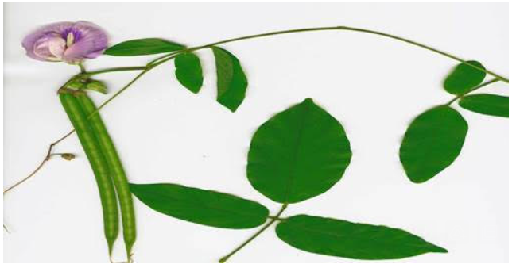
Figure 1: Centrosema pubescens plant, notice the slender stem, flower, triple leaflets and long pods with seeds.

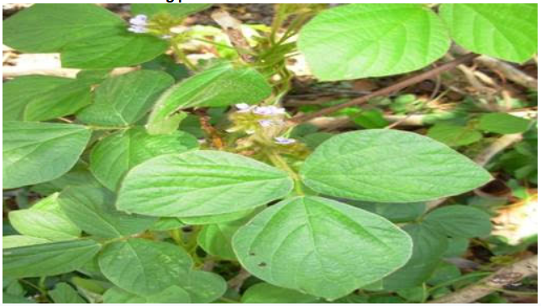
Figure 2: Calopogonium mucunoides plant, a hairy annual or short-lived perennial trailing legume.

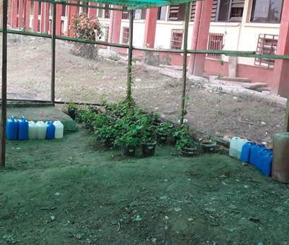
Figure 3: Simulation experiment in-progress; Notice the legumes arranged in column with the varying concentration of effluent labelled on the bucket.

RESULTS
Microbiology of Cassava Mill Effluent-Simulated Soil
i. Fungal Isolates from Cassava Mill Effluent-Simulated Soil
The fungal isolates from the cassava mill effluent simulated soil were virtually the same across the concentration gradients of 0%, 10%, 20%, 30%, 40%, 50% and 100%, the only difference was that different fungal genera were found in plots where different leguminous plants were used for the simulation experiment. C. mucunoides at cassava mill effluent (CME) impacted plots (0%-100%) had Saccharomyces sp. and Mucor indicus as it’s predominant fungal isolate while the C. pubescens from the same site had Fusarium sp. and Gliocladium sp. as its predominant fungal isolates. The results for the cultural characterization and identification of fungal isolates of 0-100% concentration CME-simulated soil phyto-remediated with Calopogonium mucunoides and Centrosema pubescens are presented in Table 1.
Table 1: Cultural characteristics and identification of fungal isolates from CME-Simulated Soil
Sample Code |  | Cultural Characteristics of Isolate | Microscopic Features of Isolates | Possible Organism
CM(CME)  0-100% | 1 | White to creamy coloured smooth soft and had bacteria-like appearance | Oval and elongated cell with buds attached or protruding from the mother cell and in chains | Saccharomyces sp
CM(CME)  0-100% | 2 | Fast growing colony, fluffy white in appearance | Aseptate broad hyphae, large spherical head produced by the conidiosphore | Mucor indicus
CP(CME)  0-100% | 1 | Rapid growing colony, woolly to cotton-like in appearance | Conidiosphore occurred in sickle cell shape and are multicelled | Fusarium sp
CP(CME)  0-100% | 2 | Rapid growing colony that was wolly and became empacted with greem patches | Vertically arranged conidiosphore, flask-shaped phialides and clustering conidia | Gliocladium sp
Key:
CM – Calopogonium mucunoides
CP – Centrosema pubescens
CME – Cassava mill effluent
sp –Species
ii. Bacterial Isolates from Cassava Mill Effluent-Simulated Soil
Cassava mill effluent (CME)-simulated soil (0%-100%) had Chromobacterium sp. and Corynebacterium sp as its predominant bacterial isolates from the Centrosema pubescens plots. Calopogonium mucunoides plots had Bacillus sp., Acinetobacter sp. and Escherichia coli as it bacterial isolates. The results of the biochemical characteristics of bacterial isolates from CME-simulated soil are presented in Table 2.

Table 2: Biochemical characteristics of bacterial Isolates from CME-simulated soil

Sample  Code | Isolate No | Cultural Characteristics of Bacterial Isolates | Cell Morphology | Gram Rxn | Motility | Indole | Ornithine | Methyl Red | Vogues Proskauer | Citrate | Catalase | Oxidase | Coagulase | Urease | Lactose | Sucrose | Glucose | Gas Production | H2S | Probable Organism
CP(CME)  0-100% | 1 | Circular, convex smooth and purple colony | Rod | - | + | - | - | + | - | + | + | + | - | + | + | + | + | - | - | Chromobacterium sp
CP(CME)  0-100% | 2 | Raised, translucent grey  Colony | Short straight rod | + | - | - | + | + | - | - | - | - | - | + | + | + | + | - | - | Corynebacterium sp
CM(CME)  0-100% | 1 | Large, irregular, flat, dry  Colony | Bacilli rod | + | + | - | + | - | + | + | + | + | - | - | - | - | + | - | + | Bacillus sp
CM(CME)  0-100% | 2 | Red colony, mucoid and spreading | Rod in pairs | - | - | - | - | - | + | + | + | - | - | + | + | + | - | + | - | Acinetobacter sp
CM(CME)  0-100% | 3 | Convex, circular, mucoid smooth colony | Short rod | - | + | + | + | + | - | - | + | - | - | - | + | + | + | + | - | Escherichia coli

Key:
CP – Calopogonium mucunoides
CM – Centrosema pubescens
CME – Cassava mill efflueny
sp – Specie
+ - Positive
- - Negative

Nitrogen-Fixing Bacterial Isolates from Cassava Mill Effluent-Simulated Soil
Same nitrogen-fixing bacteria were isolated from all the cassava mill effluent simulated plots (0%-100%) irrespective of the legume planted for the phytoremediation exercise. The nitrogen-fixers isolated were: Azotobacter sp., Azospirillum sp., Frankia sp., Bradyrhizobium sp., Hebaspirillum sp., Cyanobacteria (or blue green algae) and Anabaena sp. Other isolates were Nostoc sp., Clostridium sp. and Rhizobium sp. Azotobacter species was Gram positive, motile and possessed catalase and oxidase enzymes. It was able to produce acid and gas from mannitol, glucose and sucrose. Clostridium species was a spore former, Gram positive, liquefied gelatine, produced only acid from lactose but produced acid and gas from glucose. Frankia species was a spore former, Gram positive, possessed catalase enzyme and produced only acid from all the sugars tested.
Microbial Loads of Cassava Mill Effluent-Simulated Soil
The microbial loads at the plots that Centrosema pubesscens was used to phyto-remediate CME-simulated soil was 9.70+0.25x105 cfug-1, 2.30+0.12x105 cfug-1 and 2.38+0.02x106 cfug-1 for bacteria, fungi and nitrogen fixing bacteria respectively at the control plot. At the 30% CME-simulated plot, the microbial loads were 5.80+0.20x105 cfug-1, 4.30+0.20x105 cfug-1 and 1.95+0.012x106 cfug-1 for bacteria, fungi and nitrogen-fixing bacteria respectively. There were no significant differences (p >0.05) in the rhizosphere microbial load at the 30% CME-simulated plot phyto-remediated by Centrosema pubesscens.
At the 50% CME simulated plot, the bacterial load was 7.70+0.26x105 cfug-1, the fungal load was 4.60+0.20x105 cfug-1 while the nitrogen fixing bacterial load was 1.06+0.02x106 cfug-1. Statistical analysis also showed that there were no significant differences (p>0.05) in the rhizosphere microbial load at the roots of Centrosema pubesscens used for the phyto-remediation of 50% CME-simulated plot. The microbial load at the 100% CME-simulated plots were 9.60+0.20x105 cfug-1, 5.30+0.20x105 cfug-1 and 9.67+0.12x105 cfug-1 for bacteria, fungi and nitrogen fixing bacteria respectively. Once again, there was no significant differences (p>0.05) in the rhizosphere microbial load at the 100% CME-simulated plot. The results of the microbial loads of CME-simulated plots phyto-remediated by Centrosema pubescens are presented in Figure 4.
Figure 4: Effect of graded concentrations of CME on soil microbiota using C. pubesens as phytoremediation agent.

The CME simulated soil plots phyto-remediated by Calopogonium mucunoides had the microbial load of 9.23+0.25x105 cfug-1, 1.17+0.06x106 cfug-1 and 2.59+0.01x106 cfug-1 for bacteria, fungi and nitrogen-fixing bacteria respectively for the control (0%) plot. The 30% CME simulated soil plot had bacterial load of 6.57+0.20x105 cfug-1, fungal load of 3.40+0.20x105 cfug-1 and nitrogen-fixing bacteria load of 1.93+0.05x106 cfug-1. There were no significant differences (p>0.05) in the microbial load at the root of Calopogonium mucunoides used to phyto-remediate 30% CME-simulated plot.
At the 50% CME simulated plot phyto-remediated by Calopogonium mucunoides, the microbial load was 5.1+0.16x105 cfug-1, 3.97+0.16x105 cfug-1 and 1.78+0.02x106 cfug-1 for bacteria, fungi and nitrogen-fixing bacteria respectively. Statistical analysis also revealed that there were no significant differences (p>0.05) in the rhizosphere microbial load at the 50% CME-simulated plot phyto-remediated by Calopogonium mucunoides. The bacterial load at the 100% CME-simulated plot was 3.4+0.2x105 cfug-1, the fungal load was 5.3+0.06x105 cfug-1 while the nitrogen-fixing bacterial load was 1.39+0.02x106 cfug-1. The cassava mill effluent was highly acidic, as such it had negative effect on the nitrogen-fixing bacterial population. The nitrogen-fixing bacteria population progressively decreased from 2.59+0.01x106 cfug-1 at the control plot to 1.39+0.02x106 cfug-1 at the 100% plot. The fungal population increased progressively from the control plot to the 100% plot. Once again, statistical analysis showed that there were no significant differences (p>0.05) in the rhizosphere microbial load at the 100% CME-simulated plot phyto-remediated by Calopogonium mucunoides. The results of the rhizosphere microbial loads in CME simulated soil phyto-remediated by Calopogonium mucunoides are presented in Figure 5. Analysis showed that there was non-significant (p>0.05) student-test mean comparisms of the different treatments (10, 20, 30, 40, 50 and 100%) against the control.

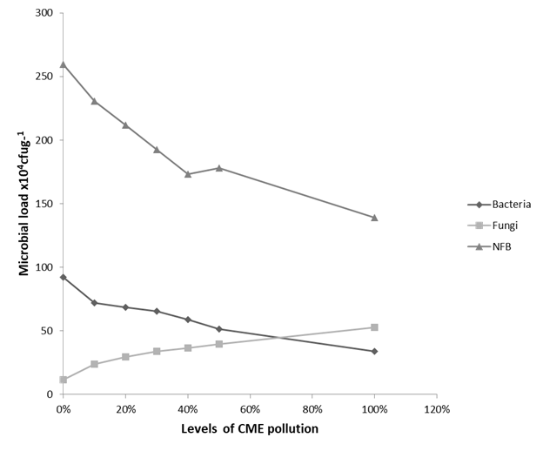
Figure 5: Effect of graded concentrations of CME on soil microbiota using C. mucunoides as phytoremediation agent.
Effect of Cassava Mill Effluent (CME) on Buds and Leaves Formation in ` ` ` Leguminous Plants

Calopogonium mucunoides used for the phyto-remediation of CME-simulated soil plots developed 2, 1 and 1 bud(s) and leaves at 10%, 20% and 100% simulated plots after 7 days. On the 42nd day of the study, 5, 16, 20, 9, 4, 13 and 7 C. mucunoides buds and leaves were formed at the control, 10%, 20%, 30%, 40%, 50% and 100% plots. On the 100th day of the study, 15, 43, 39, 23, 15, 28 and 15 C. mucunoides buds and leaves were formed at the control, 10%, 20%, 30%, 40%, 50% and 100% simulated plots. Figure 6 presents the number of buds and leaves of C. mucunoides at different levels of CME pollution.
The number of buds and leaves formed by Centrosema pubescens on the 7th day of study was 5, 4, 13, 12, 6 and 3 at the control, 10%, 20%, 30%, 40% and 50% CME-simulated plot respectively. On the 56th day of study, the number increased to, 71, 73, 81, 81, 61, 30 and 17 buds and leaves at the control, 10%, 20%. 30%, 40%, 50% and 100% effluent-simulated plots respectively. Then on the last day of the study, the C. pubescens’ bud and leaves formed were: 141, 147, 127, 112, 103.65 and 43 for the control, 10%, 20%, 30%, 40%, 50% and 100% effluent-simulated plot respectively. The results of the number of buds and leaves formation of C. Pubescens at different levels of CME are presented in Figure 7.

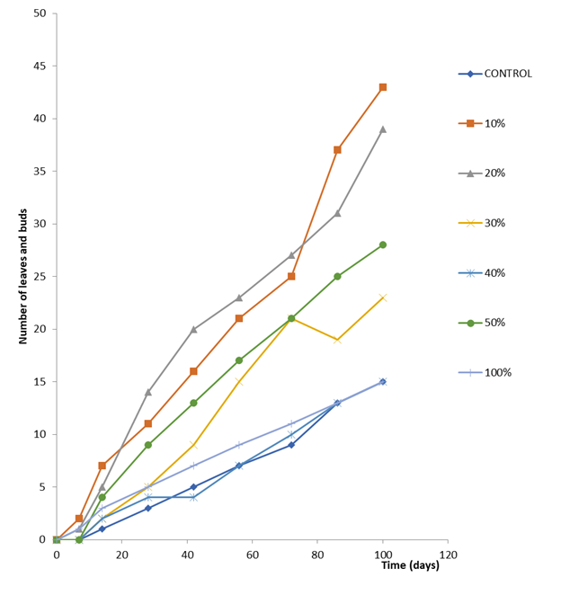
Figure 6: Number of buds and leaves of C. mucunoides at different levels of CME pollution.

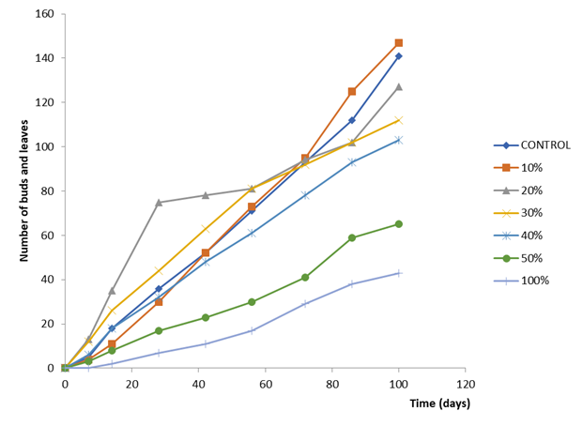

Figure 7: Number of buds and leaves of C. pubescens at different levels of CME pollution.
Effect of Cassava Mill Effluent (CME) on Nodule Formation in Leguminous Plants

Nodule formation was observed in the roots of C. mucunoides plants exposed to varying concentrations of CME on the 14th day of study. The number of nodule(s) formed were: 3, 11, 1, 1, 1, 1 and 0 for the control, 10%, 20%, 30%, 40%, 50% and 100% plots respectively. At the end of 100th day of study, a steady progressive increase was observed for the nodule formation in C. mucunoides exposed to CME. Figure 8 presents the result clearly.
C. pubescens exposed to varying concentration of CME had the following number of nodules formed on the 14th day of study; 5, 3, 3, 3, 2, 2 and 3 nodules for the control, 10%, 20%, 30%, 40%, 50% and 100% plots respectively. On the 100th day of study, a progressive increase was observed in the number of nodules formation. At the 100% plot, the number of nodule formation decreased because the high acidic nature of the effluent has had negative effect on the physicochemical property of the soil. Figure 9 presents the results for the number of nodules formation in C. pubescens exposed to cassava mill effluent.

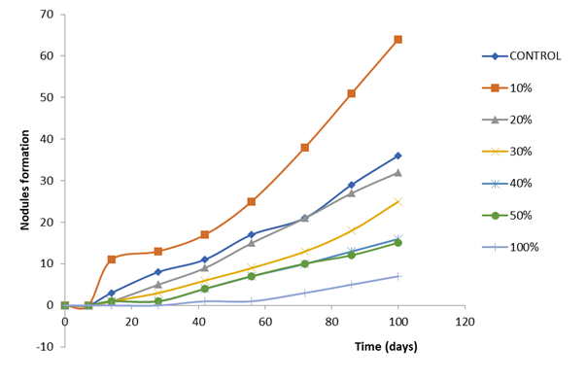

Figure 8: Nodules formation in C. mucunoides exposed to CME.

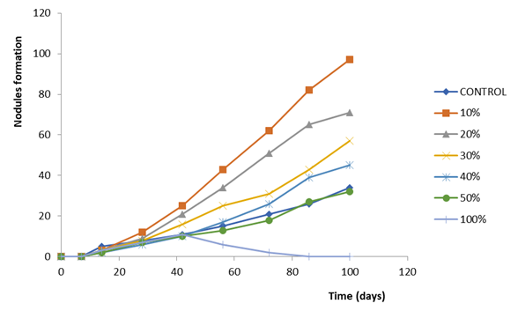

Figure 9: Nodules formation in C. pubescens exposed to CME.

DISCUSSIONS
There was progressive reduction in nodulation in the Calopogonium mucunoides plots of cassava mill effluent (CME) simulated soils with corresponding increase in the pollution levels. Akpan et al, (2017) reported that soil acidity influences many chemical and biological characteristics of soil including availability of nutrient and toxicity of metals which can also affect microbial community in many ways. Akpan et al, (2017) also reported that acidic soils can significantly reduce nodulation and nodule function in leguminous plants. The fungal isolates at the rhizosphere of Calopogonium mucunoides and Centrosema pubescens were Saccharomyces cerevisea, Mucor indicus, Fusarium sp. and Gliocladium sp., these isolates were similar to that isolated by Agbo et al, (2021). John et al, (2011) in a similar research, did not isolate fungi, their isolates were nitrogen-fixing bacteria since that was their interest.
The nitrogen-fixing bacteria isolated in this present study were Azotobacter sp., Azospirillum sp., Frankia sp., Bradyrhizobium sp., Hebaspirillum sp., Cyanobacteria (or blue green algae) and Anabaena sp. Other isolates were Nostoc sp., Clostridium sp. and Rhizobium sp. These bacterial isolates were similar to that isolated by John et al, (2011) and Agbo et al, (2021). In this present study, the microbial loads at the rhizosphere of the two plants increases with increase in concentration of the pollutant. This too was similar to the findings of Agbo et al, (2021) but differs from that of John et al, (2011) in which they reported a decrease in microbial loads with increase in concentration of pollutant. This was so because the two researchers used different pollutants in their researches. Agbo et al, (2021) used cassava mill effluent while John et al, (2011) used crude oil in their researches.
CONCLUSION
The simulation experiment analysis revealed that soil acidity influences many chemical and biological characteristics of soil including availability of nutrient and toxicity of metals which can also affect microbial community in many ways. It also revealed that acidic soils can significantly reduce nodulation and nodule function in leguminous plants. Agricultural wastes or effluents should be properly treated before been release to the environment so that it will not affect our dear microorganisms and the plants therein. Rather than releasing these agricultural effluents to harm our environment, plants and microorganisms they can be used for value-added products (waste to wealth) such as biogas, bioethanol, bioelectricity, biobutanol, biohydrogen and bio-fertilizer.

Declarations
Ethics Statement: Not applicable
Informed Consent: Not applicable
Data availability: Not Applicable
REFERENCES
Adewoye, S. O., Fawole, O. O., Owolabi, O. D. and Omotosho, J. S. (2005). Toxicity of cassava wastewater effluents to African Catfish: Clarias gariepinus (burchell, 1822), Ethiopian Journal of Science, 28(2):189–194,
Aerni, P. (2005). Mobilizing Science and Technology for Development: The Case of the Cassava Biotechnology Network (CBN), 9th ICABR International Conference on Agricultural Biotechnology: Ten years later, Ravello, Italy.
Agbo, B. E. and Mboto, C. I. (2012). Phytochemical and antibacterial evaluation of selected locally produced herbal medicines sold in Calabar, Nigeria, Archives of Applied Science Research, 4(5): 1974-1990.
Agbo, B. E., Etim, D. O., Itah, A. Y. and Brooks, A. A. (2021). Evaluation of microbial loads and physico-chemicals of cassava mill effluent simulated soil, South Asian Journal of Research in Microbiology, 9(1): 13-26
Agbo, B. E., Ogar, A. V., Itah, A. Y., Brooks, A. A. and Akonjor, M. A. (2019). Assessment of the effects of cassava mill effluent on the soil and its microbiota in Biase Local Government Area of Cross River State, Nigeria. World Journal of Advanced Research and Reviews, 1(2): 034–044
Akpan, J. F., Eyong, M. O. and Isong, I. A. (2017). The impact of long-term cassava mills effluent discharge on soil pH and microbial characteristics in Cross River State, Asian Journal of Soil Science and Plant Nutrition, 2(1): 1-9.
Alves, A. A. C. (2002). Cassava botany and physiology. In Hillocks, R. J., Thresh, J. M. and Bellotti, A. C. (Eds), Cassava biology, production and utilization. CABI Publishing, Wallingford, UK, 67-89
Association of Official Analytical Chemists (AOAC) (1984). Official Method of Analysis 14th Edition, Association of Official Analytical Chemists, Washington, D.C.
Chandrappa, C. P., Schiplasheree, C. B., Karthik, M. R., Govindappa, M. and Sadanmanda, T. S. (2011). Antibacterial and anti-oxidant activities of Adiantum pedatum, Journal of Phytology, 3(1): 26-32.
Costa, I. R. S. and Silva, S. O. (1992). Coleta de germoplasma de mandioca no Nordeste do Brasil. Revista Brasileira de mandioca, 11(1): Bahia, Brasil, 19-27.
Egwaikhide, P. A. and Gimba, C. E. (2007). Analysis of the phytochemical content and antimicrobial activity of Plectrabthus glandulosis whole plant, Middle-East Journal of Scientific Research, 2(4): 135-138.
Gafar, M. K., Hassan, L. G., Danoggo, S. M. and Hod, A. U. (2010). Amino acid estimation and phytochemical screening of Indigofera astragoline leaves, Journal of Chemical and Pharmaceutical Research, 2(5): 277-285.
Ibe, I. J., Ogbulie, J. N., Odum, D. C., Onyirioha, C., Peter-Ogu, P. and Okechi, R. N. (2014). Effects of Cassava mill effluent on some groups of soil bacteria and soil enzymes, International Journal of Current Microbiology and Applied Sciences, 3(10): 284-289
IITA (International Institute of Tropical Agriculture), (1990). Cassava in tropical Africa. Reference Manual, IITA, Ibadan, Nigeria
Izonfuo, W. A., Bariweni, P. A. and George, D. M. C. (2013). Soil Contamination from Cassava Wastewater Discharges in a Rural Community in the Niger Delta, Nigeria, Journal of Applied Science and Environmental Management, 17(1): 105-110
John, R. C., Itah, A. Y., Essien, J. P. and Ikpe, D. I. (2011). Fate of nitrogen-fixing bacteria in crude oil contaminated wetland ultisol, Bullentin of Environmental Contamination and Toxicology, 87: 343-353.
Kolawole, O. P. (2014). Cassava Processing and the Environmental Effect, World Sustainability Forum 2014 – Conference Proceedings Paper
Mofunanya, A. J. and Nta, A. I. (2011). Determination of phytochemicals in Telfaria occidentalis, Amaranthus hybridus, Phaseolus vulgaris and Sphenostylis stenocapa inoculated with Telfaria mosoaic virus (TeMV), International Journal of Natural and Applied Sciences, 6(2): 1-8.
Mofunanya, A. J., Abia-Bassey, L. N. and Akpan, J. O. (2007). Microbial sensitivity to extracts of Mitracarpus scaber, Global Journal of Pure and Applied Sciences, 13(1): 89-93.
Omomowo, I. O., Omomowo, O. I., Adeeyo, A. O., Adebayo, E. A. and Oladipo, E. K. (2015). Bacteriological Screening and Pathogenic Potential of Soil Receiving Cassava Mill Effluents, International Journal of Basic and Applied Science, 3(4): 26-36

