**Original Research Article**

**Screening of Soybean Genotypes Against Yellow Mosaic Virus Disease Under Field Conditions**

**Abstract**

*Glycine max* [L.] Merrill is a nutritionally enrich leguminous crop, playing a pivotal part in food, feed and industrial sectors. In India, its status has escalated owing to high adaptability, nitrogen-fixing capability and economic returns. However, production is significantly constrained by Yellow Mosaic Virus (YMV), a major viral disease transmitted by whitefly (*Bemisia tabaci*), leading to chlorosis, stunted growth and severe yield losses. The present investigation aimed to evaluate sixty soybean genotypes for putative resistance to YMV under natural epiphytotic field conditions during the *kharif*, 2024. The experiment was laid out in a Randomized Block Design (RBD) with two replications. Genotypes were assessed employing the 0–9 scale for disease severity, and categorized accordingly. Results revealed substantial genetic variability against YMV disease response. Thirty-four genotypes were found highly resistant, 7 resistant, 11 moderately resistant, 6 moderately susceptible and 2 susceptible. The presence of a wide range of reactions highlights the diversity in resistance mechanisms and offers promising material for performing resistance breeding. This study highlights the importance of continuous field screening to identify and utilize resistant genotype (s). The highly resistant genotypes identified can serve as vital donors in breeding programmes aimed to develop durable YMV-resistant cultivars. Future efforts integrating molecular markers and genomic tools with phenotypic selection may be instrumental in accelerating the development of resilient soybean varieties for sustainable production in YMV-endemic areas.

**Keywords:** Disease resistance, Epiphytotic screening, Soybean (*Glycine max*), Yellow Mosaic Virus (YMV), Whitefly (*Bemisia tabaci*)

**1. Introduction**

*Glycine max* [L.] Merrill is a universally significant leguminous crop, extensively cultivated for its multifaceted utility in food, feed and industrial sectors (Mishra et al., 2021a). It is highly appreciated for its seeds, which is rich in high-quality protein (~40%) and oil (~20%), making it an essential source of plant-based nutrition and a critical component of livestock feed formulations (Sharma et al., 2021; Mishra et al., 2024a). The crop’s superior nutritional profile, combined with its broad industrial applicability in products such as biodiesel, lubricants and bioplastics, underscores its strategic importance in global agricultural economies (Mishra et al., 2021b; Sharma et al., 2023; Mishra et al., 2024b).

In the Indian context, soybean has emerged as a dominant oilseed crop, particularly in central and western agro-climatic zones (Mishra et al., 2021c). Its popularity is attributed to its adaptability to diverse agro-ecological conditions, relatively short growth duration and compatibility with a variety of cropping systems (Mishra et al., 2021d; Mishra et al., 2024c). Moreover, being a legume, soybean possesses the unique ability to biologically fix atmospheric nitrogen through symbiotic association with *Bradyrhizobium* species. This not only reduces the dependency on synthetic nitrogen fertilizers but also enhances soil fertility, thereby promoting sustainable agricultural practices and improving the productivity of subsequent crops in rotation (Mishra et al., 2021d; Nakei et al., 2022; Wu & Yan, 2024; Li & Xiao, 2025). The economic significance of soybean in India is further bolstered by its role in enhancing farmers’ income, supporting agro-industries, and contributing to the national oilseed economy (Mishra et al., 2021e; Mishra et al., 2025a; Mishra et al., 2025b).

Despite its agronomic potential, soybean production is severely constrained by several biotic stresses (Upadhyay et al., 2020; Tripathi et al., 2022), among which Yellow Mosaic Virus (YMV) poses a major threat. YMV, transmitted by the whitefly (*Bemisia tabaci*), causes Yellow Mosaic Disease (YMD), leading to chlorotic yellow patches on leaves, stunted plant growth, poor pod formation, and significant yield reduction (Hajimorad et al., 2018; Mishra et al., 2020; Swathi et al., 2021; Rahman et al., 2023; Vishal et al., 2024; Jhariya et al., 2025) (Fig. 1). In epidemic years, yield losses can range from 30% to over 70%, depending on the stage of infection and susceptibility of the genotype (Mishra et al., 2024d; Roy et al., 2025). Given the limited effectiveness and environmental concerns associated with chemical control of the vector, the deployment of resistant genotypes is the most economical, eco-friendly, and sustainable approach to manage YMV (Mishra et al., 2020; Jharia et al., 2025). However, the frequent emergence of new viral strains and vector biotypes necessitates the continuous evaluation of soybean germplasm to identify and utilize as resistant sources (Karthikeyan et al., 2014; Kumar et al., 2023; Aravind et al., 2025; Mishra et al., 2024e). In this context, the present investigation was undertaken to evaluate a diverse set of soybean genotypes under natural field conditions for their reaction against YMV infection. The study aimed to identify resistant and moderately resistant lines, assess the extent of genetic variability in disease response, and contribute to the development of durable YMV-resistant cultivars for use in future breeding programmes and commercial cultivation.

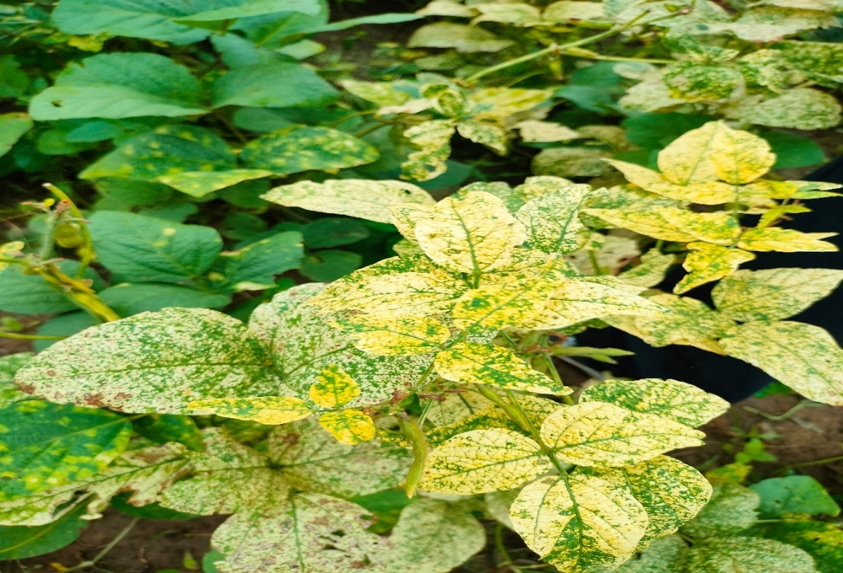

**Fig. 1: Symptoms of yellow mosaic virus on soybean leaves**

**2. Material & Methods**

**2.1 Experimental Site**

The present field experiment was undertaken during *kharif*, 2024 at the Research Farm, Zonal Agricultural Research Station, Morena, RVSKVV, Gwalior, Madhya Pradesh, India. The experimental site is geographically situated at 26.5°N latitude and 78.0°E longitude, with an average altitude of 177 meters above mean sea level. The field exhibited uniform topography and comprised medium-black soil, devoid of waterlogging circumstances, thereby offering a favourable agro-ecological environment for the successful cultivation of soybean.

**2.2 Experimental Details**

The experiment was conducted using a Randomized Block Design (RBD) with two replications. A total of sixty soybean genotypes were assessed for their agronomic performance under field conditions. The seeds were collected from College of Agriculture, Jawaharlal Nehru Agricultural University, Jabalpur, M. P., India and RAK College of Agriculture, Sehore, RVSKVV, Gwalior and National Soybean Research Institute, Indore, M.P., India (Table 1). Each genotype was sown in a single row with an inter-row spacing of 30 cm and intra-row spacing of 10 cm, allowing sufficient space for optimal plant growth, light interception, and aeration. The length of each row was maintained 5 meters, ensuring an adequate plot size for the reliable assessment of disease incidence. Uniform agronomic practices, including weeding, pest control and fertilization, were meticulously followed across all experimental plots to ensure proper crop establishment and to facilitate the accurate evaluation of the genetic potential of each genotype against YMV.

**2.3 Screening for Yellow Mosaic Virus (YMV)**

All genotypes were subjected to field screening against Yellow Mosaic Virus (YMV). Screening was carried out under natural epiphytotic conditions, with the experimental field known to have a history of YMV incidence and the presence of its vector, the whitefly (*Bemisia tabaci*). Disease incidence was recorded at the vegetative and pod formation stage, based on visual observation of characteristic symptoms such as yellow mosaic patterns on leaves, stunted growth and reduced pod development. Disease evaluation involved visual scoring of YMV symptoms manifested on foliage and overall plant vigour, using a 0–9 disease severity scale as proposed by Mayee and Datar (1986). This scale classifies disease intensity into six categories, each representing a distinct level of infection severity as presented in Table 2.

**Table 1:** **List of Soybean genotypes along with their source**

|  |  |  |  |  |  |
| --- | --- | --- | --- | --- | --- |
| **S. No.** | **Genotypes** | **Source** | **S. No.** | **Genotypes** | **Source** |
| 1. | JS-26 | JNKVV, Jabalpur | 31. | Rajsoya-24 | RAK, Sehore |
| 2. | JS-20-79 | JNKVV, Jabalpur | 32. | DLSB-40 | RAK, Sehore |
| 3. | JS-20-116 | JNKVV, Jabalpur | 33. | DS 1510 | Delhi |
| 4. | JS-22-01 | JNKVV, Jabalpur | 34. | Himaso 1695 | RAK, Sehore |
| 5. | JS-22-12 | JNKVV, Jabalpur | 35. | CAUMS-3 | RAK, Sehore |
| 6. | JS-23-05 | JNKVV, Jabalpur | 36. | Cat492A | RAK, Sehore |
| 7. | JS-24-26 | JNKVV, Jabalpur | 37. | Cat 87 | RAK, Sehore |
| 8. | JS-25-03 | JNKVV, Jabalpur | 38. | NRC-142 | NSRI, Indore |
| 9. | JS-21-07 | JNKVV, Jabalpur | 39. | NRC-201 | NSRI, Indore |
| 10. | Js-21-17 | JNKVV, Jabalpur | 40. | NRC-255 | NSRI, Indore |
| 11. | JS-20-94 | JNKVV, Jabalpur | 41. | NRC-166 | NSRI, Indore |
| 12. | RVS-23-26 | RVSKVV, Gwalior | 42. | NRC-152 | NSRI, Indore |
| 13. | RVS-23-10 | RVSKVV, Gwalior | 43. | NRC-138 | NSRI, Indore |
| 14. | RVS-23-15 | RVSKVV, Gwalior | 44. | NRC-192 | NSRI, Indore |
| 15. | RVS-23-23 | RVSKVV, Gwalior | 45. | NRCSL-7 | RAK, Sehore |
| 16 | RVS-2001-4 | RVSKVV, Gwalior | 46. | NRCSL-4 | RAK, Sehore |
| 17. | RVS-23-5 | RVSKVV, Gwalior | 47. | KDS-1203 | RAK, Sehore |
| 18. | RVS-23-12 | RVSKVV, Gwalior | 48. | KDS-1201 | RAK, Sehore |
| 19. | RVS-23-20 | RVSKVV, Gwalior | 49. | KDSIS-1394 | RAK, Sehore |
| 20. | RVSM-2012-4 | RAK, Sehore | 50. | KSS-213 | RAK, Sehore |
| 21. | RSC-10-46 | Raipur | 51. | KBSL-23-36 | RAK, Sehore |
| 22. | RSC-10-52 | Raipur | 52. | BAUS(M)-6 | Ranchi |
| 23. | AS-26 | RAK, Sehore | 53. | Pusa Sipani BS 8 | RAK, Sehore |
| 24. | ASB-85 | RAK, Sehore | 54. | PS 1569 | RAK, Sehore |
| 25. | ASB-93 | RAK, Sehore | 55. | MAUS-787 | RAK, Sehore |
| 26. | AMS-264 | PDKV, Akola | 56. | MAUS-791 | RAK, Sehore |
| 27. | AMS-2021-3 | PDKV, Akola | 57. | MACS-824 | RAK, Sehore |
| 28. | AMS-100-39 | PDKV, Akola | 58. | SL-311 | PAU, Ludhiana |
| 29. | AUKS-21-5 | RAK, Sehore | 59. | SL-1315 | PAU, Ludhiana |
| 30. | TS-208 | RAK, Sehore | 60. | VLS-104 | RAK, Sehore |

**Table 2: Scale for classifying reaction of yellow mosaic virus disease**

|  |  |  |
| --- | --- | --- |
| **Score** | **Interpretation** | **Description (visual observation)** |
| 0 | Highly resistant | No symptoms on any plants |
| 1 | Resistant | Yellow mottle or necrotic mottle in up to 1% of plants |
| 3 | Moderately resistant | Yellow mottle or necrotic mottle in up to 1.1 to 10% of plants |
| 5 | Moderately susceptible | Necrotic mottle/mild mottle/mild symptoms on 10.1 to 25% plants; no reduction in plant growth; no yield loss |
| 7 | Susceptible | Yellow mottle symptoms cover 25.1% of the whole leaf lamina; susceptible to 50% of plants; reduction in leaf and plant growth |
| 9 | Highly susceptible | Yellow mottle symptoms on more than 50% of plants; severe reduction in leaf and plant growth as well as pod formation and death of plants |

Based on the disease rating, genotypes were categorized for their resistance or susceptibility to YMV, facilitating the identification of putative YMV-resistant genotype (s) for further utilization in breeding programmes.

**3. Results & Discussion**

In the present investigation, out of the sixty soybean genotypes evaluated under natural epiphytotic conditions (Table 3; Fig. 2: A-F), thirty four genotypes including JS-26, JS-20-79, JS-23-05, JS-25-03, JS-21-07, JS-24-26, JS-21-17, JS-20-94, RVS-23-26, RVS-23-15, RVS-23-20, RVS-23-23, RVSM-2012-4, RVS-23-5, RVS-23-12, RSC-10-46, ASB-85, AMS-2021-3, AMS-100-39, TS-208, Rajsoya-24, DLSB-40, DS1510, Himso1695, CAUMS-3, NRC-201, NRC-166, NRCSL-7, NRCSL-4, KDS-1201, KBSL-23-36, Pusa Sipani BS8, SL-311 and SL-1315 were found to be highly resistant, exhibiting either no visible symptoms or only slight chlorotic spots, with disease severity scores ranging to zero. These genotypes maintained healthy plant growth and pod development, indicating strong genetic resistance to YMV. Seven genotypes *viz*., JS-20-116, RVS-23-10, NRC-138, NRC-255, AUKS-21-5, Cat 87 and KDS-1203 exhibited a resistant response, with mild mosaic symptoms on a few leaves and disease severity scores 1. Eleven genotypes, including JS-22-01, JS-22-12, AS-26, MAUS-787, MAUS-791, PS-1569, KDSIS-1394, NRC-192, NRC-142, AMS-264 and ASB-93, were categorized as moderately resistant, displaying intermediate levels of mosaic symptoms and slight plant stunting, with scores 3. Six genotypes *i.e*., RVS-2001-4, Cat492A, NRC-152, KSS-213, BAUS(M)-6 and VLS-104 were considered as moderately susceptible, displaying more extensive yellow mosaic symptoms, moderate leaf deformation and reduced vigour, with severity scores 5. Only two genotypes, *viz*., RSC-10-52 and MACS-824, were found to be susceptible, with severe leaf yellowing, curling, and considerable reduction in plant growth, corresponding to scores of 7. Remarkably, none of the genotype were categorized as highly susceptible, suggesting a relatively high base line level of resistance within the tested genotypes.

**Table 3: Reaction of different soybean genotypes against yellow mosaic virus disease**

|  |  |  |  |  |
| --- | --- | --- | --- | --- |
| **S. No.** | **Category** | **CI** | **Numbers of**  **genotypes** | **Genotypes** |
| **1.** | **Highly resistant** | **0-4** | 34 | JS-26, JS-20-79, JS-23-05, JS-25-03, JS-21-07, JS-24-26, JS-21-17, JS-20-94, RVS-23-26, RVS-23-15, RVS-23-20, RVS-23-23, RVSM-2012-4, RVS-23-5, RVS-23-12, RSC-10-46, ASB-85, AMS-2021-3, AMS-100-39, TS-208, Rajsoya-24, DLSB-40, DS 1510, Himso 1695, CAUMS-3, NRC-201, NRC-166, NRCSL-7, NRCSL-4, KDS-1201, KBSL-23-36, Pusa Sipani BS 8, SL-311, SL-1315 |
| **2.** | **Resistant** | **5-9** | 07 | JS-20-116, RVS-23-10, NRC-138, NRC-255, AUKS-21-5, Cat 87, KDS-1203 |
| **3.** | **Moderately resistant** | **10-19** | 11 | JS-22-01, JS-22-12, AS-26, MAUS-787, MAUS-791, PS1569, KDSIS-1394, NRC-192, NRC-142, AMS- 264, ASB-93 |
| **4.** | **Moderately susceptible** | **20-39** | 06 | RVS-2001-4, Cat492A, NRC-152, KSS-213, BAUS(M)-6, VLS- 104 |
| **5.** | **Susceptible** | **40-69** | 02 | RSC-10-52, MACS-824 |
| **6.** | **Highly susceptible** | **70-100** | zero | Nil |

The differential responses observed among soybean genotypes against yellow mosaic virus (YMV) infection highlights the inherent genetic variability present within the genotype. The wide spectrum of disease reactions ranging from high resistance to susceptible suggests the involvement of diverse resistance mechanisms, potentially governed by both major and minor genes (Nichal et al., 2018; Mishra et al., 2020a). This variation provides an opportunity for the identification and utilization of resistant sources in breeding programmes aimed to enhance YMV resistance (Singh et al., 2020; Thakur et al., 2024). Genotypes exhibiting high levels of resistance displayed negligible symptom expression and maintained overall plant health and productivity under natural field conditions. These responses indicate the potential presence of strong, possibly dominant resistance genes conferring stable defence mechanisms against the virus (Mishra et al., 2020b; Hoque & Haque, 2024; Roy et al., 2025; Jhariya et al., 2025). In contrast, genotypes that exhibited moderate to high levels of disease severity may lack such effective resistance genes or may possess quantitative resistance that is less effective under high disease pressure (Jeger, 2023; Dutta et al., 2025). The presence of moderately resistant and moderately susceptible genotypes advises a continuum of resistance, possibly influenced by polygenic inheritance and genotype-by-environment interactions. Such genotypes may still hold value for breeding programmes, especially when combined with agronomically superior traits and durable resistance sources (Mishra et al., 2020b; Salleh et al., 2022; Mudhalvan et al., 2024). Moreover, their evaluation under different agro-climatic zones would provide further insights into the stability of their resistance. The low frequency of susceptible genotypes and absence of highly susceptible lines is encouraging, as it indicates a general trend toward improved resistance in the tested materials (Jeevitha et al., 2022; Singh et al., 2022; Amrate et al., 2023). This may be attributed to prior selection efforts and the inclusion of improved genotypes in the breeding programme. Nevertheless, even a few susceptible entries underscore the need for continuous monitoring and elimination of vulnerable genotypes from breeding pipelines (Mallick et al., 2015; Zhu et al., 2022; Sanchez et al., 2023; Tarekegne et al., 2024; Jhariya et al., 2025).

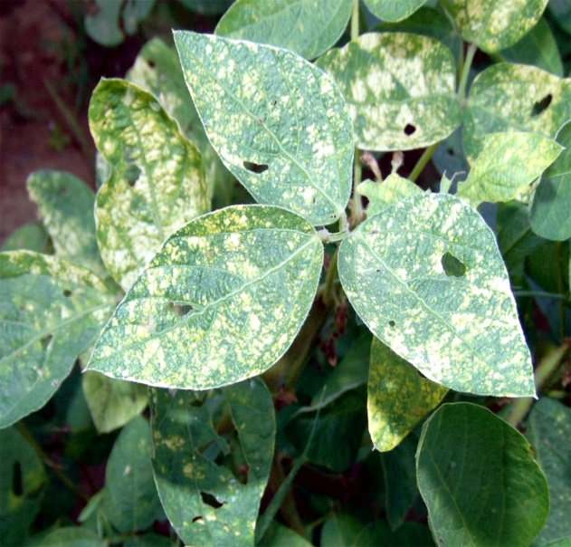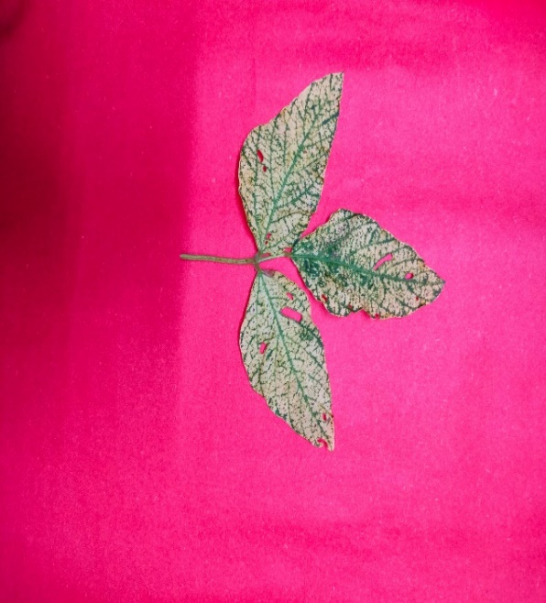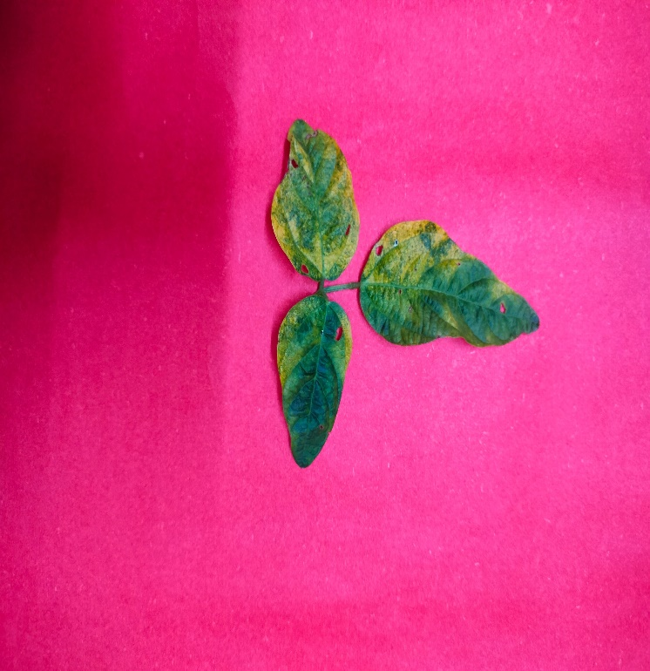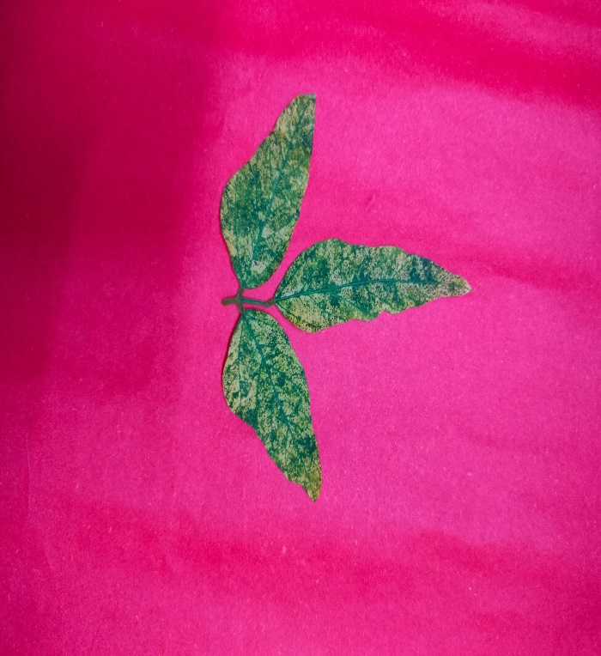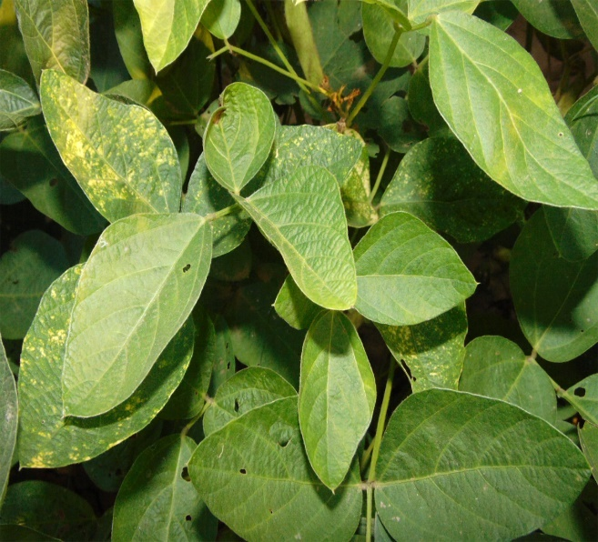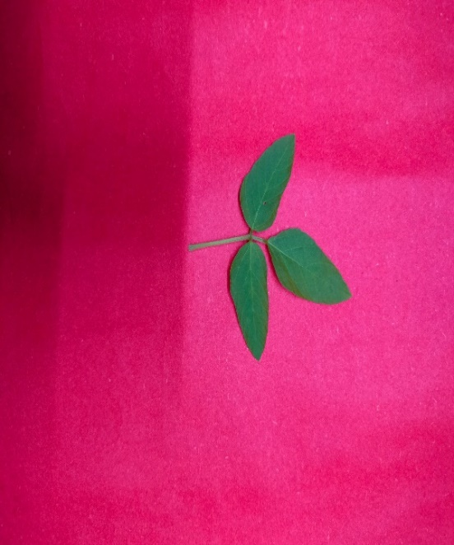

**F. Highly susceptible**

**E. Susceptible**

**C. Moderately resistant**

**D. Moderately susceptible**

**B. Resistant**

**A. Highly resistant**

**Figure 2: Severity symptoms of yellow mosaic virus disease on soybean leaves**

Overall, the findings emphasize the importance of systematic screening of soybean genotypes under natural disease conditions for effective identification of resistant genotypes. Incorporating resistant genotypes into future breeding programmes, along with molecular and biotechnological tools, can accelerate the development of cultivars with durable resistance. These efforts are crucial for sustainable soybean production, particularly in regions where YMV poses a significant threat to crop yield and farmer livelihoods (Tripathi et al., 2022; Lin et al., 2022; Jeevitha et al., 2022; Usovsky et al., 2022; Mishra et al., 2024a; Jhariya et al., 2025).

**Conclusion**

The present investigation demonstrated considerable genetic variability among the sixty soybean genotypes evaluated under natural epiphytotic circumstances for their response to Yellow Mosaic Virus (YMV). The identification of a substantial numbers of highly resistant and resistant genotypes highlights the presence of effective genetic resistance within the tested genetic material, offering promising avenues for performing resistance breeding. The differential disease responses observed, ranging from high resistance to susceptibility, suggest the involvement of both major and minor genes in governing YMV resistance, with potential for exploitation in both conventional and molecular breeding programmes. The absence of highly susceptible genotypes and the relatively low frequency of susceptible lines are encouraging outcomes, indicative of genetic improvement in contemporary soybean breeding pipelines. The resistant and moderately resistant genotypes identified in this investigation, constitute valuable resources for the development of YMV-resistant cultivars and may contribute to the creation of durable resistance through pyramiding strategies. Moving forward, these genotypes can be subjected to multi-location evaluations and molecular characterization to assess the stability and underlying genetic basis of resistance. Integrating such phenotypic data with genomic approaches may be critical in accelerating the development of resilient soybean varieties, thereby enhancing productivity, profitability and sustainability of soybean cultivation in YMV-prone agro-ecological zones.

Disclaimer (Artificial intelligence)

Author(s) hereby declares that NO generative AI technologies such as Large Language Models (ChatGPT, COPILOT, etc.) and text-to-image generators have been used during the writing or editing of this manuscript.

**References**

1. Amrate, P. K., Shrivastava, M. K., Borah, M., Routhu, G. K., Sharma, S., Nataraj, V., Pancheshwar, D. K., & Singh, G. (2023). Molecular characterization of soybean yellow mosaic virus isolates and identification of stable resistance sources in central India. *Australasian Plant Pathology*, *52*(3), 165–179. <https://doi.org/10.1007/s13313-022-00902-8>
2. Aravind, T., Singh, K. P., Borah, M., Aravind, S., Surbhi, K., & Bhatt, P. (2025). Yellow mosaic disease: Etiology, epidemiology, and host resistance in soybean. In *Soybean Production Technology* (pp. 299–312). Springer Nature Singapore. https://doi.org/10.1007/978-981-97-8104-1_17
3. Hajimorad, M. R., Domier, L. L., Tolin, S. A., Whitham, S. A., & Saghai Maroof, M. A. (2018). Soybean mosaic virus: a successful potyvirus with a wide distribution but restricted natural host range. *Molecular Plant Pathology*, *19*(7), 1563–1579. https://doi.org/10.1111/mpp.12644
4. Hoque, N., & Haque, Md. A. (2024). Detection of yellow mosaic virus resistance in soybean (*Glycine max* L.) genotypes for yield and related traits. *F1000Research*, *13*, 982. <https://doi.org/10.12688/f1000research.150924.1>
5. Jeevitha, S., Bharathi, J. K., Saravanan, K. R., Prakash, M., Murugan, S., & Anandan, R. (2022). Genetic diversity and marker trait association for yellow mosaic virus disease in green gram, *Vigna radiata* (L.) Wilczek. *Indian Journal of Experimental Biology*, *60*(7), 481-489 <https://doi.org/10.56042/ijeb.v60i07.64070>*60*.
6. Jeger, M. J. (2023). Tolerance of plant virus disease: Its genetic, physiological, and epidemiological significance. *Food and Energy Security*, *12*(6). <https://doi.org/10.1002/fes3.440>
7. Jhariya, R., Tripathi, M.K., Mishra, R., Solanki, R., and Sharma S. (2025). Field based disease indexing of soybean genotypes against yellow mosaic virus. *Journal of Scientific Research and Reports,* *31 (6)*:719-28. https://doi.org/10.9734/jsrr/2025/v31i63167
8. Karthikeyan, A., Shobhana, V. G., Sudha, M., Raveendran, M., Senthil, N., Pandiyan, M., & Nagarajan, P. (2014). Mungbean yellow mosaic virus (MYMV): a threat to green gram (*Vigna radiata*) production in Asia. *International Journal of Pest Management*, *60*(4), 314–324. <https://doi.org/10.1080/09670874.2014.982230>
9. Kumar, K., Walia, P., & Sandal, S. S. (2023). Yellow mosaic virus (YMV) in green gram: Impacts, management, and future perspectives. *International Journal of Environment and Climate Change*, *13*(9), 1461–1474. <https://doi.org/10.9734/ijecc/2023/v13i92377>
10. Li, X., & Xiao, R. (2025). Molecular dialogue in legume-rhizobium symbiosis: signalling mechanisms and genetic insights. *Rhizosphere*, *33*, 101034. <https://doi.org/10.1016/j.rhisph.2025.101034>
11. Lin, F., Chhapekar, S. S., Vieira, C. C., da Silva, M. P., Rojas, A., Lee, D., Liu, N., Pardo, E. M., Lee, Y. C., Dong, Z., Pinheiro, J. B., Ploper, L. D., Rupe, J., Chen, P., Wang, D., & Nguyen, H. T. (2022). Breeding for disease resistance in soybean: a global perspective. *Theoretical and Applied Genetics*, *135*(11), 3773–3872. <https://doi.org/10.1007/s00122-022-04101-3>
12. Mallick, N., Sharma, V. J. B., Tomar, R. S., Sivasamy, M., & Prabhu, K. V. (2015). Marker‐assisted backcross breeding to combine multiple rust resistance in wheat. *Plant Breeding*, *134*(2), 172–177. <https://doi.org/10.1111/pbr.12242>
13. Mayee, C. R., & Datar, V. V. (1986). Phytopathometry (Technical Bulletin No. 1, pp. 145–146). Maharashtra Agricultural University, Parbhani.
14. Mishra, N., Tripathi, M. K., Tiwari, S., Tripathi, N., & Trivedi, H. K. (2020a). Morphological and molecular screening of soybean genotypes against yellow mosaic virus disease. *Legume Research,* <https://doi.org/10.18805/LR-4240>
15. Mishra, G. P., Dikshit, H. K., S. V., R., Tripathi, K., Kumar, R. R., Aski, M., Singh, A., Roy, A., Priti, Kumari, N., Dasgupta, U., Kumar, A., Praveen, S., & Nair, R. M. (2020b). Yellow mosaic disease (YMD) of mungbean (*Vigna radiata* (L.) Wilczek): Current status and management opportunities. *Frontiers in Plant Science*, *11*. <https://doi.org/10.3389/fpls.2020.00918>
16. Mishra, N., Tripathi, M.K., Tiwari, S., Tripathi, N., Sapre, S. Ahuja, A. & Tiwari, S. (2021a). Cell suspension culture and *in vitro* screening for drought tolerance in soybean using poly-ethylene glycol. *Plants*.; *10*;10(3):517. <https://doi.org/10.3390/plants10030517>
17. Mishra, N., Tripathi, M.K., Tiwari, S., Tripathi, N., Gupta, N., Sharma, A., & Solanki1 R.S. (2021b). Evaluation of diversity among soybean genotypes *via* yield attributing traits and SSR molecular markers. *Current Journal of Applied Science and Technology*, *40*, 21: 9-24.
18. Mishra, N., Tripathi, M.K., Tripathi, N., Tiwari, S., Gupta, N., & Sharma, A. (2021c). Validation of drought tolerance gene-linked microsatellite markers and their efficiency for diversity assessment in a set of soybean genotypes. *Current Journal of Applied Science and Technology*. *30*,48–57. <https://doi.org/10.9734/cjast/2021/v40i2531515>
19. Mishra, N., Tripathi, M.K., Tripathi, N., Tiwari, S., Gupta, N., Sharma, A., *et al*. (2021d). Changes in biochemical and antioxidant enzymes activities play significant role in drought tolerance in soybean. *Int. J Agric. Technol. 17*, 1425-46. 41.
20. Mishra, N., Tripathi, M.K., Tiwari, S., Tripathi, N., Gupta, N., & Sharma, A. (2021e). Morphological and physiological performance of Indian soybean [*Glycine max* (L.) Merrill] genotypes in respect to drought. *Legume Res,* LR-4550.
21. Mishra, R., Tripathi, M. K., Sikarwar, R. S., Singh, Y., & Tripathi, N. (2024a). Soybean (*Glycine max* L. Merrill): A multipurpose legume shaping our world. *Plant Cell Biotechnology and Molecular Biology*, *25*(3–4), 17–37. <https://doi.org/10.56557/pcbmb/2024/v25i3-48643>
22. Mishra, R., Tripathi, M., Tripathi, N., Singh, J. & Tiwari S. (2024b). Nutritional and anti-nutritional factors in soybean. *Acta Scientific Agriculture*. 3: 8(11):46–63. <https://doi.org/10.31080/ASAG.2024.08.1432>
23. Mishra, R., Tripathi, M.K., Tripathi, N., Singh, J., Yadav, P.K. & Sikarwar, R.S. *et al.* (2024c). Breeding for major genes against drought stress in soybean. In: Tripathi MK, Tripathi N, editors. *Advances in Plant Biotechnology*. Cornous Publications LLP, Puducherry, India. p. 22–68. <https://doi.org/https://doi.org/10.37446/volbook032024/22-68>
24. Mishra, R., Tripathi, M.K., Shrivastava, M.K., & Amrate, P.K. (2024d). Genetic diversity in crop improvement: A cornerstone for sustainable agriculture and global food security. In: Tripathi MK, Tripathi N, editors. *Advances in Plant Biotechnology*. Cornous Publications LLP; p. 1–21. <https://doi.org/https://doi.org/10.37446/volbook032024/1-21>
25. Mishra, R., Tripathi, M. K., Shrivastava, M. K., Amrate, P. K., Singh, J., & Singh, Y. (2024e). From conventional to modern plant breeding: How far have we come? In M. K. Tripathi & R. Mishra (Eds.), *Recent Advances in Plant Breeding* (Vol. 1, pp. 1–20). Cornous Publications LLP. <https://doi.org/10.37446/volbook102024/1-20>
26. Mishra, R., Shrivastava, M.K., Amrate, P.K., Sharma, S., Singh, Y., Tripathi, & M.K. (2025a). Phenotypic diversity and trait analysis of soybean recombinant inbred lines. *Plant Cell Biotechnology and Molecular Biology*. May 17;26(7–8):32–52. <https://doi.org/10.56557/pcbmb/2025/v26i7-89345>
27. Mishra, R., Shrivastava, M.K., Tripathi, M.K., Amrate, P.K., Singh, Y. & Solanki R. *et al*. (2025b). Unravelling soybean yield potential: Exploring trait synergy, impact pathways, multidimensional patterns and biochemical insights. *Plant Science Today*. <https://doi.org/10.14719/pst.6401>
28. Mudhalvan, S., Sindhu, S., & Jeyaprabha, J. (2024). Genetic studies on the heredity of mungbean yellow mosaic virus resistance in green gram [*Vigna radiata* (L.) Wilczek]. *Environment Conservation Journal*, *25*(4), 1081–1084. <https://doi.org/10.36953/ECJ.28342873>
29. Nakei, M. D., Venkataramana, P. B., & Ndakidemi, P. A. (2022). Soybean-nodulating rhizobia: Ecology, characterization, diversity, and growth promoting functions. *Frontiers in Sustainable Food Systems*, *6*. <https://doi.org/10.3389/fsufs.2022.824444>
30. Nichal, S. S., Zope, A. V., Gawande, P. P., Ratnaparkhi, R. D., & Nandanwar, R. S. (2018). Genetics of yellow mosaic virus (YMV) disease in soybean [*Glycine max* (L.) Merr.]. *International Journal of Current Microbiology and Applied Sciences*, *6*, 2496-2499.
31. Parihar, P., Singh, P., Pandya, R.K., Tiwari S. & Tripathi, M.K. (2022). Screening of pearl millet promising hybrids and varieties against blast (*Pyricularia grisea*) by disease indexing. *The Pharma Innovation Journal*, *11(6)*: 664-667
32. Rahman, S. U., Raza, G., Naqvi, R. Z., McCoy, E., Hammad, M., LaFayette, P., Parrott, W. A., Amin, I., Mukhtar, Z., Gaafar, A.-R. Z., Hodhod, M. S., & Mansoor, S. (2023). A source of resistance against yellow mosaic disease in soybeans correlates with a novel mutation in a resistance gene. *Frontiers in Plant Science*, *14*. <https://doi.org/10.3389/fpls.2023.1230559>
33. Roy, G., Afandi, F., Vishnuvardhannaidu, K., Raut, R. N., & Amir, M. (2025). A comprehensive review of genomics assisted breeding and mutation strategies for yellow vein mosaic virus resistance in mung bean. *International Journal of Research in Agronomy*, *8*(5), 176–186. <https://doi.org/10.33545/2618060X.2025.v8.i5c.2885>
34. Salleh, S. B., Rafii, M. Y., Ismail, M. R., Ramli, A., Chukwu, S. C., Yusuff, O., & Hasan, N. (2022). Genotype-by-environment interaction effects on blast disease severity and genetic diversity of advanced blast-resistant rice lines based on quantitative traits. *Frontiers in Agronomy*, *4*. <https://doi.org/10.3389/fagro.2022.990397>
35. Sanchez, D., Sadoun, S. ben, Mary-Huard, T., Allier, A., Moreau, L., & Charcosset, A. (2023). Improving the use of plant genetic resources to sustain breeding programs’ efficiency. *Proceedings of the National Academy of Sciences*, *120*(14). <https://doi.org/10.1073/pnas.2205780119>
36. Sharma, A., Tripathi, M. K., Tiwari, S., Gupta, N., Tripathi, N., & Mishra, N. (2021). Evaluation of soybean (*Glycine max* L.) genotypes on the basis of biochemical contents and anti-oxidant enzyme activities. *Legume Research*, <https://doi.org/10.18805/LR-4678>
37. Sharma, A., Mishra, N., Tripathi, N., Nehra, S., Singh, J., & Tiwari S. *et al*. (2023). Qualitative trait based variability among soybean genotypes. *Acta Scientific Agriculture*. 1;02–13. <https://doi.org/10.31080/ASAG.2023.07.1212>
38. Singh, C. M., Pratap, A., Gupta, S., Biradar, R. S., & Singh, N. P. (2020). Association mapping for mungbean yellow mosaic India virus resistance in mungbean (*Vigna radiata* L. Wilczek). *3 Biotech*, *10*(2), 33. <https://doi.org/10.1007/s13205-019-2035-7>
39. Singh, G., Gudi, S., Amandeep, Upadhyay, P., Shekhawat, P. K., Nayak, G., Goyal, L., Kumar, D., Kumar, P., Kamboj, A., Thada, A., Shekhar, S., Koli, G. K., DP, M., Halladakeri, P., Kaur, R., Kumar, S., Saini, P., Singh, I., & Ayoubi, H. (2022). Unlocking the hidden variation from wild repository for accelerating genetic gain in legumes. *Frontiers in Plant Science*, *13*. <https://doi.org/10.3389/fpls.2022.1035878>
40. Swathi, M., Gaur, N., & Singh, K. (2021). Virus vector relationship of yellow mosaic virus and whitefly, *Bemisia tabaci* (Gennadius) in soybean. *Legume Research,* <https://doi.org/10.18805/LR-4479>
41. Tarekegne, A., Wegary, D., Cairns, J. E., Zaman-Allah, M., Beyene, Y., Negera, D., Teklewold, A., Tesfaye, K., Jumbo, M. B., Das, B., Nhamucho, E. J., Simpasa, K., Kaonga, K. K. E., Mashingaidze, K., Thokozile, N., Mhike, X., & Prasanna, B. M. (2024). Genetic gains in early maturing maize hybrids developed by the International maize and wheat improvement center in Southern Africa during 2000–2018. *Frontiers in Plant Science*, *14*. <https://doi.org/10.3389/fpls.2023.1321308>
42. Thakur, S., Sharma, S., Tripathi, N., Sharma, R., Kumar, A., & Ramakrishnan, R. S. (2024). Assessment of genetic diversity for MYMV resistance in mungbean [*Vigna radiata* (L.) Wilczek] using SSR markers. *Legume Research*, <https://doi.org/10.18805/LR-5341>
43. Tripathi, N., Tripathi, M. K., Tiwari, S., & Payasi, D. K. (2022). Molecular breeding to overcome biotic stresses in soybean: update. *Plants*, *11*(15), 1967. <https://doi.org/10.3390/plants11151967>
44. Upadhyay, S., Singh, A.K., Tripathi, M.K., Tiwari, S., & Tripathi, N. (2020). Validation of simple sequence repeats markers for charcoal rot and Rhizoctonia root rot resistance in soybean genotypes. *I.J.A.B.R.* *10(2),*137-144.
45. Usovsky, M., Chen, P., Li, D., Wang, A., Shi, A., Zheng, C., Shakiba, E., Lee, D., Canella Vieira, C., Lee, Y., Wu, C., Cervantez, I., & Dong, D. (2022). Decades of genetic research on soybean mosaic virus resistance in soybean. *Viruses*, *14*(6), 1122. <https://doi.org/10.3390/v14061122>
46. Vishal, K., Amaresh, Y. S., Gururaj, S., Aswathanarayana, D. S., & Sidramappa. (2024). Management of yellow mosaic disease in soybean. *International Journal of Plant & Soil Science*, *36*(11), 338–344. <https://doi.org/10.9734/ijpss/2024/v36i115150>
47. Wu, J., & Yan, S. (2024). Natural nitrogen boosters: The symbiotic relationship between legumes and rhizobia. *Molecular Soil Biology*. <https://doi.org/10.5376/msb.2024.15.0009>
48. Zhu, L., Feng, L., Yu, X., Fu, X., Yang, Q., Jin, H., & Yuan, F. (2022). Development and application of an *in vitro* method to evaluate anthracnose resistance in soybean germplasm. *Plants*, *11*(5), 657. <https://doi.org/10.3390/plants11050657>