Original Research Article

Bioenzyme-Mediated Growth Enhancement in Cordyline (Cordyline terminalis): A Developmental Study

ABSTRACT
Research on “Bioenzyme-Mediated Growth Enhancement in Cordyline (Cordyline terminalis): A Developmental Study” was carried out with objective to study the in vivo effect of bio enzymes on growth and development of Cordyline under shade-net condition and to analyze the chlorophyll content and vase life study of cut foliage of Cordyline terminalis. This comprised of 13 treatments in 117 potted plants analyzed using CRD experimental design. Out of which, treatment T₁₁: [Humic acid (15%) + Amino acids (2%) + Fulvic acid (6%)] @ 1.5 ml/l, T₁₀: [Seaweed fermented biomass (22%) + Amino acids (4%)] @ 1.5 ml/l and T₈: [Triacontanol (a.i.) 0.1% w/w (1000 ppm), emulsifier (ethoxylated esters of fatty acids) 0.5% w/w, and preservatives (esters of benzoic acid) 0.1% w/w in demineralized aqua QS with total 100% w/w] @ 1.0 ml/l were found significantly effective over control giving enhanced vegetative and qualitative traits in terms of chlorophyll content and vase life of cut foliage. It highlights the potential of bioenzymes as biostimulants, offering an organic alternative to chemical fertilizers by improving overall plant health of Cordyline in Foliage crop industry through sustainable and eco-friendly approaches by enhancing vegetative growth, developmental stages and qualitative traits.

Keywords: Cordyline, Foliage crop, Bioenzymes, Organic, Growth, chlorophyll, vase life
ABBREVIATIONS
DAP: Days after planting
%: Percentage
QS: Quantum satis
cm: Centimeter
abs: Absorbance
ppm: Parts per million
FYM: Farm yard manure
CRD: Completely randomized design

- INTRODUCTION
Foliage plants are ‘tropical exotics’ that includes all the plants grown primarily for their foliage and utilized for interior decoration, interior landscape, rooftop gardening, vertical gardening, under shade landscaping, outdoor landscaping and as border plants to add aesthetic value and creating green space. The trade of ornamental foliage plants at international market is seen as a new venture for India and is gaining wide popularity. Currently, majority of foliage plants are sold to Germany, the United States, the Netherlands, the United Kingdom, Italy, and Japan, accounting for over 60% of India's floricultural exports (Ray et al., 2006). Lack of green space and need for green environment in urban areas lead to adoption of foliage plants boosting floriculture and landscaping industry.
The genus Cordyline was first reported by Adanson (1763) and later separated from the closely related Dracaena (Commerson, 1789). The name Cordyline, is derived from the Greek "Kordule" meaning "club" and is said by Kemp and Robb (1962) to refer to the form of the flower buds. Also, its common name, cabbage palm, comes from the Greek word 'Kordyle,' which means club or cudgel, referring to root shape (Pal, 2006). Bailey (1910), attributed the origin to the “club like” form of the stem. Cordyline was placed in the Liliaceae family by Bentham and Hooker (1883). More recently Hutchinson (1959) placed Cordyline in the family Agavaceae and this classification was adopted by Melchior (1964).
It consists of about 20 species of evergreen trees and shrubs. It is indigenous to the tropical and subtropical parts of the earth, including China, Malaysia, the East Himalayas, and North Australia. Important ornamental species of Cordyline are Cordyline terminalis, C. australis, C. rubra and C. indivisa. Among these, Cordyline terminalis is the most important and commercially exploited species which is found throughout the Pacific area and in some Asiatic countries. Important varieties under cultivation are Baby doll, Lily put, Kiwi, Hawaiian flag and Mahatma. Cordyline is quite similar to dracaena and differs only in the anatomy of the ovary. Several cordyline species are usually referred to as dracaena (Randhawa and Mukhopadhyay, 2004). It is a long, thin bush that can reach 3m in height and is valued for its vibrantly colored foliage, including variegated varieties. Cordyline is an excellent ornamental plant with colored foliage, as focal point in gardens, floor plants, as a pot plant in its juvenile state, is also suitable for growing in borders and shrubberies under a mild climate, for shade gardens and greenhouse. Most of the species are extensively used for table decorations while they are young. The plant is widely found in homes, workplaces, stores, banks, hotels, restaurants, clubs, hospitals and schools and numerous plants are occasionally gathered and grown as exquisite table decorations in terrariums, bottles, bowls, plates, troughs and aquarium cases (Beura et al., 2007). It has attractive color of the foliage, hardiness, ease of cultivation, suitability to interior conditions and resistance to pests and diseases contribute to its popularity in urban agriculture and landscaping.
Rapid degradation of agricultural areas, uncertainties related to climate change, decreasing green space in urban areas led to shift of nutrient application from chemical to organic based like biostimulants, particularly bio enzymes. Bio enzymes are promising environmental production strategy for ornamental crops including foliage crops in shade net. Traon et al. (2014) defined Bioenzymes as, “Any substance or microorganism that is applied to plants, seeds, or the root environment with the intention to stimulate natural plant processes that benefit nutrient use efficiency and/or tolerance to abiotic stress, regardless of its nutrient content, is referred to as a plant bio stimulant. This definition includes any combination of such substances and/or microorganisms intended for this use.” Yakhin et al. (2017) defined bio stimulants as “a formulated product of biological origin that improves plant productivity as a consequence of the novel or emergent properties of the complex constituents, and not as a sole consequence of the presence of known essential plant nutrients, plant growth regulators, or plant protective compounds.” Kunicki et al. (2010) stated that biostimulants can be foliar or soil applied, depending on their composition and intended results.
Bioenzymes functions as an anti-stress promoting, growth-stimulating, nutrient absorption, crop productivity improvement, dormancy-breaking, boosting foliage quality, pigment content improvement, enhancing root formation, enhancing photosynthetic as well as vegetative tissue processes, enhancing plant resilience and coherence, and regulates effect on foliage crop growth, quality parameter and development. The recent in vivo study on the effect of bioenzymes on growth and development of Cordyline terminalis under shade-net condition with rigorous statistical analysis, highlights sustainable and organic alternatives to chemical inputs in urban horticulture, to analyze the response of potted plants of Cordyline under various physiological parameters, foliage quality and overall growth and vigor on commercial basis.

- MATERIALS AND METHODS

2.1 Experimental site

The experimental study on “Bioenzyme-Mediated Growth Enhancement in Cordyline (Cordyline terminalis): A Developmental Study” was accomplished from September 2022 to September 2023 at the Biotechnology-cum-Tissue Culture Centre in Baramunda, Floriculture and Landscaping Department, College of Agriculture, Odisha University of Agriculture and Technology, Bhubaneswar.

2.2 Morphological Features

Table 1: Morphological traits of Cordyline terminalis
Sl. No. | Characters | Descriptions
01. | Type of plant | Monocot, evergreen
02. | Plant height | 1-2 m
03. | Growth habit | Profusely spread at a particular axis from the base, mostly shrub
04. | Length and width of leaves | 25-50 × 5-10 cm
05. | Leaf colour | Red, pink, purple, maroon, greenish shade
06. | No of leaves/plant | 4-5
2.3 Field preparation and Layout
Mixture of FYM + Soil in 1:1 proportion were placed in 117 pots (Fig. 1) with good porosity, soil texture and soil pH. 117 young plants in polybags with 3-4 number of leaves (Table 1) and uniform size were transplanted in pots under protected shade net condition. The experimental field was laid out as plan of layout (Fig. 9) with 13 treatments, 3 replications under each treatment and 3 pots/ replication using CRD experimental design to study the effect of bioenzymes on growth and development of Cordyline terminalis (Fig. 2, Table 2 & Table 3).

Table 2: Common treatment details for in vivo effect of bioenzymes on growth and development of Cordyline terminalis
Spray duration: 30 days interval
Sl. No. | Treatments | Treatment details
01. | T₁ | Control (No bioenzyme application)
02. | T₂ | Biozyme vegetable plus @ 0.5 ml/l
03. | T₃ | Booster @ 0.5 ml/l
04. | T₄ | Biozyme crop + @ 0.5 ml/l
05. | T₅ | Vipul booster @ 0.5 ml/l
06. | T₆ | Biozyme vegetable plus @ 1.0 ml/l
07. | T₇ | Booster @ 1.0 ml/l
08. | T₈ | Vipul booster @ 1.0 ml/l
09. | T₉ | Biozyme crop + @ 1.0 ml/l
10. | T₁₀ | Biozyme vegetable plus @ 1.5 ml/l
11. | T₁₁ | Booster @ 1.5 ml/l
12. | T₁₂ | Biozyme crop + @ 1.5 ml/l
13. | T₁₃ | Vipul booster @ 1.5 ml/l

2.4 Observation to be recorded
- Plant height (cm): Plant height was measured on 30th day, 60th day and 90th day after transplanting respectively using a meter scale radially from soil surface to leaf tip of last fully opened leaf i.e., highest point of the plant (Fig. 6).
- Number of leaves/plants: The total number of matured leaves per plant in each treatment were recorded.
- Leaf length (cm): Fully developed leaf from top of the plant (second, third or fourth leaf) was measured length wise.
- Leaf breadth (cm): Fully developed leaf from top of the plant (second, third or fourth leaf) was measured breadth wise (Fig. 4).
- Leaf area (cm²): The area of the open, matured leaf from the top (second, third or fourth) was measured with the help of leaf area meter.
- Internodal length (cm): Length of each internode.
- Plant grade: The plant quality determined visually on the following scale:
Scale-1: Dead
Scale-2: Poor, unsalable
Scale-3: Moderate, saleable
Scale-4: Good, saleable
Scale-5: Excellent, saleable
- Colour grade: Leaf colour rated visually on the scale-1, 3 and 5 (Fig. 5).
Scale-1: Light reddish green
Scale-2: Medium reddish green
Scale-5: Dark greenish red
- Vase life (days): The harvesting procedure was done in the morning and mature leaf canopy with petiole and stem from each treatment were harvested in commercial stage (35-45 cm) and with no disease or pest symptoms. The material was brought to the laboratory less than one hour after harvest and was washed and then the leaves were placed in 300 ml distilled water in conical flask along with holding solution (2% sucrose) and the observation was recorded on basis of freshness and longevity of leaves for cut foliage to study vase life (Fig. 8).
- Chlorophyll content: It was measured using Spectrophotometer (Fig. 7). From middle part of Canopy, a fresh leaf was selected. 100mg of portion was taken with help of a blade and macerated with little quantity of acetone in mortar and pestle, transferred to 25 ml volumetric flask and kept overnight for chlorophyll extraction. In next day, the leaf extract was filtered to conical flask and little amount was taken and put in spectrophotometer to record the reading of absorbance at specific wavelength. Total chlorophyll was calculated with help of following formula and expressed as mg/g of leaf.
Total Chlorophyll: (8.02 × abs at 645 nm + 20.2 × abs at 663 nm) × 25/100

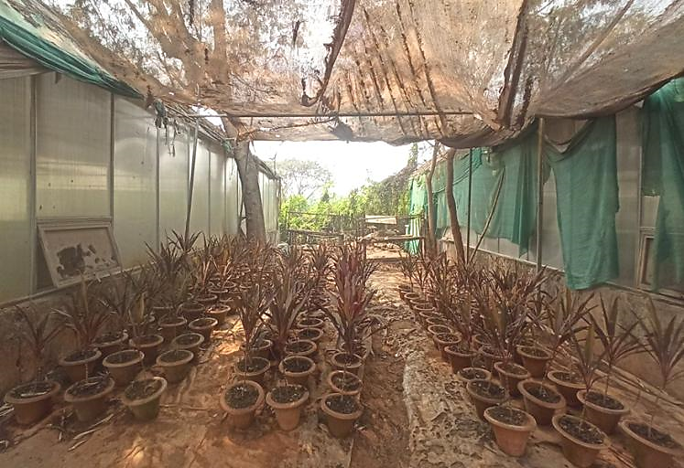
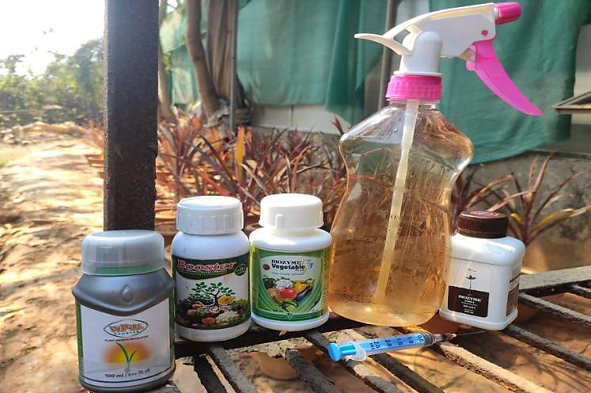
Fig. 1 Cordyline terminalis Field Plot
Fig. 2 Bioenzymes used for spraying

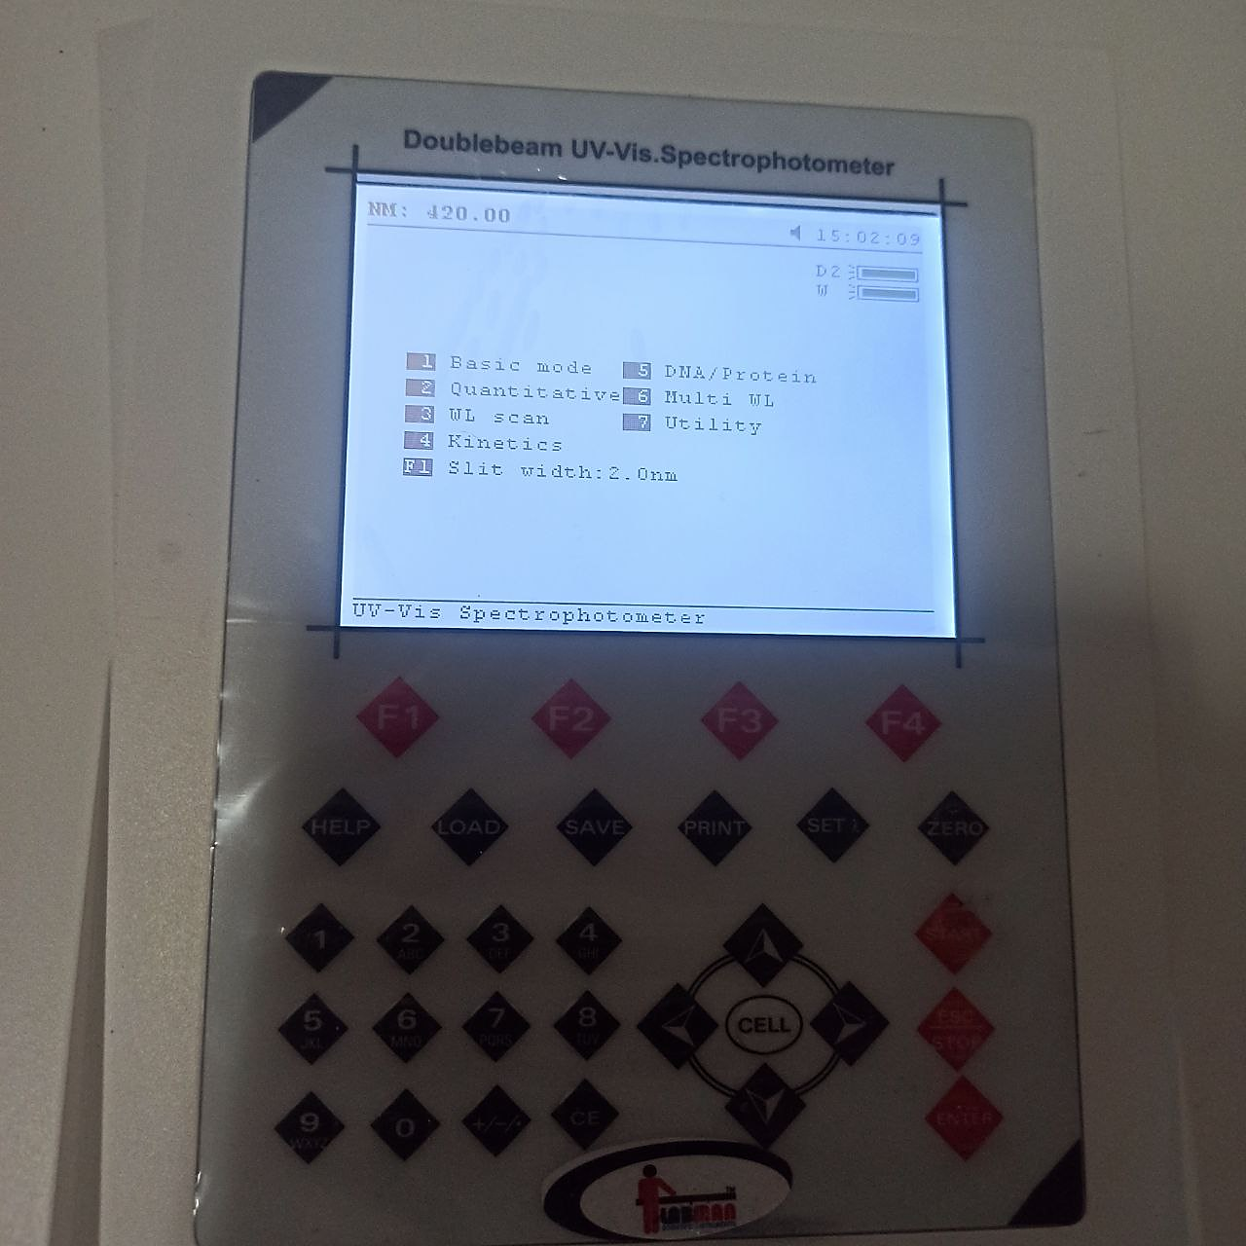
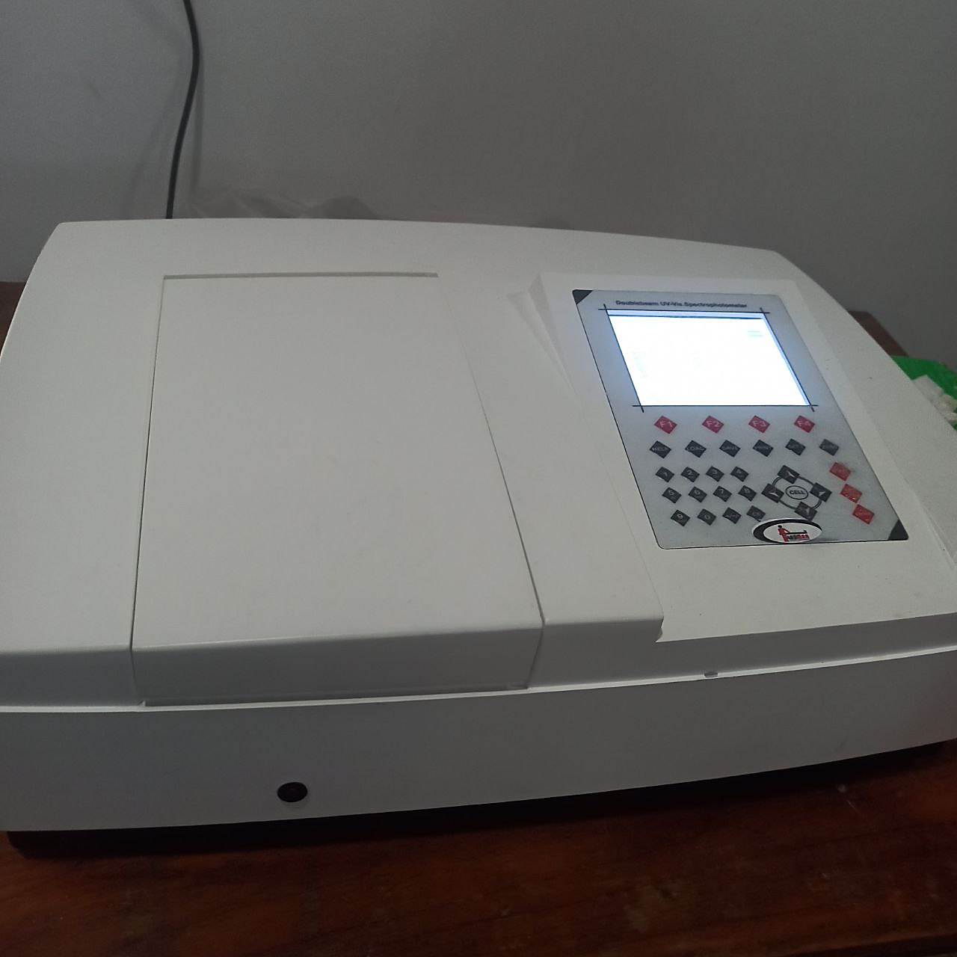

Fig. 7: Estimation of Chlorophyll content through
Spectrophotometer

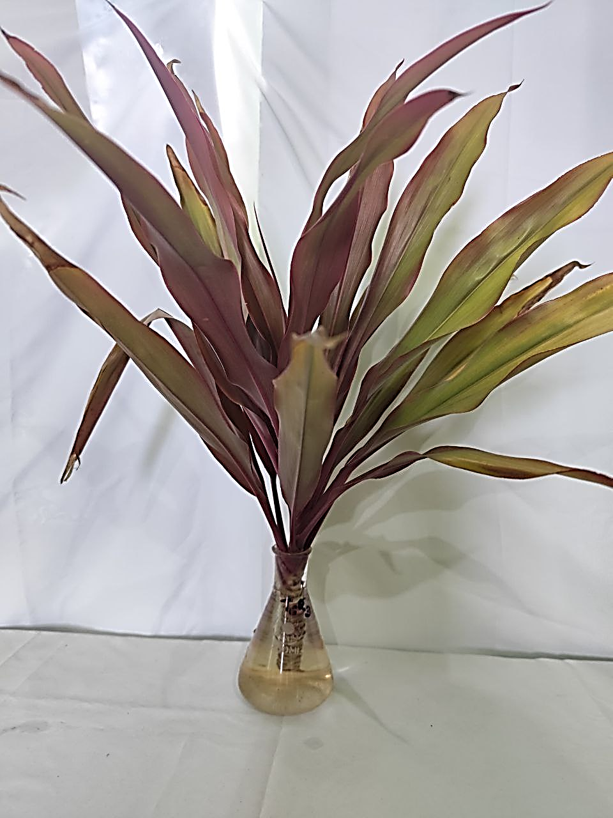

Fig. 6: Measurement of plant height and internode

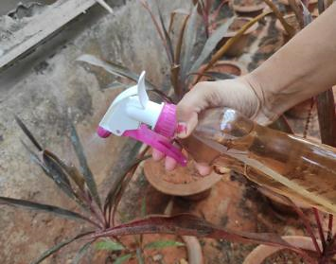
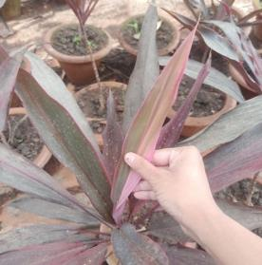
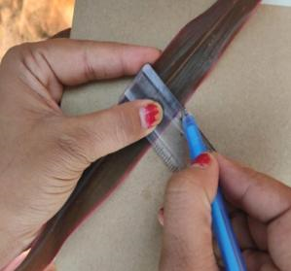
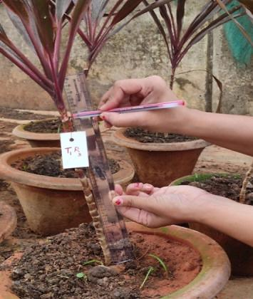
Fig. 8: Vase life study (0.2% Sucrose)
Fig. 3: Spraying at 30 Days Interval
Fig. 4: Measuring Leaf Breadth
Fig. 5: Plant grade & Colour Grade
Table 3: An overview of the bioenzymes to be used for studying growth and development in Cordyline terminalis
Sl. No. | Trade name | Chemical composition |  | Dosage | Manufactured  by | Uses
01. | VIPUL booster PGR 100 ml | Triacontanol (a.i.) 0.1% w/w (1000 ppm)  Emulsifier (Ethoxylated esters of fatty acids): 0.5% w/w  Preservatives: (Easters of Benzoic acid): 0.1% w/w  Demineralized aqua: Q.S  Total: 100.00% w/w |  | 500 ml/ha | Godrej  Agrovet Ltd. | - Triacontanol increases dry matter content, height of plant, plant spreading.  - Enhances the activity of naturally available enzymes & plant hormones.
02. | Biozyme crop + biostimulant 100 ml | Sea weed (Ascophyllum nodosum)  Fermented biomass@ 22.0 containing alginic acid 0.5% mi.  Aqueous diluents: QS,  Total: 100.00 |  | 625 to 750 ml/ha | Biostadt  India Ltd. | - Increases stress tolerance.  - Increases nutrient uptake.  - Improves plant growth.  - Increases root (See weed contains P) and shoot growth.
03. | Biozyme vegetable + plant growth stimulant 100 ml | Sea weed fermented biomass  Amino acids  Other (to make 100%)  Total | : 22%  : 4%  : 74%  : 100% | 500 ml/ha | Biostadt  India Ltd. | - Nutrient stabilizer.  - Enhances yield & crop quality.  - Provides diseases & pest resistance.
04. | Booster | Humic (15%) + Amino acid (2%) + Fulvic (6%) |  | 250 ml/acre | Mkao Agro  Chemical  Industries | - Humic acid liquid increases nutrient uptake.  - Improves aeration & water holding capacity.

 | R₁ |  |  | R₂ |  |  | R₃
T₁ | 
T₂
T₃
T₄
T₅
T₆
T₇
T₈
T₉
T₁₀
T₁₁
T₁₂
T₁₃

Fig. 9: Field plan and layout of experimental site
2.5 Statistical Analysis

The data were analyzed using ANOVA (Analysis of Variance) in a Completely Randomized Design (CRD) for in vivo work with 13 treatments and 3 replication each to study the effect of bioenzymes on growth & development. The treatment effects were tested by 'F' test at 5% level of significance. The appropriate standard error of mean S.E.(m) and the critical difference (CD) were calculated at 5% level of probability. The data have been depicted by suitable graphs and figures at appropriate places.

CD = SEd × t value at 5% at error degree of freedom

SEd =

Where,

SEd = Standard error of difference between two treatments means

EMS = Error mean of square

r = Number of replications

Standard error of mean

SE(m) ± =

T = Two-sided table value with error degree of freedom at 5% significance level

- RESULTS AND DISCUSSION
Cordyline terminalis was first field established for 30 days and after 30 DAP (days after planting) bioenzymes were sprayed in 13 treatments (Each treatment having 3 replications, per replication having 3 pots) i.e, 117 potted plants in 30 days interval and observations were recorded subsequently. The data presented in Table 4 and 6 shows the significant effect of various concentration of bioenzymes at various time interval on growth, yield and quality of Cordyline terminalis growing at in vivo condition after 60 DAP and 90 DAP using CRD statistical analysis. Apart from that, Chlorophyll content analysis and vase life study was also under taken.
3.1 Plant height (cm)
At 30 DAP, results were non-significant. However, the height of the plant was significantly increased due to bioenzyme treatments. Among the different bioenzymes tried, Booster @ 1.5 ml/l (T₁₁) was found to be most effective followed by Vipul booster @ 1.0 ml/l (T₈) and Biozyme vegetable plus @ 1.5 ml/l (T₁₀) (Fig. 11). Maximum height of 67.93 cm was obtained by spraying Booster @ 1.5 ml/l (containing fulvic acid and humic acid) followed by Vipul booster (containing Triacontanol w/w) @ 1.0 ml/l recording a height of 67.50 cm which was better over control (T₁) recording an average height of 59.17 cm after 90 DAP (Fig.10). The bioenzymes are biostimulants that are essential for carrying out a number of metabolic processes that have an impact on the vegetative growth of the plant. The use of bioenzymes in the current study may have induced metabolic activity in Cordyline plants, which may have improved physiological functions like photosynthesis. The plant height in treated plants may have risen above control plants (T₁) due to an increase in metabolic activity.
This present study validates the works of Ernst et al. (1987) in Scrophularia nodosa who investigated that application of fulvic acid and humic acid and combinations of FA and HA in the ratios 2:1, 1:1 and 1:2 stimulated plant growth. Pandita et al. (1991) studied that plant height of Okra was increased when Vipul (1.25 ppm) was sprayed twice in the rainy season. Satao (2000) recorded significantly more height with foliar application of triacontanol at 0.8 ml/1 concentration in Okra cv. Parbhani kranti. Zaghloul et al. (2009) stated that treating Thuja orientalis L. seedlings with potassium humate significantly increased plant height, stem diameter, root length, fresh and dry weights of shoots and roots. El-Khateeb et al. (2010) on Calia secundiflora plants indicated that 1% of humic or algifert, significantly increased plant height, fresh and dry weights, whereas algae gave the thickest stems. Similarly, Aziz et al. (2011) stated that application of seaweed extracts at 2.5 and 3.0 cm³/l and saline water at 1000 ppm had a favorable effect on vegetative growth, flowering and chemicals constituents of Amaranthus tricolor plants. The results obtained in present study are in similar line.
  - Leaf Characteristics (Leaf length (cm), Leaf breadth (cm), Leaf area (cm²), leaves number)
The result obtained in the present investigation indicates no significant difference between Booster @ 1.5 ml/l (T₁₁), Vipul booster @ 1.0 ml/l (T₈) and Biozyme vegetable plus @ 1.5 ml/l (T₁₀) as application of these bioenzymes at 90 DAP through foliar spray recorded an average leaf number of 10.73, 10.67 and 10.23 respectively indicating that all of these are equally effective in stimulating number of leaves in Cordyline terminalis. All the 12 treatments of bioenzymes significantly increased leaf number after 60 DAP and 90 DAP which was better over control (T₁) recording an average leaf number of 6.43 after 90 DAP(Fig. 12). The bioenzyme treatments significantly increased plant height than control. Evidently that might have resulted in increase in number of leaves than control (T₁). Photosynthetic activity occurs on the leaves. As a result, more leaves can synthesize more photosynthates, which can then be directed towards facilitating the development of more vegetative, reproductive growth and enhancing anthocyanin pigment concentration in Cordyline. These findings are corroborated by previous research with different biostimulants on plants and their influence on the development of better vegetative growth. Miniraj and Shanmgavelu (1987) reported significant increase in number of leaves with foliar spray of triacontanol in chilli. Mohammadipour et al. (2012) on Calendula officinalis observed that 2000 mg/l of humic acid increased dry weight, plant height, leaves and flowers number. Similarly, El-Bably (2017) on tuberose (Polianthes tuberosa), indicated that humic acid treatment significantly increased all growth parameters (leaf length, number of leaves and fresh weight).
For leaf area study, the result presented in previous chapter indicates that leaf area at 60 DAP significantly increased after 90 DAP in all the treatments (Table 4 and 6). Since the bioenzyme treatments significantly increased plant height and leaf number, hence it has also shown a level of significance in terms of leaf area (cm²). This study discloses that the maximum leaf area was seen in treatment sprayed with Biozyme vegetable plus @ 1.5 ml/l (T₁₀) with an area of 147.4 cm² and it was significantly different from rest treatments. All the treatments of bioenzymes were better over control (T₁) which recorded an average leaf area of 71.08 cm² (Fig. 14). Biozyme vegetable plus contains sea weed extract which has cytokinin and auxin precursors, macro and micronutrients that increase the cell division, cell enlargement with better utilization of chemical fertilizers resulting in leaf area expansion. It is also due to improved nutrient absorption capacity and increased photosynthetic activity of the plants.
This study is in similar line with works of Befrozfar et al. (2013) on Ocimum basilicum, who found that foliar spray of humic acid increased plant height and leaf area in comparison to control. Ali et al. (2015) on Tulipa gesneriana observed that humic acid treatment increased plant height, leaf area expansion and stem diameter. Abdel-Rahman et al. (2020) on Conocarpus erectus noted that treating tip cuttings of C. erectus with either coconut water for 1 hour or seaweed extract as drench enhanced the shoot growth parameters. Similarly, El-serafy et al. (2020) on Cordyline observed that foliar spray of oligo-chitosan increased growth rate, improved photosynthesis, increased leaf area and resulted in increased quality.

  - Internodal length(cm)
The results obtained in the present investigation indicated significant increase in internodal length due to application of bioenzymes than control. The internodal length after 90 DAP was more prominently increased in the treatment of Vipul booster @ 1.0 ml/l (T₈) with 6.20 cm which was significantly different than rest. All the bioenzyme treatments were better and significant over control (T₁) which recorded 4.53 cm (Fig. 15). Vipul booster contains triacontanol which boost plant height, plant spread, enhances nutrient uptake and thus increases internodal length and stem girth.
Similar type of result has been reported by earlier workers for the effect of bioenzymes.
El-khateeb et al. (2018) on Dracaena surculosa found that all treatments of some biostimulants, algae @ 5-10 g/l, fulvic acid @ 5-10 m/l and chitosan @ 0.5-1 g/l increased the plant height and spraying plants with low level of algae produced the tallest plants with thickest stems.
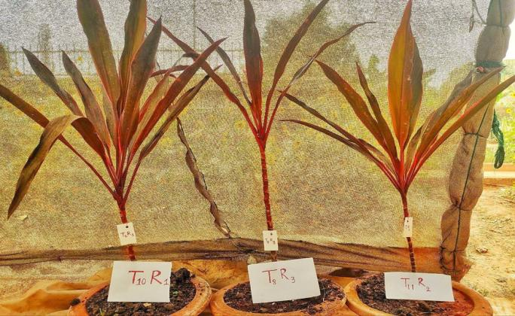

T₁₀R₁: Biozyme vegetable plus @ 1.5 ml/l
T₈R₃: Vipul booster @ 1.0 ml/l
T₁₁R₂: Booster @ 1.5 ml/l
Fig. 10: View of best resulted bioenzymes potted plants of Cordyline terminalis

Table 4: Effect of bioenzymes application on different parameters of Cordyline at 60 days after planting (DAP)
Treatment No. | Treatment details | Plant height  (cm) | Leaf number | Leaf length  (cm) | Leaf breadth  (cm) | Leaf area  (cm²) | Internodal length (cm)
T₁ | Control (No bioenzyme application) | 58.63c | 6.27d | 29.77bc | 2.20d | 65.63d | 4.20c
T₂ | Biozyme vegetable plus @ 0.5 ml/l | 61.10b | 7.93c | 31.56b | 2.68bc | 81.05c | 4.47cb
T₃ | Booster @ 0.5 ml/l | 61.13b | 8.13b | 31.59b | 2.44cd | 81.67c | 4.57b
T₄ | Biozyme crop + @ 0.5 ml/l | 61.40b | 8.40b | 31.61b | 2.57c | 82.31c | 4.40cb
T₅ | Vipul booster @ 0.5 ml/l | 61.87b | 8.00b | 30.73bc | 2.55c | 75.47cd | 4.39cb
T₆ | Biozyme vegetable plus @ 1.0 ml/l | 61.60b | 8.80b | 31.90b | 2.74bc | 88.33b | 4.67b
T₇ | Booster @ 1.0 ml/l | 61.90b | 9.00ab | 31.74b | 2.73bc | 86.40c | 5.00ab
T₈ | Vipul booster @ 1.0 ml/l | 64.63a | 9.67a | 34.13a | 3.05a | 109.25a | 5.53a
T₉ | Biozyme crop + @1.0 ml/l | 62.70b | 8.93 | 32.23b | 2.54c | 89.71b | 5.07ab
T₁₀ | Biozyme vegetable plus @ 1.5 ml/l | 63.73a | 9.50a | 34.10a | 3.10a | 107.41a | 5.43a
T₁₁ | Booster @ 1.5 ml/l | 64.19a | 9.87a | 34.27a | 3.13a | 111.15a | 5.20a
T₁₂ | Biozyme crop + @ 1.5 ml/l | 62.80b | 9.00ab | 33.00ab | 2.82b | 95.11b | 4.89b
T₁₃ | Vipul booster @ 1.5 ml/l | 63.47b | 9.23ab | 32.53b | 2.80b | 93.03b | 4.97b
SE(m) ± |  | 2.79 | 1.93 | 2.02 | 0.42 | 52.51 | 0.50
CD (5%) |  | 6.71 | 4.65 | 4.87 | 1.00 | 126.64 | 1.21

3.4 Plant grade and colour grade
Colour grade and plant grade parameters were also influenced by bioenzyme application. Light reddish green colour leaves with poor, unsaleable traits were observed visually in case of control (T₁), whereas application of different bioenzymes improved colour, saleable quality and visual appealing of Cordyline foliage giving luxurious growth in rest of the treatments (Table 5). Application of Triacontanol @1.0 ml/l in treatment T₈ also resulted in emergence of flower stalk measuring 16.5 cm with cup shaped sweet smelling pinkish white colour flower (Fig. 13)

3.5 Vase life (days)
The result pertaining to vase life studies of cut flower in distilled water indicated that maximum vase life was seen in foliage of the Cordyline plants sprayed with Booster @ 1.5 ml/l (T₁₁) with 23 days. It was followed by Biozyme vegetable plus @ 1.5 ml/l (T₁₀) with 22 days. The effect of bioenzymes on vase life was significantly increased in all treatments and was different. Minimum vase life was seen in control (T₁) with 13 days (Table 5).
The result obtained in the present investigation were in line with the works of Favero et al. (2011) who observed that Branches of C. terminalis ‘Green’ and ‘Red’ from control group, pulsed with GA₃, wax sprayed and the ones stored at 5, 10 and 13°C for 10 days had a vase life of 21 days and those kept at 5, 10 and 13°C for 20 days had a vase life of 14 days. It was concluded that C. terminalis ‘Green’ and ‘Red’ can be cold stored from 5 to 13°C without any damage up to 10 days. GA₃ or wax spray does not improve vase life of both cultivars. Similarly, Gaurav et al. (2015) observed that higher vase life was obtained at 35% and 50% shade level due to better chlorophyll content, fresh weight, photosynthesis rate and lower transpiration rate.

3.6 Chlorophyll content
Chlorophyll content of leaf was estimated with help of spectrophotometer after 90 DAP. Maximum Chlorophyll content (3.08 mg/g leaf) was recorded in T₁₁ which was at par with T₁₀ (3.08 mg/g leaf) significantly (Table 5).

Table 5: Effect of bioenzymes on quality parameters in Cordyline terminalis
Treatment No. | Treatment details | Vase life (days) | Plant grade | Colour grade | Chlorophyll content (mg/g leaf)
T₁ | Control (No bioenzyme application) | 13.00c | Poor, unsalable | Light reddish green | 2.08d
T₂ | Biozyme vegetable plus @ 0.5 ml/l | 17.00b | Moderate, saleable | Medium reddish green | 2.16cd
T₃ | Booster @ 0.5 ml/l | 17.00b | Moderate, saleable | Medium reddish green | 2.20cd
T₄ | Biozyme crop + @ 0.5 ml/l | 16.00bc | Poor, unsaleable | Light reddish green | 2.19cd
T₅ | Vipul booster @ 0.5 ml/l | 17.00b | Moderate, saleable | Medium reddish green | 2.61c
T₆ | Biozyme vegetable plus @ 1.0 ml/l | 19.00b | Good, saleable | Medium reddish green | 2.18cd
T₇ | Booster @ 1.0 ml/l | 19.00b | Moderate, saleable | Medium reddish green | 2.72b
T₈ | Vipul booster @ 1.0 ml/l | 18.00b | Good, saleable | Medium reddish green | 2.90ab
T₉ | Biozyme crop + @ 1.0 ml/l | 19.00b | Good, saleable | Medium reddish green | 2.63cd
T₁₀ | Biozyme vegetable plus @ 1.5 ml/l | 22.00a | Good, saleable | Dark greenish red | 3.01a
T₁₁ | Booster @ 1.5 ml/l | 23.00a | Excellent, saleable | Dark greenish red | 3.08a
T₁₂ | Biozyme crop + @ 1.5 ml/l | 20.00ab | Good, saleable | Medium reddish green | 2.88ab
T₁₃ | Vipul booster @ 1.5 ml/l | 19.00b | Moderate, saleable | Medium reddish green | 2.74b

Table 6: Effect of Bioenzymes application on different parameters of Cordyline at 90 days after planting (DAP)
Treatment No. | Treatment details | Plant height  (cm) | Leaf number | Leaf length  (cm) | Leaf breadth (cm) | Leaf area  (cm²) | Internodal length (cm)
T₁ | Control (No bioenzyme application) | 59.17cd | 6.43d | 30.27c | 2.33b | 71.08c | 4.53c
T₂ | Biozyme vegetable plus @ 0.5 ml/l | 62.27ab | 8.27c | 32.32b | 2.78b | 90.32b | 4.90c
T₃ | Booster @ 0.5 ml/l | 62.07c | 8.80c | 32.28b | 2.50b | 89.56b | 4.97c
T₄ | Biozyme crop + @ 0.5 ml/l | 61.93c | 8.73c | 32.00b | 2.70b | 88.21b | 4.73c
T₅ | Vipul booster @ 0.5 ml/l | 63.27b | 8.33c | 31.40c | 2.71b | 79.61c | 4.62c
T₆ | Biozyme vegetable plus @ 1.0 ml/l | 63.27b | 8.80c | 32.60b | 2.77b | 93.04b | 5.00b
T₇ | Booster @ 1.0 ml/l | 63.07b | 9.33b | 32.14b | 2.79b | 91.18b | 5.17b
T₈ | Vipul booster @ 1.0 ml/l | 67.50a | 10.67a | 36.20a | 3.67a | 140.4a | 6.20a
T₉ | Biozyme crop + @ 1.0 ml/l | 63.96b | 9.27b | 32.27b | 2.73b | 90.99b | 5.40b
T₁₀ | Biozyme vegetable plus @ 1.5 ml/l | 67.33a | 10.23a | 37.87a | 3.70a | 147.4a | 5.90a
T₁₁ | Booster @ 1.5 ml/l | 67.93a | 10.73a | 37.20a | 3.50a | 136.57a | 5.63a
T₁₂ | Biozyme crop + @ 1.5 ml/l | 64.27b | 9.00b | 33.60b | 2.82b | 97.27b | 5.22b
T₁₃ | Vipul booster @ 1.5 ml/l | 63.73b | 9.67b | 34.13b | 2.84b | 99.96b | 5.10b
SE(m) ± |  | 2.12 | 1.73 | 2.81 | 0.54 | 27.11 | 0.38
CD (5%) |  | 5.11 | 4.17 | 6.77 | 1.32 | 65.37 | 0.91

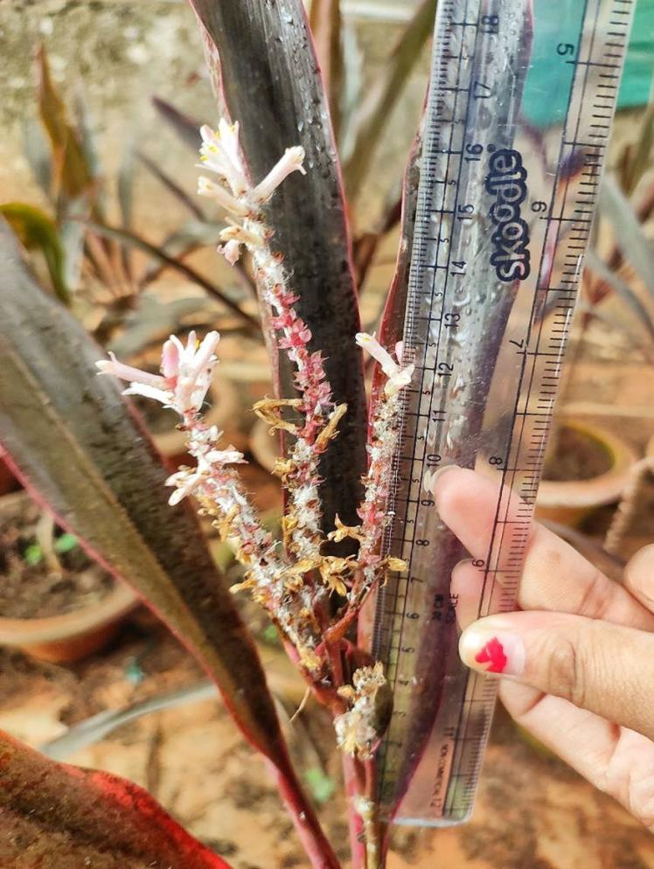

Fig. 13: Flower stalk measuring of about 16.5 cm in treatment T₈ (Vipul booster @ 1.0 ml/l) with cup shaped sweet smelling pinkish white colour flower

- CONCLUSION

Cordyline is an excellent ornamental plant with colored foliage and has wide landscaping utility. Also, to restore environmental degradation and limit the use of chemical fertilizer, study of bioenzymes is essential as they improve growth and development, quality parameters and vase life of foliage crops. Bioenzymes application in 13 treatments were done in separate 117 potted plants out of which Booster @ 1.5 mg/l (T₁₁), Biozyme vegetable plus @ 1.5 mg/l (T₁₀) and Vipul booster @ 1.0 mg/l (T₈) performed well over rest in terms of vegetative growth characters like plant height, leaf number, leaf length, leaf breath, leaf area, internodal length and quality attributes like Chlorophyll content, plant grade, colour grade and vase life for cut foliage in Cordyline terminalis.

The natural compounds in Bio enzymes like Fulvic acid, humic acid, sea weed extract, amino acids and triacontanol helped in enhancing both quantitative and qualitative parameters. This was seen in T₁₀ (Biozyme vegetable plus @ 1.5 ml/l) and T₁₁ (Booster @ 1.5 ml/l) where vase life & freshness of cut foliage was reported till 22 and 23 days respectively, along with increase in chlorophyll content than rest treatments concluding that sea weed biomass formulation and triacontanol helped in enhancing overall quantitative and qualitative attribute in Cordyline. It was also observed that application of Triacontanol i.e, Vipul booster @ 1.0 ml/l resulting in emergence of flower stalk with pinkish-white sweet smelling cup shaped flower showing that bioenzyme has stimulative effect on both vegetative and reproductive phase. Findings of this study will be positive, paving the way for large-scale plantlet production in the future. It will benefit hi-tech farmers and entice entrepreneurs for commercialization. It will also shift the present use of chemical fertilizers towards organic fertilizers through application of bioenzymes and will restore environmental, soil and plant health.

DISCLAIMER (ARTIFICIAL INTELLIGENCE)

Author(s) hereby declares that NO generative AI technologies such as Large Language Models (ChatGPT, COPILOT, etc.) and text-to-image generators have been used during the writing or editing of this manuscript.

COMPETING INTERESTS

Authors have declared that no competing interest exists.

REFERENCES
Abdel-Rahman, S. S. (2020). Influence of rooting media and indole-3-butyric acid (IBA) concentration on rooting and growth of different types of Conocarpus erectus L. stem cuttings. Scientific Journal of Flowers and Ornamental Plants, 7(3), 199-219.
Adanson M. 1763. Familles des plantes par M. Adanson, chez Vincent, 2: 9-54.
Ali A, Rehman SU, Raza S and Allah SU. 2014. Combined effect of humic acid and NPK on growth and flower development of Tulipa Gesneriana in Faisalabad, Pakistan, Journal of Ornamental Plants, 4(4): 39-48.
Aziz NGA, Mahgoub MH and Siam HS. 2011. Growth, flowering and chemical constituents performence of Amaranthus tricolor plants as influenced by seaweed (Ascophyllum nodosum) extract application under salt stress conditions, Journal of Applied Sciences Research, 1472-1484.
Bailey LH. 1910. Cyclopedia of American Agriculture: Farms (Vol. 1). Macmillan.
Bentham G and Hooker JD: General Plantarum, Vol. III, London (1883).
Beura S, Samal P and Jagadev PN. 2007. Preliminary studies of in vitro cloning of Draceana sanderiana Acta Hort., 760: 241-245.
Befrozfar MR, Habibi D, Asgharzadeh A, Sadeghi-Shoae M and Tookallo MR. 2013. Vermicompost, plant growth promoting bacteria and humic acid can affect the growth and essence of basil (Ocimum basilicum L.), Ann Biol Res, 4(2): 8-12.
Commerson, in de Junica, AL: Genera plantarum, p.41. Paris. 1789.
Ernst WHO, Kraak MHS and Stoots L. 1987. Growth and mineral nutrition of Scrophularia nodosa with various combinations of fulvic and humic acids, Journal of plant physiology, 127(1-2): 171-175.
El-Bably SMZ. 2017. Effect of some Natural Material Additives on Growth and Flowering of Tuberose (Polianthes tuberosa, L.) Bulbs. J. Plant Production, Mansoura Univ., 8(9):895 -906.
El-Khateeb MA, Nasr AA, Fahmy AN and Dorgham AHH. 2010. Effect of GA₃ and growth biostimulants on growth and chemical composition of Califia secundiflora plants, Journal of Horticultural Science & Ornamental Plants, 2(2): 118-124.
El-Khateeb MA, Nasr AAM and Hassan NAA. 2018. Growth and quality improvement of Dracaena surculosa, Lindl by the foliar application of some biostimulants. International Journal of Environment, 7(2): 53-64.
El-Serafy, R. S. (2020). Phenotypic plasticity, biomass allocation, and biochemical analysis of cordyline seedlings in response to oligo-chitosan foliar spray. Journal of Soil Science and Plant Nutrition, 20(3), 1503-1514.
Gaurav AK, Raju DVS, Janakiram BS, Jain RI and Krishnan SG. 2015. Effect of shade levels on production and quality of cordyline (Cordyline terminalis). Indian Journal of Agricultural Sciences, 85(7): 1-5.
Hutchinson J. 1959. The families of flowering plants, Vol. II, Monocotyledons, The families of flowering plants, Vol. II, Monocotyledons, (2nd Ed).
Kemp EB and Robb FD. 1962. Cordyline terminalis, Quarterly Journal of Crude Drug Research, 2(4): 299-307.
Kunicki E, Grabowska A, Sękara A and Wojciechowska R. 2010. The effect of cultivar type, time of cultivation and biostimulant treatment on the yield of spinach (L.). Folia Horticulturae, 22(2): 9-13.
Melchior H. 1964. A. Engler's Syllabus der Pflanzenfamilien , Angiospermen., 2: 666.
Minraj N and Shanmugavelu KG. 1987. Studies on the effect of triacontanol on growth, flowering, yield, quality and nutrient uptake in chillies (Capsicum annuum L.), S. Indian Hort., 35(4): 362-366.
Mohammadipour E, Golchin A, Mohammadi J, Negahdar N and Zarchini M. 2012. Effect of humic acid on yield and quality of marigold (Calendula officinalis L.). Annals of Biological Research, 3(11): 5095-5098.
Pandita MLN, Sharnia K and Arora SK. 1991. Effect of Miixtalol and Vipul on growth, flowering and yield of okra (Abelmoschus esculentus L. Moench). Veg. Sci, 18(1): 32-40.
Pal AK. 2006. Ornamental plants with attractive foliages, Advances in ornamental horticulture, Pointer publishers, India, 2: 273-343.
Ray T, Saha P and Roy SC. 2006. Commercial production of Cordyline terminalis (L) Kunth. from shoot apex meristem and assessment for genetic stability of soma clones by isozyme markers, Scientia horticulturae, 108(3): 289-294.
Randhawa GS and Mukhopadhyay A. 2004. Floriculture in India, Allied publishers Pvt Limited, pp. 258-259.
Satao PJ. 2000. Effect of Aminocel and bioenzyme on growth flowering and yield of okra. M.Sc. Thesis submitted to Dep. of Hort. M. A. U., Parbhani
Traon D, Amat L, Zotz F and du Jardin P. 2014. A Legal Framework for Plant Biostimulants and Agronomic Fertilizer Additives in the EU-Report to the European Commission, DG Enterprise & Industry.
Yakhin OI, Lubyanov AA, Yakhin IA and Brown PH. 2017. Biostimulants in plant science: a global perspective, Frontiers in plant science, 7: 2049.
Zaghloul SM, El-Quesni FEM and Mazhar AAM. 2009. Influence of potassium humate on growth and chemical constituents of Thuja orientalis L. seedlings, Ozean Journal of Applied Sciences, 2(1): 73-78.

