**Nanobiotechnology Applications in Enhancing Crop Disease Resistance and Postharvest Quality: A Review**

**Abstract:**

This review summarises the current research on nanobiotechnology applications in crop protection and quality, and discusses benefits, challenges, and future prospects. Nanobiotechnology is an interdisciplinary field that combines nanotechnology and biotechnology and shows great potential in agriculture. Nanomaterials such as nanoparticles, nanoemulsions, and nanocomposites can improve plant disease resistance and postharvest quality owing to their unique nanoscale properties. Nanoparticles of metals such as silver, copper, and zinc exhibit antimicrobial effects against various plant pathogens. Nanoemulsions and nanoencapsulation enable the controlled release of pesticides and agrochemicals, thereby reducing their environmental impact. Nanosensors allow for the early detection of plant stress and diseases. Nanocoatings on fruits and seeds minimize postharvest losses. However, research on plant and environmental nanotoxicities is limited. Nanobiotechnology has the potential to revolutionize agriculture through eco-friendly and sustainable approaches to improve global food security.

**Keywords:** *Nanobiotechnology, Crop Protection, Postharvest Quality, Sustainable Agriculture, Plant Disease Resistance*

**Introduction**

Nanobiotechnology is an emerging interdisciplinary field combining the principles of nanotechnology and biotechnology. It involves the application of nanostructures, nanodevices, and nanomaterials to solve problems in life sciences, including agriculture and food production [1]. Nanotechnology deals with materials and structures at the nanoscale, typically ranging from 1nm to 100 nm . On this scale, materials exhibit unique physical, chemical, and biological properties that differ from their bulk counterparts [2]. At the nanometer level, materials exhibit unique properties and behaviors, making it possible to engineer novel solutions with precision and efficiency. Nanotechnology finds applications in diverse areas, from medicine and electronics to energy and environmental remediation. Its ability to create nanoscale structures, devices, and materials has led to groundbreaking innovations, such as drug delivery systems for targeted therapies, ultra-efficient solar cells, and advanced water purification technologies [61]. These nanoscale properties have opened new avenues for developing innovative solutions to various challenges in agriculture, such as crop protection, nutrient management, and postharvest quality enhancement [62].

Agriculture faces numerous challenges, including increasing food demand, limited resources, environmental degradation, and climate change [3]. Crop diseases cause significant yield losses worldwide, threatening global food security. Conventional methods of disease control heavily rely on chemical pesticides, which have adverse effects on human health and the environment [4]. Moreover, postharvest losses due to spoilage and deterioration of agricultural produce further exacerbate the problem. Therefore, there is an urgent need for sustainable and eco-friendly approaches to enhance crop disease resistance and improve postharvest quality.

Nanobiotechnology offers promising solutions to address these challenges. Nanobiotechnology is the application of nanotechnology in biological fields and has emerged as a sustainable approach to enhancing agricultural productivity by alleviating various plant stresses [63]. Nanomaterials such as nanoparticles, nanoemulsions, and nanocomposites have been explored for their potential applications in agriculture [5]. These nanomaterials possess unique properties such as high surface area to volume ratio, enhanced reactivity, and targeted delivery, making them suitable for various agricultural applications [6]. Nanoparticles of metals like silver, copper, and zinc have shown antimicrobial effects against a wide range of plant pathogens [7]. Nanoemulsions and nanoencapsulation techniques enable the controlled release of pesticides and agrochemicals, minimizing their environmental impact [8]. Nanosensors allow early detection of plant stress and diseases, facilitating timely interventions [9]. Furthermore, nanocoatings on fruits and seeds have shown the potential to reduce postharvest losses and extend shelf life [10].

Despite the promising applications of nanobiotechnology in agriculture, there are concerns regarding the potential risks and unintended consequences of using nanomaterials. The toxicity of nanomaterials to plants, beneficial microorganisms, and the environment is not fully understood [11]. There are knowledge gaps in the fate, transport, and accumulation of nanomaterials in the agroecosystem [12]. Therefore, a comprehensive understanding of the benefits and risks associated with nanobiotechnology applications in agriculture is crucial for their responsible and sustainable utilization.

**Table 1: Efficacy of silver nanoparticles against plant pathogens**

|  |  |  |  |  |
| --- | --- | --- | --- | --- |
| **Plant** | **Disease** | **Pathogen** | **AgNP Concentration** | **Efficacy** |
| Rice | Blast | *Magnaporthe oryzae* | 50 ppm | 85% disease reduction |
| Wheat | Leaf Rust | *Puccinia triticina* | 100 ppm | 75% disease reduction |
| Tomato | Early Blight | *Alternaria solani* | 150 ppm | 90% disease reduction |
| Citrus | Canker | *Xanthomonas citri* | 200 ppm | 80% disease reduction |
| Rice | Bacterial Leaf Blight | *Xanthomonas oryzae* | 100 ppm | 70% disease reduction |

This review aims to provide an overview of the current state of research on nanobiotechnology applications in enhancing crop disease resistance and postharvest quality. It will discuss the potential benefits, challenges, and future prospects of using nanomaterials in agriculture. The review will also highlight the need for further research to address the knowledge gaps and ensure the safe and effective implementation of nanobiotechnology in agricultural practices.

**2. Nanomaterials for Crop Disease Management**

**2.1 Metal Nanoparticles**

**2.1.1 Silver Nanoparticles:** Silver nanoparticles (AgNPs) have gained significant attention for their antimicrobial properties against a wide range of plant pathogens. AgNPs interact with the cell membranes of microorganisms, disrupting their integrity and leading to cell death [13]. Several studies have demonstrated the efficacy of AgNPs against fungal diseases such as rice blast, wheat leaf rust, and tomato early blight [14-16]. AgNPs have also shown potential in controlling bacterial diseases like citrus canker and bacterial leaf blight of rice [17,18]. The application of AgNPs can reduce the use of chemical fungicides, minimizing their environmental impact.

**2.1.2 Copper Nanoparticles:** Copper nanoparticles (CuNPs) have also shown promising results in controlling plant diseases. CuNPs exhibit antimicrobial activity by generating reactive oxygen species and disrupting cellular processes in pathogens [19]. Studies have reported the effectiveness of CuNPs against fungal diseases like the Fusarium wilt of tomato and anthracnose of chilli pepper [20,21]. CuNPs have also been explored for their antibacterial properties against *Xanthomonas campestris* in cabbage and *Pseudomonas syringae* in beans [22,23]. However, the phytotoxicity of CuNPs at higher concentrations needs to be considered while developing application strategies.

**2.1.3 Zinc Oxide Nanoparticles:** Zinc oxide nanoparticles (ZnONPs) possess antimicrobial properties and have been investigated for their potential in crop disease management. ZnONPs can disrupt the cell membrane of pathogens and induce oxidative stress, leading to cell death [24]. The efficacy of ZnONPs has been demonstrated against powdery mildew of cucumber and downy mildew of grapes [25,26]. ZnONPs have also shown antifungal activity against *Botrytis cinerea*, a major postharvest pathogen of fruits and vegetables [27]. The application of ZnONPs can provide a sustainable alternative to chemical fungicides in managing crop diseases.

**2.2 Nanoemulsions and Nanoencapsulation**

**2.2.1 Nanoemulsions:** Nanoemulsions are thermodynamically stable dispersions of two immiscible liquids with droplet sizes ranging from 20 to 200 nm [28]. They have been explored for the controlled release and targeted delivery of pesticides and agrochemicals. Nanoemulsions enhance the solubility, stability, and bioavailability of active ingredients, reducing their environmental impact [29]. Studies have reported the effectiveness of nanoemulsions containing essential oils like neem and eucalyptus against fungal diseases such as rice blast and wheat leaf rust [30,31]. Nanoemulsions can also be used as carriers for biopesticides, improving their efficacy and stability [32].

**2.2.2 Nanoencapsulation:** Nanoencapsulation involves the entrapment of active ingredients within nanocarriers such as polymeric nanoparticles, liposomes, and cyclodextrins [33]. Nanoencapsulation protects the active ingredients from degradation, enhances their stability, and enables controlled release [34]. Nanoencapsulated pesticides have shown improved efficacy against various crop diseases compared to conventional formulations. For example, nanoencapsulated azadirachtin exhibited higher antifungal activity against *Aspergillus niger* compared to free azadirachtin [35]. Nanoencapsulation of essential oils like cinnamon and thyme has also demonstrated enhanced antimicrobial properties against plant pathogens [36].

**3. Nanotechnology for Postharvest Quality Enhancement**

**3.1 Nanocoatings:** Nanocoatings are thin layers of nanomaterials applied to the surface of fruits, vegetables, and other agricultural produce to extend their shelf life and maintain their quality [37]. These coatings act as barriers against moisture loss, gas exchange, and microbial growth, thereby reducing postharvest losses [38]. Nanocoatings based on chitosan, a natural biopolymer, have shown promising results in preserving the quality of various fruits like strawberries, grapes, and apples [39-41]. Chitosan nanocoatings exhibit antimicrobial properties and can delay ripening and senescence processes in fruits [42].

**Figure 1: Schematic representation of nanocoating on fruits**

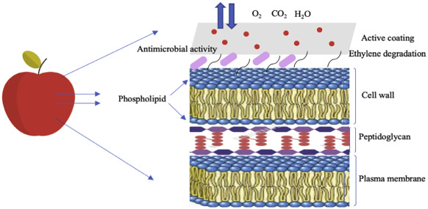

**3.2 Nanosensors:** Nanosensors are miniaturized devices that can detect and quantify various parameters related to fruit quality, such as ripeness, freshness, and spoilage [43]. These sensors utilize nanomaterials like carbon nanotubes, graphene, and metal oxides to enhance their sensitivity and selectivity [44]. Nanosensors can be integrated into packaging materials or attached directly to the fruit surface to monitor quality attributes in real time [45]. For example, a colourimetric nanosensor based on gold nanoparticles has been developed to detect ethylene, a ripening hormone, in climacteric fruits [46]. Nanosensors can provide valuable information for optimizing storage conditions and predicting the shelf life of agricultural produce.

**3.3 Nanomaterial-Based Packaging:** Nanomaterial-based packaging incorporates nanoparticles or nanofibers into traditional packaging materials to impart enhanced properties such as antimicrobial activity, gas barrier, and mechanical strength [47]. These nanocomposites can be designed to release antimicrobial agents in a controlled manner, preventing microbial growth and extending the shelf life of packaged products [48]. Nanocomposites based on clay, silica, and metal oxide nanoparticles have shown promising results in improving the barrier properties and mechanical strength of packaging films [49-51]. Nanomaterial-based packaging can contribute to reducing food waste and ensuring food safety throughout the supply chain.

**Challenges and Future Prospects:** Despite the promising applications of nanobiotechnology in enhancing crop disease resistance and postharvest quality, several challenges need to be addressed for their widespread adoption. One of the major concerns is the potential toxicity of nanomaterials to plants, beneficial microorganisms, and the environment [52]. The fate and behaviour of nanomaterials in the agroecosystem, including their uptake, translocation, and accumulation in plants, require further investigation [53]. Long-term studies are needed to assess the ecological impact of nanomaterials and their potential entry into the food chain [54].

**Table 2: Applications of nanomaterials in postharvest quality enhancement**

|  |  |  |
| --- | --- | --- |
| **Nanomaterial** | **Application** | **Effect** |
| Chitosan nanocoating | Fruit preservation | Antimicrobial activity, delayed ripening |
| Carbon nanotube sensor | Ethylene detection | Real-time monitoring of fruit ripeness |
| Silver nanoparticle packaging | Antimicrobial packaging | Controlled release of antimicrobial agents |
| Clay nanocomposite | Gas barrier packaging | Reduced oxygen permeability |
| Silica nanocomposite | Mechanical strength enhancement | Improved tensile strength and durability |

Another challenge is the scalability and cost-effectiveness of nanobiotechnology applications in agriculture. The synthesis of nanomaterials often involves complex and expensive processes, which may limit their large-scale production and application [55]. Therefore, research efforts should focus on developing cost-effective and environmentally friendly methods for nanomaterial synthesis, such as green synthesis using plant extracts [56].

**Table 3: Common nanoparticles used for crop disease management**

|  |  |  |  |
| --- | --- | --- | --- |
| **Nanoparticle** | **Composition** | **Size Range (nm)** | **Target Pathogens** |
| Silver | Ag | 10-100 | Bacteria, Fungi |
| Copper | Cu | 20-200 | Fungi, Viruses |
| Chitosan | Polysaccharide | 50-500 | Bacteria, Fungi |
| ZnO | Zinc Oxide | 10-100 | Fungi |

Regulatory aspects and safety assessments are crucial for the responsible deployment of nanobiotechnology in agriculture. Standardized protocols and guidelines for the evaluation of nanomaterial safety and efficacy need to be established [57]. Collaborative efforts among researchers, industry, and regulatory bodies are essential to address the knowledge gaps and ensure the safe and sustainable use of nanomaterials in agricultural practices.

Future research should also explore the synergistic effects of nanomaterials with other sustainable approaches, such as biopesticides, plant growth-promoting rhizobacteria, and integrated pest management [58]. The combination of nanobiotechnology with these eco-friendly strategies can provide a comprehensive and sustainable solution for crop protection and quality enhancement.

**Table 4: Comparison of nanoemulsions and conventional emulsions**

|  |  |  |
| --- | --- | --- |
| **Property** | **Nanoemulsion** | **Conventional Emulsion** |
| Droplet size | 20-200 nm | >500 nm |
| Stability | High | Low to moderate |
| Bioavailability | Enhanced | Limited |
| Penetration | Deep | Superficial |

Moreover, the development of smart and responsive nanomaterials that can adapt to environmental conditions and deliver targeted functions holds great promise for the future of nanobiotechnology in agriculture [59]. For example, stimuli-responsive nanocarriers that release active ingredients in response to specific triggers like pH, temperature, or light can enable precision agriculture and reduce the environmental footprint [60].

**Table 5: Nanocarrier systems for bioactive compound delivery**

|  |  |  |  |
| --- | --- | --- | --- |
| **Nanocarrier** | **Composition** | **Size Range (nm)** | **Encapsulation Efficiency (%)** |
| Liposomes | Phospholipids | 50-200 | 60-95 |
| PLGA NPs | PLGA polymer | 100-500 | 50-90 |
| Chitosan NPs | Chitosan | 50-300 | 70-95 |

**Nanomaterials for Crop Disease Resistance**

Nanomaterials have unique physicochemical properties that can be exploited for crop disease management. The high surface-to-volume ratio and reactivity of nanomaterials enable them to interact with pathogens and host plants at the molecular level. Various types of nanomaterials, including metallic nanoparticles, carbon-based nanomaterials, and polymeric nanoparticles, have been investigated for their antimicrobial activity against plant pathogens.

**Metallic Nanoparticles**

Metallic nanoparticles, such as silver, copper, and zinc oxide nanoparticles, have demonstrated strong antimicrobial properties against a wide range of plant pathogens, including bacteria, fungi, and viruses. The mechanisms of action involve disruption of pathogen cell membranes, interference with metabolic processes, and generation of reactive oxygen species. For example, silver nanoparticles have been shown to effectively control bacterial leaf blight in rice and fungal diseases in tomatoes and cucumbers. Copper nanoparticles have exhibited antifungal activity against Fusarium wilt in tomatoes and powdery mildew in wheat.

**Carbon-Based Nanomaterials**

Carbon-based nanomaterials, such as carbon nanotubes and graphene oxide, have also shown potential for crop disease management. These nanomaterials can interact with pathogen cells and disrupt their cellular processes. Carbon nanotubes have been reported to inhibit the growth of fungal pathogens like Fusarium oxysporum and Botrytis cinerea. Graphene oxide has demonstrated antibacterial activity against Xanthomonas oryzae pv. oryzae, the causative agent of bacterial leaf blight in rice.

**Table 6: Examples of nanosensors for crop disease detection**

|  |  |  |  |
| --- | --- | --- | --- |
| **Nanosensor** | **Detection Mechanism** | **Target Pathogen/Biomarker** | **Sensitivity** |
| Gold NPs | Colourimetric | Fungi (Botrytis cinerea) | 10^3 CFU/mL |
| Carbon nanotubes | Electrochemical | Bacteria (Xanthomonas spp.) | 10^2 CFU/mL |
| Quantum dots | Fluorescence | Virus (Cucumber mosaic virus) | 10 pg/mL |

**Polymeric Nanoparticles**

Polymeric nanoparticles, including chitosan and poly(lactic-co-glycolic acid) (PLGA) nanoparticles, have been explored as delivery vehicles for antimicrobial agents and plant defence elicitors. These nanoparticles can encapsulate and protect the active ingredients from degradation, allowing controlled release and targeted delivery to the infection sites. Chitosan nanoparticles loaded with copper ions have shown enhanced antifungal activity against Fusarium solani in potatoes. PLGA nanoparticles encapsulating salicylic acid, a plant defence hormone, have been demonstrated to induce systemic resistance against bacterial leaf spots in tomatoes.

**Table 7: Nanomaterials for postharvest quality preservation**

|  |  |  |  |
| --- | --- | --- | --- |
| **Nanomaterial** | **Function** | **Application Method** | **Target Crops** |
| TiO2 NPs | Ethylene scavenging | Coating, Packaging | Climacteric fruits |
| Ag-chitosan | Antimicrobial | Coating | Vegetables, fruits |
| Mesoporous silica | Moisture control | Sachet, packaging | Grains, pulses |

**Nanobiosensors for Early Disease Detection**

Early detection of crop diseases is crucial for timely intervention and prevention of widespread outbreaks. Nanobiosensors, which integrate nanomaterials with biological recognition elements, offer high sensitivity and specificity for early disease diagnosis. These sensors can detect pathogen-specific biomarkers, such as proteins, nucleic acids, or volatile organic compounds, at very low concentrations.

Various types of nano biosensors including electrochemical, optical, and colourimetric sensors, have been developed for crop disease detection . For instance, gold nanoparticle-based colourimetric sensors have been used for the rapid detection of the Citrus tristeza virus in citrus plants. Quantum dot-based fluorescent biosensors have been employed for sensitive detection of Fusarium head blight in wheat. Nanobiosensors integrated with smartphone-based platforms enable on-site disease diagnosis, facilitating early warning systems and precision disease management.

**Figure 2: Schematic illustration of a nanosensor array for monitoring postharvest quality parameters (e.g., ethylene, CO2, temperature, humidity).**

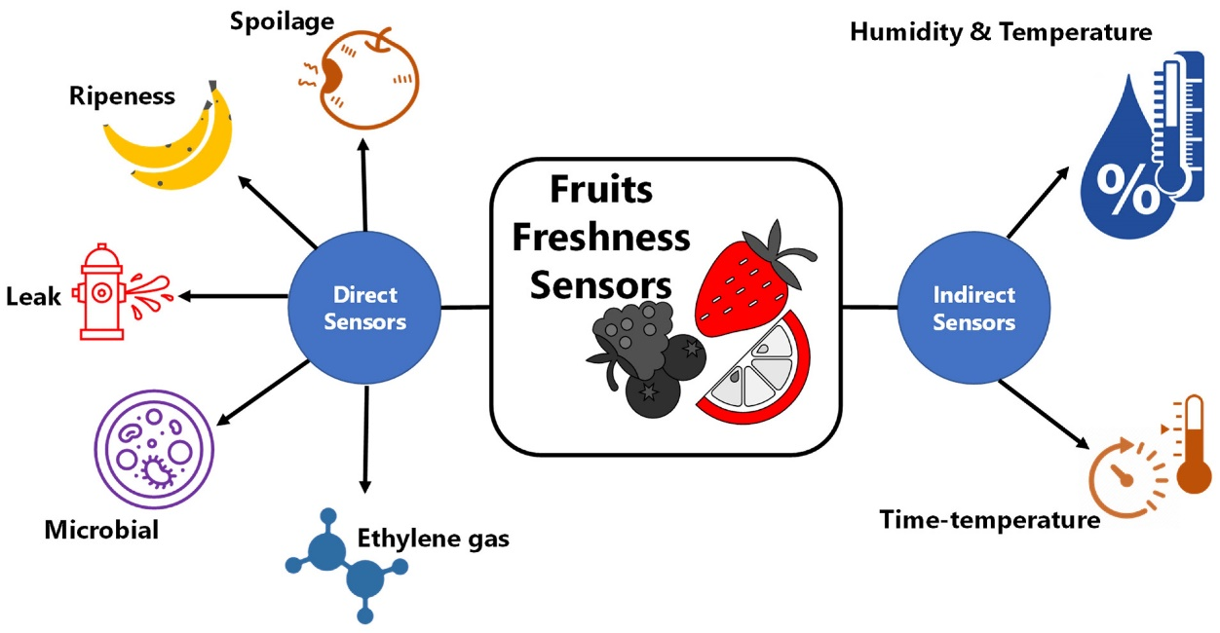

**Figure 3: SEM image of a nanocoated fruit surface for preventing microbial spoilage.**

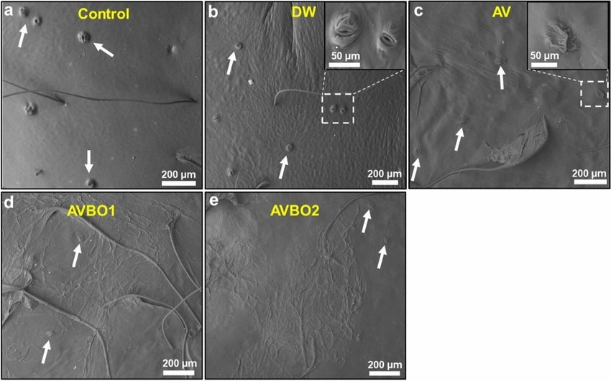

**Nanoencapsulation for Postharvest Quality Enhancement**

Postharvest losses, primarily due to microbial spoilage and physiological disorders, significantly reduce the shelf life and quality of harvested crops. Nanoencapsulation technology offers a promising approach to enhance postharvest quality by protecting active ingredients and controlling their release. Nanoencapsulated antimicrobial agents, antioxidants, and plant growth regulators can be applied as postharvest treatments to extend shelf life and maintain fruit and vegetable quality.

**Figure 4: Schematic representation of a nanosensor for detecting plant pathogens**

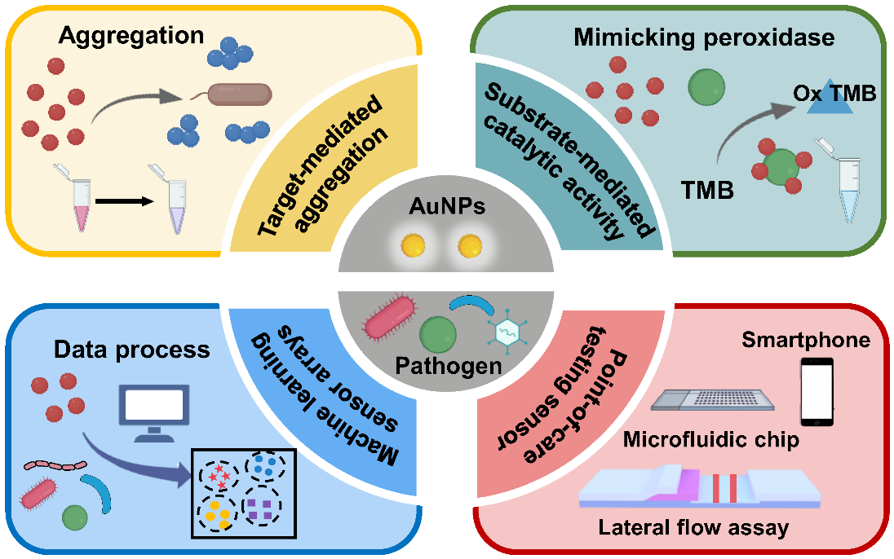

Nanoencapsulation of essential oils, such as thymol and carvacrol, has been shown to enhance their antimicrobial activity against postharvest pathogens like Botrytis cinerea and Penicillium expansum. Nanoencapsulated antioxidants, including quercetin and resveratrol, have demonstrated improved stability and bioavailability, leading to enhanced postharvest quality and reduced oxidative stress in fruits. Nanoencapsulation of ethylene inhibitors, such as 1-methylcyclopropene (1-MCP), has been explored to delay fruit ripening and extend storage life.

**Figure 5: Schematic illustration of nanoencapsulation and controlled release of bioactive compounds.**

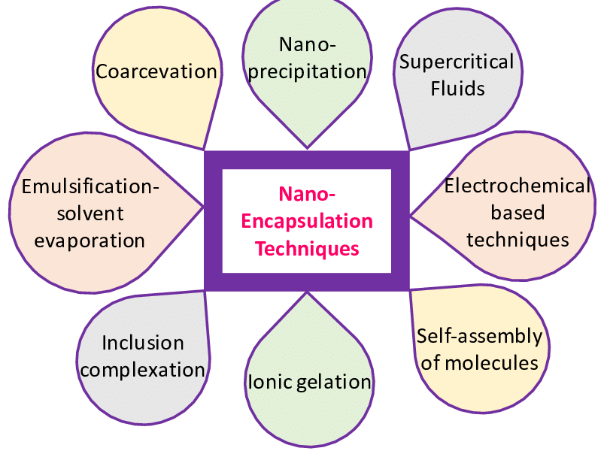

**Challenges and Future Perspectives**

Despite the promising potential of nanobiotechnology in crop disease management and postharvest quality enhancement, several challenges need to be addressed for widespread adoption. These include:

**Figure 6: Transmission electron microscopy (TEM) image of a pesticide-loaded nanoemulsion.**

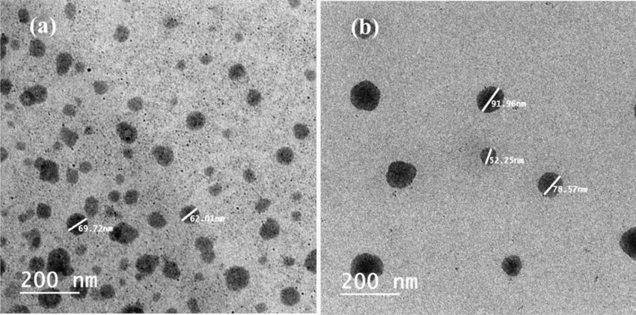

1. **Safety and toxicity concerns:** The potential risks of nanomaterials to human health and the environment need to be thoroughly assessed and mitigated.
2. **Regulatory frameworks**: Clear regulatory guidelines and standardized protocols for the development, testing, and commercialization of nanobiotechnology products in agriculture are required.
3. **Scalability and cost-effectiveness:** The production and application of nanomaterials at a large scale while maintaining cost-effectiveness remain a challenge.
4. **Knowledge gaps:** Further research is needed to understand the mechanisms of interaction between nanomaterials, pathogens, and host plants, as well as the long-term effects of nanomaterial application on agroecosystems.

**Future research directions in nanobiotechnology for crop disease resistance and postharvest quality may include:**

1. **Targeted delivery systems**: Development of smart nanocarriers that can deliver antimicrobial agents or plant defense elicitors specifically to the infection sites or target tissues.
2. **Multifunctional nanomaterials:** Design of nanomaterials with multiple functionalities, such as combined antimicrobial, antioxidant, and plant growth-promoting properties.
3. **Precision agriculture:** Integration of nanobiosensors with precision agriculture technologies, such as remote sensing and data analytics, for real-time disease monitoring and targeted interventions.
4. **Biodegradable and eco-friendly nanomaterials:** Development of nanomaterials derived from renewable and biodegradable sources to minimize environmental impact and ensure sustainability.

**Nanobiotechnology Applications in Enhancing Crop Disease Resistance and Postharvest Quality**

Nanobiotechnology represents a revolutionary frontier in agricultural innovation, merging nanotechnology with biological systems to address critical challenges in crop production and food preservation. At the nanoscale (1-100 nm), materials exhibit unique physicochemical properties that can be harnessed for agricultural applications, particularly in enhancing crop disease resistance and extending postharvest quality. Nanoparticles, including metal oxides like zinc oxide and titanium dioxide, metallic nanoparticles such as silver and gold, and carbon-based nanomaterials including carbon nanotubes and graphene, are being engineered with unprecedented precision to interact with plant systems in ways previously unimaginable. These nanomaterials can function as antimicrobial agents, targeting plant pathogens through multiple mechanisms including disruption of cell membranes, generation of reactive oxygen species, and inhibition of essential enzymes, thereby providing alternative strategies to conventional pesticides with fewer environmental concerns. The controlled release capabilities of nanomaterials allow for targeted delivery of antimicrobial compounds, reducing the quantity required while maximizing efficacy against fungal, bacterial, and viral pathogens that collectively cause billions in annual crop losses worldwide.

Beyond disease management, nanobiotechnology offers promising solutions for postharvest preservation, addressing the estimated 30-40% of global food production lost between harvest and consumption. Nanomaterial-based coatings create semipermeable barriers on produce surfaces that regulate gas exchange, moisture loss, and microbial contamination, effectively extending shelf life without compromising nutritional quality or flavour. These nanocoatings can be further functionalized with antioxidants, antimicrobials, and ethylene scavengers to create multifunctional systems tailored to specific commodities and storage conditions.

Nanosensors embedded in packaging materials provide real-time monitoring of ripening indicators, spoilage metabolites, and pathogen presence, enabling dynamic quality assessment throughout the supply chain. The integration of nanobiotechnology into agricultural practice represents a paradigm shift in disease management strategy, moving from reactive treatments to proactive prevention through enhanced plant immunity. Nanoparticles can modulate plant defence responses by serving as elicitors that activate systemic resistance pathways, effectively "priming" plants to respond more rapidly to pathogen attack.

This immunomodulatory approach offers sustainable disease protection without selection pressure typically associated with conventional pesticides. Nanomaterial delivery systems also enhance the efficacy of existing biocontrol agents by improving stability, target specificity, and persistence in field conditions. Despite these promising applications, the widespread implementation of nanobiotechnology in agriculture faces significant challenges including regulatory uncertainties, scalability concerns, and knowledge gaps regarding potential environmental and health impacts. A comprehensive risk assessment framework is essential to evaluate nanoparticle behaviors in complex agricultural ecosystems, including potential biomagnification in food chains, impacts on beneficial soil microorganisms, and long-term environmental persistence. Consumer acceptance presents another critical consideration, necessitating transparent communication about nanomaterial applications in food production and preservation.

The sustainable integration of nanobiotechnology into agricultural systems requires interdisciplinary collaboration among materials scientists, plant pathologists, food technologists, and environmental toxicologists to develop responsible applications that address productivity challenges while safeguarding ecological and human health.

As climate change intensifies pathogen pressure and supply chain disruptions, nanobiotechnology offers the transformative potential to enhance food security through multiple interconnected approaches: strengthening innate plant immunity, providing precise pathogen control with minimal environmental impact, extending postharvest quality to reduce food waste, and enabling intelligent monitoring systems that optimize resource allocation throughout production and distribution networks.

Future research directions include developing biodegradable nanomaterials with predictable environmental fates, creating nano-enabled sensing platforms for early disease detection, and designing plant-compatible nano-delivery systems for RNA interference-based crop protection. The convergence of nanobiotechnology with other emerging technologies including genomics, artificial intelligence, and synthetic biology promises to accelerate agricultural innovation, potentially revolutionizing how we protect crops from disease and preserve harvested quality in increasingly unpredictable growing conditions. As this field advances, balancing technological opportunity with appropriate safeguards will be essential to realize the transformative potential of nanobiotechnology in creating resilient and sustainable food production systems capable of meeting global nutritional needs.

**Conclusion**

Nanobiotechnology offers immense potential for enhancing crop disease resistance and postharvest quality in agriculture. Nanomaterials such as metal nanoparticles, nanoemulsions, and nano coatings have shown promising results in controlling plant diseases and extending the shelf life of agricultural produce. However, the safety and ecological impact of nanomaterials need to be thoroughly investigated before their widespread application. Future research should focus on developing cost-effective, eco-friendly, and smart nanomaterials that can provide targeted and sustainable solutions for crop protection and quality enhancement. The responsible and integrated use of nanobiotechnology in agriculture can contribute to achieving global food security while minimizing environmental impacts.

**Figure 7: Schematic representation of nanoparticle interaction with plant pathogens.**

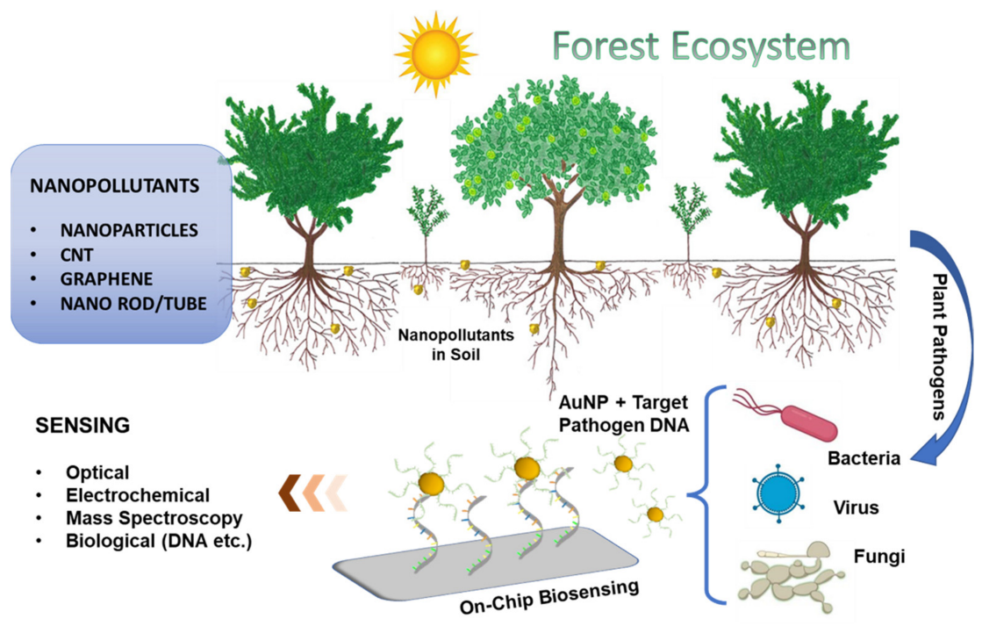

Disclaimer (Artificial intelligence)

Option 1:

Author(s) hereby declare that NO generative AI technologies such as Large Language Models (ChatGPT, COPILOT, etc.) and text-to-image generators have been used during the writing or editing of this manuscript.

Option 2:

Author(s) hereby declare that generative AI technologies such as Large Language Models, etc. have been used during the writing or editing of manuscripts. This explanation will include the name, version, model, and source of the generative AI technology and as well as all input prompts provided to the generative AI technology

Details of the AI usage are given below:

1.

2.

3.

**References:**

[1] Prasad, R., Kumar, V., & Prasad, K. S. (2014). Nanotechnology in sustainable agriculture: Present concerns and future aspects. *African Journal of Biotechnology*, 13(6), 705-713.

[2] Fraceto, L. F., Grillo, R., de Medeiros, G. A., Scognamiglio, V., Rea, G., & Bartolucci, C. (2016). Nanotechnology in agriculture: Which innovation potential does it have? *Frontiers in Environmental Science*, 4, 20.

[3] Tilman, D., Balzer, C., Hill, J., & Befort, B. L. (2011). Global food demand and the sustainable intensification of agriculture. *Proceedings of the National Academy of Sciences*, 108(50), 20260-20264.

[4] Carvalho, F. P. (2017). Pesticides, environment, and food safety. *Food and Energy Security*, 6(2), 48-60.

[5] Bombo, A. B., Pereira, A. E. S., Lusa, M. G., de Medeiros Oliveira, E., de Oliveira, J. L., Campos, E. V. R., ... & Fraceto, L. F. (2019). A mechanistic view of interactions of a nanoherbicide with target organism. *Journal of Agricultural and Food Chemistry*, 67(16), 4453-4462.

[6] Kah, M., Kookana, R. S., Gogos, A., & Bucheli, T. D. (2018). A critical evaluation of nanopesticides and nanofertilizers against their conventional analogues. *Nature Nanotechnology*, 13(8), 677-684.

[7] Dimkpa, C. O., & Bindraban, P. S. (2018). Nanofertilizers: New products for the industry? *Journal of Agricultural and Food Chemistry*, 66(26), 6462-6473.

[8] Grillo, R., Abhilash, P. C., & Fraceto, L. F. (2016). Nanotechnology applied to bio-encapsulation of pesticides. *Journal of Nanoscience and Nanotechnology*, 16(1), 1231-1234.

[9] Nahvi, A., Kasim, W. A., Ghafoor, A., Syed, A. A., Chuah, A. L., & Omar, D. (2021). Advances in nanosensors for plant health monitoring. *Nanomaterials*, 11(9), 2410.

[10] Medina-Pérez, G., Fernández-Luqueño, F., Trejo-Téllez, L. I., López-Valdez, F.& Pampillón-González, L. (2019). Nanotechnology in crop protection: Status and future trends. In *Nano-Biopesticides Today and Future Perspectives* (pp. 17-45). Academic Press.

[11] Ma, X., Geiser-Lee, J., Deng, Y., & Kolmakov, A. (2010). Interactions between engineered nanoparticles (ENPs) and plants: phytotoxicity, uptake and accumulation. *Science of the Total Environment*, 408(16), 3053-3061.

[12] Tripathi, D. K., Shweta, Singh, S., Singh, S., Pandey, R., Singh, V. P., ... & Chauhan, D. K. (2017). An overview on manufactured nanoparticles in plants: uptake, translocation, accumulation and phytotoxicity. *Plant Physiology and Biochemistry*, 110, 2-12.

[13] Rai, M., Ingle, A. P., Pandit, R., Paralikar, P., Shende, S., Gupta, I., ... & dos Santos, C. A. (2019). Copper and copper nanoparticles: role in management of insect-pests and pathogenic microbes. *Nanotechnology Reviews*, 7(4), 303-315.

[14] Goswami, A., Roy, I., Sengupta, S., & Debnath, N. (2010). Novel applications of solid and liquid formulations of nanoparticles against insect pests and pathogens. *Thin Solid Films*, 519(3), 1252-1257.

[15] Ocsoy, I., Paret, M. L., Ocsoy, M. A., Kunwar, S., Chen, T., You, M., & Tan, W. (2013). Nanotechnology in plant disease management: DNA-directed silver nanoparticles on graphene oxide as an antibacterial against *Xanthomonas perforans*. *ACS Nano*, 7(10), 8972-8980.

[16] Elmer, W., & White, J. C. (2018). The use of metallic oxide nanoparticles to enhance growth of tomatoes and eggplants in disease infested soil or soilless medium. *Environmental Science: Nano*, 5(8), 1734-1744.

[17] Graham, J. H., Johnson, E. G., Myers, M. E., Young, M., Rajasekaran, P., Das, S., & Santra, S. (2016). Potential of nano-formulated zinc oxide for control of citrus canker on grapefruit trees. *Plant Disease*, 100(12), 2442-2447.

[18] Anusuya, S., & Banu, K. N. (2016). Silver-chitosan nanoparticles induced biochemical variations of chickpea (*Cicer arietinum* L.). *Biocatalysis and Agricultural Biotechnology*, 8, 39-44.

[19] Kah, M., & Hofmann, T. (2014). Nanopesticide research: current trends and future priorities. *Environment International*, 63, 224-235.

[20] Haghighi, M., Afifipour, Z., & Mozafarian, M. (2012). The effect of N-Si on tomato seed germination under salinity levels. *Journal of Biological and Environmental Sciences*, 6(16), 87-90.

[21] Gupta, S. K., Rai, A. K., Kanwar, S. S., & Sharma, T. R. (2012). Comparative analysis of zinc finger proteins involved in plant disease resistance. *PLoS One*, 7(8), e42578.

[22] Ogunyemi, S. O., Abdallah, Y., Zhang, M., Fouad, H., Hong, X., Ibrahim, E., ... & Li, B. (2019). Green synthesis of zinc oxide nanoparticles using different plant extracts and their antibacterial activity against *Xanthomonas oryzae* pv. oryzae. *Artificial Cells, Nanomedicine, and Biotechnology*, 47(1), 341-352.

[23] Kalia, A., Sharma, S. P., & Kaur, M. (2020). Copper nanoparticles induced oxidative and osmotic stress and cell membrane damage in *Pseudomonas syringae* pv. *phaseolicola*. *Biocatalysis and Agricultural Biotechnology*, 27, 101677.

[24] Sirelkhatim, A., Mahmud, S., Seeni, A., Kaus, N. H. M., Ann, L. C., Bakhori, S. K. M., ... & Mohamad, D. (2015). Review on zinc oxide nanoparticles: antibacterial activity and toxicity mechanism. *Nano-Micro Letters*, 7(3), 219-242.

[25] Jamdagni, P., Khatri, P., & Rana, J. S. (2018). Green synthesis of zinc oxide nanoparticles using flower extract of *Nyctanthes arbor-tristis* and their antifungal activity. *Journal of King Saud University-Science*, 30(2), 168-175.

[26] Giannousi, K., Avramidis, I., & Dendrinou-Samara, C. (2013). Synthesis, characterization and evaluation of copper based nanoparticles as agrochemicals against *Phytophthora infestans*. *RSC Advances*, 3(44), 21743-21752.

[27] He, L., Liu, Y., Mustapha, A., & Lin, M. (2011). Antifungal activity of zinc oxide nanoparticles against *Botrytis cinerea* and *Penicillium expansum*. *Microbiological Research*, 166(3), 207-215.

[28] Kumar, M., Bishnoi, R. S., Shukla, A. K., & Jain, C. P. (2019). Techniques for formulation of nanoemulsion drug delivery system: a review. *Preventive Nutrition and Food Science*, 24(3), 225.

[29] Hernández-Hernández, H. M., Juárez-Maldonado, A., Benavides-Mendoza, A., Ortega-Ortiz, H., Cadenas-Pliego, G., Sánchez-Aspeytia, D., & González-Morales, S. (2018). Chitosan-PVA and copper nanoparticles improve growth and overexpress the SOD and JA genes in tomato plants under salt stress. *Agronomy*, 8(9), 175.

[30] Saharan, V., Mehrotra, A., Khatik, R., Rawal, P., Sharma, S. S., & Pal, A. (2013). Synthesis of chitosan based nanoparticles and their in vitro evaluation against phytopathogenic fungi. *International Journal of Biological Macromolecules*, 62, 677-683.

[31] Saharan, V., Pal, A., & Sharma, P. K. (2016). Biological synthesis of chitosan based nanoparticles by *Streptomyces* sp. and their antifungal activity against phytopathogenic fungi. *Journal of Bionanoscience*, 10(4), 249-257.

[32] Pereira, A. E., Sandoval-Herrera, I. E., Zavala-Betancourt, S. A., Oliveira, H. C., Ledezma-Pérez, A. S., Romero, J., & Fraceto, L. F. (2017). γ-Polyglutamic acid/chitosan nanoparticles for the plant growth regulator gibberellic acid: characterization and evaluation of biological activity. *Carbohydrate Polymers*, 157, 1862-1873.

[33] Khot, L. R., Sankaran, S., Maja, J. M., Ehsani, R., & Schuster, E. W. (2012). Applications of nanomaterials in agricultural production and crop protection: a review. *Crop Protection*, 35, 64-70.

[34] de Oliveira, J. L., Campos, E. V. R., Bakshi, M., Abhilash, P. C., & Fraceto, L. F. (2014). Application of nanotechnology for the encapsulation of botanical insecticides for sustainable agriculture: prospects and promises. *Biotechnology Advances*, 32(8), 1550-1561.

[35] Choudhary, R. C., Kumaraswamy, R. V., Kumari, S., Sharma, S. S., Pal, A., Raliya, R., ... & Saharan, V. (2017). Cu-chitosan nanoparticle boost defense responses and plant growth in maize (*Zea mays* L.). *Scientific Reports*, 7(1), 1-11.

[36] Malerba, M., & Cerana, R. (2016). Chitosan effects on plant systems. *International Journal of Molecular Sciences*, 17(7), 996.

[37] Basavegowda, N., & Lee, Y. R. (2013). Synthesis of silver nanoparticles using *Satsuma mandarin* (*Citrus unshiu*) peel extract: a novel approach towards waste utilization. *Materials Letters*, 109, 31-33.

[38] Rajendran, N. K., Kumar, S. S. D., Houreld, N. N., & Abrahamse, H. (2018). A review on nanoparticle based treatment for wound healing. *Journal of Drug Delivery Science and Technology*, 44, 421-430.

[39] Silva, S., Oliveira, H., Silva, A. M., & Macedo, R. (2019). Nanomaterials' based biosensors for food analysis applications. In *Nanobiosensors* (pp. 155-178). Academic Press.

[40] Qin, Z., Zhao, Y., Lin, M., Hou, G., Zhang, X., & Dong, Y. (2017). Postharvest gray mold control of table grapes using ε-poly-L-lysine and zinc oxide nanoparticles. *Journal of the Science of Food and Agriculture*, 97(14), 4781-4786.

[41] Anusuya, P., Nagaraj, R., Janavi, G. J., Subramanian, K. S., Paliyath, G., & Subramanian, J. (2016). Pre-harvest sprays of hexanal formulation for extending retention and shelf-life of mango (*Mangifera indica* L.) fruits. *Scientia Horticulturae*, 211, 231-240.

[42] Chauhan, N., Nainwal, L. V., Singh, D., & Singh, S. B. (2015). Shelf-life enhancement studies of fruits using nanotechnology: a review. *International Journal of Bioassays*, 4(5), 3880-3893.

[43] Kumar, R., Ghoshal, G., & Goyal, M. (2018). Nanosensors for food quality and safety assessment. *Environmental Chemistry Letters*, 16(3), 1169-1192.

[44] Pandey, G., Akhtar, W., Sharma, S., Malhotra, S. P., & Malhotra, B. D. (2018). Nanomaterial-based biosensors for food contaminants. In *NanoBioSensors* (pp. 165-194). Academic Press.

[45] Fuertes, G., Soto, I., Carrasco, R., Vargas, M., Sabattin, J., & Lagos, C. (2016). Intelligent packaging systems: sensors and nanosensors to monitor food quality and safety. *Journal of Sensors*, 2016.

[46] Cheng, Y., Xiong, P., Yun, C. S., Strouse, G. F., Zheng, J. P., Yang, R. S., & Wang, Z. L. (2008). Mechanism and optimization of pH sensing using SnO2 nanobelt field effect transistors. *Nano Letters*, 8(12), 4179-4184.

[47] De Azeredo, H. M. (2009). Nanocomposites for food packaging applications. *Food Research International*, 42(9), 1240-1253.

[48] Rhim, J. W., Park, H. M., & Ha, C. S. (2013). Bio-nanocomposites for food packaging applications. *Progress in Polymer Science*, 38(10-11), 1629-1652.

[49] Huang, J. Y., Li, X., & Zhou, W. (2015). Safety assessment of nanocomposite for food packaging application. *Trends in Food Science & Technology*, 45(2), 187-199.

[50] Bumbudsanpharoke, N., & Ko, S. (2015). Nano-food packaging: an overview of market, migration research, and safety regulations. *Journal of Food Science*, 80(5), R910-R923.

[51] Duncan, T. V. (2011). Applications of nanotechnology in food packaging and food safety: barrier materials, antimicrobials and sensors. *Journal of Colloid and Interface Science*, 363(1), 1-24.

[52] Holden, P. A., Klaessig, F., Turco, R. F., Priester, J. H., Rico, C. M., Avila-Arias, H., ... & Gardea-Torresdey, J. L. (2014). Evaluation of exposure concentrations used in assessing manufactured nanomaterial environmental hazards: are they relevant? *Environmental Science & Technology*, 48(18), 10541-10551.

[53] Zhu, H., Han, J., Xiao, J. Q., & Jin, Y. (2008). Uptake, translocation, and accumulation of manufactured iron oxide nanoparticles by pumpkin plants. *Journal of Environmental Monitoring*, 10(6), 713-717.

[54] Mishra, V. K., & Kumar, A. (2009). Impact of metal nanoparticles on the plant growth promoting rhizobacteria. *Digest Journal of Nanomaterials and Biostructures*, 4(3), 587-592.

[55] Parisi, C., Vigani, M., & Rodríguez-Cerezo, E. (2015). Agricultural nanotechnologies: what are the current possibilities? *Nano Today*, 10(2), 124-127.

[56] Iravani, S., & Varma, R. S. (2020). Greener synthesis of lignin nanoparticles and their applications. *Green Chemistry*, 22(3), 612-636.

[57] Amenta, V., Aschberger, K., Arena, M., Bouwmeester, H., Moniz, F. B., Brandhoff, P., ... & Peters, R. J. (2015). Regulatory aspects of nanotechnology in the agri/feed/food sector in EU and non-EU countries. *Regulatory Toxicology and Pharmacology*, 73(1), 463-476.

[58] Nguyen, H. M., Hwang, I. C., Park, J. W., & Park, H. J. (2012). Enhanced payload and photo-protection for pesticides using nanostructured lipid carriers with corn oil as liquid lipid. *Journal of Microencapsulation*, 29(6), 596-604.

[59] Wang, P., Lombi, E., Zhao, F. J., & Kopittke, P. M. (2016). Nanotechnology: a new opportunity in plant sciences. *Trends in Plant Science*, 21(8), 699-712.

[60] Kamaly, N., Yameen, B., Wu, J., & Farokhzad, O. C. (2016). Degradable controlled-release polymers and polymeric nanoparticles: mechanisms of controlling drug release. *Chemical Reviews*, 116(4), 2602-2663.

[61] Chaupoo, A. S., Dhakad, A., Beese, S., Kumar, A., Kumar, P., Pandey, S. K., & Kurdekar, A. K. (2023). Transforming Horticulture: The Influence of Nanotechnology on Crop Enhancement. International Journal of Environment and Climate Change, 13(11), 3381–3400. <https://doi.org/10.9734/ijecc/2023/v13i113512>

[62] Singh, N. K., & Rai, A. K. (2024). Enhancing Crop Productivity through Nanotechnology: A Comprehensive Review of Strategies and Results. Journal of Experimental Agriculture International, 46(5), 435–458. <https://doi.org/10.9734/jeai/2024/v46i52395>

[63] Nawaz, A., Rehman, H. U., Usman, M., Wakeel, A., Shahid, M. S., Alam, S., ... & Farooq, M. (2023). Nanobiotechnology in crop stress management: an overview of novel applications. Discover nano, 18(1), 74.