**Geographical Assessment and Correlations between Flood Vulnerability Levels and Morphometric Parameters in the Lower Orashi River, Niger Delta Region, Nigeria**

**Abstract**

*Flood is an important natural disaster type that needs to be studied better to reduce its impact on human life***.***The study examined the correlations between flood vulnerability levels and morphometric parameters in the lower Orashi River, Niger Delta Region, Nigeria To achieve this, the river course was divided into 30 segments whereby the information for morphometric parameters such as width, depth, velocity, cross sectional area and discharge are generated using standard methods. The flood vulnerability data were obtained using UNION method from ArcGIS platform and the point segment was overlaid on the flood vulnerability to actually observed actual flood vulnerability levels of each segment. Descriptive and inferential statistics were used for the data analysis. Findings showed that flood vulnerability is positively correlated with width of the river (R2=0.1994); cross sectional area (R2 = 0.1635) and discharge (R2=0.1762) while it was negative with the elevation (R2=0.0002); depth (R2=0.0387) and velocity (R2=0.0323). The study concluded that width of river, cross sectional area and discharge are the dominating river morphometric parameters influencing the flood vulnerability in the Lower Orashi River. It is thus recommended that the Lower Orashi River can be dredged so that the depth can be increased to reduce the levels of flood vulnerability.*

**Keywords**: Correlation; Flood; Vulnerability; Morphometric; Lower Orashi

**Introduction**

“Vulnerability implies the potential for loss, considering the nature of a hazard, who and what are exposed to it” (Karmakar et al., 2010). Flood vulnerability is thus the degree to which a person, people or place are at risk of flooding and its adverse effects (Conix & Bachus, 2007). Consequently, risk infers the “the probability that a hazard would occur and trigger a disaster or series of events with an undesirable outcome” (Brooks, 2003). “It is the probability of a loss that depends on three elements; hazard, vulnerability and exposure” (Crichton, 2010). There is a strong relationship between hazard and vulnerability, both of which cannot exist independently. Hazard is “an event with the potential to cause harm” (Brooks, 2003) “while vulnerability is examined in this study as the specific sense of an aggregate measure of exposure to the risk of flooding. It is adopted as the risk indicator in this study because of its importance to the risk discourse” (Musungu et al., 2012). “Flood-risk vulnerability is a function of natural and anthropogenic factors” (Danumah et al., 2016). “While the natural factors, like excessive rainfall, topography and soil type” (Rimba et al., 2017) “may be uncontrollable, the man-made activities such as an intentional sprawl to the riverbanks, deforestation, etc.” (Billi et al., 2015), aggravate vulnerability levels. In view of this, Wilde’s risk homeostasis theory states that “individuals and communities maintain a specific level of risk irrespective of external influences”. “For instance, the perceptions and defenses that make people reside very close to rivers and in flood plains despite the unpredictable behaviour of the river which increases their vulnerability to risk” (Wilde, 1982; 2014). “People are becoming more vulnerable to flooding due to a combination of natural and anthropogenic activities resulting from socio-economic necessities” (Blistanova et al., 2016). “What may not be possible is man’s ability to stop the occurrence of flooding. What is possible however, is man’s ability to become less vulnerable and minimize the impacts. This follows from the idea of environmental possibilism which provides that humans are able to use tools and technology to either alter or address environmental concerns.Morphometric analysis on the other hand is a quantitative measurement and mathematical analysis of landforms in order to understand the hydrological and morphological characteristics from morphometric parameters and compare the morphometric characteristics in two different morpho-climatic settings. Morphometric analysis has been extensively used for the purpose of prioritisation and assessment of watersheds susceptibility to natural hazards such as flash floods and erosion” (Abuzied et al., 2016; Alam et al., 2020; Ameri et al., 2018). These studies have used the classic works of Horton (1945; 1932), Smith (1950), Strahler (1952),Miller (1953), and Schumm (1956) as a guidance.

“Morphometry is defined as the quantitative analysis of the earth's surface, as well as the shape and dimensions of its landforms” (Kaur et al., 2014; Vaidya, et al., 2013). “Morphometric parameters represent relatively simple approaches that can be utilised to investi-gate a hydrologic basin, and its geological and geomorphic history” (Strahler, 1964). “Morphometric characteristics of watersheds are a crucial factor that influences flash flood intensity; hence, investigation of the watershed morphometry provides useful insights regarding their hydrological response to rainfall” (Borga, et al., 2008). “Morphometric parameters involve linear aspects, areal aspects, and relief aspects, which can be employed in several investigations such as natural resources assessment and protection, and environmental hazards assessment” (Charizopoulos et al., 2019).

“Development of land and water conservation measures necessitates morphometric analysis and prioritisation of sub-watersheds within a basin” (Aher et al., 2014). “Worldwide, morphometric analysis was successfully used for flash flood susceptibility mapping” (Alam et al., 2020). “Watershed prioritisation refers to ranking sub-watersheds of a watershed according to the order in which they must be considered for the purposes of treatment” (Puno & Puno, 2019). “Morphometric analysis involves computation of basic parameters, linear parameters, relief parameters, and shape parameters of a watershed, and those gain insights about the watersheds characteristics” (Strahler, 1964; Obeidat et al., 2021). Previous studies have been focused on either the flood vulnerability or morphometric analysis separately. The previous studies did not consider the level of the correlations that might be occurring between flood vulnerability levels and morphometric parameters. Thus, the present study examined the geographical assessment of the correlations between flood vulnerability levels and morphometric parameters in the Lower Orashi River, Niger Delta Region, Nigeria.

**Study Area**

“This study was carried out in the lower Orashi River, Niger Delta Region, Nigeria. Orashi River takes off as a stream, from the rocks, at the base of a waterfall, 183 m above mean sea level, in the Orashi enclave of Ezeama in Dikenafai, Imo State, Nigeria. From Dikenafai, Urashi flows through several towns, including Urualla, Akokwa, Okija, Orsu, Ukpor, Ihiala, Uli, Oguta, Osemotor, Omoku, Obiakpo, Ebocha, Ukodu, Okarki, Mbiama and Epie. The river forms tributaries along its flow from Imo through Anambra, Rivers to Bayelsa, before empting into the Atlantic. It splits into two at Egbema” (Agarwal, 2023). “The larger portion (right), continued the flow through Eluku before splitting further into two and emptying its waters and sediments at Edi Kalama (Degema) and Abonnema into the gulf of Biafra” (Mmom, 2013). The Orashi Region is home to over 35% of the oil wells in the Niger Delta States of Imo and Rivers. The Orashi River is located geographically within latitude 4047’20”N and 50 06’20”N and longitude 60 24’40”N and 60 43’40”N (Figure 1).

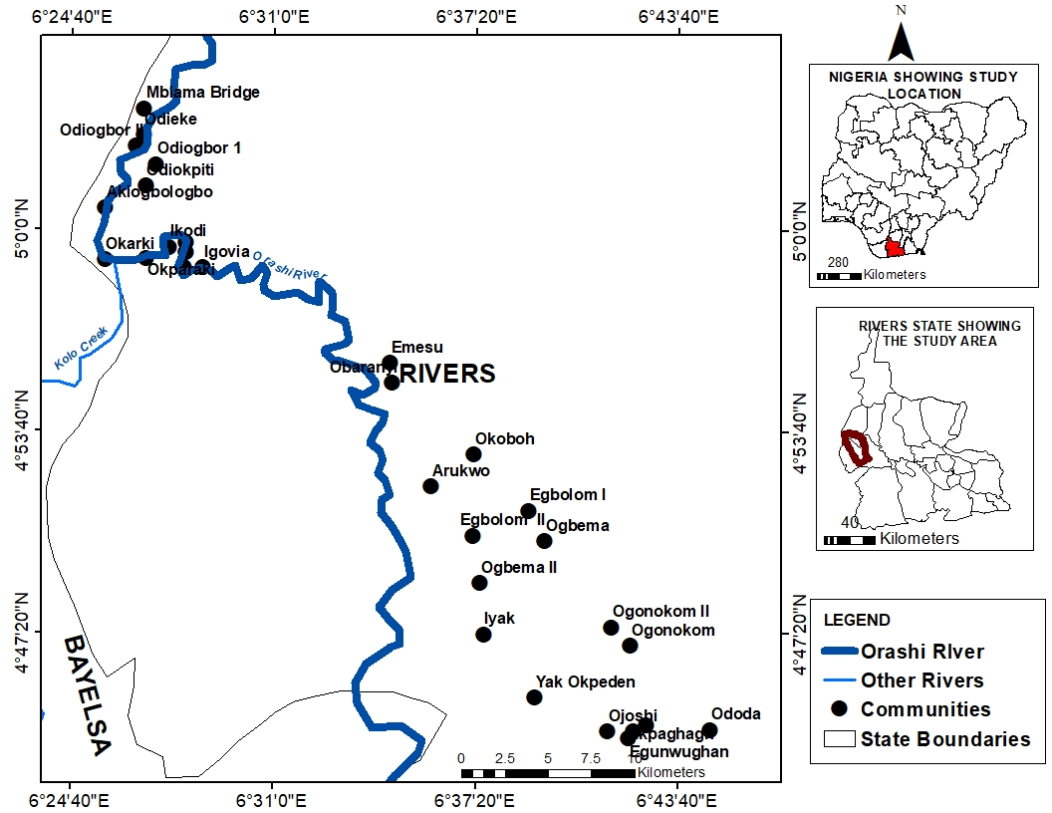

Figure 1: Orashi River and Surrounding Communities

Source: Adapted from Google Earth (2021)

“The study area features a tropical monsoon climate, designated by the Koppen climate classification as "Af", and it is mostly found in the southern part of the country. This climate is influenced by the monsoons originating from the South Atlantic ocean, which is brought into the country by the (maritime tropical) MT air mass, a warm moist sea to land seasonal wind. Its warmth and high humidity gives it a strong tendency to ascend and produce copious rainfall, which is a result of the condensation of water vapour in the rapidly rising air. The tropical monsoon climate has a very small temperature range. Then temperature ranges are almost constant throughout the year. For example, Warri Town in the southern part of Nigeria, records a maximum of 28 °C (82.4 °F) for its hottest month while its lowest temperature is 26 °C (78.8 °F) in its coldest month. The temperature difference of Warri town is not more than 2 °C (5 °F)” (Park, 2004). “The study area experiences heavy and abundant rainfall. These storms are usually convectional in nature due to the regions proximity, to the equatorial belt. The annual rainfall received in this region is very high, usually above the 2,000 mm (78.7 in) rainfall totals giving for tropical rainforest climates worldwide. Over 4,000 mm (157.5 in) of rainfall is received in the coastal region of Nigeria around the Niger Delta area. Bonny town found in the coastal region of the Niger delta area in southern Nigeria receives well over 4,000 mm (157.5 in) of rainfall annually. The rest of the southeast receives between 2,000 and 3,000 mm (118.1 in) of rain per year” (Geographical Alliance of Iowa, 2010). “The coastal sedimentary basin of the region has been the scene of three depositional cycles. The first began with a marine incursion in the middle Cretaceous and was terminated by a mild folding phase in Santonian time. The second included the growth of a proto-Niger delta during the late Cretaceous and ended in a major Paleocene marine transgression.The third cycle, from Eocene to Recent, marked the continuous growth of the main Niger delta. A new threefold lithostratigraphic subdivision is introduced for the delta parts subsurface, comprising an upper sandy Benin formation, an intervening unit of alternating sandstone and shale named the Agbada formation, and a lower shale Akata formation. These three units extend across the whole delta and each ranges in age from early Tertiary to Recent. They are related to the present outcrops and environments of deposition. A separate member of the Benin formation is recognized in the Port Harcourt area. This is the Afam clay member, which is interpreted to be an ancient valley fill formed in Miocene sediments. Subsurface structures are described as resulting from movement under the influence of gravity and their distribution is related to growth stages of the delta” (Short & Staeuble, 1967). “The study area is well drained with both fresh and salt water. The salt water is caused by the intrusion of seawater inland, thereby making the water slightly salty. The vegetation of the study area consists mainly of forest swamps. The forests are of two types, nearest the sea is a belt of saline/brackish Mangrove swamp separated from the sea by sand beach ridges within the mangrove swamp. Numerous sandy islands occur with fresh water vegetation. Fresh water swamps gradually supersede the mangrove on the landward side. Some of the forest zone's most southerly portion, especially around the Niger River and Cross River deltas, is mangrove swamp. North of this is fresh water swamp, containing different vegetation from the salt water mangrove swamps, and north of that is rain forest” (Geographical Alliance of Iowa, 2010). According to Fabiyi (2011), “the region is endowed with mosaic of fragile sensitive and diverse ecosystem. The major ecological zones of the region include mangrove forest and coastal vegetation zone, freshwater swamp forest zone, lowland rainforest zone and the derived savannah zone found in the northern part of the region”.

“The primary economic activities in most rural communities in the around the Orashi River include peasant farming, petty trading and fishing, shifting cultivation (Slash and burn), which involves cultivating a piece of land for a number of years and then abandoning it for a more fertile land is traditionally practised in the area. Some of the cash crops grown in the study area include oil palm (*Elaeis guineensis*), cacao (*Theobroma cacao*), cassava (*Manihot esculenta*) and rubber (*Herea brasiliensis*)” (Enaruvbe & Atafo, 2015).

**Material and Methods**

The study adopted mixed research design which included both descriptive and longitudinal research designs. A pre-field survey was carried out involving site visitation of the study area which is the lower Orashi River segment in River State, Nigeria.

The survey exercise aided in establishing points of references for the study. The possibility of carrying out an empirical survey of this nature was also justified through a reconnaissance survey exercises. The primary data source involved data gathering of points of references for the study with the help of a hand-held global positioning system (GPS), in-situ measurement of the river morphometric parameters like depth, width, and discharge velocity. Secondary data were gotten from the USGS, the land use imageries, DEM data, rainfall data (from WorldClim), soil texture data from FOA Digital Soil Map. The river length was determined manually and related with measurements obtained from the ArcGIS platform. The river channel was divided into thirty segments of equal lengths to determine the morphometric characteristics of each segment. This was achieved by field surveys and GIS – based method similar to studies conducted in river Ogunpa and Ogbere drainage basin, Ibadan, Southwest Nigeria (Ajibade et al., 2010). However, this was conducted by earmarking known points of 100m distance apart along each segment (point A to B) and taking the geographic coordinate of each point. These two locations were aligned with map information in order to determine the exact points of these two locations along the river course. The river depth profiles was determined by measuring the width of the channel, divided the width into equal distances of 50m interval each, took measurement at point A – B by placing a long stick into the water body till it gets to the base of the river. The point where the stick surfaces from the water is marked out and removed from the water body. Measurement in meters of this point is recorded and taking as the river depth for each segment to be earmarked as two known points along the course of the River. This process was repeated for other segments of the River.

**Mathematical Computation**

The flow velocity of the river at each segment was computed because the flow velocity changes at various points along a river course. Thus:

Flow velocity = Distance from point A to B divided by the average time in seconds x 0.85 (Constant) …………………………………………………………………….. …(Eqtn 1)

**Flow velocity** = Total Distance (A to B) x 0.85 ..................................................... (Eqtn 2)

Average time in seconds

**Cross Sectional Area = ∑D x W** ………………………………………………….(Eqtn 3)

Where D is the depth of the river at each section

W is the width of the river at each section

Discharge = V x D x W or V x Cross Sectional Area (m3/s) ………………………(Eqtn 4)

Descriptive and inferential statistics were employed for data analysis while results are presented using tables and graphs. The relationship between morphometric parameters (depth, width, velocity, cross sectional area and discharge velocity) was achieved using Pearson’s Correlation Coefficient as represented by the equation below.

**r = $\frac{rn ∑xy- ∑x∑y}{\sqrt{(n\sum{x^{2}- \left(\sum{x^{2}}\right)-(n\sum{y^{2}}-(∑y)^{2})}}}$** …………………………………………………….Eqtn(5)

For the flood vulnerability of lower Orashi River, the landuse, soil, relief, proximity to river channel, and annual rainfall were made use of. The land use/land cover was determined from the landsat imageries downloaded from the website of the United States Geological Survey. This was followed by classification into different land use types. The supervised classification method was employed because of its high accuracy and the knowledge of the training areas. The coordinates of the points of relevance/references for the study for each land use class were collected with the aid of GPS during the reconnaissance survey for ground truthing purposes. This was done to aid the supervised classification method to be applied for land use analysis. Thereafter sets of pixels were identified and the datasets were classified into land use classes/types.

The elevation or relief was obtained from the Shuttle Radar Topography Mission (SRTM) is an international Research effort that obtained DEM on a near-globe scale from 560 S to 600 N to generate the most complete high resolution digital topographic database of the earth.

The slope map was used to indicate based on topographic features showing changes in elevation which aided the study in analyzing the flow of the river. The projected SRTM data were utilized in order to generate the slope in degrees for the study (figures 2&3).

The soil texture maps was provided using the FAO Digital Soil Map of the World (DSMW) Shapefile (2020) whereby the zone of interest (Orashi River) was captured over respective area and their soil data was clipped to the study area in ArcGIS 10.5 platform (figures 4&5). This information aided the study in determining soil textural classes which can determine the rate of infiltration or percolation of runoff in the study area and this was useful for exposing flood prone areas in the study.

The rainfall data were obtained from the WorldClim website Historical Climate Data for Monthly Precipitation between 1982 and 2022. The rainfall characteristics quantify the influence of precipitation on the amount and rate of runoff factor on soil in the study area (Praveen, & Sharma, 2019). The amount of rainfall thus had several implications on flood potentiality of the study region.

The flood vulnerability levels were assigned values 3, 2, 1 to high vulnerability, moderate vulnerability and low vulnerability respectively by applying the ranking method to the factors. Using these values, the landuse vulnerability map, drainage network vulnerability map, soil texture vulnerability and elevation vulnerability map were overlaid in ArcGIS 10.7 with the use of UNION MODULE. Reclassification method was applied to have very high vulnerability, high vulnerability, moderate vulnerability, low vulnerability and very low vulnerability. The study employed the descriptive statistics for data presentation for the study.

Thereafter, a buffering analysis was carried out within the 500m radius from the centre of the river course and the buffered polygon was used to clip the entire flood vulnerability. Thus, the point segment demarcation was used to extract the status of the flood vulnerability existing at that point which could be of very low (1), low (2), moderate (3), high (4) and very high (5). The values attached to each level of flood vulnerability are used to run the correlation analysis to the morphometric parameters like depth, width, flow velocity, cross-sectional area and discharge. The descriptive statistics were in form of percentages, tables, and charts to describe the data obtained. Inferential statistics involving analysis of correlation analysis were employed for data analysis. It is as well considered that results and findings were presented using tables, graphs and charts.

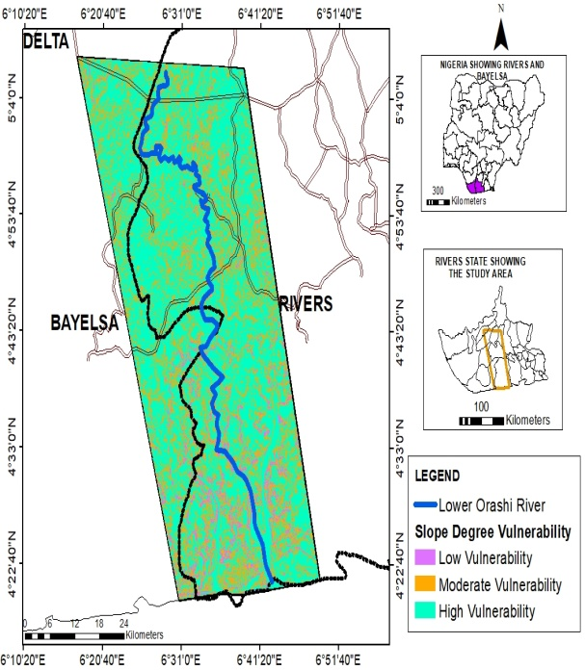 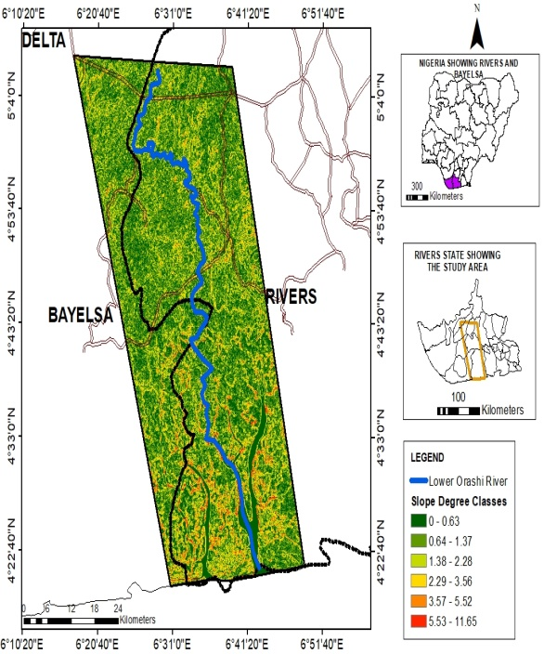

Figure 2: Slope (Degree) Vulnerability to Flood Figure 3: Slope (Degree) of the Study Area

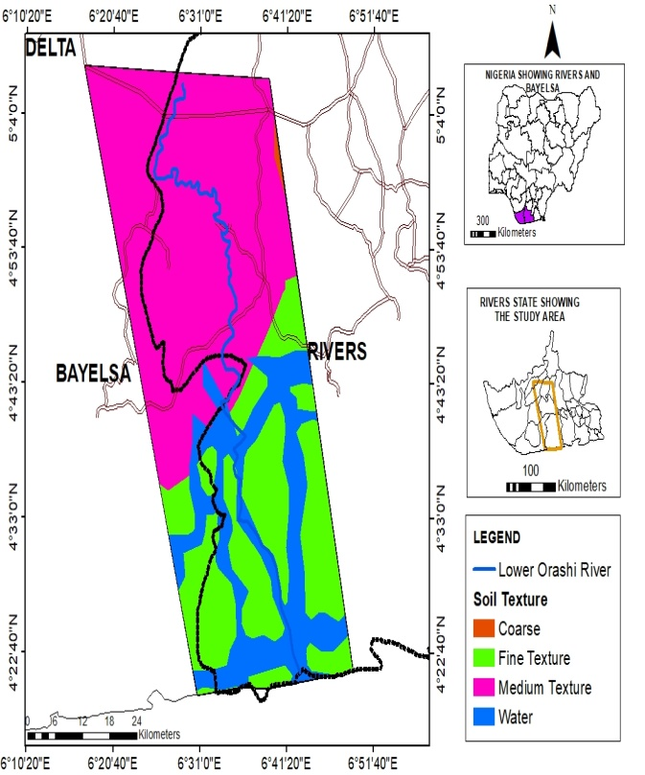 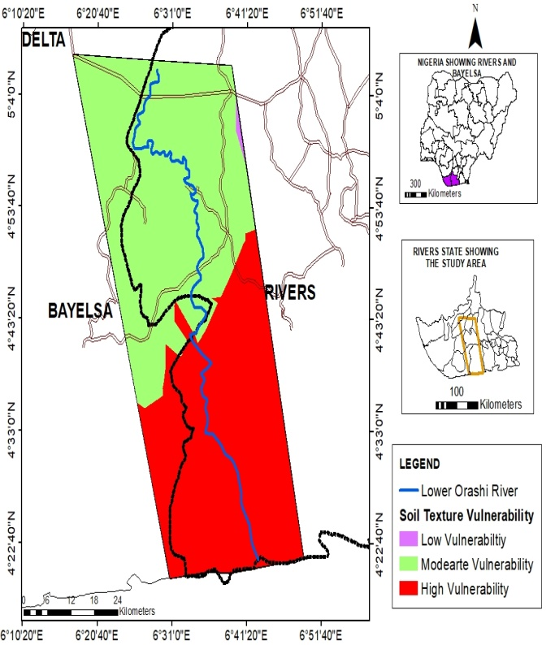

Figure 4: Soil Texture of Lower Orashi River Figure 5: Soil Texture Flood Vulnerability of the Study Area

**Result and Discussion**

**Morphometric characteristics and Level of Flood Vulnerability of Lower River Orashi**

The analysis of morphometric characteristics of Lower Orashi River are shown in the Table 1**.** The morphometric characteristics displayed in Table 1 showed that the width of the river ranged from 77.90m to 2788.00m with the mean width of 318.83m. The width of Orashi River was relatively uniform from the upper section and continues to increase at the lower section where the river enters the Atlantic Ocean. Furthermore, it is revealed that the elevation of the river ranged from -2m to 15 m with the mean elevation which was 5.07m. The elevation of Orashi river displayed in Table 1 showed that at segment 11 and 12 it is observed that the elevation was relatively high but the highest was noticed at the segment 25 and whereas at the mouth of the river, the elevation reduced to negative. The depth ranged from 2.10 to 7.60m with the mean depth recording 4.14m. The time of flow between the segments was also recorded and this ranged from 1.15s to 2.30s with the mean time of 1.71s. It is also recorded that the velocity flow in the Orashi River ranged from 1.80m/s to 3.60 m/s with the mean velocity of 2.53 m/s. In addition, the cross sectional area was found to range from 280.44 m2 and 12685.40 m2 with the mean cross sectional area of 1303.61 m2. The discharge ranged from723.79 m3/s to 26233.18 m3/s with the mean discharge which was 3021.51 m3/s.

The flood vulnerability levels as found in Figures 6 and 7, revealed that 6.67% of the entire segment were found to be of low flood vulnerability within the entire Lower Orashi River; 30% were moderate, 53.33 were high flood vulnerability while 10% were of very high flood vulnerability. The implication of this is that majority (over 60%) of the entire river course was of high flood vulnerability.

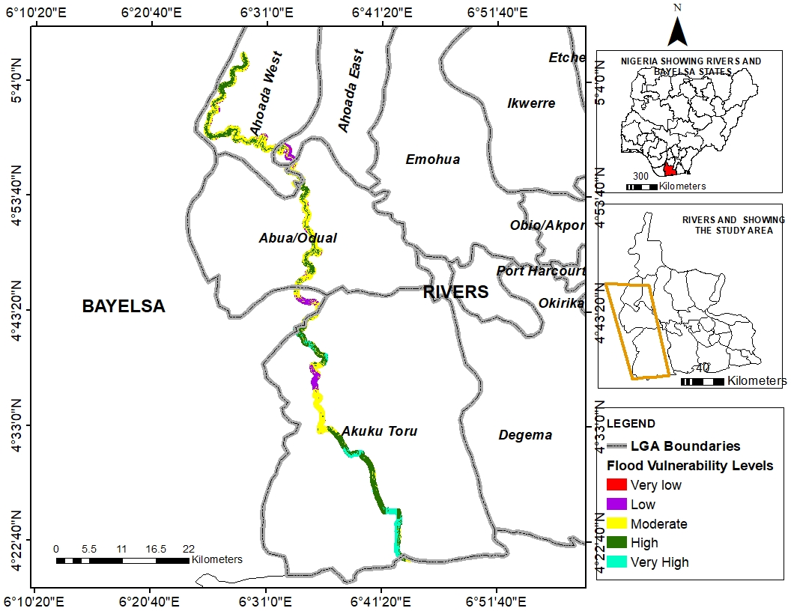

Figure 6: Flood Vulnerabilities along the lower Orashi river

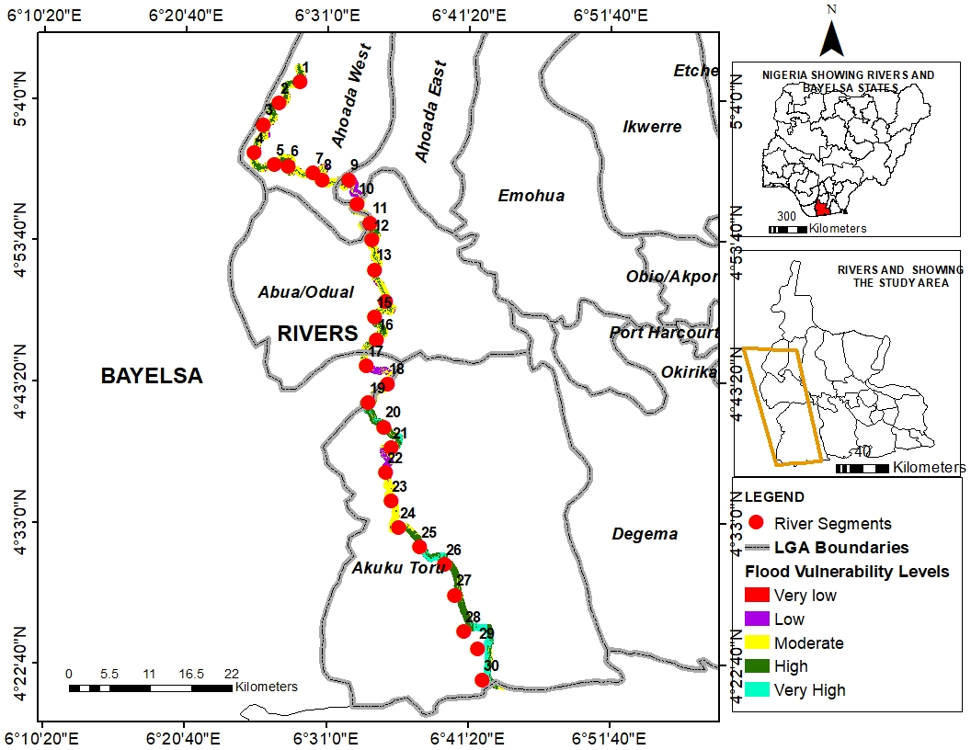

Figure 7: Segments along the lower Orashi river

Table 1: Morphometric Characteristics of Lower Orashi River

|  |  |  |  |  |  |  |  |  |  |
| --- | --- | --- | --- | --- | --- | --- | --- | --- | --- |
| Latitude | Longitude | Flood Vulnerability Rate | Width (m) | Elevation (m) | Depth(m) | Time (s) | Velocity Distance /Time) | Cross sectional area (Width x Depth) | Discharge (Velocity x Cross Sectional) |
| 6.4831 | 5.0878 | 4 | 148 | 8 | 5.5 | 2.2 | 2.211746 | 814 | 1800.361 |
| 6.4578 | 5.0622 | 4 | 142 | 7 | 6.35 | 2.1 | 2.317067 | 901.7 | 2089.299 |
| 6.4388 | 5.0356 | 4 | 152 | 8 | 6.5 | 1.3 | 3.742955 | 988 | 3698.039 |
| 6.4280 | 5.0015 | 4 | 161 | 5 | 2.5 | 2.3 | 2.115583 | 402.5 | 851.5222 |
| 6.4526 | 4.9869 | 4 | 134 | 7 | 2.7 | 1.15 | 4.231166 | 361.8 | 1530.836 |
| 6.4698 | 4.9850 | 4 | 160 | 6 | 7.6 | 1.55 | 3.139252 | 1216 | 3817.331 |
| 6.5001 | 4.9769 | 3 | 138 | 7 | 5.3 | 2.25 | 2.162596 | 731.4 | 1581.723 |
| 6.5108 | 4.9683 | 4 | 140 | 5 | 2.1 | 1.37 | 3.551709 | 294 | 1044.202 |
| 6.5433 | 4.9685 | 3 | 93.6 | 7 | 4.5 | 1.4 | 3.475601 | 421.2 | 1463.923 |
| 6.5537 | 4.9393 | 3 | 93.3 | 6 | 3.6 | 1.53 | 3.180288 | 335.88 | 1068.195 |
| 6.5697 | 4.9161 | 4 | 150 | 6 | 3.85 | 1.45 | 3.355752 | 577.5 | 1937.947 |
| 6.5718 | 4.8953 | 4 | 111 | 14 | 3.6 | 1.35 | 3.604327 | 399.6 | 1440.289 |
| 6.5755 | 4.8588 | 4 | 154 | 4 | 3 | 1.53 | 3.180288 | 462 | 1469.293 |
| 6.5882 | 4.8208 | 4 | 102 | 6 | 3.9 | 1.42 | 3.426649 | 397.8 | 1363.121 |
| 6.5748 | 4.8010 | 3 | 126 | 8 | 4.75 | 1.55 | 3.139252 | 598.5 | 1878.842 |
| 6.5778 | 4.7735 | 3 | 158 | 5 | 4.5 | 1.27 | 3.831371 | 711 | 2724.105 |
| 6.5655 | 4.7418 | 2 | 99 | 6 | 5 | 2.2 | 2.211746 | 495 | 1094.814 |
| 6.5913 | 4.7199 | 3 | 77.9 | 6 | 3.6 | 1.55 | 3.139252 | 280.44 | 880.3719 |
| 6.5674 | 4.6971 | 4 | 101 | 9 | 2.95 | 1.45 | 3.355752 | 297.95 | 999.8464 |
| 6.5872 | 4.6674 | 5 | 152 | 7 | 3.9 | 1.42 | 3.426649 | 592.8 | 2031.317 |
| 6.5959 | 4.6420 | 3 | 159 | 2 | 4.35 | 1.59 | 3.060277 | 691.65 | 2116.641 |
| 6.5893 | 4.6120 | 2 | 307 | 0 | 5.5 | 2.1 | 2.317067 | 1688.5 | 3912.368 |
| 6.5957 | 4.5770 | 3 | 209 | 0 | 2.75 | 2.23 | 2.181991 | 574.75 | 1254.1 |
| 6.6053 | 4.5445 | 3 | 161 | 2 | 4.5 | 2.1 | 2.317067 | 724.5 | 1678.715 |
| 6.6308 | 4.5210 | 4 | 205 | 15 | 3.5 | 2 | 2.432921 | 717.5 | 1745.62 |
| 6.6614 | 4.5001 | 4 | 447 | 0 | 2.95 | 1.54 | 3.159637 | 1318.65 | 4166.455 |
| 6.6738 | 4.4624 | 4 | 619 | 0 | 3 | 1.57 | 3.099262 | 1857 | 5755.329 |
| 6.6852 | 4.4183 | 4 | 1006 | 0 | 3.8 | 1.59 | 3.060277 | 3822.8 | 11698.83 |
| 6.7021 | 4.3972 | 5 | 1071 | -2 | 3.5 | 2.1 | 2.317067 | 3748.5 | 8685.526 |
| 6.7079 | 4.3587 | 5 | 2788 | -2 | 4.55 | 2 | 2.432921 | 12685.4 | 30862.57 |

Flood Vulnerability Interpretation: 1-Very Low; 2-Low; 3-Moderate; 4-High; 5-Very High

**Relationship between Flood Vulnerability and River Morphometric Parameters**

It is shown in Figure 8 that the flood vulnerability had a positive correlation with the width of the river. This shows that the higher the width of the river, the higher the flood vulnerability. The flood vulnerability increased at rate of 0.0006m width and percentage contribution of width was 19.94%. It is shown in Figure 9 that the flood vulnerability had a negative correlation with the elevation of the river. This shows that the lower the elevation of the river, the higher the flood vulnerability. The flood vulnerability decreased at rate of 0.00027m elevation and percentage contribution of elevation was 0.002%. This is negligible because the river floor is with little difference except where anthropogenic activities have taken place which must have drastically affected the river floor either to increase it or decrease it. It is shown in Figure 10 that the flood vulnerability had a negative correlation with the depth of the river. This shows that the lower the depth of the river, the higher the flood vulnerability. The flood vulnerability decreased at rate of 0.1165m depth and percentage contribution of depth was 3.87%.

In Figure 11, the flood vulnerability had a negative correlation with the flow time taken. This shows that the lower the time taken of the river, the higher the flood vulnerability. The flood vulnerability decreased at rate of 0.4039s of time taken to flow from one segment to the other and percentage contribution of time taken was 3.63%. It is shown in Figure 12 that the flood vulnerability had a negative correlation with the velocity of the river. This shows that the lower the velocity of the river, the higher the flood vulnerability. The flood vulnerability decreased at rate of 0.2284 m/s velocity and percentage contribution of velocity was 3.23%.

In Figure 13, the flood vulnerability had a positive correlation with the cross sectional area of the river. This shows that the higher the cross sectional area of the river, the higher the flood vulnerability. The flood vulnerability increased at rate of 0.0001 sq m cross sectional area and percentage contribution of cross sectional area was 16.35 %.

It is also shown in Figure 14 that the flood vulnerability had a positive correlation with the discharge of the river. This shows that the higher the discharge of the river, the higher the flood vulnerability. The flood vulnerability increased at rate of 0.000001 sq m discharge and percentage contribution of discharge was 17.62%.

Figure 8: Scatter Diagram between Width of River and Flood Vulnerability

Figure 9: Scatter Diagram between Elevation from River Floor and Flood Vulnerability

Figure 10: Scatter Diagram between Depth of River and Flood Vulnerability

Figure 11: Scatter Diagram between Flow Time Taken and Flood Vulnerability

Figure 12: Scatter Diagram between Velocity of River Flow and Flood Vulnerability

Figure 13: Scatter Diagram between Cross Sectional Area of River and Flood Vulnerability

Figure 14: Scatter Diagram between Discharge and Flood Vulnerability

**Discussion**

The higher the positive relationship between width of the river and flood vulnerability suggested that areas with higher width may be subjected to higher flood vulnerability because of the tendency to receive more waters from runoff or from neighboring streams and rivers.

The percentage contribution of elevation This is negligible because the river floor is with little difference except where anthropogenic activities have taken place which must have drastically affected the river floor either to increase it or decrease it. This is in disagreement with the study of Obeidat et al, (2021) because of the high elevation environment that the study was based which has the potentiality to produce surface runoff which can produce only flash flood. In the case of Lower Orashi River, it was discovered that the elevation was lower and this can easily accommodate higher flood for many day. The lower the depth of the river, the higher the flood vulnerability. This is possible because the higher depth of the river would accommodate the water content and reduce flood. The lower depth might have been possible because of higher depositional rate tendency which can easily aid flood as percolation is reduced. This shows that the higher the cross sectional area and discharge of the river, the higher the flood vulnerability. The two morphometric parameters work together as they possessed similar correlations with flood vulnerability. If the cross sectional area is higher, the discharge is supposed to be higher and this is really influenced by the width of the river. Thus, the flood vulnerability in the lower Orashi River could be higher under the influence of discharge and cross sectional area.

**Conclusion and Recommendations**

The study concluded that the morphometric parameters like the width of river, cross sectional area and discharge have positive relationship with flood vulnerability which depth and velocity are found to have negative relationship with flood vulnerability in the lower Orashi River. The study thus recommended that Lower Orashi River can be dredged so that the depth can be increased to reduce the levels of flood vulnerability. Also, watershed trees can be grown to reduce the runoff that will be deposited into the river course.

Disclaimer (Artificial intelligence)

Option 1:

Author(s) hereby declare that NO generative AI technologies such as Large Language Models (ChatGPT, COPILOT, etc.) and text-to-image generators have been used during the writing or editing of this manuscript.

Option 2:

Author(s) hereby declare that generative AI technologies such as Large Language Models, etc. have been used during the writing or editing of manuscripts. This explanation will include the name, version, model, and source of the generative AI technology and as well as all input prompts provided to the generative AI technology

Details of the AI usage are given below:

1.

2.

3.

**References**

Abuzied, S., Yuan, M., Ibrahim, S., Kaiser, M., & Saleem, T. (2016). Geospatial risk assessment of flash floods in Nuweiba area, Egypt. Journal of Arid Environments, 133, 54–72.

Agarwal, C. S. (2023). Study of drainage pattern through aerial data in Naugarh area of Varanasi district, UP*. Journal of the Indian Society of Remote Sensing, 26*(4), 169- 175.

Ajibade, L. T., Ifabiyi, L. P., Iroye, K. A., and Ogunteru, S. (2010). Morphometric analysis of Ogunpa and Ogbere drainage basins, Ibadan, Nigeria. *Ethiopian Journal of Environmental Studies and Management*, *3*(1).

Aher, P. D., Adinarayana, J., & Gorantiwar, S. D. (2014). Quantification of morphometric characterization and prioritization for management planning in semi-arid tropics of India: A remote sensing and GIS approach. Journal of Hydrology, 511, 850–860

Alam, A., Ahmed, B., & Sammonds, P. (2020). Flash flood susceptibility assessment using the parameters of drainage basin morphometry in SE Bangladesh. Quaternary International. https://doi.org/10.1016/j.quaint.2020.04.047

Ameri, A. A., Pourghasemi, H. R., & Cerda, A. (2018). Erodibility prioritization of sub-watersheds using morphometric parameters analysis and its mapping: A comparison among TOPSIS, VIKOR, SAW, and CF multi-criteria decision making models. Science of the Total Environment, 613–614, 1385–1400.

Billi, P., Alemu, Y. T., & Ciampalini, R. (2015). Increased frequency of flash floods in Dire Dawa, Ethiopia: Change in rainfall intensity or human impact? *Natural Hazards, 76*(2), 1373–1394.

Blistanova, M., Zelenakova, M., Blistan, P., & Ferencz, V. (2016). Assessment of flood vulnerability in Bodva River Basin, Slovakia. *Acta Montanistica Slovaca, 21*(1), 19–28.

Borga, M., Gaume, E., Creutin, J. D., & Marchi, L. (2008). Surveying flash floods: Gauging the ungauged extremes. Hydrological Processes, 22, 3883–3885.

Brooks, N. (2003). *Vulnerability, risk and adaptation: A conceptual framework*. Tyndall Centre for Climate Change Research, Working Paper 38.

Charizopoulos, N., Mourtzios, P., Psilovikos, T., Psilovikos, A., & Karamotsou, L. (2019). Morphometric analysis of the drainage network of Samos Island (northern Aegean Sea): Insights into tectonic control and flood hazards. Compes Rendus-Geoscience, 351, 375–383

Coninx, I., & Bachus, K. (2007). *Integrating social vulnerability to floods in a climate change context*. Higher Institute for Labour Studies, Catholic University of Leuven.

Crichton, D. (2010). *The risk triangle*. Tudor Rose.

Danumah, J. H., Odai, S. O., Saley, B. M., Szarzynski, J., Thiel, M., Kwaku, A., & Akpa, L. Y. (2016). Floodrisk assessment and mapping in Abidjan district using multi-criteria analysis (AHP) model and geoinformation techniques, (Cote d’Ivoire). *Geoenvironmental Disasters, 3*(10), 1–13.

Enaruvbe, G. O., & Atafo, O. P. (2015). Change in the rate and pattern of deforestation in part of the Niger Delta, Nigeria. *Journal of Land use Science*, *4*(1), 1-16.

Fabiyi, J. S. (2011). Effects of wood species on durability and chemical changes of fungal decayed wood plastic composites. *Composites Part A: Applied Science and Manufacturing*, *42*(5), 501-510.

Geographical Alliance of Iowa (2010). *Teaching geography & standards*. <https://gai.uni.edu/> teaching- geography-standards.

Horton, R. (1932). Drainage basin characteristics. Transactions, American Geophysical Union, 13, 350–361.

Horton, R. E. (1945). Erosional development of streams and their drainage basins; hydrophysical approach to quantitative morphology. Bulletin of the Geological Society of America, 56, 275–370.

Karmakar, S., Simonovic, S. P., Peck, A., & Black, J. (2010). An information system for risk-vulnerability assessment to flood. *Journal of Geographic Information System, 2*(03), 129–146.

Kaur, M., Singh, S., Verma, V. K., & Pateriya, B. (2014). Quantitative geomorphological analysis and land use/land cover change detection of two sub-watersheds in NE region of Punjab, India. The International Archives of the Photogrammetry, Remote Sensing and Spatial Information Sciences, Volume XL-8, 2014 ISPRS Technical Commission VIII Symposium, 09–12 December 2014, Hyderabad, India.

Miller, V. C. (1953). A quantitative geomorphic study of drainage basin characteristics on the Clinch Mountain area, Virgina and Tennessee, Proj. NR 389–402, Tech Rep 3. New York: Columbia University, Department of Geology, ONR.

Mmom, P. C. (2013). Impact of the 2012 Flood on Water Quality and Rural Livelihood in the Orashi Province of the Niger Delta, Nigeria. Journal of Geography and Geology. 5(4) 1916–9779 .

Musungu, K., Motala, S., & Smit, J. (2012). Using multi-criteria evaluation and GIS for flood risk analysis in informal settlements of Cape Town: The case of Graveyard Pond. *South African Journal of Geomatics, 1*(1), 77–91.

Obeidat M, Awawdeh M, Al-Hantouli F. Morphometric analysis and prioritisation of watersheds for flood risk management in Wadi Easal Basin (WEB), Jordan, using geospatial technologies. J Flood Risk Management. 2021;14:e12711. https://doi.org/10.1111/jfr3.12711

Puno, G. R., & Puno, R. C. C. (2019). Watershed conservation prioritization using geomorphometric and land use-land cover parameters. Global Journal of Environmental Science and Management, 5(30), 279–294.

Rimba, A. B., Setawati, M. D., Samba, A. B., & Miura, F. (2017). Physical flood vulnerability mapping applying geospatial techniques in Okazaki City, Aichi Prefecture, Japan. *Urban Science, 1*(70), 1–22.

Schumm, E. (2005). Influence of catchment processes on fluvial morphology and river habitats. *Limnetica*, *30*(2), 0169-182

Short, K. C., & Stäuble, A. J. (1967). Outline of geology of Niger Delta. *AAPG bulletin*, *51*(5), 761-779.

Smith, K. (1950). Standards for grading texture of erosional topography. American Journal of Science, 248(9), 655–668.

Strahler, A. (1952). Hypsometric (area-altitude) analysis of erosional topography. Geological Society of America Bulletin, 63, 1117–1142.

Strahler, A. (1957). Quantitative analysis of watershed geomorphology. Transactions, American Geophysical Union, 38, 913–920.

Strahler, A. (1964). Quantitative geomorphology of drainage basins and channel networks. In V. Chow (Ed.), Handbook of applied hydrology (pp. 439–476). New York: McGraw Hill.

Vaidya, N., Kuniyal, J. C., & Chauhan, R. (2013). Morphometric analysis using geographic information system (GIS) for sustainable development of hydropower projects in the lower Satluj river catchment in Himachal Pradesh, India. International Journal of Geomatics and Geosciences, 3(3), 464–473

Wilde, G. J. S. (1982). The theory of risk homeostasis: Implications for safety and health. *Risk Analysis, 2*(4), 209–225.

Wilde, G.J.S. (2014). *Target Risk 3 – Risk Homeostatis in Everyday Life.* Toronto: PDE Publications – Digital Edition, William Kaufman Press.