Spatiotemporal Analysis of Land Use and Land Cover Dynamics Under the Pressure of Artisanal Mining in the Central Zone of Taraba State, Nigeria

Abstract
Artisanal and small-scale mining (ASM) has emerged as an essential livelihood activity in Taraba’s Central Zone, driven by the increasing demand for mineral resources and limited employment opportunities. However, the sector's rapid and largely unregulated expansion has raised serious environmental concerns, particularly regarding land degradation and deforestation. This study provides a comprehensive spatiotemporal assessment of land use and land cover (LULC) changes in the Central Zone between 1994 and 2024, focusing on quantifying the environmental impact of ASM activities. Multi-temporal Landsat satellite imagery from 1994, 2004, 2014, and 2024 was analyzed using supervised classification techniques within a geographic information system (GIS) environment. Ground-truthing and field surveys conducted in 2025 were used to validate classification accuracy and interpret ASM footprints. Results indicate a significant decline in vegetative cover from 97.29% in 1994 to 69.15% in 2024, accompanied by a sharp increase in bare surface area from 2.05% to 29.71% over the same period. Built-up areas and water bodies showed minor fluctuations with no consistent trend. The spatial patterns strongly suggest that ASM has been a major driver of ecological disturbance, primarily through vegetation clearance, soil disruption, and surface scarring. The findings reveal the urgent need for targeted environmental policies, sustainable mining frameworks, and land rehabilitation programs to mitigate further degradation and promote ecological resilience in ASM-affected landscapes.
Keywords: Spatiotemporal Analysis, Land Use, Land Cover, Environmental Impact, Mining Dynamics, Landscape Degradation
1.0 Introduction
Artisanal and small-scale mining (ASM) has emerged as a vital socio-economic activity in many developing countries, particularly in Sub-Saharan Africa, where it serves as a major source of income and employment for millions of rural populations (Hilson, 2002; Bansah et al., 2016). In Nigeria, ASM plays a central role in the exploitation of gold (Au), tin (Sn), columbite (FeNb₂O₆), and other mineral resources, especially within the mineral-rich Central Zone of Taraba State. The sector is largely informal, often operating outside regulatory frameworks, which limits the enforcement of environmental standards such as the Nigerian Mineral and Mining Act (2007) and the National Environmental Standards and Regulations Enforcement Agency (NESREA) guidelines, contributing to unsustainable resource extraction (Garvin et al., 2009).
Despite its contribution to poverty alleviation and rural livelihoods, ASM is widely recognized for its detrimental environmental impacts. These include deforestation, land degradation, soil erosion, water contamination, and disruption of local ecosystems through habitat loss, alteration of ecological niches, reduced biodiversity, and potential impacts on species reproduction due to morphophysiological changes in the ecosystem (Hilson & Potter, 2003; Tschakert & Singha, 2007).
In the Central Zone of Taraba, Nigeria, these impacts have intensified over the past three decades, driven by increased mineral demand, population growth, and lax environmental governance. Vegetation clearance, topsoil removal, and the creation of extensive deforested and degraded surfaces are typical outcomes of ASM practices, transforming previously productive landscapes into ecologically fragile zones (Ibrahim et al., 2021).
While several studies have documented the socio-economic and ecological dimensions of ASM (Barenblitt et al., 2021), there remains a significant knowledge gap in the long-term spatial assessment of ASM’s environmental impact. Specifically, there is limited evidence on how ASM has altered land use and land cover (LULC) patterns in the Central Zone of Taraba State using systematic, multi-decadal remote sensing data. Most existing environmental assessments are either qualitative or limited in temporal and spatial scope, making it difficult to inform sustainable land management policies.
This study addresses this gap by conducting a 30-year spatiotemporal analysis (1994-2024) of LULC dynamics using satellite imagery, GIS tools, and field-based validation. The objective is to quantify ASM’s environmental impacts on vegetation, bare surfaces, built-up areas, and water bodies. By establishing the relationship between ASM proliferation and landscape transformation, this research strengthens the evidence base for implementing environmentally responsible mining practices and guiding ecological restoration policies in resource-dependent regions.
2.0 Materials and Methods
2.1 Study Area
The Central Zone of Taraba State, located in northeastern Nigeria, spans key Local Government Areas such as Bali, Gassol, Gashaka, Kurmi, and Sardauna, positioned between latitudes 6°30'N to 8°00'N and longitudes 10°00'E to 11°30'E. The region features a diverse ecological landscape, encompassing Guinea savanna and montane forests, moderate to high relief, and major rivers like the Taraba River. It includes the Mambilla Plateau in the southeast and transitions into forested and riverine areas in the northwest, supporting a mix of agriculture, livestock grazing, and increasing artisanal and small-scale mining (ASM) activities. Rich in gold, columbite, tantalite, and alluvial deposits, the Central Zone has seen a surge in informal mining since the early 1990s, particularly in farmlands, protected forests, and along riverbanks.The region experiences a tropical climate with wet (April–October) and dry (November–March) seasons, annual rainfall between 1,200 mm and 1,800 mm, and temperatures ranging from 21°C to 32°C.
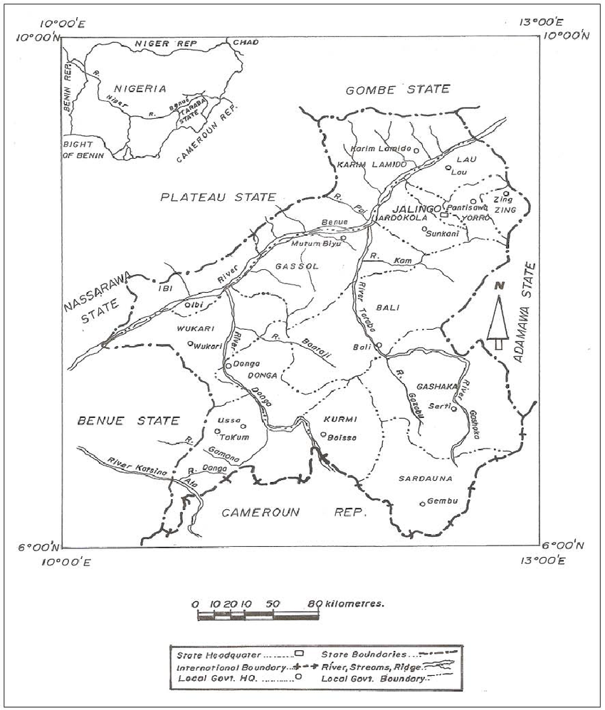
Fig .1 Map showing study location
2.2 Data Sources
LULC data were derived from Landsat satellite imagery for 1994, 2004, 2014, and 2024. Ground truthing was conducted through fieldwork in 2025. Standard supervised classification techniques were employed using ENVI and ArcGIS software. LULC was categorized into four classes: Bare Surface, Built-up Area, Vegetation, and Waterbody.
2.3 Data Analysis
The data analysis in this study employed a combination of remote sensing techniques, geographic information system (GIS) tools, and statistical methods to assess land use and land cover changes (LULC) and the spatial expansion of artisanal and small-scale mining (ASM) activities from 1994 to 2024.
2.3.1 Preprocessing of Satellite Data
Satellite imagery from Landsat 5 TM (1994), Landsat 7 ETM+ (2004), Landsat 8 OLI/TIRS (2014), and Landsat 9 (2024) was downloaded from the United States Geological Survey (USGS) Earth Explorer. The images were subjected to the following preprocessing steps:
2.3.2 Land Use and Land Cover (LULC) Classification
The corrected images were classified into five major land cover categories using supervised classification with the Maximum Likelihood Algorithm:
Forest, Agricultural Land, Built-up Area, Bare Surface, and Water Bodies
2.3.3 Change Detection Analysis
Post-classification comparison was conducted to detect changes between the classified images of 1994, 2004, 2014, and 2024. The area, measured in hectares, for each class was computed for each year, and the magnitude, percentage, and rate of change were calculated as:
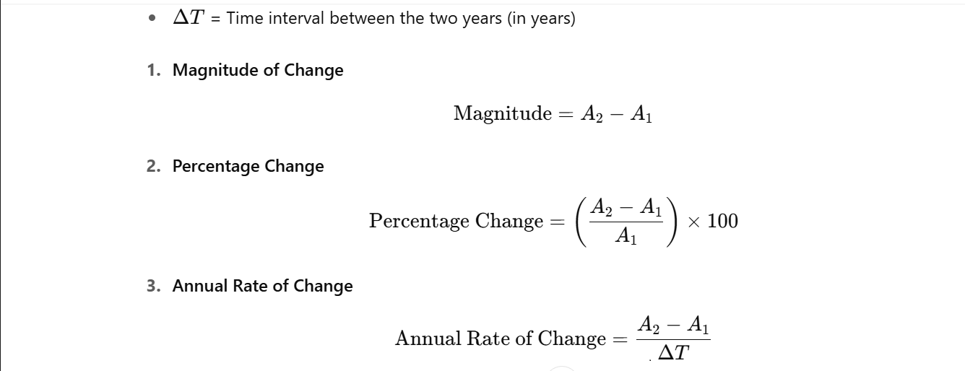
Figure 2: Formula for Land Cover Change Analysis
2.4 Mapping and Analysis of ASM Sites
Field data collected using GPS coordinates and interviews were used to identify active ASM sites. These were digitized and overlaid on LULC maps using ArcGIS 10.x and QGIS. Spatial overlays allowed for the identification of land cover classes most affected by ASM activities.
Buffer analysis (100m, 200m, and 500m) around mining sites was used to quantify environmental impacts on adjacent land use types.
2.5 Integration of Socioeconomic Data
Structured interviews and focus group discussions (FGDs) were conducted with local residents, miners, and community leaders to complement remote sensing findings. The qualitative data were analyzed using thematic coding to identify common environmental and socio-economic concerns linked to ASM.
2.6 Statistical Analysis
Descriptive statistics were computed to summarize changes in LULC categories. Pearson correlation analysis was applied to determine the relationship between the expansion of mining areas and the loss of forest or farmland. ANOVA tests were used to evaluate the statistical significance of LULC changes over the study period.

3.0 Results and Discussion
3.1 Results
Table 1: Land Use and Land Cover Change in the Central Zone (1994–2024)
Land Use Category | 1994 Area (ha) | % | 2004 Area (ha) | % | 2014 Area (ha) | % | 2024 Area (ha) | %
Bare Surface | 45,414.35 | 2.05 | 537,952.75 | 28.60 | 22,080.79 | 29.71 | 22,080.79 | 29.71
Built-up Area | 7,480.08 | 0.10 | 2,193.95 | 0.12 | 129.05 | 0.17 | 129.05 | 0.17
Vegetation | 2,148,304.23 | 97.29 | 1,321,280.09 | 70.24 | 51,397.16 | 69.15 | 51,397.16 | 69.15
Waterbody | 12,414.17 | 0.56 | 19,782.31 | 1.05 | 719.68 | 0.97 | 719.68 | 0.97
Source: Researcher’s Fieldwork, 2025

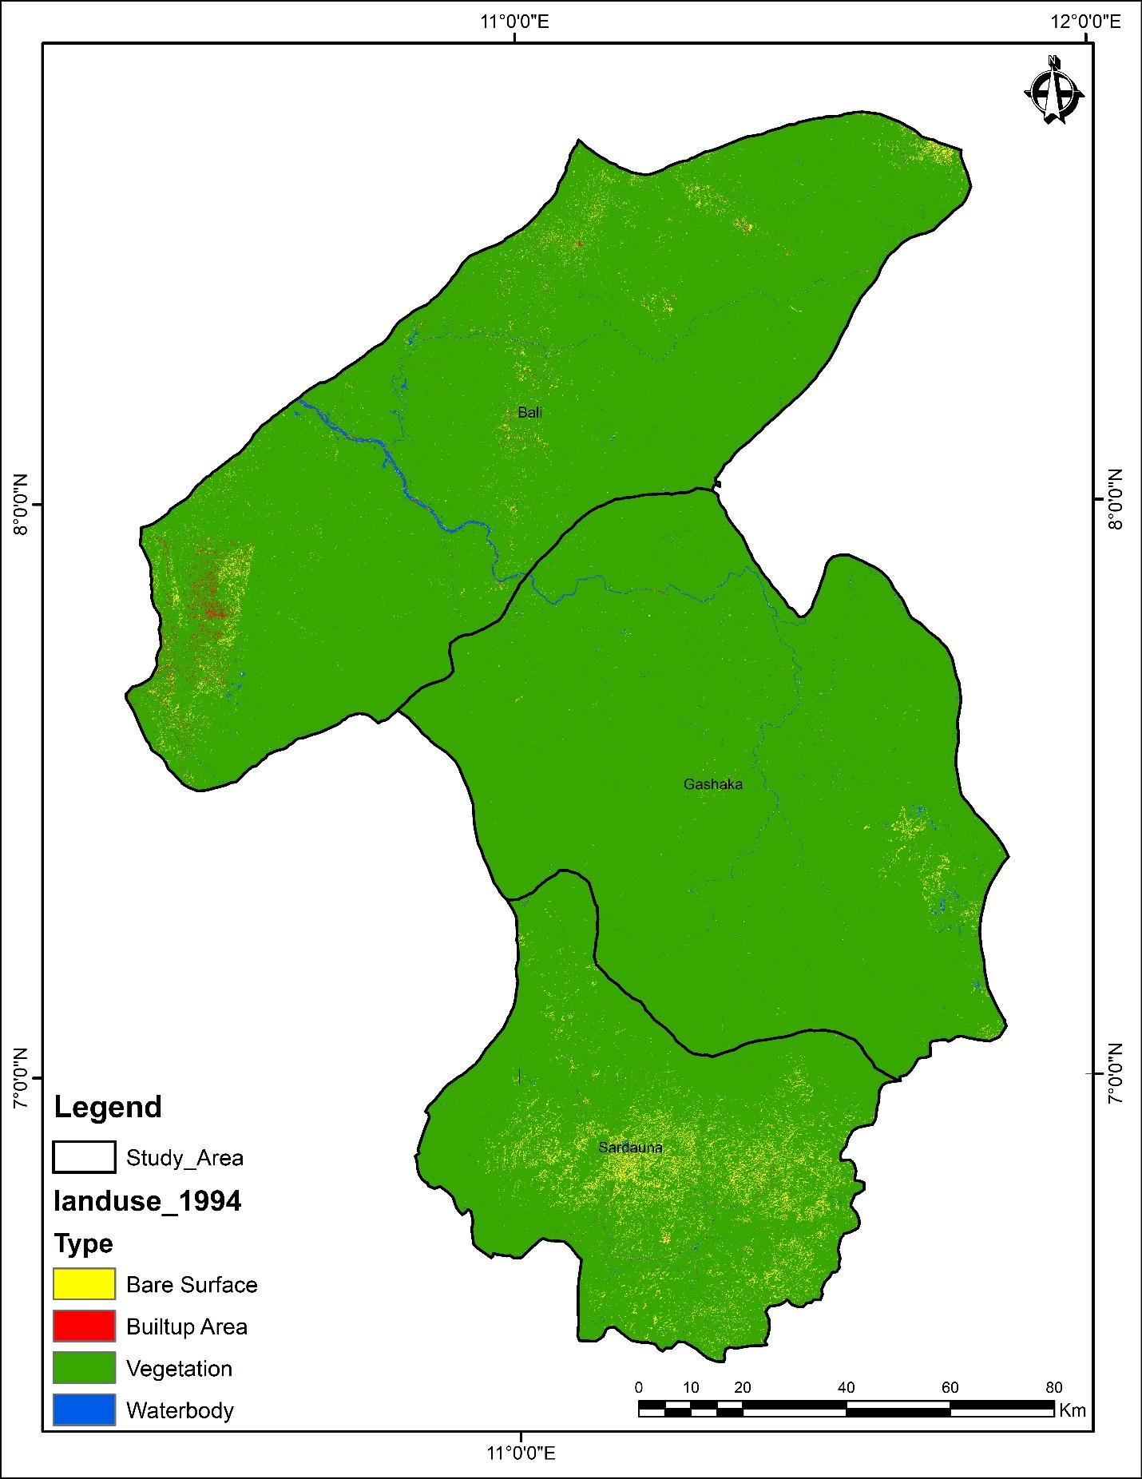
Fig 3: Land use map of 1994

Vegetation cover experienced a dramatic decline from 97.29% in 1994 to 69.15% in 2024. This decline aligns with periods of peak ASM activity. However, the degradation is attributable not only to mining activities but also to widespread deforestation, exposure of bare soil, and ecological instability resulting from the disruption of the rhizosphere, the complex root-soil interactions formerly maintained by tree vegetation. This is often followed by excavation activities such as modular digging or circular aspirations characteristic of ASM techniques. Bare surfaces rose from 2.05% to 29.71%, reflecting land degradation, topsoil removal, and erosion due to mining.

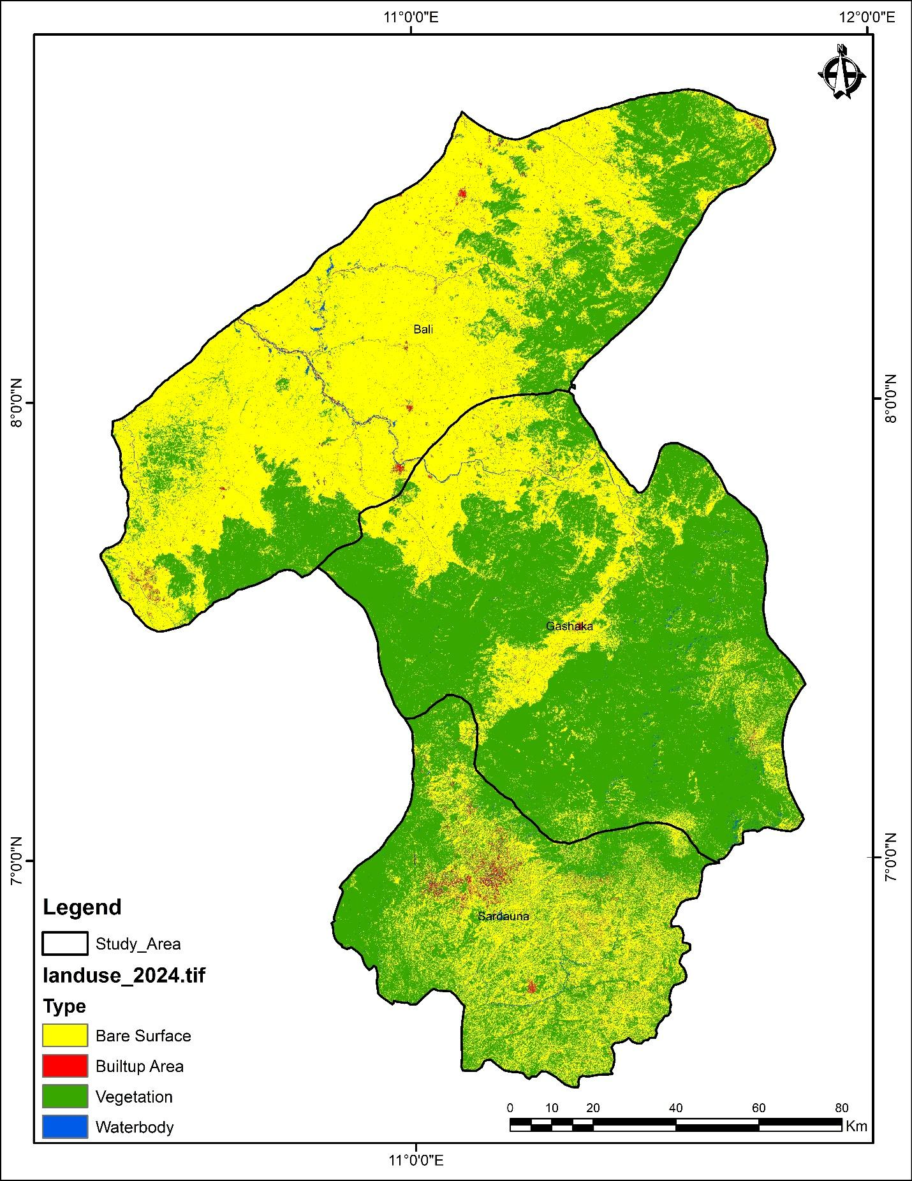
Fig 4: Land use map of 2024

Built-up areas show inconsistent spatial trends, which likely reflect the impermanent nature of ASM-related settlements. These settlements are often established rapidly in response to resource availability and are abandoned just as quickly, resulting in fluctuating development patterns rather than consistent urban expansion. This may explain the seemingly erratic figures seen across the time series. Further, the minor fluctuations in waterbody area, though not forming a consistent temporal trend could be associated with seasonal sedimentation, mining runoff, or hydrological alterations around excavation zones
4.0 Discussion
The study revealed a substantial decline in vegetation cover in Nigeria’s Central Zone, from 97.29% in 1994 to 69.15% in 2024, representing a 28.14% reduction over three decades. This dramatic decrease corresponds closely with areas where artisanal and small-scale mining (ASM) activities intensified, particularly in forested and agricultural zones. These patterns strongly suggest that vegetation loss is not incidental but directly tied to ASM-driven land conversion and deforestation practices.
The findings align with prior studies reporting widespread ecological disturbances from ASM in other Nigerian states. For instance, Ogundele et al. (2017) documented a 35% vegetative loss in Plateau State due to similar extraction practices, while Musa et al. (2024) noted forest decline in Zamfara as a result of unregulated mining. Such cases reinforce the link between ASM and the disruption of land cover integrity through excavation, vegetation clearing, and alteration of soil structures.
Bare surface expansion from 2.05% in 1994 to 29.71% in 2024 also reinforces the strong connection between ASM and land degradation. These transformations are characterized by topsoil removal, exposure of subsoils, and deforestation. Unstable terrain and gully formation observed during field visits are indicative of the long-term physical degradation of the landscape. This finding is consistent with empirical work by Nwibo and Okorie (2013), who documented how ASM in Ebonyi State left vast stretches of land devoid of vegetation and rendered infertile due to unfilled pits and soil toxicity. Similarly, Abubakar et al. (2019) highlighted that ASM activities in Kwara State led to surface scarring and irreversible terrain alteration, further confirming that the transformation of green cover into bare landscapes is a recurring environmental outcome of ASM across Nigeria.
Structural developments in ASM zones remain largely impermanent Adepoju et al. (2018). Field observations confirmed that many of these sites consist of temporary shelters, tool sheds, and transport corridors that vanish once resource yields decline. This impermanence explains the irregular growth trends in built-up areas, which contrast with consistent urban expansion observed in other studies.
The minor and inconsistent variations in waterbody area, though numerically marginal, were found to correspond with sedimentation events, altered water flow patterns, and pollution from tailings and heavy metals. These were particularly pronounced in mining clusters adjacent to rivers and streams. Similar contamination patterns were noted by Obaje (2009), underscoring the need for water quality monitoring and remediation.
Overall, the spatiotemporal evidence establishes a clear cause-effect link between ASM expansion and environmental degradation, especially in vegetation and soil integrity, while also drawing attention to the indirect effects on water and settlement dynamics.
5.0 Conclusion
This study confirms that artisanal and small-scale mining (ASM) has significantly altered land use and environmental balance in Nigeria’s Central Zone over the past three decades. These impacts are most evident in the large-scale reduction of vegetative cover, expansion of deforested (bare) surfaces, and degradation of water quality in riverine mining areas. The spatial and statistical findings clearly establish ASM as a principal driver of environmental transformation, especially through vegetation removal, topsoil disruption, and surface scarring.
Field-based observations supported the satellite-derived evidence, reinforcing that ASM activities not only alter land cover but also contribute to physical instability and declining ecosystem services. Built-up area trends further reveal that ASM settlements are often temporary and unplanned, reflecting the transient and informal nature of mining camps.
These findings highlight the urgency for policy-makers, researchers, and community leaders to align environmental management efforts with the spatial realities of ASM expansion. By documenting these changes with scientific clarity, the study contributes to the knowledge base necessary for effective ecological rehabilitation and land-use planning in mining-affected areas.
6.0 Recommendations
Implement a national policy on sustainable ASM with environmental safeguards.
Introduce community-based land rehabilitation programs.
Strengthen satellite monitoring for real-time environmental surveillance.
Engage miners in participatory environmental education.

7.0 Disclaimer (Use of Artificial Intelligence Tools)
The authors affirm that no generative artificial intelligence technologies (e.g., ChatGPT, Copilot, or similar AI tools) were utilized during the writing, analysis, or editing of this manuscript. All data interpretation and content generation were conducted manually by the research team.
References
Aigbedion, I., & Iyayi, S. E. (2007). Environmental effect of mineral exploitation in Nigeria. International Journal of Physical Sciences, 2(2), 033–038. Journal Link: [International Journal of Physical Sciences (Academic Journals)](https://academicjournals.org/journal/IJPS)
Abubakar, R. B., Bada, I. A., & Opeyemi, S. (2019). Teaching outstanding mathematics lessons: pros and cons. In The COLLOQUIUM (Vol. 7, No. 1, pp. 127-136).
Barenblitt, A., Payton, A., Lagomasino, D., Fatoyinbo, L., Asare, K., Aidoo, K., ... & Wood, D. (2021). The large footprint of small-scale artisanal gold mining in Ghana. Science of the Total Environment, 781, 146644. https://doi.org/10.1016/j.scitotenv.2021.146644
Bansah, K. J., Dumakor-Dupey, N. K., Kansake, B. A., Assan, E., & Bekui, P. (2016). Socioeconomic and environmental implications of artisanal and small-scale mining (ASM): A case study of Ghana. Journal of Cleaner Production, 129, 683–690. DOI: [10.1016/j.jclepro.2016.03.085](https://doi.org/10.1016/j.jclepro.2016.03.085). Journal Link: [Journal of Cleaner Production](https://www.sciencedirect.com/journal/journal-of-cleaner-production)
Garvin, T., McGee, T. K., Smoyer-Tomic, K. E., & Aubynn, E. A. (2009). Community–company relations in gold mining in Ghana. Journal of Environmental Management, 90(1), 571–586. https://doi.org/10.1016/j.jenvman.2007.12.014
Hilson, G. (2002). Small-scale mining and its socio-economic impact in developing countries. Natural Resources Forum, 26(1), 3–13. https://doi.org/10.1111/1477-8947.00002
Hilson, G., & Potter, C. (2003). Why is illegal gold mining activity so ubiquitous in rural Ghana? African Development Review, 15(2–3), 237–270. https://doi.org/10.1111/j.1467-8268.2003.00032.x
Ibrahim, A. M., Okunlola, I. A., & Ogunkoya, O. O. (2021). Environmental impact of artisanal gold mining in Luku, North Central Nigeria. Environmental Earth Sciences, 80, 64. https://doi.org/10.1007/s12665-021-09392-4
Musa, K. O., Akpah, F. A., Akudo, E. O., II, J. B. A., Odoma, A. N., Shaibu, M. M., ... & Oyem, A. O. (2024). Anthropogenic Effects of Coal Mining on Water Resources in Parts of Northern Anambra Basin, North–central, Nigeria. health, 21, 22.
Obaje, N. G. (2009). Geology and mineral resources of Nigeria. Springer Science & Business Media. https://doi.org/10.1007/978-3-540-92685-6
Ogundele, L. T., Owoade, O. K., Hopke, P. K., & Olise, F. S. (2017). Heavy metals in industrially emitted particulate matter in Ile-Ife, Nigeria. Environmental research, 156, 320-325.
Tschakert, P., & Singha, K. (2007). Contaminated identities: Mercury and marginalization in Ghana’s artisanal mining sector. Geoforum, 38(6), 1304–1321. https://doi.org/10.1016/j.geoforum.2007.05.002

