Impact of silicon along with microbial supplements in enhancement of seed germination parameters of wheat seedlings (Triticum aestivum L. )

Abstract: The most important variable in determining the finished output of the main yield is seed germination and seedling growth. Effective seed germination is the first stage that affects the plant's establishment. The current study has been designed to observe the effects of silicon, silicon solubilizing bacteria and phosphate solubilizing bacteria on the seed germination and seedling growth parameter on varieties Golden Sharbati 306 and HD 2967 of wheat (Triticum aestivum L.) in the soil of district Rohtak, Haryana, India. This study aims to evaluate the effects of Silicon along with two combined doses of SSB and PSB on wheat crop. The experiment was performed in thermocol disposable containers. The effect of different concentration 5 and 7mg of silicon, 0.25 ,0.50, 0.75 and 1mg of SSB and PSB have been studied on seeds of wheat (Triticum aestivum L.) varieties Golden Sharbati 306 and HD 2967 . In this study Si, along with SSB and PSB has found quite effective at all parameters and decrease in 39.16% and 37.8% in MGT was observed in T5 and T6 than control in HD 2967 variety. Additionally, Markedly increase of 24.44% and 31.25% in CVG value in the T5 and T6 was observed than control in Golden Sharbati 306 variety. Furthermore a significant increase of 36.27% and 38.28% in CVG value was observed in T5 and T6 than control in HD 2967 variety, a significant increase of 2.08 and 1.87% in G value in T5 and T6 in HD 2967 variety than control. Consequently, combination of Si, SSB and PSB lead to rise of 28.18% and 29.33% in MDG in T5 and T6 in Golden Sharbati 306 variety in comparison to control. Similarly, an increase of 7.04% and 8.66 % in MDG value in T5 and T6 in HD 2967 variety than control. Hence, Si along with SSB and PSB in T5 and T6 in high amount enhance the growth of wheat seedlings. This knowledge can contribute to reducing the reliance on chemical phosphorus fertilizers, decreasing phosphorus accumulation in paddy soils, and mitigating environmental risks associated with non-point source pollution.
Key Words: Silicon, Silicon solubilizing bacteria, Phosphate solubilizing bacteria, seed germination, wheat crop
Introduction
Crop species around the world are challenged by climate change, and biotic and abiotic stressors significantly lower crop yields. At the current rate of crop production, it will be difficult to meet the growing food demand by 2050 due to the rapidly increasing global population. According to FAOSTAT data, wheat is the most produced cereal crop in the world, with an estimated 785 million metric tons produced in 2023. Therefore, in order to increase crop productivity, a variety of management technologies are needed. Notably, sustainability is essential to both the planet's and agriculture's future. In this regard, the application of better fertilizers, like Si fertilizer, can have a significant impact on plant characteristics and help to increase plant yield and health. Silicon fertilizers are safe for the environment, contribute significantly to better soil health, and give plants resistance to a range of biotic and abiotic stresses through a variety of mechanisms. It has been discovered that applying silicon fertilizers improves the physical, chemical, and nutrient qualities of soil (Tayade et al., 2022). Through the mobilization of Fe(II)-P phases from mineral surfaces, silicon addition has also been shown to significantly increase phosphorus mobility. Silicon has the potential to be significant for sustainable phosphorus management since it promotes soil respiration in phosphorus-deficient soils and is crucial in phosphorus mobilization in Arctic soils (Schaller et al.,2019).
Through a variety of processes, rhizospheric and endophytic plant-growth-promoting microorganisms (PGPMs) greatly increase plant growth and yield. It is well known that PGPMs generate phytohormones that control plant growth and development, including auxins, cytokinins and gibberellins (Adhikari et al., 2020; Kim et al., 2020). According to (Etsami and Maheshwari (2018), the interaction between PGPMs and plants has a substantial impact on biochemical and physiological traits, improving resistance to abiotic challenges such heat, drought, and salinity. Combining insoluble silicates with several PGPMs can improve heat-stressed plants (Chaganti et al. 2023). Silicon-solubilizing bacteria (SSB) improve plant root health by increasing nutrient availability, root development, and resistance to various stresses. SSB plays multiple roles in root health, making it crucial for sustainable agriculture. SSB improves soil nutrient bioavailability, particularly for silicon. SSB solubilizes insoluble silicates, allowing plants to access silicon for physiological processes such as cell wall strengthening and photosynthesis. It has been demonstrated that increased silicon availability enhances the uptake of other nutrients, especially phosphorus, which is frequently a limiting factor in many soils (Yadav et al., 2017).Silicon increases microbial activity, which benefits SSB and other beneficial microorganisms. It also releases more nutrients from silicate minerals, further enriching the soils (Bist et al., 2020).In order to solubilize the insoluble forms of silicates and phosphates necessary for crop growth, beneficial soil microorganisms like SSB and PSB are essential. The availability of silicon, which is essential for the structural integrity and stress resistance of plants, is improved by SSB. ). Another essential nutrient for plants is phosphorus, which is crucial for stress tolerance, root growth, and energy production (Kafle et al., 2019) Precipitation and fixation activities remove a considerable amount of phosphorus from soils. Because of this difficulty, further research is being done on phosphate solubilizing bacteria that can boost phosphorus availability and encourage plant growth (Pan et al., 2023).
Phosphate-solubilizing bacteria (PSB) are thought to be an effective, secure, commercially sustainable, and environmentally friendly environmentally friendly substitute to help plants absorb P that is fixed in the soil. Field research has shown that crops treated with both PSB and SSB together have better growth parameters than crops treated with either type of bacteria alone. Phosphorus availability is increased by the addition of phosphate-solubilizing microbes because they increase ion exchange and phosphatase enzyme activity (Kaur et al., 2015; Yadav et al., 2017).
When incubated with rock phosphate, several bacteria, including Pantoea, Burkholderia, Rhodococcus, Azotobacter, Xanthomonas, and Enterobacter, have demonstrated encouraging outcomes (Mahanta et al., 2018). In the rhizosphere, the small area around plant roots, these bacteria solubilize inorganic phosphates, allowing plants to absorb them (Gupta et al., 2014; Elhaissoufi et al., 2021; Alori et al., 2017). The application of SSB and PSB together improves soil health in addition to plant health itself. These bacteria promote microbial activity that improves aeration and water retention by forming aggregates that strengthen soil structure. By improving the decomposition of organic matter, this creates a more stable environment for root growth and gradually raises soil fertility (Kausadikar et al., 2023).
Around the world, wheat (Triticum aestivum L.) is a cereal crop that is extensively farmed (Cuong et al., 2020; Chang et al., 2022). It belongs to the Poaceae family. Around 808.44 million tons were produced globally in 2022 (Anonymous, 2024). The physiological processes of germination and dormancy of seeds are different, and the success or failure of the subsequent establishment of seedlings. According to Rana (2020), the output of the wheat crop increased by up to 8.1% from the previous year. gent upon the shift from dormancy to germination. This is a crucial developmental stage in the life cycle of higher plants. Following the dry seed consumes water (imbibition), the process of seed germination comes to an end once the radicles protrude. Unfavorable environmental factors, such as salinity, high temperatures, and drought, can hinder the germination of seeds. Co application of silicon along with microbial supplements is expected to benefit the wheat crop. Overall, the data points to the importance of consuming enough silica for preserving bone strength and general health.
Both agricultural productivity and human health are improved by the use of silicon-solubilizing bacteria (SSB) and phosphate-solubilizing bacteria (PSB).However, research on the synergistic effects and combined application of siliceous material along with microbes for seed germination is very scarce. Keeping above in view, the objectives of this study were to study the combined and single effects of Si and PSB and SSB on seed germination parameter.
Material and methods:
Experimental site :
The current investigation was conducted from October to November of 2023 in Baba Mastnath University's Department of Botany, Ashtal Bohar, Rohtak, Haryana, India. The village of Ashtal Bohar is located in the Rohtak district of the state of Haryana. It spans 1668 square kilometers and is located between latitudes 28°40'30" N and 29°05'35" N and longitudes 76°13'22" E and 76° 51'20" E. The region experiences hot summers and an arid to semi-arid climate.. The texture of the soil was loamy sand, its pH was 7.5, its reaction was slightly alkaline, its organic carbon content was low (0.12%), and

Potash availability is high (321.0 kg/ha), available phosphorus availability is medium (22.2 kg/ha), and nitrogen availability is medium (177 kg/ha). A semi-arid climate prevails in the area, with an average annual temperature of 24.8°C and 443 mm of precipitation. From May to October, the Southwest monsoon is responsible for about 90% of the yearly precipitation. The lowest and highest mean maximum temperatures were recorded in January and May, respectively. With the exception of the monsoon season, humidity is typically low. The district grows its main crops during Rabi and Kharif seasons. The principal crops grown during rabi are wheat, mustard and peas.
Collection of the wheat seeds and chemicals:
Wheat seeds:
The certified and healthy seeds of selected wheat variety HD 2967 and Golden Sharbati 306 (Triticum aestivum L.) were collected from “The Haryana State Seed Certification Agency”, Rohtak, India.
Chemicals: Silicon fertilizer, Silicon solubilizing bacteria (SSB) and Phosphate solubilizing bacteria (PSB) are purchased from Akshar Chem. Private limited , Mumbai.
Experiment in Disposable Thermocol Glasses:
The wheat seeds of inferior quality were discarded by floating in tap water After being surface sterilized for five minutes with a 0.01% mercuric chloride solution to rid them of surface pathogens, healthy, uniformly sized seeds were repeatedly cleaned with double distilled water (DDW). . The experiment was tested in disposable thermocol glasses with seven treatment including control. Each treatment and control were replicated thrice. In accordance with the treatments, recommended doses of Silicon, Silicon solubilizing bacteria and Phosphate solubilizing bacteria fertilizers were given as basal application at the time of sowing . Seeds of two wheat varieties, HD 2967 and Golden Sharbati 306 , were sown in thermocol disposable glasses’ s soils. Five seeds per glasses were sown.
Treatment index : The arrangement of thermocol glass was done in the following way:
•Control: Garden soil + wheat seeds
• Treatment 1: Garden soil +5mg Si +0.25mg SSB +wheat seeds
•Treatment 2: Garden soil +5mg Si +0.50mg SSB+ wheat seeds
•Treatment 3: Garden soil + 5mg Si+0.25mg SSB+0.25mgPSB+wheat seeds
•Treatment 4: Garden soil +5mg Si+0.50mg SSB +0.50mg PSB+ wheat seeds
•Treatment 5: Garden soil+7mgSi+0.75mg SSB+0.75mgPSB+wheat seeds
•Treatment 6: Garden soil +7mg Si+1mgSSB+1mgPSB.+wheat seeds
Determination of Seed Germination Parameters
Different growth parameters such as germination percentage, relative germination rate, germination index, mean germination time, coefficient of velocity of germination, mean germination rate , peak value , mean daily germination were measured by the following methodology and equations:
1. Germination percent is the percentage of seeds that sprouted dividing by the total number of seedlings calculated by 100.
2. Mean Germination Time (MGT) = G×/G, where G is the number of seeds germinated on day X and G is the number of seeds germinated on day G.
3. Coefficient of Velocity of Germination (CVG) = X1+X2+.X3......+ /100 ×X1T1+...+XiTi; where X is the number of seeds germinated per day and T is the number of days from seeding corresponding to X.
4. The mean germination rate (MGR) is calculated as Coefficient velocity/100 = 1/T, where T is the mean germination time.
5. X1/1+X2/2+ X3/3.. +Xi/i was the formula used to calculate the Germination Rate Index (GI), where X1 is the amount of germination at day 1, X2 at day 2, X3 at day 3, and so on.
6. Germination index (GI) = (15×X1) +(14×X2) + ... +(1×X15)
7 The following formula was used to determine germination (G): Number of seeds germinated / Days of first count + + …number of seeds that sprouted divided by the final count days (seed day-1)
8. Mean Daily Germination (MDG) was calculated according to the formula
MDG = GP/D
9. The highest quotient obtained from the total cumulative full-seed germination percentages on any given day or number of days to reach that percentage is known as the peak value (PV).
Statistical analysis
MS Excel was utilized to statistically analyze the data using analysis of variance (ANOVA).The treatment means were analyzed by Turkey HSD Test at p value<0.05.

Results and discussion:
Effect of Silicon and Silicon solubilizing bacteria and Phosphate solubilizing bacteria in various amount on seed germination parameters:
- Mean Germination Rate (MGR), Mean Germination Time (MGT),Germination Index (GI)
Silicon, SSB, PSB has been found effective in promoting in germination of wheat seeds and resulted in significant increase in values of MGR,MGT ,GI values on both varieties than control. Markedly decrease of 20.15 and 18.89% in MGT value in the T5 and T6 was observed than control in Golden Sharbati 306 variety. Furthermore a significant decrease of 39.16% and 37.8% in MGT value was observed in T5 and T6 than control in HD 2967 variety in Figure(1B).
Interaction of Si supplementation along with SSB and PSB lead to rise of rise of 25 %and 33.33% in MGR value in the T5 and T6 in comparison to control in both the varieties in
Figure (1A).
- Mean Germination Rate (MGR) B. Mean Germination Time (MGT)
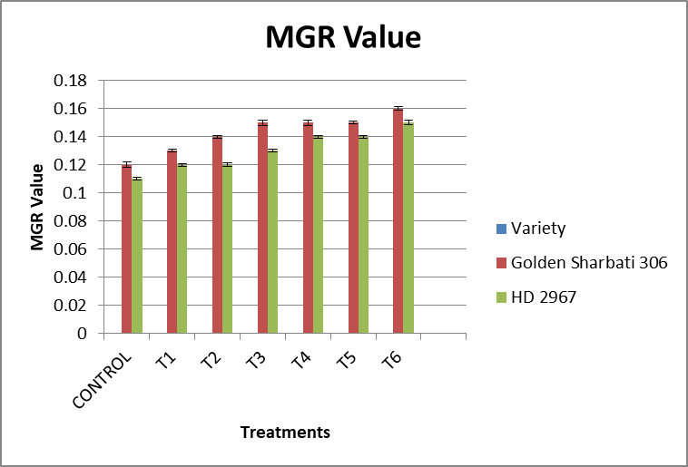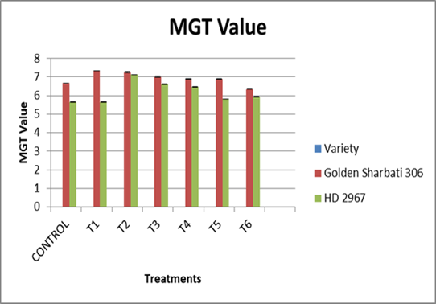
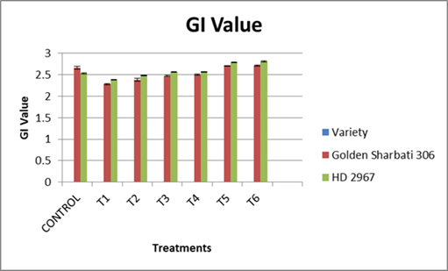
C. Germination Index (GI)

Figure 1. Influence of Si, SSB and PSB on Mean Germination Rate (A) Mean Germination time (B), and Germination Index(C)
Data shown in the figure indicates Mean ± SE; Two-factor analysis with Tukey’s HSD post hoc test; Each bar with a distinct letter differsed significantly among treatments as well as varieties (p<0.05). The symbols in the figure represent respectively Control: Garden soil + Wheat seeds , T1: Garden soil+ Si (5mg) +SSB(0.25mg)+ wheat seeds , T2: Garden soil+ Si (5mg) +SSB(0.50mg)+wheat seeds, T3: Garden soil+ Si (5 mg) + SSB(0.25 mg )+PSB (0.25mg )+wheat seeds, T4: Garden soil +Si (5mg)+SSB (0.50mg) + PSB ( 0.50mg)+wheat seeds, T5: Garden soil+ Si(7mg)+SSB(0.75 mg)+PSB (0.75mg)+ wheat seeds,T6:Garden soil+ Si(7mg),SSB (1mg)+PSB(1mg)+wheat seeds
Consequently, Si addition with SSB and PSB shows a significant rise of 21.95% and 24.39% in GI value in T5 and T6 in comparison to control in Golden Sharbati 306 respectively in Figure (1C). Furthermore an increase of 6.72% and 7.11% in GI value was observed in T5 and T6 in comparison to control in HD 2967 variety in Figure(1C).
- Germination (G),Germination percentage(G%),Peak Value
Silicon, SSB, PSB has been found effective in promoting in germination of wheat seeds and resulted in significant increase in values of G , G% and Peak values on both varieties than control. Markedly increase 1.78% and 2.06% in G value was observed in T5 and T6 in Golden Sharbati in comparison to control.
Additionally, a significant increase of 2.08 and 1.87% in G value in T5 and T6 in HD 2967 variety than control in Figure (2A).
Interaction of Si supplementation with SSB and PSB resulted in rise of 5.96% and 6.28% in G% value in T5 and T6 in Golden Sharbati 306 in comparison to control. Furthermore, a rise of 5.32 and 4.53% in G% value in T5 and T6 in HD 2967 variety in comparison to control in Figure (2B).
- Germination (G) value B. Germination Percent (G%) value
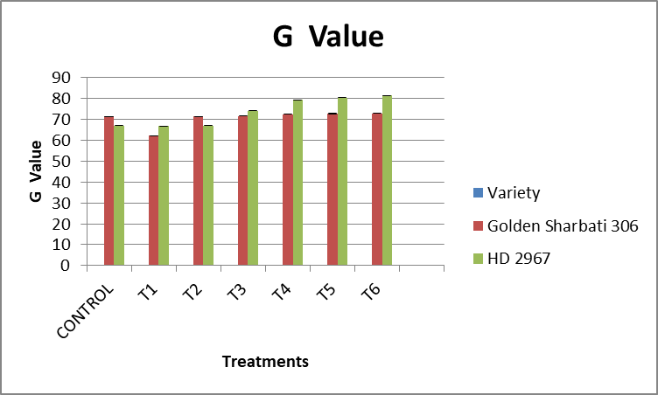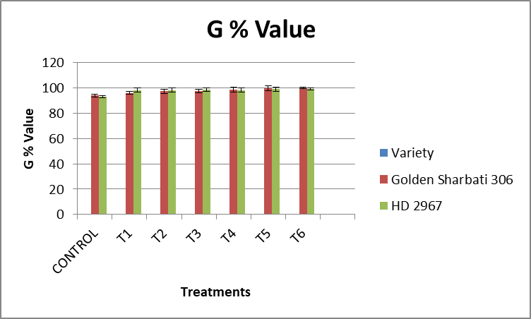
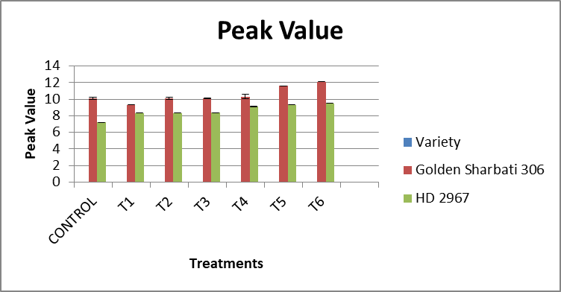
C.Peak Value
Figure 2. Influence of Si, SSB and PSB on Germination (G) value(A), Germination Percent (G%) value (B), and Peak value (C)
Data shown in the figure indicates Mean ± SE; Two-factor analysis with Turkey’s HSD post hoc test; Each bar with a distinct letter differed significantly among treatments as well as varieties (p<0.05). The symbols in the figure represent respectively Control: Garden soil + Wheat seeds , T1: Garden soil+ Si (5mg) +SSB(0.25mg)+ wheat seeds , T2: Garden soil+ Si (5mg) +SSB(0.50mg)+wheat seeds,T3: Garden soil+ Si (5 mg) + SSB(0.25 mg )+PSB (0.25mg )+wheat seeds, T4: Garden soil +Si (5mg)+SSB (0.50mg) + PSB ( 0.50mg)+wheat seeds, T5: Garden soil+ Si(7mg)+SSB(0.75 mg)+PSB (0.75mg)+ wheat seeds,T6:Garden soil+ Si(7mg),SSB (1mg)+PSB(1mg)+wheat seeds

Similarly, Si addition with SSB and PSB shows a significant rise of 14.85% and 20% in Peak value in T5 and T6 in comparison to control in Golden Sharbati 306 variety. Furthermore an increase of 29.49% and 32.11% in Peak value was observed in T5 and T6 in comparison to control in HD 2967 variety in Figure(2C).
- Coefficient of velocity of germination (CVG), Mean Daily Germination (MDG)
Silicon, SSB, PSB has been found effective in promoting in germination of wheat seeds and resulted in significant increase in values of CVG and MDG values on both varieties than control. Markedly increase of 24.44% and 31.25% in CVG value in the T5 and T6 was observed than control in Golden Sharbati 306 variety. Furthermore a significant increase of 36.27% and 38.28% in CVG value was observed in T5 and T6 than control in HD 2967 variety in Figure (3A).

A.Coefficient of Velocity of Germination B. Mean Daily Germination(MDG)
(CVG) Value value
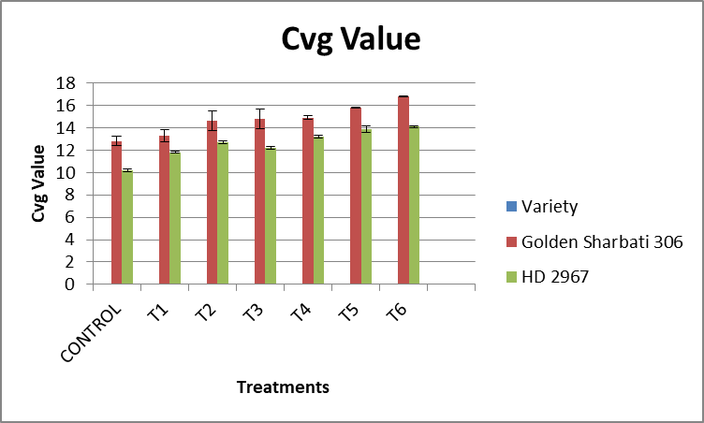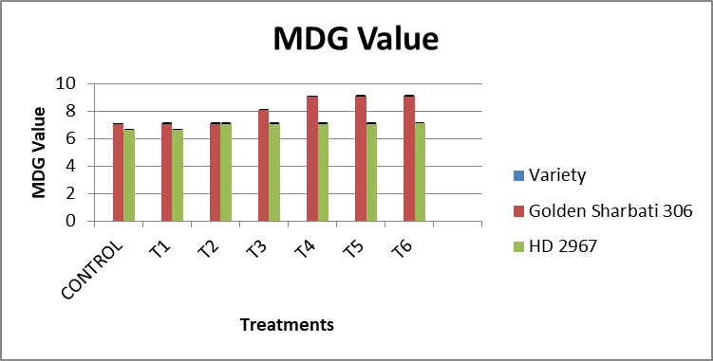
Figure3. Influence of Si, SSB and PSB on Coefficient of Velocity of Germination (CVG) value(A),Mean Daily Germination ( MDG) value (B)
Data shown in the figure indicates Mean ± SE; Two-factor analysis with Turkey’s HSD post hoc test; Each bar with a distinct letter differed significantly among treatments as well as varieties (p<0.05). The symbols in the figure represent respectively Control: Garden soil + Wheat seeds , T1: Garden soil+ Si (5mg) +SSB(0.25mg)+ wheat seeds , T2: Garden soil+ Si (5mg) +SSB(0.50mg)+wheat seeds,T3: Garden soil+ Si (5 mg) + SSB(0.25 mg )+PSB (0.25mg )+wheat seeds, T4: Garden soil +Si (5mg)+SSB (0.50mg) + PSB ( 0.50mg)+wheat seeds, T5: Garden soil+ Si(7mg)+SSB(0.75 mg)+PSB (0.75mg)+ wheat seeds,T6:Garden soil+ Si(7mg),SSB (1mg)+PSB(1mg)+wheat seeds
Consequently, combination of Si, SSB and PSB lead to rise of 28.18% and 29.33% in MDG in T5 and T6 in Golden Sharbati 306 variety in comparison to control. Similarly, an increase of 7.04% and 8.66 % in MDG value in T5 and T6 in HD 2967 variety than control in Figure (3B).
Conclusion: A key component in determining the overall yield and biomass generated of any crop is seed germination, which is the first set of plant establishment. This study displayed how inoculating wheat plants with Si, SSB,PSB had positive effects on their MGR , MGT, G% , GI , MDG value, Peak value. These results demonstrate the potential of Silicon, SSB and PSB as useful tactics for promoting wheat growth. Phosphate-solubilizing bacteria (PSB) and silicon-solubilizing bacteria (SSB) are two multifaceted approaches that improve crop productivity while also indirectly improving human health. In addition to improving nutrition through higher crop yields and improved nutrient content, this synergy reduces the need for chemical fertilizers, which can be harmful to the environment and public health. Furthermore, the use of SSB and PSB improves microbial diversity and activity, which is essential for soil fertility and nutrient cycling, thereby preserving soil health. As a result, farmers can more effectively incorporate these tools into their operations to boost ecosystem services and increase crop yields. However, the advancement of biofertilizer technology for successful adoption requires a multidisciplinary approach involving farmers, microbiologists, and agronomists. To confirm the advantages of biofertilizers in various settings and guarantee their scalability for broad use, long-term research and field tests are crucial. In the end, biofertilizers present a viable way to advance sustainable agriculture, increase food security, and lessen the negative environmental effects of contemporary farming methods.
Disclaimer (Artificial intelligence)
Option 1: option 1
Author(s) hereby declare that NO generative AI technologies such as Large Language Models (ChatGPT, COPILOT, etc.) and text-to-image generators have been used during the writing or editing of this manuscript.
Option 2:
Author(s) hereby declare that generative AI technologies such as Large Language Models, etc. have been used during the writing or editing of manuscripts. This explanation will include the name, version, model, and source of the generative AI technology and as well as all input prompts provided to the generative AI technology
Details of the AI usage are given below:
1.
2.
3.

References
- Rana, A. W. (2020). Rationalization of Wheat Markets in Pakistan: Policy Options. Washington, DC: International Food Policy Research Institute. doi: 10.2499/p15738coll2.133728
- Cuong, D. M., Kwon, S.-J., Nguyen, B. V., Chun, S. W., Kim, J. K., and Park, S. U. (2020). Effect of salinity stress on phenylpropanoid genes expression and related gene expression in wheat sprout. Agronomy 10:390. doi: 10.3390/agronomy10030390
- Lark, T. J., Schelly, I. H., and Gibbs, H. K. (2021). Accuracy, bias, and improvements in mapping crops and cropland across the United States using the USDA cropland data layer. Remote Sens. 13:968. doi: 10.3390/rs13050968
- Ahmed, H. G. M. D., Zeng, Y., Raza, H., Muhammad, D., Iqbal, M., Uzair, M., ... & El Sabagh, A. (2022). Characterization of wheat (Triticum aestivum L.) accessions using morpho-physiological traits under varying levels of salinity stress at seedling stage. Frontiers in Plant Science, 13, 953670.
- Samal, D. K., & Sukla, L. B. (2024). Assessment of potent Phosphate-Solubilizing Bacteria isolated from Rice Fields in Odisha and Unraveling their Growth-Promoting Efficacies. Geomicrobiology Journal, 41(2), 135-148.
- Wang, W., Sun, X., Zheng, F., Zhang, Z., Wang, Z., Qu, L., & Hong, X. (2024). Salt–alkali-resistant phosphate-solubilizing bacterium: Kushneria sp. YCWA18 improves soil available phosphorus and promotes the growth of Suaeda salsa. Journal of Plant Growth Regulation, 43(1), 272-282.
- Ramegowda, V., Senthil, A., & Senthil-Kumar, M. (2024). Stress combinations and their interactions in crop plants. Plant Physiology Reports, 29(1), 1-5.
- Dönmez, D., Isak, M. A., İzgü, T., & Şimşek, Ö. (2024). Green Horizons: Navigating the future of agriculture through sustainable practices. Sustainability, 16(8), 3505.
- Wei, J., Zhang, Q., Zhang, Y., Yang, L., Zeng, Z., Zhou, Y., & Chen, B. (2024). Advance in the thermoinhibition of lettuce (Lactuca sativa L.) seed germination. Plants, 13(15), 2051.
- Bhatla, S. C., & Lal, M. A. (2023). Seed dormancy and germination. In Plant physiology, development and metabolism (pp. 625-640). Singapore: Springer Nature Singapore.
- Etesami, H. (2025). Unveiling a Hidden Synergy: Empowering Biofertilizers for Enhanced Plant Growth With Silicon in Stressed Agriculture. Plant, Cell & Environment, 48(3), 2411-2433.
- Anonymous.Economic survey of India. Economics Division, Ministry of Finance, Government of India; 2023
- Adhikari, A., Kafle, A., & Kim, K. S. (2020). Role of beneficial microbes in sustainable agriculture. Frontiers in Plant Science, 11, Article 1065.
- Etesami, H., & Jeong, B. R. (2018). Role of PGPRs in enhancing abiotic stress tolerance. Frontiers in Microbiology, 9, Article 1203. 849-859.
- Bist, V. S., Kumar, R. A. K., & Singh, A. (2020). Soil health management. Soil Biology, 58, 113-122.
- Kafle, A., Adhikari, A., & Kim, K. S. (2019). Phosphorus availability enhancement. Agronomy Journal, 111(5), 2362-2371.
- Pan, L., & Cai, B. (2023). Phosphate-solubilizing bacteria: Advances in their physiology, molecular mechanisms and microbial community effects. Microorganisms, 11(12), Article2904.
- Gupta, A., Gupta, R., & Gupta, P. (2014). Phosphate solubilization potential. Journal of Microbiology, 52(1), 95-103.
- Mahanta, D., Das, P., & Dutta, P. (2018). Phosphate solubilization potential. Journal of Microbiology, 56(3), 213-220.
- Elhaissoufi, M., Elhadi, A., & Belghit, A. (2021). Phosphate-solubilization potential. Applied Soil Ecology, 167, Article 104065.
- Alori, E. T., Glick, B. R., & Daryaei, M. (2017). Phosphate-solubilizing microorganisms. Microbial Ecology, 73(4), 849-859.
- Kausadikar, P., Patil, S., & Patil, V. (2023). Soil health management through microbial interactions. Soil Biology, 170, Article 108421.
- Chaganti, C., Phule, A. S., Chandran, L. P., Sonth, B., Kavuru, V. P. B., Govindannagari, R., & Sundaram, R. M. (2023). Silicate solubilizing and plant growth promoting bacteria interact with biogenic silica to impart heat stress tolerance in rice by modulating physiology and gene expression. Frontiers in Microbiology, 14, 1168415.
- Haque, M. A. (2024). Effect of Seed Priming on Germination Behavior and Emergence of Wheat (Triticum aestivum L.). Journal of Agriculture and Ecology Research International, 25(2), 53–61. https://doi.org/10.9734/jaeri/2024/v25i2584.

