Case report

Investigation and treatment of iodine deficiency in a buffalo calf

Abstract
Iodine is crucial for ensuring proper growth and survival in the early developmental stages of young calves. Its deficiency can impair thyroid function, leading to hormonal imbalances that affect skin and hair health. This report describes the diagnosis and successful treatment of iodine deficiency in a one-month-old female buffalo calf presented with history of inappetence and generalized alopecia. Skin scrapings, biochemical, minerals and hormonal analyzes revealed low levels of triiodothyronine and thyroxine. The calf was treated with oral levo-thyroxine (Thyronorm; 75mcg, ABBOTT IND. LTD) @20 mcg/kg PO for one month. Marked clinical improvement was observed following therapy. Thus, generalized alopecia in female buffalo calf may be attributed to iodine deficiency. In conclusion, this case highlights the importance of early diagnosis and therapeutic management of iodine deficiency in young calves to ensure optimal growth and development.
Keywords: Alopecia, triiodothyronine, Levo-thyroxine, Iodine
Introduction
“Iodine is essential for the thyroid gland and thyroid hormone production” (Walther et al. 2018). “Thyroxine and triiodothyronine contain 65% and 59% of iodine, respectively” (SCF 2002; Mikláš et al.2021). “These hormones regulate key processes of metabolism, brain development” (Grau et al. 2015) and growth (SCF 2002). “Therefore, iodine is very important for maintaining physiological processes” (Flachowsky et al. 2014). “According to several authors, the lactating cows require intake of 0.5 mg iodine/kg dry matter” (van der Reijden et al. 2017). “On the other hand, according to Commission Regulation (EC) No 1459/2005, the lactating cows should not consume more than 5 mg iodine/kg dry matter. That reflects the importance of the iodine intake regulation in dairy animals” (Flachowsky et al. 2014) due to a risk of their iodine overconsumption (Kursa et al. 2005), but more importantly because of its impact on human nutrition (Flachowsky et al. 2014). Not observing the lower limits of iodine intake requirements in dairy animals causes goitre, higher incidence of stillbirths, and increased embryonal mortality (Schone and Rajendram 2009). In animal nutrition iodine is supplied by feeds and additional supplementation, which is essential for ensuring the sufficient intake of iodine (Flachowsky et al. 2014). “On conventional farms it is most often administered using mineral and vitamin premixes and in ecological farming it is via mineral licks” (Schone and Rajendram 2009). “The mineral supplements contribute 10-40 mg iodine/day to dairy cow’s iodine intake” (Troan et al. 2015) “and therefore they represent an important source of iodine for farm animals. Concentrations of iodine in forages reach up to 0.2 mg/kg dry matter” (Flachowsky et al. 2014), which is comparable with Travnicek et al. (2004), who “determined iodine content in grass silage (213.3 ± 169.3 μg/kg dry matter). Moreover, it is also possible to administer organically bound iodine to dairy animals, using algae” (Travnicek et al. 2010; Brito 2020). “Iodine concentration in milk is influenced to a great extent by iodine intake in feed” (Flachowsky et al. 2014; Rezaei Ahvanooei et al. 2021).
Hair loss (alopecia) is a complex condition that remains not fully understood in both humans and animals. Throughout life, alopecia can be broadly categorized into inflammatory and non-inflammatory types. In buffalo calves, most reported cases of alopecia are attributed to ectoparasitic infestations such as Haematopinus spp. (Arunachalam et al. 2013), Ctenocephalides felis (Iqbal et al. 2012), mange (Purohit et al. 1997; Naresh et al. 2005), as well as endocrine disturbances, seasonal shedding, and genetic disorders. Among livestock, nutritional iodine deficiency tends to play a more significant role than thyroid gland dysfunction, particularly in regions where iodine levels are naturally low.
Case presentation
One month old female buffalo calf was presented to the Veterinary Clinical complex, Abhilashi University, Himachal Pradesh with the history of loss of appetite, alopecia in various parts of the body (Fig.1). The clinical examination of skin revealed rough hair coat with alopecia, moderately thickened and fissured skin along with scaling throughout the body. The severity of skin lesions increased significantly within a span of two weeks. The rectal temperature and other vital parameters like heart rate and pulse rate were within the normal range. Skin scrapings were collected to examine the presence of fungus and mites. Plucked hairs and scrubbed scales were also examined for fungal agents by direct microscopy in 10% KOH and lactophenol. Samples were also inoculated on mycobiotic agar and then plates were incubated at 28°C for 2-6 weeks and were further examined for colony formation. Various liver tests, minerals and thyroid hormone profile were also assessed. Serum AST, ALT, ALP, albumin and bilirubin were analyzed by chemistry analyzer (IDEXX vet test TM kit, manufactured by IDEXX laboratories, USA) as per standard diagnostic protocol. Mineral (Se, Zn, Cu, Co, and Fe) digestion was done by Microwave digestion System model MDS-10 of SINEO Microwave Chemistry Technology Co. Ltd. China and estimation by Inductively Coupled Plasma – Optical Emission Spectrometry (ICPOES) as per the manufacturer's instructions (Thermo Scientific Ltd. USA). Serum T3 and T4 concentrations were determined in duplicate using a coated tube radioimmunoassay kit, that has been validated for use in cattle (Millar and Albyt, 1985) according to the manufacturer’s instructions (Coat-A-Count® Total T3 and Coat- A-Count® Total T4; Diagnostic Products Corporation, Los Angeles, California, USA). Estimation of TSH was not performed, as its concentration remains very low during the initial months after birth and shows minimal variation up to 4–5 months of age (Jain et al. 2006).
Skin scrapings and cultural examination does not reveal any probable cause. All the analyzed liver enzymes (Table 1) and minerals (Table 2) were within the normal range. The T4 and T3 concentration was 33 nmol/L (normal range: 59.57 ± 1.53nmol/L; Singh et al. 2008) and 1.2 nmol/L (normal range: 1.47 ± 0.05 nmol/L; Ingole et al. 2012), respectively. Based on anamnesis and diagnostic profiling, the calf was diagnosed to be suffering from iodine deficiency. It was administered levo-thyroxine @ 20 mcg/kg (Thyronorm; 75mcg, ABBOTT IND. LTD) PO for 1 month. Post-treatment evaluation (Fig. 2) showed marked improvement in clinical signs, including restoration of appetite, disappearance of alopecic patches and normalization of skin texture. No adverse reactions to the treatment were observed.
Discussion
“Milk iodine intake is mostly dependent on the concentrates consumed by animals” (Troan et al. 2015). “However, as already mentioned, the iodine content of most concentrates is less than 0.1 mg/kg” (Haldimann et al. 2005), 0.2 mg/kg in forages (Flachowsky et al. 2014), “due to the mostly poor iodine content in soils and in this connection also in plants” (Travnicek et al. 2006). Therefore, in practice the oral iodine supplementation is mostly used, in form of mineral premixes and lick stones (Schone and Rajendram 2009) that mainly fulfil iodine demand (van der Reijden et al. 2017). Thus, oral supplementation is crucial for optimal iodine intake in animals (Franke et al. 2009). “Thyroid hormones, triiodothyronine (T3) and thyroxine (T4) in conjunction with growth hormone and insulin stimulate protein synthesis and reduce nitrogen excretion. This coordinated action supports growth, regulates metabolism, and ultimately influences productivity” (Van Knegsel et al. 2007; Meikle et al. 2004). “Triiodothyronine is an active thyroid hormone; derived from direct thyroid gland production and its conversion from T4” (Sesmilo et al. 2011) “occurs via the action of 5′-deiodinase enzymes outside of the thyroid gland. Among domestic animals, thyroid function and its diseases are well known in companion animals but less so in livestock” (Kaneko et al. 1997). “The importance of thyroid function and related diseases has also become progressively more important as the production of livestock has increased” (Meikle et al. 2004). “Iodine is an essential mineral obtained from the diet which is required for thyroid hormone synthesis. The detrimental effects of iodine deficiency or excess have been well reported in the veterinary literature and are characterized, classically, by thyroid hyperplasia, growth retardation, and fetal and neonatal death” (Paulikova et al. 2002). “Serum levels of T4, FT4, T3 and FT3 in a cattle herd have been shown to be increased in hyperthyroidism and decreased in hypothyroidism” (Sesmilo et al. 2011). The free (non–protein bound) fractions are biologically active and a better measure of thyroid gland functions. In cases of alopecia in ruminants, the diagnostic tests employed in this study are valuable for reaching an accurate diagnosis. Furthermore, iodine deficiency should be evaluated as a potential underlying cause during treatment planning.
Conclusion
This case underscores the significance of considering endocrine causes along with mineral (iodine) deficiencies in dermatological presentations like alopecia in young ruminants and demonstrates the effectiveness of levo-thyroxine in therapeutic management. Further studies on iodine supplementation strategies, early diagnostic markers and regional mineral mapping in livestock may enhance prevention and therapeutic outcomes in iodine-related disorders.

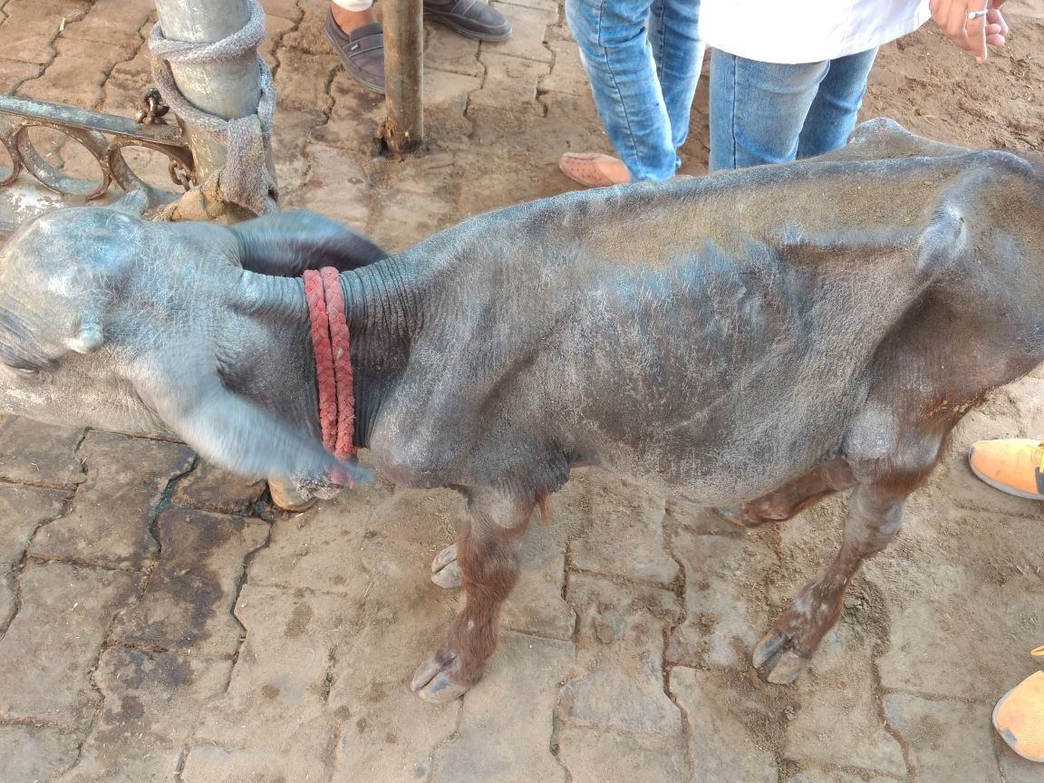
Fig. 1: Alopecia in various parts, thickening and scaling of the skin

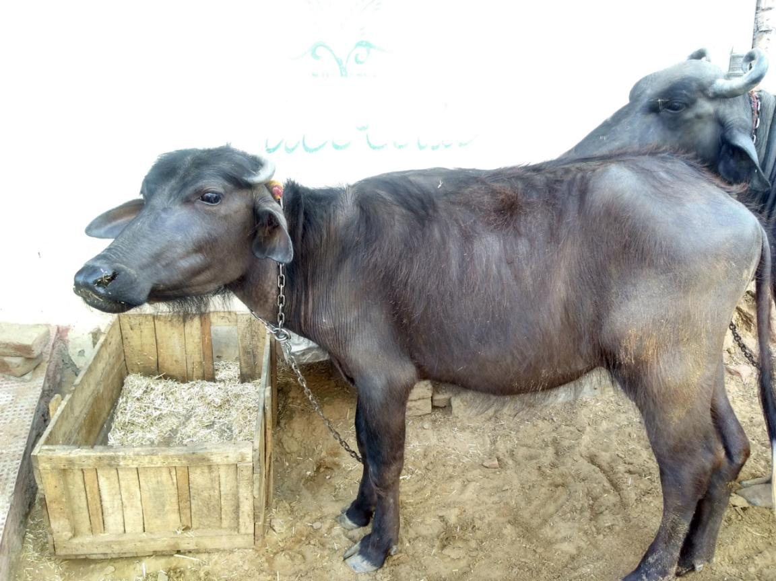
Fig. 2: Hair reappeared in regions previously affected by alopecia

Table 1: Biochemical profile of buffalo calf
S.No. | Enzyme | Level | Value
 | Serum Aspartate amino transferase (AST/ SGOT) (IU/litre) | 128.7 | 78-132 (Underwood et al. 2015)
 | Serum alkaline phosphatase SAP (IU/litre) | 27.4 | 27.85 (Bishr et al. 2025)
 | Serum Gamma glutamyl transferase (GGT) (IU/litre) | 7.42 | 6.2–26.2 (Hue et al. 2021)
 | Total Serum Bilirubin (mg/dl) | 0.41 | 0.1-0.8 (Dhillon et al. 2020)
 | Total serum proteins (g/dl) | 7.15 | 5.63 - 8.10 ( Maheta, 2022)

Table 2: Mineral profile of buffalo calf

- No. | Mineral | Value (mg/L) | Range (mg/L)
1. | Selenium | 0.019 | 0.018-0.109 (Stahl et al. 2024)
2. | Copper | 0.138 | 0.124- 0.213 (Sallam et al. 2009)
3. | Zinc | 0.88 | 0.75-0.76 (Amaravathi et al. 2016)
4. | Cobalt | 0.01 | 0.01 - 0.16 (Jadhav et al. 2018)
5. | Fe | 3.88 | 2.89 - 4.22 (Kochan et al. 2023)

Ethical Approval
Animal Ethic committee approval has been collected and preserved by the author(s)
Disclaimer (Artificial intelligence)
Author(s) hereby declare that NO generative AI technologies such as Large Language Models (ChatGPT, COPILOT, etc.) and text-to-image generators have been used during the writing or editing of this manuscript.

References
Amaravathi, M., Bharath, R., & Jyosthna, D. (2016). Clinical, haemato-biochemical and managemental studies of zinc deficiency in a calf. International Journal of Advanced Research in Biological Sciences, 3(3), 227-229.
Arunachalam, K., Raman, M., Harikrishnan, T. J., & Anna, T. (2013). Efficacy of deltamethrin against lice infestation in buffalo calves. Buffalo Bulletin, 32(3), 162-164.
Bishr, N. M., Abdel-Rahman, A. A., Ashour, A. M., Abu-Setta, M. H., Ghomim, A., & Ibrahim, H. M. (2025). Biochemical, hematological and immunological influence of toxoplasmosis and neosporosis in bovine models from Delta, Egypt. Egyptian Journal of Veterinary Sciences, 59(1), 1-2.
Brito, A. F. (2020). Assessing the potential of milk iodine intake to mitigate iodine deficiency in pregnant women of the United States via supplementation of Ascophyllum nodosum meal to dairy cows: A sensitivity analysis. Journal of Dairy Science, 103(8):6798-809.
Commission Regulation (EC) No 1459/2005 of 8 September 2005 amending the conditions for authorisation of a number of feed additives belonging to the group of trace elements. OJEU 2005 Sep 9;L233: 3 p.
Dhillon, K. S., Randhawa, C. S., Gupta, K., Singh, R. S., & Chhabra, S. (2020). Reference values for haematological and biochemical profile in adult Indian buffaloes. Buffalo Bulletin, 39(2), 145-154.
Flachowsky, G., Franke, K., Meyer, U., Leiterer, M., Schone, F. (2014). Influencing factors on iodine content of cow milk. European Journal of Nutrition, 53(2), 351-65.
Franke, K., Meyer, U., Wagner, H., Flachowsky, G. (2009). Influence of various iodine supplementation levels and two different iodine species on the iodine content of the milk of cows fed rapeseed meal or distillers dried grains with soluble as the protein source. Journal of Dairy Science, 92(9), 4514-23.
Grau, G., Aguayo, A., Vela, A., Aniel-Quiroga, A., Espada, M., Miranda, G., Martinez-Indart, L., Martul, P., Castano, L., Rica, I. (2015). Normal intellectual development in children born from women with hypothyroxinemia during their pregnancy. Journal of Trace Elements in Medicine and Biology, 1(31), 18-24.
Haldimann, M., Alt, A., Blanc, A., Blondeau, K. (2005). Iodine content of food groups. Journal of Food Compostion and Analysis, 18(6), 461-71.
Hue, D. T., Skirving, R., Chen, T., Williams, J. L., Bottema, C. D., & Petrovski, K. (2021). Colostrum source and passive immunity transfer in dairy bull calves. Journal of Dairy Science, 104(7), 8164-8176.
Ingole, S. D., Deshmukh, B. T., Nagvekar, A. S., & Bharucha, S. V. (2012). Serum profile of thyroid hormones from birth to puberty in buffalo calves and heifers. Journal of Buffalo Science, 1(1), 39-49.
Iqbal, A., Bhutta, M. S., Khan, M. K., & Furhaad, Z. (2012). Concurrent infestation of buffalo calves with Ctenocephalides felis strongylus and piroplasms. Pakistan Veterinary Journal, 32(1), 144-146.
Jadhav, R. K., Dar, A. A., Dimri, U., Kumar, P., & Sharma, M. C. (2018). Mineral profile of water buffaloes under different physiological and production status in Western Maharashtra. Indian Journal of Animal Sciences, 88(2), 186-190.
Jain, A. K., Sharma, I. J., Tripathi, R. K., Agrawal, R. G., & Quadri, M. A. (2006). Status of thyroid hormones and development of internal defense of neonatal buffalo calves and cow calves from precolostral feeding through 91 days. Buffalo Bulletin, 25(4), 73-78.
Kaneko, J. J. (1997). Thyroid function. In: Kaneko, J.J., Harvey, J.W. and Bruss, M.L. (Eds.), Clinical Biochemistry of Domestic Animals. Academic Press, San Diego, pp. 571-588.
Kochan, A., Simsek, A., & Arica, E. (2023). Serum mineral levels and haematobiochemical parameters in buffalo calves with allotriophagy (pica syndrome). Veterinary Medicine and Science, 9(2), 123-130.
Kursa, J., Herzig, I., Travnicek, J., Kroupova, V. (2005). Milk as a food source of iodine for human consumption in the Czech Republic. Acta Veterinaria Brno, 74(2), 255-64.
Maheta, P. J. (2022). Effect of feeding complete feed block on blood biochemical profiles in calves of Surti buffalo (Bubalus bubalis). Indian Journal of Animal Nutrition, 39(1), 45-50.
Meikle, A., Kulcsar, M., Chilliard, Y., Febel, H., & Delavaud, C. (2004). Effects of parity and body condition at parturition on endocrine and reproductive parameters of the cow. Reproduction, 127(6), 727-737.
Millar, K. R., Albyt, A. T. (1985). Evaluation of RIA kits for the measurement of thyroid hormones in sheep and cattle sera. New Zealand Veterinary Journal, 33, 116-117.
Naresh, R., Swarup, D., Sharma, M. C., & Ranjan, R. (2005). Clinical management of sarcoptic mange in Indian buffalo calves with a botanical ointment. Veterinary Record, 156(21), 684-685.
Purohit, G. N., Vyas, S. K., & Yadav, S. B. S. (1997). Efficacy of ivermectin treatment for sarcoptic mange in Surti buffalo calves. Indian Veterinary Journal, 74(8), 689-690.
Rezaei Ahvanooei, M. R., Norouzian, M. A., Hedayati, M., Vahmani, P. (2021). Effect of potassium iodide supplementation and teat-dipping on iodine status in dairy cows and milk iodine levels. Domestic Animal Endocrinology, 74: 5 p.
Sallam, A. A., Moghney, A. F. (2009). A case report: copper deficiency syndrome in a buffalo farm in Behaira Governorate. Alexandria Journal of Veterinary Sciences, 30(1), 110-115.
SCF – Scientific Committee on Food. Opinion of the Scientific Committee on Food on the tolerable upper intake level of iodine. Brussels (Belgium): European Commision-Health and Consumer Protection Directorate- General; 2002 Oct 7. 25 p.
Schone, F., Rajendram, R. Iodine in farm animals. In: Preedy VR, Burrow GN, Watson R, editors. Comprehensive handbook of iodine: Nutritional, biochemical, pathological and therapeutic aspects. Amsterdam (NL): Academic Press; 2009. p. 151-70.
Sesmilo, G., Simo, O., & Choque, L. (2011). Serum free triiodothyronine (T3) to free thyroxine (T4) ratio in treated central hypothyroidism compared with primary hypothyroidism and euthyroidism. Endocrinologia y Nutricion, 58, 9-15.
Singh, R. A., Garg, S. L., Sangwan, N., & Gerai, S. (2008). Peripheral concentration of thyroid hormones in buffaloes suffering from foreign body syndrome. Haryana Veterinarian, 47, 115-116.
Stahl, L. T., Büttner, K., Krohn, J., & Wehrend, A. (2024). Serum selenium concentrations in neonatal calves: Influence of postnatal selenium injection and health status. Canadian Veterinary Journal, 65(10), 1041-1047.
Travnicek, J., Kroupova, V., Konecny, R., Stankova, M., Stastna, J., Hasonova, L., Mikulova, M. (2010). Iodine status in ewes with the intake of iodine enriched alga Chlorella. Czech Journal of Animal Science, 55(2), 58-65.
Travnicek, J., Kroupova, V., Soch, M. (2004). Iodine content in bulk feeds in western and southern Bohemia. Czech Journal of Animal Science, 49(11), 483-8.
Troan, G., Dahl, L., Meltzer, H. M., Abel, M. H., Indahl, U. G., Haug, A., Prestlokken, E. (2015). A model to secure a stable iodine concentration in milk. Food & Nutrition Research, 59(1): 9 p.
Underwood, W. J., Blauwiekel, R., Delano, M. L., Gillesby, R., Mischler, S. A. & Schoell, A. (2015). Biology and diseases of ruminants (sheep, goats, and cattle). Laboratory Animal Medicine. Academic Press, pp. 623-694.
van der Reijden, O. L., Zimmermann, M. B., Galetti, V. (2017). Iodine in dairy milk: Sources, concentrations and importance to human health. Best Practice & Research Clinical Endocrinology & Metabolism, 31(4), 385-95.
Van Knegsel, A. T. M., Van den Brand, H., Graat, E. A. M., Dijkstra, J., Jorritsma, R., & Tamminga, S. (2007). Dietary energy source in dairy cows in early lactation: metabolites and metabolic hormones. Journal of Dairy Sciences, 90(3), 1477-1484.
Mikláš Š., Tančin V., Toman R., Trávníček J. (2021): Iodine concentration in milk and human nutrition: A review. Czech J. Anim. Sci., 66: 189–199.

