Original Research Article
Monitoring of Permethrin Resistance in Houseflies Around the Experimental Animal Center

Abstract:
This study was conducted from 2023 to 2025 to assess the resistance of houseflies (Musca domestica), which is a significant disease vector, to permethrin in diverse environments surrounding the Experimental Animal Center of Chiang Mai University. These environments included forests, farmlands, markets, indoor areas, and villages. Houseflies were collected using bait and netting methods, then classified and subjected to toxicity tests using a topical application technique to determine resistance levels. The findings indicate that, although housefly populations in this region have developed permethrin resistance over approximately two decades, the environmental diversity has helped slow this progression compared to other areas. Given the importance of maintaining controlled environments, especially in barrier laboratories, pyrethroid insecticides like permethrin are commonly used due to their safety and environmental compatibility. However, prolonged and exclusive use increases the risk of resistance development. As permethrin is widely used across different sectors, the threat of resistance is becoming increasingly critical. To mitigate this issue, the study recommends maintaining ecological diversity around the center and implementing targeted resistance management strategies based on bioassay data to ensure effective vector control.
Keywords: resistance monitoring, biosafety, medial lethal dose, R language, Experimental Animal Center

- Introduction
Biosafety ensures the safe handling of biological agents to prevent accidental exposure and environmental release. Without proper safeguards, unintended pathogen spread or ecological disruptions could occur, making biosafety essential for scientific advancement and sustainability. Controlling the source of animals is one approach to addressing microbial and parasitic risks in experimental animals (Liu Qishuai et al., 2022; Yang Guolin et al., 2017). During daily operations, experimental animal centers inevitably utilize animal feed and generate waste. As long as there is an exchange of solid, liquid, or gaseous materials between the experiment center and the external environment, these factors can attract vector organisms such as flies and mosquitoes. These vectors also serve as significant ectoparasites for experimental animals, including important vectors like the housefly (Musca domestica), a dipteran insect (Diptera: Muscidae) and a human symbiont organism (Malik A et al., 2007). Various stages of the housefly's life cycle can interfere with human production and daily life in multiple ways, such as causing or exacerbating food spoilage and acting as vectors for numerous pathogens (Wang Dong et al., 2015). This makes the control of houseflies particularly important. In the past, various methods have been used to manage houseflies, such as biological control, physical control, and chemical control. Among these methods, chemical control has the following characteristics: First, it acts quickly, significantly reducing the target pest population in a short time, making it highly effective for controlling sudden pest outbreaks. Broad-spectrum chemical control agents can even target multiple pests simultaneously with a single application. Second, it is convenient to use, adaptable to various application methods, and suitable for large-scale implementation. Third, it requires small quantities and is cost-effective. The convenient application method of chemical control allows it to be combined with other pest management approaches, better achieving Integrated Pest Management (IPM) (Fan Dong, 2022). However, chemical control also has notable drawbacks, such as the tendency to induce pesticide resistance in target pests and the resulting cascade of issues. Increased resistance leads to higher usage and concentration of chemical pesticides, gradually putting non-target organisms at greater risk with previously more environmentally friendly agents. This can trigger secondary pest outbreaks or even severe ecological imbalances (Tabashnik BE, 1989). The rise in pesticide usage also elevates potential health risks, both for applicators and humans exposed to treated environments. Therefore, pesticide resistance monitoring is particularly critical. Resistance monitoring provides a basis for developing pest control strategies and helps slow the development of resistance (Ma Zhuo et al., 2019). For experimental animal center facilities, monitoring pests around the facilities helps ensure the secure operation of containment systems. Permethrin is a common pyrethroid insecticide that possesses excellent characteristics of this class, such as environmental friendliness, low toxicity to higher animals, and high efficacy, among others. It is widely used in many countries and regions but also carries the risk of fostering pest resistance. This study integrates previous research data to monitor the development of permethrin resistance in houseflies around the Experimental Animal Center of Chiang Mai University from 2023 to 2025, aiming to provide a reference for the biosafety assurance of the center's laboratories.
2 Materials and Methods
2.1 Housefly
The houseflies used in the study were collected from areas within a radius of approximately 10-kilometer around the experimental animal center from 2023 to 2025. The collection sites were diverse, including woodlands, indoor areas, markets, farmlands, and villages. The collection of houseflies involves placing bait and then netting the adult flies. Beef is naturally exposed to the open air for 24 hours in advance to serve as bait. For each trapping session, approximately 150 grams of the prepared beef is used, and adult flies are collected using a net. Eggs of flies were collected at some sampling sites. After identification and classification, the collected flies were transferred to the field collection and breeding area in the laboratory. Houseflies from different habitats are reared together under controlled conditions (Freeman JC et al., 2019; Li Xue et al. 2025): relative humidity of 50±10%, a 12:12-hour light-dark cycle, and a temperature cycle of 25±2°C. Adult flies were fed a mixture of defatted milk powder and granulated sugar (1:1 volume ratio) along with drinking water. The larval diet consisted of pig liver. The larval rearing boxes measured 200*90*50mm, filled with approximately one-quarter of their volume in wood shavings. Medical-grade absorbent cotton with a diameter of about 15mm is used for localized moisture retention and water supply. The wood shavings in the rearing boxes serve not only as a habitat but also provide an environment for mature larvae to pupate. After the pupae emerge as adults, they are reclassified and identified within 2-5 days. Female adults are then used for laboratory bioassays.
2.2 Pesticides and Bioassays
The insecticide used in this study was permethrin (99.7% purity, chemservice, PA, USA).
The bioassay was conducted following the methods described by the National CDC (2016) and Freeman et al. (Freeman JC et al., 2019) as outlined below: A topical application method was used to assess toxicity. The insecticide was diluted with acetone to prepare a stock solution, which was then serially diluted into five concentration gradients. Based on preliminary experiments, the permethrin concentrations were formulated as 12.5, 25, 50, 100, and 200 mg/kg. Test insects were anesthetized with carbon dioxide until comatose. A Hamilton microsyringe was used to topically apply 1 μL of the test solution per insect. Through conversion, the corresponding dose gradients for toxicity determination were thus calculated as 12.5, 25, 50, 100, and 200 ng per insect. The acetone solution of permethrin was applied to the thoracic dorsum of female houseflies. Each treatment used 30 female houseflies aged 3–5 days post-eclosion, with 1 µL of solvent acetone applied topically per fly as the blank control. The experiment was replicated three times independently. The treated insects were transferred into clean containers with adequate ventilation and provided with a 15%(w/v) sucrose solution as the food source. After 24 hours of standard rearing, mortality was recorded. Insects were considered dead if they exhibited complete immobility, abdominal dorsoventral inversion, convulsions, or ataxia preventing locomotion.
2.3 Data Analysis
The mortality data obtained from experimental studies were subjected to regression analysis using R software (version 4.3.3). The probit analysis was performed by fitting the relationship between mortality and corresponding concentrations, where the logarithm of dose (or concentration) served as the independent variable, and the probit unit [calculated as qnorm (mortality proportion) + 5] was defined as the dependent variable. From the regression equation, the medial lethal dose (LD₅₀) and its 95% confidence limits, the slope and intercept of the toxicity regression line, the chi-square value, and the coefficient of determination (R-squared) were determined (Sun Ruiyuan et al., 1989; Zhou Haijun et al., 1983; Jiang Xiaodong et al., 2011).
The R code used in this experiment is as follows. The sample data referenced in the code originated from the book "Statistical Methods for Biological Assay" (Zhou Haijun et al., 1983), primarily for illustrative purposes. Readers can input their own experimental data into Code 1-5 using R software to perform general toxicity bioassay analysis and visualization:
nCK <- 20 #Number of control insects
nCKS <- 20 # Number of control live insects
n <- c(20, 20, 20, 20, 20) # Number of Pre-treatment insects
r <- c(20,16,14,4,1) #Number of post-treatment insects
x <- log10(c(30.7, 38.4, 48, 60, 75)) #Dose logarithm as the independent variable
p <- 1-(nCK*r)/(nCKS*n) #Abbott's formula for corrected mortality rate
y <- ifelse(p == 0, 3.97 - 0.93 * log10(n), ifelse(p == 1, 6.03 + 0.93 * log10(n), qnorm(p) + 5))
# Mortality probability value qnorm()+5
u <- y-5; Z <- dnorm(u); P <- pnorm(u)
w <- ifelse(p %in% c(0, 1), 2.9/(n+6), Z^2/(P*(1-P))) #Calculate weight w
LDP <- lm(y~x, weights=w) #Weighted regression of mortality odds using weight coefficient w
Yee <- predict(LDP, data.frame(x)) #Expected death probability used for chi-square value
#To visually represent data distribution and regression line, use the following code
plot(x, y,
main = "", # Set title
xlab = "Log dose",
ylab = "Probit",
pch = 1, # hollow circle
col = "orange", #color
cex = 1.2, # point size
bg = NA, # Remove background
bty = "l") # border type
lines(x, Yee, col = "black", lwd = 2)
points(x, Yee, col = "blue", pch = 15)
# Add the regression equation and R-squared in the upper left corner
a <- round(coef(LDP)[1], 4) # Intercept
b <- round(coef(LDP)[2], 4) # slope
r2 <- round(summary(LDP)$r.squared, 4) # r.squared
text (min(x), max(y), pos = 4, labels = paste0("y = ", a, " + ", b, "x"), cex = 1.2, col = "black", font = 1)
text (min(x), max(y) - 0.08*(max(y)-min(y)), pos = 4, labels = paste0("r² = ", r2), cex = 1.2, col = "black", font = 1)
legend("bottomright", legend = c("Observed", "Expected"), col = c("orange", "blue"), pch = c(1, 15), cex = 0.8, box.col = NA) #End of plotting code
#Calculate chi-square value
Chi <- sum ((n*p-n*pnorm(Yee-5))^2/(n*pnorm(Yee-5)*(1-pnorm(Yee-5))))
p_value <- pchisq(Chi, length(n)-2, lower.tail = FALSE) #Chi-square cumulative distribution function value
mortality <- c(0.5)
m <- (5 + qnorm(mortality) - a) / b
LD₅₀ <- 10^m #Median lethal dose
MeanX <- sum(n*w*x)/sum(n*w)
Sxx <- sum(n*w*x^2) - sum(n*w*x)^2 / sum(n*w)
Sm1 <- (sqrt(1/sum(n*w)+(m-MeanX)^2/Sxx))/(b)
#Calculate the standard error Sm of logLD50
LD50confidence1 <- 10^(m+1.96*c(-1,1)*Sm1)
summary(LDP)
#Output result
cat(
"R-squared =", round(summary(LDP)$r.squared, 4), "\n",
", Adjusted R-squared =", round(summary(LDP)$adj.r.squared, 4), "\n",
", Intercept (a) =", round(coef(LDP)[1], 4), "\n",
", Slope (b) =", round(coef(LDP)[2], 4), "\n",
", LD₅₀ =", LD₅₀, "\n",
", confidence =", LD50confidence1, "\n",
", Chi-square value =", Chi, "\n",
", P(Chi-square value) =", p_value, "\n",
"\n"
) #Display by line
After statistical analysis of the experimental results, the coefficient of determination, adjusted coefficient of determination, LD₅₀ value and its 95% confidence interval, chi-square value, slope and intercept of the regression equation will be obtained, from which the regression equation can be derived. Resistance ratio is used to describe the degree of resistance, where resistance ratio = LC₅₀ (LD₅₀) value of the tested population / LC₅₀ (LD₅₀) value of the susceptible population. A population is considered resistant when the 95% confidence limits of the monitored subjects do not overlap with those of the laboratory-susceptible strain and the resistance ratio is ≥5-fold (Standards Press of China, 2011).
3. Results
Based on the live insect rearing and bioassay results sampled around the experimental animals center between 2023 and 2025, as shown in Table 1, the LD₅₀ for adult insects ranged from 50.3 to 59.3, with chi-square values between 5.2737 and 6.6502. Under the experimental design parameters of this toxicity bioassay (degrees of freedom, *n* = 5 – 2 = 3), the critical χ² value at a 0.95 probability level was 7.8147. All statistical results fell below this threshold, indicating no significant deviation between observed and expected mortality values (Sukontason K et al., 2005). This conclusion was further supported by the coefficient of determination (R²), with a minimum value of 0.9312 in the regression models. The resistance rations were 10.6-fold, 12.1-fold, and 10.3-fold, respectively. The specific LD₅₀ values, 95% confidence intervals, toxicity regression equations, and other statistical results for each year are shown in the table below.
Table 1 Results of Drug Resistance Testing for Houseflies Around the Laboratory Animal Center, 2023-2025
Year | LD₅₀  (ng/fly) |  | 95% confidence interval (ng/fly) |  | toxicity regression equation | Decision  coefficient |  |  | χ2 |  | Laboratory population LD50 (ng/fly) |  | Resistance Ratio
2023 | 52.0 | 44.3-61.0 |  | y = 1.8655x + 1.7995 |  |  | 0.9312 | 6.6502 |  | 4.9 (Sukontason K et al., 2005) |  | 10.6
2024 | 59.3 | 50.4-69.7 |  | y=1.8453x+1.7283 |  |  | 0.9543 | 5.5494 |  |  |  | 12.1
2025 | 50.3 | 43.4-58.4 |  | y = 2.0515x + 1.5085 |  |  | 0.9628 | 5.2737 |  |  |  | 10.3
The regression equations fitted to toxicity bioassay data of houseflies from 2023 to 2025 are illustrated in Figures 1, 2, and 3. Combined with Table 1, figures reveal that
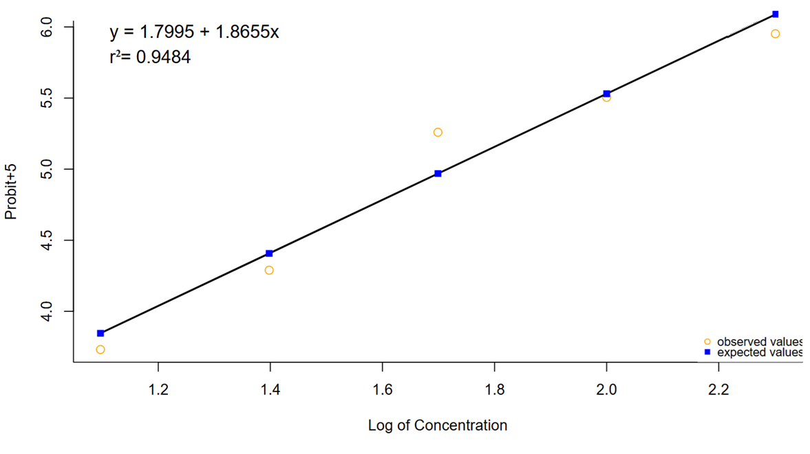

Figure 1 Regression equation for toxicity bioassay of houseflies in 2023

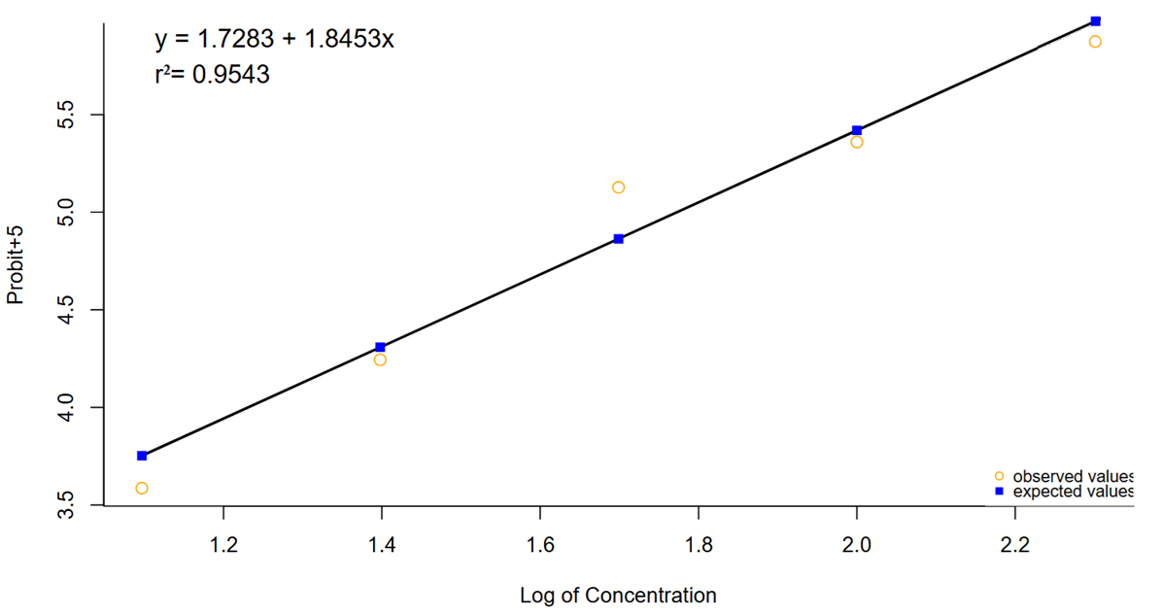

Figure 2 Regression equation for toxicity bioassay of houseflies in 2024

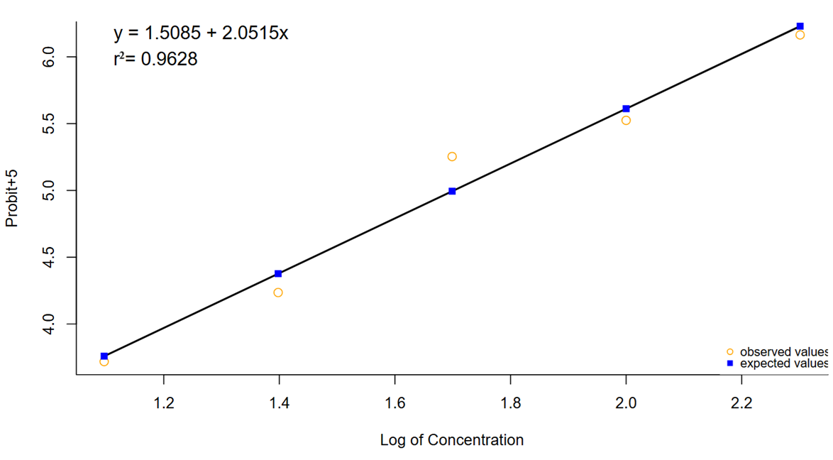

Figure 3 Regression equation for toxicity bioassay of houseflies in 2025

the LD₅₀ values fluctuated moderately across the three years but remained within the range of 50–60 ng/insect. Notably, the data from all three years shared the following characteristics: Observed responses (hollow circles in the plots) exhibited heightened sensitivity as the log(dose) approached the probit value of 5 (corresponding to 50% mortality). This was reflected by steeper slopes between the first and third data points, followed by a gradual reduction in slope magnitude. In Figures 1–3, the third observed value showed greater deviation from the regression line compared to other points, potentially indicating variability in dose-response dynamics. The cumulative mortality-concentration (dose) curve typically follows an asymmetric sigmoidal ("S-shaped") pattern. However, log(dose) transformation normalizes the distribution of insecticide sensitivity, converting the asymmetric curve into a symmetrical one, as demonstrated in the linearized probit models (Mu Liyi, 1994)." The slight deviation of the intermediate orange data points from the regression lines in Figures 1-3 (scatter plots) can be attributed to various factors, such as the need for additional experimental replicates to stabilize the measurement results or the development of pesticide resistance in pests, which warrants further investigation. Nevertheless, the reliability of the three models is supported by both the coefficient of determination (R²) values in Table 1 and the chi-square test results, which collectively indicate acceptable goodness-of-fit.
4. Discussion
Pyrethroid insecticides are a class of highly effective and broad-spectrum synthetic insecticides. Their chemical structures mimic natural pyrethrins derived from chrysanthemum plants, featuring rapid knockdown of pests, low mammalian toxicity, and environmental friendliness, making them widely utilized in pest control (Burns CJ et al., 2018). The latter two features, in particular, make pyrethroid insecticides commonly used for vector control in the surrounding environment of the experimental animal center. The routine operations within the center—including the storage and distribution of animal feed, disposal of residual feed, management of animal excreta, and handling of animal carcasses—tend to attract pest vectors such as houseflies. Inadequate vector control in surrounding areas would pose significant challenges to maintaining the biosecure environment essential for animal facilities. However, long-term and exclusive use of pyrethroid insecticides can lead to an increase in the frequency of resistance genes within pest populations. Studies have demonstrated that the development of insecticide resistance is strongly correlated with the selection pressure imposed by these chemical agents (Zhang Jie et al., 2021). Based on this analysis, it is believed that the above factors can, to some extent, explain why the resistance ratios of houseflies in this study were 10.6-fold, 12.1-fold, and 10.3-fold, respectively, compared to the results of the 2005 study (Sukontason K et al., 2005). In the 2005 study results, the laboratory population's LD₅₀ was 4.9 ng/fly, with a 95% confidence interval(CI) of 2.6–19.7 ng/fly. In contrast, the current study recorded LD50 values of 50.3 ng/fly (95% CI: 43.4–58.4 ng/fly) for the year with the lowest toxicity threshold and 59.3 ng/fly (95% CI: 50.4–69.7 ng/fly) for the year with the highest threshold. Notably, these values exceed the 2005 baseline by over 10-fold (resistance ratio [RR] ≥ 10.3–12.1), and their 95% CIs show no overlap with those of the historical laboratory population. These data strongly suggest that over approximately two decades, housefly populations around the experimental animal center have developed resistance to permethrin. On the other hand, the experimental animal center in this study is surrounded by forests, farmland, villages, and markets, where the biodiversity of the environment plays a role in slowing the development of housefly resistance to insecticides. Over approximately 20 years, the highest resistance ratio reached 12.1-fold. Previous studies (Wang Q et al., 2023; Edi CA et al.,2014; Lee CY et al.,2024) suggest that a high environmental biodiversity index can delay the development of pest resistance in a given area. In contrast to previous monitoring studies on housefly resistance in other regions, housefly resistance to permethrin has escalated dramatically (with RR values exceeding 100-fold or even several hundred-fold in some areas) ( Freeman JC et al., 2019; Zhang Jie et al., 2021).
From the linear regression equation of toxicity bioassay, the scatter plots of observed values and distributions of predicted values exhibited similar characteristics over three consecutive years. The LD₅₀ and slope values remained remarkably similar. Notably, the third observed value, located in the middle of the range, showed a greater deviation from the regression line compared to other points. Although the coefficient of determination and chi-square test results confirmed the reliability of all three models, statistical principles underlying toxicity bioassays indicate that the mortality rate of test subjects is proportional not to the absolute increase in dose but rather to the "proportional increase in dose" (Mu Liyi, 1994). This principle is mathematically equivalent to the logarithmic transformation of dose/concentration gradients, which converts a geometric sequence (original dose series) into an arithmetic sequence (log-transformed values), thereby linearizing the dose-response relationship. In practice, this manifests as a well-designed toxicity bioassay where the response of insects to insecticides should remain relatively stable at and around the median concentration or dose gradient for a susceptible population. What is the reason for the relative deviation of the intermediate observed value in the aforementioned figure? Analysis suggests this is due to the pests developing a certain level of resistance to the pesticides. Generally, people tend to assume that when pests develop resistance, low concentrations or doses of insecticides become ineffective. This is intuitive, and it's not wrong to think this way. However, we shouldn't conclude that if pests develop resistance, we must first observe abnormalities in the low-concentration treatments set in toxicity bioassays. In practical applications, the primary objective of insecticide use is to achieve effective pest eradication, rather than targeting parameters like the LD₅₀ or concentration central to toxicity bioassays. The concentrations and doses employed in these two contexts differ substantially. Phenomena such as anomalous responses to low insecticide concentrations are typically observed during preliminary experiments. In formal toxicity bioassays, however, experimental designs are required to ensure that the tested dose/concentration gradients yield mortality rates encompassing both >80% and <20% across treatment groups (Standards Press of China, 2011). Therefore, even if the test insects have developed resistance, they typically exhibit robust responses to the low concentrations or doses in toxicity bioassays. As evidenced by Figures 1–3 of this study, however, the houseflies demonstrated reduced sensitivity beyond mid-range doses within the experimental design. This is attributed to the development of resistance in the test subjects. The findings, including the resistance ratio and the 95% confidence interval of the median lethal dose in toxicity bioassays, also support this view: houseflies in the vicinity of the experimental animal center are highly likely to have developed resistance. However, bioassays alone provide insufficient support for this hypothesis. The knockdown effect of pyrethroid insecticides is closely related to the sodium ion channels in insects, and the decreased sensitivity of the insect nervous system to pyrethroids is primarily associated with reduced sensitivity of sodium ion channels in nerve cell membranes (Cao Xiaomei et al., 2001; Chen B et al., 2015). Further studies should incorporate molecular biology experiments to determine whether gene mutations in sodium ion channels underlie the insecticide resistance observed in these houseflies the sodium ion channels in houseflies. Monitoring insecticide resistance is not only related to biosafety, but also an important part of the United Nations Sustainable Development Goals, it is essential to acknowledge this matter. Research suggests that, for ASEAN countries environmental SDG targets require more attention to ensure meaningful progress on sustainability goals (Elder M et al., 2022).
5. Conclusion
The houseflies in this study have developed resistance to permethrin. Therefore, to delay resistance development, continuous resistance monitoring and evaluation of resistance ratios are necessary. In addition to pyrethroid insecticides, monitoring resistance to insecticides with other modes of action is also crucial. If abnormally high resistance ratios are detected for a specific insecticide, immediate discontinuation of its use is required. For necessary pest control, rational rotation and mixture of insecticides with distinct modes of action—such as alternating organophosphates and insect growth regulators—should be implemented to slow resistance development. Using insecticide synergists (e.g., combining pyrethroids with synergists) can enhance efficacy. Additionally, the concept of IPM is also effective here, emphasizing environmental management (e.g., eliminating breeding sites by timely removal of garbage, feces, and decaying organic matter). Biological control methods can also be considered, such as natural enemy introduction or microbial agents. However, as the experimental animal center houses sensitive animal colonies, thorough risk assessments must precede the use of biological agents or natural enemies in adjacent areas to avoid new biosafety risks. Finally, optimizing chemical control methods can be considered, such as adopting targeted application technologies (e.g., electrostatic spraying for pest control to reduce chemical usage while improving efficacy), using slow-release microcapsule formulations to extend residual activity, and employing ultra-low volume (ULV) drone spraying technology for precision delivery. Being lightweight and flexible, the drone spraying method minimizes excessive localized dosing inherent in conventional high-volume sprays and may further delay resistance emergence.

DISCLAIMER (ARTIFICIAL INTELLIGENCE)
Author(s) hereby declare that NO generative AI technologies such as Large Language Models (ChatGPT, COPILOT, etc.) and text-to-image generators have been used during the writing or editing of this manuscript.

References
Liu Qishuai, Li Zhao, Ren Xiaoxia. (2022). Construction and Management of New Experimental Animal Centers under the Background of "Double First-Class" University Developement. Experimental Technology and Management, 39(9), 266-268. DOI: 10.16791/j.cnki.sjg.2022.09.045.

Yang Guolin, Li Yangyou, Su Chang, et al. (2017).Exploration on Construction and Management of Experimental Animal Barrier Systems. Modern Agricultural Science and Technology, (16), 236-237.

Malik A, Singh N, Satya S. (2007). House fly (Musca domestica): a review of control strategies for a challenging pest. Environmental Science and Health Part B, 42(4), 453-469. DOI:10.1080/03601230701316481.PMID: 17474025.

Wang Dong, Wang Yongming, Xin Zheng, et al. (2015).Advances and Challenges in Chemical Control of Flies. Chinese Journal of Hygienic Insecticides & Equipments, 21(3), 226-230. DOI: 10.19821/j.1671-2781.2015.03.003.

Fan Dong. (2022). General Entomology and Experiments . Chemical Industry Press: August 2022. 345.

Tabashnik BE. (1989). Managing resistance with multiple pesticide tactics: theory, evidence, and recommendations. Journal of Economic Entomology, 82(5), 1263-1269. DOI: 10.1093/jee/82.5.1263.PMID: 2689487.

Ma Zhuo, Zhou Xiaojie, Li Jing, et al. (2019). Investigation on resistance of Housefly populations to six common insecticides in Beijing, 2017. Chinese Journal of Vector Biology and Control, 30(1), 69-71.

Freeman JC, Ross DH, Scott JG. (2019). Insecticide resistance monitoring of house fly populations in the United States. Pesticide Biochemistry and Physiology, 158, 61-68. DOI: 10.1016/j.pestbp.2019.04.006.Epub 2019 Apr 20.PMID: 31378362.

Li Xue, Ling Feng, Qu Zhiqiang, et al. (2025). Monitoring of Resistance in Aedes albopictus to Common Insecticides in Nanning, 2022- to 2024. China Tropical Medicine. 1-10.
[2025-04-16].http://kns.cnki.net/kcms/detail/46.1064.R.20250220.1119.002.html.

Chinese Center for Disease Control and Prevention. National Vector Surveillance Program. Beijing: Chinese CDC,2016.Heart, 2016.

Sun Ruiyuan, Song Jianguo. (1989). Biological Assay Statistics. People's Medical Publishing House.

Zhou Haijun, Shen Yunru. (1983). Statistical Methods in Biological Assay. People's Medical Publishing House.

Jiang Xiaodong, Yan Zhengli, Zhou Guifeng. (2011). Application of R Program in Blis Methods for Calculating Medial Lethal Dose. Practical Preventive Medicine, 18(3), 431-432.

Standards Press of China. (2011). GB/T 26350-2010: Methods for testing insecticide resistance in flies—Bioassay for houseflies. Beijing, China: Standards Press of China.

Sukontason, K., Chaiwong, T., Tayutivutikul, J., Somboon, P., Choochote, W., Piangjai, S., et al. (2005). Susceptibility of Musca domestica and Chrysomya megacephala to Permethrin and Deltamethrin in Thailand. Journal of Medical Entomology, 42(5), 812-814. doi: 10.1093/jmedent/42.5.812.PMID: 16363164.

Mu Liyi, (1994). Research Methods in Plant Chemical Protection. China Agriculture Press.

Burns CJ, Pastoor TP. (2018). Pyrethroid epidemiology: a quality-based review. Critical Reviews in Toxicology, 48(4), 297-311. doi:10.1080/10408444.2017.1423463. Epub 2018 Feb 1. PMID: 29389244.

Zhang Jie, Lu Chonghua, Zong Lili, et al. (2021). Study on Insecticide Resistance of Houseflies in Yangpu District, Shanghai. China Tropical Medicine, 21(8), 800-803. DOI: 10.13604/j.cnki.46-1064/r.2021.08.17.

Wang Q, Luo C, Wang R. (2023). Insecticide Resistance and Its Management in Two Invasive Cryptic Species of Bemisia tabaci in China. International Journal of Molecular Sciences, 24(7), 6048. doi: 10.3390/ijms24076048.PMID: 37047017; PMCID: PMC10094485.

Edi CA, Koudou BG, Bellai L, Adja AM, Chouaibou M, Bonfoh B, et al. (2014). Long-term trends in Anopheles gambiae insecticide resistance in Côte d'Ivoire. Parasites & Vectors, 7, 500. doi: 10.1186/s13071-014-0500-z.PMID: 25429888; PMCID: PMC4269959.

Lee CY, Scharf ME. (2024). Editorial overview: Insecticide resistance mechanisms—from behavior and physiology to microbiome science. Current Opinion in Insect Science, 63, 101204. doi: 10.1016/j.cois.2024.101204.Epub 2024 May 8.PMID: 38729425.

Cao Xiaomei, Sun Chenxi. (2001). Research Progress on Sodium Ion Channels and Knockdown Resistance to Pyrethroids. Chinese Journal of Vector Biology and Control, (6), 466-469.

Chen B, Xian PJ, Qiao L, et al. (2015). Advances in Insect Sodium Ion Channel Gene Mutations and Their Relationship with Insecticide Resistance. Acta Entomologica Sinica, 58(10), 1116-1125. DOI:10.16380/j.kcxb.2015.10.010.

Elder M, Ellis G. (2022)ASEAN countries' environmental policies for the Sustainable Development Goals (SDGs). Environ Dev Sustain. Jul 23:1-19. doi: 10.1007/s10668-022-02514-0. Epub ahead of print. PMID: 35909424; PMCID: PMC9307434.

