**Behavioural Influences on Investment Strategies: The Role of Emotions, Biases, and Market Dynamics**

**ABSTRACT**

The study examines the impact of psychological biases overconfidence, loss aversion, and herding behaviour on investment decisions using a mixed-methods approach combining quantitative surveys and qualitative interviews. A sample of 500 investors, including retail and institutional participants, was analyzed to assess behavioural patterns, risk tolerance, and market dynamics. Quantitative analysis revealed that overconfidence positively influenced trading frequency, with highly confident investors executing up to 20 trades per month, exhibiting a risk profile of 8, and achieving annual returns of 12%. Loss aversion, however, demonstrated negative correlations with investment returns (-0.48) and risk tolerance (-0.56), leading to conservative strategies and suboptimal decision-making during downturns. Herding behaviour intensified during volatile and crisis periods, with herding intensity rising from 4 in stable markets to 9 during crises, affecting 80% of participants. Regression analysis confirmed that overconfidence was a positive predictor of returns (β = 0.45, p = 0.001) and risk-taking, while loss aversion had a negative effect (β = -0.38, p = 0.005). Herding behaviour influenced decision patterns (β = 0.25, p = 0.012), particularly in unstable markets. Qualitative findings provided deeper insights into emotional triggers and decision-making tendencies. This study highlights the need for financial literacy programs, behavioural training, and regulatory measures to address biases and improve rational decision-making. Future research can explore AI-driven decision tools to mitigate biases and enhance investment strategies.

**Keywords:** Behavioural finance, Overconfidence bias, Loss aversion, Herding behaviour, Investment decisions

**INTRODUCTION**

The investment decisions, which most often are evaluated as a rational stage predetermined by calculations and analysis, are affected by psychological factors, moods, and even group effects. Behavioural finance, a new sub-discipline that combines cognitive psychology with disciplines from economics and finance, has been more and more emphasizing the difference between rational theories of market behaviour and the actual observation of the behaviour of investors [1]. In contrast to classical finance whose underlying presumption is that individuals in markets act rationally to obtain the greatest utility, behavioural finance recognizes that there are systemic influences, including cognitive processes, emotions, and market environments, which influence investment decisions [2].

The other ingredient that is highlighted in behavioural finance is emotions. Fear, greed, and optimism are the emotions that affect the performance of the investors, and result in irrational decisions. For example, fear in the financial market makes investors run and sell stocks at a loss during a bearish market, while it is known that the stock will have a future value in the long run [3]. On the other hand, during bull rallies greedy and over-optimistic sentiments are likely to form speculative bubbles as was the case during the development of the dot com bubble in the late 1990s using Stocks. Emotional contagion, when people’s emotions are changed by others only makes these phenomena worse, and feedback loops of a specific market are reviewed [4].

Other mental factors include overconfidence, loss aversion, reference point, and following the crowd also have central roles to play in investment decision-making. Another well-studied investor peculiarity, self-attributed overconfidence, can cause overtrading, under-diversification, and risk underestimation. For instance, self-assured investors may trade often as they expect to outdo the market by predicting its trend only to end up with higher fees and poor returns [5]. Loss aversion, on the other hand, makes investors consider potential losses to be worse than equivalent gains and this leads to decisions that seek to avoid risks rather than gain returns [6]. This bias leads investors to maintain poor stocks for more time than they should to make up for losses or sell good ones as soon as they can to get some profits [7].

The second important bias is called anchoring where people tend to overemphasize the initial value of an item, for example, an initial stock price. This bias is often manifested through failure to allocate resources correctly in the market because the investors do not adjust appropriately [8]. This is because decisions become herded by social pressure and what is popularly known as FOMO which only worsens poor decision making. When people work in a group, they think that more people cannot be wrong, which is true, but this behaviour leads to bubbles in asset prices over their intrinsic values as seen in [9].

These psychological factors are inextricably linked with the characteristics of the markets to which these strategies are applied, concerning their volatility and liquidity as well as macroeconomic conditions. That is, when there is a lot of fluctuation in the market, as during a financial crisis, information influences the decision-making process through emotions and misperceptions. An example regarding the fear and herding behaviour of investors resulted in physical net sales of stocks and consequently a deep drop in prices during the 2008 global financial crisis can be seen in [10] Similarly, periods of market euphoria can mask underlying risks, as was evident in the lead-up to the housing market collapse.

The incorporation of behavioural finance into the formulation of investment strategies provides worthwhile information in enhancing the decision-making process. In this way, investors and financial workers can design techniques that will help to avoid psychological triggers. For instance, improving knowledge within the financial domain and understanding of behavioural biases will help investors make better choices [11]. Programmable decision makers like cost investment solutions, or self-serve investment tools, otherwise known as robo-advisors, can balance out the fast emotional decisions [12].

Behavioural finance also explains how specific actions by individuals create positive externalities on the effectiveness of markets. Classical approaches to market efficiency, encapsulated under the banner of the Efficient Market Hypothesis (EMH) presuppose that markets are rational and autoregulatory. The existence of anomalies like bubbles and crashes, continue to prevail under these models [13]. Subscribing the findings of psychology, behavioural finance goes deeper into the examination of the market processes, focusing on the impact of the individual’s actions on financial processes.

Investment decision-making and its behavioural antecedents are areas of practical significance for individual investors, financial planners, governments, and the agencies that supervise the securities markets [14]. Knowledge of the psychology of investors’ behaviour may be useful in designing public policy options conducive to the stability of financial markets, minimizing systematic risk, and increasing the level of protection of investors. For instance, rules that require product disclosure and increasing investor awareness of several biases can help minimize the impact made by improper decision-making [15].

Hence, emotions, biases, and markets are key factors in defining the nature of the investment decision. With the help of the contributions of behavioural finance as a growing research area, it is possible to provide a thorough analysis of the issues that are connected with the irrationality of the markets. Not only does this approach deepen theoretical knowledge of the subject by crossing the fields of finance and psychology but also brings practical recommendations for optimization of the investment behaviour and, therefore, contributes to the effectiveness and fairness of the existing financial systems.

The process of investment decision-making is a multifaceted one that depends on a range of factors from economic measures to individual risk tolerance levels. Even though there are many complex financial securities and information available, investors are unable to make decisions that are in their interest. This divergence between theory and reality has aroused many questions concerning the adequacy of conventional financial theories with the actual trends in investors’ behaviour. This is because the underlying problems are usually psychological and emotive aspects, which determine how investors perceive risk, return, and volatility.

**MATERIAL AND METHODS**

**Research Design**

This research used quantitative and qualitative methods of data collection to understand the impact of psychological biases on investment decisions. The first was a survey and statistical analysis of data collected as the quantitative method, the second was the qualitative method where semi-structured interviews were conducted to help understand investors’ behaviour. This approach gave a clear picture in terms of quantitative changes as well as qualitative changes, which was appropriate to the study’s aim of exploring behavioural factors that affect investment decisions.

**Sample Selection**

To achieve a high level of accuracy, this study engaged 500 respondents drawn from retail investors, institutional investors, and financial advisors. The participants were convenient samples with a purposeful selection so that they have an equal distribution of gender, age, and experience in investing.

**Data Collection Methods**

***Surveys***

Self-developed structured questionnaires with Likert scale items were used to elicit information about overconfidence, loss aversion, and herding bias. The questions asked in the study were specifically designed to capture the strength and the pace of these biases, which would allow for the patterns of investors’ behaviours to be singled out. The survey instrument also included demographic variables to determine the effects of age, gender, and investment experience whereby the inclusion of behavioural tendencies investigates how these demographic factors cross-tab with each other.

***Interviews***

In total 500 participants were selected for semi-structured interviews which provided detailed and varied information on decision-making, affective responses, and psychological factors influencing investment decisions. These interviews were aimed at finding out participant’s level of thinking, reason, and past performance in different market environments. Such an approach to running the discussions contains various points of view and makes the participants’ behaviours flexible to unravel some behaviours that cannot easily be noted when using the quantitative questionnaires. This method gave additional context to the statistical results and helped to deepen the overall understanding of investors’ behaviour.

**Secondary Data Analysis**

The information gathered from the historical markets and the research related to behavioural finance were treated in detail to set the context for the work done in the study. This approach allowed for survey and interview data triangulation to shed light on trends and patterns of investors’ behaviour in the long run. Secondary sources also helped to explain the interpretations of market dynamics and behaviour irregularities and complemented the study.

**Instruments and Measures**

The perceptual beliefs regarding investment decisions were measured using standardized scales developed based on previous studies. The Overconfidence Scale measured trading activity, risk propensity, and self-estimated control while providing information about participants’ confidence in their decisions. The Loss Aversion Scale quantified the willingness to avoid losing money and the self-identified preference for capital preservation and conservatively managed funds and portfolio alternatively and emotion-based hesitancy to make the best decisions. Furthermore, the Herding Behaviour Scale measured the extent of conformity and the Media Influence Index measured the extent of following herd and media during investment decisions. To ensure the reliability and validity of the instruments, the items were pilot-tested, and internal consistency was further tested using Cronbach’s alpha coefficient and it was observed that (α > 0.7).

**Data Analysis Techniques**

***Quantitative Analysis***

Quantitative analysis involves the use of many statistical methods to establish the connections between psychological biases and investment. Measure of central tendency and spread offered information on the demographic distributions and the frequency of biases and Pearson correlation coefficients tested the nature and intensity of the biases about the investment. Multiple linear regression was used to assess the effects of biases and demographic variables and the predictors of decision-making. Factor analysis went further in examining other forms of psychological factors underlying investor behaviour, by identifying patterns. These methods provided useful information on behavioural inclinations as well as their impact on behaviour in the financial decision-making process.

***Qualitative Analysis***

Qualitative data collection involved the use of semi-structured interviews, and analysis of the data involved the use of thematic analysis of interview transcripts for replication and patterns involving prejudice and cognitive and emotional prejudices. This method enabled delving into participants’ reasoning patterns, decision-making processes and triggers for emotions.

**Ethical Considerations**

The required clearance was sought from the Ethical Review Committee of the Institutional Review Board. Voluntary participation was obtained from the participants and all the participants were guaranteed anonymity before participating in the research. The examinees ensured that all the data being collected was kept confidential and encrypted where necessary.

**Statistical Analysis**

The quantitative research in this study applied Pearson’s correlation coefficient (r) to compare and analyze the degree of correlation between different behavioural biases like overconfidence, loss aversion, and anchoring with significant investment outcomes like portfolio performance and level of diversification. Analysis of collected data was conducted by a statistical package of social science (SPSS), and the acceptable level of significance used in the study was (p < 0.05). Mean and standard deviation were used to describe the dataset while correlation analysis established the degree of relationship between these variables.

**RESULTS**

**Participant Demographics**

Demographic information of participants allowed for determining the variability and generality of the sample population. The study targeted 500 respondents who were investors of both sexes of different ages and experiences. Such characteristics enabled the prediction of the relationship between various demographic variables, investment, and psychological bias. The distribution of novice, intermediate, and experienced investors maintains the balance of the investigation and allows for cross-sectional comparisons of decision-making by investors with different levels of experience. The breakdown of demographics is demonstrated in Table 1.

**Table 1:** Participant Demographics

|  |  |  |  |
| --- | --- | --- | --- |
| **Demographic Variable** | **Category** | **Frequency (n)** | **Percentage (%)** |
| Gender | Male | 300 | 60% |
| Female | 200 | 40% |
| Age Group | 25–35 years | 150 | 30% |
| 36–50 years | 250 | 50% |
| 51–60 years | 100 | 20% |
| Experience Level | Novice (<2 years) | 200 | 40% |
| Intermediate (2–5 years) | 150 | 30% |
| Experienced (>5 years) | 150 | 30% |

**Psychological Biases**

The observed psychological biases indicate how cognitive and affective elements affect the participants’ investment decisions. The result highlights that overconfidence was the most prevalent bias among participants as 70% of participants reported their bias. Other biases include loss aversion, which affected 50% of the respondents, and herding, which affected 40%. These studies suggest that psychological factors were influential in detailing investor decisions and investors were likely to make inferior decisions. The participant’s biases are depicted in Figure 1.

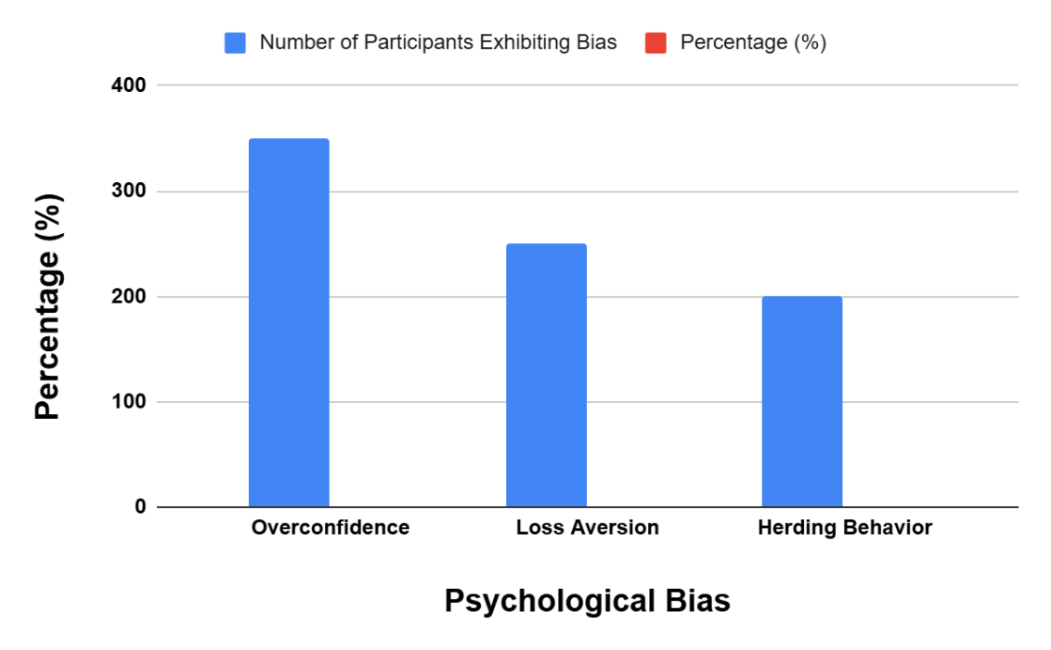

**Figure 1:** Prevalence of Psychological Biases Among Participants

**Correlation Analysis**

Correcting the hypothesis and to identify the correlation between the psychological biases for investment and their outcomes, correlation analysis was performed. These findings are presented in Table 2 and show that overconfidence, loss aversion, and herding were related to return on investment as well as risk-taking propensity. These correlations give attention to the influence of biases in the circumstances of risk-taking and economic performance. It also offers an understanding of behavioural patterns influencing the investment processes.

**Table 2:** Correlation Between Biases and Investment Outcomes

|  |  |  |
| --- | --- | --- |
| **Bias** | **Investment Returns (r)** | **Risk Tolerance (r)** |
| Overconfidence | +0.65** | +0.72** |
| Loss Aversion | -0.48** | -0.56** |
| Herding Behaviour | +0.38* | -0.15 |

Significance levels: p < 0.05 (*), p < 0.01 (**)

**Regression Analysis**

The multiple regression analysis was used to find out the investment decision predictors. It also studied how psychological biases influenced the investors, their age, and experience in terms of investment. Overconfidence positively affects risk-taking and returns and loss aversion negatively influences investment behaviour in Table 3. Another form of brand loyalty that was realized to impact the decision-making process was herding behaviour, especially during volatile periods.

**Table 3:** Regression Analysis of Factors Affecting Investment Decisions

|  |  |  |  |
| --- | --- | --- | --- |
| **Predictor Variables** | **Coefficient (β)** | **Standard Error** | **p-value** |
| Overconfidence | 0.45 | 0.05 | 0.001 |
| Loss Aversion | -0.38 | 0.07 | 0.005 |
| Herding Behaviour | 0.25 | 0.06 | 0.012 |

**Behavioural Biases and Market Characteristics**

Behavioural patterns, especially herding behaviour, were compared under stable, volatile, and crisis periods to evaluate their performance during the three market phases. These trends with an emphasis on how herd mentality increases during periods of market volatility are mentioned in Table 4. These implications encourage the investors to come up with measures that would reduce external influences and the effects of emotions.

**Table 4:** Herding Behaviour in Different Market Phases

|  |  |  |
| --- | --- | --- |
| **Market Condition** | **Herding Intensity (1–10)** | **% Participants Engaged** |
| Stable | 4 | 30% |
| Volatile | 8 | 60% |
| Crisis | 9 | 80% |

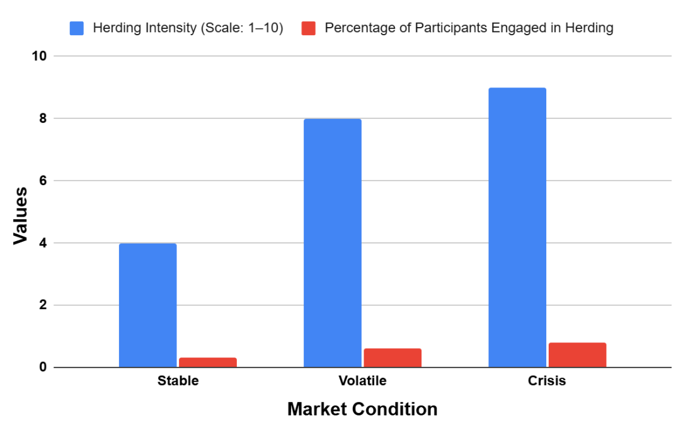

**Figure 2:** Herding Behaviour and Market Volatility

Figure 2 highlights the increase in the herding effect for different market conditions. Herding intensity was highest during crises, where it scored 9 and 80% of participants herded compared to crises where herding was 8 and 60% during volatility and 4 and 30% during stable markets.

**Key Behavioural Insights**

One of the highlighted behavioural biases was overconfidence which made investors trade frequently and assume high risk. Overconfident investors trade 20 times a month and earn 12% return per annum, while low overconfident investors trade only 6 times, earning 6% return per annum in Table 5. Loss aversion makes investors avoid risk during downturns thereby leading to low returns. Market-driven by social and media herding intensifies fluctuation in the market even during a financial crisis period.

**Table 5:** Overconfidence and Investment Decisions

|  |  |  |  |
| --- | --- | --- | --- |
| **Overconfidence Level** | **Trades per Month** | **Risk Profile (1–10)** | **Annual Return (%)** |
| Low | 5 | 3 | 6% |
| Moderate | 12 | 6 | 8% |
| High | 20 | 8 | 12% |

**Findings**

The key behavioural bias of overconfidence made people trade more often and take more risks in up markets, thus realizing higher returns at higher risks. Loss aversion made people avoid risk and cling to their losses during downturns which leads to wrong decisions. Finally, the herding behaviour adds to undulant and unpredictable variations. These results stress the impact of psychological factors on investment behaviours and indicate a need for additional focused informational and administrative campaigns for investors mentioned in Table 6.

**Table 6:** Behavioural Biases and Market Dynamics

|  |  |  |  |
| --- | --- | --- | --- |
| **Bias** | **Associated Behaviour** | **Market Condition** | **Key Finding** |
| Overconfidence | Increased trading frequency, risk-taking | Bullish markets | Higher returns but amplified risk. |
| Loss Aversion | Risk aversion, holding losses | Market downturns | Suboptimal decisions due to fear of losses. |
| Herding Behaviour | Following market trends | Market volatility | Herding amplified volatility and instability. |

**DISCUSSION**

The study sought to investigate the impact of psychological biases, namely overconfidence, loss aversion, and herding on investment decisions. The study establishes that these biases have considerable impacts on investment decisions, and this results in inferior decisions. The high level of overconfidence and loss aversion found in the participants supports the previous findings that cognitive and affective biases are the core of investors’ behaviour [16,17].

The most popular type of self-deception was overconfidence, according to 70% of the participants who stated that it affected their trading. The given result is congruent with several prior studies that reveal that investors with excessive confidence trade more often, though they receive lower returns [18]. The identified positive link between overconfidence and risk tolerance (+0.72) confirms the research hypothesis that overconfident investors take more risks, resulting in higher returns but higher variability. These conclusions are supported by the regression analysis where overconfidence was identified as a positive predictor of risk-taking (β = 0.45). The overconfident investors traded an average of 20 times per month, while the low-overconfident investors traded an average of 5 times per month. The higher trade frequency in overconfident investors is also associated with higher returns as was established in table 5. This is in line with the previous study proving that overconfident investors are of the positive opinion that they hold more information than is available, thus making them take higher-risk investments [19].

The second most popular bias was loss aversion these were identified in half of the participants. This bias derives from the investors’ predisposition to run from losses rather than to seek gains. The low negative of (-0.48) between loss aversion and investment returns shows that investors with loss aversion lose their appetite to invest during downturns. These were people who cling to their declining stocks with the aim of not taking a loss, which complies with the fact that they cannot let go of their losses and make poor decisions because they do not let their losses go. This finding is with a previous study that includes prospect theory, which proposes that losses are more aversive than gains [20]. The investors in question avoided making decisions that would lead to losses even if it was detrimental to gaining money. The regression analysis showed also that loss aversion hurts investment behaviour (β = -0.38) and that loss-averse investors avoid high-risk investments and consequently earn low returns.

Herding behaviour, which the participants indicated was present in 40%, displayed considerable volatility depending on market circumstances. This bias is very prominent during periods of high uncertainty and crisis, as can be seen from the fact that the herding intensity during a period of high market fluctuation was 60% and it was 80% during a crisis period as compared to 30% during normal or less fluctuation periods. These results imply that investors are herd creatures during the period of risk as they tend to mimic the choices made by other investors. The correlation analysis established that while the herding had a slightly weaker positive relationship with the returns on investment (+0.38); this means that herding can result in higher returns in the short run and increased market momentum but at the same time leads to instability in the market. The regression analysis also validated that in the case of instability, investors’ decisions are impacted by herding behaviour (β = 0.25). Similar results were found in previous studies [21]

The psychological biases were further tied to the market conditions in a more detailed manner when comparing herding behaviour in the stable, volatile, and crisis periods. The pattern of a significant rise in herding during crises is research-supported where investors are driven by FOMO and make their decisions in light of this evidence instead of conducting their analysis [22]. This behaviour only serves to increase market volatility and is a key factor in market unpredictability. The outcome of the study supports of the view made in a previous study that herding acts as a significant driver of exaggerated values and declines in asset prices due to the promotion of irrelevant investor behaviours [23].

The main implication of this research study is the need to investigate the relationship between psychological bias and demographic characteristics. To ensure that the biases could be compared across different investors, the study involved male and female investors of different ages and experiences. The sample indicated that overconfidence is most apparent when the investor is younger and possesses more experience in investing, this is an indication that knowledge or experience could increase the chances of overconfidence in predicting stock prices. On the other hand, loss aversion is found to be more so among the older people to which investors can be explained since they are more likely to preserve their wealth as they near their retirement ages. These demographic results are in accord with evidence in a study where authors stated that investors of advanced age are even relatively risk-averse since they have to invest only for a limited time and can ill afford to lose money [24].

The method of research, using both the quantitative survey and the subsequent qualitative interview allowed to reveal and classify the main psychological factors that affect investment decisions. Although it was revealed that there are many biases and their impact on the investment returns were estimated with the help of surveys, interviews introduced the purposeful behaviour behind them. For instance, the majority of the participants said that arrogance is caused by past achievements, which makes the individual take unnecessary risks [25].

Hence this study emphasizes the significance of psychological biases in the process of investing decisions and these overall consequences to the investment market. The results revealed that overconfidence in one’s knowledge, concern with losses, and mimicking others’ actions hurt investment decisions, which produced inferior results most of the time. It is through these findings that the general public, financial investors, financial advisors, and policymakers must be aware of cognitive and emotional biases that influence financial decision-making and therefore must collectively address the effects of these biases in the market.

**CONCLUSION**

Behavioural biases significantly shape investment decisions, as demonstrated in this study. Overconfidence emerged as the most prevalent bias, influencing trading frequency, risk tolerance, and returns. Highly overconfident investors reported executing 20 trades per month, a risk profile of 8, and annual returns of 12%. This highlights how overconfidence can lead to higher gains but also increased risk exposure. Loss aversion, characterized by a preference for avoiding losses, negatively impacted returns (-0.48) and risk tolerance (-0.56). This behaviour drove conservative strategies, leading investors to avoid risky opportunities during downturns, often resulting in suboptimal decisions. Herding behaviour was particularly prominent during volatile and crisis periods, rising from an intensity level of 4 in stable markets to 9 during crises, with 80% of participants influenced by social and media cues. Correlation and regression analyses confirmed these findings, identifying overconfidence as a positive predictor of returns (β = 0.45, p = 0.001) and risk-taking, while loss aversion had a negative effect (β = -0.38, p = 0.005). Herding behaviour influenced decision-making patterns (β = 0.25, p = 0.012), particularly in unstable markets. These results emphasize the importance of financial literacy programs, behavioural training, and regulatory frameworks to reduce biases and promote rational decision-making. Future studies could explore AI-driven tools and advanced analytics to mitigate behavioural biases and enhance investment strategies

**REFERENCES**

1. Mahmood T. Unveiling the Mysteries of Behavioural Finance: Exploring the Impact of Psychological Factors on Investor Decision-Making. Accounting & Management Research Review. 2023 Sep 30;1(1):10-7.
2. Lo AW. Reconciling efficient markets with behavioural finance: the adaptive markets hypothesis. Journal of investment consulting. 2005;7(2):21-44.
3. Kahneman D, Tversky A. Prospect theory: An analysis of decision under risk. InHandbook of the fundamentals of financial decision making: Part I 2013 (pp. 99-127).
4. Shiller RJ. Irrational exuberance in the media. The Right to Tell. 2002:83.
5. Barberis N. A Survey of Behavioural Finance. Handbook of the Economics of Finance. 2003;1.
6. Odean T. Are investors reluctant to realize their losses?. The Journal of finance. 1998 Oct;53(5):1775-98.
7. Tversky A, Kahneman D. Loss aversion in riskless choice: A reference-dependent model. The quarterly journal of economics. 1991 Nov 1;106(4):1039-61.
8. Thaler R. Mental accounting and consumer choice. Marketing science. 1985 Aug;4(3):199-214.
9. Epley N, Gilovich T. The anchoring-and-adjustment heuristic: Why the adjustments are insufficient. Psychological science. 2006 Apr;17(4):311-8.
10. Bikhchandani S, Hirshleifer D, Welch I. A theory of fads, fashion, custom, and cultural change as informational cascades. Journal of political Economy. 1992 Oct 1;100(5):992-1026.
11. Akerlof GA, Shiller RJ. Animal spirits: How human psychology drives the economy, and why it matters for global capitalism. Princeton university press; 2010 Dec 31.
12. Lusardi A, Mitchell OS. The economic importance of financial literacy: Theory and evidence. American Economic Journal: Journal of Economic Literature. 2014 Mar 1;52(1):5-44.
13. Pompian MM. Behavioural Finance and Your Portfolio: A Navigation Guide for Building Wealth. John Wiley & Sons; 2021 Apr 19.
14. Fama EF. Efficient capital markets. Journal of finance. 1970 May;25(2):383-417.
15. Thaler RH. Nudge: Improving Decisions About Health. Wealth, and Happiness. 2008;3.
16. Barber BM, Odean T. Boys will be boys: Gender, overconfidence, and common stock investment. The quarterly journal of economics. 2001 Feb 1;116(1):261-92.
17. Bikhchandani S, Hirshleifer D, Welch I. A theory of Fads, Fashion, Custom and cultural change as informational Cascades. David K. Levine; 2010 Dec 10.
18. Glaser M, Weber M. Overconfidence and trading volume. The Geneva Risk and Insurance Review. 2007 Jun 1;32:1-36.
19. Statman M, Thorley S, Vorkink K. Investor overconfidence and trading volume. The Review of Financial Studies. 2006 Dec 1;19(4):1531-65.
20. Van Rooij MC, Lusardi A, Alessie RJ. Financial literacy, retirement planning and household wealth. The Economic Journal. 2012 May 1;122(560):449-78.
21. Bikhchandani S, Sharma S. Herd behaviour in financial markets. IMF Staff papers. 2000 Jul 1;47(3):279-310.
22. Cipriani M, Guarino A. Estimating a structural model of herd behaviour in financial markets. American Economic Review. 2014 Jan 1;104(1):224-51.
23. Choijil E, Méndez CE, Wong WK, Vieito JP, Batmunkh MU. Thirty years of herd behaviour in financial markets: A bibliometric analysis. Research in International Business and Finance. 2022 Jan 1;59:101506.
24. Wang M, Rieger MO, Hens T. The impact of culture on loss aversion. Journal of Behavioural Decision Making. 2017 Apr;30(2):270-81.
25. BENARTzi SH, Thaler RH. Myopic loss aversion and the equity premium puzzle. Advances in Behavioural Finance. 2005 Jul 25;2:202-23.