GROUNDWATER POTENTIAL ASSESSMENT USING ELECTRICAL RESISTIVITY METHOD: A CASE OF ARATO SUB- CATCHMENT, ENDERTA WOREDA, MEKELLE CITY, ETHIOPIA

# Abstract

Research for groundwater today has become crucial to obtain quality water from the bedrock. This study was conducted to assess groundwater potential of Arato sub-catchment of Eastern Mekelle city Using Electrical Resistivity Method. Vertical Electrical Sounding was conducted at the site within the area coverage of about 2km2. The schlumberger array was carried out with half current electrode spacing (AB/2) of maximum 500m and profile line spacing of 100m. Data was collected along selected four profiles with four VES points for the three profiles and one profile with three VES points with an interval of about 250m for each VES points. The data acquired from fifteen (15) VES stations using ABEM TERRAMETER (SAS 4000) was tabulated in a table which showed the resistivity, thickness and the number of layers for each VES points. And the data obtained during the survey were interpreted using IPI2WIN and surfer computer software‟s. The curve matching interpretation showed that the VES data‟s were three to six layered formations with error of minimum 0.6% and maximum 3.06%. Pseudo sections were used in order to identify which section had high groundwater potential based on their resistivity distribution and geological parts were done by comparing and evaluating the interpreted VES data‟s with the characterized rock and soil materials from existing borehole indicating different layered formation. From the survey it showed that marl-shale intercalation, fractured limestone and dolerite are dominant rock types ascending with depth. The geological profile sequence in the study area included the top clay soil, marly shale intercalation, highly fractured limestone, fractured limestone and dolerite. From the interpreted geological and geophysical data‟s VES 1, VES 6 and VES 9 showed low resistivity values of 101 ohm-m, 49 ohm-m and 79 ohm-m with depth of 128 m, 187 m and 120 m. Those low resistivity zones showed highly fractured limestone and were concluded as good groundwater aquifer zones. Also from the geo-electric section interpretation it was concluded that profile one, two and three were identified as highly aquifer zones. This showed that the occurrence of groundwater was highly influenced by the geologic forms, such as fracturing and contacts. Lastly borehole investigations were recommended at VES 1, VES 6 and VES 9 with depth from 120 m up to 130 m.

**Keywords:** *Assessment,Groundwater potentials,Electrical Resistivity, Arato Mekele city.*

# Introduction

One of the crucial natural resources for all living things to exist on the earth is water in which is crucial to bring notable socioeconomic development [Dhinsa et al., 2022].

Groundwater, on the other hand is justified to be about ninety-eight percent of the world‟s reasonably constant supply [Lateef, 2012]. Groundwater occurs almost everywhere

underneath the earth surface in a single widespread aquifer and in thousands of local aquifer systems [Dhinsa et al., 2022].

Although it is widely distributed, nature does not provide groundwater at the places of our choice. It is also one of major source, which contributed a lot to the world water demand [Alabi et al., 2010]. Groundwater is most extensively dispersed resource of earth and nearly all the water in the ground comes from

precipitation that has infiltrated into the earth [Ali et al., 2017]. The occurrence and distribution of groundwater resources are compacted to certain geological formations and structures [Ayenew et al., 2008 & Amadi,A.N. et al., 2011]. The occurrence is mainly controlled by geology degree of fracturing, topography and also by amount and distribution of rainfall [Tesfa and Girum, 2019].

The groundwater resource play a remarkable role in Ethiopia used for irrigation, industries, and domestic purpose and is accessible in sediments, sandstone, alluvial and karstic limestone [Ali and Goshu, 2017]. Because of an increasing population growth and urbanization it is leading to distraction of the groundwater. The short age of fresh drinking water for human and livestock population and for agriculture asses is known in lowland. Whereas in some highland areas of Ethiopia found essential to explore water; resource for sustainable water supply and food self- sufficient [Ali and Goshu, 2017]. In Ethiopia lack of awareness towards the sustainable use of groundwater resource made gaps in exploring the water. Most water supply for Mekelle city and the village around the city are from the groundwater of Aynalem and Chinfers well fields that faces rapid water table lowering due to increased distraction for domestic and industrial water demand [Abdelwassie et al., 2021].

Research for groundwater today has become essential, due to its chance of obtaining quality water from the bedrock. Therefore, the application of geophysics to the successful exploration of groundwater in sedimentary terrain requires a proper understanding of its hydro-geological characteristics. Evidence has shown that geophysical methods are the most reliable means of all surveying method of subsurface structural investigations, rock variation and for groundwater sustainability studies [Carruthers, 1985; Emenike, 2001; Mbiimbe et al 2020]. Several methods employed in groundwater exploration include electrical resistivity, gravity, seismic, magnetic, remote sensing and electromagnetic methods, out of

which the resistivity method is the most effective for locating productive well [Olaseeni et al., 2019]. The vertical electrical sounding (VES) technique can come up with significant information on the vertical variation in the resistivity of the ground with depth. In this research the vertical electrical sounding (VES) technique was used for assessing the groundwater potential in Arato case study, eastern Mekelle, Northern Ethiopia. Mekelle city water is mainly supplied by groundwater of Aynalem catchment. The groundwater table lowering of the well field creates a great concern in the region and shortage of drinking water is one of the critical issues in the city. According to Gebregziabher B. (2003), who studied geological structures and hydrostratigraphic unit of Aynalem area of Southeast mekelle using the integrated geophysical methods concluded that the geological structures (fractures, faults, and contacts) play a considerable role in the movement and occurrence of the groundwater in the study area. According a study done by Castro, A., And Maoulidi, M in November 2009, while gaining fresh water and sanitation is improving in Mekelle, plentiful still need to be done to decrease the number of people by half which remains without access to safe drinking water and sanitation by 2015. Rapid population growth and expansion of the city to include formerly rural areas has rendered the existing water supply insufficient and one of the recommendation of the authors was the increase in number of boreholes/wells, and explore alternative water supply systems. As the result different geological and hydro geological studies has been conducted by different consultancy and researchers, but there is no research conducted around Arato catchment which need to be considered as one source of drinking water.

1. **Materials and methods**
   1. **Description of Study Area**
      1. **Location**

The Geographical location of the area is between 39**o**32**’**30**”** to 39**o**40**’**0East and 13**o**26**’**30**”**to 13**o**36**’**30**”**North .The study area

covers about 8.46km2 with mean altitude 2209 meter above sea level.

# Geomorphology and Drainage

The Arato sub catchment is topographically bounded to North and South by dolerite ridges and the valley is characterized by almost a gently rolling to flat topography. The elevation in the central part ranges from 2163m to 2416m above sea level (Fig 1).

The river is part of the Tekeze river basin and it crosses the catchment dividing the areas almost in to two equal halves. The river drains from east to west direction in which the river coming along west flows forming the Giba River. As the result, the area is underlain by two prominent topographic features, namely; steep gradient along the river valleys, and undulating between the river valleys.

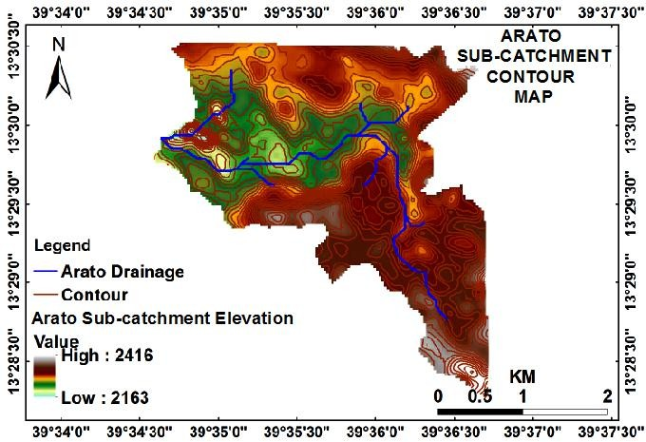

**Fig 1.** Arato sub-catchment elevation and drainage map

# Climate and hydrology

Climatically, the area is classified as "WoinaDega" (temperate) with an effective temperature between 140C and 200C (Ethiopian Mapping Agency, EMA, 1981), which for most of the time is comfortable. It has a moisture index (P/ET) ranging in between 0.25 and 0.5, which indicates moderately dry area and precipitation almost 250 mm. The mean annual temperature ranges between 160C and 200C (Gebremedhin, 2002).

# Geology of the area

The sub-catchment area is surrounded by plateaus and ridges of bedded limestone‟s and marly shale‟s in which physically the river comes across and meets with the adjacent catchments of Ilala then to Giba River. The dominant units outcropping in the study area

are the sediment deposits, fractured limestone, marly shale with thin beds of limestone intercalation and dolerite. The study area is structurally affected by faults, fractures and joints. The existence of these faults is recognized from the alignment of the dolerite ridges having the same trend to the Mekelle fault belts and from the sharp contact of different lithologic units, older and younger units (Teklay, 2006).Locally, the intensity of fracturing and faulting as well as the degree of weathering determines the aquifer potential and direct infiltration of the rock (Tesfaye and Gebretsadik, 1982).

The water is drained in to Illala catchment. And the hydrogeological conditions of Illala catchment as well as Arato sub-catchment is mainly controlled by the lithologies, geological structures and geomorphology

(Teklebirhan *et al*., 2012). Almost all its discharge occurs during the rainy season with a flood that lasts for a short period.

According to Gebrehaweria (2009), DEVECON (1993) describes geology, structure and hydrogeology of Mekelle area,

aquifer properties of the major litho logical units around the areas and pointed out that, the groundwater is confined due to the alternative layer of shale, marl, limestone and dolerite; the main aquifers are found in the limestone and dolerite unit.

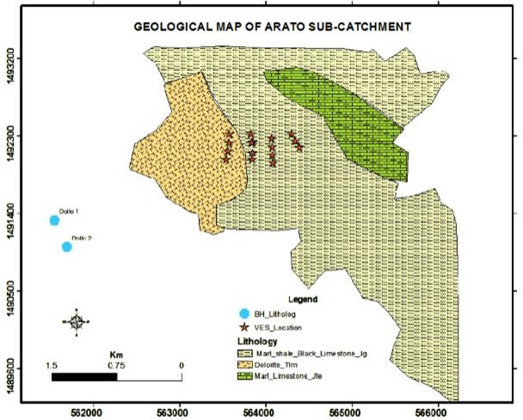

**Fig 2:** Geological map of Arato sub-catchment

# Geological and Hydrogeological data collection

The secondary data related to geological and hydro geological were collected from all drilled borehole around and near the study area i.e., the depth and elevation of the bedrock surface, thickness of aquifers and elevations of

**Table 1.** Litho logical log of drilled well

identifiable geological units from the well logs data were evaluated (Table 1). Beside the geological approach, the geophysical survey was done with the objective of identifying potentially aquifer zones of the study area. The target areas for survey were identified based on potentially suitability.

|  |  |  |  |
| --- | --- | --- | --- |
| **Site location: Dollo Easting : 561547**  **Total drilled depth : 180m Northing : 1491325 Elevation : 2173** | | | |
| **Depth(m)** | | **Lithologic Description** | **Remark** |
| **From** | **To** |
| 0 | 3 | Clayey top soil |  |
| 3 | 6 | Moderately fractured black limestone |  |
| 6 | 10 | Marly shale |  |
| 10 | 12 | Fractured limestone | Water strike/ Aquifer |
| 12 | 30 | Marly shale with thin beds of limestone intercalation | Aquitard |
| 30 | 48 | Slightly fractured dolerite | Water increased/ Aquifer |

|  |  |  |  |
| --- | --- | --- | --- |
| 48 | 54 | Highly fractured limestone |  |
| 54 | 60 | Slightly fractured black limestone |
| 60 | 80 | Moderately fractured black limestone |
| 80 | 84 | Fractured limestone |
| 84 | 90 | Highly fractured limestone |
| 90 | 96 | Moderately fractured limestone |
| 96 | 102 | Fractured limestone |
| 102 | 110 | Slightly fractured black limestone |
| 110 | 126 | Moderately fractured dolerite |
| 126 | 160 | Slightly fractured dolerite |
| 160 | 180 | Massive dolerite |  |

# VES Data Acquisition

Vertical electrical sounding (VES) method was carried out at the site with area coverage of about 2km2 by using Schulumberger configuration. In this survey, electrical current was sent into the ground through two electrodes known as current electrodes and the resulting potentials were measured with the help of two other electrodes known as potential electrodes. The measured apparent resistivity (ρa) for each half-electrode separation „a‟ is computed from the following formula:

ρa= 2πK(V/I)

Where, ρa is apparent resistivity, K is the factor depending on the geometry of electrode configuration, V is the voltage measured across potential electrodes and I is the current sent into the ground. The apparent resistivity for a given electrode separation may vary within wide limits depending upon the nature of surface material [Zohdy et al., 1974]. In this Schulumberger configuration, four electrodes were placed symmetrically along a common line with the outer two serving as current electrodes and the inner two as potential electrodes. The inner pair of potential electrodes (CD) was located at the center of the array and the separation between them was small compared to the current electrode distance (AB), usually less than one-fifth of the current electrode distance as shown in fig- 1, and was carried out with half current electrode spacing (AB/2) of maximum 500m.The apparent resistivity values obtained with this array were attributed to the midpoint

of configuration, which is called as the observation point ‘O’. The apparent resistivity for this setup over a completely uniform earth is given by the formula [Keller and Frischknecht, 1966]

ρa = 2π V/I ([1/AM - 1/BM - 1/AN + 1/BN])-1

Where, ρa= apparent resistivity, V = potential difference between potential electrodes, I = current flowing, AB= current electrodes, CD = potential electrodes.

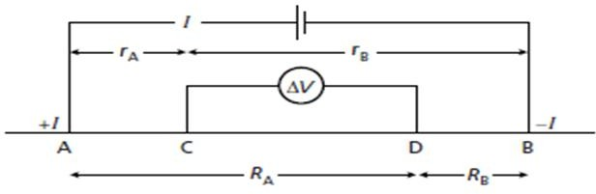

**Fig 3**.Schlumberger Electrode Configuration

Electrodes were inserted in to the ground properly by dragging them with hammer in order for the currents to penetrate deeply so that the data will be recorded.

# Materials

The instrument used during this survey was ABEM TERRAMETER SAS4000 with an

External battery adapter with its DC input cable of using an external 12V battery. This instrument displays the apparent resistivity of subsurface layers. SAS stands for signal averaging systems in which means readings are taken automatically and the results are averaged. Other accessories used during this study included laptop , photo camera, Metal electrodes, labeled tag (used in locating station position), hammer (used in driving the

electrodes into the ground), compass and GPS (to measure elevation, longitude and latitude), external battery, and connecting cables (crocodile cables).

# VES Data Processing and interpretation

Different software and computer codes such as Microsoft Excel, IPI2WIN, IPI-res3 and Surfer 10(32-bit) were used to develop cross-sections and analyze data. In which Microsoft Excel was used to arrange field data and plot graphs whereas IPI2WIN software was performed to determine number of layers and their thickness based on their resistivity inputs while Surfer 10 was used to obtain geo-

electric sections. The field results of the study were then presented in both qualitative and quantitative interpretations. When the data was interpreted qualitatively the shape of the field curves were observed to get an idea about the number of layers and resistivity of layers. The results of this method of interpretation involved pseudo and geo-electric sections. The VES data collected in the field were plotted on a bi-log paper and then curve matching was performed using IPI2WIN software to find out initial model parameters of possible layers. In the quantitative method geo-electrical parameter, i.e., true resistivity and layer thickness were obtained to make geo-electrical section using Surfer 10 software.

# Results and Discussion

* 1. **VES Results**

**Table 2.** Result of Interpretation of VES Curves from the Study area

|  |  |  |  |  |  |  |
| --- | --- | --- | --- | --- | --- | --- |
| **VES**  **no** | **Layers in no** | **R(Ω**⋅**m)** | **Thickness(m)** | **Depth(m)** | **Expected Geological formations (Litho logical Description)** | **Curves Types** |
| 1 | 1  2  3  4  5  6  7 | 23.9  1249  36.5  1346  118  412  101 | 0.516  0.446  3.17  18  30.6  75.3 | 0.516  0.446  4.13  22.1  52.8  128 | Top soil Fractured dolerite  Shale-marl intercalation Dolerite  Highly fractured limestone Fractured limestone  Highly fractured limestone | 1.18%(KHQ) |
| 2 | 1  2  3  4  5  6  7 | 56.17  210.6  23.25  137.8  63.54  1554  139.7 | 1.77  1.783  4.145  4.862  45.74  60.03 | 1.77  3.55  7.698  12.56  58.3  118.3 | Clay top soil Top dry soil  Shale-marl intercalation Highly fractured limestone Highly fractured limestone Dolerite  Highly fractured limestone | 1.12%(KH) |
| 3 | 1  2  3  4  5  6  7 | 4.289  29.43  7.449  83.18  19.06  1188  49.28 | 2.271  10.8  8.603  10.81  53.43  110.4 | 2.271  13.07  21.67  32.48  85.91  196.3 | Saturated clay soil  Marl-shale with thin beds of limestone intercalation Shale-marl intercalation Highly fractured limestone Shale- marl intercalation Dolerite  Highly fractured limestone | 1.16%(KH) |
| 4 | 1  2  3  4  5 | 34.1  327  36.5  178  1460 | 1.9  2.12  24.6  85 | 1.9  4.02  28.62  113.6 | Clay top soil Dry top soil  Marl-shale with thin beds of limestone intercalation Highly fractured limestone  Dolerite | 2.09%(KH) |

|  |  |  |  |  |  |  |
| --- | --- | --- | --- | --- | --- | --- |
| 5 | 1  2  3  4  5 | 53.29  15.74  25.75  20.14  5859 | 1.491  2.772  55.85  58.6  69.03 | 1.491  4.263  60.11  118.7  211.1 | Clay top soil  Marl-shale intercalation  Massive dolerite | 1.19%(HH) |
| 6 | 1  2  3  4  5  6 | 115.5  6.899  41.91  14.3  48.7  578.9 | 0.652  0.67  10.37  20.74  154.6 | 0.652  1.317  11.69  32.43  187 | Dry top soil Moist clay soil  Highly fractured limestone Marl-shale intercalation Highly Fractured limestone  Fractured limestone | 1%(HHA) |
| 7 | 1  2  3  4 | 24.96  37.7  57.58  373 | 1.254  20.51  103.1 | 1.254  20.51  124.9 | Clay top soil  Marly shale intercalation  Highly fractured limestone Fractured limestone | 0.979%(A) |
| 8 | 1  2  3  4 | 10.39  81.01  21.71  648.1 | 0.842  1.618  176.9 | 0.842  1.618  179.4 | Saturated clay soil  Highly fractured limestone  Marly shale intercalation Fractured limestone | 1.29%(KH) |
| 9 | 1  2  3  4 | 22.2  97.8  473  79.4 | 0.666  9.25  109.6 | 0.666  9.92  120 | Top clay soil Top dry soil  Fractured limestone Highly fractured limestone | 1.78%(AK) |
| 10 | 1  2  3  4  5 | 26.28  14.69  1722  100.2  335.3 | 8.997  5.358  24.71  127.6 | 8.997  14.35  39.06  166.7 | Top clay soil  Shale marl intercalation Dolerite  Highly fractured limestone Fractured limestone | 1.1%(HH) |
| 11 | 1  2  3  4  5  6  7 | 20.48  12.77  17.8  9.499  199.3  83.34  414.7 | 1.63  1.14  6.075  7.821  34.23  97.22 | 1.63  2.77  8.845  16.67  50.9  148.1 | Top clay soil  Marly shale intercalation Highly fractured limestone Fractured limestone | 0.648%(HH) |
| 12 | 1  2  3  4  5 | 20.9  4.31  34.6  1155  732.2 | 0.908  1.61  13.64  189.2 | 0.908  2.518  16.16  205.4 | Top clay soil Moist soil  Marly shale intercalation Dolerite | 3.06%(HA) |
| 13 | 1  2  3  4  5 | 26.6  4.56  23.5  63.9  1023 | 0.659  6.2  26  115 | 0.659  6.859  32.86  147.9 | Top clay soil  Marly shale intercalation  Highly fractured limestone Dolerite | 2.13%(HA) |
| 14 | 1  2  3  4  5  6  7 | 135  19.8  75.3  21.5  110  1138  113 | 0.526  0.713  4.66  10.2  60  97.8 | 0.526  1.24  5.9  16.1  76  174 | Top dry soil Saturated top soil  Marly shale with limestone intercalation  Marly shale intercalation Highly fractured limestone Dolerite  Highly fractured limestone | 1.06%(HHA) |
| 15 | 1 | 6.689 | 0.707 | 0.727 | Top saturated clay soil | 0.959%(KHA) |

|  |  |  |  |  |  |  |
| --- | --- | --- | --- | --- | --- | --- |
|  | 2  3  4  5  6 | 95.65  20.4  55.16  5817  81.56 | 0.6437  18.68  31.54  58.68 | 1.351  20.03  51.57  110.3 | Top dry soil  Shale-marl intercalation Marly shale with thin beds of limestone intercalation Massive dolerite  Highly fractured limestone |  |

# Interpreted VES Curves

**Profile 1**

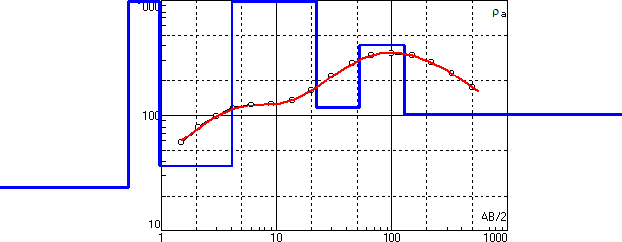

**Profile 2**

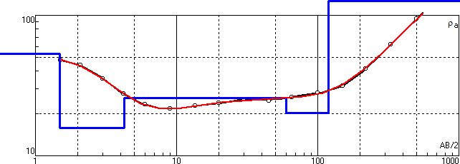

**Profile 3**

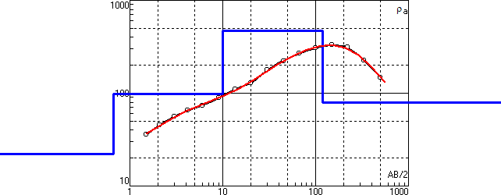

**Profile 4**

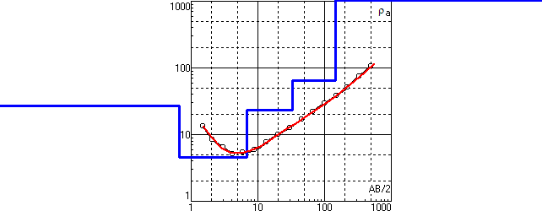

**Fig 4.** Interpreted Resistivity curves

# Pseudo Section

* + 1. **Pseudo Section of Profile One**

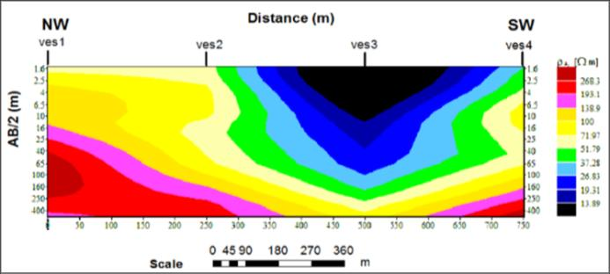**Fig 5.** Pseudo section of Profile one

The pseudo section constructed for VES-1, 2, 3 and 4 that lie on the survey traverse line-1 are given in fig-5. From the figure, there is lateral variation in resistivity of all the four VES points. There is low resistivity zone in VES-3 which is the black colored, then high resistivity zone in the blackish red left side of the section. The low resistivity values of VES- 3 ranging from 4.3 ohm-m to 29.43 ohm-m are indicators of porous materials. On this profile VES-1 seems groundwater potential zone because the resistivity increases to 1346 ohm- m with depth of 22 m then decreases to 101 ohm-m with increasing depth up to 128 m.

# Pseudo Section of Profile Two

**Fig 6.** Pseudo section of Profile two

This profile is pseudo section of VES-5, 6, 7 and 8 given in fig-6. There is relatively small resistivity at the top of all VES points, indicating lower groundwater potential, and are high porous with low permeability and are so shallow. According to the figure, there is variation in resistivity extending to large depth. There is prominent high resistivity value away from the top at depth extending to 120 m for all the VES points. There is low resistivity zone which is below the top layer with resistivity ranging from 14 ohm-m to 81 ohm-m and depth up to 187 m and this is indicator of groundwater potential zone. These low resistive zones are located in between VES-5 and VES-6 also in VES-8.

# Pseudo Section of Profile Three

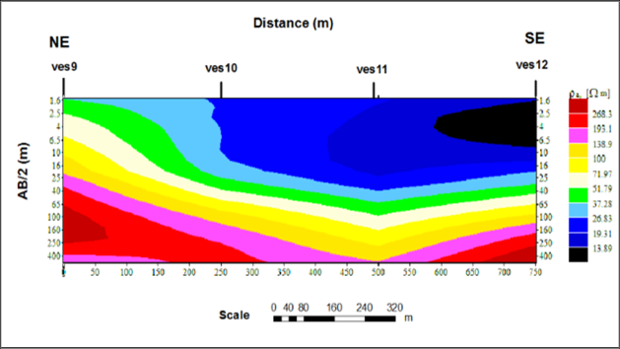

**Fig 7.** Pseudo section of Profile three

The pseudo depth section constructed for VES-9, 10, 11 and 12 is given in the fig-7 below. There is a lateral variation in resistivity in the section with prominent high resistivity zone in the deep left side of the section near VES-9 greater than 268 ohm-m. The large area of the top section, especially VES-10, VES-11 and VES-12 has low resistivity. Whereas low resistive Zones between VES-10 and VES-11 indicating potential water saturation when going deeper from 38.7 m to 145 m with resistivity value of 100 ohm-m and 83 ohm-m to 199 ohm-m respectively. The high resistivity valued region that does not extend to large extent is mapped at VES-9 whereas there is low resistivity in this region when extending with depth in which may be good water potential zone.

# Pseudo Section of Profile Four

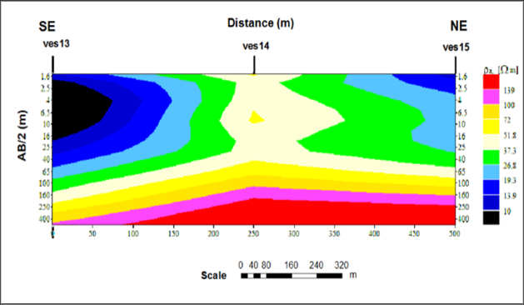

**Fig 8.** Pseudo section of Profile four

This profile consists pseudo section of VES- 13, 14 and 15 as shown in fig-8. There is a lateral variation in resistivity in the section with prominent low resistivity zone in the top left side of the section near VES-13 with resistivity of 15 ohm-m and right side of the section near VES-15 with resistivity ranging

10 ohm-m to 13.9 ohm-m. In this profile, VES-13 shows great water potential with

resistivity value of 64 ohm-m at thickness of

44.1 m to 148 m. The large area of the medium of the section has small resistivity less than 120 ohm-m and the deep depth of VES-13 has small resistivity value of 64 ohm-m. And this region seems potential water saturation zone. The vast section of the bottom shows extensive coverage of the high resistivity zone.

# Geo-electric Section

* + 1. **Geo-electric Section of Profile one**

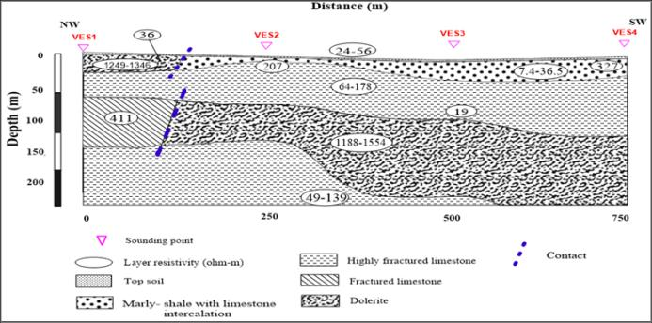

**Fig 9.** Geo-electric section of Profile one

The resulting geo-electric section of profile one of VES-1, VES-2, VES-3 and VES-4 is given below in fig-9. It consist different geo- electric layers and resistivity values. The first geo-electric section layer having resistivity of 24 ohm-m to 56 ohm-m with thickness from

0.51 m to 2.32 m interpreted as topsoil. And this layer has relatively low resistivity value indicating the presence of clay intercalation. The second one is the marly-shale with limestone intercalation of resistivity value from 7.4 ohm-m to 327 ohm-m and thickness of 1.77 m to 29 m respectively and in VES-1 dolerite rock unit with 1249 ohm-m to 1346 ohm-m resistivity value and at depth up to 22

m. The third geo-electric layer with resistivity value ranging from 64 ohm-m to 178 ohm-m with thickness variation from 7.7 m to 114 m shows highly fractured limestone. The expected lithological description of the fourth geo-electric layer manifested by VES-1 having resistivity value 411 ohm-m of depth from 53 m to 128 m is fractured limestone. Whereas the geo-electric section of the same layer marked by VES-2, VES-3 and VES-4 is assumed to be dolerite with resistivity value of 1188 ohm-m to 1554 ohm-m and thickness between 58 m to 196 m. The last geo-electric layer marked by VES-1, VES-2 and VES-3

with resistivity value of 49 m to 139 ohm-m found at 118 m deep may represent highly fractured limestone.

# Geo-electric Section of Profile two

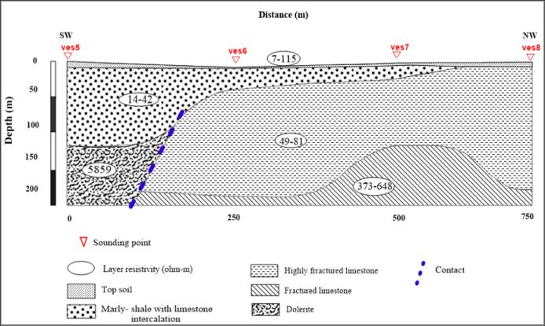

**Fig 10.** Geo-electric section of Profile two

The resulting geo-electric section constructed from the interpreted layer parameters of four VES lying along profile two is given in fig-10. The first geo-electric layer shows top clay soil with resistivity ranging from 7 ohm-m to 115 ohm-m and thickness variation of 0.6 m to 4.3 m which may be saturated and dry topsoil respectively. The second geo-electric layer marked by VES-5, VES-6 and VES-7 indicates marly shale with limestone intercalation of resistivity value from 14 ohm- m to 42 ohm-m and 11 m to 120 m of depth variation. The third layer marked by VES-5 with resistivity value of 5859 ohm-m with depth of greater than 120 m likely reflects massive dolerite. While the geo-electric section of the same layer marked by VES-6, VES-7 and VES-8 with resistivity value 49 ohm-m to 81 ohm-m and depth between 2.5 m and 187 m reflects the presence of highly fractured limestone. The last geo-electric layer marked by VES-6, VES-7 and VES-8 with resistivity value of 373 ohm-m to 648 ohm-m shows presence of fractured limestone.

# Geo-electric section of Profile three

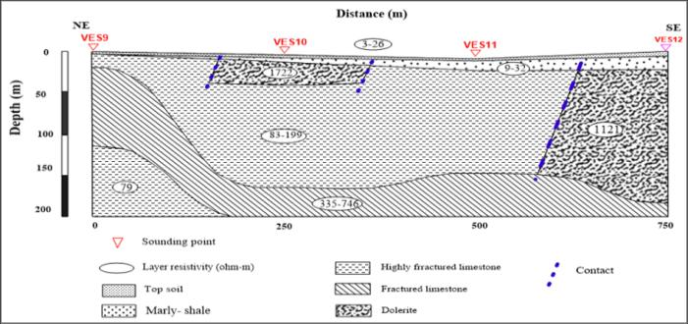

**Fig 11.** Geo-electric section of Profile three

As shown in fig-11, the first geo-electric layer is the top clay soil with resistivity ranges from

3 ohm-m to 20.2 ohm-m with thickness between 0.6 m and 9 m. This layer is a good site for evapotranspiration and pipeline lying. In this layer groundwater accumulation cannot be verified. The second geo-electric layer marked by VES-9, VES-10 and VES-11 show marly shale with resistivity values of 9 ohm-m to 32 ohm-m and thickness of 3 m to 17 m. The third layer marked by VES-9, VES-10 and VES-11 with resistivity value of 83 ohm-m to 199 ohm-m and depth from 0.6 m to 167 m likely reflects highly fractured lime stone whereas the geo-electric section of the same layer marked by VES-12 and some top parts of VES-10 with resistivity value 1121 ohm-m to 1722 ohm-m and thickness of 14 m to 39 m and 17 m to 185 m respectively reflects the presence of dolerite. The fourth layer with resistivity value ranging from 335 ohm-m to 746 ohm-m shows presence of fractured limestone. The last geo-electric section marked by VES-9 shows highly fractured limestone with resistivity value of 79 ohm-m.

# Geo-electric section of Profile four

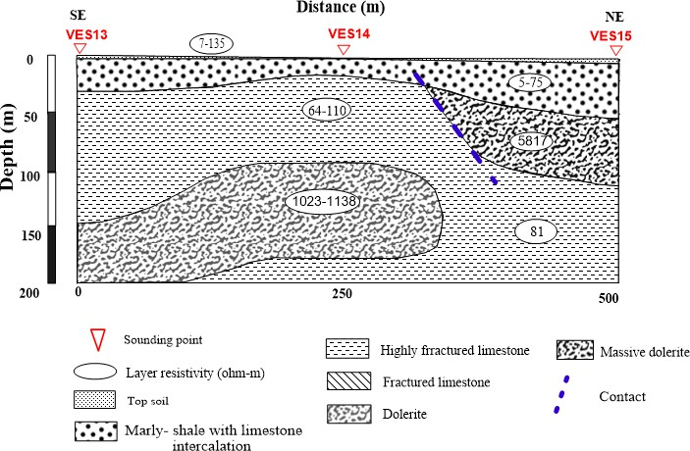

**Fig 12.**Geo-electric section of Profile four

The geo-electric section of profile 4 consists VES-13, 14 and 15 as shown in fig-12. The top layer is in generally combination saturated and dry clay soil with resistivity values of 7 to 135 ohm-m with thickness up to 1.5 m. The second layer shows marly shale with limestone intercalation of resistivity ranging from 5 ohm- m to 75 ohm-m and depth of 1.5 m to 52 m. The third layer marked by VES-13 and VES-

14 clarifies highly fractured limestone with resistivity of 64 ohm-m to 110 ohm-m and thickness of 16 m to 148 m. While the geo- electric section of the same layer marked by VES-15 with resistivity value of 5817ohm-m and thickness from 52 m to 110 m reflects presence of massive dolerite. The last geo- electric layer marked by VES-13 and VES-14 shows dolerite with resistivity ranging from 1023 ohm-m to 1138 ohm-m, whereas highly fractured limestone appears in the same layer connected with the third geo-electric layer with resistivity value of 81 ohm-m.

# Conclusion

The vertical electrical sounding (VES) survey of geophysical method was carried out in Arato sub-catchment, Eastern part of Mekelle city, Ethiopia. A total of 15 VES were collected in the Arato flat areas. From the survey it showed that marl-shale intercalation, fractured limestone and dolerite are dominant rock types with ascending of depth. When the interpreted VES data‟s were compared with the borehole data, the only difference showed was difference in thickness. The apparent resistivity pseudo-depth sections and the resistivity geo-electric sections illustrated the presence of shallow as well as deeper low resistivity horizons which showed potential zones of groundwater saturation. The low resistivity and high depth of these horizons may be an indicator of groundwater potential zone in the study area.

Generally geological profile sequence in the study area included the top clay soil, marly shale intercalation, fractured limestone and dolerite. And all profiles were interconnected with highly fractured limestone with an averaged maximum depth of 200 m. This

showed that there exists fractured limestone rock type with large width and depth.

From the geo-electric section of profile one VES-1 and VES-2 with resistivity value of 101 ohm-m and 140 ohm-m at depth of greater than 128 m and 118 m respectively seems good aquifer zones. The geo-electric section of profile two showed low resistivity zone in VES-5 and VES-6 with the value of 20 ohm-m and 49 ohm-m with depth to 118 m and 187 m respectively, and geo-electric section of profile three displayed aquifer zone at VES-9 with resistivity of 79 ohm-m and depth of 120 m which is highly fractured zone. Whereas from the last profile four VES-14 seemed good potential zone of groundwater with resistivity value of 113 ohm-m at depth greater than 174

m. Comparing the potential aquifer level of each geo-electric sections, VES-1 from profile one, VES-6 from profile two and VES-9 from profile three seemed good aquifer zones. There existed highly fractured limestone rock unit in VES-1, VES-6 and VES-9, and it is known that these rock units are layers of water bearing permeable fractured rocks. And from this result it was concluded that VES-1, VES-6 and VES-9 may be suitable zone of groundwater potential, as it has low resistivity with depth of 128 m, 187 m and 120 m respectively. Thus, borehole may be recommended in these VES points at depth of about 120 m to 130 m.

The occurrence of groundwater was highly influenced by the geologic forms, such as fracturing and contacts. These contacts may be due to the sedimentary rock deposited on an older rock or due to rocks intruded to another rock unit. The geology of the area especially topographically higher lands were mostly dolerite and limestone were affected by fracturing. This fracturing controlled the flow of groundwater in other words the recharge rate of the area increased due to fractured rocks of highly elevated areas. As understood from the result, observation and different research‟s done around the study area, the groundwater potential in the base of mountains and flat areas is high, due to high recharge rate of highlands, thick and small soil amount, ground flow and most of the water is drained

in to the flat lands. Generally the study area can be graded as high aquifer level. Therefore this result is significant in alleviating the freshwater problems around the study area and Mekelle city.

Disclaimer (Artificial intelligence)

Option 1:

Author(s) hereby declare that NO generative AI technologies such as Large Language Models (ChatGPT, COPILOT, etc.) and text-to-image generators have been used during the writing or editing of this manuscript.

Option 2:

Author(s) hereby declare that generative AI technologies such as Large Language Models, etc. have been used during the writing or editing of manuscripts. This explanation will include the name, version, model, and source of the generative AI technology and as well as all input prompts provided to the generative AI technology

Details of the AI usage are given below:

1.

2.

3.

# References

Abdelwassie,H., Tesfamichael,G.Y., Miruts,H., Gebremedhin,B., Kassa,A and Gebremdhin,B.Z., 2021. High- resolution Data Based Groundwater Recharge Estimations of Aynalem Well Field. *Momona Ethiopian Journal of Science (MEJS)*, *©CNCS, Mekelle University.* 13,1-20. DOI: 10.4314/mejs.v13i1.1

Alabi, A.A., Bello, R., Ogungbe, A.S. and Oyerinde, H.O., 2010. Determination of groundwater potential in Lagos State University, Ojo; Using geoelectric methods(vertical electrical sounding and horizontal profiling). Report Opinion, 24, 68-75.

Ali S., Goshu A,2017. Ground water resource management – A case study of Nekemte, Oromia region, Ethiopia. *Advance Research Journal of Multidisciplinary Discoveries.*12,2456- 1045.

[http://www.journalresearchijf.come](http://www.journalresearchijf.come/).

Ali S ; Gurmu D.A. & Dr.Soni S.,2017. Assessment of Ground Water Occurrence using by Geological, Geomorphological and Geospatial methods: A case study of East Wollega Zone, Ethiopia. Advance Research Journal of Multidisciplinary Discoveries.10.0,C-1(2017):01-07

ISSN-2456- 1045.

[http://www.journalresearchijf.come](http://www.journalresearchijf.come/);

Amadi, A. N., Nwawulu, C. D., Unuevho, C. I., Okoye, N. O., Okunlola, I. A.,

Egharevba, N. A., Ako, T. A., & Alkali, Y. B. (2011). Evaluation of the Groundwater Potential in Pompo Village, Gidan Kwano, Minna Using Vertical Electrical Resistivity Sounding. Current Journal of Applied

Science and Technology, 1(3), 53–66. https://doi.org/10.9734/BJAST/2011/1 92

Ayenew, T., Demlie, M. and Wohnlich, S., 2008. Hydrogeological framework and occurrence of groundwater in the Ethiopian aquifers. *Journal of African Earth Sciences*, 52, 97-13.

Carruthers, R.M.,1985. Review of geophysical techniques for groundwater exploration in crystalline basement terrain. British Geological Survey, Regional Geophysics Research Group, Report 85, 30 p.

Castro, A.; Maoulidi, M., 2009. A Water and Sanitation Needs Assessment for Mekelle City, Ethiopia. MCI Social Sector Working Paper Series N7/2009. Available online:

https://academiccommons.columbia.ed u/doi/10.7916/D8GM8F57 (accessed on 2 June 2021).

Dhinsa D, Tamiru F, Tadesa B., 2022. Groundwater potential zonation using VES and GIS techniques: A case study of Weserbi Guto catchment in Sululta, Oromia, Ethiopia. Heliyon. 2022 Aug 15;8(8):e10245. doi:

10.1016/j.heliyon.2022.e10245. PMID:

36046528; PMCID: PMC9421194.

Emenike, E.A., 2001. Geophysical exploration for groundwater in a Sedimentary Environment: A case study from Nanka over Nanka Formation in Anambra Basin, Southeastern Nigeria. Global Journal of Pure and Applied Sciences, 7, p. 1-11.

Ethiopian Mapping Agency. (1981). National Atlas of Ethiopia. Addis Ababa, Ethiopia.

Gebregziabher B., 2003. Integrated Geophysical Methods to Investigate the Geological Structures and Hydrostratigraphic Unit of the Aynalem area, Southeast Mekelle, Msc Thesis, Addis Ababa University.

Gebrehaweria Gebrekirstos T. (2009). Ground water Resource Assessment of the AynalemWellfield through Transient flow Modelling, Msc Thesis, International Institute for Geo- Information Science and Earth Observation Enschede, The Netherlands.

Gebremedhin B. (2002). Engineering Geological Investigation of Mekelle area, Tigray, Northern Ethiopia. M.Sc. Thesis, Addis Ababa University, Addis Ababa, 163pp (Unpub).

Goni, Ibrahim & El-Nafaty, Jalo & Yuguda, A.U.. (2020). Assessment Of The Protective Capacity Of Vadoze Zone Over Aquifer Systems Using Secondary Geoelectrical Parameters: A Case Study Of Kaltungo Area North East, Nigeria. Journal of Environmental & Earth Sciences. 2. 10.30564/jees.v2i2.1633.

Keller GV., Frischknecht FC., 1966. Electrical Methods in Geophysical Prospecting, Pergamon Press. 179-187

Lateef T.A,2012. Geophysical Investigation for Groundwater Using Electrical Resistivity Method: A case Study of Annuciation Grammer School, Ikerelga, Ekiti State, South- Western Nigeria. *Journal of Applied Physics (IOSRJAP)*, 2, 01-06.

Olaseeni O.G., Oladapo M.I., Olayanju G.M., Dada O.J. and Oyebamiji A.R., 2019. Groundwater Vulnerability Assessment using Electrical Resistivity Method in the Northern part of Ado-Ekiti, Southwestern Nigeria. *Journal of Physics:*Conf. Ser. 1299 (2019)

012068. doi:10.1088/1742-

6596/1299/1/012068

Teklay Z., 2006. Conjugate use of surface and Ground water of Aynalem area, Msc Thesis, Mekelle University.

Teklebirhan A., Dessie N, Tesfamichael. (2012). Groundwater Recharge, Evapotranspiration and Surface Runoff

Estimation Using Wets pass Modeling Method in Illala Catchment, Northern Ethiopia. Momona Ethiopian Journal of Science (MEJS), V4(2):96-110.

Tesfa, G.A., Girum, G.D. Demeke., 2019. Groundwater potential assessment using GIS and remote sensing: A case study of Guna tana landscape, upper blue Nile Basin, Ethiopia. *Journal of Hydrology: Regional Studies,* 24, 100610.

Tesfaye C, Gebrestadik E. (1982). Hydrogeology of the Mekelle area (N D37-11). Ministry of mines and energy Ethiopian Institute of Geological Surveys.

Zohdy A. A.R., Eaton G.P., Mabey D.R., 1974. “Application of Surface Geophysics to Ground-Water Investigation,” Techniques of Water- Resources Investigations (Series number 02-D1), *U.S. Geological Survey Techniques of Water- Resources Investigations, U.S. Government Printing Office*. <https://doi.org/10.3133/twri02D1>.