Real-Time IoT-Enabled Monitoring and WebGIS-Based Visualization of Soil Moisture, Temperature, and Humidity

ABSTRACT
The design and deployment of a real-time environmental monitoring system that integrates WebGIS for data visualization with Internet of Things (IoT) technologies, applied to the study area of Bryant Nagar in Thoothukudi district, Tamil Nadu, is described in this paper. The hardware setup is established using the NodeMCU ESP8266 microcontroller to interact with sensors measuring temperature, humidity, and soil moisture content. The collected data is wirelessly transmitted at regular intervals and stored in a MySQL database. Environmental parameters can be interacted with and viewed on a map through a dynamic web interface developed using HTML, CSS, JavaScript, and Leaflet. A seamless user experience and fast data retrieval are ensured by the combination of PHP and AJAX. Effective decision-making is facilitated by the system through interactive and intuitive interfaces that support environmental data monitoring and geographic visualization.

Keywords: IoT, NodeMCU ESP8266, Soil Moisture, Humidity, Temperature, WebGIS, Real- Time Data, Leaflet, AJAX, MySQL, Environmental Monitoring, Dynamic Visualization.

INTRODUCTION

The incorporation of contemporary technologies such as the Internet of Things (IoT) into farming systems has been driven by the growing need for sustainable agricultural practices. With real-time environmental monitoring, the "IoT-Based Soil Moisture, Humidity, and Temperature Monitoring System with WebGIS Visualization" presents a state-of-the-art approach to improving precision agriculture. This system continuously collects vital data on temperature, ambient humidity, and soil moisture using IoT-enabled sensors, facilitating effective crop management and irrigation scheduling. The integration of WebGIS (Web-based Geographic Information System) visualization in the system ensures efficient data collection while enabling interactive mapping and spatial analysis of environmental conditions across agricultural areas. Combining WebGIS and IoT allows farmers and other stakeholders to make better-informed decisions, maximize crop yields, and promote environmentally friendly farming practices. Monitoring environmental factors such as soil moisture, humidity, and temperature has been revolutionized by the introduction of IoT into agriculture. These factors significantly influence plant health and agricultural productivity. Traditional methods of monitoring these parameters are often time-consuming and ineffective. In contrast, IoT-based solutions enable real-time monitoring and data collection, empowering farmers and researchers to make well-informed decisions. These monitoring systems typically rely on soil moisture sensors (such as capacitive or resistive sensors), DHT11/DHT22 sensors for temperature and humidity, and microcontroller units like Arduino or Raspberry Pi (Kamilaris et al., 2017). Once deployed in the field, these sensors use communication protocols such as Wi-Fi, LoRa, or GSM to continuously gather data and transmit it to a central system. The microcontroller reads analog or digital data from the sensors and converts it into usable information. Depending on the system design, these measurements can be transmitted continuously or recorded at predetermined intervals. IoT-enabled machine-to-machine (M2M) connectivity allows devices to operate autonomously with minimal human intervention, making environmental monitoring more scalable and efficient. Analysing the collected data aids the advancement of precision agriculture by investigating plant behaviour, seasonal patterns, and soil health (Nandurkar et al., 2014). Integration with cloud platforms enables centralized data storage and instant access from any location. These systems often feature dashboards that display important information through tables and graphs. Web-based Geographic Information Systems (WebGIS) are essential for visualizing geospatial data collected by IoT sensors. By presenting sensor data on an interactive map interface, WebGIS bridges the gap between real-time data capture and actionable insights. Users can examine environmental parameters such as temperature, humidity, and soil moisture at specific geographic coordinates. This capability is particularly critical for dispersed farms or large agricultural areas where productivity is significantly affected by microclimate variations (Wang et al., 2024). In a WebGIS-enabled monitoring system, temporal sensor data from IoT devices is superimposed onto geographical data layers. GPS modules embedded in IoT devices geotag these data points. After transmission to a cloud server, the data is processed for spatial visualization using software such as ArcGIS Online, Leaflet, or Open Layers. This type of geographic visualization enables better agricultural planning, including targeted fertilization, irrigation, and pest management. For example, areas with consistently low soil moisture can be prioritized for irrigation, conserving water and improving productivity. Additionally, the WebGIS interface can issue real-time alerts based on user-defined thresholds or those determined through machine learning algorithms analysing historical trends (Chlingaryan et al., 2018). WebGIS also facilitates collaborative decision-making by allowing stakeholders such as farmers, agronomists, and government agencies to remotely access shared data in real time. This accessibility promotes data-driven agricultural governance and transparency. Furthermore, integrating WebGIS with historical datasets and weather APIs enhances forecasting and anomaly detection by adding contextual richness to the visualizations. Despite the transformative potential of IoT and WebGIS integration in agriculture, several challenges hinder widespread adoption. Sensor reliability and durability under harsh field conditions remain significant concerns. Soil sensors, in particular, are prone to degradation due to fluctuations in temperature, moisture, and salinity. Essential maintenance and calibration are often overlooked at the local level due to limited technical expertise (Wolfert et al., 2017). Connectivity and power supply issues present additional obstacles. Remote farms often lack reliable internet access or power sources, complicating real-time data transmission to cloud platforms. Although LoRa-based communication and solar-powered nodes offer partial solutions, they face scalability and cost limitations (Rawat et al., 2014). Privacy and data security are also critical, especially when processing and storing agricultural data on cloud systems. Protecting data confidentiality and integrity is essential to maintaining stakeholder trust. From a software perspective, developing a WebGIS system that effectively manages large volumes of real-time data while providing seamless user interaction is complex. It requires integration across multiple layers, including user management, data processing, visualization, and collection. Latency in data updates and map rendering can affect real-time decision-making. Nonetheless, WebGIS-based monitoring systems and IoT have a promising future. Emerging technologies such as 5G, edge computing, and AI-enhanced analytics are expected to address many current limitations. For example, edge computing enables local data processing at sensor nodes, reducing latency and dependency on internet connectivity. AI and machine learning can enhance anomaly detection, predictive analytics, and system optimization (Khanna & Kaur, 2019). Salam (2024) highlights the challenges posed by rapid urbanization—two-thirds of the world’s population will live in cities by 2050—leading to water and food shortages, rising temperatures, and energy concerns. The IoT’s integrated sensing and communication capabilities offer strong potential for sustainable and resilient resource management in both urban and rural areas. This chapter also discusses the role of communication technologies and Sustainable Development Goals (SDGs) in sustainable community development, emphasizing the benefits and challenges posed by IoT. In today’s environmentally sensitive world, with air, water, and radiation hazards, rigorous monitoring is more crucial than ever. The rapid advancement of IoT and novel sensor technologies has enabled sophisticated and intelligent environmental monitoring (Ramani et al., 2025). Panduman et al., (2024) developed SEMAR (Smart Environmental Monitoring and Analytics in Real-Time), an IoT application server platform designed for rapid deployment of IoT systems, integrating sensor data collection, presentation, and analysis on a single platform. AI has become increasingly popular and widely applied in IoT applications. To support this growth, SEMAR incorporates AI to enhance its capabilities by analysing IoT AI technology trends. Our study begins with a detailed literature review of AI-based IoT applications, including predictive analytics, image classification, object detection, text spotting, audio perception, natural language processing (NLP), and collaborative AI. We then examine key criteria such as software requirements, input/output data formats, processing techniques, and algorithms to identify the features of each technique. Using these insights, we propose AI integration for SEMAR and conclude with use cases demonstrating SEMAR’s AI capabilities. Implementation of the proposed SEMAR and IoT application design is planned for the future. Soni et al., (2025) introduced a Self-Regulating Particle Swarm Optimization-based Chebyshev Functional Link Artificial Neural Network model for predicting soil moisture in precision agriculture. This model optimizes cognitive and social parameters and inertia weight functions to improve particle position and velocity. By incorporating multiple climatic variables, it enhances prediction accuracy, optimizes irrigation timing, maximizes resource use, and minimizes water waste. The model was compared with other methods and validated using non-parametric statistical tests, with robustness evaluated across diverse datasets. Torres-Quezada et al., (2025) found strong correlations between soil moisture sensor data at 30 cm depth and satellite-derived estimates, reflecting avocado tree root zone dynamics. Their study demonstrates the potential of remote sensing for large-scale water stress assessment, offering a scalable and cost-effective solution for optimizing irrigation in water-limited regions. Despite advances in IoT-based environmental monitoring, significant research gaps remain in integrating real-time soil moisture, humidity, and temperature data with WebGIS systems for comprehensive visualization and decision-making. While smart environmental monitoring systems, AI-integrated IoT platforms, and predictive modeling of soil moisture and climate variables have been studied, few systems seamlessly combine sensor data acquisition, intelligent analysis, and spatial visualization accessible via WebGIS. Remote sensing and machine learning have improved large-scale predictive accuracy but are underexplored for real-time micro-level applications (e.g., farm plots or localized regions), especially for actionable insights for farmers and water managers. Existing models often neglect concerns related to secure data transfer, network efficiency, and energy optimization for sensor deployments. These limitations highlight the need for a comprehensive, secure, and scalable IoT-based monitoring system with WebGIS visualization to support precision agriculture and sustainable water management at micro and macro scales. Moreover, open-source platforms and affordable hardware are democratizing IoT technologies, increasing system accessibility. Governments and NGOs are increasingly funding smart agriculture projects to accelerate adoption. Research continues into adaptive WebGIS interfaces that learn from user interactions and energy-efficient, self-healing sensors.

MATERIALS
The study area is Bryant Nagar, a locality in Thoothukudi city, Tamil Nadu, India (Figure 1). The latitude and longitude of Bryant Nagar, Thoothukudi, Tamil Nadu, India are 8.79017° N and 78.1274° E, respectively. The average temperature in Bryant Nagar ranges from 28.7°C to 35.9°C, with average humidity around 60% to 80%. Soil moisture ranges from 1000 wfv to 1200 wfv (water fraction by volume). As part of the study's approach, IoT-based environmental sensors were integrated with a WebGIS platform to develop a real-time soil moisture, humidity, and temperature monitoring and visualization system. A methodical procedure— including hardware setup, sensor calibration, software programming, database management, and frontend web development—was followed to create the system. This approach ensured accurate data collection, efficient storage, and user-friendly access through a dynamic online interface and map visualization.

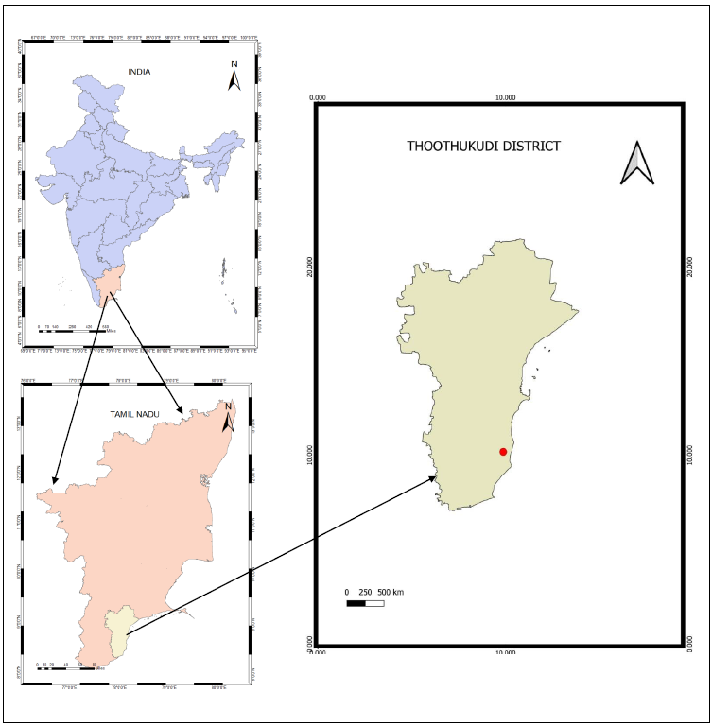
Fig. 1 Study Area

METHODOLOGY

Hardware Configuration

The hardware configuration began by connecting a NodeMCU ESP8266 microcontroller to a soil moisture sensor and a DHT11 temperature and humidity sensor. The sensors' data pins were linked to digital I/O ports, while their VCC and GND pins were connected to the NodeMCU’s corresponding power and ground connections. An embedded C++ application was uploaded to the NodeMCU using the Arduino IDE. This application utilized libraries such as DHT.h, Arduino.h, and Adafruit_Sensor.h to communicate with the sensors and collect data. The NodeMCU, configured to connect to a Wi-Fi network, transmitted the sensor data to a remote server every 15 seconds.
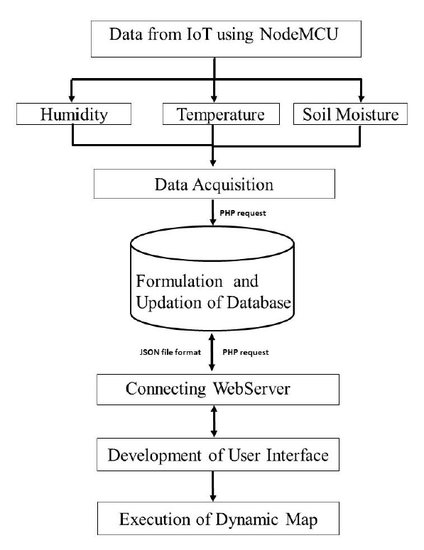

Fig. 2 Flow Chart of the Methodology
Data Transmission and Database Management
Using HTTP requests managed by PHP scripts, the NodeMCU sent the collected sensor data to a server-side MySQL database. Each data record was stored in a dedicated database table with columns for temperature, humidity, soil moisture, and date. PHP scripts enabled real-time data insertion into the database as well as retrieval in JSON format. By dynamically obtaining relevant data, this organized backend facilitated efficient handling of environmental data and ensured the system could effectively meet user requirements.

User Interface Development
To provide users with an engaging experience, a responsive web interface was developed using HTML, CSS, JavaScript, and AJAX. The interface included a user dashboard for data monitoring, a login page for authentication, and a registration page for new users. AJAX enabled asynchronous communication with the server, allowing updated sensor values to be retrieved and displayed without page reloads. The user interface was optimized for both desktop and mobile platforms, enabling users to easily monitor real-time environmental conditions linked to their individual monitoring stations.
WebGIS Integration
The WebGIS component was developed using Leaflet.js and OpenStreetMap (OSM) to spatially visualize sensor data. Each monitoring station was represented by a point on the map, with popup windows displaying the latest soil moisture, humidity, and temperature readings retrieved from the MySQL database. PHP scripts dynamically fetched and delivered this data, enabling users to interact with the Leaflet map in real time. This geographic visualization enhanced environmental monitoring and supported better agricultural decision-making by allowing users to assess spatial variability in environmental conditions.
Summary of Methodological Steps
The methodology followed clear and logical steps: setting up a MySQL database and PHP backend for data storage and access; configuring and connecting the hardware (NodeMCU and sensors); programming the microcontroller for data acquisition and transmission; developing an intuitive web interface for data monitoring; and integrating Leaflet-based WebGIS to display real-time environmental data on an interactive map. Each component was tested for responsiveness, compatibility, and usability to ensure smooth operation across platforms.
Tools and Technologies Used
The study utilized the NodeMCU ESP8266 microcontroller, DHT11 and soil moisture sensors for environmental data collection, and the Arduino IDE with embedded C++ for device programming. MySQL managed database operations, PHP handled server-side scripting, and HTML, CSS, JavaScript, and AJAX supported frontend development. Backend services were hosted on XAMPP or a similar local server environment. Geographical data visualization was achieved using Leaflet.js and OpenStreetMap. Together, these technologies contributed to creating an IoT-WebGIS system that is efficient, scalable, and user-friendly.

RESULT

The results of each step are described, from configuring the hardware to building a WebGIS application that is portable and responsive across all mobile devices.

Hardware setup

First, the hardware setup is established by connecting the NodeMCU ESP8266 board to the soil moisture, humidity, and temperature sensors. The VCC and GND pins of each sensor are connected to the corresponding pins on the NodeMCU ESP8266 using jumper wires. The data pins of the sensors are connected to available digital input pins on the NodeMCU ESP8266. In an Arduino IDE-based project for monitoring soil moisture, humidity, and temperature using the DHT11 sensor, the necessary libraries—DHT.h, Arduino.h, and Adafruit_Sensor—are typically included. Communication with and data retrieval from the DHT11 sensor are enabled by the DHT.h library, allowing humidity and temperature values to be read. Fundamental functionalities for Arduino boards are provided by the Arduino.h core library. The data feed is sent to the designated database via the Wi-Fi feature of the module at intervals of fifteen seconds. This process is facilitated by an algorithm written in embedded C++ on the Arduino IDE. Soil moisture, humidity, and temperature data are acquired and transmitted by the hardware system under standard experimental conditions following these procedures. The hardware requirements of the project were successfully fulfilled by the setup.
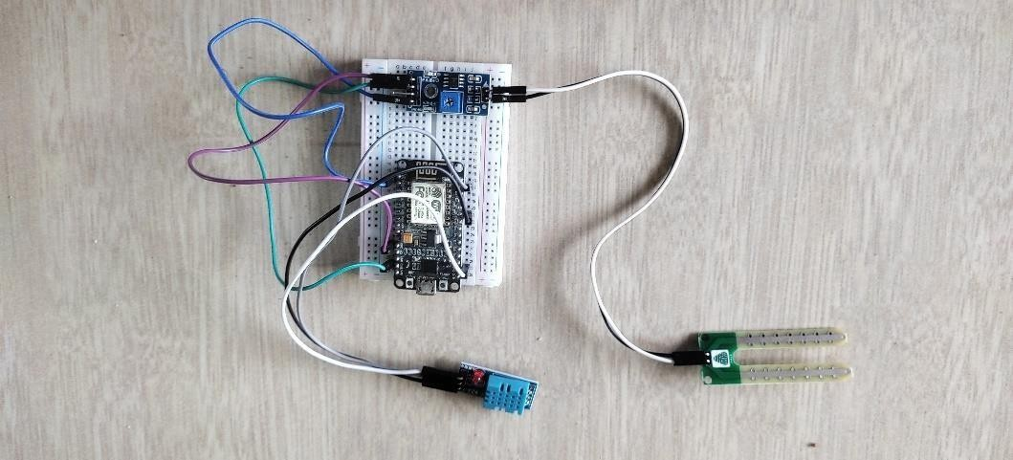
Fig. 1 Hardware Setup

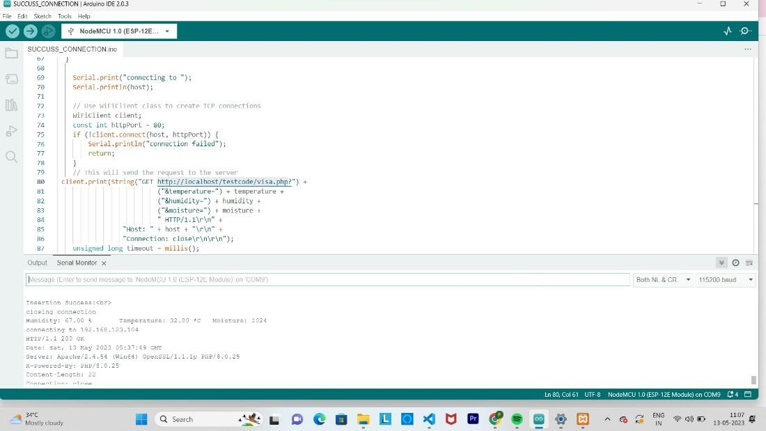
Fig. 2 Device Connection Established

This page in the Arduino IDE shows the successful connection (Figure 2). The messages "Insertion successful" or "Closing connection" displayed in the serial monitor indicate that the hardware connection and communication process between the device and the computer have been successfully established and terminated, respectively.
Database Management
A MySQL database and table are created to store the data collected by the IoT device. A table is formulated using PHP to record the data feed and to disperse the data based on client requests. The dispersed data is received by the client in JSON file format. MySQL is used here for its functionalities to record, manage, and retrieve data based on user queries.

User Interface
A web-based platform is employed to create an interface for users to monitor real-time soil moisture, humidity, and temperature data from their fields. HTML, CSS, JavaScript, and Leaflet are used on the frontend to develop user interaction components such as the registration page, login page, and visualization page in a responsive manner. AJAX is used to enhance the user experience by providing dynamic, active responses to user queries. Soil moisture, humidity, and temperature data are retrieved from the server at specified intervals and displayed in their respective sections representing different monitoring stations. The monitoring stations are also visualized on an interactive web map. Users can click on a monitoring station to view its status, thereby facilitating easier monitoring. This view displays the spatial locations of the stations.

Fig.3 User Registration Portal
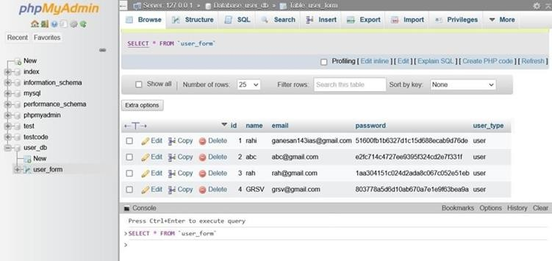

Fig. 4 User Information Database


Fig. 5 User Login portal

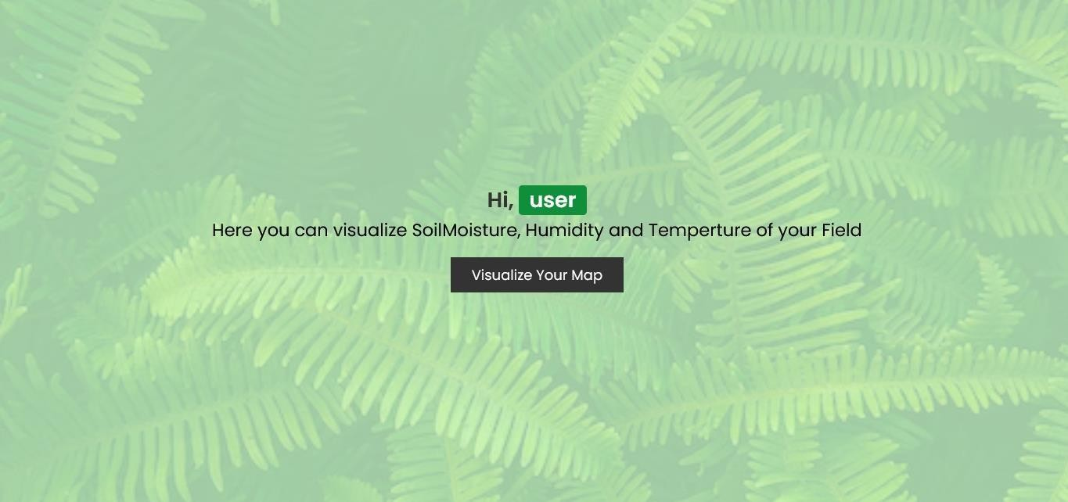

Fig. 6 User Dashboard

The required details should be entered by the user on the registration page (Figure 3), and these details are then stored in the database, as shown on the sample database page (Figure 4). After registration, the user must log in to access the relevant data about their field (Figure 5). Once logged in, the next page, shown in the image above, is displayed. By clicking on ‘Visualize Your Map,’ the dynamic map shown below (Figure 6) can be viewed by the user.

WebGIS

WebGIS, also known as Web Geographic Information System, is a technology that combines Geographic Information System (GIS) capabilities with web mapping technologies to enable the visualization, analysis, and sharing of geospatial data and maps over the internet. It allows spatial data and maps to be accessed and interacted with through a web browser without the need for specialized GIS software.

INTERACTIVE DYNAMIC MAP VISUALIZATION
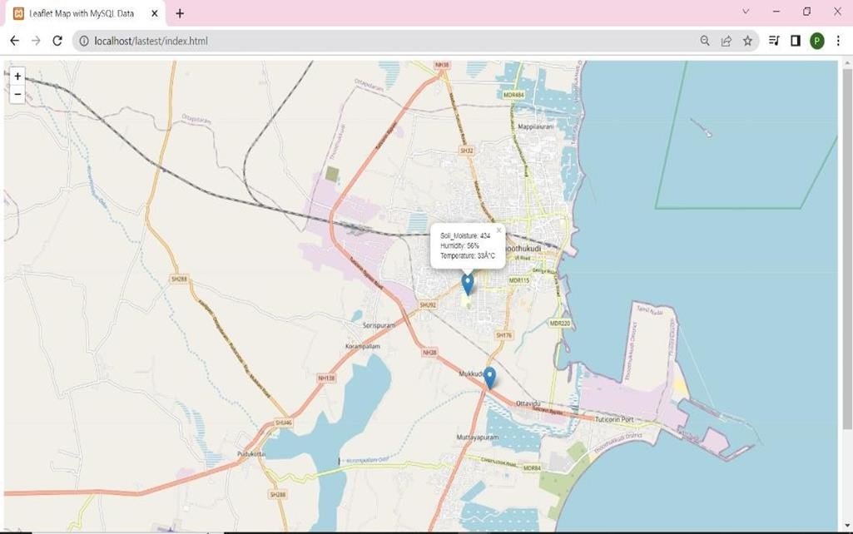
Fig. 7 Interactive Map Visualization

The dynamic map, which uses the Leaflet library, is displayed with an OpenStreetMap (OSM) base map. Data is fetched from a MySQL database (Fig. 7) where the IoT data is stored using PHP. The IoT data is displayed on the map by creating markers and popup visual elements. Thus, the data of the desired station is shown on this dynamic map:

Soil Moisture: 434

Humidity: 56%

Temperature: 32°C

Discussion
"The solution demonstrates how contemporary web technologies and embedded hardware systems can be leveraged to provide real-time monitoring and visualization of environmental parameters. The NodeMCU ESP8266 confirms the reliability of Wi-Fi-enabled microcontrollers for remote sensing applications by consistently gathering data from multiple sensors and transmitting it wirelessly. Efficient client-server data processing and exchange are ensured through the use of PHP for server-side scripting and JSON for data formatting. The platform’s usability is enhanced by a dynamic frontend powered by AJAX, enabling real-time user interaction without page reloads. Moreover, clear geographic representation of sensor data is achieved through the WebGIS platform’s integration of Leaflet with OpenStreetMap. Together, these components offer a scalable and efficient solution for remote environmental monitoring with valuable geographic insights."

Conclusion
"The system employs a compact and efficient IoT setup to enable precise and reliable monitoring of three key environmental parameters: temperature, humidity, and soil moisture. Timely and geographically relevant insights are ensured through the wireless transmission of sensor data to a centralized database, accompanied by dynamic visualization via a responsive web interface. The platform’s ability to integrate spatial representation through WebGIS with real-time sensor data enhances the value of the information for informed analysis. The results confirm the system’s functionality, responsiveness, and user accessibility, validating its role in enabling data-driven environmental assessment using integrated IoT and web technologies."

Disclaimer (Artificial intelligence)
AI used for grammar checking

References:
Chlingaryan, A., Sukkarieh, S., & Whelan, B. (2018). Machine learning approaches for crop yield prediction and nitrogen status estimation in precision agriculture: A review. Computers and electronics in agriculture, 151, 61-69.
Kamilaris, A., Kartakoullis, A., & Prenafeta-Boldú, F. X. (2017). A review on the practice of big data analysis in agriculture. Computers and electronics in agriculture, 143, 23-37.
Khanna, A., & Kaur, S. (2019). Evolution of Internet of Things (IoT) and its significant impact in the field of Precision Agriculture. Computers and electronics in agriculture, 157, 218-231.
Nandurkar, S. R., Thool, V. R., & Thool, R. C. (2014). Design and development of precision agriculture system using wireless sensor network. In 2014 First international conference on automation, control, energy and systems (ACES) (pp. 1-6). IEEE.
Panduman, Y. Y. F., Funabiki, N., Fajrianti, E. D., Fang, S., & Sukaridhoto, S. (2024). A survey of AI techniques in IoT applications with use case investigations in the smart environmental monitoring and analytics in real-time IoT platform. Information, 15(3), 153.
Ramani, D. R., Sujitha, B. B., & Tangade, S. (2025). Smart Environmental Monitoring Systems: IoT and Sensor‐Based Advancements. Environmental Monitoring Using Artificial Intelligence, 45-60.
Rawat, P., Singh, K. D., Chaouchi, H., & Bonnin, J. M. (2014). Wireless sensor networks: a survey on recent developments and potential synergies. The Journal of supercomputing, 68, 1-48.
Salam, A. (2024). Internet of things for sustainable community development: introduction and overview. In Internet of Things for Sustainable Community Development: Wireless Communications, Sensing, and Systems (pp. 1-31). Cham: Springer International Publishing.
Soni, P., Kumar, R., Mishra, S., Swain, S., Mishra, P., & Kumar, S. S. (2025). Optimized neural network for soil moisture prediction in precision agriculture. Measurement, 252, 117380.
Torres-Quezada, E., Fuentes-Peñailillo, F., Gutter, K., Rondón, F., Marmolejos, J. M., Maurer, W., & Bisono, A. (2025). Remote Sensing and Soil Moisture Sensors for Irrigation Management in Avocado Orchards: A Practical Approach for Water Stress Assessment in Remote Agricultural Areas. Remote Sensing, 17(4), 708.
Wang, J., Wang, Y., Li, G., & Qi, Z. (2024). Integration of remote sensing and machine learning for precision agriculture: a comprehensive perspective on applications. Agronomy, 14(9), 1975.
Wolfert, S., Ge, L., Verdouw, C., & Bogaardt, M. J. (2017). Big data in smart farming–a review. Agricultural systems, 153, 69-80.

