Enhancing Wheat Yield by Controlling Phosphorus Availability and Physiological Reactions through the Integration of Organic Amendments and Silicon Supplement

Abstract
One of the primary problems with soil used for crop production worldwide is phosphorus (P) deficiency. Using bacteria and silicon (Si) as inoculants is one of the most effective and economical ways to increase phosphorus availability and improve phosphorus utilization rates in low phosphorus conditions. Few studies have examined how silicon and phosphate-solubilizing bacteria interact to influence wheat biological reactions and yield, despite the fact that their effects on crop performance are well established. A field experiment was conducted at the botany department of Baba Mastnath University in Rohtak between November 2023 and March 2024. The study aimed to examine the combined effects of NPK and Si at four levels (5 g added as silicic acid), PSB at two levels (7.5 and 10 grams of Bacillus megaterium), and SSB at four levels (2.5, 5, 7.5, and 10 g of Bacillus mycoides) on phosphorus uptake by wheat plants and on yield parameters like grain yield, biological yield, number of spikes per spikelet and filled spikelet number, harvest index, spike length, of two wheat varieties—Golden Sharbati 306 and HD 2967. Si, SSB, and PSB were found to be effective in this study across all wheat yield metrics.The quantity of grains per panicle in each wheat variety rose more in T4 when the concentration of Si supplementation, in addition to SSB and PSB, was higher. The greatest increase in the number of filled spikelets in T4 was 17.65% for the golden sharbati 306 variety and 18.4% for the 2967 variety. In contrast, the grain yield of the HD 2967 and Golden Sharabati 306 varieties increased by 13.31% and 15.7%, respectively, when Si was added to SSB in the T2 treatment. In the T4 treatment of both wheat varieties, Si in conjunction with SSB and PSB enhanced biological yield by 11.63% and 14.55%, respectively.The results of the study show that Silicon, SSB and PSB increased the phosphorus uptake of both wheat varieties and enhanced their yields.
Keywords: Phosphorous, Bacillus mycoides, Bacillus megatarium, Phosphate solubilizing bacteria
Introduction:
Wheat is a staple crop that provides food for billions of people worldwide. It is crucial to the security of the world's food supply (Dadrasi et al., 2023). There is an urgent need to increase output by 77%, particularly among developing nations, as the world's wheat production is currently at 750 million tons, while the demand is expected to reach 840 million tons by 2050. Increasing yield per unit area will be the primary means of achieving this [FAO2021). In order to maintain soil health and boost crop productivity, sustainable wheat production relies on effective nutrient management, which also guarantees ideal soil fertility and boosts nutrient use efficiency. Excessive use of fertilizers, such as urea, ammonium sulfate, and nitrate or phosphate compounds, can be harmful. Pollution results from farmers using a lot of NPK fertilizers under continuous irrigation conditions, which are unavailable to plants because of runoff or leaching. Agronomic techniques that prioritize nutrient input balance are essential because phosphorous has a significant influence on critical physiological and biochemical processes that propel plant growth and yield. Phosphorous, a primary macronutrient that that plants require along with nitrogen and potassium has a direct impact on the growth, development, and grain yield of wheat. P deficiency, a significant constraint on crop growth and yield, affects approximately 50% of all agricultural ecosystems globally (Lynch, 2011;Ringeval et al., 2017;Etesami, 2020). In an attempt to solve this issue, Phosphorus based fertilizers in the form of Diammonium phosphate are being used more frequently worldwide. Since the potential increase in plant growth efficacy from adding chemical P fertilizers has peaked, it is impossible to predict that additional chemical P fertilization will result in a significant increase in plant yield. (Etesami 2020). Crop productivity can be changed by microorganisms due to changes in soil conditions. Bacteria weather silicates, dissolving them so that plants can use them, according to numerous studies (Chandrakala et al., 2019). As an example, a mix of phosphate-solubilizing bacteria and silicon-solubilizing bacteria could improve the availability and uptake of P in plants like wheat. It is thought that the best way for boosting wheat growth and yield is to combine the use of PSB and SSB with Si fertilizer.
2.Materials and methods
A pot experiment was conducted to study the synergistic role of silicon and phosphate solubilizing bacteria and silicon supplement in enhancing the bioavailability of phosphorous at Botanical garden , Department of Botany, Baba Mastnath University , Rohtak ,Haryana in Novemeber 2023 to March 2024.
2.1 Fertilizer Treatments Table :
Treatment | N (g) | P (g) | K (g) | Si (g) | SSB (g) | PSB (g) | Description
Control | 5 | 5 | 5 | – | – | – | Basel fertilizer only
Treatment 1 | 5 | 5 | 5 | 5 | 2.5 | – | NPK + Si + SSB
Treatment 2 | 5 | _ | 5 | 5 | 5 | – | NK + Si + SSB
Treatment 3 | 5 | 5 | 5 | 5 | 7.5 | 7.5 | NPK + Si + SSB + PSB
Treatment 4 | 5 | _ | 5 | 5 | 10 | 10 | NK + Si + SSB + PSB

Note: N( Urea for Nitrogen), P ( Diammonium Phosphate (DAP) for Phosphorus) K ( Potash for Potassium ) Si ( Silicon ) SSB ( Silicon solubilizing bacteria ) PSB ( Phosphate solubilizing bacteria).g ( g for gram in weight ).
2.2.Collection of wheat crop seeds
The "Haryana State seed Certification Agency, Haryana" provided the certified wheat cultivar seeds. In order to prevent contamination, seeds were kept in sterile bags made of polythene.
Fertilisers : Basel fertilizer (Urea for nitrogen, Diammonium phosphate (DAP) for phosphorous and potash for potassium) was purchased from Indian farmer fertilizer cooperative limited , Delhi and Silicon fertilizer, was purchased from kisan chemical and fertilizer, Bhadra ,and SSB from Sonkul agro industries private Limited and PSB was purchased from Akshar chem. private limited,Mumbai.
2.3. Pot experiment
Local cultivars of wheat and different concentrations of all the 5 treatments including control was chosen for the pot experiment. The size of each pot was 11.5 cm in height 7.5 cm in diameter. Three duplicates of each treatment and control were made .The Si fertilizer along with SSB and PSB was thoroughly mixed with soil prior to potting. Basel fertilizers such as urea for nitrogen, Diammonium phosphate (DAP) for Phosphorus and Potash for Potassium was used as control. All the pots were kept weed free for the entire growing season by hand hoeing as weeds appeared. All the pots were irrigated as per requirement.
2.4. Watering
A total of four irrigations were administered during the growing season.
First = 25 days after seeding (when the crown root first appears)
Second =55 days after sowing (the tillering stage).
Third = 80 days afterwards the heading stage of seeding)
Fourth = 110 days post-sowing (soft dough/milky stage)
2.5. Yield attributes (130 DAS)
At the time when plants reached maturity, the following yield data and the characteristics that
contributed to it were noted.
1. The number of grains in each spike
Each spike's total number of grains was carefully counted.
2. Weight of grains per spike
The spikes of the wheat were thrashed and grains were harvested and weighed using a weighing
machine to obtain the total grain weight per plant which was expressed in g.
3. Each spike's number of spikelets
All the spikelets have been counted to determine the number of spikelets per spike.
5. Length of spike
The spike length of each plant was noted manually from the base of a spike of the spike up to
its last spikelet.
6. Biological yield per plant
Three plants from each treatment were taken out and dried in the sun before being weighed
with a weighing balance and the yield per plant was noted.
7.Grain yield per plant
From each treatment, three plants were removed and allowed to dry in the sun. Grain yield was
determined by the threshing of sample grains.
8.Harvest index (%)
The harvest index for each treatment was estimated by the following formula:
Harvest Index = (Grain yield / Biological yield) × 100
9.Filled spikelets in spike
Each spikelet was pushed between the thumb and fingers to figure out whether it was filled or not.. Filled and unfilled grains were counted for all the spikes from both varieties.
2.8 .Statistical analysis
Statistical analysis of the data was done using analysis of variance (ANOVA) technique recommended for the design. Critical difference (CD) values were calculated at the 5% level of significance.
3. RESULTS AND DISCUSSION
3.1. Impact of treatments on wheat crop yield-attributing traits
A. Number of Spikelets per Spike, filled spikelet no, and No. of Grains per Panicle
Interaction of NK with silicon and Bacillus mycoides (SSB) showed a substantial increase in the yield of both the varities .The rise was more noticed in golden Sharbati 306 then HD 2967 variety. T2 showed a greater increase in the number of filled spikelets, grains per panicle, and spikelets with 5 g levels of silicon and Bacillus mycoides (SSB) compared to their respective control. Additionally , in each wheat variety during higher concentration of Bacillus megatarium (PSB) in T4 showed a greater rise in no. of grains per panicle. The maximum rise in filled spikelets no was 17.65% in golden sharbati 306 variety and 18.4% in no. of spikelets in 2967 variety in T4.No important role was found of DAP when subjected with Si, SSB and PSB in both the varities respectively .
A.No of spikelets / spike B. Filled spikelet no.
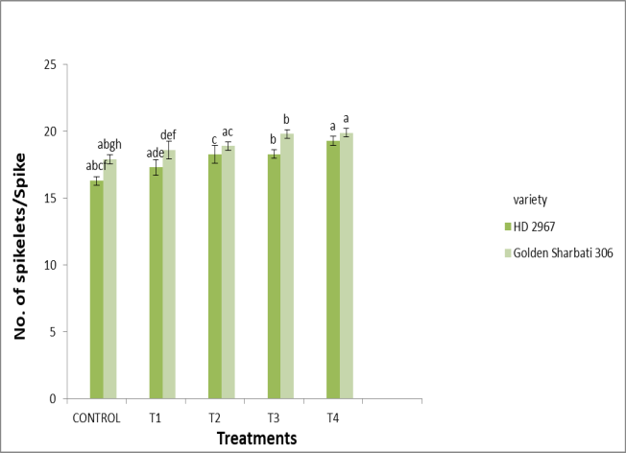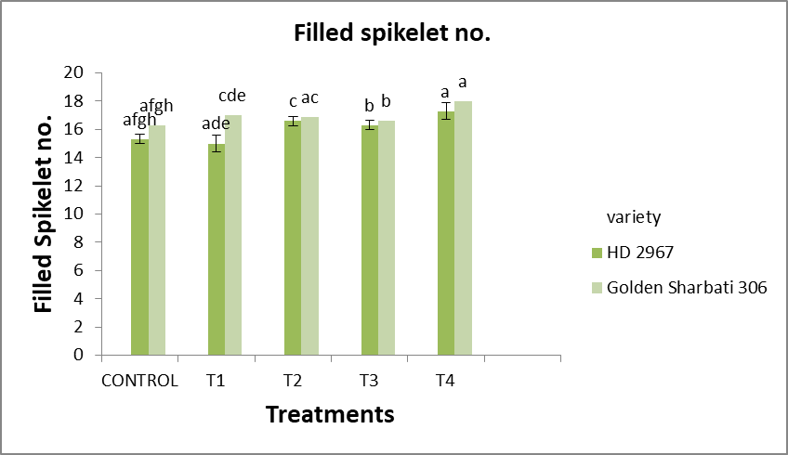
C. No. of Grains per panicle
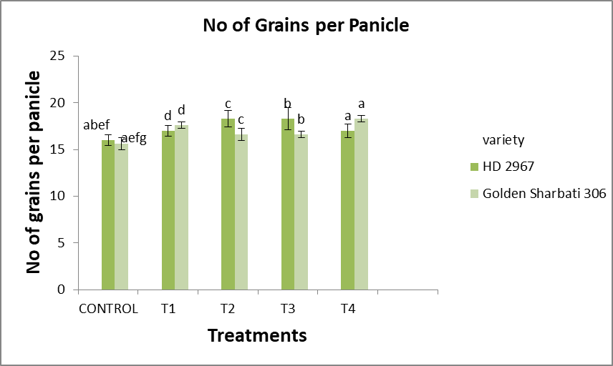

Figure 1. Influence of Si, SSB and PSB on Number of Spikelets per Spike (A) filled spikelet no (B), and No of grains panicle(C) of wheat plants . Data shown in the figure indicates Mean ± SE; Two-factor analysis with Tukey’s HSD post hoc test; Each bar with a distinct letter differed significantly among treatments as well as varieties (p<0.05). The symbols in the figure represent Control:NPK (5g) each, T1: control +Si (5g) +SSB(2.5g) , T2: NK(5g) +Si(5g)+SSB(5g), T3: control+ Si (5 g) + SSB(7.5 g )+ PSB ( 7.5 g ), T4: NK (5g)+Si (5 g )+ SSB ( 10 g ) + PSB (10g)
No. of grains per panicle decreased with an increase Bacillus magatarium concentrartion from(7.5g to 10 g) in HD 2967 variety while in Golden Sharbati 306 variety no of grains per panicle increased with increase in concentraton of Baciilus megatarium. The no. of grains per panicle decreased from 14.38%(T3) to 6.25 %(T4) in HD 2967 and increase from 6.41% (T3) to 17.31% (T4) in the Golden Sharbati 306 variety.Contrarily, Si supplementation , SSB and PSB improved no. of grains per panicle (T4) by 6.25% in HD2967and 17.31% in the Golden Sharbati variety with respect to control plants (figure 1 C)
B.Spike length and Seed length
Si treatments lead to a considerable increase in spike length and seed length in both varieties (Figure 2 A, B) under increased concentration of SSB and PSB levels . In the T3 treatment, the spike length of HD 2967 and Golden Sharbati 306 were 15.12% and 17.2% Higher than those in the control treatment, respectively (Figure 2B).However, Si along with Bacillus mycoides (SSB ) and Bacillus megatarium (PSB) addition resulted in a 13.21% increase in seed length in the T2 and T4 treatment of both wheat varieties. No substantial impact of DAP on both parameters under Si supplementation.
- Seed length B. Spike length
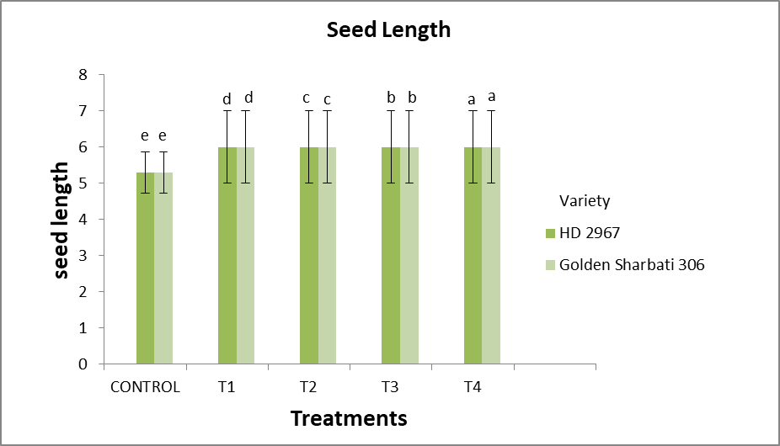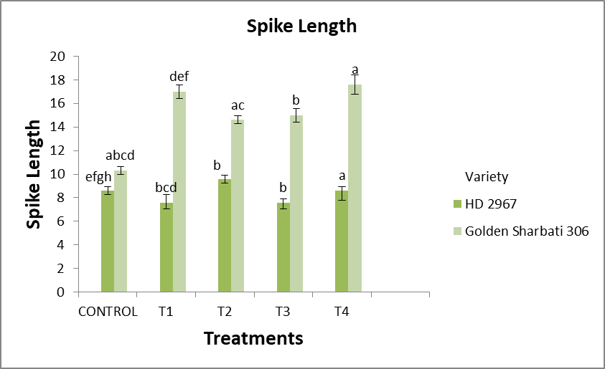
Figure 2. Influence of Si, SSB and PSB on Seed Length (A) Spike Length (B)of wheat plants . Data shown in the figure indicates Mean ± SE; Two-factor analysis with Tukey’s HSD post hoc test; Each bar with a distinct letter differed significantly among treatments as well as varieties (p<0.05). The symbols in the figure represent Control:NPK (5g) each, T1: control +Si (5g) +SSB(2.5g) , T2: NK(5g) +Si(5g)+SSB(5g), T3: control+ Si (5 g) + SSB(7.5 g)+ PSB ( 7.5 g ), T4: NK (5g)+Si (5 g )+ SSB ( 10 g ) + PSB ( 10 g )
C.Biological Yield, Grain Yield and Harvest Index:
Si supplemention along with Baciilius mycoides(SSB), Bacillus megatarium (PSB) positively influenced the biological yield, grain yield, and harvest index of both varieties during different concentrations of Si (5g),SSB(5g,7.5g,10g ) PSB ( 5g, 7.5g ,10g ). The positive effects were more noticeable in HD 2967 variety than in Golden Sharbati 306 in (Figure 3 ). Si treatment influenced all yield parameters and improved the yield across all treatments. The biological yield of both varieties increased under increased concentration of SSB and PSB conditions (Figure 3 A). In the T3 treatment, the biological yield of HD 2967 and Golden Sharbati 306 were 11.4% and 12.14% more than those in the control plants, respectively. However, Si supplementation along with SSB resulted in a 9.07% and 11.66% increase in biological yield in the T2 treatment of both wheat varieties. Likewise, Si along with SSB and PSB resulted in a 11.63% and 14.55% increase in biological yield in the T4 treatment of both the wheat varities. Likewise, concerning control, the grain yield (Figure 3 B) was high in the T3 treatment for HD 2967 by 5.93%, whereas for Golden Sharbati by 9.67% under silicon , SSB and PSB supplementation in comparison to control . However,applying Si along with SSB increased the grain yield 13.31%, and 15.7% of HD 2967 and Golden Sharabati 306 varities. Whereas, Si along both SSB and PSB increased the grain yield by 18.02% and 19.57% of HD 2967 and Golden Sharbati 306 respectively. The application of DAP has no significant impact on yield parameters of both wheat varities.
A. Biological Yield /Plant B. Grain Yield / Plant
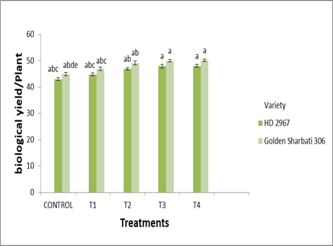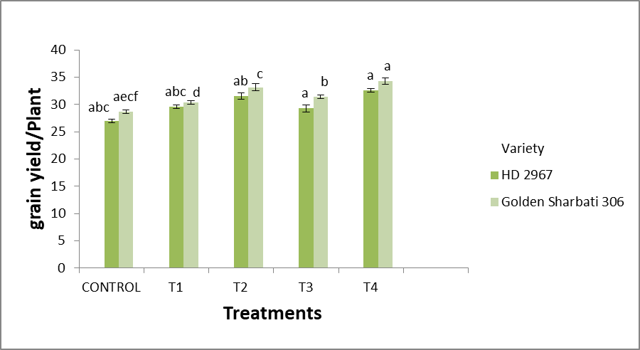
C.Harvest Index%
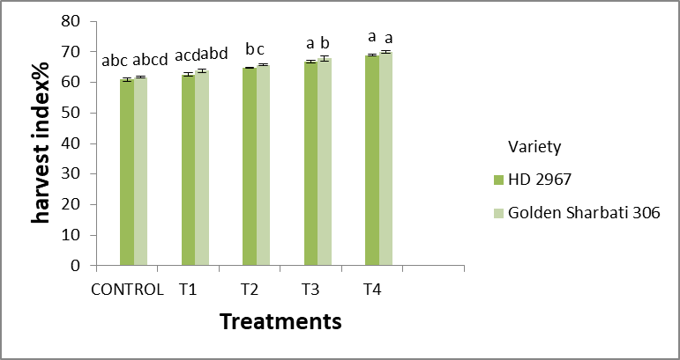

Figure 3. Influence of Si, SSB and PSB on Biological Yield / plant (A) Grain Yield / Plant (B), and Harvest Index%(C) of wheat plants . Data shown in the figure indicates Mean ± SE; Two-factor analysis with Tukey’s HSD post hoc test; Each bar with a distinct letter differed significantly among treatments as well as varieties (p<0.05). The symbols in the figure represent Control:NPK (5g) each, T1: control +Si (5g) +SSB(2.5g) , T2: NK(5g) +Si(5g)+SSB(5g), T3: control+ Si (5 g) + SSB(7.5 g )+ PSB ( 7.5 g ), T4: NK (5g)+Si (5 g )+ SSB (10 g) + PSB ( 10 g)
With higher levels of SSB and PSB, the Si treatment improved the harvest index of both wheat varities (Figure 3 C). In comparison to the control treatment, the harvest index rises to 9.52% and 9.89% in the HD 2967 and Golden Sharbati 306 varieties in (T3). The harvest index of both varieties was significantly raised across all treatments by the addition of Si along with SSB. In two wheat varieties under T2, Si with SSB increased the harvest index by 6.4% in HD 2967 and 6.48% in Golden Sharbati 306 respectively. In the T4 treatment, Si with SSB and PSB enhances the harvest index by 13.14% in HD 2967 and 13.29% in Golden Sharbati 306.
4. Conclusion : According to research, the best yield and yield component results are obtained when PSB is applied in conjunction with varying amounts of silicon and silicon solubilizing bacteria . The application of silicon, SSB, and PSB significantly increased the yield of the wheat crop (69%).For optimal productivity, 100% of P must come from inorganic sources in addition to PSB. Through phosphorus solubilization and cationic exchange, it can release silicon and phosphorus into soil solution, making them easily accessible to plants. We were able to create biostimulators that can function as soil conditioners in agriculture thanks to the ecological approach developed in this study. In order to maximize the use of natural phosphate worldwide and increase the resilience and yield of the wheat crop, these possible formulations could be used in place of chemical fertilizers.

Disclaimer (Artificial intelligence)
Option 1: option 1
Author(s) hereby declare that NO generative AI technologies such as Large Language Models (ChatGPT, COPILOT, etc.) and text-to-image generators have been used during the writing or editing of this manuscript.
Option 2:
Author(s) hereby declare that generative AI technologies such as Large Language Models, etc. have been used during the writing or editing of manuscripts. This explanation will include the name, version, model, and source of the generative AI technology and as well as all input prompts provided to the generative AI technology
Details of the AI usage are given below:
1.
2.
3.

References
- Dadrasi, A., Chaichi, M., Nehbandani, A., Sheikhi, A., Salmani, F., & Nemati, A. (2023). Addressing food insecurity: An exploration of wheat production expansion. PLOS ONE, 18(12), e0290684.
- Food and Agriculture Organization of the United Nations. (2021). FAOSTAT.
- Ali, N., & Akmal, M. (2022). Wheat growth, yield, and quality under water deficit and reduced nitrogen supply: A review. Gesunde Pflanzen, 74(2), 371–383.
- Ghafoor, I., Habib-ur-Rahman, M., Ali, M., & Afzal, M. (2021). Slow-release nitrogen fertilizers enhance growth, yield, NUE in wheat crop and reduce nitrogen losses under an arid environment. Environmental Science and Pollution Research, 28(32), 43528–43543.
- Lynch, J. P. (2011). Root phenes for enhanced soil exploration and phosphorus acquisition: Tools for future crops. Plant Physiology, 156(3), 1041–1049.
- Ringeval, B., Augusto, L., Monod, H., Apeldoorn, D., Bouwman, L., Yang, X., et al. (2017). Phosphorus in agricultural soils: Drivers of its distribution at the global scale. Global Change Biology, 23(8), 3418–3432.
- Etesami, H., & Jeong, B. R. (2020). Importance of silicon in fruit nutrition: Agronomic and physiological implications. In Fruit Crops (pp. 255–277).
- Ameen, F., AlYahya, S. A., AlNadhari, S., Alasmari, H., Alhoshani, F., & Wainwright, M. (2019). Phosphate solubilizing bacteria and fungi in desert soils: Species, limitations and mechanisms. Archives of Agronomy and Soil Science, 65(10), 1446–1459.
- Chandrakala, C., Voleti, S. R., Bandeppa, S., Kumar, N. S., & Latha, P. C. (2019). Silicate solubilization and plant growth promoting potential of Rhizobium sp. isolated from rice rhizosphere. Silicon, 11(1), 1–12.
- Gu, H. H., Zhan, S. S., Wang, S. Z., Tang, Y. T., Chaney, R. L., Fang, X. H., Cai, X. D., & Qiu, R. L. (2012). Silicon-mediated amelioration of zinc toxicity in rice (Oryza sativa L.) seedlings. Plant and Soil, 350(1–2), 193–204
- Jeong, S., Ko, J., & Yeom, J. M. (2018). Nationwide projection of rice yield using a crop model integrated with geostationary satellite imagery: A case study in South Korea. Remote Sensing, 10(10), 1665.
- El-Awady, R. A., Nada, A. M., & Elekhtyar, N. M. (2022). Effect of different sources of nitrogen application on rice yield and soil health in saline sodic soil. Journal of Soil Sciences and Agricultural Engineering, 13(4), 371–380.
- Wilson, M. A., Tran, N. H., Milev, A. S., Kannangara, G. S. K., Volk, H., & Lu, G. H. M. (2008). Nanomaterials in soils. Geoderma, 146(1–2), 291–302.
- Etesami, H., & Jeong, B. R. (2021). Use of plant growth promoting rhizobacteria (PGPRs) with multiple plant growth promoting traits in stress agriculture: Action mechanisms and future prospects. Ecotoxicology and Environmental Safety, 209, 111750.
- Etesami, H., & Jeong, B. R. (2021). Silicon (Si): Review and future prospects on the action mechanisms in alleviating biotic and abiotic stresses in plants. Ecotoxicology and Environmental Safety, 209, 111835.
- Pathan, S. I., Vetrovsky, T., Giagnoni, L., Datta, R., Baldrian, P., Nannipieri, P., & Renella, G. (2018). Microbial expression profiles in the rhizosphere of two maize lines differing in nitrogen use efficiency. Plant and Soil, 433(1–2), 401–413.
- Raymond, N. S., Gómez‐Muñoz, B., van der Bom, F. J., Nybroe, O., Jensen, L. S., Müller‐Stöver, D. S., & Richardson, A. E. (2021). Phosphate‐solubilising microorganisms for improved crop productivity: A critical assessment. New Phytologist, 229(3), 1268–1277.
- Wahid, F., Fahad, S., Danish, S., Adnan, M., Yue, Z., Saud, S., & Datta, R. (2020). Sustainable management with mycorrhizae and phosphate solubilizing bacteria for enhanced phosphorus uptake in calcareous soils. Agriculture, 10(8), 334.

