# A Narrative Review on Transforming Finger millets (*Eleusine coracana*) into a Superfood through Germination

Review Article

**ABSTRACT**

Millets have been a staple grain for ages, they are essential for maintaining food security in semiarid region. They are considered as a functional food because of their low glycemic index, gluten-free status and high dietary fiber and mineral content. Finger millet is a type of major millet. It is known by different names in different regions. Finger millet is one of the most nutrient-dense grain because of its high protein content and well-balanced amino acid profile. It contains high level of various micronutrients, including vitamins and minerals such as riboflavin, nicotinic acid, thiamine, calcium, phosphorus, and iron content. Numerous processing methods, including popping, roasting, germination, fermentation, and others, have been shown to improve the nutritional profile. Germination was determined to be the most effective processing method out of all of them. It aided in enhancing the nutritional profile, reducing the level of anti-nutrients and improving the functional properties of finger millet which ultimately improved sensory aspects, which aids in the creation of a variety of food products with enhanced nutritional content and sensory qualities. Thus, the present review study focuses on understanding the significance of finger millet with the help of various processing techniques and the role of germination on finger millet and its value-added product.

**KEYWORDS**

Finger Millet, Functional Properties Germination, Millets, and Nutritional Composition,

**INTRODUCTION**

### Millets

The word "millet" comes from the French word "mille," which means "thousand," because as many as 1,000 grains can be found in a handful of millet. These tiny-seeded crops, which are part of an agronomic functional group, can be fed to people or used as fodder. The grass family includes the tiny, delicious seeds known as millets (Rajkumar *et al.,* 2024). The Poaceae family includes a variety of small grains regarded as millets. Small seeds and the capacity to flourish in less fertile soils are characteristics of these annual cereal grasses. They have evolved to survive in hot, dry conditions. Millets are often considered a food refuge crop due to their resilience in harsh agro-climatic conditions (Patil *et al.,* 2023). Millets are of two types namely major millets and minor millets. Major millets include Sorghum (*Sorghum bicolor* L.), Pearl millet (*Pennisetum glaucum*), Finger millet (*Eleusine coracana*), whereas minor millet includes Kodo millet (Paspalum setaceum), Proso millet (Penicum miliaceum), Foxtail millet (*Setaria italic*), Little millet (*Panicum sumatrense*), and Barnyard millet (*Echinochloa species*). Millets are a staple grain for ages, they are essential for maintaining food security in semiarid areas. They are considered functional foods because of their low glycemic index, gluten-free status, and high dietary fiber and mineral content (Kumar *et al.,* 2021). Millets also include ẞ-glucan and water-soluble gums, which help to improve glucose metabolism (Chaudhary and Vyas, 2014). They provide a balanced nutritional profile that can greatly improve the nutritional security of many people because they are high in protein, minerals, and dietary fiber (Raj kumar *et al.,* 2024). They can help in managing diseases like diabetes, obesity, and hyperlipidemia along with several health benefits. Millets have high mineral content, which may aid in preserving the acid-base balance of body, and this high mineral content makes them regarded as "cool" meal. Compared to people who eat food other than millet, millet eaters typically reported feeling more hydrated and less thirsty (Patil *et al.,* 2023). The aim of the present study is to understand finger millet, the effect of germination on the nutritional composition, anti-nutritional factors and functional properties of finger millet along with the application of germinated finger millet into the production of value-added products.

**Finger Millet**

Finger millet was referred to as "nrttakondaka," or "dancing grain," in ancient Indian Sanskrit literature. It was also termed as "rajika" and "markataka". Among other Indian states, it is called as "umi" in Bihar and "nachni" (meaning "dancer") in Maharashtra (Patil et al., 2023). India is one of the world's biggest producers of finger millet. With approximately 1,138.2 thousand hectares of land devoted to its cultivation a production of roughly 1,821.9 thousand tons in 2015-16 was made (Kumar et al., 2021). The taxonomical classification of finger millet in presented in figure 1.

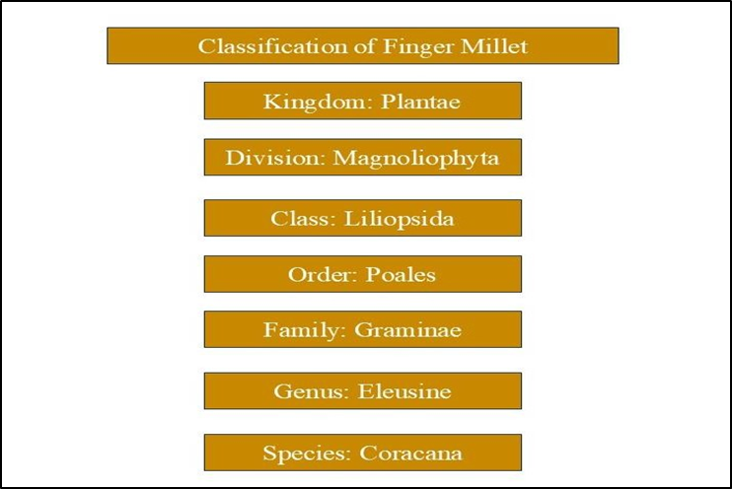

**Figure1: Taxonomical classification of Finger millet**

The morphological features of finger millet are diverse. The testa is a seed coat that covers the embryo and endosperm of finger millet. It is a single-seeded, tiny grain with a kernel that is categorized as an achene rather than a normal caryopsis. The grains are rubbed and then immersed in water to remove the small seed covering. The kernels range in size from 1 to 1.8 mm and could be globular, round, or oval in shape (Rajkumar et al., 2024). This crop has a variety of colours, including white, red, yellow, violet, tan, and brown. Finger millets are cultivated in 25 countries across Asia and Africa, occupying about 12% of the land dedicated to millet crops. Finger millet is also a drought-tolerant crop that grows well in salty soils with a pH between 5.0 and 8.2, which makes it appropriate for dryland farming. It is one of the most nutrient-dense grains because of its high protein content and well-balanced amino acid profile. Although finger millet is more nutritious than other cereal grains, it is not widely utilized (Rajkumar et al., 2024). However, they are frequently disregarded and misused in tropical and semi-arid areas. Further, varieties of finger millets and their area of adaptation are presented in Table 1.

**Table 1: Variety of finger millet along with Year of release and Area of adaptation**

|  |  |  |
| --- | --- | --- |
| **Variety** | **Year of release** | **Area of adaptation** |
| Finger millet VL Mandua 149 | 1991 CVRC | Uttarakhand Hills and all millet growing areas except Tamil Nadu and A.P. |
| Finger millet VL Mandua  146 | 1996 CVRC | UP, Orissa, South Bihar, Maharashtra and  Karnataka |
| Finger millet VL Mandua 315 | 2006 SVRC | Uttarakhand Hills |
| Finger millet VL Mandua  324 | 2006 SVRC | Uttarakhand Hills |
| Finger millet VL Mandua  347 | 2012 CVRC | Bihar, Gujarat, Jharkhand, Karnataka,  Madhya Pradesh and Uttarakhand |
| Finger millet VL Mandua  352 | 2014 CVRC | All finger millet growing state except Tamil  Nadu and Maharashtra |
| Finger millet VL Mandua  348 | 2016 SVRC | Uttarakhand Hills |
| Finger millet VL Mandua 376 | 2018 CVRC | Andhra Pradesh, Bihar, Gujarat, Jharkhand, Karnataka, Madhya Pradesh, Odhisa, Uttarakhand, Maharashtra and Tamil Nadu |
| Finger millet VL Mandua 379 | 2018 CVRC | Uttarakhand, Bihar, Jharkhand, NE States and Madhya Pradesh |
| Finger millet VL Mandua  380 | 2019 SVRC | Uttarakhand |
| Finger millet VL Mandua 378 | 2021 SVRC | Uttarakhand |
| Finger millet VL Mandua  382 | 2021 SVRC | Uttarakhand |

Finger millet is traditionally processed in India using a variety of techniques, including grinding, malting, and fermentation, to create dishes such as porridges, drinks, sand roti (unleavened flatbread), idli, and dosa. The grain of finger millet is gluten-free (Rajkumar *et al.,* 2024). Compared to regular cereal rice, it is more nutrient-dense and has higher levels of protein, fat, minerals, and dietary fiber. Its nutritional profile is presented in Table 2. Finger millet is an easy-to-digest grain that doesn't generate acid and has low allergenicity (Chaudhary and Vyas, 2014). Finger millet contains high levels of various micronutrients, including vitamins and minerals such as riboflavin, nicotinic acid, thiamine, calcium, phosphorus, and iron (Rajkumar *et al.,* 2024). Furthermore, finger millet contains a significant amount of bioactive substances that support its antibacterial and antioxidant qualities (Kumar *et al.,* 2021). The calcium level of finger millet ranges from 300 to 400 mg, which is around ten times that of typical grains like rice and wheat (Patil *et al.,* 2023). However, its nutritional value may be limited by the presence of anti-nutrients such phytic acid, trypsin inhibitors, and certain phenolic chemicals. These substances can interfere with the absorption of vital nutrients like proteins and chelate minerals.

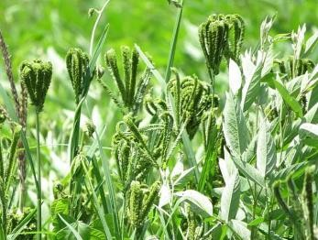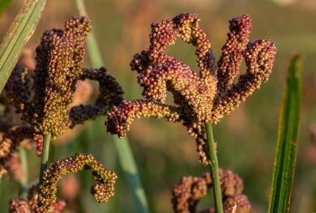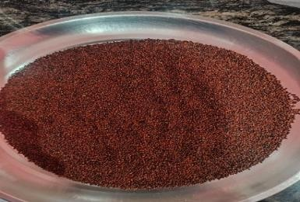

**Figure 2:** Represents Underripe Finger Millet (left), Ripe Finger Millet (middle), Grains of Finger Millet (right)

(Source: Image (left) [**https://images.app.goo.gl/8BqyePHoZPtUZzri9**](https://images.app.goo.gl/8BqyePHoZPtUZzri9) **)**

**(**Source: Image(middle)[**https://www.google.com/imgres?imgurl=https%3A%2F%2Fbold.croptrust.org%2Ffileadmin%2Fuploads%2Fcroptrust%2FPhoto**](https://www.google.com/imgres?imgurl=https%3A%2F%2Fbold.croptrust.org%2Ffileadmin%2Fuploads%2Fcroptrust%2FPhoto)[**s%2FCWR%2F1_3CWRFingerMillet.jpgandtbnid=RIEdgnWBWhJ3kMandvet=1andimgrefurl=https%3A%2F%2Fbold.croptrust.org**](https://www.google.com/imgres?imgurl=https%3A%2F%2Fbold.croptrust.org%2Ffileadmin%2Fuploads%2Fcroptrust%2FPhotos%2FCWR%2F1_3CWRFingerMillet.jpg&tbnid=RIEdgnWBWhJ3kM&vet=1&imgrefurl=https%3A%2F%2Fbold.croptrust.org%2Fcrops%2Ffinger-millet%2F&docid=j9r49NpT9QJZfM&w=7415&h=5020&itg=1&hl=en-IN&source=sh%2Fx%2Fim%2Fm1%2F4&kgs=ca67f98b3190246f)

[**%2Fcrops%2Ffinger-millet%2Fanddocid=j9r49NpT9QJZfMandw=7415andh=5020anditg=1andhl=en-**](https://www.google.com/imgres?imgurl=https%3A%2F%2Fbold.croptrust.org%2Ffileadmin%2Fuploads%2Fcroptrust%2FPhotos%2FCWR%2F1_3CWRFingerMillet.jpg&tbnid=RIEdgnWBWhJ3kM&vet=1&imgrefurl=https%3A%2F%2Fbold.croptrust.org%2Fcrops%2Ffinger-millet%2F&docid=j9r49NpT9QJZfM&w=7415&h=5020&itg=1&hl=en-IN&source=sh%2Fx%2Fim%2Fm1%2F4&kgs=ca67f98b3190246f)[**INandsource=sh%2Fx%2Fim%2Fm1%2F4andkgs=ca67f98b3190246f**](https://www.google.com/imgres?imgurl=https%3A%2F%2Fbold.croptrust.org%2Ffileadmin%2Fuploads%2Fcroptrust%2FPhotos%2FCWR%2F1_3CWRFingerMillet.jpg&tbnid=RIEdgnWBWhJ3kM&vet=1&imgrefurl=https%3A%2F%2Fbold.croptrust.org%2Fcrops%2Ffinger-millet%2F&docid=j9r49NpT9QJZfM&w=7415&h=5020&itg=1&hl=en-IN&source=sh%2Fx%2Fim%2Fm1%2F4&kgs=ca67f98b3190246f))

Fortunately, various processing techniques such as popping, roasting, germination, and fermentation have been found to reduce these anti-nutritional factors to safe levels. Among these methods, germination is considered an important and cost-effective approach to enhance the digestibility of finger millet while decreasing its anti-nutritional content (Kumar *et al.,* 2021). The nutritional benefits of germinated millets arise from the significant changes that occur during the germination process, which enhance their nutrient profile (Rajkumar *et al.,* 2024).

**Table 2: Nutritional composition of finger millets**

|  |  |  |  |
| --- | --- | --- | --- |
| **Nutritional value** | **g/100g or mg/100g** | **g/100g or mg/100g** | **g/100g or mg/100g** |
| **Protein content** | 6.04±0.14 g | 7.16 g | 6.3 ± 0.2 g |
| **Fat content** | 0.57±0.02 g | 1.92 g | 1.3± 0.2 g |
| **Ash content** | 2.27±0.12 g | 2.04 g | 2.8± 0.17 g |
| **Crude fibre content** | 3.74±0.16 g | - | 18.9 ± 0.2 g |
| **Carbohydrate content** | - | 66.82 g | 71.9± 1.9 g |
| **Starch** | 62.83±0.65 g | - | - |
| **Calcium content** | 193.5 + 0.9 mg/100g | 364 mg | 342.4 ± 1.36 mg |
| **Iron content** | 5.56±0.39 mg/100g | 4.62 mg | 3.7 ± 0.06 mg |
| **Phosphorus content** | 219.7±0.6 mg/100g | 210 mg | 280.1± 1.23 mg |
| **Magnesium content** | - | 146 mg | - |
| **Vitamin C content** | 9.76±0.24 mg/100g | - | 0.04 ± 0.01 mg |
| **Reference** | (Kumar *et al.,* 2021) | (Bisht *et al.,* 2023) | (Chauhan *et al.,*  2018) |

**PROCESSING TECHNIQUES FOR FINGER MILLETS**

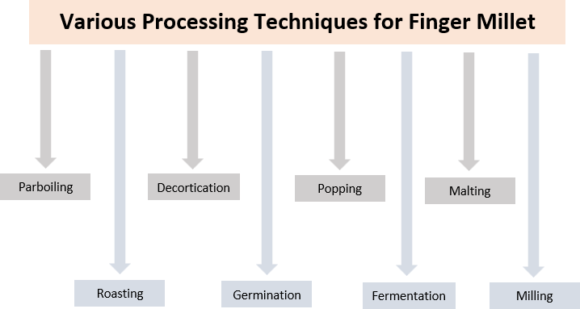

**Figure 3**: Processing techniques for finger millets

### Parboiling

In order to maximize grain recovery without nutrient loss, parboiling is a hydrothermal treatment applied to cereals and millets before decortications. Soaking, heating, and drying are the methods used. In addition to increasing endosperm hardness compared to unparboiled grains, parboiling aids in the penetration of water-soluble nutrients from the outside layer of the grain seed coat to the inner layer of the grain. As a result, during the decortication process, the nutrients found in the grains' outer layer remain intact (Rathore *et al.,* 2019).

### Roasting

Roasting is the most widely used cooking method where hot air cooks the food material evenly from all sides at around 150°C temperature in an open pan. grinding and roasting enhances grain digestibility and prevent nutrient losses (Rathore *et al.,* 2019). Roasting is similar to the puffing process but differs in volume expansion which is higher in puffing. Roasting improves the nutritional quality and increases the shelf-life of the roasted grains. Trypsin inhibitors, hemagglutinin, alkaloids, glycosides, giotero genic compounds, saponins, and other substances with toxic or anti-nutritional effects are eliminated during roasting (Ramashia *et al.,* 2019).

### Decortication

Decortication is a process that involves mechanically removing the outer layer of the grains' seed coat to debran the grains. The presence of a seed coat affixed to delicate endosperm makes decortication of finger millet challenging. Therefore, hydrothermal treatments like hydration, steaming, and drying are used to decorticate finger millet. This makes the endosperm texture harder and the nutritional value of the finger millet grains higher (Rathore *et al.,* 2019). The small millets can be dehulled and decorticated using a centrifugal sheller (Jaybhaye et al. 2014). It was previously impossible to cook the decorticated millet as separate grains like rice and achieve a soft, edible texture in just five minutes. To enhance their edible and sensory qualities as well as the visual appeal of their food items, they are decorticated prior to eating (Saleh *et al.,* 2013).

### Popping

Popping is a type of starch cookery which is the simplest, inexpensive and fastest traditional method. It is a procedure of dry heat application on kernels of seeds until internal moisture expands, for the preparation of healthy ready-to-eat snack products as well as making weaning foods. In addition to being crunchy, porous, and pre-cooked, popped grain adds flavor to food. Upon popping, finger millet develops a very palatable flavor.

### Fermentation

A metabolic process called fermentation uses microorganisms to break down complex materials into simpler forms. Changes during fermentation, such as the degradation of protein, the increase in amino nitrogen, and the removal of inhibitors, it is the oldest and most efficient food processing and preservation technique (Rathore *et al.,* 2019). Fermentation reduces antinutrient factors in millets. When microorganisms proliferate and break down starch during fermentation, they create their byproducts, including acids or antibiotics (Ramashia *et al.,* 2019). One method that improves protein availability, in vitro protein digestibility (IVPD), and nutritional value while lowering anti-nutrient levels in dietary grains is fermentation (Saleh *et al.,* 2013). Fermentation enhances food's flavor and reduces anti-nutrients while raising its protein and calcium content (Birania *et al.,* 2020). Depending on the product or beverages to be made, finger millet can be fermented for 24 to 72 hrs at room temperature (Ramashia *et al.,* 2019).

### Malting

To attain excellent nutritional quality, improved starch digestibility, improved sensory qualities, and decreased anti-nutritional activities, malting combines the steps of steeping, germination, drying, toasting, grinding, and sieving. While the anti-nutritional properties of tannins and phytic acid in brown millet are greatly reduced, malting enhances the grain's fiber, crude fat, vitamin B, vitamin C, and mineral content. Other advantages of malting include the elaboration of vitamin C, the increase in phosphorus availability, and the synthesis of lysine and tryptophan (Sahoo *et al.,* 2010). Ragi is the best millet in terms of product quality and the release of enzymes during the malting process (Rao and Muralikrishna 2001). An added advantage of malting of ragi is in the production of an agreeable odour developed during the kilning of germinated grain (Malleshi and Desikachar 1981).

### Milling

The pericarp, seed coat, nucellar epidermis, and aleurone layer are all typically removed during milling. The finger millet's soft, friable endosperm is firmly attached to its seed coat. Colored pigments are present in finger millet. It has been discovered that using abrasive-type milling equipment to debran finger millet is inefficient (Birania *et al.,* 2020). Using a wooden or stoned mortar and pestle, is the most popular traditional processing method for turning dried and moistened cereal grains into flour. The primary purpose of milling is to eliminate the grain's seed coat or fibrous coarse bran (Ramashia *et al.,* 2019). Particularly in rural areas, millet grains are often ground for domestic consumption using a hand-cranked, non-motorized grain mill or another non-electric method. It is also possible to use a manual grain mill that has been connected to an electric or gas motor via a pulley system (Saleh *et al.,* 2013). Finger millet grain requires dehulling and debranning before consumption because grain contains large portions of husk and bran. About 10% water is added to the grain during the milling process to help remove the fibrous husk. Furthermore, the removal of some phytochemicals such as phytates and tannin during milling improves the bioavailability of iron (Pragya Singh 2012). Finger millet flours prepared in different types of cereal pulverizes differ in the digestible.

### Germination

The process through which the embryo in the seed is activated and starts to develop into a new seedling is known as germination. It also involves the reactivation of the seed's metabolic machinery, which leads to the appearance of a plumule and radicle. The process of germination is a biochemical enrichment tool (Chauhan *et al.,* 2018). It improves the nutritive value of seed and reduces the levels of anti-nutritional factor as well as maximizes the optimum level of absorbable nutrients. It is a traditional and economical processing technique which is used to improve or enhance the nutritional and functional properties of grains including their digestibility (Nefale and Mashau 2018). When a portion of the embryo, typically the radicle, extends to penetrate the surrounding structures, germination is complete. Germination begins when the dry seed absorbs water, a process known as imbibition. The radicle's penetration of the surrounding structures is typically the obvious indication that germination is complete; this process is frequently referred to as visible germination (Bewleyl 1997).

The following five modifications or actions are part of the seed germination process. (Abayechaw and Wulchafo 2020).

During seed germination, these five modifications or processes take place:

1. Imbibition
2. Respiration
3. Effect of Light on Seed Germination
4. Mobilization of Reserves during Seed Germination and Role of Growth Regulators
5. Development of Embryo Axis into Seedling. STAGES OF SEED GERMINATION (Bareke, 2018)

1st Stage

* + Imbibition - initial absorption of water to hydrate seed
  + Activation of metabolism - increased respiration and protein synthesis. 2nd Stage
  + Digestion of stored food- for example, starch to sugars in cotyledon or endosperm
  + Translocation to embryo- sugars move to embryo for growth 3rd Stage:
  + Cell division and growth-development of seedling.

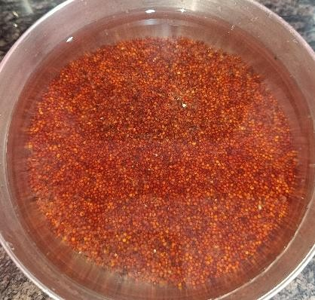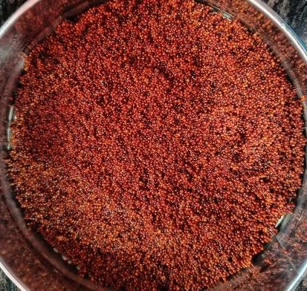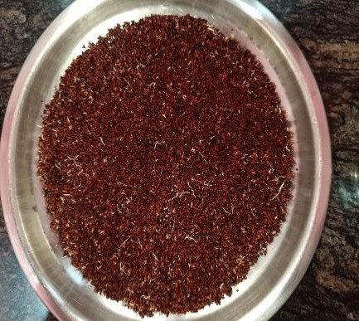

**Figure 4** Represents soaking (left), after 12 h soaking (middle), 24h germination (right)

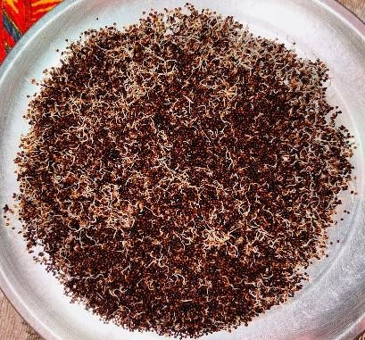 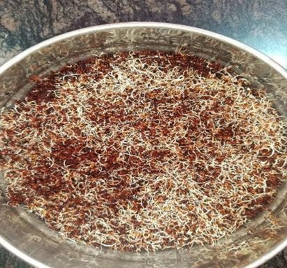 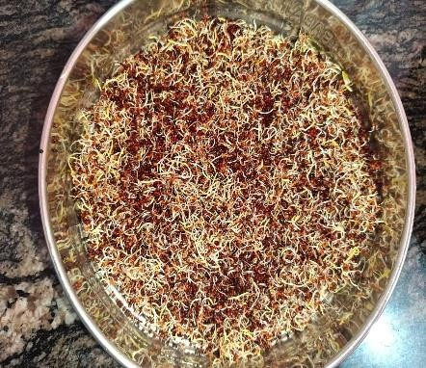

**Figure 5** Represents 48 h germination (left), 72 h germination (middle), 168 h germination (RIGHT)

Further, Table 3 present impact of various processing techniques on the nutritional profile of finger millet.

**Table3: Impact of Different Processing Techniques on the Nutritional Composition of Finger Millet**

|  |  |  |  |  |  |  |
| --- | --- | --- | --- | --- | --- | --- |
| **Parameter** | **Roasting** | **Popping** | **Germina- tion (96h)** | **Parboiling/ hydro-**  **thermal treatment** | **Decortication** | **Malting (36h)** |
| **Moisture** | ↓ | ↓ | - | NC | ↓ | ↑ |
| **Total Solid** | ↑ | - | - | - | - | - |
| **Carbohydrate/**  **Total Sugar** | ↑ | ↑ | ↑ | ↑ | ↑ | ↑ |
| **Ash** | ↑ | ↑ | ↓ | - | ↓ | ↓ |
| **Crude Fibre** | ↑ | - | ↑ | ↓ | ↓ | ↑ |
| **Crude Fat** | ↓ | ↓ | ↑ | - | - | ↓ |
| **Protein** | ↓ | ↑ | ↓ | ↓ | ↓ | ↓ |
| **Iron** | ↑ | ↑ | ↓ | NC | ↓ | - |
| **Calcium** | ↑ | ↑ | ↑ | ↓ | ↓ | - |
| **Total Phenol** | ↓ | - | ↓ | - | - | - |
| **Antioxidant**  **Activity** | ↓ | - | ↑ | - | - | - |

↑- increase, ↓- decrease, NC- No Change

*Sources- Singh et al., 2018; Kumar et al., 2021; Dharmaraj and Malleshi, 2011; and Banusha and Vasantharuba, 2013*

## IMPACT OF GERMINATION ON NUTRITIONAL COMPOSITION

The nutritional and functional qualities of grains, especially their digestibility, can be improved or enhanced using this time-honored and cost-effective processing method (Nefale and Mashau, 2018). During germination, various biochemical changes occur, leading to increased levels of essential nutrients and bioactive compounds. This includes the activation of enzymes, which hydrolyze complex compounds such as starch, proteins, and fats into simpler forms like sugars, amino acids, and fatty acids. Additionally, the levels of certain bioactive constituents, including phenolics, flavonoids, and antioxidants, are enhanced through germination (Rajkumar *et al.,* 2024).

## IMPACT OF GERMINATION ON PROTEIN CONTENT

The protein content of finger millet increases after germination. The protein content rose dramatically from 6.3±0.20 g/100g to 7.1±0.30 g/100g during the germination period (Chauhan *et al.,* 2018). Similar findings were reported in other studies, the protein concentration increased as the germination period increased and ranged from 8.57% to 9.80% (VF *et al.,* 2018). (Mbithi-Mwikya *et al.,* 2000) agrees that germination led to a small rise in protein content. The germination rate increases from 6.1% to 7.9% after 96 hrs. Overall, there was a 29.5% gain. This rise has been linked to respiration-induced dry matter loss, especially of carbs, which appears to increase other nutrients like protein. Conversely, the protein content gradually decreases as the germination time increases was mentioned by (Kumar *et al.,* 2021). The protein level decreased from 6.04% to 3.41% after 96 hrs of germination. The decrease in protein content during germination might be due to the outpacing of protein synthesis by proteolysis, and hence, an increase in free amino acid content (lysine, tryptophan, methionine and cysteine) and migration of seed nitrogenous matter to the growing embryo. (Banusha and Vasantharuba, 2013) agrees with the decreasing protein content.

## IMPACT OF GERMINATION ON FAT CONTENT

Kumar *et al.,* 2021 observed that after 48 hrs of germination, the crude fat level dropped from 0.57% to 0.41%, then gradually increased to 0.85% in samples that germinated for 96 hrs. It's possible that fat oxidizes to fatty acids and water and is used as a carbon source, which explains why fat decreases as germination increases. During extended germination, the amount of fat in the grains may rise as a result of the substitution of sugars as an energy source and the depletion of carbs. Banusha and Vasantharuba, 2013 had an observation, total fat content in un-germinated and 36 hrs after germinated finger millet was found as 1.42% and 1.32%, respectively. A decrease was observed. Owheruo *et al.,* 2019 agrees on the decrease of fat content upon germination. In other research, the opposite outcome is seen. Chauhan *et al.,* 2018mentioned the fat content of GFMF (germinated finger millet flour) is 2.0±0.2 g/100g, while that of WRFMF (whole raw finger millet flour) is 1.3±0.2 g/100g. Following germination, it was discovered that the fat content rose. Similar result was obtained by (VF *et al.,* 2018). As the germination period grew, so did the fat content.

## IMPACT OF GERMINATION ON CRUDE FIBRE CONTENT

The level of crude fiber significantly increased with germination. It was found that, the crude fibre increased from initial 3.74% to 5.09% after 96 h of germination. The increase in crude fibre content might be due to rapid loss of starchy components. Parts of roots and shoots that remain adhered to millet grains after deculming can also increase the crude fibre content (Kumar *et al.,* 2021). This finding was in line with other studies (Owheruo *et al.,* 2019). According to previous research, finger millet's moderate amount of crude fiber contributes to its low energy content and high fiber content. Crude fiber values for WRFMF (whole raw finger millet flour) and GFMF (germinated finger millet flour) were 18.9±0.2 and 20.0±0.3, respectively. The crude fiber content rose noticeably in the germinated samples (Chauhan *et al.,* 2018). The longer the germination period, the higher the fiber content. After germination, it rose from 2.30% to 2.65% (VF *et al.,* 2018). The production of structural carbohydrates like cellulose and hemicelluloses could be the cause of the rise in crude fiber content (Banusha and Vasantharuba, 2013).

## IMPACT OF GERMINATION ON MOISTURE CONTENT

The moisture content of finger millet increase with germination. WRFMF (whole raw finger millet flour) and GFMF (germinated finger millet flour) had moisture contents of 13.1±0.1 and 16.25±0.25 (g/100g), respectively. The moisture content of GFMF was significantly higher than that of WRFMF (Chauhan *et al.,* 2018). The findings were in line with other study. The moisture content increased as the germination period increased to 9.20% from 8.87%. This makes it clear that there are noticeable increases in moisture content during germination, which could be explained by the fact that the entire grains take up moisture from the soaking media to start metabolism, which in turn affects the grain's structure. A greater number of the seeds' cells become hydrated as the soaking period increases (VF *et al.,* 2018). On the other hand, no significant change was found in the moisture content of the finger millet by (Banusha and Vasantharuba, 2013) and (Owheruo *et al.,* 2019).

## IMPACT OF GERMINATION ON ASH CONTENT

The amount of ash decreased from 2.27% at the beginning of germination to 1.24% after 96 hrs. The utilization of certain minerals in the metabolism of seed sprouting may be the cause of the reduced ash content of germinated grains. Mineral loss may also be caused by abrasion during the removal of germinated grains' roots and shoots, which removes the bran layer (Kumar *et al.,* 2021). Similar results were found by (VF *et al.,* 2018) it rose from 3.47% to 3.73% after germination. On the contrary, (Chauhan *et al.,* 2018) mentioned WRFMF (whole raw finger millet flour) and GFMF (germinated finger millet flour) had respective total ash contents of 2.8±0.17 and 2.7±0.10 (g/100g). GFMF (Germinated Finger Millet Flour) and WRFMF (Whole Raw Finger Millet Flour) did not significantly differ in terms of ash concentration. No significant difference in ash content was found in other studies also (Banusha and Vasantharuba, 2013) and (Owheruo *et al.,* 2019).

## IMPACT OF GERMINATION ON SUGAR OR CARBOHYDRATE CONTENT

After 96 hrs of germination, it was found that reducing sugars rose from the initial 0.86% to 10.54% and total sugars from 1.70% to 16.10%, indicating a positive linear relationship between germination time and sugar content. This increase in sugars and decrease in starch may be the result of starch being broken down into sugars during germination (Kumar *et al.,* 2021). Over the first 36 hrs of germination, the amount of starch gradually decreased. A significant rise in sugars and a matching drop in starch content occurred between 36 and 48 hrs. Between 0 and 96 hrs, the total amount of starch dropped from 71.3% to 35.1%. The abrupt alterations that occur between 36 and 48 hrs may be the result of a type of loss of dormancy, in which amylolytic enzymes that are produced in the aleurone layer move to the endosperm and initiate the hydrolysis of the starch granules (Mbithi-Mwikya *et al.,* 2000). On the contrary, a drop in the amount of carbohydrates after germination was noticed by (Chauhan *et al.,* 2018). The decrease in carbohydrate content may be the result of increased α-amylase activity and its use as an energy source to start the germination process. The complex carbohydrates are broken down into simple sugar by the enzyme α-amylase, which is used to develop seeds during the initial stage of germination. The findings of decreasing carbohydrate content were agreed by other studies (VF *et al.,* 2018) and (Owheruo *et al.,* 2019).

## IMPACT OF GERMINATION ON VITAMIN C

The level of vitamin C increases with germination. Vitamin C concentration is greatly increased during the germination phase, rising from 0.04 to 0.06 mg/100 g (Chauhan *et al.,* 2018). Similar results were obtained in another study. After 96 hrs of germination, the finger millet's ascorbic acid level rose from 9.76 to 17.40 mg/100 g. Vegetative growth, which is known to increase ascorbic acid content, may be the cause of the ascorbic acid rise (Kumar *et al.,* 2021).

## IMPACT OF GERMINATION ON MINERAL CONTENT

The level of calcium of finger millet increases significantly after germination (Owheruo *et al.,* 2019). Similar findings were observed by (Chauhan *et al.,* 2018) and (Kumar *et al.,* 2021). It was found that after soaking, the calcium content of non-germinated finger millet decreased, and then increased linearly as the germination period increased. The loss of organic dry matter from the grains during germination may be the cause of the rise in calcium, which would raise the grains' calcium percentage (Kumar *et al.,* 2021). The iron concentration is negatively impacted by germination. After 96 hrs of germination, the iron content decreased by 63.7% (Kumar *et al.,* 2021). The results were in line with the findings of (Owheruo *et al.,* 2019). On the contrary, (Chauhan *et al.,* 2018) found following germination, the finger millet's iron concentration rises noticeably. found a significant decrease in the iron content of finger millet after germination. Germination has a negative effect on the level of phosphorus. Phosphorus content decreased linearly as germination time increased, with a 28% phosphorus loss detected after 96 hrs of germination (Kumar *et al.,* 2021). Similar results were found by (Chauhan *et al.,* 2018).

**IMPACT OF GERMINATION ON ANTINUTRIENT COMPOUND**

Germination had a negative impact on the anti-nutrients present in the finger millet. As the time increases, the tannin content decreases (Kumar *et al.,* 2021). Another studies had similar findings (Owheruo *et al.,* 2019). During the germination process, the tannin content dramatically dropped. It was discovered that leaching caused a decrease in tannin during germination (Chauhan *et al.,* 2018). It has been determined that the reported decrease in tannin concentration in germinated seeds is not the result of tannin loss or degradation, but rather of the hydrophobic interactions that tannins make with seed proteins and enzymes (Mbithi-Mwikya *et al.,* 2000). The phytic acid content significantly decreases after germination because phytase activity during germination hydrolyzes phytate to phosphate and myoinositol phosphates, increasing the availability of phosphorus over phytate, the meal becomes more nutritious (Chauhan *et al.,* 2018). (Owheruo *et al.,* 2019) had similar findings. A decrease in the level of trypsin is observed after germination (VF *et al.,* 2018). Similar results were observed in other study (Chauhan *et al.,* 2018). The use of trypsin inhibitor as an energy source and its breakdown by peptic and pancreatic hydrolytic enzymes may be the causes of the apparent drop in trypsin inhibitor activity that was seen during germination.

## IMPACT OF GERMINATION ON FUNCTIONAL PROPERTIES

After 96 hrs of germination, WSI rose from 3.64% to 15.73%, a substantial rise with an increase in germination period. The breakdown of starch into smaller granules and an increase in sugar content could be the cause of the WSI increase (Kumar *et al.,* 2021). After 60 hrs of germination, WAI and OAI rose before declining linearly. The rise in surface area and damaged starch is the cause of this increase in WAI and OAI. Damaged starch absorbs more water because it is more hygroscopic than native starch (Kumar *et al.,* 2021). After 60 hrs of germination, the breakdown of starch to sugars and a decrease in starch content may be the cause of the drop in WAI and OAI. Similar results were coated by other studies (VF *et al.,* 2018), (Nefale and Mashau, 2018) and (Yenasew and Urga 2023) an increase in oil absorption capacity and water absorption capacity and oil absorption index respectively. It was observed that, up to 36 hrs after germination, foam capacity rose; after that, it significantly decreased. A similar pattern was seen in the stability of the foam, and as the germination time increased, so did the foam's stability, which may have been brought on by the higher concentration of salts and sugars. The loss of foaming capabilities may be caused by a decrease in protein content. An increase in bulk density after 96 hrs was observed by (VF *et al.,* 2018). The bulk density is generally affected by the particle size and the density. Contrasting results were obtained by (Yenasew and Urga 2023) he observed a decrease in bulk density after 72 hrs of germination. (Nefale and Mashau 2018) also observed the similar result. It was found that there is a decrease in swelling capacity after 96 hrs of germination by (VF *et al.,* 2018). The swelling capacity of flour depends on the size of particles, type of variety and type of processing method. Similar results were obtained by (Yenasew and Urga 2023) and (Nefale and Mashau 2018) after 72 hrs of germination.

## VALUE ADDED PRODUCTS OF GERMINATED FINGER MILLET

As the world is switching to more of nutritious food, millets offer the required nutrition. Finger millet is one of the most nutrient rich millet among all. It's nutrition and sensory properties are improved by germination. Germinated finger millet possess more of nutrients and less of anti- nutrients. Germinated finger millet can be used in the development of various kind of value added food products. It offers the development of different types of value-added food products such as bread, premix, cookies, noodles, porridge etc. as mentioned in the table no. 4.

**Table 4: Value Added Products Developed with Germinated Finger Millet.**

|  |  |  |  |
| --- | --- | --- | --- |
| **Product name** | **Optimum germination time/Optimum ratio** | **Outcomes** | **Reference** |
| **Porridge** | _ | * Finger millet porridge's   physico-chemical functional and sensory qualities were positively impacted by germination.   * The flour's pH, viscosity, solubility, and bulk density all decreased as a result of germination. * With germination time, finger millet flour's TTA and   lightness value improved noticeably. | (Nefale and  Mashau, 2018) |
| **Ragi based premix** | 48 hrs | * The nutritional value enhanced with germination. * Increased the premix's energy density while decreasing its bulk density. | (Chaudhary *et al.,* 2019) |
| **Finger Millet**  **cum Wheat Bread** | 70:30  (Ragi flour: Wheat flour) | * In order to improve the   functional qualities, decrease antinutrients, and increase nutritional quality,  germination was essential.   * Germination improved all the required properties of the   product. | (Aanchal *et al.,*  2024) |
| **Malted Ragi Cookies** | _ | * When compared to the unmalted control sample,   cookies made with malted ragi flour performed better and had higher nutritional  benefits. | (Kokani *et al.,* 2016) |

|  |  |  |  |
| --- | --- | --- | --- |
|  |  | * Iodine, minerals (Fe, Ca, P), fiber, and vitamins are   abundant in it. |  |
| **Malted Ragi Flour supplemented Noodle** | 70:30  (Wheat flour: Ragi flour) | * Compared to the control sample, it has greater values   for protein, fat, and minerals like calcium, iron, and phosphorus.   * It will be an excellent source of RTE for kids, teens, athletes, and women who are pregnant or breastfeeding. | (Kulkarni *et al.,* 2012) |
| **Weaning**  **food premix** | 25:37.5:37.5  (Rice: Green gram: finger millet) | * A high-quality, nutrient-dense   malt weaning food with  pleasing sensory qualities is  made. | (Jadhavar *et al.,*  2022) |

**FUTURE RESEARCH DIRECTION**

Finger millet is a very underrated crop. Though it is packed with bunch of nutrients, its acceptability and usage is very less. The research in the field of finger millet should be done to increase its usage. Future research can be done to explore ways to enhance its nutritional value, its bioavailability and reduce anti-nutritional factor with other economic and sustainable processing techniques along with the production of various food products for various age groups such as children, lactating and pregnant women also for old age people. The potential of finger millet is very unexplored which can be explored by future researchers.

## CONCLUSION

Millets are a staple grain for ages, they are essential for maintaining food security in semiarid areas. These tiny-seeded crops, which are part of an agronomic functional group, can be fed to people or used as fodder. Finger millet or "ragi" is one of the most nutrient - dense grains because of its high protein content and well-balanced amino acid profile. Finger millet contains high levels of various micronutrients, including vitamins and minerals such as riboflavin, nicotinic acid, thiamine, calcium, phosphorus, and iron. Furthermore, finger millet contains a significant amount of bioactive substances that support its antibacterial and antioxidant qualities. Various processing techniques such as popping, roasting, germination, and fermentation have been found to reduce these anti-nutritional factors to safe levels. Among all, germination was found to be the best. Germination had a very positive impact on the nutritional profile of finger millet. Protein content, ash content, crude fiber content, calcium content, and iron content, increased significantly with germination. Whereas germination reduced the level of anti-nutritional factor such as phytate, tannin, oxalate and trypsin inhibitor. Various functional properties such as water holding capacity, oil absorption capacity, foaming capacity, foaming stability etc. improved after germination. Which improved the sensorial properties of finger millet and its flour. The product made with the germinated finger millet flour not only had higher nutritional value but better sensorial acceptance and hence various products have been made with it. This review concludes, germination is considered an important and cost- effective approach to enhance the nutritional composition, functional properties of finger millet while decreasing its anti-nutritional content. The nutritional benefits of germinated millets arise from the significant changes that occur during the germination process, which enhance their nutrient profile. Germination also improves the sensory attributes of finger millets which facilitates the development of various value added products. Finger millet is a nutrient dense grain consisting various health benefits. Research in this section need to be done as millets are the future food.

Disclaimer (Artificial intelligence)

**Author(s) hereby declare that NO generative AI technologies such as Large Language Models (ChatGPT, COPILOT, etc.) and text-to-image generators have been used during the writing or editing of this manuscript.**

**REFERENCES**

1. Abayechaw, Desta and Wulchafo, Kedir. (2020). International Journal of Current Research and Academic Review The Concept and Process of Seed Germination -A Review. 100-112. 10.20546/ijcrar.2020.805.011.
2. Aanchal, R., Bansal, U., Bansal, V., Sobti, A. K., and Pradhan, R. (2024). Study on the Effect of Germination on the Nutritive Value of Finger Millet-Cum-Wheat for Developing Bread. *RandD of Functional Food Products*, *1*(5), 15–32. https://doi.org/10.31989/RDFFP.v1i5.1343
3. Banusha, S., and Vasantharuba, S. (2013). Effect of Malting on Nutritional Contents of Fingermillet and Mungbean. *J. Agric. and Environ. Sci*, *13*(12), 1642–1646. <https://doi.org/10.5829/idosi.aejaes.2013.13.12.12285>
4. Bareke, T. (2018). Biology of seed development and germination physiology. Advances in Plants and Agriculture Research, 8(4). <https://doi.org/10.15406/apar.2018.08.00335>
5. Bewley J. D. (1997). Seed Germination and Dormancy. The Plant cell, 9(7), 1055–1066. <https://doi.org/10.1105/tpc.9.7.1055>
6. Birania, S., Rohilla, P., Kumar, R., and Kumar, N. (2020). Post harvest processing of millet s :

A review on value added products. *International Journal of Chemical Studies*, *8*(1), 1824– 1829. https://doi.org/10.22271/chemi.2020.v8.i1aa.8528

1. Bisht, K., Bisht, K., Gudadhe, N. N., Raut, A. A., and Dobhal, N. (2023). Nutritional composition, health benefits, production, processing and marketing of finger millet. Indian Journal of Fertilisers, 19(10), 1036–1046. <https://www.researchgate.net/publication/374730425>
2. Chaudhary, N., Vyas, S., and Joshi, I. (2019). Nutritional composition and anti-nutritional content of ragi-based amylase rich premixes. Department of Home Science (Foods and Nutrition), The IIS University, 1594–1596.
3. Chaudhary, N., and Vyas, S. (2014). Effect of germination on proximate composition and anti-nutritional factor of millet (Ragi) based premixes. International Journal of Food and Nutritional Sciences, 3(4), 1–6.
4. Chauhan, E. S., and Sarita, S. (2018). Effects of processing (Germination and popping) on the nutritional and Anti-Nutritional properties of finger millet (Eleusine coracana). Current Research in Nutrition and Food Science Journal, 6(2), 566–572. <https://doi.org/10.12944/crnfsj.6.2.30>
5. Dharmaraj, U., and Malleshi, N. G. (2011). Changes in carbohydrates, proteins and lipids of finger millet after hydrothermal processing. *LWT*, *44*(7), 1636–1642. https://doi.org/10.1016/j.lwt.2010.08.014
6. Jadhavar, R. S., Jaiswal, S. G., and Bornare, D. T. (2022). Development of Weaning Food Premixes for Infants Based on Ragi, Green Gram and Rice. *International Journal of Food and Nutritional Sciences |*, *11*(6). https://doi.org/10.4103/ijfans_173_22
7. Jaybhaye, R. V., Pardeshi, I. L., Vengaiah, P. C., and Srivastav, P. P. (2014). Processing and technology for millet-based food products: A review. Journal of Ready to Eat Food, 1(2), 32–48. <https://doi.org/10.15740/has/fsrj/6.2/285-291>
8. Kokani, R. C., Pournima Bharat, H., and Sakharam, K. S. (2016). Studies on Utilization of Ragi for Preparation of Malted Ragi Cookies. *International Journal of Science and Research*, *7*, 2319–7064. https://doi.org/10.21275/ART2018273
9. Kumar, A., Kaur, A., Gupta, K., Gat, Y., and Kumar, V. (2021). *Current Science Association Assessment of germination time of finger millet for value addition in functional foods*. *120*(2), 406–413. https://doi.org/10.2307/27310197
10. Mbithi-Mwikya, Stephen and Camp, John and Yiru, Y. and Huyghebaert, André. (2000). Nutrient and Antinutrient Changes in Finger Millet (Eleusine coracan) During Sprouting. LWT - Food Science and Technology. 33. 9-14. 10.1006/fstl.1999.0605.
11. Nefale, F. E., and Mashau, M. E. (2018). Effect of Germination Period on the Physicochemical, Functional and Sensory Properties of Finger Millet Flour and Porridge. In *Asian Journal of Applied Sciences*. [www.ajouronline.com](http://www.ajouronline.com/)
12. Owheruo, Joseph and Ifesan, Beatrice and Kolawole, Ayodele. (2018). Physicochemic a l properties of malted finger millet (Eleusine coracana) and pearl millet (Penniset um glaucum). Food Science and Nutrition. 7. 10.1002/fsn3.816.
13. Patil, P., Singh, S. P., and Patel, P. (2023). Functional properties and health benefits of finger millet (Eleusine coracana L.): A review. *The Journal of Phytopharmacology*, *12*(3), 196–

202. https://doi.org/10.31254/phyto.2023.12308

1. Pragya Singh. (2012). Finger millet for food and nutritional security. *African Journal of Food Science*, *6*(4). https://doi.org/10.5897/ajfsx10.010
2. Rajkumar, H., Muthu, I., James, P., Baskaran, S., Lakshmanan, K., Vellaichamy, M., Jeyaraj, S., and Pandi, P. (2024). “Enhancing Nutritional Profile, Functional Properties, Therapeutic Attributes of Finger Millet (Eluesinecoracana) by Germination: A Comprehensive Exploration.” In *Natural Product Communications* (Vol. 19, Issue 12). SAGE Publications Inc. https://doi.org/10.1177/1934578X241293027
3. Ramashia, S. E., Anyasi, T. A., Gwata, E. T., Meddows-Taylor, S., and Jideani, A. I. O. (2019). Processing, nutritional composition and health benefits of finger millet sub-Saharan Africa. *Food Science and Technology (Brazil)*, *39*(2), 253–266. https://doi.org/10.1590/fst.25017
4. Rao, M. V. S. S. T. S., and Muralikrishna, G. (2001). Non-starch polysaccharides and bound phenolic acids from native and malted finger millet (Ragi, Eleusine coracana, Indaf-15). Food Chemistry, 72(2), 187–192. <https://doi.org/10.1016/S0308-8146(00)00217-X>
5. Rathore, T., Rakhi Singh, I., Dinkar Kamble, I. B., Upadhyay, A., Thangalakshmi, I. S., Correspondence Rakhi Singh, I., Singh, R., Kamble, D. B., and Thangalakshmi, S. (2019). Review on finger millet: Processing and value addition. *~ 283 ~ The Pharma Innovation Journal*, *8*(4), 283–291. [www.thepharmajournal.com](http://www.thepharmajournal.com/)
6. Kulkarni, S. S., Desai, A. D., Ranveer, R. C., and Sahoo, A. K. (2012). Development of nutrient-rich noodles by supplementation with malted ragi flour. International Food Research Journal, 19(1), 309–313. <https://www.researchgate.net/publication/221941493>
7. Sahoo, A. K., Desai, A. D., Kulkarni, S. S., Ranveer, R. C., and Dandge, P. B. (2010). Effect of Supplementation of Malted Ragi Flour on the Nutritional and Sensorial Quality Characteristics of Cake. *Advance Journal of Food Science and Technology*, *2*(1), 67–71.
8. Saleh, A. S. M., Zhang, Q., Chen, J., and Shen, Q. (2013). Millet grains: Nutritional quality, processing, and potential health benefits. *Comprehensive Reviews in Food Science and Food Safety*, *12*(3), 281–295. https://doi.org/10.1111/1541-4337.12012
9. Singh, N., Rajput Chhatrapati Shahu Ji, H., Morya, S., Singh Scholar, N., David Professor, J., Thompkinson Professor Emeritus, D., Sagar Seelam Scholar, B., Rajput Scholar, H., Morya Scholar, S., Neha Singh Scholar, C., David, J., Thompkinson, D., Sagar Seelam, B., and Rajput, H. (2018). *Effect of roasting on functional and phytochemical constituents of finger millet (Eleusine coracana L.) The Pharma Innovation Journal 2018; 7(4): 414-418 Effect of roasting on functional and phytochemical constituents of finger millet (Eleusine coracana L.)*. *7*(4), 414–418. https://[www.researchgate.net/publication/349713343](http://www.researchgate.net/publication/349713343)
10. VF, A., GO, O., and G, T. (2018). Effect of Germination on Anti-oxidant Activity, Total Phenols, Flavonoids and Anti-nutritional Content of Finger Millet Flour. *Journal of Food Processing and Technology*, *09*(02). https://doi.org/10.4172/2157-7110.1000719
11. Yenasew, A., and Urga, K. (2023). Effect of the germination period on functional properties of finger millet flour and sensorial quality of porridge. *Food Science and Nutrition*, *11*(5), 2336–2343. <https://doi.org/10.1002/fsn3.3240>