***Original Research Article***

**Bioenzyme-Mediated Growth Enhancement in Cordyline (*Cordyline terminalis*): A Developmental Study**

# ABSTRACT

An investigation on “Bioenzyme-Mediated Growth Enhancement in Cordyline (*Cordyline terminalis*): A Developmental Study” was conducted during 2022 and 2023 at the Biotechnology-cum-Tissue Culture Centre in Baramunda, Department of Floriculture and Landscaping, College of Agriculture, Odisha University of Agriculture and Technology, Bhubaneswar.Bioenzyme applications comprising 13 treatments were evaluated in 117 potted plants. Among the treatments, the following were found effective:- Booster: [Humic acid (15%) + Amino acids (2%) + Fulvic acid (6%)] @ 1.5 ml/L (**T₁**),  
- Biozyme Vegetable Plus: [Seaweed fermented biomass (22%) + Amino acids (4%)] @ 1.5 ml/L (**T₁₀**),  
- Vipul Booster: [Triacontanol (a.i.) 0.1% w/w (1000 ppm), emulsifier (ethoxylated esters of fatty acids) 0.5% w/w, and preservatives (esters of benzoic acid) 0.1% w/w in demineralized aqua QS with total 100% w/w] @ 1.0 ml/L (**T₈**).  
  
These treatments significantly enhanced vegetative growth and qualitative traits compared to the control.   
This study presents original empirical findings on the in vivo effect of bioenzymes on the vegetative and qualitative traits of Cordyline terminalis, highlighting the potential of bioenzymes as biostimulants. It offers an organic alternative to chemical fertilizers by improving plant health through sustainable and eco-friendly approaches.

1. **INTRODUCTION**

The amount of arable land and urban space is diminishing quickly because of growing industrialization, urbanization, and globalization. There is a lack of green space and a need for a green environment. Under these circumstances, people mostly take no chance to leave a little space unutilized and do their best for a green cover. In urban areas where people live in high-rise buildings and there is less space available for green areas, foliage plants are used for landscaping, indoor gardening, adding aesthetic values and maintaining a green environment.

Foliage plants are ‘tropical exotics’ that include all the plants grown primarily for their foliage and utilized for interior decoration, interior landscape, rooftop gardening, vertical gardening, under shade landscaping, as well as outdoor landscaping as border plants to add aesthetic value and create green space. Ornamental foliage plants of tropical and subtropical regions thus boost the floriculture industry. The trade of ornamental foliage plants at the international market is seen as a new venture for India and is gaining wide popularity. Currently, the majority of foliage plants are sold to Germany, the United States, the Netherlands, the United Kingdom, Italy, and Japan, accounting for over 60% of India's floricultural exports (Ray *et al*., 2006)

The genus Cordyline was first reported by Adanson (1763) and later separated from the closely related Dracaena (Commerson, 1789). The name Cordyline is derived from the Greek "Kordule," meaning "club," and is said by Kemp and Robb (1962) to refer to the form of the flower buds. Also, its general name, cabbage palm, comes from the Greek word 'Kordyle,' which means club or cudgel, referring to the root shape (Pal, 2006). Bailey (1910), however, attributed the origin to the club-like form of the stem. Cordyline was placed in the Liliaceae family by Bentham and Hooker (1883). More recently, Hutchinson (1959) placed Cordyline in the family Agavaceae and this classification was adopted by Melchior (1964).

It consists of about 20 species of evergreen trees and shrubs. It is indigenous to the tropical and subtropical parts of the earth, including China, Malaysia, the East Himalayas, and North Australia. Important ornamental species of Cordyline are *Cordyline terminalis*, *C. australis*, *C. rubra* and *C. indivisa*. Among these, *Cordyline terminalis* is the most important and commercially exploited species. Of all the species of Cordyline the most widely distributed and most extensively investigated is *C. terminalis,* which is found throughout the Pacific area and in some Asian countries. Important varieties under cultivation are Baby doll, Lily Put, Kiwi, Hawaiian flag, and Mahatma. Cordyline is quite similar to dracaena and differs only in the anatomy of the ovary. Several Cordyline species are usually referred to as dracaena (Randhawa and Mukhopadhyay, 2004). It is a long, thin bush that can reach 3m in height and is valued for its vibrantly colored foliage, including variegated varieties. Cordyline is an excellent ornamental plant with colored foliage, as focal point in gardens, floor plants, as a pot plant in its juvenile state and is also suitable for growing in borders and shrubberies under a mild climate, for shade gardens and greenhouse. Most of the species are extensively used for table decorations while they are young. The plant is widely found in homes, workplaces, stores, banks, hotels, restaurants, clubs, hospitals and schools and numerous plants are occasionally gathered and grown as exquisite table decorations in terrariums, bottles, bowls, plates, troughs and aquarium cases (Beura *et al*., 2007). It has attractive color of the foliage, hardiness, ease of cultivation, suitability to interior conditions and resistance to pests and diseases contribute to its popularity in urban agriculture and landscaping.

In the face of degraded agricultural areas, uncertainties related to climate change and decreasing green space in urban areas, bioenzymes can proof beneficial. Bioenzymes are promising environmental production strategy for ornamental crops including foliage crops in green house. Traon *et al*. (2014) defined Bioenzymes as, “Any substance or microorganism that is applied to plants, seeds, or the root environment with the intention to stimulate natural plant processes that benefit nutrient use efficiency and/or tolerance to abiotic stress, regardless of its nutrient content, is referred to as a plant bio stimulant. This definition includes any combination of such substances and/or microorganisms intended for this use.” Yakhin *et al*. (2017) defined bio stimulants as “a formulated product of biological origin that improves plant productivity as a consequence of the novel or emergent properties of the complex constituents, and not as a sole consequence of the presence of known essential plant nutrients, plant growth regulators, or plant protective compounds.” Kunicki *et al*. (2010) stated that bio stimulants can be foliar, or soil applied, depending on their composition and intended results.

Bio enzymes functions as an anti-stress promoting, growth-stimulating, nutrient absorption, crop productivity improvement, dormancy-breaking, boosting foliage quality, pigment content improvement, enhancing root formation, enhancing photosynthetic as well as vegetative tissue processes, enhancing plant resilience and coherence, and regulating effect on foliage crop growth and development. The recent *in vivo* study on the effect of bio enzymes on the growth and development of *Cordyline terminalis* under protected conditions with rigorous statistical analysis, highlighting sustainable and organic alternatives to chemical inputs in urban horticulture. The study was conducted to analyze the response of potted plants of Cordyline under various physiological parameters, foliage quality, and overall growth and vigor on a commercial basis.

1. **MATERIALS AND METHODS**

**2.1 Experimental site**

The experimental study on “Bioenzyme-Mediated Growth Enhancement in Cordyline (*Cordyline terminalis*): A Developmental Study” was accomplished in the year 2022 and 2023 at the Biotechnology-cum-Tissue Culture Centre in Baramunda, Floriculture and Landscaping Department, College of Agriculture, Odisha University of Agriculture and Technology, Bhubaneswar.

**2.2 Geographical location of experimental site**

Bhubaneswar is 63 kilometers west of the Bay of Bengal at an elevation of 25.50 meters above mean sea level. It is geographically located in the subtropical region, with latitudes of 20°15' North and longitudes of 85°52' East.

**2.3 Climate and weather conditions during the experimental period**

Bhubaneswar has a subtropical climate. Approximately 85% of the rainfall occurs between June and September, with the remaining fifteen percent falling between October and May. The average maximum temperature is between 38 to 42°C from May to June, while the minimum temperature ranges between 15 to 16°C from December to January. The relative humidity ranges from 50% in the winter to 90% during the rainy season. The annual average temperature is 26.6°C/79.9°F. The annual rainfall is 1628 mm/64.1 inch.

**Table 1: Morphological and Economic traits of *Cordyline terminalis***

|  |  |  |
| --- | --- | --- |
| **Sl. No.** | **Characters** | **Descriptions** |
| 01. | Type of plant | Monocot, evergreen |
| 02. | Plant height | 1-2 m |
| 03. | Growth habit | Profusely spread at a particular axis from the base, mostly shrub |
| 04. | Length and width of leaves | 25-50**×** 5-10 cm |
| 05. | Leaf colour | Red, pink, purple, maroon, greenish shade |
| 06. | No of leaves/plant | 4-5 |

***In vivo* effect of Bioenzymes on the growth and development of *Cordyline terminalis***

**Soil**

One tractor load of well-decomposed FYM/Cow dung and 1 tractor load of Soil were bought. A mixture of FYM + Soil in a 1:1 proportion were placed in 117 pots (Fig. 1). The mixture composition was well-drained, uniform texture, and was brought to fine tilth by breaking soil compaction through manual soil raking. Digging to increase soil porosity and daily watering was done.

**Planting materials**

117 young plants in polybags with 3-4 number of leaves and uniform size were taken and planted in 117 pots under protected shade net condition. The experimental field was laid out as plan of layout (Fig. 1).

**Experimental details**

Number of treatments : 13

Experimental design : CRD

Number of replications per treatment : 03

Number of pots/replications : 03

Total number of pots : 117

Number of plants/treatments : 09

Date of transplanting : 08/02/2023

Biofertilizers spray duration : 30 days interval for 3 months

**Table 2:** **Common treatment details for *in vivo* effect of bioenzymes on growth and development of *Cordyline terminalis***

**Spray duration: 30 days interval**

|  |  |  |
| --- | --- | --- |
| **Sl. No.** | **Treatments** | **Treatment details** |
| 01. | T1 | Control (No bioenzyme application) |
| 02. | T2 | Biozyme vegetable plus @ 0.5 ml/l |
| 03. | T3 | Booster @ 0.5 ml/l |
| 04. | T4 | Biozyme crop + @ 0.5 ml/l |
| 05. | T5 | Vipul booster @ 0.5 ml/l |
| 06. | T6 | Biozyme vegetable plus @ 1.0 ml/l |
| 07. | T7 | Booster @ 1.0 ml/l |
| 08. | T8 | Vipul booster @ 1.0 ml/l |
| 09. | T9 | Biozyme crop + @ 1.0 ml/l |
| 10. | T10 | Biozyme vegetable plus @ 1.5 ml/l |
| 11. | T11 | Booster @ 1.5 ml/l |
| 12. | T12 | Biozyme crop + @ 1.5 ml/l |
| 13. | T13 | Vipul booster @ 1.5 ml/l |

**Observation to be recorded for *in vivo* effect of bioenzymes on growth and development of *Cordyline terminalis***

* **Plant height (cm):** Plant height was measured on 30th day, 60th day and 90th day after transplanting respectively using a meter scale from soil surface to leaf tip of last fully opened leaf i.e., highest point of the plant (Fig. 6).
* **Number of leaves/plants:** The total number of matured leaves per plant in each treatment were recorded.
* **Leaf length (cm):** Fully developed leaf from top of the plant (second, third or fourth leaf) was measured length wise.
* **Leaf breadth (cm):** Fully developed leaf from top of the plant (second, third or fourth leaf) was measured breadth wise (Fig. 4).
* **Leaf area (cm²):** The area of the open, matured leaf from the top (second, third or fourth) was measured with the help of leaf area meter.
* **Internodal length (cm):** Length of each internode.
* **Plant grade:** The plant quality determined visually on the following scale:

Scale-1: Dead

Scale-2: Poor, unsalable

Scale-3: Moderate, saleable

Scale-4: Good, saleable

Scale-5: Excellent, saleable

* **Colour grade**: Leaf colour rated visually on the scale-1, 3 and 5 (Fig. 5).

Scale-1: Light reddish green

Scale-2: Medium reddish green

Scale-5: Dark greenish red

* **Vase life (days):** The harvesting procedure was done in the morning and mature leaves with petiole from each treatment were harvested in commercial stage (35-45 cm) and with no disease or pest symptoms. The material was brought to the laboratory less than one hour after harvest and was washed and then the leaves were placed in plastic bottles filled with tap water and the observation was recorded on basis of freshness and longevity of leaves for cut foliage.

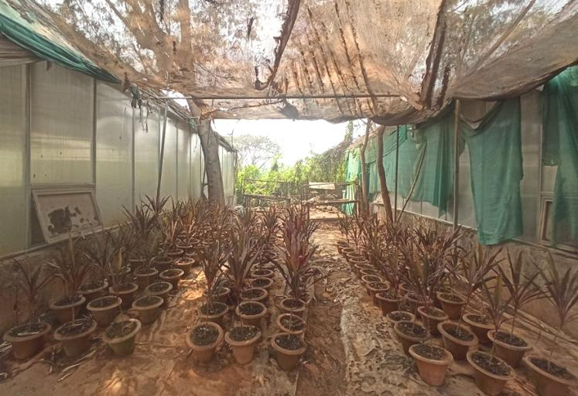

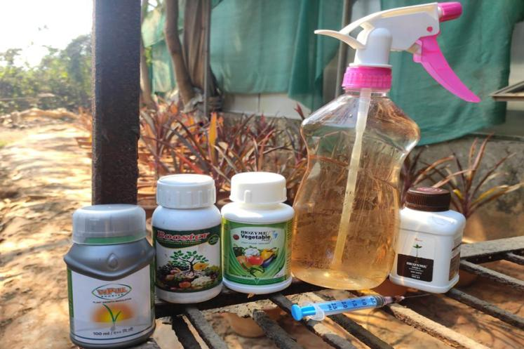

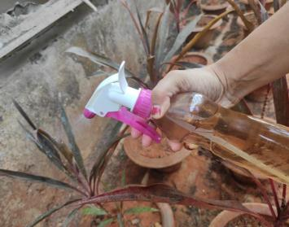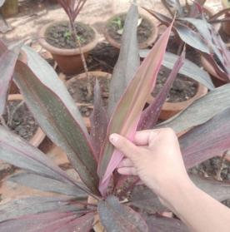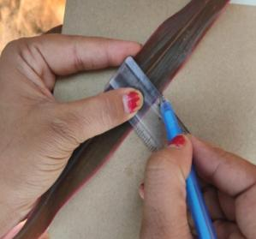

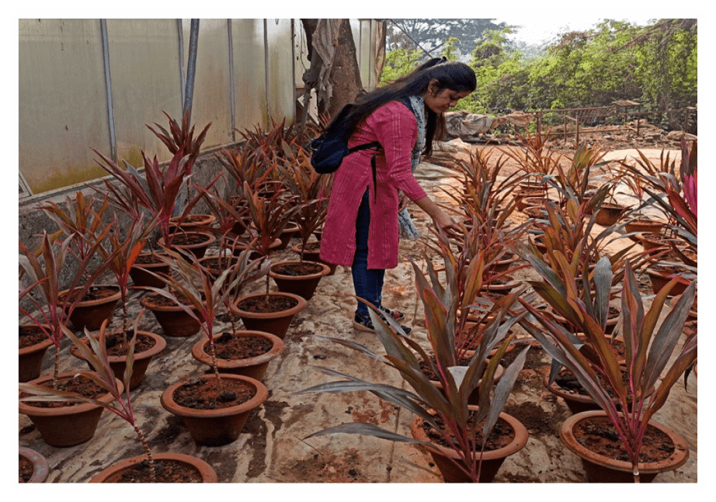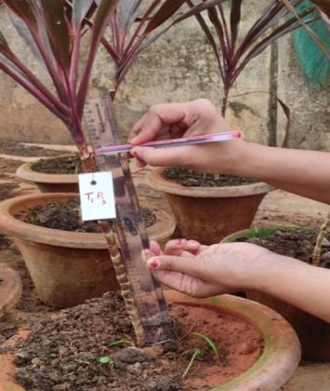

**Table 3: An overview of the bioenzymes to be used for studying growth and development in *Cordyline terminalis***

|  |  |  |  |  |  |  |
| --- | --- | --- | --- | --- | --- | --- |
| **Sl. No.** | **Trade name** | **Chemical composition** | | **Dosage** | **Manufactured**  **by** | **Uses** |
| 01. | VIPUL booster PGR 100 ml | Triacontanol (a.i.) 0.1% w/w (1000 ppm)  Emulsifier (Ethoxylated esters of fatty acids): 0.5% w/w  Preservatives: (Easters of Benzoic acid): 0.1% w/w  Demineralized aqua: Q.S  Total: 100.00% w/w | | 500 ml/ha | Godrej  Agrovet Ltd. | * Triacontanol increases dry matter content, height of plant, plant spreading. * Enhances the activity of naturally available enzymes & plant hormones. |
| 02. | Biozyme crop + biostimulant 100 ml | Sea weed (*Ascophyllum nodosum*)  Fermented biomass@ 22.0 containing alginic acid 0.5% mi.  Aqueous diluents: QS,  Total: 100.00 | | 625 to 750 ml/ha | Biostadt  India Ltd. | * Increases stress tolerance. * Increases nutrient uptake. * Improves plant growth. * Increases root (See weed contains P) and shoot growth. |
| 03. | Biozyme vegetable + plant growth stimulant 100 ml | Sea weed fermented biomass  Amino acids  Other (to make 100%)  Total | : 22%  : 4%  : 74%  : 100% | 500 ml/ha | Biostadt  India Ltd. | * Nutrient stabilizer. * Enhances yield & crop quality. * Provides diseases & pest resistance. |
| 04. | Booster | Humic (15%) + Amino acid (2%) + Fulvic (6%) | | 250 ml/acre | Mkao Agro  Chemical  Industries | * Humic acid liquid increases nutrient uptake. * Improves aeration & water holding capacity. |

|  |  |  |  |  |  |  |  |  |  |
| --- | --- | --- | --- | --- | --- | --- | --- | --- | --- |
|  | **R1** | | | **R2** | | | **R3** | | |
| **T1** |  |  |  |  |  |  |  |  |  |
| **T2** |  |  |  |  |  |  |  |  |  |
| **T3** |  |  |  |  |  |  |  |  |  |
| **T4** |  |  |  |  |  |  |  |  |  |
| **T5** |  |  |  |  |  |  |  |  |  |
| **T6** |  |  |  |  |  |  |  |  |  |
| **T7** |  |  |  |  |  |  |  |  |  |
| **T8** |  |  |  |  |  |  |  |  |  |
| **T9** |  |  |  |  |  |  |  |  |  |
| **T10** |  |  |  |  |  |  |  |  |  |
| **T11** |  |  |  |  |  |  |  |  |  |
| **T12** |  |  |  |  |  |  |  |  |  |
| **T13** |  |  |  |  |  |  |  |  |  |

**Fig. 8: Field plan and layout of experimental site**

**Statistical analysis**

The data was subjected to statistical analysis as per Gomez & Gomez (1984) utilizing one way ANOVA in a Completely Randomized Design (CRD) for *in vivo* work with 13 treatments and 3 replication each to study the effect of bioenzymes on growth & development. The treatment effects were tested by 'F' test at 5% level of significance. The appropriate standard error of mean S.E.(m) and the critical difference (CD) were calculated at 5% level of probability. The data have been depicted by suitable graphs and figures at appropriate places.

CD = SEd × t value at 5% at error degree of freedom

SEd = 

Where,

SEd = Standard error of difference between two treatments means

EMS = Error mean of square

r = Number of replications

**Standard error of mean**

SE(m) ± = 

T = Two-sided table value with error degree of freedom at 5% significance level

**RESULTS**

*Cordyline terminalis* was first field established for 30 days and after 30 DAP (days after planting) bioenzymes were sprayed in 13 treatments (Each treatment having 3 replications, per replication having 3 pots) i.e, 117 potted plants in 30 days interval and observations were recorded subsequently.

The data presented in Table 4 and 6 shows the significant effect of various concentration of bioenzymes at various time interval on growth, yield and quality of *Cordyline terminalis* growing at *in vivo* condition after 60 DAP and 90 DAP.

**Plant height (cm)**

The data on plant height at 60 and 90 days after planting (DAP) as influenced by different growth treatments of bioenzymes are presented in Table 4 and 6. The maximum height after 60 DAP was recorded in treatment T8 (Vipul booster @ 1.0 ml/l) with 64.63 cm which was significantly at par with treatment T11 (Booster @ 1.5 ml/l) with a height of 64.19 cm. This was followed by treatment T10 (Biozyme vegetable plus @ 1.5 ml/l) with a height of 63.73 cm. The lowest height was recorded in control (No bioenzymes application) recording an average height of 58.63 cm.

The plant height at 90 DAP varied significantly among different bioenzymes studied and it ranged between 59.17 cm to 67.93 cm. Among the treatments, foliar spray of T11 (Booster @ 1.5 ml/l) recorded maximum plant height and was found to be statistically at par with treatment T8 (Vipul booster @ 1.0 ml/l) measuring 67.50 cm and treatment T10 (Biozyme vegetable plus @ 1.5 ml/l) with an average height of 67.33 cm, while control recorded minimum height with 59.17 cm. The average plant height found statistically is indicating treatment T11 (Booster @ 1.5 ml/l) giving better result over rest.

**Leaf number**

The results on number of leaves per plant is presented in Table 4 and 6 reveals that, at 60 DAP, maximum number of leaves was recorded in (T11) Booster @ 1.5 ml/l (9.87) which was statistically on par with (T8) Vipul booster @ 1.0 ml/l (9.67) and (T10) Biozyme vegetable plus @ 1.5 ml/l (9.50), whereas, control recorded minimum number of leaves (6.27). At 90 DAP number of leaves varied from 6.43 to 10.73. Foliar application of Booster @ 1.5 ml/l (T11) recorded maximum number of leaves per plant (10.73) and it was statistically on par with (T8) Vipul booster @ 1.0 ml/l (10.67) and (T10) Biozyme vegetable plus @ 1.5 ml/l (10.23), while, minimum number of leaves was recorded in (T1) control (6.43). The average leaf number found statistically is given indicating treatment T11 (Booster @ 1.5ml/l) giving better result over rest.

**Leaf length (cm)**

The result on leaf length (cm) is presented in Table 4 and 6 reveals that, at 60 DAP, maximum length of leaf was recorded in (T11) Booster @ 1.5 ml/l (34.27) which was statistically at par with (T8) Vipul booster @ 1.0 ml/l (34.13) and (T10) Biozyme vegetable plus @ 1.5 ml/l (34.10), whereas, control recorded minimum leaf length (29.77). At 90 DAP length of the leaf varied from 30.27 to 37.87. Foliar application of Booster @ 1.5 ml/l (T11) recorded maximum leaf length (37.87) and it was statistically at par with (T8) Vipul booster @ ml/l (37.2) and followed by (T10) Biozyme vegetable plus @ 1.5 ml/l (36.2), while, minimum leaf length was recorded in (T1) control (30.27). The average leaf length found statistically is indicating treatment T10 (Biozyme vegetable plus @ 1.5ml/l) giving better result over rest.

**Leaf breadth (cm)**

Results were found for the parameter of leaf breadth (cm). All the treatments showed no significant difference for the leaf breadth (cm). At 60 DAP, leaf breadth varies from 2.20 (control) to 3.13 (Booster @ 1.5 ml/l). At 90 DAP, leaf breadth varies from 2.33 (control) to 3.70 (Biozyme vegetable plus @ 1.5 ml/l).

**Leaf area (cm²)**

The data pertaining to the leaf area (cm2) recorded during different stages of crop growth by application of different bio stimulant treatments are presented in Table 4 and 6. Leaf area varied significantly among the biostimulants sprayed at different stages of crop growth. At 60 DAP, (T11) Booster @ 1.5 ml/l recorded significantly higher leaf area per plant (111.15 cm2) when compared to the rest of the treatments except Vipul booster @ 1.0 ml/l (109.25 cm2) and Biozyme vegetable plus @ 1.5 ml/l (107.41 cm2) were statistically at par with each other, while significant lower leaf area was recorded in (T1) control (65.63 cm2) (Fig. 9).

At 90 DAP, (T11) Biozyme vegetable plus @ 1.5 ml/l recorded significantly higher leaf area per plant (147.4 cm2). Minimum leaf area was recorded in (T1) control (71.08 cm2).

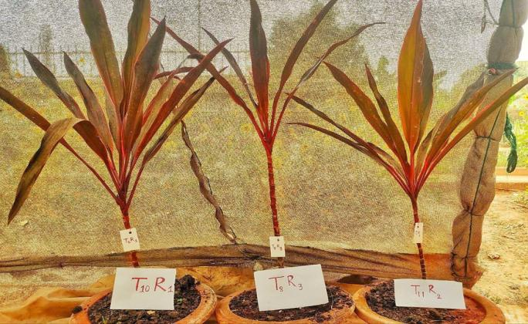

**T10R1:** **Biozyme vegetable plus @ 1.5 ml/l**

**T8R3: Vipul booster @ 1.0 ml/l**

**T11R2:** **Booster @ 1.5 ml/l**

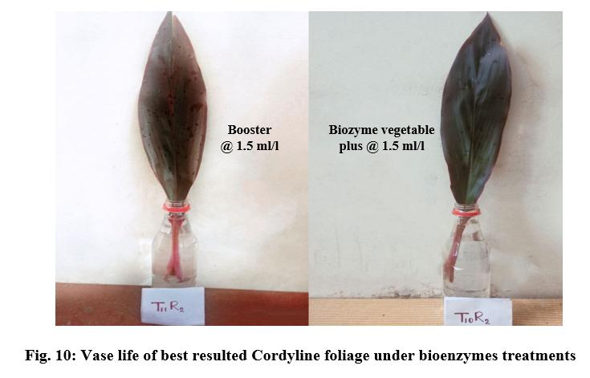**Fig.**  **9: View of best resulted bioenzymes potted plants of *Cordyline terminalis***

**Table 4: Effect of bioenzymes application on different parameters of Cordyline at 60 days after planting (DAP)**

|  |  |  |  |  |  |  |  |
| --- | --- | --- | --- | --- | --- | --- | --- |
| **Treatment No.** | **Treatment details** | **Plant height**  **(cm)** | **Leaf number** | **Leaf length**  **(cm)** | **Leaf breadth**  **(cm)** | **Leaf area**  **(cm²)** | **Internodal length (cm)** |
| T1 | Control (No bioenzyme application) | 58.63 | 6.27 | 29.77 | 2.20 | 65.63 | 4.20 |
| T2 | Biozyme vegetable plus @ 0.5 ml/l | 61.10 | 7.93 | 31.56 | 2.68 | 81.05 | 4.47 |
| T3 | Booster @ 0.5 ml/l | 61.13 | 8.13 | 31.59 | 2.44 | 81.67 | 4.57 |
| T4 | Biozyme crop + @ 0.5 ml/l | 61.40 | 8.40 | 31.61 | 2.57 | 82.31 | 4.40 |
| T5 | Vipul booster @ 0.5 ml/l | 61.87 | 8.00 | 30.73 | 2.55 | 75.47 | 4.39 |
| T6 | Biozyme vegetable plus @ 1.0 ml/l | 61.60 | 8.80 | 31.90 | 2.74 | 88.33 | 4.67 |
| T7 | Booster @ 1.0 ml/l | 61.90 | 9.00 | 31.74 | 2.73 | 86.40 | 5.00 |
| **T8** | **Vipul booster @ 1.0 ml/l** | **64.63** | **9.67** | **34.13** | **3.05** | **109.25** | **5.53** |
| T9 | Biozyme crop + @1.0 ml/l | 62.70 | 8.93 | 32.23 | 2.54 | 89.71 | 5.07 |
| **T10** | **Biozyme vegetable plus @ 1.5 ml/l** | **63.73** | **9.50** | **34.10** | **3.10** | **107.41** | **5.43** |
| **T11** | **Booster @ 1.5 ml/l** | **64.19** | **9.87** | **34.27** | **3.13** | **111.15** | **5.20** |
| T12 | Biozyme crop + @ 1.5 ml/l | 62.80 | 9.00 | 33.00 | 2.82 | 95.11 | 4.89 |
| T13 | Vipul booster @ 1.5 ml/l | 63.47 | 9.23 | 32.53 | 2.80 | 93.03 | 4.97 |
| SE(m) ± | | 2.79 | 1.93 | 2.02 | 0.42 | 52.51 | 0.50 |
| CD (5%) | | 6.71 | 4.65 | 4.87 | 1.00 | 126.64 | 1.21 |

**Internodal length (cm)**

The result on internodal length (cm), reveals that, at 60 DAP and 90 DAP, maximum length of internode was recorded in (T8) Vipul booster @ 1.0 ml/l (5.53 cm and 6.20 cm, respectively) which was statistically on par with (T10) Biozyme vegetable plus @ 1.5 ml/l (5.43 cm and 5.90 cm, respectively) and (T11) Booster @ 1.5 ml/l (5.20 cm and 5.63 cm, respectively), whereas, control recorded minimum internodal length (4.20 cm and 4.53 cm, respectively). The average internodal length found statistically is indicating treatment T8 (Biozyme vegetable plus @ 1.5 ml/l) giving better result over rest.

**Vase life (days)**

In terms of vase life, foliar spray with Booster @ 1.5 ml/l was found to be more effective with a vase life of 23 days in *Cordyline terminalis* followed by Biozyme vegetable plus @ 1.5 ml/l with a vase life of 22 days. Control recorded a vase life of 13 days indicating that Biozyme application improves vase life with increase in concentration.

**Plant grade and colour grade**

Colour grade and plant grade parameters were also influenced by bioenzyme application. Light reddish green colour leaves with poor, unsaleable traits were observed visually in case of control (T1), whereas application of different bioenzymes improved colour, saleable quality and visual appealing of Cordyline foliage giving luxurious growth in rest of the treatments.

**Table 5: Effect of bioenzymes on quality parameters in *Cordyline terminalis***

|  |  |  |  |  |
| --- | --- | --- | --- | --- |
| **Treatment No.** | **Treatment details** | **Vase life (days)** | **Plant grade** | **Colour grade** |
| T1 | Control (No bioenzyme application) | 13.00 | Poor, unsalable | Light reddish green |
| T2 | Biozyme vegetable plus @ 0.5 ml/l | 17.00 | Moderate, saleable | Medium reddish green |
| T3 | Booster @ 0.5 ml/l | 17.00 | Moderate, saleable | Medium reddish green |
| T4 | Biozyme crop + @ 0.5 ml/l | 16.00 | Poor, unsaleable | Light reddish green |
| T5 | Vipul booster @ 0.5 ml/l | 17.00 | Moderate, saleable | Medium reddish green |
| T6 | Biozyme vegetable plus @ 1.0 ml/l | 19.00 | Good, saleable | Medium reddish green |
| T7 | Booster @ 1.0 ml/l | 19.00 | Moderate, saleable | Medium reddish green |
| T8 | Vipul booster @ 1.0 ml/l | 18.00 | Good, saleable | Medium reddish green |
| T9 | Biozyme crop + @ 1.0 ml/l | 19.00 | Good, saleable | Medium reddish green |
| **T10** | **Biozyme vegetable plus @ 1.5 ml/l** | **22.00** | Good, saleable | Dark greenish red |
| **T11** | **Booster @ 1.5 ml/l** | **23.00** | Excellent, saleable | Dark greenish red |
| T12 | Biozyme crop + @ 1.5 ml/l | 20.00 | Good, saleable | Medium reddish green |
| T13 | Vipul booster @ 1.5 ml/l | 19.00 | Moderate, saleable | Medium reddish green |

**Table 6: Effect of Bioenzymes application on different parameters of Cordyline at 90 days after planting (DAP)**

|  |  |  |  |  |  |  |  |
| --- | --- | --- | --- | --- | --- | --- | --- |
| **Treatment No.** | **Treatment details** | **Plant height**  **(cm)** | **Leaf number** | **Leaf length**  **(cm)** | **Leaf breadth (cm)** | **Leaf area**  **(cm²)** | **Internodal length (cm)** |
| T1 | Control (No bioenzyme application) | 59.17 | 6.43 | 30.27 | 2.33 | 71.08 | 4.53 |
| T2 | Biozyme vegetable plus @ 0.5 ml/l | 62.27 | 8.27 | 32.32 | 2.78 | 90.32 | 4.90 |
| T3 | Booster @ 0.5 ml/l | 62.07 | 8.8 | 32.28 | 2.50 | 89.56 | 4.97 |
| T4 | Biozyme crop + @ 0.5 ml/l | 61.93 | 8.73 | 32.00 | 2.70 | 88.21 | 4.73 |
| T5 | Vipul booster @ 0.5 ml/l | 63.27 | 8.33 | 31.40 | 2.71 | 79.61 | 4.62 |
| T6 | Biozyme vegetable plus @ 1.0 ml/l | 63.27 | 8.80 | 32.60 | 2.77 | 93.04 | 5.00 |
| T7 | Booster @ 1.0 ml/l | 63.07 | 9.33 | 32.14 | 2.79 | 91.18 | 5.17 |
| **T8** | **Vipul booster @ 1.0 ml/l** | **67.50** | **10.67** | **36.2** | **3.67** | **140.4** | **6.20** |
| T9 | Biozyme crop + @ 1.0 ml/l | 63.96 | 9.27 | 32.27 | 2.73 | 90.99 | 5.40 |
| **T10** | **Biozyme vegetable plus @ 1.5 ml/l** | **67.33** | **10.23** | **37.87** | **3.70** | **147.4** | **5.90** |
| **T11** | **Booster @ 1.5 ml/l** | **67.93** | **10.73** | **37.2** | **3.50** | **136.57** | **5.63** |
| T12 | Biozyme crop + @ 1.5 ml/l | 64.27 | 9.00 | 33.60 | 2.82 | 97.27 | 5.22 |
| T13 | Vipul booster @ 1.5 ml/l | 63.73 | 9.67 | 34.13 | 2.84 | 99.96 | 5.10 |
| SE(m) ± | | 2.12 | 1.73 | 2.81 | 0.54 | 27.11 | 0.38 |
| CD (5%) | | 5.11 | 4.17 | 6.77 | 1.32 | 65.37 | 0.91 |

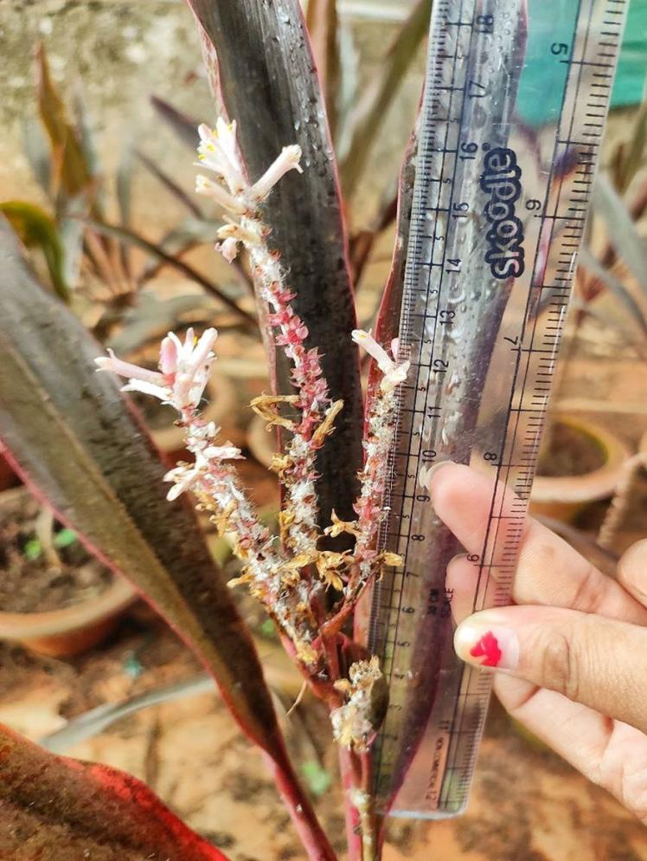

**Fig. 13:** **Flower stalk measuring of about 16.5 cm in treatment T8 (Vipul booster @ 1.0 ml/l) with cup shaped sweet smelling pinkish white colour flower**

**DISCUSSION**

This study discloses the effect of bioenzymes spray on growth and development of 117 potted plants of *Cordyline terminalis* at 60 DAP and 90 DAP*. Cordyline terminalis* was first field established for 30 days and after 30 DAP (days after planting) bioenzymes were sprayed in 13 treatments (Each treatment having 3 replications, per replication having 3 pots) i.e, 117 potted plants in 30 days interval (Table 4 and 6). Four different bioenzymes like Vipul booster (containing Triacontanol w/w, benzoic acid, emulsifier 0.5 w/w), Biozyme crop + (see weed fermented biomass @ 22%, alginic acid @ 0.5%), Biozyme vegetable + (see weed fermented bio mass @ 22%, amino acids 4%) and Booster (Humic acid, amino acids, fulvic acid) were taken in concentration of 0.5%, 1% and 1.5%. With different level of treatment of bioenzymes, there was a significant effect on growth parameters like plant height (cm), leaf number, leaf area (cm2), internodal length, vase life (days), foliage colour and quality.

**Plant height (cm)**

In the present study, the result indicates that the different bioenzymes treatment on Cordyline significantly increased the plant height at 30, 60 and 90 days after planting (DAP). At 30 DAP, results were non-significant. However, the height of the plant was significantly increased due to bioenzyme treatments. Among the different bioenzymes tried, Booster @ 1.5 ml/l (T11) was found to be most effective followed by Vipul booster @ 1.0 ml/l (T8) and Biozyme vegetable plus @ 1.5 ml/l (T10). Maximum height of 67.93 cm was obtained by spraying Booster @ 1.5 ml/l (containing fulvic acid and humic acid) followed by Vipul booster (containing Triacontanol w/w) @ 1.0 ml/l recording a height of 67.50 cm which was better over control (T1) recording an average height of 59.17 cm after 90 DAP. The bioenzymes are biostimulants that are essential for carrying out a number of metabolic processes that have an impact on the vegetative growth of the plant. The use of bioenzymes in the current study may have induced metabolic activity in Cordyline plants, which may have improved physiological functions like photosynthesis. The plant height in treated plants may have risen above control plants (T1) due to an increase in metabolic activity.

This present study validates the works of Ernst *et al*. (1987) in *Scrophularia nodosa* who investigated that application of fulvic acid and humic acid and combinations of FA and HA in the ratios 2:1, 1:1 and 1:2 stimulated plant growth. Pandita *et al*. (1991) studied that plant height of Okra was increased when Vipul (1.25 ppm) was sprayed twice in the rainy season. Satao (2000) recorded significantly more height with foliar application of triacontanol at 0.8 ml/1 concentration in Okra cv. Parbhani kranti. Zaghloul *et al*. (2009) stated that treating *Thuja orientalis* L. seedlings with potassium humate significantly increased plant height, stem diameter, root length, fresh and dry weights of shoots and roots. El-Khateeb *et al*. (2010) on *Calia secundiflora* plants indicated that 1% of humic or algifert, significantly increased plant height, fresh and dry weights, whereas algae gave the thickest stems. Similarly, Aziz *et al*. (2011) stated that application of seaweed extracts at 2.5 and 3.0 cm3/l and saline water at 1000 ppm had a favorable effect on vegetative growth, flowering and chemicals constituents of *Amaranthus tricolor* plants.

The results obtained in present study are in similar line.

**Leaf number**

The result obtained in the present investigation indicates no significant difference between Booster @ 1.5 ml/l (T11), Vipul booster @ 1.0 ml/l (T8) and Biozyme vegetable plus @ 1.5 ml/l (T10) as application of these bioenzymes at 90 DAP through foliar spray recorded an average leaf number of 10.73, 10.67 and 10.23 respectively indicating that all of these are equally effective in stimulating number of leaves in *Cordyline terminalis*. All the 12 treatments of bioenzymes significantly increased leaf number after 60 DAP and 90 DAP which was better over control (T1) recording an average leaf number of 6.43 after 90 DAP. The bioenzyme treatments significantly increased plant height than control. Evidently that might have resulted in increase in number of leaves than control (T1).

Photosynthetic activity occurs on the leaves. As a result, more leaves can synthesize more photosynthates, which can then be directed towards facilitating the development of more vegetative, reproductive growth and enhancing anthocyanin pigment concentration in Cordyline. These findings are corroborated by previous research with different biostimulants on plants and their influence on the development of better vegetative growth. Miniraj and Shanmgavelu (1987) reported significant increase in number of leaves with foliar spray of triacontanol in chilli. Mohammadipour *et al*. (2012) on *Calendula officinalis* observed that 2000 mg/l of humic acid increased dry weight, plant height, leaves and flowers number. Similarly, El-Bably (2017) on tuberose (*Polianthes tuberosa*), indicated that humic acid treatment significantly increased all growth parameters (leaf length, number of leaves and fresh weight).

The current research findings confirm those reported by previous researchers.

**Leaf area (cm2)**

The result presented in previous chapter indicates that leaf area at 60 DAP significantly increased after 90 DAP in all the treatments (Table 4 and 6). Since the bioenzyme treatments significantly increased plant height and leaf number, hence it has also shown a level of significance in terms of leaf area (cm2). This study discloses that the maximum leaf area was seen in treatment sprayed with Biozyme vegetable plus @ 1.5 ml/l (T10) with an area of 147.4 cm2 and it was significantly different from rest treatments. All the treatments of bioenzymes were better over control (T1) which recorded an average leaf area of 71.08 cm2 (Fig. 9). Biozyme vegetable plus contains sea weed extract which has cytokinin and auxin precursors, macro and micronutrients that increase the cell division, cell enlargement with better utilization of chemical fertilizers resulting in leaf area expansion. It is also due to improved nutrient absorption capacity and increased photosynthetic activity of the plants.

This study is in similar line with works of Befrozfar *et al*. (2013) on *Ocimum basilicum*, who found that foliar spray of humic acid increased plant height and leaf area in comparison to control. Ali *et al*. (2015) on *Tulipa gesneriana* observed that humic acid treatment increased plant height, leaf area expansion and stem diameter. Abdel-Rahman *et al*. (2020) on *Conocarpus erectus* noted that treating tip cuttings of *C. erectus* with either coconut water for 1 hour or seaweed extract as drench enhanced the shoot growth parameters. Similarly, El-serafy *et al*. (2020) on Cordyline observed that foliar spray of oligo-chitosan increased growth rate, improved photosynthesis, increased leaf area and resulted in increased quality.

**Internodal length (cm)**

The results obtained in the present investigation indicated significant increase in internodal length due to application of bioenzymes than control. The internodal length after 90 DAP was more prominently increased in the treatment of Vipul booster @ 1.0 ml/l (T8) with 6.20 cm which was significantly different than rest. All the bioenzyme treatments were better and significant over control (T1) which recorded 4.53 cm. Vipul booster contains triacontanol which boost plant height, plant spread, enhances nutrient uptake and thus increases internodal length and stem girth.

Similar type of result has been reported by earlier workers for the effect of bioenzymes.

El-khateeb *et al*. (2018) on *Dracaena surculosa* found that all treatments of some biostimulants, algae @ 5-10 g/l, fulvic acid @ 5-10 m/l and chitosan @ 0.5-1 g/l increased the plant height and spraying plants with low level of algae produced the tallest plants with thickest stems.

**Vase life (days)**

The result pertaining to vase life studies of cut flower in distilled water indicated that maximum vase life was seen in foliage of the Cordyline plants sprayed with Booster @ 1.5 ml/l (T11) with 23 days. It was followed by Biozyme vegetable plus @ 1.5 ml/l (T10) with 22 days. The effect of bioenzymes on vase life was significantly increased in all treatments and was different. Minimum vase life was seen in control (T1) with 13 days.

The result obtained in the present investigation were in line with the works of Favero *et al*. (2011) who observed that Branches of *C. terminalis* ‘Green’ and ‘Red’ from control group, pulsed with GA3, wax sprayed and the ones stored at 5, 10 and 13°C for 10 days had a vase life of 21 days and those kept at 5, 10 and 13°C for 20 days had a vase life of 14 days. It was concluded that *C. terminalis* ‘Green’ and ‘Red’ can be cold stored from 5 to 13°C without any damage up to 10 days. GA3 or wax spray does not improve vase life of both cultivars.Similarly, Gaurav *et al*. (2015) observed that higher vase life was obtained at 35% and 50% shade level due to better chlorophyll content, fresh weight, photosynthesis rate and lower transpiration rate

**CONCLUSION**

The present study on **“**Bioenzyme-Mediated Growth Enhancement in Cordyline (*Cordyline terminalis*): A Developmental Study” was accomplished in the year 2022 and 2023 at the Biotechnology-cum-Tissue Culture Centre in Baramunda, Floriculture and Landscaping Department, College of Agriculture, Odisha University of Agriculture and Technology, Bhubaneswar.

Amongst all the species of Cordyline, the most extensively investigated is *C. terminalis*. Cordyline is very closely related to Dracaena and differs from the later only in the structure of ovary. Cordyline is an excellent ornamental plant with colored foliage and has wide landscaping utility. To restore environmental degradation and limit the use of chemical fertilizer, study of bioenzymes is essential. Bioenzymes are organic formulation of living organism which is applied to plants, seeds or the root environment with the intention to stimulate natural processes of plants like enhancing nutrient use efficiency, tolerance to abiotic stress, boosting foliage quality, pigment concentration and vegetative parameters. Thus, Study of bioenzymes in Cordyline is vital as they are promising environmental production strategy for ornamental crops including foliage crops in green house.

* Bioenzymes treatment on Cordyline significantly increased the plant height at 30, 60 and 90 days after planting (DAP). Booster @1.5 ml/l (T11) was found to be most effective followed by Vipul booster @ 1.0 ml/l (T8) and Biozyme vegetable plus @ 1.5 ml/l (T10). After 90 DAP, maximum height of 67.93 cm was obtained by spraying Booster @ 1.5 ml/l (containing fulvic acid, humic acid & amino acids) followed by Vipul booster (containing Triacontanol w/w) @ 1.0 ml/l recording a height of 67.50 cm which was better over control (T1) recording an average height of 59.17 cm.
* Booster @ 1.5 ml/l (T11), Vipul booster @ 1.0 ml/l (T8) and Biozyme vegetable plus @ 1.5 ml/l (T10) at 90 DAP through foliar spray recorded an average leaf number of 10.73, 10.67 and 10.23 respectively indicating that all of these are equally effective in stimulating number of leaves in *Cordyline terminalis*. All the 12 treatments of bioenzymes significantly increased leaf number after 60 DAP and 90 DAP which was better over control (T1) recording an average leaf number of 6.43 after 90 DAP.
* Maximum leaf area was seen in treatment sprayed with Biozyme vegetable plus (containing sea weed extract) @ 1.5 ml/l (T10) with an area of 147.4 cm2 whereas control (T1) recorded an average leaf area of 71.08 cm2.
* The internodal length after 90 DAP was more prominently increased in the treatment of Vipul booster @ 1.0 ml/l (T8) with 6.20 cm. All the bioenzyme treatments were better and significant over control (T1) which recorded length of 4.53 cm.
* Maximum vase life of 23 days was seen in foliage of the Cordyline plants sprayed with Booster @ 1.5 ml/l (T11). It was followed by Biozyme vegetable plus @ 1.5 ml/l (T10) with 22 days. The effect of bioenzymes on vase life was significantly increased in all treatments and was different. Minimum vase life of 13 days was seen in control (T1).
* Colour grade and plant grade parameters were also influenced by bioenzyme application. Light reddish green colour leaves with poor, unsaleable traits were observed visually in case of control (T1), whereas application of different bioenzymes improved colour, saleable quality and visual appealing of Cordyline foliage giving luxurious growth.

**Summary**

Cordyline is an excellent ornamental plant with colored foliage and has wide landscaping utility. Also, to restore environmental degradation and limit the use of chemical fertilizer, study of bioenzymes is essential as they improve growth and development parameters of foliage crops.

Bioenzymes application in 13 treatments were done in separate 117 potted plants out of which Booster @ 1.5 mg/l, Biozyme vegetable plus @ 1.5 mg/l and Vipul booster @ 1.0 mg/l performed well over rest in terms of vegetative characters like plant height, leaf number, leaf area, internodal length and quality attributes like vase life, plant grade and colour grade.

As a result, findings of this study will be positive, paving the way for large-scale plantlet production in the future. It will benefit hi-tech farmers and entice entrepreneurs for commercialization. It will also shift the present use of chemical fertilizers towards organic fertilizers through application of bioenzymes and will restore environmental, soil and plant health.

**DISCLAIMER (ARTIFICIAL INTELLIGENCE)**

Author(s) hereby declares that NO generative AI technologies such as Large Language Models (ChatGPT, COPILOT, etc.) and text-to-image generators have been used during the writing or editing of this manuscript.

# REFERENCES

Abdallah S. 2015. *In vitro* micro-propagation of cordyline and dieffenbachia plants, *Hortscience Journal of Suez Canal University*, **4**(1): 17-24.

Adanson M. 1763. *Familles des plantes par M. Adanson,* chez Vincent, **2**: 9-54.

Ali A, Rehman SU, Raza S and Allah SU. 2014. Combined effect of humic acid and NPK on growth and flower development of *Tulipa Gesneriana* in Faisalabad, Pakistan, *Journal of Ornamental Plants*, **4**(4): 39-48.

Alla AH and Van SJ. 1996. Somatic embryogenesis from leaves of *Yucca aloifolia* L, *J. Southern Afr. Soc. hort. Sci*., **6**(1): 4-7.

Anand M and Bir SS. 1984. Organogenetic differentiation in tissue cultures of *Dalbergia lanceolaria*, *Current Science*, **53**(24): 1305-1307.

Ancora G, Belli-Donini ML and Cuozzo L. 1981. Globe artichoke plants obtained from shoot apices through rapid *in vitro* micropropagation. *Scientia Horticulturae*, **14**(3): 207-213.

Aziz NGA, Mahgoub MH and Siam HS. 2011. Growth, flowering and chemical constituents performence of *Amaranthus tricolor* plants as influenced by seaweed (*Ascophyllum nodosum*) extract application under salt stress conditions, *Journal of Applied Sciences Research*, 1472-1484.

Bach A, Malik M and Zolneczko B. 1998. Organogenesis and somatic embryogenesis in cultures of *Cyclamen persicum* Mill. F1 Medium. *Acta Biologica Cracoviensia, Series Botanica*, (40): 47-51.

Badawy A, Habib A, El-Ban A and Yosry G. 2005. Propagation of *Dracaena fragrans* plants by tissue culture technique, *Arab J. Biotech*, **8**(2): 329-342.

Bailey LH. 1910. *Cyclopedia of American Agriculture: Farms* (Vol. 1). Macmillan.

Balachandran M. 1993. Induction of genetic variability in *Musa sp.* var*.* Nendran *in vitro* methods (Doctoral dissertation, Department of pomology and floriculture, College of horticulture, Vellanikkara).

Beckett KA and Jahn V. 1987. The RHS encyclopedia of house plants, including greenhouse plants, Swallow editions Ltd.

Befrozfar MR, Habibi D, Asgharzadeh A, Sadeghi-Shoae M and Tookallo MR. 2013. Vermicompost, plant growth promoting bacteria and humic acid can affect the growth and essence of basil (*Ocimum basilicum* L.), *Ann Biol Res*, **4**(2): 8-12.

Bentham G and Hooker JD: General Plantarum, Vol. **III**, London (1883).

Beruto M, Curir P, Lercari GB and Giusta R. 1985. The *in vitro* propagation of *Cordyline terminalis* L. “Calypso”, *Annali dell Instito sperimentale per la floricoltura*, **14**(1): 37-46.

Beura S, Samal P and Jagadev PN. 2007. Preliminary studies of *in vitro* cloning of *Draceana sanderiana* *Acta Hort.*, **760**: 241-245.

Bhojwani SS and Razdan MK. 1986. *Plant tissue culture: theory and practice*, Elsevier, New York, p. 502.

Binh LT, Muoi LT, Oanh HTK, Thang TD and Phong DT. 1990. Rapid propagation of Agave by *in vitro* tissue culture, *Pl. Cell tissue organ cult*., **23**(1): 67-70.

Booth E. 1969. The manufacture and properties of liquid seaweed extracts, In *Proc Int Seaweed Symp*., **6**: 655-662.

Chandrikapure KB, Sadawarte KT, Panchbhai DM and Shelke DB.1999. Effect of bioinoculants and graded dose of nitrogen on growth and flower yield of marigold (*Tagetes erecta* L.), *Orissa J. Hort*., **27**(2):31-34.

Chinnu JK, Mokashi AN, Hegde RV, Patil VS, and Koti RV. 2012. *In vitro* shoot multiplication and *ex vitro* rooting of cordyline (*Cordyline sp*.), *Karnataka Journal of Agricultural Sciences*, **25**(2): 221-223.

Chua BU, Kunisaki JT, and Sagawa Y. 1981. *In Vitro* Propagation of *Dracaena marginata* ‘Tricolor’, *Hort Science*, **16**(4): 494.

Commerson, *in de Junica*, AL: Genera plantarum, p.41. Paris. 1789.

Das T. 1992. Micropropagation of *Agave sisalana*, *Plant Cell, Tissue and Organ Culture*, **31**: 253-255.

Datta JK. 1993. Response of okra (*Abelmoschus esculentus* (L.) Moench) foliar application of chemicals, Industrial Waste, sludge and molasses. *Ann. PI. Physiol*., **9**(l): 38-42.

Debergh P. 1975. Intensified vegetative multiplication of *Dracaena deremensis*, In *Symposium on Propagation in Arboriculture,* **54**: 83-92.

Dewir YH, El-Mahrouk ME, and El-Banna AN. 2015. *In vitro* propagation and preliminary results of Agrobacterium-mediated genetic transformation of *Cordyline fruticosa*, *South African Journal of Botany*, **98**: 45-51.

Dodds JH and Roberts LW. 1985. *Experiments in plant tissue culture*, International Potato Center.

Doreswamy R, Rao NKS and Chacko EK. 1983. Tissue culture propagation of banana, *Science Horticulture*, **18**:247-252.

Ekanayake EMEGP, Attanayake AMKB, and Perera PIP. 2016. Optimization of sterilization and regeneration protocol in micropropagation of *Agave angustifloia*.

El-Bably SMZ. 2017. Effect of some Natural Material Additives on Growth and Flowering of Tuberose (*Polianthes tuberosa*, L.) Bulbs. J. Plant Production, Mansoura Univ., **8**(9):895 -906.

El-Khateeb MA, Nasr AA, Fahmy AN and Dorgham AHH. 2010. Effect of GA3 and growth biostimulants on growth and chemical composition of *Califia secundiflora* plants, *Journal of Horticultural Science & Ornamental Plants*, **2**(2): 118-124.

El-Khateeb MA, Nasr AAM and Hassan NAA. 2018. Growth and quality improvement of *Dracaena surculosa*, Lindl by the foliar application of some biostimulants. *International Journal of Environment*, **7**(2): 53-64.

El-Serafy RS. 2020. Phenotypic plasticity, biomass allocation, and biochemical analysis of cordyline seedlings in response to oligo-chitosan foliar spray, *Journal of Soil Science and Plant Nutrition*, **20**(3): 1503-1514.

Eltorky MG, Elmahrouk ME, Elmokadem H and El-Sammak H. 2018. Micropropagation and Genetic Variations of *Cordyline terminalis* cv. Red Top, *Journal of the Advances in Agricultural Researches*, **23**(2): 328-349.

Ernst WHO, Kraak MHS and Stoots L. 1987. Growth and mineral nutrition of *Scrophularia nodosa* with various combinations of fulvic and humic acids, *Journal of plant physiology*, **127**(1-2): 171-175.

Evaldsson IE and Welander NT. 1985. The effects of medium composition on *in vitro* propagation and *in vivo* growth of *Cordyline terminalis* cv. Atom, *J. hort. Sci.,* **60**(4): 525-530.

Evans DA, Sharp WR and Flick CE. 1981. Growth and behavior of cell cultures: embryogenesis and organogenesis, *Plant tissue culture*, 45-113.

Favero BT, Carmello QAC and Dias GM. 2011. Vase life of new tropical cut foliage: *Cordyline terminalis,* In IV International Conference Postharvest Unlimited 2011 945 (pp. 351-356).

Gaikwad SC. 2002. Effect of bioenzymes on growth, seed yield and quality of fenugreek cv. Rmt-1, M.Sc. (Agri.) Thesis, MAU, Parbhani.

Gaurav AK, Raju DVS, Janakiram BS, Jain RI and Krishnan SG. 2015. Effect of shade levels on production and quality of cordyline (*Cordyline terminalis*). *Indian Journal of Agricultural Sciences*, **85**(7): 1-5.

Gautheret RJ. 1939. *Sur la Possibilite de reliser la culture indefinite de tissues de tubercules de carotte*, CR *Acad. Sci*., Paris, **208**: 118-00120.

George EF and Sherrington PD. 1984. *Plant propagation by tissue culture*. Exegetics Ltd.

Gomez KA and Gomez AA. 1984. *Statistical procedures for agricultural research*. John wiley & sons.

Gore AK. 2001. Effect of different bioenzymes on growth, flowering and yield of green chilli (*Capsicum annuum* L.) variety Pusa Jwala. M.Sc. (Agri.) Thesis, MAU, Parbhani (Maharashtra), India.

Guha S and Maheshwari SC. 1966. Cell division and differentiation of embryos in the pollen grains of Datura *in vitro*, *Nature*, **212**:97-98.

Haberlandt G. 1902. *Culturve ssuchemitisolierten Pilanzenzellen. Sitzungsber Math Naturwiss k: i kais Akad Wiss*, **111**: 69-92.

Hu CY and Wang PJ. 1983. Meristem, shoot tip and bud cultures, *Handbook of plant cell culture (USA)*, pp. 177-227.

Hughes KW. 1981. Ornamental species, *In vitro* Cloning Agricultural plants via *in vitro* techniques. *Ed. Conger.,* CRC press, Boea Raton*.* Fla., 5-50.

Hutchinson J. 1959. The families of flowering plants, Vol. **II**, Monocotyledons, The families of flowering plants, Vol. **II**, Monocotyledons, (2nd Ed).

Hvoself-Eide AK. 1990. The effect of irradiance and temperature on *in vitro* cultures of *Nephrolepis exaltata* (L.) Schott and *Cordyline fruticosa* (L.) A.chev, *Gartenbauwissenschaft,* **55**(6): 259-264.

Hvoself-Eide AK. 1993. Influence of environmental conditions on *Cordyline fruticosa* (L) A.chev. mother plants and on the subsequent growth of i*n vitro* explants, *Gartenbauwissenschaft,* **58**(2): 89-94.

Kadam ND, Patil GD, Chougle and Kadam SS. 1988. Effect of foliar application of triacontanol on Yield, soluble protein, total protein and nitrate reductase activity in spinach, *Indian J. Plant Physiol*, **31**(1): 123-125.

Kemp EB and Robb FD. 1962. *Cordyline terminalis*, *Quarterly Journal of Crude Drug Research*, **2**(4): 299-307.

Khan S, Naz S and Saeed B. 2004. *In vitro* production of *Cordyline terminalis* for commercialization, *Pak. J. Bot*, **36**(4): 757-761.

Kobza F and Vachunova J. 1989. Propagation of *Dracaena* *in vitro*, Propagation of *Dracaena deremensis*, *Acta University Agric. Faculty of Hort*, **4**: 33-37.

Kunicki E, Grabowska A, Sękara A and Wojciechowska R. 2010. The effect of cultivar type, time of cultivation and biostimulant treatment on the yield of spinach (L.). *Folia Horticulturae*, **22**(2): 9-13.

Kunisaki JT. 1975. *In vitro* Propagation of *Cordyline terminalis* (L.) Kunth., *HortScience*, **10**(6): 601-602.

Leffring L, Vonk CR and Ribot SA. 1985. Hormonal effects on shoot formation of *Cordyline* cultivars, *Acta Botanica Neerlandiea*, **34**(2): 238.

Letouze R and Beauchesne G. 1969. *Action d'eclairements monochromatiques sur la rhizogenese de tissus de topinambour*. *CR Acad. Sci. Paris*, **269**: 1528-1531.

Li L, Huang W, Peng PA, Sheng G and Fu J. 2003. Chemical and molecular heterogeneity of humic acids repetitively extracted from a peat, *Soil Science Society of America Journal*, **67**(3): 740-746.

MA SS and Shii CT. 1972. Growing banana plantlets from adventitious buds, *J. Chin. Sec. Hort. Sci*., **18**: 135- 142.

Maene LJ and Debergh PC. 1985. Optimalisation of the transfer of tissue cultured shoots to *in vivo* conditions, In Symposium on *In Vitro* Problems Related to Mass Propagation of Horticultural Plants, **212**: 335-348.

Maharana K, Beura S and Sarathi Munsi P. 2017. A Fast Protocol for *in vitro* Cloning of Banana (*Musa acuminata*) cv. Amritpani, *Int J Curr Microbiol Appl Sci*., **6**(10): 586-594.

Maity I, Ghosh PD, Jana BK and Bose T .1994. Micropropagation of some house plants, *Floriculture Technology, Trades and Trends* (ed. Prakash, J. and Bhandary, K.R.) Oxford and IBH Publishing Co., Bombay, pp. 357-366.

Matraszek R, Hawrylak-Nowak B and Chwil M. 2015. Protein hydrolysate as a component of salinized soil in the cultivation of *Ageratum houstonianum* Mill, (Asteraceae), *Acta Agrobotanica*, **68**(3): 247-253.

Mee, GW. 1978. Propagation of *Cordyline terminalis* from Callus Culture, *Hort Science*, **13**(6): 660-660.

Melchior H. 1964. A. Engler's Syllabus der Pflanzenfamilien , *Angiospermen.*, **2**: 666.

Meshkova NV, Makarova RV, Borisova TA and Lapotyshkina LI. 1999. The role of exogenous auxins and cytokinins at different stages of the *in vitro* propagation of *Cordyline terminalis*, *Biotekhnologiya* **15** (1): 71-79.

Minraj N and Shanmugavelu KG. 1987. Studies on the effect of triacontanol on growth, flowering, yield, quality and nutrient uptake in chillies (*Capsicum annuum* L.), S. *Indian Hort.*, **35**(4): 362-366.

Mohammadipour E, Golchin A, Mohammadi J, Negahdar N and Zarchini M. 2012. Effect of humic acid on yield and quality of marigold (*Calendula officinalis* L.). *Annals of Biological Research*, **3**(11): 5095-5098.

Morel G and Martin C. 1952. Virus-free Dahlia through meristem culture, *CR Hebd. Seances Acad. Sci. Paris*, **2351**:324-1325.

Morel GM. 1960. Producing virus-free cymbidium orchids, *American Orchid Society Bulletin*, **29**: 495–497.

Murali TP, Rangan VV and Rajeevan PK. 1999. *In vitro* propagation of *Cordyline terminalis*. National Symposium on Emerging Scenario in Ornamental Horticulture in 2000 A.D. and Beyond, Indian Society of Ornamental Horticulture, Division of Floriculture and Landscaping, IARI, New Delhi. *Abstract of papers*

Murashige T. 1974. Plant propagation through tissue cultures, *Annual review of plant physiology*, **25**(1): 135-166.

Murashige T.1977. Plant cell and organ cultures as horticultural practices, *Acta Hort*, **78**: 17-30.

Nikam TD. 1997. High frequency shoot regeneration in *Agave sisalana*, *Plant Cell, Tissue and Organ Culture*, **51**(3): 225-228.

Oliphant J. 1990. The use of paclobutrazol in the rooting medium of micropropagated plants, *The use of paclobutrazol in the rooting medium of micropropagated plants*, **40**: 358-360.

Paek KY, Oh MO and Choi JK. 1985. Mass propagation of *Cordyline* and *Scindapsus* *in vitro*, *J. Korean Soc. hort. Sci*., **26**(1): 83-92.

Pal AK. 2006. Ornamental plants with attractive foliages, Advances in ornamental horticulture, Pointer publishers, India, **2**: 273-343.

Pandita MLN, Sharnia K and Arora SK. 1991. Effect of Miixtalol and Vipul on growth, flowering and yield of okra (*Abelmoschus esculentus* L. Moench). *Veg. Sci*, **18**(1): 32-40.

Paola MKDI, Siri A, Fossi D and Tognoni J. 1986. *In vitro* propagation of *Dieffenbachia amoena,* *Hort. Rivista della ortoflorofrutticoltura Italiana,* **70**(4): 245-252.

Patil OH. 2002. Effect of bioenzymes on growth, yield and quality of tomato (*Lycopersicon esculentum* Mill) M.Sc. (Agri.) Thesis, MAU, Parbhani (Maharashtra), India.

Piccolo A, Celano G and Pietramellara G. 1993. Effects of fractions of coal-derived humic substances on seed germination and growth of seedlings (*Lactuga sativa* and *Lycopersicum esculentum*), *Biology and Fertility of Soils*, *16*: 11-15.

Podwyszynska M and Olszewski T. 1995. Influence of gelling agents on shoot multiplication and the uptake of macroelements by *in vitro* culture of rose, cordyline and homalomena, *Scientia Horticulturae*, **64**(1-2): 77-84.

Poincelot RP. 1994. The use of a commercial organic biostimulant for field-grown bedding plants, *Journal of home and consumer horticulture (USA)*,**1**(1): 95-110.

Powers DE and Backhaus RA. 1989. *In vitro* propagation of *Agave arizonica* Gentry & Weber, *Plant cell, tissue and organ culture*, **16**: 57-60.

Raj Deepa Raju (2000). Effect of different bio stimulants on growth, flowering and yield of tomato (*Lycopersicon esculentum*, mill) M.Sc. Thesis submitted to Dep. of Hort. M. A. U., Parbhani.

Randhawa GS and Mukhopadhyay A. 2004. Floriculture in India, *Allied publishers Pvt Limited*, pp. 258-259.

Ray T, Saha P and Roy SC. 2006. Commercial production of *Cordyline terminalis* (L) Kunth. from shoot apex meristem and assessment for genetic stability of soma clones by isozyme markers, *Scientia horticulturae*, **108**(3): 289-294.

Ray T, Saha P and Roy SC. 2013. Micropropagation of *Cordyline terminalis*, Protocols for Micropropagation of Selected Economically-Important Horticultural Plants, 269-277.

Razdan MK. 1993. An introduction to plant tissue culture, Oxford & IBH Publishing Co. Pvt. Ltd., Calcutta, p.397.

Reinert J. 1959. Über die Kontrolle der Morphogenese und die Induktion von Adventivembryonen an Gewebekulturen aus Karotten. *Planta*, **53**: 318-333.

Ries SK and Wert V. 1977. Growth responses of rice seedlings to triacontanol in light and dark, *Planta*, **135**: 77-82.

Robert ML, Herrera JL, Contreras F and Scorer KN. 1987. *In vitro* propagation of *Agave fourcroydes* Lem. (Henequen). *Plant Cell, Tissue and Organ Culture*, **8**: 37-48.

Sakr SS, El-Khateeb MA and El-Kareim AHA. 1999. *In vitro* production of *Yucca elephantipes*, *Bulletin-Faculty of Agriculture University of Cairo*, **50**: 265-282.

Samyn G. 1995. Influence of the sucrose concentration in the growth medium on adventitious and axillary shoot production and on the stability of the chimeral *Cordyline fructicosa* (L.) A. Chev. Cultivar ‘Rosa’, *Bulletin des Recherches Agronomiques de Gembloux (Belgium)*, **30** (1-2):67-75.

Sanjeewa T and Peiris SE. 2011. *In Vitro* Propagation of *Cordyline terminalis* CV' Gold-Compacta' and CV' Red-Compacta'.

Sarsamkar SS. 2001. Effect of Novazyme and Biozyme on growth, flowering and yield of okra. M.Sc. (Agri.) Thesis, MAU. Parbhani.

Satao PJ. 2000. Effect of Aminocel and bioenzyme on growth flowering and yield of okra. M.Sc. Thesis submitted to Dep. of Hort. M. A. U., Parbhani.

Schnitzer M. 1991. Soil organic matter-the next 75 years. *Soil science*, **151**(1), 41-58.

Schnitzer, M. 1999. A lifetime perspective on the chemistry of soil organic matter. *Advances in agronomy*, **68**: 1-58.

Skoog F and Miller CD. 1957. Chemical regulation of growth and organ formation in plant tissue cultivated *in vitro, Symp. Soc. Expt Biol.*, **11**: 118- 131.

Stevenson FJ. 1994. *Humus chemistry: genesis, composition, reactions*, John Wiley & Sons.

Suh HY, Yoo KS and Suh SG. 2014. Effect of foliar application of fulvic acid on plant growth and fruit quality of tomato (*Lycopersicon esculentum* L.). *Horticulture, Environment, and Biotechnology*, **55**: 455-461.

Traon D, Amat L, Zotz F and du Jardin P. 2014. A Legal Framework for Plant Biostimulants and Agronomic Fertilizer Additives in the EU-Report to the European Commission, DG Enterprise & Industry.

Valenzuela-Sánchez KK, Juárez-Hernández RE, Cruz-Hernández A, Olalde-Portugal V, Valverde ME and Paredes-Lopez O. 2006. Plant regeneration of *Agave tequilana* by indirect organogenesis, *In Vitro Cellular & Developmental Biology-Plant*, **42**: 336-340.

Vasil V and Hildebrandt AC. 1965. Differentiation of tobacco plants from single isolated cells in microculture, *Science*, **150**: 889-892.

Vinterhalter DV. 1989. *In vitro* propagation of green-foliaged *Dracaena fragrans* Ker. *Plant cell, tissue and organ culture*, **17**: 13-19.

Wainwright H. 1988. Overcoming problems in establishing micropropagules- guidelines for growers, *Prog. Hort*., **2**(3): 67-72.

Weerahewa HLD and Somaratne S. 2011. Effect of some selected vase water additives on vase life of *Cordyline terminalis'* red'foliage.

Weis JS and Jaffe MJ. 1969. Photo enhancement by blue light of organogenesis in tobacco pith cultures, *Physiologia Plantarum*, **22**(1): 171-176.

Welander T. 1988. Micropropagation of *Cordyline terminalis* cv. Atom-a European cooperation project, *Rapport Institutionen for Tradgardsvetenskap,* **54**:13.

White PR.1934. Potentially unlimited growth of excised tomato root tips in a liquid medium, *Plant Physiol.,* **9**: 585-600.

Wong WC. 1986. *In vitro* propagation of Banana (*Musa* spp.): initiation, proliferation and development of shoot-tip cultures on defined media. *Plant cell, tissue and organ culture*, **6**: 159-166.

Yakhin OI, Lubyanov AA, Yakhin IA and Brown PH. 2017. Biostimulants in plant science: a global perspective, *Frontiers in plant science*, **7**: 2049.

Yeoma M.M. 1986 *Plant cell culture technology*. Blackwell Scientific Publications, Malabourne, p. 33

Youssef H. 2012. Production *cordyline fruticosa*, l. By using tissue culture, *Egyptian Journal of Agricultural Research*, **90**(2): 747-758.

Zaghloul SM, El-Quesni FEM and Mazhar AAM. 2009. Influence of potassium humate on growth and chemical constituents of *Thuja orientalis* L. seedlings, *Ozean Journal of Applied Sciences*, **2**(1): 73-78.

Ziaullah A, Asghar N, Amin N and Arshad M. 1999. Genotypic variation in two *Cordyline* species and their performance in different growth media, *Sarhad J. Agric.,* **15**(3): 177-179.

Ziv M, Meir G and Halevy AH. 1981. Hardening carnation plants regenerated from shoot tips cultured *in vitro*, *Environ. & Exptl*. *Bot*., **21**: 243.