Review Article

The Factors Influencing the Disparity in the Distribution of Medical Doctors in Rural and Urban Areas
ABSTRACT
Background: The global disparity in the distribution of medical doctors between rural and urban areas remains a significant challenge, particularly in developing countries like Ghana. Despite policies aimed at improving salaries and retention, rural areas continue to face severe shortages of healthcare providers. This study examines the preferences of medical students in Ghana regarding rural versus urban practice and identifies key factors influencing their decisions.
Method: A cross-sectional study was conducted among 150 clinical-year medical students at the University of Ghana Medical School. Data were collected using a structured questionnaire, capturing demographic details, rural exposure, career aspirations, and motivational factors. Quota sampling ensured equal representation across clinical years. Descriptive statistics and chi-square tests were employed for analysis, with significance set at p < 0.05.
Results: Surprisingly, 60% of respondents expressed a preference for rural practice, though only 18% had rural clinical experience. Good working conditions (78%) and social recognition (77%) ranked higher than salary (67%) as influencing factors. Older students and those in advanced clinical years showed greater rural practice inclination (p = 0.001 and p = 0.023, respectively). Notably, 69.1% planned to pursue speciality training, with only 8.7% opting for general practice.
Conclusion: While medical students demonstrate a willingness to work in rural areas, limited exposure and systemic challenges hinder actual retention. Non-monetary factors, such as career development and working conditions, are significant in shaping preferences. Strategies to enhance rural infrastructure, structured clinical rotations, and targeted incentives are recommended to address workforce disparities.
Keywords: Medical doctors, rural-urban disparity, Ghana, workforce distribution, medical students, retention strategies, healthcare access.
1.0 INTRODUCTION
The problem of insufficient numbers of health personnel to cater for the constantly growing populations around the world has been an issue of immense concern all over the world, though different countries experience this problem to varying degrees [1]. Even worse, there is the imbalance in the distribution of health personnel between rural and urban areas within individual countries, with the former being at a great disadvantage [2]. Almost all developing countries suffer the most from inequality as a result of various reasons, including the massive emigration of health personnel to foreign countries, usually the western developed countries, to seek greener pastures [3]. The interrelation of several factors, including improper management of the health workforce and health systems have contributed to the existing imbalances. This is made evident by the fact that not only developing countries, but also developed countries are facing the challenge.
In Ghana, recent health sector policies resulting in increasing doctors’ salaries have contributed to decreasing the rate of resettlement of doctors out of the country, but the problem of gross disparities in the rural and urban distribution has not been significantly affected by these policies [4]. The inability of the various stakeholders in health to adequately recruit and retain qualified health personnel leads to deficiencies in the human resource base, whereas unsatisfactory remuneration for those already in the system causes low productivity [5]. Concerning this problem, as stated already, Ghana is not an exception, and the need to identify the fundamental causes of this headache and to design and implement appropriate interventions to upturn the trend cannot be overstressed.
Doctors are the health care providers in greatest shortage and yet highest demand compared to nurses and other health workers, and this makes the situation very disturbing because they head any healthcare delivery team and take direct responsibility for all patients [6]. In developing countries, including Ghana, this shortage of doctors, especially where it is notable and has become a major setback to the attainment of the proposed health-related Millennium Development Goals (MDGs) [7]. According to the World Health Organization’s (WHO) World Health Report 2006 [8], there are at least 4 million health workers needed for the minimum level of health outcomes to be achieved. Basically, the problem is with the inadequate production capacity for these health workers, especially doctors, and the inability to maintain those trained in the places where their services are most required [9]. Therefore, whatever plans are put in place to address the problem must be aimed at increasing the number of doctors to be trained and also to develop strategies to attract and retain both existing and newly trained doctors in places where their services are mostly needed.
The demographic context of Ghana presents compelling evidence of this disparity. WHO figures for 2009 indicate that 51% of the country’s population lives in urban areas compared to the global average of 50% while 49%, a significant portion, live in rural communities [10]. In addition, according to the WHO figures for 2008, to population ratio (per 10,000 population) for Ghana was 0.9 compared to the Africa regional average, which was 2.3 [11]. The Africa Health Workforce Observatory (AHWO) 2010 country profile for Ghana also shows that out of the total of 1945 general medical practitioners, 1362 work in urban areas, whereas only 538 work in rural areas [12]. From the same source, all 695 specialist medical practitioners are in urban areas, with none in rural areas. These statistics paint a stark picture of the magnitude of inequality in healthcare provision between urban and rural populations.
From a global perspective, worldwide, only 24% of the total number of physicians take care of the 50% of the world population living in rural areas [13, 14]. The other 76% are all concentrated in the urban areas. It is really interesting to note however, that even though at the national level, especially in sub-Saharan Africa and other developing nations these shortages are reflected due to inadequate numbers of health workforce, some countries have the situation where there is high rate of production of health workers with many of them unemployed in the urban areas, and yet with severe shortages in the rural areas [15]. Examples include Côte d'Ivoire, Mali, and the Democratic Republic of Congo. Some countries have sufficient numbers on average, but with marked deficiencies in the rural areas. Examples include Germany and France. By and large, the effects of these shortages mitigate against the achievement of the Millennium Development Goals.
The understanding of factors motivating healthcare workers has evolved significantly over time. It is also important to state that over the years, some of the perceived or indeed scientifically determined factors accounting for the imbalances in rural/urban distribution of health workforce, especially doctors, have changed and are therefore no longer valid. For instance, it has been a widely held view that once doctors are given larger salaries and other monetary benefits, they would be happy to accept a posting to any remote area, but this is not exactly so from more recent studies [16]. More doctors, and indeed other healthcare professionals, are moving more towards a work/life balance phenomenon. In other words, they would consider things like having a satisfactory social life and access to desired recreational activities/facilities for themselves and their families before making a decision [17].
So, it has been obvious that motivation for health workers, including doctors, has become quite complex, involving different things with non-monetary benefits becoming increasingly important. People may let go of a job if their expectations are not met [18]. Generally, factors that attract health workers to a new work location are known as the “pull” factors, whereas those motivating them to leave the current workplace are known as the “push” factors [19]. Different “measuring scales" can be used to assess the extent of these imbalances and deficiencies in health worker distribution, including health worker densities, vacancy rates (defined as the percentage of unfilled posts), turnover rates, attrition rates, unemployment rates, and absenteeism.
Only a few countries have developed and implemented large-scale interventions aimed at upgrading infrastructure in rural areas and improving the general living conditions of health workers in such places. Thailand, Mali, and Zambia are typical examples. Factors that rank highest in workers’ considerations of choice of location are those directly related to infrastructure and working conditions [20]. In Ghana, the Ministry of Health proposed some incentives, including a 10% benefit for accommodation, free boarding school placement for one child, and reduced years of service before promotion [21]. In a study by Snow et al [4], it was revealed that “career advancement incentives will be critical to any successful incentive package.” Proposed incentives included a guaranteed promotion or study opportunity after years of serving in hardship areas.
Having laid this background, it is already evident why this study is important, because it seeks to find important underlying factors of the current trends in the country at the very basic level; young undergraduate students of medicine who are yet to join the health workforce. This study looks at the broad areas of personal factors, career prospects, remuneration, and how these affect the choices of young medics when it comes to whether to work in a rural or urban setting. This study is aimed at determining the preferences of medical students in the clinical years of their training with respect to practicing in a rural or urban setting, the factors influencing these preferences, and possible interventions that could improve interest and retention of doctors in rural communities.
2.0 METHOD
2.1 Study Design
This study employed a cross-sectional design to assess medical students’ preferences regarding rural versus urban medical practice. A cross-sectional approach was chosen because it allowed for the efficient collection of data at a single point in time, providing a snapshot of students’ attitudes and intentions during their clinical training years [22]. This design was particularly suitable as it enabled the examination of associations between variables such as demographic characteristics, rural exposure, and career preferences without the need for long-term follow-up [23]. The choice of this design aligns with similar studies on healthcare workforce distribution, which have successfully used cross-sectional surveys to identify factors influencing practice location decisions [24].
2.2 Study Location and Population
The study was conducted at the University of Ghana Medical School (UGMS), located within the Korle Bu Teaching Hospital in Accra. This setting was selected because UGMS is Ghana’s premier medical training institution, producing a significant proportion of the country’s doctors. The target population comprised medical students in their clinical years (third, fourth, and fifth years) of study. These students were chosen because their clinical exposure provided them with sufficient experience to form informed opinions about future practice locations. At the time of data collection, the total population of clinical-year students was 602.
2.3 Sampling Technique and Sample Size
A quota sampling method was used to ensure equal representation across the three clinical years. Fifty students were selected from each year group, resulting in a total sample size of 150 students. Quota sampling was preferred because it guaranteed balanced representation from all clinical levels, allowing for comparisons across different stages of training [25].
Inclusion and Exclusion Criteria
The study included:
- Medical students in their first, second, or third clinical year (equivalent to third, fourth, and fifth years of the MBChB program).
- Ghanaian students, as the study focused on domestic workforce distribution.
Exclusion Criteria
- Medical students in basic science or paraclinical years
- Non-Ghanaian medical students
2.4 Data Collection Tools and Procedures
Data were collected using a structured questionnaire containing 18 questions. The instrument captured:
- Demographic information: Age, sex, class, and marital status.
- Rural exposure: Previous living experiences and clinical rotations in rural areas.
- Career plans: Postgraduate aspirations and preferences for public or private practice.
- Motivational factors: Rankings of factors influencing practice location choices (e.g., salary, working conditions, career development).
Trained facilitators administered the questionnaires during school hours at lecture halls and clinical wards. The facilitators underwent a one-day training session to standardise data collection procedures and minimise bias. No incentives were provided to participants to avoid coercion.
2.5 Variables and Measurements
- Independent variables: Demographic characteristics (age, sex, class), rural experience (residence, clinical attachments), and career plans.
- Dependent variables: Preferences for rural or urban practice, ranked factors influencing location choices (rated on a 5-point scale, where 1 = most important).

2.6 Data Analysis
Data were analysed using SPSS version 20.0. Descriptive statistics (frequencies, percentages, means, and standard deviations) summarized demographic and preference data. Pearson’s chi-square test examined associations between demographic variables and practice location preferences, with statistical significance set at p < 0.05. Open-ended responses were analysed thematically.
Quality Control
To ensure reliability:
- The questionnaire was pre-tested and refined.
- Facilitators were trained and monitored.
- Data entry was performed twice to verify accuracy.
2.7 Ethical Considerations
The study does not require any formal ethical approval, as no formal ethics committee review was required for this academic exercise. All participants provided written informed consent after receiving complete explanations about the study’s purpose and their rights as participants. The consent forms emphasised voluntary participation, with students free to withdraw at any time without consequence.
3.0 RESULTS
The study yielded important findings across four key areas: demographic characteristics of respondents, rural experiences, career development plans, and factors influencing practice location choices. These results provide valuable insights into medical students’ preferences regarding rural versus urban medical practice.
3.1 Demographic Characteristics
The study surveyed 150 clinical-year medical students from the University of Ghana Medical School. The respondents’ ages ranged from 19 to 29 years, with a mean age of 22.7 ± 1.74 years. The majority (82%) fell within the 21-23 age group, while smaller proportions were aged 18-20 (2%), 24-26 (9.3%), and 27-29 years (6.7%). This distribution reflects the typical age range of medical students in their clinical training years.
Regarding sex distribution, male students slightly outnumbered females (53.3% vs. 46.7%), consistent with historical enrollment patterns in Ghanaian medical schools. The sample included equal representation across class years due to the quota sampling method with 50 students each from the first (33.3%), second (33.3%), and third (33.3%) clinical years.
Marital status data revealed that nearly all respondents (96%) were single, with only 4% married and no divorced or widowed participants. This predominance of single students is expected given their stage in professional training and typical age range. (Table 1).
Table 1: Demographic Characteristics
Age group | Frequency | Percentage (%)
18-20 | 3 | 2.0
21-23 | 123 | 82
24-26 | 14 | 9.3
27-29 | 10 | 6.7
Sex
Male | 80 | 53.3
Female | 70 | 46.7
Class
1st Clinical Year | 50 | 33.3
2nd Clinical Year | 50 | 33.3
3rd Clinical Year | 50 | 33.3
Marital Status
Single | 144 | 96
Married | 6 | 4.0
Divorced | 0 | 0.0
Widowed | 0 | 0.0

3.2 Rural Experience and Practice Preferences
Figure 1 presents the striking finding that 60% of respondents preferred to work in rural areas after graduation, while only 14% favoured urban practice. However, 26% remained undecided about their future practice location. This apparent willingness for rural service merits careful interpretation given other findings.
Figure 1: Distribution for preferred working centre
Furthermore, most respondents had lived predominantly in urban areas during their lives as related in Figure 2, though 64% reported some rural living experience at some point.

Figure 2: Distribution for respondents who have lived in a rural area before
Among those with rural exposure, 40.4% rated their experience as below expectations, while 35.4% said it met expectations (Table 2). Only 9.1% reported that their rural experience exceeded expectations.
Table 2: Distribution of rural experience expectations
Rural Experience | Frequency | Percent
Exceeds Expectation | 9 | 9.1
Meets Expectations | 35 | 35.4
Below Expectations | 40 | 40.4
Indifferent | 15 | 15.2
Total | 99 | 100

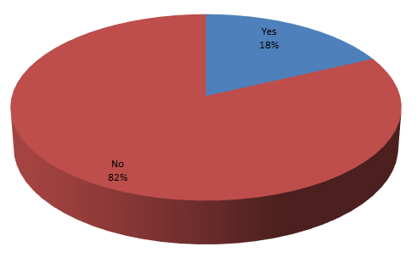
Clinical exposure to rural settings proved limited with 82% of students having never done clinical rotations in rural areas (Figure 3).

Figure 3: Distribution for Respondents who have had a Clinical rotation in rural settings
However, among the 18% with rural rotation experience, 31% said it met expectations and 28.6% reported it exceeded expectations as related in figure 4. This suggests that well-structured rural clinical exposures may positively influence perceptions.
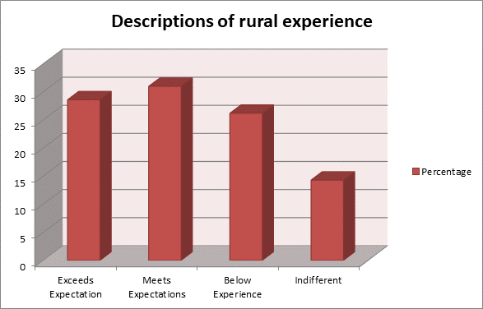

Figure 4: Distributions for descriptions for rural experience

3.3 Career Development Plans
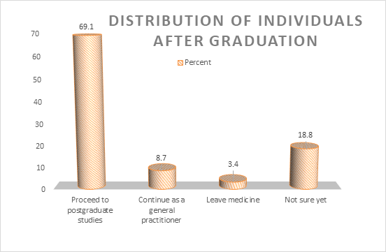
Postgraduate aspirations strongly featured in students’ plans, with 69.1% intending to pursue specialty training after graduation, as related in Figure 5. Only 8.7% planned to work as general practitioners, while 3.4% contemplated leaving medicine entirely.

Figure 5: Distribution of individuals after graduation
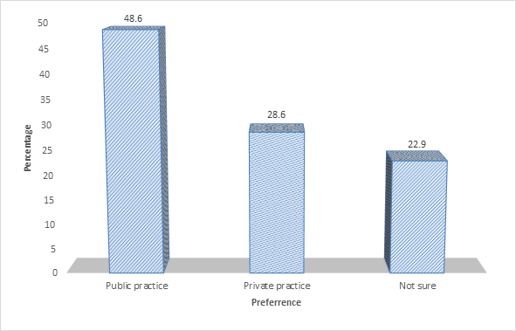
Regarding practice type, 48.6% preferred public sector work, while 22.9% favoured private practice (Figure 6).

Figure 6: Respondents preference for Public or Private Practice

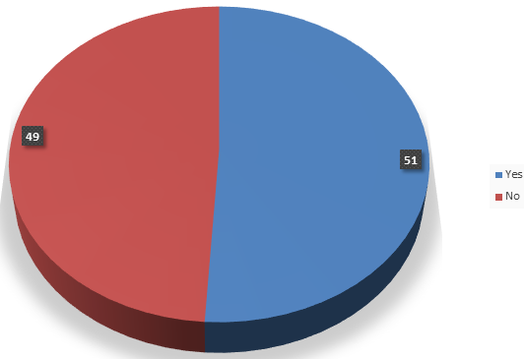
Notably, 51% reported their public/private preference was influenced by career path considerations (Figure 7).

Figure 7: Distribution for decisions influenced by career path
Among those considering private practice, 39.4% would establish this in rural areas versus 35.4% in urban centres (Table 3).
Table 3: Distribution for Location of Private Practice
Location | Frequency | Percentage (%)
Rural Area | 39 | 39.4
Urban Area | 35 | 35.4
Not Sure | 25 | 25.3

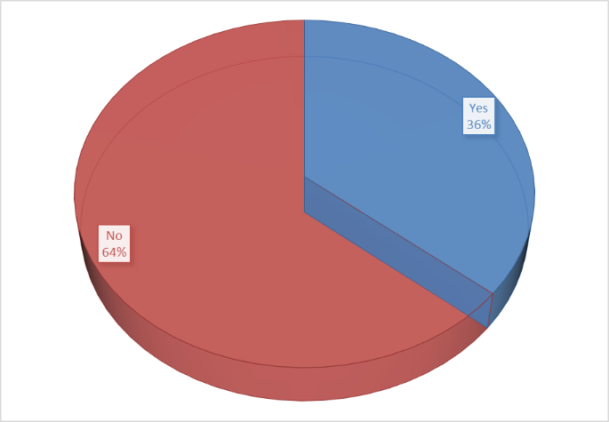
The data revealed an important pattern about practice types: while 58% of prospective specialists planned public sector work, only 36% of would-be general practitioners intended public service (Figures 8-9).

Figure 8: Distribution for public practice (General Practitioner)

Figure 9: Distribution for public practice (Specialist)

3.4 Factors Influencing Practice Location Choices
Table 4 details how students ranked 15 factors affecting their practice location decisions using a 5-point importance scale. Good working conditions emerged as most critical (78% ranking it as most important), followed by social recognition (77%), and demand for services (75%). Contrary to conventional assumptions, high salary ranked sixth (67%), below factors like good living conditions (70.5%) and professional development opportunities. The table revealed that allowances and children’s education grants ranked moderately important, security and spousal employment opportunities ranked lower, while recreation and loan availability ranked least critical.

Table 4: Factors Influencing Choice of Rural or Urban Areas
Factors | 1 | 2 | 3 | 4 | 5
Demand | 54.7 | 20.7 | 32 | 7.3 | 12
Socio-cultural setting | 38 | 20.7 | 21.3 | 7.3 | 10.3
Opportunity to continue medical education | 48 | 18 | 21 | 2.7 | 16.7
Availability of adequate supervision | 37 | 38 | 15 | 2 | 7.4
Good working conditions | 61.5 | 16.2 | 5.4 | 3.4 | 13.5
High salary | 42.6 | 24.3 | 15.3 | 8.1 | 9.5
Allowances | 43 | 28 | 20.7 | 14 | 6
Grants for children’s | 37.2 | 20.7 | 20.7 | 10 | 10.3
Loans | 31 | 26 | 15 | 20.8 | 7.4
Good living conditions | 49 | 21.5 | 5.4 | 8.7 | 15.4
Adequate recreation | 37.6 | 20.1 | 24.2 | 10.1 | 8.1
Gainful employment opportunities | 48.3 | 13.4 | 15.4 | 7.4 | 15.4
Good schools for children to attend | 36 | 20 | 25 | 13 | 6
Social recognition | 49 | 28 | 11 | 3.4 | 9
Security | 37.6 | 20.1 | 24.2 | 10.1 | 8.1

3.5 Association between Demography and Choice of Working Area
The analysis of associations between demographic variables and practice location preferences revealed several important findings, as shown in Table 5. A statistically significant relationship emerged between respondents’ age and their choice of practice location (χ² = 14.562, p = 0.001). This strong association suggests that age plays an important role in shaping medical students’ preferences for rural or urban practice, with older students demonstrating different location priorities compared to their younger counterparts. Similarly, the students’ class year showed a significant association with practice location preference (χ² = 9.423, p = 0.023). This finding implies that as students progress through their clinical training, their attitudes toward practice locations evolve, possibly due to increased clinical exposure or changing professional aspirations during medical education.

In contrast, the analysis revealed no statistically significant associations between practice location preferences and either sex (χ² = 2.369, p = 0.634) or marital status (χ² = 1.281, p = 0.734). These non-significant results suggest that gender and marital status may not be determining factors in Ghanaian medical students’ decisions about where to practice, at least at this stage of their career development.

Table 5: Association between Demographic Characteristics and Practice Location Preferences
Demography | χ² | P-value | Decision
Age | 14.562 | 0.001 | Significant
Sex | 2.369 | 0.634 | Not-Significant
Class | 9.423 | 0.023 | Significant
Marital Status | 1.281 | 0.734 | Not-Significant

4.0 DISCUSSION
The findings of this study reveal important insights into the factors influencing medical students’ preferences for rural or urban practice in Ghana, contributing to the broader discourse on healthcare workforce distribution. The results both align with and challenge existing literature, offering different perspectives on strategies to address rural-urban disparities in physician distribution.
The significant association between age and practice location preference (χ² = 14.562, p = 0.001) aligns with the study of Ghazali et al. [26], demonstrating that career priorities evolve with maturity. Older students in this study showed greater inclination towards rural practice, possibly reflecting heightened awareness of healthcare disparities or financial stability, enabling them to prioritise service over urban conveniences. This contrasts with findings from South Africa, where younger doctors were more willing to work in rural areas [27], suggesting cultural or educational system differences in career decision-making.

The class year association (χ² = 9.423, p = 0.023) supports Dunbabin & Levitt, (2003) [28] evidence that clinical exposure shapes career aspirations. As students progressed through training, their preferences shifted, likely due to increasing awareness of rural healthcare needs. However, the lack of gender and marital status significance diverges from studies in high-income countries [29], highlighting how local context mediates these relationships. While 60% of respondents expressed rural practice interest, only 18% had rural clinical experience. This discrepancy mirrors findings from Campbell & Ebuehi’s [29] research in Nigeria, where aspirational willingness outweighed actual exposure. Also, among those with rural rotations, 59.6% reported experiences meeting or exceeding expectations, reinforcing evidence that structured rural placements improve retention likelihood [27]. The predominance of urban-raised students (87%) with limited rural exposure explains why 40.4% rated past rural experiences negatively. This aligns with Snow et al.’s [4] contention that urban upbringing fosters unrealistic expectations about rural practice. However, the strong rural interest despite minimal exposure suggests untapped potential for targeted recruitment, consistent with Agyei-Baffour et al.’s [30] Ghanaian study.

Furthermore, the overwhelming preference for postgraduate training (69.1%) over general practice (8.7%) compounds Ghana’s specialist mal-distribution. This mirrors global trends where medical education systems inadvertently steer students toward speciality practice [31]. The finding that 58% of prospective specialists preferred public service while general practitioners leaned private (64%) contradicts patterns in South Africa [27], suggesting Ghana’s public sector may better accommodate specialist careers. In addition, the ranking of good working conditions (78%) and social recognition (77%) above salary (67%) challenges conventional reliance on monetary incentives [5]. This supports Snow et al.’s [4] Ghanaian findings that career advancement opportunities outweigh financial benefits. However, it contrasts with Wiwanitkit’s [32] Thai study, where salaries remained paramount, highlighting how economic contexts shape motivations.

5.0 CONCLUSION
The findings of this study highlight the factors influencing medical students’ practice location preferences in Ghana. While a significant proportion of respondents expressed willingness to work in rural areas, this aspiration must be contextualised within the broader realities of inadequate rural exposure and systemic challenges. The results demonstrate that financial incentives alone are insufficient to address workforce mal-distribution, echoing broader shifts in understanding health worker motivation globally.

Medical education systems must be reconfigured to provide structured rural clinical experiences early in training, as these have proven significant in shaping positive perceptions of rural practice. Simultaneously, policy interventions should prioritise improving rural infrastructure and career development pathways to create enabling environments for healthcare professionals. The strong preference for specialist training over general practice presents both a challenge and an opportunity; strategic reforms could channel this inclination towards addressing critical gaps in rural specialist care.

Therefore, sustainable solutions require multisectoral collaboration between medical schools, health ministries, and local communities. Aligning educational experiences with workforce needs and creating practice environments that meet professionals’ expectations can help Ghana make meaningful progress towards equitable healthcare access. These efforts must be underpinned by long-term monitoring to assess their impact on actual workforce distribution patterns, ensuring that policies translate into tangible improvements in rural healthcare delivery. The study provides a foundation for such initiatives while highlighting areas requiring further investigation to refine intervention strategies.

6.0 LIMITATION
This study has several limitations that should be considered when interpreting its findings. The cross-sectional design provides only a glimpse of medical students’ preferences at a single point in time, rather than tracking how these attitudes evolve throughout their careers. The exclusive focus on one medical school limits generalisability to all Ghanaian medical trainees, as institutional cultures and curricula may vary. The reliance on self-reported data introduces potential response bias, with participants possibly providing socially desirable answers regarding rural practice intentions. Furthermore, the study did not examine how external factors such as family pressures or debt obligations might influence career decisions. These limitations highlight the need for broader, longitudinal research to validate the findings.

REFERENCES
[1] Kruk ME, Gage AD, Arsenault C, Jordan K, Leslie HH, Roder-DeWan S, et al. High-quality health systems in the Sustainable Development Goals era: time for a revolution. Lancet Glob Health. 2018 Sep 5;6:e1196–e1252. https://doi.org/10.1016/S2214-109X(18)30386-3.
[2] Dussault G, Franceschini MC. Not enough there, too many here: understanding geographical imbalances in the distribution of the health workforce. Hum Resour Health. 2006 May 27;4:12. https://doi.org/10.1186/1478-4491-4-12.
[3] Akinwale OE, George OJ. Personnel brain-drain syndrome and quality healthcare delivery among public healthcare workforce in Nigeria. Arab Gulf J Sci Res. 2022 Sep;41(1). https://doi.org/10.1108/AGJSR-04-2022-0022.
[4] Snow RC, Asabir K, Mutumba M, Koomson EK, Gyan K, Dzodzomenyo M, et al. Key factors leading to reduced recruitment and retention of health professionals in remote areas of Ghana: a qualitative study and proposed policy solutions. Hum Resour Health. 2011;9:13. Available from: http://www.human_resources_health.com/content/9/1/13
[5] Dolea C, Stormont L, Zurn P, Shaw D, Braichat J-M. Increasing access to health workers in remote and rural areas through improved retention [Internet]. 2009 [cited 2025 May 31]. Available from: http://www.who.org/hrh/
[6] Mohammadiaghdam N, Doshmangir L, Babaie J, Khabiri R, Ponnet K. Determining factors in the retention of physicians in rural and underdeveloped areas: a systematic review. BMC Fam Pract. 2020 Oct 23;21(1):216. https://doi.org/10.1186/s12875-020-01279-7.
[7] Osei-Assibey E, Grey SK. Millennium Development Goals in Ghana [Internet]. Ghana: Ghana Statistical Service; 2013 Jul [cited 2025 May 31]. Available from: https://www2.statsghana.gov.gh/docfiles/2010phc/MDG%20report%20(24-10-13).pdf
[8] World Health Organization. The world health report 2006: working together for health. Geneva: World Health Organization; 2006.
[9] Azevedo MJ. The State of Health System(s) in Africa: Challenges and Opportunities. In: Historical Perspectives on the State of Health and Health Systems in Africa. Vol II. 2017 Feb 3;1–73. https://doi.org/10.1007/978-3-319-32564-4_1.
[10] Aliyu AA, Amadu L. Urbanization, cities, and health: The challenges to Nigeria - A review. Ann Afr Med. 2017 Oct-Dec;16(4):149-58. https://doi.org/10.4103/aam.aam_1_17.
[11] WHO. World Health Statistics 2008 [Internet]. Geneva: World Health Organization; 2008 [cited 2025 May 31]. Available from: https://www.who.int/docs/default-source/gho-documents/world-health-statistic-reports/en-whs08-full.pdf
[12] Africa Health Workforce Observatory. Africa Health Workforce Observatory [Internet]. AHO; 2025 [cited 2025 May 31]. Available from: https://aho.afro.who.int/hrh/af
[13] Scheil-Adlung X. Global evidence on inequities in rural health protection: new data on rural deficits in health coverage for 174 countries. International Labour Organization; 2015.
[14] Grobler L, Marais BJ, Mabunda S. Interventions for increasing the proportion of health professionals practising in rural and other underserved areas. Cochrane Database Syst Rev. 2015 Jun 30;2015(6):CD005314. https://doi.org/10.1002/14651858.CD005314.pub3.
[15] Oleribe OO, Momoh J, Uzochukwu BS, Mbofana F, Adebiyi A, Barbera T, et al. Identifying key challenges facing healthcare systems in Africa and potential solutions. Int J Gen Med. 2019 Nov 6;12:395-403.
[16] Mseke EP, Jessup B, Barnett T. Impact of distance and/or travel time on healthcare service access in rural and remote areas: A scoping review. J Transp Health. 2024 Jul;37:101819. https://doi.org/10.1016/j.jth.2024.101819.
[17] de Vries N, Boone A, Godderis L, Bouman J, Szemik S, Matranga D, et al. The race to retain healthcare workers: a systematic review on factors that impact retention of nurses and physicians in hospitals. Inquiry. 2023 Jan-Dec;60:469580231159318. https://doi.org/10.1177/00469580231159318.
[18] Shom PW, Griffeth RW, Palich LE, Bracker JS. Revisiting met expectations as a reason why realistic job previews work. Personnel Psychol. 1999;52(1):97-112.
[19] Ejebu OZ, Philippou J, Turnbull J, Rafferty AM, Palmer W, Prichard J, et al. Coming and going: A narrative review exploring the push-pull factors during nurses' careers. Int J Nurs Stud. 2024 Dec;160:104908. https://doi.org/10.1016/j.ijnurstu.2024.104908.
[20] Ebuehi OM, Campbell PC. Attraction and retention of qualified health workers to rural areas in Nigeria: a case study of four LGAs in Ogun State, Nigeria. Rural Remote Health. 2011;11:1515. Available from: http://www.rrh.org.au
[21] Abukari Z, Kuyini AB, Kuyini Mohammed A. Education and Health Care Policies in Ghana: Examining the Prospects and Challenges of Recent Provisions. SAGE Open. 2015;5(4). Available from: https://doi.org/10.1177/2158244015611454
[22] Maier C, Thatcher JB, Grover V, Dwivedi YK. Cross-sectional research: A critical perspective, use cases, and recommendations for IS research. Int J Inf Manag. 2023 Jun;70:102625. https://doi.org/10.1016/j.ijinfomgt.2023.102625.
[23] Wang X, Cheng Z. Cross-sectional studies: strengths, weaknesses, and recommendations. Chest. 2020 Jul;158(1 Suppl):S65–71. https://doi.org/10.1016/j.chest.2020.03.012.
[24] Sanuade OA, Awuah RB, Kushitor M. Hypertension awareness, treatment and control in Ghana: a cross-sectional study. Ethn Health. 2020 Jul;25(5):702-16. https://doi.org/10.1080/13557858.2018.1439898.
[25] Etikan I, Musa SA, Alkassim RS. Comparison of Convenience Sampling and Purposive Sampling. Am J Theor Appl Stat. 2016; 5:1-4. https://doi.org/10.11648/j.ajtas.20160501.11.
[26] Ghazali A, Khalid NM, Yahya AN, Harrington I. Career maturity and intervention strategies: a bibliometric approach. J Asian Behav Stud. 2024; 9(28):23-35.
[27] Reid SJ, Couper ID, Volmink J. Educational factors that influence the urban-rural distribution of health professionals in South Africa: a case-control study. S Afr Med J. 2011; 101(1):29-33. https://doi.org/10.7196/samj.4342.
[28] Dunbabin JS, Levitt L. Rural origin and rural medical exposure: their impact on the rural and remote medical workforce in Australia. Rural Remote Health. 2003; 3(1):212.
[29] Campbell PA, Ebuehi OM. Job satisfaction: rural versus urban primary health care workers’ perception in Ogun State of Nigeria. West Afr J Med. 2011;30(6):407–13.
[30] Agyei-Baffour, P., Kotha, S.R., Johnson, J.C. et al. Willingness to work in rural areas and the role of intrinsic versus extrinsic professional motivations - a survey of medical students in Ghana. BMC Med Educ 11, 56 (2011). https://doi.org/10.1186/1472-6920-11-56.
[31] Abbasi Abianeh N, Yazdani S, Heydari M, Farmad SA. Global perspectives on trends in health higher education. J Family Med Prim Care. 2022 Sep;11(9):4991-5003. https://doi.org/10.4103/jfmpc.jfmpc_2461_21.
[32] Wiwanitkit V. Mandatory rural service for health care workers in Thailand. Rural Remote Health. 2011;11(1):1583.

