Spatiotemporal Analysis of Land Use and Land Cover Dynamics Under the Pressure of Artisanal Mining in the Central Zone of Taraba State, Nigeria

Abstract
Artisanal and small-scale mining (ASM) has emerged as an essential livelihood activity in Taraba’s Central Zone, driven by the increasing demand for mineral resources and limited employment opportunities. However, the sector's rapid and largely unregulated expansion has raised serious environmental concerns, particularly regarding land degradation and deforestation. This study provides a comprehensive spatiotemporal assessment of land use and land cover (LULC) changes in the Central Zone between 1994 and 2024, focusing on quantifying the environmental impact of ASM activities. Multi-temporal Landsat satellite imagery from 1994, 2004, 2014, and 2024 was analyzed using supervised classification techniques within a geographic information system (GIS) environment. Ground-truthing and field surveys conducted in 2025 were used to validate classification accuracy and interpret ASM footprints. Results indicate a significant decline in vegetative cover from 97.29% in 1994 to 69.15% in 2024, accompanied by a sharp increase in bare surface area from 2.05% to 29.71% over the same period. Built-up areas and water bodies showed minor fluctuations with no consistent trend. The spatial patterns strongly suggest that ASM has been a major driver of ecological disturbance, primarily through vegetation clearance, soil disruption, and surface scarring. The findings reveal the urgent need for targeted environmental policies, sustainable mining frameworks, and land rehabilitation programs to mitigate further degradation and promote ecological resilience in ASM-affected landscapes.
Keywords: Spatiotemporal, Analysis, Land Use, Land Cover, Dynamics, Artisanal Mining
1.0 Introduction
Artisanal and small-scale mining (ASM) has emerged as a vital socio-economic activity in many developing countries, particularly in Sub-Saharan Africa, where it serves as a major source of income and employment for millions of rural populations (Hilson, 2002; Bansah et al., 2016). In Nigeria, ASM plays a central role in the exploitation of gold, tin, columbite, and other mineral resources, especially within the mineral-rich Central Zone of Taraba State. The sector is largely informal, often operating outside regulatory frameworks, which limits the enforcement of environmental standards and contributes to unsustainable resource extraction (Garvin et al., 2009; Yakubu, 2020).
Despite its contribution to poverty alleviation and rural livelihoods, ASM is widely recognized for its detrimental environmental impacts. These include deforestation, land degradation, soil erosion, water contamination, and the disruption of local ecosystems (Hilson & Potter, 2003; Tschakert & Singha, 2007). In the Central Zone of Taraba, Nigeria, these impacts have intensified over the past three decades, driven by increased mineral demand, population growth, and lax environmental governance. Vegetation clearance, topsoil removal, and the creation of extensive bare surfaces are typical outcomes of ASM practices, transforming previously productive landscapes into degraded and ecologically fragile zones (Ibrahim et al., 2021).
While several studies have documented the socio-economic dimensions of ASM (Mmom & Arokoyu, 2010; Ofosu et al., 2020), there remains a significant knowledge gap in the long-term spatial assessment of ASM’s environmental impact. Specifically, there is limited evidence on how ASM has altered land use and land cover (LULC) patterns in the Central zone of Taraba State, Nigeria, using systematic, multi-decadal remote sensing data. Most existing environmental assessments are either qualitative or limited in temporal and spatial scale, making it difficult to inform sustainable land management policies. This study addresses this gap by conducting a 30-year spatiotemporal analysis (1994–2024) of LULC dynamics in Nigeria’s Central Zone, using satellite imagery, GIS tools, and field-based validation. The objective is to quantify the environmental impacts of ASM activities on key land cover categories—vegetation, bare surface, built-up areas, and water bodies. By establishing the relationship between ASM proliferation and landscape transformation, this research contributes to the evidence base for implementing environmentally responsible mining practices and guiding ecological restoration policies in resource-dependent regions.
2.0 Materials and Methods
2.1 Study Area
The Central Zone of Taraba State, located in northeastern Nigeria, spans key Local Government Areas such as Bali, Gassol, Gashaka, Kurmi, and Sardauna, positioned between latitudes 6°30'N to 8°00'N and longitudes 10°00'E to 11°30'E. The region features a diverse ecological landscape, encompassing Guinea savanna and montane forests, moderate to high relief, and major rivers like the Taraba River. It includes the Mambilla Plateau in the southeast and transitions into forested and riverine areas in the northwest, supporting a mix of agriculture, livestock grazing, and increasing artisanal and small-scale mining (ASM) activities. Rich in gold, columbite, tantalite, and alluvial deposits, the Central Zone has seen a surge in informal mining since the early 1990s, particularly in farmlands, protected forests, and along riverbanks.The region experiences a tropical climate with wet (April–October) and dry (November–March) seasons, annual rainfall between 1,200 mm and 1,800 mm, and temperatures ranging from 21°C to 32°C.
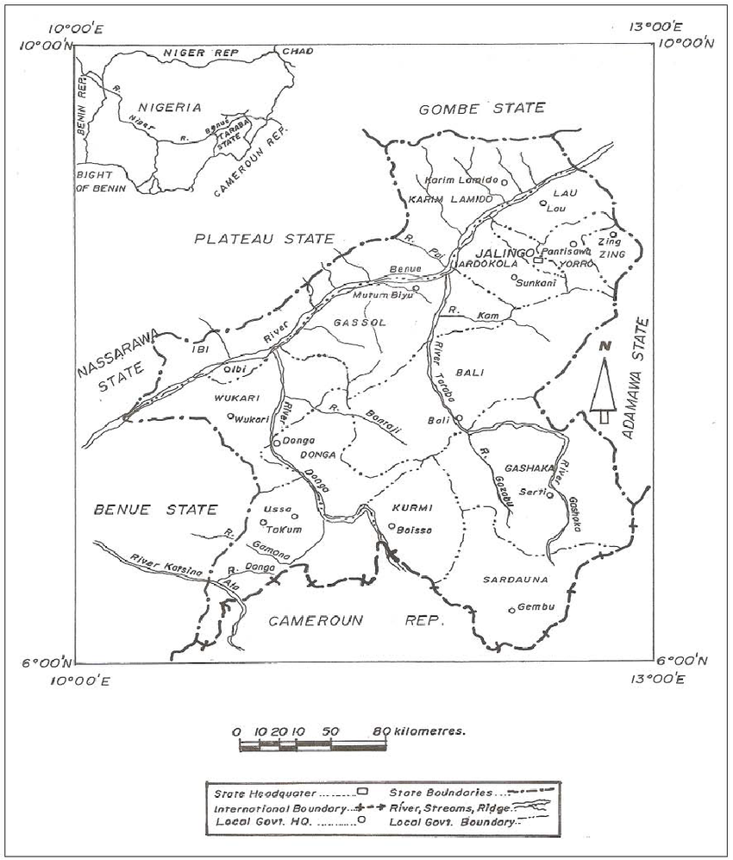
Fig .1 Map showing study location
2.2 Data Sources
LULC data were derived from Landsat satellite imagery for 1994, 2004, 2014, and 2024. Ground truthing was conducted through fieldwork in 2025. Standard supervised classification techniques were employed using ENVI and ArcGIS software. LULC was categorized into four classes: Bare Surface, Built-up Area, Vegetation, and Waterbody.
2.3 Data Analysis
The data analysis in this study employed a combination of remote sensing techniques, geographic information system (GIS) tools, and statistical methods to assess land use and land cover changes (LULC) and the spatial expansion of artisanal and small-scale mining (ASM) activities from 1994 to 2024.
2.3.1 Preprocessing of Satellite Data
Satellite imagery from Landsat 5 TM (1994), Landsat 7 ETM+ (2004), Landsat 8 OLI/TIRS (2014), and Landsat 9 (2024) was downloaded from the United States Geological Survey (USGS) Earth Explorer. The images were subjected to the following preprocessing steps:
2.3.2 Land Use and Land Cover (LULC) Classification
The corrected images were classified into five major land cover categories using supervised classification with the Maximum Likelihood Algorithm:
Forest, Agricultural Land, Built-up Area, Bare Surface, and Water Bodies
2.3.3 Change Detection Analysis
Post-classification comparison was conducted to detect changes between the classified images of 1994, 2004, 2014, and 2024. The area, measured in hectares, for each class was computed for each year, and the magnitude, percentage, and rate of change were calculated as:
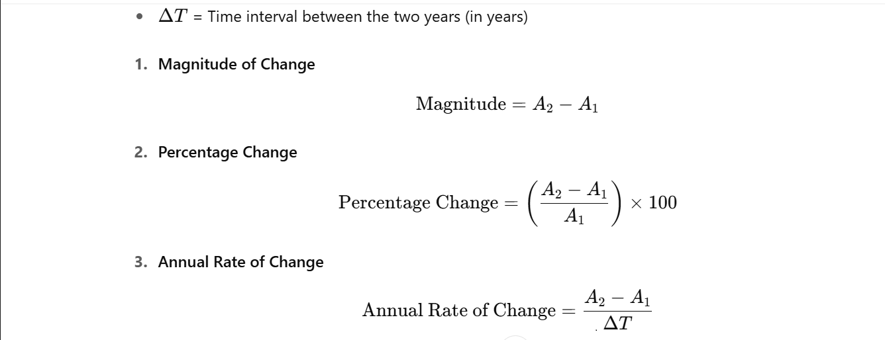
Figure 2: Formula for Land Cover Change Analysis
2.4 Mapping and Analysis of ASM Sites
Field data collected using GPS coordinates and interviews were used to identify active ASM sites. These were digitized and overlaid on LULC maps using ArcGIS 10.x and QGIS. Spatial overlays allowed for the identification of land cover classes most affected by ASM activities.
Buffer analysis (100m, 200m, and 500m) around mining sites was used to quantify environmental impacts on adjacent land use types.
2.5 Integration of Socioeconomic Data
Structured interviews and focus group discussions (FGDs) were conducted with local residents, miners, and community leaders to complement remote sensing findings. The qualitative data were analyzed using thematic coding to identify common environmental and socio-economic concerns linked to ASM.
2.6 Statistical Analysis
Descriptive statistics were computed to summarize changes in LULC categories. Pearson correlation analysis was applied to determine the relationship between the expansion of mining areas and the loss of forest or farmland. ANOVA tests were used to evaluate the statistical significance of LULC changes over the study period.

3.0 Results and Discussion
3.1 Results
Table 1: Land Use and Land Cover Change in the Central Zone (1994–2024)
Land Use Category | 1994 Area (ha) | % | 2004 Area (ha) | % | 2014 Area (ha) | % | 2024 Area (ha) | %
Bare Surface | 45,414.35 | 2.05 | 537,952.75 | 28.60 | 22,080.79 | 29.71 | 22,080.79 | 29.71
Built-up Area | 7,480.08 | 0.10 | 2,193.95 | 0.12 | 129.05 | 0.17 | 129.05 | 0.17
Vegetation | 2,148,304.23 | 97.29 | 1,321,280.09 | 70.24 | 51,397.16 | 69.15 | 51,397.16 | 69.15
Waterbody | 12,414.17 | 0.56 | 19,782.31 | 1.05 | 719.68 | 0.97 | 719.68 | 0.97
Source: Researcher’s Fieldwork, 2025

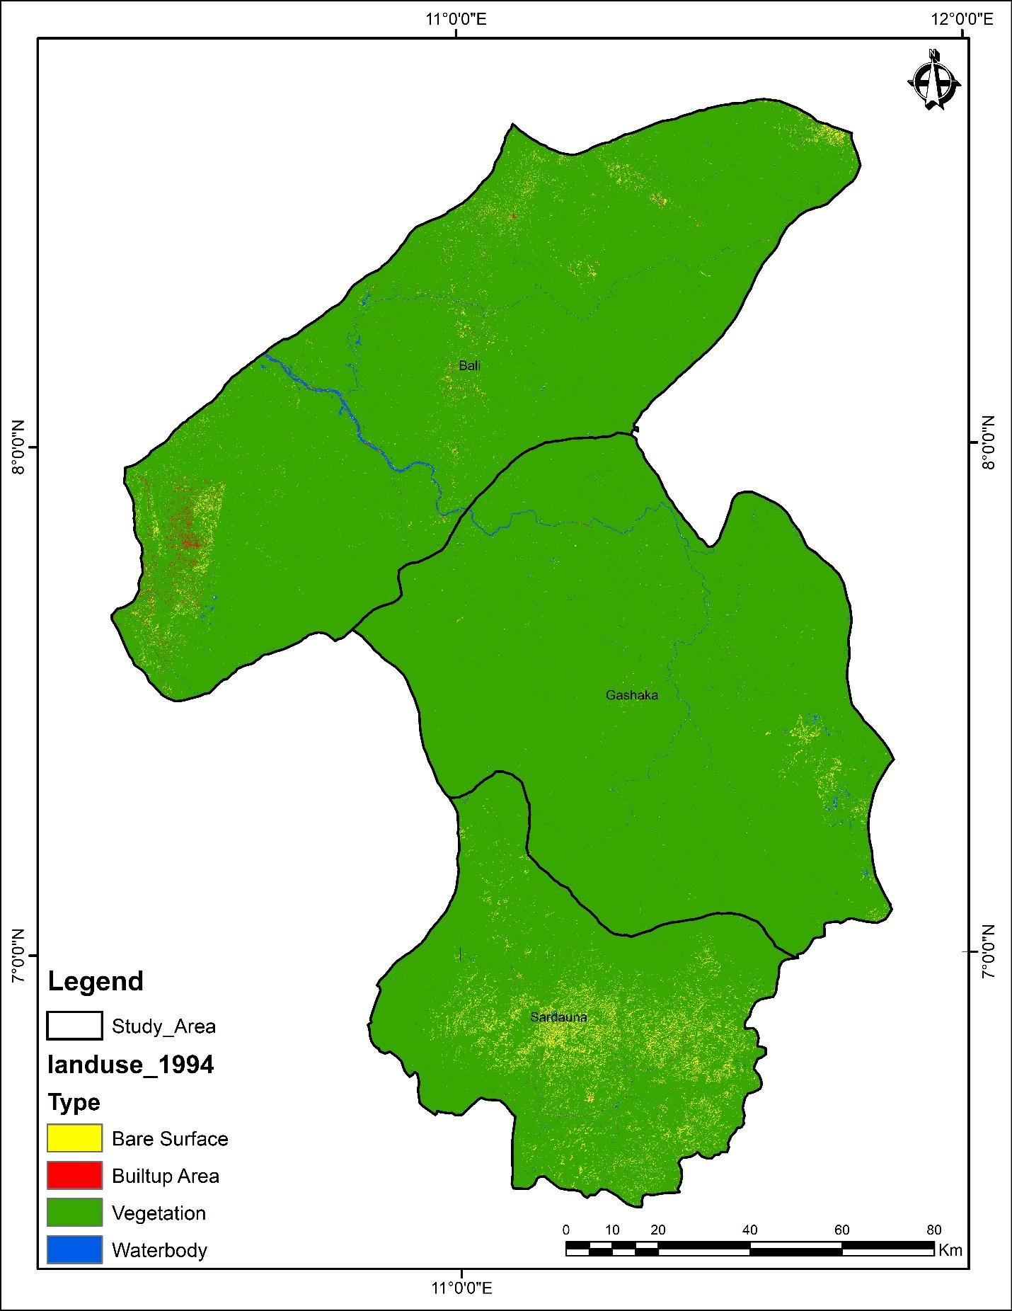

Fig .3 Land use map of 1994

Vegetation cover experienced a dramatic decline from 97.29% in 1994 to 69.15% in 2024. This decline aligns with periods of peak ASM activity. Bare surfaces rose from 2.05% to 29.71%, reflecting land degradation, topsoil removal, and erosion due to mining.

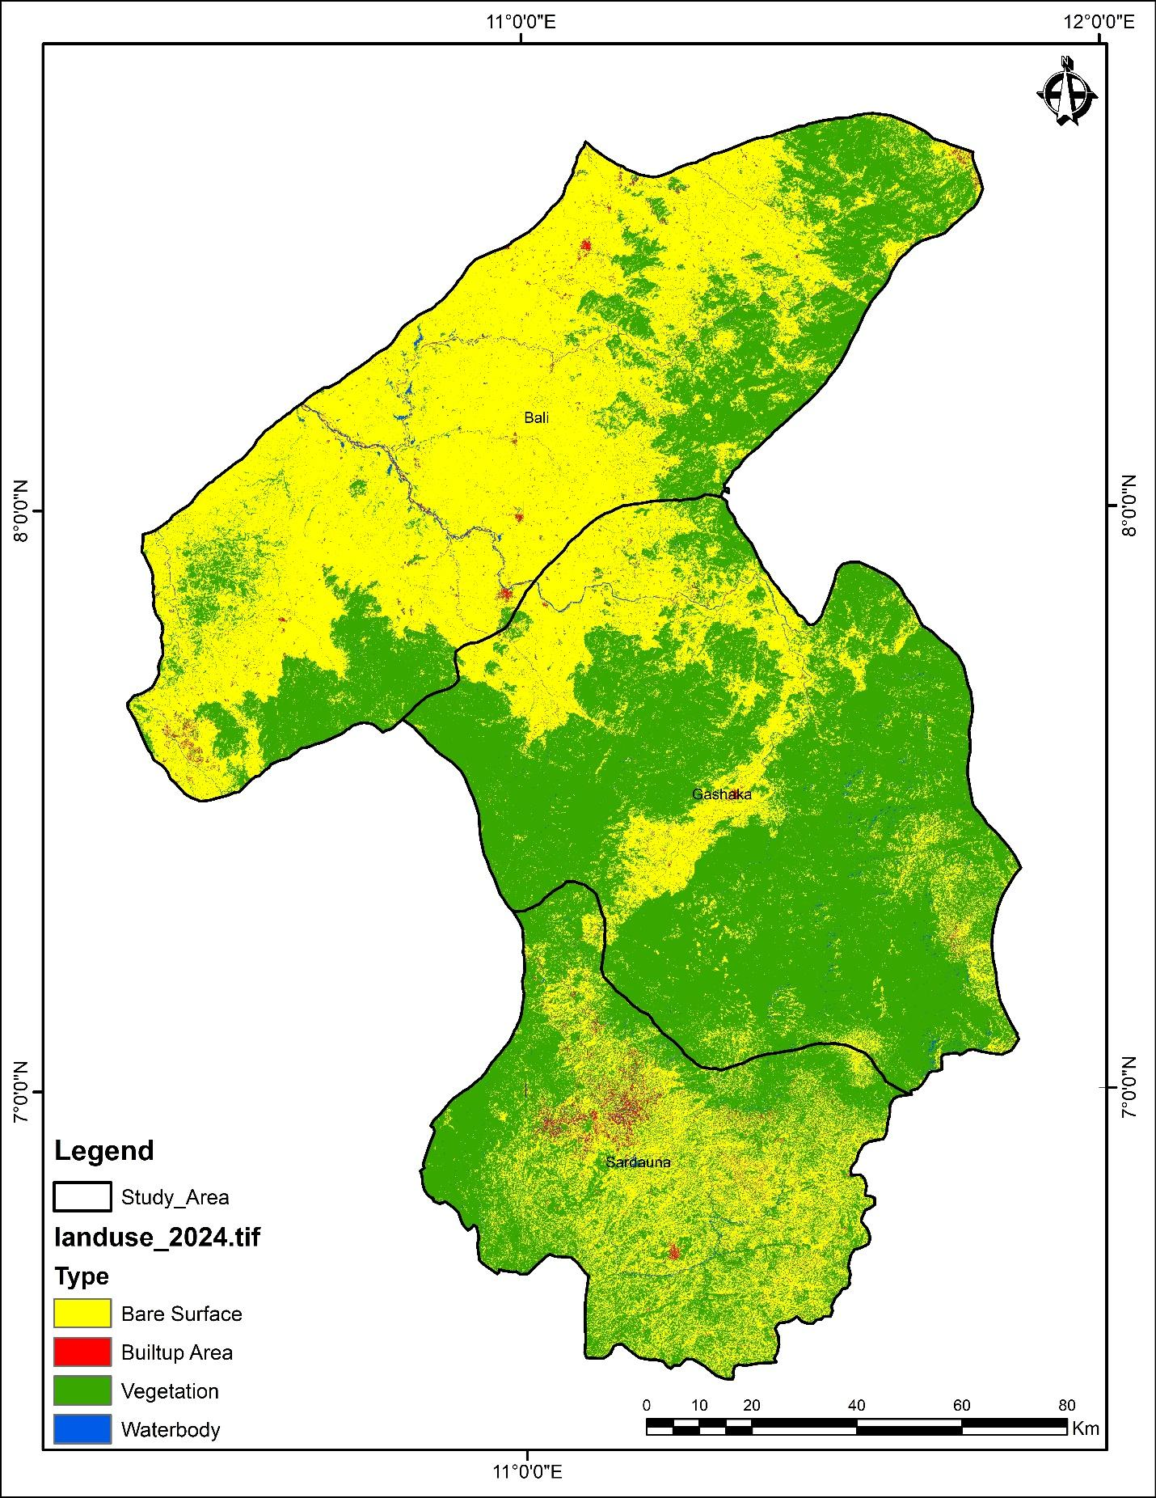

Fig .4 Land use map of 2024

Built-up areas show inconsistent trends, likely due to displacement and temporary structures rather than permanent urban growth.
Waterbodies fluctuate slightly, but field observations suggest sedimentation and contamination from mining effluents.

4.0 Discussion
The study revealed a substantial decline in vegetation cover in Nigeria’s Central Zone, from 97.29% in 1994 to 69.15% in 2024, representing a 28.14% reduction over three decades. This dramatic decrease closely aligns with periods of intensified artisanal and small-scale mining (ASM) activity. The findings corroborate previous studies that report widespread deforestation and vegetation clearance associated with ASM in mineral-rich zones across Nigeria (Ibrahim et al., 2021; Aigbedion & Iyayi, 2007). For example, Ogundele et al. (2016) reported a 35% loss in vegetative cover in parts of Plateau State due to ASM-induced bush clearing, excavation, and panning.
Similar patterns were observed by Musa et al. (2020) in Zamfara State, where artisanal gold mining led to notable forest decline and conversion of farmland to extraction sites. These findings collectively affirm that ASM, especially when unregulated, is a key driver of deforestation and landscape destabilization. Vegetation loss not only reduces biodiversity but also accelerates soil erosion, diminishes carbon sequestration, and undermines local climate resilience (Ocheni & Nwankwo, 2012).
The sharp increase in bare surfaces from 2.05% in 1994 to 29.71% in 2024, is a direct indicator of land degradation resulting from surface excavation, topsoil removal, and exposure of subsoils due to mining. This finding is consistent with empirical work by Nwibo and Okorie (2013), who documented how ASM in Ebonyi State left vast stretches of land devoid of vegetation and rendered infertile due to unfilled pits and soil toxicity. Similarly, Bada and Opeyemi (2019) highlighted that ASM activities in Kwara State led to surface scarring and irreversible terrain alteration, further confirming that the transformation of green cover into bare landscapes is a recurring environmental outcome of ASM across Nigeria.
These bare areas often evolve into erosion hotspots, triggering gully formation and sediment transport into adjacent water bodies (Amangabara & Obenade, 2015). The severity of this land degradation underscores the need for mining reclamation policies and environmental audits before the commencement of new mining operations.
Most structural developments in ASM zones are temporary rather than permanent, noted by Adepoju et al. (2018), in mining camps in Osun State. Such instability in built-up growth contradicts the patterns seen in urban expansion studies (e.g., Ololade et al., 2019), indicating that ASM settlements lack the infrastructural permanence required to support sustainable rural development.
Although water bodies in the study area exhibited only slight areal fluctuations, field verification and community interviews revealed significant qualitative degradation. Observations indicated increased sedimentation, turbidity, and contamination from mercury and other mining-related effluents, especially in riverine ASM zones. These findings are consistent with studies by Olatunji et al. (2015) and Obaje (2009), who highlighted heavy metal pollution and the adverse effects of unregulated mining activities on water quality. Such disruptions threaten aquatic ecosystems, compromise potable water sources, and pose serious health risks to surrounding communities
5.0 Conclusion
This study confirms that artisanal and small-scale mining has significantly altered the land use and environmental balance in Nigeria’s Central Zone over three decades. The environmental footprint is most evident in vegetation loss and land degradation. Immediate policy interventions are needed, including land reclamation, reforestation, and community sensitization on sustainable mining practices.
6.0 Recommendations
Implement a national policy on sustainable ASM with environmental safeguards.
Introduce community-based land rehabilitation programs.
Strengthen satellite monitoring for real-time environmental surveillance.
Engage miners in participatory environmental education.

REFERENCES
Bansah, K. J., Dumakor-Dupey, N. K., Kansake, B. A., Assan, E., & Bekui, P. (2016). Socioeconomic and environmental implications of artisanal and small-scale mining (ASM): A case study of Ghana. Journal of Cleaner Production, 129, 683–690. https://doi.org/10.1016/j.jclepro.2016.03.085
Garvin, T., McGee, T. K., Smoyer-Tomic, K. E., & Aubynn, E. A. (2009). Community–company relations in gold mining in Ghana. Journal of Environmental Management, 90(1), 571–586. https://doi.org/10.1016/j.jenvman.2007.12.014
Hilson, G. (2002). Small-scale mining and its socio-economic impact in developing countries. Natural Resources Forum, 26(1), 3–13. https://doi.org/10.1111/1477-8947.00002
Hilson, G., & Potter, C. (2003). Why is illegal gold mining activity so ubiquitous in rural Ghana? African Development Review, 15(2–3), 237–270. https://doi.org/10.1111/j.1467-8268.2003.00032.x
Ibrahim, A. M., Okunlola, I. A., & Ogunkoya, O. O. (2021). Environmental impact of artisanal gold mining in Luku, North Central Nigeria. Environmental Earth Sciences, 80, Article 64. https://doi.org/10.1007/s12665-021-09392-4
Mmom, P. C., & Arokoyu, S. B. (2010). The environmental implications of oil exploration and exploitation in the coastal region of Nigeria. Environmentalist, 30(4), 293–301. https://doi.org/10.1007/s10669-010-9275-z
Ofosu, G., Dittmann, A., Sarpong, E. O., & Addo, M. A. (2020). Socio-economic impact of small-scale mining on rural communities in Ghana. GeoJournal, 85, 819–830. https://doi.org/10.1007/s10708-019-10033-0
Tschakert, P., & Singha, K. (2007). Contaminated identities: Mercury and marginalization in Ghana’s artisanal mining sector. Geoforum, 38(6), 1304–1321. https://doi.org/10.1016/j.geoforum.2007.05.002
Yakubu, S. I. (2020). Regulating small-scale mining in Nigeria: Challenges and prospects. The Extractive Industries and Society, 7(4), 1281–1290. https://doi.org/10.1016/j.exis.2020.07.010

