Investigating the host range potential of Fusarium equiseti (Tuberose Blossom Blight) in Chilli and Tomato

Abstract
Fusarium species is a versatile fungal pathogen, is known for its broad species concept and ability to survive in soil due to resistant chlamydospores. This study investigates the host range potential of F. equiseti, isolated from tuberose blossom blight (PP663913), by assessing its ability to cause Fusarium wilt in chilli and tomato plants. Materials and methods included isolation and culture of F. equiseti, inoculation procedures using sand-maize media and root-dipping methods, and pathogenicity assessment. Morphological studies and genetic confirmation were conducted through microscopic examination, DNA extraction, PCR amplification, and phylogenetic analysis. Results demonstrated successful infection of both chilli and tomato plants by F. equiseti. Chilli plants exhibited symptoms within 15 days post-inoculation, including leaf discoloration and inward curling. Tomato plants showed signs of infection after 8 days, with leaf firmness loss and color changes. Microscopic examination revealed fungal mycelium and spores in vascular tissues. Re-isolation and characterization confirmed the pathogen's identity. Morphological studies showed distinct features of Fusarium species in both isolates. Genetic analysis using ITS sequencing assigned unique accession numbers for chilli (PQ073350) and tomato (PQ074082) isolates, confirming their identity as F. equiseti. Phylogenetic analysis placed these isolates within the F. equiseti clade, supporting their identification and relationship to known strains. The study expands our understanding of F. equiseti's host range and highlights its potential threat to diverse cropping systems.
Keywords: Fusarium equiseti, Cross-pathogenicity, Tuberose, Chilli, Tomato

Introduction:
The genus Fusarium comprises diverse, widespread fungal species with significant morphological and phylogenetic variations. These economically important soil-borne plant pathogens have a wide host range. Traditional Fusarium identification relied on observable traits like colony appearance, morphology of both macro- and microconidia, and chlamydospore characteristics before the introduction of molecular techniques (Aoki et al., 2014; Nelson et al., 1994). Fusarium equiseti is one of the few Fusarium species that never becomes red in culture. Currently, F. equiseti is recognized under a broad species concept, with strains from different substrates and temperature regions exhibiting significant variation in mycotoxin profiles and morphological features. Primarily, F. equiseti is recognized as a secondary invader in agricultural crops after soil contamination, where it can survive for years due to its abundant production of resistant chlamydospores (Thrane, 2014). F. equiseti is a versatile fungal pathogen affecting various crops in India. It was first reported as causing wilt in wild pigeonpea (Cajanus scarabaeoides) by Mishra et al. (2021). Ramachandra and Bhatt (2012) identified it as the cause of vascular wilt in cumin. Gupta et al. (2013) reported F. equiseti infecting Cyperus iria, a rice weed, at the University Research Farm in Chatha, Jammu. Hami et al. (2021) discovered it as the causal agent of chilli wilt in Kashmir. These studies highlight F. equiseti's expanding host range and increasing significance as a plant pathogen in India.
Tuberose (Polianthes tuberosa L.) is a commercially important flower in India, available in single and double cultivars. It's known for its waxy white flowering spikes and sweet fragrance (Benschop et al., 1993). Widely cultivated in several Indian states, including West Bengal, Karnataka, Tamil Nadu, and Maharashtra (Gadakh and Kamble, 2023), tuberose farming thrives in specific districts of Tamil Nadu due to suitable climate and soil conditions. Karnataka and Tamil Nadu contribute 70% of India's tuberose absolutes export. As per 2016-17 government data, India cultivated tuberose on 1.49 lakh ha, producing 106.49 mt of loose flowers and 89.82 lakh no. of cut flowers. (Ministry of Agriculture and Farmers Welfare. Govt. Of India, 2016-17). Tuberose is valued for its natural aromatic oil used in the perfume industry and as a cut flower (Shadhukan et al., 2021). The oil is exported to countries like France and Italy. As commercial cultivation grows, identifying high-yielding varieties for specific regions is crucial for farmers to achieve sustainable and economic profits.
Chilli (Capsicum species) serves dual purposes as both a vegetable and a spice. In India, it covers an area of 364’000 ha, and 3851’000 mt in production (Source: Department of Agriculture Cooporation & Farmers Welfare, 2019-20). It is naturally rich in a variety of beneficial compounds, including bioactive substances, flavonoids, and capsaicinoids. Additionally, it contains numerous phytochemicals, phytonutrients, and pharmacologically active components. These compounds are associated with various potential health advantages, making the crop not only a culinary ingredient but also a source of possible therapeutic benefits (Bal et al., 2022). Heterosis breeding has emerged as a critical method for quickly improving yield and other economic traits in chilli (Herath et al., 2021).
Tomato (Solanum lycopersicum L.) is a versatile and widely consumed vegetable in India covers 812’000 ha area, and 205.73 lakh tonnes in production (Source: Department of Agriculture Cooporation & Farmers Welfare, 2019-20), ranking third in cultivation after potato and onion. It's an important source of income and employment for small farmers. Consuming tomatoes is linked to several health advantages. These benefits encompass potential anticancer effects, positive impacts on cardiovascular health, and possible protection against neurodegenerative conditions. Additionally, tomatoes are believed to contribute to maintaining skin health (Collins et al., 2022). However, pest and disease outbreaks can significantly reduce yields and profits. While tomato production can be profitable, especially with hybrid varieties, several factors affect profitability, including education, labour costs, transportation, purchase and selling prices, and market volatility due to supply fluctuations (Vanitha et al., 2018).
Given the economic significance of chilli and tomato crops and previous reports of Fusarium species affecting host of chilli (Hami et al., 2021) and tomato (Darmadi et al., 2019), this study aims to investigate whether F. equiseti, isolated from blossom blight in tuberose, is able to cause Fusarium wilt in chilli and tomato plants. Understanding the host range potential of this pathogen is crucial, as its ability to infect other economically important crops could have significant implications for agricultural biosecurity and crop management strategies. The findings of this study will contribute to formulating better management practices and mitigating risks to diverse crop species.
Materials and Methods:
Isolation and Culture of Fusarium equiseti:
To isolate fungal pathogen, the infected tissue was carefully excised into small segments (5mm). These segments underwent a surface sterilization process, which involved a brief immersion in 70% alcohol, followed by treatment with 1% sodium hypochlorite for one minute, and two subsequent rinses with sterile distilled water. The sterilized tissue pieces were then dried on a sterile paper towel within a fume hood. Once dry, the segments were placed on potato dextrose agar medium, which was supplemented with a small amount of cefotaxime to inhibit bacterial growth. The Petri dishes were incubated at 28 ± 1 °C in darkness for 2-3 days, during which time fungal growth emerged from the tissue. These fungal growths were then carefully separated and transferred to fresh plates. To ensure pure cultures, the single-spore subculture technique was employed for further isolation and identification of the Fusarium species causing wilt in chilli and tomato plants.
Culture was collected from tuberose plants showing symptoms of blossom blight caused by Fusarium equiseti from the Dharmapuri district. From infected tuberose samples, the pathogen was isolated and identified as Fusarium equiseti based on morphology and molecular characterisation further verified with NCBI (accession number - PP663913). The pure cultures of Fusarium equiseti is maintained on Potato Dextrose Agar (PDA) slant for experimental use to identify whether Fusarium equiseti is able to infect multiple host range (chilli and tomato).
Inoculation Procedures:
Spores of Fusarium equiseti were collected and suspended (1.5 x 10⁶ spores/mL) for inoculation. The experiment utilized healthy chilli and tomato seedlings purchased from a nursery, employing both the sand-maize media (Kala et al., 2016; Hami et al., 2021) and the root-dipping method (Rowe, 1980; Darmadi et al., 2019; Ma et al., 2022). For the sand-maize media method, a mixture of 90g riverbed sand, 10g maize meal, and 20ml distilled water was prepared in a 250ml conical flask. This double-sterilized medium was then inoculated with a fungal spore suspension and incubated at 27±1°C for 15 days. The fully colonized inoculum was subsequently mixed with sterilized soil at a 1:10 ratio and used to fill pots. The root-dipping method involved inoculating 14-day-old seedlings with a fungal suspension. The roots were first injured, and then immersed in the spore suspension for either 1 or 12 hours. Control seedlings underwent root injury with a sterile needle followed by immersion in sterile water.
Pathogenicity Assessment:
Plants were monitored for fusarium wilt symptoms in chilli and tomato. In chilli, symptoms included leaf discoloration and inward curling, eventually leading to complete plant wilting. This occurs due to vascular system damage, which impairs the plant's ability to absorb water and nutrients (MacHardy and Beckman, 1981; Morid et al., 2012). In tomato plants, the disease progression is characterized by leaves losing their firmness, becoming limp, and changing color from light green to yellowish-green. The affected foliage then droops, turns yellow, progresses to brown, and ultimately wilts, often resulting in plant death. These symptoms are attributed to the obstruction of xylem vessels by fungal mycelium, spores, or fungus-produced polysaccharides (Agrios, 2005; Di Pietro et al., 2003). The severity of symptoms, including wilting, chlorosis, necrosis, and overall plant health, was recorded and compared to controls to evaluate the pathogenicity of Fusarium equiseti on both crops.
Morphological identification
To identify the associated pathogen (Fusarium sp.) from the inoculated chilli and tomato, morphological characteristics were studied under microscope after culturing on artificial medium, specifically PDA. For microscopic observation semi-permanent slides were prepared from 10-day-old colonies, allowing for detailed examination of critical structures including hyphae, chlamydospores, microconidia, and macroconidia. This thorough methodology facilitates precise recognition and categorization of the disease-causing fungi (Fusarium spp.) by analyzing their unique structural features (Leslie and Smmerell, 2006).
DNA extraction, PCR, sequencing & phylogenetic studies:
DNA extraction: The extraction of DNA from fungal mycelia involves harvesting mycelia from 15-day-old cultures by modified CTAB method (Moller et al., 1992). A single gram of mycelia was harvested and ground in liquid nitrogen and transferred to a 1.5 mL Eppendorf tube. The frozen sample was then promptly pulverized into a fine powder with a homogenizer. To initiate cell lysis, each tube was filled with 750 µL of lysis buffer and thoroughly mixed using a vortex to ensure uniformity. The mixtures were then subjected to water bath at 65⁰ C for 30-minute. A 700 µL solution of chloroform and phenol in equal parts was then added and gently combined with the sample, followed by a centrifugation at 10,000 rpm for 10 minute. The resulting aqueous layer was carefully transferred to a new tube, and the chloroform: phenol extraction process was performed once more. To precipitate the DNA, 70 µL of sodium acetate and 300 µL of isopropanol were added to the final aqueous phase. The mixture was then centrifuged at 13,000 rpm for 5 minutes, producing a DNA pellet which was subsequently washed with 70% ethanol, and air-dried. The resulting pellet was washed again with 70% ethanol and ultimately dissolved in 100 µL of TE buffer / sterile distilled water. To ensure complete dissolution, the DNA sample was left overnight at 4°C.
PCR amplification: Genomic DNA extracted from the sample was subjected to PCR amplification (White et al., 1990) using Universal internal transcribed spacer (ITS) primer pair of ITS-1F-TCCGTAGGTGAACCTTGCGG, and ITS-4R-TCCTCCGCTTATTGATATGC. The PCR reaction mixture containing final volume of 40 µL, contained 20 µL Master Mix, 4 µL each primer, 4 µL template genomic DNA, and 8 µL sterile distilled water. Amplification was performed in a Thermocycler with the following program: initial denaturation at 94ºC for 4 minutes, followed by 35 cycles of denaturation (94°C for 60 seconds), annealing (58ºC for 60 seconds), and extension (72ºC for 60 seconds), concluding with a final extension at 72ºC for 10 minutes. The PCR products were visualized using 2% agarose gel electrophoresis in 1x TBE buffer. The gels were stained with ethidium bromide and photographed under a computerized UV trans-illuminator.
Sequencing and Phylogenetic analysis: Subsequently, the amplified PCR products were sequenced using the Sanger dideoxy method at Biokart India Pvt. Ltd., Karnataka. The resulting nucleotide sequences were submitted to the GenBank database at NCBI to obtain unique accession numbers for each isolate. For phylogenetic analysis, these sequences were combined with relevant GenBank sequences. A phylogenetic tree was constructed using MEGA11.0 software, employing the neighbor-joining method with 1000 bootstrap replications to ensure statistical robustness.
Results:
In 2024, an experiment was conducted in the Laboratory of the Department of Plant Pathology at Tamil Nadu Agricultural University, Coimbatore; to investigate the host range potential of infection of Fusarium equiseti isolated from tuberose, to infect chilli and tomato. The experiment included chilli and tomato seedlings from a nursery in Thondamuthur, with F. equiseti isolates (Accession number - PP663913) originating from diseased tuberose plants obtained from the Dharmapuri district.
Symptom Development and Pathogenicity:
The host range potential of Fusarium equiseti (PP663913) was evaluated through pathogenicity assessments on chilli and tomato plants.
In chilli plants, Fusarium wilt symptoms emerged within 15 days of post-inoculated seedlings in sand-maize media. Initial signs included leaf discoloration, progressing from green to yellowish, followed by inward leaf curling, indicating a compromised vascular system. As the disease progressed, complete wilting of the plants was observed in three out of four inoculated seedlings, while control plants remained healthy throughout the experiment period.
Tomato seedlings, treated by root dipping in a spore suspension (1.5 x 10⁶ spores / mL) for 12 hours, exhibited a distinct symptom development pattern. Loss of leaf firmness, was first noticed 8 days after inoculation, with leaves becoming limp and gradually changing color from light green to yellowish-green. As the infection progressed, leaf drooping became more pronounced. In severe cases, leaf color changed from yellow to brown, culminating in complete wilting. By the experiment end, two out of four inoculated tomato seedlings displayed full-scale wilting symptoms, with some plant dying. In control, the seedlings which underwent root injury but were treated with sterile water, showed no symptoms of Fusarium wilt throughout the experiment, further validating the pathogenicity of the Fusarium isolate (Figure 1 and 2).
Microscopic examination of the vascular tissues from both chilli and tomato plants revealed the presence of fungal mycelium and spores, confirming the successful colonization of the pathogen. This observation aligns with the typical disease progression in Fusarium wilt, where fungal colonization leads to xylem vessel obstruction.
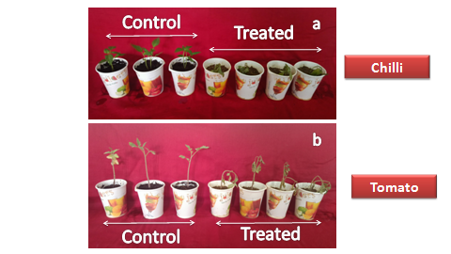
Figure 1 - Effects of Fusarium equiseti Inoculation on Chilli (a) and Tomato (b) Seedlings
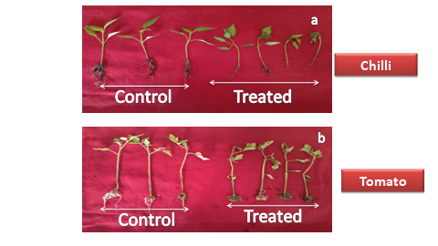 | 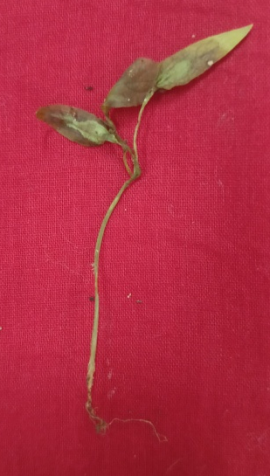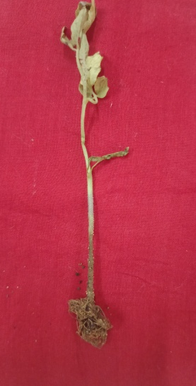  a  b
Figure 2 - The image illustrates the stark contrast between healthy control and treated plants, exhibiting clear signs of leaf discoloration and wilting on (a) Chilli and (b) Tomato.
Isolation:
To isolate the pathogen, small pieces of infected root or stem tissue from post-inoculated seedlings of chilli and tomato were carefully cut out and underwent surface sterilized with 70% alcohol/1% sodium hypochlorite, rinsed in water, and dried. These dried tissue segments were then placed on a potato dextrose agar (PDA) medium. After incubating, the plates were kept for a period of 2-3 days at room temperature. From the 3 days old culture a single-spore subculture technique was performed to obtain pure fungal cultures. The culture plate of chilli (C-FE) and tomato (T-FE) shows a creamy-white to grayish color, with fluffy, cotton-like appearance, with texture appears to be uniform and dense, suggesting a healthy and vigorous fungal growth (Figure 3).
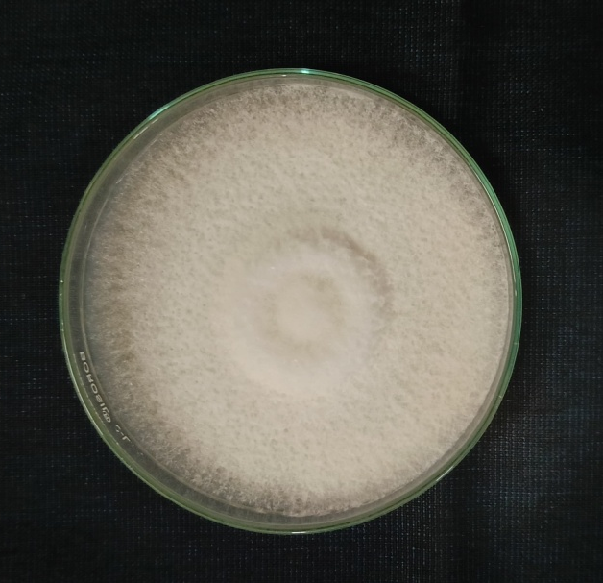  a | 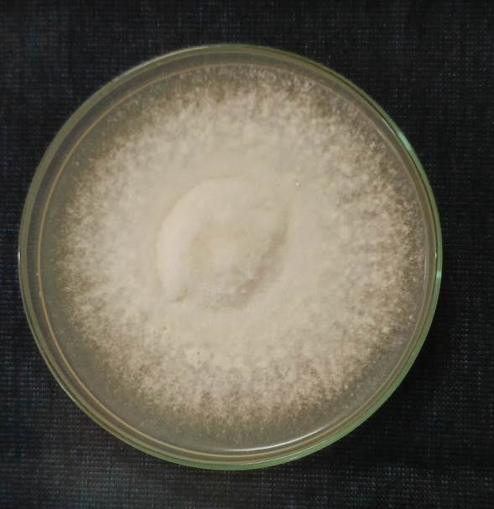  b
Figure 3 – Isolation of pathogen from inoculated a. Chilli (C-FE) and b. Tomato (T-FE).
Morphological studies and Genetic Confirmation:
Morphological: The microscopic examination of 15 days old fungal cultures grown on PDA medium revealed distinct structural features of the Fusarium isolates obtained from the inoculated chili (C-FE) and tomato (T-FE) plants. The analysis focused on the characteristics of the hyphae, chlamydospores, microconidia, and macroconidia present in the both cultures of C-FE and T-FE. For the chilli isolate (C-FE), the microconidia had a length of 165.693 μm, width of 63.747 μm, and 0-1 septate, while the macroconidia had a length of 227.305 - 306.689 μm, width of 60.475 - 62.093, and 3-5 septate. In contrast, the tomato isolate (T-FE) exhibited macroconidia with a length of 264.317 - 338.971 μm, width of 47.641 - 66.370 μm, and 3-4 septate, and microconidia with a length of 199.11 μm, width of 71.360 μm, and 0-1 septate (Figure 4).
DNA extraction: The extraction of DNA from the culture plate of C-FE and T-FE was carried out using a modified CTAB method. Following the extraction procedure a clear DNA pellet was obtained after the cell lysis, precipitation, and purification steps, which was then dissolved in TE buffer. Later, the DNA sample of C-FE and T-FE were left overnight at 4°C.
PCR and gel-documentation: The extracted genomic DNA of C-FE and T-FE was subjected to PCR amplification using the universal ITS primer pair, ITS-1F and ITS-4R. The PCR reaction mixture contains Master mix, primer pair, C-FE genomic DNA, and sterile distilled water, total volume of 40 μL. The amplification was performed in a Thermo cycler using the following program: followed by 35 cycles of denaturation, annealing, and extension. The gel electrophoresis of the PCR products revealed distinct bands for the chilli isolates (C-FE-C1 and -C2) and the tomato isolates (T-FE-T1 and -T2), indicating that the PCR amplification was successful (Figure 5). Moreover, the size of the amplified bands matched the expected size for the ITS region (500 bp).
Sequencing and phylogenitic analysis: To confirm the genetic identity of the isolates (C-FE & T-FE), the amplified PCR products were sequenced using the Sanger dideoxy method at Biokart India Pvt. Ltd., Karnataka. The resulting nucleotide sequences were submitted to the GenBank database at NCBI, and unique accession numbers were assigned for each isolate: PQ073350 for the chili isolate (C-FE) and PQ074082 for the tomato isolate (T-FE). These accession numbers confirmed the genetic identification of the isolates as Fusarium equiseti. For phylogenetic analysis, the obtained sequences were combined with relevant GenBank sequences, and a phylogenetic tree was constructed using MEGA11.0 software. The neighbor-joining method with 1000 bootstrap replications was employed to ensure the statistical robustness of the analysis with out-group of Alternaria solani (Figure 6).
CHILLI ISOLATE (C-FE)
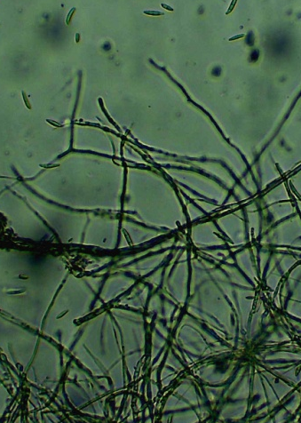 | 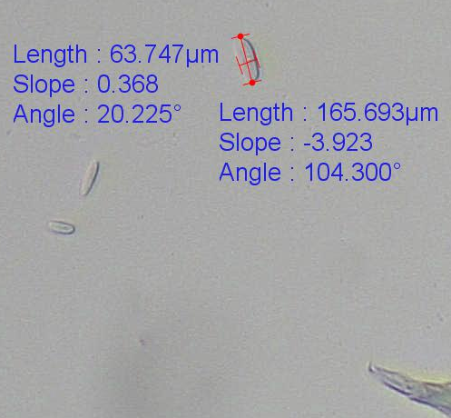 | 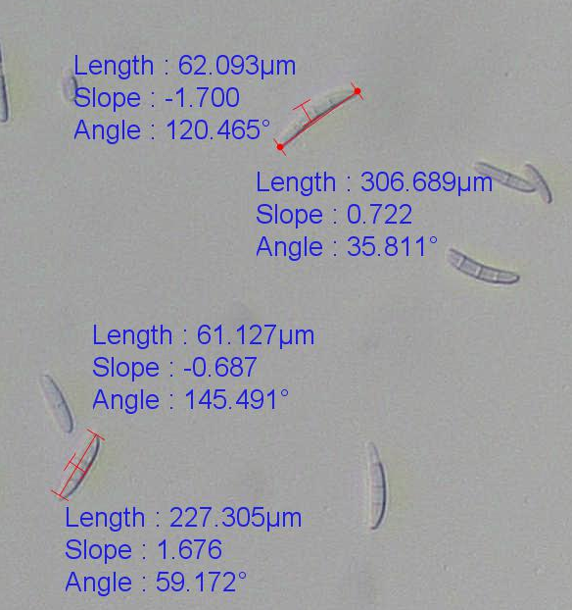
Hyphae | Microconidia | Macroconidia
TOMATO ISOLATE (C-FE)
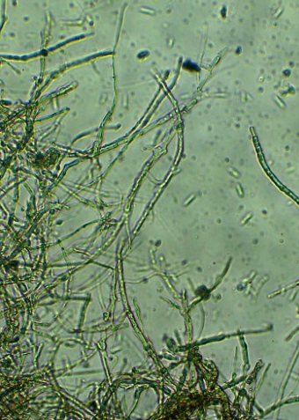 | 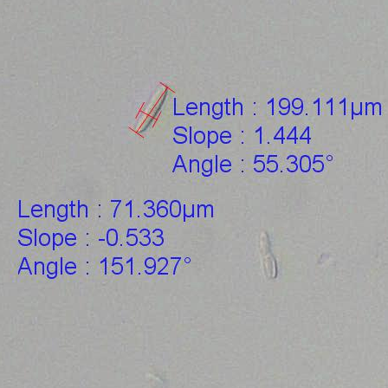 | 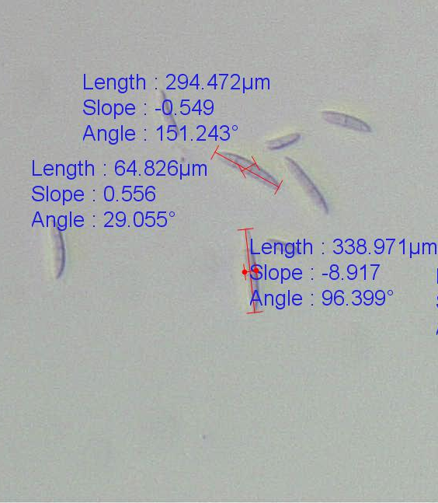
Hyphae | Microconidia | Macroconidia
Figure 4 – Microscopic observation of C-FE and T-FE isolates
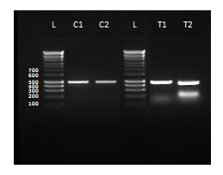
Figure 5 – Gel documentation Lane L-100 bp ladder, lane -C1 & -C2 are isolate of C-FE, and lane –T1 & -T2 are T-FE isolates.
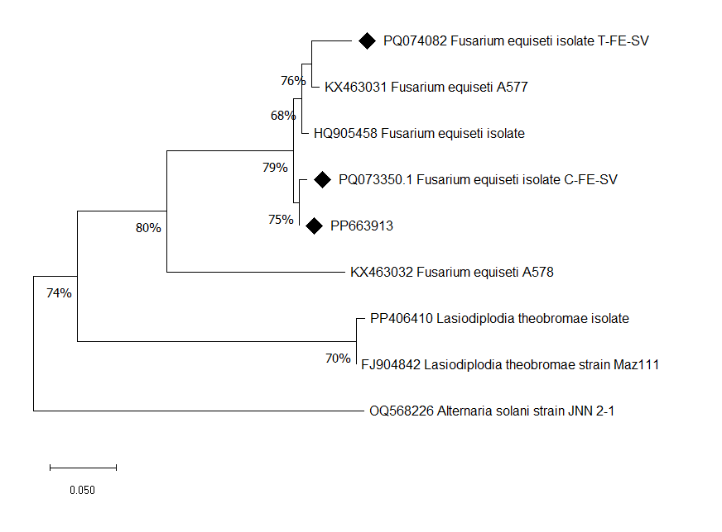
Figure 6 - The neighbor-joining tree showing the relationships of isolates (PQ074082 – Tomato isolate, PQ073350 – Chilli isolate) with the reference sequences obtained from the NCBI data base based on the ITS region. The isolate OQ568226 (Alternaria solani) was used as an out-group.
Discussion:
The study demonstrates that Fusarium equiseti, responsible for blossom blight in tuberose, can cross-infect chilli and tomato plants to cause wilt symptoms after incubation periods, suggesting a broad host range and significant pathogenic potential. The results demonstrate that F. equiseti can indeed infect and cause disease in both crops, expanding our understanding of its host range and potential threat to agriculture. The successful infection and symptom development in chilli and tomato plants highlight the adaptability of F. equiseti as a pathogen. In chilli, symptoms appeared within 15 days post-inoculation, while tomato plants showed signs of infection after 8 days. The progression of symptoms in both crops followed typical patterns of Fusarium wilt, including leaf discoloration, wilting, and eventual plant death in severe cases. The pathogenicity of F. equiseti on chilli and tomato was confirmed through re-isolation of the fungus from infected plant tissues and subsequent morphological and molecular characterization. The microscopic examination revealed characteristic features of Fusarium species, including hyphae, septate, chlamydospore, macroconidia and microconidia. The genetic analysis using ITS sequencing further confirmed the identity of the re-isolated pathogens as F. equiseti, with unique accession numbers assigned for both chilli (PQ073350) and tomato (PQ074082) isolates. The phylogenetic analysis placed these isolates within the F. equiseti clade, further supporting their identification and demonstrating their close relationship to other known F. equiseti strains. This genetic confirmation is crucial in understanding the evolutionary relationships and potential variations within the F. equiseti species complex. The ability of F. equiseti to infect multiple economically important crops (tuberose, chilli, and tomato) raises concerns about its potential impact on agriculture. This broad host range suggests that F. equiseti may be more versatile and adaptable than previously thought, potentially posing a threat to diverse cropping systems.
Conclusion:
This study demonstrates that Fusarium equiseti, isolated from tuberose (PP663913), can cause Fusarium wilt in chilli and tomato plants, expanding our understanding of its host range and pathogenicity. This finding has significant implications for agriculture and plant disease management, including the need to re-evaluate crop rotation strategies, incorporate F. equiseti resistance into breeding programs, update integrated pest management approaches, conduct further research on infection factors and control measures, and expand surveillance efforts for future research. The study underscores the importance of continuously assessing plant pathogen host ranges and developing comprehensive strategies to mitigate their impact on agricultural production.
Ethics Approval and Consent to Participate
Not applicable.
Consent for Publication
Not applicable.
Competing Interests
No potential conflict regarding interests is disclosed by the authors.

Reference
- Aoki, T., O’Donnell, K. and Geiser, D.M., 2014. Systematics of key phytopathogenic Fusarium species: current status and future challenges. Journal of General Plant Pathology, 80, pp.189-201.
- Nelson, P.E., Dignani, M.C. and Anaissie, E.J., 1994. Taxonomy, biology, and clinical aspects of Fusarium species. Clinical microbiology reviews, 7(4), pp.479-504.
- Benschop, M., De Hertogh, A., Le Nard M (1993). The physiology of flower bulbs (Edn) Elsevier, Amsterdam, The Netherlands 589-601
- Gadakh, A.S. and Kamble, S.D., 2023. Economics analysis of tuberose flower production in Akola district, Maharashtra. Small (Up to 2 Ha.), 45(50.00), pp.1-47.
- Sadhukhan R, Chowdhuri TK and Datta SK (2021) Tuberose (polyanthes tuberosa linn./agave amica). In Floriculture and Ornamental Plants (pp. 1-52)
- Thrane, U. 2014. Fusarium. In Encyclopedia of Food Microbiology (Second Edition), 2014
- Mishra, R.K., Mishra, M., Bohra, A., Naik SJ, S., Saabale, P.R., Kumar, K., Patil, P.G., Srivastava, D.K. and Singh, N.P., 2021. First report of Fusarium equiseti causing wilt of Cajanus scarabaeoides, a wild relative of Pigeonpea, in India. Plant Disease, 105(9), p.2735.
- Ramchandra, S. and Bhatt, P.N., 2012. First report of Fusarium equiseti causing vascular wilt of cumin in India. Plant disease, 96(12), pp.1821-1821.
- Gupta, V., Razdan, V.K., John, D. and Sharma, B.C., 2013. First report of leaf blight of Cyperus iria caused by Fusarium equiseti in India. Plant Disease, 97(6), pp.838-838.
- Hami, A., Rasool, R.S., Khan, N.A., Mansoor, S., Mir, M.A., Ahmed, N. and Masoodi, K.Z., 2021. Morpho-molecular identification and first report of Fusarium equiseti in causing chilli wilt from Kashmir (Northern Himalayas). Scientific Reports, 11(1), p.3610.
- Bal, S., Sharangi, A.B., Upadhyay, T.K., Khan, F., Pandey, P., Siddiqui, S., Saeed, M., Lee, H.J. and Yadav, D.K., 2022. Biomedical and antioxidant potentialities in chilli: Perspectives and way forward. Molecules, 27(19), p.6380.
- Herath, H.N., Rafii, M.Y., Ismail, S.I., JJ, N. and Ramlee, S.I., 2021. Improvement of important economic traits in chilli through heterosis breeding: a review. The Journal of Horticultural Science and Biotechnology, 96(1), pp.14-23.
- Collins, E.J., Bowyer, C., Tsouza, A. and Chopra, M., 2022. Tomatoes: An extensive review of the associated health impacts of tomatoes and factors that can affect their cultivation. Biology, 11(2), p.239.
- Vanitha, S.M., Reddy, B.C. and Gajanana, T.M., 2018. Economic analysis of profitability in tomato production at different seasons and market prices: a study in Kolar district of Karnataka.
- Darmadi, A.A.K., Suriani, N.L., Sudirga, S.K. and Khalimi, K., 2019. First study on Fusarium equiseti: causes Fusarium wilt in tomato crop in Bali, Indonesia.
- Ma, T., Yang, C., Cai, F. and Chen, Z., 2022. Morpho-cultural, physiological and molecular characterisation of Colletotrichum nymphaeae causing anthracnose disease of walnut in China. Microbial Pathogenesis, 166, p.105537.
- Kala C, Gangopadhyay S, Goden SL. Ecofriendly management of wilt caused by Fusarium oxysporum f. sp. ciceri in Chickpea. Legume Research 2016;39(1):129-134.
- Rowe, R.C., 1980. Comparative pathogenicity and host ranges of Fusarium oxysporum isolates causing crown and root rot of greenhouse and field-grown tomatoes in North America and Japan. Phytopathology, 70(12), pp.1143-1148.
- MacHardy, W.E., and Beckman C.H., 1981. Vascular wilt Fusaria: infection and pathogenesis.
- Morid, B., Hajmansoor, S. & Kakvan, N., 2012. Screening of resistance genes to Fusarium root rot and Fusarium wilt diseases in tomato (Lycopersicon esculentum) cultivars using RAPD and CAPs markers. Eur. J. Exp. Biol. 2(4), 931–939.
- Agrios, G.N., 2005. Plant pathology. Elsevier.
- Di Pietro, A., Madrid, M.P., Caracuel, Z., Delgado-Jarana, J. and Roncero, M.I.G., 2003. Fusarium oxysporum: exploring the molecular arsenal of a vascular wilt fungus. Molecular plant pathology, 4(5).
- Leslie J.F., Summerell B.A., 2006. The Fusarium Laboratory Manual. Blackwell Publishing Professional, Ames, IA, USA.
- Moller, EM, G Bahnweg, H Sandermann and HH Geiger. 1992. A simple and efficient protocol for isolation of high molecular weight DNA from filamentous fungi, fruit bodies and infected plant tissues. Nucl Acids Res 20:6115–6116
- White, T.J., Bruns, T., Lee, S. and Taylor, J. 1990. Amplification and direct sequencing of fungal ribosomal DNA for phylogenetics. In: M.A. Innes, D.H. Gelfand, J.J. Sninsky and T.J. White, (Eds.). PCR protocols: a guide to methods and applications. pp. 315-322. Academic, Sandiego, CA.

